EDITORIAL WINTER 2010

A tradition is born, it would certainly seem,
For Derek to bring Bill some H. B. Cream,
What could be better I hear you ask?
Bill drinks it from his own wine glass.

To those of you who don’t attend our convention the above doggerel may not make much sense, but at our last convention Derek Connell brought me a bottle of Harvey’s Bristol Cream, while I took a glass to drink it with. At the end the glass went missing, and could not be found. It turned out that Mike Perkins who was staying with me for a couple of days after the convention, put the glass in his bag for safe keeping, so it was not lost at all. Now when a noble deed happens a second time, it becomes a habit or as I prefer to say, a Tradition, and that’s what happened this year, Derek brought the sherry and I brought the glass to drink it with. I think this is a very worth while sensible sort of tradition and really needs perpetuating so Derek, I’m going to finish the bottle in the comfort of my home drinking to next year and to your very good health. Gord bless you Guvnor.
I’ve never been able to understand elderly people who say they are lonely, and how time drags. I still can’t find enough hours in the day. September was a busy month for me, starting off with Bipex, the Post Card Fair organised by the Postcard Traders Association. Don Knight and myself were asked to put on the main display and between us we mounted up 288 A4 sheets on the Japan-British Exhibition which must have contained at least 550 post cards. I attended two of the three days.
Then on September 8th I met Don again at Fulham Palace to see a display and attend a talk by Dr Hotta-Lister in the museum there, again on the Japan-British Exhibition. I had also arranged to meet a new Exhibition Study Group member Phillipe Dallias who came over from Switzerland to attend the talk and display. Phillipe took back with him a copy of Don’s ‘White City Exhibitions’ and a copy of my magnum opus the ‘Post Cards of the Great White City 1908-1914’.
Bipex this year produced more really first class post cards for me than I can ever remember finding before at a single fair. I have been so filled with stories of friends going to fairs and getting nothing, that it came as a very pleasant surprise. The haul included three Imperial Airways cards that I had not got, two of them of pilots standing by their machines. It must be five or six years ago I bought eight of these pilot cards, and that occasion and now at Bipex is the only time I have ever seen them offered for sale, that’s how scarce they are. I also got another of the Coronation Exhibition poster cards (similar to the cover of Don’s book) but this time with a printed back for the London Underground.
In the Winter 2009 Journal I wrote about a series of Valentine’s post cards available to the workmen employed at the Franco-British Exhibition before it opened. I had eleven of them and at Bipex I got the twelfth one of the set. I was so pleased I told the dealer, Frank Tonelli of Cornucopia Cards that it completed my set, and he was so pleased for me he said “Have it from me as a gift”.
I have been interested for a long time on the various series of remaindered cards left over from previous continental exhibitions the Senegal Village appeared at. At Bipex I found two cards of the Exposition Internationale d’Armiens 1906 both posted in 1908 one with a Franco-British Exhibition post mark. Add to these half a dozen Malaya Pavilion cards, a beautiful Formosa Tea Room card and a Japan-British Tanaka advertising card. Pullouts of the North-East Coast Exhibition, the Imperial Services Exhibition and the Anglo-American Exposition were just some of the 59 post cards I found in two days at Bipex.
I mentioned in the last Journal that one of our members John Fowler who is Honorary Editor of the British Postmark Society Journal requesting permission to publish an article on Crystal Palace post marks. I have had another request from the Editor of ‘Wild Goose’ the Journal of the Falkland Islands Society to reprint an article we published some time ago on The Falkland Pavilion at Wembley. I would like to thank George Burr for drawing their attention to the article.
The Editors
Exhibition Study Group
24th Annual Convention 2010
Held at Crystal Palace Sports Centre

Report by Don Knight

Displays Saturday morning 9th October
Don Knight started by explaining how he collects the Japan British Exhibition. First up was a picture of Imre Kiralfy Director General of the exhibition followed with the Japanese and British officials, a plan showing the 140 acre site, guides postmarks including those done in Tokyo, picture postcards in colour, decorative frames, photo type, giant postcards and some advertising cards. This covered two layouts. (12 frames of 12 sheets)
Bill Tonkin followed with a very different display of the Japan British Exhibition with sets of very nice postcards from Japanese ladies to Japanese scenes. His section on ethnic cards of the Formosa Village showed the natives some with stands of human hair hanging from their sword scabbards. This also covered two layout and along with Don's showed the vast amount of postcard produced for the Japan British Exhibition. These displays were on show up to lunch time.

Displays Saturday afternoon 9th October
The afternoon started with Jean Osborne showing Cinderella labels from the Franco-British Exhibition 1908, on show were sets in their various colours, blocks essays and even a full sheet in red of a printers sample showing other advertising events they had done, along with a whole strip of Franco-British Olympic Committee labels.
Fred Peskett put up a display of early Crystal Palace, 1911 Festival of Empire, Motor Racing programs and arm bands that should have been handed back. Fred always comes along with something special.
Derek Connell collects London related items and exhibitions, so this year saw London 2010 Stamp exhibition at Islington. He showed the special set of 20 pictorial labels and stamps, these he had put onto the relevant picture postcard and had been duly handstamped. We saw the whole range of memorabilia, postcards, and stamps for the 2010 London Stamp Show. Derek enjoys his collecting and when talking about this he is very entertaining.
Don Knight followed on with the 2010 London Stamp show with the emphasis on the special sheet showing the 2 Wembley British Empire stamps. Posted at the show and covers connected to Wembley, on show was one cover bearing the two value 1924 stamps as first class and directly below the two original values all being tied to the cover with one handstamp.
Alan finished the afternoon with two unrecorded views of the 1925 British Empire Exhibition post cards, a hunter pocket watch and views of the 1908 White City Stadium.
In the evening twelve members enjoyed a two course meal of roast lamb with trimmings and a desert with wines.
Displays Sunday morning 10th October
Ron Trevelyan put up the first display of British Industries Fairs starting from the beginning in 1915 and going through to when they lost the purpose, due to the many countries holding exhibitions. The Industries Fairs had been held over the years at Victoria & Albert Museum, Glasgow, Birmingham, Crystal Palace, White City London and Earls Court. From 1946 to 1957 they were call British Weeks.
Ramon Goody showed items he had found connected to the British Empire Exhibitions, rare Wembley slogans , unrecorded labels, including a block of 4 De La Rue labels, followed by South Africa covers with labels.
Bill Tonkin displayed Congresses of Great Britain 1909 to 1950, with the special postcards, labels and cancellation, it was amazing to see the many fine items along with single labels, blocks and sheets some in all the colours produced.
This took us to 11.30 and we could have all said our good byes, as nobody had anything more to show other than Don Knight. He had been home over night and came back with 2 folders, not knowing what Bill was showing Don filled the display boards twice with G. B. special event covers and cancellations from 1951 to 1986. Every one enjoyed the displays as they could remember going to one or more of the events portrayed.
George Burr thanked those members for all their work in making this years convention a great success. Over the two days as you can see there was something for every one. Next year you could be part of our 25th Convention.

Letters to the Editors

From Roger Weeks

In our last Journal I reported that Alan Sabey had found two of the Fleetway Type 24. Sepia R/Photo with coloured tints, brown back with ‘British Empire Exhibition’, and the Wembley Lion logo between ‘POST’ and ‘CARD’. The titles end with ‘The British Empire Exhibition’. and ‘Photo by Campbell Gray’. A letter from Roger Weeks adds a bit more knowledge to this very scarce Fleetway series and he points out that his copy of ‘The Burma Building’ does not have the word ‘by’ between ‘Photo’ and ‘Campbell’. When I checked on my two copies of this set mine both omitted ‘by’ So it must be accepted that Mike Perkins and I got it wrong when we included ‘by’ in our 1994 ‘Post Cards of the British Empire Exhibition 1924-25’ book. We compounded the mistake in our 2004 up-date of Wembley cards, but now the matter has been corrected.

From Ken Peters

Ken Peters attended our convention for the first time this year and had a query for me regarding the British Empire Catalogues. I asked him to write to me as my head is like a sieve these days, here is his letter.
Dear Bill,
A pleasure meeting up again at the Convention. Glad to learn that it will be at Crystal Palace again next year.
You kindly said you would sort out some information for me, but would appreciate a reminder, so here goes:
1. I was surprised to learn from you that there are three variations of the B.E.E. catalogue. My two are 115 and 124 pages. I believe you said there was one with over 200 pages. Could you let me know the actual number of pages please. Also, if you have time, whether it mentions the Royal Mint.
2. The Royal Mint postcards I have are c. 1912 (one card has a caption bearing the date 1911, so the Coin Yearbook (attached) saying c. 1900 is a few years out! Your mention of a set prompted me to look more closely at what I thought was a complete set of 20 cards. But have found five different backs (as is the way with postcards). Caption styles show four to be slightly varying reprints. But the fifth is clearly a more modern set. So I have now found something else to hunt for! The photos are not numbered, so I have no idea how many there are to a complete set. The Yearbook illustrates one card I haven't got. Do you think the cards you know of are from the same set as those shown in the Yearbook?
3. Sales Page. Looking through copies of the Journal, I realise for the first time that the coverage doesn't seem to encompass Exhibition souvenirs. Over the years I have managed to duplicate B.E.E. postcards, which I could list for sale, or perhaps also exchange. However, I have also managed to duplicate souvenirs, but wonder if there would be members interested?
4. Do you think a WANTED Section might be worth trying? If so, I would certainly contribute. Again though, would it be worth mentioning my desire to acquire replica coins struck at Wembley by the Royal Mint. Final point - I could write a couple of paragraphs about these replicas.
Kind regards Ken.
Reply,
1. Well Ken, Firstly, these catalogues are not to be confused with the Official Guides also published by Fleetway, which are fairly common for both years, they are interesting reading, and are a mine of information about the exhibition. The catalogues on the other hand, are just a straight forward list of exhibitors, and deal with each pavilion separately. They list in alphabetical order the name, address, and in some cases the addresses of branch offices, subsidiary companies, registered offices and principal products. Again a mine of information, but unfortunately not the sort of book that people keep, which after the exhibition, had about as much interest as an out of date telephone directory, so they were scrapped, and the war time salvage drives completed the process. Today copies in private hands, are very scarce. I know of only two collectors who has a copy of both a 1924 and 1925 catalogues and two collectors who have copies of the 1925 only, that is how scarce they are.
Way back in 1997 I decided to publish a list of all the exhibitors at the exhibition in 1924 & 1925 with their stand numbers, location and year they exhibited. At that time Alan Sabey knew there was a copy of the 1924 Catalogue in the Brent Local History Archives, and he approached the then curator Adam Spencer who was good enough to agree to let me have it on extended loan, and this together with Alan Sabey’s 1925 catalogue meant that I could now copy out the name, address, stand number and stand location, of all the listed exhibitors at the exhibition. About 3,500 entries in all
When I was nearly through collating all this information, I came across a list of the British Empire Exhibition material held in the British Library and found to my surprise that Fleetway had published no less than three 1924 catalogues, (a) I-XXIII & 172 pp, (b) I-XXIII & 244 pp, and (c) 292 pp, (with no pre paginated pages). I had been working off the 244 page catalogue from Brent, fortunately I was able to borrow through the library service a copy of the 292 page edition, and could then include this additional information into my own listing.
I think the two Fleetway catalogues of 115 and 124 pages Ken mentions in his letter are actually Fleetway Official Guides. In the 1924 Catalogue there is a very short four line entry on the Royal Mint which I reproduce below.

Royal Mint. Tower Hill, London, E.I, (Avenue 3870) (Wembley 2530)
Coinage processes, ancient and modern, with a modern press in operation; Naval, Military and other medals; Seals; History of typical coins and coinage systems associated with the British Empire, as illustrated by actual specimens.

There is a much better three page description in the ‘Guide to the Exhibits in the Pavilion of His Majesties Government’ which I have copied out.

ROYAL MINT

Everyone knows that the Royal Mint is the place in which his Majesty’s Government make money out of gold and silver and bronze. Any person who brings gold to the Mint is entitled by law to receive in exchange for it an equivalent amount in gold coin; but in practice gold is usually exchanged for notes at the Bank of England, which then brings gold to the Mint for coining as required.
No British gold has been coined at the London Mint since 1917. Sovereigns have been struck since that date at the branch Mints in Australia, Canada and South Africa. Gold coins are intrinsically worth their full face value. Silver and bronze coins are only tokens, worth less than their face value.
The Mint also makes coins for the Crown Colonies and Dependencies. Some of the African coins are pierced for the convenience of the natives, who like to hang them on a string. Others are square in shape. Some Colonial coins are made of cupro-nickel, or of other alloys differing from the composition of British coins.
There are five branches of the Royal Mint in the Dominions, established at Sydney, Melbourne, Perth, Ottawa and Pretoria respectively. The sovereigns struck by them are only to be distinguished from the gold coins of the English Mint by a small Mint mark, These branches also strike the special silver and bronze coin required locally.
The Mint manufactures the medals, naval, military and civil, required by his Majesty’s Government for the awards conferred by his Majesty the King. The Deputy Master and Comptroller of the Royal Mint is Engraver of his Majesty’s Seals. The last Great Seal of Queen Victoria and the Seals of King Edward VII and his present Majesty were made by the Royal Mint, Another department of the Mint is concerned with the manufacture of embossing dies for the stamps of the Inland Revenue, the dies for embossing cheques, transfers and various legal documents, and plates for the printing of adhesive stamps.
The right of coining has always been the prerogative of the Sovereign; who, however, during many centuries delegated the right to eminent persons. Mints were established in various important towns. The Royal Mint was established in the Tower from an early period until 1810, when it was removed to its present building on Little Tower Hill. The King’s Master of the Mint, until 1850, granted contracts for the actual manufacture of coin to persons called Moneyers. The present constitution of the Royal Mint is ordained in the Coinage Act of 1870.
Upon the site on which now stands the Royal Mint once stood the Cistercian Abbey of Grace, East Minster, which was founded by Edward III and which was suppressed by Henry VIII. The site was afterwards occupied by the storehouses and bakeries of the Navy Victualling Office.
The Chancellor of the Exchequer is the Master of the Mint, whose duties as such are performed by the Deputy Master and Comptroller, the actual head of the Royal Mint. The staff numbers about 400 persons, including the accounting and administrative branches, engineers, chemists, assayers, engravers, mechanics and workmen.
Since sovereigns were first coined, in 1817, the Mint has issued some 600 million pounds worth of gold coin, apart from the amounts issued by the branch Mints. During the present century about 4,000 million coins have been struck at the Royal Mint for use throughout the Empire.
The exhibit of the Royal Mint in the Annexe to the Pavilion of his Majesty’s Government in the British Empire Exhibition illustrates the methods and processes employed in the production of coins and medals. It is shown how the metal is treated before it becomes a disc or blank ready to receive the final blow in the coining press; and how a steel die is produced to give that blow.
The final process of coining is demonstrated upon a coining press of the latest type in operation. Actual coins are not, however, turned out at the Exhibition. Instead, small medals are struck in the view of the public. These bear a design commemorating the Exhibition, and replicas are on sale at a very moderate charge. The Mint film exhibited in the Pavilion of H.M. Government shows the actual processes at the Royal Mint.
Adjacent to the modern coining press will be represented the early method of coining by hand, Imitation King Alfred pennies will be struck, and these also may be purchased.
The manufacture of dies is illustrated, from the preliminary stage in the large model in relief prepared by the artist, to the intaglio copy in steel of the required size from which the coins or medals themselves are struck. The processes followed in the manufacture of more elaborate and highly finished articles, such as seals, medals and plaquettes, are shown.
A series of exhibits illustrates the history and evolution of certain well-known coins and designs, such as the sovereign, florin and penny, Saint George and the Dragon and the figure of Britannia, from their earliest appearance in British numismatic history to the present day. Another series shows the history and pedigree of well-known British designs.
An exhibit illustrates the various crises which have arisen from time to time in the matter of currency, and the various expedients employed either in the debasement of coinage, or in finding substitutes for coins when the supplies in circulation have been insufficient to meet requirements.
There are exhibits illustrating the coinage of the Dominions, Protectorates and Colonies of the Empire, including coins struck at the branch Mints, a series of British Naval and Military Medals; impressions of the Great Seals of England from the earliest time; examples of the existing Colonial Seals; and illustrations of the development of British Note issues.
In addition to the keepsakes, which may be seen in the course of actual manufacture, visitors who wish to take home a more elaborate souvenir may choose from the group of plaquettes illustrative of London as the capital city of the Empire. Replicas are obtainable of the plaquette commemorative of the Exhibition, the design for which is the result of a limited competition open to selected artists throughout the Empire.
2. Ken’s second query about Mint post cards is one I can’t answer. I have seen mint cards usually showing scenes in the mint, but I have never bought them, as I don’t regard them as exhibition cards. It may well be that the Mint exhibit in the Government Pavilion had Mint post cards for sale, but until I find one with a message tying it to the exhibition, or a Wembley stamp and exhibition post mark, the presence of Mint post cards for sale or given free at the Mint exhibit

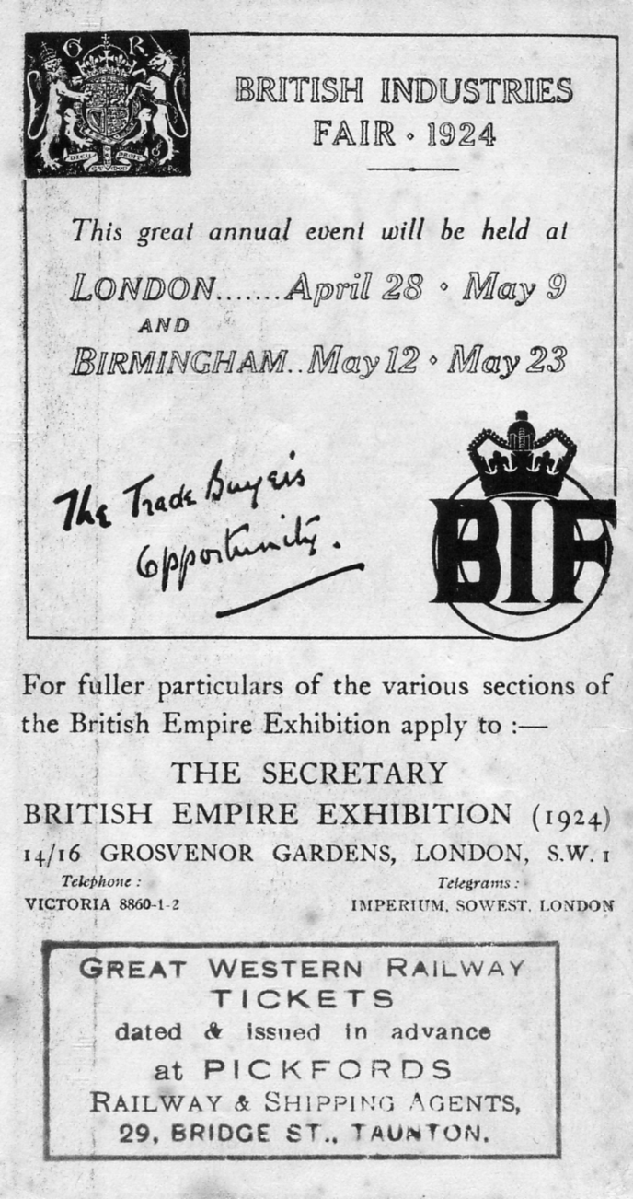
remains in doubt. If any member has such a card Ken and myself would be pleased to hear from you.
3. Sales page, this is something we discussed at our A. G. M. and I am willing to give it a try. Certainly when we organised a circulating packet it proved popular. I am sure we all have surplus material which we would like to dispose of, although the temptation of putting it on E-bay where it might (and probably would) bring higher prices might kill the idea. At our convention I brought along three boxes of exhibition cards for sale and they went very well, although I did not keep any check on how many sold. It seemed members kept thrusting money into my hand all day long.
4. A wants list, yes fine, if any member has any particular wants I will publish it in the Journal.
And finally yes Ken, please do us an article on replicas on sale at Wembley. I will welcome and print any articles on any subject. One criticism that has been levelled at me is that the Journal is very post card orientated. Believe me I am not sitting on a pile of articles on other subjects in favour of post cards, the simple truth is that I know a lot about post cards, and writing about them comes easy. Fred is working on what may well be the definitive work on crested and souvenir exhibition china, with a much smaller imput from me. So that is something different to look forward to.
Pane I of a new Wembley map sent in by Mike Gorringe

A Pickfords Personalised Wembley Map

This is an example of Map No. 10 that has been personalised by Pickfords by rubber stamping an advert on pane I and pasting a flyer inside the map in the bottom left corner. Kindly sent in by Mike Gorringe the flyer is about trips organised by Pickfords to the Wembley Exhibition.

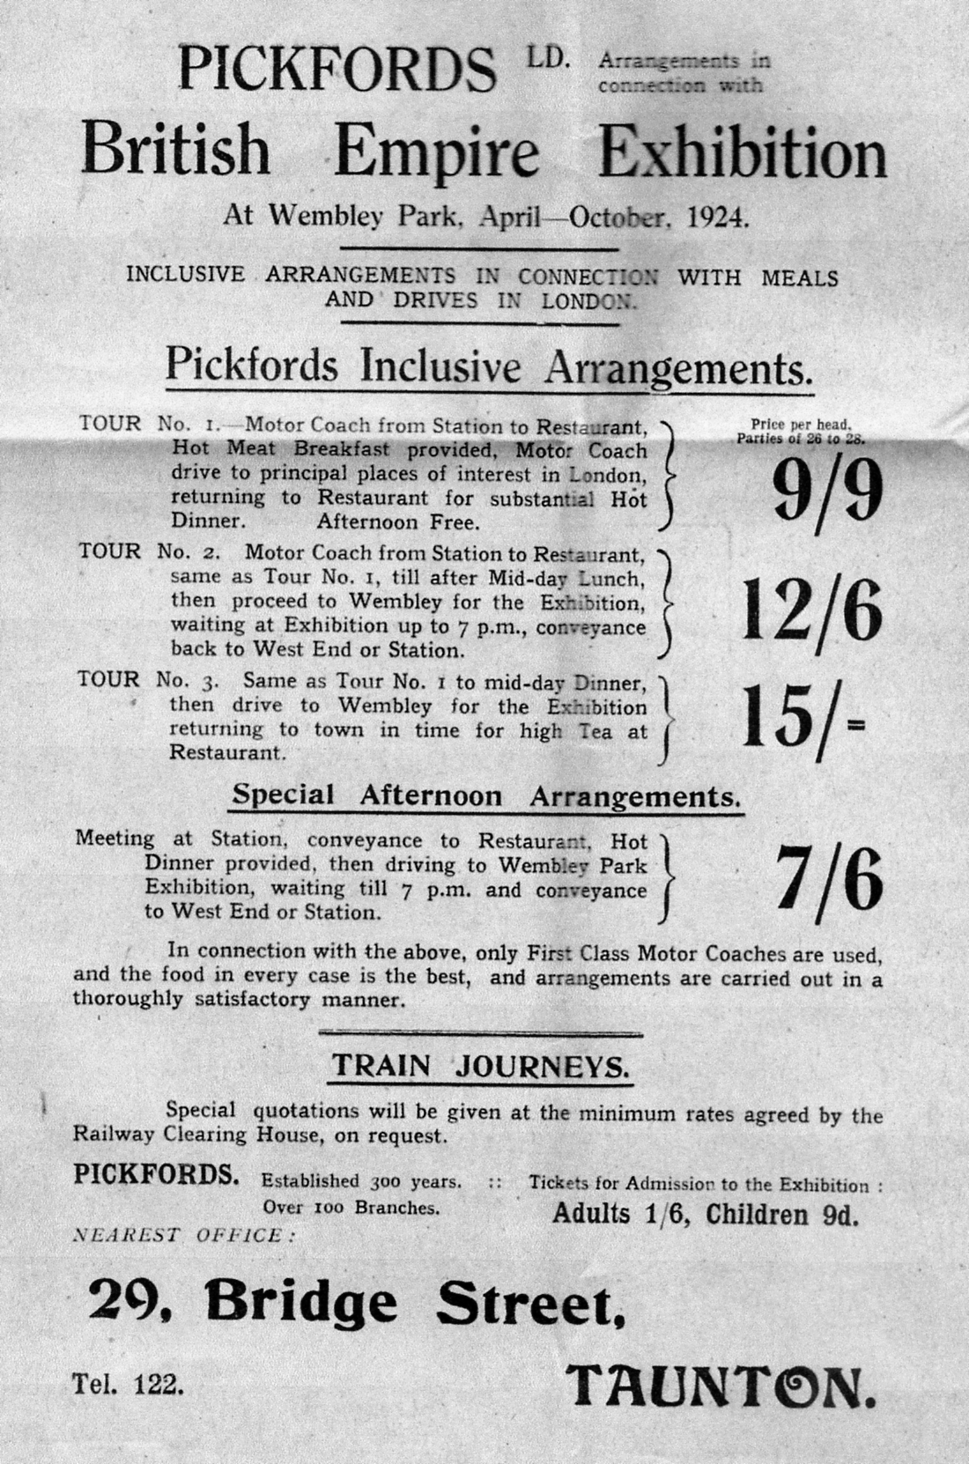

Exhibition Study Group
2010 Annual General Meeting
Held at Crystal Palace Sports Centre 9th October

Report by Don Knight

Opening address. The President Alan Sabey opened the meeting at 10.00 am and welcomed 20 members to the 24th convention. Before the main business started the members stood for a minutes silence in memory of Arthur Smith. He said that his past year had not been good health wise but is now recovering.
Apologies for absence. Mike Perkins, Derek Weston, Bob Tough and Floe Simner.
Minutes of our 2009 A.G.M. These had been published in the winter journal and were accepted, propose by Fred Peskett seconded by George Burr.
Matters arising. Bill Tonkin said he had seen the DVD done by the Japan television company and saw his cards with one being shown to a relative. The film was in Japanese so he was lost on the commentary.
Secretaries Report. Don Knight reported that we had had a committee meeting in April when we talked about this meeting and what we could celebrate in 2011. In 1911 there was the Coronation Exhibition of King George V. at the White City, Festival of Empire at Crystal Palace, the 60th anniversary of the Festival of Britain the Edinburgh Exhibition 1911. and we could include the 160th anniversary of the Great Exhibition at Hyde Park. He expressed his thanks to Bill and Fred for their work done on the journal and to Kenneth Tonkin for its printing and distribution. Alan to write thanking him for doing this on behalf of the Study Group.
Treasurer's Report. Alan apologised that copies of the accounts were not at hand, Bill has a draft but had not printed them out to bring to the meeting, but they will be seen on Sunday. He reported that the finances were good with £9,041.02 with the Yorkshire Bank and £676.84 in the current account giving a balance of £9,717.86. There was no need to change the subs. (The balance sheet was seen on Sunday and received no comments) Proposed by Ken Rumsey seconded by Ramon Goodey and carried.
Election of Officers. The President is on his second year of three, as is Ray Goodey the Vice President. The following were all prepared to stand again for election, Secretary Don Knight. Treasurer and Publicity Alan Sabey. Committee of four. Bill Tonkin. Fred Peskett. George Burr. Ken Rumsey. Proposed on block by Jean Osborne. Seconded by Richard West and carried. Web Masters Ken Rumsey and Mike Perkins. Proposed Bill Tonkin Seconded George Burr and carried. Journal team Bill Tonkin and Fred Peskett Proposed by Ken Rumsey Seconded by Alan Sabey and carried. Distribution Kenneth Tonkin Archivist Bill Tonkin both Proposed by Ramon Goodey Seconded by Ken Rumsey and carried. Accounts Checker George Burr Proposed by Bill Tonkin Seconded by Ken Rumsey and carried.
Venue and date for 2011 Convention. It was agreed that this is to be held again at the Crystal Palace on the weekend of the 8th and 9th October 2011 and to celebrate exhibitions with anniversaries in this year, along with any displays members wish to bring and show.
Any Other Business.
(1) Fred Peskett said he had been contacted by Channel 4 for a program to celebrate 2011 hosted by Fiona Bruce with Alan Hart-Davis the producer. He will be involved and give his guidance on what is to be seen and who might have items that could be used. Fred said that the Portsmouth Museum has two exhibitions on, one a cyclist who was a competitor in the 1908 Olympics at the White City, the other on Arthur Conan Doyle who was an official at the White City in 1908. Both worth a visit.
(2) Bill Tonkin is still working with Alan on his Wembley collection records.
(3) As next year will be our 25th Convention. Derek Connell asked about doing a special cover and handstamp to commemorate the Study Groups Convention. Alan Sabey has been in touch with the Olympic Society who could produce a Smart Stamp and could be possible. Or we could get a cover designed along with a special handstamp, Ramon Goody has done some designs of covers. It was proposed that the committee hold a meeting and invite Derek Connell to further this matter.

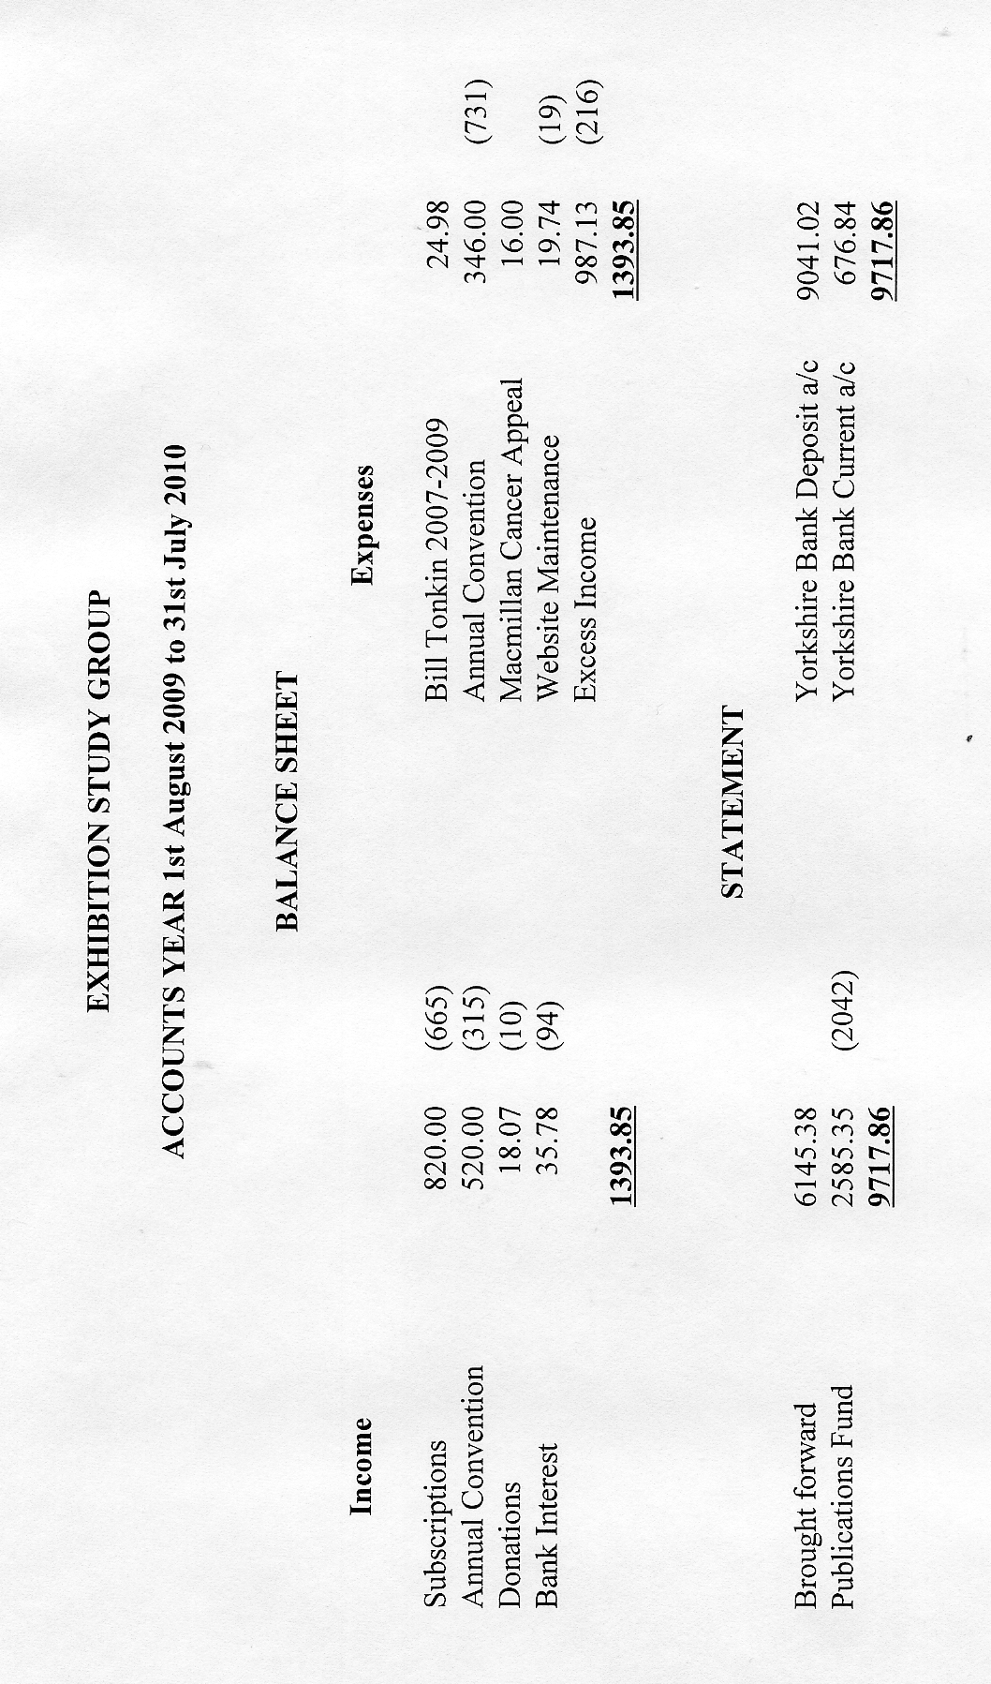
(4) Ken Rumsey asked about a packet, this had been done but packets had gone missing and cost us money. It was suggested that we get members to send in photo copies of items and a contact address or phone number and a page could be tried in the journal to see if this was supported.
(5) Don Knight said that Bill and himself had put on a display at BIPEX which lasted for three days. There were twenty display boards of sixteen sheets all from the 1910 Japan British Exhibition. That he had also lent items from his Japan British Exhibition to the Hammersmith & Fulham Museum to commemorate the 100th anniversary of this exhibition which had attracted 8 million visitors in 1910. This could have been seen in July, August and September. He has been asked to lend items in December to the Japan Embassy for an exhibition.
(6) Ken Rumsey spoke about the Study Groups name as there is a company which trades under this name, it was said that we have our name registered.
The Meeting closed at 10.55 am.

THE COALBROOKDALE GATES AT THE CRYSTAL PALACE
by
Ron Trevelyan

Over the past few years I have taken an increasing interest in the Crystal Palace with its two separate existence’s in Hyde Park and South London. My interest may have been helped from attendance at the recent Exhibition Study Group Conventions at Crystal Palace. There still seems to be an atmosphere about the place which is apparent when you stroll around the terraces surrounded by crumbling remains.

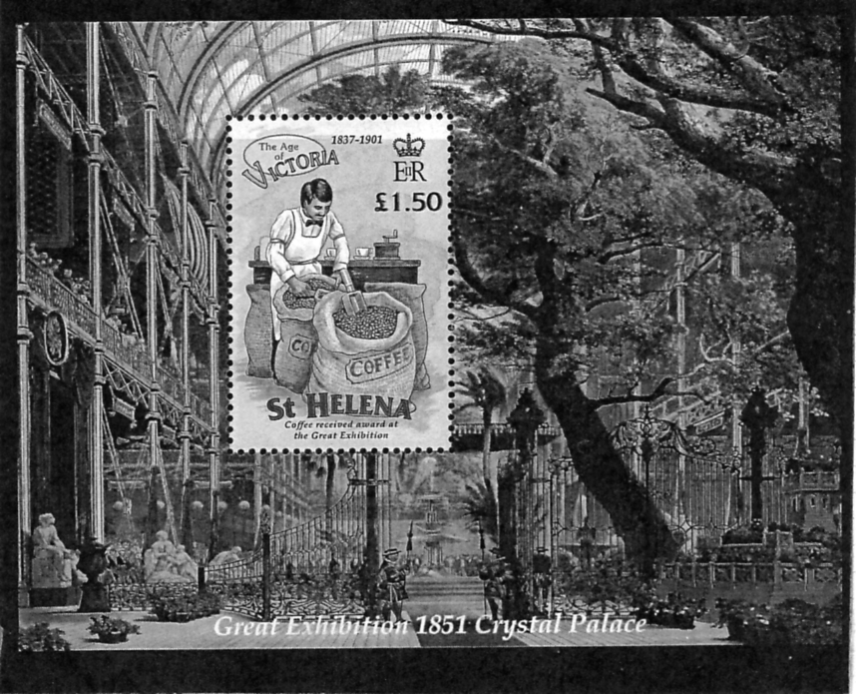
Miniature sheet issued by St. Helena

However, my subscription to ‘Gibbons Stamp Monthly’ has led me to a particular aspect of the Great Exhibition. In recent months our Study Group member Derek Connell has been producing some excellent articles in the magazine describing historical sites in London and illustrating them with appropriate stamps, postmarks etc. One of his articles included a reference to the Coalbrookdale Gates shown on a miniature sheet issued by St. Helena (see illustration). This shows the gates at the entrance to the Great Exhibition inside the Crystal Palace. Although I had photographed the gates at their current site between Hyde Park and Kensington Gardens, (see illustration), I was unaware of the miniature sheet until reading Derek’s article. The other surprising fact, unconnected with the gates, revealed by the stamp on the miniature sheet, was that St. Helena was awarded a prize at the Exhibition for its coffee.

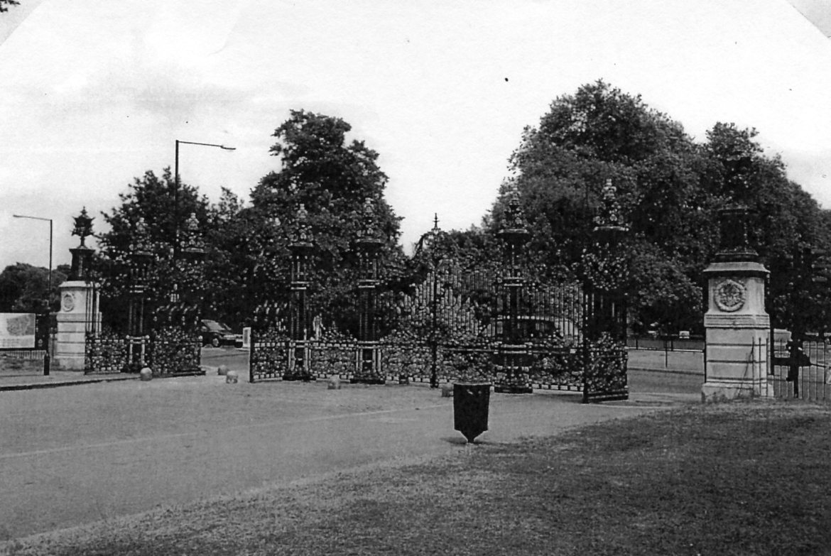
The Coalbrookdale Gates in Hyde Park

With one display given to a local history society on the Crystal Palace and another in the offing, some fascinating facts and figures emerge from research, not least how the Crystal Palace was built in such a short period of time through an English winter. Since the Coalbrookdale Gates are the only surviving elements in Hyde Park from the Great Exhibition I thought some notes on them might be of interest. The pair of gates were made of bronzed cast iron by the Coalbrookdale Iron Foundry of Shropshire who were noted for high quality iron work. They measured 60 feet across and had columns mounted with gilded crowns. Inside the Crystal Palace the gates were in a very strategic position across the North Transept. Queen Victoria passed through them with Beefeaters in attendance to reach a central dais with a State Chair to open the Exhibition.
When the Exhibition was dismantled in 1852 the gates were put up for sale with other unwanted items but they did not find a buyer. Hence they were installed across the Inner Park Road between Hyde Park and Kensington Gardens. It is gratifying to know that they are still there today in good condition. Stone piers have been added on each side of the gates which have laurel wreaths with the Royal Cypher V.R. with iron plaques indicating their makers and connection with the Great Exhibition.
In 1998 Lord Snowdon proposed that with the Millennium celebrations approaching the gates should be moved to the nearby Albert Memorial. Although this idea generated a number of favourable letters in the press Lord Snowdon’s proposal was never acted upon.

Acknowledgement: The Crystal Palace 1851 Exhibition by C.A. Bell Knight

British Empire Exhibition
Use of Postage Dues on Incoming Mail
By
Kenneth Tonkin

Under the U P U ‘double deficiency’ regulation unstamped or underpaid mail sent to the exhibition was liable to a charge equal to double the postage underpayment. Such mail usually received a charge mark denoting the postage due required and upon receipt of payment the appropriate postage due stamp was applied and cancelled with one of the special exhibition handstamps. Examples are extremely scarce and to date only seven covers are known. All were sent by George King ‘Poste Restante’ for collection at one of the exhibition post offices, four in 1924 and three in 1925, and these are shown below.
1924

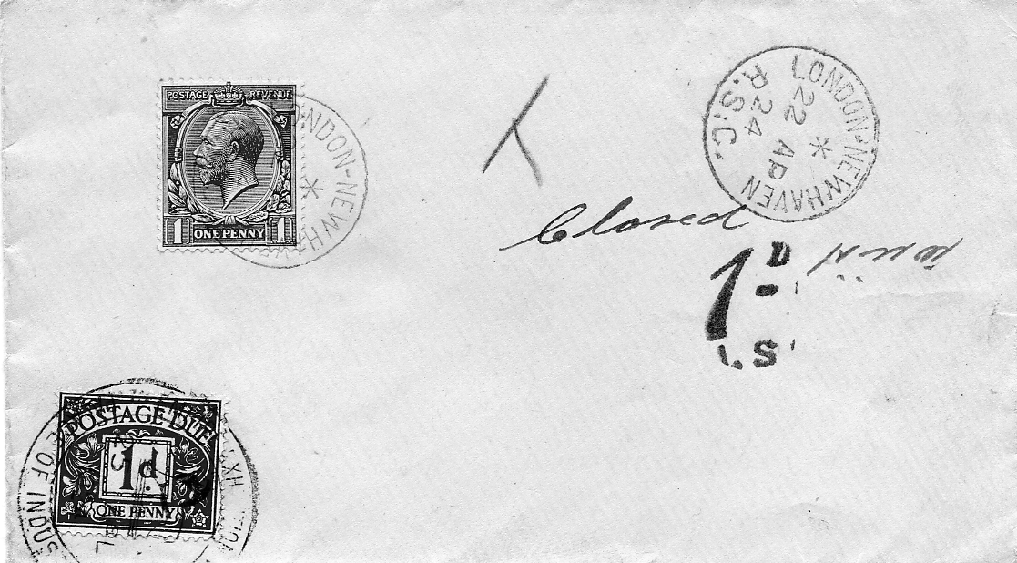

Cover No. 1

Cover No. 1 was posted on the London - Newhaven T.P.O. (travelling post office) and received a London-Newhaven R.S.C. (railway sorting carriage) datestamp of the 22nd April. Postage of 1d was paid against the correct letter rate of l½d, resulting in a 1d postage due charge. The envelope was collected on the 25th April, the day after the exhibition opened, and the postage due stamp was cancelled with the Palace of Industry handstamp dated that day. This is the earliest recorded use of a postage due stamp at the exhibition.

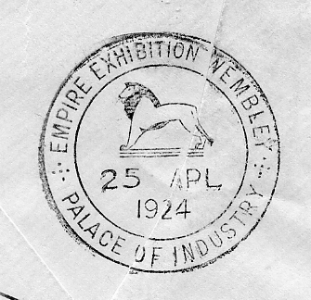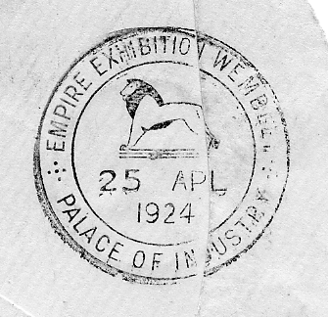

Backstamps on cover No. 1 and cover no. 2.

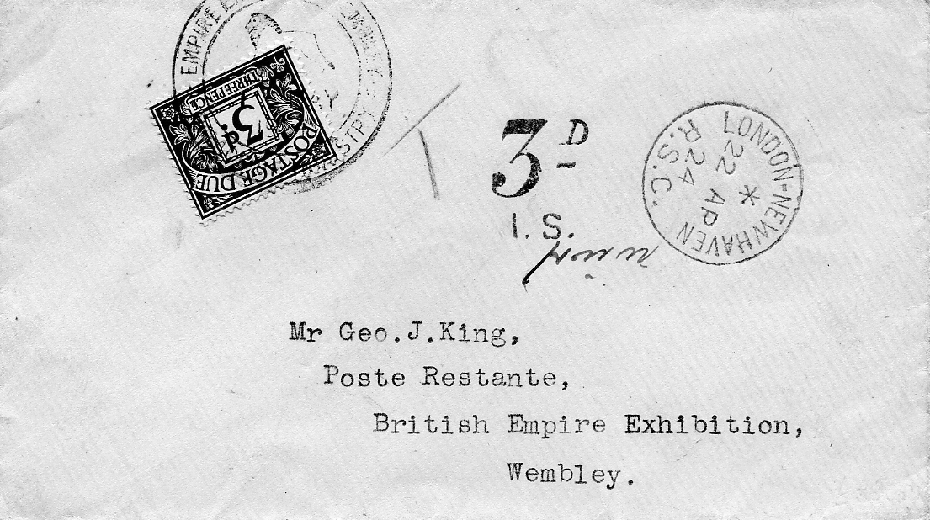

Cover No. 2

Cover 2 was sent in the same way but without a stamp and this resulted in a 3d postage due charge. The cover was received at the Palace of Industry post office and backstamped with a Palace of Industry handstamp dated 25th April. This envelope was not collected until the 1st May when the postage due stamp was applied and cancelled with the Palace of Industry handstamp for that day.

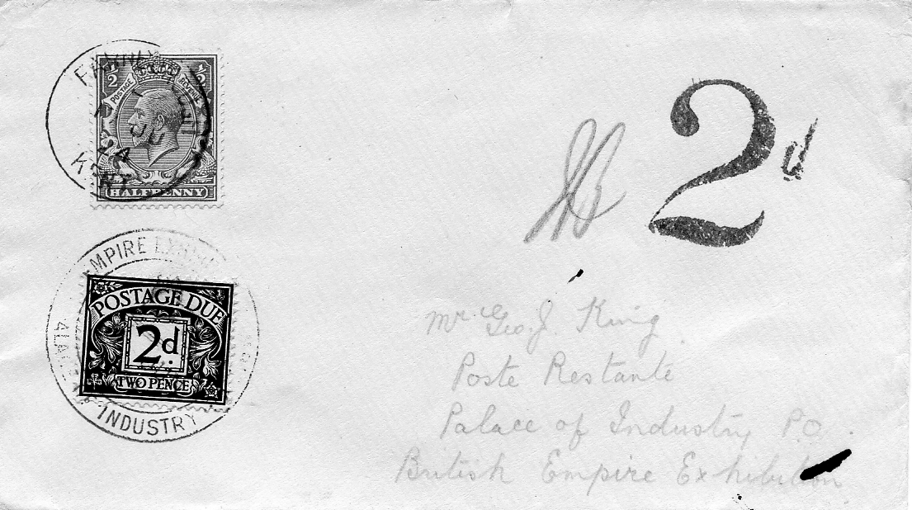

Cover No. 3

Cover 3 was posted on the 17th June at Farnborough in Kent with ½d postage paid and sent to the Palace of Industry post office. The 1d shortfall resulted in a 2d postage due charge. The postage due stamp was cancelled with Palace of Industry handstamp when payment was received.

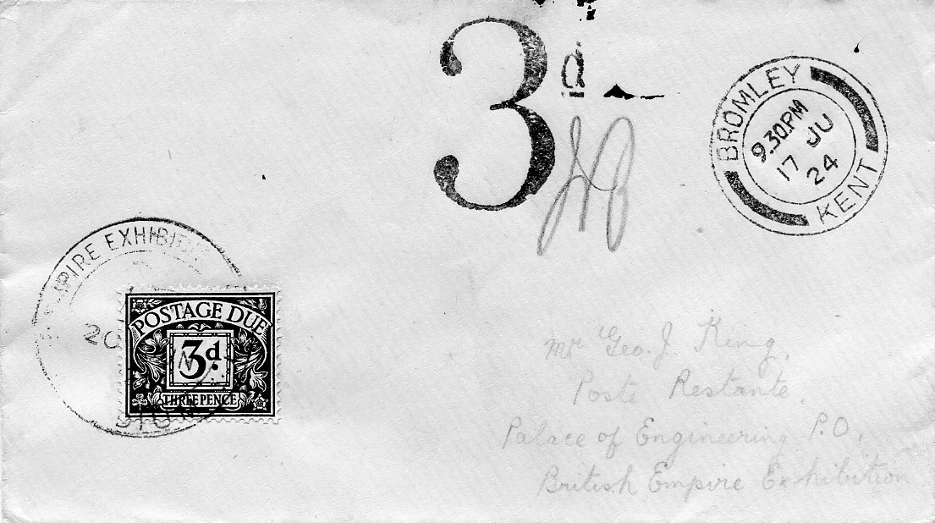

Cover No. 4

Cover 4 was posted on the same day at Bromley in Kent and no postage was paid, resulting in a 3d postage due charge. Unlike the previous envelope this was posted to the Palace of Engineering post office where a 3d postage due stamp was applied on receipt of payment. The stamp was cancelled with the extremely rare Stadium handstamp dated the 20th June and is the only example of this handstamp known used on incoming mail. Only two other covers with Stadium handstamps are known. It is unclear why this handstamp was used, but presumably the Palace of Engineering one was unavailable at the time.

1925

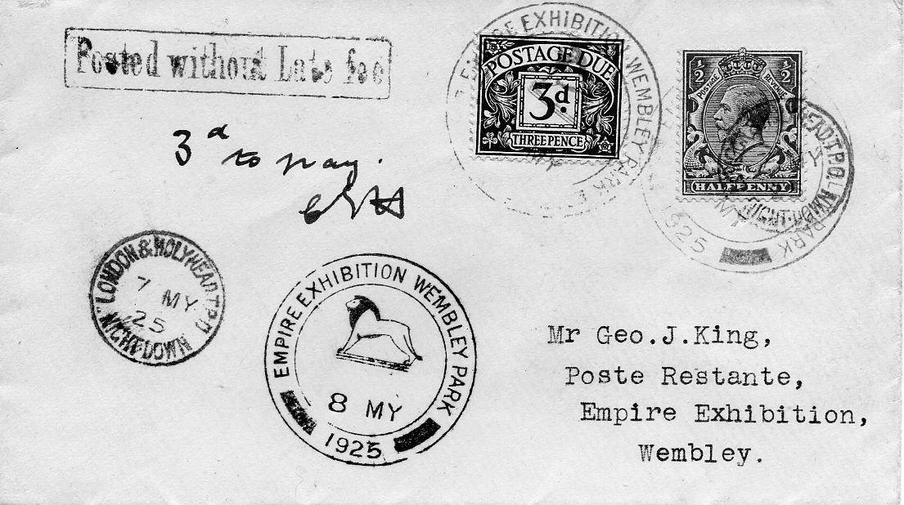

Cover No. 5

Cover 5 was posted on the 7th May on the London & Holyhead Night Down T.P.O. with ½d postage paid. In addition to the l½d letter rate this envelope was liable to a Late Fee payment of ½d taking the total underpayment to I½d, resulting in a 3d postage due charge. A 3d postage due stamp was applied and cancelled with an Empire Exhibition Wembley Park handstamp dated the 8th May, one day before the exhibition opened. This is the earliest recorded use of a postage due stamp at the 1925 exhibition

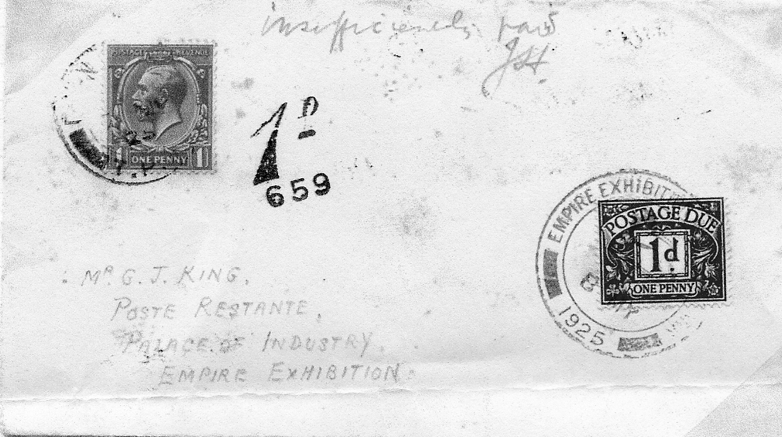

Cover No. 6

Cover 6 was also posted on the 7th May on the Down Special T.P.O. with 1d postage paid. The resulting 1d postage due was collected at the exhibition and the stamp cancelled with an Empire Exhibition Wembley Park handstamp dated the 8th May.

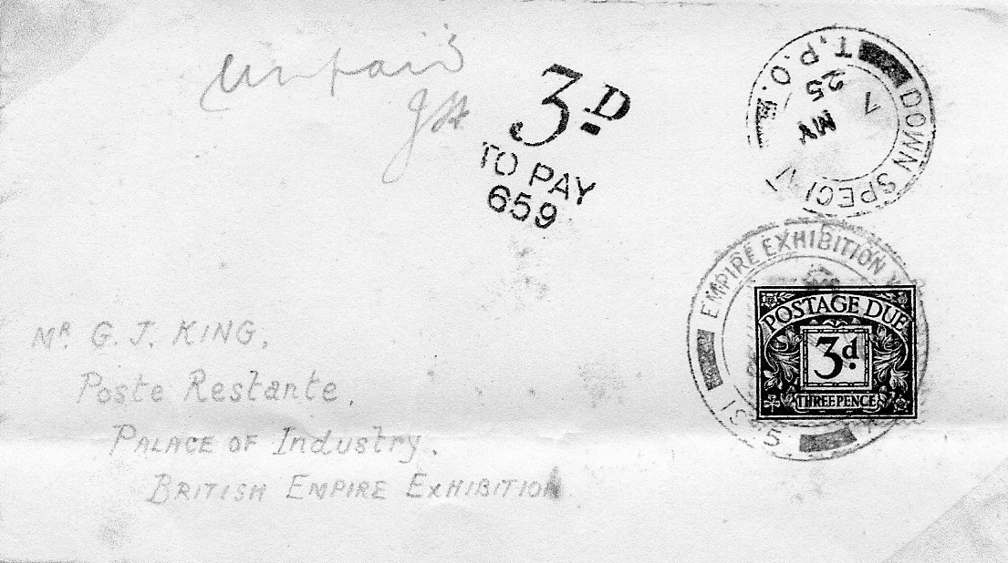

Cover No. 7

Cover 7 was posted on the same T.P.O. but without a stamp, resulting in a 3d postage due charge. The envelope was collected on the 8th May when the postage due stamp was applied and cancelled as above.

Front covers of some early Exhibition Daily Programmes

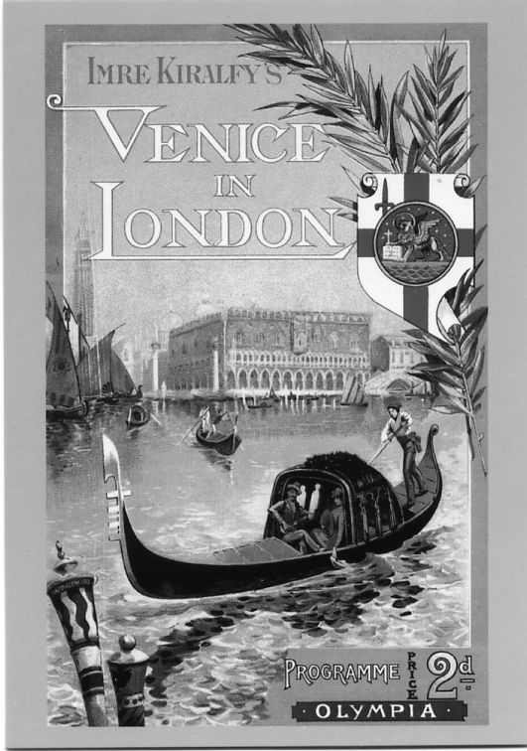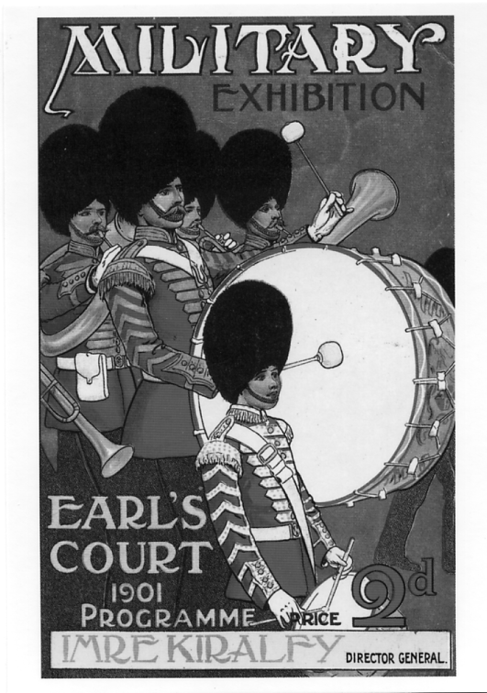

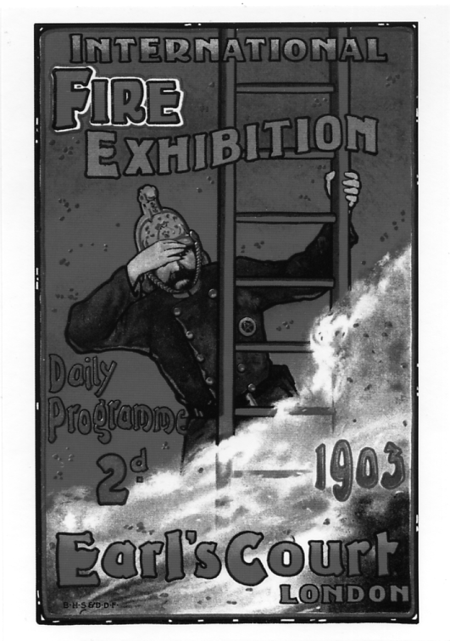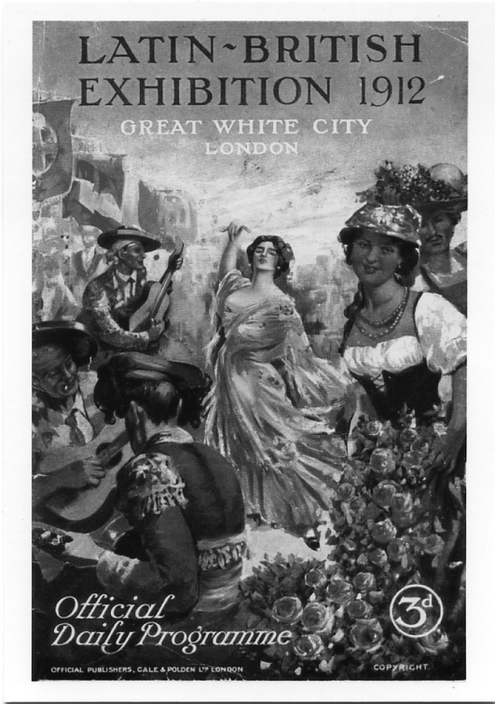

At the display at Fulham Palace Museum, the Hammersmith and Fulham Archives and Local History Centre were selling some very attractive coloured post cards featuring the front covers of some of the early Official Daily Programmes of exhibitions held at Earl’s Court, Olympia and the Great White City. These sell as a pack of four for £1.00 plus postage and can be obtained from the Hammersmith and Fulham Archives and Local History Centre. The Lilla Huset. 191 Talgarth Rd, London. W6 8BJ.

