EDITORIAL AUTUMN 2010

Come to our Convention, and have some fun,
There’ll be something there, for everyone.

The Twenty-fourth Exhibition Study Group Convention 2010

This year on the weekend of the 9th & 10th October we will be meeting at the Lodge at the site of the Crystal Palace 1854-1936. I can now give you the costs for the weekend. Bed & Continental breakfast £35-00 per night or with English cooked breakfast £36-50, our annual Dinner on the Saturday night will be £11-00, and for those arriving early and wanting a fish & chip supper on the Friday evening £7-00. I think you will agree these are all very reasonable prices.
Over the years we seem to be getting more and more members turning up on the Friday afternoon and evening, and last year for the first time Joan Miles laid on a fish & chip supper, which she has agreed to do again for us this year. We have a large block of rooms provisionally booked, both single and double so please mention the Exhibition Study Group when booking. The address is, The Lodge, Crystal Palace National Sports Centre. Ledrington Road, London. SE19 2BB. phone 020 8778 0131, if you are coming please let Don or myself know.
As you have already read in the Journal at our convention this year we intend to commemorate the 100th anniversary of the Japan-British Exhibition with the largest display of this event ever put on. I have written up and mounted just over 190 sheets (which must be about 380 post cards) and Don Knight is also displaying the Japan-British Exhibition. I have no doubt other exhibitions will be featured as well during the weekend. Friends of members and non-member visitors are welcome, as long as they let Don or myself know.
Our two displays will also be seen at the Picture Post Card Show at the Royal Horticultural Hall on September 2nd to the 4th.
One of our members Susan P. House-Wade, who has been up to her eyes in work for a long time now, will be awarded the degree of Doctor of Philosophy at the University of Brighton on 26 July. I am sure you will all wish to join me in congratulating Susan on her wonderful achievement. Susan has written to thank me for my help, which was very kind of her, but it must be said my imput was very slight.
I did not do the York two day post card fair this year, and also did not do the Upton-upon-Severn Jazz Festival this year. Nancy and I had been going to Jazz Festivals since the early 80’s, but I did not fancy walking over fields to get to the various Jazz venues any more. Besides all the good bands I used to enjoy listening to are no longer playing now. I still have an extensive Jazz collection of 78’s 45’s, L-P’s, tapes and C-D’s so I don’t miss out on good music.
In the Summer Journal I mentioned I had met an American White City collector who was over here at the Festival of Britain Convention. For a long time Randy Treadway had sent me E-mails on White City post cards. While he was over here he found time to visit the Museum of London, and found they had a lot of Valentine’s Japan-British Exhibition Giant post cards which they kindly allowed him to copy. When he got back home and checked with my book he found some of them were not listed. He sent me E-mails of the unlisted cards, and I was able to confirm that they were new to me. Unfortunately he did not record the backs of the cards, and since the J-B giants are known with eight different backs, this left me up the proverbial gum tree. Fortunately help was at hand and Kirsten Ziomek the young American lady who has been visiting me going through my Japan-British cards was also doing research at the Museum of London, and they have agreed to let her see the cards to check on the back types. So all is not lost and I hope soon to have the missing details. I would like to get up to the Museum of London myself to see what other treasures they have hidden away, but I’m afraid trips like that are a bit beyond me now.
Health wise young Fred is progressing well and is back doing the charity shops in the Portsmouth area, still finding all sorts of goodies.
The Editors.
Extract from a Letter from Graham Hall
Dear Bill,
Many thanks for the magazine which arrived the other day and there is an item I would like to add comment to in a moment.
Now what’s been happening in the collecting world ? Lots actually. Last Sunday at Pudsey Postcard Fair I picked up a totally new Bradford Exhibition card-the first for years ! It’s not in the best condition and it cost me ten quid (!) but it gives one hope that more will turn up-eventually. I have also picked up some excellent Bradford topographical cards which cost me a fortune and prices of the better quality ones do seem to climb higher and higher with each fair.
However I am in the process of purchasing a collection of very important and rare ephemera relating to Bradford from a friends widow. It is a mixture of original theatre posters and programmes produced when the late great Sir Henry Irving made his last appearance at the Bradford Theatre Royal just before he collapsed and died in the foyer of the Midland Hotel about half a mile away-the former was demolished about twenty years ago but the latter still thrives along with a plaque about the sad event. This is hens teeth stuff Bill and whilst we have come to an agreement on price I’m having to pay the dear lady over a period. Nevertheless its provenance is without question and if it had gone to an auction it would have disappeared out of Bradford for sure-probably to some member of the Irving Society.
Oh yes, a comment before I forget! It’s in relation to the interesting article by Don Knight on page 19. He mentions the birth of a baby boy at the Japan-British Exhibition to one of the ‘natives’. Well coincidentally at the Bradford Exhibition we had not only the birth of a child to one of the Somali natives appearing but we also had the death of one also. The two events occurred within days of each other. On the 9th of September a young woman of 32, Halemo Abdi, died of consumption. Her funeral procession travelled from Lister Park, where the Exhibition took place, to Scholemoor Cemetery about three miles away. It was after 7:0.p.m. in the evening before the procession arrived, where a crowd of over 200 had gathered. She was buried in the unconsecrated section of the cemetery in an unmarked grave until 2003 when David King and I carried out research and discovered it. However a later ‘discovery’ by a member of Cartwright Hall staff some months after was heavily publicised-at least our city fathers had the good sense to erect a memorial on the grave.
The “Bradford Observer” reported the birth of a child to the wife of Sultan Ali on the 12th of September, 1904. The child was christened soon after its birth and given the name ‘Hadija Yorkshire’. The report stated that the mother, Fatima, and child were making satisfactory progress... In certain local history books which mention the Bradford Exhibition it’s said that a number of Somalis died after contracting flu but I have found no evidence of this in all the research I’ve done.

Regards,
Graham Hall.

A newspaper cutting sent in by Mike Perkins. It shows that even out in the sticks in 1893, there was an interest in foreign exhibitions, or was it a more morbid attraction?

County Express, Stourbridge, Worcestershire. July 1893
Fire at the World’s Fair nearly 30 firemen killed.

A terrible fire resulting in the death of nearly 30 firemen occurred on Monday in the cold storage warehouse in the grounds of the World’s Fair at Chicago. The store, which was situated near the fence in 63rd Street, half-a-mile from the nearest exposition building, was entirely gutted. While the firemen were battling with the flames on the cupola of a lofty tower in the centre of the building, the lower portion of the structure became ignited by the falling embers, and suddenly collapsed, plunging it’s human freight into the midst of the burning mass below. The crowd of horrified spectators who stood watching the holocaust shouted to the other firemen at the foot of the tower to keep out of the way. The warning came too late, and five more men were buried under the falling mass of masonry. No damage was done to the exposition proper. The warehouse consisted of an out-lying building adjoining the stables, and contained but few exhibits of a perishable nature.

Post Cards have become respectable, but only to academics.
by
Bill Tonkin.

I feel I have been lucky to have seen a time of change and even helped to push the process along, in the way post cards are regarded. In the beginning post cards were collected, possibly mainly by the fairer sex, who were hooked on cats, dogs, horses and collected these on post cards. They built up collections which while giving the owners a lot of pleasure, could never be regarded as important collections. Soon relegated to the spare room or the attic they became forgotten, and eventually ended generations later in the skip or a boot fair.
It has to be said that post cards never had the respect as a collecting theme that stamps have. Post cards never had Royal patronage like that of King George V who was a keen stamp collector himself. Neither did we have great names within our ranks still remembered, who built up wonderful collections. I seem to remember reading that the British Museum many years ago (in possibly the early 20’s) spent £20.000 on cabinets to display the Tapling Collection, I cannot find the reference so I may be wrong on the amount. Neither did we have scholars who spent years researching post cards unlike the stamp world where to name but one, P. C. Litchfield produced ‘Guide Lines to the Penny Black’. Compared with some of the works that have been published for stamp collectors, many of the post card publications still seems stuck in a rut of admiring pretty pictures, more for entertainment rather than educational. Value wise post cards have moved forward and can no longer be considered worthless.
Apart from a few what I call ‘coffee table’ types of post card books, it was not until Anthony Byatt published ‘Picture Postcards and their Publishers’ in 1978 that it could be said that the first specialised text book became available to collectors of post cards that was not mainly concerned with the picture side of the cards. It has become the standard work on the subject and in over 30 years has never been bettered. This was soon followed by Andrew Brooks and Fred Fletcher’s two books on exhibitions, published in 1978 & 79, both now out of print. These books were the start and were regarded almost as bibles by their devotees in their time. Don Knight and Alan Sabey’s book ‘The Lion Roars at Wembley’ published in 1984 also comes into this category and looks into all the collectibles and postal history of the British Empire Exhibition in 1924 & 25.
There are two other books that come to mind, although they are more philatelic than post card oriented, Maurice Bristow’s classic ‘The Postal History of the Crystal Palace’ 1983 and John Pringle’s ‘Early British Balloon Posts’. The latter an extremely scarce privately printed book of unknown date. When I enquired after it some years ago I was told by the specialised dealer concerned that he had so many customers waiting for a copy he would no longer add names to his waiting list. One of our members Ken Harman eventually put me onto a copy which I snapped up and have never regretted it. When I got the book I never imagined in my wildest dreams that I would ever actually own a 1902 Beckenham flown Coronation Balloon card. Sent by Tom Thornton the organiser of the event to his home at 42, High Street, Beckenham, to boot.
It was not until George Ithell published his book ‘Posted at Ballymaclinton’ in 1982 that the importance of the back of the post card was first recognised. He described and illustrated 31 different Ballymaclinton post card backs. By now there must be nearly half as many again recognised.
The early 1990’s saw an explosion in books on exhibitions and exhibition post cards, some very technical, some not so. This was helped immensely by the setting up of the Exhibition Study Group Publishing Fund through the generosity of Karl Illingworth who financed it to the extent of about three and a half thousand pounds. To date there have now been about two dozen books published by the Exhibition Study Group or its members since 1984 ranging from a 12 page stapled booklet to the recent 650 page hardback on 1908-14 White City Exhibition post cards. Nine of these have been published by the Study Group itself, and many of that nine completely or partly financed by the Study Group. Most of our publications have been made available to members at the bare printing costs. Post cards of the main exhibitions have been well covered and three Study Group publications have been awarded the Desmond Chamberlain Trophy for the best book of the year. In the field of exhibition or post card related publishing no other organisation can even get near this record.
It still seems incredible to me that in early 1996, a young Japanese Professor of Archaeology, Dr Yuriko Fukasawa, phoned me asking about Japan-British Exhibition post cards, when I told her I had a fairly large collection of the ‘Ainu Home’ post cards published for that Exhibition in 1910, she asked if she might visit me to look at them, and in fact visited me twice. Yuriko’s main interest is in the Ainu, an ethnic Japanese tribe who in the early years of Japan’s awakening, were gradually driven off the mainland and are now living on the Island of Yezo. She had lived for two years among them and wrote a thesis on their customs which got her, her Doctorate. Since then she has gone on to become a full blown Professor of Archaeology and is now based at Sapporo International University.
Later in the Autumn of 2002 I had an interesting phone call all the way from Japan. It was Yuriko Fukasawa again. On her first visit Yuriko only had time for a brief look at some of my cards. She now wanted to go through my 1910 Japan-British Exhibition cards in some depth, as like myself she finds it an absorbing exhibition. Could I give her the name of a hotel in or near West Wickham where she could stay for a few days. I suggested that as I had a spare bedroom she would be very welcome to stay with me, and about a week later she arrived, complete with lap top computer, a lap top scanner and spent nearly three days delving into, and scanning my Japan-British Exhibition collection.
Another academic, Philipe Dallias of the Anthropology department of the University of Neuchatel has also visited me to go through my Ainu and Formosan native post cards. He took them back with him to photograph for the University records. These were returned to me a few weeks later. It seems I not only have more picture postcards of these native groups, but in some cases have the only known post cards featuring these peoples at the White City.
Through modern technology, images of my postcards have been made available to academics around the world, and only this week I saw some of my cards featured on a Japanese television programme which Kirsten Ziomek was able to show me on her lap top. It was on the Japanese TV channel NHK titled Japan Debut “A first rate Asian Power”, and was broadcast on 5 April 2009. While I was unable to understand the commentary, it being in Japanese, I must admit it gave me a thrill to see my cards being displayed. I had lent my cards to Don to show some Japanese people who were visiting him, and were gathering material for a program. Don and I both got a cheque for £50 for that. During the making of the program the producer visited the Ainu village, and was able to show one of my post cards to an elderly couple, it was of the man’s father taken in 1910, he had never seen a picture of his father. I hope they gave him a copy.
It is very gratifying to me to know that collecting post cards which for so long has been in my opinion a very much underrated hobby, is now moving into an area of respectability. Had someone told me fifteen years ago that people would come from Switzerland and even further afield from Japan, America and Australia to see my cards it would have been unbelievable, but it has happened.
When I look back to when I first started to collect post cards, one of the things that attracted me was the fact that almost nothing was known about them. It was a field wide open, waiting for someone to start the research. I had been involved with stamp collecting for many years and was a secretary of the forth largest philatelic society in the country for 21 years, but as I saw it there was very little scope for a person with modest means to carry out any serious research into stamps.
With post cards it was very different, they were cheap and there were so many opportunities for original research. When the Exhibition Study Group published the book by Mike Perkins and myself on the British Empire Exhibitions back in 1994 it was, I believe the first major publication devoted in such depth to a post card subject. We were both very pleased when it was awarded the Desmond Chamberlain Trophy for outstanding research. It is the standard work on the subject and will remain so for the foreseeable future. We at the time thought it was important to differentiate between litho and screened photogravure printed cards, and where sets were published in two measurements of screen to identify the different screens used. We also noted where printing plates had been retouched to sharpen or emphasise the design. We also noted and listed sets or series that were published in different thicknesses of card. I remember one Campbell Gray set was published in three distinctively different thicknesses of card. Some collectors may feel we went over the top in listing varieties, but both Mike and myself came into post cards from stamp collecting where varieties are keenly collected and catalogued.
While members of the Study Group have done so much to further the knowledge of exhibitions, their history and collectibles, it is regrettable that other societies and associations in the post card world have not followed in our footsteps. It seems that while academics are more likely to accept the historical value of post cards, the rank and file of post card collectors are still firmly hooked on the pretty picture side of cards.
There is a lot of interest in the ‘local history’ aspect of post cards (topo’s) and here there is plenty of publishing interest. The small A5 size books consisting of about 100-150 post card illustrations with the same amount of four or five line captions pour out in ever increasing numbers. Some of them even mention if the post card is a ‘real photo’ but that is about as far as their expertise goes. Most of this type of book I suspect finishes up as a present for Aunty.
Nancy got involved in this, as she was secretary of the local, Local History Society, and some years ago was approached to do one of these A5 books on Beckenham which she turned down. They came back at her, and eventually Eric Inman a friend in the society offered to help and on that arrangement she agreed to go ahead. The first stumbling block was that she refused to do an A5 with captions effort. When the Director of Phillimore who visited our home, heard she wanted to do a full length history of Beckenham he was flabbergasted and immediately doubled the commission he had offered, with the comment “it was almost impossible to get people to write full length books”.
We heard in a round-about way that her ‘Beckenham’ was the best selling local history book Phillimore had ever handled The first printing of 4,000 sold out and a second revised edition (by Eric and myself) was published after her death. So I tell my friends that she’s still up there looking after me, as the commission nearly pays for some of my booze.
In the field of post card displays, again the Exhibition Study Group has more than pulled its weight. At the Picture Post Card Show in 2001, Fred Peskett, George Simner and myself displayed 1951 Festival of Britain, in 2008 Don Knight and myself displayed the Franco-British Exhibition, and in September Don and myself will again be providing and mounting the main displays at the Picture Post Card Show. At the Royal Horticultural Society’s Tercentenary Exhibition in 2003 two members Francis Kiddle and myself were asked to put on a display reflecting the many exhibitions that had taken place in the Horticultural Halls. At all the displays we are involved in, I insist on traditional display methods using album or A4 sheets. The main reason I am sure why more clubs do not enter displays at the Picture Post Card Show is the organisers insistence on displays being mounted on huge sheets of cardboard. The problems of getting those to the hall doesn’t bear thinking about. I certainly would never do it.
The end

Crystal Palace Postmarks.

The article by Kenneth Tonkin on Crystal Palace post marks in our last Journal, must have caused a flutter in the dove cote, as I have had a request from one of our members John Fowler who is Honorary Editor of the British Postmark Society Journal requesting permission to publish the article in their Journal. John has included a nice plug for the Exhibition Study Group, Thanks John.

Death Certificate of Formosan native Ruji Suruchan an agricultural labourer who died from shock from a perforated gastric ulcer on the 25 October at the exhibition, when he was only eighteen years old. He was buried in Hammersmith Cemetery in an un-marked grave.

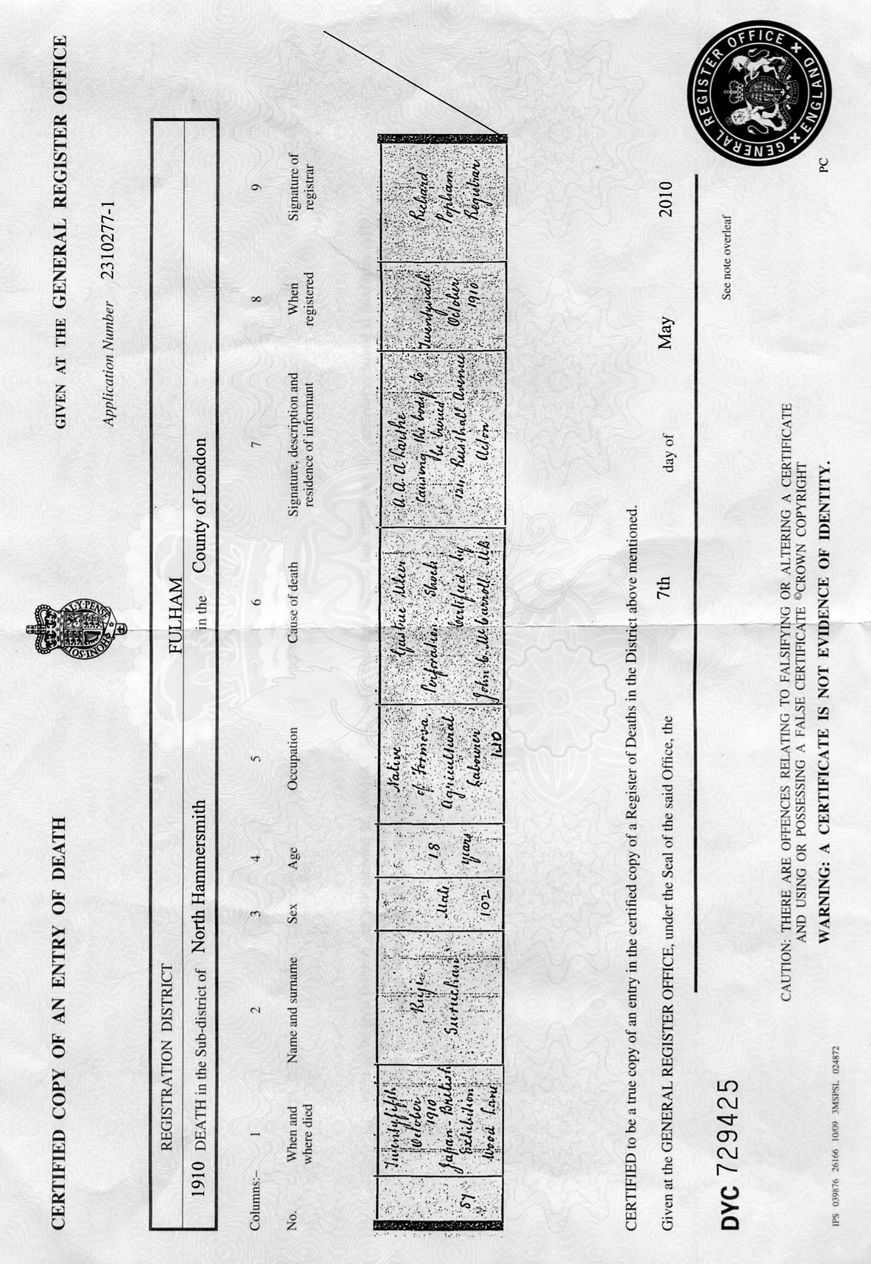

One of our members Stuart B. Smith. O.B.E. has sent in the following article on fibrous plaster taken from a book published in 1897, and contains many interesting facts about some of the early exhibitions. This was before its extensive use at the ‘White City’ in 1908, which took its name from an earlier Heathcotes & Brown’s ‘White City’ in Manchester in 1907.

Plastering
Plain and Decorative.

A practical treatise on the art & craft of
plastering and modelling.

Including full descriptions of the various tools, materials, processes, and appliances employed; also of moulded or “fine” concrete as used for fireproof stairs and floors, paving, architectural dressings, &c. &c.

together with an account of
historical plastering in England, Scotland, and Ireland,
accompanied by numerous examples.

by
William Millar,
plasterer and modeller.

with an introductory chapter entitled “a glimpse of its history”
by G. T. Robinson, Esq., F.S.A.

The whole fully illustrated with fifty-two full-page plates, and two hundred and thirty-one smaller illustrations (comprising over five hundred figures) in the text.

London.
B. T. Batsford, 94, High Holborn.
1897.

Chapter XII.
Fibrous Plaster Work.
Historical - Fibrous plaster before the Christian era - fibrous plaster ceilings used in Cairo in the
fourteenth century - uses for fibrous plaster - renovating old ceilings - fibrous plaster for panelled ceilings - fibrous plaster nomenclature - fibrous plaster materials - cutting canvas - fibrous plaster wooden laths - fibrous plaster casting - casting fibrous plaster centre flowers - undercutting fibrous plaster - fibrous plaster cornices - mitre and joint stops - casting fibrous plaster plain cornices - casting fibrous plaster enriched cornices: bedded enrichment system - moulding and casting fibrous enrichments - casting fibrous plaster enriched cornices : fixed and cast enrichment systems - frame wax and gelatine moulds - fixing fibrous plaster cornices - fibrous plaster measurements - fireproof fibrous plaster - fibrous plaster decorative sheets - muslin plaster casts - tow and plaster casts - rapid plastering - fibrous plaster slab moulds - fibrous plaster slab making - setting fibrous plaster slabs - fireproof, salamander, combination, metallic, external, reed, grooved, perforated, finished face, gesso, sgraffitto, fresco, and pugging fibrous plaster slabs - hardening and damp - proofing fibrous plaster slabs - fixing finished face slabs - fibrous plaster sign - boards and blocks.

Historical.-Fibrous plaster was patented in 1856 by Leonard Alexander Desachy, a French modeller. The patent was for “producing architectural mouldings, ornaments, and other works of art formed with surfaces of plaster.” The materials named are plaster, glue, oil, wood, wire, and canvas, or other woven fabric. A part of the specification reads: “To facilitate the fixing of such moulded surfaces to other surfaces, wires are, when required, laid into and between the two or more layers of canvas. Flat surfaces are strengthened with canvas, wires, hooks, or pieces of wood may be inserted whilst the plaster is in a fluid state.” The specification also includes the formation of solid slabs of plaster strengthened with two layers of canvas in the centre. Desachy introduced the manufacture of fibrous plaster decorations into London, where he employed a large number of hands, male and female.
The late Owen Jones, architect, and the author of “The Grammar of Ornament” was the first patron of fibrous plaster. Desachy, after a precarious run of work, returned to Paris. The business was then for a time carried on under the management of J. M’Donald and R. Hanwell, respectively foreman and modeller to Desachy. When Desachy retired from the business he was pecuniarily indebted to Owen Jones, which handicapped the efforts of M’Donald, and the business was eventually taken over by Messrs G. Jackson & Sons, London, who acquired the then existing patents. They have introduced many improvements, and brought it to a high degree of perfection. During the construction of the old Oxford Music Hall, about a generation ago, they successfully defended their patent rights. Fibrous plaster during the last two decades has been worked by other firms, and it is now open to all plasterers. Such is the British history of fibrous plaster. It is an old saying, that “there is nothing new under the sun.” This may be safely applied to fibrous plaster, as the uses of linen and canvas, in conjunction with plaster and glue was known and practised by the Egyptians long before the Christian era.
From ancient MSS still extant, and ancient coffins and mummies, now to be seen in the British Museum, it is conclusively proved that linen, stiffened with plaster, was used for decorating coffins, and when embalming human bodies, by the Egyptians, 1500 B.C. Dr Petrie’s discoveries at Kahun go even further, for he found that plaster and canvas were used for casting mummers masks nearly 4,400 years ago. Plaster, canvas, glue, and wood were used in the formation and decorations of ceilings in Cairo eight hundred years ago. According to the MS. of Cennino Cennini, who wrote in 1437, fine linen, soaked in glue and plaster, was used for forming grounds on wood intended to be painted on. Thus it will be seen that plaster combined with linen has an ancient as well as a modern history. Plaster mixed with tow was used for the decorations of a church in Hamburg about two hundred years ago. While giving Desachy the honour of reviving the process, and of introducing it into England, it is more than probable that he got the idea from some of the French writers - Reinaud, Prisse D’Avennes, Girault de Prangey, or others, who had very fully described and illustrated Egyptian arts and architecture. Coming nearer home, it will be found that canvas has been used for ages for another plastic purpose. Canvas and mortar were in everyday use in Great Britain up to the middle of the present century as a heat-resisting plaster. It is still to a small extent employed in some districts, but its general use ceased after the introduction of Portland cement.
Canvas was used as a binding power to prevent the mortar round wash-house coppers from cracking or expanding when subjected to heat. The mortar was composed of equal parts of haired lime and gritty road scrapings. Sometimes clay was substituted for the scrapings, but more often all the three stuffs were well worked together. The walls of the copper were rendered with this mortar, and allowed to stand until the next day. Then it was floated with the same kind of stuff, and while soft, a sheet of strong coarse canvas was laid over the mortar. and pressed and patted with a hand-float into the mortar, and then trowelled. I have found that this canvas plaster, after many years’ wear and exposure to heat and damp, was extremely hard and tenacious when being pulled down for alterations.
Uses for Fibrous plaster. - Fibrous plaster is an important branch of the plasterer’s craft, and is now in great request by architects, builders, and decorators. Its uses are so various that it is becoming very general for works requiring lightness and rapidity. It is fast superseding carton-pierre and papier-mâché. It is not only lighter and tougher than either, but it also can be made in larger sections, and adapted to more purposes. Fibrous plaster was used in the Paris Exhibition of 1878 for the construction of the ceilings in the principal edifice of the Exhibition. Some of the panels were nearly 40 feet square. The panels, with the enrichments, were composed of fibrous plaster, but tow was used instead of canvas or trellis cloth. In France it is known by the name of “staff” and the enrichments in their frames as chassis-en-staff.
The “Street of Nations,” as well as the large arches in the permanent buildings of the Exhibition, were composed of this material. In the South Kensington Museum there is a large figure of Moses, taken from the marble original in the Church of San Pietro in Vincoli, Rome, executed 1541-53, by Michael Angelo. The cast was made by the Desachy process, and weighs only 168 lbs. The ornamental plaster work of the new Opera House in Paris has been made in staff. Fibrous plaster affords great facilities for the faithful reproduction of ancient or modern architectural or other works, either for temporary or permanent purposes. I have used it for stage properties, notably for the column capitals in the Ducal Palace scene, when Miss Marie Wilton produced “The Merchant of Venice” at the old Prince of Wales Theatre. The caps for perspective purposes ranged from 3 feet to 4 feet 6 inches in height. The bells and the abacus and necking mouldings were composed of fibrous plaster, and the enrichments modelled in plaster and tow. I used a similar process for scenic properties for the late C. Rice at the Royal Theatre, Bradford. I used a combination of tow and canvas fibrous plaster (with iron wire instead of wood laths) for the ornamental parts of various built scenes; also a fountain and other properties for H. E. Abbey, when Miss Mary Anderson appeared as “Juliet,” in 1884, at the Lyceum, London. Fibrous plaster has been successfully adapted for construction and decoration. I used this material for constructing facsimiles of the temples of Saturn and Vespasian that stood near the Roman Forum in the grounds of the Italian Exhibition, London, 1888. The temple of Saturn, with its eight remaining columns and the entablature, was 33 feet high. The temple of Vespasian, with its three remaining columns and cornice, was 38 feet high. They were constructed from measured drawings by Mr T. W. Cutler, architect. After standing in the open air during the six months that the Exhibition was open, they were taken down, seemingly none the worse for the exposure, and were then sent “on tour” for other exhibitions. I also used plaster and tow for modelling the Italian coat of arms, and a replica of the old Roman shield for the Fine Art Galleries. The whole was made in the shop, and then fixed in position under the superintendence of my then partner, Mr G. M. Jay. it has often been used for triumphal arches in streets for public rejoicings. The decorations and guns of the old “Victory,” for the Naval Exhibition, 1891, were faithfully reproduced in this material by G. Jackson & Sons. Ten thousand superficial yards of fibrous plaster were supplied by the Plastic Decoration Company in the reproduction of ancient streets for “Venice in London.”
The Gronese Company and Marshall & Slade made many thousand yards of ornamental fibrous plaster: work for the Indian and other exhibitions at Earl’s Court, London. No less than 150,000 superficial yards of fibrous plaster were used in the buildings at the “World’s Fair,” Chicago. Besides those more or less temporary purposes, it is extensively used in the decorations of many classes of permanent building, and is sent abroad in large quantities to our own colonies and other countries. Messrs G. Jackson & Sons, the Plastic Decoration Company, C. H. Mabey, and J. Bickley, of London; Cordingley, Greenwood, and Home, of Yorkshire; Rule, of Sunderland; and T. Jones, of Liverpool, all employ a large staff of skilled workmen in the manufacture of fibrous plaster. Mr A. M’Gilvray, of Glasgow, executed a vast quantity of elaborate fibrous plaster ceilings and other works for the Glasgow Municipal Buildings. Nearly the whole of the numerous theatres and music-halls which have been built in London and the provinces during the last generation have been decorated with fibrous plaster.
This material has also been used for the decorations of ships saloons, being first introduced into the “City of New York” and her sister s.s. the “City of Paris” by Mr G. T. Robinson, in 1887, and shortly after into the “Majestic” and “Teutonic,” after which its use has become common, its lightness and elasticity rendering it very applicable to ship decorations. One of the most striking examples of the utility of fibrous plaster was the buildings erected on the Champ de Mars for the Paris Exhibition in 1889. The Indian Palace, one of the most imposing edifices in the Exhibition, was the only one that was mainly done by English plasterers, and was erected by Messrs Joubert, of King’s Road, Chelsea, London. Messrs Joubert found it more profitable to pay English plasterers 10d. per hour, with lodgings and expenses, than to pay Frenchmen 8d. per hour, with no lodgings or expenses. The Palace was about 180 feet in length and 50 feet in width. It was surmounted by a large central dome and fourteen smaller ones, with minarets and towers. It was constructed of wood framework bolted together, and the walls, ceilings, and domes lined with fibrous plaster, solid plaster being employed where necessary. The exterior was also formed with fibrous plaster. All the decorations were taken from original sculptures in the Indian Museum at South Kensington. The building was designed by Mr C. Purdon Clarke, C.I.E.

The Albert Hall used for a Marathon Race. Dorando defeated.

From a report in ‘Cycling’ 22nd December 1909

The scene at the Royal Albert Hall on Saturday evening last, (18 December 1909) on the occasion of the Marathon match between Dorando and Gardiner, was one of exceptional interest. The arena was laid with cocoa-nut matting, and around its outer edge was the track, marked out by means of whitened rope, affixed to small wooden stands, also painted white. Before the race started, there
were four humped-angular
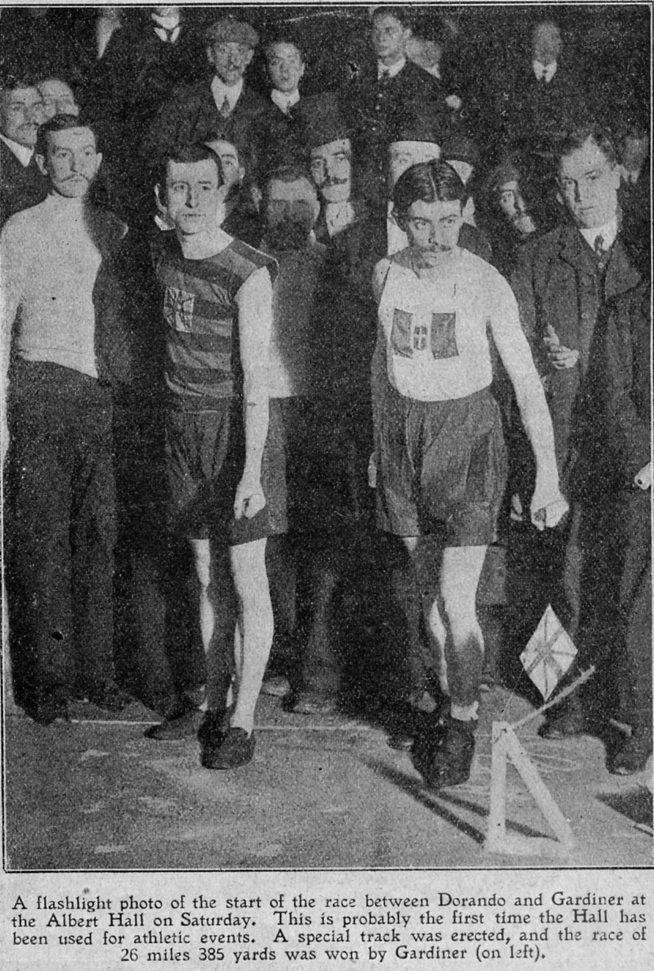
boxes, one placed at each corner, the sloping side being intended as banking. Gardiner's supporters, however, thought there was more danger in their use than in their absence, and Dorando’s brother readily consented to their removal, leaving the track quite flat. The track was 20 laps to the mile, so that 524 laps and 33 yds. had to be covered to complete the Marathon distance of 26 miles 385 yds. Back in England, Dorando has trained at Stamford Bridge, and he certainly looked fit. He is the same unassuming happy lad as he was before the Olympic Marathon. He trained from the Villa Villa Restaurant Gerrard Street, Soho, under the watchful eyes and care of his brother and Signor S. P. Tettamanti.
Although the race started at 8.20 p.m., the doors were opened at 7.15 p.m. and until the men came to the mark a concert was provided for the spectators. The band of the Civil Service Rifles played, and a giant gramophone gave selections of Caruso and other operatic favourites.

The Start.

When the contestants came to the mark the hall was fairly full, the top gallery in particular having many hundreds of Gardiner's supporters. Mr. J. T. Hulls gave the word to go. Dorando wore the Italian colours, with his national flag on his vest, Gardiner sporting the colours of the Herne Hill Harriers, with a small Union Jack on the front of his hooped jersey. From the start the pace was record-breaking, the first mile being covered by Dorando in 4 min. 39 2/5 sec. There was nothing between the men until nearly 12 miles had been run. when Dorando, who had the lead, suddenly gave way to Gardiner, who passed on the inside and shot ahead. Dorando stopped, and it. was discovered that his feet were blistered and raw beyond recovery.
By some extraordinary piece of bad judgement he had put on a pair of new running shoes, and. in consequence, had paid the penalty. He obtained another pair, and started after Gardiner whose advantage was two laps. But the plucky little Italian had lost his fire, and limped badly. The agony he was suffering was shown in his face, but physically he was as fresh as paint. He stopped again and rechanged his shoes, and Gardiner soon had a lead of 17 laps, which he increased to 21. Then Dorando made another heroic effort to get level and pegged Gardiner back a lap, leaving a mile to be made up. But it was beyond his powers. He was, to all intents and purposes, crippled.
Gardiner's friends in the gallery were almost frantic at their champion’s success and were waving huge Union Jacks and singing to their hearts content, such ditties as ‘For he’s a jolly good fellow,’ and ‘Rule, Britannia.’ They were well satisfied, and Gardiner is no doubt an athlete of exceptional calibre, and he thoroughly deserved his well-won victory. Dorando finally retired with 23 miles l½ laps to his credit, Gardiner winning in 2 hrs. 37 min. 2/5 sec., and receiving a tremendous ovation. The race was timed by Mr. E. A. Humphrey. The winner was fairly fresh, although he must have been footsore towards the end of the race. He was carried to his dressing room on the shoulders of his admirers.
On Sunday we found, on inquiry, that Dorando was quite unable to put his feet to the ground. but was otherwise in splendid form. He stated that he only went on to keep faith with those who had paid to see the race. He leaves to-day (Wednesday) for San Francisco, where he will race against Haycs the official winner of the Olympic Marathon, returning in time to meet Gardiner in the return race, which will take place at Stamford Bridge track in April next.
The End

1924 British Empire Exhibition Advertising labels
New labels reported by Ray Goodey

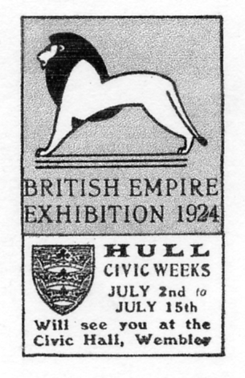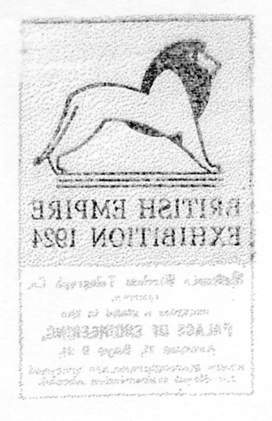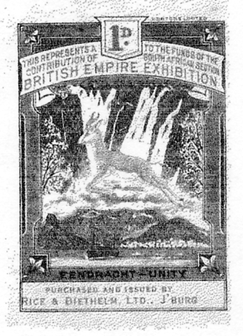
Hull Civic Week Marconi Co. Rice & Diethelm Ltd., J’burg
offsett on the back

These are two new advertising labels and one variety not recorded in the Exhibition Study Group publication number 6 ‘Publicity Labels of the British Empire Exhibition Wembley 1924-1925’. The printing on the South African Springbok label in red and blue type ‘B’ reads ‘Purchased and issued by Rice & Diethelm Ltd., J’burg.’

The 1862 International Exhibition stereo cards, published by the London Stereoscopic and Photographic Company.

One advantage of not going to as many post card fairs as I used to, is that I have more time to mount up and gloat over my collection. I have just got round to sorting out my Stereoscopic cards and have made one or two interesting discoveries.
I have a few of the 1862 International Exhibition stereos and when I got them sorted out I found I had three of one card No. 68, but when I looked at them closely, I realised each view is taken

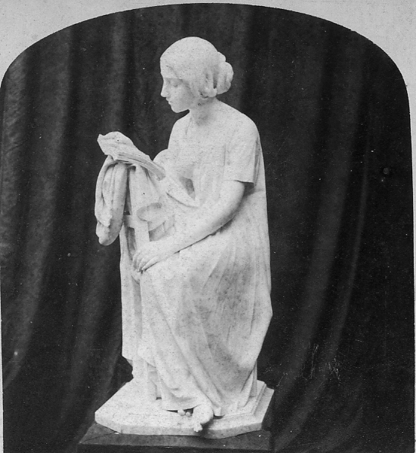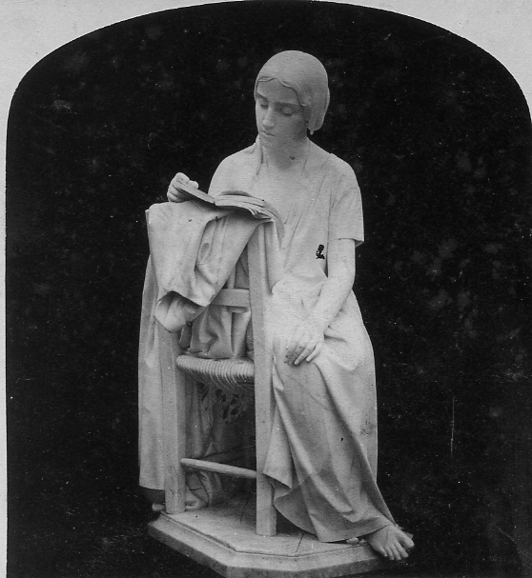
Type A. The girl is sitting side face Type B. The girl is sitting ¾ full face

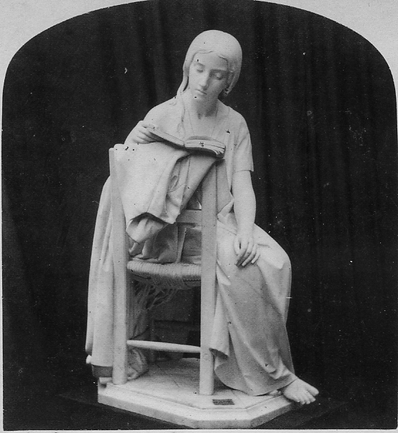
Type C. The girl is sitting full face
Note the chair is now almost full frontal
from a different angle (they all have the same number, but the titles also vary). When I checked with Michael Tongue’s book ‘Expo 1862’ I found he illustrates one of my No. 68’s, but with a further variation of title. So we now have four different number 68’s.
Ah well, we always knew variety was the spice of life.

Variations of title or position of girl

No. 68. The Reading Girl. P. Magni. Sculp. (The girl is sitting side face)
No. 68. A Girl Reading. P. Magni. Sculp. (The girl is sitting ¾ full face)
No. 68. The Reading Girl. P. Magni. Sculp. (The girl is sitting full face)
No. 68. The Reading Girl, by Magni. (The girl is sitting full face)

Alan Sabey keeps his eye open on what goes on at Wembley, and he tells me that Planning permission has been granted for a new Civic Centre on the site of the Palaces of Art and Industry on the British Empire Exhibition site at Wembley !

JAPAN IN LONDON: THE JAPAN-BRITISH EXHIBITION OF 1910
Photographic Exhibition, jointly organised by London Borough of Hammersmith & Fulham Historical Archives and Museum of Fulham Palace, Bishop’s Avenue, London SW6 6EA.
Tel: 020 7610 71G5

The Museum’s summer exhibition celebrates a major event that took place at White City a hundred years ago. The Japan-British Exhibition ran from 14 May until 29 October and attracted over 8 million visitors. The purpose of the 1910 exhibition was to strengthen the alliance between the two countries, both in terms of political friendship, and trade and commerce. As well as halls showing a wide variety of arts, crafts and industry, the exhibition included gardens, lakes, water features, temples, tea-houses and replicas of buildings and shrines.
The exhibition in Bishop Sherlock’s Room within the Museum will include photographs, postcards and posters alongside typical Japanese objects of the period. It opens on 17 July and runs until 19 September, We are most grateful to Hammersmith and Fulham Archives and Local History Centre, all the private collectors who have lent items to the exhibition and the volunteers who helped to stage it. The Museum’s opening hours have changed to five afternoons a week, Saturday to Wednesday 1 to 4pm. Admission is still free.
In 1910, exactly 100 years ago, The Japan-British Exhibition was held at White City in West London and was visited by over 8 million people. It was an occasion to celebrate the on-going Anglo-Japanese Alliance, which was signed in 1902, and lasted for twenty years. An exhibition to celebrate the centenary of the Exhibition will take place at the Museum of Fulham Palace between 17 July and 19 September 2010. The exhibition will include many photographs of the Japan-British Exhibition, as well as commemorative china, guidebooks, the Official Report of the Exhibition and Japanese prints and artefacts. Among the items on display will be the birth certificate of the baby born to parents working in the Ainu Home, one of three replica Japanese villages on the site.
Although the idea initially came from Imre Kiralfy, a London entrepreneur, its Japanese promoter was the then Foreign Minister, Komura Jutaro. Almost half of the exhibits were provided by government departments, projecting a message to the British public, that emphasised Japan as a modern civilised nation and displayed the Post Office, the Red Cross and 12 historical tableaux to show Japan’s long history. To show that Japan was an imperial power, just as Britain was, displays from her colonies and the Ainu and Taiwanese aborigines were also brought over. In order to promote Japan as a peace-loving nation, numerous rare and high quality retrospective arts and elaborate traditional architecture models were exhibited and two authentic Japanese gardens were created at the site.
At the same time, in order to promote trade, Japanese products and goods, including crafts, from many companies and artisans were exhibited. Many accompanying books, leaflets and catalogues were also published. To date, such a magnitude of displays has never been repeated outside Japan.
To re-assess the significance of the 1910 Exhibition and to mark its centenary, many events have been planned for throughout 2010, some of which have already been held successfully. On 23 May, a festival was held at the renovated original Japanese garden, the only remaining sign of the exhibition at the 140 acre site. In fact, descendants of an artisan who participated in 1910 came to see the very site. In mid-June, a whole day symposium was held at LSE, followed by a seminar at the Japan Foundation.
As for forthcoming events, a history panel will be held at BAJS conference in September and another symposium will follow in Tokyo in October.
Dr. Ayako Hotta-Lister
A historian on Anglo-Japanese relations

New Post Cards reported.

FLEETWAY PRESS LTD.

Type 15. London Views.
R/Photo with white border, various London Views, black back with 'British Empire Exhibition 1924'.
Bank of England and Exchange, London.

Two new Fleetway coloured R/Photo 1925 post cards are reported by Alan Sabey which he picked up at the Nottingham Fair on the 1st of May. This 1925 series is extremely scarce and until these two turned up only four titles were known. So now we know of six titles out of a probable set of six. And I doubt if more than one copy of each exists. If any member has any of these coloured 1925 R/Photo cards I would like to hear from you, as it would be nice to know just how scarce, or rather ‘rare’ these are. They are probably rarer than the Copes or Falkland Islands cards, and yet when one thinks of Fleetway one automatically thinks of rubbish. I think this is one of the good things about post card collecting, you can still pick up very rare cards for peanuts, Alan told me he paid £3.00 each, which was a bargain. In the 1924 issues the Pears Palace of Beauty, London Views, Palace of Arts and Pageant of Empire are all very scarce sets, I have only two London Views and four Palace of Beauty cards to show after about 40 years of serious collecting.
When the Exhibition Study Group published ‘Post Cards of the British Empire Exhibition in 1995 only two titles were known. In 2004 we published an up-date and by then two more titles had been recorded. So it has taken 15 years to be able to list what is probably the complete set of six.

FLEETWAY PRESS LTD.
Post Cards produced for the 1925 Exhibition.
Type 24. R/Photo coloured. Not numbered.
Sepia R/Photo with coloured tints, brown back with ‘British Empire Exhibition’, and the Wembley Lion logo between ‘POST’ and ‘CARD’. The titles end with ‘The British Empire Exhibition’. and ‘Photo by Campbell Gray’.
Australian Pavilion and Lake Gardens. The British Empire Exhibition.
Indian Pavilion by Night. The British Empire Exhibition.
Night View, Main Avenue. The British Empire Exhibition.
The Burma Building. The British Empire Exhibition.
The Golden Hind Treasure Island. The British Empire Exhibition.
Treasure Island. The British Empire Exhibition. Vert right.
New Giant post cards from the Museum of London.

I have mentioned in the editorial that Randy Treadway had found some Japan-British giant post cards at the Museum of London. Kirsten Ziomek who is studying for her doctorate in Japanese history was granted access to the Museum of London archives and has photographed no less than twelve previously unrecorded giant post cards.
These are all Franco-British giant post cards with the titles trimmed off and recycled for the Japan-British Exhibition two years later. The cut down cards were mounted on a larger card with a new Japan-British title and a printed post card back. Most of the cards were originally pasted in an old style post card album and have been torn out, leaving large areas of the album page stuck to the backs of the cards, making it difficult to determine what type of back it is. (Eight different backs are known for giant Japan-British post cards). Some cards seem to have an additional piece of card mounted on the back completely covering any printed detail.

Cascade, Japan-British Exhibition.
Title altered to, Congress Hall, Japan-British Exhibition.
Coloured ‘GIANT POST CARD’ mounted on additional backing card masking the printed
back, plain back, type JB 16.
433 Title in one line at bottom centre.

Court of Arts, Japan-British Exhibition, London.
Coloured ‘GIANT POST CARD’ mounted on backing card, type JB 13. Although this card is
not numbered, the same view on cards for other exhibitions is numbered 551.
N.n. Title in one line at bottom centre.

Court of Honour, Japan-British Exhibition.
Coloured ‘GIANT POST CARD’ mounted on backing card, type JB 13. Although this card is
not numbered, the same view on cards for other exhibitions is numbered 196.
N.n. Title in one line at bottom centre.

Court of Honour by Night, Japan-British Exhibition.
Coloured ‘GIANT POST CARD’ mounted on backing card the details of back is not known.
Although this card for the Japan-British Exhibition is not numbered, the same view on cards for other exhibitions is numbered 214. (This card is currently on display in the Museum of London, and the back is not visible.)
N.n. Title in one line at bottom centre.

Court of Honour, Japan-British Exhibition.
Coloured ‘GIANT POST CARD’ with sloping ‘t’, mounted on backing card, type JB 12.
Although this card is not numbered, the same view on cards for other exhibitions is numbered 248.
N.n. Title in one line at bottom centre.

Court of Honour, Japan-British Exhibition.
Coloured ‘GIANT POST CARD’ with sloping ‘t’, mounted on backing card, type JB 12.
488 Title in one line at bottom centre.

Court of Progress from Flip Flap, Japan-British Exhibition.
Coloured ‘GIANT POST CARD’ with sloping ‘t’, mounted on backing card, type JB 12.
Although this card is not numbered, the same view on cards for other exhibitions is numbered 595.
N.n. Title in one line at bottom centre.
Elite Gardens, Japan-British Exhibition, London.
Coloured ‘GIANT POST CARD’ mounted on backing card, type JB 13. Although this card is
not numbered, the same view on cards for other exhibitions is numbered 467.
N.n. Title in one line at bottom centre.

Type 10.
Elite Gardens from Flip Flap, Japan-British Exhibition.
Coloured ‘GIANT POST CARD’ mounted on backing card, plain back, type JB 16.
490. Title in one line at bottom centre.

Type 4.
The Flip Flap, Japan-British Exhibition, London.
Coloured ‘GIANT POST CARD’ mounted on backing card, type JB 13.
142 Title in one line at bottom centre. Vert. left.

The Lagoon, Japan-British Exhibition.
Title altered to, On the Lagoon, Japan-British Exhibition.
Coloured ‘GIANT POST CARD’ mounted on plain additional backing card type JB 16. Although this card is not numbered, the same view on cards for other exhibitions is numbered 280.
N.n. Title in one line at bottom centre.

Scenic Railway, Japan-British Exhibition.
Coloured ‘GIANT POST CARD’ mounted on backing card, details of back not known as this card is currently (July 2010) on display in the Museum of London, it could be either JB 12 & JB 13.
132 Title in one line at bottom centre.

This giant card is not a Franco-British Exhibition card re-cycled, but one of the few new giant cards published for the Japan-British Exhibition.
Entrance to Fair Japan, Japan-British Exhibition
Type 5 without Stadium or cart.
Title altered to, Entrance to Japanese Fair, Japan-British Exhibition, London.
Coloured, ‘GIANT POST CARD’ with sloping ‘t’, grey ‘Twin shield and sun’ back type JB
11.
667 Title in one line at bottom centre.

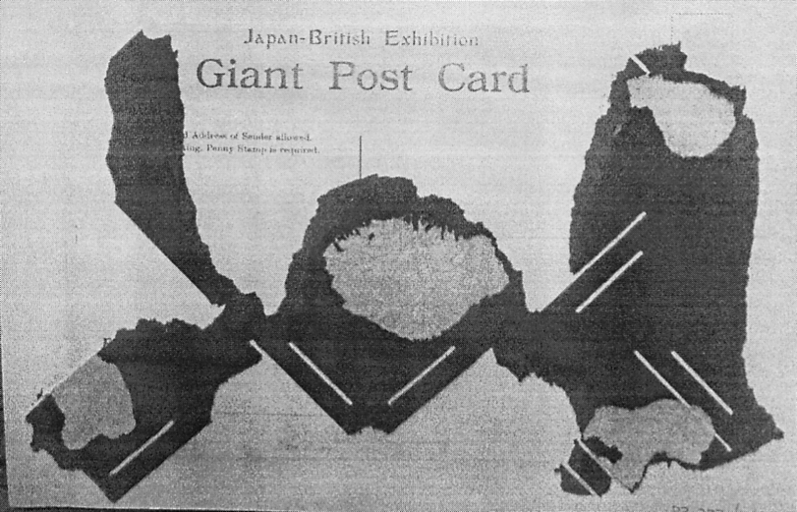

Many of the giant post card backs in the Museum of London show they
came from an old type post card album

