EDITORIAL SPRING 2010

Now in the year two thousand and ten
We start the Journal on page one agen

I wonder what this new year will bring, and what does it offer for collectors. We have seen the art market recover with spectacular prices being paid for paintings and works of art. Lower down the scale there seems to be a real shortage of quality post cards. I suppose we have come to an end of an era when old albums of post cards could be found in attics and lofts.
A catalogue of prices or valuations for post cards is now meaningless, unlike the stamp catalogues, which of course were much more than just a price list of stamps. If we were to take a stamp like the penny black we could first see a valuation in Gibbons Collect British Stamps or their Simplified Catalogue where it would be listed in probably one line. Then more detail in Gibbons British Empire Catalogue where all the plates are listed and the penny black takes up half a column. Then even more detail in the Queen Victoria Specialised Stamp Catalogue where no less than 65 pages are devoted to this single stamp in my old 1985 edition. And then on to Litchfield’s monumental work where the whole 224 pages are devoted to the penny black. Now I appreciate that no post card would warrant this amount of space or research, but the post card world has not been able to come up with even a basic list of post cards, let alone valuations and frankly is never likely to.
The great failing to my mind is that post card catalogues are not a price list backed up with a stock to supply customers, like Gibbons. This I think is really relevant, unless you can put your post cards where your mouth is, a valuation by Joe Bloggs & Co., Ltd is meaningless unless Joe can supply that card at that price. I don’t think dealers in general have ever accepted post card catalogues valuations of post cards. Why should they when they can often get two or three times catalogue at fairs.
When we look at the stamp world we see an entirely different set up. To start with we are looking at a three tier system. In the background we have the wholesalers who carry vast stocks of stamps. Then we have the shops and dealers who when their stock of a stamp runs out can often replenish it from a wholesaler. The third tier is the collector, who can shop around at fairs knowing that if he wants a penny black roughly what he will have to pay. There will be variations in the price as each dealer’s mark up varies. Stamps purchased through club packets are often priced at about a third of Gibbons catalogue price.
Just suppose you had a maverick stamp dealer who decided to shove a ‘0’ on the end of his prices. A rather poor penny black would leap from £70 to £700, while all his competitors were charging perhaps £65 to £75. He would soon fall back into line. So the three tier system and a plentiful supply keeps stamp prices regulated.
Unfortunately there will never be a regulated price system in post cards because there are no wholesale stocks of post cards (I am not talking about moderns) so dealers have in the past had to fall back on what they think the customer will pay. Now they can offer it to the world through E-bay. Here staggering prices can be realised. In this years Picture Post Card Annual Brian Lund reports a card with an estimated value at a fair of about £10 went for £1,120, two collectors chasing it past the £1,000 mark. I believe two football cards have also passed the £1,000 ceiling.
Today the whole world seems to revolve around the internet. I even had a circular from my milkman this week offering me £5 if I pay my milk bill through the internet in future. In the same week I see in the newspaper that during the past year on average three book shops have closed every week. Soon we will have a race of people who will never have known the pleasure of browsing through a second hand book shop. I sometimes visit Eastbourne to stay with my daughter and I always try to call into Camilla’s, a second hand bookshop there, where I recently picked up for £8 an eighth edition of ‘She’ by Rider Haggard a lovely book half leather bound with marbled covers, a joy to hold and read. I already have two early editions of this book. I am sure I shall get more pleasure from this, than sitting holding a plastic box and reading electronic text.
The Editors
Souvenir of the 1924 British Empire Exhibition
Mah-Jongg cards published by the Western Electric Co., Ltd.
Makers of over half of the worlds telephones

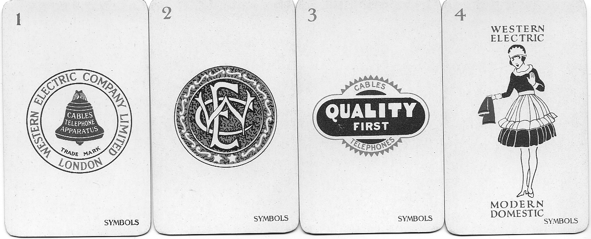

The four seasons

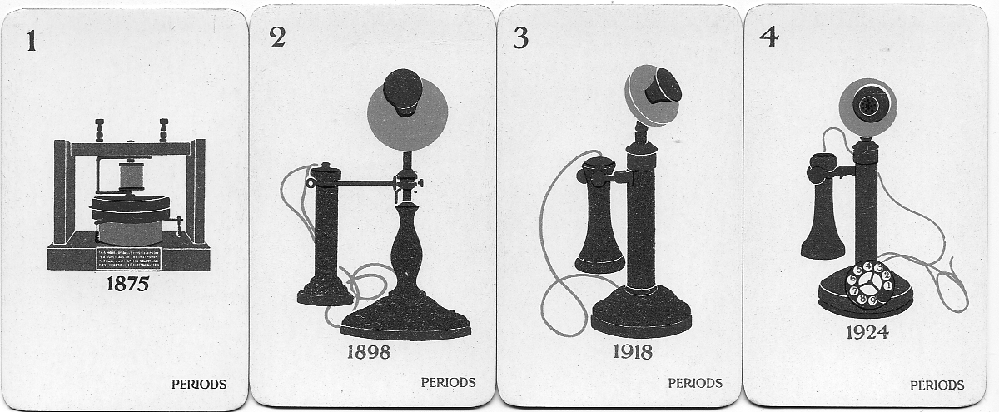

The four flowers

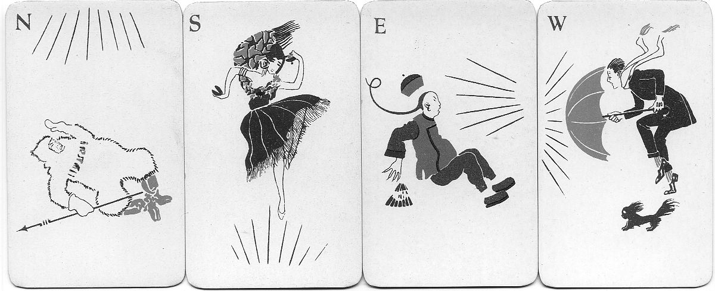

The four winds North, South, East and West

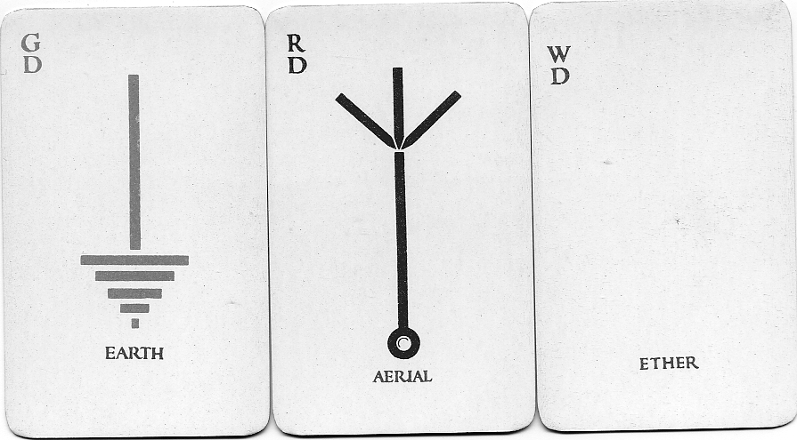

The three dragons, Green dragon, Red dragon and White dragon

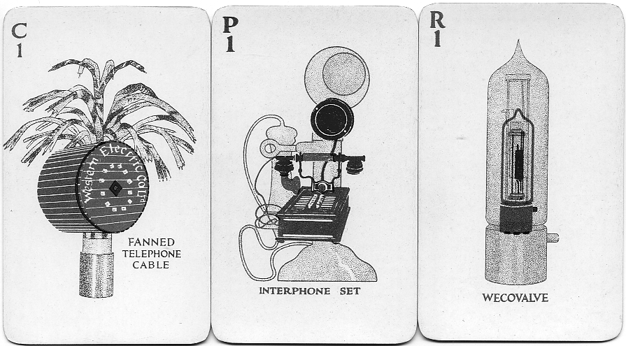

Number one of the three suits, circles, characters and bamboo’s
The three suits comprise cards numbered one to nine

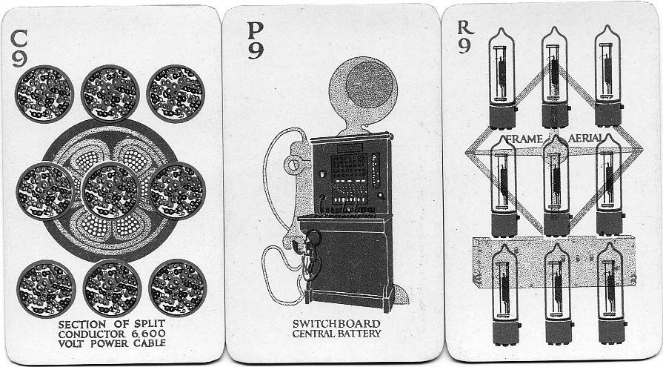

Number nine of the three suits, circles, characters and bamboo’s
The cards are reproduced 75% of full size

Mah-Jongg tiles full size

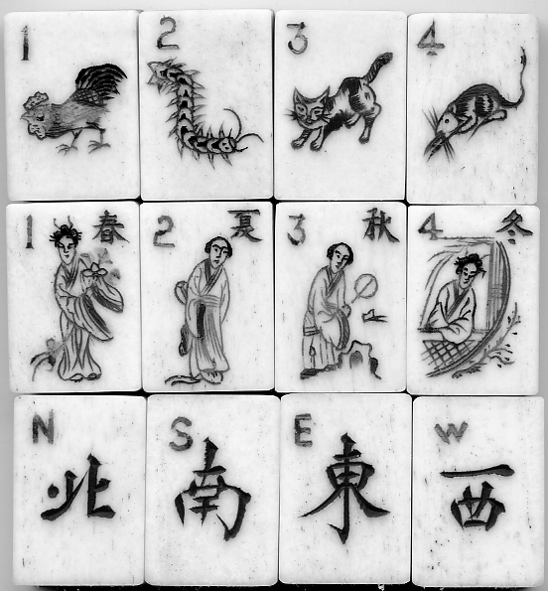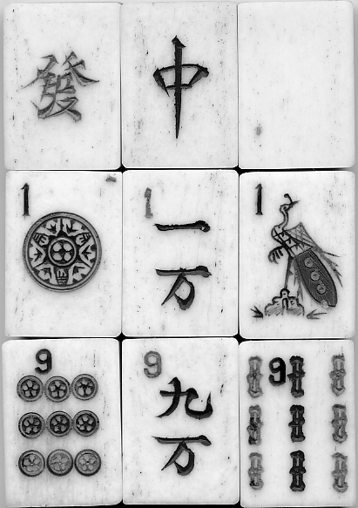

The seasons, one to four Green, red and white dragons
The flowers, one to four One of circles, characters and bamboo’s
The winds, N, S, E, and W Nine of circles, characters and bamboo’s

One of our members Jean Osborne recently sent me about a dozen images of some small cards she had acquired. These were about two thirds the size of a playing card, all the backs were the same showing a Wembley lion and a telephone (see illustration on front cover). Jean guessed they were some sort of a game but did not know what game, or even how many there were to the set. She had about 18, all with different pictures.
I am familiar with these cards so was able to inform her they were part of a set of Mah-Jongg cards. Well the bad news was, there are 144 in the set, so she was in for a long slog to get a complete set. But the good news was I had a spare set in its case, which she has snapped up.
Mah-Jongg is a Chinese game played not with cards but with tiles. I have a particularly fine set, the fronts of a white composition are individually hand engraved and these are dovetailed onto bamboo backs to make up a thickness of about half an inch. You can get sets from cheap solid plastic through to a bone and bamboo, and up to ivory with bamboo backs. The engraving is filled with red blue and green colouring, and altogether they are quite beautiful to play with.
The three suits, circles, characters and bamboo’s run from one to nine, and there are four tiles of each value. The one and nine are counted as major tiles while two to eight are minor tiles. The one of bamboo is always in the shape of a beetle which lives in bamboo. Each value has the requisite number of emblems, so the five of circles will have five circles in its design, here sections of cable, while the eight of bamboo’s will have eight sticks or in this case eight elongated valves. The set of characters is the exception, in an original Chinese set of tiles the characters would in fact be different examples of Chinese writing. Western Electric have got over this by replacing characters with various items of telephonic equipment. A genuine Chinese set would not have numbers on, as they would understand the Chinese writing.
It is a gambling game and owing to a very complex method of scoring at the end of each hand it is possible for the winner to score from 12 points to 294,912 points. Because of this it is usual to set a limit on the highest score that can be claimed for any hand. Various combinations of tiles have quaint names like ‘Eyes of the sparrow’ ‘Four blessings hang o’er the door’ and ‘Catch the moon from the bottom of the sea’ ‘Thirteen grades of Imperial Treasure’ and ‘Three Great Scholars’.
I am not going to try and explain how the game is played or describe its rules, but as I mentioned earlier the beauty of the carving on a nice set is a pleasure in itself.
Mount Everest and its 1924 Postal History

Called “Chomolungma” (Goddess Mother of the World) by the local Tibetans, Mount Everest is the highest mountain on Earth, rising in the eastern Himalayan Mountain range between Nepal and Tibet about 100 miles Northeast of Katmandu.
Originally known, as “Peak XV” in the British survey records, this mountain was renamed “Mount Everest” in 1865 in honour of George Everest (1790-1866), the surveyor general of India in 1830-1843, who first calculated this mountain’s exact location and approximate height in 1841. Everest is hidden behind other lofty mountain peaks when viewed from the south in Nepal. But it can be clearly seen from its north-eastern side in Tibet where it rises dramatically 12,000 feet above the Tibetan Plateau.
Everest is a relatively young mountain, geologically speaking, because it hasn’t yet been worn significantly by erosion. Scientists believe that Everest had its beginnings millions of years ago when the Indian subcontinent “pushed” into Asia, according to the theory of continental drift, and lifted up the Himalayan Mountain range. Further uplift occurred by the folding of Everest’s limestone layers during the last Ice Age, and scientists think that Mount Everest is still slowly rising, although counteracted by erosion.
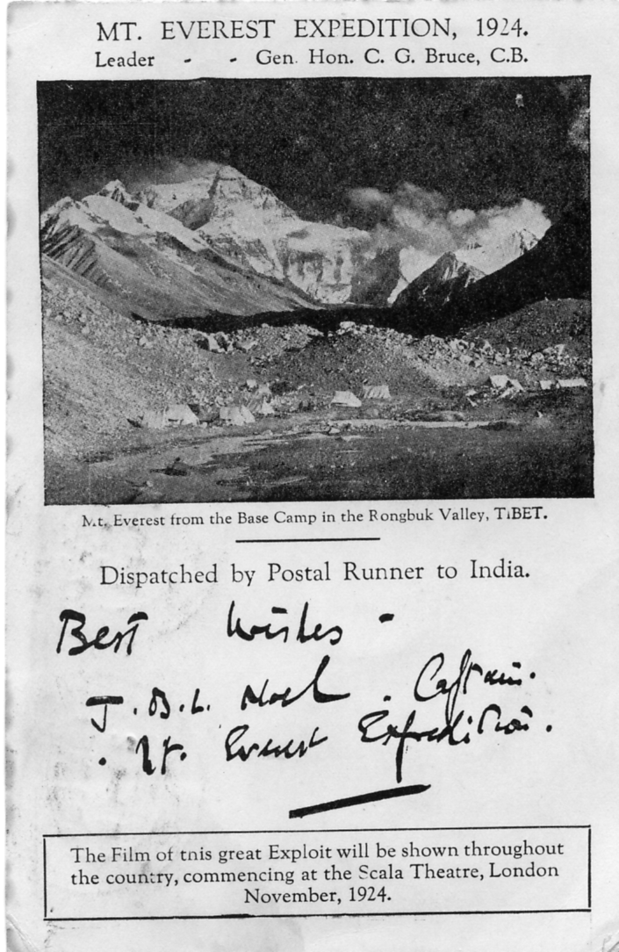
The most commonly accepted height of Mount Everest today is 29,028 feet (8,848 metres) above sea level, which is the official height that was declared by the surveyor general of India in 1954. Periodic snowfall on the mountain’s summit may cause varying height measurements with precision instruments, but the prevailing high speed westerly winds blow the snow off the barren rocky top before much can accumulate there.
Everest actually has two summits, the lower one at 28,700 feet called the “South Peak” (a “false summit” in mountaineering terminology) and the upper one at 29,028 feet (the “true summit”).
Because the summit of Everest rises up two-thirds of the way through the Earth’s atmosphere, oxygen is thin and jet stream winds reach speeds over 200 miles an hour. These fierce winds and extreme cold, unpredictable snowfall, thin dry air and the rugged slopes of Everest kept the world’s best mountain climbers from reaching its top in 10 serious expeditions from 1921 to 1952.
In 1921, for the first time, the Dalai Lama, ruler of Tibet, opened the “northern approach” (also called the “Tibetan approach”) to Everest to a team of British climbers. This opportunity had to be taken advantage of, lest the Dalai Lama change his mind. Nepal still would not permit climbers to use the easier “southern approach.”
The hastily assembled 1921 British Expedition to Everest was limited to a reconnaissance party which climbed 22,900 feet (6,980 metres) up Everest from the north and east sides of the mountain. This was followed by a 1922 British Expedition which had to turn back after reaching an elevation of 27,300 feet (8,321 metres), using bottled oxygen for the last few hundred feet. Seven porters died in an avalanche on this expedition.
The 1924 British Expedition to Everest was a massive project, initially organised under the leadership of General C. G. Bruce who had to drop out due to poor health, turning the expedition over to Lt. Colonel E. F. Norton. This was the expedition which produced the postcard discussed in this article, and it was on this expedition that mountain climbers George Mallory and Andrew Irvine disappeared into the mists and were never seen again.

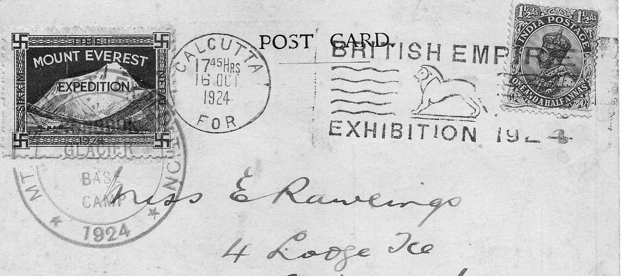

Special post card with the Rongbuk Glacier Base Camp cachet, taken by runner to Calcutta where it received the British Empire Exhibition slogan post mark.

Norton himself reached the altitude of 28,126 feet (8,573) metres on this 1924 expedition, only 902 feet from the top, before he was forced to turn back. But two climbers, Mallory and Irvine, tried to go higher, and they were reported to be “going strong for the top” when they disappeared from view. It’s possible they actually reached the summit before they died, but there is no evidence that they did, and the world had to wait for Edmund Hillary and Tensing Norgay to climb to the top of Everest on May 29,1953.

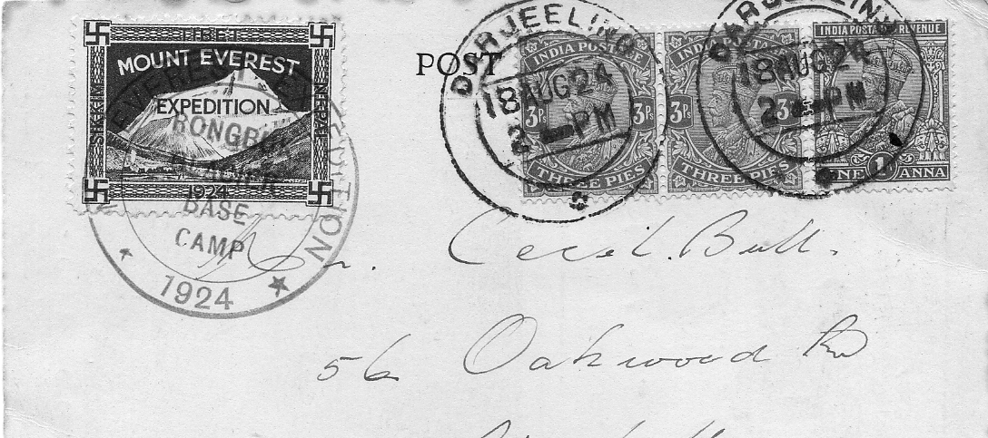

Special post card with advertising label and cachet and Darjeeling post mark.

From a newspaper article written at the time of his 94th birthday Captain Noel is reported as saying “At that time (the 1922 expedition) the climbers unlike today’s well equipped breed wore Norfolk jackets and tweed trousers and as a result, suffered severe frostbite. Tempers frayed as well, and it seems that the unappetising food caused one man to hurl a plate of sausages into the face of the Sherpa cook”.
A special illustrated post card was published for the 1924 expedition and shows a view of Snowdon from the Rongbuk Base Camp with a printed message and signature of Captain J. B. L. Noel (John Baptist Lucien) of the 1924 expedition to climb Everest. The card is printed with the notation “Dispatched by Postal Runner to India” where it entered the normal mail system. It is believed that thousands of these postcards were produced and mailed, and many have survived to the present time.
All of these 1924 Everest postcards have the facsimile hand-written message of “Best Wishes, J. B. L. Noel. Captain. Mt. Everest Expedition.” And almost all of these cards that I have seen are slightly damaged with bent corners, small edge tears and “foxing” (paper mould stains) here and there, but such cards are still desirable. I haven’t seen any of these cards without addresses or postal markings.
It was Captain John B. L. Noel, who was also on the 1922 Everest Expedition, who thought up the idea of using a special adhesive advertising label or “stamp” to commemorate the 1924 Expedition, to be stuck onto official mail that was dispatched from the Expedition site in Tibet. The artist who designed this stamp probably worked under the guidance of Noel. The exact purposes of this Everest stamp are not entirely known today. It was possibly made to raise expedition revenue, to spread publicity about the expedition or to “mark the missives” from this 1924 British Expedition to Mt. Everest.
The other illustrations shows the Advertising label on Snowdon special post cards “postmarked” by the official Expedition hand stamp used on post cards mailed from this Expedition. They were printed in sheets of 36 stamps, and full sheets are sometimes offered for sale. These stamps are known with and without gum when unused.
This stamp or as it is generally known as an “advertising label” in philatelic terminology, meaning that is was produced privately (not by a government) for limited use on mail which then had to be placed into a real postal system somewhere. Cards sent from the Rongbuk Glacier Base Camp during the 1924 attempt to climb Mt. Everest were taken by runner to Calcutta where they were cancelled with a post mark advertising the British Empire Exhibition. Some mail was sent to Dahjeeling to be post marked.
Notice that each of these Everest stamps has a swastika in the corners of its design. The swastika is a Buddhist symbol of good luck, and 1924 was nine years before Hitler came to power in Germany and forever gave the swastika symbol an evil connotation. Such was not the case in 1924 when this Mt. Everest stamp was designed. Inscribed in the left, top and right frame margins of this stamp are the words SIKKIM, TIBET and NEPAL respectively, the three regions which the 1924 Expedition crossed. This stamp comes in various shades of blue.
The Mt. Everest advertising label described above was mainly used on special postcards sent by the 1924 Mount Everest Expedition crew from their Base Camp site in Tibet. Illustrations 2 and 3 shows the address side of two cards, with the usual position of the Everest local stamp in the upper left corner of the card. Regular postage stamps had to be affixed to the upper right of this postcard because it was eventually placed into the Indian postal system. The majority of these cards were addressed to England.
Different Expedition “postmarks” exist on the Everest local stamp. Two scarce hand stamped markings read as follows: “MT. EVEREST EXPEDITION * 1924 * TIBET” and “MOUNT EVEREST EXPEDITION / TRACTOR PARTY / TIBET / 1924.” These Expedition hand stamps are all circular, and can be found in red, black or occasionally violet.
Captain John Noel, who died in 1989 aged 99, was the last survivor of the Mount Everest Expeditions of 1922 and 1924, which he accompanied as official photographer.
In 1919, in the course of a seminal paper to the Royal Geographical Society about an expedition he had made into Tibet, Noel made the first public suggestion that Mount Everest should be climbed. The gauntlet was taken up on the Everest Reconnaissance Expedition of 1921, and Noel himself was invited by Sir Francis Younghusband, who was then president of the R. G. S., to take part in the expedition of 1922 as official photographer.
The War Office would not allow him extended leave so Noel was forced, with regret, to resign his commission. A celebrated revolver shot, at the time of his death he was one of the last surviving officers of the British Expeditionary Force of 1914.
Meticulous in his preparations, he ordered an improved model of the movie camera used by his friend and mentor Herbert Ponting, the photographer on Scott’s last expedition; the two cameras are now exhibited side by side in the Science Museum.
Noel’s 1922 film enjoyed such public success that he was invited to return to Everest in 1924. His book, Through Tibet to Everest (1927, republished in 1989), was the first to give the full story of the 1920’s expeditions. Its most dramatic passages concern the achievements and tragedies involved in the approach to the summit, culminating in the loss of George Leigh-Mallory and Andrew Irvine.
Mallory’s last message from the highest camp was addressed to Noel, instructing him where to look for his party on the morning of the last climb. In the event the view from Noel's position, on the North Col at 24,000 ft, was obscured by cloud; but he held an unshakable, almost mystical, belief that Mallory and Irvine had reached the summit.
In later years Noel became, in the words of Chris Bonington, “probably the most successful mountaineering lecturer of all time”. His splendid expedition films were supplemented by slides — coloured by a process of his own in those days before colour film — many of them showing Tibetan monasteries now sadly destroyed.
In his photographic work he combined artistic flair with great skill and a resourcefulness approaching genius. He was equally adventurous and open-minded in his approach to the techniques of mountaineering and, to the dismay of his more traditionally minded colleagues, was in favour of all technical aids for climbing.
Noel forecast the time when a man would land from the-air on the summit to make his way down; and when the climb would become routine for active tourists, after well-stocked cabins had been established along the route.
John Baptist Lucien Noel was born in 1890, a grandson of the 2nd Earl of Gainsborough. He received his early education in Switzerland, where he fell in love with the mountains and made guideless ascents of such high peaks as the Matterhorn.
Noel was commissioned from Sandhurst into the East Yorkshire Regiment in 1908 and soon found himself in India, where he spent the next five years.
On local leave in 1913, disguised as “a Mohammedan from India” and guided by three frontier hillsmen, he explored the passes leading to Mount Everest and became the first European to reach within 40 miles of the mountain, before being turned back by Tibetan soldiers.
In 1914, within weeks of beginning his first home leave, Noel was posted to the King’s Own Yorkshire Light Infantry, his own regiment being still in India. In the heavy fighting during the retreat from Mons his regiment was almost annihilated at Le Gateau; their ammunition spent, he and 22 survivors were taken prisoner.
But Noel managed to escape and, after much privation, to make his way back to the British lines; after a period in hospital in England he rejoined his regiment at Ypres early, in 1915. During the latter part of the war he was in charge of revolver training for the newly formed Machine Gun Corps.
After the war, when the Small Arms School was established at Hythe in 1919, Noel was a natural choice as revolver instructor under Major (later Maj-Gen) D. G. Johnson, VC; but his other interests were soon to claim him.
As a lecturer in the 1930s Noel made no fewer than eight coast-to-coast tours of America and Canada, and took particular pride in having introduced to his agent the name of Winston Churchill, who was then out of office; as a result of two successful lecture tours the great man was well known there by the time the 1939-45 War broke out.
During the war Noel served at home as a staff officer in the Intelligence Corps, where his main contribution was to deduce from air photographs the best supply route from India to the Allied armies in Burma; to his chagrin he was not allowed to go and check it on the ground. His exact route was later chosen, though it was rather unfairly given the name of “Stilwell Road”.
After the war he specialized in the restoration of old Kentish houses, establishing himself as an expert craftsman.
Noel had an inventive and visionary mind and was often out of step with his contemporaries. In extreme old age he retained detailed memories of the past but remained forward-looking, firm in the belief that: “This world is owned by man. Man has infinite capacity within himself.”
He married twice: in 1915, to the actress Sybil Graham, who accompanied him to Tibet in 1924 to collect fairy tales for her book, The Magic Bird of Chomolungma, who died in 1939; and to Mary Sullivan. He was survived by a daughter of the second marriage.
This article has been compiled from several sources, firstly a letter from Captain Noel in my collection, in which in answer to a question “did he actually sign the original post card” from which the printing plate was made and his reply that “yes it was his signature”. Secondly from an article by Barry Krause published in I believe a defunct post card magazine some years ago, and thirdly from the obituary published in the Daily Telegraph.

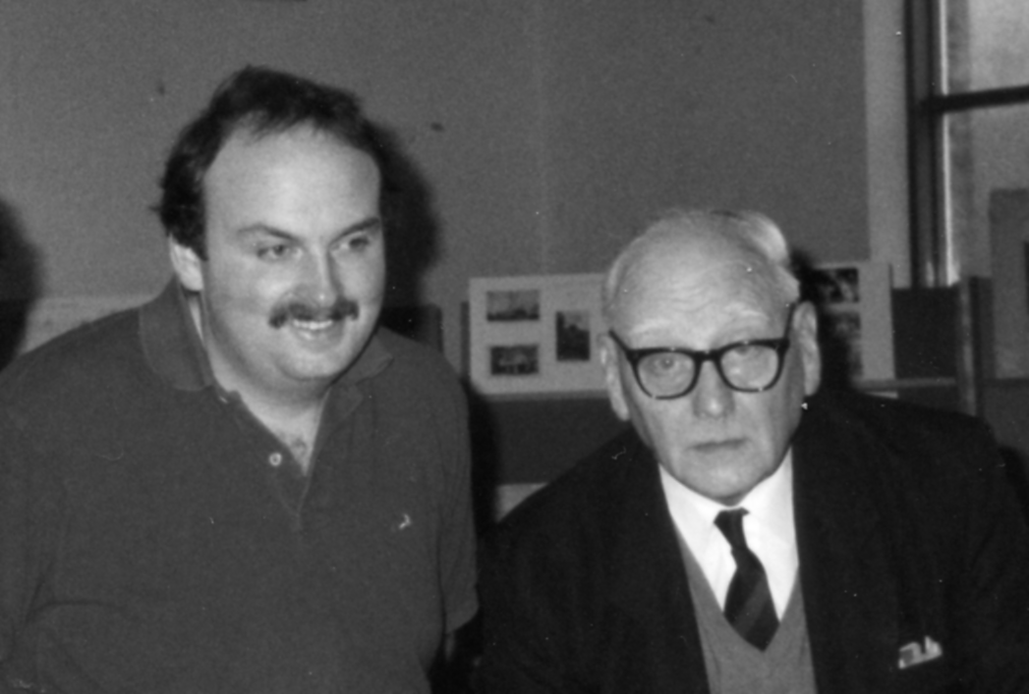

Karl Illingworth and Arthur Smith at our 1990 4th Convention at the Crystal Palace.

Obituary

Don Knight phoned me the other day with the sad news that Arthur Smith had passed away. He had been frail for some years, but still got to the occasional post card fair. His speciality was Earls Court and Olympia where his grandfather, father and brother worked for many years, his father rising from carpenter to the position of foreman. I remember him telling me his father was awarded a Medal after the First World War by the Belgian Government for his work in aiding Belgian Refugees billeted at Earls Court. Arthur and his family had special mention in ‘Earls Court and Olympia’ by John Glanfield (2003) and a photograph of his grandfather from Arthur’s collection appears in that book.
I can remember at our 1992 Convention at the Crystal Palace Arthur gave a brilliant display of Royal Tournament cards and by using his collection of Tournament programmes had been able to date many of the un-dated early tournament post cards. This led to a five page article by Arthur in our newsletter No. 34. He certainly started my interest in Tournament cards which has never flagged over the years.

I also have to record with regret the resignation of one of our oldest members (in membership years) William ‘Bill’ Early. He was not one of our founder members of whom only three remain, Andrew Brooks, Graham Hall and Don Knight. Bill’s name first appears in the June 1981 Newsletter as a new member. Living in Dundee I don’t think Bill ever attended one of our conventions unless it was one of the first at York, of which I have no record of, I believe we once met, probably at a York Post Card Fair, but it was a long time ago. So all the best Bill.

New Exhibition Post Cards
by
Bill Tonkin

I attended a display by John Gent at a local post card club recently. John is the authority on Croydon local history and amongst his display were some Croydon Airport cards. After he finished I asked John if I might borrow some of them which he very kindly agreed to. It is not often that three new Imperial Airways post cards turn up that were possibly available at the British Empire Exhibition in 1925, in fact I think it has only happened once before when Tony Davies did one better way back, as reported in Journal No. 84 page 8.

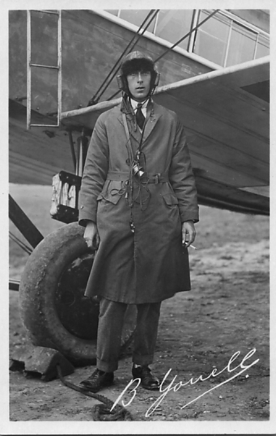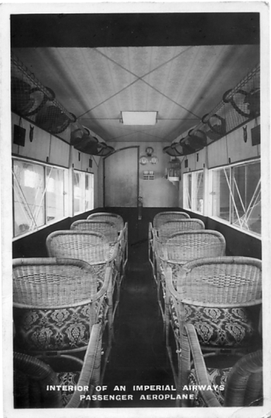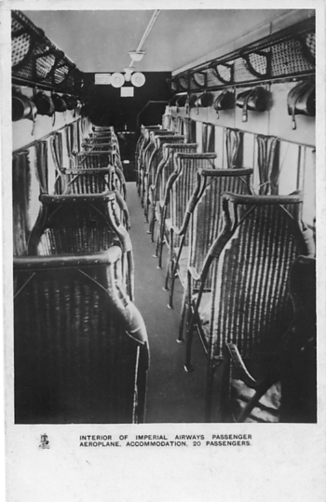
No. 1 No. 2 No. 3

When we did our book on Wembley post cards Mike Perkins and myself only knew of one card with back type as illustrations No. 1 and 2 below, this was in the Karl Illingworth collection. Now we know of five cards with this back, two with exhibition stamps and post marks, so there can be no doubt they are Wembley post cards. The pilot B Youell card is interesting as I have eight of these all showing different pilots with their autographs printed in white, but none of my pilot cards have a white border, this is the first one with a border I have seen.
Post card No. 3 is a bit of a mystery card, the back has ‘Post card No. A/C 57’ printed at the bottom left. Apart from this addition the back is the same as all the other Imperial Airways cards. I have only seen one other card of this type of imprint on the back some years ago, and at the time I did not think it was a Wembley card. Now that another one has turned up I think I may have been wrong, although I have yet to see a card with this back used from the exhibition.

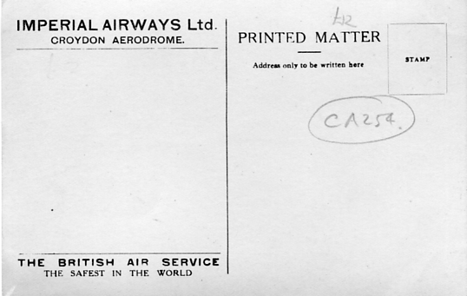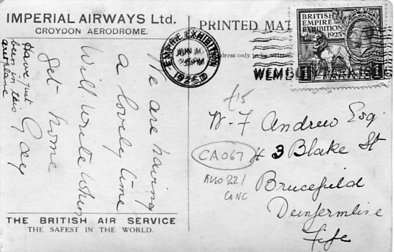
Back of No. 1 Back of No. 2
Part of message on No. 2 reads ‘Have just been in this aeroplane’.

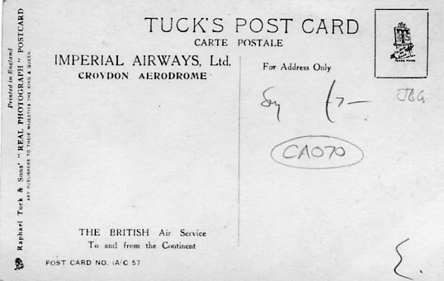
Back of No. 3
Post card No. A/C 57 may not be a Wembley post card

And now for a couple of images sent in by Ken Rumsey, the first shows Shepherds Bush before the Franco-British Exhibition was built. The second card is an un-recorded ‘Our Miss Gibbs’ card. This was a play featuring White City scenes on the backcloth and the story takes place at the Franco-British Exhibition.

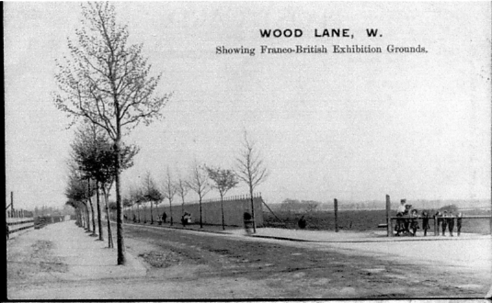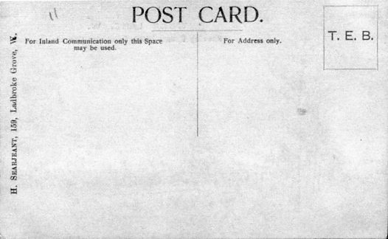

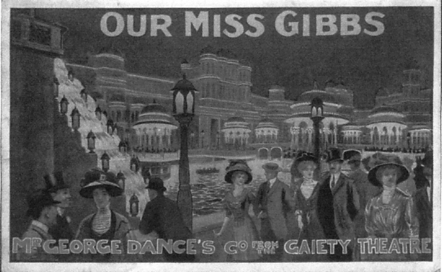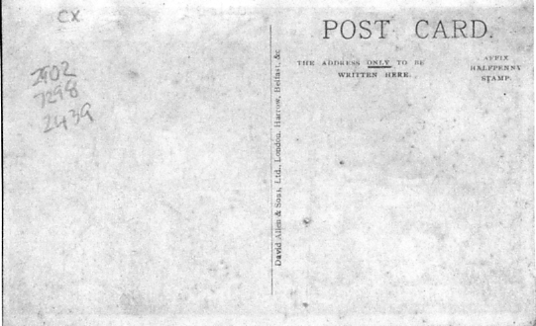
And with many thanks again to Ken Rumsey I have acquired 15 London & North Western Railway cards overprinted on the back for distribution on their stand at the Japan-British Exhibition. These cards have two different advertisements one printed in green, the other in blue.
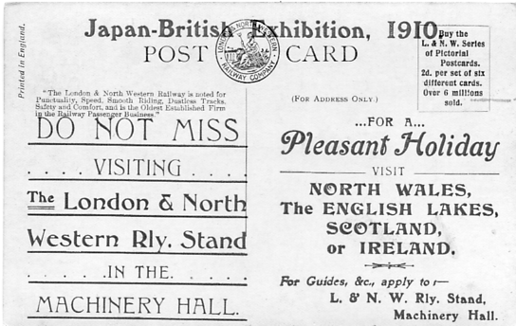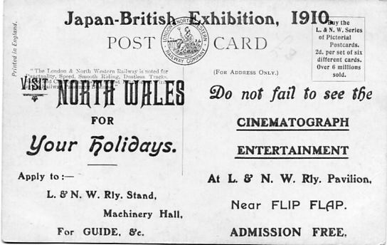

Overprinted in green Overprinted in blue

London & North Western Railway
Overprinted in blue B/W printing, over 6 million sold in stamp box.
L. & N. W. Steam Rail Motor Coach running on the Oxford & Cambridge Branches, North Wales etc.
Overprinted in green B/W printing, over 6 million sold in stamp box.
Corridor of New 57ft Corridor Coach Vert. left.
Exterior Third Class Picnic Saloon / Interior
L. & N. W. Irish Mail taking water at Bushey Troughs
New Corridor Train / New 57ft Corridor Coach
Picking up Water at full speed
Travelling Post Office
Overprinted in green Coloured printing, over 5½ million sold in stamp box.
Boxmoor Embankment, June 1837
Railways in the ‘Thirties’ Rainhill bridge
Railways in the ‘Thirties’ Taking Water at Parkside Station
Overprinted in green Coloured printing, over 6 million sold in stamp box.
Holyhead Station, Passengers Embarking for Dublin (North Wall)
L. & N. W. S. S. Cambria Deck Cabin, Holyhead & Dublin Service Vert. left.
L. & N. W. S. S. Scotia Smoking Cabin, Holyhead & Dublin Service
The ‘Wild Irishman’ En Route to Holyhead. L. & N. W. Railway
Overprinted in green Coloured printing by R. Tuck.
A Carriage of the First Class, L & M Rly 1838

I can tell you it made my day when I got that lot.

I received a letter from one of our members Ken Peters with the information that a 1924 British Empire Exhibition book has been re-published in hard back form and is now being remaindered at the reduced price of £7-50 plus postage (It was £16-99) XXIV plus 120pp, many illustrations including coloured adverts and folding map. It can be obtained from Castle Bookshop. The Old Rectory, Llandyssil, Montgomery, Powys. SY15 6LQ. Tel 01689 668 484

An Octogenarian’s Epic Walk
from ‘Tales of Old Cornwall’
by
Sheila Bird

The statuesque, handsome fishwives of Newlyn in their scarlet cloaks, long navy skirts, crisp white aprons, smart buckled shoes and comely broad brimmed black hats were much admired for their classical style and easy grace, a fact which they took advantage of. No wonder artists found inspiration in Newlyn’s colourful, work-a-day scene. Newlyn has long been a thriving fishing port and it was customary for the fishermen’s wives, who had a strong line of cheerful patter, to hawk their husband’s catches through the streets, tunefully crying their wares. They transported incredibly heavy loads of fish in specially shaped baskets or cowals, which were supported on their backs, with broad bands passing across their foreheads and through their headgear. It was the balancing of such weights which gave rise to their poise and upright bearing.
One such was Mary Kelynack, born on Christmas Day 1766, married into a well known fishing and seafaring family and with a fondness for colourful exploits and gaining media attention. She may not have been the girl she once was, her dark, flirtatious eyes and sensual charms now dimmed, but old Mary still had the gift of the gab and an engaging personality which she used to good effect. Well aware of the possible effect of the fishwives fresh and rustic charms in the dusty, dreary metropolis, she hit on the singular notion of walking to London, purportedly to attend the Great Exhibition of 1851.
But in doing so she had hopes of generating some publicity which might hold sway with the authorities in regard to a Naval pension which she seemed to believe she may be entitled to. Despite all the fuss and concern, or more probably on account of it, this game and enterprising octogenarian went ahead with the plan, reveling in all the attention and the prospect of enjoying more of the limelight when she reached the big city. Old Mary set forth in a blaze of publicity, looking every inch the part in her fishwife’s apparel and carrying a cowal suspended from her head and shoulders, endearing herself to all who saw her. She had declared from the start that she would accept no help along the way, apart from money, so the hundreds who turned out to cheer her and wish her well were generous in contributing to her funds.
The old lady was well able to handle the publicity, and had a flair for accepting their financial help and goodwill gracefully, with what she felt was an apt word or two. An example of this occurred when she reached Camborne, and a well known grocer named Shackerley presented her with a half sovereign and wished her God’s speed for the journey. She thanked him kindly, then added as an afterthought, ‘Three cheers for Chatham’, meaning William Pitt, Earl of Chatham, whose family had connections with Boconnoc, which was miles away from Camborne.
The fishwives of Newlyn had to be strong and healthy to survive their everyday workload, but it is incredible that the old lady actually walked the 300 or so miles to the capital, when going by coach or horse was reckoned to be a test of endurance. For as the old rhyme said: ‘Ride to Lunnon on a hoss? See what money it do cost. Rub us raw and rub us beer, afore we do get ‘aalf way theer!’ Mary must have had remarkable feet. But she accomplished her walk, for on October 25th 1851, The Illustrated London News reported: ‘On Tuesday, among the visitors to the Mansion House was Mary Kelynack, 84 years of age, who had traveled on foot from Penzance, carrying a basket on her head, with the object of visiting the Exhibition and of paying her respects personally to the Lord Mayor and Lady Mayoress.’ When the ordinary business was over, Mary was escorted to the justice room, where the Lord Mayor said, ‘Well, I understand Mrs. Kelynack you have come to see me.’ ‘Yes,’ replied our Mary, ‘God bless you.’ And looking round a trifle overawed, added, ‘I never was in such a place before as this.’
People were warming to the pert old lady with spirit and charm, and soft Cornish accent; and she knew it. As a ‘character’, she could get away with saying things that other people could not, and she decided to strike while the iron was hot. ‘I have come up asking for a small sum of money,’ she said, and added, ‘I am eighty four.’ This remark may have been a reference to her plea to the Admiralty; or it may not, and if the Mayor felt slightly taken aback, he did not show it. ‘Where do you come from?’ he inquired, politely. ‘From the Land’s End,’ replied Mary. Surely everyone knew the Land’s End; it had been a famous landmark for centuries. Or was it her broad, Cornish dialect that he did not quite understand? ‘Er...From what part?’ he asked. ‘Penzance,’ replied Mary.
Unabashed by the elevated company and grand surroundings, she went on to tell the Lord Mayor and the assembled company about her long walk to London, which had taken five weeks. His Worship, puzzled about the need for such a test of endurance, ventured to ask, ‘What induced you to come to London?’ Mary explained that she had a little business to attend to, and also thought it would be a good opportunity to see the exhibition. ‘I was there yesterday, and I mean to go again tomorrow,’ she declared. On being asked what she thought of it, she replied that she thought it was very good.
She stood admiring the resplendent surroundings, then casually let drop that she had precisely 5½d to her name. With Mary, it was not so much what she said, but the disarming way in which she said it, and after some light-hearted but seemly chat, the Lord Mayor presented her with a sovereign, and urged her to take good care of it as there were a lot of thieves in London. Our heroine, touched by such unexpected generosity suddenly burst into tears, saying, ‘Now I will be able to get back home!’ Unaccustomed as they were to floods of feminine tears in the manly environment of the Mansion House, she was whisked away to the housekeeper’s room to have a nice cup of tea with the Mayoress. ‘There’s nothing like a good cup of tea, is there?’ said the Mayoress, kindly. ‘No. I prefer a ‘andsome cuppa tea to all the best wines in the Kingdom!’ confessed our forthright fishwife. Then she made her departure, thanking them for all their kindness.
For Mary, now staying in Marylebone, this was a prelude to other heady experiences still to be savoured, for she had her portrait painted, gave sittings for the Cornish sculptor Nevill Northey Burnard, was an honoured guest at Greenwich Hospital and other prestigious places, and to crown it all, was presented to Queen Victoria and Prince Albert on her final visit to the exhibition. Mary, who had captured the imagination of the sophisticated capital, also made an impression on Queen Victoria, who recorded in her diary: “The old Cornish woman, who walked up several hundred miles to see the Exhibition was at the door to see me - a most hale, old woman, who was near crying at my looking at her.” The Illustrated London News, which had taken to Mary in a big way, concluded, albeit a trifle condescendingly: “She possesses her faculties unimpaired; is very cheerful, has a considerable amount of humour in her composition; and is withal a woman of strong common sense, and frequently makes remarks that are very shrewd, when her great age and defective education are taken into account. She is fully aware that she has made herself somewhat famous; and among other things which she contemplates, is on her return to Cornwall, to end her days in Paul Parish, where she wishes to be interred by the side of old Dolly Pentreath, who was also a native of Paul.”
It could be added that Dolly Pentreath also employed a wide repertoire of colourful antics which found her a place in history, by virtue of her claim to be the last speaker of the Cornish language. If The Illustrated London News saw Mary as a lovable innocent abroad, The West Briton saw her as a knowing opportunist, and reported in November: “This Cornish octogenarian, who walked to London to see the Crystal Palace, and was so kindly received by the Lord Mayor and Lady Mayoress, has returned home after an absence of two months, with her pockets well lined through the benevolence of the Londoners. We understand that on the route homewards she received much kindness. Mr Prockter, of Launceston, sent a letter to the aged woman whilst she was in the metropolis, inviting her, on her return, to take a seat inside the ‘Times’ coach from Exeter to Truro, free of charge, of which favourable opportunity she availed herself on Thursday week. She was also hospitably entertained on her journey by Messrs Pratt, of Exeter, Prockter, of Launceston, and Lenderyou, of Truro, at whose hotel she slept on Thursday night. Her appearance at Launceston excited considerable curiosity, and the Mayor, with a number of ladies and gentlemen visited her at the White Hart Hotel, where they presented her with money and useful gifts.”
Mary, pleased no doubt to be home after all the excitement, entertained local folk with her tales of the high life in the big city, until her death, four years later.
The Exhibition Study Group would like to thank Sheila Bird through her publishers who gave permission to use this extract from her book.

1906 RoyalTournament
Part 3 by
Bill Tonkin

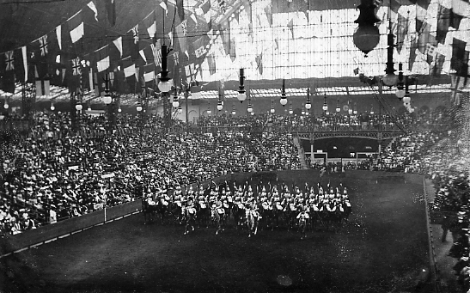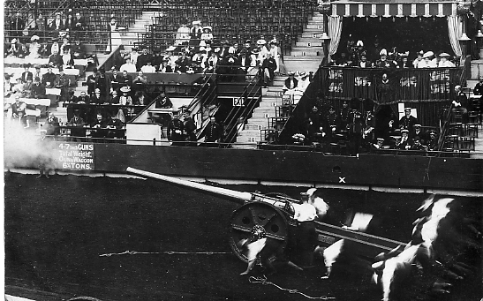
1906-13 1906-14

1906 saw the first use of the Camera back, this is known in three measurements of ‘POST CARD’ 58, 59 and 61 mm., (not counting the stop) and comes in a range of colours. Some colours were only in use for certain years.

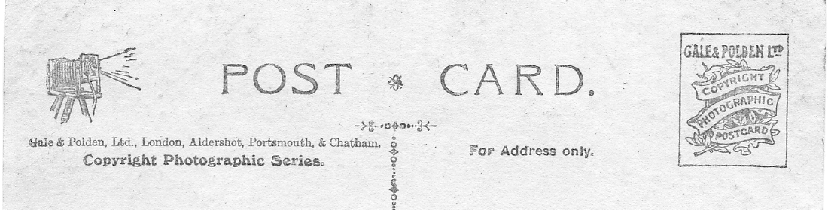
Gale & Polden. Camera back type 2. measuring 61 mm.

Type 2.
Gale & Polden. Real photograph, black Camera back type 2, ‘POST CARD’ measuring 61 mm. Printed title. This is the only card in this series with a printed title and was probably commissioned specially by the barracks or regiment to commemorate their winning the 1st prize.
Ref. 1906-15. “X” Battery R.H.A. Galloping Team. Winners 1st Prize. Royal Naval and Military Tournament, Olympia, 1906. 7-8-06.

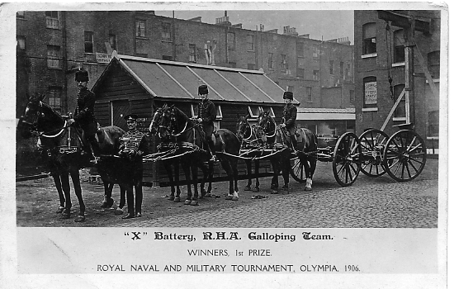
1906-15

Raphael Tuck & Sons.
Tuck published a series of Royal Tournament Post Cards the earliest known usage is 2 July 1906. Tuck’s were known for re-printing series with different backs and the Tournament cards are no exception. Three printings with different settings are known.

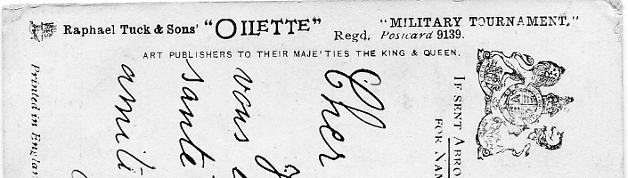
Tuck back type 3. Small 9139 Oilette to left of center.

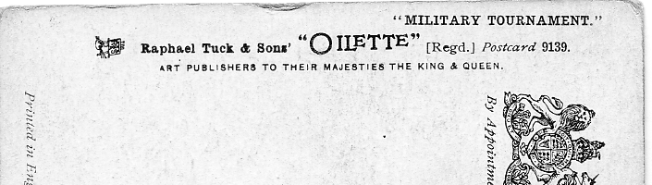
Tuck back type 4. Small 9139 Oilette to right of center.

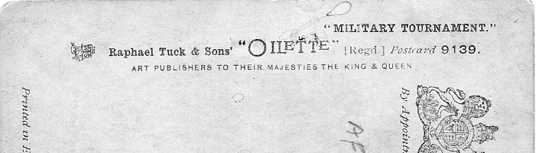
Tuck back type 5. Large 9139

Tuck. Coloured “Oilette” printings from paintings by Harry Payne, brown back.
Military Tournament. Registered postcard 9139.
Ref. 1906-16. Lance V Bayonet. Lancer and Footguard.
A.. Back type 1. Vert left. 2-7-06.
B. Back type 2. Vert left. 22-8-10.
C. Back type 3. Vert left.
Ref. 1906-17. Sword V Sword. Lifeguard and Dragoon
A. Back type 1. Vert left. 3-8-08.
C. Back type 3. Vert left. 12-2-13.
Ref. 1906-18 Tent Pegging 16th Lancers.
A. Back type 1. Not illustrated (J. Gray collection)
Ref. 1906-19 Lemon Cutting 10th Hussars.
A. Back type 1. Not illustrated (J. Gray collection)
Ref. 1906-20 Victoria Cross Race. 14th Hussars.
A. Back type 1. Not illustrated (J. Gray collection)

Ref. 1906-21 Water Jump. 7th Dragoon Guards.
A. Back type 1. Not illustrated (J. Gray collection)

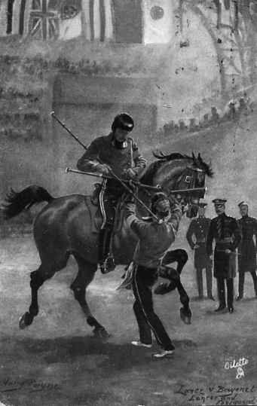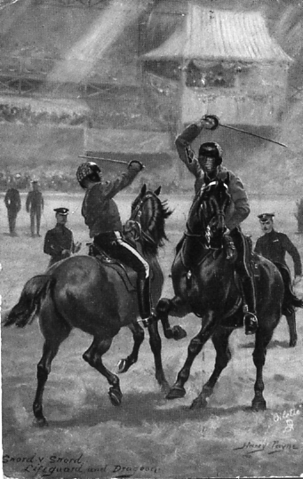
1906-16 1906-17

To finish up I have a query from a Paul Niblett who is researching a pottery firm who had a stand at the 1924 British Empire Exhibition. They are A. E. Gray & Co., Ltd. of Hanley Staffs. who had stand M.451 in the Palace of Industry Pottery Division. Apparently Grey’s supplied the dinner service in the 1924 Dining Room in the Palace of Arts. If anyone knows anything about this firm Paul would like to hear from them at 01782 641 967 or info@grayspottery.co.uk

