EDITORIAL WINTER 2009

Winter’s here, the Convention’s done
Enjoyed by all who came, by gum

We had another good turn out for our convention this year. I sometimes get a bit despondent that more of our members do not turn up. Holding it at Crystal Palace means it is within easy reach of many of our London members. I should have thought the chance of seeing selections from some of our leading collections of Exhibition material, albeit it is often post cards, would have been of interest to the membership. Every Friday I go round to the local church and have a coffee with a friend who is I believe secretary of the Papua & New Guinea Philatelic Society which has about 160 members, Their convention was the same weekend as our convention, and only eight turned up, so we don’t do too badly I suppose.
I’ve just had a long chat with Ann Stevens who rang to ask how the convention went. Ann and Ted were hoping to make it this year but Ted injured his back needing two visits to hospital and just before the convention he started a course of physiotherapy. They were both sorry to miss it. We had several other members unable to make it including Bob Tough and my son Kenneth who was hoping to get down for the Sunday and had got a display ready. We still had sixteen on the Saturday which was a nice crowd. Getting to the convention on the Friday afternoon seems to be getting more popular and this year we had eight staying at the Lodge on the Friday night. I was able to organise a three course fish and chip supper in the Lodge Friday evening, so we did not have to go out like we did last time tramping round the Crystal Palace Triangle looking for a pub meal. The thanks of those present must be recorded to Derek Connell and Mike Perkins who brought a plentiful supply of beer and a bottle of Harveys Bristol Cream to go with our fish and chips, so we spent a very pleasant evening. I went off to bed about 10.30 and I believe the others sat up till past twelve before retiring.
One invited visitor turned up on the Sunday, Don Brookfield and he obviously enjoyed himself because he has since become a member of the Study Group, he even brought a small display with him. Another new member Melvin Harrison Chairman of the Crystal Palace Foundation turned up and also gave a display. He told me he was very impressed and will certainly try and make it next year.
Else where in the Journal you will find a report of the convention by our Secretary Don Knight. You will see our practice of celebrating the centenary of an exhibition was followed with displays of the Imperial International Exhibition, Royal Tournament and other 1909 events. I personally am looking forward to our 1910 convention when we shall celebrate the Centenary of the Japan-British Exhibition. As far as I am concerned I think the highlights of my collection can be found in this exhibition, and I can promise you now there is going to be a wonderful display of Japan-British Exhibition cards and ephemera next year.
Since 1993 I have always tried to use an exhibition Christmas or New Years Greetings card and have only missed doing this on two occasions when it slipped my mind. I didn’t forget this year and you will notice I have again used a seasons greetings card on the front of the Journal, so far this is the sixteenth Exhibition Christmas or New Years greetings card I have used, fifteen really as I repeated one in 2008 but no-one noticed, not even me until after the event. I shall not be able to keep it up much longer as I am running out Exhibition Christmas cards.
When you come to think of it, shopping early for Christmas is no new thing. The Franco-British Christmas cards must have been bought before the exhibition closed on Sunday 31 October. In fact the earliest Christmas card bought and posted at the Exhibition with a Franco-British post mark was on 22 October. This must be a record for posting early for Christmas.
I have had a request from one of our members Charles Kiddle asking for details of Alexandra Palace. Can anyone help? In an article by John Allwood in our newsletter No 2 in 1980 John gives a short history of Alexandra Palace. I sent Charles some extracts from the article. To close the year Fred and I will take this opportunity of wishing you all the best for Christmas and the New Year.
The Editors.
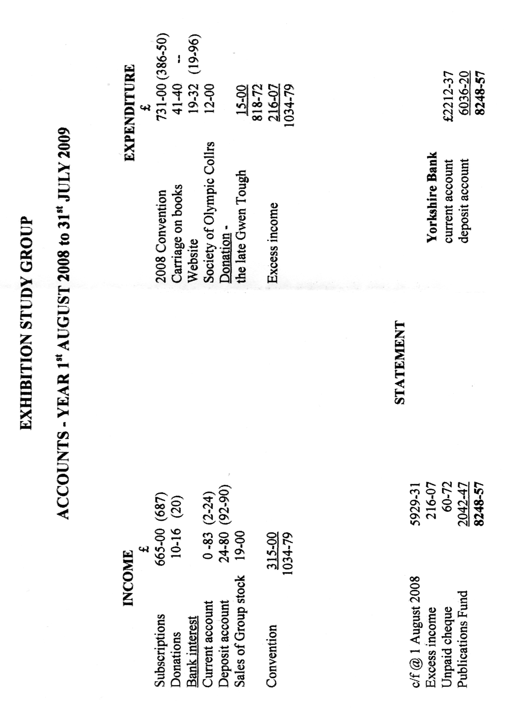
Exhibition Study Group
A.G.M. and Convention 2009.
reported by
Don Knight
Held at the Crystal Palace Sports Centre 17 & 18 October.
Opening address. The President Peter Denly opened the meeting at 10.10 am and welcomed 15 members to the 23rd convention. Before the main business started, the meeting stood for a minutes silence in memory of Gwen Tough and Mike Mobbs. The President said that the three years of holding this office had past very quickly and that it had been a great honour. He thanked the committee for their work in running the group with a big thank you to Bill Tonkin and Fred Peskett for producing our journal.
Apologies for absence. We had apologies from Floe Simner, Anne and Ted Stevens, Andy Brooks and Kenneth Tonkin.
Minutes. Acceptance of the minutes of the 2008 Convention which had been published in the Journal and were part of the agenda that each member had received, were proposed by Fred Peskett and seconded by Ray Goody and passed by the meeting as a true record.
Matters arising. Derek Connell asked about commemorating our 25th anniversary and we had spoke about producing smart stamps the do this in 2010, Alan Sabey to contact Bob Wilcock.
Secretary’s report. Don Knight reported that he had attended Gwen Tough’s funeral. That Japan Television had been and recorded for three hours at his house for a programme on the effects of the ethnic happenings from the 1900’s and through the years. The researcher had said that the Japan British Exhibition had lead to W S Gilbert and Arthur Sullivan writing the Mikado, this can be seen in a film Topsy - Turvy available from Amazon.
A man from the Oxford Railway Society had asked about a item seen at the 1901 Earls Court Exhibition and I have suggested he write a article and make a appeal for help. Alan sends me any amendments regarding the members. We held a committee meeting here at Crystal Palace in April, and our thanks go to Bill Tonkin for getting us all here this weekend.
Treasure's Report. Alan Sabey had given everyone a copy of the accounts and reported we had a small excess over income due to the secretary and treasure not claiming any expenses. We are indebted to Kenneth Tonkin for the printing and distribution of the Journal. He pointed out that in the sixteen years he had been treasurer, that we had not increased our fee’s. He proposed that the fee’s go to £10 for UK members, £15 for UK couples and £15 for members living abroad. With us meeting at Crystal Palace the charges are reasonable but we need to make provision for costs when we meet elsewhere. It was felt that members attending the convention should be charged £40 to cover Refreshments and Dinner from now on. The acceptance of the accounts were proposed by Bill Tonkin seconded by Peter Burrows and accepted.
It was proposed that the fee’s go up by Ray Goody, seconded by Bill Tonkin and accepted, and proposed that a charge of £40 be made at the convention for those members attending the full weekend and dinner, was proposed by Derek Connell, seconded by Mike Perkins and accepted.
A vote of thanks was made to Kenneth Tonkin for printing and distributing the journal over the past year.
As the retiring President after three years of holding the office Peter Denly wished the incoming President a pleasant term.
Election of Officers.
President Alan Sabey, proposed by Mike Perkins, seconded by Peter Denly.
Vice President Ray Goodey, proposed by Peter Denly, seconded by Mike Perkins
The other officers, Don Knight secretary, Alan Sabey treasure, Bill Tonkin, Fred Peskett, George Burr, Ken Rumsey committee, Web Masters Mike Perkins and Ken Rumsey, Journal Team Bill Tonkin and Fred Peskett, Archives Bill Tonkin, Account Checker George Burr, were proposed and seconded and elected for office for the next year.
2010 Convention. It was proposed and seconded that this will be held at the Crystal Palace Sports Centre as this year, the date to be Saturday and Sunday 9 and 10 October. We had changed the date for 2009 in the hopes of getting more member to attend, this did not work but we still had around the usual number of 16 members.
Any other business. Bill is working on getting the Alan Sabey collection put into book form and is a third of the way through.
The A.G.M. closed at 11. 10 am.
The displays at the Convention.
Saturday morning
Don Knight started the displays with the 100th anniversary of the Imperial International Exhibition held at the Great White City, Shepherds Bush, London 1909. Imre Kiralfy was the director general of the exhibition Don showed the programmes, a official season ticket, the postmarks on valentine postcards including the scarce Columbia machine cancellation which was in use for just a few days. The postcards followed the line of the Franco British Exhibition but with the titles changed, the 1909 exhibition was not as well attended as the 1908 so not as many are to be found. Bill Tonkin put up a display starting with the Imperial International Exhibition showing cards not displayed by Don. He then went on to the 1909 Congress and cards from the London and Liverpool Africa and the East Exhibition, Olympia and the Royal Tournaments, Silhouette cards, Golden West Exhibition Earls Court and Missionary Cards.
Peter Denly showed Wembley 1924-25 with the slogan cancellations , covers from the Empire countries which advertised the exhibition and finished with the Mount Everest Expedition 1924.
Saturday afternoon
John Greatorex showed the corner of the Crystal Palace reproduced and now standing on what had been the original site on what is left of the 1854 exhibition. Then came the story of the 1948 Olympic Torch, he had one and it had been used just recently to advertise the paralympic games, first held in 1948 at Stoke Mandeville, England.
Ron Trevelyan displayed the Paris Exhibition 1938 with stamps, postcard, labels, bookmarks, slogan s and franking machine along with some ephemera.
Fred Peskett put on a display of Crystal Palace with early catering seals found on the companies envelopes, cigarette cards from 1937 and the Ogden card which came from the packets sold abroad. Brocks Firework postcards and early hand bills. The afternoon finished with
Derek Connell as a Butlin’s Redcoat. Billy Butlin had been involved with the fun fair at the 1938 Glasgow Exhibition and when he built his first one, had one of it’s building’s as part of the Holiday Camp. Derek told how Butlin had started and that after the war went on with others. Derek had been a redcoat and while working there had gone into a store room were he noticed a box of 12 x 8 inch glossy photo’s he finished up with them. He showed postcards and items he had collected over the years along with a card of a Guinness Clock, like the one seen at the 1951 Pleasure Gardens. To finish with we saw the wonderful photo's, some had Billy Butlin in along with the many top film stars, theatrical people and comedians, they were all there.
In the evening 10 members enjoyed a three course meal of Roast Lamb and wine.
Sunday morning at 10 00 we met again
Don Knight put up a display of G.B. Congresses from 1909 through to the 1936, with cards and covers cancelled at the congresses and the many Cinderella labels in sets and sheetletts.
Don Broadfield a visitor (now a new member) showed hand drawn envelopes done by a Mr Mulland a ironmonger who lived in Exeter, Devon, these are unique and were connected to the Festival of Britain 1951.
Bill Tonkin put up a display on the Crystal Palace, the 1862 Exhibition, Earls Court Navel Exhibition and the Victorian Era Exhibition 1897, along with a selection of cards showing statues of nude ladies that had been on display in the Crystal Palace.
Ray Goodey showed Wembley labels he had found which had not been recorded in Alan Sabey 's book on the Wembley Poster Stamps. To finish the Convention
Melvin Harrison a new member and Chairman of the Crystal Palace Foundation put up and talked about motor car and motor bike racing in the grounds of Crystal Palace. He talked about a man who had a large collection of memorabilia on the motor bike events, he had left a note with his will on where they were to go, but his son put them all into a skip, now they are lost for ever.
The President Alan Sabey thanked all those members who had displayed a wide range of subjects over the two days and said he hoped to see everyone next year on the 9-10 October 2010.

Note. All member are welcome at the convention, everyone is made to feel at home by the regulars. The Crystal Palace Sports Centre Lodge is nice and next years Convention is booked. There could be a bonus, with the Olympic games coming to London many athletes will be in training, bring a autograph book.
Don Knight, Hon Secretary.

A Few New Wembley Advertising Labels

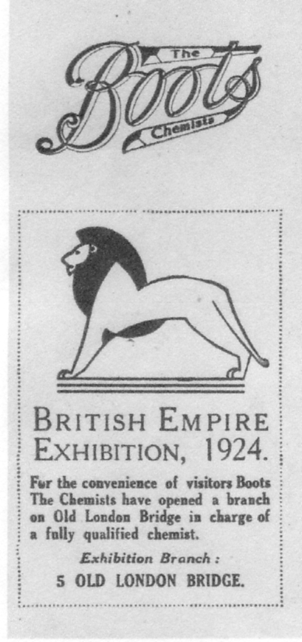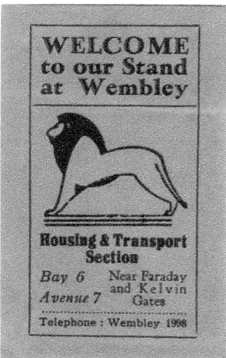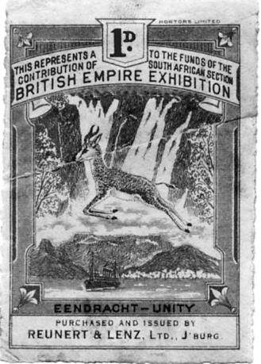
Dark blue on cream paper 1925 Ardente “Acoustique” Purchased and issued by
Supplied by Alan Sabey (deaf aids) Gold colour Reunert & Lenz Ltd., J’burg
supplied by Mike Perkins

I met Ramon Goodey at our convention showing some of the British Empire Exhibition labels he has, which are not listed in the Alan Sabey labels book published by the Study Group in 2003. He kindly sent me scans of them which are produced above, also the following note on one of his labels. Unfortunately I did not record the name of who sent in a scan of the Ardente “Acoustique” label for which I apologise.
The De La Rue Label.
by
Ramon Goodey

In 1918 one of the Directors of D.L.R ‘with fine abandon’ acquired a collection of concerns, as war reparations which bore no relation to each other, and none to D.L.R. Included was a small plastic affair, the property of two Germans. It consisted of two small houses and a garden shed in Walthamstow. Late in the 1920’s, during a visit by a D.L.R representative to Bangkok, they obtained an order from the Ministry of Finance, and sold a quantity of Insulators (for telegraph poles) to the Siamese Post Office, which were to be manufactured at ‘the little Plastics factory’ in Walthamstow. Insulators were about the only product it was capable of making.
In the 1930’s, D.L.R. decided they must expand the plastic manufacturing side, so bought a 10 acre site in Avenue Road Walthamstow, and built a new factory, thus Formica Ltd was born. One of their first orders came from the Post Office for telephone mouldings!

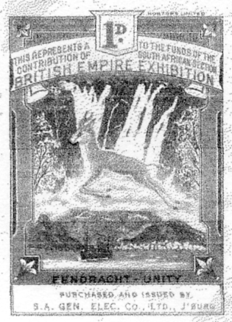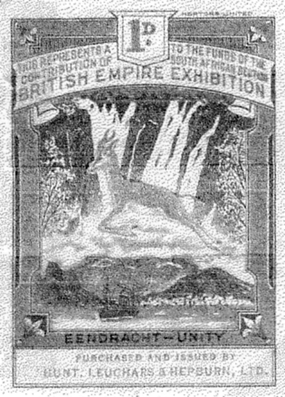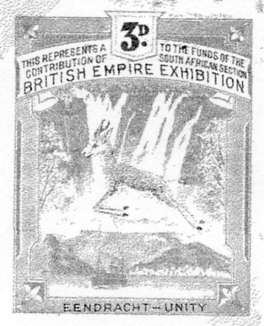
Purchased and issued by Purchased and issued by Endracht-Unity
S. A. Gen Elec Co. Ltd Hunt, Leuchars & Hepburn Ltd Blue and orange
Supplied by Ramon Goodey Supplied by Ramon Goodey Supplied by Ramon Goodey

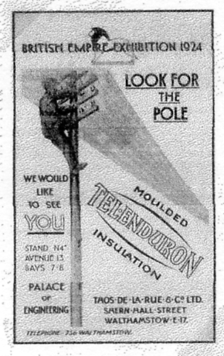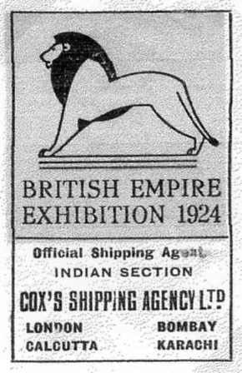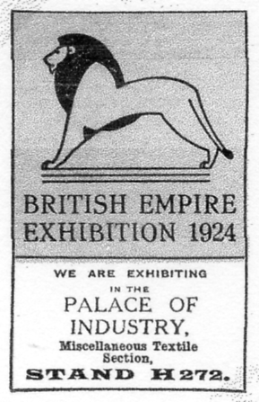
Thos De La Rue & Co., Ltd. Cox’s Shipping Agency Ltd. H. & B. Hoffman & Sons Ltd.
Black on grey Supplied by Ramon Goodey Supplied by Ramon Goodey
Supplied by Ramon Goodey

In 1987 George E. R. Ithell sent to a limited number of people a supplement to his book ‘Posted at Ballymaclinton’. I know some of our members have an interest in Ballymaclinton so I am publishing his notes, and a letter to me.
Supplement to
Posted at Ballymaclinton 1995
by
George E. R. Ithell

Since the publication of this work in 1982, interest and further research has been maintained. Consequently, postcards relevant to the theme have been recovered. Though mainly with new details of their printing, they cover more interestingly a picture hitherto not seen. These latest finds are listed with acknowledgements to Arthur Smith of Hammersmith and G. S. Baillie from Bungay, Suffolk, who both reported examples which differed from the original index. With these new discoveries and adding my own from the renewed searches, gives one the impression that there could be many more yet to be unearthed.
Much excitement was caused when a letter arrived from the Isle of Wight, which opened up great possibilities for a complete new chapter, but alas, circumstances prevented this. The letter was from Norah Gallaher! A copy of this book was obtained by a Mrs. Isobel Scott of Belfast who, on reflection recalled that her teacher had mentioned an exhibition in London and her association with it as a child. After a great deal of effort and perseverance Mrs. Scott contacted her old mentor and to the delight of both ladies, discovered that this exhibition was the subject of those recollections many years before.

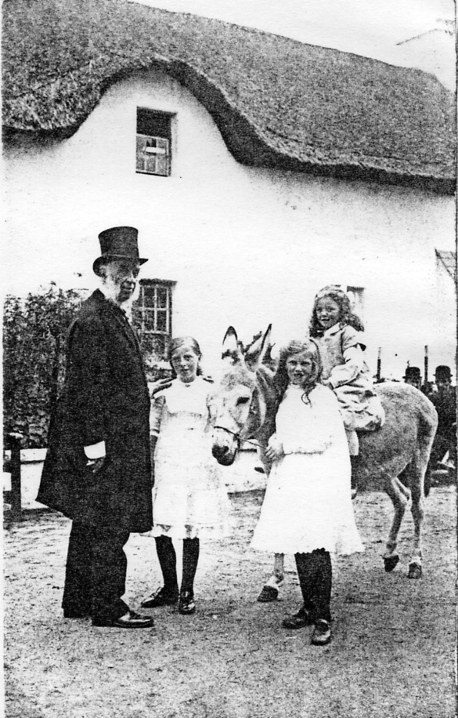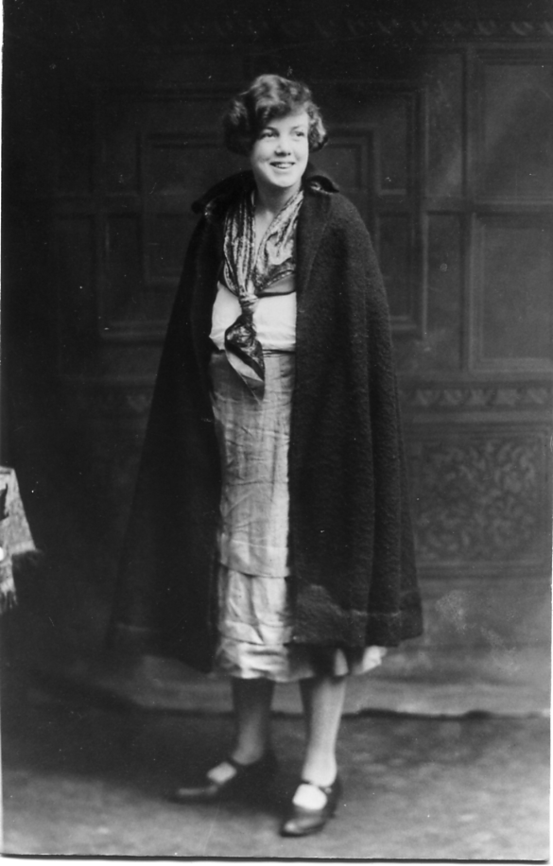
A famous photographer, Sir Benjamin Stone Nora Gallaher at the British Empire
with Kathleen Hicks, Marie Routledge and Exhibition in 1924 in her Colleens
Nora Gallaher mounted on ‘Wee-Wee’ later dress and cloak.
renamed ‘Napper Tandy’ Ballymaclinton 1910

Norah Gallaher’s Father was a salesman and traveller for the firm of David Brown & Son, Ltd, and McClinton’s Ltd., eventually to be a director and during the period of the Village at the White City’s Japan British Exhibition in 1910 he was the Manager. Samuel Gallaher and his wife Anne were residents in the Village and took along their baby daughter, Norah, then aged five years. Sadly, a month before a proposed second meeting with her, Norah died in June 1993, she was 89 years old. She was a remarkable lady with a memory to match. It was obvious that her time in the Village left many cherished memories. At our meeting in 1987, amongst a case full of mementoes and photographs, were letters and billheads, relics from her Father’s old desk. This desk had once been the property of Imre Kiralfy, who from the outset was Director General of the White City Exhibitions.
Most of the photographs Norah had to show were taken at the Japan-British Exhibition of 1910 and included a group photograph of all the staff. Again remarkably, she was able to identify some of the staff without any hesitation. Amongst these were of course, her Mother and Father, a Mr. Amos, Mr. Hicks, ‘Old Dan, Girala Murphy and her two young friends, Kathleen Hicks and Marie Routledge. Norah is seen, as on many occasions, mounted on the donkey ‘Napper Tandy. The two younger girls, Kathleen and Marie were experts in their field of spinning and weaving, the former being the Junior Spinning Champion of Ireland. Most of the time these girls were at a collecting post for donations, along with other celebrities who gave their services for the Health Organisation.

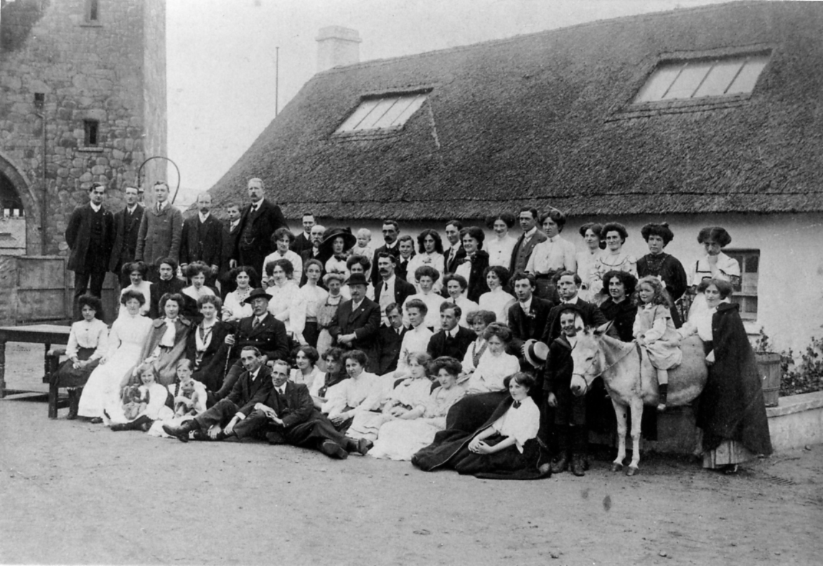
Staff at Ballymaclinton at the Japan-British Exhibition in 1910

Amongst the many bits of ephemera, Norah gave me a couple of items which I found very Interesting. One whole plate print, possibly the original photograph of my index card number 77 which is seen obviously untouched and shows Norah with other members of staff on the area of the Crystal Palace exhibit which was on show from May 12 to October 27 1911. The other item given to me was a card written to her from her Father at Crystal Palace with the knowledge that he misses his family. It is dated on May 25 1911, so it is known that Norah and her Mother joined the staff later. The card addressed to Ivy Cottage, Donaghmore says. “I was in the old village today and felt sorry to see it in such a dilapidated state and inhabited by natives of Indagoes, etc, etc. The Exhibition in White City is not such at all and you would get thoroughly tired of it in a week. Mr. McClean was over here yesterday and asking for you and Mother. The weather is just lovely and I wish you were both here. We will be in shape at about next Tuesday. There are good crowds in today”. (signed) D.
The card received the special event postmark (Whitney 405) code 3. The card is also showing a rubber stamped address, Ballymaclinton/ Irish Village/ Crystal Palace/ London. One other postcard is extant addressed to Norwood Central Dairy, 3 & 5, Central Hill, Upper Norwood, with a request to cancel some milk!. This card was dated August 21 1911, receiving the special event postmark, but with the code 1, codes 1-8 of these postmarks are known. The Ballymaclinton handstamp, again in purple ink and the address of Crystal Palace, but signed this time by S. Gallaher, Norah’s Father, The obverse shows Norah in one of the four postcard pictures in which she is featured.
Another interesting card recovered is indexed as No. 78, similar to the previously mentioned card re the milk. This cord however, was used as an introductory card by a representative of David Brown & Sons Ltd., intimating that a Mr. Ferris is to call in a few days and receive the favour of an Order. The George V ½d definitive is cancelled at Donaghmore, Co. Tyrone on April 15 1912 and sent to an address in Lisburn. The stamp is punctured with the perfin D.B/&S, only one of three known to date. The other two addressed to firms In Manchester and Birmingham, are both on Card Index 78. A Mr. Milton and Mr. Crawshaw were the representatives respectively in these instances. These items were reported to me by the Perfin Society Editor, Mrs. Rosemary Smith, J.P.
No postcards of the 1908-1910 Exhibitions feature the young girl, Norah, but on cards found from the Festival of Empire, Imperial Exhibition in 1911 at Crystal Palace, she appears in four scenes. Although the exhibit of the Brown brothers at this exhibition was titled Ballymaclinton, it was not on the scale as were the projects at the White City in the previous years.
Norah was able to identify many of the colleens whose photographs I was able to show to her, which were those that had been reproduced from originals loaned to me by Mr. Wilson’s daughters, Mrs. Mollie Whiteside and Mrs. Isobel Irwin, both of Dungannon, Co. Tyrone. She immediately recognised Anna McErval, the sisters Cecilia and Eileen Barnard, Miss Simpson and a Daisy Beattie, of whom she was especially fond and was delighted to be able to recollect them so vividly. All these girls are also to be seen featured on postcards and Norah admits that she was terribly spoilt by all the staff.
In 1986 I was able to visit Robert Brown’s daughter, Miss Alice Brown who still lives in Donaghmore where she actively pursues her charitable work. For nearly sixty years her chief interest has been in the Ulster S.P.C.A. In July 1993 she had a very exciting trip to Buckingham Palace where she received the M.B.E from the Queen for ‘Services to the Welfare of Animals’. Memories of the days of the exhibitions are not vivid, but she remembers being taken for a few days to London when only a very small child. Which venue was visited was obscure, but amongst her souvenirs were trade cards, a collection of the indexed postcards and a number of teaspoons engraved ‘Ballymaclinton’. These have been donated by her to the newly formed Donaghmore Historical Society, instituted in March 1983, which has premises on the very spot of the original soap works in Main Street. Immediately opposite is the new Post Office, the area having been very much rebuilt.
The soap firm had a site during the British Empire Exhibition at Wembley in 1924, but its participation in 1925 is not catalogued. Norah Gallaher and her family were there with a few others of the staff, but it is presumed that this exhibit was only on the scale of the first venture at Dublin in 1907. An Irish tower was however added. This part of the exhibit was a replica of the Tower in Devenish, Fermanagh, said to be the most perfectly preserved of these Irish landmarks. It commanded a magnificent view for visitors to the Exhibition who paid to climb the steps to the look-out.
Probably unique is an envelope addressed to Capt. The Hon. E. Cochrane at Red Castle, Co. Donegal, Ireland. Bearing the two requisite ½d Edward VII stamps, it is cancelled with the Post Office handstamp of Ballymaclinton on both definitives dated October 26 1908. Richard Francis Ernest Cochrane (1877-1952), was the second grandson of the Earl of Dundonald and son of the famous Admiral Sir Ernest Cochrane. Captain Cochrane served in the Inniskilling Fusiliers and succeeded to the Baronetcy on the death of his father in 1911. In 1908-1909 he was appointed a Gentleman-at-Arms to the Lord Lieutenant of Ireland the Earl of Aberdeen and this connection makes it possible that he was very familiar with and often a visitor to, the Irish Village.
Abbreviations
Col. Coloured Blk Black
H Horizontal format Brn Brown
Sep. Sepia Grn Green
V Vertical format Gry Grey

1908 7j 175 H Col. Colleen’s Dancing vii Blk
1908 7k 175 H Col. Colleen’s Dancing iv Gry-Grn
1908 71 175 H Col. Colleen’s Dancing vii Grn
1908 7m 175 H Col. Colleen’s Dancing iv Gry
1908 8n 176 H Col. Ballymaclinton Colleen with Donkey vii Gry
1908 8o 176 H Col. Ballymaclinton Colleen with Donkey iii Brn
1908 8p 176 H Col. Ballymaclinton Colleen with Donkey iii Blk
1908 8q 176 H Col. Ballymaclinton Colleen with Donkey. vii Grn
8r 176 H Col. Ballymaclinton Colleen with Donkey. Palette iib Gry
1908 9j 177 H Col. Main Street & Ancient Church iv Gry
1908 9k 177 H Col. Main Street & Ancient Church ii Gry
1908 10q 178 H Blk. Irish Village Entrance Ballymaclinton iii Blk
1908 10r 178 H Sep. Irish Village Entrance Ballymaclinton xxviii Brn
1908 10s 178 H Col. Irish Village Entrance Ballymaclinton i Gry
1908 12d V Sep. Cead Mile Failte on Portcullis xxii Gry
1908 13o 179 V Col. Ballymaclinton Cross v Gry
1908 13p 179 V Col. Ballymaclinton Cross iv Gry
1908 14j 211 H Sep. McKinley’s Cottage xxv Blk
1908 14k 5205-3 H Sep. McKinley’s Cottage xxv Gry
1908 14l 211 H Col. McKinley’s Cottage v Gry
14m 5205-3 H Sep. McKinley’s Cottage. xxv Blk
15d 510 H Col. McKinley’s Cottage. (palette) iib Gry
1908 16g H Sep. Fisherman’s and Model Cottages
1908 16h H Blk. Fisherman’s and Model Cottages vii Blk
1908 17c H Sep. The Irish Village xxiii Blk
17d H Col. The Irish Village (small frame) xxx
1908 20i V Col. The Round Tower (palette) ii Gry
1908 21e V Blk. Village Colleens Spinning vii Blk
1908 21f V Col. Village Colleens Spinning
24g H Col. (Art Gallery added) viii Grn
1908 30d 408 H Col. Colleens Dancing (palette) ii Gry
1908 34b H Irish Village xxvii Lt-brn
1908 35b H Sep. Pride of the Village iii Blk
1908 37c H Sep. Irish Village Entrance (framed) xxvii Brn
1908 37d as 37c in smaller frame. xix Brn
1908 40e 394 V Col. Kissing the Blarney Stone viii Lt brn
1908 42a* H Sep. Entrance (McKinley’s Home) xxviii Brn
45e V Sep. A Ballymaclinton Colleen iii Blk
1908 46b 405 V Blk. Ballymaclinton Colleen viii Gry
55e 578 H Col. The Square Ballymaclinton (palette) ii Gry
1909 56b 579 H Col. Post Office Ballymaclinton viii Brn
1909 56c 579 H Col. Post Office Ballymaclinton viii Plum
1909 56d 579 H Col. Post Office Ballymaclinton (palette) ii Gry
1908 61b H Sep. Napper Tandy Ireland’s smallest horse. xiii Blk
80 V Col. Humorous cartoon (By Jove etc.)
81 H Col. Jaunting Car.
82 H Col. Ballymaclinton. (scene of centre)
83 H Col. The Irish Village (variation of No. 54.)
84 H Col. Ballymaclinton (variation of No. 21) viii Gry-Grn
* Original Index No. 42 is now No. 42b.

Dear Mr. Tonkin,
Many thanks for your order and it is much appreciated that you thought it best to have one’s own copy rather than having to continually borrow. There have been many additions to the index since the publication as you may guess, and it is very probable that you may find cards on this theme which can also be added. I do hope that you will find a great deal of interest and I would like to hear from time to time, observations and finds which occur to you.
Sincerely, George E. R. Ithell March 1987
Page Card No.
10. 8. Left to right. Angel Atkinson, Mrs Gee and Myrtle Atkinson.
10. 13 & 21. Eileen Atkinson,
13. 9. L to R. Eileen Atkinson, Mrs Gee, Myrtle and Angel Atkinson,
32. 43. Miss Baxter.
37. 24. Marie Walker. (centre with donkey)
37. 44. Miss Simpson.
52. 23. Mr. K. P. Wilson, (extreme left, back to the wall)
57. 16. Miss Simens with donkey. Mrs Gee seated on the right.
72. 50. Girala Murphy drives the cart.
72. 53. Miss Kavanagh standing on the left, Cecilia Barnard seated first (from the left.)
73. 52. Eileen Atkinson.
The frontispiece of the book is from card No. 65 (rare)
Card no. 30. not shown, ‘Dancing on the green’ includes Monica Logan and Molly O’Brien.
More possibilities could be found, no doubt, but I am fairly confident about the above.
P.S. Early last year, a Miss Norah Gallaher contacted me on learning of the existence of the handbook. Undeniable proof of her involvement and that of her parents in the exhibitions of 1910. Norah herself, is featured on Index cards. 77, 78 and 79. Card 79 is reproduced inside back cover (n.b) and Norah is seen standing on a chair with the group in the foreground She is now 83 and is a very active lady and I have seen pictures of her as a colleen in the McClinton exhibit of Wembley 1924. Not on the scale of Ballymaclinton and only for the first year at Wembley, but probably the only surviving member of this great event in McClinton’s interest.

Shepherds Bush Post marks used at the
Franco-British Exhibition
by Bill Tonkin

Over the years I have spent hundreds if not thousands of hours studying White City post cards, and inevitably the bulk of this time has been spent on Valentine & Sons post cards. When I discovered the extent of their cut and pasting operation, and their painting out of unwanted features I thought there could not be a lot more to learn about Valentine’s cards, I was wrong, there was still more to discover.
Recently when Mike Perkins stayed with me for a couple of days we took the opportunity to list the dates of all my White City special exhibition post marks, and while we were at it, also list the Shepherds Bush post marks. Since this involved twenty two boxes of White City cards, this kept us busy for a couple of days.
Why the Shepherds Bush post marks? Well the Franco-British Exhibition opened on 14 May, but the two special Exhibition hand stamps did not go into use until 26 May, and all the mail posted up to that date received a Shepherds Bush post mark. So you could say that these pre-exhibition Shepherds Bush post marks are really the official cancellation in use for the twelve days until the two special exhibition hand stamps came into use.
In fact they were in use for longer than that, because there were posting facilities available for the staff employed in building or working on the pavilions, palaces and grounds in general, plus as the buildings neared completion, staff who would occupy the stands would arrive to prepare them for the opening day. So all in all there would have been a large volume of post to be dealt with for months before opening day.
Most of this post would have gone un-recognised, incoming mail would have been addressed to the lodgings or homes of the workers while outgoing mail would just be ordinary mail addressed to homes all over the country.
When I started examining the early Shepherds Bush post marks on Franco-British exhibition post cards, I realised these exhibition cards must have been on sale at the White City before the exhibition opened. I found I had three Valentine exhibition cards postally used with Shepherds Bush post marks for the 1, 4 and 12 May, and bearing in mind the exhibition did not open until the 14 May this meant the cards were available on Valentine’s stand for sale to the workmen.
When I examined the three cards I realised
In my book ‘Postcards of the Great White City Exhibitions 1908-1914’ I list a type of cards I have called pre-exhibition forerunners. These are cards Valentine & Sons produced before the exhibition opened. And here the word ‘produced’ is used in preference to ‘published’ as the views on these cards are actually produced in Valentine’s photographic dark room before the builders had finished work on the pavilions they depict.
On the opening day of the exhibition Valentine’s had to have kiosks full of post cards to sell, and the public would have wanted to buy post cards of the exhibition. So Valentine’s would have sent their photographers down to the White City taking pictures of the unfinished pavilions and palaces, weeks before the exhibition opened, and these were carefully doctored, one or two visitors drawn in, grass lawns and paths added and generally made to look as if they were natural photographs.
That is until Valentine’s staff arrived to decorate, hang advertising matter and stock their kiosks with post cards. These must have been offered for sale to other workmen on the site, and it is these Valentine’s exhibition post cards sold before the exhibition opened, and posted at the exhibition that I find interesting.
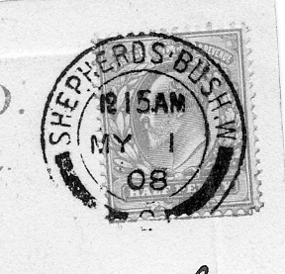
Bridge in Court of Honour posted on 1 May 1908

This is the earliest Franco-British exhibition card posted before the exhibition opened that I have found. It establishes that from at least 1 May Valentine’s were selling cards from their stand. The message is interesting ‘A part of the exhibition, hope you will have the pleasure of seeing it. We here will get fed up with it I suppose’.

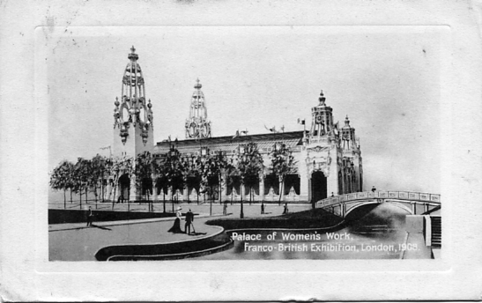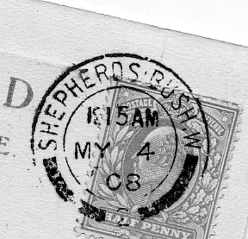
Palace of Women’s Work posted on 4 May 1908

Another pre-opening Valentine’s exhibition card this one posted on the 4 May, with a message reading ‘I thought you would like a post card of the new exhibition’. Both the hand stamps have ‘2’ at the bottom between the arcs.
A third Shepherds Bush post mark this time with ‘1’ at the bottom and dated 12 May two days before the exhibition opened has a message ‘more of exhibition for you, are they not lovely buildings’. Again sent by somebody inside the exhibition probably a workman. The ‘more’ suggests this is not the first exhibition card sent to Miss Hassall at Saxmundham.
It is interesting to note that the three cards are of the same type, litho printed plate sunk with large white borders. The interesting thing is the titles, these are all written in the same style by the same person in white imposed within the picture. Now this style of writing the title and the position it is in, was not used on any other of the other 16 copies of ‘Bridge in Court of Honour’ I have in my collection of this view ranging from R/Photo, litho and coloured and the same can be said for the 18 copies of ‘Palace of Woman’s Work’ both litho and coloured, and the 26 copies of ‘South Front British Applied Arts Palace’. I have so many copies of some cards in my collection because I collect different cloud patterns, settings of the titles and the various types of backs.

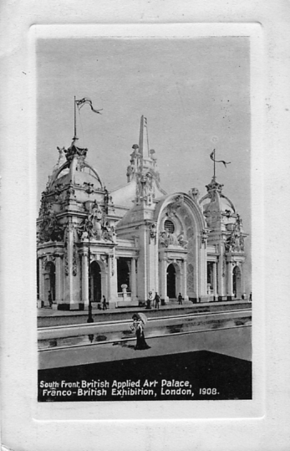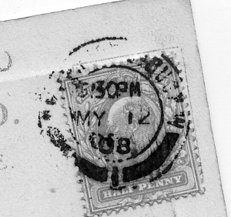
South Front, British Applied Art Palace posted on 12 May 1908

Another important difference is that none of these cards has ‘Valentine’s Copyright’ printed on them. On going through my collection again looking specifically for white titles within the picture and no ‘Valentine’s Copyright’ I found that all to-gether I had 10 of these cards, most of the others being unused. There are probably two more out there somewhere to make up two packets of six. Other dates are London 16 May, Folkestone 15 July and a very late usage Purfleet 16 September 1909.
This leads to the conclusion that these early cards sold before the exhibition opened were a special printing done for early sales, possibly before Valentine’s main stock arrived or was unpacked. The titles of the ten cards are,
Bridge in Court of Honour
French Applied Arts Palace
In Court of Arts (Vert left)
In Court of Honour
In the Court of Honour (Vert left)
Palace of Women’s Work (bridge on right)
Palace of Women’s Work (bridge on left)
South Front, British Applied Art Palace (Vert left)
Tower of French Applied Arts (Vert left)
View from Palace of Music

Getting back to Shepherds Bush post marks we are left with the twelve days that the exhibition was open and before the Franco-British Exhibition hand stamp was brought into use. These seem to be fairly thin on the ground and I only have two.

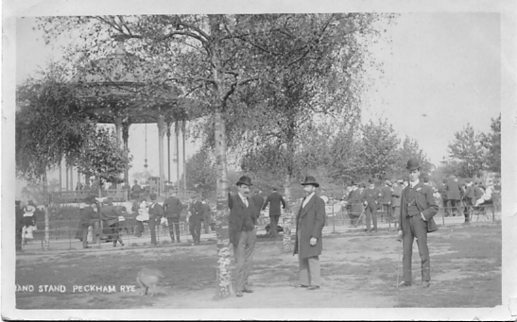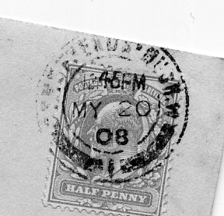
Band stand, Peckham Rye posted on 20 May 1908

Postmarked 20 May, but what’s a Peckham Rye card doing at the White City. The message on the card reveals all ‘I am going to Franco-British Exhibition to-day’.

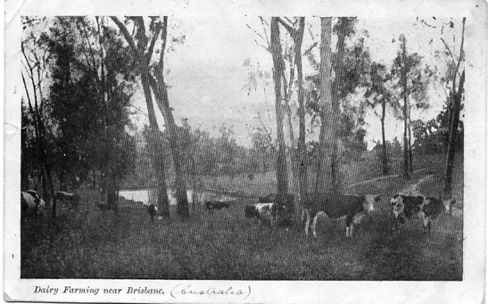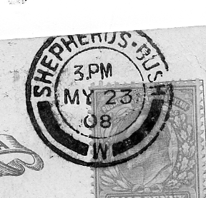
Dairy Farming near Brisbane posted on 23 May 1908

Posted 23 May, notice the ‘W’ after ‘Bush’ is now moved to the bottom in place of the ‘1’ or ‘2’ in the post mark.
1906 Royal Tournament
Part 2 by
Bill Tonkin

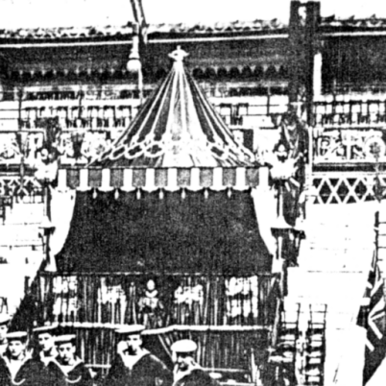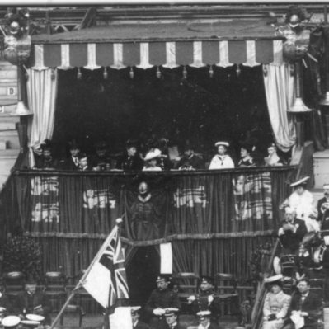
Box C. 1906-3 Box D. 1906-6

Gale & Polden Ltd.

Index to 1906 Gale & Polden post cards.

Black back type 1. with four lines of text.
No titles on Olympia pictures Type 1.
Black Camera back type 2, ‘POST CARD’ measuring 61 mm.
Printed title. Type 2.
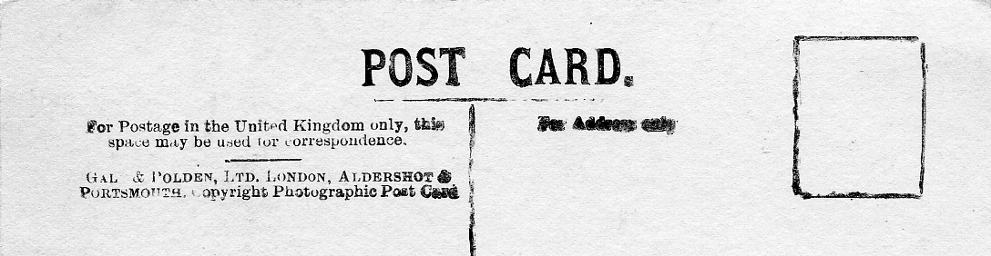
Gale & Polden. Back type 1 with four lines of text.

Type 1.
Gale & Polden. Real photograph, black back type 1. with four lines of text. Gale & Polden did not put titles on their views taken at Olympia. There are two post cards however, one taken at an unknown site and the other of an artists painting that do have titles. Dates after the entry are the postally used dates or where a date is written on the card in manuscript.
Ref. 1906-1 No title. 30-5-06
Ref. 1906-2 No title. (A Smith collection) 21-5-06
Ref. 1906-3 No title. (A Smith collection)
Ref. 1906-4 No title. 24-5-06
Ref. 1906-5 No title. 30-5-06
Ref. 1906-6 No title.
Ref. 1906-7 20th Hussars Long and Short of it 10,002 Vert right.
Ref. 1906-8 The Guns. (Artists impression) Vert left.
Ref. 1906-9 No title.
Ref. 1906-10 No title. 23-5-06.
Ref. 1906-11 No title.
Ref. 1906-12 No title.
Ref. 1906-13 No title.
Ref. 1906-14 No title.

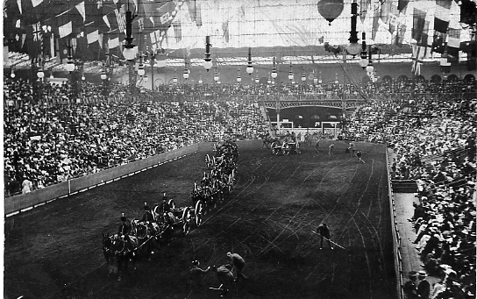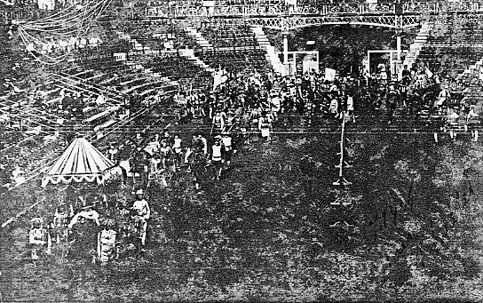
1906-1 1906-2

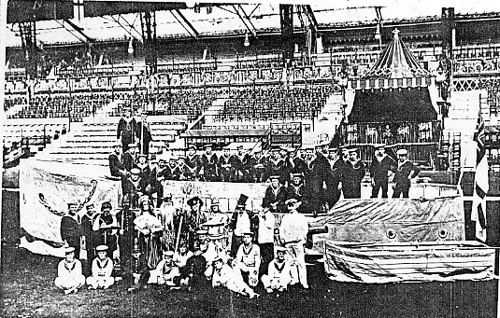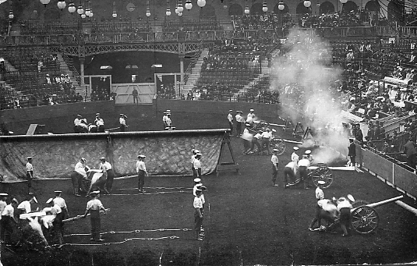
1906-3 1906-4

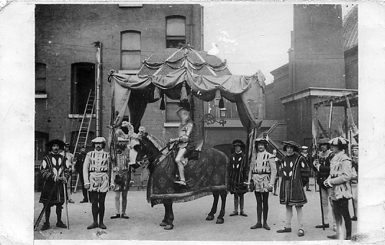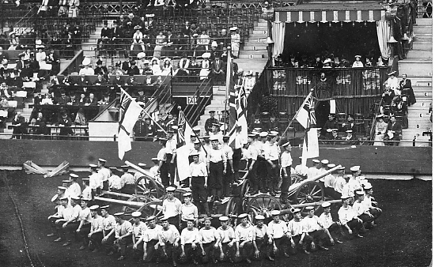
1906-5 1906-6

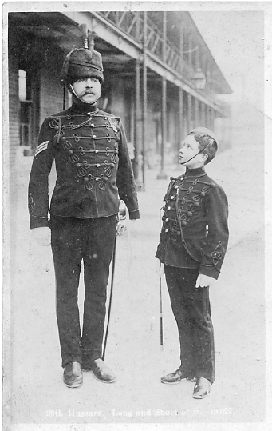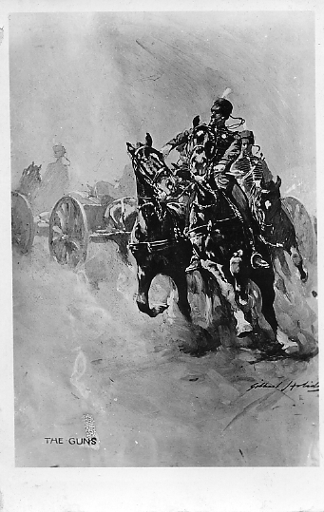
1906-7 1906-8

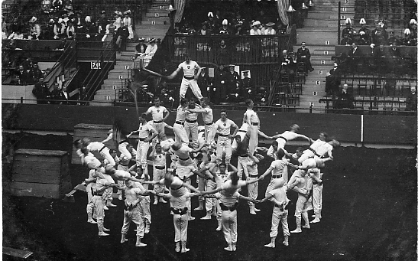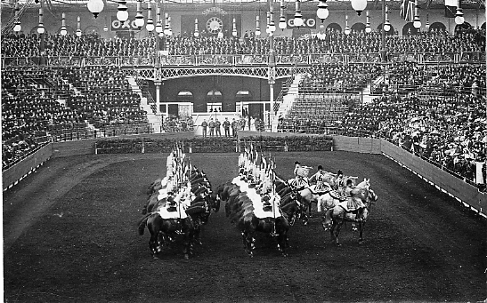
1906-9 1906-10

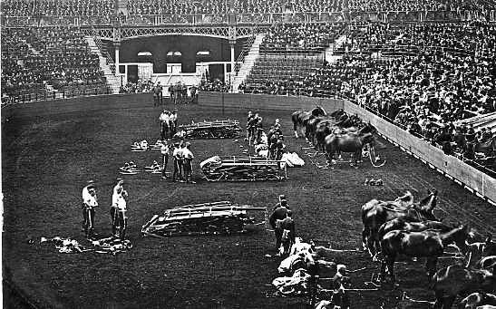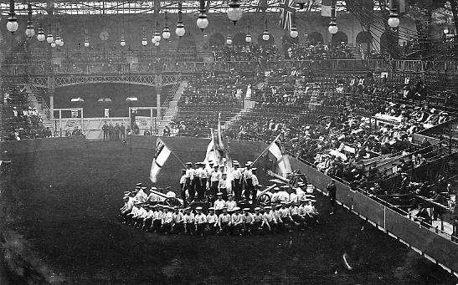
1906-11 1906-12

