EDITORIAL AUTUMN 2009

Summer’s come at last I fear
Why? because it means that winter’s near

In the June issue of Picture Postcard Monthly there was a letter from Jack Stasiac one of the stalwarts of postcard fairs, informing readers that he will no longer be taking topographical post cards to fairs. They will all be sold on E-bay in future. Jack is the first dealer to openly admitt that selling on E-bay produces better results than offering your cards for sale at fairs. He’s honest about it, and I cannot blame him for his decision. We have all known for several years that some of the prices paid on E-bay are beyond belief, and a dealer who has to earn his living selling post cards cannot afford to ignor this fact of life. We know there are dealers who wish to run with the fox and hunt with the hounds, and do not have the courage to be so open about their intentions as Jack, but as more and more dealers turn to selling their cards on E-bay, then collectors will find it will become less and less worth while going to fairs, which as I have always enjoyed going to fairs will be a great pity.
Having said that it is not all doom and gloom, I have done three large fairs this year, Shepton, York and Reading and I have done well, but the thought must be at the back of my mind that I might have done better.
I have recently become a subscriber to ‘PostScript’ a monthly list put out by a firm that sells remaindered books at greatly reduced prices. If you write to them they will put you on their mailing list. Their address is PostScript. 24, Langroyd Rd, London. SW17 7PL. I heard about them from one of our members Ken Harman who brought to my notice that they are selling a book titled ‘3D Expo 1862’ by Michael Tongue. This was selling at £20 but can now be bought for £7.99 plus £2.00 post & packing. It deals with a collection of sterioscopic cards published for the 1862 International Exhibition, and the book combines a built in viewer so all the illustrations can be viewed as they were meant to be, as through a sterioscopic viewer. You can also view any sterioscopic cards you have, using the book as a hand held viewer. I have had four of the books for various friends as they are a good buy. The reference number is 61646.
In this months list they are offering the English Heritage hard back book ‘Delamotte’s Crystal Palace’ based on a collection of 47 photographs taken of the Crystal Palace at Penge that were acquired by English Heritage in 2004. It was a £18.00 book with 122 pp now being offered at £6.99 plus £2.00 post & packing. The reference number is 61310.

Convention 2009
A reminder from our Secretary Don Knight
Dear members,
As you know for the past we have held a convention in September at a venue connected with an Exhibition. At our A.G.M. last year it was decided we meet again at Crystal Palace, it was felt that by changing the month it could help to get more members attending. So the date is now 17 and 18 October, a Saturday and Sunday.
This year is the 100th anniversary of the Imperial International Exhibition held at the White City. There will be many other displays by members on other themes, to help me make up a programme if you are bringing something please let me know. Please make a note of the dates and try to come along, we meet in a nice room, there is a hotel on site. This is not a 5 star hotel but is good at the price, please contact me or Bill for more information or you can make your own booking at The Lodge, Crystal Palace National Sports Centre, Ledrington Road, London SE19 2BB. phone 020 8778 0131. Please mention the Exhibition Study Group.
The cost is £33.50 per person, and the evening meal will be £10.00 wine extra. As usual the Study Group has made a block booking so when you phone mention you are a member. The lady to ask for is Joan Miles.

The Editors
Jeremiah James Colman ("the Mustard King")
and his exhibition memories
by Ken Harman

Some interesting pieces about exhibitions were written by Jeremiah James Colman and fortunately included in a book written and privately published in 1905 by one of his daughters, Helen Caroline Colman. The book (“Jeremiah James Colman: A Memoir by one of his Daughters”) was really a tribute to her father after his death in 1898. Obviously Helen had been to a lot of trouble to write this 464 page volume and have it printed on thick laid paper by the famous Chiswick Press. Jeremiah James Colman’s main memories were of the Manchester Exhibition of 1857.

The Manchester Art Treasures Exhibition of 1857

Colman had prepared an article as a supplement for the “Norfolk News” to show how much he appreciated the exhibition and in an unpublished supplement, he contrasted it with the Great Exhibition of 1851 at the Crystal Palace.
“Just as emphatically as 1851 saw the homage to Industry, so does 1857 witness the homage to Art. The Hyde Park collection was fine, but there is a marked difference in the fact that its contents were modern, and could easily have been replaced, perhaps improved. In the present instance we have what ‘Once destroyed, could never be supplied.’ “. Colman then went on to emphasise his love of pictures and how in his view a good painting told its own tale.
In the main article there is a more light-hearted account of the day the exhibition was opened by Prince Albert, on the 5th May 1857. “The Prince, with his suite, having marched through the building, the barriers were removed, and then followed a rush to the refreshment room, and a scene such as “Punch’s” pencil alone can describe. Imagine scores of little tables, with plates, and knives and forks, and people, hungry as hunters, keeping up a perpetual ringing of bells, and call of “waiter,” “bitter beer,” “fowl,” “beef,” etc., etc., the poor bewildered waiters rushing about in a frantic state, giving you a bottle, and forgetting to draw the cork, or two glasses for half a dozen people, champagne and sherry in hock glasses or tumblers, and ale and porter in champagne and sherry ditto, imagine first Pater Familias rushing away with a knife and fork in one hand, and carrying a chicken by its leg in the other, to his hungry spouse, second ditto, able to get a bottle of porter and one glass for his party, but no cork-screw, knocking off the neck, and receiving the contents of the bottle quicker than he wished or expected, third ditto bringing a tribe, and waiting round a table which a party was leaving, so as to seize the chairs almost before they were vacated, fourth ditto, of a meeker turn, going away unfed and in utter despair! Such and similar scenes give a notion of the refreshment room.”
It may be worth adding a few notes about this exhibition. Instead of highlighting the industry and technology of the great manufacturing city of Manchester, it brought together the many private art collections of Great Britain. When this was first suggested by leading citizens, the establishment was shocked. The organisers then suggested that a special exhibition hall should be built and furthermore, one that would be well away from the worst pollution by constructing it on the Old Trafford cricket ground to the Southwest.
Henry Mayhew who did so much to highlight the plight of the poor in London, wrote about the Manchester of those days in his light-hearted book “1851: or The Adventures of Mr. & Mrs. Sandboys and Family who came up to London to enjoy themselves and see the Great Exhibition” which was embellished with etchings by the famous George Cruikshank. “Manchester at any time is, perhaps, one of the peculiar sights that this country affords.
To see the city of factories in all its bustle and all its life, with its forests of tall chimneys, like huge masts of brick, with long black flags of smoke streaming from their tops, is to look upon one of those scenes of giant industry that England alone can show. As you pace its busy streets, you can hear the drone of a thousand steam-engines, humming in the ears like a hive. As you sit in your home, you feel the floor tremble with the motion of the vast machinery, whirling on every side.
Here the buildings are monstrous square masses of brick, pierced with a hundred windows, while white wreaths of steam puff fitfully through their walls. Many a narrow thoroughfare is dark and sunless with the tall warehouses that rise up like bricken cliffs on either side. The streets swarm with carts and railway-vans, with drivers perched high in the air.”
Nevertheless the organisers managed to persuade the great noble families of Britain to lend their art works mainly by setting out three main aims: to educate the masses, to promote British wealth, and to gain Royal patronage. The latter was sought by sending a deputation to Buckingham Palace and fortunately the Queen and Prince Albert supported the scheme. The building on over three acres of land was designed by a local architect, Edward Salomons, and was called the Art Treasures Palace. This was a metal and glass structure adopting not dissimilar methods to those used at the Crystal Palace.
The exhibition marked the summit in the history of private art collecting in Britain and is now regarded as the outstanding British artistic occasion of the nineteenth century. There were 2,000 paintings by old and modern masters, around 1,000 water-colours, together with many other drawings, plus 10,000 examples of the “ornamental” arts. The total ran to 16,000 exhibits and actually held one third of the country’s art treasures, a massive feat of organisation and local enterprise. Fortunately the show was a big success, it ran from May to October 1857 and was visited by over 1,300,000 people.
The absence of the Queen from the opening ceremony was because she was recovering from the birth of Princess Beatrix and thus Prince Albert attended - although I have the feeling he would have gone anyway with his interest and support for such things. However, the Queen did visit it later on.
Out of the exhibition came a lasting effect on British music - the Halle Orchestra. Charles Halle, who had come from Hagen, Westphalia, Germany but had by then altered his name from the original Carl Halle, had assembled a group of musicians to entertain exhibition guests and so successful was this that he formed his orchestra the next year. This is now Britain’s longest established symphony orchestra.
In 1957, the Manchester authorities held a centenary exhibition to commemorate the event.

The International Exhibition of 1862

Colman also wrote about his firm’s visit to the 1862 exhibition in London. Arrangements had been made for an excursion for the workmen so that they could see the International Exhibition at South Kensington. Five hundred people went from Norwich at the firm’s cost. Colman wrote to his sister:
“If you had happened to be in London last Monday you would have liked to see the men - they were out for a day’s frolic which they meant to enjoy, and enjoy it they did with no mistake about it. A good many, I understand, were up at two o’clock. Our time for starting was 4.30, and within five minutes we were off, reaching London most comfortably at 9, and in ¼ of an hour the twenty buses started, and in about an hour landed their passengers at the Exhibition ready for breakfast. As I had several things to do in the City I did not go with them, but I believe they did justice to the provision, and whatever the “Times” may say about the refreshments department, at all events we have no reason to complain. The men enjoyed it, having no doubt been appetited, and one of them told Gandy he had often tasted ham, but never such ham as that before, and did not suppose he should again as long as he lived.
I got up to the Exhibition soon after 1, and met with a good many wandering about, and was pleased to see their look of contentment and wonder, though towards the end they began to look as if they had had enough. After tea they got back to the omnibuses, and without much difficulty were got to the station, and we started at 10 minutes to 7. The day was unfortunately wet, but that did not matter much, and it did not make the men in love with London - most of them thought it a dirty place such as they should not like to live in. They did not either fancy the people they saw, and one said he ‘did not see a decently fat man the whole time he was there.’ I am very glad we took them, they seem so thoroughly to have enjoyed it. Several told me they never enjoyed a day so much in their lives. I am especially glad that I made up my mind to go with the men in the same train.”
Thus we can thank Helen Caroline Colman for providing us with an unusual resource: interesting and genuine records of two visits to nineteenth century British exhibitions. They may not be the ones we remember most these days but the writing gives a true flavour of the times and events.

Reminiscences of my Grandfather James Brown as dictated to his daughter
Nora Brown in the winter of 1904-5

Recorded by Alice G. G. Brown for George Ithell in 1982.
Part 2

Wages were very low prior to the 47 famine, 4 shillings a week was the usual wages for a labouring man, but my father always paid his men five shillings. Some farmers gave their men food instead of wages and I was told by a man in Omagh of a neighbour of his who hired his men on these terms, but would just not feed them on Sundays and gave them a penny instead. Servant girls were paid as low as five shillings a quarter, but by late November when food was dear, many were glad to work for their food with out any wages. After the famine emigration increased largely, and wages have never been so low since.
The Donaghmore Brewery was owned by Mr Alexander McKenzie who lived in Malligdown? and by my uncle Mr James King who lived in the cottage. He was one of my mother’s three brothers Alexander who married Miss Turnbull, and lived in Mahon, and Henry who became a Doctor in the navy being the others, James married Miss Trimble of Clocka? On retiring from the Navy Henry married Miss (somebody) and lived in Castlecaulfield in the house now occupied by Mr David Achison. My mother had two sisters, one married William Struthie and the other Hugh Weir.

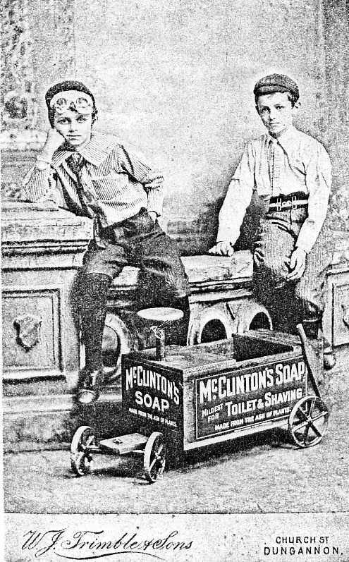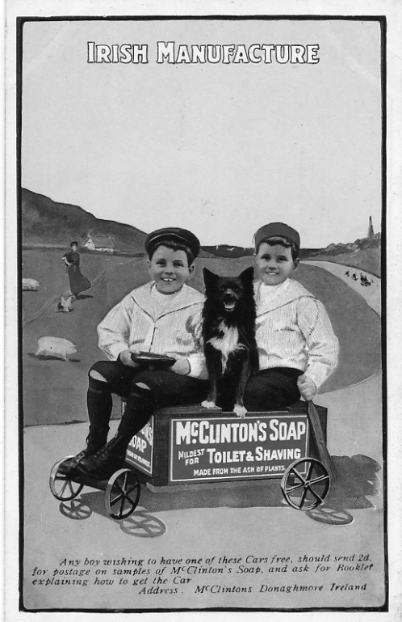

Robert Brown’s two sons, Lawrence killed in action in 1914-18 War, and Oliver who became a Missionary, from an original photograph which was later produced as an advertising post card

The brewery by then had became such a prosperous concern that I can remember 28 carts loaded with beer and whiskey leaving it in a single morning. Mr Corone who came as a book keeper afterwards became a partner in the business together with Mr George Slithen who was a nephew of Mr McKenzie and lived in Dungannon where they had another brewery on the site of the present railway station. In my recollection it was not used as a brewery but the buildings were turned into a corn store. Part of the premises now used by Messrs Dickson as a bacon factory and then a distillery owned by Mr John Falls. In 1841 Mr Falls opposed Lord Lochlan as parliamentary representative for Dungannon and the Labour latter gained his seat, a very bitter spirit was aroused. The woollen traders of Dungannon having sided with Falls the local gentry boycotted them and bought their goods from Silas Weir of Cookstown. This boycotting affected some so severely that they had to emigrate to America, amongst these being Henry Oliver and Richard Tenner and although this seemed a hardship at the time the families of both succeeded much better in America than they ever could have done in Ireland.
The Presbyterian Minister of Castlecaulfield was the Rev. John Bridge who read his services in the old Meeting House which had been one of the out buildings of the Castle. He became very unpopular owing to his having failed to attend the Omagh Assizes to give a character to a man called Ritchie who was tried and afterwards hanged for murder. It was a party quarrel and he was said to have struck with his spade shaft the man who was killed In consequence of this Mr Bridge left Castlecaulfield and was succeeded by the Rev. Joseph Acheson who married my sister Amelia. He preached at the Old Castle until he built the present Meeting House in 1841.
The character present preaching at this time was the Rev. Robert Hollafield, an excellent man who worked very devotedly for the spiritual and temporal well being of his people.
John Wesley visited Castlecaulfield on one of his tours of Ireland and my grandmother who was a Godly woman took my father though a little boy to hear him preach there. He said the circumstances impressed him very much and the seed then sown did not fall on stony ground. There were two doctors in Donaghmore, Doctor Neill and Doctor Corr, the following had retired from the Navy and did not practice much. He lived in a cottage on the site of which side a bank was after built. Doctor Corr was the general practishioner and a Roman Catholic he was followed by Doctor McMullan and Doctor McClean. Mrs McClean and Mrs Corr assisted their husbands in their practice and continued it after they became widows. Both were celebrated for pulling teeth, Mrs Corr was said to have removed an inch and a quarter of Thomas Hoggets jaw bone along with the tooth one day. In later years Doctor Henry A’Way? had a considerable practice in this neighbourhood, Doctor Nevill of Dungannon being dispensery Doctor.
When anyone in my young day required a suit he took the tailor with him to a cloth shop together they choose the stuff which was taken home by the tailor to make up, in the same way the shoemaker went with the customer who required boots or shoes and helped to choose a piece of leather of which to make them. In the country there were no shops where ready made goods could be had. The shoemaker in Donaghmore used to make cheap shoes and take them to Dungannon to the market where they were sold on the streets. It was a common sight to see the women on the market day, sitting down at the foot of Gallows Hill to wash their feet in the little stream before putting on their shoes and stockings they had carried so far, and which they only intended to wear in the town.
There was then a court for the recovery of small debts called the Seneshals Court which was held monthly in Dunleys public house. Donald McKenzie was the seneshal and he called a jury of twelve men to help him to ajucicate and it was said he looked under the table to see which men had boots on before deciding who should be foreman
Fees or costs were largely spent on drink for the good of the public house of which there were five in Donaghmore and two on the back road. These courts ceased when the County Court were established.
People here often date from the time of the big wind, that was the 5th of January 1839. It unroofed the brewery coolers and did much damage elsewhere. When George Mahood came to his work next morning, someone asked him how he got on during the night, knowing he had a thatched cottage, ‘Oh all right’ said he ‘I just slept on the roof to keep it on’.
About 1845 Daniel O’Connell was at the height of his popularity a comical illustration of this I had, when talking with a man in Beira, a small grocer who was a great admirer of his. He told me O’Connell had attended Omagh assizes as a barister on one occasion, and that he had ridden into Omagh six miles off that he might see Daniel. He stood about the Courthouse steps until he had the opportunity to shake him by the hand, when telling the story to me afterwards he held his right hand aloft and said emphatically, “and I never put that hand into a herring barrel since”.
Illicit distillation was very prevalent then, so much so that my mother told me on one occasion the military came to Middletown and seized twenty two stills, it is easy to understand what a demoralising effect such a state of things must have entailed.

The end.

Footnotes by the Editor
Alice G. G. Brown was the daughter of Robert Brown who with twin brother David organised Ballymaclinton from 1908 to 1910 at Shepherds Bush, London. In 1993 Alice was awarded the M.B.E. for ‘services to the welfare of animals’ being actively engaged for 57 years with the Ulster S.P.C.A..

Barilla was a Mediterranean plant which when burnt produced Alkali. This was used to produce a plain unscented soap and was one of the firms main products with large sales in the colonies, mainly Australia, Canada, New Zealand and South Africa. This came about as the result of a book ‘Papers on Health’ published by Professor Kirk, a man with a considerable reputation as a nature cure practitioner of Edinburgh, in which he recommended the use of McClinton’s Barilla Soap for its purity.

About 1820 David Brown started making houshold soap in a room at the back of his grocers and bakery shop for sale to his customers. From this small beginning, he built up a family business. He was succeeded by his son James, who considerably expanded the business until, he was employing upwards of a 100 people in the soap works and a farm. About 1895 he purchased a toilet soap business Messrs McClinton of Belfast and moved the production to Donaghmore.

A long car was an Irish cart where the passengers sat sideways, back to back, also known as a Jaunting car.

After David’s death Robert carried on until he became too old to run the business. There being no-one in the immediate family to succeed him the soap works was sold to a relative Mr David Acheson of Castlecaulfield. Unfortunately he contracted a serious illness and in 1953 it was decided the works must be closed down. The goodwill was purchased by one of the firm’s travellers Mr Smyton, who carried on the business from Dublin. On his death the manufacture of Colleen Soap was taken over by Messrs McCormack of Dun Laoghaire Co. Dublin. Miss Alice G. G. Brown’s notes written in 1977 tells us, as far as she was aware it was still being manufactured at that date.

MECCANO and the Exhibitions. (Part 1, 1901 to 1914).
by
Fred Peskett

When Frank Hornby first patented his construction toy in 1901 and called it “Mechanics Made Easy” he advertised it as Engineering in Miniature. It was fairly slow to take off, but sales were sufficient to keep his new company running with a small profit. A change of name to “Simplified Mechanics” in 1906 made little difference to an increase in sales, but when he changed the name in

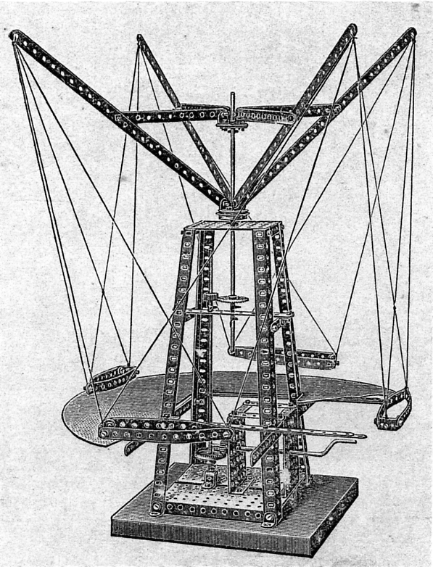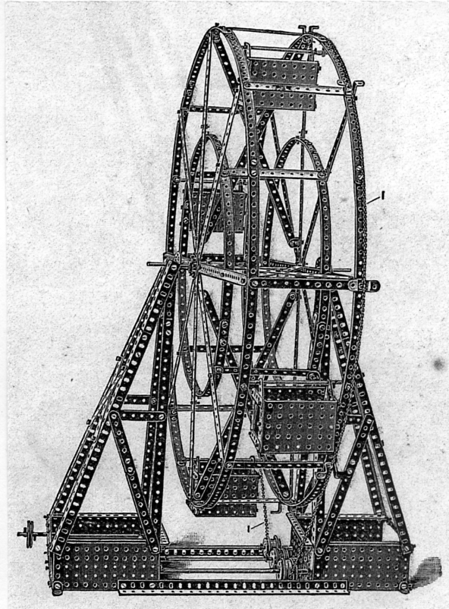

Model No. 70. Flying Machine Model No. 105. Big Wheel
Made with Meccano Outfit No. 4 or No. 3 & 3a Made with Meccano Outfit No. 6 or No. 5 & 5a

1907 to MECCANO, sales and profits rocketed. The name MECCANO is thought to be derived from one of Hornby’s favourite sayings “Make and Know” little did he know that the word would become a household name and even be included in the Oxford English Dictionary.
By 1909 the MECCANO system had expanded to have six numbered outfits, each being larger with an accessory to convert to the next larger set. Frank Hornby was keen to put in as much engineering knowledge into his instruction books as possible and included in the 1909 manual for outfits 4 to 6 were several models of engineering constructions to be seen at the Great Exhibitions.
Hornby wanted movement in his models and right from the start a clockwork motor and a steam engine were available as an extra, so it comes as no suprise to see models included such as The Big Wheel from Earl’s Court, The Hiram Maxim Flying Machine from the Crystal Palace and the Flip Flap from the White City exhibitions. All of these models do bear some resemblance to their original counterparts, however, his early model of the Eiffel Tower is somewhat poor and could have been made a lot nearer to the actual shape with the number of strips and girders that were included in the number 6 outfit.
The illustrations are from the 1909 instruction book. The Flip Flap continued to be included until the 1916 manual when it was replaced by a similar device called the Aeroscope used to elevate an observer above the battlefields during the First World War. The Maxim Flying Machine was not included after 1911. The Eiffel Tower was replaced with a Helter Skelter in 1912, but a better looking model was featured in 1926. The Big Wheel was improved and was featured in most of the larger set manuals until the MECCANO Company ceased in the U.K. in 1980.
In Part 2, MECCANO from 1915 to 1933, it will be shown how the system expanded with many new parts, new sets and electric motors to produce models of a far more realistic appearance. It was also during this period that Frank Hornby started to introduce new products, such as Hornby Trains, and to exhibit his range at the major exhibitions such as The British Empire Exhibitions 1924-5 and the British Industries Fairs.

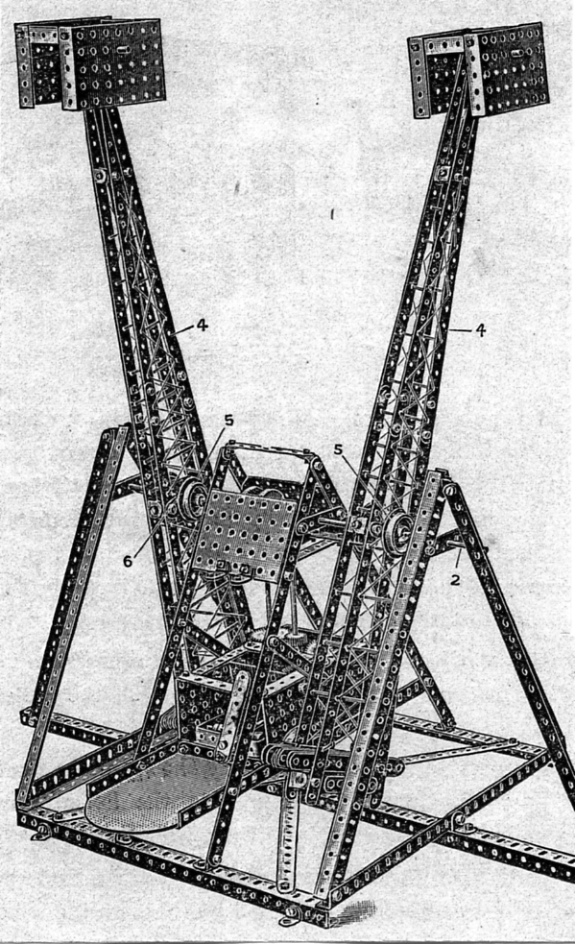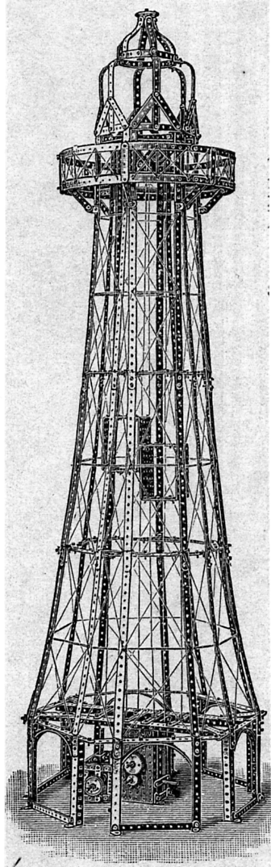

Model No. 102. Flip Flap Model No. 108. Eiffel Tower
Made with Meccano Outfit No. 6 or No. 5 & 5a Made with Meccano Outfit
No. 6 or No. 5 & 5a

Another new Franco-British Advertising label on an original 1908 Pilchers invoice for a 41 gallon barrel of Genuine American Turps @ 2/3¾ per gallon, total £ 4-16-0. For those of you too young to remember the good old days of real money, two shillings and three pence three farthings was about 12 p in todays money. In case you have forgotten there were 960 farthings in a pound and they were still used up into the 1950’s but gradually went out of use when inflation was invented.

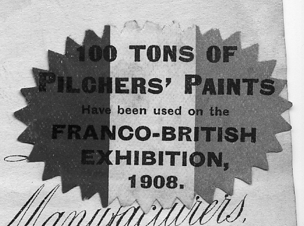

100 Tons of Pilchers Paints have been used on the Franco-British Exhibition 1908.
Brent Museum & Brent Archives
London Borough of Brent
Willesden Green Library Centre. High Road, London. NW10 2SF
TEL 020 8937 3603 FAX 02089373601 EMAIL gillian.spry@brent.gov.uk
WEB www.brent.gov.uk

Environment & Culture Head of Libraries,
Arts & Heritage: Sue McKenzie

Dear Mr Knight,

Invitation - Brent Archives Official Launch

I would like to cordially invite you and all the members of the Exhibition Study Group to the official opening of Brent Archives by the former Mayor of Brent, Cllr Ralph Fox, at 6:30pm on Thursday 17th September 2009.
Brent Archives are grateful for the continued support from local history societies and study groups towards our service and we are very keen to celebrate the opening of our new home with you all.
As you know, we are currently moving to Willesden Green Library Centre and it is envisaged that the archives will be open to the public and start dealing with enquiries from mid/late August.
I would be grateful if you could extend this invitation to all your members. Please RSVP from the 1st September 2009 to, hannah.phung@brent.gov.uk or phone 0208 937 3600.
I look forward to welcoming you on the 17th September.
Yours sincerely,
Gillian Spry
Museum & Archive Manager

Another Gem found in a Charity Shop.
by
Fred Peskett

Since I retired I have worked most weeks for various Charities by pricing collectables, books and any old furniture that comes their way. When looking at old books I always go through the pages to make sure that there are no goodies tucked away for safe keeping. This does pay dividends, since I have found bank notes from the 1930’s, British Armed Service Vouchers (BASVs) from the 1940’s and 50’s, these were used by British Servicemen for spending in the NAAFI shops mainly in Germany, postage stamps, but never an unused sheet of 1d blacks I and the rare Crystal Palace Christmas card from 1854. So it was no surprise when turning the pages of a very tatty “Great Expectations” (the title could not have been more appropriate) that a slip of paper fell out marked,

The Ballad on the 1851 Exhibition, by W. M Thackeray.

This Palace tall,
This Christial Hall,
Which Imperors might covet,
Stands in High Park,
Like Noah’s Ark,
A rainbow bint above it.

With conscious proide,
I stud inside,
And look’d the World’s Great Fair in,
Until me sight,
Was dazzled quite,
And couldn’t see for staring.

There’s statues bright,
Of marble white,
Of silver and of copper,
And some in zinc,
And some I think,
That isn’t over proper.

Amazed I pass,
From glass to glass,
Delighted I survey ‘em,
Fresh wondthers grows,
Before me nose,
In this sublime Musayum.

There’s lashins more,
Of things in store,
But thim I don’t remimber,
Nor could disclose,
Did I compose,
From May time to Novimber.

The spelling is as written.

William Makepeace Thackeray, the well known author was also a member of the Central Working Classes Committee for the Great Exhibition of 1851 along with fellow author Charles Dickens. This committee was set up to ensure that the forthcoming exhibition looked after the needs of the working exhibitor and visitor, it was probably responsible for the introduction of the “one shilling” day to give the workers a chance to see the exhibition.
Thackeray put much of his thoughts and feelings about the Great Exhibition into verse, here is another poem from his pen, this time describing the machinery section of the Great Exhibition and in praise of the host country’s contribution to the mechanised age in shipbuilding, the clothing industry, agriculture and mining.

A May Day Ode

A peaceful place it was but now,
And lo! within its shining streets,
A multitude of nations meets,
A countless throng!

I see beneath the crystal bow,
And Gaul and German, Russ and Turk,
Each with his native handiwork,
And busy tongue.

Look yonder where the engines toil,
These England’s arms of conquest are,
The trophies of her bloodless war;
Brave weapons these.

Victorious over wave and soil,
With these she sails, she weaves, she tills,
Pierces the everlasting hills,
And spans the seas.

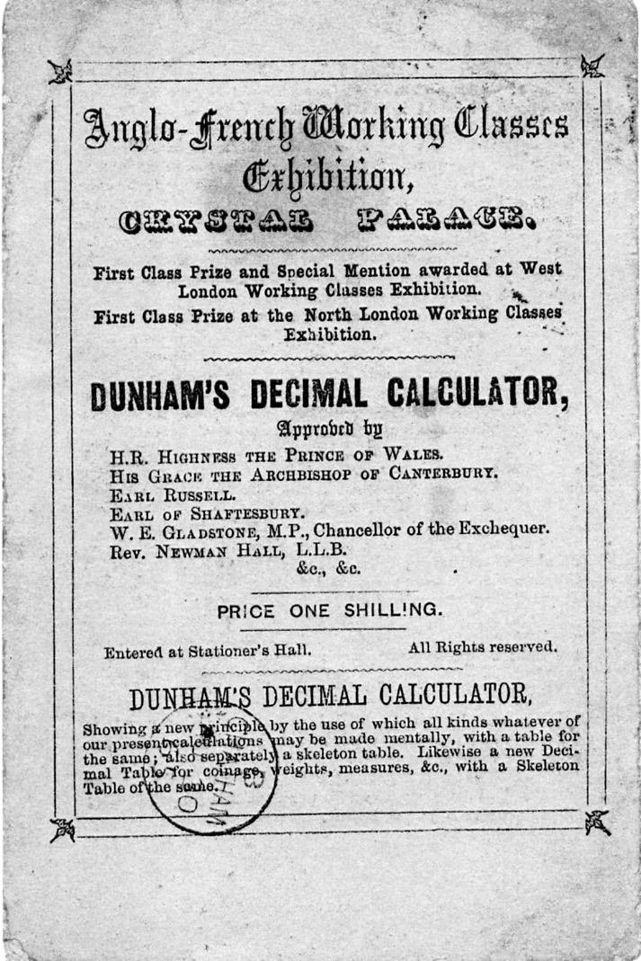
Going back to the original theme of catering for the Working Classes, there was during the Victorian era a demand for “Working Class Exhibitions”, these exhibitions generally were devoted to the arts and crafts of the working man and to the products of cottage industries. One such exhibition was at the Crystal Palace during 1865 “The Anglo-French Working Classes Exhibition”.
An exhibitor at this exhibition was a certain mathematician, come philosopher. Professor George Dunham, who had on sale a very interesting souvenir called “Dunham’s Decimal Calculator” priced at 1/-. Professor Dunham advocated in his little booklet that all Imperial Systems of linear measurement, weights and coinage should be replaced by the decimal system. His proposed coinage system was that the lowest coin value be termed one unit, with ten units making one common, ten commons would make one peer and ten peers equal one sovereign. Prof Dunham was over a hundred years ahead of his time, but it is doubtful if he made his fortune with the booklet selling at a shilling?
The illustration shown is the cover of the booklet (actual size) which had been addressed on the back and postally used with a Duplex cancel of London S.E.17. (Dulwich) on 30th August 1865 to Chatham, on the front is a Chatham Single Circle coded “B” for the same date.

Introduction to Royal Tournament Postcards.
by Bill Tonkin.

My interest in the Royal Tournaments was boosted at our 1992 Convention held at the Crystal Palace, when one of our members Arthur Smith gave a display of the post cards and guide books of the event, and I found it fascinating to say the least. So much so that that in the 1994 Autumn Journal we printed a five page article by Arthur.
Until then I had not concentrated on Tournament cards, but that all changed, and about a year later I had the opportunity to buy a collection of about 200 early tournament cards. I remember at the time how pleased I was that there was virtually no duplication with my own collection which by then was also around the 200 mark. Over the last fifteen years I have probably trebled my collection.
The early 1906 to 1909 cards present many problems, and I have spent years studying them. I soon realised that Gale & Polden the publisher of the early tournament cards had the same problem that Valentine had, and resorted to ‘cut and paste’ to help fill their kiosks with cards for sale on opening day.
The early visual history of the Royal Naval and Military Tournament was adequately covered by Gale & Polden who published all the post cards up until the mid 20’s when they lost the sole franchise, first to Fleetway Press Ltd., and then to Betts Son & Malyon Ltd., not getting it back again until the mid 1940’s.
I suppose it would not be correct to say sole franchise, because throughout the Gale & Polden period there were a handful of other publishers like Cribb and the various Poster cards published from time to time. Cribb certainly published Tournament cards but they were not photographed inside Olympia but at an unknown barracks, and were probably not on sale at Olympia.
When Gale & Polden secured the rights to publish and sell post cards at an event running for a short period one of their problems was how to have a large range of cards for sale on the first day. For the Royal Tournament they could send their photographers in on the non public days when rehearsals and preliminary events were taking place (Which explains the many post cards with rows of empty seats) or they could prepare and print artist drawn views well before the opening. The third option, after they had built up a stock of various 1906 negatives, was to use these over and over again in the following years from 1907 to 1912. It can be a little confusing trying to date a card you are sure was published in 1909 with a view you know was taken in 1906.
One of the first little upsets was to discover that yes the camera does lie. Or rather the technicians in the dark room can get up to all sorts of tricks. Cut and Paste was not invented for the computer, they were doing it a hundred years ago. They have for instance taken a group of performing soldiers from a 1906 negative, cut them out of the centre of the picture, leaving the barrier surrounding the arena and all the visitors, and inserted the centre into the surround of another
picture taken several years later. They have also worked the other way round and inserted several different events, one by one into the same surround. This explains the postcards showing different events all with un-moving spectators and even the clock at the end of the hall frozen at the same time.

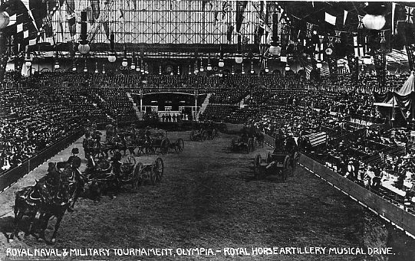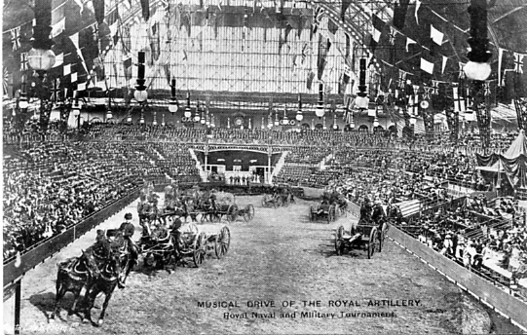
Type 1 used in 1908 Type 2 used in 1909
Ref. 1908-16 Ref. 1909-11

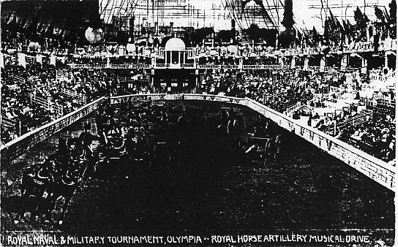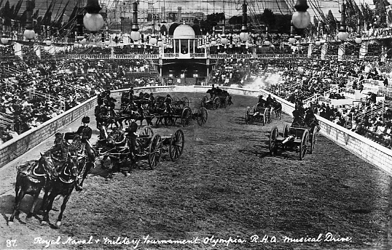
Type 3 used in 1910 Type 4 used in 1911
Ref. 1910-26 No. 97.

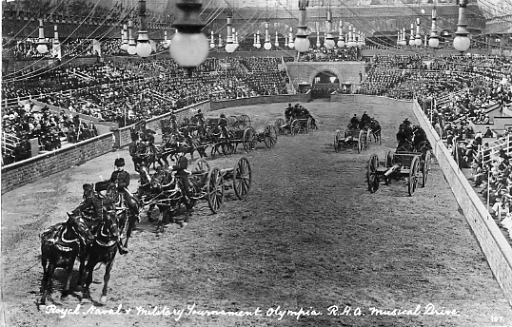
Type 5 used in 1912. No. 107.
The 1906 centre was then used once more, this time with a 1912 surround showing the curved arch.

Gale & Polden not only used the centres of a negative in different surrounds, but they used the same surround on several occasions with different inserted centres.

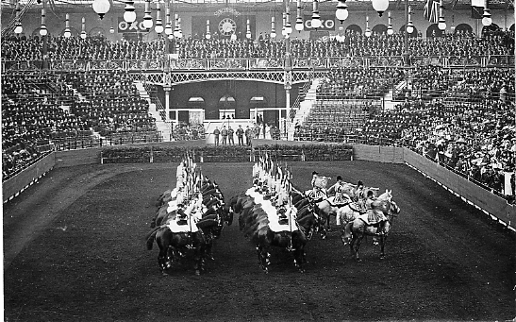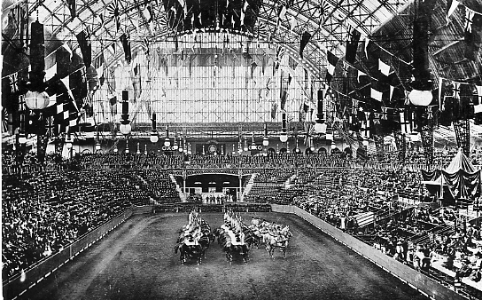
Type 1 used in 1906 Type 2 used in 1907
Here Gale & Polden were able to use a 1906 negative to publish in 1907, what looks like a more
distant view by using more of the surround on the same negative.

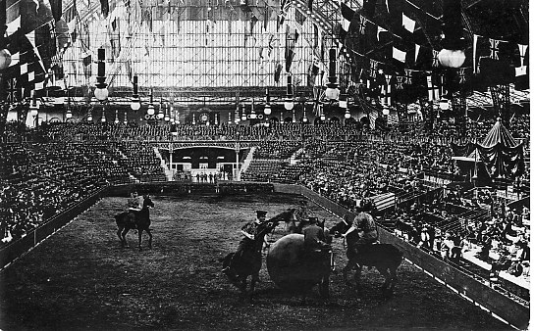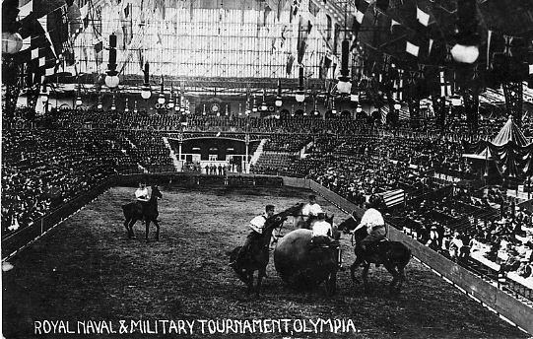
1907 1908
The Royal Horse Artillery Musical Drive post card has caused problems in allocating it to a year of publication. The centre is from a 1906 photograph which was published in 1908 & 1909. It was then inserted into a 1910 surround, as the band stand above the exit shows. Gale & Polden carried out this exercise twice using a 1910 surround, enlarging the centre slightly on type 4 so the performers very nearly overlap out of the arena. I am sure the post card with the medium sized block title was used in 1910, but they did not need two pictures of the same event in that year so they saved type 4 until 1911, giving the card a new title in joined up script with number 87. Numbers were not introduced until 1911 and it must have been published that year as in 1912 another view was allocated No. 87.
The 1908 Rollaball post card was just a re-issue of the 1907 card with a title added. In the 1907 picture four of the men’s shirts look dark, while in 1908 the shirts have been washed persil white.
Where the same surround was used with different centres, not only are all the visitors in exactly the same position but the clock shows the same time, thirty five minutes past three. Dating Royal Tournament cards without titles with dates added to help you, can be difficult, but there are several clues. The photographs for some of the Tournament cards were not taken at Olympia but probably taken in barracks. If these do not have a date in the title or a post mark then they can be difficult to date, and you have to rely on the type of back and the style used in writing the title.
The light fittings hanging from the roof did not change from 1906 to 1913, but in 1914 lights with huge lamp shades appeared and these were changed in design every few years until the mid 1930’s.
A change of publisher favoured other types of views not necessarily of the arena and details of barriers, light fittings and Royal boxes were no longer available on post cards.
Dates given after the entry is the post mark date if postally used or is in manuscript if not posted. The use of post marks is a useful aid to dating the year of publication of a post card, but it must be bourne in mind that a card may well be pressed into use several years after it was purchased. While on the other hand if a card bears a 1908 post mark then for sure it could not have been first published in 1909 or 1910.
I had better explain the system of numbering cards that I have devised. In the years before titles and numbers were used by Gale & Polden I give the card the year it was published ie 1909, this is followed by say -36 which tells me that it is the 36th card for that year in my collection. If I get two more 1909 cards then their reference number would be 1909-37 and 1909-38. Once Gale & Polden started using titles I just give the Year, title and a reference number of my own starting at No. 1 and so on. This is necessary as Gale & Polden has been known to use the same title on 17 different views in one year. From 1911 They added numbers as well as titles, and there is then no need for reference numbers.
Hand written titles.

Hand written titles were not introduced until 1908 and Gale & Polden employed several staff writing titles. The individual writers can be identified, but unfortunately not named. The first titles in 1908 were written in two sizes by the same person, title No. 1. a large rather tall and narrow style using block capital letters (Large size block capitals) and title No. 2. written in the same style but slightly smaller (Medium size block capitals) This later medium size must have proved more popular as it was used after 1908 in 1909, 1910, 1911 and 1912. Taking up slightly less room it was possible to get more details of the event onto a single line, and this probably explains why the large size was discontinued. The illustrations are 150% of full size

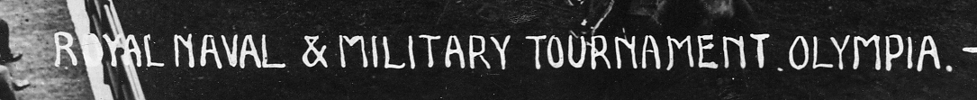
Title written in large size block capital letters.
Title type 1. (1908)
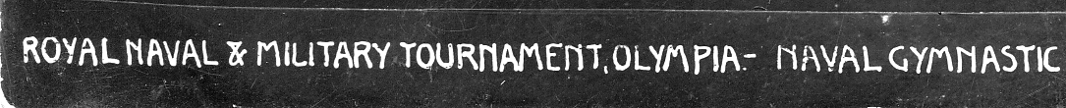
Title written in medium sized block capital letters.
Title type 2. (1908, 1909, 1910, 1911 & 1912)

The hand writing in title type 3 was only used on one post card in 1908 and is smaller than the previous styles. The initials R.N.& M. are used instead of the full words, and this is the only 1908 post card to be numbered.
Title No. 4 has a very distinct ampersand and the letters are much rounder in form as well as being smaller than No. 3. Title No. 5. is even smaller and has an artistic flourish to the letters ‘K’ and ‘R’ with exaggerated long tails. Quite a distinctive hand.

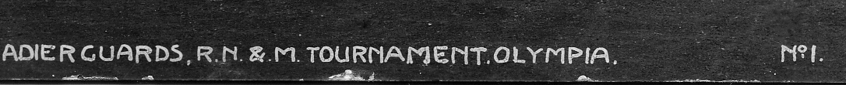
Title written in small rounded capital letters.
Title type 3. (1908)

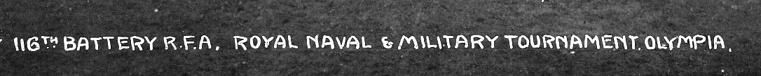
Title written in very small sized block capital letters. Note different way of writing the ampersand.
Title type 4. (1911, 1912)

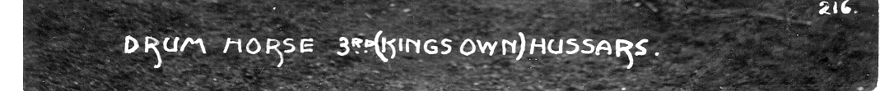
Title written in very small sized block capital letters with long tails to ‘K’ and ‘R’.
Title type 5. (1912)

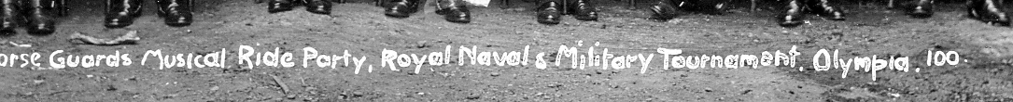
Title in very small sized capital and non capital letters.
Title type 6. (1912)

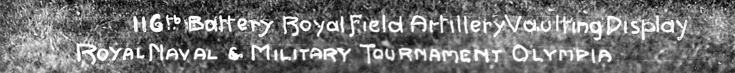
Title written in a mixture of fairly small sized capital and script unjoined letters. (1912)
Title type 7. (1912)

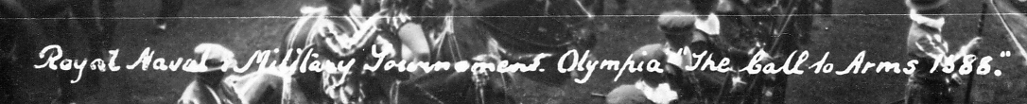
Title in very small sized mixture of joined and unjoined script letters.
Title type 8. (1912)
1906 Royal Tournament

In the early days around the arena was erected iron railings similar to the three bar railings you still see sometimes in parks. These were faced with horizontal rows of planks, in 1906 with four rows of planks and in 1907 with six rows of planks. In 1910 the planks were covered with canvas painted to simulate brick or stone walls. The design of wall was changed every year until well into the 1920’s.
In the 1906 view of the barrier, the top rail of the three bar railing can be seen above the four horizontal boards. The white dashes at the bottom of the barrier are the gaps between the uprights of the iron fence showing below the boards against a white background. This feature can be easily recognised on most of the 1906 views, and let it be said on many post cards re-published in later years from photographs taken in 1906.

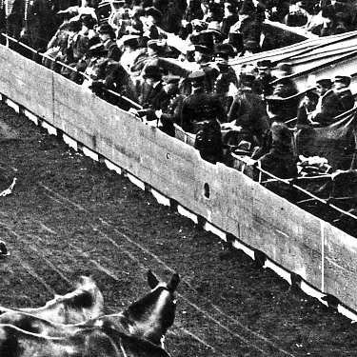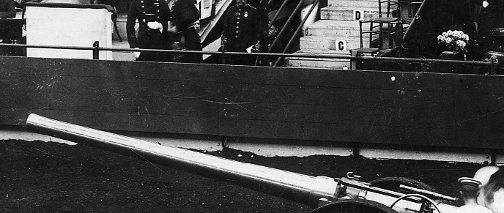
1906 four board barrier and closer view of the barrier showing the white base that
appears under the boarding as a series of white dashes from a distance.

Most years Gale & Polden would include a view of the Royal Box, sometimes occupied by Royalty, sometimes by lesser mortals. In 1906 there was a bunch of accoutrements (helmet shield and swords) fixed to the lances at each side of the box, these come just above the level of the roof, there is also a helmet in the centre of the apron which is decorated with six lions. The box has a cone shaped roof, with a pattern of vertical stripes ending in a circular design at the bottom, see Box C.
The early stages of building the box in 1906 appears on later cards, but as far as is known no post cards of the unfinished 1906 Royal Box before the pelmet was added was published in that year see Box A. At one time the sides of the box were shielded by hangings see Box A and B. The cone roof must have obstructed the view of those sitting behind it, and it is possible that complaints led to the removal of the cone roof. In Box D it appears to have a flat roof. Cards showing the unfinished box were published in 1907, 1908 and 1909. Some times other events were cut and pasted into the arena without disturbing the 1906 barrier or visitors.

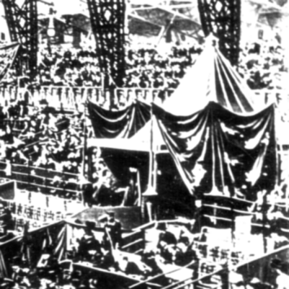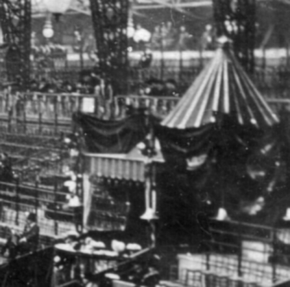
Box A. 1907-1, 1907-2, 1908-2, 1908-16, Box B.1907-4
1909-36, 1909-40 & 1909-41.

