EDITORIAL SUMMER 2009

Summer’s come at last I fear
Why? because it means that winter’s near
Have you paid your subs yet???
I understand from Alan that there are still a few subscriptions outstanding, after sending out two reminders there will now be no more Journals after this one.
I am finding it increasingly difficult to walk now but thank goodness I can still sit in the car and drive all day. So I managed to do Shepton Mallet and York. I split the journey to York both ways stopping at the George in Stamford. It’s a nice hotel, and they look after you well but you have to watch them. On the journey up after my dinner I asked for an apricot brandy with my coffee. “I’m sorry sir, we don’t have that” they told me, so I went without. On the way home three days later while I was sitting in the bar having my pre-dinner Harvey’s Bristol Creams I asked the girl behind the counter if they stocked any liquor brandies. Oh yes she replied we have cherry, apricot and named a few others, but I’d found out all I wanted to know.
While I was eating my dinner that evening the floor manager came round asking if all was well. I said it wasn’t all well, and complained about his staff who were too idle to get me an apricot brandy after my meal a few days ago. He apologised and brought me a double on the house, so it pays to have a little moan now and again.
Shepton Mallet was a good fair and I got 96 cards, when I got home I found some of them were duplicates, but I’m afraid that’s the name of the game now. Two of our members Ann and Ted Steven’s, once again very kindly put me up. I took Ann a small present, a nice presentation box of three handkerchiefs, which she won’t use to blow her nose on, as they were 1938 Glasgow Empire Exhibition embroidered hankies. Ted misses out on the presents but he did have the pleasure of my company.
I also did well at York with 84 cards purchased. It is a pity it comes so soon after Shepton, as many dealers look at me and say “Nothing new since I saw you at Shepton”. York is an un-tidy fair, laid out in short runs of stands and little odd blocks of about a dozen dealers. I always get lost and find I’m looking through the same stocks twice. I know I should mark off on my programme dealers as I do them, but I always think ‘this year I shall remember where I’ve been’, which I don’t and promptly get lost again.
I have raided our archives to produce the reminiscences of James Brown the son of the founder of David Brown & Son Ltd the soap maker of Donaghmore, Co. Tyrone. It was James’s two sons Robert and David who were running the firm and made the decision to create Ballymaclinton at the Franco-British Exhibition in 1908 through to the Japan-British Exhibition in 1910.
James Brown dictated his reminiscences when he was 82 to his daughter Nora Brown in the winter of 1904-05. These remained in the family until George Ithell met James’s grand daughter Alice G. G. Brown in 1982 and Alice read out the reminiscences to George who recorded them on a tape, which is now in the Study Group Archives. It took me nearly a week to transcribe the tape and I’m afraid I have had to put a query mark after some names of people and places. Most of the text was plain sailing but on some words Alice’s Irish brogue defeated me.
The tale is terrible in places when he describes the damage caused by the potato blight in Ireland. The first year was bad enough, as it was localised, but in the second year almost the entire crop in the whole of Ireland was destroyed. He mentions making a journey and passing through fields of healthy crops and three days later returning and seeing it all black and rotting. If that wasn’t bad enough the third year saw a plague that killed off many of the weakened survivors.
An article appears in this summer Journal that has been sent in by a new contributor Derek Connell, it illustrates the fact that we all, and I include myself here, have material which we never bother or rather never get round to really studying. Derek gave a display at our last convention on the Franco-British labels and while some of the labels represent actual palaces or buildings, not all represent real buildings. Derek has spotted something we have all missed, good on yer Derek.
The Editors
Exhibition Study Group Convention 2009

Dear members,
The Exhibition Study Group has been having a weekend convention for the past 22 years. These have been held at many different venues around the country, from Portsmouth to Glasgow, with many of those who came to first one at York still attending. This year on the weekend of the 17 & 18 October we will be meeting at the site of the Crystal Palace in South London. This is a very good venue, easy to get to by car or train, the hotel has just been refurbished and the cost is very reasonable.
Over the years members have given a display of items from their collections, we have six display boards which take twelve sheets each. You do not have to fill all of them, but it gives you a chance to show what you collect. Other members may have items to sell and you could expand your collection.
We start on the Saturday morning with a short A.G.M at 10. o'clock with displays starting at around 11 o'clock, we have a short break at 1 o'clock restart at 2 and go on until 4.30. in the evening we sit down for dinner and wine. On Sunday morning we start at 10 o'clock and finish at around 1 o'clock. If you can not make the weekend we would like to see you on either day.
Good collecting,
Don R. Knight Hon Sec.

IMPERIAL INTERNATIONAL EXHIBITION 1909
GREAT WHITE CITY LONDON
By
Don R. Knight

With the success of the Franco British Exhibition in 1908 which had attracted some 8 million 200 thousand visitors between the 14 May until 31 October, bringing buyers and visitors from all around the world. Imre Kiralfy and the directors of The Shepherds Bush Exhibition Company made plans to hold another exhibition on the 1908 site. Countries had shown interest in coming to show their industries and products at another exhibition. So in 1909 from the 20 May until 25 September the Great White City staged the Imperial International Exhibition, with Austria, China, Denmark, Holland, Italy, Persia and Russia being invited by the exhibition committee to come to London.
The opening ceremony was held at 3.30 p.m. on Thursday, 20 May 1909, with the Honorary President, the Duke of Argyll, dedicating the new Imperial Pavilion, this had been in 1908 the Imperial Terrace and was the only major change made to the site. With the ceremony over, the invited guests and visitors were entertained by the Massed Bands of the Grenadier Guards, Scots Guards, Duke of Cornwall Light Infantry, Corps of Scots Pipers, 2nd Grenadier Drums and Fife Corps, Trumpets and Grand Chorus. They then visited the Pavilions to see the displays, could ride on the Flip-Flap, Mountain Railway, Canadian Toboggan Run, Witching Waves, Wiggle Woggle, ride on the Motor Launches in the Court of Honour and visit the Restaurants or Cafe's. The opening day finished in the Stadium with a grand fireworks display staged by James Pain & Son.
Visitor came to the exhibition by either the entrance at Shepherds Bush Green and walk through the eight narrow buildings all with exhibits and displays and arrive at the main 140 acre exhibition site, or by the Wood Lane Entrance which lead into the Court of Honour. Visitors had to pay 1 shilling entrance fee (5 pence), 1 shilling for a guide book or 2 penny's (1 pence) for a Daily Programme.
In the Great Stadium on Saturday 22nd May a grand sporting meeting was held with 741 competitors competing for prizes money of £650, the entrance fee to the stadium ranged from 1 shilling up to 10 shillings & six pence.
On Monday 24 May, Empire Day, another ceremony took place at the Imperial Pavilion when Lord Strathcona unveiled a statue of King Edward VII. followed by patriotic addresses given by Sir Gilbert Parker MP, The Hon W Hall-Jones (the High Commissioner of New Zealand) and other dignitaries, followed by music from the massed bands.
The Ballymaclinton Village which had been an attraction at the Franco-British Exhibition 1908, reopened on 1st June, closed 25 September 1909, bringing back many of the colleens who had worked there in 1908. All the buildings remained, from the Blarney Stone, the Dairy, Fortune Tellers. Lace Makers and the McKinley Cottage, (this cottage had been the home of the grand parents of the Irish man William McKinley who became President of America 1897-1901). Visitors could buy picture postcards, postage stamps and post them at the Ballymaclinton Post Office where they would receive the special hand stamp. Special items could also be posted there and would be cancelled with a large single hand stamp, items known, a large envelope and certificates of posting.
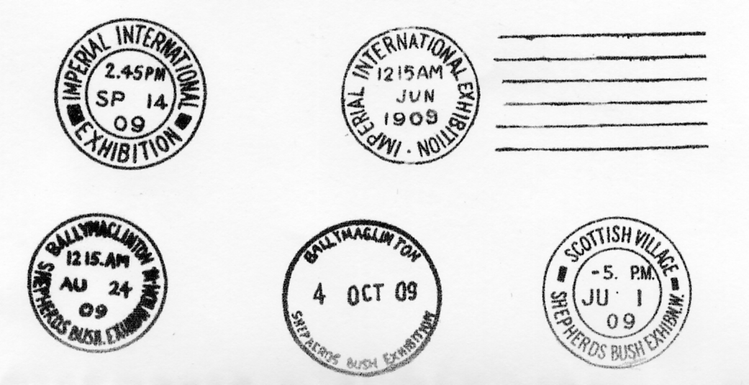

A new attraction had been built. Opening on the 4th June, closed 14th September 1909, this was the Scottish Village with a general store and post office, Robert Burns Cottage, the art of tweed making with women working at their spinning wheels and looms. On the village green Scottish Pipers and Highland dancing entertained visitors. At the Village Post Office, visitors could buy picture postcards, postage stamps and post them and would receive the special Scottish Village hand stamp. (this is one of the scarcer cancellations to find).
The picture postcards for the Imperial International Exhibition seem to be the same as the Franco-British Exhibition but with the titles changed, the kiosks were open for the sale of postcards and souvenirs and postage stamps, the cards posted in the exhibition grounds were taken to the Paddington sorting office and received the Imperial International Exhibition hand stamp with just a few being cancelled with the Columbia Machine cancellation, due to technical problems this was in use from the 1-26 June. These are very scarce and can be found with the whole date and Imperial International Exhibition inverted.

Franco-British Labels Revisited
By
Derek Connell

Casting round for a subject to display at last year’s E.S.G. Convention, I was inspired by Bill Tonkin’s article in the Summer Journal on the advertising labels of the Franco-British Exhibition.
There are of course many varieties of colour, paper, perfs. and overprints, not to mention shapes and sizes, and Bill’s article is the definitive study on the subject But because I am a thematic collector (my subject is London) I am more interested in the actual illustrations on the labels.
Because 2008 is the centenary of the White City I guessed there would be some excellent displays by the experts, so I’d better come up with something original. I decided to mount each advertising label alongside a postcard of the same subject, to emphasise the label’s image. Simple? Don’t you believe it!
The project started easily enough. There’s a lovely postcard showing the same scene as the “Three Ladies” label. Marianne represents France to the left, and Britannia represents Great Britain to the right. They have been brought together by London in London and the mysterious “third lady” in the middle is indeed the Spirit of London herself She has the Arms of the City at her neck, and wears a turreted crown, representing the Walled City.
Three different labels show the Court of Honour flanked by Britannia and Marianne, and a fourth shows the Congress Hall. No problems there. Moving North into the Court of Arts, labels were produced for the Fine Arts Palace (incorporating the Imperial Sports Club) and the Decoration and Furnishing Palace. Again, no problems.
On the East of the Court of Arts stood the Palace of Women’s Work and this is where the puzzle begins. The illustration on the label is nothing like the building shown on the postcards. Instead of the two distinctive towers the label shows a single tower, similar to the neighbouring Palace of Music. However, the tower on the label is topped with a spire whereas the Palace of Music is topped with a sphere.
On the West of the Court of Arts was the French Applied Arts Building. None of the postcards look like the illustration on the label. Instead of a single tower, the label shows two towers, more like the neighbouring British Applied Arts Building. However, the label shows a statue on the central dome whereas the building has no such statue.
And what of the label entitled “British Applied Arts Building”? Does it show a building similar to the French Applied Arts Building? In fact the illustration definitely is the single-towered French Applied Arts Building!
Moving North again, we come to the Elite Gardens, and on the West is the Franco British Pavilion. The squared arch leads through to the Court of Progress, and the Machinery Halls. No problems with these two labels.
To the East of the Elite Gardens is the Garden Club, but the illustration on the label of that title is quite different! To the North is the Grand Restaurant, and voila, this is the Building! So, the advertising label entitled “Garden Club” actually shows the Grand Restaurant.
Between the Court of Arts and the Elite Gardens stands the Imperial Pavilion. Here was to be constructed a 250 foot high “Imperial Tower” as a centre point of the exhibition. Despite appearing on many early illustrations, it was never built. The less ambitious Imperial Pavilion was erected in its place. So the label entitled “Imperial Tower” is a work of fiction.
One other label in this series shows a building. Its title is the “Daily Mail Pavilion” and, thank goodness, that’s just what it shows!
To summarize:-
Four of the labels in this interesting series issued in 1908 for the Franco-British Exhibition have titles that do not match the buildings they illustrate and a fifth shows a building that was designed but never built.
1. The label entitled “Palace of Woman’s’ Work” (sic) show an unidentified building, similar to the Palace of Music.
2. The label entitled “French Applied Arts Building” shows an unidentified building, similar to the British Applied Arts Building.
3. The label entitled “British Applied Arts Building” shows the French Applied Arts Building.
4. The label entitled “Garden Club” shows the Grand Restaurant.
5. The label entitled “Imperial Tower” shows a building that was planned, but never built.
I think this last item gives us the clue to the whole puzzle. The labels were designed not from real life, but from early architects’ drawings. In the process of constructing the White City some buildings were altered too late for the labels to be changed.
And to compound the mistake, the neighboring French and British Applied Arts Buildings were interchanged, and the neighboring Palaces of Women’s Work and Music were interchanged, although a label for the Palace of Music (which would have shown the Palace of Women’s work) was never printed.
If the printers were aware of this they decided to go ahead anyway and hope no-one would notice. And it seems no-one has until now!

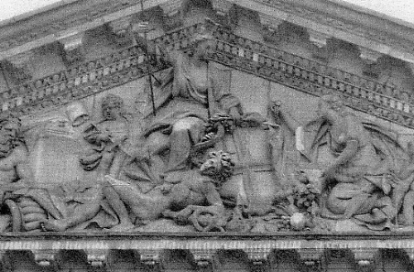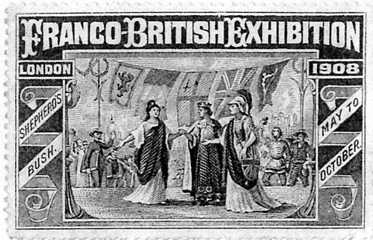

Spirit of London in the portico above the Mansion House (Photo by Don Knight) and Three Ladies label
with the Spirit of London in the centre.

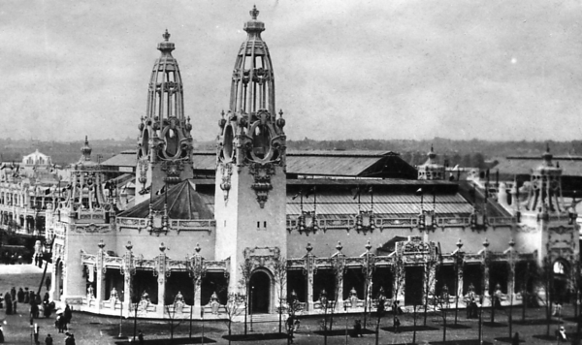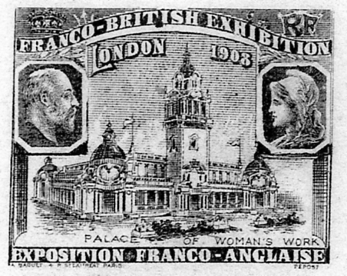

Palace of Women’s Work

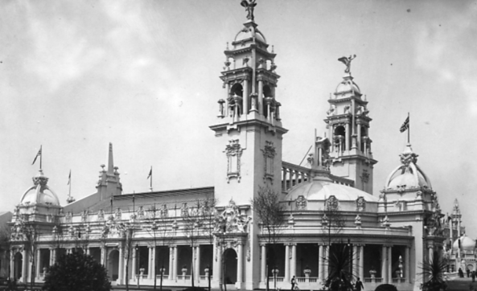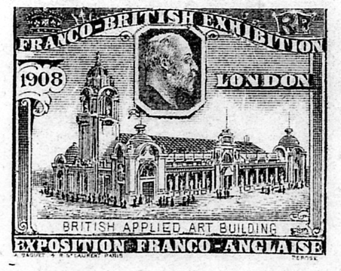

British Applied Art Building

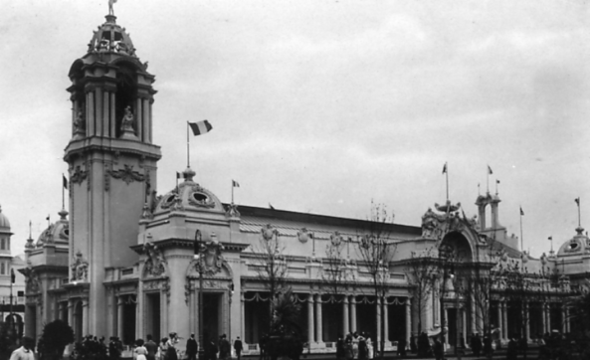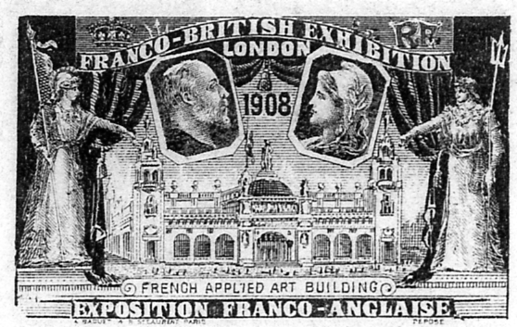

French Applied Art Building

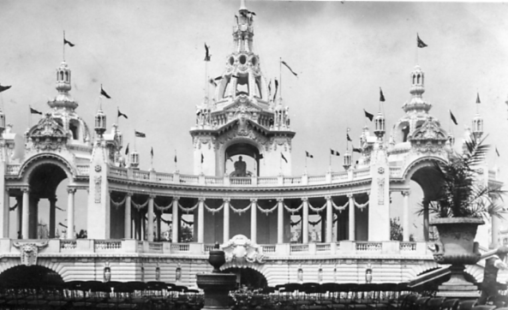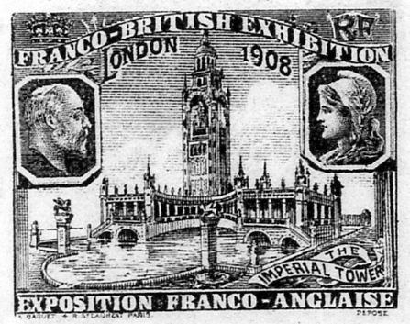

Imperial Tower

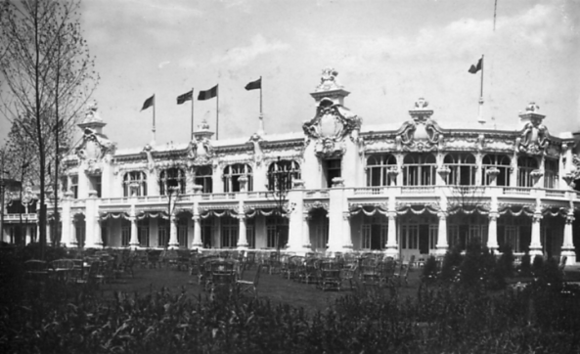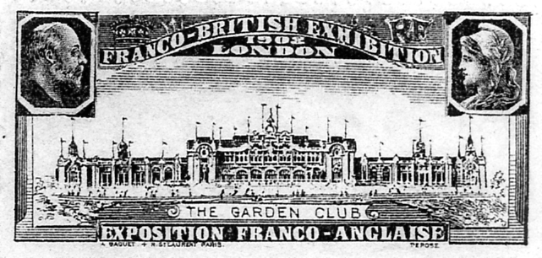

The Garden Club

A New Wembley Map

Contents of different panels on Map number 43.
I. Advert for W. & T. Avery Ltd.
K, L, M & N Picture of the Imperial Stadium and text on the British Empire Exhibition. The headings of the paragraphs are, Variety and Colour, Monster Military Tattoos, A Fellowship of Empire, The Great Home-coming.
S, T, U & V. Advert for W. & T. Avery Ltd.

The Centenary of the Great Exhibition
by
Fred Peskett

As part of their contribution to the 1951 Festival of Britain the Victoria and Albert Museum presented a loan exhibition to commemorate the centenary of the Great Exhibition, which in many respects was their own centenary since the land on which the museum was built was purchased by the 1851 Commission from the profit made from the exhibition. Many of the exhibits shown at the Great Exhibition were either purchased or donated for show at the first museum in South Kensington known by the shape of the building as the “Brompton Boilers”.
For the 1951 exhibition the “loan” items included many choice 1851 exhibits from the Royal Family such as Queen Victoria’s Great Jewelled Casket, The fabulous Prussian Shield, King Edward VII’s lace christening shawl, four paintings of the interior of the Great Exhibition, Prince Albert’s season ticket to the exhibition, portraits of Queen Victoria and Prince Albert, the chair used by Queen Victoria during the opening of the Great Exhibition, the “Official” painting by H.C. Selous of the opening of the exhibition and the priceless jewelled Kniphausen Hawk. The Duke of Devonshire loaned the Devonshire Emerald, and a portrait of Joseph Paxton. From the Victoria and Albert Museum collection the blotting paper “doodle” of his initial design for the Crystal Palace by Joseph Paxton, a model of the Crystal Palace made in 1851 together with many prints and paintings of both the interior and exterior of the Crystal Palace. There was a toy model of the Great Exhibition made from lead and glass complete with trees, carriages and visitors.
Replicas of 1851 sculptures, including the “Greek Slave” by Hiram Powers and “Andromeda” by John Bell. A large Persian Carpet, an Indian Throne, decorative chairs featuring the Royal Portraits, a large cabinet designed by Pugin, an elaborate chair from the Cape of Good Hope, a prize winning Grand piano, tables, screens, clocks and fire irons. Jewellery by Pugin, silver objects, pottery, porcelain and several items of crafted glassware. There were also some of the curiosities from the 1851 exhibition including an electric telegraph in the form of a talking head, a book made from cork, cases of stuffed animals posed in “human” situations! A gun breech, and a knife with eighty blades. Also on show were a number of mementoes and souvenirs from the Crystal Palace at Penge, the base of one of the iron columns, glass paper weights, pot lids, plates, mugs, and medals from the various exhibitions and shows over the years to 1936. Also made specially for the exhibition was a replica of the dress worn by Queen Victoria for the Opening of the Exhibition.
For the 1951 exhibition there were a few souvenirs on sale:-
A plaster cast of a small bust of Queen Victoria by F. Chantrey, at the price of 25 shillings.
A plaster cast of the Council Medal of the Great Exhibition, at three shillings.
The Great Exhibition, A Commemorative Album compiled by C.H. Gibbs-Smith at six shillings.
and six coloured postcards at fourpence each.
A short 16 page guide to the exhibition was also available for threepence.
The 1951 souvenirs are now quite collectable. The plaster bust of Queen Victoria is scarce and sells for around £25. The cast of the Council Medal at about £5, although this plaster cast was still available in the V & A shop up to 1978. The commemorative album by C.H. Gibbs is fairly common at around £6 for the 1951 edition, it was reprinted in 1981 but with a different cover and revised contents, however the postcards are very difficult to find and no price is available, it is possible but not certain that they were available in a special envelope for the set of six. There is one very rare item from this exhibition, the advertising handbill, only a couple seem to have surfaced in last 50 odd years?
The actual exhibits shown in 1951 can still be seen, those loaned by the Royal Family are at Buckingham Palace and Windsor Castle. All of the V & A items are still on show in the Museum, Joseph Paxton’s blotting paper sketch and Prince Albert’s season ticket are in the Henry Cole gallery. The original statue of Andromeda is outside the front of Osbourne House on the Isle-of-Wight, but you will have to visit New York Art Gallery to see the original Greek Slave statue.
Over at the South Bank Exhibition there was on display several of the exhibits first shown at the Great Exhibition. In the Dome of Discovery in the Sky section was an original weather map of 1851 as sold to the visitors to the exhibition, this was loaned by The Royal Meteorological Society, also in this section was a 1951 reconstruction by Cockade of Dr. Merryweather’s “Tempest Prognosticator” a device said to be able to predict the occurrence and direction of a forthcoming storm by leaches in glass tubes who were disturbed by a change in barometric pressure and in trying to climb out of the tube rang a bell there is no evidence that this device actually worked.
In the Lion & Unicorn Pavilion a printed tapestry sofa rug made by John Crossley and Sons for show at the Crystal Palace, loaned by the Crossley Company Ltd. Also in this Pavilion was the original die for minting the Prize Medal of The Great Exhibition loaned by John Pinches who produced all the medals for the Great Exhibition.
In the Sports Pavilion there were two cricket balls made for display in 1851 and loaned by Phillip Wickham from Croydon. The 1851 Centenary Pavilion had a model of a farm wagon, used as a goat cart by Queen Victoria’s children in 1851 on show, and a small glass panel with the Crystal Palace of 1851 with iridescent windows made from butterfly wings was fitted into one of the end glass panels of the Pavilion, this small glass panel is now in the Fred Peskett collection.
Also at the South Bank one of the largest survivors from 1851 was the Buddicom Locomotive in the Transport Pavilion, made in Britain for the French Railways and shown at the Crystal Palace, this locomotive was still in running order. It was again shown in this country in 1976/7 at the V & A at the Tonic to the Nation Exhibition to mark the 25th Anniversary of the Festival of Britain. It was on loan for both exhibitions by the Societe Nationale des Chemins de Fer Francais, Paris.

Crystal Palace Paperweights
by
Fred Peskett

Prior to the passion for collecting picture postcards in the late Victorian/Edwardian times there was another collecting fad, that of glass paperweights. It was common for families on holiday to take home or purchase as a present for a friend a souvenir of the places that had been visited, so glass paperweights were a fairly inexpensive and long lasting memento or gift. These paperweights were available long before the Great Exhibition of 1851 and can be found from most coastal resorts, town centres and famous buildings such as St Paul's Cathedral, Clifton Suspension Bridge, Stonehenge and other "must see" places to visit. My own collection is from the Crystal Palace and like the postcards the collection can be enhanced by the number of variations of type, shape, colour and view.
The types normally found are (a) Hand drawn, (b) Photographic, sepia, (c) Photographic, colour. The hand drawn types are usually hand finished in colour, some have an iridescent finish to Crystal Palace glass windows, once thought to be made from tropical butterfly wings but now known to be laid on coloured foil papers. The photographic types generally date from the early 1900's into the 1930's.
The shapes come in several forms, (a) Circular, domed, (b) Circular, slab, (c) Square, slab, (d) Square, vertical, (e) Obelisk, vertical. There are also many variations to the dimensions of these forms.
The most common view depicts the Central Transept and North Tower with the Terrace Gardens in the foreground, however, there are many variations which can aid to the dating of the paperweight, such as the inclusion of the North Transept which was destroyed by fire in 1866 and never re-built. Such paperweights may of course have been in stock and sold long after the 1866 fire. There are views known of the Interior of the Crystal Palace, but these are fairly rare.
Virtually none of the glass paperweights can be attributed to a maker mainly because there was no place to engrave or stamp such detail!
The known Crystal Palace glass paperweights are listed as follows, please note, the reference numbers quoted are the inventory numbers from my own collection.
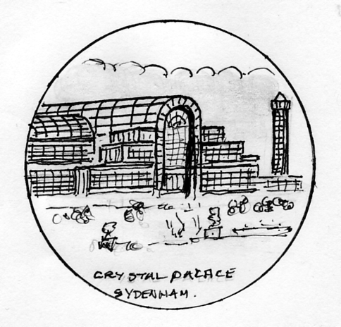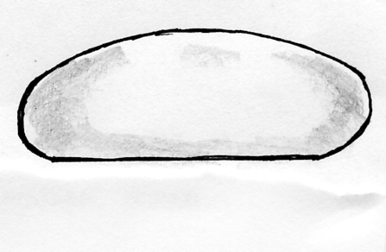

(a) Circular domed

(a) Circular, domed.
CPPWO1. Hand drawn multi-coloured view showing the Central and North Transepts with the North Tower in the background. Fountains in the foreground. Iridescent windows on the Palace. Title:-"CRYSTAL PALACE SYDENHAM" 2 1/2" diameter x I 1/4" high (pre 1866 view)

CPPW02. Hand drawn, multi-coloured view of the Central and North Transepts with the North Tower and North Wing in the background. The foreground shows the fountain basins with the fountains working and two groups of visitors, ladies wearing crinolines and men in black suits with stovepipe hats. Title:- "CRYSTAL PALACE SYDENHAM 2 1/2" diameter x 1" high, (pre 1866 view).

CPPW03. Hand drawn, multi-coloured view showing the Central and North Transepts with the North Tower and North Wing in the background. The foreground shows the fountain basins and jets of water. Statues surround the paths with two ladies in crinolines on the path. No title. 2 1/4" diameter x 7/8" high, (pre 1866 view).

CPPW04. Hand drawn, multi-coloured showing a small view of the Central and North Transepts with the North Tower and North Wing in the background. A large foreground view shows the fountains, statues and groups of visitors on the paths. Title:- "CRYSTAL PALACE". 2" diameter x 7/8" high, (pre 1866 view).

CPPW05. Hand drawn, multi-coloured showing a large view of the Central and North Transepts with the North Tower in the background. The foreground is a view of the fountain basins but fountains are not working, statues line the paths. Iridescent windows on the Palace. No title. 1 7/8" diameter x 1" high, (pre 1866 view).

CPPW06. Hand drawn, multi-coloured view of the Central and North Transepts with the North Tower in the background. There are no fountains or basins in the foreground but statues and plant pots are dotted around. Two ladies, one in a white crinoline with a blue shawl and the other in a red crinoline are on the path. Title:- "CRYSTAL PALACE" 2 1/4 diameter x I 1/4 high, (pre 1866 view).

CPPW07. Hand drawn, multi-coloured view of the Central and North Transepts, both with iridescent windows. North Tower and Wing in background. The foreground has no fountains or basins but has many statues and a man in a black suit with stovepipe hat and a lady in a violet crinoline. Title:- "CRYSTAL PALACE FROM THE GROUNDS" 2 1/2" diameter x 1" high, (pre 1866 view).

CPPW08. Hand drawn, multi-coloured view showing the Central and North Transepts with the North Tower and Wing in the background. The foreground has no fountains but many statues with three groups of visitors. A lady in a red crinoline with a blue shawl with a child in a red outfit. Gentleman in black suit with a lady wearing a white crinoline, and a lady in a pink crinoline and
blue shawl with man in grey suit. Title:- "CRYSTAL PALACE FROM THE GROUNDS". 2 1/2" diameter x 1" high, (pre 1866 view)

CPPW09. Hand drawn, multi-coloured view showing the Central and North Transepts with the North Tower and Wing in the background. The foreground has fountains and many statues with three groups of visitors. A lady in a red crinoline with a blue shawl with child in red outfit. Gentleman in black suit with a lady wearing a white crinoline, and a lady in a pink crinoline and blue shawl with man in grey suit. Title:- "CRYSTAL PALACE FROM THE GROUNDS". 2 1/2" diameter x 1" high, (pre 1866 view) Note this is identical to CPPW08 with the addition of the working fountains.

CPPW10. Real photograph in colour showing the Central Transept and North Tower. The view shows the staircase built from the Central Transept to Terrace for the Festival of Empire Exhibition in 1911. No fountains or visitors are shown in the foreground. Title "CRYSTAL PALACE". 2 3/4" diameter x 1" high, (post 1911 view).

CPPW11. Real photograph in colour showing the Central Transept and North Tower. The view shows the staircase from the Central Transept to Terrace built for the Festival of Empire Exhibition in 1911. No fountains or visitors are shown in the foreground. Title "CRYSTAL PALACE". 2 1/8" diameter x 1/2" high, (post 1911 view).

CPPW12. Real photograph, sepia. Full length view of the Crystal Palace with the North Tower in the background. The foreground shows the fountain basins and fountains working, there are no visitors depicted. No Title. 2 7/8" diameter x 1 1/8" high (pre 1911)
CPPW13. Real photograph in sepia with a view of the Central Transept and North Transept with the North Tower in the background. Fountain basins and working fountains in the foreground, there is no title. 2" diameter x 1" high, (pre 1866 view but the paperweight was probably made in late 1890's to early 1900's using a Negretti & Zambra or Delamotte photograph)

CPPW14. Real photograph, sepia. View shows the Central and South Transepts and South Tower with fountains in the foreground, there are no steps to the Central Transept so the view is pre 1911. No title. 3" diameter x 3/4" high.
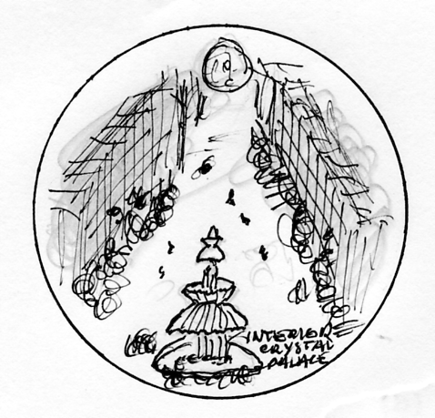
(b) Circular slab

(b) Circular, slab.
CPPW14. Real photograph, multi-coloured view of the interior of the Crystal Palace with Osier's Crystal Fountain in the foreground. Title:- "CRYSTAL PALACE INTERIOR". 2 3/4" diameter x 1" high.

CPPW15. Real photograph in colour, the circular form is rouletted around the sides. Central Transept and North Tower with steps from the Central Transept to Terraces, No fountains or people. Title:- "CRYSTAL PALACE" 3 1/2" diameter x 1" high, (post 1911 view)
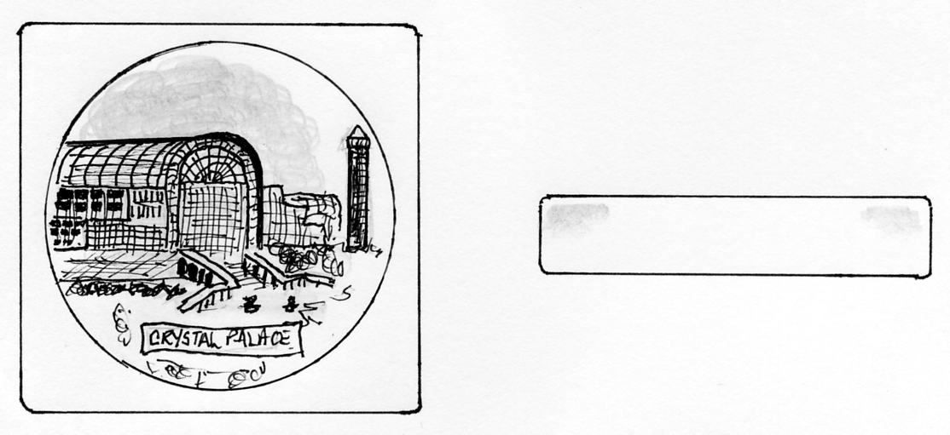
(c) Square or oblong, slab.

(c) Square or oblong, slab.
CPPW16. Real photograph in colour of Central Transept and North Tower with steps from Central Transept to the Terraces. No fountains or people. 3 1/4" x 3 1/4" square. Title:- "CRYSTAL PALACE", (post 1911 view).
CPPW17. Real photograph in colour of Central Transept and North Tower with steps from Central Transept to the Terraces, fountains working but no people. 4 1/4" x 2 7/8" Title:- "CRYSTAL PALACE", (post 1911 view).
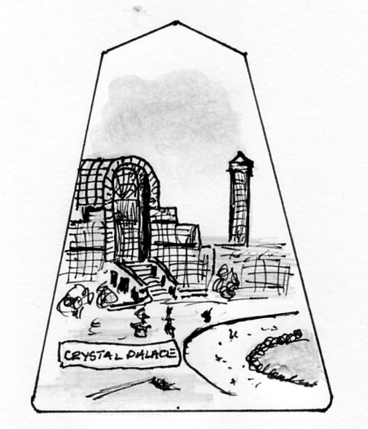
(d) Square vertical. (e) Obelisk, vertical.

(d) Square, vertical.
CPPW18. Real photograph in colour of Central Transept and North Tower with steps from Central Transept to the Terraces, fountains working but no people. 3" wide x 2 1/4" high. Title:- "CRYSTAL PALACE", (post 1911 view).

CPPW19. Real photograph in colour of Central Transept and North Tower with steps from Central Transept to the Terraces, fountains working but no people. I 7/8" wide x 3" high. Title:- "CRYSTAL PALACE", (post 1911 view).

(e) Obelisk, vertical.
CPPW20. Real photograph in colour of Central Transept and North Tower with steps from Central Transept to the Terraces. fountains working but no people. 1 5/8" wide at base x 2 1/2" high to apex. Title:- "CRYSTAL PALACE", (post 1911 view).

CPPW21. Real photograph in colour of Central Transept and North Tower with steps from Central Transept to the Terraces, fountains working but no people. I 3/4" wide at base x 3 1/4" high to apex. Title:- "CRYSTAL PALACE", (post 1911 view).

CPPW22. Real photograph in colour of Central Transept and North Tower with steps from Central Transept to the Terraces, fountains working but no people. 2" wide at base x 4" high to apex. Title:- "CRYSTAL PALACE", (post 1911 view).

In addition to the Crystal Palace at Penge paperweights there are also those produced as souvenirs for the Great Exhibition of 1851
those known are:-

GEPW01. Circular, domed. Hand drawn, multi-colour view of the Transept of the Exhibition building with a carriage drawn by a pair of horses, and two ladies, one in a blue gown with a white shawl and red bonnet and one with a red gown, white shawl and blue bonnet. No title. 3" diameter x 2" high.

GEPW02. Circular, domed. Hand drawn, multi-coloured view of the Transept of the Great Exhibition building with trees on left side, a horse and cart and twenty visitors making their way to the entrance. No title. 2 7/8" diameter x 2" high.
GEPW03. Circular, domed. Hand drawn, multi-coloured view of the interior of the Great Exhibition with Osier's Crystal Fountain in the foreground. Title:- Crystal Fountain, Exhibition of All Nations 1851" 2 7/8" diameter x 1 3/4" high.

The above list probably represents the tip of the iceberg of glass paperweights depicting the Crystal Palace, examples made for the Military and Naval Exhibition in 1901 and The Festival of Empire and Pageant of London in 1911 are said to have been seen.
Glass paperweights are known to have been produced for most exhibitions from 1851 through to at least 1914. External and internal views of the Kensington International Exhibition of 1862, The Dublin, Cork and Glasgow International Exhibitions. Most of the French and Belgian exhibitions have associated paperweights, those of Paris Exhibition of 1900 being very attractive including some featuring the Eiffel Tower. Like the Crystal Palace, other exhibition venues such as The White City, Earl's Court, Olympia and Alexandra Palace also have their own souvenir paperweights to add to a collection.
Paperweights were produced for the 1951 Festival of Britain by a Birmingham company Wilmot-Breden, but moulded in three-dimensional plastics, most of these have by now suffered from polymer breakdown and have turned into a sticky, foul smelling mess! In hindsight they would have been better made from glass.

Reminiscences of my Grandfather James Brown 1904-5

As recorded by Alice G. G. Brown for George Ithell in 1982.
Part 1

This is Alice Brown. (see footnote) speaking at Balrath Beg, Donaghmore, Dungannon, Co. Tyrone in February 1982. I am going to read the reminiscences of Old Donaghmore dictated by my Grandfather James Brown to my Aunt Miss Nora Brown during the winter of 1904-05 when he was in his 82nd year.
I was born on July 25 1823 in the old house in Donaghmore in our part of the Soap Works. My father was David Brown son of John Brown who married Miss McClennant and lived in Mogmore. Miss McClennant’s brother married my grandfather’s sister and also lived in Mogmore.
My father had one brother John who lived in Irish Street and carried on a bakery, he married Miss Jane Mcdowell. My mother was Betty, daughter of Henry King of Middletown Co. Mahone. When just married my parents lived in a small house in Mogmore, since pulled down, and afterwards in a house in Donaghmore opposite the Chapel, from there they moved to the house where I was born.
They had ten children, Mary married Richard Terran, Henry married Jane Carr, Ann and Thomas who died in childhood, Margaret who married Henry Oliver, Eliza married Robert Swift, Jane married Thomas Layborn, Amelia married Joseph Acheson, Isobella married John Beatie, and myself who married Jane Ellen Nicholson.
The first thing I can remember is a servant of ours Mary Layland going to America on St. Patrick’s Day 1828. She and the rest of the party drove to Belfast in a cart to sail hence to America. They took with them provisions for the journey, chiefly oat cakes as then was the custom. The outward voyage averaged 30 days, but occasionally was 6 or 7 weeks, and on these occasions provisions ran short and the poor people were in danger of starvation.
Another early recollection is being taken into a darkened bedroom to see a little play fellow who was ill of small pox, there being little knowledge of the risk of infection then.
My first teacher was Mr Richard Robinson whose school was in the space now planted with trees behind the cross. It was then the only school in the Village. Later I had lessons at home from Mr Stuart who taught at the Roman Catholic school in Dungannon. After leaving the Village school I was sent to my sister Mary Terran in Firth Street Dungannon where her husband had a grocers shop, and I attended a school kept by two teachers from the South of Ireland Messrs Murphy and Reardon.

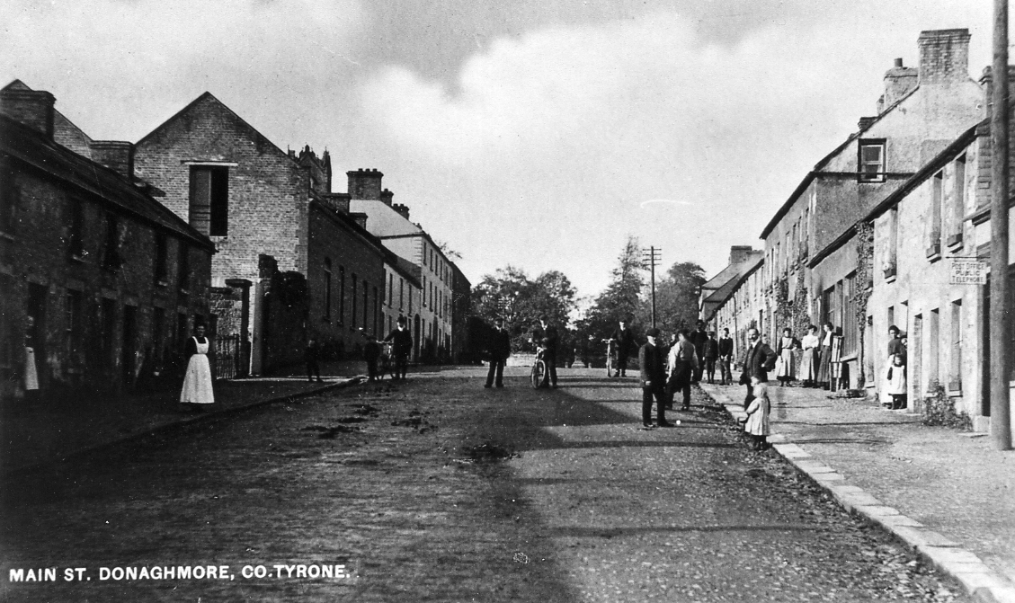

The David Brown Soap Works in Main Street, Donaghmore.

Afterwards I lived with my sister Margaret in Church Street where her husband carried on a saddlery trade and I went to Mr Bether’s School in Castle Dillin?
I went there until I was nearly 13 when in the summer of 1836 I went to the Rev John Blackleys school in Mahon. There I stayed until I was sent for, to come to the death bed of my father on November 17 1837. He died on November 22, and I did not return to school but went to business with my brother in Donaghmore.
Previous to the year 1816 my father was engaged in the linen trade, giving out home spun yarn and getting it woven in hand looms in the cottages. At that time a great deal of the loom trade was transacted in Dublin, not Belfast, probably in consequent of better banking facilities. My father used to go to Dublin to sell his linen in company with other merchants. They rode on horse back in parties for protection from highway men. The journey up to Dublin occupying three days. The later years when linen trade in Belfast had increased, buyers for the pieces came to Dungannon every Thursday and took their places on the standings on the East side of the square, where the farmers brought the webs woven by their families and servants. The standings were benches with boards in front of them on which the webs were thrown for examination. When the price was arranged the buyer put his mark on it and the seller took it to Mr Robin Teller in Perry Street who measured it. He got a few pence for each web measured in consideration for which he supplied the buyers with dinner.
Travellers then wishing to go to Belfast used to leave Dungannon at 4 a.m. on a long car (see footnote) which took them by Moy and Loch Dorn? to Portadown. There they joined John Barrs coach running between Amagh and Belfast, reaching the latter place about 1 p.m. During the war with Napoleon, prices for agricultural produce were high but the peace of 1815 was followed by a time of great depression partly caused by two bad seasons, a very wet summer and a very dry one, during the latter the corn was so short it could not be reaped in the usual way, but had to be pulled. The depression in the linen trade caused my father to open a bakery in Donaghmore, and I remember his telling me that the first flour he used was American and cost four guineas a barrel.
About the year 1820 (see footnote) partly from the wish to find employment for an old and respected friend my father conceived the idea of beginning soap and candle making. This being before the days of railways the materials were brought chiefly by canal either to Moy? or Connant? except what was produced locally. In those early years of the last century each market town had one or more tan yards and a candle factory, sometimes including a soap works. Now in the following century, the soap trade has left those country towns and settled in the sea ports, so that the Donaghmore factory is the only country one still working in Ireland. There used to be

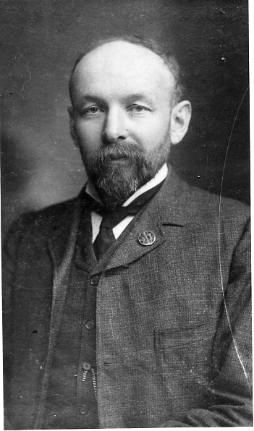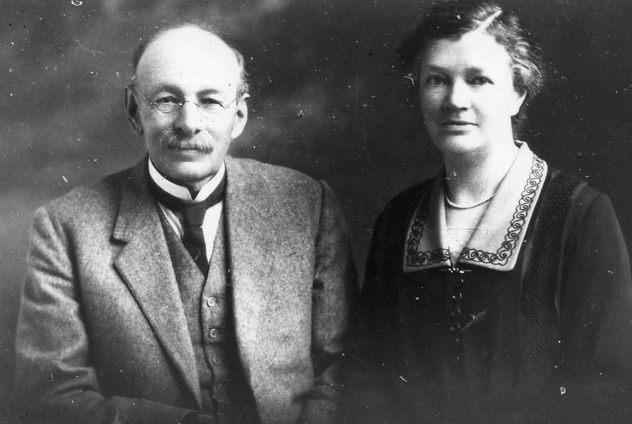

Robert Brown David Brown married Ada Wilson
The twin brothers responsible for the 1908-1910 Ballymaclinton Village at the White City

two tan yards in Dungannon, one in Beragh, three in Omagh and several in Strabanderlay?, but that business has practically ceased in Ireland after centring in Dublin for a time.
Another extinct industry is the making of nails which was carried on by the Huggett’s, father and son until a comparatively recent date. Each nail was made separately with a hammer of small iron rods supplied for the purpose. These nails cost four pence to eight pence per hundred according to size. Now they are made by machinery at a quarter the price. The open window of the nailers shop was a very favoured spot at which to linger and stop, and watching him busily hammering and chopping of the nails and giving the chat of the village without stopping his work.
Few people nowadays would know what a ‘shelling’ or ‘shelling in’ was, this was a usual adjunct to the village corn mill in my young day. The oats were dried in the kiln and after shelling were fed into a sack, this was thrown over a horses back and taken to the nearest rising ground where the chaff was removed by the wind. After this process which is now superseded by the use of fans the winnowed grain was refilled into the sack and taken back to the mill to be ground into meal.
When I was a boy, my father began to make mould candles in addition to the dips which were the first candles made. The old process of making dips was a very slow one, one man only making about twenty dozen pound per day. With improved appliances a man afterwards could make eighty dozen pounds. In those days tallow alone was used but in later years paraffin wax has supplanted it, and dip candles are no longer made.
Rush lights also were made and were used as night lights they gave a small slowly burning light. The partially paid? rush taking the place of candle wick. A strip of paid? was left on each side of the rush and the ends of the strips being knotted they were suspended from the dipping rods by this means.
The wicks for the dips were made from flax too, which was loosely spun by Rowan? and after boiling with alkali was pitched on the grass. This made a very rough wick. Later cotton was used, being supplied from Manchester ready for use.
Prior to the Blows? discovery of the process of producing alkali from salt, the river? of kelp was used for soap making. The Kelp was made on the sea shore and brought inland to the factories at Castle Fin where the Messrs Baird had a soap works in the early part of last century. An autumn morning would find the fair green crowded with horses laden with trays of kelp brought from the North West coast of Donegal to supply these works. Russia was the main source of imported tallow and Barilla (see footnote) was also brought from the Mediterranean.
When the soap box was started Mr Martin the traveller for the brewery introduced our manufactures on his journeys and brought orders from Omagh and Eskrinega? which assisted us considerably, afterwards Mr William Owen and Mr John Clark travelled for the firm, an occupation which I took up about 1842. As this was before the days of railways I drove my own horse and gig once a month through Tyrone and Fermanagh also parts of Amagh and Derry.
In this way I became well acquainted with these districts and with our customers. During the early years of my business career our principal competitors were in Belfast, the chief makers there were Mr Findlay Messrs Greir and Mr Glenfield. Locally we had Mr John Shlington of Portadown and later on Mr Robert McClennon in Dungannon while Mr George and Robert sons of Mr John Teller started to make soap and candles at Marie. This came to an end in a few months however. Robert McClennant had a tannery and also sold tea in the same districts which we visited, so he was a serious competitor. He and his nephew Joseph moved to Belfast later on, but afterwards returned to Dungannon and bought the Spinning Wheel off Messrs Hail and Martin.
Up to the opening of the railway in 1865 our goods were entirely delivered by our own Carter’s, until 1830 we had no Post Office, letters were brought from Dungannon by a messenger to the brewery and he also carried those to the village. The Mail Coach from Dublin took our own letters to Dungannon. Our first postmaster had the munificent salary of £3 annually. In my boyhood there was no place of worship in Donaghmore but the Chapel of which Prior Conway was priest, Rev. Thomas Carpenter was Rector of this Parish and Rev. Robert Fraser was his curate. The Parish Church being in Castlecaulfield.
The Chapel of Ease in Donaghmore was built in 1836 or 1838 through the influence of Mr McKenzie who up to then had been a Presbyterian and attended the First Dungannon of which Church Rev. Mr Bennet was minister. The Church at Donaghmore was enlarged and altered during Rev. James McNeeses incumbency about 1866.
The levying of tariffs caused a very bitter feeling so much so that on one occasion a mob of angry Protestant parishioners surrounded the Glebe House and threatening to hang the Rector on one of his own trees. About 1845 the matter was altered so that the landlord paid the tariff being empowered to add it to the rent.
Prior McCaughlin was the Parish Priest who rebuilt the Chapel about 1845. My father always lived on very good terms with his Roman Catholic neighbours, as an instance of this, on one occasion when the weather looked threatening the priest gave him the use of the Chapel as a temporary store for his corn. A funeral had to take place in the morning before his offer could be taken advantage of, and as the sky became more overcast Prior Conway more than once, anxiously went to the top of the hill, looking down the road by which the funeral was to come, at last he came back to my father “Here they are” he said “Coming as if they were on their way to the gallows”. The funeral took place and the corn was safety housed in the Chapel before the storm came.
In October 1845 came the first potato blight, we had a field of potatoes that year on the back lawn and in one night they were struck with the blight and both tops and roots were blackened. The damage done in 45 was only partial, that is to say only a portion of the country was affected and the blight did not strike the plants until the crop was almost matured. Only a part could be used for food, the rest was given to pigs or used to make starch. We put up a small machine to grind them and extract the farina but for this purpose they still served very well.
On the night of August 3rd 1846 came the bad potato blight. I remember driving to Dumbordin? through County Fermanah with my sister Bella on August 3rd and as we went, seeing the fine crops of potatoes in the fields. We spent three days in Bundorra? and returning found these same crops blackened and useless.
The same state of affairs prevailed practically over the whole of Ireland, and in consequence 1847 was the famine year, it was felt severely here, but nothing like so much as in the South and West. Indian corn and meal were introduced for the first time from America and I remember the poor people coming into the shop and asking to see this yellow maize, they would then take some in their hand, ostensibly to look at it as a novelty but truly to satisfy their hunger with it. It was an anomaly at this time that open and Indian meal rose as high in price as fine flour, owing to the fact that as parched meal, could be used more economically than flour in bread.
A committee was formed in Donaghmore which met in the schoolhouse at the Cross, and contributions were raised for the relief of the worst cases. In other parts works were began such as cutting views? on the roads but they were found a wasteful and useless means of relief and eventually the Government made a grant of £7,000,000 to be used directly to supply the starving people with food.
The fever followed the famine and broke out in the emigrant ships in which the poor people were flying to America. These were sailing vessels and far inferior in speed and comfort to those now used, and many of the passengers never reached the other continent. Those who did
were taken to a hospital near the battery, New York and there numbers died of the fever they had contracted before leaving Ireland. The fever was not so rife here as further West and South but I remember feeling nervous about it when in Ennispring two of our oldest customers there, contracted the disease and died. They sold meal and bread and probably the poor starving people who came to seek for food had brought the infection.

To be continued.

New post cards

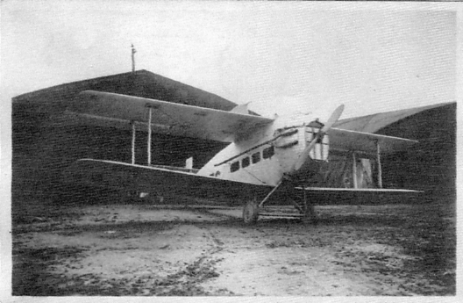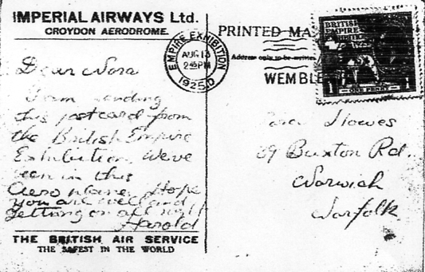

When the Exhibition Study Group published an update of Postcards of the British Empire Exhibition in 2004, one of the new Imperial Airways cards listed printed under Raphael Tuck was aeroplane No. 11 a plane outside a hanger. Alan Sabey has just added the above sepia R/Photo card to his collection. Now there are several interesting things about it. First of all Allan’s card has a white border and no title or even a Tucks trade mark in the bottom left corner, although the other two cards known both have a title and trade mark. It was produced from Tuck’s original negatives used for Imperial Airways postcards. In Journal No. 84 page 8 we illustrated some new Imperial Airways finds sent in by Tony Davies and two of these had a previously un-illustrated back. Alan’s card also has the same back and was posted at the exhibition with a Wembley stamp, and the message ‘I am sending this postcard from the British Empire Exhibition, we’ve been in this aeroplane’.

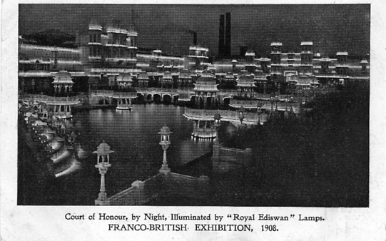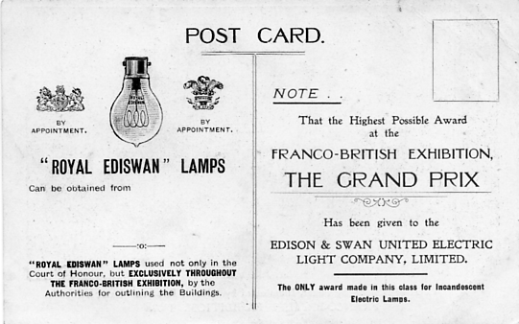

Royal Ediswan Lamps, photogravure printing black back with additional overprint on right side of back in red.

