EDITORIAL SPRING 2009

Some recent prices on E-bay
Are much much more, than I would pay

Some of the prices paid by collectors on E-bay are just out of this world, or is it just me that’s old fashioned in what I think post cards are worth. It must be about six or seven years ago that I had managed to get a card showing the T.S.S. “Baltara” a ship of the United Baltic Corporation. This ship and another of the same company the T.S.S. “Baltanic” were used to transport a contingent of Scouts straight from the Imperial Jamboree held at the British Empire Exhibition in 1924 over to Denmark to attend the second World Jamboree held in the Forest of Ermelunden near Copenhagen. Both cards have the boy scout emblem printed in the top left corner, with ‘Be Prepared’ in a scroll underneath. Later I saw another copy of a Baltic Corporation card, but by then I had forgotten which ship I already had, so I bought it just in case it was the missing one that I wanted. Of course when I checked at home I found I now had two copies of the “Baltara”, so one went into my swap box. In last months Picture Postcard Monthly I see a creased copy of the “Baltara” went for £476 while a copy of the “Baltanic” went for £105. So the crease put £370 on the value of the card. I have just had a look at my spare copy of the “Baltara” and I was over joyed to find that mine also has a slight corner crease. So if anyone out there wants a £476 card they can have mine for a copy of the “Baltanic” but it’s got to have the scout emblem on it, but I don’t mind if it’s not creased.
I have started looking at my E-mails now and again, and this week there was a message from Ken Rumsey. An American, James Dailey, had got in touch with him asking if he knew the owner of a Great White City Exhibition pull out titled ‘We are not Downhearted The Great White City’. Ken put him on to me, and I soon received an E-mail offering me $200 for it. I thanked him for his kind offer, but declined to sell my card. This brought another E-mail listing a second Great White City pull out featuring the same coloured lad on a card titled ‘I am coming out of my Shell at the Great White City’ which I also have. The offer was increased to $500 for the pair of post cards. James is interested in the coloured lad and not the exhibition. I have posted James scans of the cards as I cannot send E-mails with attachments of pictures of post cards. James interest in the lad is connected with a display he is giving on ‘Black History’.
I have just had another E-mail from Ken to tell me he has sold his copy of ‘I am coming out of my Shell’ to James for $87. The price was dropped because James in the meantime had picked up another copy of ‘I am coming out of my Shell’ overprinted for Rothsay instead of The Great White City for $7
I used to think collectors who paid well over what a card was worth were mad. I’m now beginning to wonder if I have got it all wrong and perhaps, just perhaps mind you, it’s me who’s mad.
I had an enquiry on the inter-net about the Palestine Pavilion at Wembley in 1924 and 1925 or to be more specific the exhibitors in the pavilions for those years. As I have the guide books for both years it was no trouble to copy out the list of exhibitors and send it off. In case anyone else is interested in a list of the exhibitors, let me know and I will send them a list.
Palestine did not publish guides for both years, instead the re-published the 1924 guide in 1925 without alteration, and just added a few extra pages. One new sheet containing the members of the various committees inserted between pages 4 and 5, and after page 118 they added pages 119 to 126 which contains a map showing the new layout of stands, and a list of 1925 exhibitors.
There have been several other enquiries which Ken Rumsey has pushed onto me that have come from our Web Site and one concerned Japanese Wrestlers. I answered this and said I had five out of a possible set of six post cards published by Valentine. As Dr. Emelyne Godfrey who is doing post doctoral research, lived in London she asked if she might visit me to see the cards and on Sunday 25 January she turned up with her boyfriend and stayed I suppose for a couple of hours. In addition to the Wrestling cards I got out the cards featuring the Japanese Wrestling Arena at the Japan-British Exhibition in 1910. The same negative was used to produce the card titled ‘Bostock’s Jungle’ next year for the Coronation Exhibition in 1911. When I looked at the two cards I noticed in the 1910 card, the front of the building had a row of Japanese flag like long banners on poles. When Valentine’s re-used the picture after the Japanese had gone home they carefully removed all the Japanese flags.

The Editors
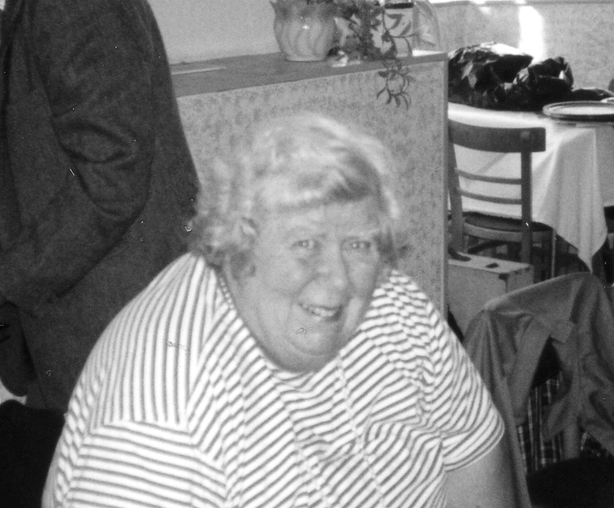

It is with regret that we have to announce the passing of Gwen Tough, on Christmas Day 2008. Our thoughts are with Bob and their son John. Gwen has been one of our keenest supporters for many years, going back to about 1990, only missing I think two conventions when we met at Glasgow and Bradford as these were too far for Gwen to drive. I remember Gwen and Bob attended Expo 92 and at our convention that year we all got a half pint mug, a souvenir from the British Pavilion. Although Gwen had to give up driving she and Bob managed to attend our last convention albeit in a wheel chair, brought over for the day by John. The Study Group was represented at the funeral by Don Knight, and a donation was sent to the R.N.L.I. instead of flowers.

Crystal Palace Park Masterplan

I thought the following article which appeared in the Crystal Palace Foundation News may be of interest to our members, and Melvyn Harrison Chairman of the Crystal Palace Foundation has kindly given us permission to use it in our Journal
In June, the Foundation made observations and objections relating to the London Development Agency’s outline planning application. These can be seen at www.crystalpalacefoundation.org.uk - click on ‘News’. The Agency's application divides the Park into zones. To summarise:
In Zone A. adjacent to Anerley Hill, the objection is to the number of trees to be removed, the removal of the boundary wall and reconfiguration of the landscape, the erection of a College and Lodge behind Ledrington Road and a ‘greenhouse’ to reflect one of the wings of the Palace.
On Zone B. the hilltop, the Foundation observed that it might be better to delineate the footprint of the Palace with box hedge or shrub planting than with a ‘tree palace’. Adjacent to the Parade and directly above the subway would be a new Museum. The outline application is short on detail and it appears as a glass box surmounted by a flat viewing area and no indication of a Paxton signature feature - the ridge and furrow roof. The phasing proposals indicate that any new Museum would not be completed until around 2014 (the present Museum being refurbished and used as a Park Rangers facility). The Foundation recognised that a Museum worthy of the Palace and its history is essential, but could not support the proposals as presented.
On Zone C. the terraces, the Foundation is concerned about the integrity of the terrace structures - especially that the lost north staircase would be replaced by ramps or slides ‘to aid both accessibility and enjoyment’. Proposed sunken gardens would also cut into the grassed fountain basin area.
Zone D. adjacent to the station, is described as the transitional landscape. The Foundation understands the reasons to remove some trees here, but would also like to see the complete rebuilding of the Rosery, together with the bandstand.
Zone E is the National Sports Centre, about which no comment is made.
Zone F is the tidal lakes area, the principal building here being the cafe and dinosaur interpretation centre. The illustrative drawing is said to refer back to Paxton but because it is short on detail and would not enhance the character or appearance of the conservation area, the Foundation was unable to support the proposal.
On the periphery of Zone G. the cricket ground area, the proposal for ‘Sydenham Residential’ housing is opposed and, further in, the removal of trees to enable a Park Rangers building is resisted.
The most contentious area falls within Zone H - the English Landscape. Here is proposed the removal of 33 trees and the insertion of flats described as ‘Rockhills Residential’. This would provide funding to improve other areas of the Park, and release land currently occupied by the Caravan Club. In line with its adopted policy the Foundation cannot support this proposal for housing on the Park. Also in Zone H is the proposed north ‘greenhouse’. As with the proposed south greenhouse, this owes little to Paxton’s design, and a number of mature and healthy trees would be felled to facilitate it. In Zone H there is also a proposal for a treetop walkway. The Foundation considers that this would neither preserve nor enhance the conservation area, and that money might better be spent on restoring the Aquarium instead of turning it into a mist garden.
Your Vice Chairman's statement regarding the Aquarium is included as an addendum to the observation/ objection letter. Note: on a Park-wide basis, it is proposed that approximately 470 mature, semi-mature and younger trees would be removed, around 370 of which are shown as healthy specimens in the tree survey schedule; the Foundation considers that replacement planting could not compensate for this scale of felling.
At Bromley's Development Control Committee meeting on 9th December the Foundation referred to a new Museum's projected completion date being around 2014 and asked what would happen to the present one in the meantime. Comments made at the meeting appear to indicate that there is no specific funding stream for a new Museum. Two Councillors expressed concerns that a new Museum should be a priority and one of them wanted (a) to see a legal agreement that it would be an early part of any development and (b) a guarantee that a Museum would be built. Following the Committee’s decision to grant planning permission the application has now been called in for examination by the Government Office for London. Meanwhile, the Foundation will seek to meet with the other key player, the Crystal Palace Museum Trust, to discuss the matter of the Museum.
Contacting the Crystal Palace Foundation. C.P.F., 58 Laurier Road, Addiscombe, Croydon, Surrey CRO 6JQ Voice-mail: 020 8653 5995 e-mail: crystalpalacefoundation@hotmail.com Website: www.crystalpalacefoundation.org.uk

Another little red book has come to light as listed below.
12 sepia Photographic Views of the Crystal Palace and Upper Norwood
Book eight. Published by F. Stevens (Stationer) 50 Westow Street. Red card covers with title blocked in gold. 7½" 6½" There is no indication as to the photographer but the views of the Crystal Palace do have certain similarities with known postcards by unknown printers/publishers. Not dated but Circa 1900.
1st View Serial number 3893. Crystal Palace. This is a view of the Crystal Palace taken from the Low Level Station area, Negative No 8, but with additional detail in the foreground, ie The lower end of the toboggan run can be seen, two concrete blocks on the railway side of the wall , handrails and forked posts on the footbridge.
2nd View Serial number 3886. Westow Hill.
3rd View Serial number 3888. Westow Street, Upper Norwood.
4th View Serial number 3908. Royal Normal College, East Front.
5th View Serial number 3906. White Hart Hotel and Church Road.
6th View Serial number 3907. All Saints Church.
7th View Serial number 3890. Gipsy Hill and Christ Church.
8th View Serial number 3887. Anerley Hill. (known as a postcard)
9th View Serial number 3911. Beulah Hill with Spa Hotel.
10th View Serial number 3883. The Parade, Upper Norwood.
11th View Serial number 3889. Central Hill.
12th View Serial number 3910. Dulwich College

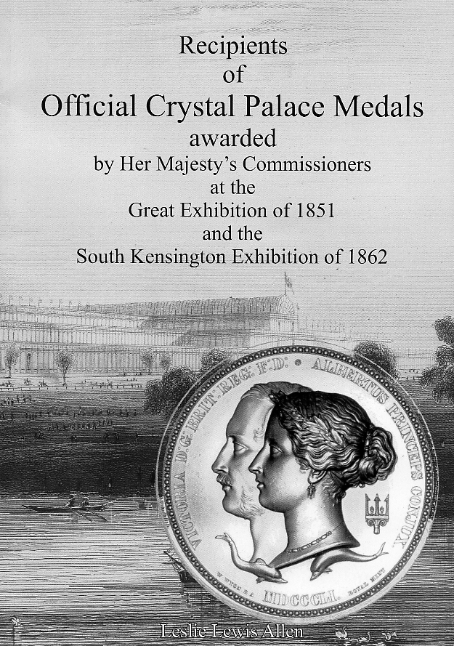
Awards made by Her Majesty's Commissioners at the Great Exhibition of 1851 and the South Kensington Exhibition of 1862
By Leslie Lewis Allen

This meticulous work is a companion volume to The World's Show Coincraft’s Catalogue of Crystal Palace Medals and Tokens, 1851 - 1936 also by Leslie Lewis Allen.
He reproduces detailed alphabetical indices of the Great Exhibition of 1851 and South Kensington Exhibition of 1862 Medal Awards.
For the 1851 Exhibition the book records 169 Council Medal and 2,972 Prize Medal awards, 403 Jurors Medals and 2,617 For Services Medals.
For anyone researching medal winners or a family connection with the 1851 Exhibition or 1862 Exhibitions this book is a must.
180 pages paperback
Price £14.95 plus £2.00 p&p UK or £6.00 p&p overseas, from The Crystal Palace Foundation. 58, Laurier Rd, Addiscombe, Croydon., Surrey. CR0 6JQ

The Falkland Islands

Around 1990 Mike Perkins and myself were well into our researches for our book on the Postcards of the British Empire Exhibition at Wembley. After we had produced a basic list of both of our combined collections, we set about trying to visit every British Empire Exhibition collector we knew of, looking for additions to our list. Mike covered the Midlands and I did the South.
The help we received from collectors amazed and encouraged us in our efforts. I remember at the time one of our members in America Professor Burton Benedict sent over photo-copies of his entire B.E.E. collection. On another occasion Mike and I visited a Wembley exhibition and topographical collector Lyn Lane who lived in the Wembley area, after first phoning her to see if we could visit her. At the end of our visit we asked if it would be possible to borrow some of her post cards to photograph and she willingly let us take 28 trade and advertising B. E. E. post cards from her collection. Apart from that one phone call to Lyn we were two complete strangers. Another Sussex collector who had a huge collection loaned us all his albums, delivering them one day and collecting them the next day giving us time to photograph scarce cards to add to our records.
One of our early stumbling blocks was the difficulty of finding out anything about the postcards issued by the Falkland Islands Court at Wembley. This is the story of our researches into this very elusive set of post cards. At that time we knew of only one English collector who owned one single copy of a Falkland Islands Court Post Card.
In 1990 Mike had started corresponding with an American collector Henry R. Heburn who was the author of the standard work ‘Postcards of the Falkland Islands 1900-1950, and in his book he illustrated the only Falkland Court card he had been able to find. He told us he had visited the Falkland’s three times looking for cards and the one illustrated in his book was the only post card he had ever found. By a coincidence this was another copy of the card owned by the English collector. On one of his trips Heburn had managed to borrow from a Miss Madge Biggs living at Stanley a Falklands 1924 ‘British Empire Exhibition Guide to the Exhibits at the Falkland Islands Court’, which he had copied, and kindly sent another copy of this to Mike. In this 32 page booklet were eight illustrations taken inside the Court of the exhibits on display and one of the pictures and caption was identical to the two known post cards mentioned above. Heburn claimed there were eight post cards published, but for some time we had no evidence that apart from the one card known, that the other illustrations were in fact published as post cards.
My own researches had turned up a member of one of my clubs the Surrey Walking Club, he was Edgar Frost, who was an accountant by trade and his job took him to the Falklands once a year to audit the books of a company out there. He in turn had made friends with Phil Summers who was Deputy Financial Secretary out there in 1975. Phil was a local man born and bred in the Falklands.
Edgar wrote to me, “There were two classes in the Falklands the locals and the ex-patriates and the two did not meet socially. I made the big break through and suddenly Phil and Dot (his wife) asked me to dinner. It was announced on the local radio”. Edgar contacted Phil about my wanting information on Falkland postcards and in a letter to Edgar, Phil writes “Reference your request about the postcards of the British Empire Exhibition of 1924 I am sure that it will be almost impossible to obtain the cards after such a long time. I cannot remember having ever seen any.
However as you mention postcards, we do have a volume of the ‘F. I. Magazine and Church Paper’ of 1925 which has the postcards illustrated in it. There appears to have been six. I took the book to work with me yesterday and photocopied them but I am afraid the reproduction is not very good. I also copied the article about the exhibition of which your friend may well be interested. I can remember seeing some of the displays in the old Stanley Museum which unfortunately was completely destroyed in the fire of 1944”.
I have printed this article in full as it shows what the Exhibit was like, as well as being complementary to our research. The six photographs were of such poor quality they would not have reproduced.
The British Empire Exhibition 1924. The Falkland Islands Court
an extract from a 1925 bound volume of the
F. I. Magazine and Church Paper

On the 23rd April 1924, the British Empire Exhibition was officially opened and on that date the Falkland Islands Court was ready to receive visitors.
May 14th. Their Majesties visited the pavilion accompanied by the King and Queen of Roumania.
June 23rd. The King and Queen of Denmark paid an informal visit to the Pavilion.
June 27th. The Right Hon. J. H. Thomas M. P., Secretary of State for the Colonies, visited the Court and spent some time with the Commissioner inquiring about the various exhibits.
July 14th. His Royal Highness the Prince of Wales visited the Court and congratulated the Commissioner on the excellent show made by the Falkland Islands Court.
July 25th. Lord and Lady Olivier visited the Court.
July 30th. His Royal Highness the Duke of Connaught visited the Court.
August 21st. Madam H. Middleton visited the Court.
August 23rd. Mr. W. A. Thompson the Commissioner handed over the Court to Mr. W. A. Harding.
The Falkland Islands Court occupied the South West corner in the West Indian and Atlantic Group Pavilion, and was directly under the Clock Tower. The Court was ‘L’ shaped. It had the Barbadoes Court next to it on the East, the Bahamas next on the north. It faced across the South Gangway, the two courts, British Honduras and Jamaica. The Court had the appearance of being divided into three sections, with the Diorama in the middle.
The Diorama formed a complete room in itself, and measured about 15ft by 15ft. It was in the middle of the court, at the extreme end of the West Gangway. The diorama was a model and painting combined. It depicted a scene in the Antarctic outside of Melchion Harbour, in the South Shetlands, and was illuminated by six large electric lamps. When viewed through its prencenium, or large aperture, the effect towards evening was most realistic, with the stuffed penguins standing on what appeared to be ice in the foreground, and the model of a whaler with three whales in the background, surrounded by pieces of floating ice.
A good deal of attention was given to the mounted Sea Lion at the entrance to the section next to the Bahamas Court, at the extreme end of the South Gangway, to the West of the diorama. That section of the court to the West of the diorama was devoted to exhibits connected with the Whaling Industry in the Dependencies. It contained specimens of the different grades of whale and seal oil, of ambergris and of baleen or whalebone. There were several models of whale-catching steamers and a model of the modern harpoon-gun. Also the various implements employed at the present date, in carrying on this industry, together with a short length of whale line and fore-runner. The enlarged photographs and illuminated transparencies also assisted to illustrate Whaling in the South Polar Seas.
The Eastern Section of the court which ran parallel with the South Gangway, and was between the diorama and Barbadoes. had a most striking model of a horse on which was exhibited a set of horse gear, made locally from raw hide, by Mr. J. McGill. It was the model horse which drew the attention of many a visitor to the court from the Centre Gangway. Next to the model horse, in the front of this section, in a large glass case was exhibited a model of Stanley Harbour in plastic relief, shewing the positions of the British and German Squadrons on the morning of the 8th December, 1914.
In the same section and next in front of the model of Stanley Harbour, there was a glass showcase containing a necklace, bracelet and earrings of Falkland Islands pebbles, set in gold; specimens of bone work, in the shape of walking stick and riding whips, a set of nine Sperm Whale teeth, also eggs of the Albatross, Molly Hawk, Giant Petrel, as well as King and Gentoo Penguin eggs. In this section there was also a model of “S.S. Discovery” in 1909 when she sailed in at Port Stanley, under the command of Captain R. F. Scott in connection with the British Antarctic Expedition.
On the partition between the diorama and this section of the court, there were the five Fur Seal Skins, showing the different stages of preparation, from the raw skin, ‘washed and dried’, to the finished skin, ‘dressed and dried’ and ready to be made up by the furrier. With these seal fur skins, a ‘Motor Rug’ made from the finished skins was also exhibited. Hanging from the centre of the court was a cast of Commersons’s Dolphin, which is found in the seas about Cape Horn.
On the dais at the back of this section of the court, there were specimens of selected fleeces exhibited in a showcase, with other fleeces by the side thereof together dressed and cleaned sheepskins. Also at the dais at the back of the court, a model of the Falkland Islands Battle Memorial was on view and stood on the case containing the model of the local coasting steamer ‘Falkland’.
Many excellent specimens of the different kinds of penguins were exhibited in this section of the court, the most prominent being the Emperor Penguin and the King Penguin. The Eastern Wall of this section of the court was practically covered by an enlarged South Polar Chart and the South Wall was similarly covered by enlarged charts of the Falklands Islands, the Dependencies and South Georgia.
We are greatly indebted to the Hon. W. A. Thompson for his kindness in enabling us to produce in this issue photographs illustrative of exhibits in the Falkland Islands Court in the British Empire Exhibition at Wembley.
End

This did not take us much further forward as the origin of the six pictures mentioned in the last paragraph above are named as photographs and not postcards, although they were six of the eight illustrations in the Wembley Guide. We wanted proof that a set of either six or eight postcards were published, as apart from the two copies of the diorama, in nearly 70 years not a single post card had been recorded.
Another source of information whose name I unfortunately have not kept, told us that all the exhibits from the exhibition were taken back to the Falklands and put on display in the museum. The unsold postcards from the exhibition were sold in the museum at 1d each. He had been employed in the Falklands and remembered seeing postcards in the museum before it burned down. Unfortunately he could not remember details as he had no interest in postcards.
Then in 1991 I think it was, Nancy and I went to the York Two Day Postcard Fair. On the last day we had finished early and Nancy decided to go through Jack Stasiac’s cards. This was a dealer who we did not regularly patronise in those days, as from Nancy’s point of view it meant wading through about four or five feet of Kent cards as Jack then, as now, does not separate his counties into towns. While we were at his stand I decided to look at his exhibition cards, and there at £15 each were two Falkland Island Court cards. I don’t think I have ever been so excited over a postcard purchase in my life. The titles were ‘View of the Eastern Part of the Court as seen from the Western Gangway’ and ‘Visit of Their Majesties to the Falkland Islands Court on the 14th May, 1924, with the King and Queen of Roumania’.
When we got home I checked the two cards with the illustrations in the copy of the Wembley Exhibition Guide that Heburn had sent us, they were identical, even to the titles on the cards although they were in a different font to the captions under the pictures in the booklet. This established that the illustrations in the Guide book were from the photographs which were reproduced as post cards. Now we knew that three of the illustrations were published as post cards we took the decision that all eight illustrations were also published as post cards.
When our book was published in 1993 we were able to say that five out of the eight cards were known to exist. Today both Mike and I have six of the cards but we do not have a complete set, even between us, and I doubt very much if anyone has a complete set of eight cards.
In February 2004 a dealer acquired three Falklands Court cards and put them on E-bay where they all went to the same buyer for £92, £127.50 and £162.50. Later in October 2005 a collector friend obtained five of these cards paying £40.00 each this being a third over the current catalogue valuation of £30.00. He let me have three of them, very generously at what he paid for them and put the other two on E-bay where they failed to reach their previous heights and sold for £35.00 and £38.00 so he lost out on the deal. It is known that a collector in the Falklands is trying to complete a set but so far I believe he is still one card short, the Diorama.
Titles of the Post Cards
1 View of Back of Western Part of Court
2 View of Back of Court looking East
3 View of the Eastern Part of Court as seen from the Western Gangway
4 View of Eastern Part of Court as seen from the Centre Gangway of the Pavilion
5 Diorama, as seen from the Western Gangway, showing Melchion Harbour in the South Shetlands (the correct spelling is Melchior and it is not in the South Shetlands but in Graham Land)
6 Visit of Their Majesties to the Falkland Islands Court on the 14th May, 1924, with the King and Queen of Roumania
7 View of Back of Court looking West Vertical left.
8 View of Western Part of Court as seen from the South Gangway Vertical
Illustrations No. 5 and 8 are rather poor as they are taken from the Guide to the Falkland Islands Court, No. 5 is poor from a scanned image and No. 8 the title illustrated from the Guide is in a different font to the published post card. The numbers used are my reference numbers as the cards are not numbered.

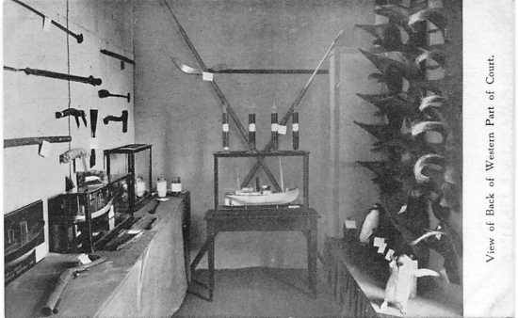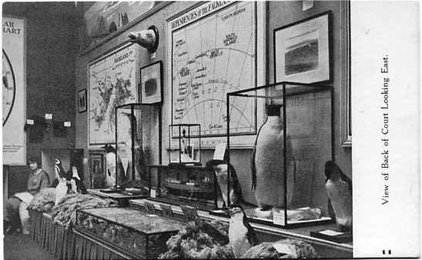
1 2
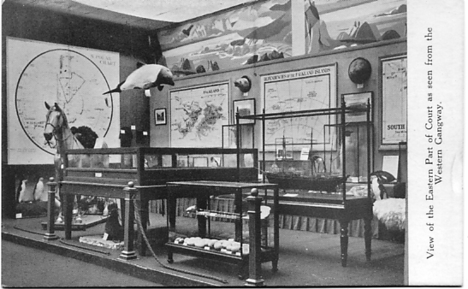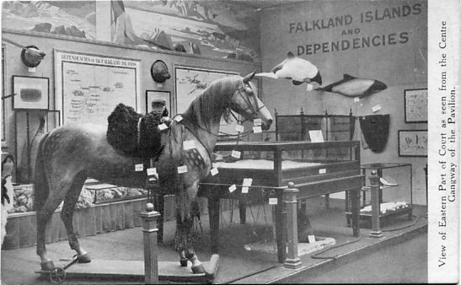
3 4
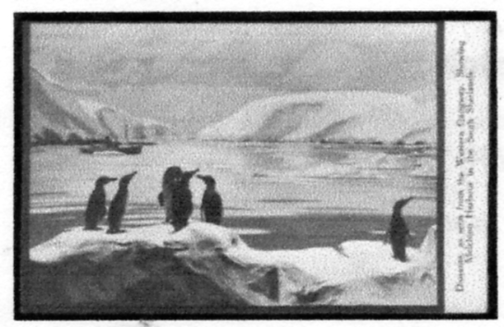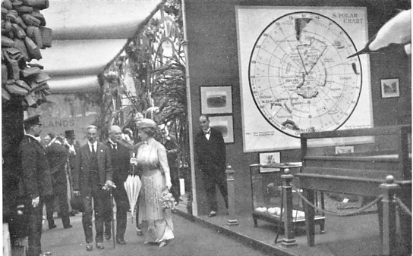
5 6

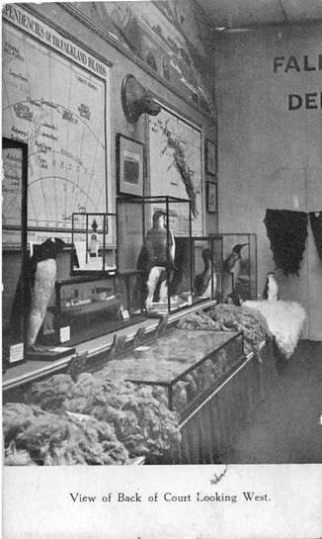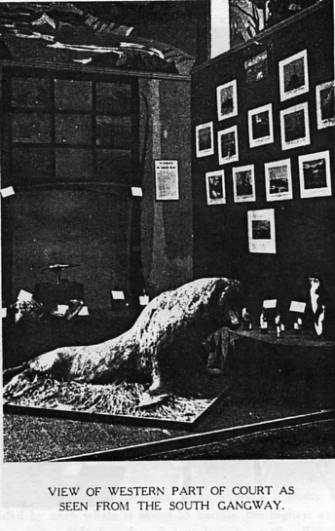
7 8

This is copied from the official guide to the Falkland Islands Court. Since it is unlikely that any reader has ever seen a copy, as the guide must be even rarer than the post cards. It is of interest as it shows what a visitor would have seen if he could put the clock back and visit the Court at the British Empire Exhibition in 1924.

Official 1924 British Empire Exhibition
Guide to the Exhibits at the Falkland Islands Court.

The term Falkland Islands and Dependencies comprehends more than one-and-a-half per cent, of the whole surface of the globe. Within this little Court will be found some of the strangest, most wonderful birds, and the products of whales which, of all animals, have come to take the most important place in the history of the world. Here, too, are models of exploring ships more truly treasure ships than gold-laden galleons of old.
The Charts.
On the wall-to the left is the South Polar Chart with a triangular space coloured off to show the Falkland Islands and Dependencies. This apparently small space consists of a total area of over 3,000,000 square miles, including about 1.000.000 square miles of sea, and a whaling field of more importance than all others in the world combined. It reaches from the Falkland Islands, ice-free and temperate, right down to the fastnesses of the unknown South, and includes part of the Weddell Sea, where are the thickest floes and greatest icebergs ever seen.
Next, on the south wall, is a chart of the Falkland Islands, the total area of which is 4,618 square miles. Their mean daily maximum temperature varies from 40" F. to 55 F. Known under various names, for the last three and a half centuries, the first British settlement was made on Saunders Island, in 1766. Far as they are from any mainland (being 480 miles N.E. of Cape Horn and about 1,000 miles due south of Monte Video), they have been the scene of events that need a book to do them justice. The population is almost entirely of British descent, and the one industry sheep farming; the divisional lines on the chart showing the various sheep-farming stations. Although in 1886 the Falklands sent over to England three times as much frozen mutton as did New South Wales, the chief consideration is now the production of wool, of which, according to the latest report, nearly 5.000,000 lbs. were exported, 1/- to 1/5 per lb. being obtained for fine-grade produce.
Among the exhibits in the Eastern Court, see specimens of Sheep Skins, Fleeces (of hogget, wether, and ewe), and articles made of locally spun wool.
Among the as yet undeveloped products of the islands are the deposits of fine peat, unlike any other in the world (note photographs on wall at the back of the court); workable accumulations of fish are known to exist which might supply the South American market; exploratory boring may bring to light oil-bearing rocks: while the white beach sand, which contains aluminium, may some day be used for making glass.
The only town is Port Stanley, which dates from 1842, and boasts of a cathedral and town hall. Outside Stanley there are no roads, and traveling is done on horseback. In early days, when wild horses and cattle roamed the islands, the capturing and slaughtering was done by Gauchos from Argentina. Hence to-day most terms connected with horses and cattle are Spanish. Note the two sets of riding harness, hand-made from the raw hide at the Falklands. One set is on the model of the horse. Each piece will be found labeled with the Spanish name in use to-day.
In the Eastern Court will also be found illustrations of some of the shy-blossoming, sweet-scented flowers of the Falkland, painted by Mrs. E. F. Vallentin. They include Oxalis enneaphylla (wood sorrel), its pale flowers being found near the sea; Veronica eliiptica, the tallest plant in the islands, with a small white flower, sweet as orange blossom: and Empetrum rubrum (diddle-dee), which covers miles of country like the heather on English moorlands.
N.B.—A copy of the book may be seen on application to the Attendant of the Court.
The most notable day for Port Stanley was the day 8th December, 1914 when the British warships, under Admiral Sturdee, went forth from Port William to defeat the German squadron under Admiral von Spee. In the foreground of the Court is a model of Stanley Harbour and Port William, showing the position of the warships, with the British ships leaving the harbour to meet the Germans.
The Canopus is seen in the inner harbour embedded in the mud as she had been since the middle of November, preparing to defend the colony. Midway in Stanley Harbour is the hulk of the old Great Britain, which, in 1842, was the wonder of the shipping world.
Admiral Sturdee reached Port William on the 7th December with the battle cruisers Invincible, Inflexible, the light cruisers Carnarvon, Cornwall and Kent: the Glasgow, Bristol, and an armed liner. When the German ships, under Admiral von Spee, were sighted, at 7.56 on the morning of the 8th December, the British ships were coaling. the four-funneled Gneisenau and three-funneled Nürnberg approached the nearest, when the Canopus fired at them. They then caught sight of the two battle cruisers and turned away to join the Scharnhorst, the Leipzig and the Dresden being farther away to the southward. The Kent, Glasgow, Invincible, Inflexible, Carnarvon and Cornwall are shown steaming out of the harbour in pursuit.
Off Port Pleasant were the enemy colliers, which were afterwards captured by the Bristol and Macedonia. The signal to engage the enemy was not given until 12.47 the actual engagement took place some miles off Stanley and was over by nightfall. Of the enemy ships, only the Dresden escaped.
Model of the Falkland Islands Battle Memorial.
This is designed and being executed by Mr. Frank Ransom, Carried out in grey granite and bronze, it is to be about 32ft. high, the pedestal will be surmounted by a bronze globe with ship symbolical of the birth of the Navy. In the front will be a bronze figure of Victory, at the back a trophy of flags in bronze,
Charts of the Dependencies.
The whaling field within the Dependencies is of greater importance than all the others in the world combined. Of the population of the Dependencies the greater number are Norwegians, engaged in the whaling industry. The principal islands are,
SOUTH GEORGIA, about 100 miles long with a maximum breadth of 20 miles. It is an alpland with many mountains. The harbours are all on the east coast. At Grytviken is stationed a Resident Magistrate. Five land factories have been set up for treating the whale carcasses brought in.
THE SOUTH SHETLAND ISLANDS lie about 400 miles S.E. of Cape Horn. There are several good harbours open during the summer, notably that of Port Foster in Deception Island, with its hot springs. Much whaling is carried on, but there is only one shore station; the whale catchers are accompanied by vessels known as floating factories, which provide accommodation for the factory hands and have on board large boilers for boiling down the oil. Tank steamers going south, laden with coal and returning with oil, may supersede shore stations in the future. One of the mountains of the group is supposed to be a copper mountain.
Whaling is also carried on about the coasts of Graham Land and the Islands of
THE SOUTH ORKNEY ISLANDS, which lie about 200 miles east of the South Shetlands, and
THE SOUTH SANDWICH ISLANDS, a volcanic group about 250 miles south-east of South Georgia.
Scene in the Antarctic.
The diorama shows a scene outside the harbour of Melchion Island a little island in Dallmann Bay, one of the Palmer Archipelago to the west of Graham Land. It is an attempt to show something of the beauty of Antarctic colouring, with the cold violet-white of icebergs, the delicate gradation of soft blues, lit up at times by a flash of sunlight into flame and gold and dazzling emerald green.
The photographs for this scene were lent by the Southern Whaling and Sealing Company. In the foreground is a whale catcher towing dead whales.

Penguins.
Patient, persevering, lovable, laughable, with moments of deep dignity on land, penguins in the water are like fish, like anything but birds. Here and there in the East Court the following Penguins will be found represented. First and foremost in size and dignity is the
Emperor Penguin (A ptenodytes forsteri). Found only in the far south, these penguins have the peculiarity of nesting during the winter. They lay but one egg, and carry it resting on a small depression of the foot, wedged in between the legs and the lower abdomen, and over it falls a fold of heavily feathered skin, which is very loose and can cover first the egg and then the chick. This fold of skin looks like a pouch: out of it peeps at times a small downy head. The Emperor's voice is loud and trumpet-like; he approaches a stranger with a deep bow. He only loses his dignity when he is in a hurry and sledges himself forward on the ice, using both feet and flippers. He weighs upwards of 80 - 901bs.
King Penguin (Aptenodytes paiagonica). Although not so large as the great Antarctic Emperor, the King is more beautifully marked, with his orange-yellow bands which run below his black throat and widen on the upper breast. They carry their egg as do the Emperor Penguins. They are rarely seen in the Falkland Islands now, only farther south. Note egg in show case.
Jackass Penguin (Sphiniscus magellanicus). The bill is rather long and stout, with forehead, crown, and nape, black shading into slate grey; chin, throat and cheeks black, with broad white stripes enclosing the last and a broad black band across the white breast. They bray like a jackass and make their nests by burrowing in the sand and tussac grass in the Falkland Islands and South Georgia.
Gentoo Penguin (Pygoscelis taeniata). This penguin's white patch over each eye gives it a somewhat blank expression. Its rookeries are sometimes a mile from the sea. A Gentoo will fight to the death in defense of its young. (See Gentoo egg in show case.) South of 63° S. latitude, its place is taken by the
Adelie Land Penguin (Pygoscelis adeliae) has been described as “the most excellent company possible in such a desolate region as the Antarctic.” It makes love in a most ecstatic manner.
The Macaroni Penguin (Catarrhactes chrysolophus) is, as its name denotes, one of the crested penguins, and has a golden yellow eyebrow with stripes of similar feathers joining on the forehead.
Ringed Antarctic (Pygoscelis antarctica). These ringed. or bridled penguins make their rookeries on steep rock-faces close to the sea. They spend many patient hours in climbing up and down from their positions, hopping carefully from ledge to ledge.
Wilson's Storm Petrel (Oceanites oceanicus). This little bird is not much larger than Mother Carey’s chickens, from which, as from any other of the small blackish Petrels, it can be distinguished by its unusually long legs and the bright yellow colour of the webs between the toes; the single egg is of a dull white colour, with minute purplish-red spots at the broader end. After the breeding season the Stormy Petrel wanders widely.
Contents of Show Case.
From right to left (upper shelf)
Necklace and Bracelet of Falkland Islands pebbles, set in gold. (Lent by Mrs. Pole-Evans.)
Belt of Pebbles, set in silver. (Lent by Mrs. Vere Pack.)
Skin of Blue Petrel (Heteroprion desolatus called by sailors “Whale Bird,” and found only in the Ross Sea and round South Georgia. (Lent by Mr. Percy Stammwitz.)
Specimens of bone work Walking Stick (lent by Mr. ]. Miller), Riding Whips (lent by Mr. Vere Packe).
(Lower shelf)
Nine Sperm Whale Teeth.
Five Eggs of the Wandering Albatross (Diomedea Exulans), the largest and strongest of all sea birds it sometimes measures 17 feet between the tips of the extended wings. The main colour of the bird is white (see its skull).
Four Molly Mawk Eggs. The Molly Mawk (Diomedea melanophrys) is the small black-browed albatross found in numbers on the Falkland Islands and South Georgia. With the exception of back, wings, and tail which are a blackish grey, and a dusky superciliary streak, the bird is white.
Two Sea Gull Eggs. The sea gull (Larus Dominicanus) nests in great rookeries, the nests very close together. Three eggs are generally laid about 12th December.
Three Eggs Of the Giant Petrel (Ossifraga gigantea), commonly known as “Nelly”, the vulture of the sea. It is a large ungainly bird on land, but most graceful on the wing, with a powerful yellow beak. It is said it will attack a drowning man.
One King Penguin Egg. One Gentoo Penguin Egg.

Seals.
Sea Lion (Otaria byronia). This is the male of this hair seal, the female being much smaller. Sea lions may be seen in great numbers on the rocks and islets round the Falklands and farther south. The old bulls live to a great age and size, and may be heard roaring out a challenge to a rival to come and fight. They can waddle on their long flapping flippers over greater distances than might be expected.
Under the west wall is the beautiful little Fur Seal (Arctocephalus australis) with its large dark eyes. Ruthless slaughter in the past almost exterminated this species, which is now slowly returning to the Falklands and Dependencies under the protective measures adopted by the Colonial Government. The skins on the wall above show the various stages of development from the time they were received by Messrs. George Rice in a raw, salted state, to the time, from two to three months later, when the skin is ready to be made up by the furrier. As is briefly explained on the labels, the skins pass through many and complicated processes unhairing especially requiring highly skilled work. From seven to nine skins are needed to make up a three-quarter length coat.
Leopard Seal (leptonyx). The skin and skull of this seal is on view in the West Court. It derives its name from the spots on its skin. It is found in the seas round the Falklands and on the pack ice of the south. Note the length of the skull and the large powerful teeth with the peculiar arrangement of the cusps. It is a carnivore, and its maximum length is about 13 feet.
Weddell Seal (Leptonychotes weddelli). (The head may be seen on the wall.) It measures upwards of 9—10 feet, with the enormous girth of 6—7 feet. The coat is richly marked with black and grey and silvery white. It spends much of its time asleep.
Crab-eater Seal (Lobodon carctnophagus). (Head on the same wall.) It is about 8 feet in length and very active. In an old seal the coat sometimes becomes white.
Sea Elephant (Mirounga leonina). In the West Court is a skull of the great sea elephant, the male of which is sometimes 20 feet long. The female is only 8 to 9 feet, and is without the inflatable proboscis from which her mate gets his name. Terrible encounters take place sometimes between the bulls. The body of the sea elephant is covered with a mass of blubber as thick as in a whale. Sealing in the Dependencies now yields annually about 2,509 barrels of oil.
Commerson’s Dolphin. (Cephalorhynchus Commersonii) Hanging from the centre of the East Court is a cast (by Mr. Percy Stammwitz, of the Natural History Museum) of the beautiful Dolphin, known as Commerson's Dolphin after its French discoverer. Its body is a shining, silvery white, only the head, tail and fins being a deep black. It is found in the seas about Cape Horn and Tierra del Fuego.

Whales and Whaling.

The southern whales, the products of which will be found in the West Court, are :
The Right Whale (Balaena australis).
The Blue Whale (Balasnoptera musculus).
The Fin Whale (B. physalus)
The Sei Whale (B. borealis)
The Humpback (Megaptera nodosa). (All whalebone whales).
Sperm or Cachalot Whale (Physeter catodon) (a toothed whale).
(Note ear drum of Firmer Whale, and barnacles from off a whale.)
Whalebone more properly Baleen is a horny substance found in the roof of the whale's mouth. The plates of baleen are triangular in shape, the base of attachment being broader than the lower free extremity. The inner edges are frayed out into hair-like bristles, which serve as a kind of sieve to retain the shrimps and other small organisms on which these whales feed and filter the water through. To prepare baleen for economic use (it is now used principally in the brush trade) it is boiled for about 12 hours until it is soft and is then cut into narrow strips or filaments.
Note on the walls specimens of baleen.
The Right Whale is distinguished by its lack of dorsal fins and the remarkable size, and excellent quality, of its baleen. Its entire length averages 54 feet, the great head being about one-fourth of its total length.
The Blue Whale (so-called because of the bluish tinge of its body) is the largest animal in the world, and has been known to measure 100 feet in length. The baleen is black. (Note sections of vertebra.)
The Fin Whale averages about 65 feet in length, its comparatively slender body is grey. Fin whale baleen is grey, striped with yellowish white.
The Sei Whale is smaller, with a large, truncated dorsal fin. The baleen is bluish black with white bristles.
The Humpback is from 45 to 55 feet long, with a massive form and a flat blunt head. It is of a playful disposition and shows great affection for its young. The baleen is dull black, with brownish black bristles.
The Sperm Whale's greatest length is 70 feet. It has from 18 to 25 teeth on each side of the lower jaw, which fit into sockets in the upper jaw and assist in holding its food (see teeth in show case). It has a catholic appetite, but its favourite food is the giant squid. Its great blunt head contains a cell filled with the spermaceti, from which comes the fluid known as sperm oil (see specimen in Western Court with other whale oil). Refined sperm oil is a most valuable lubricant for all delicate machinery, from large calibre guns to the smallest watches.
Whale Oil.
The oil of other whales is obtained chiefly from the blubber, the whole of the carcass now being in various ways. The demand for whale oil is practically unlimited; during the war the development of its use was phenomenal, since its use in the production of glycerin freed other fats for edible purposes. The average quantity of oil yielded by each whale is about 65 barrels, the highest average known being 86¾ barrels. A barrel contains 40 gallons, and about 6 barrels go to a ton. Whale oil is now about £30 a ton, and the yearly value of the industry is now over £2,000,000. Whale oil is classified into five grades, 0, 1, 2, 3, and 4. (See specimens against the wall.) 0 and 1 are made entirely from the blubber, are of a pale yellow colour and contain a very small quantity of free fatty acids.
The mass in the boiling pans, with the flesh of the whale, is “tried down” under pressure, and 2 is produced. It is brown, with a strong fishy smell, and a higher proportion of fatty acids than in 1.
The bones are then worked up, and yield No. 3. This is bone oil. No. 4 is made from the refuse. It is darker than the above and has a more objectionable smell, with a higher proportion of free fatty acids. The lower grades of whale oil are used for making lubricating greases.
Hardened Whale Oil. The result of hydrogenation is a hard fat, white, odourless and tasteless; a substitute for tallow. 0 and 1 oils, if carefully treated, are edible. So far it has not been much used for making margarine.
Other products shown are,
Bone Meal, made from the bones of the whale; it contains about 4% ammonia and 50% phosphates.
Whale Guano, made from whale flesh, with about one-third of bones. It contains about 8.50% ammonia and about 2I%, tribasic phosphates.
Whale Hunting.
A century ago whales were hunted from the ship s boats, and were harpooned with a hand lance. As an improvement on the hand-lance a bomb-lance was introduced, which was fired from a shoulder gun. Note in the West Court old whaling weapons Hand Harpoon. Bomb Lances. Shoulder Gun. It is during the last thirty years or so that whaling has developed on modern scientific lines, and it is now the sole industry of the Dependencies.
Note the model of the Modern Whaling Gun in the Western Court. It is a glycerin recoil muzzle-loading cannon. The harpoon, which is of steel, and about 6 feet long, has four prongs which spring out to an angle of about 45 degrees on tightening the line after the harpoon is lodged in the whale's body. At the point of the harpoon is a shell charged with gunpowder, which is fired by a time-fuse about three seconds after the harpoon has been shot from the cannon. To a ring in the shank of the harpoon is attached a very strong pliable line, some 60 fathoms long and about 4½ inches in circumference, which is called the forerunner, to which is spliced on another thicker whale line. If a whale be struck in a vulnerable part death is usually instantaneous, and the whale will sink, drawing with it the whale line. The steamer is then brought to a stand still and the rope is passed over the snatch block at the shrouds, from whence it goes to the winch, which raises the whale to the surface. A chain is then passed round the tail and made fast at the bow of the ship, and, after the carcase has been inflated with air, the dead whale is towed at the side of the vessel, tail foremost.
Note the photographs showing various stages of whale hunting in Western Court.
Note also modern whaling implements in the same Court Flensing knife and hook. Forerunner. Tail spade (for cutting off tail flukes) Whale line.
An examination of the fine models of Whale Catchers, exhibited by Messrs. Chr. Salvesen and the Southern Whaling and Sealing Company will illustrate the development of the modern steam whale catcher during the last 20 years. Note the dimensions first of the Busta and her sister ship Foula of 1906. Then turn to the half model of the sister ships Scapa, Silva and Sonja of 1910, the first whale-catchers to be built in Great Britain. They returned to Leith last year after an absence of 13 years spent whaling, chiefly in the South Shetlands, all repairs, etc., being carried out at Leith Harbour, South Georgia. The Subra, built in 1916, has since been whaling from Leith Harbour, South Georgia. (The above are owned by Messrs. Salveson.)
The Southern Maid is the latest model in the Court, and was built by Smiths Dock Co., Ltd., at South Bank, on Tees. She is entirely British. Her dimensions, etc., are Length 110ft., breadth 23ft., moulded depth 13ft. 6in. Indicated h.p. 630. Speed 10 knots. (Owned by the Southern Whaling and Sealing Co.) During the season 1921-22 she fished at South Georgia, for the next two seasons she fished at the South Shetlands.
S-S. DISCOVERY. A model of the first vessel ever built in Great Britain for scientific exploration. Built in Dundee, in 1900-1, for the British Antarctic Expedition of 1901-4, she sailed for the Ross Sea under the leadership of Captain R. F. Scott. Although the model shows her solid hull, short masts, square spars and heavy rigging, it is difficult to realize the strength of her sides, to bore a hole through which would mean getting through 26 inches of solid wood of various kinds, the outer skin being English elm, or green heart. Her stern was an enormous mass of solid wood. Both stern and bow were protected on either side with steel plates. Note also her lifting propeller and rudder.
Twenty years after her return from her battle with Antarctic ice she is to return thither as H.M.C.S. Discovery to study the whaling industry with its attendant questions of hydrography, meteorology, magnetism and tidal work. She is now at Portsmouth, in dry dock under cover, being reconditioned by Messrs. Vosper. It is hoped she will start on her expedition the end of 1924. She will do much of her work under sail only, and possibly she may carry an aeroplane.
Her commanding officer will be Lieutenant J. R. Stenhouse, D.S.O., O.B.E., D.S.C., R.N.R., already well known for his work in Antarctic seas. In the Shackleton Expedition of 1914-17 he brought the Aurora from the Ross Sea safely through drifting ice to New Zealand, thus successfully accomplishing one of the most difficult voyages on record. The Director of Research will be Dr. Stanley W. Kemp, Superintendent of the Zoological Survey of India, in addition to whom four other scientists will be appointed.
V. F. Boyson.
End

Postmarks of the Crystal Palace area.
Part 1. 1898 to 1918.
by
Fred Peskett

In his book ‘The Postal History of the Crystal Palace’ Maurice H. Bristow describes the various cancellations of mail from 1854 to 1936, however, there is one area he did not fully cover, that being the role of the Norwood Chief Office and the various cancellation stamps/dies used on Crystal Palace outgoing mail. I have made an attempt to research this area by examining many hundreds of postcards featuring views of the Crystal Palace sent to family and friends listing the types of cancels from 1898 to 1936.
As stated by Maurice Bristow, Registered letters and Express letters were handed in at one of the two counters in the Palace, either the Western Entrance or the New Book Court. A hand stamp was applied before the mail was sent to the Norwood Chief Office for registration and cancellation of the adhesive stamp or prepaid fee. The general mail including postcards were posted in the letter boxes around the building and grounds, these were also taken to the Norwood Chief Office for cancellation and onward routing.
From 1858 the Norwood Office had in use The London District Post and Suburban Office DUPLEX datestamp with ‘54’ in the upright oval, (figure 1) Just one postcard has been seen with this cancel dated 22nd November 1898, The Norwood SQUARED CIRCLE (Whitney Type 2) (figure 2) is noted from December 22nd 1898 and is in use until at least May 11th 1904. At the same time, from 1st July 1900 a DOUBLE CIRCLE NORWOOD WITH 1 BETWEEN THE RADIAL BARS is noted, (figure 3) this cancel is seen until July 21st 1912 with the majority of cancels between 1905 and 1909. There is one anomaly, with a cancel of this type being dated to July 6th 1921. This may well be a setting error to the date/time/year slug with the 2 and 1 reversed, (no recorded use of this cancel has been recorded after 1912.
During this period one example found is a DOUBLE CIRCLE NORWOOD S.E. WITH A + BETWEEN THE RADIAL BARS (figure 4) this is post dated December 23rd 1906, Also current with the above two cancels is a NORWOOD DOUBLE CIRCLE WITH S.E. BETWEEN THE RADIAL BARS,
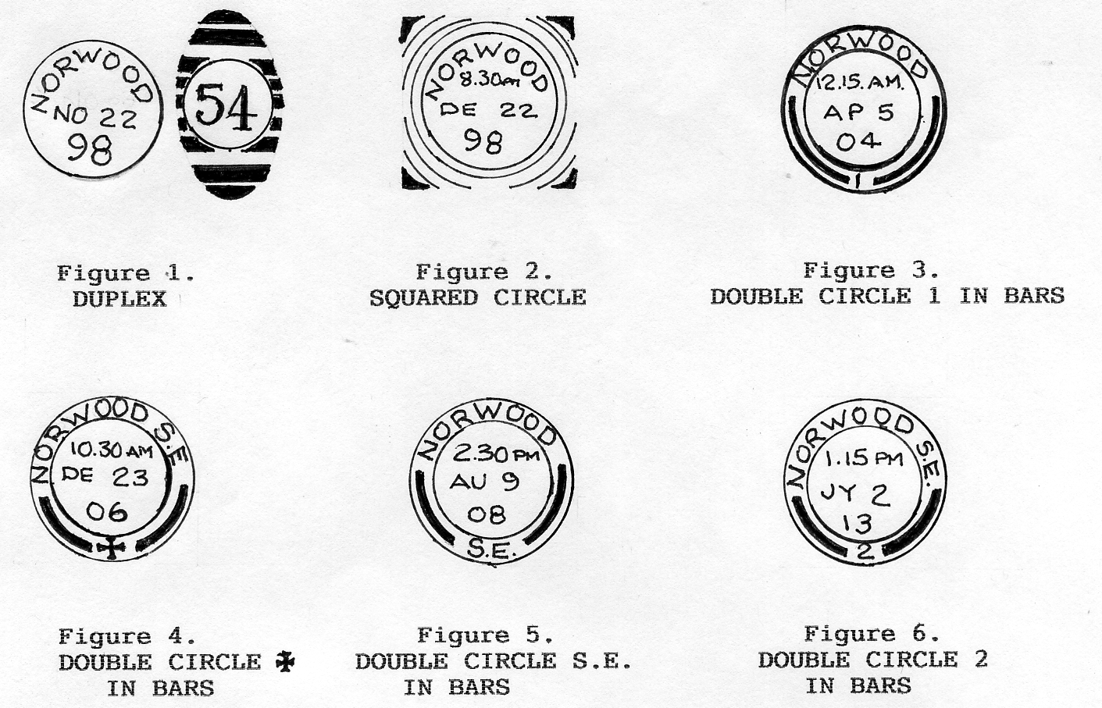

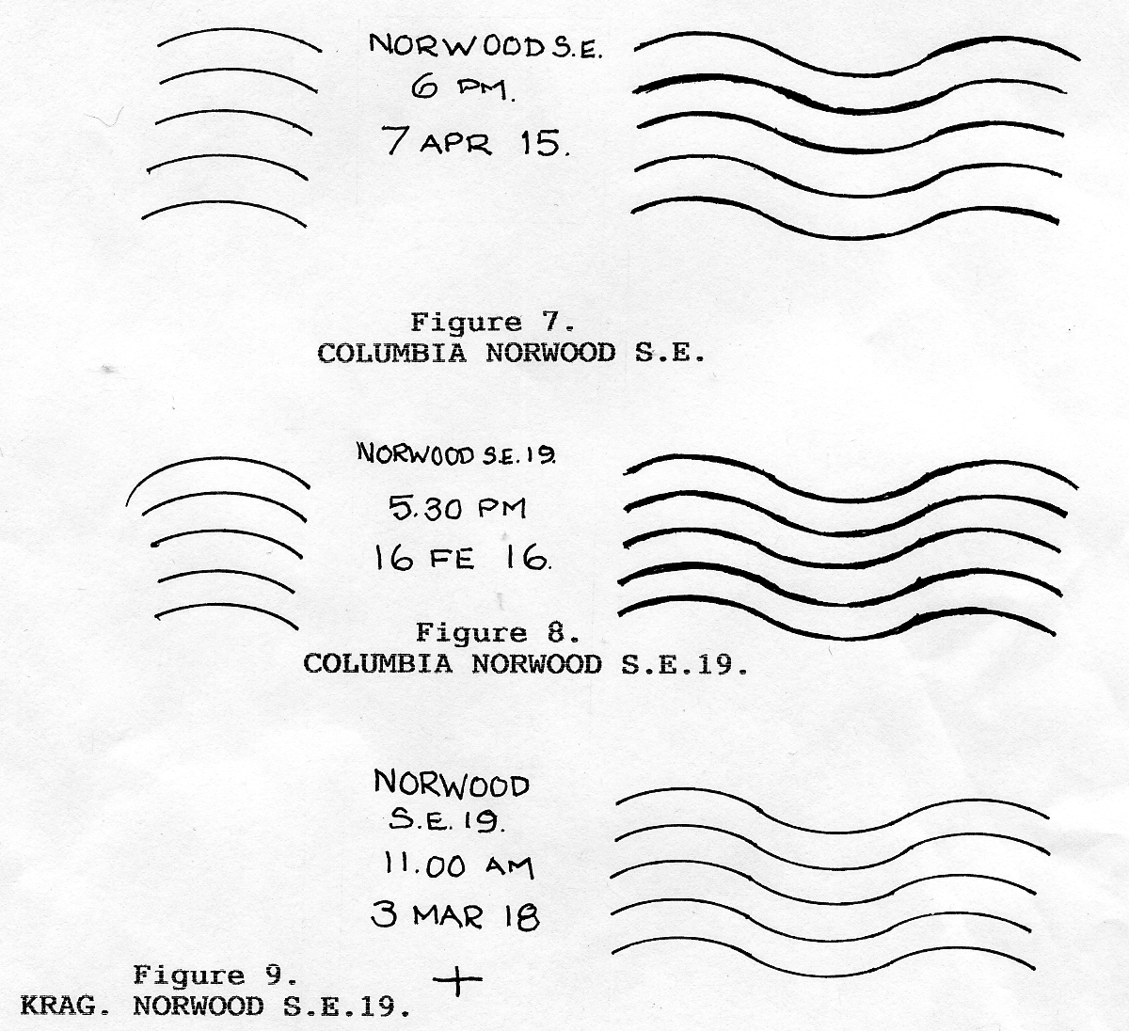

(figure 5) These are recorded between 9th August 1908 to 9th July 1914, with the majority of postcards being cancelled with this mark during May to October 1911 at the Festival of Empire Exhibition.
During 1913 a further NORWOOD DOUBLE CIRCLE S.E. WITH 2 BETWEEN THE RADIAL BARS, (figure 6) occurs. These date between 12th May and 2nd July 1913, and are most likely to be the reserve die from the 1 between the radial bars period.
During the Admiralty occupation of the Crystal Palace, the postal arrangements were similar to those in peacetime, with members of the Y.M.C.A. now collecting letters/postcards from the boxes and taking them to the Norwood Chief Office. With such vast increase in the demand for outgoing mail, the Norwood Office it would seem to have installed a COLUMBIA CONTINUOUS CANCELLING MACHINE. The office slug is NORWOOD S.E. (figure 7} with examples seen from
7th April 1915 to 3rd September 1917, then for a short time NORWOOD S.E.19. (figure 8). The 19 being the London District Code to assist the lady sorters in the Mail Offices.
From some time between September 1917 and February 1918 the machine changes to a KRAG (figure 9) machine with cancels from this machine seen from 3rd March 1918 to the middle of 1919. Cancels from the KRAG machine can be identified by a -*- under the last line of the Time/Date/Year slug, the difference between the COLUMBIA and the early KRAG machine cancels are very minor.
These dates can be plotted year against type to show how and when the cancels were used:-

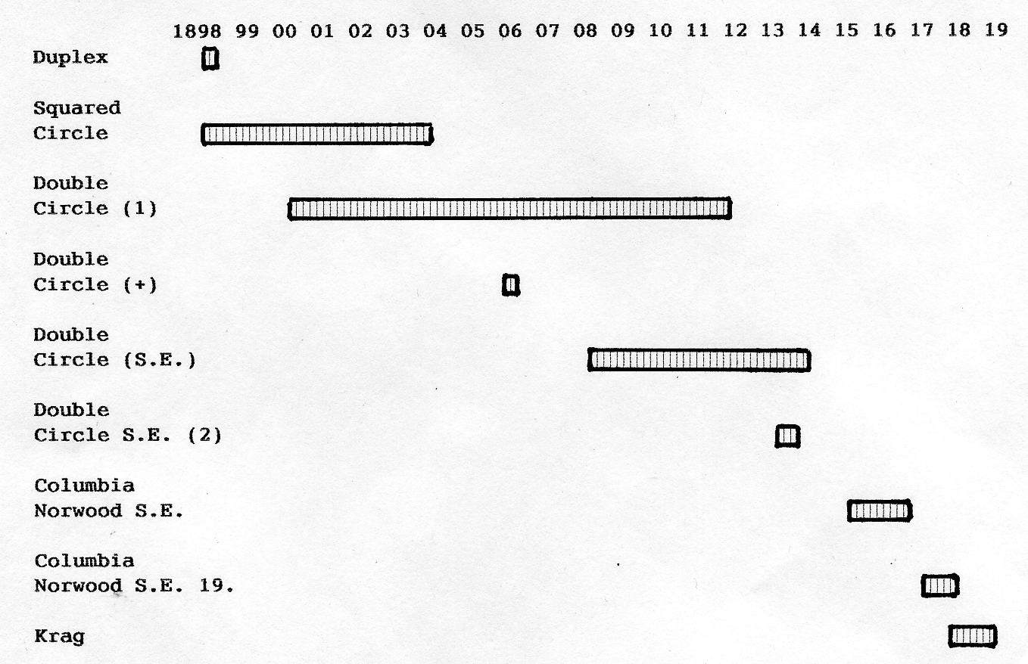

In Part 2 the period between 1920 and 1936 will be described as well as some of the other Post Offices in the Crystal Palace area however, these will have been used to post cards and letters probably on the way to catch buses or trains home after a day at the Palace.
It is appreciated that the dates of the cancels shown may well vary either side of those given according to "used" postcards in other collections. Please forward any additional information to Fred Peskett, 124 Havant Road, North End, Portsmouth P02 OBP. or telephone 02392 665630 so that a more complete picture can be built up.
New post cards

E. Gerrett & Co. R/Photo trade card with black back. A new Wembley card found by Mike Perkins

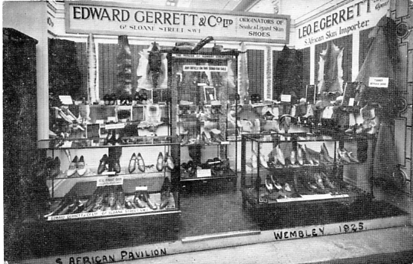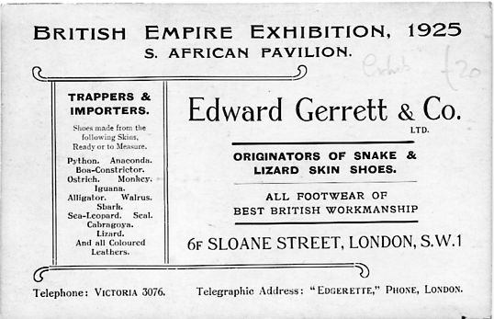

Malaya Pavilion

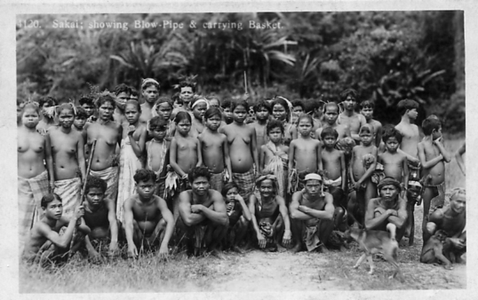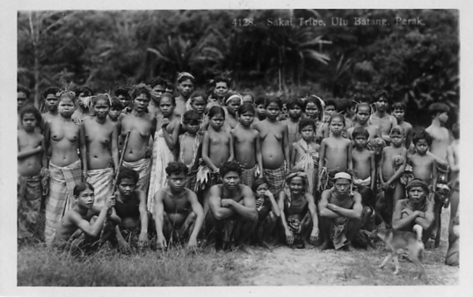

4120 Sakai showing blow-pipe & carrying basket. 4128 Sakai Tribe, Ula Batang, Perak.

R/Photo, black back printed by Houghton Butcher (Eastern) Ltd. It has been noticed after 84 years that a wrong title has been printed on one of this long series of Malaya post cards. The two cards shown above are the same view of a group of natives, but with different numbers, 4120 and 4128 and titles. It is obvious that 4120 does not show a native with a blow pipe and carrying basket. The rightly numbered and titled 4120 this time a vertical card does show a native with a blow pipe and carrying basket

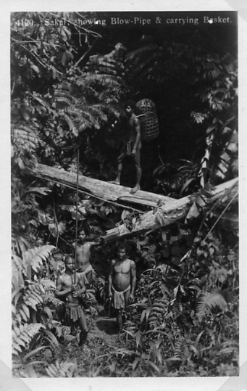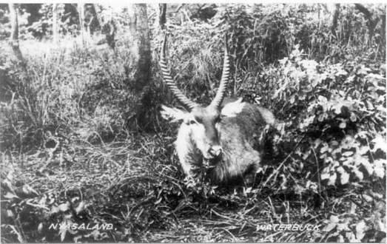

4120 Sakai showing blow- Waterbuck. British Empire Exhibition card
pipe & Carrying basket of Nyasaland not seen before sent in by
Shirley Baker.
The Waterbuck is one of the R/Photo Nyasaland series and we now have twenty titles for this set.

