EDITORIAL WINTER 2008
Caveat emptor as they said in Rome
If you get done, it’s too late to moan

I suppose nobody likes to get caught, and your editors have both been done recently. First Fred who purchased a nice Crystal Palace Festival of Empire card with the very scarce number four duplex hand stamp. When he got it home and examined it carefully he found it was the much commoner number one hand stamp, the cross bar to the four being added in pencil which he removed with a rubber. It has to be said that if Fred fell in the pit, he would come up smelling of violets. When he looked closely at the number one hand stamp he realised it was dated for the last day of the exhibition.
I of course, do not have Fred’s luck, and when I got a friend to buy me a Beckenham post card on E-Bay, I was naturally disappointed to find that the seller, to get the card into a plastic sleeve had cut half an inch off the top of the card. It hadn’t even got a post mark on it to save the day.
An even more dangerous fraud was shown to me by Ken Harman a member of the Study Group who I see once a month at the Croydon Post Card Club. It was a rather faded sepia real photo post card of a view of a row of old houses in Middle Street, Croydon, certainly a pre first Great War view. It had a normal post card back and was not postally used. I don’t know what made Ken suspicious but when he examined it under a glass the real photo turned out to have a screen, proving it was a computer generated copy of a post card. I asked to borrow the card to carry out some tests under an ultra violet light.
Now ultra violet lamps while used extensively by stamp collectors are not used by post card collectors as generally there is no need. Back in 1962 the post office started using a whiter paper for stamps, and this whiteness was obtained by adding an agent to the paper that also causes a fluorescence to show up when exposed to an ultra violet light source. This caught on and now all paper has the whitener added. This confirmed Ken’s doubts as the card fluoresced under ultra violet light.
It’s easy to be wise after the event. When examined Ken’s card has razor sharp edges and corners, certainly not in keeping with a card that should be 100 years old. Another point of contention was the thickness of the card, Ken’s post card was evidently manufactured from glossy photo paper manufactured within the last couple of years for computers and when measured with a micrometer was found to be as not as thick as a genuine old real photo post card.
Glossy photo paper can be purchased for as little as 10p a sheet and you can get four post cards from one sheet. Since topographical post cards now sell for anything between £15.00 and £30.00 or even more. I think we can rest assured that a flood of computer copied post cards will come on the market, either from E-Bay or via the post card fairs, where many dealers will be as easily fooled as collectors.
When both the front and the back are copied from an original post card and printed on glossy photo paper, and the result is put in a plastic sleeve, there are very few collectors who have the knowledge to spot it’s a reproduction or fraud at a fair.
This raises another point, is it a fraud? If the card has a post card back with room for a message on one side, the address on the other side a divider and a stamp box to show you where to stick the stamp, then by all criteria it is a post card. The seller on E-Bay who describes his goods as a post card showing a street scene in, say, West Wickham in about 1907 is not committing any crime for which he could be prosecuted. The buyer who was mistakenly under the impression he was getting a genuine 100 year old post card, was at fault and I should think have no grounds to demand his money back when he discovers his treasure was printed to order.
Perhaps at the end of the day a post card collector is just as happy with an unusual view on a post card and is not really concerned as to whether it is an original or a reproduction, after all he may say to himself, what difference does it make? I know this attitude would not do in the world of stamp collecting where crooks have to be really skilful to deceive the collector, although it can still happen.
For those who do care I suggest you pay particular attention to the condition of the card, if it’s immaculate, has sharp edges and corners and is not postally used, be suspicious. In short if it’s too good to be true, then it probably isn’t true. If the real photo has a screen you can be sure it’s a computer reproduction. Since the man behind the scam can produce any number of the cards at a cost of under 3p each, don’t pay over the top for it.
I see another of our members was among the winners at Beijing, Jack Murray won a medal in the Philatelic Exhibition held during the Olympic Games. Congratulations Jack.
The Editors.
Exhibition Study Group
Minutes of Annual General Meeting
Held at the Ramada Jarvis Hotel, Hatfield on Saturday 27 September 2008

The President, Peter Denly, opened the meeting and remarked on the smiling faces in front of him at the 22 Convention, after what had been a gloomy summer, Seventeen Group members were present and apologies for absence had been received from Andrew Brooks, Ken Rumsey, Ann and Ted Stevens and Richard West and. The President welcomed Bob Farley, the President of the Society of Olympic Collectors. Kenneth Tonkin was thanked for producing and posting the Group Journal at his own expense.
Members stood for a Minutes Silence in memory of George Simner who had passed away in January.
Minutes. The Minutes of the 2007 Convention were proposed by Fred Peskett and seconded by Peter Burrows and were accepted by all as a true record.
Secretary’s report. In his Report, Don Knight spoke about countrywide publicity of the Centenary of the Franco-British Exhibition and that there had been exhibitions staged at Fulham Palace and at Hertford County Hall.
Treasurers Report. Alan Sabey explained the Annual Accounts and invited questions, of which there were none. The acceptance of the Accounts was proposed by Mike Perkins and seconded by Peter Burrows and accepted by all present
Election of Officers. The existing Committee was re-elected. The Accounts Checker is now just George Burr. The proposal coming from Ron Trevelyan and seconded by Flo Simner.
2009 Convention. It was agreed that we would try to return to the Crystal Palace in 2009, subject to their remedial work being completed in time. As one or two members were forced to be absent from the Convention for various reasons, it was decided to change the date to the third weekend of October, which will be 17 &18 October 2009, It is hoped that some members who sent their apologies, would be able to attend on the revised date.
Any Other Business
1 Decision about the remaining stock of the Wembley Exhibition postcard book to rest with the Committee,
2 The next publication should be narrative and illustrations from the Alan Sabey “British Empire Exhibition Philatelic Collection” now sold and dispersed.
3 Members were pleased to learn that Bill Tonkin had been awarded the Desmond Chamberlain Trophy (jointly with Bob Wilcock of the Society of Olympic Collectors) for his book Post Cards of the Great White City 1908-1914 recently published.

The displays at the Convention.

The Committee had decided to commemorate the Centenary of the Franco-British Exhibition and of the 1908 Olympic Games at the White City Stadium with displays of the two occasions.
Don Knight began the displays with a wide range of Franco-British Exhibition postcards by various publishers including the Giant Cards that are not often seen. Don produced a modern mode! of how the fibrous plaster for the buildings was constructed and was then painted. The BBC Television Centre was built on the site of the Court of Honour and a block of the original tiles has been preserved by the BBC. The Exhibition was opened on 14 May 1908 and Don explained how a view of the Royal Pavilion with a group of Royals in front of it had been put together by superimposing the picture of the Group from another occasion onto the view-card of the Royal Pavilion. More “cut and paste” literally, not in the modern computer jargon.
Bob Tough spoke about Airships and Balloon Flights. A balloon had exploded on 14 August 1908 before the first flight and killing the 21 -year-old seamstress. He also showed the Davidson card of the Marathon Runners coming down the hill out of the Castle at Windsor and a modem reproduction of the Rowing card from Henley. There were also enlargements to A3 size of coloured Valentines postcards and post-exhibition period photos.
Bob Farley spoke to the Group about the use of Smart stamps to publicize an event and presented Alan Sabey and Bob Wilcock with their medals for their achievements in the Philatelic Exhibition held in conjunction with the Olympic Games in Beijing.

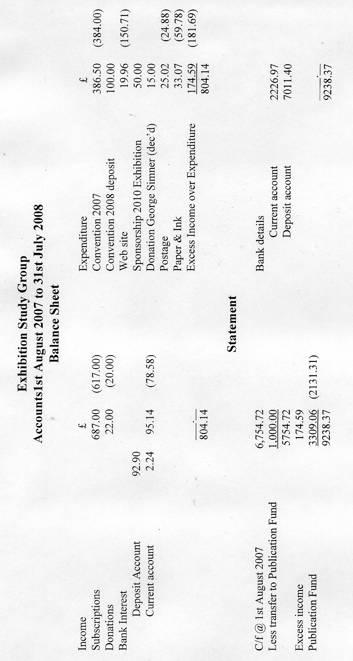

Alan Sabey gave his display of postcards -with the 1908 Olympic Games as their theme. There were scenes in and around the Stadium with publicity banners to be seen and Notices about the Games at the Uxbridge Road Entrance, as well as cards showing a good number of the competitors. These included some scarce Swedish cards.
Bob Farley showed, with permission, a small display from SOC member John Crowther and this included a section of the tape from the finish of the Marathon and an Oak Leaf from Windsor presented to Johnny Hayes, the declared winner of the Marathon.
Fred Peskett ended first day's displays talking about cards, photos and ephemera from the 1951 Festival Gardens in Battersea Park,
On Sunday morning,
Bill Tonkin. Showed a display of the cutting and pasting done so well by Valentines that it had gone un-known and un-noticed for a hundred years until the extent of the operation was unraveled by Bill. He had discovered no less than 160 examples where Valentine had carefully cutout visitors to Franco-British Exhibition and used the cutouts again several years later at other exhibitions.
Derek Connell spoke about London’s link with the 1908 Olympics, the decision to hold the Games being taken at the Mansion House. He also showed vignettes of the Exhibition and spoke about the International Exhibition at Earls Court, the Paris Exhibition of 1900 and the Franco-British Exhibition. The second, third and fourth Olympic Games are linked to exhibitions viz. 1900 Paris, 3904 St. Louis and 1908 Franco-British Exhibition
Ron Trevelyan spoke about the Entente Cordiale and about French exhibitions, bringing in trade for hotels and other businesses. The 1889 Exhibition with the Eiffel Tower marked the Centenary of the French Revolution There was a moving platform to transport visitors around the site. The decision by the French in December 1898 to issue commemorative stamps came about with their issue on 4 December 1900.
Ray Goodey spoke of and showed newly acquired covers to add to his British Empire Exhibition collection and the Cinderella publicity labels. He spoke about the designs submitted by various invited and uninvited persons and the new British Empire Exhibition stamps of GB.
Don Knight ended the displays talking about the Scottish National Exhibition also in 1908 and the Ballymaclinton and Senegalese Villages.
It was estimated that over me whole weekend some 1,500 postcards had been on show.

Some years ago I remember Arthur Smith sent me a photo-copy of a post card of one of the scenes of a play named ‘Our Miss Gibbs’ put on at the Gaiety Theatre with the comment that a scene of the play took place at the White City. At this years Post Card Show one of the displays mounted on boards showed a series of post cards featuring this Edwardian play ‘Our Miss Gibbs’ with the White City back cloth. I spoke to Brian Lund who was able to arrange a meeting with Ken Reeves the owner of the display and I took the opportunity to ask for some photo-copies of his post cards, which he kindly forwarded to me. Ken not only sent me scans of the cards but some notes which I reproduce herewith.

Our Miss Gibbs
by Ken Reeves

Our Miss Gibbs was a two act musical comedy play which was staged at the Gaiety Theatre. The Gaiety Theatre, in common with all West End theaters featuring musical comedy plays in the late Victorian and early twentieth century eras, spared little expense in devising stage sets. Accordingly the Gaiety's second act stage set for Our Miss Gibbs was no roughly produced replica of part of the White City’s Court of Honour.
The play scene series of postcards which show features of this second act set were parts of the 7460 and the entirety of the 7461 Rotary Photographic Series. The 7459 Rotary series was entirely devoted to action which took place against the musical play's first act set background. Each of the series featured numbered cards with letter suffixes which ran from A to F. Unfortunately, as you are undoubtedly aware, it cannot be assumed in the picture postcard world that there is only one image which pertains to every coded card. Hence 7460C comes with two images (or, perhaps I should say guardedly, at least two) and so does 7461E. Here then, to the exclusion of card images for 7459A to F and 7460A and B which feature only the Our Miss Gibbs first act backdrop, are the card images for 7460C to F and 7461A to F which show the Our Miss Gibbs White City's Court of Honour setting. I've also enclosed, as you requested, an image of the back of one of the cards.
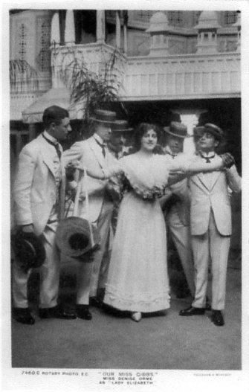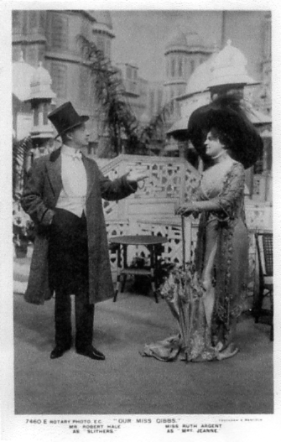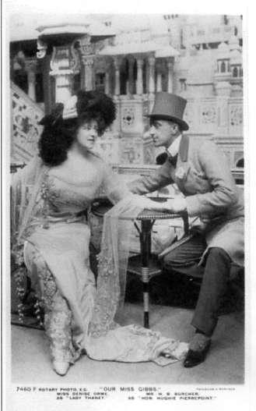
7460 C 7460 E 7460 F

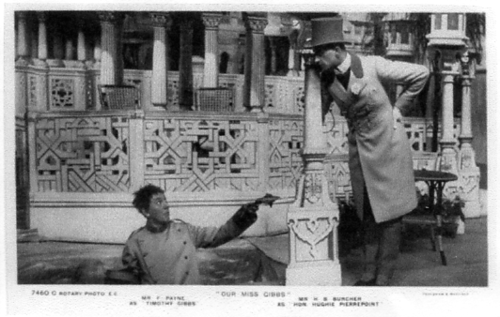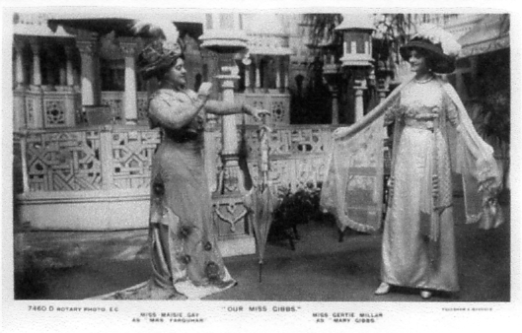
7460 C 7460 D
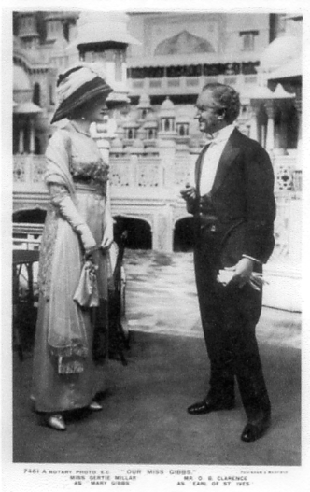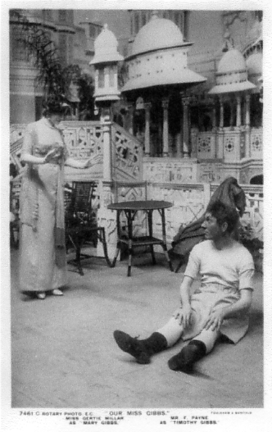
7461 A 7461 C

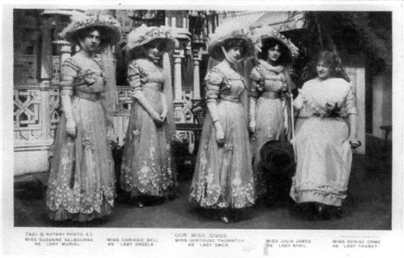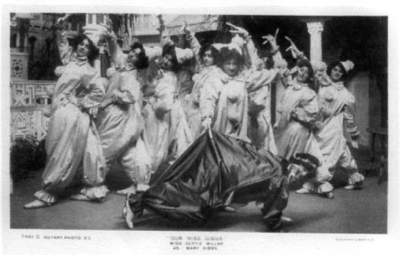
7461 B 7461 D

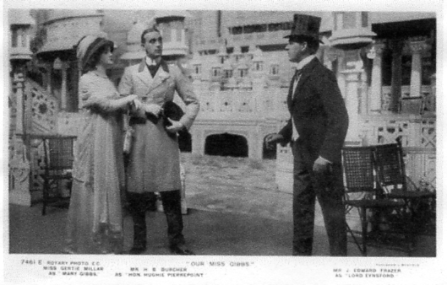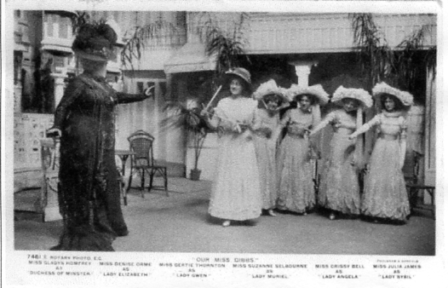
7461 E 7461 E

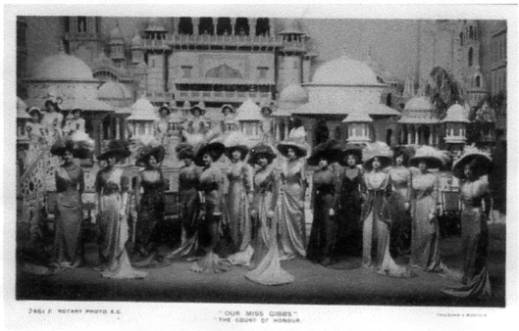
7461F

A Nostalgic last trip to Wembley
by
Alan Sabey

The glory that was Wembley is almost gone. I went there a couple of weeks ago for a tour of the Stadium. It was something I felt I should do once and its very impressive inside and from what I remember of the old Stadium, makes that look very downmarket. Whereas the old stadium had the bust of Sir Arthur Elvin on the upper terraces, the new one has a life-size statue of Bobby Moore.
I asked the tour guide about the Museum that was to be created with items from the old stadium but he was unsure of its progress.
The Palace of Arts portico and Basilica, Poster Street next to it and the frontage of the Palace of Industry have all gone and the frontage of the Palace of Industry is now restricted car parking. I noticed that some of the roof trusses have been partially retained and form an ornamental edge to the south facing front of the remains of that Palace. The companies along the side of the building facing onto Olympic Way are still there, so at least one small part of an original building remains.
The rest of the land surrounding Wembley Stadium (as it is termed on planning consent notices I receive on behalf of Wembley History Society) will be built as housing and retail blocks. One block on the corner of Empire Way seems almost complete.
Wembley as we remember it, we still adore you and may you rest in peace.

Odd Snippets

Here is an interesting little snippet sent in by Ken Harman who recently went on a guided ‘Open day’ tour of the Foreign & Commonwealth Office in King Charles Street SW1. This is an extract from the guide sheet.
The large painting on the corridor wall is entitled ‘India’s Homage to the Tomb of the Unknown Warrior in Westminster Abbey’ (Frank O. Salisbury, 1924). It was presented by the artist at the conclusion of the British Empire Exhibition, Wembley, where it had hung in the Bengal Court. The Earl of Birkenhead, Secretary of State for India, unveiled the painting at the India Office on 11 December 1924.
Postcards of the Great White City Exhibitions
1908 - 1914
by Bill Tonkin

662 pages profusely illustrated, this is the book I have always wanted to write. It was started about twenty years ago but for the last couple of years I have worked nearly non-stop to get it published in 2008 the Centenary year of the Franco-British Exhibition.

It covers in depth the seven exhibitions held at Imre Kiralfy’s Shepherds Bush Exhibition ground, The Franco-British 1908, The Imperial International 1909, The Japan-British 1910, The Coronation 1911, The Latin-British 1912, The National Gas 1913 and The Anglo American 1914.

The first 251 pages covers all the smaller publishers of postcards from A-N Paris to “Zog” the paint cleaner. It is as far as is known the most complete listing of all the postcards they produced for the exhibitions from the Franco-British Exhibition to the Anglo-American Exposition. Only one postcard was published for The National Gas Exhibition by an unknown publisher.

The rest of the book is concerned with the out put of Valentine & Sons. 26 pages deal with the “cut and paste” method used by them to produce so many of their views. I scanned and enlarged over 600 people at White City exhibitions to find to my surprise that no less than 160 people were cut out and pasted onto other exhibition scenes, some people being used three or four times, appearing as far away as Crystal Palace, Glasgow and even tripping abroad to Belgium. And Valentine got away with it for a hundred years before it has been exposed.

164 pages list all of the Valentine Franco-British Exhibition postcards in the only listing ever attempted of this popular exhibition.

43 pages are devoted to postcards titled “The Great White City” used from 1908 to 1912 published by Valentine.

44 pages cover the postcards of The Imperial International Exhibition published by Valentine.

73 pages deal with the Japan-British Exhibition postcards published by Valentine. In the small publishers section are listed some of the most beautiful post cards ever published for an exhibition by such firms as Formosa Tea, The Imperial Government Railways of Japan and Raphael Tuck.

29 pages cover Valentine’s The Coronation Exhibition.

13 pages for Valentine’s The Latin-British Exhibition.

Only 2 pages for the seven postcards which was Valentine’s total out put for the Anglo-American Exposition before Gale & Polden took over the contract.

This truly magnificent book for £30 plus £7 postage to members in UK. £40 to non members
from Bill Tonkin. 23, Bramley Way, West Wickham, Kent. BR4 9NT phone 020 8777 8861
Statue from the 1938 Empire Exhibition, Glasgow
By
Ken Harman

During a recent holiday in Scotland organized by the excellent coach firm “Lochs & Glens”, there was a visit each day to at least one National Trust for Scotland property. One of these was Greenbank Gardens south-west of Glasgow. Although the house remains, it is the garden one goes to see for it has been well-restored by the Trust. There are divided sections and in one of these I found a rather fine statue with fountain giving visitors a refreshing spray. Then I found a small plaque set in the paving at the pond edge, and to my surprise, this informed me that the figure was originally on show at the 1938 Empire Exhibition, Glasgow.
It is entitled “Foam” and was sculpted by Charles d’Orville Pilkington Jackson for the Exhibition which had been held in Bellahouston Park. Although I did not visit this park, I understand that one building from the 1938 Exhibition remains (the Palace of Art) although it has been altered somewhat over the years. The artist kept the statue but after his death in 1973, his trustees gifted it to the National Trust for Scotland (in 1983). The Trust then chose Greenbank Gardens to display it as it is the nearest Trust site to Bellahouston Park.
Looking at the statue today one can spot the unmistakably clean-lines of the 1930s, the style which has come to be known as “Art Deco”. “Foam” appears to be a work of merit and is most attractively sited in the gardens. A little gentle research on “the web” reveals that Jackson was born at Garlennick, Cornwall in 1887 and studied sculpture at the Edinburgh College of Art after winning a traveling scholarship. He obviously “dug-in” for he then taught at the same college and executed architectural and public sculpture in Scotland for many years. Amongst his works are the Rothesay War memorial (1922), panels of David Livingstone at Blantyre together with a fountain called the “World Fountain”, the 1938 “Foam” fountain (about which we now know), gates at the University of Glasgow, and last but not least, the statue of Robert the Bruce at Bannockburn which was finished in 1964.

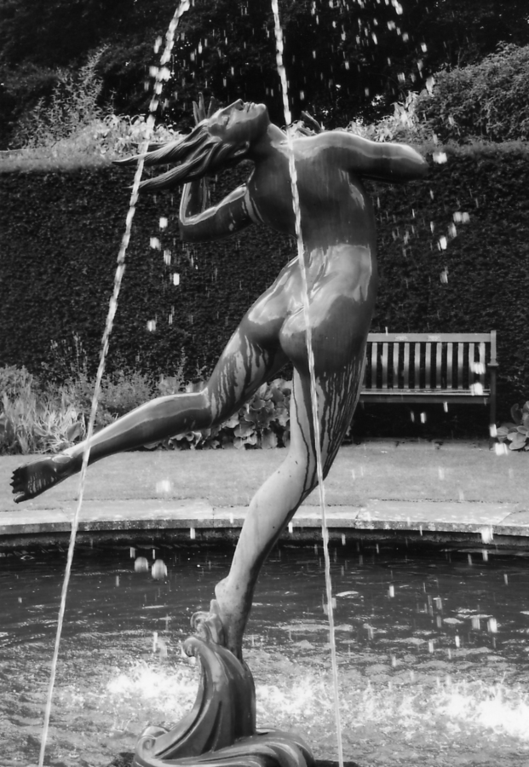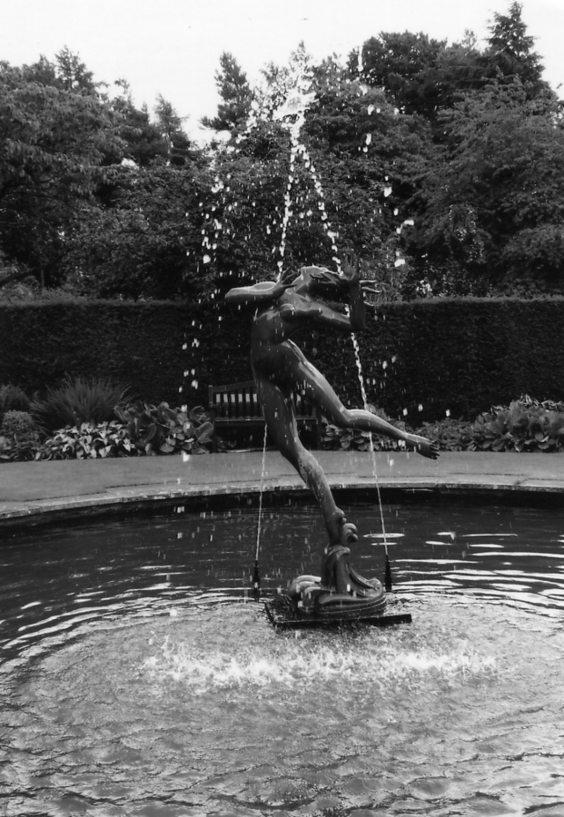

1938 Glasgow Empire Exhibition statue at Greenbank Gardens south-west of Glasgow.
White City Advertising Labels Part 2
by
Bill Tonkin
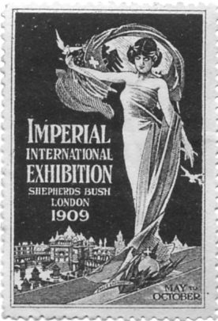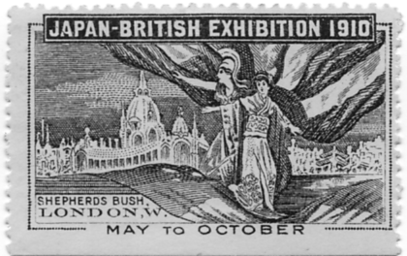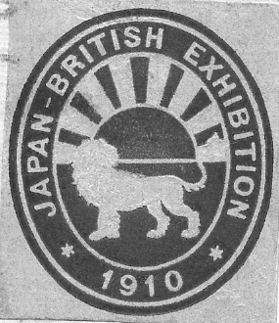
Fig Imp Ex 1. Fig J-B Ex 1. Fig. J-B Ex 2.

Imperial International Exhibition 1909

General labels
Woman with dove and exhibition grounds in back ground.
Perf 11, 31 x 48 mm. Fig. Imp Ex 1.
Blue

Exhibitors labels
Woman with dove and exhibition grounds in back ground, overprinted in red ‘Stand 137’.
Perf 11, 31 x 48 mm. (No illustration)
Blue

Japan-British Exhibition 1910

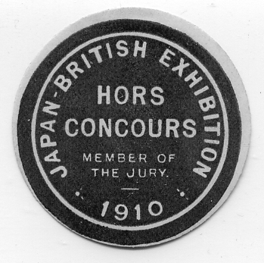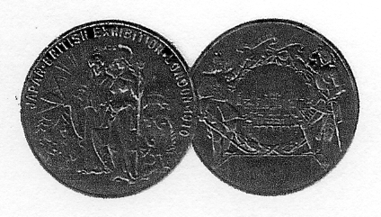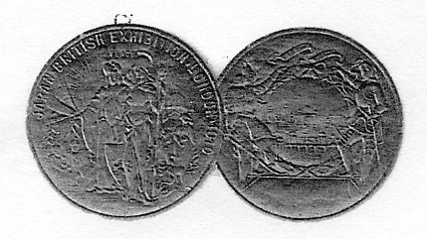

Fig. J-B Ex 3. Fig. J-B Ex 4 Fig. J-B 5

General labels
Britannia and Japanese Lady with exhibition grounds in back ground.
Perf 11, 48 x 29 mm. Fig. J-B Ex 1.
Blue
Lion and rising sun.
Oval imperf label 35 x 40 mm. Fig. J-B Ex 2.
Red on white paper.

Round type labels
Hors Concours Member of the Jury.
Round 38 mm. diam. Fig. J-B Ex 3.
Purple on white paper
Grand Prix award labels
Two joined imperf round labels 25 mm. diam. Fig. J-B Ex 4.
Brown.
Gold medal award labels
Two joined imperf round labels 25 mm. diam. Fig. J-B Ex 5.
Gold.

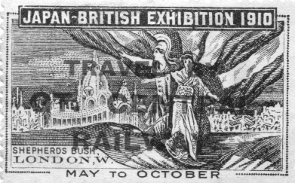
Fig. J-B Ex 6

Exhibitors labels
Britannia and Japanese Lady with exhibition grounds in back ground Fig. J-B 6, Blue, Perf 11 or mixed perf, 48 x 29 mm.
A. Overprinted in red ‘Travel by Gt. Central Railway’. Mixed perf from the top clockwise, 11, 10, 9½ and 11
B. Overprinted in red ‘Travel by Gt. Central Railway’. Perf 11
C. Inverted overprint in red ‘Travel by Gt. Central Railway’. Perf 11

Coronation Exhibition 1911

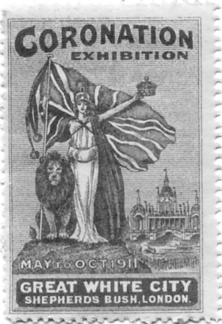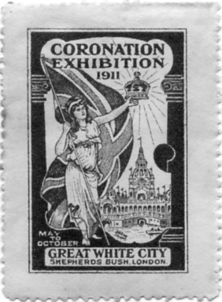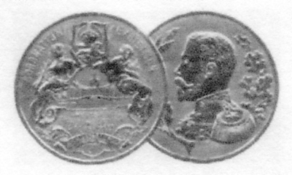
Fig. Cor Ex 1. Fig. Cor Ex 2. Fig. Cor Ex 3.

General labels
Britannia with lion at her side.
Perf 11½, 30 x 47 mm. Fig. Cor Ex 1.
Blue
Green
Purple
Red
Britannia without lion at her side.
26 x 40 mm. with large margins. Fig. Cor Ex 2.
Blue
Brown
Green
Purple
Red

Exhibitors labels
Bowesfield Steel Co., Ltd. Gold medal award label.
Two joined round medal labels 26 mm. diam. Fig. Cor Ex 3.
Gold.

National Gas Exhibition 1913

General labels
Boedicea with chariot on plinth with ‘Come to the National Gas Exhibition’ .
Perf 11, 49 x 30 mm. Fig. Gas Ex 1.
Multi coloured

Visit the National Gas Exhibition.
Imperf, 45 x 63 mm. Fig. Gas Ex 2.
Blue and orange

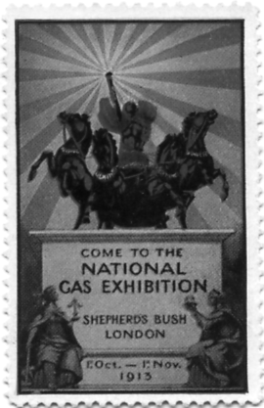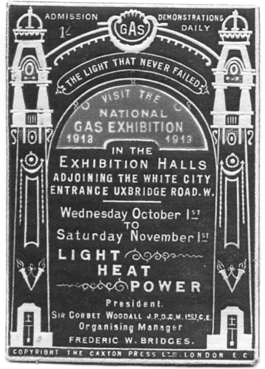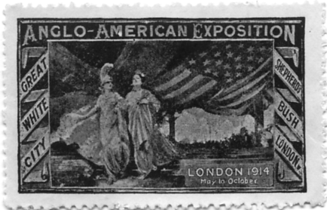
Fig. Gas Ex 1. Fig. Gas Ex 2. Fig. A-A Ex 1.

Anglo-American Exposition 1914
General labels
Britannia and American allegorical lady with American flag and exhibition grounds in back ground.
Perf 11, 49 x 30 mm. Fig. A-A Ex 1.
Blue

Souvenir View Albums by Crystal Palace Postcard Publishers.
by
Fred Peskett

Several of the postcard publishers used the same negatives for the production of albums of views of the Crystal Palace. In some albums there are other views which have not as yet been identified in the postcard form, but never-the-less may well exist as such.
From 1854 to 1870 there seems to be several Official Crystal Palace Photographers, Gogerty, Delamotte and Negretti. All of these produced Stereographs, of which several bear a great similarity to postcards printed after 1900. In 1870 the “Official” title went to J. Russell, it is likely that many of the Negretti negatives were passed to Russell, by reason of the many cards published by this photographer showing the North Transept which was destroyed in 1866. Russell passed the title on to T. Everitt in 1914, and finally it went to Photochrom in 1920.

Souvenir Album of the Crystal Palace. F.P. & S. London.
Book one. Red card, covers, bound, embossed with geometric design Gothic lettering infilled with gold. 7½" x 5½". Pull out panorama with 15 views which have been hand drawn from photographs. Black and white with a tint of blue on glossed paper. (These views may well have been original photographs by Negretti) Circa 1867 to 1870. The books are known with three patterns of embossing on the covers, these are illustrated as type 1, 2 and 3. The Albums must have been produced after 1867 by reason of view shown at No 12.
Type 1 The embossed designs at the top and bottom of the cover are repetitive and consist of two halves of a design or full designs. Type 1 contains a half a design, full design, full design, full design and half a design.
Type 2 Contains four repetitive complete embossed designs at the top and bottom of the cover the same as type 1, but in this case they are now all full designs with no half designs, giving full design, full design, full design, full design. There are other minor differences in the embossing.
Type 3 Is an entirely new designed cover with very shallow embossing, or perhaps it’s only the pressure caused by the gold blocking. The designs at the top and bottom are different and a new type and consist of four complete designs at the top and three at the bottom.
1st View General view (From the Grounds, shows North Transept)
2nd View North Nave. (Vertical view of the interior)
3rd View South Nave. (Vertical view of the interior)
4th View Egyptian Court.
5th View The Pompeian Court.
6th View Orchestra.
7th View Interior. (Facing Medieval Court)
8th View Alhambra Court.
9th View Greek Court.
10th View The Byzantine Court.

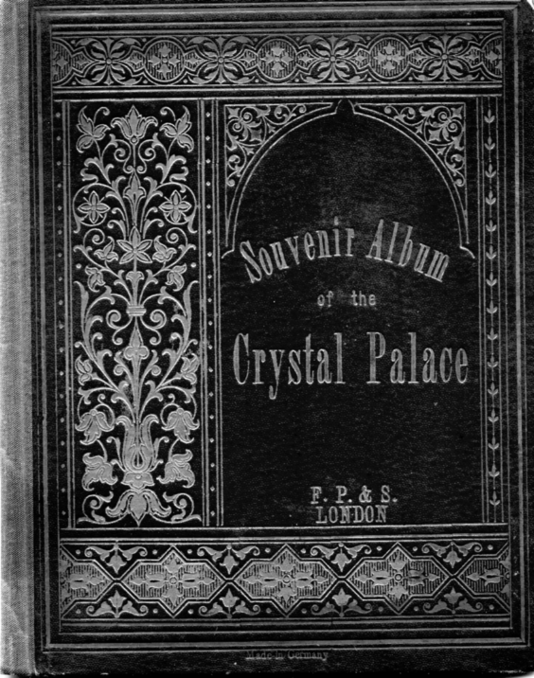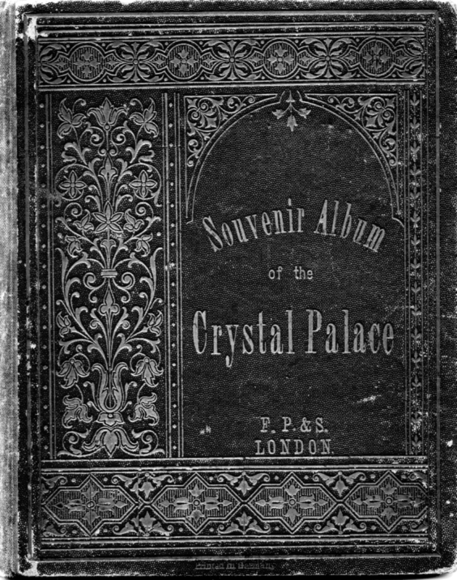
Souvenir Album of the Crystal Palace Type 1 Souvenir Album of the Crystal Palace Type 2

11th View Exterior from South. (Showing North Transept)
12th View Exterior. (View looking towards North Tower without the North Transept)
13th View Gardens.
14th View Italian Court. (Half size view)
15th View Sculpture. (Half size view)

The Royal Album of Crystal Palace Views
Book two. This book is very similar to the F. P. & S London books listed above and may well have come from the same stable. 7½" x 5½". Pull out panorama with twelve views (Unless the last page has been cut out) but each drawing which is almost identical, has been altered very slightly, usually by drawing in one or two extra visitors and the white line box round the illustrations is replaced by a red line. All the titles are the same although they are printed in a different order. The missing views are the 7th view Interior and the 14th and 15th the half size views)
1st View General view (From the Grounds, shows North Transept)
2nd View Alhambra Court.
3rd View North Nave. (Vertical view of the interior)
4th View Greek Court.
5th View South Nave. (Vertical view of the interior)

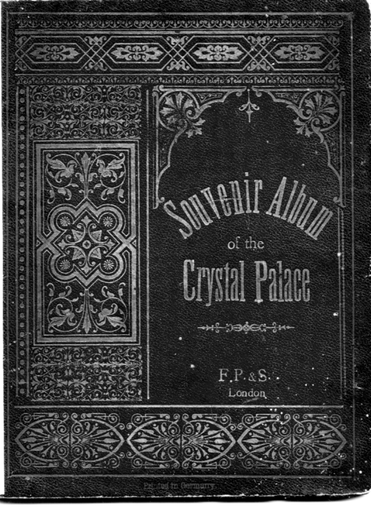
Souvenir Album of the Crystal Palace Type 3

6th View The Byzantine Court.
7th View Egyptian Court. Interior. (Facing Medieval Court)
8th View Exterior from South. (Showing North Transept)
9th View The Pompeian Court.
10th View Exterior. (View looking towards North Tower without the North Transept)
11th View Orchestra.
12th View Gardens.

The New Album of London.
Book three. This book again is very similar to the F. P. & S London books listed above and may well have come from the same publisher as The Royal Album of Crystal Palace Views. 7¼" x 5½". Pull out panorama with 27 views As its title would imply it includes 17 London views at the beginning. This is followed by two full size Crystal Palace views and eight half size views. Unfortunately the illustration of the cover has not come out very well as nearly all the gold blocking has come off and the cover is left in the same colour red overall. We have not listed the London views in this book. Again the views are very similar with mainly just a few extra visitors drawn in. From view 20 to 27 the views are all half size.
18th View Crystal Palace. (This is similar to the view titled ‘Crystal Palace’ in book one and two.)
19th View Crystal Palace Interior. (This is similar to the view titled ‘Interior’ in book one.)
20th View Sculpture
21st View Alhambra Court
22nd View Egyptian Court
23rd View Pompeian Court
24th View Italian Court. (This is similar to the view titled ‘Italian Court’ in book one.)
25th View Sculpture. (This is similar to the view titled ‘Sculpture’ in book one.)
26th View Byzantian Court
27th View Mediaeval Court

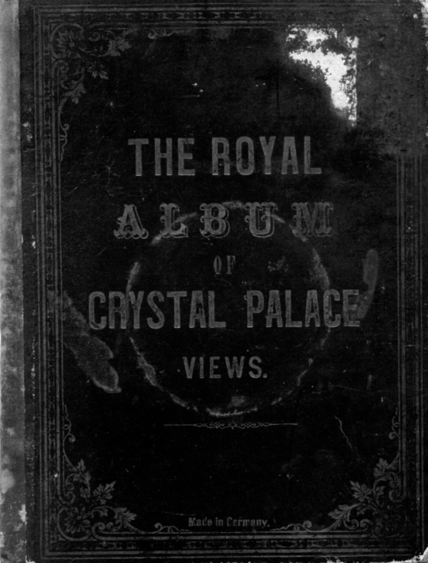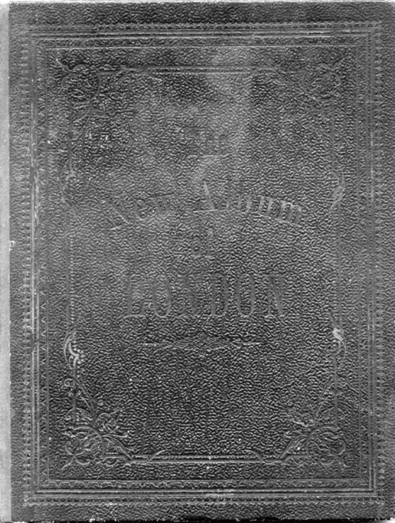

The Royal Album of Crystal Palace Views The New Album of London

Russell & Sons “Crystal Palace View Album”.
Book four. Hard card red covers with the lettering and the Crystal Palace embossed in gold. Pull out panorama of nine views circa 1905.
1st View Crystal Palace and Grounds, Long view taken from the north west corner which shows the North Transept which was destroyed by fire in 1866.
2nd View Crystal Palace, view of Central Transept and South Tower with fountains in the foreground.
3rd View South Nave, looking north.) Interior Views by Russell
4th View North Nave, looking south.) both are known as postcard views.
5th View Handel Festival and Orchestra. (Main view) Three small insets (a) Crystal Palace, Orchestra, (b) Mr. Walter Hedgecock, Musical Director, (c) The Dulwich Philharmonic Society, (postcards not seen of the insets.)
6th View Football Grounds, Final Tie Day and Main view of ground with goal mouth inset. (Neither seen as postcard views.)
7th View North Tower Gardens. Main view is The Fairy Archipelago (seen as a postcard) with two views of the Topsy Turvy Railway, The Rapids, two views. (All seen as postcards) The Bandstand. (Not seen as a postcard) and Front view of the Crystal Palace, 1866 View. (Seen as a card)
8th View Extinct Animals. Main picture known as a postcard, the four insets of the animals are not known as postcards.
9th View Fireworks Display. Main picture known as a postcard but the inset of the Crystal Palace is not.

J. Russell & Sons, Crystal Palace Views.
Book five. Fifteen views in hard card covers red binding with Crystal Palace view and lettering embossed in gold. 10 ¼" x 7 ¼", dated 1907
1st, - 4th Views as the 1905 album.
5th View Pompeian Court and inset both known as a postcard.
6th View The Alhambra Court, Main view known as a postcard, four small insets of the Court not known. Two further insets of statuary (both known as postcards)
7th View The Greek Court and Statuary. Main picture and twelve insets all known as postcards.
8th View Panorama of the Crystal Palace, (post 1866, not known as a postcard)
9th View Egyptian Court. Main view known as a postcard, six inset views are not)
10th View Football Ground. As the 1905 album views.
11th View North Tower Gardens.)
12th View Crystal Palace Sports. Main view of the Maze known as a post card but the six views of sporting activities are not.
13th View The Lakes. Main view known as a postcard, the three insets are not.
14th View Extinct Animals, as the 1905 album views.
15th View Fireworks Display, as the 1905 album views.

General Guide and Souvenir of the Crystal Palace.
Book six. Published by J.J. Kelhier, London, with sixteen coloured photographs by J. Russell and Sons. C1910. Soft green thin card covers Printing in brown. 10" x 7". The colour views are negatives which have been hand tinted prior to printing.
1st View The Great Centre Fountain. (Not known as a postcard)
2nd View The Grand Nave. (Known as a postcard by Russell.)
3rd View The Handel Festival Choir. (Known as a postcard.)
4th View The Alhambra Court. (Not known as a postcard.)
5th View The Egyptian Court. (Known as a B/W real photo postcard)
6th View The Mediaeval Court. (Known as a colour postcard.)
7th View The Renaissance Court. (Not known as a postcard.)
8th View The Italian Court. (Not known as a postcard.)
9th View The Pompeian House. (Not known as a postcard.)
10th View The Lower Lake and Extinct Animals. (Known as postcard)
11th View The Lower Lake for Boating & Fishing, (Known as a postcard)
12th View The Cycle Track. (Not known as a postcard.)
13th View The Lower Lake and Rustic Bridge. (Known as a postcard)
14th View The Lower Lake for Aquatic Sports (Not known as postcard)
15th View The Cricket Ground. (Not known as a postcard.)
16th View The Football Ground. (Not known as a postcard.)

Crystal Palace Illustrated Souvenir.
Book seven. Printed by J. J. Keliher and Co., Official Printers to the Crystal Palace. 33 King William Street, E.G. and Marshalsea Works, Boro' S.E. Undated but before 1899 (*probably during 1898, see note at foot of text) All photographs by J. Russell.
Red card covers, stapled. Black title, 7¼" x 9¾". 16 views.
1st View The Great Centre Fountain. (Seen as a postcard)
2nd View The Grand Nave. (Seen as a postcard)
3rd View The Lower Lake, devoted to Boating and Fishing. (Seen as a postcard)
4th View The Cycle Track, (Not seen as postcard)
5th View The Football Ground. (Not seen as postcard)
6th View The Cricket Ground. (Not seen as postcard)
7th View View of Lower Lake spanned by rustic bridge, (Seen as a postcard)
8th View View of Lower Lake, devoted to Boating and Aquatic Sports. (Not seen as a postcard)
9th View The Lower Lake with Extinct Animals. (Seen as a postcard)
10th View The Pompeian House. (Seen as a postcard)
11th View View no The Egyptian Court. (Seen as a postcard by Hartmann)
12th View The Medieval Court. (Seen as a postcard)
13th View The Renaissance Court. (Seen as a postcard)
14th View The Italian Court. (Not seen as a postcard)
15th View The Alhambra Court. (Seen as a postcard)
16th View The Handel Festival Choir. (Seen as a postcard)
*In the text. a chapter “The Park and Gardens” the following gives a clue as to the date of publication. “perhaps the Palace grounds are seen to the best advantage, when they are illuminated. and the coloured electric and gas illuminations will be more extensive and beautiful than ever during the coming summer season of 1899. The Great Fountains too, will be electrically illuminated on a scale never before attempted in England.”
The Name is Bond, John Bond, Licensed to Quill.
by
Fred Peskett

The firework company C.T. Brock was well known in adopting the name “Crystal Palace” and the image of the building as their trade mark for many years. However, there was another company using both the name and image of the Crystal Palace, John Bond who manufactured Marking Inks to identify laundry. These were made from the early 1800’s right through to the 1950’s when it was the custom to mark linens with a name or some other identification prior to sending to the laundry or bag-wash. When John Bond, who had a factory in North London’s Balls Pond Road area first started using the “Crystal Palace” and image of the building as a trade mark is uncertain, the establishment of the firm was in 1806, and it has been suggested that they exhibited at the Great Exhibition in 1851 and later supplied their Marking Kits to the Crystal Palace Company from 1854, hence using the Palace connection as a trade mark was given as a favour.
The Marking Kits in the early 1800’s comprised a small bottle of permanent marking ink, a short quill pen, and a linen stretcher or writing tablet made in two wooden parts. A central disc with tapered sides and a matching annulus with the internal tapered diameter a little larger than that of the disc. The method was to place the piece of linen to be marked over the disc and press the annulus over the cloth and disc, thus providing a taut surface to write upon. From about 1890 to the 1950's the guill pen was replaced by a conventional steel nib pen.
The 1860's design of the Linen Stretcher/Writing Tablet was 2 5/8" diameter by 5/8" thick, the annulus is 2 7/8" diameter by 3/8" thick, a blue label covers the tablet and is marked “CRYSTAL PALACE” BOND’S CABINET. LINEN STRETCHER. 1/6. This design was changed in the early 1900’s to a 2 1/4" diameter by 1/2" thick disc with the annulus 2 3/8" diameter by 3/8" thick, now with printed labels in red, which range from light red to orange red, and from deep red to scarlet, all are now marked, JOHN BOND’S “CRYSTAL PALACE” WRITING TABLET, and have a view of the Palace and Terraces. There is a minor difference on some whereby the quotation marks of “CRYSTAL PALACE” are sometimes reversed.
These tablets were given free with the 1/- kit. There is also a “Presentation Linen Stretcher” which comes in two sizes of disc, 1 7/8" and 2 1/8" diameter with orange-red or deep red labels. The larger size has a view of the Crystal Palace without the Terrace in front. These were also given free with the enlarged 1/- kit. Finally the Linen Stretchers from the 1950's are made of tin-plate, 1 3/8" diameter by 3/8" thick with a metal circlip instead of the annulus and no longer having the “CRYSTAL PALACE” words or view.
The “Kit” and ink bottle packaging boxes also reflect the Crystal Palace trade mark and did so right up to early 1950’s. The John Bond “Crystal Palace” Marking Ink products make an unusual and cheap theme to collect in respect of Palace memorabilia, there are probably more variations yet to be found. There was of course another Bond associated with writing, Basildon Bond, however, he was a man of “Letters”.

