EDITORIAL AUTUMN 2008

Our Convention’s on 27th - 28th September, 2008,
So hurry, get booked in now, don’t leave it too late.

As I mentioned in our last Journal Don has visited the Ramada and has arranged for us to have a conference room for all of Saturday and up to lunch time on Sunday. They will also do our Annual Dinner on the Saturday evening. They have offered reduced rates for those staying overnight but you must mention ‘Event Rates’ and the name of the Exhibition Study Group when booking. They have informed me that the Bar and Restaurant have been refurbished since we were last there so we can wallow in luxury. The rates for bed and breakfast are £65.00 for a double or twin bedroom and £55.00 for a single room. Our contact there is Marje Purden. Conference & Event Sales Supervisor, and the address is Ramada Hatfield. St. Albans Road West, Hatfield, Hertfordshire. AL10 9RH. Phone 01707 265411. Last year we had 21 attending on the Saturday and 18 for our Annual Dinner, it would be nice to beat those figures this year. Those who will be giving a display, please let Don know so he can sort out a programme. I shall be one of the usual crowd who will be there on Friday night
Congratulations to Alan Sabey who has been awarded a Vermeil Medal for his entry in the 2008 Olympic Philatelic Exhibition held at Beijing while the Games were on. His display featuring the 1948 Olympics. Alan might not be able to run very fast but he can sure win medals.
Don and myself have been asked to put on the main display at the Post Card Show being held at the Royal Horticultural Society Lawrence Hall 28 to 30 August. Don will display Franco-British post cards and I shall show how Valentine & Sons cut and pasted Franco-British Exhibition visitors to other later exhibitions at the White City, Crystal Palace and Glasgow. Bob Wilcock has also agreed to give a display of the 1908 Olympic Games post cards. So all in all there should be some first class material on show.
The displays will be in typical stamp club style on album sheets and should number between three and four hundred sheets. I can’t understand post card displays being mounted on large boards, as a more inconvenient way to display post cards would be difficult to imagine. I am sure this method of display must do a lot to discourage collectors from entering post card competitions.
The Summer article on Franco-British labels was appreciated by at least three members who were prompted to put pen to paper, or rather fingers to keyboard, Charles Kiddle congratulated me on the article and praise from Charles is praise indeed and was much appreciated. As also was his scan of a previously unknown Franco-British label. Graham Hall also sent me a scan of a lovely card related to one of the labels, and Mike Mobbs wrote to me and here I am reproducing his letter as it may be of interest to members.
Dear Bill,
I have just received the latest edition of the ESG journal and read your excellent article on the advertising labels for the 1908 Franco-British Exhibition. I don’t collect British exhibitions, but can tell you that the Abadie label is probably not an exhibitor’s vignette. Most likely it was published for sale to collectors. I have a very similar item depicting the medal for the 1910 Brussels World's Fair. It would seem therefore that the series depicted exhibition medals. I may be able to tell you more after 19 July when the Belgian Study Circle has a joint meeting with the Cinderella Stamp Club at the Royal Philatelic Society.
In passing I should say that I am preparing a series of publications on the vignettes of Belgium. The first three volumes will deal with commemorative vignettes (including exhibitions). I have completed two of them. Volume 1 (135 pages) covers the period from 1876 to 1914 and includes a lot of items not mentioned in Cazin & Rochas. Volume 2 (92 pages) covers the period from 1915 to 1940. Both are wire-bound, but fully illustrated in colour. Sample pages are attached. The price (including postage and packing) will be £28 for Volume 1 and £23 for Volume 2. I don't know if the ESG would like copies for its library, but if they do I would be prepared to forgo the costs of postage and packing reducing the prices to £25 and £20 respectively. Cheques should be made payable to me, but this is not a personal business venture. I have gifted the copyrights to the Belgian Study Circle and any profits are going to them.
Kind regards, Mike
Mike sent me two sample pages of his proposed books on Belgian Exhibition Labels and I produce one here, in B/W I’m afraid as I don’t have a colour printer. My feelings on coloured printers can be summed up very simply, for many years (over a hundred years) Stanley Gibbons produced the worlds finest catalogues, all in B/W. Publishing them in colour as I believe they now do, in my opinion does not make them any better. It’s the contents not the colour that counts. The Editors
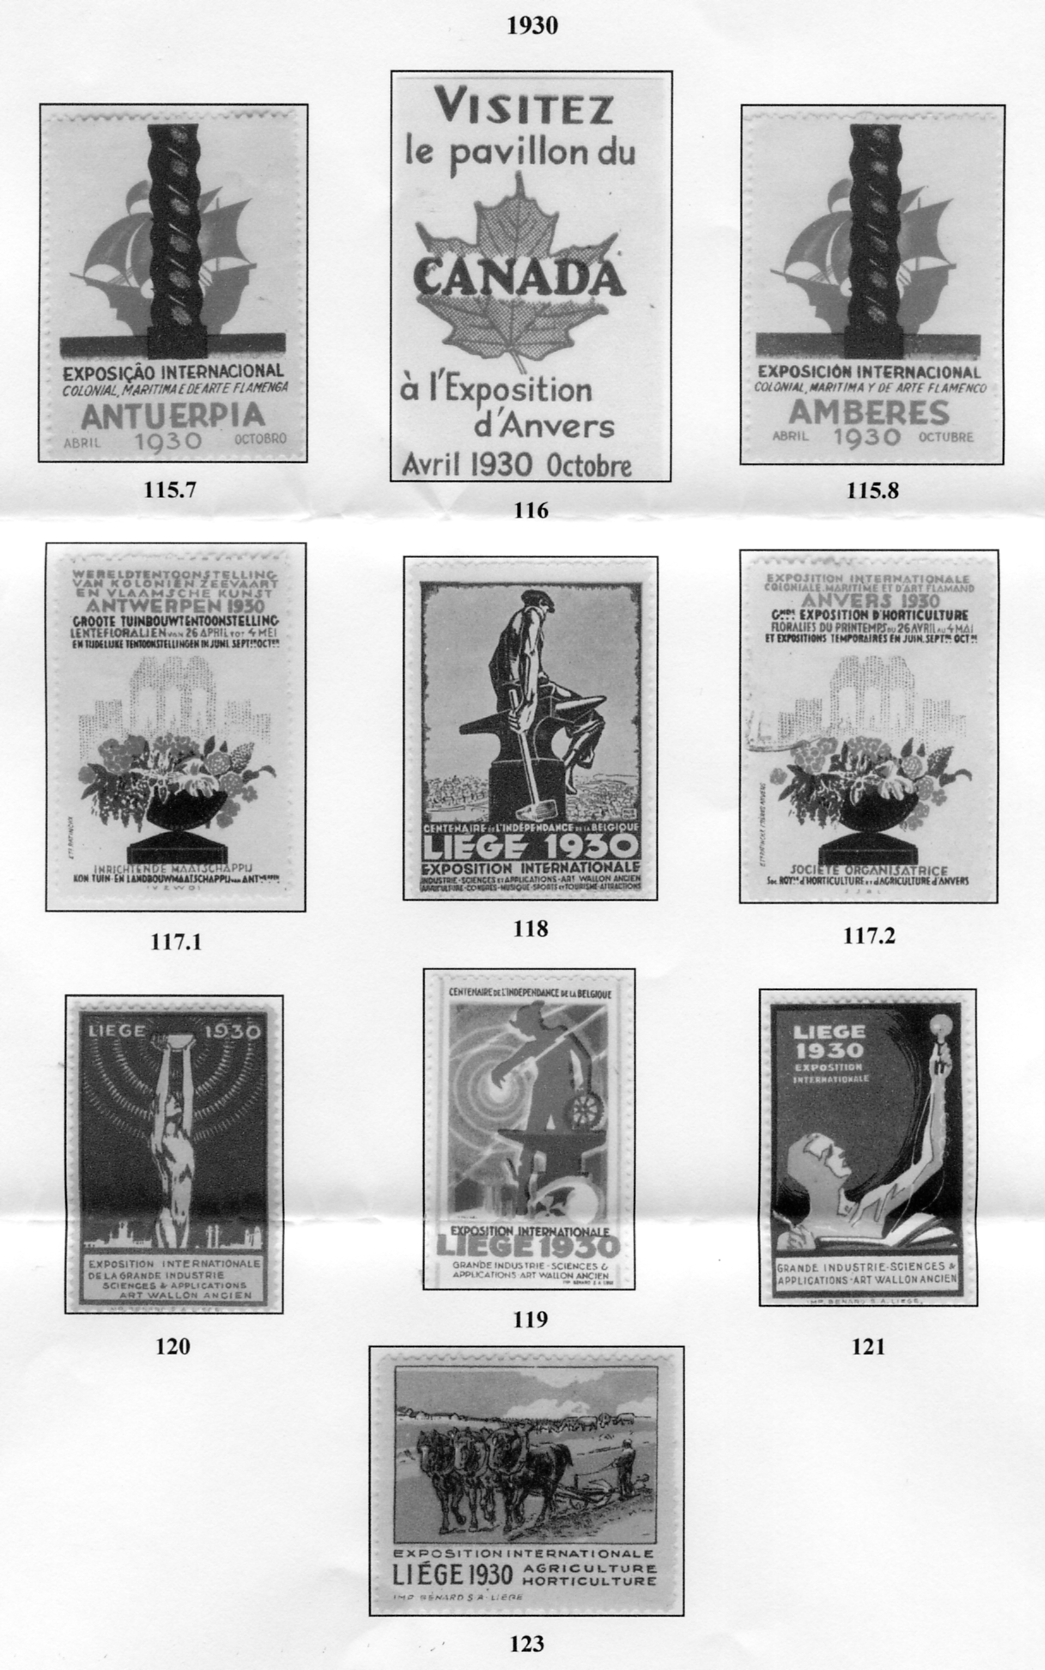

Page 64 of Commemorative Vignettes of Belgium 1915-1940
Unfortunately the sheet was folded and the shadows created have come out on this image
Don has sent me details of two exhibitions that he has been involved in, to celebrate the centenerary of the opening of the Franco-British Exhibition, The first is put on by Hammersmith & Fulham Archives, and is open four days a week for two months
The Great White City The Franco-British Exhibition & The 1908 Olympics
At the Museum of Fulham Palace. Bishops Avenue, London SW6 6EA nearest tube station Putney Bridge. Open Monday and Tuesday 12pm to 4pm, Saturday 11am to 2pm, Sunday 11.30am to 3.30pm. It is open from 19 July to the 21 September. phone 020 7736 3233 free admission

The second is put on by Hertford County Hall Archives
The 1908-1948 Olympics and Franco-British Exhibition
At County Hall Archive, Pegs Lane, Hertford SG13 8EJ. Open from August to Mid September (might carry on till end of September) Monday to Friday 10am to 5.30pm, Saturday 9.00am to 1.00pm. phone 01438 737 333. free admission.

White City Exhibitions
Extract from the Philatelic Bulletin sent in by
Don Knight

Don R Knight is the acknowledged expert on the Franco-British Exhibition of 1908, his passion having started back in 1972 when he acquired some of the picture postcards produced for the exhibition. Finding that there was no existing book on the subject, he set about writing one ‘Exhibitions Great White City’. If is now 30 years since that first edition was released, and with 2008 being the centenary of the .show, Don has taken the opportunity of reprinting and updating his earlier work, to include colour imagery of the exhibition's delights, labels, post cards, and souvenir china along with a fold out map of the site as it appeared in 1908.
The exhibition was clearly a success, as over eight million attended, having each paid their one shilling admittance charge. After its closure the site was used for other exhibitions in later years, in 1909-12 and 1914. Various buildings and facilities continued to be used for different events well into the 1980’s, but it appears that nothing now remains following the demolition in 2003 of the main entrance in order to make way for a shopping and leisure complex.
The BBC now occupies some of the site, which it uses as offices and to broadcast, among other programs, The One Show each weekday evening. Sharp eyed viewers will have noticed the Olympic rings and a commemorative inscription reading ‘1908 / The Great Stadium / Shepherds Bush’ with a league table of all medal winning countries below on the outside of the building, which records the hosting of the 1908 Olympics at that site. Britain headed the table with 56 gold, 51 silver and 38 bronze medals.
Much of the book is, as would be expected, non-philatelic, but it is still of great general interest. Ten postal markings are illustrated and there are also nine souvenir labels depicted in colour, with supporting text. The book is priced at a very reasonable £5.00 to Study Group members post free.
Visit the Exhibition Study Group website at www.studygroup.org.uk if membership of this active group of around 100 members is of interest.

The 1908 Olympic Games, the Great Stadium & the Marathon
by
Bob Wilcock

Members will find a post card enclosed with their Autumn Journal, if they wish to purchase a copy of the above book return the card with a cheque for £10.00 (usual price £14.00) to Mr R. J. Wilcock, 24, Hamilton Crescent, Brentwood, Essex. CM14 5ES and they will receive a signed copy of the book and the post card will be returned with a Dorando SmartStamp.

The Story Behind a Postcard
The Brock’s Benefit Crystal Palace September 24 1903.
a joint effort by
Fred Peskett and Bill Tonkin

There is a story to be told behind this very colourful and common post card. The pyrotechnics firm of Charles Thomas Brock first staged one of their fireworks displays at the Crystal Palace on the 12th July 1865. These displays became a very popular feature every Thursday and Bank Holidays during the summer months and were usually accompanied by music from the Crystal Palace Band.
In 1870 the Crystal Palace Company directors decided to award the Brock Company with a ‘Brock's Benefit’ as gratitude for helping to make the Palace and Grounds more of a commercial success, these Benefit days became an annual event and continued up to 1936 with the exception of 1911 when the organizers of the Festival of Empire Exhibition awarded the pyrotechnics contract to Brock's rival firm Pains, and during the 1914-18 war when the Palace was occupied by the Admiralty.
Why the 1903 Brock's Benefit was celebrated with an advertising postcard remains a mystery, none of the other Benefit days have a postcard issued either before or after 1903. The year 1903 was after all fairly early in the use of the postcard, so perhaps the Crystal Palace Company thought it worth a try as an advertising medium. There are other Brock's postcards which feature the Crystal Palace, but these were for commercial advertising for the product and not to mark an event.
A newspaper cutting for September 9th 1903 reveals that the invitation postcards were ordered by the Crystal Palace Company for 64,000 postcards. The cards were sent to The Crystal Palace Company Shareholders, The Brock's Company Shareholders and Crystal Palace Season Ticket Holders. The printer of the postcard is unknown.

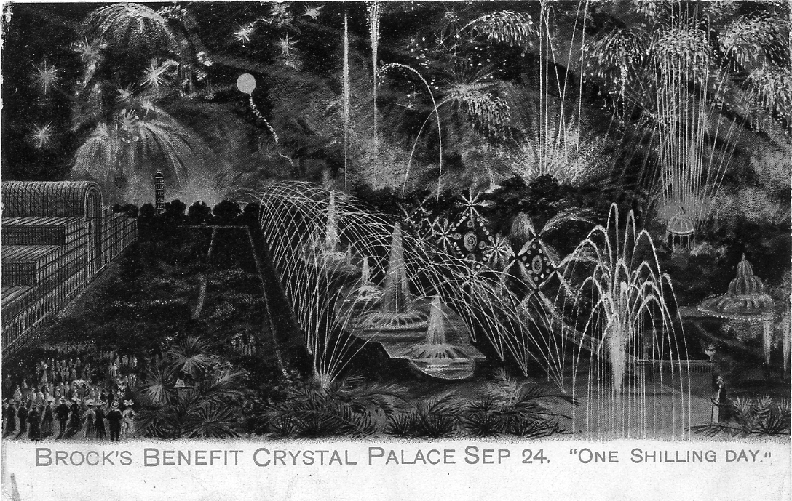

Brock’s Benefit post card

Two Post Offices are known to have canceled the postcards with the red skeleton ½d PAID hand stamp. LONDON on the 18th September 1903_{r} and LONDON. E.C. on the 19th September 1903. For the LONDON cancel, dies number 5, 6, 12, 21, 22, 23, 24, and 53 are known to have been used, and for the LONDON. E.C. dies number 3, 9, 10, 19, 22, 26, 29, 36, and 41, it is most likely that other die numbers exist and have yet to be recorded. It is noted that on the LONDON cancel the date is given as 18 SP 03 but on the LONDON. E.C. it is given as SP 19 03, (i.e. the day and month reversed) There are also variations known to the letters on the dies, on both the LONDON and LONDON E.C. cancels, certain die numbers have either a round or oval ‘O’ to LONDON, the same is for the ‘0’ in 03, these may be constant varieties, however they
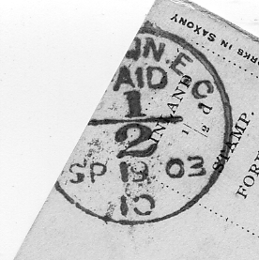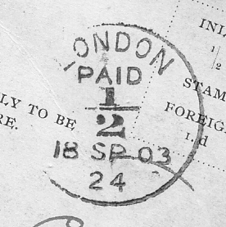

The curved foot and straight foot to the 2 of ½
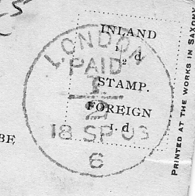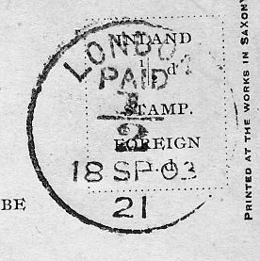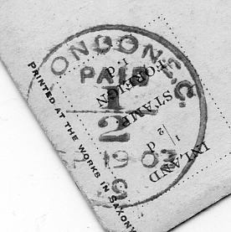

Oval ‘O’ to LONDON Oval ‘O’ to LONDON Round ‘O’ to LONDON
Oval ‘O’ to 03 Round ‘O’ to 03 Round ‘O’ to 03
Tall letters Tall letters Squat letters

may have also occurred due to the pressure and direction of the strike when hand canceling, more will have to be examined before this is clear. However, there is one variety that cannot be explained by pressure or direction. The ‘2’ of ½ generally has a straight foot but on die numbers 3, 10, 12 and 22 there is a curved foot. The postcards are also known postally used without the ‘PAID’ hand stamps and are dated up to 23rd September 1903, (the day before the Benefit) There is a further example known which is unused and has a purple oval rubber stamp ‘C.T. Brock & Co. 109 Cheapside, London, E.C.’ on the back. This may have been a remainder after the event and was perhaps used as an advertising postcard?

Table of Post mark varieties

Number Wording Foot of ½ ‘O’s of London ‘0’ of 03 Notes

3 With E.C. SP 19 Curved Oval Round Squat London
5 Without E.C. SP 18 Straight Round Round Squat London
6 Without E.C. 18 Sp 03 Straight Oval Oval Tall London
9 With E.C. SP 19 (Other details not known)
10 With E.C. SP 19 Curved Oval Round Squat London
12 Without E.C. 18 Sp 03 Curved Round Round Squat London
21 Without E.C. 18 Sp 03 Straight Oval Round Tall London
22 With E.C. SP 19 Curved Round Round Squat London
22 Without E.C. 18 Sp 03 Straight Oval Round Tall London
22 Without E.C. 18 Sp 03 Curved Oval Round Tall London
23 Without E.C. 18 Sp 03 (Other details not known)
24 Without E.C. 18 Sp 03 Straight Oval Oval Tall London
25 With E.C. SP 19 Straight Round Round Tall London
26 With E.C. SP 19 (Other details not known)
29 With E.C. SP 19.03 Straight Round Round Squat London
36 With E.C. SP 19 (Other details not known)
41 With E.C. SP 19 (Other details not known)
53 Without E.C. 18 Sp 03 (Other details not known)

The term ‘BROCK'S BENEFIT’ was listed in the Oxford Dictionary to describe certain ‘fiery’ Parliamentary Debates, and during the First World War it was used to describe an intense artillery barrage at the Front, ‘We are giving the Hun a Brock’s Benefit’ or ‘The Kaiser gave us a Brock's Benefit last night’ are sometimes seen written on postcards sent home.
There is one film which depicts the fireworks at the Crystal Palace, ‘The First Great Train Robbery’ with Donald Sutherland and Sean Connery, The background for the pair meeting at the Palace to plan their robbery is well contrived and worth seeing. It was made in 1978 and is still available on Video.
There is so much variety in this post mark that I think it may well be worth members spending a few minutes looking at their Brock Fireworks cards and letting us know what they have, as I am sure there are more to be discovered. It is regrettable that when we were gathering material for our book on the Crystal Palace, we had spotted the different dates and recorded them but at that point had not noted or recorded the other varieties of the post mark.
An 1851 Poem
Discovered by Fred Peskett

I was browsing through an old book and came across this poem, written in 1851, it relates to a farmer and his family visiting the Great Exhibition and the effort he made to raise the money for the Journey to London and the admission to the Exhibition on the One Shilling Day.

The Shilling Day at the Exhibition.
If I sell the pig and donkey, the frying pan and bed.
I will see the Exhibition while it’s a bob a head.
Never mind the rent or taxes, dear Polly come with me.
To the Great Exhibition, all the wonders for to see.

There we may see King Alfred and Billy Rufus bold.
Prince Albert all in silver and Victoria made of gold.
Queen Anne made out of beeswax sat on a wondrous perch.
With her nose stuck in a gin shop and her rump against a church.

There’s syllabubs and sandwiches, bath buns and nice cheese cakes
Sew up your trouser pocket Tom, some people make mistakes.
Nanny hold your bustle up and do not let it drop
It’s only twopence halfpenny for a bottle of ginger pop.

Tie up your garters, Caroline, the Exhibition for to see.
I have pawned my coat and trousers to pay for you and me
Isabella, love, get ready, along with me to trip.
And you shall see the foreigner with a funny hairy lip.

Alexis Soyer and The Gastronomic Symposium of All Nations. 1851.
by
Fred Peskett

Today, ‘Alexis Soyer’, ‘The Gastronomic Symposium’ and ‘Gore House’ are names which nobody would have a clue as to what they represent, but in 1851 at the time of the Great Exhibition they would have meant a great deal, particularly if you were fairly wealthy or from the Upper Classes.
Alexis Soyer was born in Paris in 1809 and as a vocation trained as a chef, he came to London to seek his fortune in 1842 and became the manager of the well respected Reform Club in Pall Mall where his organization of the kitchens and his Gallic menus had made him something of a celebrity. In 1846 he had written and published a book ‘The Gastronomic Regenerator’. He invented a sauce which was marketed by Messrs. Crosse & Blackwell, also a relish which he called ‘Ozmazone’ a sort of meat extract and a fruit sauce ‘Soyer’s Nectar’ both of which were also marketed by Crosse & Blackwell. He invented a spirit stove which he called ‘The Magic Stove’ and as a publicity stunt he cooked a meal on one at the top of a Pyramid. In 1847 he invented a portable soup-boiler to help the poor of London, and went to Ireland to supervise his invention in the provision of 9,000 meals a day for the poor of Dublin.
Alexis Soyer was horrified to learn that the catering arrangements for the forth-coming Great Exhibition did not include any hot meals, only cold platters, pickles and buns, and the strongest beverage would be Ginger Beer. Soyer doubted that this form of refreshment would have no impact on the success of the exhibition, so he had the idea of setting up an alternative establishment to cater for those who could afford the luxury of high class dining and found that a large mansion ‘Gore House’ was up for sale just across the road from the Exhibition building. He purchased the house using the revenue from his book and set about converting the house into a huge restaurant which he called ‘The Gastronomic Symposium of All Nations’. On the grand staircase he had painted a great panorama by his artist friend George Augustus Sala which he called ‘The Grand Macedoine of All Nations’ featuring Greek Goddesses to current Political Statesmen, one huge room was decorated as a Baronial Banqueting Hall in the Gothic style, there was a Banqueting Bridge and a Monster Pavilion of All Nations which had a table and tablecloth some 307 feet long, where 1,500 people could dine at one sitting There were several smaller dining rooms for select parties to wine and dine. Always seeking the fast buck, he charged one guinea to visit the kitchens between noon and 2pm, where over 600 joints of meat were being cooked. The amount of money spent on decoration and the entertainment extravaganzas hardly made a profit for Soyer, but he thought it worthwhile to keep going.

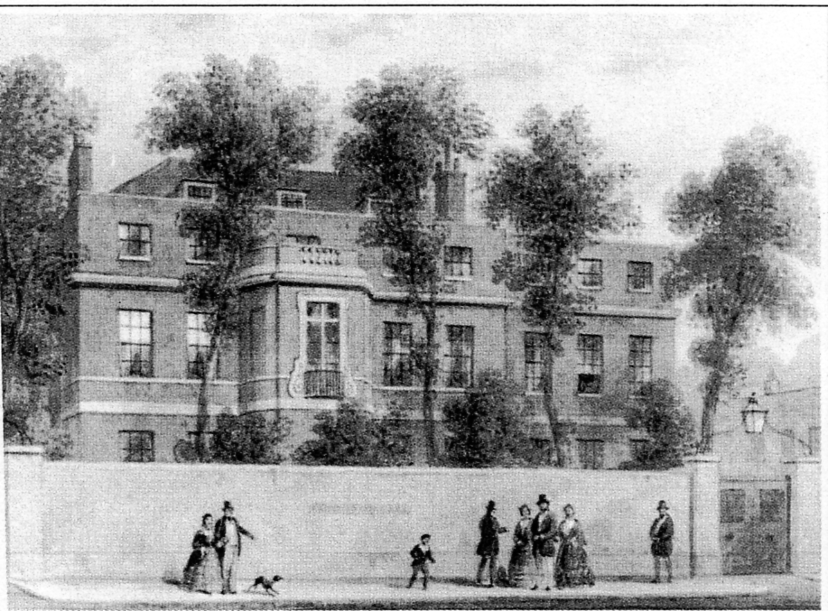

Gore House, Kensington, as it was around the time of the Great Exhibition.

It seemed that all the world and his wife went to the Symposium to dine, but Punch magazine was critical about the ‘over-the-top’ decor in saying ‘ However good thy palate be, we must dispute thy taste’. Soyer also provided entertainment in the form of orchestras, and strolling minstrels, each afternoon there was the attraction of a balloon ascent. The rich and famous patronized the Symposium including Disraeli and Thackeray, Soyer also catered for various clubs and societies and thought that once the Exhibition was over, he would make the establishment a permanent London feature.
A close friend, Jullien, a composer and famous conductor of the time suggested that they seek a license to build a Music Hall in the grounds, and this was applied for to the planning committee. It was well known that some of the parties held at the Symposium tended to get a little out of hand and during one of the more riotous sessions the Chairman of the Middlesex Sessions happened to be in the grounds, he made it known that on no account would a license to build a Music Hall in the grounds of Gore House would ever be granted to Soyer. On hearing this Soyer became so furious that he closed the Symposium in a rage. It cost him £7,000 to pay off all his debts and left him with just £100 to his name. Soyer bounced back by inventing an aromatic mustard for Crosse & Blackwell, and published a new book on the history of food preparation ‘Pantropheon’, but his fame was re-kindled when he developed his Magic Stove into the Field Kitchens used by the Army during the Crimean War.
Gore House was built in 1750 and purchased by Admiral Lord Rodney, renovated in 1808 by William Wilberforce, and was later the home of the Countess of Blessinton, writer and society hostess. Among her friends and house guests were Lord Byron, Benjamin Disraeli, Louis Napoleon and Charles Dickens. The House was demolished in 1857 to make way for The Royal Albert Hall which now stands on the site, so in one sense Soyer’s dream of a Music Hall became a reality. As for the Great Exhibition catering, well, they provided 2,000,000 buns, 1,100,000 bottles of mineral water and over 1,000 gallons of pickles to over 6,000,000 visitors, hardly the failure Soyer may have predicted!

The Senegal Village at the Franco-British Exhibition

Part 2 taken from the official guide price 2d

Not far away is the Mosque, dear to the heart of all Mohammedans, of whom many devout will be found in the village. Here, at fixed hours, they recite their prayers, accompanying them with those gestures which give to the ceremonies of the religion of the Prophet so strange an appearance. If it were not for the fact that the devotees are sincere and grave in their religious beliefs, these public prayers would have an air of the grotesque.
In another corner we find the chief shop of the village where the goods of European merchants who have penetrated to the remotest villages of Western Africa are displayed, tempting the native, and the visitor, alike by their brightness and cheapness.
Now take a hasty glance at the interior of this hut on your right,, and make a rapid inventory of the contents. That will not be difficult. Inside you will see a bed of straw—nothing more. These primitive people have not yet adopted all the fashions and utensils of the luxurious life. Coupled with this simple life you will now be surprised to see evidences of great taste in the work of the jeweler, who is sitting in front of the hut with a wonderful array of silver filigree, arabesques of gold, and strangely-wrought trinkets before him. As he uses his simple tools you marvel at the skill of his hands, and the ingenuity of design. A woman of fashion would be glad to adorn herself with the result of his patient labour.
Come over here and watch this cobbler, and the Turkish slippers in gay colours, which he is making. If you will give him a piece of doeskin he will make for you in a day or two a delightful pair of slippers, which will serve to remind you for many a year of your visit to Sunny Senegal.
His neighbour is a weaver, who looks up from his-work and smiles, showing a double row of gleaming white teeth. You smile in return as you see his primitive material, admiring all the same his bizarre designs,, and the daring manner in which he combines the most brilliant colours in the production of his cloth.
Give, in passing, a look at the embroiderer, whose needlework would do credit to our most skillful workers. His designs are naive and fresh, giving originality to-his work ; he is evidently an artist of his kind and. proud of it.
One thought will strike you as you watch these clever artisans of the village. In Europe we specialize too much. Where is the workman who can do as this-weaver can ?—this man, who will take a live sheep and give you from its wool in a few days a many-coloured waistcoat.
If they live simply these black people yet know something about the art of cooking. Grave and conscious of her importance is the cook, who washes-her vegetables, and prepares her rice in the full view of yourself. Notice how skillfully she introduces into-her ball of rice tasty little bits of beef and mutton. It. is quite curious to watch her black hands, and if you. saw the same in the kitchen of a London restaurant you might be disturbed. I assure you the colour of those hands, like her smile, is one that “won’t come off.” Like all Mohammedans, the natives of this-village insist upon scrupulous cleanliness in the preparation of their meals.
If you are so fortunate as to see one of these families at their meal you will notice that they use only the forks nature has generously given them. Each puts his fingers into a large bowl of rice, and taking a portion rolls it deftly into a ball which he transfers at once to his mouth so easily and naturally that though you may be amused you will not be shocked.
But the dances are beginning and it is time for us to leave the huts and gather round the hall in which they are given. Here are the musicians with their tom-toms suspended round their necks. Two or three rolls upon these drums with their quick, pliant fingers,, and the dance begins.
They may not dance with the airs and graces of the ball-room, but they are far cleverer than the American negro, with his much-admired cake-walk. While the young girls move simply, advancing, bowing, and turning with graceful movements, the elder women make rapid pirouettes, balancing themselves-from their hips. But the men are the best dancers, throwing themselves into the exercise with warlike and unbridled energy, displaying in their steps their exuberant and primitive natures. In all their dances the natives of the village observe the greatest decency and good conduct, naturally and without prompting.
If you are fond of wrestling and athletic sports, you will stay after the dance to watch the work of these two colossal negroes, who look like statues of ebony as they prepare to grip. As soon as they are locked together you will notice with admiration how their muscles tighten and stand out like steel—a magnificent exhibition of natural force, which it is worth a visit to the Senegal village to see. You may be surprised at the guttural sounds which proceed from the throat of the conqueror. They prove at all events that in spite of the strain of battle his lungs are in good condition.
From great strength pass on to great weakness. Here is the village school with its little black scholars learning their' lessons under the guidance of the marabout, or priest-teacher. They sing and study their lessons under the eyes of onlookers with much unconcern, but cannot resist the temptation to study occasionally the white hands of their visitors. Are you surprised ? They are greedy little chaps, and soon spoiled by the mothers of their small white visitors, who insist upon giving them sweets, greatly to the worry of the grave and learned teacher. Before they have been with us long we have to beg visitors to refrain from giving them too many sweets, which are sadly destructive of the very excellent digestion’s nature has given these fascinating little atoms of colour.
It has been said that the Franco-British Exhibition is a very “serious” exhibition where visitors come to study and be wise. If you wish to study as well as amuse yourself you can find no better place than this corner of Africa. In this circumscribed spot you may conduct an inquiry into the manners, customs, and language of many strange races, inhabiting, it is true, the same country, but differing in many important and most interesting ways. A few notes on the different people here will add greatly to your interest in the Senegal Village.
Look at this tall negro with the bangles on his arm and his gaudy waist-belt. You saw him dancing just now. He is a true Griot, one of the troubadours of the Dark Continent. Not for him the hard work of making earthenware pots, or beating brass into cunning shapes. His sole mission in life is to amuse and startle the simple negroes of other castes, first with his dance and music, and secondly with his weird ability to forecast the future. Should a Griot see a distinguished person passing before his hut he will at once improvise a chant in his honour, celebrating the glory of his ancestors, and promising him illustrious. descendants, continuing the eulogy until he has drawn a gift from him.
If you are a musician you will be delighted with, the harmonious sounds these Griots draw from their primitive instruments, of which you will recognize the following : The Kora, a sweet-sounding harp of sixteen strings. The Balafon, a sort of xylophone, in which little calabashes full of water are placed under the reeds to modify the sound. Musicians declare that there are few instruments in Europe equal to this for correctness and harmony of sounds. The Bourou, a trumpet. The Kalarn, a violin. The Tom-Tom, a little drum held in the hand and struck with a single stick.
Thanks to their skill with these instruments the Griots are able to give a most entertaining exhibition, which it will repay every musician to study.
Among the dancers you will notice several tall good-looking negroes wearing beards, but without mustaches. They wear a head-dress called the “subakane”, a hat of white calico of cylindrical form. Their wives cover their heads with a handkerchief folded in turban fashion, and paint their gums and lips blue. Mohammedans, polygamous, and very superstitious, the Ouolofs, as they are called, are the blackest and finest of the negro races of Senegal. Notice the amulets and “gris-gris” they are wearing. These are charms against the eye of the Griots, who, jolly fellows enough when dancing and singing, may yet prophesy evil.
The Madingoes are a different type. This middle-sized man is evidently one. of them, for he wears the, characteristic double-peaked hat, and he has the enormous jaw, flattened nose, and wide nostrils of the typical negro. He is a traveler and a merchant, and has made journeys as far as the Sudan. At home you will never see him without a gun or sword hanging from his shoulder. He, too, is very superstitious, and never makes a bargain without consulting the sorcerer.
Probably the weaver you were looking at just now is a Sereres. His race are great weavers and workers in metal. Unlike the other people of the village the Sereres are not Mohammedans, but cling to the ancient belief in fetishism which preceded the cult of the Prophet. This man will tell you that he believes his soul after death will enter into the body of a bird, and enjoy a second existence free from the necessity for; toil. Being a married man his head is shaved. His wife has not tattooed her gums and lips like other women in the village, but decorates her body with various patterns instead.
This war-like person with the austere look, wearing white pantaloons and a burnous, his arms and legs weighted with bangles and gris-gris, is one of the Toucouleur race, the most fanatical and courageous of all these Senegal people. He is a strict Mussulman,. and ever ready to wage a holy war against the infidel at the bidding of some mad prophet. The French have wisely enlisted many of these warlike spirits in their native regiments, and find them excellent soldiers under strict discipline. You may find them among the weavers and workers in metal, but they regard manual labour of this sort with disgust, and prefer agriculture.
The Soussous are also represented in this village They are a pacific people except when provoked to internal discord by secret societies. The men embroider and sew while the women are busy in the kitchen. The latter are clothed only in cotton “knickers” and a piece of stuff, which, having a hole in the middle, can be drawn over the head and chest. Both men and women are cultivators of the soil, growing cereals of all kinds, and the arachide nut. If they were not the most improvident of people they would soon be wealthy, for the soil of Senegal quickly repays a hundredfold the little labour they bestow upon it.
I have now introduced you to the people of the Senegal Village, and can leave you to make their better acquaintance, assured that you will return many times.

The End.

Valentine’s published one view of the Senegal Village, but the promoters of the Village brought a plentiful supply of their own post cards with them. These French post cards of the Senegal Village were probably taken from photographs originally taken at a Belgian Exhibition at Liége in 1905. Many of them bear Ballymaclinton or Franco-British Exhibition post marks and messages tying them to the White City exhibition. All of the titles include Village Sénégalais followed by a description of the view or activity in French. There are four series of post cards.
Senegal Series 1.
B/W litho printing, title printed in black upright letters, green back with ‘CARTE POSTALE’ without full stop measuring 52 mm., double line ‘T’ divider with short single top bar, no stamp box.
Senegal Series 2.
B/W litho printing, titles printed in red. On the front down the left side also printed in red is ‘Roch et Lyon, édit., Neuilly-s-Seine. Reprod Interdite’. Green back with ‘CARTE POSTALE’ without full stop measuring 51 mm., single zigzag line divider with long top bar measuring 122 mm, no stamp box.
Senegal Series 3.
B/W litho printing with title printed in black italics, black back with ‘CARTE POSTALE’ without full stop measuring 53 mm., double line divider with long top bar measuring 116 mm., no stamp box.
Senegal Series 4.
Coloured printing, titles printed in red. On the front down the left side also printed in red is ‘Roch et Lyon, édit., Neuilly-s-Seine. Reprod Interdite’. Green back with ‘CARTE POSTALE’ measuring 51 mm., single zigzag line divider with long top bar measuring 122 mm., no stamp box, as type 2.

The Country Home
Vol 1 May to October 1908

This article appeared in a bound half year of a monthly magazine ‘The Country Home’
kindly lent to me by Ken Rumsey

The many exhibitions which will be held in London during the coming summer will, no doubt, attract a larger number of visitors than ever to the metropolis. The quantity of things to be seen and the size, at least, of the great Franco-British Exhibition will make it difficult for many to find just what they would like to examine, and we have endeavored to discover, so far as is possible, those matters which are likely to be of interest to our readers. Maybe, after looking at the following pages, many who before were doubtful as to whether the exhibition would appeal to them will decide that they must, after all, pay it a visit.
It is common knowledge that the Franco-British Exhibition, which was opened on May 14th by the Prince of Wales, has become possible owing to the pleasant relations that of late years have prevailed between the two great countries concerned. The daily papers have told us of the size of the grounds a hundred and forty acres in extent and have kept us posted as to the progress of the work, the gradual, in some cases, in others the mushroom-like growth of courts and galleries and ornate buildings of white plaster which are appropriately styled palaces. To a few the decoration may appear overdone, but the many, no doubt, will appreciate it. Mr. Imre Kiralfy is a marvelous showman, and at night, under artificial light, we shall, no doubt, have another example of his genius as regards spectacular effect.
Then, in his own words, “The view will be specially dazzling. Every building will be picked out with rows of electric lights of many hues, and these will be reflected in the rippling waters, forming a masterpiece of colour more fairy like than the most fanciful imagination can picture.”
We cannot, however, think of Mr. Kiralfy only in the capacity of stage manager; we must recognize that his enterprise is strengthening the ties between France and England, making for the improvement of trade, and has, at a time when work is not easy to obtain, given employment to thousands of mechanics and labourers. This will not be so obvious to the visitor who comes on the scene now that the exhibition is open as it was to those who, like the writer, have had to make their way amongst armies of men, who for months at Shepherd's Bush have been striving in different directions but with the same ultimate object.
We think that the following contentions will be justified (1) That while not suffering from the drawbacks attendant on the mammoth shows of the United States, the Franco-British Exhibition will establish a record, and (2) That British manufacturers and producers will have an opportunity such as has not been enjoyed since 1862 of showing the progress that they have made. The amount of material that will be gathered together from France, from England, and from the Colonial possessions of both will be stupendous, and we cannot here attempt to deal generally with it. Art, Costume, Decoration, Machinery, Food, Education, will all be represented on a gigantic scale. The Olympic games will appeal to thousands of our countrymen, and have an international significance, while those who, visit exhibitions for amusement or wish for relaxation when they are there will not be disappointed.
After these few preliminary remarks we will see what matters call for attention which are cognate to those which come within the scope of ‘The Country Home’. The first to be mentioned may prove a little unexpected, for a Tudor house, unless it be but a representation, seems somewhat out of keeping with a modern exhibition, and one might be pardoned for wondering whether there was still such a thing at Shepherd’s Bush.
The explanation is very simple. Until quite recently an old Elizabethan building stood in Ipswich at the corner where Cox Lane meets Carr Street. During last year it was pulled down to make way for the enlargement of adjoining premises. Messrs. Gill and Reigate, whose names are well known in connection with antique furniture, bought the materials, numbered them as they were taken down, and conceived the idea of putting them together again, much in the same way that has been so much talked about in the case of Crosby Hall.

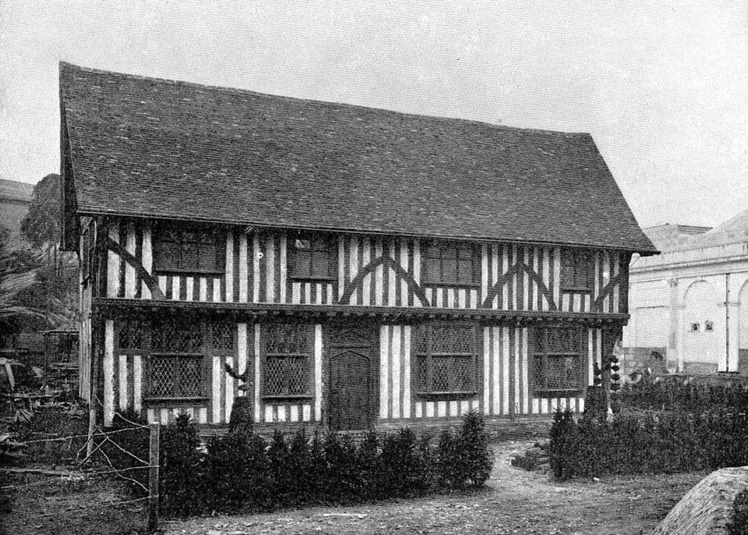
The Old Tudor House

The first site selected was one in the Franco-British Exhibition, though, no doubt, the trouble spent on restoring the house will not be allowed to be wasted, and it will again go through the process of being pulled to pieces and rebuilt. The door of the old house is a fine piece of workmanship, and bears the date 1563, though probably the building itself was older. This latter was converted into shops, but now, with the help of materials obtained in the same locality, the house has been fitted up once more as a dwelling-house. Where brickwork was required, original Suffolk “reds” have been put in. The paneling of the dining room was taken from an old house in Fore Street, Ipswich, and is quite in keeping with the rest of the house.
All sorts of details have to be borne in mind when restoring Tudor houses. The peculiarities of the district have to be studied; for instance, in the Eastern Counties the oaks are of straighter grain than those elsewhere, and as the outside timbers are made to follow the grain, they are upright in the Ipswich house, and not curved as are those in the Tudor buildings of Chester and Bristol.
We give an illustration of an old jack to be seen in the kitchen of the Tudor house. A point of interest is the excellent state of preservation in which the wood of the Tudor house was found to be, and the timbers were so skillfully mortised and tenoned that mechanical contrivances had to be employed to pull them apart, and this after they had been together for more than three hundred and fifty years.
It is intended to exhibit contemporary and later furniture in the rooms of the old house, as well as modern reproductions of old styles. Quite in keeping with the house will be the formal garden which Messrs. J Cheal and Sons of Crawley have reconstructed from authentic sources. It was not finished when our photographs was taken.
The Tudor house is not very much further from the new station on the Hammersmith and City Railway. It can be reached through the Palace of Textile Industries on the west side of the Court of Honour. Differing from our last subject in that it is merely a replica of an old building, may be mentioned the copy of the old Sulphur Well at Harrogate in which sweetmeats will be shown by Messrs. Farrar and Company of that town.
Messrs. Schweppes have had a copy made of the old house at Bristol called Fontaine House, in which the founder of their firm, Johan Schweppes, a chemist, first manufactured soda-water in 1789. A feature of the exhibit is the house-leeks on the roof and other plants in the crevices of the walls.
In the Decorative Arts Palace the committee (of which Mr. Charles Allom is the chairman) has arranged for a series of rooms to be fitted up illustrative of various periods. In many cases both the wall-coverings and the furniture are both original, but in one or two instances the walls have had to be reproduced. There will be a James I. room, and by the courtesy of Messrs. White, Allom and Co. we have seen the mantelpiece which will adorn it. There will be a Grinling Gibbons room, a Queen Anne room, of which the paneling came from the old Orthopaedic Hospital in Hatton Garden, a Chippendale room, and a George II. room. Messrs. Hampton and Sons are fitting up the latter and one or two others. Old Gothic furniture will also be represented. Among the exhibitors whose treasures will adorn this section are the Princess of Wales and the Duke and Duchess of Beaufort. Mrs. Hudson is lending a Sheraton piano which was made for the Queen of Spain. Sixteenth century furniture will be lent by Lord de L’lsle and Mrs. Percy Macquoid, while Lord Sackville is sending some Elizabethan chairs.

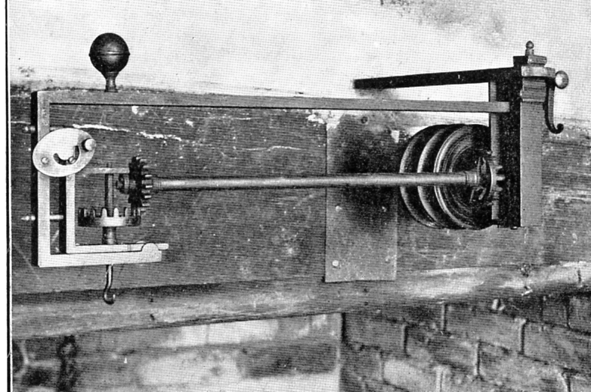
Mechanical Jack driven by hot air raising in the chimney.

There will also be representative series of old china and table glass, chosen and lent by well-known collectors. A host of matters dealing with the present-day decoration of the country home will be exhibited in the same section.
The Bromsgrove Guild will have on view a garden ornaments cast in metal, which are of special artistic merit. By the courtesy of the Guild, we will see one in lead as well as an example of a vase.
Many well-known makers of wall papers will be represented in this section, such as Messrs. Sanderson and Sons, Mr. Godfrey Giles, Messrs. John Line and Sons, and Mr. Jeffry. Ceramics will be shown by the Pilkington Tile Company and the Royal Worcester Company. Silks will be exhibited by Messrs. Debenham and Freebody and by Messrs. Wainer and Sons. Billiard tables, which form such a valuable adjunct to the country house, will be exhibited by Messrs. Burroughs, Watts and Co. and Messrs. Thurston and Co. Perhaps the largest exhibition of stoves brought together will be in this section.
The country cottage is in such vogue nowadays that it would be surprising if the erection of a number of these had not been contemplated. The First Garden City, Ltd., has, however, contented itself with showing plans and photographs, of which, by their courtesy, we shall see three, but Messrs. Oetzmann have put up a weekend cottage or bungalow, which is estimated to cost from £200 to £230. By the kindness of the builders we are enabled to give a plan of the cottage, the walls of which are of rough cast, while the roof is of red tiles. The features of the cottage are that the front door can be reached without disturbing the occupants of the living room, and that the kitchen and maid’s bedroom are separated from the rest of the house. These might be occupied by a caretaker and his wife, who would look after the cottage when the owner was away and attend to his needs at other times. Further suggestion has been made that the cottage would serve excellently as a gardener's lodge to a country house. In this case the three best rooms could be kept for visitors who could not be accommodated in the house, or used by the owner when the latter was shut up. The cottage is towards the north end of the Exhibition. An extra bedroom and a bath room (without fittings, however) can be added at a cost of from between, £270 and £300.

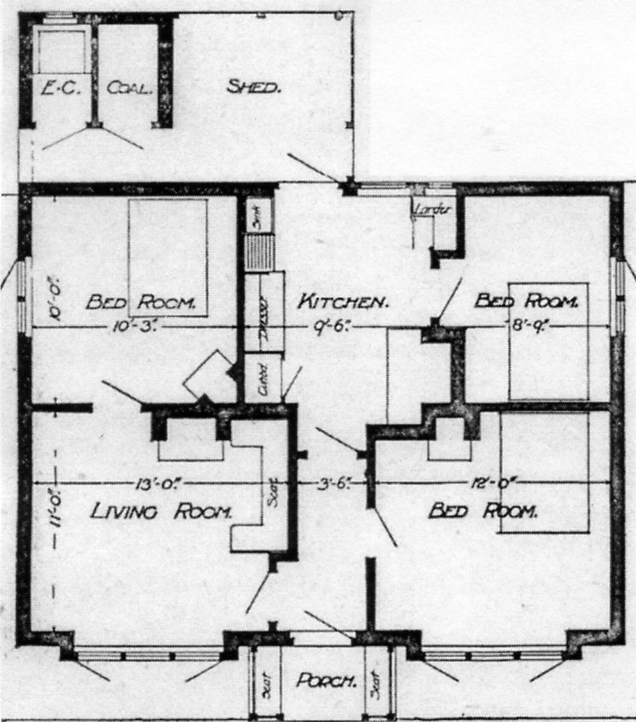
The plan of the Oetzmann’s cottage

A second cottage of larger pretensions will be found just behind the old Tudor house, and is part of the scheme of the Guild of Perfect Cottage Builders, and costs about, £400 or more to erect. A third model cottage will be found in the Irish village of Ballymaclinton, which we may mention here, as it cannot be considered under any particular heading. Its existence, though incidentally connected with the business of its originator, speaks for health reform and preventive medicine, for all the profits derived from it are to be used in the campaign against consumption in Ireland. The importance of this work will be manifest when it is pointed out that the number of deaths from this disease has decreased nearly fifty per cent, in this country during the last ten years, while in Ireland it has steadily increased.
Lady Aberdeen's Consumption Hospital, which has attracted so much attention in Ireland, will also be on view. The visitor is shown a hall divided into two compartments, one of which realistically portrays the home where consumption is likely to be rife, with its dirty furniture and its general air of oppressiveness, while the other shows an ideal arrangement in the same amount of space on hygienic principles.
The settlement portrays a typical Irish village, and occupies in all ten and a half acres, and the archaeological interest is quite as great as any other; in fact, the most striking building is the round tower. This is a replica of one of the numerous examples to be seen in Ireland at the present time. One, of which we reproduce a photograph, is situated near Antrim, and is an unusually fine example.
There is a certain amount of controversy respecting the origin and uses of these towers. Some writers attribute them to a race who lived in Ireland in ancient times, and who worshipped the sun.
This theory does not, however, seem to hold water, for the towers are invariably found in valleys, and not on hills as might have been expected. It is practically certain that they were built by the Christian monks in the tenth century as a place of refuge from the raids of the Danes. Upon sighting the enemy, the priests and villagers took their goods and fled to the tower, where they were safe from all assaults, even fire being of no avail against the towers.
The ruins of a Norman chapel are reproduced, together with some old Irish coffin slabs. One of these is of Anglo-Norman date, and our illustration well shows its cuneiform writing and the shears upon it. The latter show that the tomb was that of a woman who had her hair shorn, and from this we infer that she was an abbess or priestess.
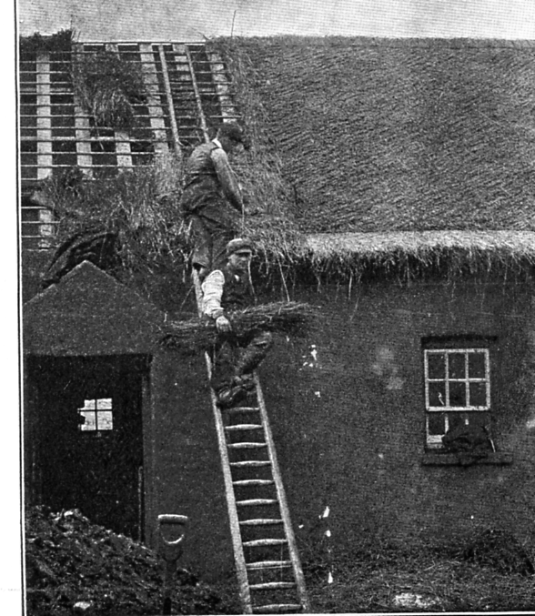
The cottages, thatched and turfed in the old-fashioned way

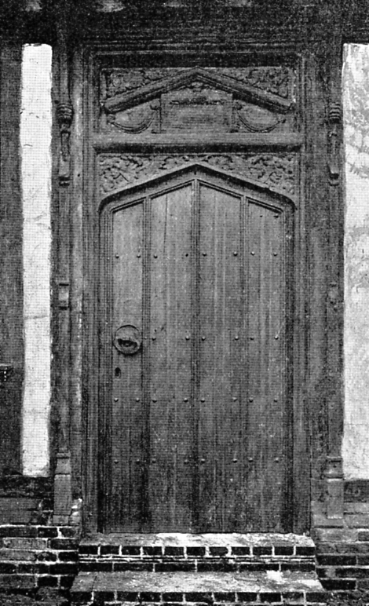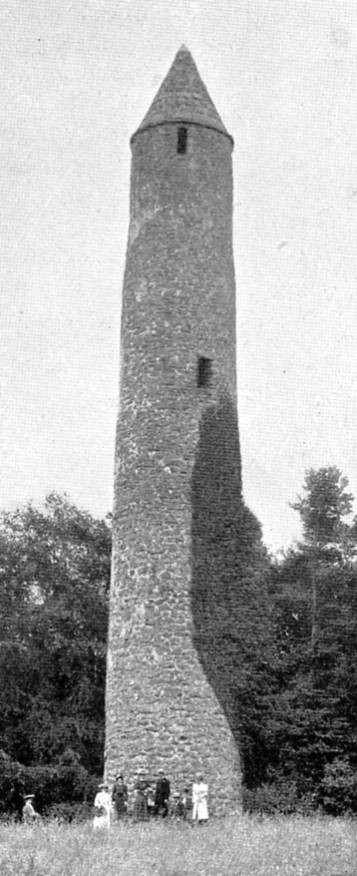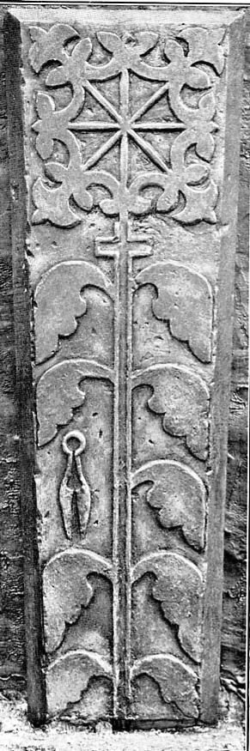
The door of the old Tudor Cottage Refuge Tower near Antrim. Irish coffin top with shears

Another of these, which is called the Ogham stone, shows the earliest form of Irish writing, a certain arrangement of straight lines of varying length, cither vertical, or horizontal, or oblique, each group of which represents a particular meaning. The third stone is one erected to the memory of an Irish monk, and bears an inscription in Erse. A copy of an ancient Irish village cross and a holy well are also to be seen. In the various cottages which go to make up the village, and in which families of Irish people will reside during the exhibition, the visitor will be able to see the actual processes used in the manufacture of various Irish industries.
In one cottage two hand looms will be at work making beautiful Irish linen, which is so fine that 25/-. (£1.25) a yard is often paid for it. Hand-woven linen surpasses that made by machinery in the fineness of the yarn. The motion of the hand loom, being slower, does not put so much strain upon the yarn as a machine worked loom does, and consequently the weavers are able to use a much finer yarn without fear of its snapping. The time occupied in the manufacture of this linen is the factor that makes its price so prohibitive.
In a neighbouring cottage, girls will be at work making up the linen into hem stitched handkerchiefs, and the Irish carpet making industry will be represented in still another cottage, where peasant girls from Donegal will produce hand-made carpets, rugs, and Irish tweeds.
Sixty years ago every little town in Ireland possessed its soap works, now Donaghmore is the only inland town which manufactures soap in any large quantities. Mr. Brown, who is responsible for the whole idea of having an Irish village at the exhibition, is showing the manufacture of toilet and shaving soap from natural alkalies i.e. alkalies made from vegetable ash.
The cottages, thatched and turfed in the old-fashioned way, are typical of the dwellings in which Irish people live to-day. A pleasing contrast to these is the model cottage which is a replica of those erected by Mr. Brown for his tenants at Donaghmore. The rent for these cottages, placed in a garden of half an acre, is 2/- (10p) per week, and we are forced to envy the good fortune of those Irishmen who get such comfortable homes at such low rates.
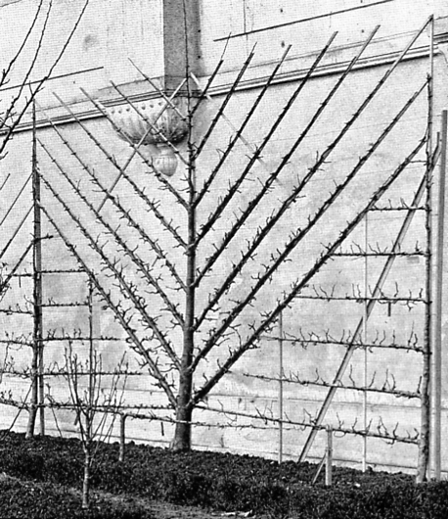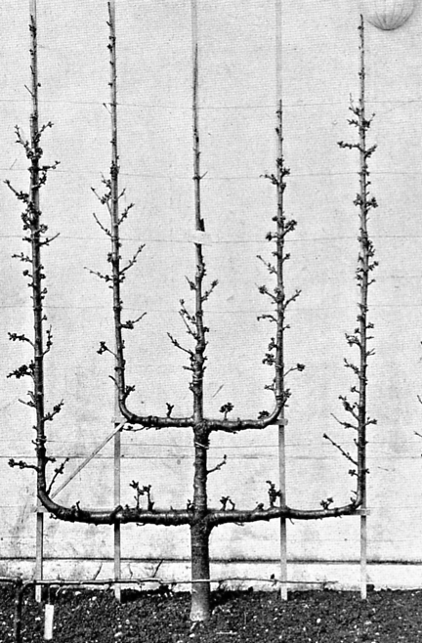

Marvelously-trained trees shown by Messrs. Pinquet Guindon, Tours.

All the occupants of the village will be dressed in Irish costume. Two hundred girls and half that number of men, with several entire families, will be at work in the settlement. Everything seems to have been thought of for their comfort. Priests, both Roman Catholic and Protestant, will be in residence, and it is hoped that a detachment of the Royal Irish Constabulary will be there to aid in keeping the place in order.
The whole idea of the village originated with Mr. David Brown, of Donaghmore, and the work has been admirably carried out. The architect is Mr. W. J. Fenncll, of Belfast. Messrs. McLaughlin and Harvey have done the building, and the very important work comprised, under the word decorating has been entrusted to Messrs. George Morrow and Sons, of Belfast.
A novelty in the way of roofing is to be seen on the pavilion which Messrs. Maple & Co. have built for Messrs. Liebig & Company. It consists of Eternit Slates which contain asbestos, and are fire and damp-proof as well as being lighter and cheaper than ordinary slates.
Turning now to the horticultural side of the Exhibition, which at the moment of writing is by no means completed, we must mention the marvelously-trained trees shown by Messrs. Pinquet Guindon, of Tours. The two illustrations which we show will speak for themselves.

The way to use the back pages of the Journal.
by
Bill Tonkin

For many years I have had mountains of material on the White City to use to fill in any space at the end of the Journal if I was running out of other material to use. This served me well on 40 occasions but with the publication of my book this month I feel I can no longer use this material, as it will all be in the public domain now. Two ideas are running through my mind, one is to publish updates of new finds by collectors. As is always the way once my book was at the printers Graham Hall sent me an image of a lovely Franco-British card I have never seen before. Graham was prompted by seeing the Slingsby label Fig. 52 in the last Journal and his card is a Slingsby’s advertising card rushed out when they were awarded a gold medal for their products, the card features their display of ladders. Graham’s interest in the card, is based on the fact that Slingsby was a Bradford firm, which as you all know is his main collecting interest.

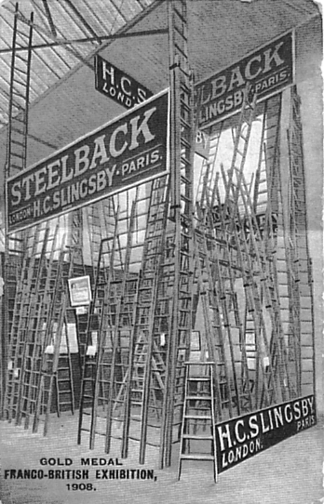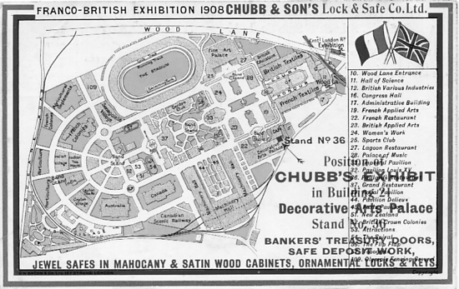

Slingsby of Bradford Chubb & Sons Lock & Safe Co.

While my book was at the printers I had the good fortune to pick up a lovely Chubb Lock and Safe Co. card that was new to me, although I have several of the Chubb Bacon map cards with a different map on the front..
The second idea is to publish through the Journal an in depth study of Royal Tournament post cards. My interest in these goes back a long way to 1992 when at our Annual Convention Arthur Smith gave a wonderful display of Royal Tournament post cards and catalogues. Incidentally I met Arthur at the Bloomsbury Post Card Fair in July.
I have written about the problems Valentine’s had making sure they had plenty of post cards for sale on the opening day of an exhibition, and how they satisfied the demand. Gale & Polden had the same problem at the Tournament, on opening day their post card kiosk had to be full of post cards for sale.
They never got into the cut and pasting of visitors to the extent that Valentine perfected, but their post cards of scenes taken in the arena at Olympia are not quite what they appear to be. Once they had a nice view taken with crowds of visitors watching an event taking place in the arena, they could use this for several years just cutting and pasting a new event in the center. The Royal Horse Artillery Musical Drive was a popular spectacle and Gale & Polden used a 1906 picture of it several times with different surrounds for different years. In their enthusiasm they sometimes enlarged the centers to such an extent that the horses come out nearly the size of elephants.
Of course Gale & Polden had one great advantage over Valentine in that they could take photographs at the rehersals of events before the Tournament opened, which explains why so many Royal Tournament cards show an Olympia empty of visitors.

