Editorial No. 9 January 1988

The great success of our Exhibition Study Group meeting in York last October prompts me to give members early warning of the 1988 event. This year the weekend of September 24/25th. has been chosen, with the venue the same as 1987 i.e. The Black Swan, Peasholm Green, York, we intend to run a two day conference and as before, members will be expected to make their own arrangements for travel and accommodation. I will act as a clearing house for members offering or requesting transport to York.
October 3rd. 1987 must go down as a milestone in the short history of the Study Group. Fifteen members attended and the day passed over too quickly (one of the reasons why this year's event will be a weekend!) as friendships were renewed and new acquaintances made. Cards were exchanged and everyone went home happy - see Mike Perkin's letter!
A prompt start was made after 10 o'clock coffee and Don Knight gave an excellent talk on the White City. His movie film, especially the shots showing the overhead exhibition halls between Wood Lane and Shepherds Bush, were very illuminating to collectors like myself who have never visited the site of this famous exhibition. Spontaneous applause greeted his working model of the Flip- Flap and he could have sold ten on the spot if they had been available. Alter the film, Don provided a comprehensive display of postcards covering the events at Shepherds Bush.
(Don wrote in November to say that he had lent some items from his Franco- British collection to the Barbican Art Gallery, London for their exhibition ‘The Edwardian Era 1900-1910’)
A provincial exhibition provided the next topic for discussion and an admirable piece of scholarship was provided by Graham Hall on the Bradford '04. Graham has been known for his collection of Bradford material for more years than he would probably care to remember but as he freely admits, something new always turns up to push his knowledge to new limits. Graham shows to perfection how one relatively small exhibition provides the collector with a wealth of material and avenues for research. He reminds me very much of the redoubtable Ed. Orth, the president of 'ECHO', the U.S.A. Expo, group, who has been researching the 1939 New York World's Fair for a lifetime. Keep it up Graham, you have a few years to catch up with Ed! I must redeem myself for calling Bradford a 'small' expo’, by saying that it is very important to postcard collectors, arguably the premier English provincial expo, in terms of postcards issued.
Most members adjourned for lunch downstairs in the bar and tried to exchange a lifetime's information in one hour - no easy task even with some liquid refreshment.
Professor Burton Benedict enchanted the members with a very lucid, amusing and knowledgeable slide display on Expositions in general and the Panama - Pacific 1915 in particular. It was all over too soon. Burton enjoyed meeting the members and hopes to see us all again before returning to the U.S.A. sometime this year.
Stanley Hunter was given the unenviable task of filling the final slot - but fill it he did! He could also have lined the walls with his collection of the printed ephemera of the Scottish Exhibitions. This was another display which brought forth the superlatives and although my account of the day seems to be nothing but superlatives, I am sure everyone there would agree that all I have said was true.

The day was not over. A short walk through the centre of York brought us to the premises of Inche's Books. (Peter and Janette had been at the meeting during the day). They produced a welcome glass of wine and tempted us with exhibition items for sale.
The only criticism I have received relates to the lack of time we had to talk to each other about our shared interests. This will certainly be reflected in the programme for the next meeting and this is in preparation at the moment. I would like members to volunteer their services or ideas for the next 'weekend'. British Empire 24/25, Earls Court, Crystal Palace etc. - what shall it be
I have spent enough time on York so must move to other problems and news .For some time I have been worried that we have recruited members that we don’t cater for, namely those interested in Philatelic Exhibitions. I don't want to turn collectors away but unless we get some appropriate articles specific to their needs they may lose interest. This is an area where your editor cannot write with any authority so come along colleagues and put your pens to paper.
This newsletter has been set out on an Amstrad PCV 6256. It doesn't seem five minutes ago that my wife surprised me with an electronic typewriter and the quality of the newsletter improved. Will it improve yet again, I wonder? If any member can supply me with a suitable database that will enable me to transfer fourteen A4 files of postcard checklists, I would be most obliged. At the moment I can just about manage the simple things on the machine, so there is no hurry.
I hope that all those members who received the excellent copy of 'Postcards 01 Palestine' have sent any information of unrecorded exhibition cards to David Pearlman.
Finally, my promise to issue a 'special' on Scotland has not been forgotten but just put on the back burner for the moment. The two Scottish items in this newsletter have been sent by Stanley Hunter, with an added thanks to Ian Robertson 01 the Huntly House Museum, who provided the copies of 'The Edinburgh Inter, Ex. 1886.

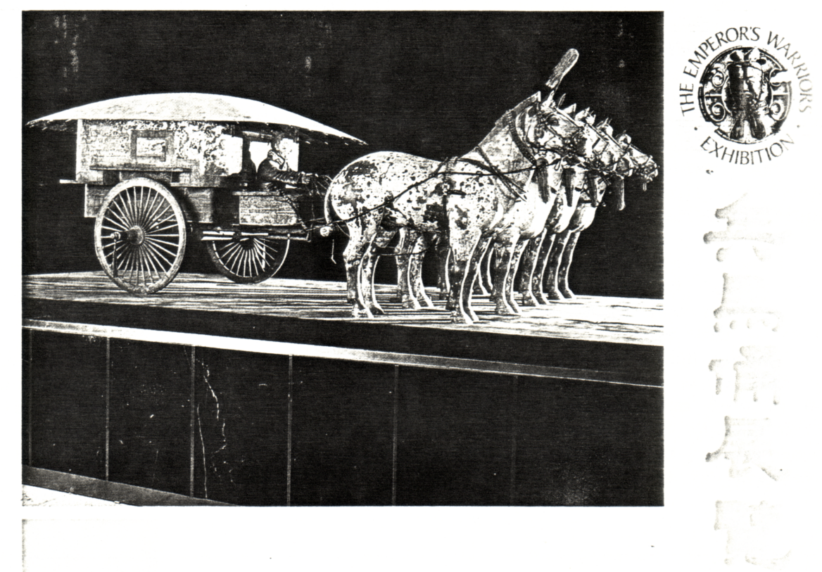

Britain Can Make It Exhibition 19461

Alan Sabey sent the two press photographs of himself at this event and they are reproduced over leaf. The lady is Frances Day.
In 1945 Sir Stafford Cripps, who was well known for his encouragement of industrial design, persuaded British manufacturers to take part in a post-war exhibition demonstrating their latest products. Organised by the Council for Industrial Design, the 'Britain Can Make It' exhibition opened in September 1946 at the Victoria and Albert Museum. Six thousand products by 1300 firms were displayed to wondering crowds tantalised by the sight of fascinating but- unavailable new household goods. Reserved for export, they would not be seen in shops at home for several years to come. (Extract from Now the War is Over).
A slogan postmark was also used to promote this event.

Fred Fletcher Corner
It was reported in the Newcastle Evening Chronicle ( Oct. 9th. 87 ) that Prince Edward had launched a new London Festival designed to emulate the 1951 Festival of Britain. The Prince said it would take place in the grounds of the Alexandra Palace between July 23rd. - August 7th. 1966. Does anyone have any further details of this event ?

Has any member details of the Ruhleben Camp Exhibition (P.O.W.)? I have a P.P.C. of this event and have managed to find out that it was held in the Westminster Hall, London between Jan. 14th. - Aug. 14th. 1919 I would like information about the exhibits, stalls etc., not the P.O.W. camp In Germany.

I am sure that all members will have come across cards of the Bombay Expo. So far I have been unable to find out anything about this event and we don't even know in which year it was held. Any answers ?
The Exhibition of the Emperor's Terracotta Warriors and Horses of the Qin Dynasty is the subject or the postcard on page 2 and 1 would like to thank the Merseyside Maritime Museum for the cards of the Emigrants to a New World Exhibition.

Fred Fletcher. 35 St. Georges Terr. East Boldon, Tyne & Wear,

Membership for 1988 £2.00 This
is due for nearly everyone

Adverts
Palestine- I collect Postcards of Palestine. I am looking for all series even the commonest types, covering all parts of Palestine and all periods. I am also interested in any ephemera from Palestine, including Travel items from hotels, shipping lines, souvenir items such as dried pressed flowers. In fact most anything except books.
Best Prices Paid (Your Prices Usually !) Plus Postage Always Refunded.
David Pearlman 36, Asmuns Hill, London NW11 6ET Tel. 01-4552149.

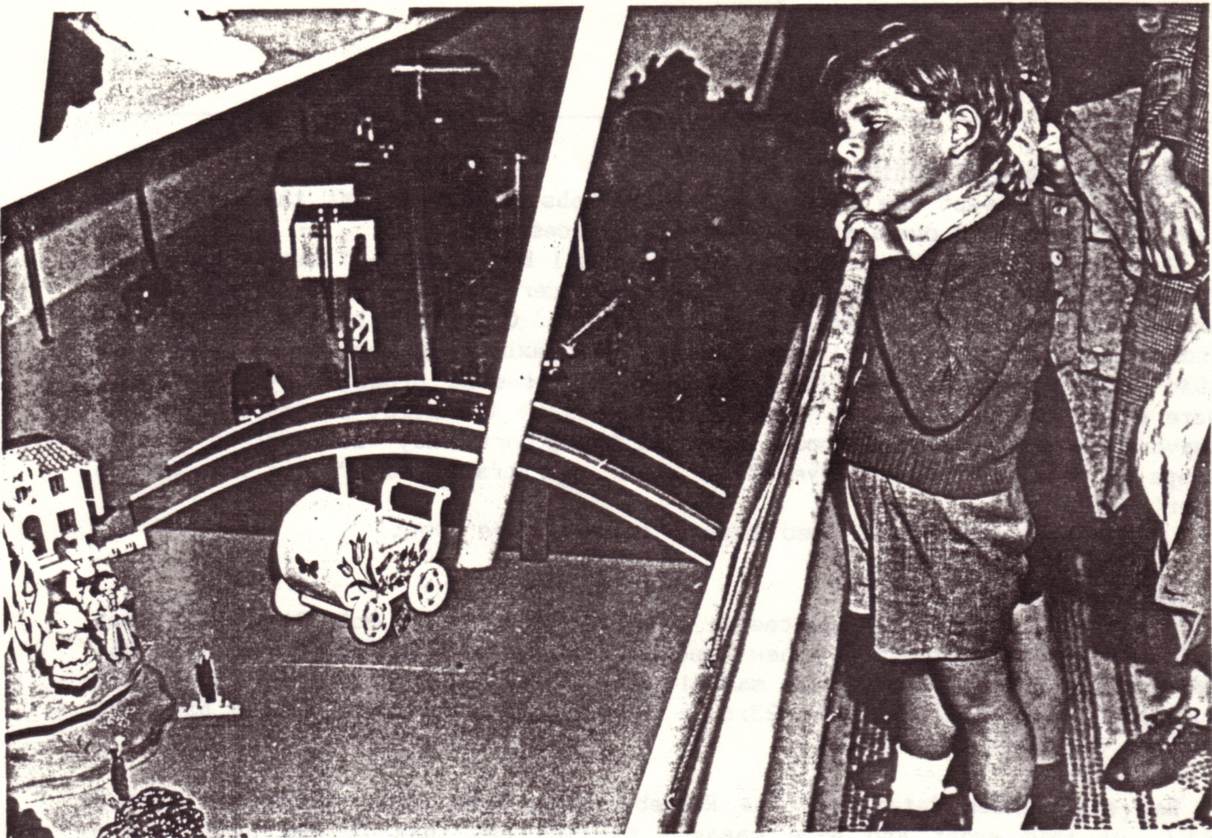

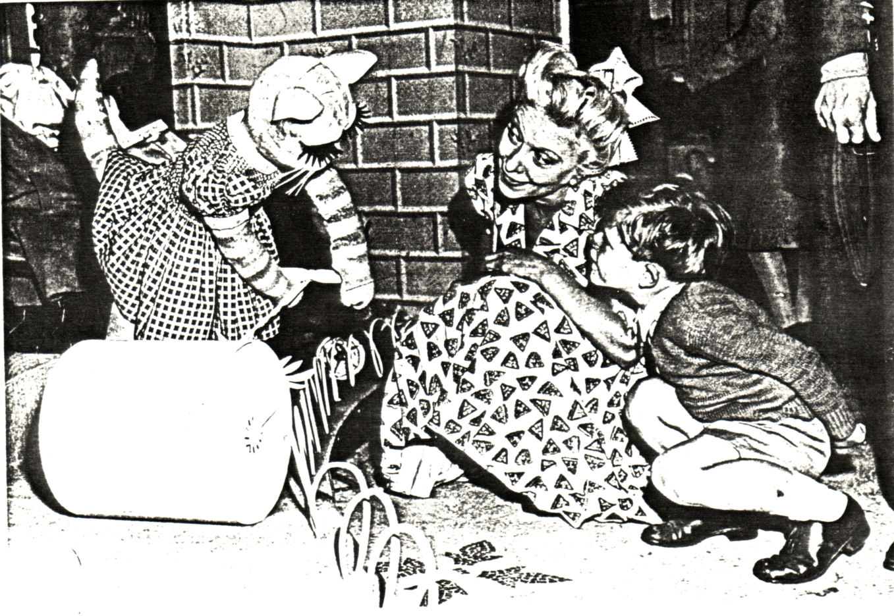

Glass Slipper P.O.Box 62. York, England. YO1 1YL. tel (0904) 701505 (24 Hour) Andrew Hall offers a regular catalogue of Cinderella material including a big selection of Exhibition and Philatelic Exhibition labels.

Bill Tonkin of 153, Blanford Rd., Beckenham, Kent. BR4 9NG would welcome any exhibition cards on approval - sale or swop.

Change of Address and New Members.
Change V.Early 7,Whitetauds Rd. Ninewells, Dundee. DD21RH. Tel. 0384 373576.
M. Graham Bonnalie, 21 Onslow Gardens, London, SW7. Iel.01 561
M. Harrison, 72, Woodbank Rd. Downham, Bromley, Kent BR15HH. Tel. 01-
2134121.
New Members
D. Haig, 41, Easterly Rd., Leeds. Vest Riding of Yorks. LS62TV.
A. Young, 26, Corrie Av. Southgate, London. N14 7HL.

The Rev. Jeremy Howat contributes his checklist of Argentinian Exhibitions and invites us to add to his list. He would obviously welcome any Xerox copies of postcards for any Argentinian exhibition and as he is interested in ALL Agentinian cards, now is the time to unload all those tea chests of South American cards you have been saving for a rainy day.

Jean Osborne has suggested an exchange packet for cards etc., any comments? It would have to be postal but provided we could keep the insurance to a reasonable level I'm sure it would work. Do not send her material just yet!

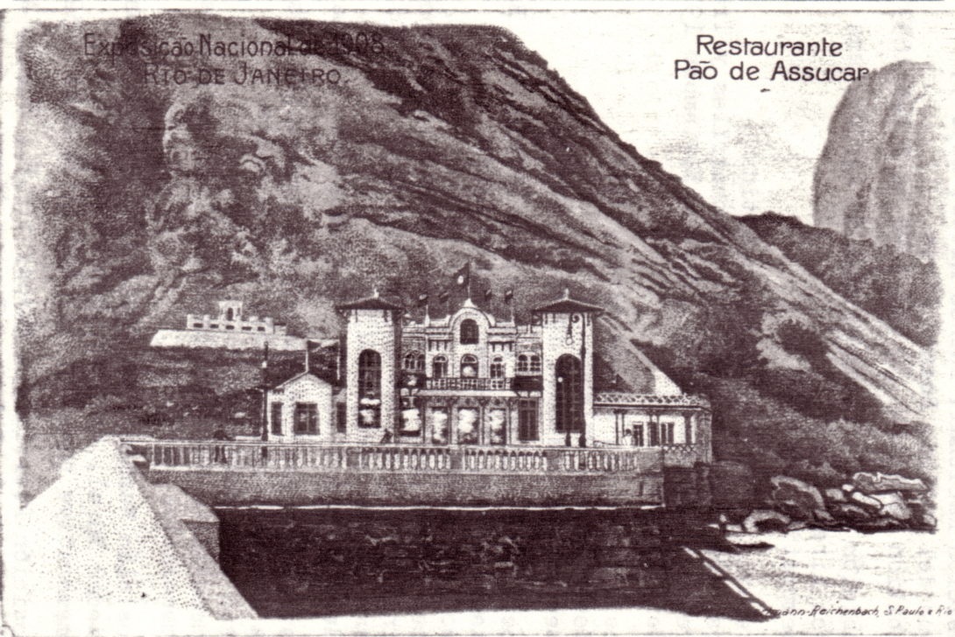

ARGENTINE EXHIBITIONS 1898-1950
by the Rev. Jeremy Howat

(a) General Exhibitions

1 Exposición Nacional, Buenos Aires, 1898-99
Parque del Retiro, Buenos Aires
Exhibition Postmark 16 Oct 1898 to 7 Feb 1899
2 Exposicióm Rural Internacional de Agricultura
Buenos Aires, 1910
Commemorative postcard
3 Centenario de la Republica Argentina
Exposiclon Internacional de Ferrocarriles y Transportes Terrestres,
Buenos Aires, Mayo a Foviembre 1910
Cinderella stamp
4 Exposición Rural, Buenos Aires, 1928
Sociedad Rural, Palermo
Commemorative postmark 19 to 31 May 1928
5 Exposición de Artes e Industrias Britanicas, Bs. As., 1931
Sociedad Rural, Palermo, Buenos Aires
Marzo 14 a Abril 27
Commemorative postcard issued by 'Mackera'a Bookshop (painting of a street scene with three searchlight beams in the background) Cinderella stamp issued Commemorative postmark
6 Muestra "Harrods" de Industrias Argentinas, Bs. As., 1931
Casa Harrods, Florida 877, Buenos Aires
Agosto 24 a Setiembre 5
Commemorative postcard issued of the Harrods shop Commemorative postmark
7 Exposición Nacional de Ganaderfa, Buenos Aires, 1932
Sociedad Rural, Palermo, Buenos Aires
Commemorative postmark 31 Aug to 12 Sept 1932
8 Exposición Petrolffera Fiscal Y.P.F., Buenos Aires, 1932-3
Sociedad Rural, Palermo, Buenos Aires
Commemorative postmark 13 Dec 1932 to 22 Jan 1933
9 Muestra y Feria Nacional, Buenos Aires, 1933
Sociedad Rural, Palermo, Buenos Aires
Commemorative postmark 1 Mar to 30 Apr 1933
10 Exposición TransoceSnica Argentina, 1934
Marzo - Diciembre 1934 Pro mision Argentina
Cinderella stamp
(evidently a floating national exhibition) (the stamp shows a map and itinerary: Buenos Aires-Brazil - West Indies-East Coast of USA and Canada-France-Spain-Italy-Greece-Suez Canal-India-West Coast of Central and South America-Straits of Magellan-Buenos Aires)
11 Exposición de Telecomunicaciones, Buenos Aires, 1939
Sallon de la Comisitfn Nacional de Bellas Artes, Posadas 1725
Commemorative postmark 14 Apr to 16 May 1939
12 Exposicitón de Artes e Industrias, Buenos Aires, 1940
Sociedad Rural, Palermo, Buenos Aires
Commemorative postmark 1 to 15 February 1940
13 Feria de la Industria Argentina, Buenos Aires, 1943
Casa Gath y Chaves, Buenos Aires
Commemorative postmark 2 to 16 September 1943

14 Exposición Oficial del Primer Aniversario del Movimiento
del 4 de Junio 1943-44 Buenos Aires, 1944
Avenida 9 de Julio y Sarmiento, Buenos Aires
Commemorative postmark 4 Jun to 30 Jul 1944
15 Gran Exposición Marltima, Buenos Aires, 1944
(organizada por la Liga Naval Argentina)
Avenida 9 de Julio y Sarmiento, Buenos Aires
Commemorative postmark 9 Sep to 9 Oct 1944
16 Exposición Argentina Minerla e Industrias Afines, 1944-45
Avenida 9 de Julio y Sarmiento, Buenos Aires
Commemorative postmark 18 Dec 1944 to 4 Mar 1945
17 Primera Exposicióm Argentina de Salud Pfiblica, 1948
Cinderella stamp issued (no other details known)
18 Exposiciffn "Correos y Telecomunicaciones en el Plan Quinquenal", 1949
Set of 12 stamped commemorative cards issued by the Argentine Post Office on 19 Nov
1949 . (no other details known)

(b) Philatelic Exhibitions

1 Exposición Pilatelica Intemacional del Centenario de la Revolucitfn de Mayo, Buenos Aires, 1910
Salón Principe Jorge, Buenos Aires
Commemorative postmark 3 to 9 Sept 1910
2 Exposición Filatglica del Centenario de la Independencia Nacional, Buenos Aires, 1916
Salón Principe Jorge, Buenos Aires
Commemorative postmark 23-28 Sept 1916
3 Exposición Filatelica Continental, Buenos Aires, I926
ConmemoraciSh del Primer Centenario de la Organizacitfn del Correo Argentino
Salón Principe Jorge, Buenos Aires
Commemorative postmark 8-13 Sept 1926
4 Exposición Filat61ica del Cincuentenario de La Plata, 1932
Pasaje Dardo Rocha, La Plata, Provincia de Buenos Aires
Commemorative postmark 19-26 Nov 1932
5 Exposición Filat£lica de Buenos Aires, 1935
"EX.FI.B.A." Salón de los Amigos del Arte, Florida 659, Buenos Aires Commemorative postmark 17-24 Oct 1935
6 Exposición Filatelica Internacional, Buenos Aires, 1939
"C.Y.T.R.A." conmemorativa del XI Congreso de la U.P.U.,
Buenos Aires, Mayo 1939
Palacio de Correos y Telegrafos, Buenos Aires
Issue of commemorative sheetlets postmark 12-28 May 1939
7 Muestra Filat^lica de La Plata, 1939
Salón de Fiestas de la Municipalidad, La Plata
Commemorative postmark 24-30 Nov 1939
8 Exposición Filatelica Nacional, Córdoba, 1940
Salón Blanco del Ministerio de Obras Ptzblicas, CCrdoba
Commemorative postmark 25-31 May 1940 and sheetlet
9 Exposición Filatelica Interamericana, Rosario, 1941 Palacio de Correas, Rosario de Santa Fe
Commemorative postmark 6-13 August 1941
10 Exposición Filat^lica Internacional de la Reptlblica Argentina "E.F.I.R.A.",
Buenos Aires, 1950
Facultad de Derecho y Ciencias Sociales, Buenos Aires
Commemorative postmark 4-I5 Nov 1950
Commemorative stamps and sheetlet Ano del Libertador General San Martin

(c) Argentine stands at international exhibitions

1 Gand, France, 1913
Postcard: Souvenir du Museo Social Argentino a
1'Exposicion intemationale de GAND, 1913
Pont de Chemin de Fer du Sud sur le fleuve "Riachuelo"
Buenos Aires (agricultural statistics on reverse)

(any more information on these would be appreciated)

Additional Notes

General Exhibition 5 (of British Arts and Industry in 1931) coincided with the visit to Argentina of the Prince of Wales (later the Duke of Windsor) and the Duke of York (later King George VI).
General Exhibition 8 commemorated the 25th anniversary of the discovery of oil in Patagonia at Comodoro Rivadavia (Province of Chubut).
Miniature sheets (or sheetlets) were issued for the Philatelic Exhibitions 5 (Buenos Aires 1935), 6 (C.Y.T.R.A., Buenos Aires 1939) 8 (Córdoba 1940, marking the centenary of the issue of the penny black) and 10 (E.F.I.R.A., Buenos Aires 1950).

4, Churchill Drive,
Amblecote,
Stourbridge,
Worcs.
DY8 4JS

Dear Andrew
Many thanks for a great day at York It was good to meet the other members and put faces to names. It’s always easier to talk than write. Ideas and questions flow more easily.
Can I claim a record for the longest journey home. In time that is.
I left Inch’s Bookshop in the company of Bill and his wife and we went back to the Black Swan. We spent a very pleasant hour or so discussing the Wembley cards and around 7-15 pm I said I’d better go. I’d come up by train and checked the return train at 5-10 pm and 6-30 pm with two later trains (I didn’t note the times). I arrived at the station just after 7-30 pm to be told by a ticket collector that I was too late. I asked about the other trains and was told that one was ‘Saturday Excepted’ and the other ‘Friday Only’ I was stuck, I checked at the Enquiry Office and was told the next train to Birmingham was 11.30 am, Sunday.
I didn’t mind the idea of an overnight stay but the late start put me off. I wanted to get home. I asked about alternatives, I could go to London and then back to Birmingham arriving about 1-30 pm too late to get home other than by taxi, plus I’d have to get a ticket London to B’ham. Cheaper to stay overnight. No. 2 was to get to Preston and wait there for the 8-30 pm from Inverness. Idea number three was to head for Crewe and get the same train at 5-30 pm.(a five hour wait). I decided on this alternate
I had a pint, phoned home, and set off from York at 8-55 pm. First stop was Stalybridge where I was concerned to find the connecting train was emblazoned ‘Valley train’ with a large Welsh Dragon. ‘How far does this train go’ I wondered. I wandered up the train and found an elderly couple who assured me we wouldn’t end up in Cardiff and I sat down. We got to Stockport about 10-30. pm and I enquired about the Crewe train, ‘Get on the next train on this platform and change at Wilmslow’ said the guard, its quicker’, after a ten minute wait I was on train no. 3. I got off at Wilmslow to be told 1 had a 25 minute wait until the 11-25 pm.
Well, it wasn’t too bad a night and train no. 4 got me in to Crewe at midnight. A quick check on the timetable told me the Birmingham train was 5-58 am. I went and sat in the coffee bar and had a quick look at Bill’s cards. However I wasn’t in the mood for sorting cards so I found a quiet corner, set my alarm and got a bit of sleep. ‘Peep, Peep, Peep’ at 5-20 am got me awake, so it was a cup of coffee, a bite to eat and onto the train. It finally left at 6-35 am, having had to wait for the London train, we pulled into New Street at 8 am and I checked with the booking office for the train to Stourbridge, 16-45 pm but there were no trains anyway because the lines were up!
There would be a coach at 10.30am. I went down to the Bus Station to try my luck there, the only person there was a mechanic who didn’t know anything. Then a bus came in so I grabbed the driver. The Stourbridge bus didn’t go from there anymore but he couldn’t think of its new terminus. ‘Jump on’ he said and we roared off into Birmingham. After 5 mins, we pulled alongside another bus. The driver sounded his horn and opened the doors. ‘No. 9’ he asked. ‘Yes’ came back the reply. Expressing my thanks I swopped buses and set off for home. About a mile from Stourbridge we came to a section of road that was flooded, with a Cortina stuck in the middle. It bad been raining quite steadily since we had left Crewe, the bus got through O.K. and I was dropped off at the nearest point to home about 9-25 pm., tired, wet, but on the whole having enjoyed the adventure.
So, can anyone beat 12½ hours to get home?
Regards Mike.

Ed, comments! 1 am sure we would all agree that Mike deserves the Golden Postcard Award for 1987! It will be forwarded to him by T. N. T. I was worried when he doesn’t appear to have the stamina to check Bill’s cards, is he about to sell up I thought! Then I remembered that whilst we were all downstairs in the pub bar at dinner time, Mike was upstairs checking through two albums of Wembley cards, we will forgive the moment of weakness.
I am sure members would also like to know about some of Mike’s further exploits, in October when we met briefly at the Cheltenham Postcard Fair, I understand that he suffered a puncture on the way home and when he visited Bill in December his car broke down on the way back.
He is looking for a travelling companion for Expo. Day 88!

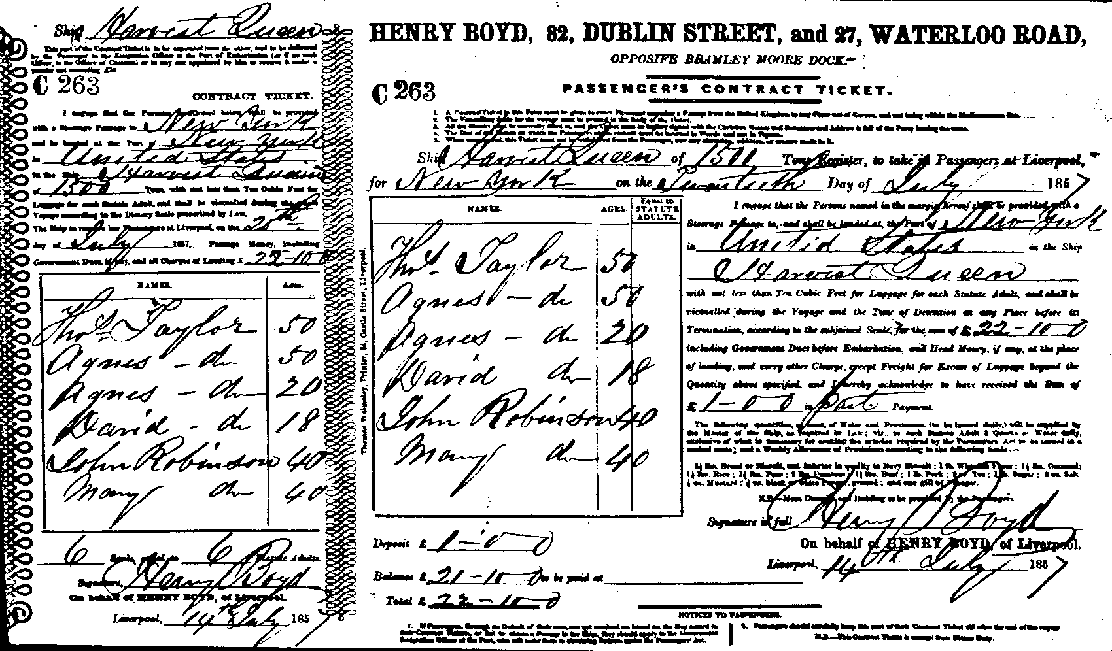

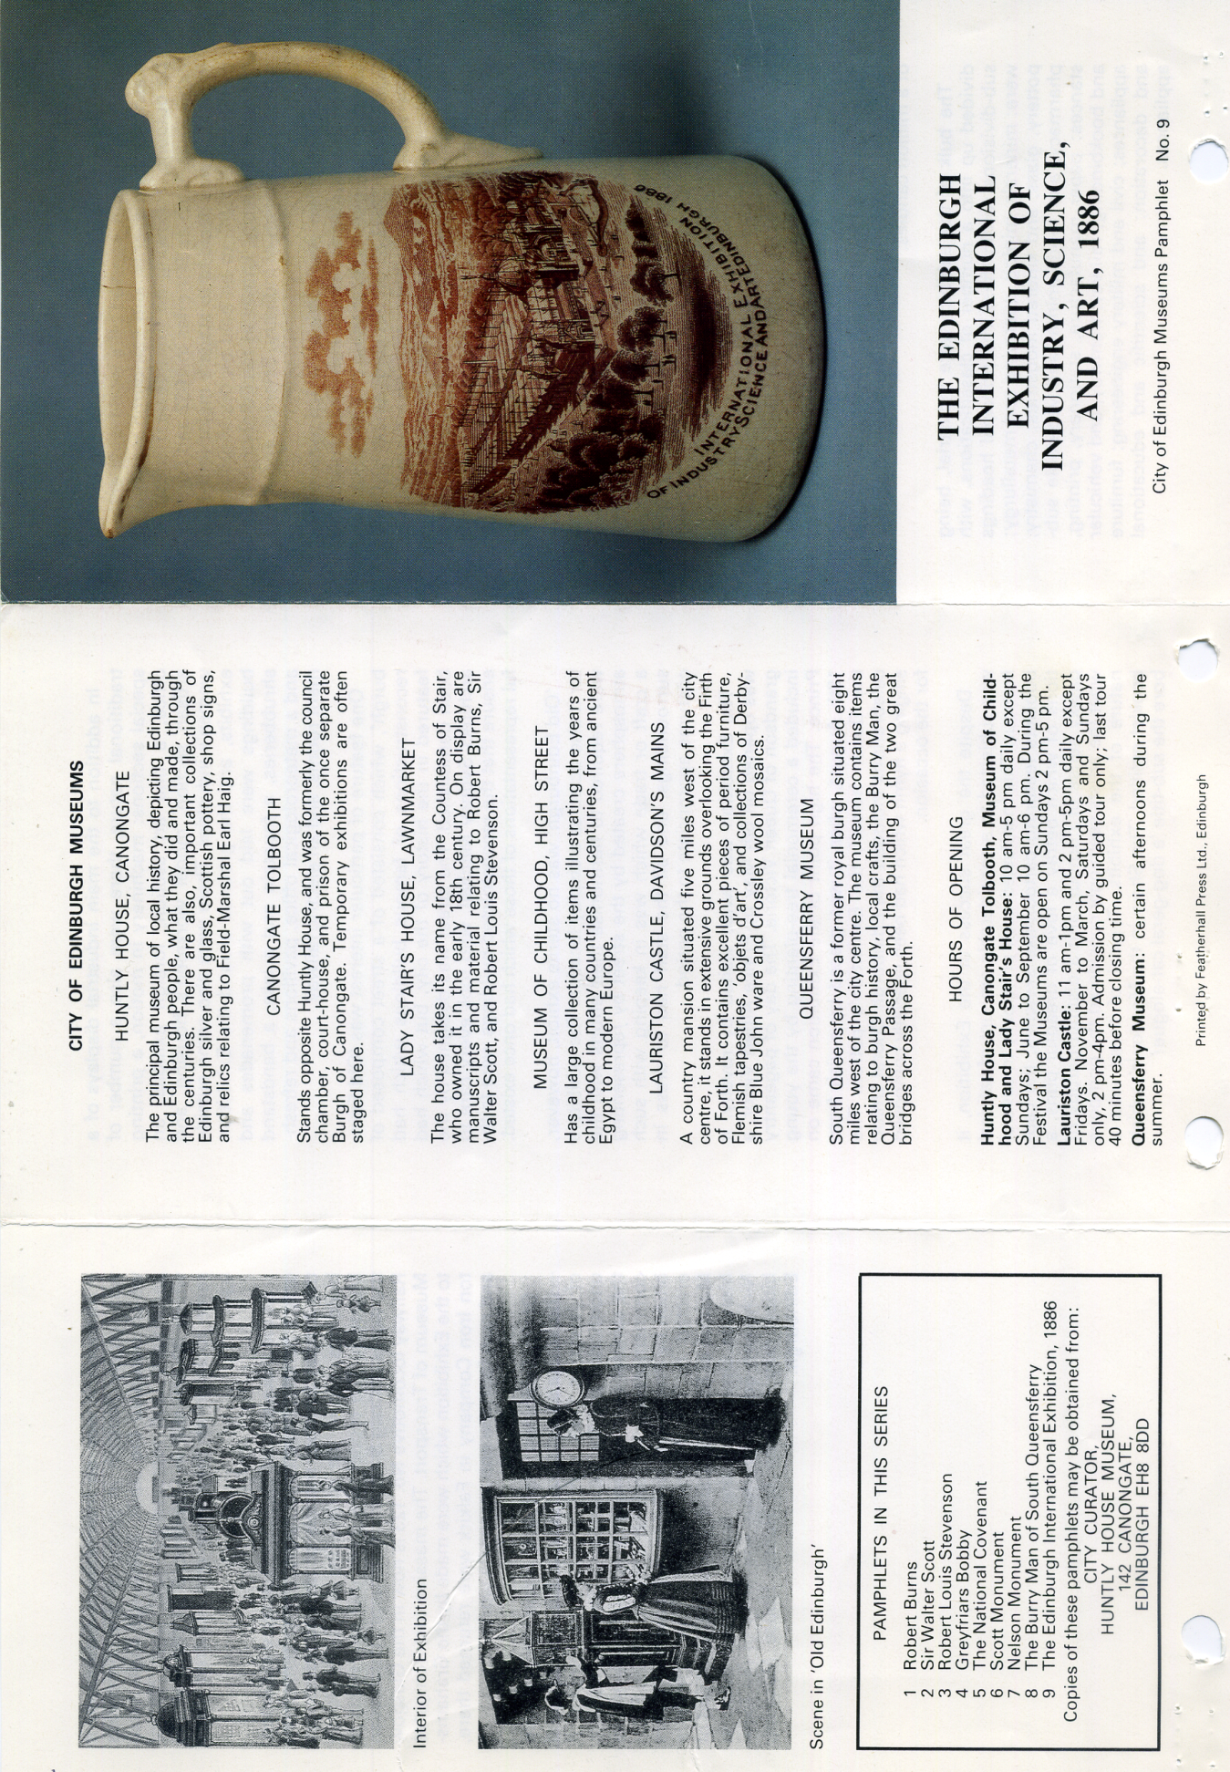

Text of the City of Edinburgh Museums pamphlet No. 9

The Great Exhibition of 1851, held at the Crystal Palace in London, sparked off a world-wide enthusiasm for such events, and Edinburgh was not to be outdone. Following on from several specialist exhibitions, such as Fisheries in 1882 and Forestry in 1884, it was decided to stage a major industrial exhibition in 1886, to be held on the Meadows in the heart of the city, known as the Edinburgh International Exhibition of Industry, Science, and Art.
The Exhibition Association, which was established to organise the event, saw its task as being to secure "a good representation of such Industries, Sciences, and Arts as do not come under ordinary observation, so that visitors may note the progress that is being made in different departments of trade throughout the world". The Exhibition was a great popular and commercial success; when it closed after a six-month run, it had been seen by 2,769,632 visitors.
To house the exhibits, a huge edifice was constructed which covered seven acres of the West Meadows consisting of thirty-four courts, plus a central court separating the two rows of bays. The main entrance led through the Grand Hall, a palatial structure which was embellished with towers and domes, and was capable of accommodating 10,000 people.
The Grand Hall was intended to stand as a permanent reminder of the event, but Parliament had decreed that no structures could be erected on the Meadows, so at the end of the show it all had to come down. A striking feature of the Exhibition was that it was illuminated by electric light, with 3,200 lamps equalling the power of quarter of a million candles.
The bulk of the exhibits were industrial, being divided up into a number of classifications, with sub-divisions within these. The principal headings were: minerals, mining, quarrying and metallurgy; pottery, glass, and kindred industries; chemistry, pharmacy, and food; animal and vegetable substances; paper manufacture, stationery, printing, and bookbinding; railway, tramway, and vehicular appliances; civil and military engineering; furniture and decoration; and scientific and educational appliances.
In addition to the main industrial displays of a traditional nature, there were also a number of special sections: machinery in motion, a printing office, a fine art section, foreign exhibits, an artisan section, model workmen's housing, and women's industries. There were also some outside exhibits, and the grounds around the Exhibition buildings were laid out with promenades and shrubberies, a fountain and a lake, a bandstand and a meteorological office, pavilions and refreshment rooms, and an electric railway.
One feature of particular interest was 'Old Edinburgh', which consisted of a street composed of reconstructions of famous buildings which had featured in the history of the city, but which had been demolished. The street was designed by the architect Sydney Mitchell, who took every care to ensure that the reconstructed buildings were faithful representations of those which had once existed.
'Old Edinburgh' was no sterile exhibit, however, for it also acted as a display location. The exhibitors were required to harmonise their efforts with the atmosphere created by the street by representing a craft or trade which was in keeping with such surroundings, and all the staff had to dress in costume appropriate to the period.
The Exhibition was twice visited by royalty. It was opened on 6th May by Prince Albert Victor, a grandson of Queen Victoria. The day of pageantry included a ceremonial tree-planting by the young Prince. The high point of the Exhibition came on 18th August, when it was graced by a visit from the Queen herself, the Exhibition's patron. The celebrations included the Edinburgh Choral Union singing a hymn which had been specially composed for the occasion.
Despite the great success of the Exhibition, it was subjected to a considerable amount of satirical humour. This manifested itself principally in several booklets featuring cartoon-like sketches, the captions of which betray a love of dreadful puns, a pawky sense of humour, and a distinct parody of what the artists seemingly considered the pompous nature of the exhibits. Typical of these was a booklet entitled The Show in the Meadows', which bore the sub-title 'a dog-geral cat-alogue!
Although it was an International Exhibition, it was largely Scottish in terms of the companies which occupied the stalls. Edinburgh firms were particularly well represented, well over 700, of which 39 are still in business, 6 of them at the same location as they were one hundred years ago.
Of the thousands of objects which were exhibited, only a handful have been traced. Three items from the Artisan Section, models of historic Edinburgh buildings, are in the collections of Huntly House Museum. The model of a paint mill still exists at the works of Craig & Rose in Edinburgh. Caledonian Railway locomotive No. 123 is now in the Glasgow Museum of Transport.

Glasgows Garden Festival 1988

