EDITORIAL SUMMER 2008

The fourteenth of May’s an important date,
It’s when it all started in 1908.

I don’t know what it is about the Franco-British Exhibition that first grabbed me, but it’s always been one of my favourite exhibitions. Perhaps it’s because the post cards were so cheap in my early collecting days, that I was able to build up a good collection of them. However I think for sheer beauty of post cards the laurels must go to the Japan-British Exhibition two years later.
One thing’s for sure the centenary is not going to pass un-noticed. Two books are already published one by our secretary Don Knight who has up-dated his book ‘Exhibitions Great White City’ first published in 1978 and now with all the illustrations in full colour. See the front cover for an illustration of the cover of his book. This is a good book and has been up-dated to 2008, and is a mine of information. Don is making it available to Study Group members in the U. K. at £5.00 post free. Don’s address and phone number is on the inside cover of the Journal.
Another book that came out in April was Bob Wilcock’s book on the 1908 Olympic Games. Alan Sabey has arranged to have some copies available at our convention, and I will give you another reminder nearer the time.
My own book ‘Post Cards of the Great White City Exhibitions 1908-1914’ is at the printers and I am waiting to check the proofs as soon as they come. It has finished up at 664 pages and will cover the period of Imre Kiralfy’s management at the White City until the site was taken over by the Army at the start of the First World War.
Don was featured on a TV programme on BBC 2 Newsnight on Wednesday 14 May and it must be said they put on a first class program. Don escorted the presenters round the site pointing out where features were in 1908 and the whole was beautifully illustrated with post cards from Don’s collection. I was also involved when a BBC programme man visited me for three days going through my collection of Franco-British post cards looking for interesting messages on the back. He went away with over 200 to sort out. They were getting the messages read out by members of a school of acting to get different voices. On the third day he brought a colleague with a recording machine to record me talking, but my moment of glory was literally over in a moment as it got edited down to about 30 seconds.
Mike Perkins has reported that he has moved the web site to a new host. The web site has slowly grown over the years, and reached the limit of the space we pay for. Another problem we have experienced is what the host calls ‘traffic’ basically we have become popular and each visit to the site results in ‘traffic’, which has a small cost to us. All of this cost us about £40 - £50 a year and to increase the space would have doubled this. The new host gives us 10 times more space and unlimited ‘traffic’, and is free for the first year, after that it should cost about £20 - £25 each year. This means the site can grow as we add more articles from the Journal, and our success will not be a burden to us. Have a look at ‘studygroup.org.uk’.
This edition of the Journal is being devoted to The Franco-British Exhibition and the main article is about the Advertising labels used for the Franco-British Exhibition. These have been steadily gaining in popularity and in price too. In my early stamp collecting days collectors stuck them on the back pages of their albums because they didn’t know what they were.
I went to the Surrey Federation do some weeks ago and added quite a lot to my collection from one of our members Charles Kiddle who is one of the few dealers who only deals in advertising labels. When one considers that many of these labels are a lot scarcer than, say, penny blacks, and some of them are exceedingly rare, far out stripping plate 11, it follows that they are going to be expensive.
Mike Perkins has just spent a few days with me and part of the time we spent going through my White City collection listing the times of cancellations on the Exhibition post marks. When this is finished I will do an article on our findings. Some treasures have turned up that I didn’t know I had, like a Shepherds Bush W circular hand stamp for the first of May on a cheap old Valentine’s ‘Bridge in Court of Honour’ card obviously written by one of the staff working at the exhibition with the message “A part of the exhibition. Hope you will have the pleasure of seeing it. We here will get fed up with it.” It suggests that Valentine’s were selling their cards to workers on the site weeks before the exhibition opened.
The Editors
Convention 2008

There has been an alteration in the venue for our 2008 22nd Convention. The Lodge at the Crystal Palace where we were going to hold our Convention is undergoing a multi million pound overhaul to the water systems and has cancelled all bookings until it is estimated, next January. I notified Don Knight that we either had to find a new venue or miss a convention this year and have two in 2009. He felt it was important to keep to our fixed convention dates and suggested we return to our 2005 venue at the Ramada Hatfield. Don has been able to visit the Ramada and has arranged for us to have a conference room for all of Saturday and up to lunch time on Sunday. They will also do our Annual Dinner on the Saturday evening. They have offered reduced rates for those staying overnight but you must mention ‘Event Rates’ in the name of the Study Group.
They have informed me that the Bar and Restaurant have been refurbished since we were last there (a case of gilding the Lilly perhaps?) and after the rather Spartan Crystal Palace we can wallow in luxury. The rates for bed and breakfast are £65 00 for a double or twin bedroom and £55 00 for a single room. On his visit Don was able to twist their arm slightly and get a reduction of £75.00 off the price of hiring the conference room. Our contact there is Mare Purred. Conference & Event Sales Supervisor, and the address is Ramada Hatfield. St. Albans Road West, Hatfield, Hertfordshire. AL10 9RH. Phone 01707 265411. Once again if you are booking to stay for our convention don’t forget to mention ‘event rate for the Exhibition Study Group’.

The Crystal Palace Corner
by
Fred Peskett

After seventy-two years a part of the Crystal Palace building now stands proud overlooking the terraces and grounds of Penge Park. On Saturday 7th June 2008 a corner made to the specification of the original Crystal Palace was unveiled. The ceremony was performed at noon with John Greatrex welcoming the Civic Dignitaries and Guests and reading a poem he had written about the Crystal Palace.
Soloist Rita Marie-Lauren sang “Abide With Me”, then the corner was unveiled by children from the Paxton School accompanied by the Pearly King & Queen of Crystal Palace, and “Queen Victoria & Prince Albert”. After the National Anthem, John called for “Three Cheers for Joesph Paxton and his Amazing Crystal Palace”, then it was time for some refreshments from a superb buffet and glasses of Pimms!
The Crystal Palace Corner is the work of Exhibition Study Group member John Greatrex, who is to be congratulated on re-instating a piece of lost history. It is hoped that this is the start of something big and perhaps there will be another two-thousand plus columns put in place to recreate the whole building?

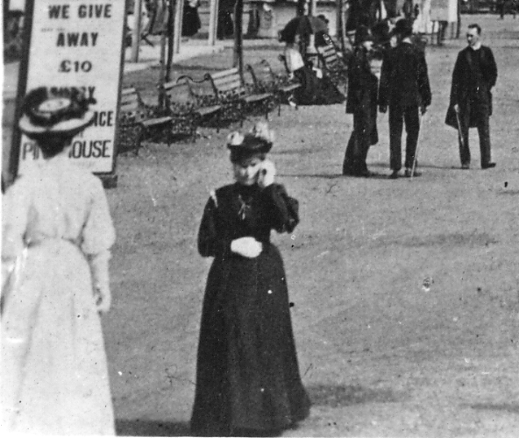

An amazing picture of a lady using a mobile phone at the Franco-British Exhibition in 1908 on a Rapid Post Card V384-10 titled The Flip-Flap. Well seeing’s believing, aint it. The camera cannot lie, can it?
The Senegal Village at the Franco-British Exhibition

Part 1 taken from the official guide price 2d

Introduction.

In presenting at the Franco-British Exhibition a corner of savage dark Africa, we desire to express our thanks to the Chairman of the French Colonial Committee, who has given us his very valuable assistance in adding this living picture to the most interesting exhibits shown in the official buildings of Algeria, Tunis, and Indo-China.
We are also greatly indebted to His Excellency the Governor of the Senegal, who, without any hesitation whatever, has granted us the privilege of taking nearly 150 natives out of the Colony to form the population of the Senegal Village.
His Excellence’s permission was accorded readily, because he is aware that we have always treated natives well, and have done our best, without counting the cost, to make them comfortable in a foreign country on the occasion of former exhibitions in France.
Mr. Victor Barnberger, who presents pictures of the life of India and its natives in the British Colonial section, has united his efforts with ours to present the Senegal Village in a most dignified and effective form to the British public.
The amount of work involved has been very great, but we have no doubt that the ultimate success of our venture will recompense everyone concerned for the .great trouble they have taken.
Aime Bouvier
Fleury Tournier
Explorers.

A Visit to the Romantic Country at the Gate of the Sahara.

Twin watch towers mark the entrance to the most fascinating corner of the Franco-British Exhibition. Do you hear, as you approach, the rhythmic chant of voices, the mysterious beat of drums. These are your invitations to penetrate the mysteries of the sunlit Continent, to transport yourself at a moment from the prosaic world in which you live to a land of mystery and romance. Behind these high walls another life is lived, a life which no reading of books and seeing of photographs can depict for you. If you would join the select band of travelers who have explored the hidden world of Africa you must pass through these gates. Here you may behold the true life of the natives. Before your eyes you will see one hundred men, women, and children, living and loving, working and playing, just as they do in that far-off land.
This is the Senegal Village. Here among the palm huts are living natives from that great territory of West Africa, in which France has carried on a civilizing mission since the fourteenth century, when merchants of Dieppe and Rouen founded their trading-houses on the low coast line. A peaceful and prosperous colony, inhabited by a strange medley of native races, tribes, and castes, little known to the outside world, but preserving in all its characteristics that peculiar charm and fascination which the land of sunlight holds for everyone who has once visited it. Such is Senegal, and of such is the Senegal Village at the Franco-British Exhibition.
When you have once felt the charm you will find it difficult to escape. Again and again you will come back, drawn by the strangeness of the scene, the amusements you will witness, the quaintness of the things you will buy. Here is colour such as you may see nowhere else ; here are men and women living in a manner as little like your own as any life could be; here are sounds and sights which catch your attention by their strangeness and charm by their novelty.
Let me act as your guide as you walk through the winding streets of this native village lined on either side by these low huts, with their palm roofs and jet black inhabitants. This is evidently a well-ordered community. It has its public buildings. In the middle stands a large common hall, where the villagers hold their council, and decide any matters of dispute which may arise between themselves. It has not the grand appearance of a European town hall, for its palm roof is supported by unhewn timbers, but it serves for the celebration of marriages and a place where the villagers can amuse themselves with games and dancing.
Advertising Labels of the Great White City.
Part 1 the Franco-British Exhibition 1908

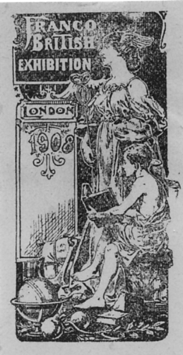
This listing has been compiled from my own collection and with the help of four contributors Jean Osborne, Ken Rumsey, Alan Sabey and Kenneth Tonkin who have kindly kept me supplied with images of their collections and updates of new additions. Without this help this list could never have been contemplated to the degree of completeness presented here. If any members have White City labels not listed here I should be pleased to hear from them with images if possible.
The first published catalogue of advertising labels was in 1914, the Catalogue des Timbres Commémoratifs by Cazin & Rochas a French publication. Part of this relating to the Franco-British Exhibition was copied and published by an English firm now defunct who traded in the 1980’s, as Glass Slipper. The Cinderella Stamp Club Handbook No. 8 by Chris Chatsfield published in 1991 also gives a short list of Franco-British Labels.
White City labels for other exhibitions will be covered in Part 2.

Fig. 1.

General labels as listed by Cazin & Rochas

C & R Type 1 Standing woman and seated boy with book. 30 x 60 mm. Fig. 1.
Perf. 11. Black on coloured paper.
Black on blue
Black on brick red
Black on green
Black on yellow
Imperf. proofs black on coloured paper. The imperf proofs are known with the normal small margins and with very large margins on three sides of the label.
Black on blue
Black on green
Black on orange
Black on pale pink
Black on pale yellow
Black on pink
Black on red
Black on yellow

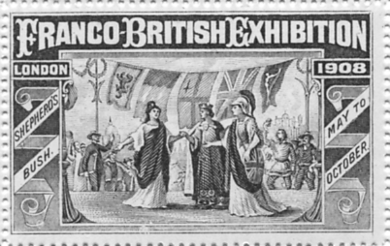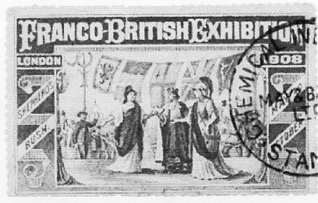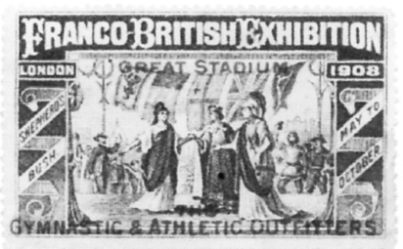
Fig. 2 & 3. Fig. 4. Fig. 5

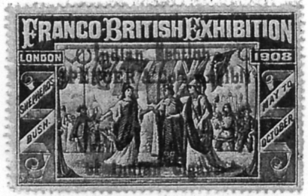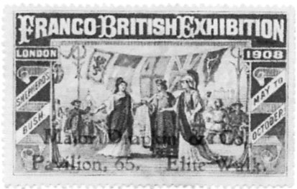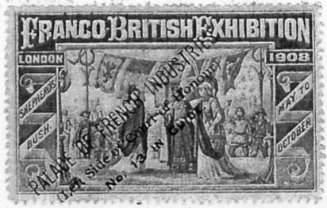
Fig. 6. Fig. 7. Fig. 8
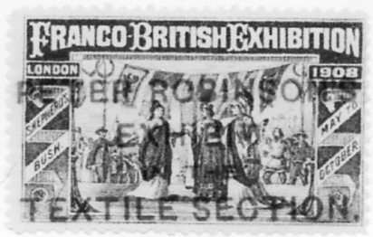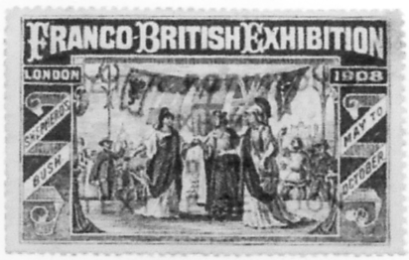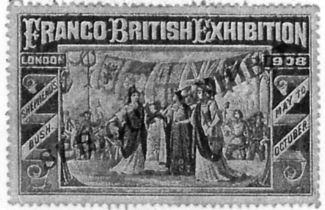
Fig. 9. Fig. 10. Fig. 11

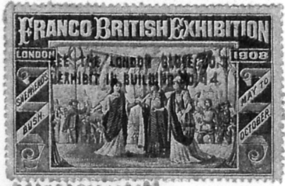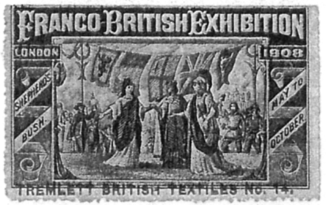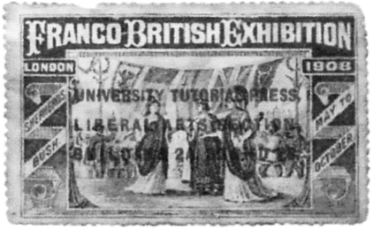
Fig. 12. Fig. 13. Fig. 14

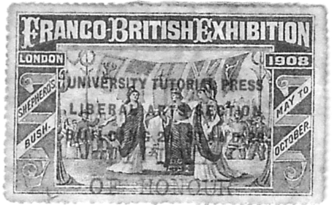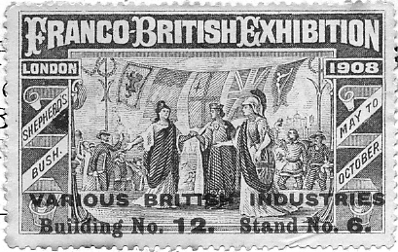
Fig. 15. Fig. 16

C & R Type 2 Britannia, Republique and third lady in front of row of flags. unoverprinted
Blue perf 10. 48 x 29 mm. Fig. 2.
Blue perf 14. 48 x 29 mm. Fig. 3.
C & R Type 2 ‘Building No. 21 Allotment 82, Decorative Arts and Furnishing Section.
Blue perf 14. 48 x 29 mm. (Not illustrated).
C & R Type 2 ‘Chemical Industries Stand. May & Baker.’ overprinted in black (like a post mark)
Blue perf 14. 48 x 29 mm. Fig. 4.
C & R Type 2 ‘Great Stadium, The Gymnastic & Athletic Outfitters.’ overprinted in red.
Blue perf 14. 48 x 29 mm. Fig. 5.
C & R Type 2 ‘Indian Section Spencer & Co’s Exhibit of Indian Cigars.’ overprinted in red.
Blue perf 14. 48 x 29 mm. Fig. 6
C & R Type 2 ‘Indian Section Spencer & Co’s Exhibit of Indian Cigars.’ overprinted in red and additional “Awarded Grand Prix” in yellow.
Blue perf 14. 48 x 29 mm. (Not illustrated)
C & R Type 2 ‘Major Drapkin & Co. Pavilion 65, Elite Walk.’ overprinted in red.
Blue perf 14. 48 x 29 mm. Fig. 7.
C & R Type 2 ‘Palace of French Industries. Left side of Court of Honour. No. 13 in Guide’ overprinted diagonally in black.
Blue perf 14. 48 x 29 mm. Fig. 8
C & R Type 2 ‘Peter Robinson’s Exhibit in the Textile Section.’ in large font overprinted in red.
A. Blue perf 10. 48 x 29 mm. Fig. 9.
B. Blue perf 14. 48 x 29 mm. Fig. 9.
C & R Type 2 ‘Peter Robinson’s Exhibit in the Textile Section.’ in small font overprinted in red.
Blue perf 14. 48 x 29 mm. Fig. 10.
C & R Type 2 ‘See Our Exhibit.’ overprinted diagonally in red.
Blue perf 14. 48 x 29 mm. Fig. 11.
C & R Type 2 ‘See the London Glove Co’s Exhibit in Building No. 14.’ overprinted in red.
Blue perf 14. 48 x 29 mm. Fig. 12.
C & R Type 2 ‘Stand No. 608’ overprinted diagonally in red.
A. Blue perf 10. 48 x 29 mm. (Not illustrated).
B. Blue perf 14. 48 x 29 mm. (Not illustrated).
C & R Type 2 ‘Tremlett British Textiles. No. 14.’ overprinted in red.
Blue perf 14. 48 x 29 mm. Fig. 13.
C & R Type 2 ‘University Tutorial Press. Liberal Arts Section. Building 2a Stand 28.’ overprinted in red.
Blue perf 14. 48 x 29 mm. Fig. 14.
C & R Type 2 ‘University Tutorial Press. Liberal Arts Section. Building 2a Stand 28.’ with additional ‘Diploma of Honour.’ overprinted in red.
Blue perf 14. 48 x 29 mm. Fig. 15.
C & R Type 2 ‘Various British Industries Building No. 12. Stand No. 6.’ overprinted in red.
Blue perf 14. 48 x 29 mm. Fig. 16.

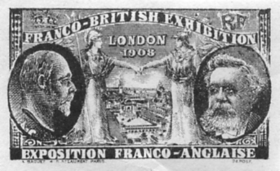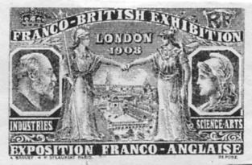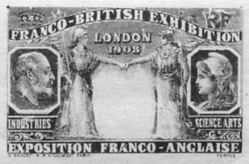
Fig. 17. Fig. 18. Fig. 19.

C & R Type 3. (A. Baguet I) Edward VII and President Fallieres. Britannia and Republique shaking hands over exhibition grounds. Fig. 17.
Perf. 11.
Blue
Brown
Green
Red
Violet.
Imperf. proofs on white paper.
Blue
Brown
Green
Red
Violet.
Imperf. proofs on coloured paper.
Brown on blue
Brown on green
Brown on pink
Red on blue
Red on green
Red on grey
Red on pink
C & R Type 4. (A. Baguet 2nd issue) Type (a) these are very similar to the Baguet 1st issue except President Falieres is replaced with Republique, the heads are reduced in size. Fig. 18.
Perf. 11.)
Red
Slate-blue
Violet.
Violet-blue.
Imperf. proofs on white paper.
Blue
Red
Violet
Violet-blue
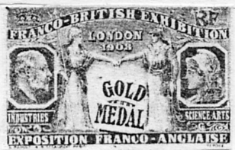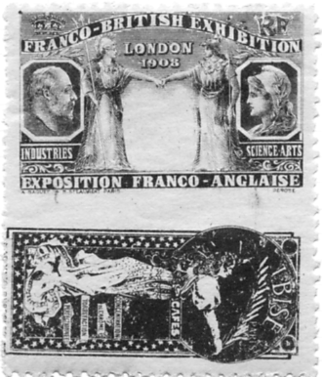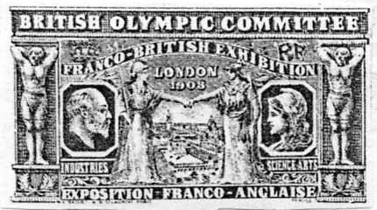
Fig. 20. Fig. 21. Fig. 22

C & R Type 4. (A. Baguet 2nd issue) type (b) as type (a) but without the Exhibition grounds in the center
Fig. 19.
Perf. 11.
Blue
Brown
Olive green
Red
Violet.
Imperf. proofs on white paper.
Blue
Brown
Olive green
Red
Violet.
C & R Type 4. (A. Baguet 2nd issue) type (c) without the Exhibition grounds in the center but overprinted Gold Medal in black. Fig. 20.
Perf. 11.
Blue
Brown
Olive green
Red
Violet.
C & R Type 4. (A. Baguet 2nd issue) type (d) without the Exhibition grounds in the center and with an Ibise Cafe label below. Fig. 21.
Imperf proofs on white paper
Brown
Red

C & R Type 5. (A. Baguet 3rd issue) British Olympic Committee. Fig. 22.
Perf 11.
Carmine
Dark brown
Orange
Red brown
Sky blue
Slate blue
Vermilion
Yellow green
Imperf proofs on white paper, complete sheets of these are known.
Carmine
Dark brown
Orange
Red brown
Sky blue
Slate blue
Vermilion
Yellow green
The Olympic labels were printed in sheets of 71 labels, only nine of which were Olympic labels. This odd number came about because the first column was one label short leaving an 18 mm. unprinted space in the top left corner and a wider selvidge by the top two rows. There are seven columns of nine labels and one column of eight labels. This is not the only oddity as the four labels at the top of the first column are long horizontal labels printed in pairs vertically. The labels come in four different sizes,
(a 69 x 23 mm. Four labels at top of the first column
(b 61 x 28 mm. Four labels at bottom of the first column and columns five, six, seven and eight.
(c 44 x 28 mm. Columns two and three
(d 53 x 28 mm. Olympic labels in forth column
The labels were printed in seven different designs.
1 (a Fetes du Carnaval Nice 1908 (Pavilion on end of pier and obelisk)
2 (a Fetes du Carnaval Nice 1908 (Small island and obelisk)
3 (b Courses de Canots Principaute de Monaco. Organisees par l’International Sporting Club de Monaco
4 (b Exposition des Canots Automobiles. Principaute de Monaco.
5 (c 5e Foire de Paris Grand Palais
6 (c Concours General Agricole Paris.
7 (d British Olympic Committee. Franco-British Exhibition.

 |  |  |  | (c  5 | (c  6 | (d  7 | (b  3 | (b  3 | (b  4 | (b  4
 | (a |  | (a | 5 | 6 | 7 | 3 | 3 | 4 | 4
 | 1 |  | 2 | 5 | 6 | 7 | 3 | 3 | 4 | 4
 | (a |  | (a | 5 | 6 | 7 | 3 | 3 | 4 | 4
 | 1 |  | 2 | 5 | 6 | 7 | 3 | 3 | 4 | 4
(b  3 |  |  |  | 5 | 6 | 7 | 3 | 3 | 4 | 4
(b  3 |  |  |  | 5 | 6 | 7 | 3 | 3 | 4 | 4
(b  4 |  |  |  | 5 | 6 | 7 | 3 | 3 | 4 | 4
(b  4 |  |  |  | 5 | 6 | 7 | 3 | 3 | 4 | 4
Layout of British Olympic Committee and other labels

C & R Type 6. (A. Baguet 4th issue) This was a complex issue published in four different shapes, one shape having five different views, another with three views. Each title was printed in five colours. It would appear the labels were printed in se-tenant pairs horizontally but not always vertically, the layout of a complete sheet has not been recorded. The largest known pane is of ten labels with a selvidge at the top. A strip of four of the smaller sized labels is known with a selvidge at each side which gives the width of the sheet. It is not known where the smallest label Fig. 32 fits in, perhaps it had a sheet of its own. Many pairs and strips of three exist but they all confirm to the layouts below.
Perf 11. 55 x 25 mm.
The Decoration and Furnishing Palace Fig. 23.
The Fine Art Palace Fig. 24.
The Franco-British Pavilion Fig. 25.
The Garden Club Fig. 26.
The Palace of Machinery Fig. 27.
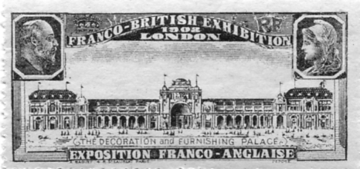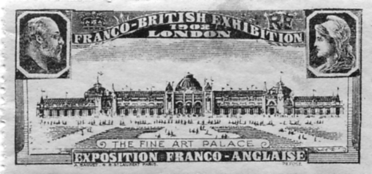
Fig. 23. Fig. 24.

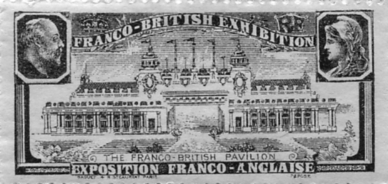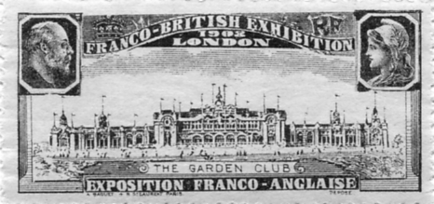
Fig. 25. Fig. 26.

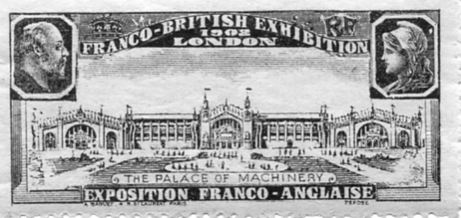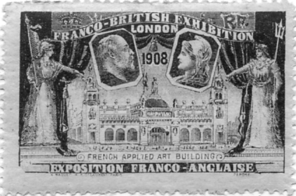
Fig. 27. Fig. 28.

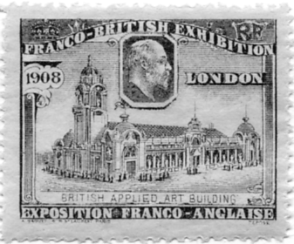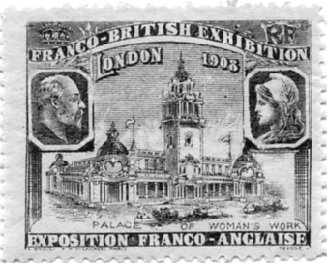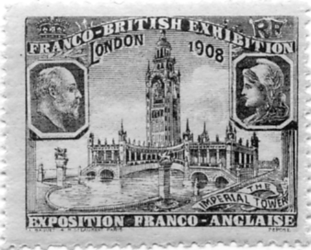
Fig. 29. Fig. 30. Fig. 31

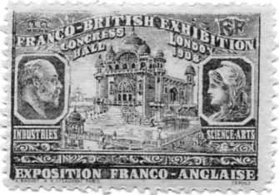
Fig. 32.

Perf 11. 48 x 30 mm.
French Applied Art Building Fig. 28.
Perf 11. 38 x 30 mm.
British Applied Art Building Fig. 29.
Palace of Women’s Work Fig. 30.
The Imperial Tower Fig. 31.
Perf 11. 38 x 26 mm.
Congress Hall Fig. 32.
Blue
Brown
Olive-green
Red
Violet-blue
Imperf proofs on white paper. 55 x 25 mm.
The Decoration and Furnishing Palace Fig. 23.
The Fine Art Palace Fig. 24.
The Franco-British Pavilion Fig. 25.
The Garden Club Fig. 26.
The Palace of Machinery Fig. 27.
Imperf proofs on white paper 48 x 30 mm.
French Applied Art Building Fig. 28.
Imperf proofs on white paper 38 x 30 mm.
British Applied Art Building Fig. 29.
Palace of Women’s Work Fig. 30.
The Imperial Tower Fig. 31.
Imperf proofs on white paper
Congress Hall Fig. 32.
Blue
Brown
Olive-green
Red
Violet-blue

26 | 24
23 | 24
26 | 25
23 | 27
25 | 27
Layout of pane of the 55 x 25 mm. size labels

 | 28 | 29 | 31 | 30
Layout of a strip of the 48 x 30 and 38 x 30 mm. size labels

Round medallion type labels
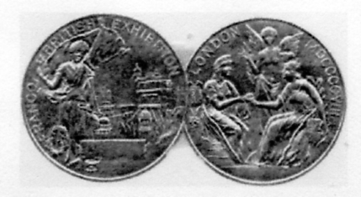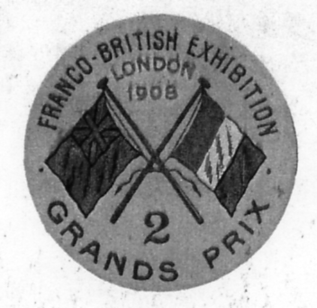
Fig. 33. Fig. 34.
Award labels without inscription,
Two joined imperf round labels 25 mm diam. Fig 33.
Gold.
‘Franco-British Exhibition London 1908 2 Grands Prix’
Round label 39 mm. diam. Fig. 34.
Gold.

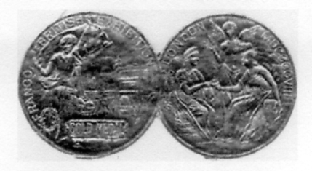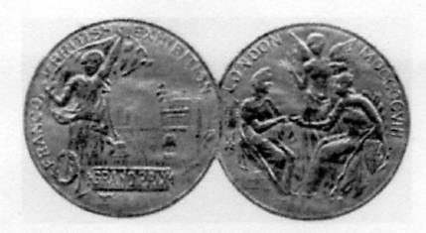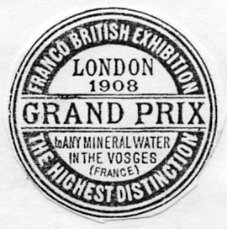
Fig. 35. Fig. 36. Fig. 37.

Gold medal award labels
Two joined imperf round labels 25 mm. diam. Fig. 35.
Gold.
Grand Prix award labels
two joined imperf round labels 25 mm. diam. Fig. 36.
Gold.
Grand Prix to any Mineral Water in the Vosges (France).
Imperf round label 32 mm. diam. Fig. 37.
Black.

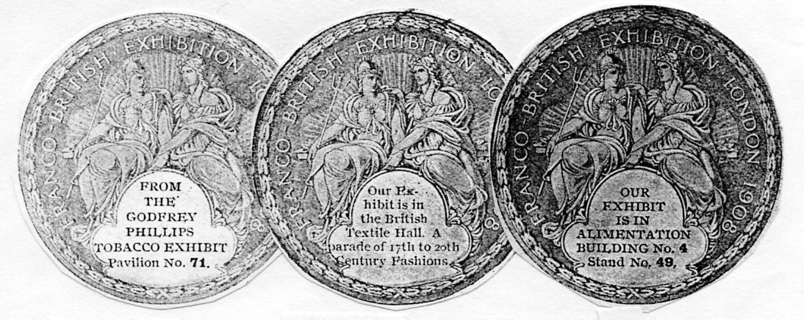
Fig. 38. Fig. 40. Fig. 39.

From The Godfrey Phillips Tobacco Exhibit Pavilion No. 71.
Imperf round label 50 mm diam. Fig. 38.
Green on green paper.
Our Exhibit is in Alimentation Building No. 4 Stand No. 49
Imperf round label 50 mm. diam. Fig. 39.
Green on green paper.
Our Exhibit is in the British Textile Hall. A Parade of 17th to 20th Century Fashions.
Imperf round label 50 mm. diam. Fig. 40.
Green on green paper.
Our Exhibit is in the Palace of Industries Chemical Section Stand 44. Overprinted ‘Grand Prize (Highest Award).
Imperf round label 50 mm. diam. Fig. 41.
Green on green paper.
Royles Limited. Engineers & Specialists Irlam. Manchester. Stand No. 89. Machinery Hall. Franco-British Exhibition. 1908.
Imperf round label 50 mm. diam. Fig. 42.
Blue on blue paper.

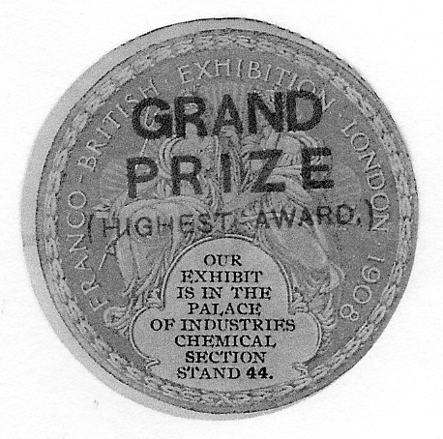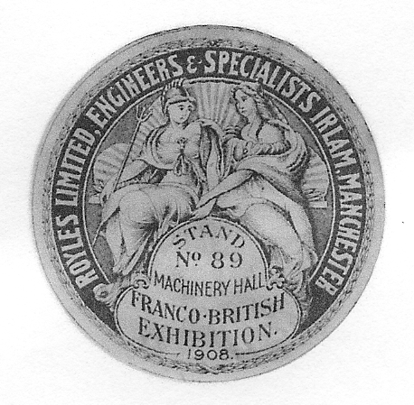
Fig. 41. Fig. 42.

Free form plaques

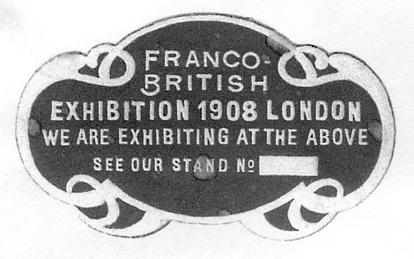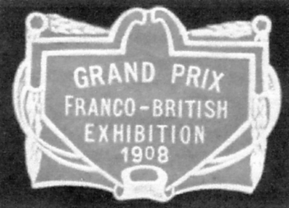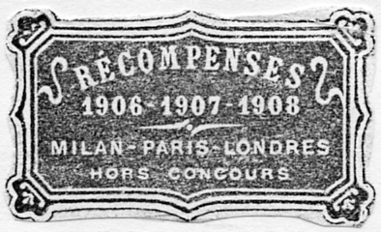
Fig. 43. Fig. 44. Fig. 45

Franco-British Exhibition 1908. London We are Exhibiting at the above see our stand No.......
Imperf free form plaque 42 x 30 mm. Red on white background Fig. 43.
Grand Prix Franco-British Exhibition 1908.
Imperf free form plaque 42 x 30 mm. Fig. 44.
Blue
red
violet.
Recompenses 1906-1907-1908 Milan-Paris-Londres Hors Concours.
Imperf free form plaque 48 x 28 mm. Fig. 45.
Green.

Exhibitors labels

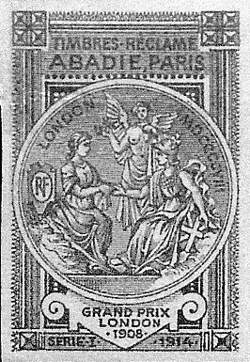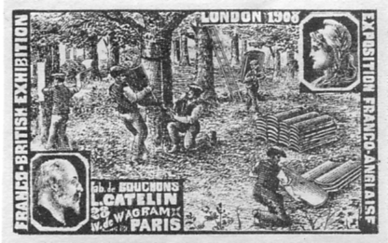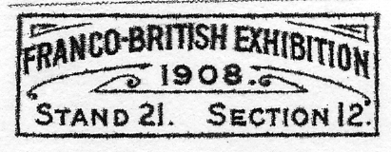
Fig. 46. Fig. 47. Fig. 51 x 200

Abadie. Paris. This label is a bit of a mystery, it would appear to be published in 1914 and has ‘Serie 1 1914’ printed at the bottom, announcing that Abadie of Paris was awarded a Grand Prix in London 1908
Imperf 32 x 48 mm. Fig. 46.
Reddish brown at the top changing to violet at the bottom.
L. Catelin. 28 V. de Wagram, Paris. Edward VII and Republique and workmen stripping cork off trees
Perf. 11. 50 x 30 mm. Fig. 47.
Blue
Brown
Green
Red
Violet.
Imperf. proofs on white paper.
Blue
Brown
Green
Red
Violet.
Imperf. proofs on coloured paper.
Brown on blue
Brown on green
Brown on pale orange
Brown on pink
Brown on sage green
Red on blue
Red on green
Red on greenish brown
Red on grey
Red on pale orange
Red on pink
Red on sage green
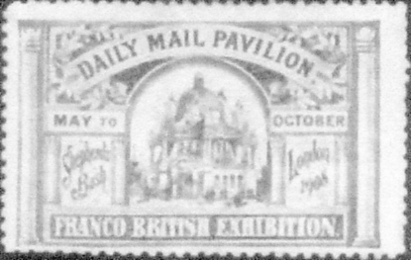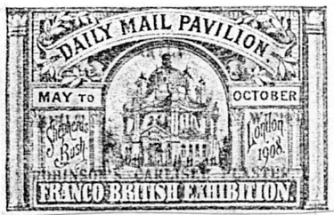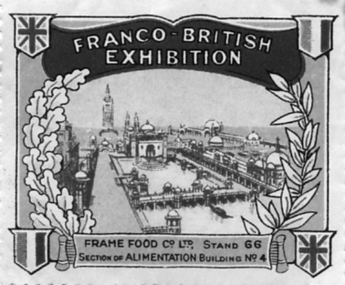
Fig. 48. Fig. 49. Fig. 50.

Daily Mail. Unoverprinted label.
Perf 10½, 46 x 29 mm. Fig. 48.
Blue
Daily Mail. Label overprinted in red ‘Partly built with Robinson’s Carlisle Plaster’
Perf 10½, 46 x 29 mm. Fig. 49.
Blue
Frame Food Co. Ltd.
Perf 11, 45 x 37 mm. Fig. 50.
Green

Robinson Bros. Watchmakers & Silversmiths.
Imperf. 25 x 8 mm. A small label pasted to business visiting cards Fig. 51.
B/W

Slingsby’s Trucks. Old St. London. Stand No. 18. Palace of Machinery.
Perf 11, 26 x 45 mm., Fig. 52.
Blue on light brown paper

Teofani & Co.
In the Glass Slipper catalogue there is mention of a Teofani label with ‘Franco-British Exhibition’ (in English) at the bottom (C & R type a), although they do not illustrate it. I think it is likely this does not exist as far as I can find out nobody has ever seen a copy. It may have arisen through a mistake in translating from the French original. Glass Slipper lists it as Perf. 11 in Blue, Brown, Green, Red and Violet. Chris Chatsfield does not include this label in his 1991 Catalogue.
Of the three labels they do illustrate, the one without the exhibition named is not I feel a label that should be catalogued in this list as a White City label, although I have illustrated it to show the similarity of the design Fig. 53. The fact that the name of the exhibition is not included in the design implies the label was either published before or after the exhibition.

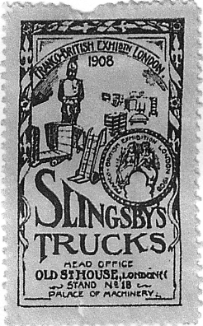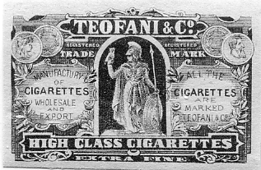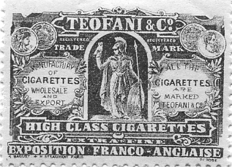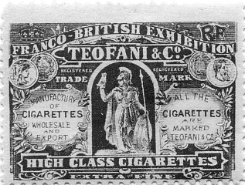
Fig. 52. Fig. 53. Fig. 54. Fig. 55.

‘Exposition Franco-Anglaise’ (in French) at bottom (C & R type b)
Perf. 11. 37 x 26 mm. Fig. 54.
Blue
Brown
Green
Red
Violet.
Imperf 37 x 26 mm.
Brown on buff paper
Brown on greenish paper
Red on greenish paper
Brown on pink paper

Redrawn label ‘Franco-British Exhibition’ at top above ‘Teofani & Co.’ (C & R)
Perf. 11, 37 x 26 mm. Fig. 55.
Blue
Brown
Green
Red
Violet.
Imperf. proofs on white paper.
Blue
Brown
Green
Purple
Red
Imperf. proofs on coloured paper.
Brown on greenish paper
Brown on grey paper
Brown on pink
Red on greenish paper
Red on grey paper
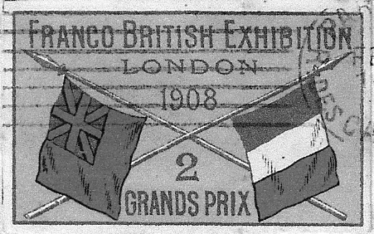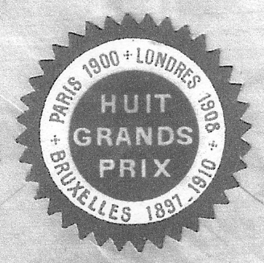
Fig. 56a. and 56b an unknown exhibitor

The two labels Fig. 56a and 56b are both on the same envelope. The 2 Grand Prix is on the front and the round label on the back, unfortunately there is no clue as to the firm that published them.
Imperf, 55 x 33 mm. multi coloured label. Fig. 56a.
Imperf round label with serrated edge, in red white and blue colours. 38 mm. diam. Fig. 56b.

Valentine’s post card views published as labels, printed in four rows of three, a complete pane of 12 is known. Since many of the labels bear Valentine’s copyright mark it is possible the labels were published by Valentine’s.
Perf 11, 34 x 26 mm. 12 multi coloured labels.

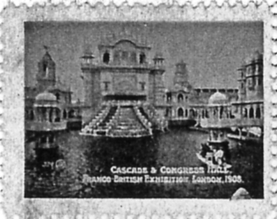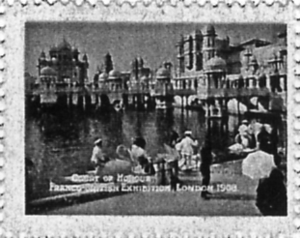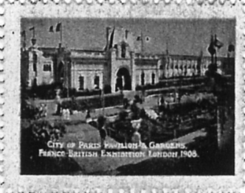
Fig. 57. Fig. 58. Fig. 59.

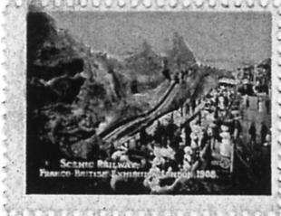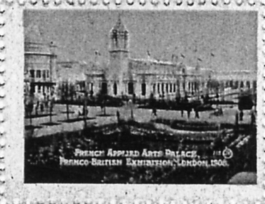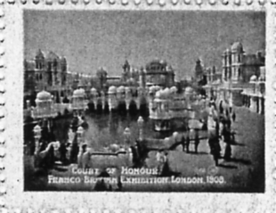
Fig. 60. Fig. 61. Fig. 62.

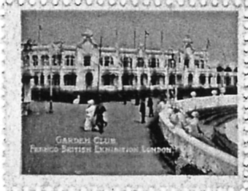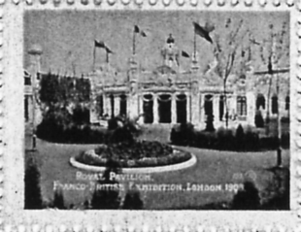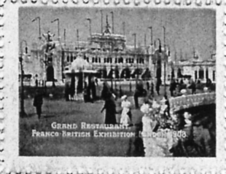
Fig. 63. Fig. 64. Fig. 65.

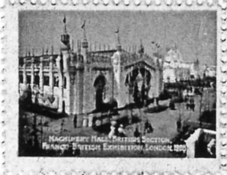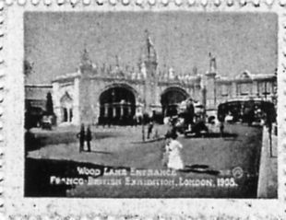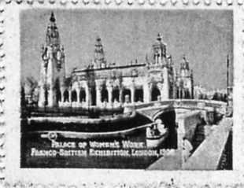
Fig. 66. Fig. 67. Fig. 68.

Cascade & Congress Hall. Franco-British Exhibition. London. 1908. Fig. 57.
This label was published as a post card by Valentine & Sons, No. 374
City of Paris Pavilion & Gardens. Franco-British Exhibition. London. 1908. Fig. 59
This label was published as a post card by Valentine & Sons, No. 264
Court of Honour. Franco-British Exhibition. London. 1908. Fig. 58
This label was published as a post card by Valentine & Sons, No. 168
Court of Honour. Franco-British Exhibition. London. 1908. Fig. 62
This label was published as a post card by Valentine & Sons, No. 248
French Applied Arts Palace. Franco-British Exhibition. London. 1908. Fig. 61
This label was published as a post card by Valentine & Sons, No. 115
Garden Club. Franco-British Exhibition. London. 1908. Fig. 63
This label was published as a post card by Valentine & Sons, No. 192
Grand Restaurant. Franco-British Exhibition. London. 1908. Fig. 65
This label was published as a post card by Valentine & Sons, No. 194
Machinery Hall British Section. Franco-British Exhibition. London. 1908. Fig. 66
This label was published as a post card by Valentine & Sons, with no number.
Palace of Women’s Work. Franco-British Exhibition. London. 1908. Fig. 68
This label was published as a post card by Valentine & Sons, with no number.
Royal Pavilion. Franco-British Exhibition. London. 1908. Fig. 64
This label was published as a post card by Valentine & Sons, No. 193
Scenic Railway. Franco-British Exhibition. London. 1908. Fig. 60
This label was published as a post card by Valentine & Sons, No. 132
Wood Lane Entrance. Franco-British Exhibition. London. 1908. Fig. 67
This label was published as a post card by Valentine & Sons, No. 302

57 | 58 | 59
60 | 61 | 62
63 | 64 | 65
66 | 67 | 68
Layout of Valentine & Sons post card view labels

