EDITORIAL SPRING 2008

Yes I still go off to the Post Card Fairs
Enjoying myself without any cares

I’m afraid I must start the Journal off with a bit of sad news, George Simner, a close personal friend and long time member of the Exhibition Study Group is now no longer with us. He died on the fifteenth of January after a long illness, and I shall miss him phoning up and making a date to go over to the Croydon post card fair, where we never got much but came back home and had a bite to eat afterwards. Elsewhere Fred Peskett an even longer friend of George’s has written a few words about George.
As members may know the last several years I have cut down on the number of post card fairs I go to. I have just been to the Shepton Mallet fair where once again Ann and Ted Stevens were good enough to put me up from Thursday to Sunday. They live about five minutes car drive from the Bath and West Showground. This fair has become one of the best two day fairs going, and I think it has over taken York as the prime fair. The layout of York is unfortunately very much an odds and ends of small blocks of dealers fair. Having a large staircase in the middle does not help. I find it is very difficult to remember who you have been to after a couple of hours, whereas Shepton, being held in a large cow shed is planned in orderly lines of dealers.
It has to be said Friday at Shepton was a red letter day finding at least two cards that were ‘throwing your hat in the air’ cards. One was a 1924 British Empire Exhibition Cope’s Tobacco advert card. I haven’t seen one of those for perhaps five or six years, and a dealer had two, one of which I had not got. I now have six out of the set of seven cards. Cope cards are very rare and I doubt if there are much more than about a dozen of them in existence.
The other good card was a R/Photo Festival of Britain card, published by Photochrom. When George Simner and I did our book on Festival cards I sent a 26 page questionnaire to any Festival collectors who offered to help in the task. Out of all those who asked for the questionnaire only one collector had any of these Photochrom cards and he had five out of a probable set of six cards. At that time, and to date, neither George or myself had ever even seen one, that’s how rare they were, and still are.
The card I got was very tatty, being badly creased, but it had an imprint down the left side reading ‘Published by Photochrom Co. Ltd., Tunbridge Wells, for Kennedy’s, 223, Brompton Rd. S.W.3.’. The only five known cards recorded did not have this imprint.
All together I got 96 cards, but there will be a lot of duplicates among them when I finish sorting them out. Many cards I can tell at a glance whether I have got it or not, but my memory is not as good as it used to be, and accumulating duplicates if in good condition and the price is right is part of the game now.
2008 is going to see several books published to commemorate the 100th anniversary of the Franco-British Exhibition, our secretary Don Knight is bringing out an up-dated book on the White City Exhibitions printed in colour. My own book will be published within the next few months on the White City post cards and there will be another book on the 1908 Olympic Games by an Olympic collector Bob Wilcock.
A few months ago I was sent a few items for sale, by a past member of the Group who has now moved onto other interests. Most of this was disposed of at our convention and now I have just one item left. This is a 1908 Ward Lock Illustrated Guide for London and the Franco-British Exhibition. There are 23 pages about the exhibition and three related exhibition maps. This is a fairly scarce book and I feel it is worth £15 plus £2 postage if anyone is interested. It is slightly tatty but it must be borne in mind that these guides were made to last a year and then be renewed, not last 100 years. A phone call to 020 8777 8861 will secure it.

The Editors
Convention 2008 an early reminder from our Secretary Don R. Knight

Dear members
As you know for the past twenty one years we have held a convention in September at a venue connected with an Exhibition. At our A.G.M. last year it was decided we meet again at Crystal Palace, the date is 27th and 28 September 2008, a Saturday and Sunday. This year is the 100th anniversary of the Franco-British Exhibition and the Olympic Games. With this in mind display’s to be seen will include items from this exhibition, not to be missed if you are interested in the White City postcards etc. There will be other displays from other exhibitions.
Please make a note of the dates and try to come along, we meet in a nice room, there is a hotel on site. This is not a 5 star hotel but is good at the price, please contact me or Bill for more information or you can make your own booking at The Lodge, Crystal Palace National Sports Centre, Ledrington Road, London SE19 2BB. phone 020 8778 0131. Please mention Exhibition Study Group. I will remind you in the Autumn Journal.

Letters to the Editors

From Don R. Knight. 2, Crescent Rd, New Barnet, Herts. EN4 9RF Phone 020 8440 3574

The Franco-British Exhibition
100th Anniversary 1908-2008

In 1978 I published a small book The Exhibitions, The Great White City, London to commemorate the 70th anniversary of the Franco-British Exhibition 1908. This lead to me meeting Andrew Brooks who had just published with Fred Fletcher part 1 and 2 on Exhibition postcards. This lead to talks along with others to found the Exhibition Study Group to day we have some 100 members. This year being the 100th anniversary of the White City I will be involved in one or more exhibitions to commemorate this. To do my bit for history I am reprinting The Exhibition with a new front cover, some amendments, a update to 2008 and putting in coloured pictures.
The price for it is £5.00 plus Postage £1.00. To Study group members in the UK £5.00. To be published in March 2008.

From David J. Hiscock. 18 Clinton Drive, Sleaford, Lincs. NG34 7LU Phone 01529 303355

I have just joined the Exhibition Study Group. I have several collecting interests but only the collection of Lighthouse Philatelic items has a link to any exhibitions as far as 1 have discovered. I wonder whether it is possible to ask through your magazine whether any members are also interested in the following exhibitions:
The International Exhibition of Navigation, Travelling, Commerce and Manufacture held in Liverpool in 1886.
The Royal Jubilee Exhibition again held in Liverpool in 1887.
The Royal Naval Exhibition held at Chelsea in 1891.
The Gardening and Forestry Exhibition at Earl's Court in 1893.
The connection between the above exhibitions is that there was a full size replica of the Eddystone Lighthouse in the Exhibition grounds. I am very interested to ascertain whether this model appeared in any other exhibition, particularly between 1887 and 1891. Did it also make any appearance after 1893? As part of my interest too, I collect mail posted from these exhibitions and am currently studying the several varieties of the postcards, etc. posted from the top of the lighthouse at the Royal Naval Exhibition. May I ask through you if any member has an item posted from the exhibition to send me a photocopy (both sides please) of the item for which I will refund cost to the above address.
Should I receive sufficient material I will then send you an article about the lighthouse, its travels and the postcards.

I replied as follows,

Many thanks for your letter, it’s nice to hear from a new member and I can help you with some of your queries. It so happens we have a member one of whose interests is Lighthouses, and I believe he has a large collection of post cards on the subject. He is Peter Denly. 9, Oaklands Park, Bishop's Stortford, Herts. CM23 2BY. phone 01279 652 458.
There was another exhibition that was going to have an Eddystone Lighthouse and that is the 1890 “Old America” Exhibition to be held in Manchester, although I believe it in fact never took place. They published a post card which is almost identical with the Royal Naval card apart from the colour which is in rose red, showing the lighthouse on the left side and in place of the ‘Royal Naval Exhibition’ heading it reads ‘“Old America” Exhibition’. An illustration of this card appeared in Picture Postcard Monthly May 1996 in an article by Peter J. Jones titled ‘The Eddystone Postcards’. You should try to get a copy of the magazine as it gives a lot of information on the full size replica lighthouse. If Brian Lund cannot supply a magazine I can do you a copy of the article.
I am intrigued by your comment of several varieties of the Naval post card. I am only aware of the official illustrated card, and when supplies of this ran out plain stationery pre stamped cards were used. I have the handstamp in light blue, dark blue and violet ink.
My collection of these cards which is very limited tends to suggest that they ran out of illustrated post cards by 10 October and it will be interesting to see if any illustrated cards turn up after that date.
I will put your request for information in our next Journal. I am also enclosing a list of publications by the Exhibition Study Group.
All the best,

David phoned me and we had quite a chat about the Royal Naval Exhibition cards, I was able to send him five scans of these items. I was not aware that there were varieties of the cards and I hope members will respond to David’s request for scans to help him in his research. I for one am looking forward to receiving his article on these cards. I wonder does any member have a copy of the 1890 “Old America” Exhibition held in Manchester?

From Alan Sabey 46, Thorncliffe Rd, Norwood Green, Southall, Middx. UB2 5RQ. Phone 020 8843 9920

Old London at the Franco-British Exhibition

Way back in Journal No. 77 Summer of 2005 we published some correspondence from Arthur Smith on two series of post cards he had of models made by John B. Thorp of old London buildings which appeared on show in the ‘Old London’ exhibit at the Franco-British Exhibition in 1908. I have just had an E-mail from Alan Sabey who informs me that one of the original models from the exhibition is on display at the Museum of London. Apparently the museum acquired it in 1912, and it is a wooden model of the old St. Paul’s Cathedral which was destroyed in the Great Fire of 1666.

From Arthur Smith Arthur P Smith. 22, Ongar Rd, Fulham. London. S.W.6. Phone 020 7381 9062

As you may be aware I have been living in this area for a long time. My Father and Grandfather both working in the old Earl’s Court Exhibitions.
In Journal No. 87 in Alan Sabey’s article on ‘Some notes on the Great Wheel’ I would like to correct one point he makes. At the end of paragraph two he says you look across to Earls Court 2. This should read ‘you look across to the Empress State Building’.
The enclose illustrations make this plain. Alan is confusing the shape of Earls Court 2 with a somewhat similar shape of the old Empress Hall of my youth when it was a skating rink.
Earls Court 2 was built on an elevated car park and seat deposit for Earls Court 1 and the entrance of the Lillie Bridge Works is straddled by Earls Court 2. Lillie Bridge Works has been widened since 1895 by taking in the adjacent railway line.
When my Father died in the early 60’s I started researching Earls Court Exhibition and managed to get London Transport to allow me on the site of the Great Wheel. Those days it appeared to be concreted over and in use as a van park with some low buildings on the edges. This makes sense as they did not wish to disturb those massive foundations.

From Derek Connell. The Three Horsehoes, Duton Hill, Nr. Great Dunmow, Essex. CM6 2DX.
01371 870681
I was interested to read the article about the big wheel at the 1938 Glasgow Exhibition in the Autumn Journal. I have possibly found another reason why it was so unpopular. On the second day of the exhibition two drunks managed to get on the big wheel. They stood up when their car reached the top of its circle, and fell out and were killed. That would put the dampeners on it, I guess! The story is recorded in Billy Butlins Biography of which I enclose the relevant pages.

Obituary.

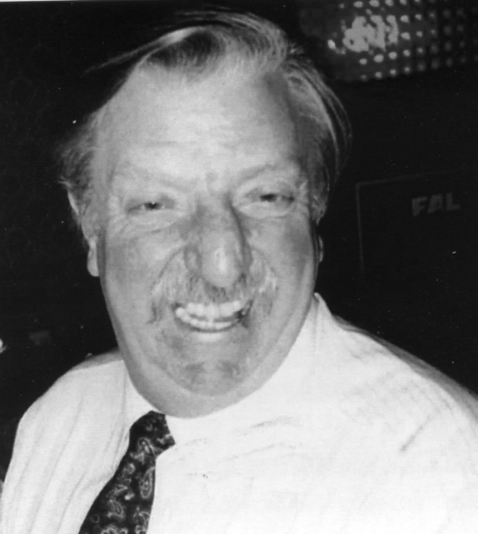
George Frederick Simner. 23-08-1934. 15-01-2008. It is with sadness that I have to tell you that George Simner died peacefully in his sleep during the early hours of the 15th January 2008. Our heartfelt sympathy goes to Florrie and George's family on their loss. George became ill with cancer several months ago which entailed many hospital stays and intensive chemotheraphy, yet he kept on being cheerful and enthusiastic in publishing the Festival Times and arranging the conventions, and as those who were there know, he managed to come along to the Exhibition Study Group Convention back in September 2007 at the Crystal Palace.
George had many interests, apart from the 1951 Festival of Britain for which he was one of the founder members of the Society. He collected material from the 1937 Paris Decorative Arts Exhibition and the Empire Exhibition in Glasgow in 1938, for which he put together superb collections of postcards, ephemera and souvenirs, George also was a member of the German Philatelic Society and had assembled a unique collection of the postcards from the Nurenburg Rallies in the 1930's, his interest was the art-work and graphic design. George was an active member of the Royal British Legion, The Multiple Sclerosis Society, and the East Ham Local History Society, for which he was near to completing a book on his local area
George was one of the nicest persons one could ever wish to meet, I counted him a great friend and feel sure that all members of the Exhibition Study Group will share my thoughts in that he will be sadly missed.
George's funeral was on the 21st January at the East London Cemetery, there must have been over 200 people attending. The Festival of Britain Society and Exhibition Study Group were well represented. The Festival of Britain Society is arranging to have a balcony seat dedicated to George's memory in the Royal Festival Hall, this will be at their Spring Convention on the 26th April this year. Fred Peskett.
Negretti & Zambra
Carte~de-Visites taken at the Crystal Palace.
by
Fred Peskett

A recent find of a Negretti & Zambra Carte-de-Visite shows an event at the Crystal Palace whereby a man standing on a ball of about two feet in diameter which he had rolled up a spiral construction at least 75 feet high. I estimate the height based on the man at 5 ft. 10 inches to be at least 75 ft. high. It must have been a super-human feat to walk the ball up that spiral and presumably back down again. The view is looking towards the fountain basin to the left of the Central Transept, The flag mast of the Maze can be seen in the background. I have looked through all my books on events at the Palace and can find no record of this event.
In common with cartes featuring Crystal Palace views and events this one was not dated nor was it serial numbered. I have been collecting Negretti & Zambra cartes for some time, mainly for the back styles, it became obvious that all of their studio portraits were serial numbered and that groups of numbers could be associated with certain back styles. The serial numbers were given so that further copies could be obtained at a later date if required. Of the couple of published views I have none feature serial numbers, so I conclude that copies sold in their shop were done in batches?
In looking through all the cartes I have there is one which is dated in ink and a couple that were dated to a place and time. By the large serial numbers used on some it became clear that Negretti had probably used a continuous sequence since they became ‘Official’ photographers in March 1855 until the time they left during 1898. From this information I thought it may be possible to work out a means of dating using serial numbers in combination with the back styles. Unfortunately, at the moment this is not possible to achieve with any sort of accuracy until further dates to serial numbered cartes are found, however, there does seem to be a distinct sequence of back styles for which the serial numbers can be grouped. But, first, some known information about the Negretti & Zambra Company.
The company was a leading manufacturer of optical, metrological and scientific instruments in the 1800’s. Their head office and factory was at 38, Holborn Viaduct. London, E.C. with branches at 45, Cornhill and 122, Regent Street. After taking over as the Official Photographers to the Crystal Palace Company in March 1855, they quickly established their portrait studio in the Ceramic Court, they also had a stall selling Cartes and Steroscopic photographs. On the 9th June 1855, Negretti took a photograph of Prince Albert at the Crystal Palace Floricultural Show, and in May 1856 he presented Queen Victoria with a Stereoscope of her visit just a few minutes after the photograph was taken, which suggests that processing facilities were also established by this time. The company was also credited with the views in the revised Crystal Palace Guide by Phillips in 1856.
So far there are eleven different back styles known:-
Figure 1 (Type 1) is the earliest I have recorded serial numbered 7690. Black printing on thin grey
card.
Figure 2 (Type 2) has the design printed in red with a serial number to at least 80002. This design is
also known in black printing, (Type 3) all of this type found so far have no serial numbers and are either views or of general interest. These also have square corners, whereas all others are rounded.
Figure 3 (Type 4) is serial numbered from 86423 to 88689, however, there are other features such as
the colour of card. 86423 is dated to 22/2/72 and is brown printing on buff card, 86492 is lilac printing on cream card (Type 5) and 88689 is purple printing on brown card. (Type 6).
Figure 4. Shows cartes on a light cream card with the printing in lilac. In small letters at the bottom is
‘Marion, Imp Paris’ the printers of the basic card. These are serial numbered 91987 to 96974, (Type 7) Similar cartes but without the printer details these are serial numbered 105285 to 105452. (Type 8)
Figure 5. is a similar design to Figure 3, now with a coat of arms and ‘Sydenham’ in fancy letters.
The printing is in gold on a buff card, one of these is serial numbered 111111 and has the printer details as W.W. Hughes & Co London E.C. (Type 9) There are others in this design but on yellow card without the printer details and serial numbered up to 118008. (Type 10)

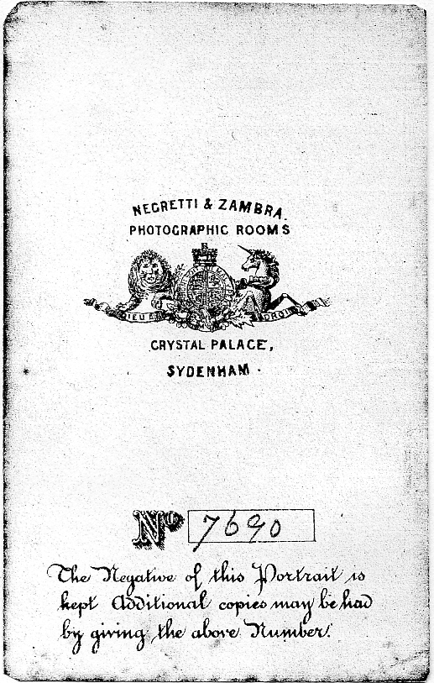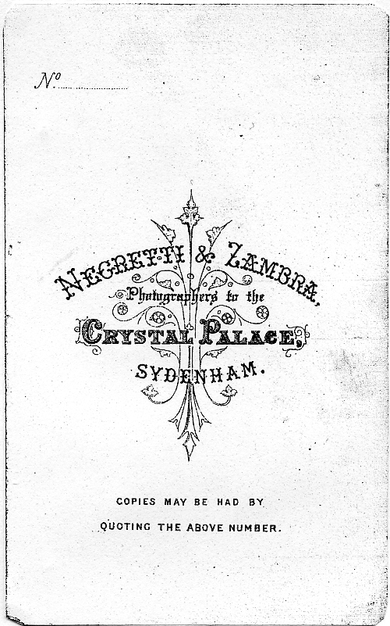
Fig. 1 Fig. 2

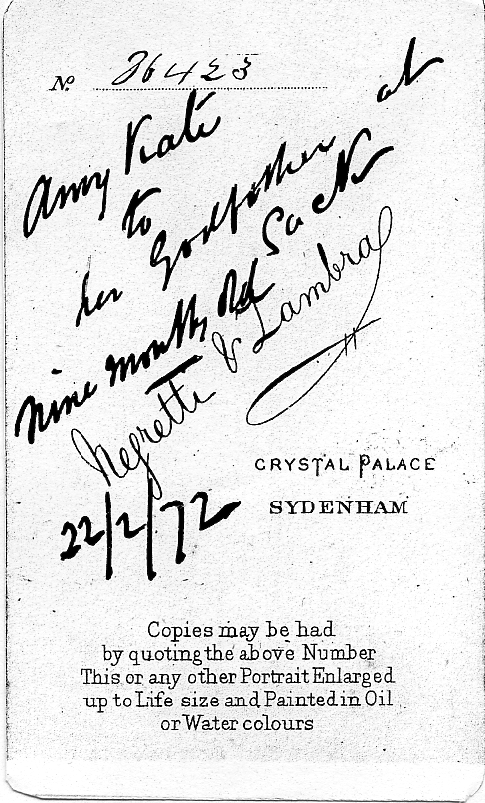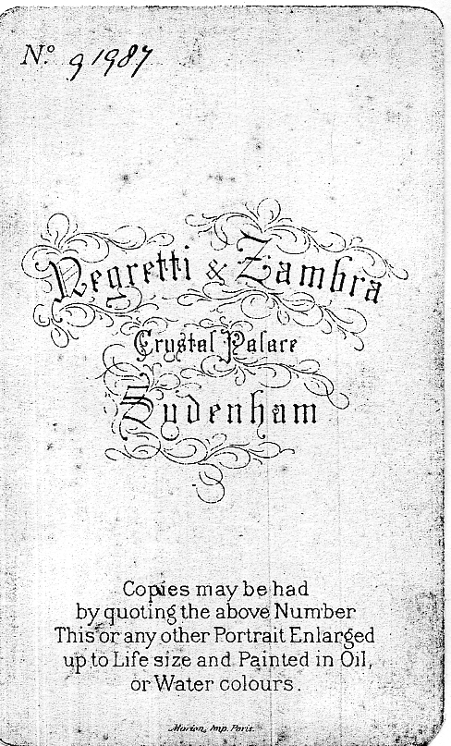
Fig. 3 Fig. 4

Figure 6. is the last known back style, printed in brown on buff card, the re-ordering information now
quotes ‘number and letter’ Serial numbers run from 118037 to 121323, although on the examples known only a number is given. (Type 11)
Figure 7. shows the carte of the man on the ball and has the back style Type 3.

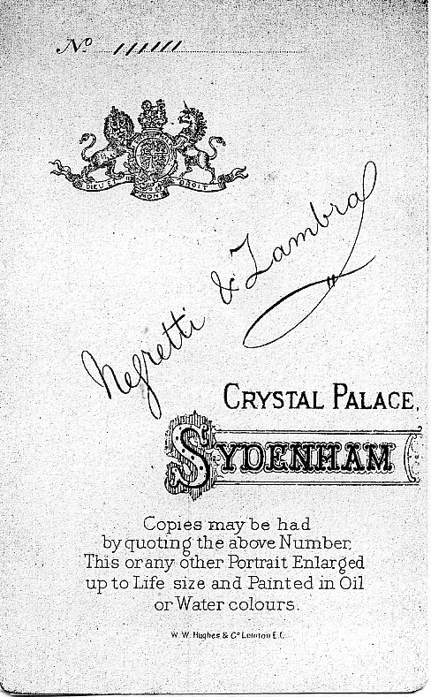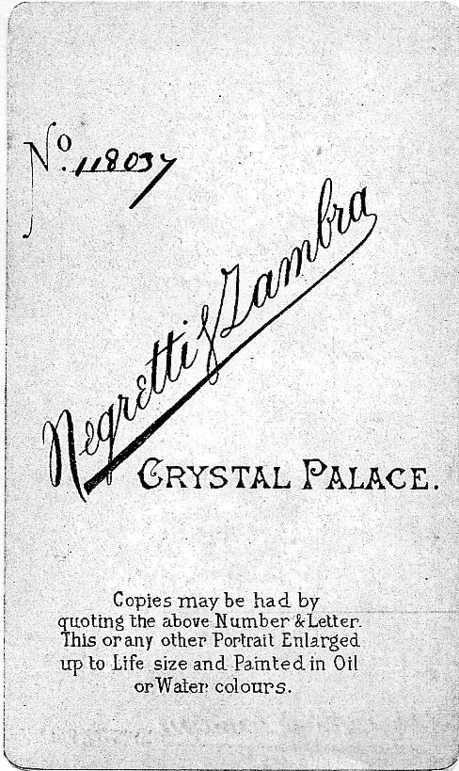
Fig. 5 Fig. 6

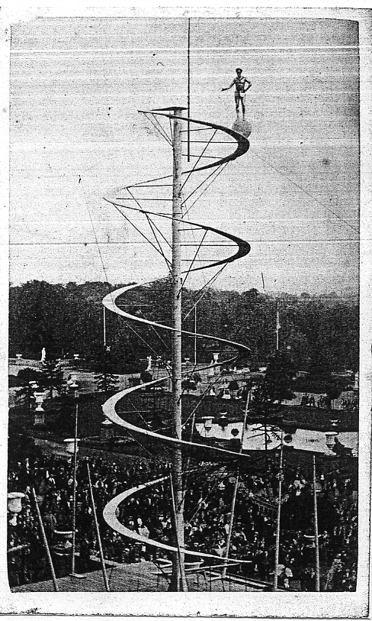
Fig. 7

Figures 8. & 9. are drawings not photographs and feature women criminals convicted at the Old
Bailey. These were probably sold to satisfy the Victorian obsession with morbidity and they may be women who had been convicted of murder, it is doubtful if cameras were allowed in the Court, even if they were, the long exposures required would not have been possible in the circumstances, both of these are dated to August 1868, which is probably the same date as the man on the ball? (back style Type 3)
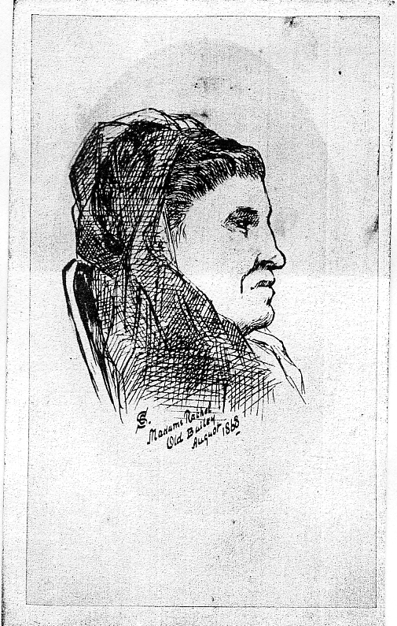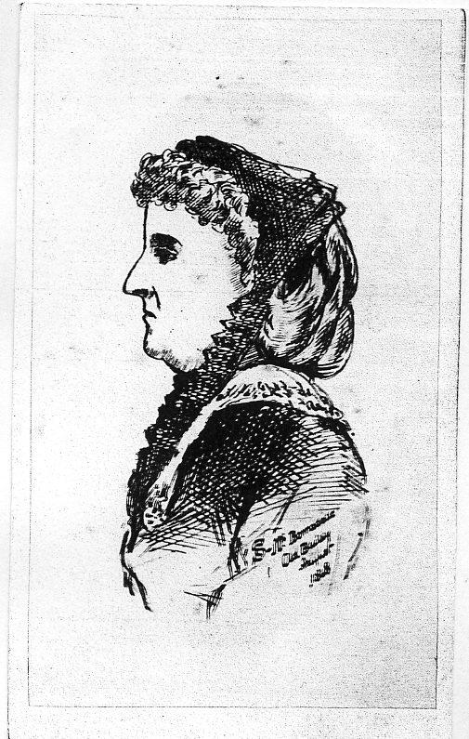
Fig. 8 Fig. 9

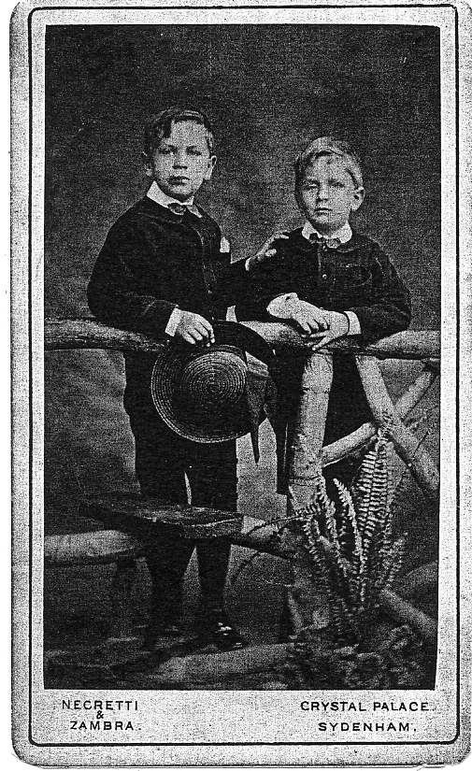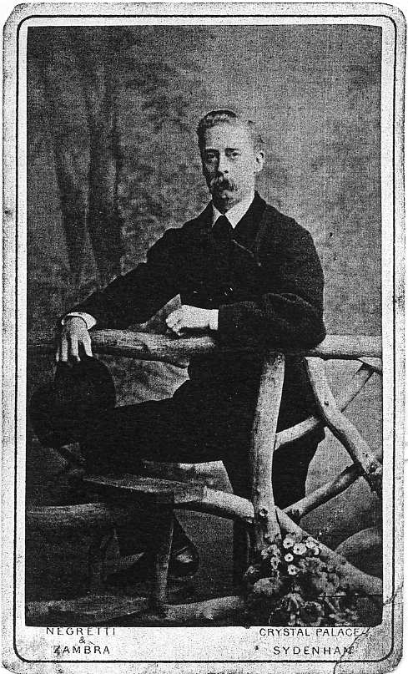
Fig. 10 Fig. 11

Figures 10 & 11. There is one other area that may be useful to date Negretti & Zambra cartes, the
background in the studio against which the portraits were taken, some feature a rustic fence and stile on which the subject leans or sits, sometimes this has ferns sprouting from the base, others have bunches of daisies. Some only show part of this set slightly modified. Others are taken sitting on a chair with a floral curtain drape, the same chair and drape is used from at least serial number 80002 to 104541, this however, needs further investigation as more cartes are found.
Other studio photographers in the area are Fred Harrison of Norwood, who also used the cards printed by Marion, Paris. E.T.F. (Edward) Goodwin. 63 Anerley Road, Crystal Palace. S.E. this was near to the Low Level Railway Station. His cards were printed by Trapp & Munch, Berlin. Masonic symbols are a feature on the backs of his work. David Rees of Clapham Road, who although not in the area, does state on the backs of his portraits that he was awarded a Prize Medal for his photographs at the South London Exhibition, Crystal Palace. There is also a Peter Greenhalgh whose photographs were taken in the ‘Crystal Palace Photo Rooms’, but his address is given as 45 Bridge Street, Bolton, so I think the Crystal Palace reference was just using it as a trade name?
So far I have not found any cartes by J. Russell, it is likely that by the time Russell took over from Negretti the fashion for them had diminished and Russell probably concentrated on the new craze for picture postcards.

Poole Pottery and the Festival of Britain.
by
Fred Peskett

There are collectors for Poole Pottery all over the world, the fact that the company has been closed several times and restarted has the effect of making the collecting even more ardent and certainly pushed the prices of the earlier pieces upwards. So it was with some degree of surprise when I spotted three Poole Festival items on a stall at one of the Midhurst Antique Fairs on the 3rd February this year. There was a 10 inch diameter plate with the floral symbols of Great Britain with 1951 at the bottom, underneath it is marked FOB 1 (B) A two piece preserve pot, again with the floral decoration and 1951 each side of the lid, marked on the base FOB 3, and a mug with a gardener sweeping up fallen leaves and 1951 on the sides, marked FOB 6.
The stall holder gave me a good deal on the three items and went on to say that one of the pieces was designed by her late mother who worked at the Poole factory in 1951, in fact she also offered to send me the original art-work and sample transfer at no extra cost!
Looking through specialist books on Poole Pottery only one plate is listed, it is the same floral design as the one I found but also has FESTIVAL OF BRITAIN marked around the rim, the number on base was not recorded, I understand that many of the Poole Pottery records have either been destroyed or sold off in auction a year or so ago, some of the remaining items have been given a grant for recording and preservation, perhaps a little too late for posterity? I would like to try and find out just what Poole did produce for the Festival, if the plate number FOB 1(B) was significant and was there a 1(A) and so on as variants? The output from the Poole Pottery was huge in respect of the everyday items of domestic ware, tea and coffee pots, cups, saucers and plates etc., however, when it comes to the “Studio” pottery the output was very small, in some instances only a half dozen or so pieces were made, and for commemoratives to order perhaps only one or two. There is supposed to be a large plate made for the sales shop at the Poole Pottery with the Festival of Britain Symbol in the centre and Poole Pottery round the outside, it was last seen in the Pottery Museum, but is now believed that it was sold off in an auction after one of the factory closures.
So, information is required on any types of souvenir for the Festival made by Poole and any details on the undersides relating to FOB numbers, to Fred Peskett, 124 Havant Road, North End, Portsmouth. PO2 OBP. Thank you,
I note in the so called “definitive” book of Poole Pottery that some Commemorative Souvenirs in ceramics were made for the Empire Exhibition, Glasgow in 1938. Although being listed, there is no illustration, has anyone either seen or perhaps, have one?
The Crystal Palace Army.
by
Fred Peskett

When Great Britain declared war on Germany in August 1914 The Call to Arms was sent to members of the Royal Naval Volunteer Reserve. The R.N.V.R. had been established for some eleven years, the aim being to make up ship's crews during the time of war. Those members who held Trade Certificates were drafted straight into the Fleet, the remainder of the R.N.V.R. some 4,000 Officers and men waited for orders, which when they came were disappointing since they were not to serve with the Fleet on-board ships but to become part of a land fighting force to be known as The Naval
Brigade.
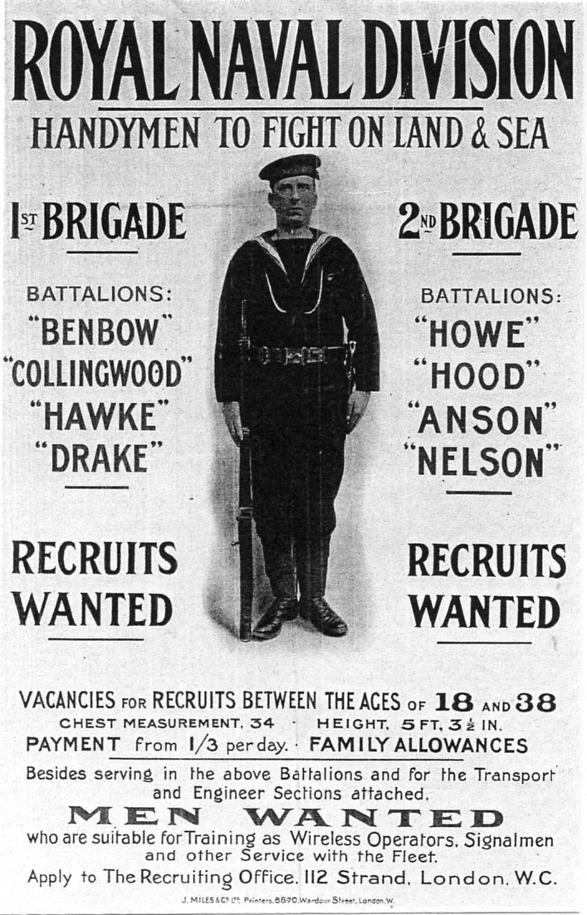
The decision to form a Naval Brigade was made by the then First Lord of the Admiralty, Mr. Winston Churchill. Added to the numbers of the R.N.V.R were also members of the Royal Fleet Reserve, and the Royal Naval Reserve to bring the total number serving in the Brigade to 30,000 Officers and men. The force was divided into two Naval Brigades with each Brigade being formed into four Battalions. The First Brigade had Hawke, Benbow, Drake and Collingwood, whereas the Second Brigade comprised Anson, Hood, Nelson and Howe Battalions.
The two Battalions were sent to the front in Belgium, poorly trained and badly equipped. Ammunition Pouches were not available so the men had to carry their 120 issued rounds in their pockets! They arrived by ship at the port of Ostend and were taken by trucks to assist in the defense of the town of Antwerp alongside the Marine Brigade. Their mission was a complete disaster, since after only ten days they were ordered to retreat back to Ostend. The Second Battalion returned back to the U.K., almost intact, but the First Brigade came under heavy fire and lost seven Officers and fifty-three men killed in action, five Officers and nine hundred and thirty-one men were captured by the Germans, a further thirty-seven Officers and one thousand four hundred and forty-two men had to march through Holland, where they were interned in a camp at Groningen for the rest of the war.
The Naval Brigade had to be rested, re-trained and re-formed. The Crystal Palace in Public Ownership since 1911 was taken over by the Admiralty for this purpose and commissioned as H.M.S. Victory VI (nicknamed H.M.S. Crystal Palace) under the Portsmouth Command. The two Brigades were now formed into The Royal Naval Division. Officers and Petty Officers from the original R.N.V.R. were sent to the Crystal Palace as instructors. After basic training, the men were sent to Blandford Camp in Dorset for further training in land fighting. Gradually the complement of the Battalions lost at Antwerp were replaced as men entered the R.N.D. from the Crystal Palace and Blandford.
In February 1915, the R.N.D. sailed for Gallipoli. Turkey had declared war on the Allies and had become a major threat to the Russian flank. The British Government decided to attack the Turks at the Dardanelles. If the forts guarding the Straits could be either captured or destroyed then the British Fleet could sail inwards to take the pressure away from the Russians. The plan was to destroy the forts by a heavy bombardment from the sea with landings by the Royal Naval Division to complete the destruction and capture of the forts. It was a failure. Minefields in the Straits took a heavy loss of ships engaged in the bombardment and minesweepers were sunk by the Turkish artillery. The R.N.D were put ashore but suffered heavy casualties during the action. Seven thousand were either killed or wounded. By June 1915 the R.N.D. losses were so high that two of the Battalions, Benbow and Collingwood had to be disbanded. A complete withdrawal was made in January 1916. The R.N.D. was rested and gradually re-built and in May 1916 the Division was sent
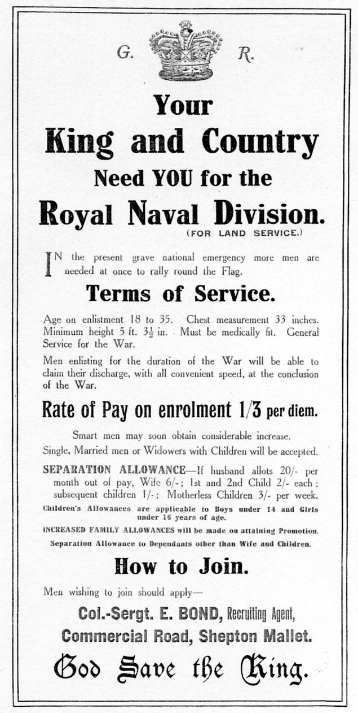
to France where it took part in many of the famous battles at Lens, Vimy Ridge, Arras, Gavrelle, Passchendale Cambrai, Ancre and Drocourt-Queant. When the Armistice was declared at 11 o-clock on the llth November 1918, the Division was still fighting at Mons.
During the Royal Naval Divisions time in France the casualties were eight thousand three hundred and twenty Officers and men killed in action, twenty-six thousand wounded, and three thousand taken prisoner of war. During the war Officers and men of the R.N.D. were awarded many decorations for valour including four Victoria Crosses. The Royal Naval Division had played it's part in the outcome of the First World War indeed so had the Crystal Palace, but it's service to the Crown was not yet over, since it became a Demobilization Centre for the Navy during 1919 before being handed back to the Nation in 1920.
During the Admiralty occupation of the Crystal Palace, five thousand Officers and one hundred and twenty thousand ratings had their basic training there before going on to Blandford or joining the Royal Naval Division. Thus they were immortalized as The Crystal Palace Army" "The Glass-House Soldiers" or "The Green-House Gunners".
One wonders what thoughts Sir Joseph Paxton would have had, if he had seen the hundreds of hammocks strung up along the Egyptian, Roman and other Galleries, or boat-training in his Fountain Ponds and Ornamental Lakes in the Palace Grounds.
On the 6th June 1931 a Commemoration Trophy was unveiled by H.R.H. The Prince of Wales in the grounds of the Crystal Palace, this Trophy was rededicated on the 6th June 1992.
Ephemeral items from the Crystal Palace and the Royal Naval Division from 1914 to 1919 are much collected and make superb additions to any “Palace” collection. Picture Postcards produced by T. Everitt can be found which show the day to day life of the sailors at the Palace. Most of the postcards sent home were from the Photochrom Series and can be identified by either the NORWOOD Krag or Columbia cancellation to the postage stamp between 1914 and 1919. Although it was forbidden to say where the sender was stationed, many of the cards show a view of the Crystal Palace with a X on one of the windows to indicate “This is my billet” Everitt also took group photographs of the sailors and Officers in the Grounds of the Palace.
Handbills for recruiting to the Royal Naval Division can also be found from many towns. The Shepton Mallet poster illustrated is 66 % of full size. There is also evidence that other areas of the Royal Navy were located at the Crystal Palace, in particular, the Royal Naval Air Service and The Kite and Balloon Squadron, (which may have been part of the Naval Air Service?) One “comic” Crystal Palace postcard names the R.N.A.S. and it is quite feasible since Colonel Samuel Franklin Cody once had offices at the Palace where he conducted experiments on his man lifting kites, and the Grounds were a Mecca for balloon flights since it opened in 1854. Original artifacts such as cap badges for the eight Battalions are difficult, but not impossible to find, however, Benbow and Collingwood are very rare, if purchasing make sure they are original, they were generally made by Gaunt, but beware of modern replicas, if a replica is acceptable then it should only be a pound or two, a fraction of the cost of an original. The members of the R.N.D. were fond of designing their own Christmas Cards as did the Kite and Balloon Squadron. Finally the Demobilization Certificates from 1919 stamped up with the Crystal Palace cachet are much sought after and highly prized.

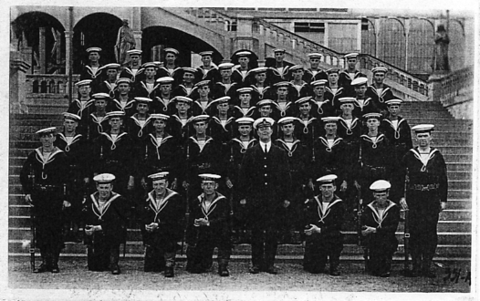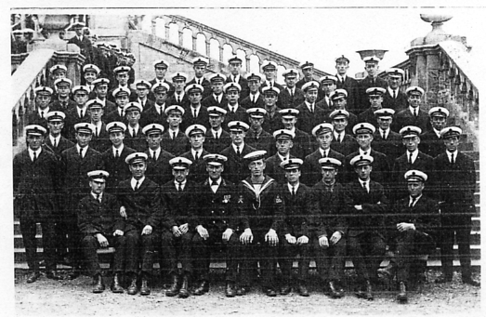
Ratings Petty Officers

A group of Ratings and a group of Petty Officers on the steps of the Crystal Palace. These photographs by T Everitt are probably passing out photographs. Notice in the second photograph another group of officers waiting at the top of the steps for their turn.

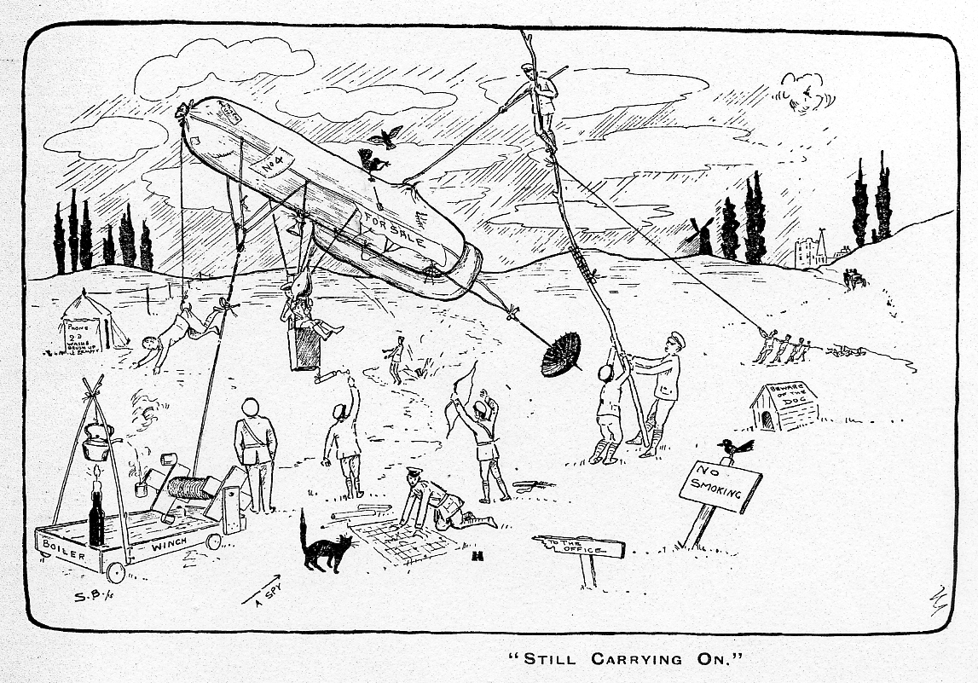
1915 Christmas card from No. 4 Kite & Balloon Squadron, Royal Naval Air Service. Crystal Palace.
Painting out at the Exhibition.
by
Bill Tonkin

I have mentioned in a previous article how Valentine’s were past masters at cutting and pasting visitors from one exhibition to another exhibition held several years later. They were also very good at painting out unwanted objects from their views. They had to get post cards on sale on the opening day of the exhibition, but once the exhibition was under way came the time of reflection, when they would be able to examine the cards they had produced to see how they could be improved, now that the initial rush was over and they had some time on their hands.
Of necessity their photographers had had only a short period to take photographs before opening day, and on closer examination Valentine’s decided some of the original photographs included many undesirable items and now was the time to correct them. Many of the buildings were not completed when the photographs were taken, workmen were rushing to get the job finished, and the last thing the exhibition organisers wanted was a lot of cards on sale showing work still being carried out. Ladders leaning up against buildings and workmen engaged on various jobs would have been one of the priorities to be removed from the scenes.

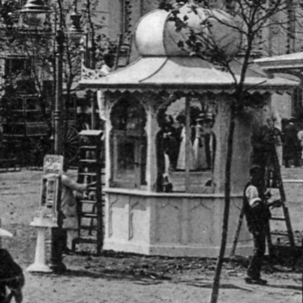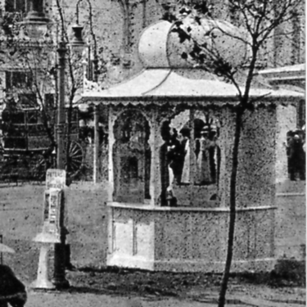

(Fig. 1) No. 307. (Fig. 2) No. 307

In this post card No. 307. Australian Palace, Franco-British Exhibition, (Fig. 1) published by Valentine, painters or builders are still working on the kiosk which was to become a Valentine’s post card kiosk. In (Fig. 2) the workmen and ladders were removed when the cards were re-printed, but the workman’s shadow is still on the ground.

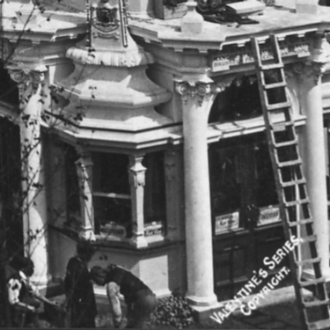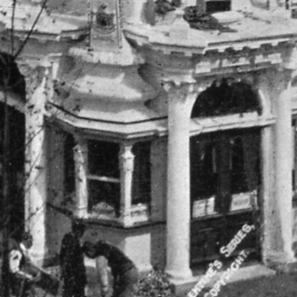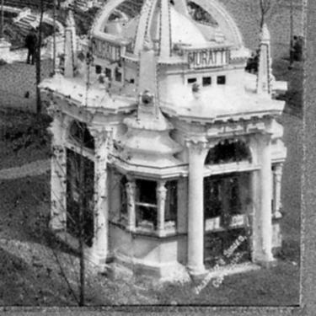

(Fig. 3) No. 202. (Fig. 4) No. 202. (Fig. 5) No. 202.

This is a view of the Muratti Pavilion on No. 202. Garden Club & Elite Gardens, Franco-British Exhibition, not yet completed. It is known in three stages all published as post cards in 1908 with the same number and title. In the first which was published as a real photo post card (Fig. 3) there is a ladder leaning against the pavilion, boxes of tools? on the roof over the entrance, and workmen working at ground level. In the second picture which was published as a coloured card (Fig. 4), the ladder has been painted out, but still leaving the workmen and their tools on the roof. In the third picture which was published as a card with an ornamental border (Fig. 5), Valentine’s artists have completed their work on the view, the workmen have been removed and also their boxes of tools off the roof. Feint traces of the ladder can still be seen.

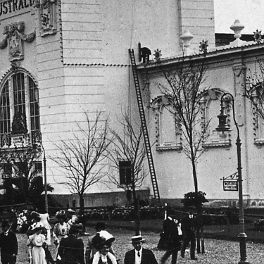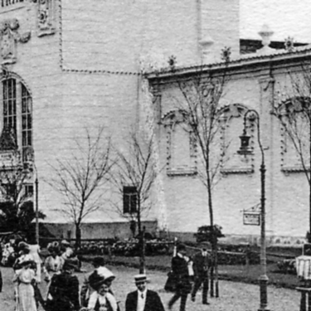

(Fig. 6) No. 257 (Fig. 7) No. 257

In the real photo post card of No. 257 Australian Pavilion, Franco-British Exhibition, (Fig. 6) there is a ladder leaning against the pavilion wall, also a workman on the roof, on the B/W litho and coloured printings the ladder and workman were removed (Fig. 7) leaving only a slight discolouration where the ladder was.

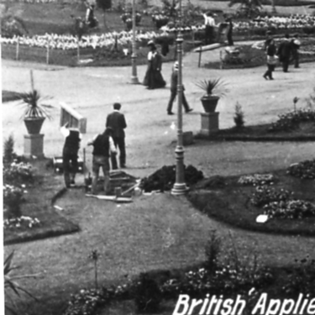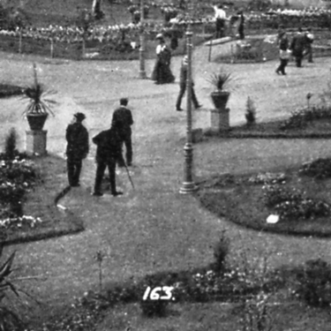

(Fig. 8) No. 163. (Fig. 9) No. 163.

On this real photo post card No. 163. British Applied Arts Palace, Franco-British Exhibition, (Fig. 8) are a group of workmen who have apparently just dug a hole in the ground, there is a large pile of earth beside the hole and one of the workmen is carrying a pair of steps on his shoulder. In the coloured post card (Fig. 9) the workman has been relieved of his ladder, the hole filled up, the pile of earth removed and the workmen have become visitors.

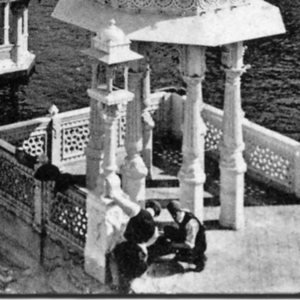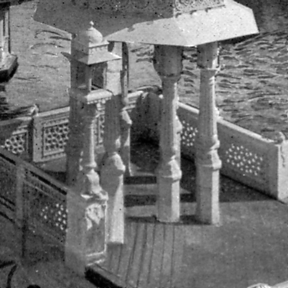

(Fig. 10) No. 184 (Fig. 11) No. 184
A post card No. 184 In Court of Honour, Franco-British Exhibition, (Fig. 10) shows workmen busy on the wall of the bridge across the lake in the Court of Honour. In the coloured printing (Fig. 11) the men have been painted out.

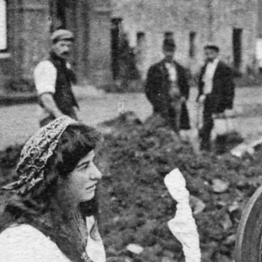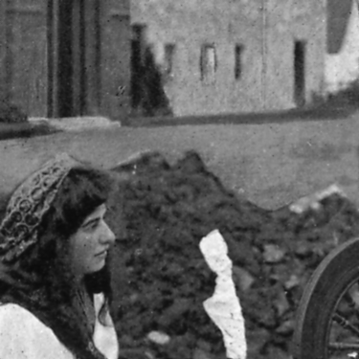

(Fig. 12) Irish Village Colleen (Fig. 13) Irish Village Colleen

The same action was taken on an un-numbered card titled Irish Village Colleen, Franco-British Exhibition, (Fig. 12) Three workmen watching the Irish Colleen were quietly sent about their business (Fig. 13) without the girl even noticing they have gone.

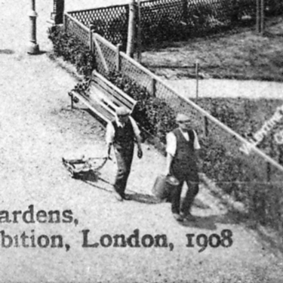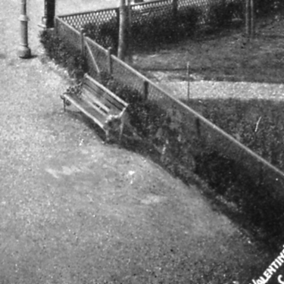

(Fig. 14) No. 241 (Fig. 15) No. 241

On the whole Valentine’s were not too keen on gardeners appearing on their post cards, here we have on No. 241 Elite Gardens, Franco-British Exhibition, two men, one dragging a lawn mower, and the other carrying the container for the grass. (Fig. 14) At the earliest opportunity they were painted out (Fig. 15). On No. 542 Aberfoyl Clachan, Imperial International Exhibition, 1909, the coloured cards show a gardener with a hose pipe busy watering. (Fig. 16) The hose pipe was carefully taken out on the sepia and B/W cards published, (Fig. 17) leaving the gardener as a visitor.

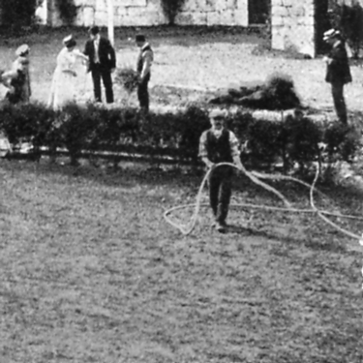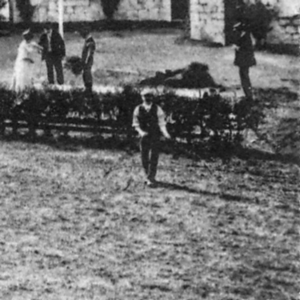

(Fig. 16) No. 542 (Fig. 17) No. 542

Elephants as everyone knows are very large beasts, and it follows that everything about them is very large. Not to put too fine a point on it there is sometimes the need for an attendant and a large wheel barrow as seen on No. 229 Entrance Ceylon Village, Franco-British Exhibition, (Fig. 18). On the coloured post card the wheel barrow was removed (Fig. 19).

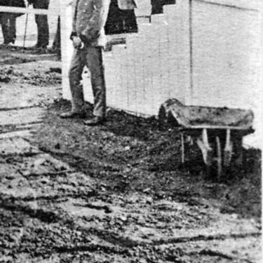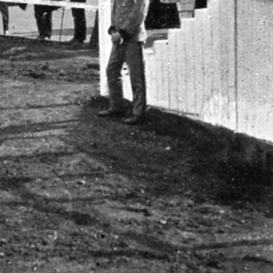

(Fig. 18) No. 229 (Fig. 19) No. 229

Parts of the surround of the lake on an un-numbered card titled In Court of Honour, Franco-British Exhibition, had iron railings as can be seen, note the cloth wrapped round the railing (Fig. 20), these were later replaced with a low pierced concrete wall. There are several post cards that in their early state show the iron rail before it was removed. The original photograph was taken on a sunny day, and the rail cast a shadow on the ground, which is still showing. When the artist painted in the concrete wall he omitted to remove the shadow (Fig. 21).

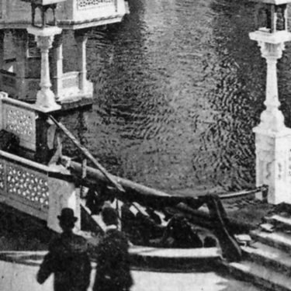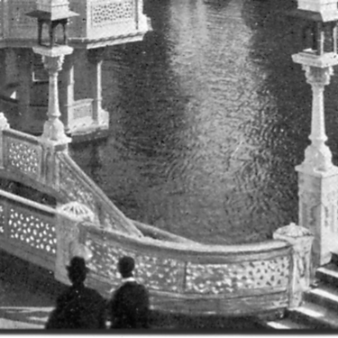

(Fig. 20) In Court of Honour (Fig. 21) In Court of Honour

Exactly the same thing happened on No. 184. In Court of Honour, Franco-British Exhibition, on another 1908 post card. This clearly shows the iron rail (Fig. 22). When the artist painted in the pierced concrete wall he forgot the shadow (Fig. 23).

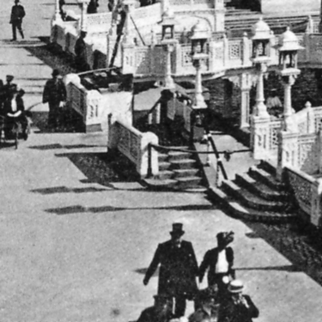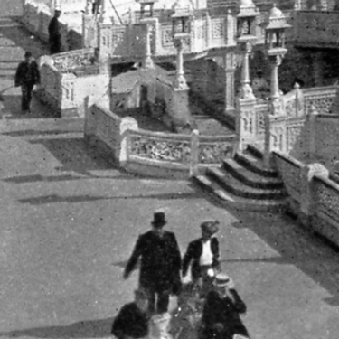

(Fig. 22) No. 184 (Fig. 23) No. 184

