EDITORIAL WINTER 2007

Our 21st has been and gone
and those that missed it are all forlorn.

Our 21st Annual Convention at the Crystal Palace on 29th & 30th September is over and done with. I think I can safely say every body thoroughly enjoyed themselves. The talks and displays were first class, and our invited guest speaker Professor Ian Stevenson gave a mind boggling display of the collectibles and postal history of the 1938 Empire Exhibition at Glasgow. It’s a pity Ann Stevens could not be there, as that’s her collecting interest. But perhaps it was just as well, after seeing Ian’s display she might have felt like giving up.
I should like to thank Alan Sabey who, while we were all sitting back enjoying our selves, was busy making notes of what was going on at the convention, and has been able to compile the report which appears elsewhere.
Last year we were at a bit of a loss for finding somewhere to eat on the Friday evening, and although we eventually found somewhere it has to be said it was somewhere to eat and that’s all that could be said about it. This year we found a really nice restaurant where the manager put himself out to make us comfortable, moving tables to accommodate us and even leaving a half full bottle of Harvey’s Bristol Cream on the table for me to help my self from. Such excellent service was greatly appreciated, we shall certainly go there next year, that’s for sure.
The pre convention get together of just over half a dozen of us on the Friday evening is becoming quite popular, and is now regarded by some of us as part of the convention.
Way back in about 1994 there was an article in Picture Postcard Monthly about missionary post cards by a Dr. D. Pocock. I got in touch with Brian Lund who gave me Derek Pocock’s address in Australia and I wrote to him, congratulating him on the article and we started exchanging information on Missionary post cards, and since then towards the end of each year we correspond and up-date our knowledge of various missionary groups who published post cards.
In July 2001 I was at a post card fair at Worcester, going through exhibition cards and just as I reached for the religious section the man standing next to me beat me to it. “can I have them after you I said to him” “Yes” he replied “I’m only looking for Missionary cards” “Oh! that’s what I’m after I said” “I’m working on a list of S.P.G. cards” he replied. “So am I” there was a long silence, “you’re not Bill Tonkin are you” I admitted this was so. He was my correspondent from Australia who had come over to visit his mother, and finding there was a post card fair on locally had looked in. Since then he has visited me at home several times on trips over here. A coincidence not likely to be repeated you say.
Four days ago I went to Bloomsbury and after I had been there about an hour I went to the organisers stand to get a message announced over the speaker system. I knew that an Australian collector was hoping to make it, on a visit to this country and I wanted to make contact with him if he was present. I spoke to the man behind the stand asking if he would put out a message for an Australian named Reg Stonard, when the man standing next to me said with a grin “look no further, you’re Bill Tonkin aren’t you?” A second coincidence.
We went off to the cafe for a coffee and a long chat, during which he mentioned that another Australian. collector, a friend of his, Ernie Goleby, who I have also been corresponding with for a couple of years about Queensland Franco-British Exhibition post cards, was likely to come here for the next Bipex. I shall not leave this third encounter to chance. I shall make sure Ernie is wearing the National dress of Australia which I believe is a wide brimmed hat with corks dangling on strings round the edge. I shall creep up and stand next to him.
Looking through last quarters Autumn Journal I was horrified to spot a mistake on the front cover. Under the picture of the Lodge where we stayed for the convention I mentioned it was our 25th convention. Every where else I got it right and called it our 21st. I’ve made sure I got it right in this journal.

The Editors
The 2007 21st Convention of the Exhibition Study Group
by
Alan Sabey

The Annual Convention was opened at The Lodge, Crystal Palace by the President, Peter Denly, on 29th September 2007 at 10am. During his opening speech of the Annual General Meeting, the President thanked the Committee for keeping the Group functioning and special thanks were expressed to Kenneth Tonkin for continuing to publish and distribute the Journal. He also referred to the thriving membership of the Group.
1 Apologies for absence had been received from Andrew Brooks, Ken Rumsey, Dilwyn Chambers, Ted and Ann Stevens, twenty members attended the Convention.
2 Minutes. The Minutes of the 2006 A.G.M. had been circulated in the Journal and were taken as read, these were proposed by Mike Perkins and seconded by Fred Peskett, and were agreed and passed.
3 Secretary’s report. Don Knight referred to the possibility of a photograph appearing in Brian Lund’s Picture Postcard Annual. The Society of Olympic Collectors is producing a book about the Olympic Games of 1908 which took place in conjunction with the Franco-British Exhibition. Professor lan Stevenson has been invited to speak to the Group about the 1938 Empire Exhibition in Glasgow, and to be the Speaker at the Annual Dinner.
4 Treasurers report. Alan Sabey, presented the Accounts for the year 2006/2007 which showed the Group to be in a sound financial state. Acceptance of the Accounts was proposed by Bill Tonkin and seconded by George Burr, these were agreed and passed.
5 Election of Officers. The Committee was proposed by Ray Goodey and seconded by Mike Perkins and was elected en-bloc with Joint Webmasters - Ken Rumsey and Mike Perkins. George Burr has agreed to be the second Accounts Checker.
6 2008 Venue. It was agreed that the venue for the 2008 Convention would again be at Crystal Palace and inquiries would be made to find out what Hammersmith and Fulham Council's Archives were doing to mark the Centenary of the Franco-British Exhibition. The date of the 2008 Convention will be Saturday 27th September and Sunday 28th September 2008.
7 A.O.B.
A. Derek Connell asked about the possibility of commemorating the 25th anniversary of the Group with a smart-stamp. Inquiries are being made with another Society who use these.
B Ray Goodey asked whether there could be a publication by the Group on the contents of the Alan Sabey British Empire Exhibition Collection. This will be considered after the publication of the Bill Tonkin book on the White City. This will be considered at the April 2008 Committee meeting when Bill Tonkin will have got the cost involved.
The A.G.M. was declared closed at 10.55am.

Displays at the 2007 Convention.
by
Alan Sabey

Saturday’s displays.
Don Knight kicked off with a display of postcards of the 1907 Dublin Exhibition which ran from May to October 1907. A second display was about the Alexandra Palace in North London built in 1863 from some of the stonework from the 1862 Exhibition at South Kensington sold to the Alexandra Palace Company. There were post cards of the Park and a display of Programmes of Events there.
Fred Peskett then showed postmarks and printed ephemera for the Crystal Palace, south London's Palace. There were also private photographs taken immediately after the 1936 fire which destroyed the building. Fred continued with displays of photos of the 1951 Festival of Britain of scenes not seen on postcards.

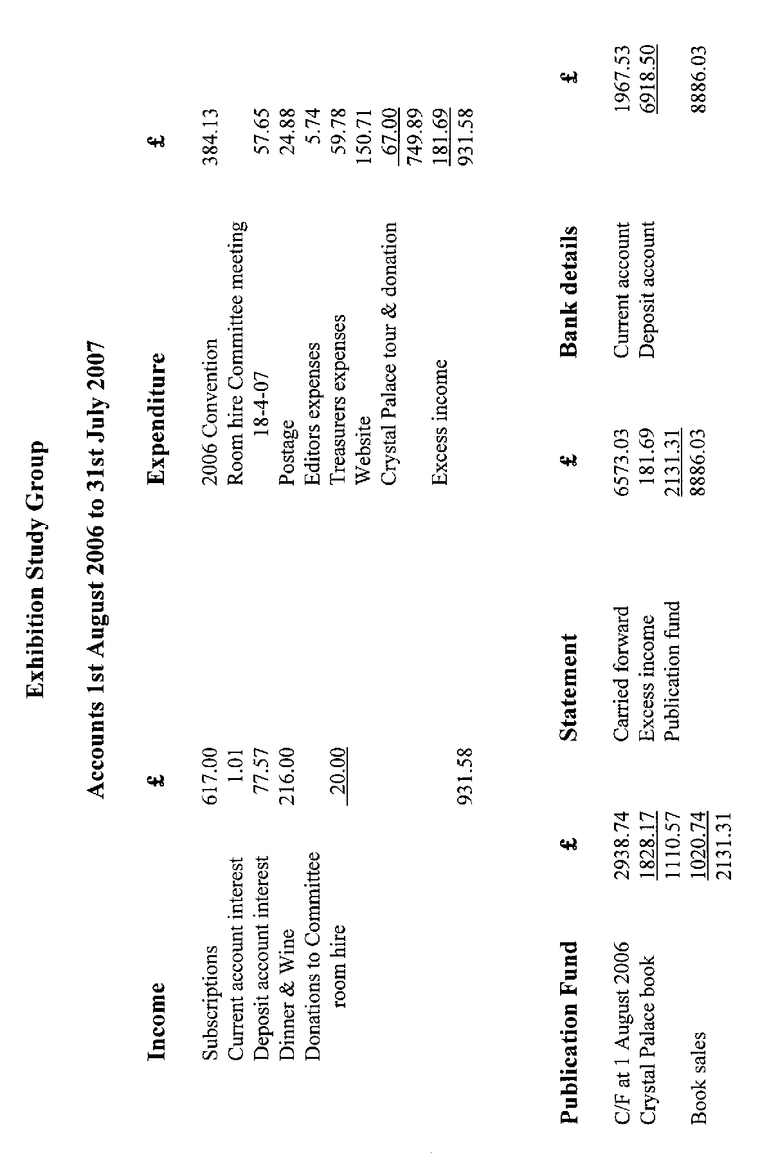
Peter Denly showed postcards of and talked about his further research into Ballymaclinton at the White City and referred to the George Ithell Archive now owned by the Group.
Bob Tough spoke about Aviation and its links with the Crystal Palace. This began in May 1851 when there was a balloon flight over the building in Hyde Park as Queen Victoria performed the Opening Ceremony. When the Palace was re-erected on a hill at Penge in 1854, it lent itself to ballooning. In 1868 the World's first Air Show was staged at Crystal Palace. Crystal Palace was famous for its Fireworks Displays at which there were hot-air ascents by balloon. There was a Balloon Post at the Beckenham Flower Show in 1905 from which only a few cards are known
Alan Sabey showed British Empire Exhibition 1924/25 Publicity Labels sorted into types according to the catalogue, and used on covers and letter-heads.
Ron Trevelyan spoke about the British Industries Fairs with the history from 1916, publicity labels up to 1939. It was revived from 1947 to 1957. In the pre-War years it was often visited by King George V and Queen Mary. The King had asked about an electric fire for his bedroom!
Ray Goodey showed some covers of GB and Colonial recently acquired by him for his collection on the British Empire Exhibition.
Kenneth Tonkin showed recently acquired covers ranging from the 1851 Great Exhibition to Wembley with some assorted ones for other exhibitions where a special postmark did not exist.
Peter Burrows spoke about more unusual exhibitions and displayed covers from them.
Our Guest speaker, Prof. Ian Stevenson, brought Saturday's displays to a close with a detailed display and talk on the 1938 Empire Exhibition held in Glasgow. Incoming mail is scarce and the Post Office opened for business on 25th April 1938 whilst the Official Opening by King George VI was on 3rd May 1938. The Exhibition Post Office was open from 9am to 5.30pm and any mail posted after that was canceled at the Glasgow Head Post Office. There was postal publicity through slogans on the mail throughout the UK. Don Knight gave the Vote of Thanks to lan for a very fine display.
Annual Dinner
In the evening, members enjoyed the Annual Dinner served in the meeting room with some good wines and an excellent After-Dinner speech by Prof. Stevenson before members retired to their rooms in the Accommodation Block.
Sunday's displays
Derek Connell spoke on and gave a display about the Anniversaries of Penny Postage over the years, beginning by showing a Penny Black on cover and a Wyon Guildhall medal. There were the two anniversary venues in 1890. He also covered the 1940 centenary and the commemoration at Stamp World 1990 with postmarks, the series of postcards about Postal Officials and British and Colonial stamp issues..
Bill Tonkin revealed his research in the composition of scenes on postcards revealing that Valentines and others “transported” visitors from one exhibition onto the scene at another exhibition to enhance the views at that exhibition. He had discovered that some 160 characters had been “cut and pasted” from one exhibition to another! It was quite an amusing display to see how a couple or a group suddenly appeared in their same clothes at another exhibition!
Don Knight brought the displays to a close with Earls Court Exhibition and the Giant Wheel (the forerunner of the London Eye) and some Registered covers from the 1928 Stamp Exhibition.
The President, in summing up the Convention said it had been another good one. He thanked all who had attended.

The Great Wheel at Earl’s Court

From an article taken from a contemporary souvenir booklet, written by
Walter B. Basset the constructor of the Great Wheel.

The Great Wheel at Earl’s Court, although entirely of English manufacture, is more or less an American innovation, as the idea of combining a huge vertical wheel, carrying passenger carriages on its periphery, with restaurants and promenade rooms on the supports of its axle, is due to Lieutenant Graydon. an American, late United States Navy.
Mr. Graydon secured patents for the idea and entered into agreements for building with the constructor of the Earl's Court Wheel, Mr. Walter B. Basset, to whom he ceded the sole right for building his wheels in this country.
Mr. Basset then proceeded with the drawings, and, with the aid of Mr. J. J. Webster completed them, and the Gigantic Wheel and Recreation Towers Company, who are the owners of the Great Wheel at Earl's Court, was then formed, and in March, 1894, the work was commenced by digging the foundations, which consist of eight solid cubes of concrete, each weighing over 250 tons, with steel bolts 16 feet long; bedded into them, and to which arc attached the bases of the eight columns. These columns arc each four feet square-, built of steel plates with internal diaphragms.
Picture No. I. shows the first lengths of these columns in place, with the 96 feet pair of sheer legs in position ready to hoist the second section on the west side. This pair of sheer legs, which in this drawing appears so tall, can be seen half buried in the scaffolding in Picture No. 4, and not reaching much more than one-third of the height of the Wheel itself.

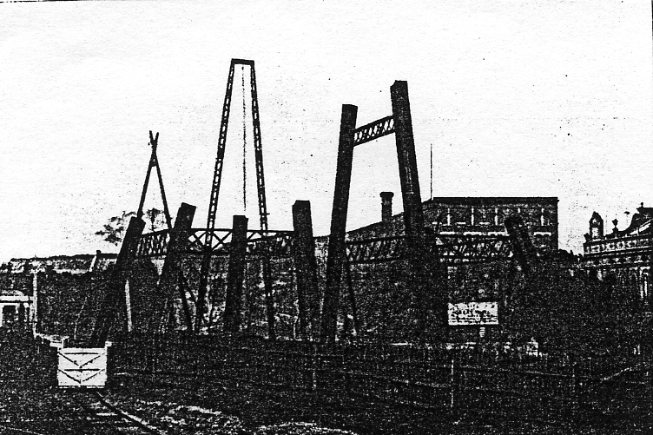
No. 1 shows the first lengths of the columns in place, and the 96 feet pair of sheer legs.

These sheers only served to erect the first half of the columns, being “walked”, as it is termed, to positions exactly above the girders they were intended to lift.
The method employed to lift the upper half of the columns is shown in picture No. 2. A wooden stage was built across the gap through which the wheel now revolves, and on it two powerful Scotch cranes were set up. one to work on each side, by which the upper lengths of the columns were erected before being riveted, this latter being done when the four sides of each column were in place. This photograph was taken from the front of the old theatre which used to stand on the site now occupied by the menagerie, and will doubtless remind many of the position of the work during the early part of the rainy summer of 1894.
About the middle of July the columns were completed, and the great axle, built of 1-inch steel plates and 9-inch steel girders bent into circular form, was brought from Messrs. Maudslay’s works at East Greenwich to Earl's Court. The axle arrived in three sections, each drawn by a traction engine, and, traveling across Waterloo Bridge. passed through the Strand, Whitehall and Victoria Street to Earl’s Court, causing much astonishment and no little strong language on the way, for it can be imagined that the procession of over a hundred tons of steelworks and three traction engines through London could not be accomplished without a good deal of difficulty.
It arrived, however, in safety; and to hoist it into place the wooden bridge or gantry shown in picture No. 3. was used. This formed a bridge across the tops of the columns, and a strong trolley was fitted on it to run on rails. With tackles hung from this trolley, the bearings, weighing 11 tons each, and the axle, weighing 57 tons, were safely hoisted, and the most minute care was taken to adjust the whole to run smoothly and true to enable it to carry the enormous weight that now depends upon it. Time after time the axle was turned and scraped where untrue, while the bearings were leveled with wedges and hydraulic jacks, and it was not until the end of August that the whole was pronounced satisfactory and the gantry and trolley sent down to the ground again.
The Exhibition authorities of 1894 had then determined to close their doors without waiting for the completion of the Wheel, and thus more leisure was afforded for the difficult task of erecting the Wheel proper. The double shift of men that had been working before, was discontinued and on September 6th, night work was given up.

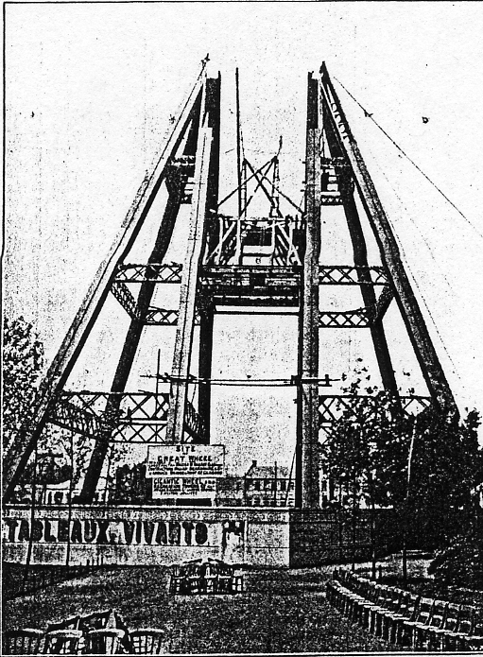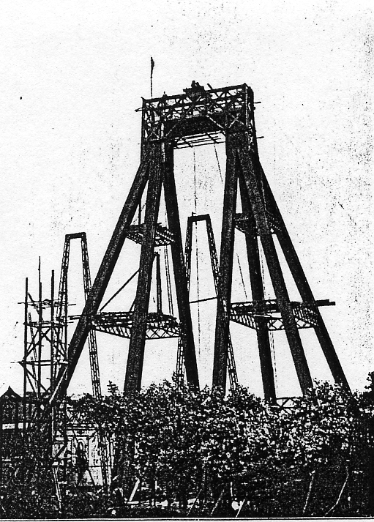
No. 2. A wooden stage was built across the gap. No. 3. Showing wooden bridge or gantry.

Picture No. 4, from a photograph taken at the end of October, shows the first quadrant of ten spokes in position. This part was built in the following manner. A spoke was first hung from the axle, the length being carefully adjusted to gauge, and the portions of the periphery, or outer ring, were attached. Two powerful tackles, capable of exerting together a pull of 120 tons, were fixed to an anchor-post buried in front of the late theatre (in the position shown surrounded by chairs in the foreground of Picture No. 2.), and towards this anchor the spoke was hauled out of the way when finished. Another spoke was then hung in its place, and connected to its periphery girders, and in this manner the ten shown in Picture No. 4. were hung and adjusted until the quadrant was held in the curious position shown in the picture, when the steam-winches actuating the tackle could pull no more, and great cracks, caused by the strain, formed in the ground surrounding the anchor.
The second quadrant Picture 5. was then added as follows. A scaffold 150 feet high was built, to the northward of the columns and on the side opposite the anchor, and each successive spoke on that side was built from it, until the Wheel had progressed to the position shown in Picture No. 5, (engraved from a photo taken just before Christmas), when the first and second quadrants balanced each other, and all the strain was thus removed from the anchor.
Whilst at this stage the Wheel was subjected to the great gale of December 22nd, when a velocity of wind of over 100 miles per hour was registered at several places in the United Kingdom. No damage whatever was done to the Wheel, but several planks on the top of the scaffolding, although nailed down to the beams supporting them, were torn from their holdings and carried for yards by the wind, fortunately, however, without doing injury to anyone.
Notice should be taken, by the reader interested in engineering details, of the introduction of the timber strut for supporting the third quadrant, on which, in the photograph, a party of men can be seen engaged. The strut, which weighed alone over 60 tons, being securely fixed in the first built quadrant, the tackles and anchor were again brought into play for each successive spoke of the third quadrant to be added from the top of the scaffold, till the position shown in Picture No. 6. was reached, when the anchor and tackles were again strained to their safe limit, and the timber strut supported the weight of the first erected portion.
The abnormal frost of January and February greatly interfered with work, for to touch the steel work during the severe days of this historic frost was to get frost-bitten, so that the first week of March was reached before the position shown in Picture 6. was attained.
Here the greatest engineering difficulties of the problem began. It was impossible to build any further in the manner hitherto pursued, viz., by hauling round as just explained, as no strutting' within practical limits would have been capable of supporting the great weight of the overhanging portion had the Wheel been turned further, as it must be remembered that this Wheel is constructed on the tension principle, in which, as in the modem bicycle, no strain is taken by the upper spokes.

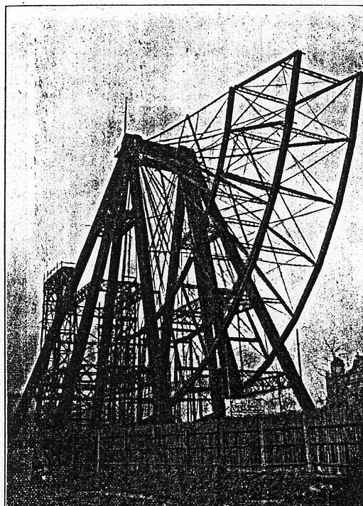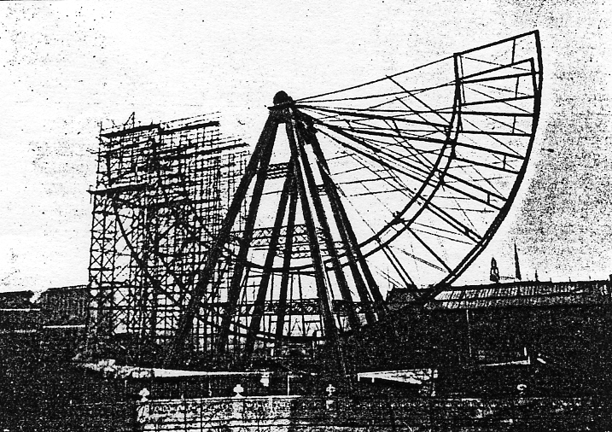
No. 4. The first ten spokes in position. No. 5. The second quadrant added.

How the difficulties were surmounted and the Wheel completed is shown in Picture No. 7. On closely examining this plate, wires will be seen to be stretched from the top of the Wheel to the northern end of the scaffold. From these wires, by the aid of a hanging scaffold, were hung the sections of the inner periphery, or ring, which was built up, piece by piece, till it joined the top where, when viewed from the ground, the men at work appeared like flies, and with the aid of hydraulic jacks and much perseverance, the fortieth and last section of the inner periphery was added; and in spite of another heavy gale, that of March 24th, the whole was bolted together, and the last two bolts in the outer peripheries were driven by Mrs. Walter Basset at a height of 280 feet on April 26th.
The finish was easy. It remained only to take out the timber struts, pull down the scaffold and attach the carriages.
The Wheel is driven by means of two steel wire ropes passing round its peripheries to powerful gearing in the middle of the engine-house, situated some yards to the northward. Two 50 horse-power Robey engines actuate the gearing by means of friction clutches, and the whole is arranged so that one man can easily start the huge fabric, ease it, or stop it, as may he required, without moving from the platform where he stands in the engine-house with the whole Wheel under his control. On his right and left are the main engines, dynamo engine and funicular Railway pumps ; and it may be added for the assurance of the timid, that the entire machinery is duplicated throughout, i.e., that one of the main engines, alone, is capable of moving the Wheel, while one of the driving ropes, alone, is equal to the task of transmitting the power to its periphery, and, as an additional security, tackles are always kept rove, which, in the very improbable event of a total break down of the machinery, would be capable of hauling the Wheel round and permitting the exit of the passengers from the cars.
The Wheel was tested by Mr. J. J. Webster, M.I.C.E., the Company's Engineer, and passed fit for service on July 3rd, 1895.
To turn to the Towers these are built on steel brackets attached to the columns, and are connected with each other by the axle, in the centre of which a tall man may stand upright without fear of hurting his hat. No axle of this size has ever been built before, and it is well worth a visit to the tops of the Towers to see it slowly working in its bearing, while the Wheel with its load of passengers revolves in the air.
Access to the Towers is provided by the Funicular Railways on the legs. The wel1-known Alpine principle is here employed. Two passenger carriages run on rails attached to the columns on the north side. Two tanks are constructed on the tops of the columns and water is continually forced into them by the powerful hydraulic pump in the engine house. When one carriage is at the top, the tap on the outside of the column on its side in opened. The tank at the base of the car is filled and under the force of gravity the carriage descends, hauling up, as it does so, the carriage sliding on the opposite leg. A powerful hydraulic cylinder bolted to the column on the eastern side controls the speed of the carriage, while two strong friction brakes, worked from each carriage, are provided as additional safeguards. Even then, supposing the ropes were to break, the carriages would not descend at an unsafe speed, as a safety clutch is provided in each car which would prevent them from passing the safe limit.

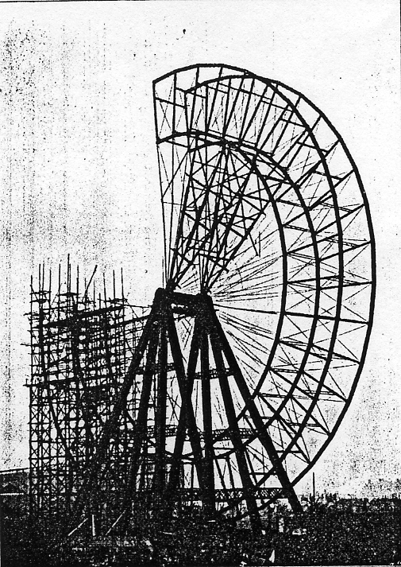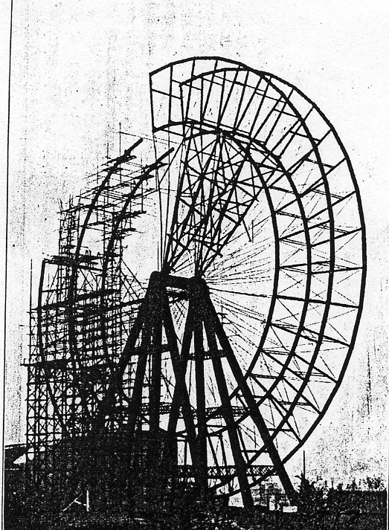
No. 6 Third quadrant added from the scaffold. No. 7. Wheel nearly completed.

Such arc the Gigantic Wheel and Recreation Towers. Safe, as far as human care and ingenuity can make them, and a work worthy of more than a passing glance even from those who do not care to ascend by their means to view the marvelous sight of modern London spread out as in a map beneath them.
As the carriage slowly rises to the eastward the most prominent buildings in sight are the Imperial Institute and Kensington Museum, while to the left and slightly behind them rises the Albert Hall and Memorial with the dome of St. Paul’s Cathedral showing over the tops of both. To the south-east ward the Houses of Parliament and Westminster Abbey standout clearly against the grey background of St. Thomas's Hospital and the buildings on the Surrey side. When the wind is in the west the Tower Bridge and the Tower of London may be sometimes seen through the haze that never seems to leave the City and Fast London.
To the southward the Crystal Palace stand-; prominently on the horizon formed by the range of hills that appear to run continuously from Sydcnham Hill to Epsom Downs and to join on to the Hogs Back which shows up clearly to the westward.
It is of course possible to see much farther to the westward than in the opposite direction on account of the smoke, and in the flat country through which the Thames runs by Hammersmith, Kew, and Richmond, every detail can be plainly traced and every bend and twist of the river be followed, while- exactly over the bend above Hammersmith Bridge the Round Tower of Windsor Castle shows clearly above the trees of the Park.
Look which way you will, it is a view never to be forgotten, and at night, when a myriad lights twinkle in every direction, it is, if possible, oven more impressing than by day, while the strange sensation of moving through the air impelled by an invisible force forms a sensation as novel as it is attractive.
Taken all round the Earl’s Court Wheel is an engineering work well worth seeing, and a trip through the air by its means is an experience not to be missed.

The Exhibition Study Group would like to thank Mrs. C. M. Bayliss of the Hammersmith & Fulham Archives and Local History Centre for kindly supplying a photo-copy of the Souvenir guide from which this article was taken.

Some notes on the Giant Wheel
by
Alan Sabey

At the turn of the last Century, there was another Great Wheel in London, and it was at the former Earls Court exhibition grounds near to where “Stamp Show 2000” was held. The Wheel was an enlargement of the prototype at the Worlds Columbian Exposition in Chicago which was open from May 1st to October 30th 1893.
Work began on the construction of the Gigantic Wheel at Earls Court in March 1894 and its location was near the Lillie Bridge Works of London Transport and could easily be seen by looking in an easterly direction from West Kensington Underground Station. For those wishing to locate the site in today's world, with the many changes made to the road layout in that area after the Second World War, it would be east of where the West Cromwell Road begins after the Traffic lights at the junction of Talgarth Road and North End Road, where the present road bears to the left (if one is heading east) over the railway bridge by a large brick-built warehouse, which was formerly William Whiteley’ Depositories. From that point if one stands on the opposite side of the road to the Depositories and looks across to "Earls Court 2", the Wheel would have been right in front of you.
The Earls Court Exhibition Grounds in those days were in three sections separated by railway lines. The western-most section backed onto Beaumont Road and Mund Street heading south down North End Road from West Kensington station. For postcard collectors this was where the "Western Gardens" (a view often seen on postcards) were. The second section heading east was across the Midland Railway by footbridge and is the section which is now fully occupied by London Transport. This was the location of the Gigantic Wheel at its northern end. The third and eastern-most section was the triangle between various parts of the District Line and the West London Extension Railway, where the present Earls Court Exhibition Building was built in 1937, The Empress State Building (the large triangular shaped office building) stands on the middle of the three parts of the Exhibition Grounds.
Eight 4 foot square and 150 foot high supporting columns were constructed at which level there were two promenade or recreation rooms. The bearings on the plummer blocks at the top were the largest ever constructed and were made by Tandem Smelting Syndicate Ltd. of Jubilee Buildings, Queen Victoria Street, London E.G. who were the largest smelters and the greatest experts on anti-friction metals in Europe. These plummer blocks on which the axle rested weighed 11 tons each and the axle was built at East Greenwich by Maudsley Sons and Field. When assembled it was a steel tube which had been constructed in three sections that measured 35 feet long and 7 feet in diameter. It weighed 60 tons and was brought from Greenwich to Earls Court by road in June 1894, which aroused much interest from the general public en route.
Work on the assembly of the Wheel was slow because of the 1894 Exhibition that was in progress, but this closed early so that the Wheel could be built, and this was done in four sections each weighing 150 tons and was achieved about the end of June 1895.
The total height of the Earls Court Wheel was 300 feet which is 143 feet lower than the Millennium Wheel on the South Bank of the River Thames next to County Hall which is 135 metres (443 feet) high. There were forty cars, constructed by Brown, Marshall & Company of Birmingham, each measuring 24 feet long, 9 feet wide and 10 feet high capable of carrying thirty passengers each. Thus the total capacity of the full Wheel was 1200 persons. Ten of the cars were furnished as First Class cars at a cost of £100 each - five of these were for Non Smokers and the other five were for those wishing to smoke. The other thirty cars were furnished in a plainer style. There were eight platforms on either side of the wheel for embarking on one side and disembarking on the other side.
The Wheel was driven by steam from two 50 horse-power Robey engines housed in an engine house at the foot of the towers. The driving mechanism was a pair of chains which were 1000 feet in length and weighed 8 tons. Either chain was capable of driving the Wheel so there was said to be no danger of it stopping. However according to the "Daily Graphic" on May 23rd 1906, the Wheel stopped suddenly two days before. 74 people were suspended on the Wheel overnight for 15 hours. Some people let down strings in the hope of getting food. Some men climbed the metalwork to reach the lower cars with some refreshments. On their return to solid ground each person was given a £5 note (a great deal of money in 1896) by way of compensation.

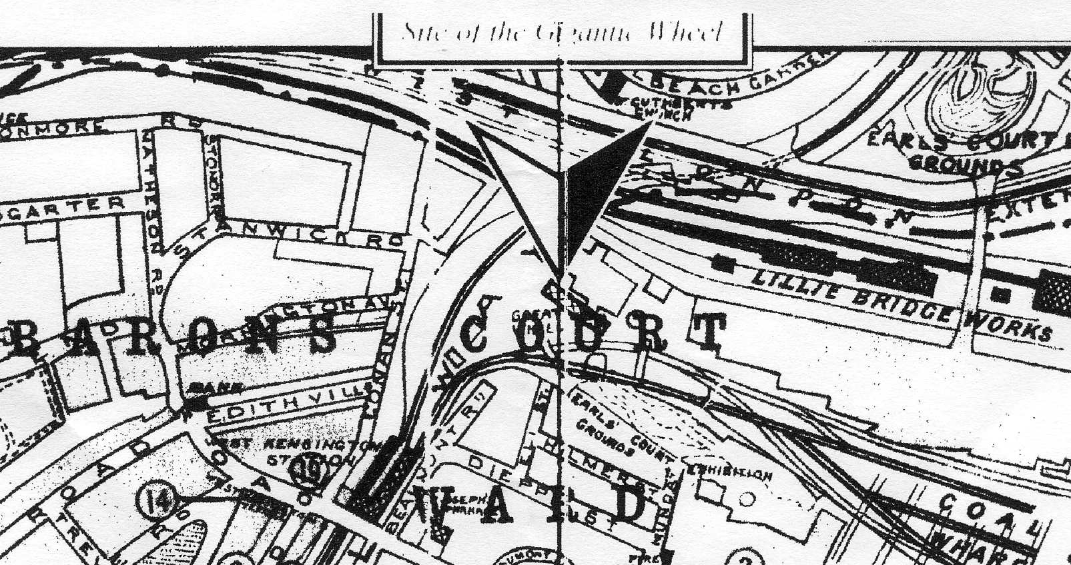
Map showing location of the Great Wheel.

Access to the Recreation Rooms at the tops of the towers was by a double funicular railway. On a clear day the view from the top of the Wheel was over the sights of London in one direction and to Windsor Castle in the other direction. At night there was a double row of glow lamps around its circumference and the cars were lit by electricity. Construction of the Wheel was carried out by Mr. Walter Basset's Company, and on Saturday April 27th 1895, Mrs. Basset ceremonially screwed the last bolt in each rim of the Wheel.
The Wheel opened to the public on July 6th 1895 for the "Empire of India" Exhibition and last turned on the closing day of the 1906 Austrian Exhibition. Due to high winds and frost not much headway was made in the dismantling of the Wheel until a Month's Contract was made on February 8th 1907, because the Wheel Company became bankrupt so it had to be dismantled to sell the metal in order to raise funds for the creditors.
It had a life of eleven years but in that time had given visitors unparalleled views over London and the Home Counties, before the days of aircraft.

To summarize: Tons

Weight of the wheel 600
Weight of the axle 60
Weight of the eight supporting legs 250
Weight of the 40 cars (4 tons each) 160
Total unladen weight 1070

1914 Anglo-American Exposition post mark Code Number 2
by
Kenneth Tonkin

Two double ring circular date stamps, numbered 1 and 2, were issued for use at the 1911 Coronation Exhibition held at Shepherds Bush. As is well known the number 2 date stamp was re-issued for use at the 1912 Latin-British Exhibition with the word ‘CORONATION’ removed. Pearson also records the use of the number 1 date stamp in ‘Special Event Postmarks of the United Kingdom Fourth Edition’ but I have been unable to find any example of this.

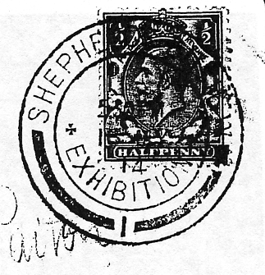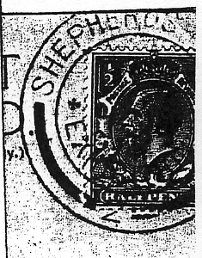
Fig. 1. Fig. 2.

In 1914 the Anglo-American Exposition was held at Shepherds Bush and on this occasion the Coronation Exhibition number 1 date stamp was re-used with the word ‘CORONATION’ removed (fig. 1). Pearson also records the number 2 date stamp being used on 1st June. I recently obtained a photocopy of Michael Goodman's collection of special event postmarks which included an example of this (fig. 2). This was subsequently sold by Cavendish Philatelic Auctions when they disposed of the John Swanborough collection in 1997 and to date appears to be the only known copy.

Aviation and the Crystal Palace Exhibition
by
Bob Tough

The connection between Aviation and the Great Exhibition in Hyde Park in 1851 started right from the very opening of the Exhibition by Queen Victoria on May 1st. While the Queen was performing the opening ceremony in the building designed by Paxton, the Chairman of the Organizing Committee, being her husband, Prince Albert, a balloon flew overhead. The balloon was piloted by Charles Spencer, a family who were leaders in ballooning for well over half a century. No doubt some of the exhibits referred to ballooning. The Crystal Palace was re-erected on Sydenham Hill and reopened by Queen Victoria on 10th June 1954. Ballooning had taken place in Britain for nearly half a century, either using hot air or domestic gas. Vauxhall Gardens were a favourite ballooning site.
With the Exhibition being on a hill it was not long before the idea of ballooning from the Exhibition taking passengers, was commenced in 1859 by Mr. Lythgoe who worked for the local gas company. By 1862 Harry Coxwell had been appointed Crystal Palace Aeronaut and was regularly taking passengers at £5 per flight. The Royal Aeronautical Society has a lithograph coloured by Josiah Taylor showing his mammoth balloon flying over the Crystal Palace; it was 55 ft in diameter. This did not compare in size with the French aeronaut and photographer Nadar’s giant balloon, the basket of which containing a saloon, captain's cabin, dark room, laboratory and printing press which was exhibited at Crystal Palace in the following- year. Nadar is remembered for organizing the balloon postal service out of Paris during the German siege of 1870. Many balloons were flown and a number of very small letters written on very thin paper still exist. In fact, in the same year mail was flown by balloon from the Crystal Palace; there were four flights and six cards are known which were carried on these flights.
In 1868 the world's first Air Show was staged at Crystal Palace, comprising models of airships and various flying machines, one model actually worked. This was made by John String-fellow and was driven by a small motor along a wire but was seen to lift off the wire and actually fly.
Other attempts at flying machines seem to have concentrated at the Crystal Palace; Thomas May built an aerial ‘Steamer’ which was seen to lift off a track round one of the fountains at Crystal Palace. It could not, however, be manned.
Sir Hiram Maxim, who lived near the Palace, built what he called a ‘Flying Machine’ there, which was in effect a free-flying roundabout, the cars could be controlled by rudder and ailerons. The back of a card says that the writer traveled at 100 mph on this contraption. There is no doubt that it must have been very fast, and precarious. The machine was moved to Earls Court and to Blackpool and may still be operating there. This was first introduced in 1894.
By the end of the century the Crystal Palace was having difficulty in attracting visitors; a spectacular trapeze act from a balloon by Leona Dare was one of the attractions in about 1890. Despite her risky activities she lived to an age of almost 90.
Firework displays were another attraction and the Brock’s Benefit was born. These displays included hot-air balloons made of Japanese tissue paper on wire frames, some of which carried postcards asking for the finder to return then to the sender. Although quite a number were dispatched only about four are now known. Meanwhile Mr. Spencer continued with his balloon ascents. He also flew the first successful airship in Britain, departing from the Palace for St. Paul's and actually landing at Highgate in 1902. The first British military airship, ‘Nulli Secundus’, built and flown by Captain Cody, flew from Farnborough to St. Paul's but came to grief on the return at Crystal Palace in 1907. It was taken back to Farnborough by road, rebuilt and renamed ‘Alpha’.
In 1905 balloon post was an attraction at Beckenham Flower Show; cards were dropped from a balloon and posted by passers-by back to the sender. Only about 7 cards are known. In 1907 the Daily Graphic mammoth balloon flew from the Palace, mail was thrown overboard at Mullerud in Sweden, and returned to the senders. A number of cards exist, some with Swedish stamps and others ‘postage due’. 1907 was a busy year at Sydenham, for the Wright Brothers made the first aeroplane flight in Britain from the cycle track at Crystal Palace. Bleriot’s monoplane, which flew across the Channel was exhibited in 1909 and in the following year Claude Grahame White made flights from there. In that year the unfortunate British airship. pioneer, E. T. Willows flew No. II from its building shed at Cardiff to the Palace and subsequently flew off to Paris. Although his airships were quite successful he never achieved any real government support, and his firm foundered before the First World War.
The Festival of Empire in 1911 included at least one aeroplane exhibit. I have a postcard of Mr. Beaumont’s aeroplane on view there. In the same year a Miss Alice Honeyman had a balloon flight and has written a vivid account of it.
During the first World War the Crystal Palace became a Royal Naval Depot but after the war in 1920 it was chosen for the Imperial War Museum and Victory Exhibition with a whole section of aviation including Barrage Balloons and a whole range of aeroplanes and seaplanes. during the same year the world’s first regular overseas air service was set up from Hounslow to Le Bourget. The Crystal Palace on Sydenham Hill was used for navigation as the aircraft regularly flew over it.
Two of the few British airships also flew over the Palace, the R33 when she made her only visit to Croydon Airport in 1921, her sister ship the R34 being the first aircraft to fly both ways across the Atlantic, and in each crossing had flown almost twice the distance that Alcock and Brown flew to cross the Atlantic the previous year.
I have a card of the R100 over Crystal Palace in 1950, she did a number of flights around Britain and like the R34 flew across the Atlantic this time to Canada and back. Her sister ship, the R101, was lost with nearly all hands in a tragic accident on a hillside in Beauvais on the way to India. The Palace continued to be important from an air navigation point of view; in 1931 the Battle of Britain pilot Douglas Bader, flying a Bristol ‘Bulldog’ was lost in fog. He landed in a field and asked a passerby for directions. The passerby directed him to the Palace and from there he knew the route to nearby Kenley Aerodrome
There is no doubt had the Crystal Palace or even one of its towers survived until the second World War, they would have been an important landmark for the German bombers. It is said this is why a second tower which survived the fire in 1936 was demolished.
Exhibitions in the grounds continue and as recently as 1990 the Transport Spectacular included model aircraft, model balloon flights etc. Eighty .years after the first balloon flight, Kevin Johnson flew a hot-air balloon from the site in 1991 with Tony Stevens and Gill Ridgewell as passengers. This appeared to be the end of aviation from Crystal Palace.

The Story behind a Postcard
By
Fred Peskett

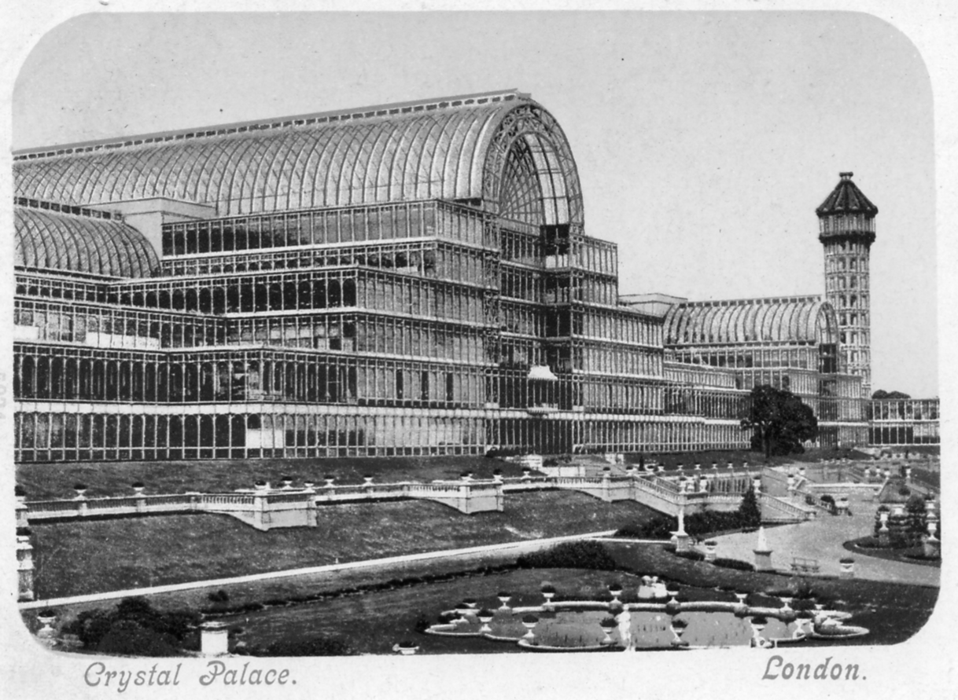

An enlargement of the Blum & Degan post card.

A recent article in Journal No 85 “Cut and Paste at the Franco-British Exhibition in 1908” where the postcard publisher Valentine invited visitors to see other exhibitions many years later, possibly sometimes posthumously, gave me much food for thought. One view of the Crystal Palace shown above has intrigued me for many years, so I thought I would look at it a little more closely.
At a first glance this is just another postcard view of the Crystal Palace published by Blum & Degan and postally used in 1901, however, a close examination reveals that the view includes the North Transept which was destroyed by fire on Sunday 30th December 1866 and never re-built. It seemed a little odd that such an old view was being used some thirty five years later, with probably many hundreds if not thousands of visitors buying and sending a postcard of the Palace that they would never had seen! During the survey for the “Postcards of the Crystal Palace” book by Bill Tonkin and myself, it became apparent that several printers/publishers had used this view for postcards around 1895 to 1910, it was obvious that they were all produced from the same negative. This needed some further investigation, so it was time to don the Deer-stalker, polish up the magnifying glass and light up and have a puff on the old Funkle Trumpet.
There are several features which identify the postcards as coming from the same negative, these are:-
a. The position of the North Tower in relation to the square portion on the roof of the North Transept, they almost touch.
b. A tree situated on the Terrace between the Central and North Transepts. This tree is shown on the ground-plan published in 1853, it is known Sir Joseph Paxton retained as many of the trees as was possible from the original landscape of Penge Place.
c A bench seat near the curved path in the foreground.
d A row of double bench seats near the edge of the diagonal path on the right hand side.
e A circle of dots in the fountain basin in the foreground, these were the spouts for the fountains. In the original negative the fountains were not operating, but on some of the postcards the fountains have been drawn in, sometimes leaving the ring of dots showing.
f The original negative had no cloud formations, but in most of the subsequent postcards they have been drawn or coloured in by the various publishers including “night views” whereby the reproduction has been darkened and a moon and moonlit clouds have been added.
One other feature that all these cards have in common is that they were all printed in Germanic States, this is not unusual since most of the early post cards came from these printers. The publishers/printers identified are:-
1 Blum & Degan. (Printed in Munich) Blum & Degan used this view at least eight times in various formats, with and without the fountains operating, they were produced as black and white vignettes both in the court and standard sizes, and with added colour and night views, several back styles are known. The earliest recorded use of the negative by this company is in 1899.
2 S. Hildesheimer. (Printed in Saxony) Four different printings both in black & white and added colour. The imprint on these cards claim “copyright” The earliest date recorded for use is 16th March 1903.
3 A. G. Taylor. (Printed in Bavaria). Copyright to Taylor Series/Pictorial Postcards is claimed. Earliest use known is 18th November 1905.
4 Gottschalk, Dreyfus and Davis. (F. F. & Co.) (Printed in both Germany and Bavaria) The view was used on at least nineteen different issues with various type settings and different backs, in both black and white and colour. First recorded use was 28th November 1905. On all issues “copyright” was claimed.
5 Horniman’s Pure Tea. This was probably an advertising postcard produced for Horniman by Gottschalk, Dreyfus and Davis since it has the F. F. Copyright mark. The earliest recorded use is October 1905.
There is also a postcard by an unknown publisher as a black & white vignette, printed in Prussia and postmarked November 12th 1904. Copyright was also claimed!
Having established who used the negative, it was now time to investigate who produced it? From 1853 to 1914 there were only three “Official Photographers” appointed by the Crystal Palace Company, The first was Phillip Henry de la Motte, 1852 to 1855. His work mainly concentrated on photographs of the construction of the Crystal Palace building and the finished Courts. As well as being a photographer, he was also a very accomplished artist, his line engravings were used in the first Palace Guide to the Building and Grounds published in 1854. One of the illustrations is a near match to the negative in question, but the North Tower is missing, it was yet to be constructed when he did the drawing. He resigned from the Crystal Palace Company in March 1855, to take up the position as Professor of Drawing at King’s College, London. De la Motte also produced a series of twenty stereoscopic cards of the interior views of the Crystal Palace Courts for the Crystal Palace Art Union.
The second “Official Photographer” was Mr. Negretti of the Negretti & Zambra Company and remained as the “Official Photographer” from 1855 to 1898. It is known that the firm had a studio in the Crystal Palace and produced the “Carte-de-visites” and the larger “Cabinet” size portraits of visitors to the Crystal Palace, as well as Crystal Palace views, stereoscopic cards and photographs for the Guide books. Souvenir Handbooks and programmes of events at the Palace. They also produced a series of Lantern Slides, one of which I have in my collection is very close to the negative under investigation, (more about this later) Negretti & Zambra continued as the “Official Photographer” until 1898 when the company left the Palace to concentrate on their photographic and scientific equipment manufacture. There is no record of Negretti & Zambra publishing any postcard views.
The “Official” status passed to J. Russell, who also had a studio in the Crystal Palace. Russell continued until 1914 during which time he produced thousands if not millions of postcards, this was the peak of the postcard production era. Russell took the photographs for the up-to-date guide books and souvenir books of views of the Palace and Grounds, also views of personalities and events at the Palace from 1900 which were used to produce cigarette cards in the Ogden’s Tab Series.
Based on the information gathered it is almost certain that the originator of the “negative” was in fact Negretti & Zambra and they may even have sold it on to the other publishers who later produced it in a postcard form, with each one claiming copyright! The glass lantern view mentioned earlier was used by Russell, both as a vertical format postcard and as a circular inset on views of the North Tower Gardens. It is known postmarked as early as 1901, so it is most probable that in taking over the “Official” title. Russell may have also inherited or purchased negatives from Negretti & Zambra
The postcard view by Russell uses only a portion of the negative used to produce the Lantern Slide and is known postdated to September 1910, at least forty four years after it was first taken!
It has taken many hours of research using original guide books, programmes and other ephemera to try and find out a story behind this postcard view, Q.E.D. (I think?)

The Crystal Palace Festival of Empire O X O Post Cards.
by
Bill Tonkin.

I was at a post card fair the other day and another collector was looking through the exhibition section. I asked him what his interest in exhibitions was, and he said he was not really into exhibitions, but was looking there for cards relating to the O X O company. Before we parted I got his address and said I would send him a list of all the Crystal Palace Festival of Empire O X O cards.
I soon had a reply to my letter, and Tony Atkins, like myself is interested in varieties and had spotted some that Fred Pesket and myself had missed when we did the Crystal Palace book. Briefly O X O’s pavilion was situated next to the Abdulla Cigarette pavilion and they obviously did not want to advertise Abdulla’s cigarettes on their post cards so they got the printer to carefully blank out Abdulla’s name. I have made out a list of this variety, which only appears on the cards with the heads on the right side of the card.
The numbers 4 to 7 are the numbers we had allocated to these cards in our book. We had listed the different measurements of the titles, but had not realised that the cards with different measurements of the title used a second picture from the same negative for each size of title. this is proved by card No. 7. where the 88 mm. size of title has Abdulla’s name blocked out whereas on the 92 mm. title they forgot to block out Abdulla and Cigarettes just above it. See picture 7a and 7b.

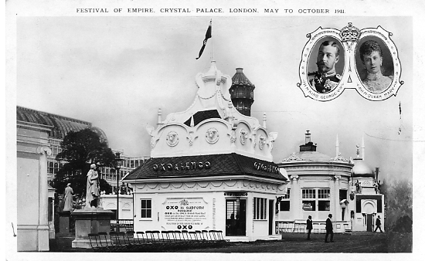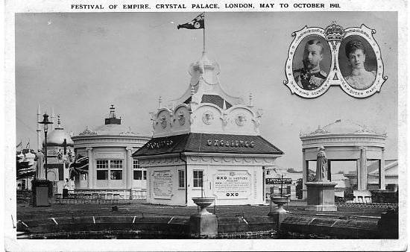
Kiosk views. Picture No. 4. Kiosk views. Picture No. 5

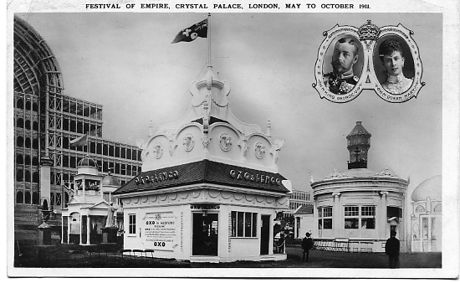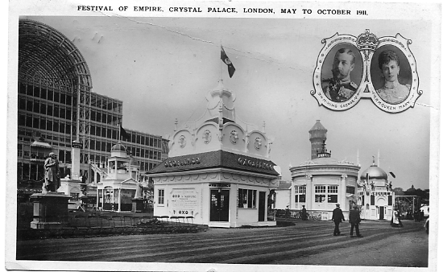
Kiosk views. Picture No. 6. Kiosk views. Picture No. 7.

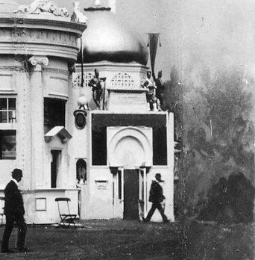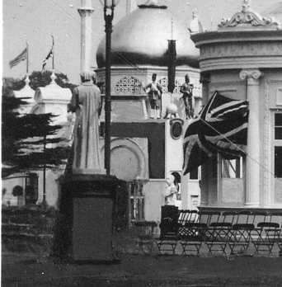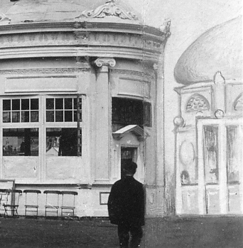
No. 4. No. 5. No. 6.

N.n. Festival of Empire. Crystal Palace. London. May to October 1911. Pict. No. 4.
A. Title measures 88 mm. Abdulla name blocked out.
B. Title measures 92 mm. Abdulla name blocked out.
N.n. Festival of Empire. Crystal Palace. London. May to October 1911. Pict. No. 5.
A. Title measures 88 mm. Abdulla name blocked out.
B. Title measures 92 mm. Abdulla name blocked out.
N.n. Festival of Empire. Crystal Palace. London. May to October 1911. Pict. No. 6.
A. Title measures 86 mm. The Abdulla pavilion and the edge of the O X O pavilion has been cut out and a feint drawing of the Abdulla pavilion substituted.
B. Title measures 92 mm. The Abdulla pavilion and the edge of the O X O pavilion has been cut out and a feint drawing of the Abdulla pavilion substituted.
N.n. Festival of Empire. Crystal Palace. London. May to October 1911. Pict. No. 7.
A. Title measures 88 mm. Abdulla’s name and Cigarettes blocked out. Pict. No. 7a
B. Title measures 92 mm. Abdulla’s name on their pavilion is left in. Pict No. 7b.

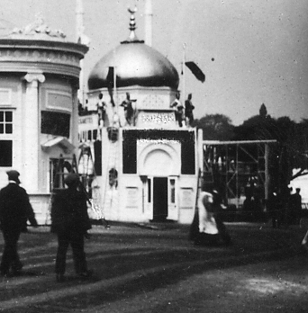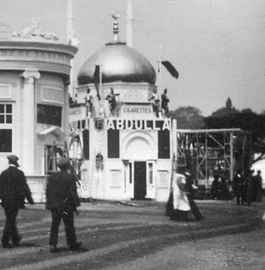
No. 7a. No. 7b.

