EDITORIAL AUTUMN 2007

Yes Scotland had a great big wheel
I got it wrong, guess how I feel

The significance of the above will become clear as you read on. That is if you do read on, as a rather disturbing thing has happened to me. On the last issue of the Journal I made a mistake. Yes remarkable as it may seem I made a mistake. I know it does not happen very often, but there you are. In an article published under the heading of “Cut and Paste” I mentioned that “in 1908 they still had to wait for over a hundred and fifty years before computers could cut and paste in the blink of an eye.” I can only assume that having just done young Fred’s ballad on the great Exhibition I still had the year 1851 firmly fixed in my mind, as of course it is only just under one hundred years from 1908 to the age of computers not a hundred and fifty.
I can’t make up my mind whether readers spotted this mistake and did not like to write or phone in and point it out in case they caused me embarrassment, or whether they didn’t notice it, or even (perish the thought) they don’t read the Journal. I don’t mind telling you this thought has kept me awake at nights.
I can still remember the occasion many years ago, just after the Study Group published ‘Post Cards of the British Empire Exhibition’ Alan Sabey phoned up to congratulate Mike and myself on our work, and asked casually if I was aware that Edward VII did not die in 1911 as we stated in the book. I shall never make that mistake again, that’s for sure.

Our 21st Annual Convention at the Crystal Palace on 29th 30th September

This is an event that I hope every member of the Study Group will make the effort to attend even if you can only make one day. 21 years is an important hall mark in any association, and the fact that we have held a convention for this number of years is a very good indication that it has stood the test of time. If members had not liked and enjoyed what they get up to, they would not have continued to support it. There are three of us who have not missed a convention since the first one, Don Knight, Mike Perkins and myself. Don has displayed at every one. I would like this to be our best attended convention ever, so no excuses please.
To those members who have not attended one of our conventions before, apart from the Annual General Meeting which is held at 10.00 on the Saturday morning, and is over very quickly, the rest of the day is taken up with displays of exhibition material and talks by members. We have some very knowledgeable members in the group and also many members with first class collections of all types of exhibition material. I can promise you will go home green with envy. The second day is also taken up with displays with the Sunday afternoon usually a more informal period when some who have to travel long distances tend to slope off during the afternoon.
The Convention is held in The Lodge. Crystal Palace National Sports Centre. Ledrington Road, London. SE19 2BB. Members wishing to stay for the week end can book by phone, but remember to mention you are part of the booking reserved for the Exhibition Study Group. The phone number is 020 8778 0131. Ask for Joan Miles. Please let Don Knight at 2, Crescent Rd, New Barnet, Herts. EN4 9RF or Tel. 020 8440 3574. know if you are coming, and if you are bringing a display. There will probably be some members arriving on the Friday afternoon as I do, and we can have a get together at the ‘Paxton Arms’ across the road.
During the day there will be breaks in the morning and afternoon for tea, coffee and snacks and we can go along to the canteen at midday for a meal. The Lodge is divided into units of one single and one double room with a shared W.C. and shower between them for each unit. So each room is 50% en-suite, with plenty of single rooms, which is not usually the case in hotels. The facilities are not shared by any of the other units. Last year was the first year we have stayed at the Lodge and it was decided to book there for this year and probably 2008. They also do our Annual Dinner on the Saturday night which this year will be free of charge (including wine) to members.
The Editors
The Big Wheel at the Glasgow Exhibition in 1938

A few months back I got involved in some correspondence with Ann Stevens who started the ball rolling by asking if I knew anything about a big wheel at the Empire Exhibition at Glasgow in 1938. I rather put my foot in it by saying I didn’t think there was a big wheel at Bellahouston. I was sure that if there had of been a big wheel it would have shown up on a post card towering up into the sky line like Tait’s Tower does. Ann delved deeper than I did, and managed to find a couple of pictures of the wheel, which she sent me. Ann also had ‘insider’ knowledge as she tells me her Mum remembers riding on the Big Wheel. I replied as follows,

Dear Ann,
Thanks for all your photo-copies on the Great Wheel at the 1938 Empire Exhibition Glasgow. I see I was wrong to say there was no great wheel there. I did cling to a hope that the wheel was at a fair either before or after the exhibition, but I’m denied even that small bit of consolation.
I have checked through all my ephemera on the 1938 Glasgow and found just three words ‘the big wheel’ on page 198 of the Official Guide. I’m surprised that in a 304 page publication they could only spare one and a half pages on the Amusement Park. On neither the aerial photograph or in the plan of the exhibition is a big wheel shown or even mentioned. Neither can I call to mind a single view of the big wheel on a post card. Even the large folded map by McCorquodale does not show or mention a big wheel. It does mention no less than 22 other attractions in the amusement park, but nothing about a big wheel.
It would seem according to Bob Crampsey in his ‘The Empire Exhibition 1938 The Last Durbar’ that there was a lot of conflict between Butlin and the Exhibition Authorities. He states on page 84 that ‘the orthodox exhibitors felt that the side shows and round-abouts detracted from the primary purpose of an International Trade Fair’ and goes on to claim ‘The Glasgow Herald was massively unsympathetic to the plaints of the showmen’. Perhaps the amusement part of the exhibition was played down, and who knows perhaps Valentine’s were aware of this and decided to ignore the ‘down market’ side of the exhibition. We shall never know now.

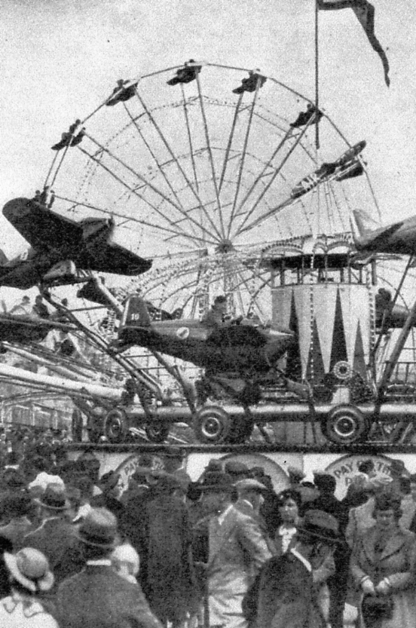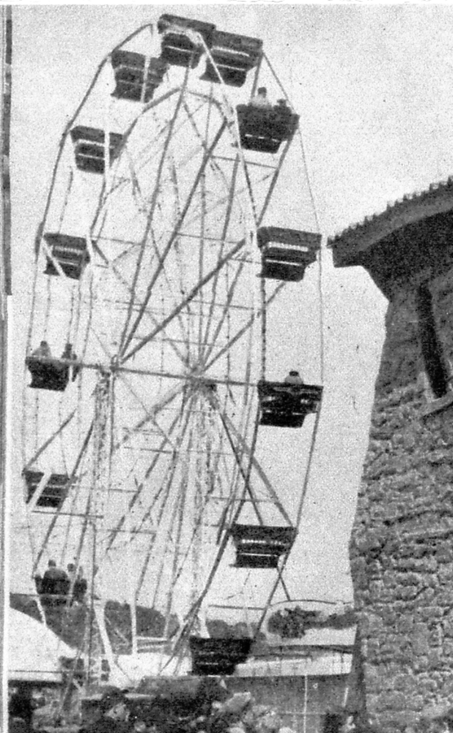

Two pictures of the Big Wheel.
I have been having a grand sort out of my odds and ends and came across two related items, the scan of the certificate was sent to me by Jean Osborne with the question did I know anything about it? At the time I did not, and then I found a photo-copy of a sheet of text titled ‘The Gold Humbug Book’ which explains what the certificate is all about. Unfortunately I can’t remember who sent me the sheet, perhaps it was Jean. The sheet came from a book and is numbered page 297
Apparently the 1908 scam is still working and improving with age, as I am sure Jean paid a lot more than a shilling for her copy of the certificate with the gilt seal. I believe that is called inflation. By an amazing flash of insight as I sat at my computer typing this out, wondering where the original article came from, I thought to my self there are not a lot of books about the White City running to over 297 pages. I got up and reached for my copy of The Franco-British Exhibition Illustrated Review by F. G. Dumas, and there on page 297 was the story of the Gold Humbug Book. So I’ve found the origin of the article, but I still can’t remember who sent it in. Thanks anyhow. The picture of the certificate is slightly reduced in size.

The Gold Humbug Book

It cometh to pass that I walk of a morning adown the flags of the Court of Honour, musing on beautiful things. Uprises a lady who lieth in wait (and in other-ways, perdie !), and she saith, “Would you like to sign your name in the GOLD BOOK, Sir? Tis only a shilling.”
I answer, “You have it the wrong way about. If I sign my name, it is you who should pay me a shilling for the labour of so doing.” But, sneering, she disdaineth argument, and I pass on, merry in the discovery of this new thing. For the predatory genius who invented the GOLD BOOK found the idea swiftly in an evil night, and it burst suddenly on the White City, twelve stalls in different places each with a monstrous early Victorian album, wherein you signed your name and received (ye pocket-rifling gods of tin!) a certificate that you had visited the Exhibition. For sixpence you received certificate with a red seal; for a shilling you had certificate with a gilt seal.
The best thing in booby-traps, I must always pay honour to any best thing. The racing crook with his upturned umbrella, his furtive eye for the police, and his brief gospel of “Find the Lady, gentlemen,” was child-brained, compared to the master mind that created the idea of the GOLD BOOK and underlined the last word in inanity. It was all so beautifully vague, though girls sat calmly in the receipt of custom with explanations. There were going to be 250,000,000 names in the GOLD BOOK. Then they were all to be bound together, the first page containing the signatures of King Edward and other notable visitors.
“What then?”
“Oh, then! They’ll be put, I think, in the British Museum.”
Why were you not true artists, dear lady attendants of the GOLD BOOK? Why did you not tell Balham, Streatham, and Walham Green, whom you persuaded to sign, that King Edward, the Sultan of Turkey, and Marie Lloyd had faithfully promised to send a bar of chocolate and a letter of thanks to all who signed in the gold book, the gold bug book, the gold humbug book?
Then, I think, there would not have been such stout portions of the six gold books pathetically unused in their brave gilt. Certainly you were very good, you sent the certificate to the signers in a neat useful roll, charging a penny, and if you buy a good pair of lenses, and pay to get them adjusted scientifically, you can make a passable telescope out of a cardboard roll. At least I think so.
Designers of the White City money-hooks, this was your crowning achievement. Take, with my compliments, the figurative crown I give. You deserve a knighthood; but at that thought I am filled with grief; I am desolé. I am very sorry. I am out of stock, or you should have one with pleasure.

Herbert Shaw

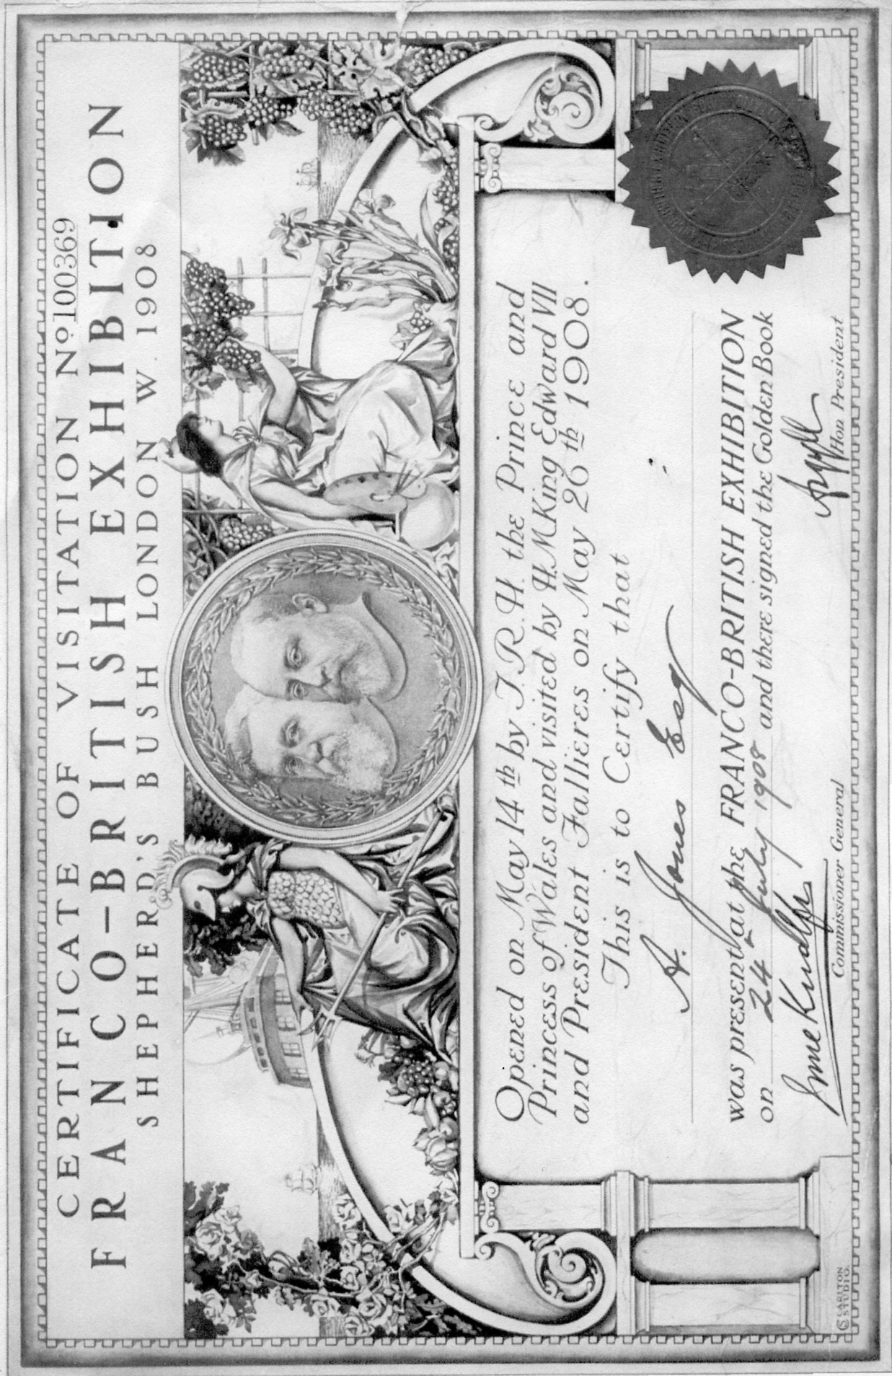

The Egyptian Court
Erected in the Crystal Palace by Owen Jones and Joseph Bonomi
1854

The Egyptian Court and indeed the other courts must have presented a wonderful spectacle to a public that in general would never have seen such splendours and probably never even seen pictures or read about the ancient objects on view. It literally opened up a new world to a large proportion of the visitors who in the main were never in their own lifetime able to afford to go on a holiday in their own country, let alone travel abroad.
The Egyptian Court guide book published by Bradbury & Evans in 1854 introduced the public to some of the objects on display of Ancient Egypt. Of these I am sure samples of the ancient hieroglyphic writing of the Egyptians must have been a major attraction. On the frieze occupying the whole length of the facade at one end of the court was painted the strange symbols and figures that were not there for ornamental purposes, but actually told the story in the ancient long dead language, of their present Queen and Consort.
Published in the guide book was a translation of the Egyptian hieroglyphics telling the story.

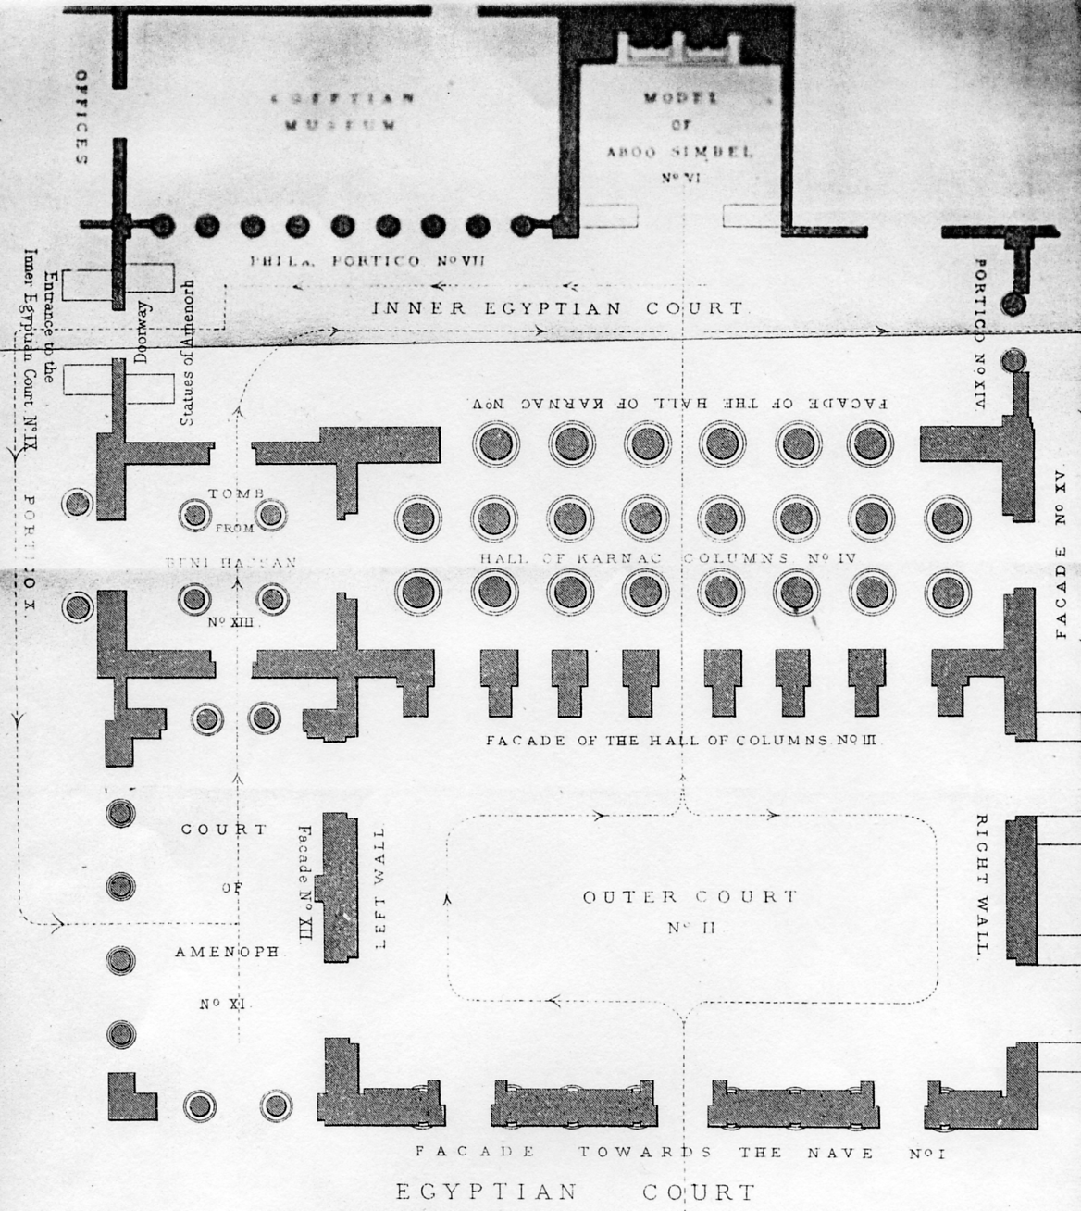

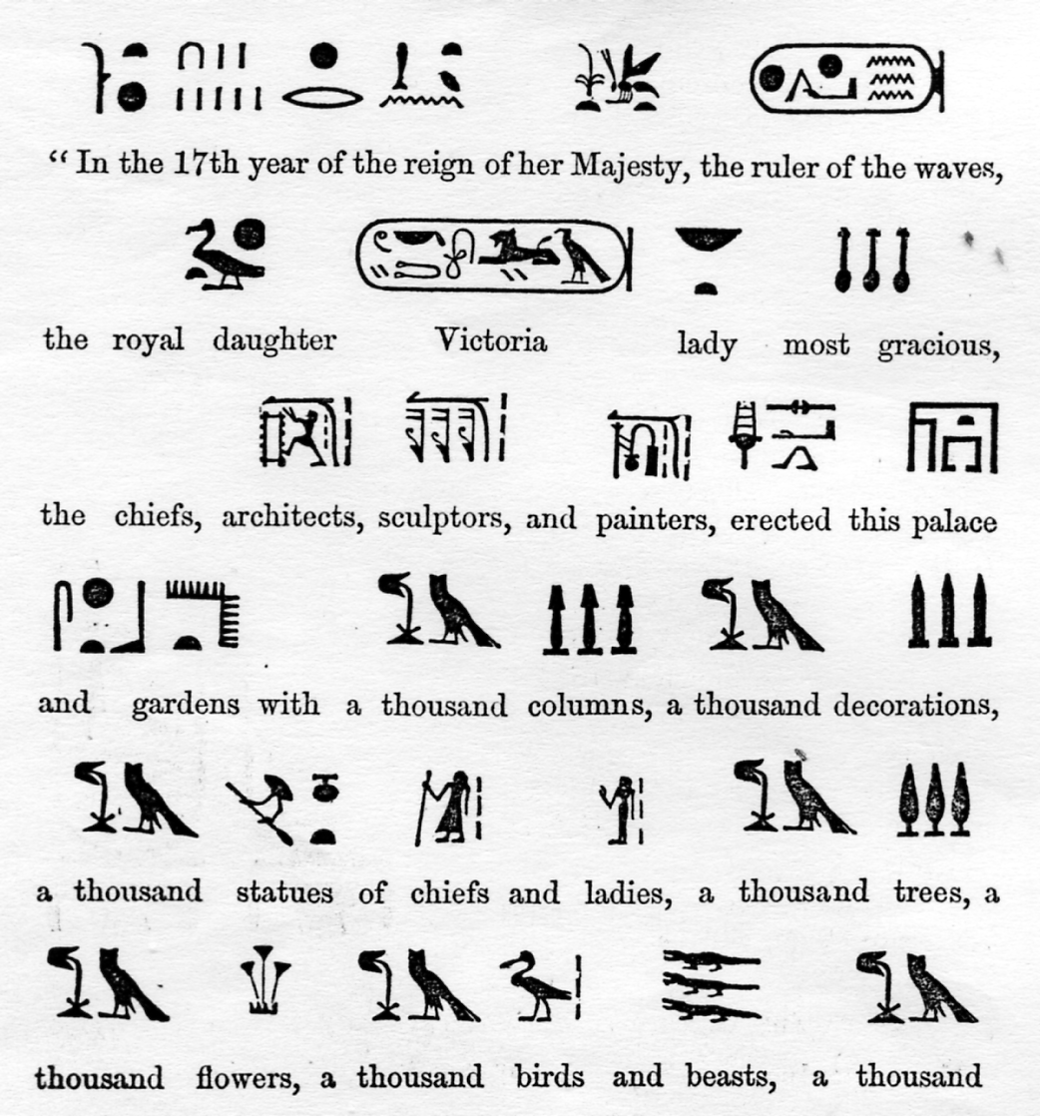
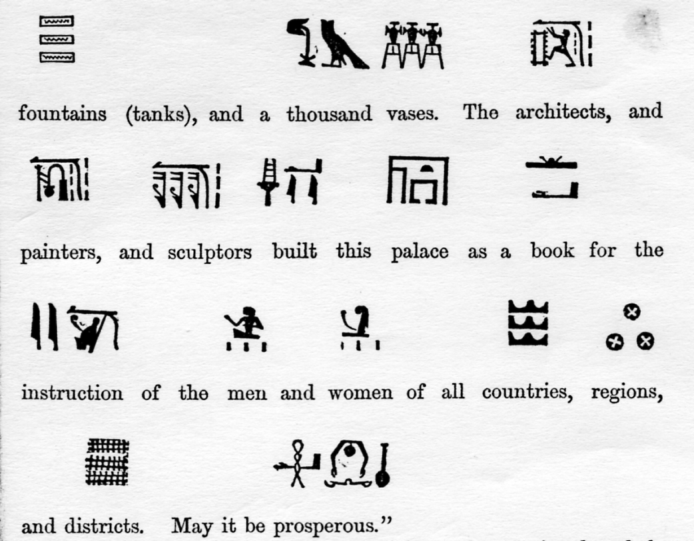
Translation of the hieroglyphics in the Egyptian Court at the Crystal Palace
Forming and Parting with a Collection
by
Alan Sabey

It was in 1974, after seeing a small exhibition, consisting mainly of postcards and souvenirs given to the Wembley History Society, that I decided to collect the philately and postal history of the British Empire Exhibition 1924 /1925.
My next step was to visit Harris Publications, then in Maiden Lane, London, to see if anything had already been published on this subject. I was pleased to buy a copy of “Wembley and Olympic Issues” by Bill Stitt-Dibden. I had no idea that there was so much to it but guessed that there had to be more. I went to the Post Office Archives, then in St. Martins-le-Grand, London hoping to find files that would give me details of all the British slogans for the Exhibition itself and its associated special events, all of which was publicized through machine slogans on the mail. I was very disappointed that they did not have this information! I presume that files must have existed at the time but were not kept because they were regarded as of little interest. It then became necessary to find covers and see if the dates expanded those in the Stitt-Dibden book.
Not a lot more was known about the colonial side of the postal publicity and when Don and I came to write “The Lion Roars” in 1984, I was then a member of the Royal Philatelic Society, London and was able to look through various books in their Library to see what had already been discovered.
When I first began to collect in 1974., most people commented “its only two or four stamps” and there was little other interest in it. Thus I was on the first rung of the ladder with little opposition from other collectors. I let my collecting interests be known to the dealers and quite a number of items came my way. The collection had not quite blossomed into magnificence by 1995 when I was invited by Stanley Gibbons Ltd. to mount a display at Wembley on the start of their few years of holding stamp shows in the (now demolished) Exhibition Halls on the Wembley site of the British Empire Exhibition. 1995 marked the 75th anniversary of the second exhibition. Along side my display was another by Hassan Shaida who had deeper pockets that I, and his display contained some magnificent material that one usually only dreams of! Stanley Gibbons Ltd. allowed the Group to have a stand opposite the display and this was manned by several of us. It helped to give the Group some more publicity as well as giving my collection an airing.
Later Hassan sold his collection to a dealer who gave me first option of buying some of his magnificent items. To do this, I decided to sell my ordinary GB collection to that dealer and to add some money to that, to enable me to make the purchases.
One of the stamps that was offered to me was the famous Three Halfpenny imperforate stamp of 1925. It was a lot of money and I did not know its status. I told the dealer, who I knew very well, that if it went to the “Royal’s” Expert Committee and came back with a good certificate, then I would be interested. We really did not know what it was at that time. It could hardly be a Colour Trial as the same stamp dated 1924 had been issued the previous year. The Expert Committee puzzled for some time over it and then decided to consult the Collection of Her Majesty The Queen. In the Collection they discovered some Imprimatur (Proof) sheets signed on the back by a Post Office official. On both the 1924 and the 1925 sheets it was found that stamps were missing form position row 7, stamp 1. This 1925 stamp, although stuck down on card, fitted the space exactly and a drop of benzine on the stamp revealed the rest of the signature from the sheet. I then made arrangements to buy the stamp which then became the key item in the collection and quite a talking point in philatelic circles. I was now in a position to re-enter competitive philately in the very late 1990’s. On 22nd April 1999 I was invited to put on a full 52 frame display to the Royal Philatelic Society London. This was the day before the 75th anniversary of the 1924 issue, a most appropriate date and the meeting was well attended.
I had decided to submit an entry in Stamp Show 2000 at Earls Court and it takes quite a long time preparing a five frame display specially for an exhibit. I thought 1 had got the balance right but was disappointed to hear that it did not get an International Gold as I expected. It was awarded an International Large Vermeil medal and the reason was that I had not shown the correct use of the 1925 Three Halfpence postcard intended for use to addresses abroad. I was sickened because I had three of them! I decided to enter the exhibition in Brussels in 2001. Being at International level, I was obliged to increase the exhibit from five to eight frames each with 16 sheets. I did some quick calculations before I submitted the application forms and found that I could manage it. Most of the sheets for the five original frames could be re-used so a great deal of rewriting was not necessary. The application was accepted and I was pleased to find my efforts had finally been recognized by the award of a Gold medal with 92 marks out of 100 and Felicitations for Research. I had set out to prove that an issue dating from 1924 in the 20th Century could be accepted as collectable. For a good many years, the judges only regarded Victorian stamps as collectable, everything later was regarded as being “too modem”.
That Gold medal at International level changed all that. Unfortunately those who tried the same thing with the 1929 Postal Union Congress issue and the 1935 Silver Jubilee issue were not so successful. However those who collected the High Values of King Edward VII and the first issues of the reign of the philatelist King, George V saw their efforts recognized.
Having been awarded a Gold medal 1 had achieved what I set out to do and as 1 am not one for a drawer full of medals, my collection of the British Empire Exhibition went into hibernation. There was little else I could add to it.
It had been my main philatelic interest since 1974 especially in the later years and I was very reluctant to part with it. I began to realize that when people of my generation die out, it would be unlikely that there would be younger collectors to continue. The collection had been showed to a number of philatelic societies up and down the country.
After a great deal of heart searching and a lot of “shall I, shalln’t I?” I decided that the Great Britain part of the collection would go into auction. I decided that a London auction house was the appropriate place and I had also realized that Grosvenor got good realizations and it was a “collector's auction house” where collectors had a good chance of finding items for their collections.
I did not want to sell the collection to a dealer but wanted to give all collectors equal opportunity of getting something. Once I had made that difficult decision to part with that part of the collection, I felt easier. I decided against including the Empire countries advertising and the Cinderella items as I thought that I could use these along with a few selected items from the British section, in a thematic or social philately collection about the British Empire Exhibition itself rather than the postage stamps issued to mark it.
It finally came home to me that it had gone when I collected the few unsold items and, of course, the cheque. My interest in Wembley has not diminished as I still look for printed ephemera but there are a lot of other collectors also interested since the publication of “The Lion Roars at Wembley” and the displays at Stamp ‘95 and to the Royal Philatelic Society London in 1999 also at Earls Court in 2000.
I have not forgotten exhibitions by any means because I have now decided to collect the various overprints in the Malaysian region for the 1922 Malaya-Borneo Exhibition, which was basically a trade exhibition timed to coincide with the visit to Malaysia in 1922 by the then Prince of Wales (later King Edward VIII / The Duke of Windsor).
Good luck to all who sail the Wembley ship.

Catering at the Crystal Palace Part 2
By
Fred Peskett

In Journal Number 85 I described the catering arrangements at the Crystal Palace, by a strange coincidence I have now acquired a small hoard of ephemera relating to “Bertram” one of the catering firms associated with the Palace during the 1800’s. The “Bertram” name had a long period at the Crystal Palace, from 1867 to 1872, 1878 to 1887 it was Bertram & Roberts, then Bertram & Company 1888 to 1892 and finally Bertram & Sons Ltd. 1893 to 1898. Sometime in 1898 the contract went to Joseph Lyons & Co. Ltd. who held the contract until 1923 including an Admiralty contract during the period of occupation of the Crystal Palace by the Royal Naval Division (1914-1919). Mecca Cafes took over the contract in 1923 and were still there until the fire in 1936 left no further demand for cups of tea and fruit buns. (From the list of stores kept under the Palace including the vast amount of alcohol it is no wonder the fire was so intense.)

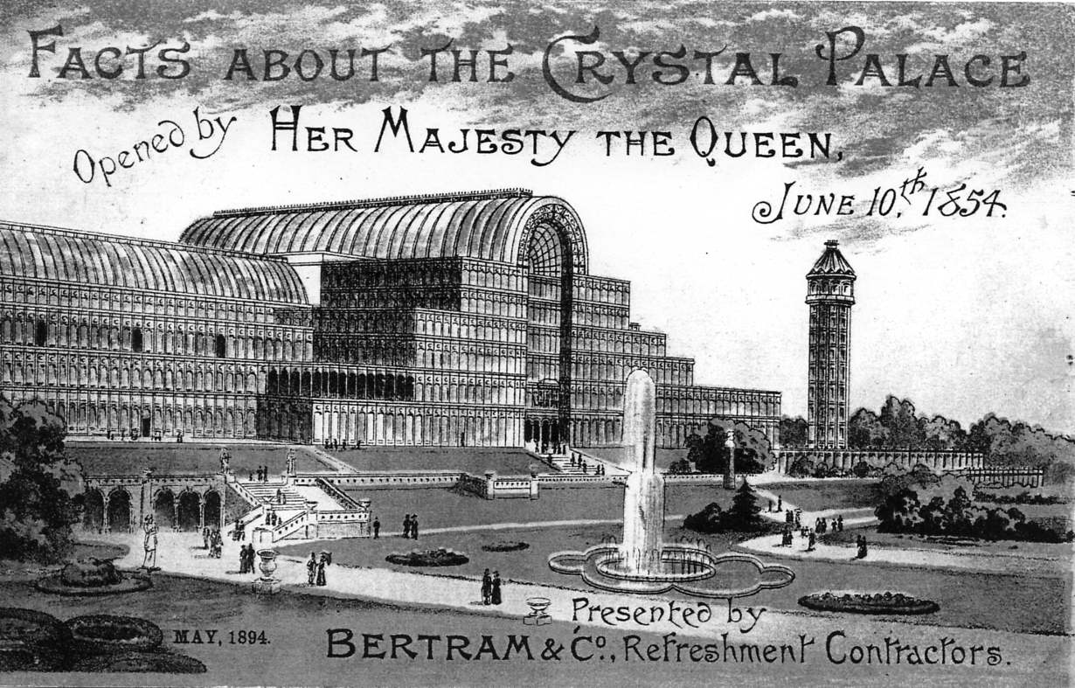

Coloured Booklet by Bertram & Co., detailing the catering services

The items of ephemera in the collection are:-
1. A booklet outlining the catering facilities offered at the Crystal Palace by Bertram & Roberts
(1867-1872) this booklet being the 19th edition is dated to 1871. The cover is mauve and cream on a blue background.

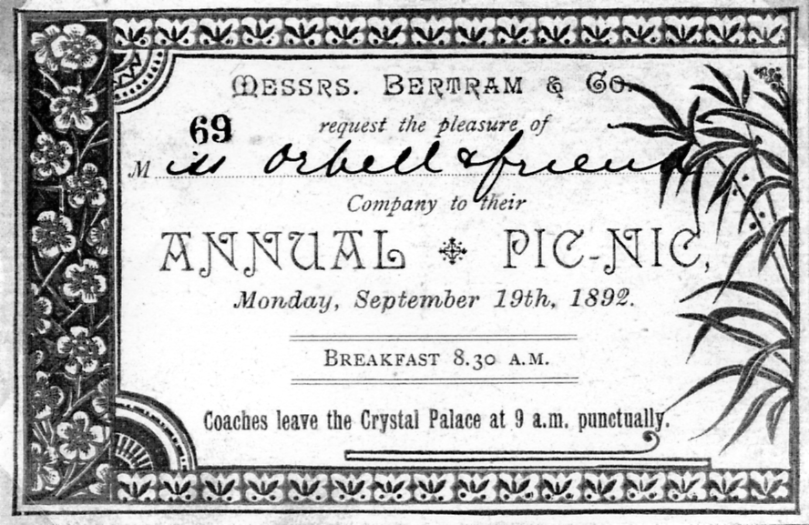

Invitation card for Bertram & Company Annual Pic-Nic

2. Two Bertram & Company envelopes with embossed back flaps.
a. A white envelope with a dark brown embossed seal of “B & Co., Refreshment Department
Crystal Palace” on a triangular flap, dated 1888.
b. A buff envelope with the same embossing but in light brown on a curved flap and is dated
1892.
3 Two invitation cards for Bertram & Company Annual Pic-Nic for Monday September 19th
1892.
a Purple and gold printing on a pink background.
b Green and gold printing on a light green background. The significance of the different
colours is not known, however, in Victorian times they may well have been used to segregate gender or status? The names on the invitation cards suggest that they were Bertram & Company employees, in fact in this “hoard” is a Crystal Palace Daily Programme for September 13th 1889 with details of the Bertram & Co. Athletics Day at the Crystal Palace Cricket Ground. A Miss J. Orbell (green card) competes in the Egg and Ladle Race and the Three Legged Race. While a Mr. A. Constable is in the 200 yards Handicap and the 150 yards Flat Race for men over 13 stone!
4. Coloured Booklet by Bertram & Co., dated May 1894 detailing the catering services and
facts about the Crystal Palace.
5. Folded Leaflet by Bertram & Sons Ltd., dated January 1897 with details of the charges for
School Treats and Bean feasts. From a historical point, the black and white engraving of the Crystal Palace features the North Transept which was destroyed by fire in 1866 and never rebuilt! For the School Treats the charge per person for parties from 500 to 1,000 was 6d (2½p) for a “Large cup of tea, a Roll, Butter, and a Piece of Cake” A glass of milk or draught ginger beer was an extra penny.

The Festival of Empire Exhibition and Pageant of London
Crystal Palace 1911
by
Fred Peskett

The Children’s Day

On the 30th June 1911. The King and Queen visited the Festival of Empire Exhibition as part of their Coronation celebrations. 100,000 children, selected from all the London Boroughs were invited to the Crystal Palace to see the Royal visitors. The Railway companies provided 96 trains to take the children to the Palace. The London, Dover and Chatham Railway terminated at the Crystal Palace High Level Station which represented quite a logistical problem, since each train once vacated had to have the locomotive turned, re-connected and taken to sidings to be parked ready for the return journey, never-the-less, the turn round time was accomplished within an average of six minutes. The London, Brighton and South Coast Railway being a through station was somewhat easier.
Of the 100,000 children, only 25,000 were selected to line up on the roads to view the Royal procession, the rest watched from wherever possible, or most likely went off to ride on the Joy Wheel, The Flying Machine, The Water Chute or the many other attractions the Palace grounds had to offer, including Scenes from the Pageant of London. Each of the 100,000 children were given a special commemorative china beaker made by Royal Doulton, and a packed lunch in a special paper bag with a commemorative paper napkin provided by the catering contractor at that time J. Lyons & Company. The commemorative beaker turns up quite frequently but the bag and napkin are very rare!
After the festivities the assembly of the children for the return journey to board the right train was achieved by a colour coded panel on each train which matched the same colours worn by each child. The boys wore a combination of a coloured cap together with a different colour patch on their jackets, some also had a letter stenciled on the patch. The girls had different colour bonnets with contrasting bands of ribbon around the brim, they also wore colour patches on their dresses. As far as it is known there were no instances of children being stranded at the Palace.
The ferrying of children to and from the Crystal Palace must have been well rehearsed, since a snippet from a magazine for the performers at the Pageant, “Festival Notes” number 2, April 1911 reads:-
“The King's Little Guests”

“The statement that those children who go to the rehearsals of the Pageant of London will not be invited to the King's Coronation Party at the Festival of Empire at the Crystal Palace is not correct. It has been arranged to take 400,000 school children of London and surrounding districts to sixteen full dress rehearsals of the Pageant which will be held from May 8th to June 2nd. These parties have nothing whatever to do with the selection of 100,000 children who will be His Majesty's guests on June 30th. The Pageant parties will be made up by the various schools while the Coronation party will be chosen by a committee appointed by His Majesty, and there is no reason whatever why some children should not take part in both functions”.

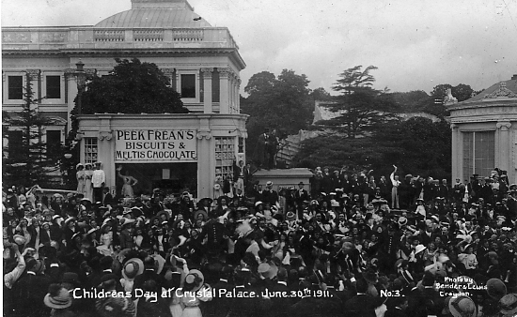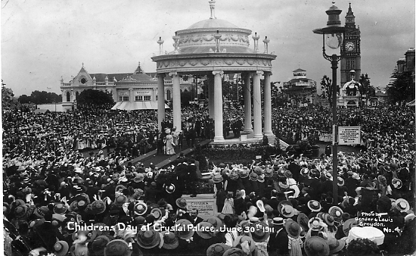

Post card publishers Bemrose and Campbell Gray recorded “The Children's Day” for posterity. Bemrose issued four cards from photographs by Bender & Lewis of Croydon, serial numbered 1 to 4. and two cards in their long “Official” Festival of Empire Series numbers 44 and 45.
Campbell Gray published at least two cards, numbers 327C and 327F but there could be another four or more if they are identified by 327A et seq.
The Daily Mirror for 30th June 1911 outlines the plan for the day to meet the new King & Queen at the Crystal Palace.
1. The 100,000 children invited were aged twelve and upwards.
2. The General Public were not permitted to enter the Crystal Palace or Grounds on the 30th
June even those holding season tickets.
3. There were no trains to the Crystal Palace for the General Public on that day and 20 suburban
stations were closed. The first train for the children arrived at the Palace at 10.30am and the last train was to leave at 8.15pm.
4. The 100,000 children were formed into nine divisions each of 11,111. The number of
teachers, nurses and supervisors for the children was 6,000.
5. 60,000 children were invited to see the Masque of Empire.
6. There were 130 van loads of refreshments delivered to include 100,000 each of bottles of
lemonade, buns, cakes, fruit and chocolate.
7. The King & Queen arrived at the Crystal Palace at 3pm and departed at 4.15pm.
8. A special viewing platform was erected for the Royal Party on Empire Avenue and a special
carpet was made measuring 24ft x 14ft. The carpet had been ordered for special occasions before the Coronation and was made by Ameer Sheer Ali from Afganistan, it took four years to weave.
9. The special Coronation beakers made for the event by Royal Doulton used twenty-two tons
of a special clay and were cast in ivory porcelain with copper-plate transfers of the King & Queen. The beakers were not presented on the day, but delivered to the various schools the following week for presentation to those children who attended the event.
10. The Daily Mirror readers subscribed £17-13-6d to a fund set up by the newspaper to provide
boots and clothing for 45 poor children who had neither shoes or decent clothes, only the poorest and most deserving children were selected.
11. From 4.30pm all the amusements at the Crystal Palace were free to the children for the rest
of the day until 8pm.
For many of the children perhaps a ride on the “All Red Route” Railway would have been one of the highlights of the day at the Crystal Palace. This was a train journey through the Dominions, so named after the colour red being used on maps and globes of the world to show the extent of the British Empire.
The railway was a circular track through the Empire Exhibition of some one and a half miles with a service running every two minutes by ten observation cars. On each train there were guides to explain details and objects of interest en route. The tour visited Newfoundland, Canada, Jamaica, Malay States, India, Australia, New Zealand and South Africa. The round trip took twenty minutes, however, each Dominion had a station where one could alight and view the pavilions and scenery at leisure.
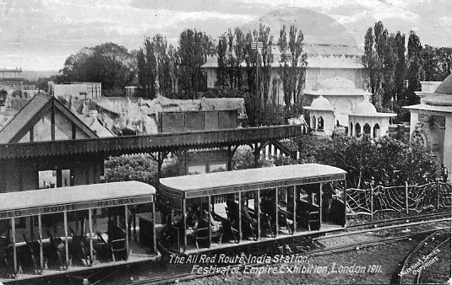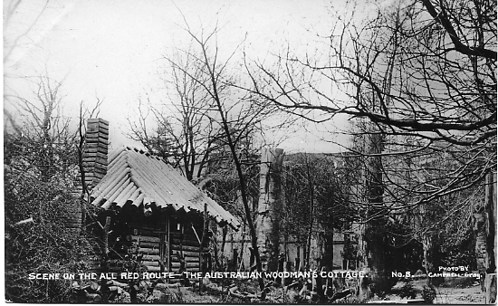

The Red Train at India Station Australian Woodman’s cabin

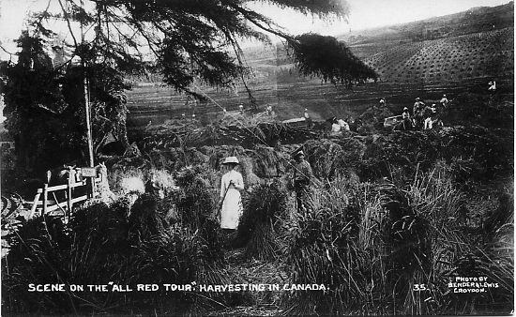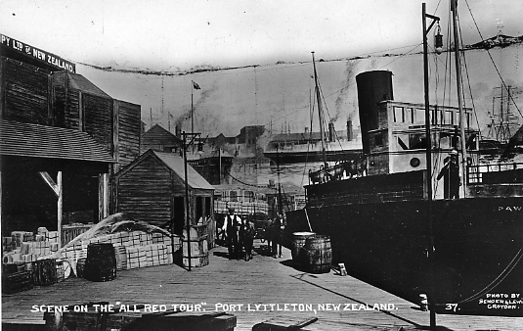

Canada New Zealand

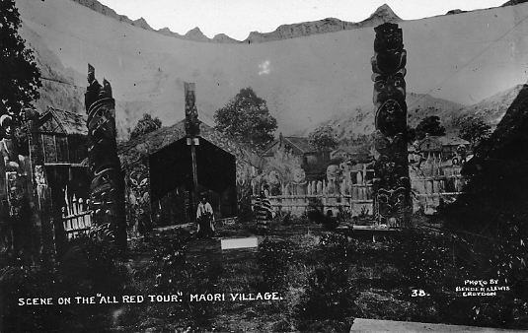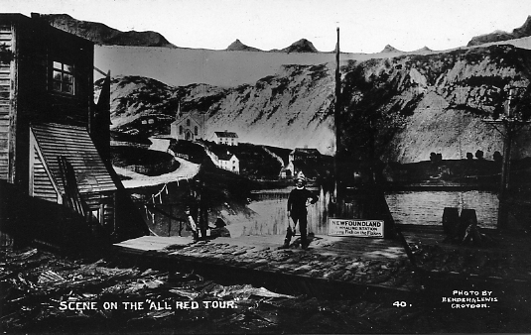

Maori Village Newfoundland

Many of the buildings and most of the scenery on the All Red Route were constructed from fibrous plaster on a strong form of canvas known as “skrim”. Some 1,500 men were employed during the construction which cost around £60,000. The material used was obviously very durable since some of the buildings were finally demolished during 1956! The trains were powered by electricity which also was used for the night illumination of the pavilions and set pieces. A new Power-House with generators was erected at a cost of £30,000 and 15 miles of electric cables installed for the railway and buildings, 75,000 lamps each of 16 candle power and 200 arc lamps were added to the myriad of gas and electric lamps already in use in the Crystal Palace grounds.
The Guide Book gives the visitor a preview of what there was to see. Tickets are taken at the Pageant entrance station. Here the visitors board a magnificently equipped Observation Car. The train runs along smoothly up and down inclines, and pulls up at the first stopping place-Newfoundland Station. Through a covered way, the exhibition building of our oldest Colony is entered, where a wonderful collection of exhibits, working models, sporting trophies etc. is on view. A complete paper making plant is also the object of interest in this section. Leaving the building, the train is rejoined and passes through picturesque Newfoundland scenery, with the town and harbour of St. John's in the distance. Then, rounding a rugged range of mountains-through a deep cutting-Canada is reached.
Canada. The first view obtained of this great Dominion is a vast stretch of forest land, with giant trees, and groups of men busily engaged in felling and clearing timber, and preparing the soil for the plough. Next, the eye rests on a great orchard farm, with men and women picking and packing the produce ready for export. Wide expanses of wheatlands are discerned, stretching as far as the vision can penetrate, with reaping and threshing machines in full operation. The visitor is next introduced to a large ranch, with cattle grazing down to the railway track. At this point the train enters a deep cutting, trestle bridges are crossed with rivers rushing below, and the train pulls up at the Canadian Station, adjoining the magnificent Ottawa Parliament Building-some 350 feet in length by 190 feet in width. In the interior of this noble building some idea of the wonderful development and resources of Canada may be obtained.
Jamaica. The harbour of Quebec slowly recedes in the distance and Jamaica is next entered. The passengers are borne through palm bearing lands into the very heart of a sugar plantation.
Malay Village. The next sight is a Malay Village and immediately the train passes on to India.
India. The first object of interest is a delightful view of Delhi. In the near distance are historical temples and a dense jungle in which a variety of animals are running wild. Then the most famous Himalaya mountains are shown, and again the interested visitor alights, and strolls through a typical Indian bazaar, in all its native colours and activity. An Indian Palace with wonderful inlaid gold and jewel work is next entered and inspected. Reluctantly leaving this beautiful building, the waiting train is entered once more, and passes through endless varieties of Indian scenery to the coast.
Australia. The fine harbour of Sydney, New South Wales, is next discerned, with the town illuminated, and reflected in the water, forming a picture charming in the extreme. The train enters the region of the famous Blue Mountains and passes through majestic panoramas, depicting the Commonwealth's scenery. The story of Australia's marvellous development is depicted en route. Pioneers are seen building their log cabins and clearing the surrounding bush. Then the result of their labour is shown, comfortable bungalows and prosperous farms. An extensive sheep farm is next visited, with shearing and dipping in active progress. Through vast plains the train proceeds, and fruit farms and vineyards are the next objectives, with men and women picking and preparing the fruit for shipment. Alighting at the Australian station, the visitor passes into the huge Parliament Building, where exhibits of the Commonwealth’s resources are displayed.
New Zealand. From Australia the passengers cross to New Zealand. At Nelson Docks a huge liner may be watched, taking on board a cargo of grain, wool and mutton. Opposite, a large building is shown in which the process of packing mutton ready for shipment to the Mother Country can be observed. A run through glorious mountain scenery is then made, among the sights being hot-water geysers, creating marvellous atmospheric effects, and a quaint Maori Village. A halt is made at the city of Wellington, to visit the replica of the Parliament Buildings, in which are displayed the productive and industrial resources of New Zealand.
South Africa. The passengers are now on the last stage of their wonderful trip. The train proceeds through the veldt, gold mines in full operation being passed. A view of a native kraal, with the process of leather dressing, is exhibited. Kimberley diamond mines in full work are visited, and then an ostrich farm. On arrival at the African station, the voyager enters the Parliament Building, where a varied display of the resources of the South African Dominion is exhibited.
A steep incline is negotiated, and the train at last deposits the visitor at the Pageant Station, after a 20 minute run through the Dominions Beyond the Seas".
The above description of the All Red Route is typical in its flowery presentation of the day. The space allocated for the Malay States and Jamaica leaves one to wonder if the author did not actually visit these areas or if he did, was not very impressed about them.
Bemrose, Campbell Gray, Millar & Lang, Rotary and Valentine all published post cards featuring scenes on the "All Red Route".

Post Cards of the White City
Part 40
by Bill Tonkin

Donaghmore Cross, Ballymaclinton, Franco-British Exhibition, London, 1908. two colleens, one seated by St. Patrick’s Cross, see under Ballymaclinton Cross, (M’Clinton’s Town erected by the Makers of M’Clinton’s Soap). No. 179.

A Dutch Love Story.
Although at first glance this does not appear to be an exhibition card, the series titled ‘A Dutch Love Story’ have the right type of back and are known with a Franco-British Exhibition cancellation.
Coloured, greenish grey ‘Artotype SOUVENIR POST CARD’ without divider, back type
FB 10.
A Dutch Love Story, Reconciliation.
N.n. Title in two lines at top left.
A Dutch Love Story, Tender Moments.
N.n. Title in two lines at bottom left. Vert left.

Valentine’s Franco-British Exhibition
Section E.

Eastern Lagoon, Franco-British Exhibition, London, 1908.
Coloured, red ‘F B seal’ back type FB 1.
272 Title in one line at top centre. Vert left.

Elite Gardens, Franco-British Exhibition, London, 1908.
Double width Panorama type card, from the back the right half has a printed post card back while the left half is blank.
B/W litho with ladder, grey ‘Throughout the World’ back type FB 2.
N.n. Title in one line at top right on the right half of the card, without ‘Valentine’s Series Copyright’.
For other cards of this type see under Panorama.
This must be one of the few examples where the right half of a double width card was published as a single card. In this instance half of the card was published as a normal sized post card, given the number 202 and titled ‘Garden Club’.

Elite Gardens, Franco-British Exhibition, London, 1908.
Coloured, red ‘F B seal’ back type FB 1.
220 Split title in two lines at top right. The gap between ‘Gardens’ and ‘Franco’ measures 56 mm.
220 Split title in two lines at top right. The gap between ‘Gardens’ and ‘Franco’ measures 8 mm, top and bottom edge rouletted.
Coloured ‘GIANT POST CARD’ grey ‘Throughout the World’ back type FB 17.
220 Title in one line at top left.
220 Title in one line at top right.
220 Title in two lines at top right.
For other large sized post cards see under Giant post cards.
Title altered to, Elite Gardens and Flip-Flap, Franco-British Exhibition, London, 1908.
B/W litho, black ‘Throughout the World’ back type FB 2.
N.n. Title in two lines at top left.
Title altered to, Flip-Flap from Elite Gardens, Franco-British Exhibition, London, 1908.
Sepia litho, black ‘Throughout the World’ back type FB 2.
N.n. Title in two lines at bottom right.
Title altered to, In Elite Gardens, Franco-British Exhibition, London, 1908.
B/W litho, black ‘Throughout the World’ back type FB 2.
N.n. Title in one line at top left.
N.n. Title in one line at bottom right, left edge rouletted.
B/W litho, grey ‘Throughout the World’ back type FB 2.
N.n. Title in two lines at bottom right, left edge rouletted.
B/W litho, greenish grey ‘Throughout the World’ back type FB 2.
N.n. Title in two lines at bottom right, left edge rouletted.
B/W litho, greenish grey ‘Throughout the World’ back type FB 2.
N.n. Title in one line at top left.
N.n. Title in one line at bottom right.
Note, In the litho printings different parts of the original negative was used. The flag at the top of the flip flap can be found at the top of the card or there can be a gap of up to 8 mm. This variation is not so great on the coloured cards.
Coloured, red ‘F B seal’ back type FB 1.
220 Split title in two lines at top right.
220 Split title in two lines at top right, top and bottom edge rouletted.
220 Title in three lines at top right.
220 Title in three lines at top right, left edge rouletted.
Coloured, dark grey ‘F B seal’ back type FB 1.
220 Split title in two lines at top right, left edge rouletted.
Coloured, brown ‘Throughout the World’ back type FB 2.
N.n. Split title in two lines at top right.
Coloured view in ornamental French and British flag border type FB Bo 4, red ‘F B seal’ back type FB 1.
N.n. Title in one line at top centre.
For other post cards with this border, see under Border FB Bo 4.
Sepia litho, black ‘Throughout the World’ back type FB 2.
N.n. Title in two lines at bottom right.
Sepia R/Photo, black ‘X L’ back type FB 11.
220 Title in one line at bottom centre in white border. This is one of the few cards Valentine’s published with borders in the Franco-British Exhibition range of cards.
Title altered to, The Flip-Flap from Elite Gardens, Franco-British Exhibition, London, 1908.
Sepia R/Photo, black ‘X L’ back type FB 11.
220 Title in two lines at bottom centre.
A. Bottom line of title measures 41 mm.
B. Bottom line of title measures 46 mm.
Note. The number, title and imprint have all been re-written, and there are many differences, the measurement of the bottom line of the title is mentioned because it is an easy one to describe.
For other post cards of this view see in The Great White City section, under ‘Elite Gardens’.

This card comes in two types, in the first there are two workmen one with a lawn mower, listed as ‘with lawn mower’ in the second type the men and lawn mower have been remover, listed as ‘without lawn mower’.
Elite Gardens, Franco-British Exhibition, London, 1908.
B/W litho with lawn mower, sunk plate with large white border, black ‘Throughout the World’ back type FB 2.
N.n. Split title in one line at bottom centre.
B/W litho with lawn mower, sunk plate with large white border, greenish grey ‘Throughout the World’ back type FB 2.
N.n. Split title in one line at bottom centre.
B/W litho with lawn mower, black ‘Throughout the World’ back type FB 2.
N.n. Title in two lines at bottom right.
B/W litho with lawn mower, greenish grey ‘Throughout the World’ back type FB 2.
N.n. Title in two lines at bottom right.
Coloured without lawn mower, red ‘F B seal’ back type FB 1.
241 Title in one line at top right.

Elite Gardens, Franco-British Exhibition, Xmas 1908.
Sepia litho view in coloured Christmas Card border type FB Bo 2d, red ‘F B seal’ back type FB 1.
467 Title in one line at bottom centre.
For other cards of this series see under Border FB Bo 2.
For other post cards of this view see in The Great White City section, under ‘Elite Gardens’, the Imperial International Exhibition section, under ‘Elite Gardens’ and the Japan-British Exhibition section, under ‘Elite Gardens’.

Elite Gardens and Flip-Flap, Franco-British Exhibition, London, 1908. No. 220, see under Elite Gardens, Franco-British Exhibition, London, 1908. No. 220.

Elite Gardens and Flip-Flap, Franco-British Exhibition, London, 1908.
Coloured, red ‘F B seal’ back type FB 1.
372 Title in two lines at top right.
For other post cards of this view see in The Great White City section, under ‘Elite Gardens’.

Elite Gardens and Flip-Flap, Franco-British Exhibition, London, 1908.
Coloured ‘GIANT POST CARD’ grey ‘Throughout the World’ back type FB 17.
466 Title in one line at top left. Vert left.
For other large sized post cards see under Giant post cards.
Sepia R/Photo, black ‘X L’ back type FB 11.
466 Title in two lines at bottom centre. Vert right.
For other post cards of this view see in the Imperial International Exhibition section, under ‘Elite Gardens’.

