EDITORIAL SUMMER 2007

Wembley

Dirty days hath September, April, June and November.
February’s days are quite alright, (It only rained from morn till night).
All the rest have thirty one, Without a blessed gleam of sun.
And if any of them had two-and-thirty, They’d be just as wet and just as dirty.

Sent in by Alan Sabey from a Wembley post card.

I don’t know whether May is the Chinese month of the poem, but certainly May has brought in poems for the Journal from near and far. Three arrived within a few days of each other, and since they deal with exhibitions we have published them. May is of course a good month for exhibitions, starting with the Great Exhibition which opened on May 1st, as did the 1862 International Exhibition. The Health 1884, Inventions 1885, Liverpool and the Indian & Colonial both in 1886, all opened in May, as did both the German and the Royal Naval in 1891 and the Gardening and Forestry Exhibition in 1893. Right through to the Festival of Britain, May was the month to open an exhibition.
In March I drove up to York on my annual pilgrimage, and while readers may be aware I have not done a lot of fairs the last couple of years, I would not like to miss the York Post Card Fair. I did very well and finished up with 130 exhibition and missionary post cards. So not everything is going on E-bay, but a lot of the best cards certainly are.
I bumped into Jack Murray a new member but an old friend, at York, where we usually meet by chance once a year. He was able to let me have two of the largest Franco-British giant post cards I have ever seen, coloured, showing the Palace of British Applied Arts and the Court of Honour, they measure 11 x 8¾ inches and the instructions in the stamp box state ‘Address only ½d Stamp’. To get the same service today it would have to go as a large letter and cost 44p, in other words the cost has been multiplied by 211 times, or to put it another way, 211 post cards of this size could be sent in 1908 for the same cost of sending one today. That’s progress for you.
There is no doubt the post card fair scene is changing. A few years ago Cheltenham, Yeovil and York were the big three. Now Cheltenham has been priced out of the race course, the farm where Nancy and I have stayed since the late 1980’s when doing Cheltenham, has changed hands and no longer does bed and breakfast, and even the Colesbourne Inn where I used to eat is under new management. Nothing lasts for ever.
The Yeovil post card fair has moved to Shepton Mallet which is a good thing, as I hated the town of Yeovil, I could never find my way about, it was a nightmare. Also my accommodation in All-Weston changed hands as well. The post card fair at Shepton Mallet might be held in a venue that could be best described as a very large cow shed, but is never the less one of our biggest and best fairs now. It has the added advantage of being situated about half a mile from the home of two of our members, Ted and Ann Stevens, those who attend our convention will know them, and they very generously put me up for the fair.
In April the Study Group held its second committee meeting since it was formed, meeting at the Crystal Palace, which was fairly convenient for most of the committee. We met to discuss our 21st convention, and a letter from our secretary below will tell you of the treats in store. We have come a long way since Andrew Brooks in the first news letter asked the ten members for 75p for the year 1981 to cover the costs of duplicating and postage. Looking through that list of founder members, only Andrew Brooks, Graham Hall and Don Knight are still with us. I joined in the second wave of members who saw the notice of the forming of the Exhibition Study Group in the Picture Post Card Monthly.

The Editors
21st Exhibition Study Group Convention
on
Saturday 29th and Sunday 30th September2007

Dear member,

This year 2007 will be the Exhibition Study Group’s 21st Convention. Our 1st one was held at The White Lion in York, we had 15 members come to this. Over the years we have been to the Crystal Palace, Glasgow, Bradford, Wembley, Southsea and Hatfield. The numbers attending have always been around 20. You do not have to give up the whole weekend to support the convention, just come on the Saturday or Sunday.
We always have a varied group of displays by members, this year you will see early Great Britain Congress postmarks and Cinderella labels, Crystal Palace items, Cigarette cards from Wembley, and the Empire Exhibition 1938 along with others. Displays can be just 4 sheets up to 60, we have some very good collections put on display.
The Crystal Palace centre is served by trains from London, by car there is no problem in parking. It is on the site of the old Crystal Palace, with the foundations still to be seen. The cost of bed and breakfast is around £30, we have tea, coffee and biscuits morning and afternoon. Lunch time tea, coffee and sandwiches.
You can bring your doubles and sell to other members, this could mean your trip did not cost you much. If you live near to London please come for one of the days if you cannot manage the full weekend.
Because this years is our 21st Convention the meal and wine at our Annual Saturday Evening Dinner will be free to members.

I hope to see you on the 29th 30th September,

Don R. Knight
Hon Secretary.

There will probably be some members arriving on the Friday as I do, and we can have a get together at the ‘Paxton Arms’ across the road, or find a meal in the evening. Members wishing to stay can book by phone, but remember to mention you are part of the booking reserved for the Exhibition Study Group. The address is The Lodge. Crystal Palace National Sports Centre. Ledrington Road, London. SE19 2BB and the phone number is 020 8778 0131. Ask for Joan Miles. Please let Don Knight at 2, Crescent Rd, New Barnet, Herts. EN4 9RF or Tel. 020 8440 3574. know if you are coming, and if you are bringing a display. The Lodge is divided into units of one single and one double room with a shared W.C. and shower between them for each unit. So each room is 50% en-suite, with plenty of single rooms, which is not usually the case in hotels. The facilities are not shared by any of the other units. Last year was the first year we have stayed at the Lodge and it was decided to book there for this year and probably 2008. Everybody agreed the meal was first class.
Any members who have not attended one of our conventions at Crystal Palace and is not sure how to get there, if they like to drop me a line I will send them a map of the 200 acre grounds showing where the Lodge and our meetings will take place.

The First Of May 1851.
by
Anna Harriet typed by Fred Peskett

Once in a while some hidden little gem comes to light. At a recent Antiques Fair at Wickham, Hants, I came across a little book ‘THE FIRST OF MAY’ (A Ballad) by Anna Harriet Drury, it wasn't until I saw a small 1851 at the bottom of the cover that I realized that it could be a Great Exhibition publication, and indeed it was! For the time the ‘Poem’ is informative, witty, and in places, downright sarcastic. Here it is in full.

Prince Albert of Saxe-Coburg, by the Cinque Ports he swore,
He'd make an Exhibition, that was never seen before,
By the Cinque Ports he swore it, and named the opening day,
And letters wrote to left and right, to bid the universe unite, upon the First of May.

Left and right the letters went, to city, realm and coast,
And answers came most civilly, by the return of post,
Shame on the lazy Nation, that will not join in her share,
With Albert and Britannia, to swell the World’s Great Fair.

The parcels and the packages, come bundling in amain,
By many a creaking wagon; by many a flying train,
By many a van of Pickford’s, that filled with ponderous care,
Makes every passer by exclaim, “Good gracious, just look there”.

From autocratic Russia, where growls the unctuous Bear,
Who covers native Poles with grief, and British polls with hair,
From France, the land of elegance, and witty elocution,
Whose clever hands make all things well, except a constitution.

From the far-off Republic, on Transatlantic waves,
Who blazons stars of liberty, upon the stripes of slaves,
From where the Alpine snows surround, the workshops of the free,
From where in fettered sadness burns, the muse of Italy.

The Prince and the Commission, a weary life they led,
No time they had for dining, And rather less for bed,
They couldn’t choose a building, They couldn't find a site,
And our good Queen Victoria, grew tired-as well she might.

For good advice in pamphlets, and prophecies in calf,
And groans to make him shudder, and sneers to make him laugh,
And hints and threats and warnings, plan, diagram and view,
Choked up the Prince’s davenport, and filled his pockets too.

“To eastward and to westward” twas said, “alarm is spreading”
“The foreigners will eat us out of house and home and bedding”
“Taxation will be trebled” and sadder far to tell,
“Thanks to the horrid papers, the tickets will not sell”.

I wish in all the Palace, there was no heart so bold,
But wished himself well out of it, when that ill news was told,
Up rose at length Prince Albert, up rose the whole Commission,
And at the footstool of the throne, they laid the Exhibition.

Just then burst in a messenger, with cold sweat on his brow,
Look here, look here, my gracious Prince, “They say there'll be a row”
Upon the fatal newspaper, Prince Albert turned his eye,
And saw a night of wretchedness, darken his sunny sky.

And plainly and more plainly, in history's page he read,
The gibes and jeers and sarcasm’s, heaped on his luckless head,
And the stigma of ridiculous, more terrible than guilt,
Stamped by unborn Macaulays, on “the House that Albert built”.

And plainly and more plainly, He heard the words of doom,
When all the year’s expenses, are checked by Joseph Hume,
And the outcry of the journals, and the angry people's hisses,
And his loving consort's mild reproof, “You know whose doing this is”.

And the Prince’s voice was sad, and dim his eyes of blue,
“It’s come to this, my gracious wife, We don't know what to do”
“There’ not a soul contented, the tickets will not sell”,
“And now the papers prophesy, such things I fear to tell”.

“The French will spoil our morals. the Russians cheat and knout us”,
They'll haunt us like mosquitoes, like snakes they’ll twine about us,
The Chartist and the Communist, will hand in hand combine,
“And break the Crystal Palace, about your head and mine”.

Then out spake Queen Victoria, and brightly glanced her eye,
“I never heard such nonsense, I only wish they'd try”,
Don't mind those vile reports dear, “Twill all come right, you'll see”,
“Just keep the workmen moving”, and leave the rest to me.

There'll be some foolish people there, indeed, where are there not?
Perhaps they'll throw a stone or two, or fire a little shot,
They never hit me yet, dear, except upon my bonnet,
So don't persuade me not to go, I’ve set my heart upon it.

Unpack the parcels, gentlemen, as quickly as ye may,
Tell all your foreign colleagues, I’ll hear of no delay,
Though foemen league in millions, we’ll charm away their malice,
And walk together, arm in arm, right through the Crystal Palace.

“My heart of hearts”, the Prince replied, “You talk just like a book”,
And the relieved Commissioners, cheered till the throne-room shook,
And through the streets of London, fast, fast, the news was borne,
And strange was the commotion, upon the morrow morn.

Then all were wild to go,
Then did the ticket offices, with claimants overflow,
And every British lady, spared neither rhyme nor reason,
To wring from consort or from sire, a ticket for the season.

Bright are the silks and satins, that gleam in Howell’s panes,
Matchless the lace of Hayward, The ribbon at Redmayne’s,
That mortal ever wore; best of all a young bride loves a Continental tour,
I'll order out the carriage, my royal robes I’ll wear.

And though the crowd be millions deep,
No matter, I'll be there,
And in the face of rough John Bull, what e’r he means to do,
I'll smile until he smiles again, and gives a cheer for you.

But now, o’er Howell's counter, no fairy buyers lean,
No snowy fingers test the lace, or ribbons blue and green,
In vain are Melnotte’s prices, raised up to three-and-three,
And vainly advertises, The Steamboat Company.

This year no golden harvest, shall prima donnas reap,
This year no Baden Croupier, shall shear the traveling sheep,
And the landladies of Brighton, shall wail o’er cliff and down,
Those cruel season tickets, that keep the world in town.

But meanwhile preparations, are briskly carried on,
And agonized exhibitors, are told they must begone,
The floor is swept and sprinkled, the panes are polished bright,
And all that isn’t finished, is hustled out of sight.

Then come the season tickets, in carriage, cab and brougham,
And long before eleven, there is scarcely standing room,
And as at every instant, the ladies ranks increase,
Pretty to see the skirmishes, they have with the police.

But lo, the cry is “Paxton” and as the waves divide,
The Architect of crystal, comes forth with modest pride,
Well may all voices cheer him, when they see what he has done,
For such a graceful victory, no mortal ever won.

Now Statesmen and Ambassadors, from all the globe flock in,
And that warm-hearted gentleman, the Chinese Mandarin,
And with his gallant comrade, the first in dangers van,
Comes England's white-haired Hero, to welcome PEACE TO MAN.

But when the face of Arthur, is seen amid the throng,
A cheer that shakes the crystal roof, bursts forth the ranks among,
On benches smiles no beauty, but would his hand have kissed,
For the fairest lip were honoured, to touch that brown old fist.

And when weak-minded foreigners, ask what it's all about,
With what enthusiastic pride, all haste to point him out,
“Now, welcome, welcome, Arthur” the greetings still increase,
Thrice welcome on thy birthday morn, to the Waterloo of Peace.

Since five o’clock this morning, nay, some have said, before,
The folks have been collecting, by myriad’s and more,
Frantically strive officials, to keep the passage free,
As well might Brighton lobsters, attempt to stop the sea.

For like a herd scholastic, let loose from desk and form,
John Bull and all his family, carry the Park by storm,
From Palace e’en to Palace, can only heads be seen,
That pushing past, in wild career, Policeman, Guardsman, Grenadier.

Rush on to meet the Queen, then round our good Victoria, as slowly on she past,
A hundred winged whispers, come floating thick and fast,
“What if these millions rise in arms?” think on the Bourbon’s fate,
“What if but one assail thee?” back ere it be too late.

Round gazed she, as not deigning, such fears to entertain,
Yes if indeed they hated her, then had she lived in vain,
For the people’s glow of welcome, is the Monarch’s purest gem,
And her heart was calm and confident, in its honest love for them.

“O England-gallant England” so tried-and yet so true,
You will not do your sovereign wrong, who trusts her all to you,
So she spake, and smiling showed, the young heir by her side,
And mid a thunder of applause, sailed through the living tide.

And now she gains the Transept, and now her royal throne,
Now burst the sweet young voices, and swells the organ’s tone,
Now with her Lord and children, and smiles of winning grace,
She passes through the joyous crowd, that all may see her face.

And that face will be remembered, to many a distant day,
When the glitter of the pageant, like a dream has passed away,
And the frankness and the kindliness, of that auspicious scene,
Shall link with all our better thoughts, our English-hearted Queen.

And in the homes of labour, when all have learnt to know,
The one sweet tie of brotherhood, God knit for man below,
When honest toil is resting, beside his quiet hearth,
And forgets the gloom of forge and loom, in his children's fearless mirth.

When the wrongs are all forgiven, and the law of kindness rules,
When the swords are turned to ploughshares, and the prisons into schools,
When the rich and poor together, flock to the House of Prayer,
And not a cloud of bitterness, disturbs the sunshine there.

When the actors in this pageant, have all been laid to rest,
And the youngest head among us, is white as Snowdon’s crest,
May that glad generation, recall this glorious day,
And Labour’s first Ovation, upon the First of May.

There are a couple of references in the verse that may need some explanation.
In verse 11, "stamped by unborn Macaulays" Thomas Babington Macaulay was a Liberal who
supported the Reform Bill in 1832, and advocated the admission of the general public to the exhibition on the 1/- days as soon as possible, (which was on the 26th May 1851)
In verse 12 "Are checked by John Hume Joseph John Hume was a Scottish Radical Member of
Parliament who championed Free-Trade and was always attacking the Government about rash spending. Including the amount spent on the Great Exhibition.
Verses 21 and 22. Howell's, Hayward's, Redmayne's and Melnotte's were all high class ladies fabric
and fashion houses in London.
Verse 23 "The Baden Croupier" refers to the common practice of cheating tourists at the gaming
tables of the Continental Casinos, hence:- "Shall shear the traveling sheep".
Verses 27,28,29. "England's white haired Hero and Arthur" refer to Arthur Wellesley, The Duke of
Wellington.
And from the same source comes the words from a song sheet published in 1900 for the Paris Exposition.
Away in gay Paree,
Across the silver sea.
They’ve got an Exposition,
We call Exhibition,
But we have got on view some Exhibitions too,
Just go by cheap excursion down to Hampton Court or Kew,
The car is full of girls and chaps,
Lounging on each other’s laps,
They look at you with a sort of air,
“What the deuce do you want there”,
But when a tunnel comes in sight,
You’re forgotton if there’s no light,
Then some curious sounds you catch,
Feeling alarmed you strike a match,
What you think cannot be proved,
Although you couldn’t swear they’ve moved,
You feel a strong suspicion,
Great fish-hooks, there’s an Exhibition.

Cut and Paste at the Franco-British Exhibition 1908.
by
Bill Tonkin

Valentine’s were past masters in the art of cutting and pasting, and it is one of the most interesting aspects of collecting post cards. As far as I know it has never been previously recorded in depth, and this is probable because of the skill with which it was done, that it has never even been suspected.
Back in 1908 Cut and Paste had a very different meaning to that of today. In 1908 they still had to wait for over a hundred and fifty years before computers could cut and paste in the blink of an eye. Then the cutting was done with a small pair of nail scissors and the paste came in pots.
When a publishers secured the sole concession to sell post cards at an exhibition, he needed to have plenty of post cards available on the opening day. This applied to all publishers for all exhibitions and other events of importance. In Valentine’s position once they had coped with the Franco-British Exhibition successfully they had a lot of material they could use in following years for White City and other exhibitions.
Some years ago while browsing through some White City cards in my collection, I noticed an elderly lady with two companions in a crowd scene holding a striped umbrella, as I looked at her I was sure I had seen her before, but where? Later I saw her again and was able to get the two cards together. One was a Franco-British card No. 285 Tunis Pavilion and the other was a Japan-British card No. 9 Temple Gate at Nara and there was the lady again, this time without her two companions. Examination of the later card showed that two years later the lady had been cut out from the 1908 scene and pasted onto a different 1910 background.
I do not collect foreign exhibition cards but when I noticed a 1910 Bruxelles Exposition card at a fair I could not resist buying it. There was my old lady again, coming up for the third time, with her two companions plus three other visitors from the Tunis Pavilion post card cut out as a group and pasted onto a Valentine’s Bruxelles Exposition back ground. From then on I started buying Belgian exhibition cards and came to realise that almost without exception all the recognisable visitors on the cards were cut from earlier British exhibition cards.
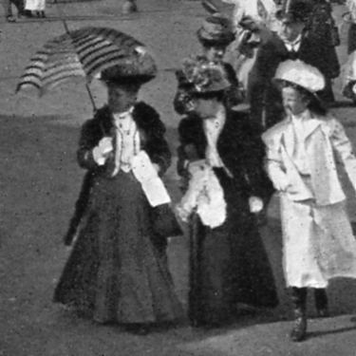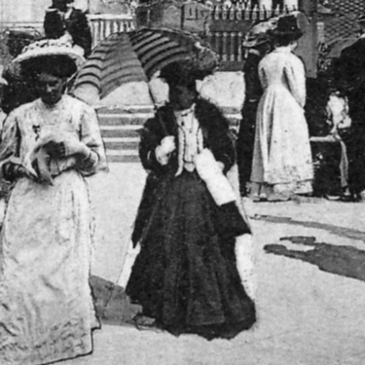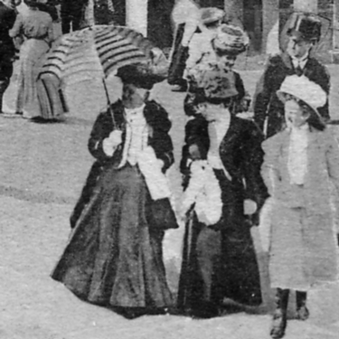
Fig. 1. No. 285 Fig. 2. No. 9. Fig. 3. No. 1007.
Franco-British Exhibition Japan-British Exhibition Bruxelles Exposition

The first picture Fig. 1. shows my old lady on post card No. 285 titled Tunis Pavilion, Franco-British Exhibition, London. 1908, on the second time of showing Fig. 2. she was by herself on post card No. 9 Temple Gate at Nara, Japan-British Exhibition 1910, the third time Valentine used her Fig. 3. was for a Belgian Exhibition, No. 1007 Exposition de Bruxelles 1910. Vue de l’Entrée Bruxelles Kermesse
Another visitor among the many hundreds featured on post cards that drew my attention was the man looking over his shoulder towards the camera on a 1909 Imperial International Exhibition card No. 566 titled the Flip Flap Fig. 4. He seemed to stick out and I remember seeing him before, just like the old lady with her umbrella, eventually I managed to match him up when I checked on some Crystal Palace cards. In 1911 Valentine published a card for the Festival of Empire Exhibition at the Crystal Palace taken before it opened, showing a part of the building site that was to be transformed into the Festival of Empire Exhibition Fig. 5. The photograph was taken when the pavilions were mere shells with the remains of what looks like a huge bonfire in the foreground.

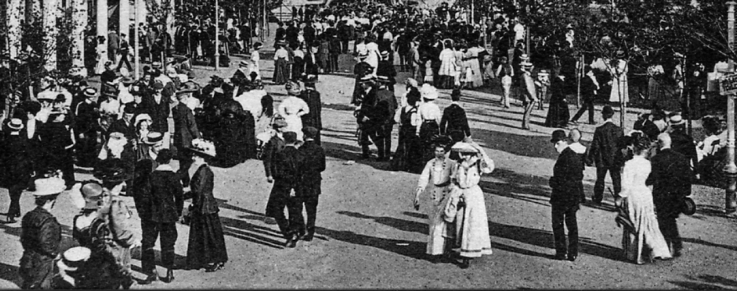
Fig. 4. No. 566 The Flip Flap. 1909 Imperial International Exhibition

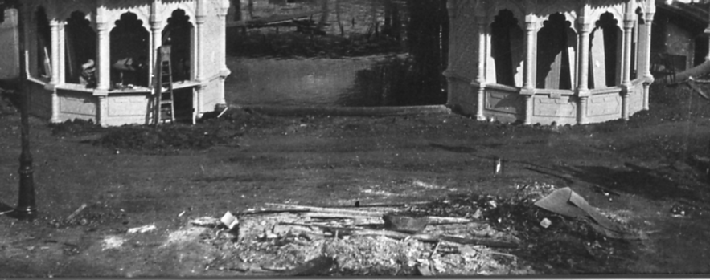
Fig. 5. Un-numbered Indian Pavilion. An unfinished building site at the Festival
of Empire, Crystal Palace in 1911

They later published the same card with the same title, but now with nearly thirty visitors including my man looking over his shoulder cut out from an Imperial International Exhibition card titled the Flip Flap pasted in. Even a small group of workmen were converted into visitors by adding a shiny top hat to one of them Fig. 6. Notice Valentine has even drawn in windows to the pavilions. They didn’t miss a trick.

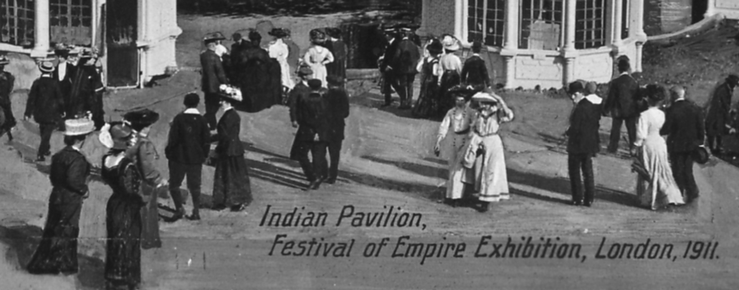
Fig. 6. Visitors at the Flip Flap cut and pasted onto the building site at the
Festival of Empire Exhibition at the Crystal Palace 1911.

It soon became obvious that this was a standard practice of Valentine’s and they were pasting cut out visitors from the White City all over the place. The 1910 Bruxelles Exposition, 1911 Glasgow Exhibition and the Festival of Empire held the same year at the Crystal Palace all had their quota of paste ups from 1908.
I decided that an in depth study of the visitors on Valentine’s post cards of the White City Exhibitions, the 1911 Glasgow Exhibition, The Festival of Empire at the Crystal Palace and the 1910 Belgian Exhibition was necessary, and the way forward was to scan every visitor that was large enough to be recognisable at those exhibitions. I finished up with over 600 scanned images of visitors, either as single persons or in groups, each one of which had to be numbered with a reference to the number and title of the post card it came from.. Then came the long slog, starting with image number one, this had to be checked with every other image looking for duplication, then number two had to be checked, and so on until every image had been checked with every other image. At least it was easier to check through pages of print outs, than continually sort through thousands of post cards.
At the end I was amazed to find that no less than 160 visitors had been cut out and pasted into other scenes, very often at different exhibitions, some visitors being used two or three times, and two ladies cut outs being used in four different settings.
Another cut and paste job where a large group of 27 people were cut from an un-numbered 1908 Franco-British Exhibition post card titled Canadian Pavilion, and pasted onto a scene at the 1911 Scottish Exhibition at Glasgow. And they say the camera cannot lie.

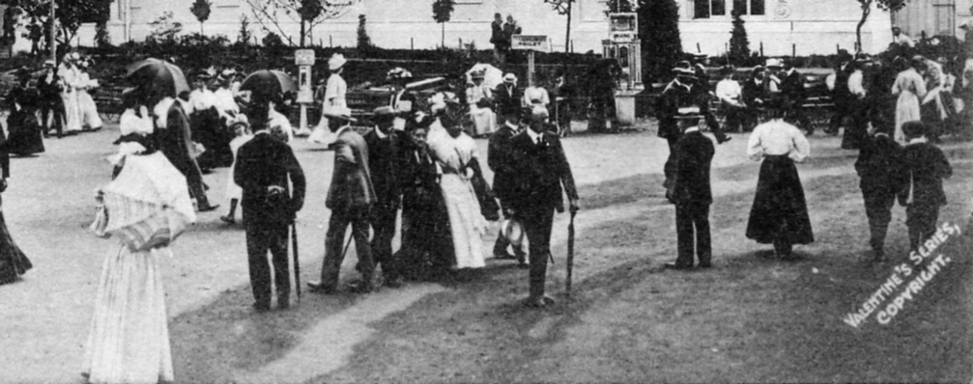
Fig. 7. Un-numbered card titled Canadian Pavilion, Franco-British Exhibition, London. 1908

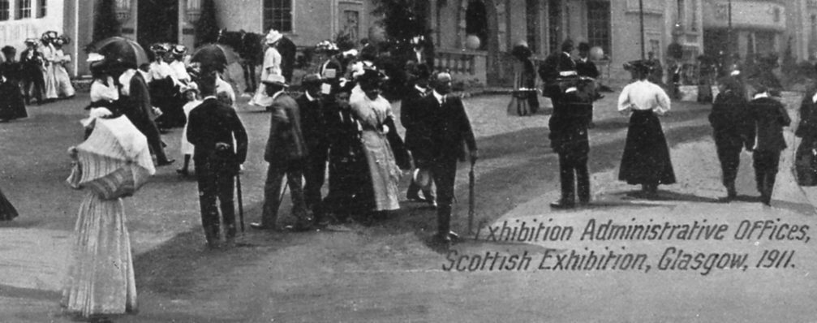
Fig. 8. Un-numbered card titled Exhibition Administration Offices, Scottish Exhibition
Glasgow 1911

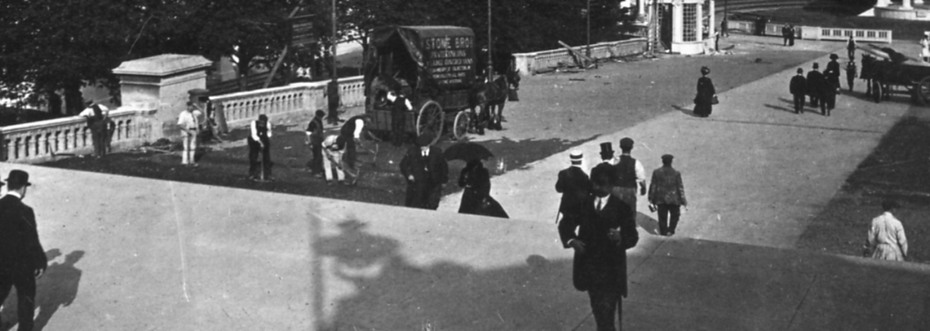
Fig. 9. South African and New Zealand Pavilions, 1911 Festival of Empire Exhibition. This post card published by Valentine was taken while work was still being carried out at the Crystal Palace, as the vans and workmen show.

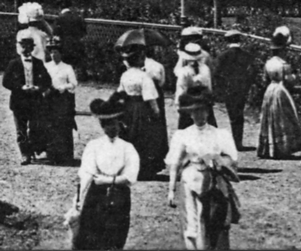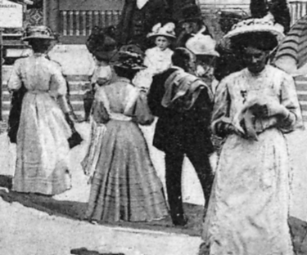
Fig. 10. Elite Gardens Fig. 11. Temple Gate at Nara

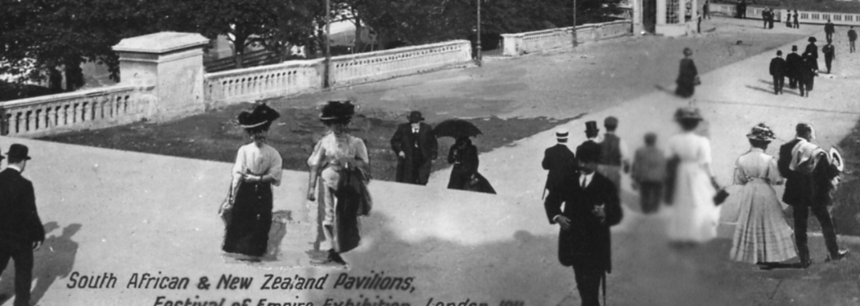
Fig. 12.

Two ladies in the foreground of an un-numbered card of the Elite Gardens at the Franco-British Exhibition Fig 10. and two ladies and a man from the Japan-British Exhibition card titled Temple Gate at Nara Fig. 11. were cut and pasted onto the Crystal Palace view Fig. 12. Valentine then took away the workmen and their carts, and we are left with a nice pleasant scene, that no one would ever guess has been doctored.

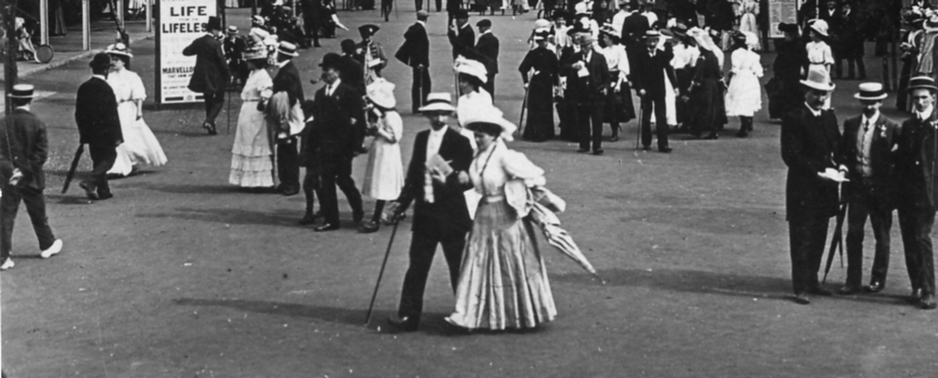
Fig. 13. No 142 The Flip-Flap

The visitors on a 1908 Franco-British post card No. 142 titled the Flip Flap Fig. 13. are probably the most cut and pasted of them all, the people turn up everywhere, sometimes as a whole group and sometimes split up into smaller groups. The man in the center with a white Panama hat and cane is easily recognised also the three men to the right, and the young man in white shoes striding out on the far left.
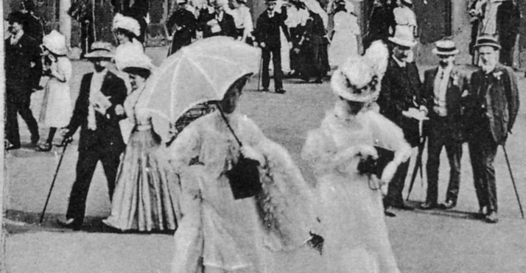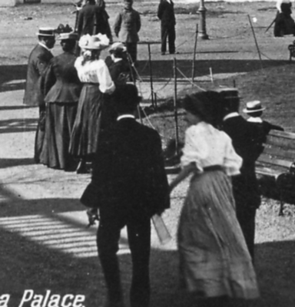
Fig. 14. Fig. 15.

Here he is again with the three men still at the right (as well as many of the small figures at the back) cut and pasted onto a 1910 Bruxelles Exposition card No 1011 titled Bruxelles Kermesse, le Marché Fig. 14. This card also had two ladies in white dresses taken from another 1908 White City card No. 437 View from Canadian Pavilion, inserted into the middle of the group (These two ladies crop up on several Belgian Exhibition cards). But we have lost the young man striding out on the left.

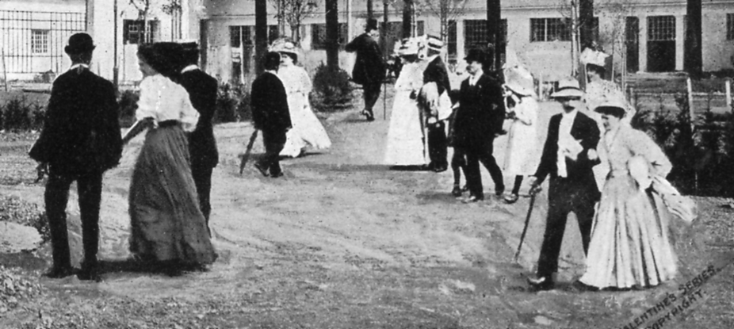
Fig. 16. No 1013 Section Allemande, Bruxelles Exposition 1910.

Part of the group was used on another 1910 Belgian exhibition card No. 1013 Section Allemande Fig. 16. without the three men, and our walker on the left is also missing. but it’s swings and roundabouts, with three additional larger than life sized people pasted in from No. 268 the Algerian Palace at the Franco-British Exhibition. Fig. 15.

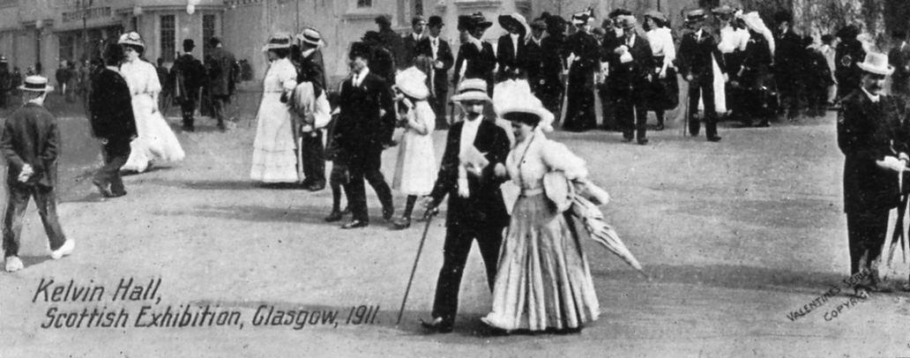
Fig. 17. card titled Kelvin Hall, Glasgow Exhibition, 1911.

And here’s our friend again for the last time with the rest of the crowd from the Franco-British Exhibition a year later, cut and pasted onto a 1911 Glasgow Exhibition card titled Kelvin Hall Fig. 17.

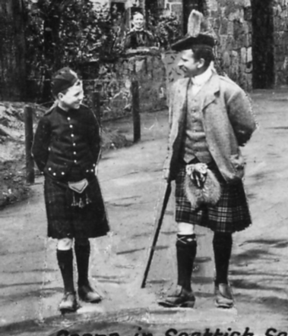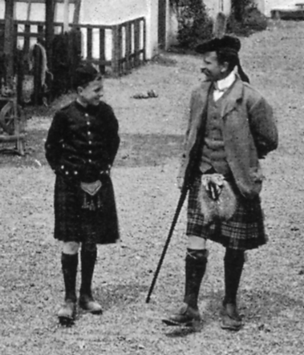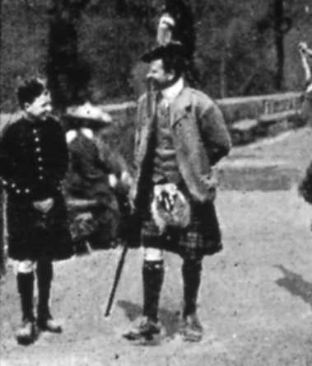
Fig. 18. No. 546 Fig. 19. No. 790 Fig. 20. N.n.

Another example of cut and pasting. The man and boy in kilts got around. The first picture is card No. 546 In Scottish Village, Imperial International Exhibition, 1909, the second No. 790 Scene in Scottish Section, Coronation Exhibition, London, 1911, and the third is not numbered and is titled An Clachan, the Highland Village, Scottish Exhibition Glasgow 1911.

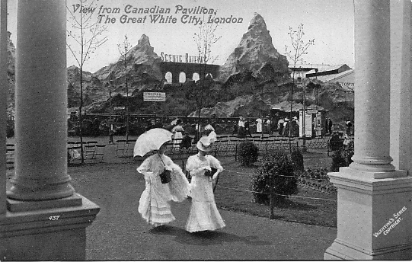
Fig. 21. No. 437 View from Canadian Pavilion, The Great White City, London.

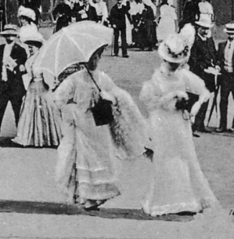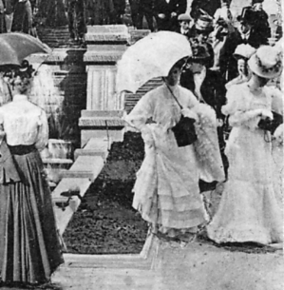
Fig. 22. No. 1010 Fig. 23. No. 1011

The two ladies featured on the above 1908 White City card Fig. 21. were cut and pasted onto two different Belgian exhibition cards in 1910. The first one No. 1010. titled Façade Principale, and the second one No. 1011. titled Bruxelles Kermesse, le Marché.

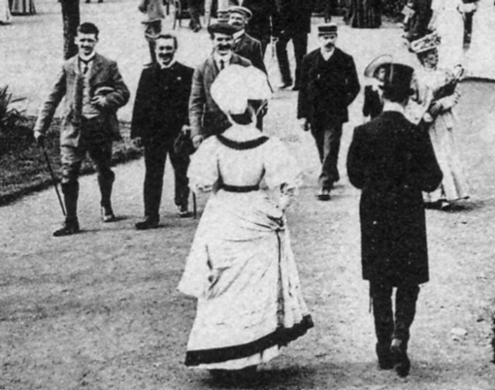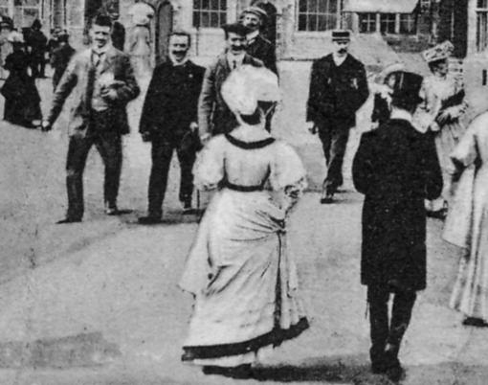
Fig. 24. No 430 Fig. 25. No. 1006

In No. 430 The Garden Club, Imperial International Exhibition, Fig. 24. the man on the far left is wearing nickerbocker trousers. When the group of people was cut and pasted onto a 1910 Belgian Exhibition card No. 1006. Une Rue dans Bruxelles Kermesse Fig. 25. Valentine’s artists took the opportunity to change his trousers for a pair more likely to be worn on the continent. Unfortunately while he was changing his trousers the poor chap had his walking stick pinched.

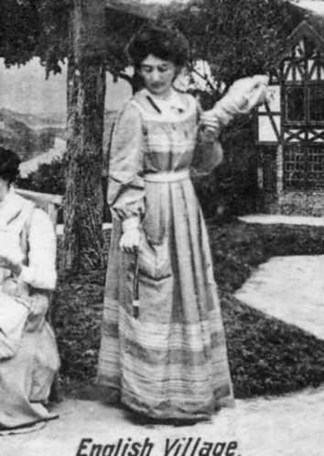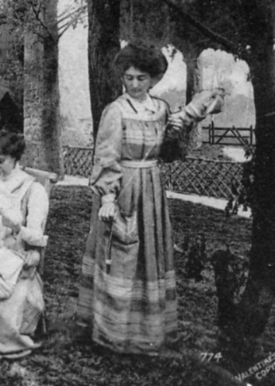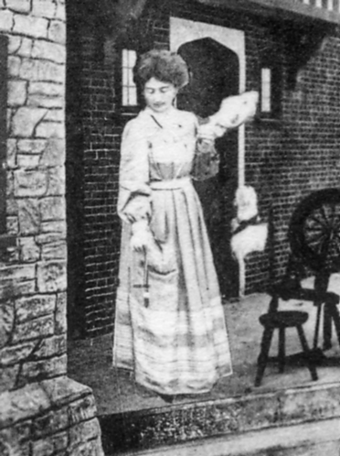
Fig. 26. No. 773b Fig. 27. No. 774 Fig. 28. No. 775

Valentine really went to town in 1911 for the Coronation Exhibition. One lady holding what I believe is called a distaff, an implement used in spinning, is seen on three different scenes on post cards, No. 773b English Village, No. 774 English Village Green, and No. 775 English Cottages.

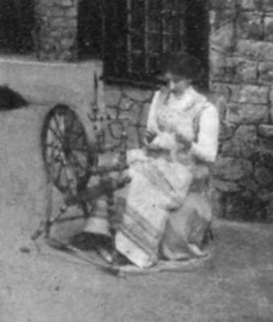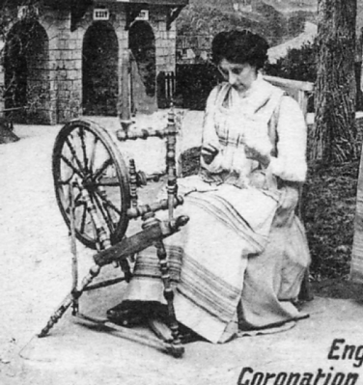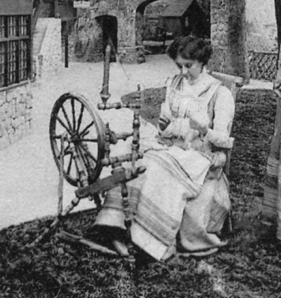
Fig. 29. No. 773a Fig. 30. No. 773b Fig. 31. No. 774

The same lady now seated at her spinning wheel was also featured on three post cards. No. 773a English Village, No. 773b English Village, and No. 774 English Village Green. On two cards she was used twice, sitting and standing. 773a and 773b comes about because Valentine’s published two different views with the same number and title.

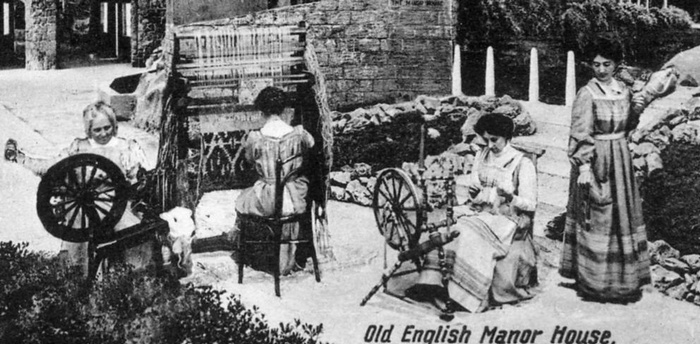
Fig. 32. No. 777

Valentine’s crowning achievement on another Coronation Exhibition card Fig. 32 No. 777 Old English Manor House, was to get the same lady pasted on in three positions performing different actions, with distaff, with spinning wheel and seated at her loom. Although this last lady has her back to us I feel sure she is the same lady performing yet another task. The older lady at a spinning wheel on the far left, was also used on three other cards.
I have always been interested in varieties and once I started examining visitors to exhibitions it added a new dimension and a new interest to my collecting. And remember, these are just a few out of the 160 visitors identified that Valentine’s cut out and pasted onto different scenes.

Awards at the A. B. P. S. Congress at Torquay 2006.

Ten Philatelists received the Association of British Philatelic Societies Award of Merit for contribution to the hobby. One of them was Don Knight our secretary. He has been a member of the Barnet & District Philatelic Society for 35 years and is the curator of the Barnet Postal History Collection and President for the last nine years. He has given displays to many philatelic societies and is a Judge at philatelic competitions.
Thanks to Alan Sabey I am also able to congratulate two other members for gaining awards at The A. B. P. S. Congress at ‘Torquay 2006’.
Revenue International Class.
Francis Kiddle Tasmanian Revenues Gold
Postal Stationery National Class.
Francis Kiddle Copenhagen Local Postal Stationery Vermeil
Francis Kiddle Mexico, the Wells Fargo Story Vermeil
Cinderella National Class.
Francis Kiddle U.K. and U.S.A. Stamp Dealers Large Vermeil
Jean Osborne Exhibition Labels of the Great White City 1908-14 Vermeil
Thematic National Class.
Francis Kiddle Golf Silver

Post Cards of the White City.
Part 39.
by Bill Tonkin

There are five different views published under the title ‘Franco-British Exhibition, Court of Honour, Night Effect’, No.s 191, 210, 214, 215 and 284, three of them have it as a secondary title and two of them 210 and 214 have it as a first title. As they are not all numbered a brief description is given to enable them to be identified, they are listed as type 19 and 20.
Type 19. A night scene looking down the lake at an angle close up of cascade at right bottom corner.
Franco-British Exhibition, Court of Honour, Night Effect.
B/W photogravure on cream, black ‘Throughout the World’ back type FB 2.
210 Title in two lines at bottom left, left edge rouletted.
B/W photogravure, matt surface, black ‘Throughout the World’ back type FB 2.
210 Title in two lines at bottom left, left edge perforated.
Coloured, red ‘F B seal’ back type FB 1.
N.n. Title in two lines at bottom right.
Title altered to, In Court of Honour at Night, Franco-British Exhibition, London, 1908.
Sepia R/Photo, black ‘X L’ back type FB 11.
210 Title in two lines at bottom left.
For other post cards of this view see in The Great White City section, under ‘Court of Honour Illuminated’.

Type 20. A night scene looking almost directly down the lake towards the cascade. A man with right leg raised and resting on balustrade looking at swan boat.
Franco-British Exhibition, Court of Honour, Night Effect.
This card comes in two types, at the front left there is a man in a straw boater, these are listed as ‘with man’, and he appears on all the Franco-British Exhibition cards. For the Japan-British Exhibition cards he has been removed and these are listed as ‘without man’. On the Coronation Exhibition cards, some have him and some don’t.
B/W photogravure on cream, with man, black ‘Throughout the World’ back type FB 2.
214 Title in two lines at bottom left, left edge rouletted.
B/W photogravure matt surface, with man, black ‘Throughout the World’ back type FB 2.
214 Title in two lines at bottom left, left edge perforated.
Coloured, with man, red ‘F B seal’ back type FB 1.
N.n. Title in two lines at bottom left.
Title altered to, In Court of Honour at Night, Franco-British Exhibition, London, 1908.
B/W R/Photo, with man, black ‘X L’ back type FB 11.
214 Title in two lines at bottom left.
Sepia litho, with man, black ‘Throughout the World’ back type FB 2.
214 Title in two lines at bottom left.
For other post cards of this view see in The Great White City section, under ‘Court of Honour, Illuminated’, the Imperial International Exhibition section, under ‘Court of Honour by Night’, the Japan-British Exhibition section, under ‘Court of Honour by Night’, and the Coronation Exhibition section, under ‘Court of Honour’.

Court of Progress, Franco-British Exhibition, London, 1908.
Coloured, red ‘F B seal’ back type FB 1.
338 Title in one line at top right.
Coloured ‘GIANT POST CARD’, red ‘Throughout the World’ back type FB 17.
338. Title in one line at top right.
For other large sized post cards see under Giant post cards.
For other post cards of this view see in The Great White City section, under ‘Court of Progress’, and the Imperial International Exhibition section, under ‘Court of Progress’, The Japan-British Exhibition section, under ‘Court of Progress’ and the Coronation Exhibition section, under ‘Court of Progress’.

In Court of Progress, Franco-British Exhibition, London, 1908.
Coloured, red ‘F B seal’ back type FB 1.
315 Title in one line at top right.
Title altered to, Machinery Hall, Franco-British Exhibition, London, 1908.
Coloured, in ornamental French and British flag border type FB Bo 4, red ‘F B seal’ back
type FB 1.
315 Title in one line at top centre.
For other post cards with this border, see under Border FB Bo 4.
For other post cards of this view see in The Great White City section, under ‘In Court of Progress’.

Valentine’s Franco-British Exhibition
Section D.

Dancing on the Village Green, Ballymaclinton, McClinton’s Town erected by the makers of McClinton’s Soap.
Coloured, brown ‘POST CARD’ with four lines of text, back type FB 13.
582 Title spelt McClinton’s, not the usual M’Clinton’s, in two lines at top right.
Title altered to, Dancing on Village Green, Ballymaclinton, (M’Clinton’s Town erected by the makers of M’Clinton’s Soap)
Coloured, greenish grey ‘POST CARD’ with four lines of text, back type FB 13.
582 Title in two lines at top right.

There are two different cards published under the title ‘Decorative Arts Palace, Franco-British Exhibition, London, 1908.’, as one is horizontal and the other vertical there is no need to describe them.
Decorative Arts Palace, Franco-British Exhibition, London, 1908.
Coloured, red ‘F B seal’ back type FB 1.
388 Title in one line at top left.

Decorative Arts Palace, Franco-British Exhibition, London, 1908.
Sepia R/Photo, black ‘X L’ back type FB 11.
445 Title in two lines at bottom left. Vert left.
Sepia R/Photo, black ‘X L’ back type FB 12.
445 Title in two lines at bottom left. Vert left.
For other post cards of this view see in The Great White City section, under ‘Decorative Arts Palace’, and the Imperial International Exhibition section, under ‘Decorative Arts Palace’.

