EDITORIAL WINTER 2006

When the Convention started, in a year long past
Andrew never thought a twentieth would come to pass

Well our 20th Annual Convention went off very well. With hindsight I realise my comments in the Spring Journal about the venue being rather Spartan, put some of our regular attendees off. But in the event it must be said everybody thoroughly enjoyed themselves. The meal on the Saturday evening couldn’t have been bettered. A three course meal with Roast Lamb at the very reasonable price of £10. A choice of wines and none of your £14 for a bottle of wine costing £4 at the super market. It was unanimously agreed at our A.G.M. to go back again next year.
It is sad that the two voluntary bodies, the ‘Crystal Palace Foundation’ and the ‘Trustees of the Crystal Palace Museum’ now seem to be locked in an irreconcilable conflict, the museum now run by the Trustees is to open Saturday and Sunday to the public instead of only one day a week as previously. The Museum Trustees were able to supply us with a lady to lead the group on a guided tour of the grounds and the Study Group has sent a suitable donation to the Trustees.
Also at the convention Fred Peskett and I were able to have some copies of Exhibition Study Group Publication Number 8 ‘The Crystal Palace 1854-1936 on Post Cards’ for sale. They had only come from the printers four days previously, else where in the journal is a description of the book and details for getting a copy
Unfortunately when the book came from the printers it was too late to get it accepted for the Desmond Chamberlain Trophy awarded by the Postcard Traders Association for the book of the year. It will be entered well in time for next year,s award, and it would be nice to see a book published by the Study Group win the award for the third time.
Readers will be pleased to know that gifts are continuing to pour in, and my thanks go to Arthur Smith for sending me 48 out of the 50 J. A. Pattreiquex British Empire Exhibition Series of cigarette cards. Arthur tells me they are cut from a proof sheet, and this may be so as the pictures do not match up with the printed backs, and informs me the set was issued in 1928. Arthur is a member of the Cartophilic Society of Great Britain, they hold an auction once a month in a room over a pub. He tells me there are several sets of cigarette cards dealing with exhibitions, from the 1938 Glasgow set catalogued at £30.00 to a 1908 White City set catalogued at £625.00. Alan Sabey showed some framed sets of British Empire Exhibition cigarette cards at our convention.
I have just about finished the Winter Journal and scrolling through the sheets I see there is an abundance of articles featuring the Crystal Palace. This was not planned it was what came up as I worked through the pile of articles sent in or written by Fred and myself.
We are always glad to receive articles from members as well as comments or additions to the lists published in the Journal, like the list of Stereographs in this issue. It has been compiled by Fred with a few additions by myself but is nowhere near complete.

The Editors

The Crystal Palace is in Penge
by
Bill Tonkin

In the 2007 Picture Post Card Annual now out, is a long article on the Crystal Palace unfortunately headed “The Crystal Palace Fire of 1937” I suspect this was a type setting mistake by Brian Lund. I phoned him up and gently chided him on the c.... up on the date. He took it in good part and did not try to blame the printers. In case you think I was taking the Mickey I might mention that when Mike Perkins and I did our first book on the Postcards of the British Empire Exhibition at Wembley, I blithely wrote that Edward VII died in 1911. I was so sure I was right, I did not bother to check. When Alan Sabey phoned me up to congratulate us on the book, he casually asked if I was aware Edward died in 1910.
The P.P.C. Annual is not alone, Judges published a set of six post cards showing pre-fire views of the Crystal Palace, adding after each title ‘Before fire of 1937’. When the wrong year was noticed they re-issued the set with the correct date.
The article was fine, but I was sorry to see the Author claim the Crystal Palace was in Sydenham. Fourteen times if I counted correctly. Ever since they opened the new building in 1854 there has been this fixation that it was in Sydenham. Nearly every book on the subject will tell you so, and most of the post cards will have as a title “Crystal Palace, Sydenham”.
Now the Crystal Palace has never been in Sydenham in the past, is not in Sydenham now, and is never likely to be in Sydenham in the future. I realise a person who stands up and says “I am right and everybody else is wrong” is going to be ignored, so let me put it like this “every Ordnance Survey map published since the earliest one of the Crystal Palace area, shows it is divided with a large part in Penge and the rest in Beckenham. I suppose later maps will show it as being in the London Borough of Bromley.
I am well off for maps as Nancy collected them like I collect post cards. I have original sheets of the 1894 - 96 drawn to a scale of 25.344 inches to the mile as well as maps of the same year to a scale of 5 ft to the mile, also the 1912 edition of 25.344 inches to the mile covering the Crystal Palace and surrounding area.
On one occasion she was touring the junk shops in Penge and went into one in Maple Road asking if they had any old maps. Yes said the man, could she see them please ? this presented a problem, they were difficult to get at he said. Instead of putting Nancy off this increased her desire to see them. Eventually after shifting a lot of furniture he was able to get at the maps. There were two on eleven foot rollers. A deal was struck and the dealer was no doubt glad to see the maps go and probably Nancy as well. We had a Cortina estate at the time and nearly half the maps hung out the back, fortunately it was all down hill going back to West Wickham, if she’d had to go up a hill she would have lost them sliding out the back of the car. When I got home from work the only place I could put them was resting up the stair well. Eventually I made iron brackets and they are now mounted up near the ceiling in the long passage from the front door. When fully un-rolled they must be about 25 feet long and cover the whole of Beckenham.
All of the Crystal Palace building including the covered walk from the Crystal Palace Low Level Station, and over half the grounds was in Penge. The Northern part of the grounds stretched into Beckenham. The boundary ran along Crystal Palace Parade and at the end of the parade by the round-about at the top of Anerley Hill (Anerley Road) it just crossed the pavement and nicked the edge of the building by the South Transept entrance. The boundary was altered in 1965 and now the whole of the Crystal Palace park area is in, and is administrated by the London Borough of Bromley, this includes the site and remains of the Palace building. If there had been the slightest chance of the Palace being in Sydenham then it would come under another borough, probably Lambeth.
It should be remembered that in the 1911 Pageant of Empire Penge had the place of Honour leading the procession in Part I while Sydenham was lost near the end in Part III scene II.
It would almost appear that since 1852 nobody writing an article or book has wanted to look at a map to see where the Crystal Palace was located. There was no need, everybody knew it was in Sydenham. It is only in a recent publication “Around Crystal Palace and Penge” by David R. Johnson that the record has been put straight. After all it must be remembered that the 200 plus acre estate that Paxton acquired for the Palace and grounds was called “Penge Place”
Why has it become accepted for over 150 years that the Crystal Palace was in Sydenham ? I would suggest the probable reason was good old fashioned snobbery and jealousy. Upper class Victorian Sydenham could not bear to let Penge have the credit for the wonderful building almost on Sydenham’s doorstep.
This stealing the credit worked both ways and when in 1877 Harriet Staunton was starved to death by her husband and members of his family in a house in Forbes Rd it became known as the Penge Murder. Nobody at the time liked to mention that the house in Forbes Rd was actually in Beckenham. Upper class Beckenham and murders just did not go together. The Beckenham Vestry even changed the name of the road to Mosslea Rd to further distance Beckenham from the crime. The Penge Murder has been kept alive up to almost the present day, in the T V programme ‘Rumpole of the Old Bailey’ when hardly a programme was shown where he did not mention the ‘Penge Murder’.

Report on The 2006 Convention
by
Alan Sabey

Nineteen members and two visitors attended the 2006 Convention held on the 23rd of September in the Paxton Suite at the “The Lodge”, the accommodation block at the Crystal Palace Sports Centre. Unfortunately one or two members thought they would like to come but were prevented at the last moment from doing so. If they had come, it would have been one of our best attended Conventions. One member actually reached the entrance to the “Lodge” when an urgent mobile phone message from his wife caused him to turn round and head back home. Some members travel from further away than Surrey or Middlesex to attend, and those who do not make it are encouraged to attend next September when the Convention will be held at the same venue. It is only a few yards from the Crystal Palace station on a line out of Victoria, London and there is plenty of parking for those who come by car.
The Annual General Meeting began at 10am. Ron Trevelyan, in his last year as President, welcomed those present and referred to the achievement of others in philately generally. The Minutes of the 2005 meeting were agreed and accepted. The Secretary gave his report mentioning the resignation of one member with effect from the new financial year and an inquiry from someone in India.
The Treasurer's report was given and was accepted without any questions as again there has been a healthy balance of finances and that the Group's main account and the Publications Fund are both in a good state. The Treasurer recommended that the annual subscription remains as before: £8 for members residing in the UK, £12 for couples residing in the UK where both wish to be members and £13 for all resident outside of the UK.
Election of Officers
At this point Ron stood down and the Chair was taken by Peter Denly, as the new President. The new Vice President, Alan Sabey the Treasurer, was proposed by Mike Perkins and seconded by Bill Tonkin. The rest of the Committee were elected en-bloc and all were agreed.
It was suggested that we meet at Crystal Palace again in 2007, possibly in 2008 as well and hiring a minibus to take us to the site of the 1908 France-British Exhibition at White City.
The new publication on the Postcards of the Crystal Palace was available at the meeting. It was agreed that it would be available to members at £20 plus postage and £25 plus postage to non-members.
Mike Perkins was concerned about the Group's website not being updated and has paid the domain charge. He will liase with Ken Rumsey about the website.
Alan Sabey told the meeting that his collection of the British side of the philately of the British Empire Exhibition would auctioned at “Grosvenor”, The Strand, London on Thursday 7 December 2006. As most of the pages had already been photocopied as a record, there was talk of producing a book of them as a permanent record of the Collection, which won a Gold Medal in Brussels in 2001 ,
The Annual General Meeting was declared closed at 10.45am.
Displays on Saturday.
Don Knight kicked off this year's displays with a look at the 1966 World Cup at the old Wembley Stadium with modem commemorative philately. Peter Denly and Ray Goodey both showed British and Empire countries postal publicity for the British Empire Exhibition. Kenneth Tonkin followed with a marvelous display of items (some scarce) connected with a number of other exhibitions, some at the Crystal Palace.
After lunch, Fred Peskett showed a collection of engraved Letter heads for the 1851 Exhibition in Hyde Park. Peter Burrows attending his first convention showed early UK and American exhibitions, plus Cape Town and Johannesburg in the thirties. George Simner showed German exhibitions in the period of the Third Reich. Bill Tonkin showed his research into the Souvenir Snapshots in boxes and wallets available at Wembley in 1924 and 1925 and this was followed by Pull-out postcards from the 1938 Empire Exhibition in Glasgow.
The Annual Dinner
We kept our usual tradition of having a Dinner on the Saturday evening and this was served in the Paxton Suite. Members enjoyed a fine meal of Roast Lamb and all the trimmings, washed down well with wine! There was plenty of opportunity for members to chat to one another during the evening.
Sunday's events
A look round the Crystal Palace Museum had been organized for 11 am when it opened with a specially arranged look inside the remains of the South Water Tower and the pumping equipment for the fountains that used to exist in the Grounds. The remains of the base of one of the supports of the Crystal Palace building could be seen close to the tower's base, thus showing how close the Water Tower was to destruction by the Fire of 30th November 1936 when the glow could be seen all over London and as far away as Brighton.
This followed with a dozen of us being taken for a guided tour of the site of the Palace and the Grounds. It was sad to see the dilapidated condition of the Grounds maintained by Bromley Council but we did get to see the models of the Prehistoric Monsters and the Coal Face constructed in 1856 as part of the education programme of the park for our Victorian ancestors. After sandwiches and refreshments at 2pm back at the Paxton Suite members began to make their way home having enjoyed another good weekend together.

Crystal Palace Fire 30 November 1936

Thanks to Alan Sabey who managed to get pictures of the hand stamp used for mail posted at the Crystal Palace, we are able to illustrate an impression from the hand stamp, the actual hand stamp it self and an enlargement of the die still set on the last day of use. The fire broke out that night, and the rest is history.

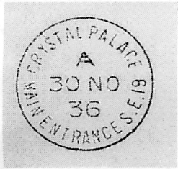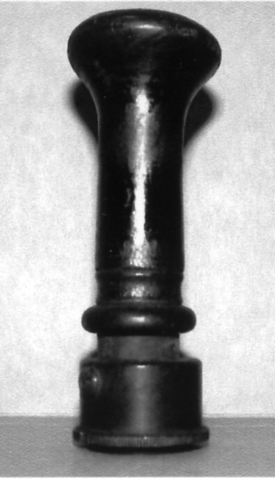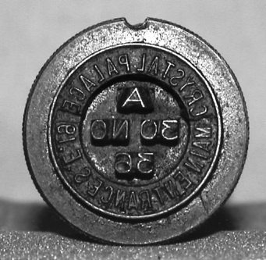

The Group is most grateful to Douglas Muir of the British Postal Museum and Archive for providing Alan with a disc containing these photographs, which were given on the understanding that they are not to be reproduced in any form without written permission from the BPMA.

The Crystal Palace

1854 - 1936

on Post Cards

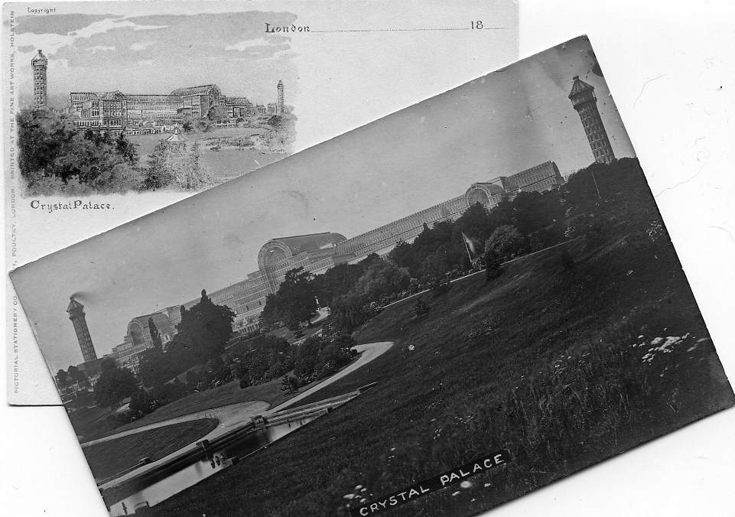
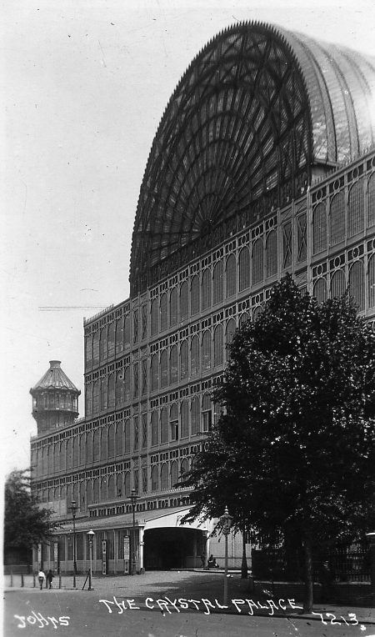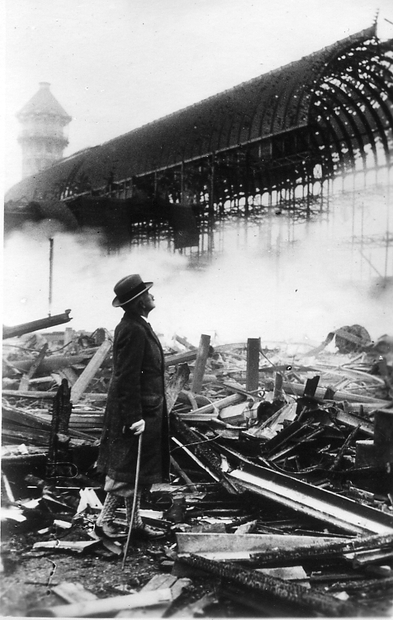

Fred Peskett and Bill Tonkin
The Crystal Palace 1854 - 1936 on Post Cards
by
Fred Peskett and Bill Tonkin

The book is in an A4 size with 326 pages laminated covers, and with many illustrations
It covers the post cards published from their beginning in the late 1890’s up until the end with the fire on November 30 1936.

This first impression has been printed in a very limited edition of 100 books
It is offered to members at the reduced price of £25.50 post free.
To non members the price will be £30.50 post free

The book can be obtained from Bill Tonkin
23, Bramley Way, West Wickham, Kent.
BR4 9NT

Please make cheques out to W. Tonkin

The printing costs of this book has been paid for by the Exhibition Study Group. This has been a non profit making and a non expense claiming exercise by the authors and all proceeds will go to the Exhibition Study Group Publishing Fund

The pictures on the cover have been chosen to illustrate various periods of the Crystal Palace history. The top court card issued in the late 1890’s is an artists impression of the Crystal Palace. any card before 1900 is scarce and not much more than a handful are known. The next card shows the Crystal Palace taken before the 1866 fire destroyed the North Transept and was one of several published by J. Russell in about 1904. The third view is of the Crystal Palace as seen from the Parade in the late 1920’s, while the last view shows the Manager Sir Henry Buckland at the scene the day after the fire.
The Authors have been working on this book since the beginning of 2003, and at last the book is finished and has been published by the Exhibition Study Group. When we say finished, this is perhaps not entirely correct, a book of this type is never finished. It would be more correct to say we have stopped to take breath. You have to set a dead line for this sort of work and to present it at the convention in 2006, the 70 th anniversary of the Fire and the end of the Crystal Palace seemed a good time.
While a few series of post cards published after 1936 are included we have not tried to cover the many cards published by libraries, art galleries, museums and other sources, as many of these only had a local circulation and were not publicised to any extent.
We have paid particular interest to what may be regarded as the commonest view of the building, taken from the Crystal Palace Low Level Railway Station. To our surprise we found all these post cards derived from about nine original photographs taken possibly by J. Russell over a period of years. He had a studio in the Palace itself and was on hand as it were. Each of the views were syndicated around the trade and the most common one from negative No. 4 was used by about 70 different publishers many who refrained from giving their names and may possibly have pirated the views without permission.
Another problem we have solved is how to classify the hundreds of different post cards sold without any publishers name or trade mark. It is essential when faced with a card and no clue as to the publisher or printer, to be able to find its location in the book straight away without going through page after page looking for an entry that matches it.
Catering at the Crystal Palace in 1894
by
Fred Peskett

Very little has been put into print about the catering at the Crystal Palace in respect of the arrangements for the exhibitions and the general need to provide food and drink for masses of visitors. Some idea of the requirements have been found in a booklet published in May 1894 by Bertram & Co, the Refreshment Contractors. Not only the daily requirement and charges, but how the catering system operated. First a tour of the principle departments.
The preparation rooms, kitchens and storage areas were situated around the South Transept area out of sight, below the public viewing galleries. The Refreshment Courts were placed around the Crystal Palace. The Grand Summer Dining Rooms both Public and Private and the Garden Hall were all situated in the South Wing, The Afternoon Tea Room was to be found adjoining the Concert Hall, with several smaller Buffets in the Palace and grounds. There was a Smoking Room, opened in 1893, which was set in luxurious surroundings near the Screen of the Kings and Queens. Over 1,000 catering staff were employed on a day to day basis rising to 1,500 when National Celebrations or Political Dinners were in progress.
The Kitchen.
The vast kitchens were in the South Transept, catering for an average of ten thousand persons every day although this could increase by up to fifty thousand during Bank Holidays, Handel Festivals, or an Imperial or Foreign visit.
The Larder.
Below the South Transept in racks hanging from the ceiling were stored several tons of hams, saddle joints, loins, haunches, whole Lambs, and thousands of game and poultry. Daily these were metered out to the Kitchen with cooked meats being returned for issue as cold joints.
The Bakery and Confectionery House.
The output from this department was vast with practically every meal requiring some form of bread, biscuits or rolls. The daily output amounted to some 10 tons.
The Ice House.
Next to the Bakery was the Ice House in which 700 tons of ice were always kept. Here also were stored barrels of preserved fruit, great tubs of ice cream, eggs, and the constituents of the famous Crystal Palace Ice Pudding.
The Coffee Kitchen.
A long room of several huge boilers, each brewing vast quantities of tea, coffee and cocoa. The brew was drawn off in large cans on trucks and distributed to the various refreshment rooms throughout! the Crystal Palace via the Paxton Tunnel.
The Grocery Store.
A huge storeroom for chests of tea, coffee, sugar, butter, eggs, flour, biscuits and barrels of aromatic spices. The stock was constantly being sent out to the kitchens at one end, and being replaced by goods inwards deliveries at the other.
The Glass and China Store.
Half a million plates, ten thousand dishes, fifty thousand cups and saucers, half a million sets of cutlery, eighteen thousand each of wine, champagne, hock and claret glasses, glowing in various colours of crystal, ruby, emerald and amethyst was only a part of this vast store.
The Laundry.
Giant steam boilers continually washed tablecloths, napkins and linens, which were then transferred to centrifugal wringers and finally into heated cupboards for drying then hand ironing.
The Scullery.
Six vats of hot, soapy water washed the thousands of plates and other items returned from the Refreshment areas, then rinsed and dried in hot air cupboards fed by steam pipes.
The Bottle Yard.
Next to the Scullery and connected to the Wine store was the Bottle Yard where nine men worked for ten hours a day cleaning and drying bottles ready for re-filling in the wine cellars.
The Wine Cellars.
The Cellarage for wine under the South Transept amounted to over a mile of shelf space. Over 10,000 bottles of wine with an equal number of champagnes from various makers and vintages were stored. Hogsheads of claret, pipes of port and butts of sherry were ready for filling the bottles straight from the Bottle Yard.
The Beer Cellars.
The Beer Cellars were directly under the Refreshment Courts since the ales and stouts were required to be freshly drawn. Messrs Allsop & Sons were the brewery to the Crystal Palace, AIlsop's were also the beer suppliers for The Great Exhibition of 1862, The Paris Exposition of 1867, The Fisheries Exhibition of 1883, The Health Exhibition of 1884, The American Exhibition of 1887, The Italian Exhibition of 1888, The Spanish Exhibition of 1889, The French Exhibition of 1890 and the German Exhibition of 1891.
The Soda Water Room.
6,000 bottles of Soda Water were prepared and used every day at the Crystal Palace, this total rose to over 15,000 during Temperance, or Band of Hope gatherings held at the Palace. The water was obtained from an artesian well in the Crystal Palace grounds and charged with gasses and a little soda and potash in the Soda Water Room under laboratory controlled conditions.
So how much would a meal at the Crystal Palace in 1894 cost? In the Second Class Dining Room, Bread and Cheese was 3d, a plate of meat 7d a Bath Bun 2d, tea and coffee at 3d per cup. In the South Wing Dining Room a Roast meat dinner with all trimmings was 2/-, and a Lobster Salad was 3/-. The Saloon Dinning Room Meat and Chicken Roasts were 2/6d, Fish with Soup and Dessert was 7/6d, while in the Grill Room, Chops and Steaks were available at 1/9d. Wine was on average 3/- a bottle and champagne at 10/- (Vintage 1884)

Samuel Franklin Cody
1867-1913
By Jean Roberts

On the afternoon of the 11th August 1913 a funeral procession began its slow journey from the Surrey village of Ash Vale to the nearby Aldershot Military Cemetery. For the first time, a civilian was being buried alongside the officers and soldiers of the British Army. The procession, over a mile in length, was led by the Band and Pipers of the Black Watch Highland Regiment. Behind then came a gun carriage of the Royal Horse Artillery, drawn by six coal-black horses, carrying a coffin draped with the Union Jack. Over one thousand representatives of the British Army, Navy and Royal Flying Corps followed the coffin. There had been no order to do so but each of the military units had chosen to attend to pay their final respects. Many hundreds of floral tributes were carried, one bearing the inscription “In Memory of England’s Greatest Airman” and the route to the cemetery was lined every step of the way by what was estimated at the time to be fifty thousand people. All had come to honour the memory of one who had captured the imagination and earnt the love and respect of the British Nation Samuel Franklin Cody.
Who was the American born Samuel Franklin Cody? First and foremost he was an aviator the first man to fly a heavier than air, powered aircraft in Great Britain; he was also a superb and successful kite flyer and designer, a well known theatrical performer and a Wild West showman he was all this and much more. His story begins in Davenport, Iowa and ends in the wreckage of his aircraft in Farnborough, Hampshire and his journey between these two places is a fascinating one.
He was born in 1867, one of five children born to Samuel and Phoebe Cowdery. Very little is known about his teenage years in Iowa, we only have Cody's own stories to go on and as he was very good at embellishing the true facts I will omit these tales! We do know that by the age of twenty one he was employed in a Wild West Show and had changed his name to Cody. Although logical, it is an assumption that this change of name was made only for theatrical reasons. William Frederick Cody, Buffalo Bill, was by this time hugely successful in both America and Europe with his traveling show. Samuel Franklin Cody with his long flowing hair, beard and waxed mustache was often mistaken for his namesake or for a member of his family, a mistake still made today.

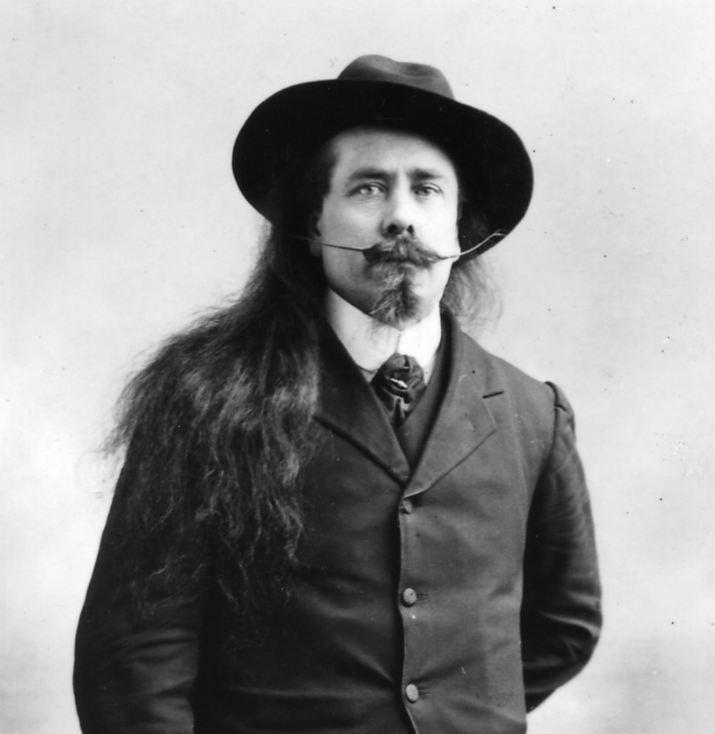

Samuel Franklin Cody

In 1890 Cody and his wife arrived in England by which time they were both excellent riders and expert shots. One of their first engagements, early in 1891 was at the Olympia appearing in "The Burlesque of the Wild West." This show was, I believe performed on roller skates and the manager of the show was shortly afterwards sued by the Buffalo Bill Company for using the term "Wild West". The couple also performed at Earl's Court and numerous Music Halls mainly, at this time, in and around London. Cody soon expanded his act to include children, and the mother of these children took over from his wife in the act. This new "Cody and Family" act toured a number of European countries with a very varied programme, the most popular being races on horseback against cyclists, from which Cody invariably emerged the winner.
In about 1897 Cody settled in England and decided to try his hand at writing a series of "Western Melodramas", a form of entertainment which was becoming increasingly popular with the audiences of the day. By far the most popular of Cody's dramas was "The Klondyke Nugget", a five act extravaganza which included in its cast five horses and a donkey! The play successfully toured the country for many years ensuring Cody a regular income.
Exactly how or when Cody became interested in kites is unclear, but by 1899 he was giving
demonstrations of kites during the intervals of his plays. These kites were not the sort we see children playing with in the parks today but huge box kites some being thirteen feet wide. His main interest was in lifting a man into the air with a kite and to this end he produced a train of five or six kites with a basket suspended beneath the ‘carrier kite’ for a passenger. During this period in 1903/4 he set up workshops at both Crystal Palace and Alexandra Palace and set about interesting the Army in using his kites in time of war for signaling and observation.
In 1904 we find Cody in Aldershot, the home of the Royal Engineers, giving demonstrations of his man-lifting kites. So successful were these that he was made the Army's Official Kite Instructor and he exchanged his show business world for a military one. It must have been a strange sight, Cody giving instructions to the soldiers still with his long hair and his waxed mustache and riding to work on his white horse!

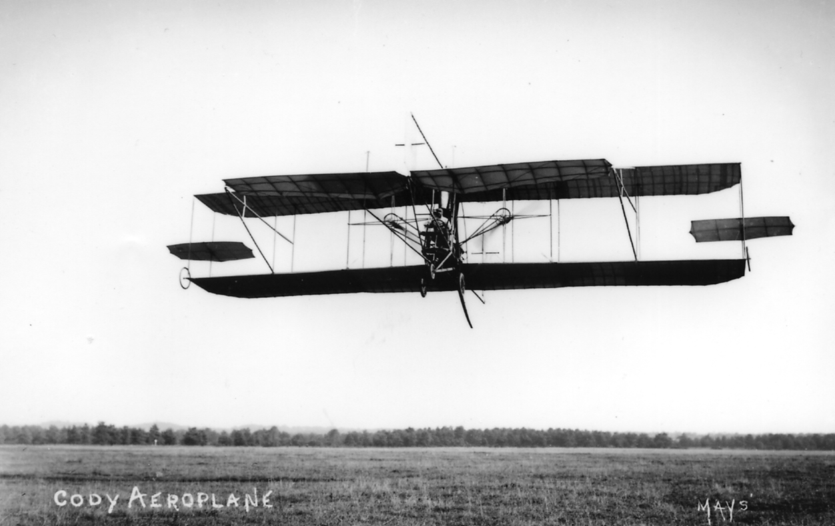

The first manned, powered aircraft flight in this country

As a natural progression from kites Cody turned his attention to aeroplanes and after a series of adventures with boats being pulled across the sea by a kite, gliders and airships he designed and built an aircraft. So it was that on the morning of 16th of October 1908 on Farnborough Common, Cody's aeroplane ran across the ground before lifting to an altitude of approximately 35 feet. This flight of 1,390 feet and lasting only 27 seconds was the first manned, powered aircraft flight in this country ensuring Cody a place in aviation history. The War Office then decided, in their wisdom, that there was no future in aeroplanes and Cody was removed from the official Farnborough scene. He now had to work on the development of his machine without the aid of government finance but, with the help of just family and a loyal band of friends, he continued to progress within the limits of his own resources. In the following years successes were achieved records were broken and many trophies were won but there were also many disappointments and a number of crashes.
Cody was killed on the morning of 7th August 1913 piloting his latest machine. During his lifetime he was an extremely popular figure with the British public but his great inventiveness and skills as an aviator were perhaps not fully appreciated by the Establishment of the day. Even though he had become a British subject in 1909 and eventually his long flowing hair and western attire had been replaced by a conventional haircut and suit he was still regarded as the “American Cowboy” turned aviator. He may have embellished his life story with tales of Indian raids and gold rushes etc. but contemporary accounts tell of a kind, considerate, indomitable and courageous man.
Within a year of his death the Great War had begun bringing to an end the Golden Era of Pioneering Aviation, an era whose most colourful character must surely have been Samuel Franklin Cody.

The Editors would like to thank Jean Roberts who is not a member of the group, for the above article which arose from a phone call from Jean asking for information about a house built at an Ideal home Exhibition. During the conversation she mentioned her large collection of S. F. Cody post cards which prompted me to ask for an article, which she has very kindly done.

Stereoscopic Views of the Crystal Palace.
by
Fred Peskett

Tremendous strides had been made in respect of photography since the 1851 Great Exhibition. When the Crystal Palace opened at Penge Place in 1854 many photographers opened studios in the galleries of the building. The Carte de Visite was a popular form of souvenir of the visit, these were usually about 3" x 2" with a view of the Crystal Palace, generally they were sepia toned photographs. Also available for sale were stereoscopic views, quite a marvel for their time, used with the special viewer they gave a perfect three dimensional record of the subject under view.

Crystal Palace Series.
The publisher of this series is unknown. They are identified by “CRYSTAL PALACE.” 50 mm long in capitals with serifs and full stop, on the back. They are 6¾" long x 3¼" wide. Sepia stereos on yellow card. Square corners.
1. The Nave (looking north)
2. to 9. Unknown.
10. The Colossal Egyptian Figures.
11. Unknown.
12. The English Mediaeval Court. (Tomb of the Black Prince)
13 & 14. Unknown.
15. The Garden Gallery.
16. Unknown.
17. Avenue (in front of Fine Arts Courts)
18 to 21. Unknown.
22. Exterior of the Palace.(View of the South Transept and Tower)
23. Unknown.
24. The Egyptian Court.
25. to 32. Unknown
33. Monti’s Fountain and Byzantine Court.
34. to 37. Unknown.
38. The Screen of the Kings and Queens of England.
39. & 40. Unknown.
41. A Pieta by Bernini. In the Italian Court.
42. Unknown.
43. The Great Palm and Ninevah Court.
44. to 46. Unknown.
47. View in the Renaissance Court.
48. to 56. Unknown.
57. Avenue in front of the Sheffield Court.
58. to 62. Unknown.
63. General view in the South Transept.
64. General view in the South Transept.
65. to 66. Unknown.
67. General view of the Nave.
68. to 80. Unknown.
81. View of the Grand Vestibule.
82. to 145. Unknown.
146. The Greek and Roman Courts.
147. Unknown.
148. Sculpture in the Greek Court.
It is not known how far this series extends after number 148.

Phillip Henry de la Motte.
The work of photographer Phillip de la Motte is legendary, his photographs of the construction of the Crystal Palace between 1852 and 1854 together with his views once the Palace was opened are about the best there are. De la Motte also produced a series of twenty Stereographs for the Crystal Palace Art Union. Art Unions were formed in 1836, the first being the London Art Union. The Unions ran a form of an Art Lottery three or four times a year, with a subscription of one guinea per ticket. New works of art were commissioned such as an oil painting or a watercolour by a leading artist of the time as the first prize. Fifty second prizes were in the form of a limited number of a ceramic item commissioned from leading manufacturers such as Spode or Copeland, One hundred third prizes were emphemeral such as the stereoscopes by De la Motte. In some modern reference books his name is shown as one word Delamotte, De la Motte is the correct way to show his name.
De la Motte’s stereos are sepia on yellow card with square corners 6¾" long x 3¼" wide, all are serial numbered. The printing on the back reads:- “A Series of 20 views for the Stereoscopc photographed expressly for The Crystal Palace Art Union” The dates of issue were between 1858 to 1866.
1. North Transept. Colossal figures from the Temple of Ramases.
2. The Renaissance Court. The Ghilberti Gates from Florence.
3. The Byzantine Court.
4. to 7. Unknown.
8. The Renaissance Court.
9. The Elizabethan Court.
10. Mediaeval Court. Easter Sepulcher from Hawton Church.
11. The Greek Court.
12. Unknown.
13. The Renaissance Court. Figures from the Tomb of Maximilian of Austria.
14. The Greek Sculptures.
15. Court of Monuments of Art. Tomb of Lady Abbess.
16. Mediaeval Court. Tomb of Humphrey de Bohun, from Hereford Cathedral.
17. Italian Court. Tomb of Lorenzo de Medici.
18. Mediaeval Court. Doorway of Rochester Cathedral, The Walsingham font, etc,
19. & 20. Unknown.

R. Gogerty. 72, Fleet Street, London.
R. Gogerty stereoscopic cards are in sepia, two types are known. Type 1. No serial Numbers, 6¾" long x 3¼" wide. Square corners, cream card. Type 2. Serial numbered, 7" long x 3¼" wide. Square corners, grey card. A Gogerty label is pasted to each one generally on the left side but can appear in many other places!
Type 1.
N.n. The Court of Lions.

Type 2.
1. The Byzantine Court.
2. The Egyptian Court.
3. Unknown.
4. The Italian Court.
5. Unknown.
6. The Renaissance Court.
7. The Egyptian Court.
8. Unknown.
9. The English Mediaeval Court.
10. The English Mediaeval Court.
11. Unknown.
12. The Assyrian Court.
13. The Egyptian Court.
14. The Egyptian Court.
15. Interior view of the Crystal Palace.
16. The Stationery Court.
17. Gallery of Greek Sculpture.
18. Gallery of Greek Sculpture.
19. Gallery of Greek Sculpture.
20. Gallery of Greek Sculpture.
21. The Byzantine Court.
22. The Byzantine Court.
23. The Italian Court.
24. The Italian Court.
25. Interior of the English Mediaeval Court.
26. to 29. Unknown.
30. The Egyptian Court.
31. Interior of the English Mediaeval Court.
32. Gallery of Greek Sculpture.
33. to 38. Unknown.
39. The Byzantine Court.
40. Unknown.
41. Interior of the English Mediaeval Court.
It is not known how far this series extends after number 41.

Goodman.
No serial numbers. Sepia on buff card, 6¾" long x 3¼" wide. Square corners.
N.n. Courage.
N.n. The Third Labour of Hercules.
N.n. Wallace and Bruce.

Negretii & Zambra.
No serial numbers or titles. Sepia on orange card. 6¾" long x 3¼" wide. Rounded corners. Negretii & Zambra, Photographers, Crystal Palace in double ring oval stamped on the back.
N.n. No title. (The fallen Knight)

S.P. Series, Stereoscopic Gems. The
No serial numbers. Sepia on brown card. 7" long x 3½" wide, rounded corners.
N.n. Crystal Palace.

Standard Stereoscopic Company. The
Imprint down the right side reads ‘Honorable Mention by the Executive Crystal Palace Photo Exhibition 1893.’ and on the left side The Standard Stereoscopic Company. They are 7¼" long x 3½" wide. Sepia stereos on buff card. Round corners.
N.n. No title (Hand written title in ink ‘Torquay’)

Stereoscopic Illustrations of the Crystal Palace, at Sydenham.
The publisher of this series is unknown, two types are known. Type 1. No serial numbers, 6¾" long x 3¼" wide. Sepia stereos on grey card. Square corners. Details and title on a printed label on the back. Type 2. Serial numbered, 6¾" long x 3¼" wide. Sepia stereos on grey card. Square corners. Number, title and about 14 lines of text on the back in English and French.
Type 1.
N.n. Tropical Department and Assyrian Court.

Type 2.
2. The Nave. Looking towards the North

Unknown Publisher.
No serial numbers. Sepia on cream card. 6¾" long x 3¼" wide. Square corners.
N.n. “Thesius”. (Statuary Court)

Unknown Publisher.
No serial numbers. Black & white on white card, 6½" long x 3½" wide. Round corners.
N.n. Statuary at the Crystal Palace.

Unknown Publisher.
No serial number or title. Sepia on white card, 6¾" long x 3¼" wide. Square corners.
N.n. No title (Ostler's Fountain)

Unknown Publisher.
No serial number, no title. Sepia on black bordered card. 6¾" long x 3¼" Rounded corners.
N.n. No title. (The Crystal Palace from the Penge Entrance, showing the North Transept, but without the North Tower, pre 1866, There is a pub sign in the foreground with “Tavern” at the top, and a Brewer’s wagon is parked outside the gates)

Post Cards of the White City.
Part 37.
by Bill Tonkin

Type 24. A close up of two ladies, one seated looking down from the balcony at the lake. They are on Congress Bridge behind the cascade which can be seen over the standing lady’s shoulder.
Court of Honour, Franco-British Exhibition, London, 1908.
Coloured, red ‘F B seal’ back type FB 1.
346 Title in one line at top left.
Sepia R/Photo, black ‘X L’ back type FB 11.
346 Title in two lines at bottom right of centre.
Title altered to, Court of Honour from Congress Bridge, Franco-British Exhibition, London, 1908.
Sepia litho, black ‘Throughout the World’ back type FB 2.
N.n. Title in two lines at top left.
Title altered to, Court of Honour, from Congress Bridge, Franco-British Exhibition, Xmas, 1908.
Sepia litho view in coloured Christmas Card border type FB Bo 2, red ‘F B seal’ back type FB 1.
346. Title in two lines at bottom centre Vert left.
For other cards of this series see under Border FB Bo 2.

Type 25. A vertical card with two ladies and a small child in the foreground, the lady in white holding an umbrella, while the other lady is in black.
In Court of Honour, Franco-British Exhibition, London, 1908.
Coloured, red ‘F B seal’ back type FB 1. Vert left.
347 Title in one line at top centre.
Sepia R/Photo, black ‘X L’ back type FB 11. Vert right.
347 Title in two lines at bottom right.

Type 26. Looking from a central position straight down the lake towards the cascade. There is a motor boat full of passengers at bottom right of centre heading towards the bridge.
The view of the Court of Honour on card No. 484 is known in four states, and these are listed. One difference between them is in the water of the cascade. The first type is from the original negative, the water of the cascade is shown with a few white waves as it tumbles down, this is listed as ‘view with little water in cascade and with bridge over the lake’ the second type shows the cascade with more water, and is listed as ‘view with half flow of water in cascade and bridge over the lake’, The second type was used only on the Japan-British Exhibition litho postcards. The third type has lot more water added and is shown as a solid white mass, it is listed as ‘view with white water in cascade and bridge over the lake’.
The fourth type was used only for the Latin-British Exhibition cards. Originally from 1908 to 1911 there was a bridge across the lake in the Court of Honour, listed as ‘with bridge’. For the Latin-British Exhibition in 1912 the bridge had been dismantled and Valentine’s have carefully taken out the bridge across the lake. They have not however removed the reflection cast on the water by the bridge, and this can still be seen, this is listed as ‘view with little water in the cascade and without bridge over the lake.’ This last type was also used for Valentine’s Anglo-American Exposition cards published by Gale & Polden. These are listed under Gale & Polden. Only the first type was used for the Franco-British Exhibition cards.
Court of Honour, Franco-British Exhibition, London, 1908.
Sepia R/Photo, view with little water in cascade and with bridge over the lake, black ‘X L’ back type FB 11.
484 Title in two lines at bottom left of centre.
For other post cards of this view see in The Great White City section, under ‘Court of Honour’, the Imperial International Exhibition section, under ‘Court of Honour’, the Japan-British Exhibition section, under ‘Court of Honour’, the Coronation Exhibition section, under ‘Court of Honour’, and the Latin-British Exhibition section, under ‘Court of Honour’. It is also included in the main list under Gale & Polden.

Type 28. The bottom and left is taken up with a pathway full of people well spaced out. On the right there is a group of people waiting to board a boat, with an electric launch heading towards the bridge. Although this card for the Franco-British Exhibition is not numbered, the same view on cards for other exhibitions is numbered 488.
Court of Honour, Franco-British Exhibition, London, 1908.
Sepia litho, black ‘Throughout the World’ back type FB 2.
N.n. Title in one line at top right.
Title altered to, Court of Honour, Franco-British Exhibition, Xmas, 1908.
Sepia litho view in coloured Christmas Card border type FB Bo 2, red ‘F B seal’ back type FB 1.
N.n. Title in one line at bottom centre
For other cards of this series see under Border FB Bo 2.
For other post cards of this view see in The Great White City section, under ‘Court of Honour’, the Imperial International Exhibition section, under ‘Court of Honour’, the Japan-British Exhibition section, under ‘Court of Honour’, and the Coronation Exhibition section, under ‘Court of Honour’.

There are three different views published under the title ‘Court of Honour at Night’, as they are not all numbered a brief description is given to enable them to be identified, they are listed as type 1 to 3.
Type 1. A night scene looking towards the bridge in the Court of Honour with a pier jutting out on the right and a swan boat heading towards the bottom left corner. In the Court of Honour illustrations this is listed as type 17.
The B/W litho cards started out numbered 191, an attempt to erase the number was only partly successful and left a feint 91. A second go resulted in the number being erased by scratching it out, this mess can be clearly seen as no attempt was made to obliterate the white scratch marks. A third attempt was successful and the white scratch marks disappeared.
When the B/W litho card was published for the Great White City, it had 91 on it, but for the Imperial International Exhibition the complete number was re-engraved in a much heavier style and in a slightly different place.
One can only wonder why Valentine’s felt it was so important to go to such lengths over the number on this card.
Court of Honour at Night, Franco-British Exhibition, London, 1908.
B/W litho, black ‘Throughout the World’ back type FB 2.
191 Title in two lines at bottom left of centre. ‘Franco-British Exhibition, London, 1908.’ measures 56 mm.
91 Title in two lines at bottom left of centre. ‘Franco-British Exhibition, London, 1908.’ measures 54 mm.
Scr. Title in two lines at bottom centre. ‘Franco-British Exhibition, London, 1908.’ measures 55 mm.
N.n. Title in two lines at bottom left of centre. ‘Franco-British Exhibition, London, 1908.’ measures 54 mm.
B/W litho, greenish grey ‘Throughout the World’ back type FB 2.
91 Title in two lines at bottom left of centre. ‘Franco-British Exhibition, London, 1908.’ measures 54 mm.
Scr. Title in two lines at bottom centre. ‘Franco-British Exhibition, London, 1908.’ measures 55 mm.
N.n. Title in two lines at bottom left of centre. ‘Franco-British Exhibition, London, 1908.’ measures 54 mm.
Note, the manuscript titles on the B/W litho cards have been written at different times or by different people as they vary in detail. they also vary in measurements and these have been given.
Sepia R/Photo, black ‘X L’ back type FB 11.
N.n. Title in two lines at bottom centre. There are two types of manuscript title on this card, and while all the letters are slightly different, the capital ‘N’ to ‘Night’ is particularly so.
Title altered to, Court of Honour from Congress Hall, Franco-British Exhibition, London, 1908.
Coloured, Although the title on the front is the Franco-British Exhibition, the card has a red Great White City ‘J V seal’ back type WC 1. An artist has been at work on this card, and visitors standing on the short pier on the right, have been painted in. There is also extra detail on the boats moored under the bridge.
N.n. Title in three lines at bottom left, with the top line curved.
Title altered to, Franco-British Exhibition, Court of Honour, Night Effect.
B/W photogravure on cream, black ‘Throughout the World’ back type FB 2.
191 Title in two lines at bottom left, left edge rouletted.
B/W photogravure, matt surface, black ‘Throughout the World’ back
type FB 2.
191 Title in two lines at bottom left, left edge perforated.
Coloured, red ‘F B seal’ back type FB 1.
N.n. Title in one line at bottom left.
For other post cards of this view see in The Great White City section, under ‘Court of Honour, Illuminated’, the Imperial International Exhibition section, under ‘Court of Honour by Night’, and the Coronation Exhibition section, under ‘Court of Honour’.

