EDITORIAL AUTUMN 2006

“My dear old friend, your cough I fear. Will soon be quite a fixture.
If you don’t take a dose or two. Of Stoddart’s Bronchial Mixture.
1/- per Bottle.

No dear reader, the above little gem does not come from the flowing pen of your geriatric editor (I say geriatric so you can tell the difference between Young Fred and myself) although the term flowing pen dates me as an oldie, perhaps I should say stomped keyboard.
This little ditty was printed on the back of a Japan-British Exhibition post card. The Plymouth Co-operative Drug Compy., of 20, Cornwall Street, Plymouth, used remaindered Japan-British cards with a printed price list on the back, to advertise their various products. Each advert included four lines of verse. This one came a few weeks ago in a bundle of cards on approval from a dealer, and at £1.50 got snapped up straight away.
Once an exhibition closed the hundreds of thousands of post cards unsold, were virtually given away to dealers to dispose of, one such dealer was A. J. Brown, Brough & Co., of 29-32, Warwick Lane London E.C. a wrapping paper and twine merchant, who advertised that he had 200,000 Bruxelles 1910 exhibition cards for sale at 4/- per 1,000, which in case you have forgotten the old currency works out at 5,000 for £1.00. He says in his advert ‘Would do for Advertising or Farthing Change. A Chelmsford Draper J. A. Rankin bought a lot and it is always worth looking in the foreign exhibition section for Bruxelles 1910 cards with Rankin’s hand stamp on the back.
A farthing was not worth much even in the days when it was legal tender, but I can remember when many goods were priced in the odd farthing, especially in the haberdashery and cloth trade. I can remember my mother talking about something priced at say ‘four three’ meaning in old money ‘fourpence three farthings’ ‘pence’ and ‘farthing’ were never mentioned, just the numbers. So a shop keeper would offer his customer a post card in place of a farthing change. I can remember sweet shops also charged a farthing for some of their sweets. As a child I received the princely sum of two pence a week pocket money, which in those days could buy you a packet of five Woodbine cigarettes, not that I could afford such luxury. When I went out to work at 14 my wages for the first year was 12/- (twelve shillings in old money 60p in new money) a week, out of which I was stopped 4d (four pence) for a stamp. After giving my mother 7/6 (seven shillings and six pence) towards my keep I was left with 4/2 (Four shillings and two pence) a week to pay for my clothing, sweets and entertainment’s. Going to the pictures now I was grown up cost 6d (six pence), as a child it cost half that.
I am very happy to say gifts continue to pour in, I mentioned in the last Journal about the gift of two bound volumes of the London Illustrated News for 1851. One of our members, a dealer Ian Clare phoned me up the other day to say he had a copy of Fleetway’s ‘Pageant of British Empire Souvenir Volume’ if I would like it, and about a week later it came. Fleetway printed two editions one the plain copy that sold for 7/6 in 1924 and the second edition overprinted ‘Presented by the London and North Eastern Railway’ on the front. The presentation copy is not only overprinted on the front but includes an extra page of text about the docks owned by the L. N. E. R. and this is backed by a painting by Frank Brangwyn R.A. ‘The Border Bridge’ showing a steam train on a brick viaduct. These large books measuring 16 x 12 inches are packed full of coloured lithographed copies of paintings by F. Brangwyn R.A., Spencer Pryse and MacDonald Gill. Many of the illustrations cover two pages and one folded painting titled ‘The Pageant’ covers four pages, the actual painting itself measuring 11½ x 40 inches. Some of the Spencer Pryse paintings in the book were used as guides for his series of 12 advertising labels given out free on application, for the 1924 British Empire Exhibition at Wembley. Or was it the other way round ? I reimbursed Ian the £6.00 postage, I felt this was the least I could do.
Even Young Fred when he sent me an article for the Journal enclosed two Ogden’s Tab cigarette cards featuring events that took place at The Crystal Palace around 1901-02. I must say all these presents are very acceptable to me , and I can’t think why it has taken so long to catch on, I just hope it doesn’t stop, and look forward to telling you about a lot more presents in the next Journal.
The Editors

20th Annual Convention at Crystal Palace.
Saturday 23 and Sunday 24 2006

As I am writing this I am conscious that in one months time the convention will have come and gone. Have you let Don Knight at 2, Crescent Rd, New Barnet, Herts. EN4 9RF or Tel. 020 8440 3574. know if you are coming and if you are displaying, and have you booked your accommodation at The Lodge. Crystal Palace National Sports Centre. Ledrington Road, London. SE19 2BB Tel 020 8778 0131. The price for B & B is £28.10 per person, for a single or double room. The accommodation block is divided into units of one single and one double room with a shared W.C. and shower between them for each unit. So it’s a half-en-suite, with plenty of single rooms, which is not usually the case in hotels. The facilities are not shared by any of the other units. When booking mention the Exhibition Study Group has reserved rooms for its members.
I have just heard that owing to a wrangle between the Crystal Palace Foundation and the Trustees of the Museum the museum is, I hope, temporarily closed and if this is not resolved by the time of our convention we shall not be able to visit it. The grounds with all the refurbished monsters can be visited and there will be more than enough to keep us busy.
Our convention will be held in the Paxton Suite in the Lodge starting at 10.00 each morning.

Engraved Pictorial Letterheads of the Great Exhibition 1851
by
Fred Peskett

Engraved Pictorial Letterheads were first introduced around the early 1840's shortly after the introduction of the Uniform Penny Post. Early examples depict popular resorts such as the Spa Towns of Bath, Cheltenham and Harrogate, also the owners of large hotels included an engraving of their premises on their notepaper to solicit business from would be clients. The engraved letterheads may be looked upon as the forerunners of the picture postcard which were to become so popular in the late Victorian and Edwardian times.
Many of the printers and publishers of the mid 1800's took the opportunity to produce engraved letterheads for the Great Exhibition of 1851, some even had stands at the exhibition, producing and selling their work.
Engraved Pictorial Letterheads are known to exist from other exhibitions including New York and Dublin, at the time of writing there does not seem to be any for the 1862 International Exhibition. There were some from the Crystal Palace when it moved from Hyde Park to Penge and opened in 1854, examples of two can be seen in Maurice Bristow's excellent book.

Day and Son, London
The engraving by Day and Son, London, was a serious attempt to reproduce the true proportions of the Crystal Palace, This letterhead was chosen by the compiler of the Great Exhibition Catalogue, Maxwell & Co., for overprinting to solicit subscribers to advertise in the One Shilling edition. It is known printed on cream and blue papers. Double page folded, 4¾" by 7¾" (12.5cm by 20cm) See View No 1.

R. E. Dear London.
Letterheads by R. E. Dear, London, show a similar view to that by J. T. Wood, the perspective is also is also quite out of proportion with the height to length ratio exaggerated. In common with other engravings the front of the building does not include a carriageway for coaches or the railings to keep visitors away from the road and building, (these are only ever shown in the original photographs taken by Fox Talbot.) R. E. Dear produced at least two variants of letterhead, the other view has different cloud formations, major changes to the flags on the building and minor changes to the people in the foreground. Single sheet, 7¼" wide by 9" long. (18.2cm by 22.6cm). See view No 2.

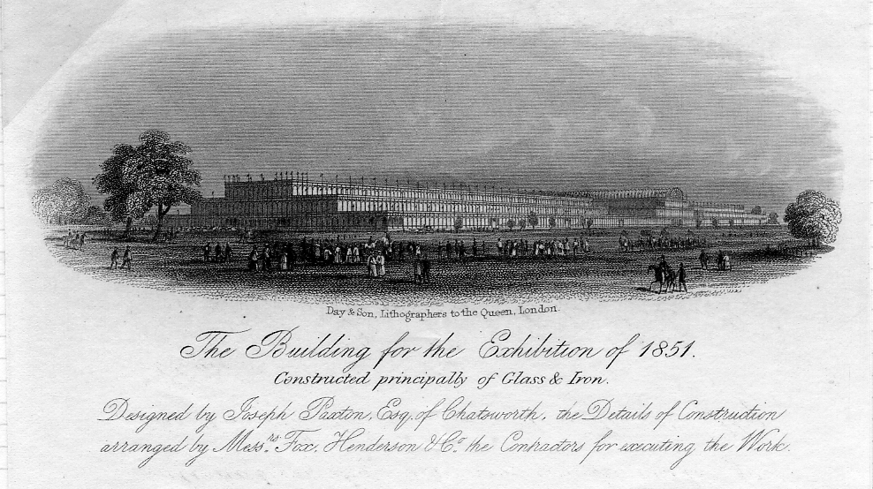

View No. 1.

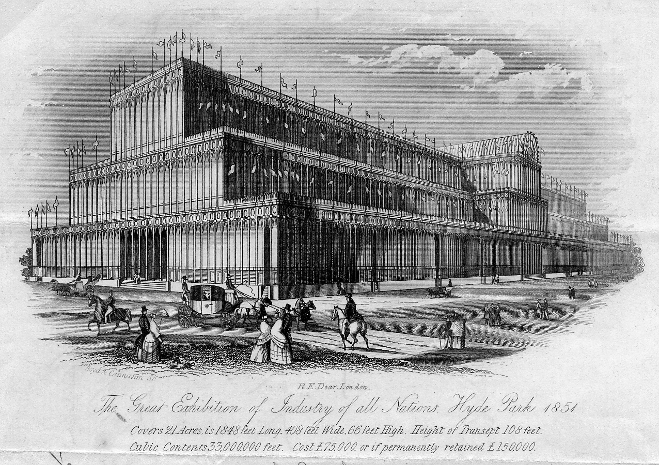

View No. 2.

H. Fletcher, 11 Paternoster Row, London
The letterhead published by H. Fletcher, 11 Paternoster Row, London, is probably one of the best and most accurate of all those produced. It gives a good idea of the proportions of the building and is the only engraving to show that the lower ground section of the building was in fact constructed from wooden panels and not glass. Double sheet, folded, 4½" wide by 7¼" long. (11.5cm by 18.5cm) See view No 3.

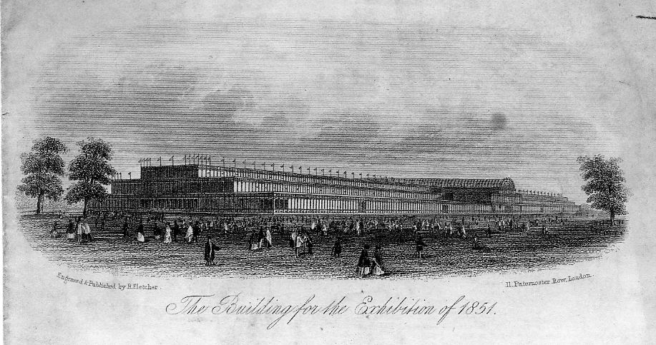

View No 3.

Kershaw & Sons, London.
Joseph Paxton first published his design for the exhibition building on July 6th 1850 in the Illustrated London News, his illustration did not have the Central Transept which he added later on 17th July 1850 to satisfy the Building Committee's wish to preserve the elm trees for which there was an outcry should these be cut down to erect such a building. Kershaw was quick off the mark to publish a letterhead without the Transept, which must have been somewhat upsetting to find out there had been a change in design! The Kershaw letterhead is quite scarce with only a couple of examples known to exist. 4½" wide by 7¼" long. (11.5cm by 18.2cm) Double page folded. See view No 4.

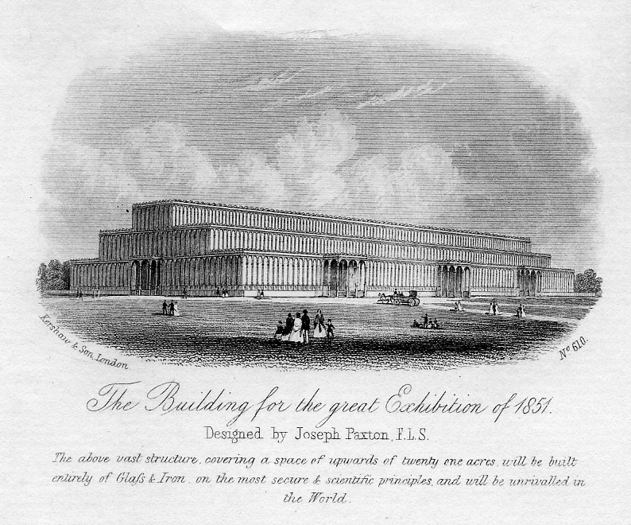

View No. 4

Rook & Co., London
Rook & Co., London produced an excellent view of the Exhibition Building from the Serpentine, in this view the inclusion of the trees add to the appeal of the engraving. The view is dated 1st May 1851 (the opening day of the exhibition). Rook had a stand in the Machinery section of the exhibition and printed their letterheads in the Crystal Palace selling in packs of six for threepence. Double sheet, folded, 4¼" wide by 6¾" long. (11.2cm by 17.5cm). See view No 5.

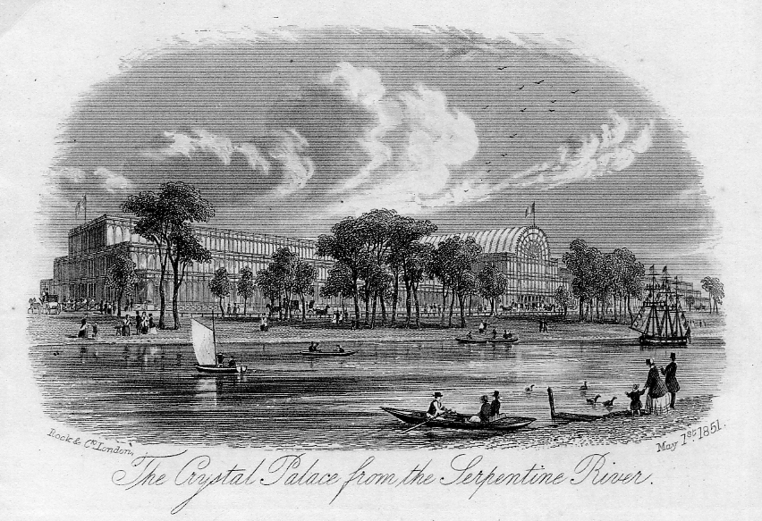

View No 5.

Rook also published a view of the Interior of the Crystal Palace also dated 1st May 1851, this view shows the exhibits being viewed by the visitors. Double sheet, folded, 4¼" wide by 6¾" long (11.2cm by 17.5cm). See view No 6.

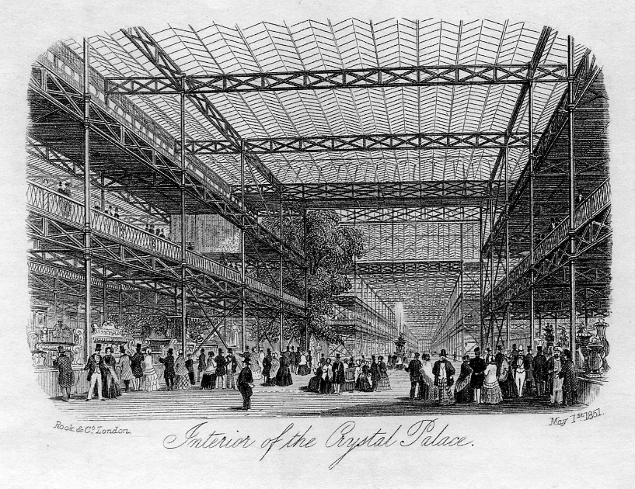

view No 6.

Unmarked publisher, probably H. Savage of London.
Another letterhead with good proportions of the building was by an unmarked publisher, probably H. Savage of London. Unfortunately the shape of the Central Transept is incorrect, but the eastern end gives a more accurate representation of how the building looked at the ends. The inclusion of the tree in the foreground somewhat upsets the view. Double sheet. 7¼" wide by 8¾" long. (18.4cm by 22.5cm). See view No 7.

J. T. Wood, Holywell Street, London.
This firm published at least three letterheads for the Great Exhibition, they were all produced once the plans for Joseph Paxton's building had been approved by the Building Committee since the text under all their engravings includes the word will, "will occupy 18 acres of ground" and "it will be 1848 feet long". The first view shows the building looking from the east (the most popular view) and shows the Central Transept, however, the perspective is out of scale, the ratio of the height to length being well out of proportion. Single sheet, 7½" wide by 10" long. (19cm by 25.3cm) See view No 8.

Another J. T. Wood engraving shows the building viewed from the west, if you hold the letterhead to the light and view from the back it will be seen that the engraving of the building is identical to the one shown from the east! only the people in the foreground have been changed. Double folded sheet, 4½" wide by 7¼" long. (11.5 cm by 18.2cm) See view No 9.

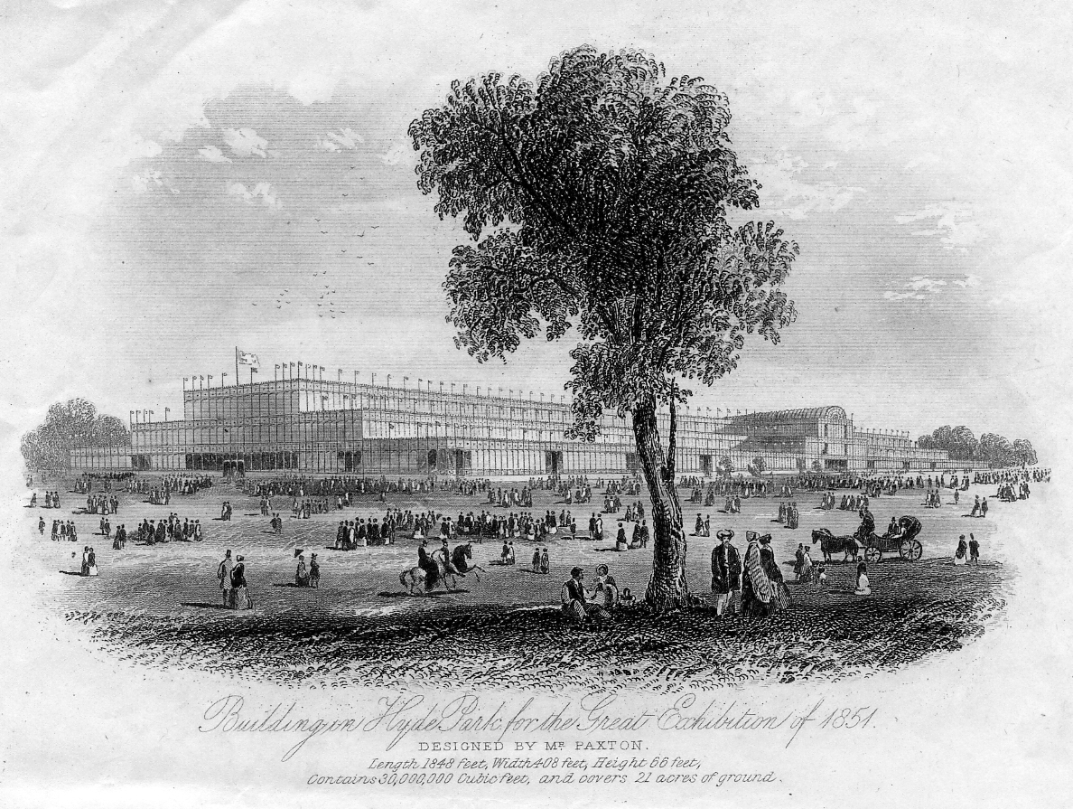

View No. 7.

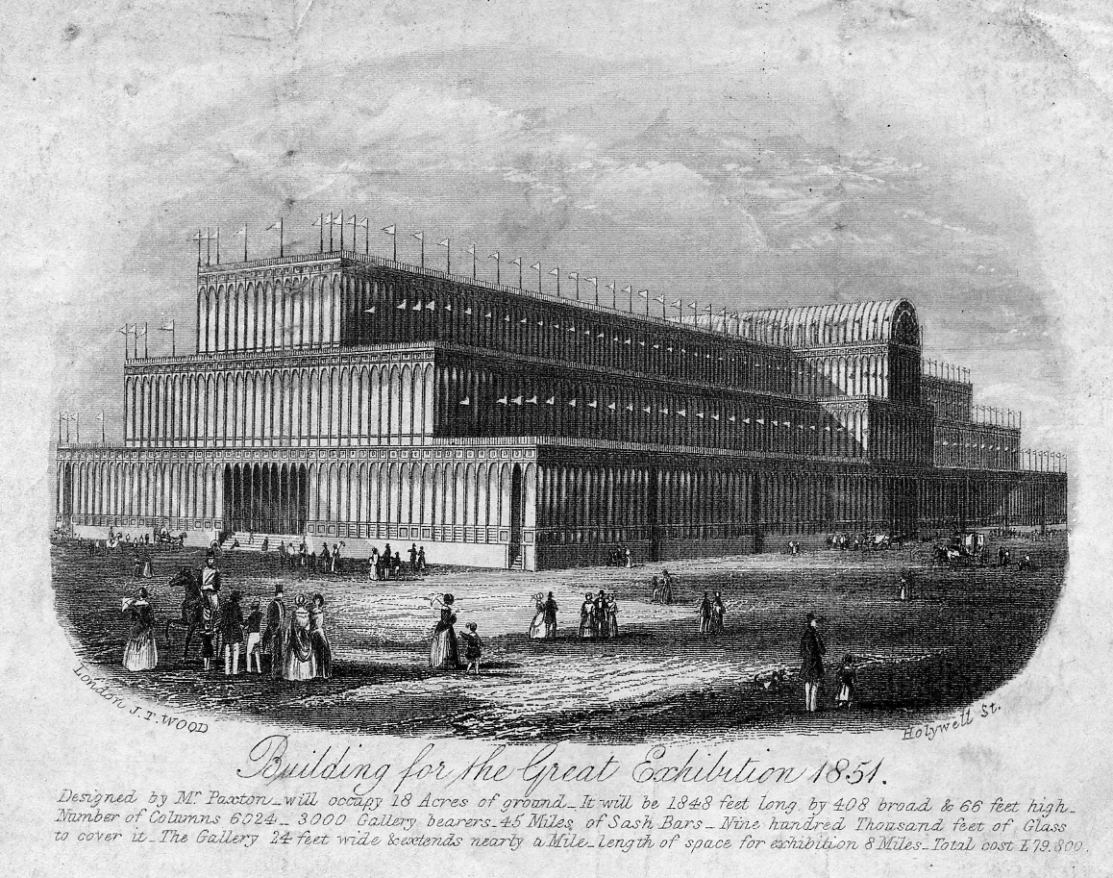

View No. 8.

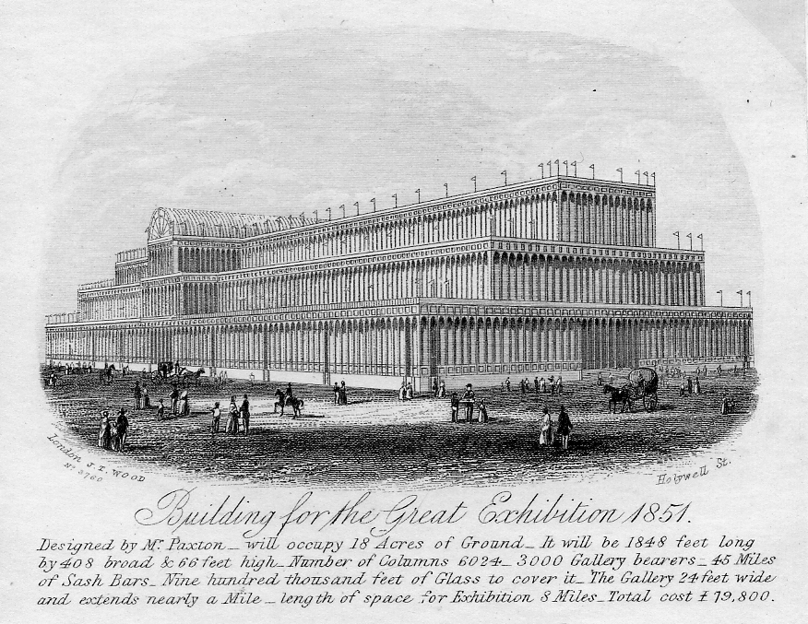

View No. 9.

J. T. Wood also published one of the few views of the Interior of the Crystal Palace, once again the view was engraved prior to the opening of the exhibition on the 1st May 1851. The view shows the Nave from the Central Transept, there are no show cases or exhibits in the building, however, there are many visitors including families which may not be artistic license, since the Illustrated London News for March 1851 does reveal that the building was open for viewing at certain times for a small charge. Double sheet, 7" wide by 9" long. (17.8cm by 22.6cm) See view No 10.

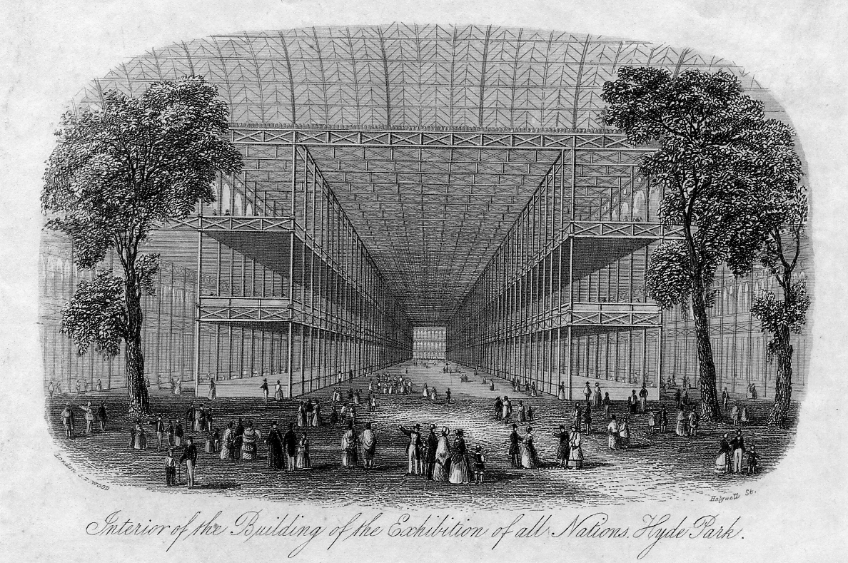

View No. 10

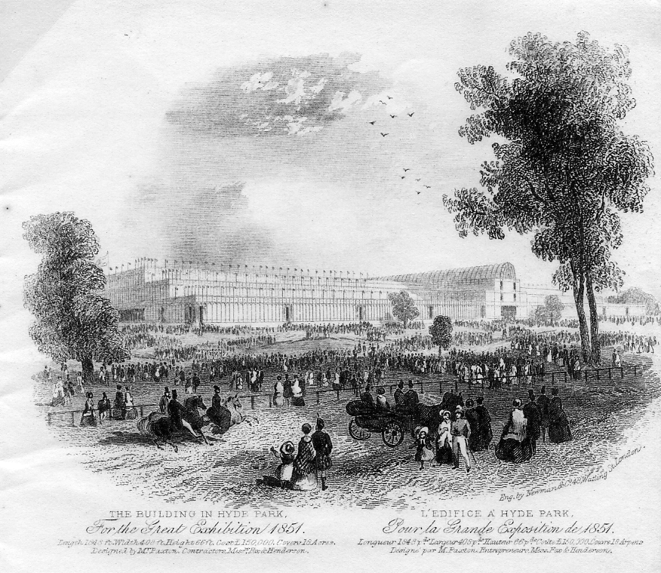

View No. 11.
Newman & Co. 48, Watling Street, London.
Dual language letterheads. One of these was produced by Newman & Co 48, Watling Street, London, with the text in both English and French. The engraving of the front of the Central Transept is poor but the activity surrounding the building is probably as the exhibition would have looked on each opening day. Double sheet, folded, 4½" wide by 7¼" long. (11.5cm by 18.5cm) See view No 11.

I & S, an unidentified publisher
The other known dual language letterhead is by I & S, an unidentified publisher. The representation of the exhibition building is poor, but once again there is much activity going on the outside. Double sheet, folded, 4½" wide by 7¼" long. (11.5cm by 18.5cm) See view No 12.

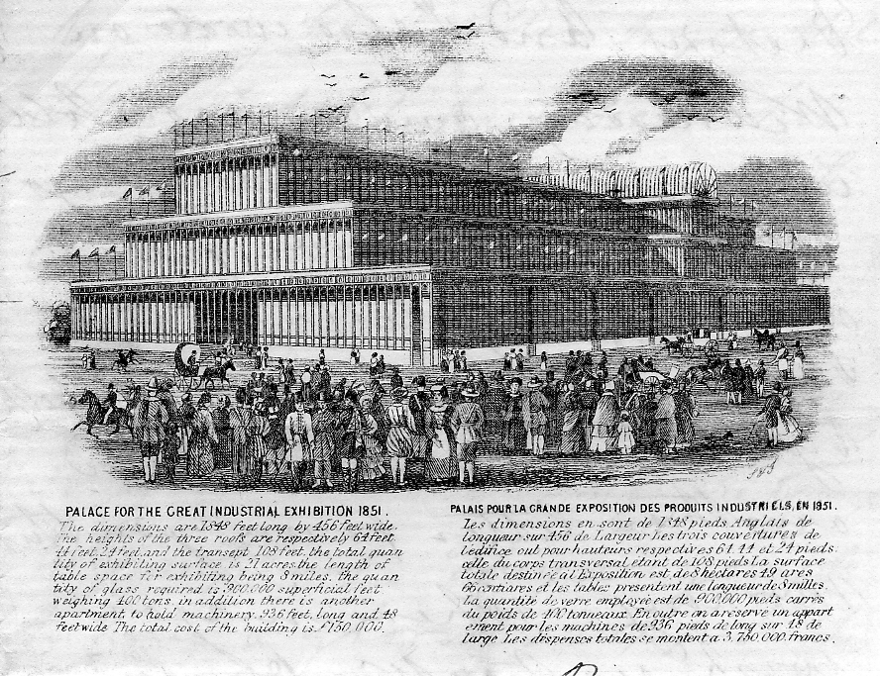

View No. 12.

Embossed Pictorial Letterheads.
There is one known design of embossed letterheads for the Great Exhibition, although there is no publishers details on the embossed view, the watermark is a CROWN over WOOD, probably J. T. Wood of London who produced several of the engraved letterheads. According to Maurice H. Bristow in his book "The Postal History of the Crystal Palace" only one copy had ever been found embossed in white on a blue background, since this book was published in 1983 a further blue copy has been found and one with a brown background, the blue background version has a wavy red line around the edge of paper whereas the brown has green. Double sheet, folded, 3½" wide by 5¼" long. (8.8cm by 13.5cm). See view No 13.

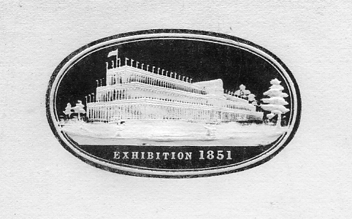

View No. 13.
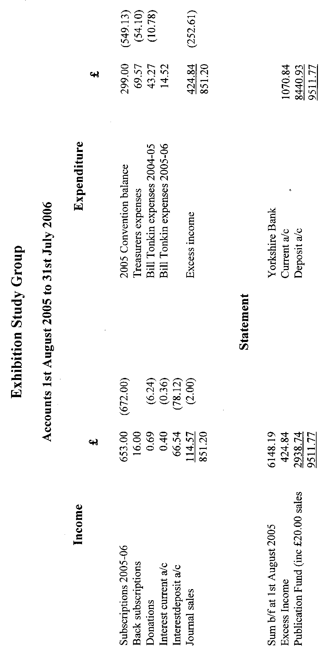

Post Cards of the White City.
Part 36.
by Bill Tonkin

Type 4. This is the only vertical card in the series of pre exhibition forerunners.
On this card ‘Valentine’s Series Copyright’ on the front can be found in four types, see notes above for type 2
In The Court of Honour, Franco-British Exhibition, London, 1908. (A pre exhibition forerunner.)
B/W litho, sunk plate with large white border, dark green ‘Throughout the World’ back type FB 2.
N.n. Title in two lines at bottom centre, with a reversed split ‘Copyright’ and ‘Valentine’s Series’.
A. Gap between ‘Copyright’ and ‘Valentine’s’ measures 34 mm. Vert left.
B. Gap between ‘Copyright’ and ‘Valentine’s’ measures 38 mm. Vert left.
B/W litho, sunk plate with large white border, grey ‘Throughout the World’ back type FB 2.
N.n. Title in two lines within the picture at bottom left, without ‘Valentine’s Series Copyright’. Vert left.
B/W litho, sunk plate with large white border, bluish grey ‘Throughout the World’ back
type FB 2.
N.n. Title in two lines at bottom centre, with a reversed split ‘Copyright’ and ‘Valentine’s Series’, the gap measures 34 mm. Vert left.
B/W litho, sunk plate with large white border, greenish grey ‘Throughout the World’
back type FB 2.
N.n. Title in two lines at bottom centre, without ‘Valentine’s Series Copyright’
Vert left.
B/W litho, sunk plate with large white border, greenish grey ‘Throughout the World’
back type FB 2.
N.n. Title in two lines at bottom centre, with ‘Valentine’s Series Copyright’ at an angle. Vert left.
B/W litho, deep green ‘Throughout the World’ back type FB 2.
N.n. Title in two lines at bottom left, with ‘Valentine’s Series Copyright’ at an angle. Vert left.
B/W litho, grey ‘Throughout the World’ back type FB 2.
N.n. Title in two lines at bottom left, without ‘Valentine’s Series Copyright’.
Vert left.
B/W litho, greenish grey ‘Throughout the World’ back type FB 2.
N.n. Title in two lines at bottom left, with ‘Valentine’s Series Copyright’ at an angle. Vert left.
Coloured, grey ‘Throughout the World’ back type FB 2.
N.n. Title in one line at top, with a horizontal ‘Valentine’s Series Copyright’ to the left. Vert left.
N.n. Title in two lines at top right, without ‘Valentine’s Series Copyright’. Vert left.
N.n. Title in two lines at top right, with a horizontal ‘Valentine’s Series Copyright’ to the left. Vert left.
Coloured, bluish grey ‘Throughout the World’ back type FB 2.
N.n. Title in three lines at top right, with a horizontal ‘Valentine’s Series Copyright’ to the left. Vert left.
Coloured, red ‘F B seal’ back type FB 1.
N.n. Title in two lines at top right, with a horizontal ‘Valentine’s Series Copyright’ to the left. Vert left.
Note, on the coloured cards five different cloud patterns are known.
Sepia R/Photo, black ‘X L’ back type FB 11.
N.n. Title in two lines at bottom left, with ‘Valentine’s Series Copyright’. Vert left.
N.n. Title in two lines at bottom left, with ‘Valentine’s Series Copyright’. Vert right.

Type 5. Artists drawing of the lake with a gondola type boat approaching the bridge over the lake. These cards do not have the Valentine’s imprint on the front.
Court of Honour, Franco-British Exhibition, London, 1908.
B/W litho, grey ‘Throughout the World’ back type FB 2.
N.n. Title in one line at top right.
Coloured, grey ‘Throughout the World’ back type FB 2.
N.n. Title in one line at top right.

Type 6. On this card there are two men striding out at bottom right of centre, and three women with umbrellas at bottom left of centre. The lake is to the right, and a tall building with dome on the left edge.
Parts of the surround of the lake in the Court of Honour had iron railings as can be seen in the B/W litho cards. The railings were later replaced with a pierced concrete low wall, and when Valentines photographer took the film from which their cards were produced the work of replacing the rail with a wall was in progress and workmen can be seen in the bottom right corner. Note the cloth wrapped round the railing to make it more noticeable. When Valentines published coloured cards they got their artist to finish the job and paint in the concrete walls in place of the railings. The original photo was taken on a very sunny day and the shadow of the railings can be seen on the pathway. When the artist painted in the wall in he left the shadow of the railing on the pathway where it can still be seen on the coloured cards.
Court of Honour, Franco-British Exhibition, London, 1908.
B/W Photogravure view, in a red, white and blue border with the Union Jack and French flag in diagonal stripes, type FB Bo 3, red ‘F B seal’ back type FB 1.
N.n. Title in one line at top right.
For other post cards with this border, see under Border FB Bo 3.
Title altered to, In Court of Honour, Franco-British Exhibition, London, 1908.
B/W litho, black ‘Throughout the World’ back type FB 2.
N.n. Title in one line at top centre.
N.n. Title in one line at top left.
B/W litho, bluish grey ‘Throughout the World’ back type FB 2.
N.n. Title in one line at top centre.
Coloured, sunk plate with large white border, red ‘F B seal’ back type FB 1.
N.n. Split title in one line at bottom centre.
Coloured, red ‘F B seal’ back type FB 1.
N.n. Title in one line at top right.

Type 7. A vertical card with a close up of the cascade on the bottom right, with two swan boats on the lake. In the bottom left corner there is a large lantern.
In Court of Honour, Franco-British Exhibition, London, 1908.
Sepia litho, black ‘Throughout the World’ back type FB 2.
N.n. Title in two lines at top left. Vert left.
For other post cards of this view see in The Great White City section, under ‘In Court of Honour’.

Type 11. This is a view looking down the lake towards the cascade, at the bottom right there are three ladies all with umbrellas up, and on the left a group of people waiting to board a motor boat.
Court of Honour, Franco-British Exhibition, London, 1908.
B/W litho, black ‘Throughout the World’ back type FB 2.
N.n. Title in one line at top centre.
N.n. Title in one line at top centre, left edge rouletted.
N.n. Title in one line at top left.
B/W litho, grey ‘Throughout the World’ back type FB 2.
N.n. Title in one line at top centre, left edge rouletted.
B/W litho, greenish grey ‘Throughout the World’ back type FB 2.
N.n. Title in one line at top centre.
Sepia litho, black ‘Throughout the World’ back type FB 2.
N.n. Title in one line at top centre.
Coloured, dark grey ‘Throughout the World’ back type FB 2.
112 Title in one line at top centre.
Coloured, dark grey ‘F B seal’ back type FB 1.
112 Title in one line at top centre, left edge rouletted.
Coloured, slate ‘F B seal’ back type FB 1.
112 Title in one line at top centre.
Coloured, red ‘F B seal’ back type FB 1.
112 Title in one line at top centre.
112 Title in one line at top centre, left edge rouletted.
Coloured ‘GIANT POST CARD’, black ‘Throughout the World’ back type FB 17.
112. Title in one line at top left.
Coloured ‘GIANT POST CARD’, grey ‘Throughout the World’ back type FB 17.
112. Title in one line at top left.
A. With comma after Honour,
B. With full stop after Honour.
For other large sized post cards see under Giant post cards.
Sepia R/Photo, black ‘X L’ back type FB 11.
112 Title in one line at bottom centre in white border. This is one of the few cards Valentine’s published with borders in the Franco-British Exhibition range of cards.
112 Title in two lines at bottom left, as normal without white border.
For other post cards of this view see in The Great White City section, under ‘Court of Honour’.

Type 12. There is a pier on the left with a swan boat coming towards the camera, in the distance behind the swan boat is a motor boat moored to some steps with passengers alighting. On the right is another swan boat.
In Court of Honour, Franco-British Exhibition, London, 1908.
Sepia R/Photo, black ‘X L’ back type FB 11.
162 Title in two lines at bottom left.

Type 13. A close up of two attendants, a turnstile and a swan boat leaving with another one just ahead.
In Court of Honour, Franco-British Exhibition, Christmas, 1908.
Sepia litho view in coloured Christmas Card border type FB Bo 2, red ‘F B seal’ back type FB 1.
168 Title in one line at bottom centre.
For other cards of this series see under Border FB Bo 2.
Title altered to, In Court of Honour, Franco-British Exhibition, London, 1908.
B/W R/Photo, black ‘X L’ back type FB 11.
168 Title in two lines at bottom left.
Coloured, red ‘F B seal’ back type FB 1.
168 Title in one line at top left.
Coloured view in ornamental French and British flag border type FB Bo 4, red ‘F B seal’
back type FB 1.
168 Title in one line at top centre.
For other post cards with this border, see under Border FB Bo 4.
Coloured ‘GIANT POST CARD’, dark grey ‘Throughout the World’ back type FB 17.
168. Title in one line at top left.
Coloured ‘GIANT POST CARD’, grey ‘Throughout the World’ back type FB 17.
168. Title in one line at top left.
For other large sized post cards see under Giant post cards.
Sepia litho, black ‘Throughout the World’ back type FB 2.
N.n. Title in two lines at top left of centre.
Title altered to, Swan Boats, Court of Honour, Franco-British Exhibition, London, 1908.
B/W litho, black ‘Throughout the World’ back type FB 2.
N.n. Title in two lines at top left of centre.
Coloured, red ‘F B seal’ back type FB 1.
168 Title in two lines at top left.
Coloured ‘GIANT POST CARD’, grey ‘Throughout the World’ back type FB 17.
168 Title in one line at top left.
For other large sized post cards see under Giant post cards.
Title altered to, The Court of Honour, Franco-British Exhibition, London, 1908.
Coloured, although the original was taken during daylight this has been darkened and well gone over by an artist and lights have been added to make it appear a night scene. On the daylight cards there is a lady with a large umbrella in the bottom right corner. When the view was converted to a night scene the lady with her umbrella was painted out, and a different figure of a lady substituted. The attendant with a pencil stuck behind his ear, was also removed at this time. Although the title on the front is the Franco-British Exhibition, the card has a red The Great White City ‘J V seal’ back type WC 1.
N.n. Title in three lines at bottom right, with the top line curved.
For other post cards of this view see in The Great White City section, under ‘Swan Boats, Court of Honour’, and the Imperial International Exhibition section, under ‘In Court of Honour’.

Type 14. Looking down the lake away from the cascade, there is a very wide path on the right, and in the lake a swan boat heading towards the right bank.
Court of Honour, Franco-British Exhibition, London, 1908.
Coloured, in ornamental Britannia and Marianne border type FB Bo 1, red ‘F B seal’ back
type FB 1.
182 Title in one line at top centre.
For other post cards with this border, see under Border FB Bo 1.
B/W Photogravure view in a red, white and blue border with the Union Jack and French flag in diagonal stripes, type FB Bo 3, red ‘F B seal’ back type FB 1.
182 Title in one line at top centre.
For other post cards with this border, see under Border FB Bo 3.
Title altered to, Court of Honour from Congress Hall, Franco-British Exhibition, London, 1908.
B/W litho, black ‘Throughout the World’ back type FB 2.
N.n. Title in two lines at top left.
N.n. Title in two lines at top left of centre.
B/W litho, bluish grey ‘Throughout the World’ back type FB 2.
N.n. Title in two lines at top left.
B/W litho, greenish grey ‘Throughout the World’ back type FB 2.
N.n. Title in two lines at top left.
Coloured, sunk plate with large white border, red ‘F B seal’ back type FB 1.
182 Split title in one line at bottom centre.
Coloured, red ‘F B seal’ back type FB 1.
182 Title in one line at top left.

Type 15. A view of the end of the lake away from the cascade, There is a good sprinkling of visitors on the pathway on the left. This card is known in two states, in the first a group of workmen are busily working under the first dome on the right, and there are at least four sections of tubular iron hand rail visible. In the second state the workmen have been removed, and the iron rails have also been removed and low pierced concrete walls has been painted in. The original photograph was taken on a very sunny day, and the tubular hand rails cast a shadow on the ground. On the coloured cards this shadow of the rails remained on the ground after the rails had been painted out. They are listed as ‘with workmen’ or ‘without workmen’.
Court of Honour, Franco-British Exhibition, London, 1908.
Sepia litho with workmen, black ‘Throughout the World’ back type FB 2.
N.n. Title in one line at top right.
Title altered to, In Court of Honour, Franco-British Exhibition, London, 1908.
B/W litho with workmen, black ‘Throughout the World’ back type FB 2.
N.n. Title in one line at top right.
B/W litho with workmen, bluish grey ‘Throughout the World’ back type FB 2.
N.n. Title in one line at top right.
Coloured without workmen, red ‘F B seal’ back type FB 1.
184 Title in one line at top right.
184 Title in two lines at top right.

Type 16. In the middle foreground is a small pier projecting out into the lake, two men are leaning on the low pierced concrete wall looking at the water. Again as in other similar views in various places where the tubular iron hand rails have been replaced with pierced concrete walls we still see the shadow of the rails on the ground. There are seven visitors in the bottom left corner.
Court of Honour, Franco-British Exhibition, London, 1908.
Coloured, red ‘F B seal’ back type FB 1.
187 Title in one line at top left.
Title altered to, Lake in Court of Honour, Franco-British Exhibition, London, 1908.
B/W R/Photo, black ‘X L’ back type FB 11.
187 Title in two lines at bottom centre.
Sepia R/Photo, black ‘X L’ back type FB 11.
187 Title in two lines at bottom centre.
Title altered to, Swan Boats, Court of Honour, Franco-British Exhibition, London, 1908.
B/W litho, black ‘Throughout the World’ back type FB 2.
N.n. Title in two lines at top left.
B/W litho, bluish grey ‘Throughout the World’ back type FB 2.
N.n. Title in two lines at top left.
B/W litho, greenish grey ‘Throughout the World’ back type FB 2.
N.n. Title in two lines at top left.
Coloured, red ‘F B seal’ back type FB 1.
187 Title in one line at top left.

Type 18. Looking down the lake away from the cascade, there appears to be four empty boats moored under or near the bridge over the lake. A swan boat is approaching the bridge. Although this card for the Franco-British Exhibition is not numbered, the same view on cards for other exhibitions is numbered 196.
Court of Honour, Franco-British Exhibition, London, 1908.
Sepia R/Photo, black ‘X L’ back type FB 11.
N.n. Title in two lines at bottom centre.
For other post cards of this view see in The Great White City section, under ‘Court of Honour’, the Imperial International Exhibition section, under ‘Court of Honour’, the Japan-British Exhibition section, under ‘Court of Honour’, and the Coronation Exhibition section, under ‘Court of Honour’.

Type 21 Looking down the lake away from the cascade, there is a motor boat full of passengers at bottom centre slightly to the left. Although this card for the Franco-British Exhibition is not numbered, the same view on cards for other exhibitions is numbered 217.
Court of Honour, Franco-British Exhibition, London, 1908.
B/W litho, black ‘Throughout the World’ back type FB 2.
N.n. Title in two lines at top right, left edge rouletted.
N.n. Title in two lines at top left, left edge rouletted.
Coloured, dark grey ‘F B seal’ back type FB 1.
N.n. Title in one line at top centre, left edge rouletted.
Coloured, red ‘F B seal’ back type FB 1.
N.n. Title in one line at top right, left edge rouletted.
Sepia R/Photo, black ‘X L’ back type FB 11.
N.n. Title in two lines at bottom centre.
For other post cards of this view see in The Great White City section, under ‘Court of Honour’, the Imperial International Exhibition section, under ‘Court of Honour’, and the Latin-British Exhibition section, under ‘Court of Honour’.

Type 22. Looking down the lake towards the cascade, at the bottom centre there are two ladies and a child with two men nearby leaning on the low pierced concrete wall looking down on a swan boat. There are quite a lot of people on the wide pathway on the right.
Court of Honour, Franco-British Exhibition, London, 1908.
Sepia R/Photo, black ‘X L’ back type FB 11.
248 Title in two lines at bottom left of centre.
Sepia R/Photo ‘GIANT POST CARD’, black ‘Throughout the World’ back type FB 18.
248. Title in two lines at bottom left of centre.
For other large sized post cards see under Giant post cards.
B/W litho, black ‘Throughout the World’ back type FB 2.
N.n. Title in one line at top left.
N.n. Title in one line at top centre.
Coloured, red ‘F B seal’ back type FB 1.
248 Title in one line at top centre.
Coloured view in ornamental Britannia and Marianne border type FB Bo 1, red ‘F B seal’ back
type FB 1.
248 Title in one line at top centre.
For other post cards with this border, see under Border FB Bo 1.
Sepia litho, black ‘Throughout the World’ back type FB 2.
N.n. Title in one line at top centre.
For other post cards of this view see in the Great White City section, under ‘Court of Honour’ and the Imperial International Exhibition section, under ‘Court of Honour’.

Type 23. Looking at an angle down the lake towards the cascade, on the right a lot of people on the wide pathway, on the left a motor boat full of passengers. On the right bottom corner a large white part of a building projects into the picture.
Court of Honour, Franco-British Exhibition, London, 1908.
B/W litho, black ‘Throughout the World’ back type FB 2.
N.n. Title in one line at top centre.
Coloured, red ‘F B seal’ back type FB 1.
250 Title in one line at top left.
250 Title in one line at top left of centre.
250 Title in one line at top centre, top edge rouletted.
Coloured view in ornamental French and British flag border type FB Bo 4, red ‘F B seal’ back
type FB 1.
250 Title in two lines at top left
For other post cards with this border, see under Border FB Bo 4.
For other post cards of this view see in the Coronation Exhibition section, under ‘Court of Honour’.

