EDITORIAL SUMMER 2006

Isn’t it sad I can’t think of a rhyme
but I’ll have a good think, before the next time

I think the last Journal went out just before I went to York. When I look to see how well I did I see I bought 52 cards but I expect about half of those would have been duplicates. The reason I get lumbered with so many duplicates is that some cards, mainly missionary cards, were on sale for so long that some were reprinted half a dozen times. Each with a different back. It was not so bad when they were about 50p each, but now when they are priced in pounds I have to use a little restraint in my collecting habits. I also buy cards for friends and at the moment am trying to complete the Mortimer Menpes 1910 Japan British Exhibition series of 48 cards for two members, Ken Rumsey and Jean Osbourne. At one time I had the only known complete set, and then some years ago Tony Warr who was a dealer specialising in Tuck post cards told me one of his customers had completed a set. Tony and myself had exchanged incomplete lists and at last by a joint effort involving other collectors managed to produce a complete list of the 48 titles.
Getting back to York, I have a favourite restaurant “Melton’s” I eat in when I go to the post card fair. A few years back the restaurant I had previously used told me they were closing down, so when I booked up I asked the land lady if she could recommend, and book me in at local restaurant within walking distance for three evenings, and please to ask them to make sure they have some Harvey’s Bristol Cream which she did. When I got there and while waiting for my meal I asked for a glass of H.B.C. Oh I’m sorry we don’t have any the waitress said. Ah well I thought you can’t win ‘em all, but I was only half way through my first glass when she came back and apologised saying she wasn’t aware the manager had gone out that afternoon and got some in specially. So it all turned out OK.
When the menu came there was nothing I really fancied but they promised to have some fillet of steak for the next two nights. It was the same with the wine list, a choice of about 50 different wines but nothing I recognised, but again they promised to have a wine of my choice for the next two evenings, which they did. I was so impressed with the service that when I got home I wrote to the proprietor commending the staff on their efforts saying “This is I feel quite exceptional service and although I requested the waitress to pass on my thanks, I am writing to thank you personally for their attention to a customers needs”. Next year when I went there the waitress remembered me and said the proprietor was so pleased with my letter that he pinned it up in the kitchen for all the staff to see.
In 2005 as I was leaving the manager came out from behind the bar with a litre bottle of H.B.C. of which I’d drunk about half, as a present to take home. This year I started out to get a box of fudge for the lady next door who looks after the cat while I’m away. I had to give it up before I even reached the City Wall, as now I can no longer walk any distance. During conversation one evening I mentioned this to the manager and when I left on the last night he brought me out a model duck the cook had made out of aluminium foil with the body filled with petite fours. He said next year he would send some one out to get me some fudge. This won’t be necessary as sadly I have just had to have the cat put down, she was eighteen and a half and had had a good innings but her kidneys had packed up. Now you’re all wondering what this has got to do with exhibitions, but read on.
At home for years I have only used one restaurant, and have introduced several members of the Study Group to it Mike Perkins, Fred Peskett and my son Kenneth. On the last occasion I went there for a meal one of the proprietors brought into the restaurant a large suit case which he handed to me. When I opened it there were two leather half bound volumes of the London Illustrated News for 1851 complete with supplements and fold out sheets, which they pressed on to me as a gift. I already had the second half of 1850 which covers the actual building of the Crystal Palace So I am now complete on the coverage of the Great Exhibition. According to them I have been a regular customer for 24 years.
The Editors
20th Annual Convention at Crystal Palace.
Saturday 23 and Sunday 24 2006

It is really important that you let Don Knight know if you will be attending our 20th Convention at the Crystal Palace National Sports Centre in the Crystal Palace grounds. Also if you are intending giving a display, please let him know, and your preference for showing on Saturday morning or afternoon. Don Knight. 2, Crescent Rd, New Barnet, Herts. EN4 9RF or Tel. 020 8440 3574. As the Crystal Palace Museum is only open on Sundays, I imagine Sunday will be used to visit the museum and tour the grounds unless it’s pouring with rain.

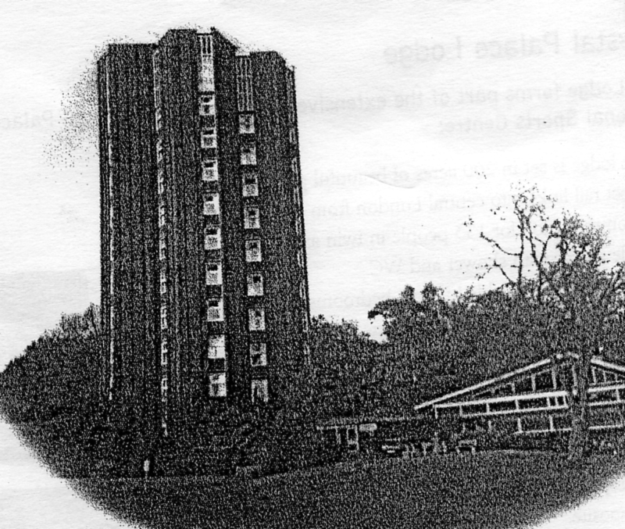

Crystal Palace Lodge and Paxton Suite Conference room

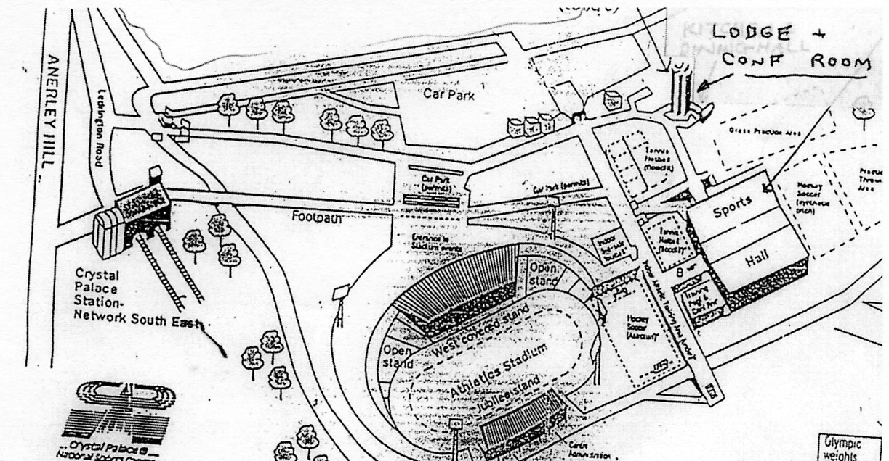

The Lodge is within easy walking distance from Crystal Palace Station and there are plenty of car parks in the grounds near the lodge

Those wishing to stay at the Lodge should mention when they write that there is a block booking in the name of the Exhibition Study Group for single and double rooms. The address to write to is Crystal Palace National Sports Centre, Ledrington Road, London. SE19 2BB. The price for B & B is £28.10 per person, for a single or double room. Unfortunately this is a Sports Centre and there is no accommodation with en-suite rooms, but on the good side there are plenty of single rooms with no surcharge. When I say there is no en-suite rooms this is not quite correct. The accommodation block is divided into units of one single and one double room with a shared W.C. and shower between them for each unit. So it’s a half-en-suite. The facilities are not shared by any of the other units.
The Lodge forms part of the extensive complex that is Crystal Palace National Sports Centre, it is set in 200 acres of beautiful park land, Direct rail links into Central London from Crystal Palace. Accommodation for 135 people in twin and single rooms with shower and WC. Televisions are available in most bedrooms. There is a choice of relaxation areas for guests to use.
They have a variety of conference rooms to cater for business groups of 10-150 people and can provide any audio-visual equipment required. They can provide refreshments throughout the day and you can choose from a selection of buffet style lunches from their menu. The standard package consists of bed and breakfast but they will also cater for lunch and dinner requirements as well. There is a number of buffet options for meeting groups.
For those of us who will be staying Friday night as I shall, may I suggest a short walk, it’s not far enough to take the car. When you come out of the Park you come on to Anerley Hill and if you cross this road diagonally walking downhill you come to the Paxton Arms on the right hand side. This is where I suggest we meet on the Friday evening. When we know numbers the Study Group will organize food for Saturday and Sunday. Those booking in on the Friday will have to organize their own supper.

Jack Murray is not a member of the Study Group, but I have known him in a very casual way for some years, first bumping into him at the York Post Card Fair when we are both looking for exhibition cards and got chatting. We have met thus several times and started corresponding, and on one occasion he told me he was wanting some ‘Olympic dates’ which I was able to help him with, his main interest is Football and he recently sent me some notes and illustrations from his collection, which I have used to put together a short article on football at exhibitions. The last chapter is by myself blowing my family trumpet.
Bill Tonkin

Football at the Exhibitions
by
Jack Murray

Glasgow International Exhibition 1888.

The 1888 Exhibition site was built partly on the grounds of Glasgow University and the present site of Glasgow Art Galleries. The exhibition was officially opened by the Prince and Princess of Wales on 8 May 1888. Queen Victoria attended on 22 August 1888 on an official visit and two days later on 24 August 1888 attended on a private visit. The exhibition was very successful and was finally closed on 10 November 1888.
As part of the exhibition attractions there were a number of football matches played at the exhibition’s small stadium between Scottish teams of the 1888 era and proved very popular. Over a number of weeks the teams competed for Exhibition Medals and in the final match of two Glasgow teams ‘Cowlairs’ (North of Glasgow) and Glasgow Celtic (East End of Glasgow) played each other ending in a 2-0 victory for ‘Cowlairs’. It should be noted that 1888 was the year that Glasgow Celtic F.C. was founded.

Glasgow International Exhibition 1901. and the Exhibition Cup.

Like the 1888 Exhibition it was decided by the organizers of the 1901 Exhibition that as part of the attractions of the Exhibition various sporting activities would take place in the ‘Exhibition Stadium’ which had been upgraded on the site of the 1888 ground. A new stand was constructed together with a cycle track but by far the most popular sport held at the stadium was the football matches played between the teams from Celtic, Hearts, Hibs, Morton, Queens Park, Rangers, St. Mirren and Third Lanark. The Cup final was finally contested between Rangers and Celtic ending in a 3-1 victory for Rangers who trooped off with the magnificent Exhibition Cup, on 9 September 1901

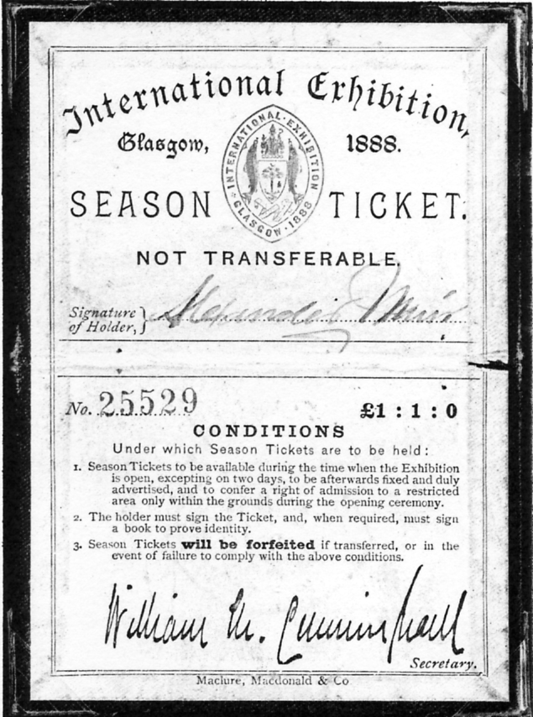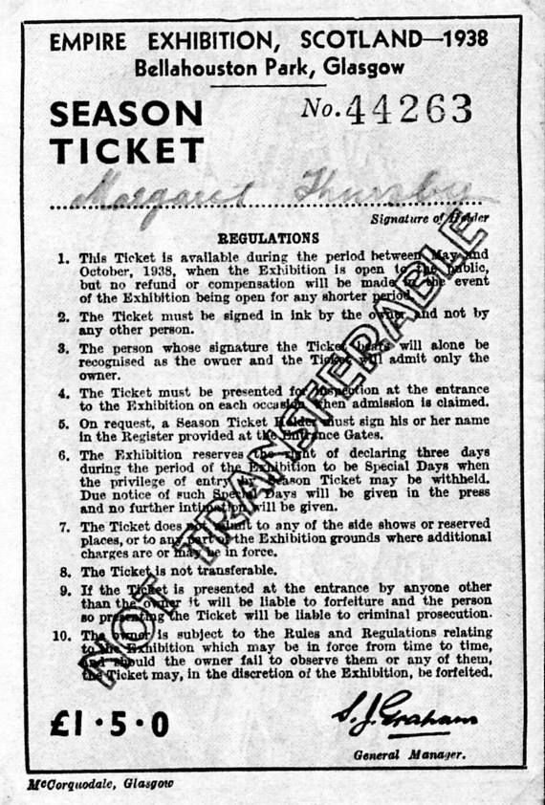

Glasgow 1888 season ticket Glasgow 1938 season ticket

Sadly the following year during an International match between Scotland and England, part of the new terracing at Ibrox Park collapsed killing and seriously injuring many spectators. As a result of this disaster Rangers and the Scottish Football Association were faced with a monumental compensation bill for the victims involved in the collapse. The clubs Directors therefore agreed to place their recently won Exhibition Cup as a permanent prize for the winners of a competition to raise funds to meet the clubs money problems. Two English and two Scottish teams agreed to participate in the tournament, namely, Everton, Sunderland, Celtic and Rangers. With both English teams being eliminated it was once again Celtic v Rangers and this time after extra time Celtic triumphed 3-2 and the trophy now rests in the Celtic Boardroom after that epic game.
An interesting footnote is that another Celtic / Rangers clash was arranged a couple of months later, again in aid of the Disaster Fund and sponsored by Bovril in the form of medals. The outcome, at Hampden on August 20th, was more conclusive, Celtic winning 7-2.

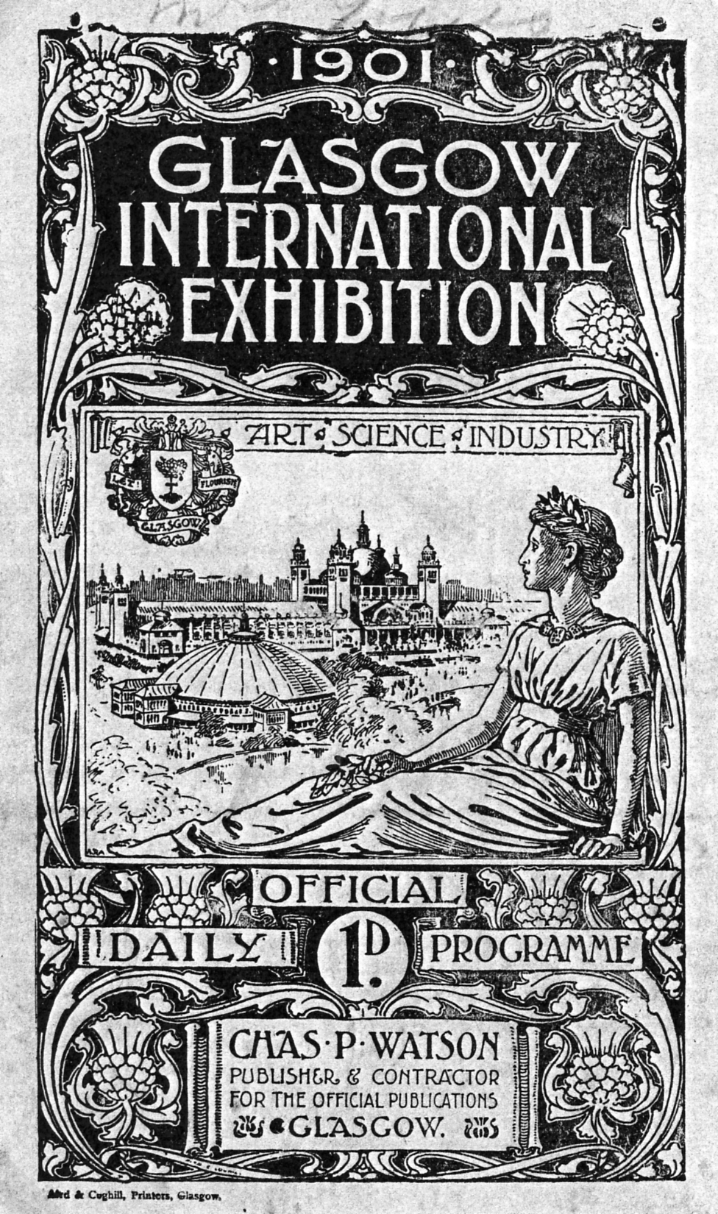

Programme of the 1901 Glasgow International Exhibition. This exhibition also
featured a football competition.

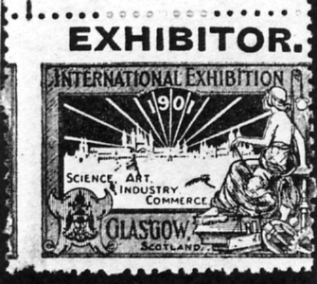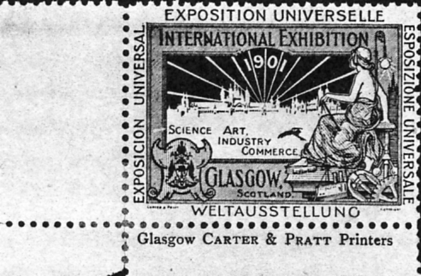

Advertising labels for the 1901 Glasgow International Exhibition. They came in five colours.

Football at the Scottish National Exhibition 1908.

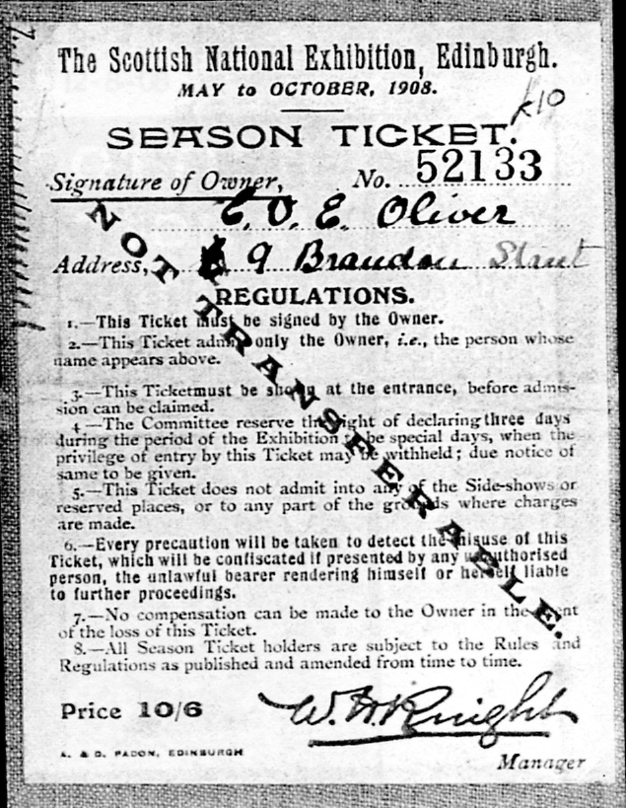

Several Scottish teams participated in the Exhibition tournament which was held at Saughton Park, the name of the Exhibitions site. The final match for the exhibition cup was contested for on 12 August 1908 between Glasgow Rangers and Dundee. After a hard fought 1-1 draw at full time it was decided that a coin would be tossed to decide the tournament winners. Fortune favoured the boys in Blue and Rangers returned with the Exhibition Cup.

Empire Exhibition 1938 at Bellahouston Park.
The Empirex Cup - 10 June.

As in all previous Scottish Exhibitions, with the exception of the 1911 Exhibition, Football competitions were a great crowd puller. Once its was decided to hold a competition for the 1938 event, the trophy was known as “The Empirex Cup” and that all matches would be played at Ibrox Park, the home of Glasgow Rangers who had featured prominently in all the past exhibitions.

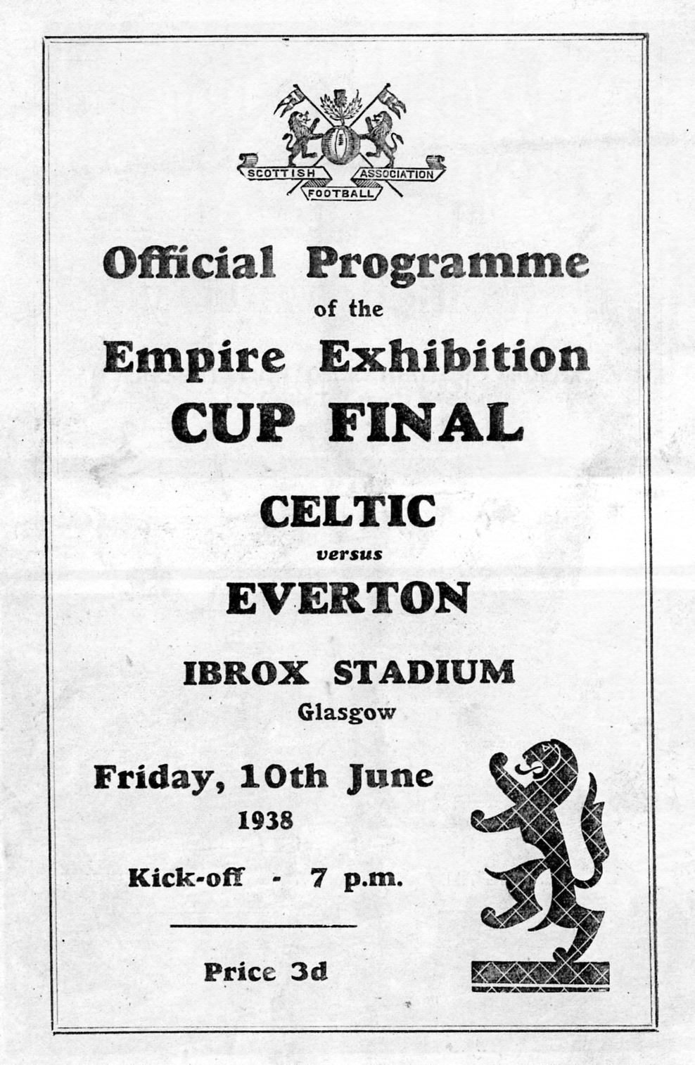

In the case of competitors it was decided that 4 leading English and Scottish clubs would participate. representing England we had Brentford, Chelsea, Everton and Sunderland. Opposing the English teams Scotland called upon Aberdeen, Celtic, Hearts and Rangers.
The games all had very good attendance figures, the competition being decided in a knock-out basis. After somewhat surprising results the final destiny of the “The Empirex Cup” was to be contested by Celtic and Everton on 10 June 1938. The game itself was end to end stuff and was only decided by a single goal scored by Johnny Crum of Celtic. At the conclusion of the match the President of the Exhibition Lord Elgin presented the trophy to Willie Lyon, Celtic's captain.

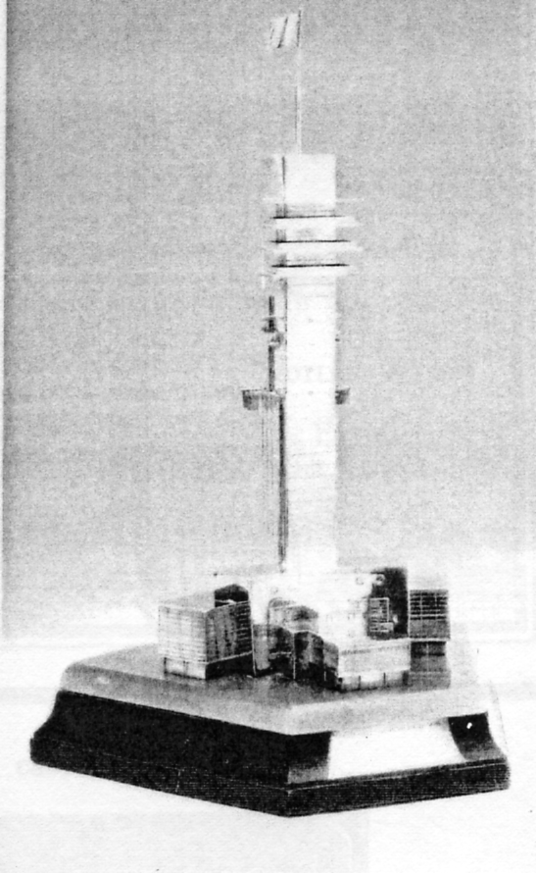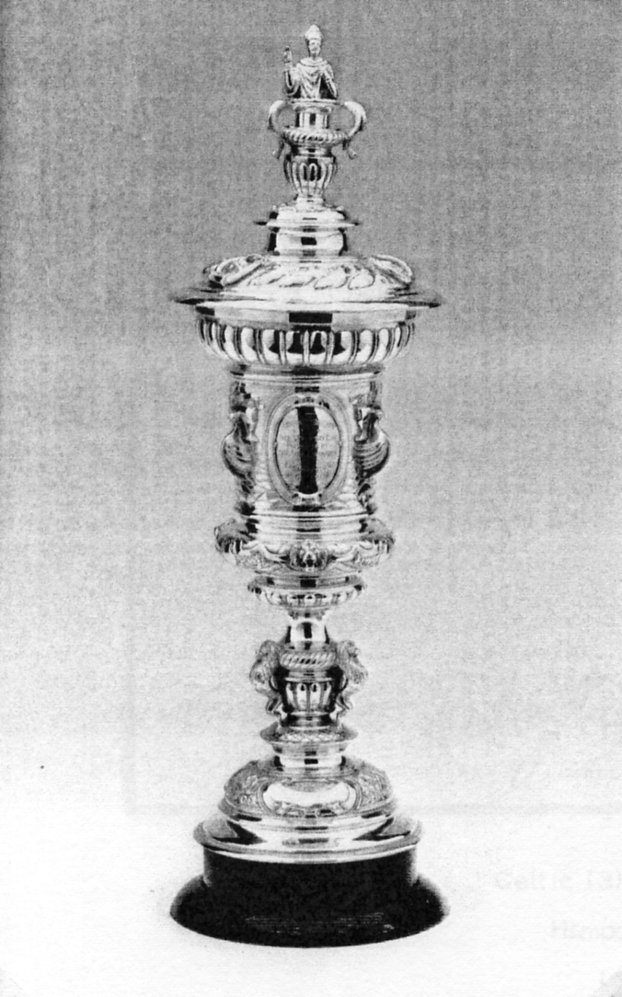

The 1938 Glasgow Empirex Cup. The 1951 Festival of Britain St. Mungo Cup.

Festival of Britain 1951 The St. Mungo Cup.

The football competition organized jointly by Glasgow Corporation and the Scottish Football Association, involved all sixteen clubs of the then First Division. the competition formed part of the ‘Festival of Britain’ celebrations. When the dust settled, Celtic and Aberdeen had duly qualified to face each other in the final on August 1st.
Celtic started badly and fell two goals behind. However, a second-half revival produced goals from Walsh, Fallen and Tully to turn what had looked like a lost cause into yet another ‘one-off’ triumph.
Behind the celebrations, though, was the whiff of parsimony. The handles of the curiously-constructed trophy had been fashioned in the shape of a salmon, one of the emblems of Glasgow. When one of these handles came away in a Celtic hand, suspicions were aroused as to the trophy's pedigree.
Investigations showed that the St. Mungo Cup was, at best, second-hand! Dating back to 1894, its history was somewhat hazy, though it was known to have been the object of a match between Provan Gasworks and Glasgow Police. For the record, the Gasworks were victorious!
Apparently, some luminary had conceived a plan to refurbish and recycle the relic as a cut-price ‘St. Mungo Cup’. Despite Celtic's understandable protestations, no replacement was made and so it is that the hybrid trophy retains a prominent place in the main trophy cabinet at Celtic Park.

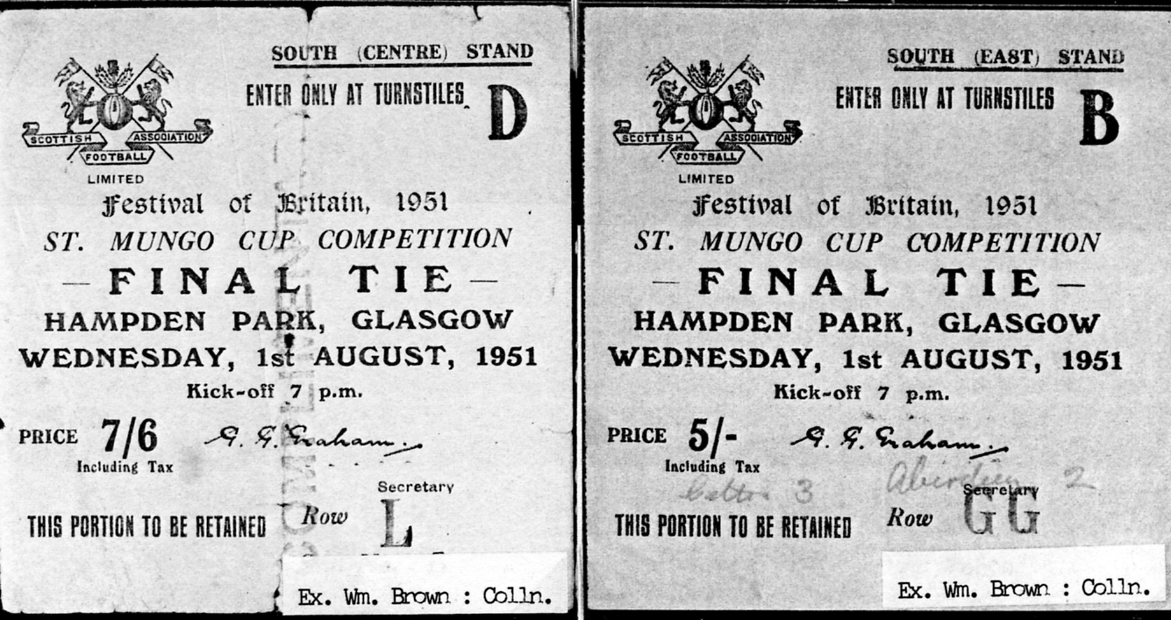

Tickets for the 1951 Festival of Britain St. Mungo Cup Competition.

1966 World Cup Winners Trophy at Stampex

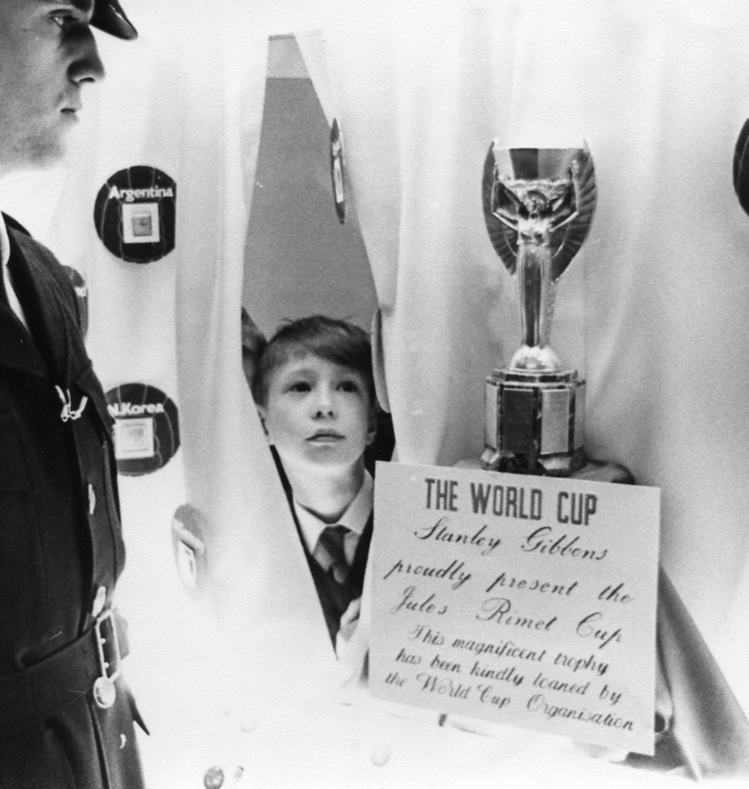

Kenneth Tonkin caught sussing out the joint only hours before the Rimel Cup was stolen.

In 1966 A. Wedgewood Benn was to open Stampex but shortly before the opening the Labour party went to the country and while Stampex was on there was no Postmaster General in office. One Saturday morning his parents had a visitor, and the man asked if he could speak to Kenneth. He was invited in and for a few minutes he spoke to Kenneth about stamps. He then introduced himself as a Director of Stanley Gibbons and explained that the organisers of Stampex had been left without anybody to officially open Stampex. It had been suggested that a lad of eleven, the youngest person to ever win a major trophy at Stampex, might possibly be suitable to perform the task. and he had been sent to interview the boy to see if he was suitable and willing. He said he was very impressed and we would be hearing more in due course.
Kenneth was due to change schools but we felt he should go in the uniform of his old school and Nancy took him out to get a new uniform. During the fitting the shop keeper said to my wife “You want to get a jacket over size as lads of that age shoot up very quickly” No said his mother I want a perfect fit “He will only wear it for one day”.
He had several perks, one was the football with the signatures of The Brazilian team who were the previous World champions. Wedgwood Benn was to have been presented with a special Stanley Gibbons G. B. Commemorative album bearing his name gold blocked and filled with the commemorative stamps issued during his reign as Postmaster General, and this too was given to Kenneth, who still has it. The football he held onto for a year and then sold it and spent the money on extending his Q. E. II Castle High Value collection. At the time a young boy opening Stampex made quite a stir and Kenneth was invited to appear on a radio program with Larry Adler who gave him a mouth organ. Also a lady sent him some Boer War covers from a relation who died in South Africa.

The F. A. Cup Finals at Crystal Palace.
by
Fred Peskett

The Football Association Cup Finals were held in the grounds of the Palace from 1895 to 1914 on a site which is now the National Sports Centre.

Year Score Score Gate

1895 | Aston Villa | 1 | v | West Bromwich Albion | 0 | 42,560
1896 | The Wednesday | 2 | v | Wolverhampton Wanderers | 1 | 48,836
1897 | Aston Villa | 3 | v | Everton | 2 | 65,891
1898 | Nottingham Forest | 3 | v | Derby County | 1 | 62,017
1899 | Sheffield United | 4 | v | Derby County | 1 | 78,833
1900 | Bury | 4 | v | Southampton | 0 | 68,945
1901 | Tottenham Hotspur | 2 | v | Sheffield United | 2 | 114,815
Replay at Bolton |  | 3 |  |  | 1
1902 | Sheffield United | 1 | v | Southampton | 1 | 76,914
replay at Crystal Palace |  | 2 |  |  | 1 | 33,068
1903 | Bury | 6 | v | Derby County | 0 | 63,102
1904 | Manchester City | 1 | v | Bolton Wanderers | 0 | 61,374
1905 | Aston Villa | 2 | v | Newcastle United | 0 | 101,117
1906 | Everton | 1 | v | Newcastle United | 0 | 75,609
1907 | The Wednesday | 2 | v | Everton | 1 | 84,584
1908 | Wolverhampton | 3 | v | Newcastle United | 1 | 74,967
1909 | Manchester United | 1 | v | Bristol City | 0 | 71,401
1910 | Newcastle United | 1 | v | Barnsley | 1 | 77,747
Replay at Goodison Park |  | 2 |  |  | 0
1911 | Bradford city | 0 | v | Newcastle United | 0 | 69.098
Replay at Old Trafford |  | 2 |  |  | 0
1912 | Barnsley | 0 | v | West Bromwich Albion | 0 | 54,556
Replay at Bramall Lane |  | 1 |  |  | 0
1913 | Aston Villa | 1 | v | Sunderland | 0 | 120,081
1914 | Burnley | 1 | v | Liverpool | 0 | 72,778

The original Crystal Palace Football Club was formed in 1861 by members of the Crystal Palace Company staff. In 1871 the first Football Association Challenge Cup event was founded with Crystal Palace joining fourteen other teams to take part in the "Challenge".
They were:- Barnes, Civil Service, Clapham Rovers, Donnington School, Hampstead Heathens, Harrow Chequers, Kitchen, Maidenhead, Marlow, Queens Park (Glasgow), Reigate Priory, Royal Engineers, Upton Park and Wanderers.
In the 1871-72 competition Crystal Palace reached the Semi-final by beating Maidenhead 3-0 only to be beaten by the Royal Engineers 3-0 in the Semi, this was played at Kennington Oval and was the furthest a Palace team has ever progressed in the history of the "Cup". Crystal Palace Football Club applied in 1904 to join the F.A. Southern League, however, this was turned down for the reason that their ground was used for the Cup Finals and would give Crystal Palace an unfair advantage, to overcome this objection a new company was formed and became tenants of the ground and subsequently joined both the Southern League and the United League.
In 1914 the Crystal Palace and Grounds were taken over by the Admiralty as part of the newly formed Royal Naval Division. Crystal Palace F.C. moved their home to Herne Hill and four years later to the “Nest” at Selhurst Park. It was in 1920 that the F.A. decided to extend the League and form a Third Division from the clubs in the South of England. Thus, Crystal Palace Football Club had taken some sixty years to transform from a group of dedicated members of the Crystal Palace Company to a fully fledged member of the Football League, maybe one day they may even progress further than the Semi Final of the F. A. Cup!

Newspaper Exhibition at the British Library

Alan Sabey tells me there is an exhibition on at the British Library in Euston Road on Newspapers, and amongst the free handouts are reproductions of some early newspapers, including a front page relating to the closing of the British Empire Exhibition in November 1924. The exhibition is open until the 8th October 2006.

War Horses

We have a new member Mrs Gaynor Renwick who is interested in War Horses as her Grandfather bred a horse who became a champion and was sold to Austria, I believe just before the First War. Gaynor is seeking information and if you know anything about War Horses at Olympia she can be reached on 020 8543 5107. I know for the 1910 Royal Tournament there are several cards showing ‘Britannia and her War Horse’.

Post Cards of the White City.
Part 35.
by Bill Tonkin

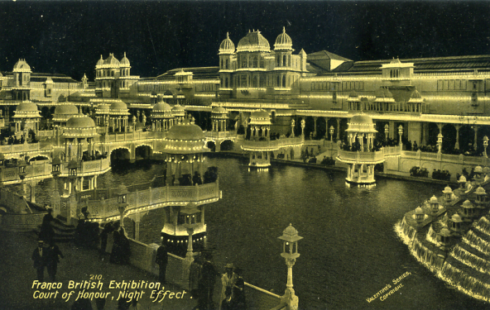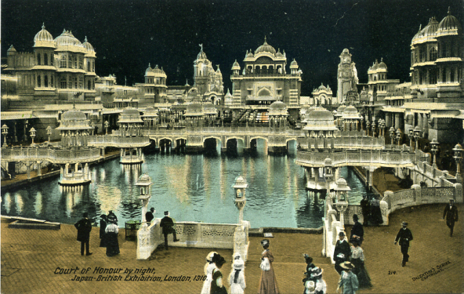

Type 19. No. 210, night scene looking at Type 20. No. 214, night scene looking
lake at an angle, close up of cascade at right. almost directly down lake towards cascade,
man with leg raised looking at water.

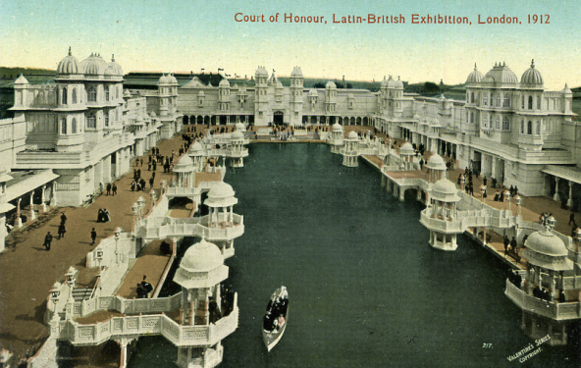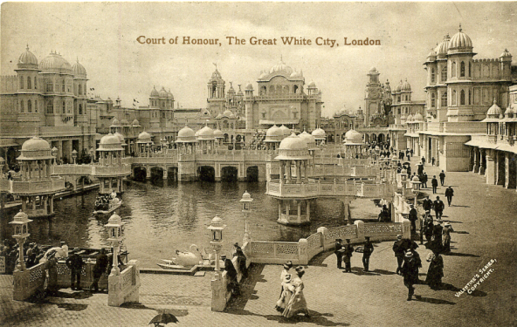

Type 21. No. 217, looking down lake away Type 22. No. 248, looking down lake
from cascade, boat full of passengers at towards cascade, at bottom right of centre
bottom slightly left of centre. two ladies with child.

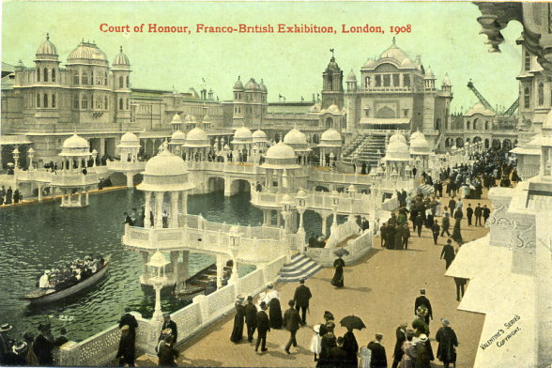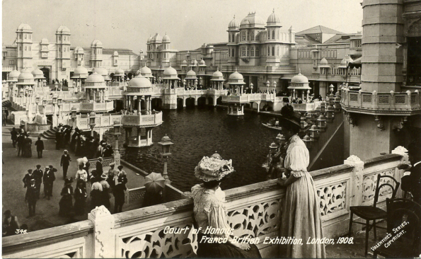

Type 23. No. 250, looking down lake towards Type 24. No. 346, close up of two ladies
cascade, on right pathway, boat in bottom left one seated, on balcony looking down at
corner. lake.

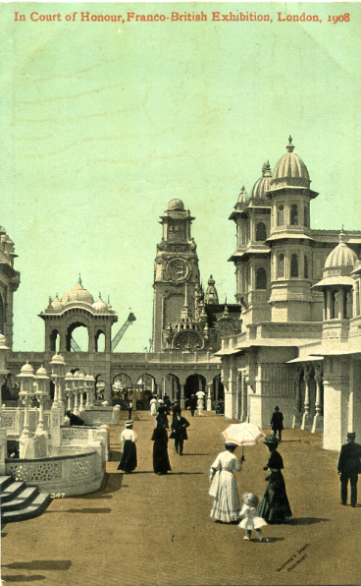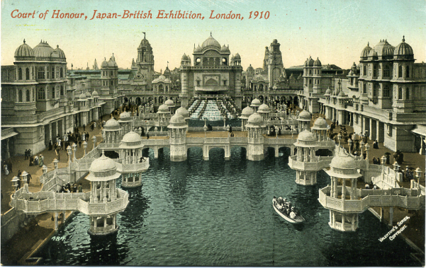

Type 25. No. 347, two ladies with small Type 26. No. 484, looking from a central
child at bottom, one holding an umbrella. position straight down the lake towards the
cascade, boat at bottom right.

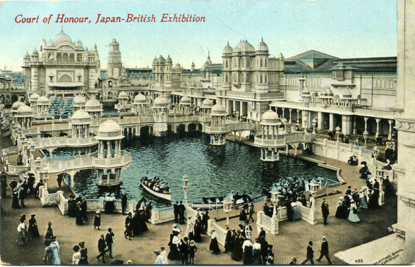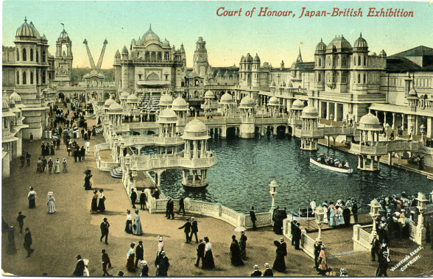

Type 27. No. 485, oblique view towards Type 28. No. 488, the bottom and left is
cascade, two boats at landing stage and taken up by a pathway and there is a group
one approaching. of visitors waiting to board a launch.

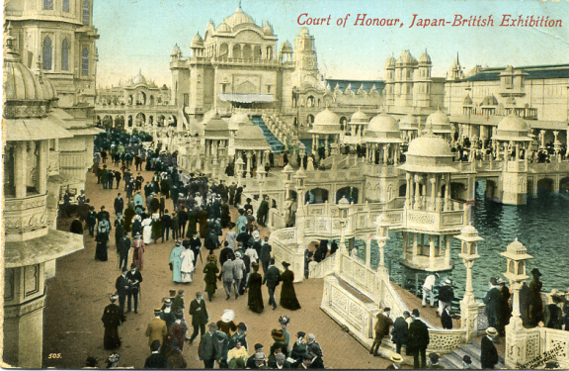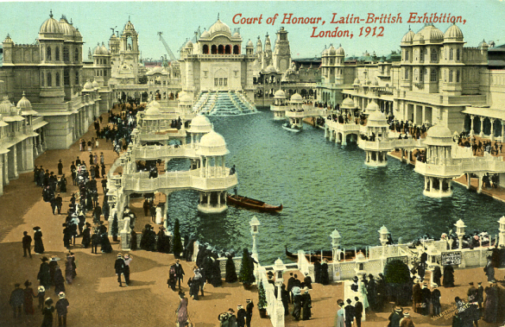

Type 29. No. 505, angled view towards Type 30. No. 836, looking down lake
cascade, wide pathway on left full of visitors. towards cascade gondola by first pier on
left.

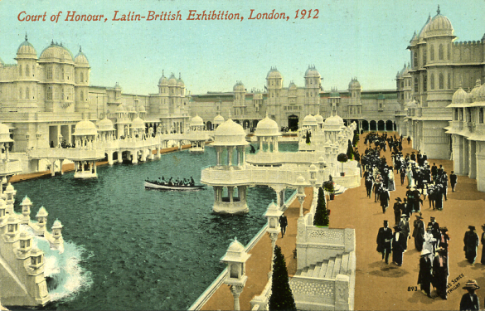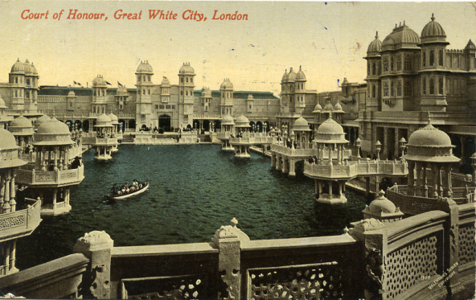

Type 31. No. 843, angled view down the lake, Type 32. No. 844, looking down the lake close up of cascade at bottom left corner. from the balcony over the cascade.

There were four pre exhibition forerunners published for the Franco-British Exhibition and they made use of the three varieties of title, ‘Court of Honour’, ‘In Court of Honour’ and ‘In the Court of Honour’ some using more than one title. As usual none of the forerunners were numbered. Three were horizontal listed as type 1 to 3 and one was vertical listed as type 4.
After these are listed the cards that were published without a number or where a card bearing a number has not yet been found. These are listed as type 5 to 7. This is followed by cards where the number is known, although since Valentine’s did not number all their cards, there will be some noted in the list without a number. The different types are listed in numerical order from type 11 to 27. The numbered cards are 112, 162, 168, 182, 184, 187, 196, 217, 248, 250, 346, 347, 484 and 488.

Type 1. This is a view looking down the lake towards the cascade, there is a wide pathway on the right and in the centre of the bridge is a woman with an umbrella. The view shown on this card is taken from a photograph and has been extensively gone over by an artist, who besides drawing in many weak lines has also added a lot of people to the scene. At the bottom right the iron railings which were later replaced with concrete, have been redrawn and now appear as a patterned concrete balustrading. On this card some are found without ‘Valentine’s Series Copyright’, others have it at an angle. This is not the only variation as the titles on the R/Photo cards have been written in two different styles, with squat and tall letters.
Court of Honour, Franco-British Exhibition, London, 1908. (A pre exhibition forerunner.)
This card is known with and without ‘Valentine’s Series Copyright’.
B/W litho, sunk plate with large white border black ‘Throughout the World’ back type FB 2.
N.n. Split title in one line at bottom centre, without ‘Valentine’s Series Copyright’.
B/W litho, sunk plate with large white border grey ‘Throughout the World’ back type FB 2.
N.n. Split title in one line at bottom centre, without ‘Valentine’s Series Copyright’.
B/W litho, sunk plate with large white border greenish grey ‘Throughout the World’ back type FB 2.
N.n. Split title in one line at bottom centre, without ‘Valentine’s Series Copyright’.
B/W litho, grey ‘Throughout the World’ back type FB 2.
N.n. title in one line at top left, without ‘Valentine’s Series Copyright’.
B/W litho, dark grey ‘Throughout the World’ back type FB 2.
N.n. title in two lines at bottom left, without ‘Valentine’s Series Copyright’.
B/W litho, bluish grey ‘Throughout the World’ back type FB 2.
N.n. Title in two lines at bottom left, with ‘Valentine’s Series Copyright’.
B/W litho, greenish grey ‘Throughout the World’ back type FB 2.
N.n. Title in two lines at bottom left, with ‘Valentine’s Series Copyright’.
Coloured, dark grey ‘Throughout the World’ back type FB 2.
N.n. Title in one line at top right, without ‘Valentine’s Series Copyright’.
Coloured, grey ‘Throughout the World’ back type FB 2.
N.n. Title in one line at top right, without ‘Valentine’s Series Copyright’.
Coloured, greenish grey ‘Throughout the World’ back type FB 2.
N.n. Title in one line at top right, without ‘Valentine’s Series Copyright’.
Coloured, red ‘F B seal’ back type FB 1.
N.n. Title in one line at top right, with ‘Valentine’s Series Copyright’.
N.n. Title in one line at top left, with ‘Valentine’s Series Copyright’. This is also known printed on very thick card.
N.n. Title in one line at top right, without ‘Valentine’s Series Copyright’.
N.n. Title in one line at top left, without ‘Valentine’s Series Copyright’.
Sepia R/Photo, black ‘X L’ back type FB 11.
N.n. Title in one line at bottom centre in tall letters, with ‘Valentine’s Series Copyright’.
N.n. Title in one line at bottom centre in squat letters, without ‘Valentine’s Series Copyright’.
Sepia R/Photo, brown ‘Throughout the World with Carte Postale’ back type FB 4.
N.n. Title in one line at bottom centre in squat letters, without ‘Valentine’s Series Copyright’.

Type 2. Looking through four very ornate columns with three ornamental branches at the top, towards the Court of Honour. On this title ‘Valentine’s Series Copyright’ on the front can be found in four types. Some cards were published without the imprint and are listed as ‘without Valentine’s Series Copyright’, some have a split imprint with the words reversed, ‘Copyright’ on the left and ‘Valentine’s Series’ on the right, listed as ‘with a reversed split Copyright Valentine’s Series’, some have the imprint in two lines in a horizontal position, listed as ‘with a horizontal Valentine’s Series Copyright’ and the imprint can also be found printed at an angle, listed as ‘Valentine’s Series Copyright at an angle’. If the angled imprint is on the left this is noted, if it is on the right this is not listed as this is the normal position.
In Court of Honour, Franco-British Exhibition, London, 1908. (A pre exhibition forerunner.)
B/W litho, sunk plate with large white border, deep green ‘Throughout the World’ back
type FB 2.
N.n. Split title in one line at bottom centre, with a reversed split ‘Copyright’ and ‘Valentine’s Series’, the gap measures 75 mm.
B/W litho, sunk plate with large white border, deep green ‘Throughout the World’ back
type FB 2.
N.n. Split title in one line at bottom centre, with a reversed split ‘Copyright’ and ‘Valentine’s Series’, the gap measures 78 mm.
B/W litho, sunk plate with large white border, grey ‘Throughout the World’ back type FB 2.
N.n. Title in two lines within the picture at bottom right, without ‘Valentine’s Series Copyright’.
B/W litho, sunk plate with large white border, bluish grey ‘Throughout the World’ back
type FB 2.
N.n. Split title in one line at bottom centre, with a reversed split ‘Copyright’ and ‘Valentine’s Series’, the gap measures 75 mm.
B/W litho, sunk plate with large white border, greenish grey ‘Throughout the World’
back type FB 2.
N.n. Split title in one line at bottom centre, without ‘Valentine’s Series Copyright’.
N.n. Split title in one line at bottom centre, with a reversed split ‘Copyright’ and ‘Valentine’s Series’, the gap measures 75 mm.
N.n. Split title in one line at bottom centre, with ‘Valentine’s Series Copyright’ at a slight angle.
B/W litho, deep green ‘Throughout the World’ back type FB 2.
N.n. Title in two lines at bottom right, with ‘Valentine’s Series Copyright’ at a slight angle.
B/W litho, grey ‘Throughout the World’ back type FB 2.
N.n. Title in two lines at bottom left of centre, without ‘Valentine’s Series Copyright’.
B/W litho, greenish grey ‘Throughout the World’ back type FB 2.
N.n. Title in two lines at bottom right, with ‘Valentine’s Series Copyright’ at a slight angle.
Coloured, grey ‘Throughout the World’ back type FB 2.
N.n. Title in two lines at bottom right, without ‘Valentine’s Series Copyright’.
N.n. title in two lines at bottom right, with a horizontal ‘Valentine’s Series Copyright’.
Coloured, greenish grey ‘Throughout the World’ back type FB 2.
N.n. title in two lines at bottom right, with a horizontal ‘Valentine’s Series Copyright’.
Coloured, red ‘F B seal’ back type FB 1.
N.n. title in two lines at bottom right, with a horizontal ‘Valentine’s Series Copyright’.
Sepia R/Photo, black ‘X L’ back type FB 11.
N.n. Title in one line at bottom centre, without ‘Valentine’s Series Copyright’.

Type 3. There is a sloping ramp with a flight of steps on each side, with a man carrying stick walking up steps onto the bridge over the Court of Honour. On this card ‘Valentine’s Series Copyright’ on the front can be found in three types, see notes above for type 2
In Court of Honour, Franco-British Exhibition, London, 1908. (A pre exhibition forerunner.)
B/W litho, sunk plate with large white border, greenish grey ‘Throughout the World’
back type FB 2.
N.n. Split title in one line at bottom centre, with a reversed split ‘Copyright Valentine’s Series’.
Sepia R/Photo, black ‘X L’ back type FB 11.
N.n. Title in one line at bottom centre, without ‘Valentine’s Series Copyright’.
Title altered to, In The Court of Honour, Franco-British Exhibition, London, 1908.
Coloured, grey ‘Throughout the World’ back type FB 2.
N.n. Title in one line at top left, with a horizontal ‘Valentine’s Series Copyright’ to the left.
N.n. Title in one line at top right, with a horizontal ‘Valentine’s Series Copyright’ to the left.
Coloured, red ‘F B seal’ back type FB 1.
N.n. Title in one line at top right, with a horizontal ‘Valentine’s Series Copyright’ to the left.

