EDITORIAL SPRING 2006

Another year older and not much wiser
hoarding my cards like an old time miser

Exhibitions are not my only interest, I got hooked on Jazz over 60 years ago and still go to Jazz clubs regularly. I’ve just bought an Album of eight CD’s the complete American Library of Congress recordings made by Jelly Roll Morton in 1938. The masters stayed in their archives until 1947 when they were issued in a limited edition of 200 sets of 45 12 inch 78 records. The 78’s were never available in this country and when I saw recently that they had been reissued as eight CD’s I ordered a set. Just in time as I got the last set the distributer had. On the first CD Jelly starts off, “When I was down on the Gulf Coast in 19-4 I missed going to the St. Louis Exposition to get in a piano contest which was won by Alfred Wilson of New Orleans. I was very much disgusted because I thought I should have gone. I thought Tony Jackson was going to be there and that sort of frightened me”. Jelly thought he could have beaten Wilson but at that time wasn’t going to risk competing against Tony Jackson. The organisers of the St. Louis Exposition commissioned another famous coloured pianist Scott Joplin to compose a tune for the Exposition, which he did, naming it ‘The Cascades’ a beautiful tune capturing the sound of the water rippling down the cascade. So you see even when I’m playing records, exhibitions are there lurking in the back ground. The first recordings of Joplin’s Cascades would only have been available on piano rolls, as although records had been invented and marketed as early as 1898, those first 7 inch Berliner’s were regarded as a toy. A lot of Joplin’s Rags were later made available on long playing records but they were all transcribed from his original piano rolls, he had probably stopped playing before recording on wax became popular.
I went down to the Shepton Mallet two day post card fair and did jolly well, in fact I got 113 post cards. I haven’t had such good results for years. I put this down firstly to Mike not going through the dealers stock before I can get in the front door, and secondly, as I now go to so few fairs, it gives the dealers time to accumulate a few goodies. Three of the cards were definitely of hat throwing in the air quality. I shall go to York at the end of March, but as I got so many at Shepton only four weeks before York I don’t expect to do so well at York this year.
I have wonderful lodgings at Alweston and enjoy a few days away. I stayed there Thursday and Friday night and another Study Group member Ken Rumsey joined me at Alweston on the Friday night. Since Barry Rollison moved the fair from Yeovil to Shepton Mallet I now have about a 50 minute journey from Alweston to Shepton Mallet, but the accommodation is so good where I stay, I’m not interested in finding somewhere nearer. On the Saturday night I stayed with another two members of the Group, Ann and Ted Stevens who actually live in Shepton Mallet, so they only had to go just round the corner to the fair. Ted kindly gave me a reprint of No. 1, the first issue of ‘The Wells Journal - Frome - Shepton Mallet - Glastonbury and Axbridge Gazette’ dated 2 August 1851 which had a report on the Great Exhibition. I have included it in this Journal as I thought it may be of interest to members. That makes three articles relating to the Great Exhibition in this Journal, they all came in at once.
The British Empire Exhibition 1924 Maps seem to have come to life after being dormant for some time. When I did the first article on Wembley maps in 1998 I was able to list only 13 different adverts on the backs of the maps. The number has now reached 40, which I think is a jolly good effort on the part of the members of the group. It just shows what can happen in the way of original research when a number of members join in. In the beginning of 1999 I did another article going into more detail on some of the maps which had by then reached No. 26. That was seven years ago, and although there has been a few up-dates I think it is about time I re-published the whole list as it stands now.

The Editors
Subscriptions

If there are any members who have not yet paid their subscriptions, they are now well overdue. Get a cheque off to Alan Sabey. Better still make out a standing order, then you will not have to remember it each year. The Study Group is fortunate in not having to increase the subscription every few years to allow for inflation. Long may this happy state of affairs last.

20th Convention Saturday 23 and Sunday 24 September 2006

Don Knight sent me the signed booking forms for our 2006 Convention, and a few weeks ago I took them up to the Crystal Palace Sports Centre and handed them in. While up there I had a look at the accommodation and there are plenty of single and double rooms, unfortunately none of them en-suite, but there are toilet facilities on each floor. One of the problems with hotels is they are usually very short on single rooms. I was impressed with how clean the rooms were, it has to be said they are rather spartan, it is after all one of our leading sports centres, catering for athletes and their coaches etc. and not a five star hotel. We shall have sole use of the “Paxton Suite” where we shall hold our convention and Saturday evening Annual Dinner. It is ideal and the Crystal Palace Sports Centre will not be charging us for the use of it. When I saw it, it was laid up for a Probus Luncheon and looked very nice, they also do a Rotary dinner there once a month. The prices given me for bed and breakfast is £28.10 per person, and double this if you have a twin bedded room.
Mike Perkins has been staying with me for a few days and I took the opportunity to make a second visit with him. This time visiting several pubs close to the Crystal Palace Park. The one I liked best, is just across the road, about five minutes from the entrance to the park, and when we saw it, seemed a very pleasant pub with a nice lounge. With the name “Paxton Arms Hotel” how can we go wrong. I must admit that for the Friday evening I would rather sit in a nice pub for a chat and a drink. Seventeen shops down the hill from the pub we come (or we would have come about 80 years ago) to the shop of William Peskett the butcher, who is I believe related to another well known Peskett, our Fred no less.
The Crystal Palace Sports Centre is situated in the middle of the Crystal Palace Park, within easy walking distance of the Crystal Palace Museum and the monsters made by Benjamin Waterhouse Hawkins who was commissioned to create the monsters in September 1852 ready for the opening in 1854.
From London Bridge or Victoria trains go to the Crystal Palace Low Level railway station which is situated at one entrance to the Crystal Palace Park and for those coming by train it’s less than ten minutes walk to the Sports Lodge where we shall be meeting and sleeping. For those coming by car there is a large car park at the Sports Lodge, and other car parks in the grounds to take 1,000 cars.
We last held a convention at the Crystal Palace in 1992 and there have been plenty of changes, the monsters have all been renovated at enormous expense, I believe it cost about 2 million. At that time it has to be said there was very little co-operation between the Crystal Palace Foundation and the Study Group. They would not even lay on a guided tour for us. Their secretary advised me to go on one of their tours, listen to the guide and then I could do it myself. I did go on a tour and at the end asked the guide if he would be prepared to give a personal tour for our party. When he heard the Foundation would not co-operate he was appalled. He made a special journey from his home in Bishops Stortford to guide us round the grounds which was very good of him.
Things are very different with the Foundation now, I have met both the Chairman Melvin Harrison and Vice Chairman Ken Lewington. In fact Melvin has very kindly offered to give a display and talk at our convention. Recently both of them have very generously loaned me their collections of post cards for periods of several weeks, to go through for additions to the book Fred Peskett and I are working on. This is now finished and I am getting in quotes for printing it. The Foundation has already agreed to have it on sale in the museum shop.

Paxton’s Crystal Palace Corner Project
by
John Greatrex
Great Exhibition 2001 Ltd
c/o 8 Grosvenor Court, 16 Anerley Hill, Crystal Palace, London. SE19 2AB

Paxton’s Crystal Palace Corner Project aims to follow in the steps of Joseph Paxton and reconstruct at the site of the Penge Crystal Palace a "Crystal Palace Corner" on the original Palace foundations; This was designed by Paxton & Fox / Henderson and temporarily erected in Hyde Park in 2001 for the BBC 2 series with Adam Hart-Davis: What the Victorians Did For Us. This will be the first Paxton-designed structure to be erected on his old palace site since 1854.
1936 Paxton's Crystal Palace burnt down.
1985 The Crystal Palace Foundation erected an original iron column outside the Crystal Palace Museum in Crystal Palace Park.
2001 A full size cast iron Crystal Palace Corner was temporarily erected in Hyde Park to celebrate
the 150th anniversary of the Great Exhibition This was filmed by the BBC for their series 'What The Victorians Did For Us' with Alan Hart-Davis.
The Crystal Palace Corner was made at the Barr and Grosvenor Iron Foundry, Wolverhampton. Patterns were taken from similar original 1850 castings designed by Paxton and used by Henderson/Fox in the construction of Oxford Railway Station. This station has recently been dismantled and re-erected as the centre-piece of the Buckingham Railway Museum at Quainton, near Aylesbury.
2002 Crystal Palace Corner sections were displayed during the Crystal Palace Victorian Day in Crystal Palace Park.
2003 Crystal Palace Corner sections were displayed at Chatsworth as part of their Paxton Bicentennial celebrations.
2004 Was the 150th anniversary of the opening of the Sydenham Crystal Palace. The celebrations
included a highly acclaimed exhibition at Dulwich Picture Gallery organised by Jan Piggott.
One of the exhibition lectures was on the subject – ‘How to Rebuild the Crystal Palace – well at least a bit of it – the Paxton Crystal Palace Corner Project’. The lecture included a practical demonstration of bolting together the top sections of the Corner.
2005 The corner parts were transported to Crystal Palace Park from the Midlands via the Grand
Union Canal with the grateful help of The Black Country Living Museum, The Friends of The President (steam powered narrow boat), Carter’s Steam Fair and Loughton’s Haulage.
The plan is to unveil the corner by November 30th 2006, the 70th anniversary of the fire.

Joseph and his Amazing Crystal Palace:
by
John Greatrex

Joseph was good at gardening. He liked to grow flowers. He liked to grow trees. But the best thing he ever grew was a crystal palace! This is how it happened.
He wanted to grow a large flower called a lily. It grew in a hot country in South America but he wanted to grow it in England where it was much colder. To keep it warm he made a special house for it. The walls and roof were made of glass. The light from the sun shone through and warmed the air inside. The lily grew and grew. It grew so big he had to make the glasshouse bigger.
Then he heard there was to be a great exhibition in London and a competition to design the exhibition building. He drew a picture of his idea. It was his glasshouse made much, much bigger. It was three times taller, ten times wider and fifty times longer! People loved his idea and called it the ‘Crystal Palace’ because it sparkled in the sunshine like crystal. Because there were some big trees in the park he put extra high roof near the middle to cover them. When the exhibition was over, he took his palace down. All the parts were taken by horse and cart to a hill in south London.
Here the parts were put back together again. Even more parts were needed because he made his second crystal palace even bigger! In it he put lots of plants and a crystal fountain. And in the water around the fountain, guess what he grew?

Joseph and his Amazing Crystal Palace:

Conceived at Chatsworth, doodled at Derby, built int’ Black Country, lent to London, scorched at Sydenham and was cast in Wolverhampton!

A moving story preceded by a one act play. This was read out at our 2005 Hatfield Convention

Scene 1 Edensor Graveyard.
Chorus Alleluia, alleluia, alleluia. (starts quietly and builds up over 30 seconds.)
(Joseph Paxton’s head appears over his gravestone.)
Joe Shut up, for heaven’s sake. Can’t I get a bit of peace and quiet even here.
(Sarah Paxton’s head appears over her gravestone.)
Sarah It’s just the angels, dear. You know they need to practise.
Joe Practice? For what? They’re dead perfect already. In fact everything is too perfectly perfect if you ask me.
Sarah But nobody does, darling.
Joe And don’t I know it. Just because you’re dead people think you’ve nothing more to say.
Sarah They might be right, love.
Joe ‘They might be right love’. When were they ever right about anything?
Sarah You remember Mr. Cole. He always said you were good at hearing but hopeless at listening.
Joe So?
Sarah He was right, and so was Mr. Brunel about the water towers. And so was the Duke - he always thought his young gardener would go far.
Joe Are you trying to flatter me?
Sarah Of course, my precious.
Joe Well, don’t stop.
Sarah Just think , my dear, if you hadn’t weeded your way into my life that bright sunny morning, we might never have found ourselves dying to be together, side by side for all eternity. Isn’t Paradise enough for you?
Joe Heaven’s great - but Earth’s one hell of a place.
(Their heads go down out of sight.)
Chorus Alleluia, alleluia, alleluia.
Side by side, their faces blurred,
The knight and lady lie in stone,
Tombed together through the ages,
Back to back and bone to bone.
But this is now. Let us relate
To you who listen to our story
How a lowly farmer’s boy
Came to wealth and came to glory.
It all began in eighteen one.
No, eighteen three. About his age
He lied to get garden job
(He knew his onions, what a sage!)
His story starts in eighteen-three
In Milton B-R-Y-A-N
(A ‘T’ was added on the tomb
For that’s the way they spelt it then.)
In ‘twenty-six, aged twenty three
The Duke appointed him to be
Head Gardener at Chatsworth House.
He packed his bag and joined by noon
The stagecoach. Soon he hurried north
Through town and village, field and farm,
Throughout that night he chased the moon
To beat the breaking dawn.
I stood outside but not for long.
The gate was locked, I climbed the wall,
A recce’s never wasted.
I put the men to work at once
And breakfasted by half past nine
The best I’d ever tasted.
Ah Mrs. Gregory bakes well:
Your food of rare delight
Fair fills my empty tum.
Yet is there something fairer still,
Your niece, the lovely Sarah. Will
I get to meet your mum
And dad to ask them for your hand,
Your arms, your every part?
We are in love before first light.
Day One - a useful start!
Chorus
Love’s a cockerel, can’t stop crowing,
Tells the sun, “Get up and shine.”
Love’s a trumpet can’t stop blowing,
Love’s a river can’t stop flowing,
Love’s a paddle can’t stop rowing,
Love’s a flag the wind is blowing,
Love is grass that can’t stop growing.
Love’s the seed that we are sowing.
Love’s the know inside of knowing
I am yours and you are mine.
(They exchange wedding rings)
Scene,
The Lily House where Annie stood
In forty-nine is long since gone,
But I have not forgotten
My daughter on the lily pad
(Some say beneath the water line
I placed a brick. How rotten!)
Scene,
At Rotten Row around a tree
With Albert’s help did Joseph P
A stately pleasure dome design:
The greatest greenhouse ever seen,
A glass cathedral on the green,
Beside the crystal Serpentine.
But not for long. Unbolted. Gone.
His gypsy palace journeyed on.
By horse and cart away it went.
Where Lewisham and Lambeth
Walk with Croydon and Southwark
Greets with Bromley on Parade
There is a green hill not so far
From Sydenham where Sir Joseph
Paxton’s palace was remade.
Just up from Penge he set it down.
To north it looked to London Town,
To Surrey south to Kent.
His gypsy palace journeyed free
To where the Effra trickles down
Through sewers under London Town
To the Thames and the cold North Sea

© John Greatrex - May 29th 2002

The Great Exhibition of 1851.
Some facts and figures
by
Fred Peskett

Doubtless you will have read many facts and figures associated with the Great Exhibition of 1851, however, here is a few that you probably have never seen before? The Refreshment Courts and the toilet facilities!
The following has been extracted from The Reports of the Jurors published in 1852, some several thousand pages in three large volumes, I was lucky to find a set of these volumes some years ago in a secondhand book shop in Ryde, Isle-of-Wight. I paid seven pounds for the set, (they had been in the shop for many years, the owner was glad to see the back of them) and very near a hernia getting them back to the ferry and home to Portsmouth. The contents of the volumes, like themselves make very heavy reading, but no expense was spared in the details published, no matter how uninteresting.
The Commissioners for The Great Exhibition contracted the catering arrangements to Messrs. Schweppes who paid the Commission £5,500 for the privilege, by the end of the exhibition they made a profit of some £45,000. The records of the goods sold were very detailed, the Jurors included Schweppes lists in their report.

The amount of refreshments sold was as follows:-

Bread, quarterns 52,094 Savoury Patties 23,040 lbs
Bread, Cottage loaves 60,698 Italian cakes 11,797
Bread, French rolls 7,617 Biscuits 37,300 lbs
Pound cakes 68,428 Bath buns 934,691
3d cakes 36,950 Plain buns 870,027
Savoury cakes 20,415 Banbury cakes 34,070
Savoury pies 33,456 lbs Sausage rolls 28,046
Victoria biscuits 73,280 Mustard 1,120 lbs
Macaroons 1,500 lbs Jelly 2,400 quarts
Rich cakes 2,280 lbs Coffee 14,299 lbs
2d pastries 36,000 Tea 1,015 lbs
School cakes 4,800 Chocolate 4,836 lbs
Preserved fruits 4,840 lbs Milk 33,432 quarts
Pineapples 2,000 Cream 32,049 quarts
Pickles 1,046 gallons Schweppes soda water, lemonade,
Meat 113 tons and ginger beer 1,092,337 bottles
Potted meats / tongues 36,130 lbs Pear syrup 5,350 bottles
Hams 33 tons Rough Ice 363 tons
Potatoes 36 tons Salt 37 tons

No tobacco or alcoholic drinks were on sale at the exhibition. It is interesting to compare the amount of tea sold with that of coffee. Tea was still one of the most expensive products in the mid 1850's.
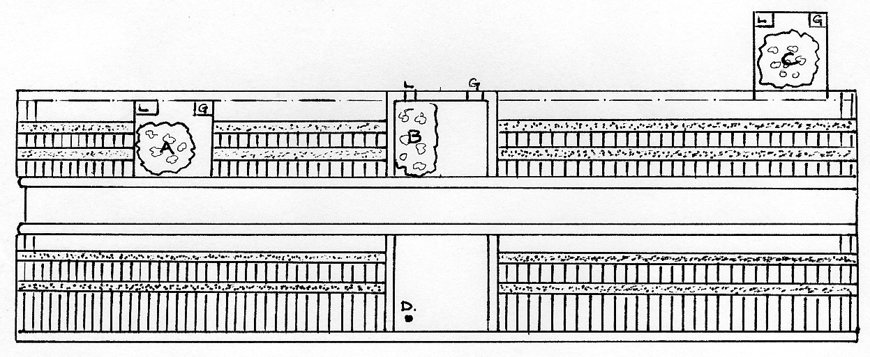

Location of the refreshment rooms, A Western Court
B Transept
C Eastern Court
Location of Post Box and Telegraph D
Location of the Ante-rooms L Ladies
G Gentlemen

Public Toilet facilities (noted in the guide as Ante-rooms) were something new for large gatherings in this country. The Great Exhibition building had some sixty nine toilets, thirty in the Transept, six for the Gentlemen and twenty four for the Ladies, the cost of use was 1d. In the Eastern Refreshment Room there were six for the Gentlemen and eleven for the Ladies the charge was ½d and in the Western Refreshment Room there were ten for the Gents and twelve for the Ladies, the charge was also ½d. In addition fifty four male urinals were provided in the Gentleman's Ante-rooms free of charge.
The cost of setting up and managing the toilets came to £1,600, and with the income from the use of the sixty nine toilets a profit of £1,769..18..6d was made. The records show that 827,820 persons made use of the facilities or 14 % of the total number of visitors over the five months duration of the exhibition. One wonders how the other 86 % managed? 532 lbs of soap and towels to the value of £281..4..8 were used during the exhibition. The toilets were maintained by six male and ten female attendants, overseen by one Superintendent (who received a "For Services" medal). Lavender Water was provided free in all the female washrooms. Lavender Water could also be obtained free from one of the fountains in the Eastern Nave.
There is one dubious postmark said to be from the Great Exhibition, but it is very doubtful. The Juror's Report seems to clarify the postal arrangements for the exhibition: "A “post” has been erected in the Transept, after the fashion used in Belgium, it is a hollow cylinder (tastefully decorated) and in imitation bronze. The post times are inscribed on a ticket on top of the “post”. On average 500 letters per day are dispatched and 300 received, the letter bags are registered and leave thrice a day at 11, 3 and 5. The Postmaster sends for the letter bags, which do not pass through any Branch Office".
I think that the above makes it clear that there never was an exhibition postmark, perhaps only the registration labels tied to the bags may be found one day?

More Wembley Maps
by
Bill Tonkin

I don’t know why, but the other day I went into my front room and switched on computer number 2. I have never got into the habit of checking to see if there are any E-mails regularly so when I do think of it, there is usually a lot. There were two from Jenny Hill who you may remember sent in the articles on crested china in 2002. She had read the article on maps and thought she would check up and see if her three were any different. Jenny couldn’t believe her eyes when she found all three were not recorded and sent me details of them.
One of them her husband Brian had made a mistake in listing the paragraphs and was in fact map no 15, but the other two were new maps, which I have listed as Number 37 and 38.

Contents of different panels on Map number 37.

I. Advert for Mazda Electric Lamps.
K, L, M & N Picture of the Imperial Stadium and text on the British Empire Exhibition. The headings of the paragraphs are, Variety and Colour, The Tomb of Tut, Monster Military Tattoos, and An Empire Parliament.
S. Advert for Mazda Gas filled Lamp and table showing watts, voltage & prices.
T, & U. Advert for Mazda Electric Lamps and the British Empire.
V. Advert for Mazda Vacuum Lamp and table showing watts, voltage & prices.

Contents of different panels on Map number 38.

I. Advert for British Industries Fair 1924. With printers reference P 129/b. 7 mm between box and ‘For fuller etc.’ seven lines of text measures 33 mm deep.
K, L, M & N Picture of the Imperial Stadium and text on the British Empire Exhibition. The headings of the paragraphs are, Variety and Colour, Monster Military Tattoos, A Fellowship of Empire and The Great Home-coming.
S. How the Exhibition began - Primary Purposes - A Co-operative Effort.
T, & U. All the World will be at Wembley, Fifteen miles of Exhibition. Bird’s eye view of the Grounds. (as Fleetway postcard No. 31).
V. Art of the Empire - The Two Georgians - Short Time Exhibits.

It turned out that Jenny had acquired these maps when she was working on her Ph.D. for research purposes, and they were now surplus to requirements. It only needed this hint, for me to make them an offer they couldn’t refuse, and I now have two more maps in my collection. Most of this went on behind Jenny’s back with Brian, and has led to another item of great interest to me.

1925 Salmon British Empire Exhibition Post Cards.

There was a Salmon packet of Wembley post cards on E-Bay and Brian Hill had noticed it was different to the packet mentioned in the Wembley up-date published in 2002. There we listed a packet of six cards sold in a window type envelope at 6 for 9d. The packet on E-Bay was for a set of 8 cards for 1/-. Brian was good enough to contact the seller for me and get a list of the cards in the packet. It then became clear that Salmon reissued their 1924 cards with two extra 1925 cards in the packet for 1/- in 1925.
The two Salmon cards issued for the 1925 exhibition are extremely rare. At the time, about 1990, we were collecting information for our book and had gone to a Salmon Study Circle to try and get evidence of the two cards. The only record we could trace was an entry in the Salmon archives to the effect they had published two cards in 1925, and it was not until our second publication in 2002 that we were able to give No. 2937 its correct title. I later wrote an article for their Salmon Study Group News Letter asking for information on these two cards, and it seems only one member has just one of the 1925 cards. Similarly as far as I know only one member of the Study Group in 1994 had one of the 1925 cards, which some years later I was able to acquire through offering in exchange a card I knew he would like.
Brian tells me the packet on E-Bay went for £70 and if the buyer is reading this he now knows he has two very rare cards.
And now for some more new maps. First of all I have had to change the description of map no 15, so here is the new description. I have recently purchased some maps and when I was able to compared map No. 10 and 15 I found they were both the same, so I have replaced No 15 with a new map.
Contents of different panels on Map number 15.

I. Blank.
K, L, M & N Picture of the Imperial Stadium and text on the British Empire Exhibition. The headings of the paragraphs are, Variety and Colour, Monster Military Tattoos, A Fellowship of Empire and The Great Home-coming.
S, T, U, & V. London Midland and Scottish Railway The Largest Railway in Great Britain and small map. The Special Arrangements, Organisers of Parties.

Contents of different panels on Map number 39.

I. Advert, When at the Exhibition call at the G. W. R. Stands. 1. Palace of Engineering 2 Kiosk (Lakeside West).
K, L, M & N Picture of the Imperial Stadium and text on the British Empire Exhibition. The headings of the paragraphs are, Variety and Colour, Monster Military Tattoos, A Fellowship of Empire and The Great Home-coming.
S. Quick trains by G.W.R. to London for the Exhibition.
T, & U. Travel by G. W. R. to London and Map of Southern England showing rail lines.
V. Special Excursion Bookings at cheap fares. G. W. R. Stations

Contents of different panels on Map number 40.

I. Advert for London Midland and Scottish Railway London now or never. Train in yellow and brown across the back of the map.
K, L, M & N Picture of the Imperial Stadium and text on the British Empire Exhibition. The headings of the paragraphs are, Variety and Colour, Monster Military Tattoos, A Fellowship of Empire and The Great Home-coming.
S.T, U & V. It’s Easy to get to Wembley The London Midland and Scottish Railway Makes it So. Advert printed in brown on yellow. Fares from Glasgow.

The Great Exhibition
An article from a reprint of No. 1 of the Wells Journal Saturday August 2, 1851
sent in by
Ted Stevens

The appearance of the Crystal Palace on this day week seemed to indicate that that most fashionable of days will soon be left mainly to the ticket holders. For some hours after the opening the interior was almost a solitude, chequered, only by the Bath chairs of the invalids that moved slowly to and fro with the most perfect freedom of way. In the afternoon the fashionable loungers mustered in tolerable force, but, after all, the day’s was the smallest assemblage of the season. The scene had not the imposing appearance of a great shilling day, with its thousands of people moving slowly, not by individuals, or by groups, but by masses, and, as it were, by some general impulse; but on the other hand the temperature was delightfully cool, and those visitors who had made the increased pecuniary sacrifice were amply rewarded by the opportunity afforded them for a comfortable and leisurely inspection of the goods, and by the sight of many attractive objects, which are never even approachable on shilling days.
To those who can afford the money, and at the same time find it necessary to study economy in time, Saturday is, undoubtedly, the best day for a visit to the Exhibition, as on that day one can certainly see much more in one day, and in comfort too, than could possibly be managed in five shilling visits. The Fine Arts court is a very mine of attractive objects; but many of these being small, are completely smothered by the crowds who assemble round the Mexican figures and other prominent features.
In the comparative quiet of yesterday we were much struck, for instance, with a specimen of leaf gilding upon plaster, the subject being an equestrian statuette, and the effect that of the most splendid gilt bronze, This figure is very suggestive, as showing how cheap and attainable might be made a now very costly species of ornament. If the aid of the electrotype were brought in, there is no knowing the extent to which this gilding of small plaster casts might be carried,
There are also some fine specimens of carving on shells, which never see the light except on Saturday, a circumstance the more to be regretted when we recollect the patient industry as well as taste that must have been necessary to bring such articles to perfection. One, on ostrich eggshell, is particularly deserving of notice, being ornamented with an elaborate design in relief, cut out of the thickness of the shell.
Many attractive articles are now being gradually released from their obscurity, by being brought from the back courts and placed prominently in the nave. This was perceptible on Friday in the case of the Genevese watches; and yesterday a similar process placed before the public a very singular and beautiful chess table, which was much and generally admired. It is the work of a gentleman named Graydon, and, independently of its costly decorative beauty, displays in its design an amount of antiquarian reading which would have delighted the great Wizard of the North, had he been alive to pore over its chivalric accessories. The pieces, by a happy conception, represent the Saracens and Crusaders; every one, kings, queens, knights, bishops, and pawns having a pedigree showing his connection with the Crusaders. They are all well carved, and have this recommendation, that they are made to be played with, without rough corners to knock each other down, and with such a correct centre of gravity as to stand upright except on very strong provocation. The chess-player will, easily understand the value of this peculiarity. The squares represent the banners and devices of the holy war, and the sides are ornamented with friezes copied from the celebrated ones of Schwanthaler, at Munich. The table itself is Italian walnut, and is supported by saracenic pillars copied from the best authorities. The work has evidently been the result of curious reading, much patience and research, and high veneration for the “game of games”, and only wants, we feel sure, to be more generally known to become the cynosure of at least all chess-players eyes at the Exhibition. Another singular article which Saturday's room gave the visitors an opportunity of examining was the cloth of two colours, exhibited by Mr. Partridge, This very curious fabric, which is intended for military cloaks, is a bright scarlet on one side and an equally bright blue on the other. This art of double dyeing must have been in vogue many years ago, as a piece of cloth of two colours was one of the rarities taken by lord Amherst to China as presents to the Emperor, but its presentation was prevented by the well known rupture of the negotiations. But the art Was subsequently lost, and to the present exhibition belongs the merit of its revival.
The latest arrival has been three tusks of an elephant, the finest specimens ever imported into this country, the property of an English gentleman of fortune, who resided in Southern Africa for a number of years, and these specimens, from the following description, may fairly be entitled the Mammoth tusks, each measuring 8 feet 6 inches in length, by 22 inches in circumference, and weighing 164 lbs. each. They arrived in this country per Bosphorus steamer, from the Cape of Good Hope, and were brought from the immediate vicinity of the Great Lake lately discovered in Southern Africa. They have already attracted the notice of the scientific, and naturalists will, doubtless, be on the qui vive to ascertain to what age the animal could live to produce such huge tusks.
One of the French stands, that of M. Matifat, was enriched on Saturday with some splendid photographs, just arrived from Paris, representing the interior of the Crystal Palace in various aspects, and the most admired groups of statuary. They had been originally taken on glass, and were subsequently transferred to paper in Paris, and are now certainly amongst the most faithful and beautiful of the Exhibition pictures. Among others, the copy of the well-known Godfrey of Bouillon was the subject of general admiration.
But the Exhibition presents almost every day some new attraction to the visitor, .and it is also satisfactory to know that it is producing satisfactory results to the spirited caterers of the feast. As a singular illustration of this, we. may mention that one of the exhibitors of chemical preparations has received more orders, in consequence of the advertisement which the Exhibition has proved to his goods, than he can possibly execute. The same good fruits are being reaped in many of the English departments, and the French, while complaining that the attractions of London have made a thin season in Paris, at the same time admit that what they have lost in customers at present has been amply made up by the orders they have received from London since May 1st. Another instance nearer home is that of Pim Brothers, of Dublin, one of the exhibitors of Irish poplin. Previous to the opening of the Crystal Palace three looms supplied all their orders for poplin, while now forty are barely sufficient, and the trade is still increasing.
It is thus that every day's experience illustrates the soundness of the views which originated this great re-union of the industry of all nations. The juries have all completed their tasks, but their decisions will remain a sealed book until the close of the Exhibition. The finance committee sat on Saturday, and Prince Albert was expected up from Osborne to preside, but the committee were obliged to dispense with the attendance of his royal highness. The only new goods added to the collection were some black silks of a peculiarly rich description, which were for the first time placed in Swan and Edgar’s case in the gallery. The total numbers were 10,399,
The Exhibition continues nearly as attractive as at first, with the exception of the five shilling days, which the departure of fashionables from town, after the example of the Court, appears likely to bring to a very low ebb. The following are the numbers of visitors and amounts received:—On Wednesday week, 50,599-£2,438 14s.; Thursday, 44,458—£2,286 Is.; Friday, 26,882—£2,990 6s.; Saturday, 10,339 — £1,484 6s.; Monday, 67,170 — Tuesday, 68,496: making the total, since the opening, 2,756,990. The amount received was, at the doors, £3,281 10s.; for season tickets, £6, 6s: making the total receipts since the commencement, from the former source, £187,493 15s. and from the latter, £66,644 11s.
The two first accidents in the building that have called for notice occurred on Tuesday. The Acis and Galatea fountain of Mr. Thomas, exhibited in the nave, fell down with a great crash. This fountain was, we believe, built, upon the flooring of the building, and not upon any foundation of its own, and the vibration of the flooring, in connection with the hasty and faulty manner in which the fountain had been erected, led to the downfall and perfect wreck which it now presents. The second casualty, which, fortunately, was not attended, with any personal injury, occurred in the Mediaeval Court, In the eastern part of the court, occupied by Messrs. Hardiman, was an altar piece, above which, and suspended from an ornamental beam or cornice, were a number of silver lamps, each containing candles. The beam was supported by cords secured to the girders of the galleries, the constant vibration of which had fretted away the substance of the cords, and yesterday the whole mass felt to the ground. The amount of damage done was very considerable.
On Monday, from an impression that, owing to the eclipse, visitors might have to grope their way through a darkness hardly visible, the committee had all the gas lamps in the interior put in requisition. Some amusement was caused by this excessive amount of precaution for a great transparency like Mr. Paxton’s Palace of Glass.
A correspondent suggests that next year the building should be devoted exclusively to an exhibition of painting and sculpture of all nations, the English societies closing for the occasion.
Mr Hobbs, the American exhibitor of locks, has succeeded in picking one of Chubb’s patent detector locks, and rcclosing it before a number of gentlemen, before whom he was invited to test his vaunted abilities. He is now about to try his hand on Bramah’s celebrated lock, for which a reward of .£200 is offered to any one succeeding in so doing-The look is to be enclosed between two boards, sealed by the committee, and nothing but the hole for the key is to be exposed to view, and thirty days is to be the period allowed for opening it. The experiment is looked forward to with considerable interest by all persons connected with the trade. We may add, that Mr. Hobbs exhibits a lock, and offers a reward of £200 to any one person who can pick it, or form a false key which will open it, after examining the lock and key for any period they may please.

Agricultural Section of the Great Exhibition.
Miscellaneous Implements used in Agriculture.

One useful article is an “irrigator, liquid-manure pump”, garden and fire-engine, invented, manufactured, and exhibited by E. Weir, of Oxford-street. It consists of a lever pump and air vessel, upon wheels, and is for the purpose of pumping fluid direct from the tank or reservoir, and distributing it at once on the land by means of a branch pipe and spreader. With the power of one man at the pump, and another to direct the nozzle of the pipe, it will throw twenty-five gallons per minute through any moderate length of pipe, without a considerable rise in the ground between the site of the tank and the part to be irrigated; so that by its use, land in the vicinity of the supply may be irrigated to the extent of some hundred feet in all directions. It may be of great use also as a farm fire engine, as it will throw more than twenty gallons a minute to a height of forty feet from the end of the nozzle, which would enable it to reach every portion of the usual form-buildings, ricks, &c. The whole of the fittings are of brass, and there is no leather or other matter which will decay from alternations of moisture and dryness, or be injured by the acids and salts of the manure. The delivery pipe is of the best canvass, lined with gutta percha; the suction pipe is of gutta percha; and should this meet with any accident, be cut in two by a cartwheel passing over it, or any other mischance a farm labourer, with a pail of hot water, can repair it as strongly as if sent back to the manufacturer. This maker also exhibits a draining level, perhaps unequaled fur simplicity and cheapness, combined with accuracy.
Though bee-management belongs more to the horticultural than the agricultural portion of a newspaper, we cannot help saying a word about one bee-hive, which struck us as right in its principle, and most simple in its construction. It is called the “Multiple Box Hive," and was invented by W. Keene, of Harpur Street, Bloomsbury. These hives are merely wooden boxes, having a slit for entrance on one side near the top, below ' which is a sloping ledge passing all round the outside. A hive ought to allow the bees access at points convenient for the labour to be performed, the work. always begins from the top, and natural hives chosen by bees have generally the entrance from the top. The common hive gives the bees labour in carrying his load upwards; it has been found by experience that when the bees enter at the top, the hive fills more rapidly with comb and honey. In the multiple hive all the boxes are alike; when one is filled, another is added the bees taking to it just like the other. Swarming being thus prevented.
We would like to thank the Editor of the Mid Somerset Newspapers Ltd., for giving permission to use this article from their souvenir printing of the No 1 issue of 1851.

Post Cards of the White City.
Part 34.
by Bill Tonkin

Court of Arts, (South), Franco-British Exhibition, London, 1908.
Double width Panorama type card, on the back the right half has a printed post card back while the left half is blank.
Coloured, red ‘F B seal’ double width back type FB 1.
N.n. Title in one line at top centre of the double width card.
Title altered to, Court of Arts, South, Franco-British Exhibition, London, 1908. (South without brackets)
B/W litho, black ‘Throughout the World’ double width back type FB 2.
N.n. Title in one line at top right on the left half of the card.
B/W litho, grey ‘PANORAMA’ back type FB 20.
N.n. Title in one line at top right on the left half of the card.
A. Title measures 82 mm.
B. Title measures 84 mm.
For other cards of this type see under Panorama.

This is a different view from the Panorama card listed above.
Court of Arts, (South), Franco-British Exhibition, London, 1908.
Coloured, red ‘F B seal’ back type FB 1.
206 Title in one line at top centre.

Court of Honour.

The main attraction of the exhibition was undoubtedly the Court of Honour, and this must have been a wonderful sight. This is reflected in the number of different views Valentine’s published. The title ‘Court of Honour’ was varied and sometimes appears as ‘In Court of Honour’ or even ‘In the Court of Honour’. Many of the cards were given more than one title, either changing from, say, ‘Court of Honour’ to ‘In Court of Honour’ or changing to different titles like ‘Lake in Court of Honour’ or ‘Swan Boats, Court of Honour’. In all there were 32 different views titled ‘Court of Honour, listed as type 1 to type 32. Out of the 32, 22 were published for the Franco-British Exhibition, and because nearly half of the cards were not numbered a picture and type number with a brief description is given to help identify them. The same type numbers will be used for all the later exhibitions.
Other post cards using ‘Court of Honour’ as part of the title such as, ‘Court of Honour at Night’, ‘Court of Honour, Night Effect’, ‘Court of Honour Entrance’ and ‘Court of Honour from Congress Hall’, will be found listed in their alphabetical order.

Un-numbered pre exhibition forerunners.

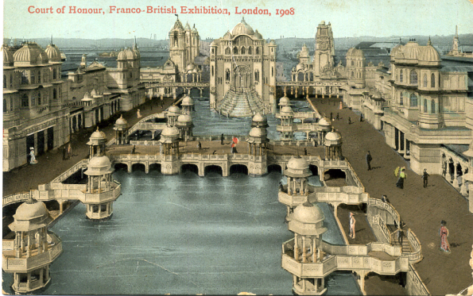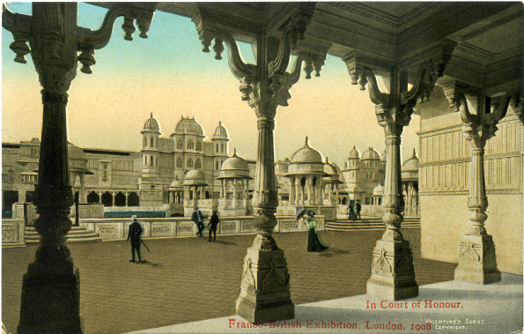

Type 1. A pre exhibition forerunner, a view Type 2. A pre exhibition forerunner, looking
down the lake towards the cascade, in the through four ornate columns towards the Court
centre of the bridge is a woman with an of Honour.
umbrella.

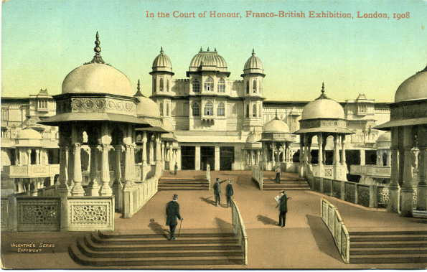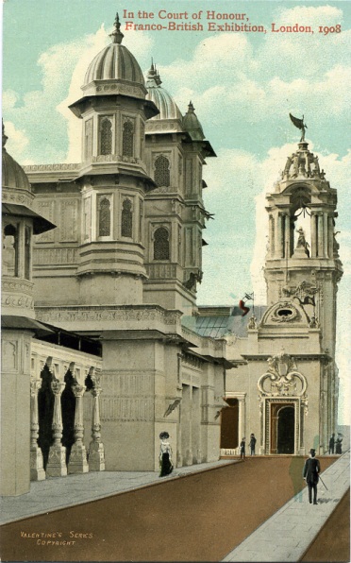

Type 3. A pre exhibition forerunner, a Type 4. A pre exhibition forerunner, this
sloping ramp between two flights of steps, is the only vertical card among the four pre
man with stick walking up steps to left. exhibition forerunners.

Un-numbered post cards or cards where the number is not known.

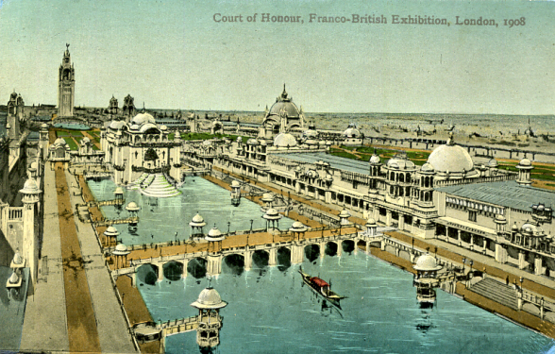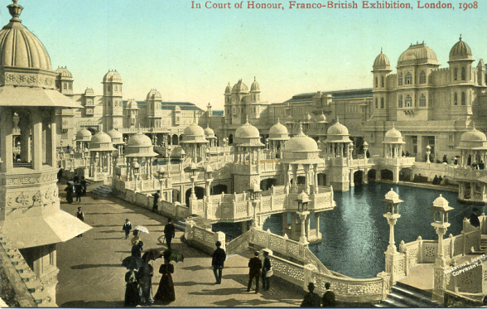

Type 5. Artists drawing of the lake with a Type 6. Two men striding out at bottom right
Gondola approaching the lake. of centre, women with umbrellas at bottom
left of centre.

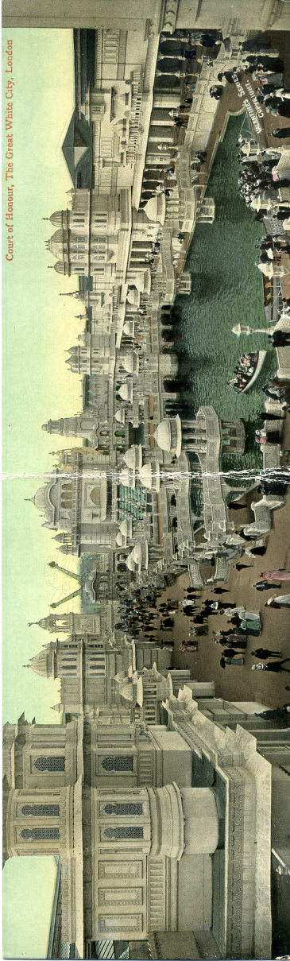

Type 8. Panoramic post card, right half shows three launches, two at landing stage taking on
passengers

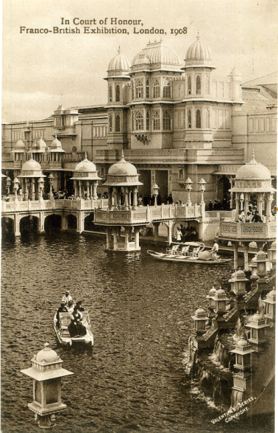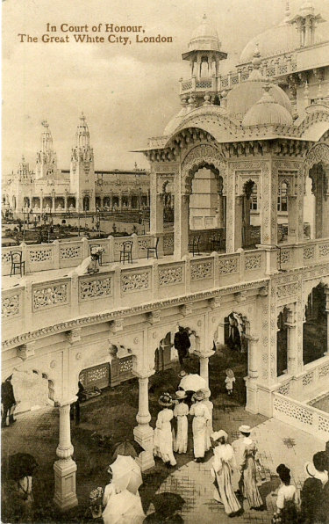

Type 7. Close up of cascade at bottom Type 10. Group of women about to walk
right, lantern at bottom left. under archway leading to gardens.

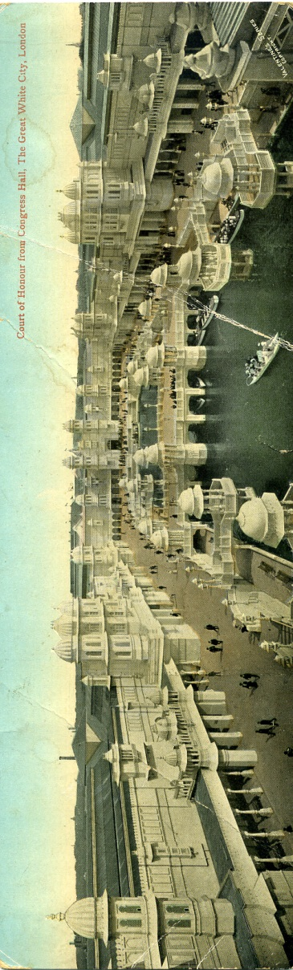

Type 9. Panoramic post card, right half looks down a wide pathway at an angle with very
few visitors.

Post cards where the number is known.

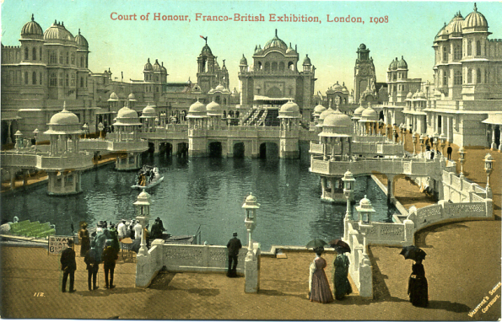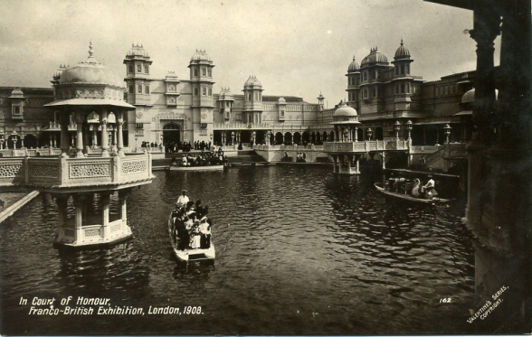

Type 11. No. 112, three ladies with Type 12. No. 162, pier on the left with swan
umbrellas at right, visitors boarding boat heading towards camera.
launch at left.

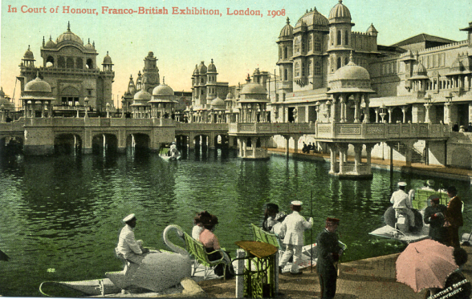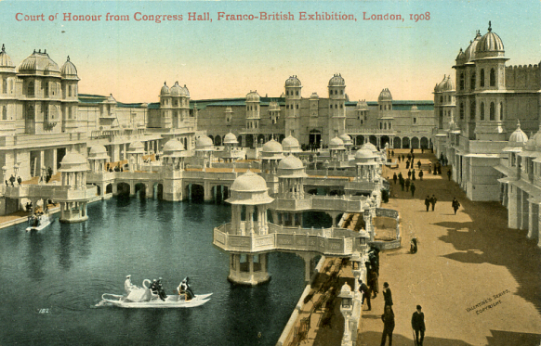

Type 13. No. 168, Close up of two attendants Type 14. No. 182, wide pathway to right in
with Swan boat in foreground. the front a swan boat heading towards right
bank.

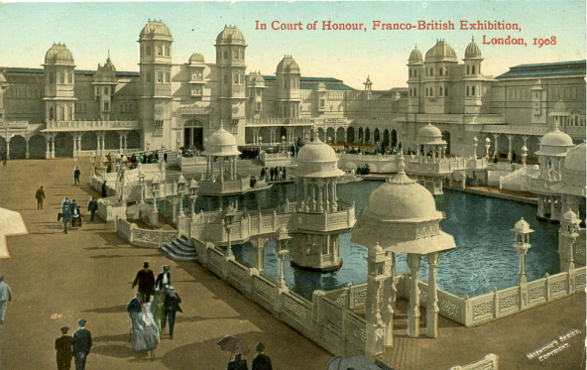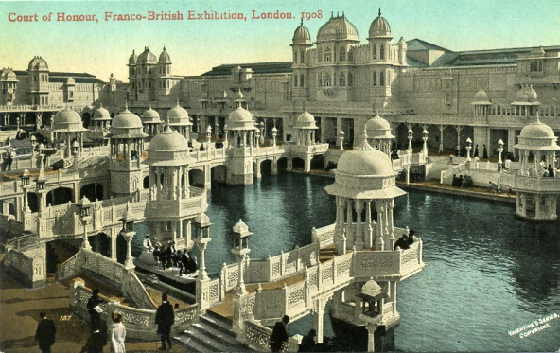

Type 15. No. 184, angled view of end of Type 16. No. 187, two men on the end of
lake away from the cascade. pier looking at water.

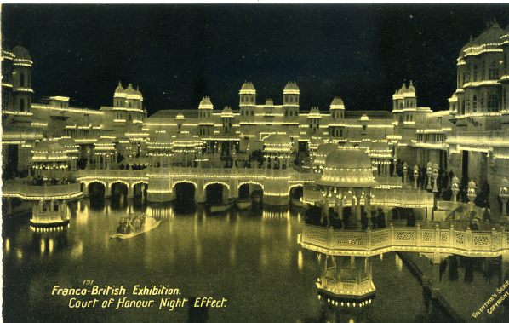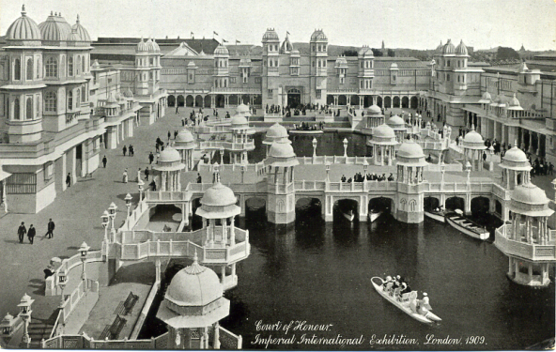

Type 17. No 191, night time view, this Type 18. No. 196, swan boat at bottom
title was only used for a 1912 Coronation right heading towards bridge, under which
Exhibition card. there are four boats moored.

