Editorial No 8 June 1987

With a membership approaching fifty; of whom at least, half are dedicated collectors and researchers my appeal this time, as always, is for articles, preferably original research into some aspect of exhibition collecting or its history. If members are reluctant, to commit themselves to print then possibly they could send material to be xeroxed ie. postcards, newspaper items and other bits of interesting ephemera. This interim newsletter has been put together with material drawn from our own files (with help from Alan Sabey)
I still feel, as 1 did in 1981, that as a 'Study Circle' we should now start to work together- in small groups and produce checklists and articles for publication in the newsletter.
Many thanks to 'Messengers' for the excellent write-up in No 19 Auction List (any member who does not subscribe to this wonderful read should get out their writing pad at once). Also a continuing thanks to Brian and Mary Lund who are always ready to give us a mention in Picture Postcard Monthly.
Members may already know of the existence of the Postcards of Palestine Group run by David Pearlman, the very knowledgeable postcard collector and an ex-editor of an excellent postcard magazine. David would like details of any postcards of Palestine but I would ask our members to concentrate their efforts on the various Palestine pavilions, Palestine exhibitions etc.. Please send your information to David at 36,Asmuns Hill, London NWI16ET, he is always keen to receive new information and punctilious with his thanks!

York – 3rd October Meeting of
Exhibition Study Group

This will be held as planned venue has still to be decided. Members who indicate a willingness to attend will receive details by post as soon as possible. If you decide to attend at the last minute, then contact me at home for information (091 -536421 9)
Don Knight, Graham Hall and Stanley Hunter have provisionally agreed to give talks/displays on their specialist areas (White City, Bradford and Scottish ex) and I am looking for someone to offer Earls Court, Wembley or Festival of Britain. I shall attempt to cover the final slot Foreign Expos.
The programme will follow the same timing as mentioned in newsletter No. 7 with plenty of time to chat, and show some of your own collection. _{f}
I Fred and I have had requests from new members for copies of our book Part. 2. It is out of print and as a reprint is out of the question, financially, we propose to run off 15 xerox copies. They will have the normal colour front and a plastic spine cost including postage will be £3. please send your order now!
New members have been, and can be supplied with back copies of all the past newsletters. 1 do apologise for the quality of some of the illustrations in these copies but they are taken from old newsletters and not the original copy. Please send 50p for each back issue. It is worth commenting that 1 am moving to another building,which has much better reprographic faci1ities after the summer holidays!
The membership fee is still £3 per year and for this magnificent sum you receive two newsletters. If it is possible to produce an 'extra’ edition (I intend one on Scottish Ex. this year) then I hope members wi11 be willing to pay an extra 5Op.

Andrew & Fred - June 1987,

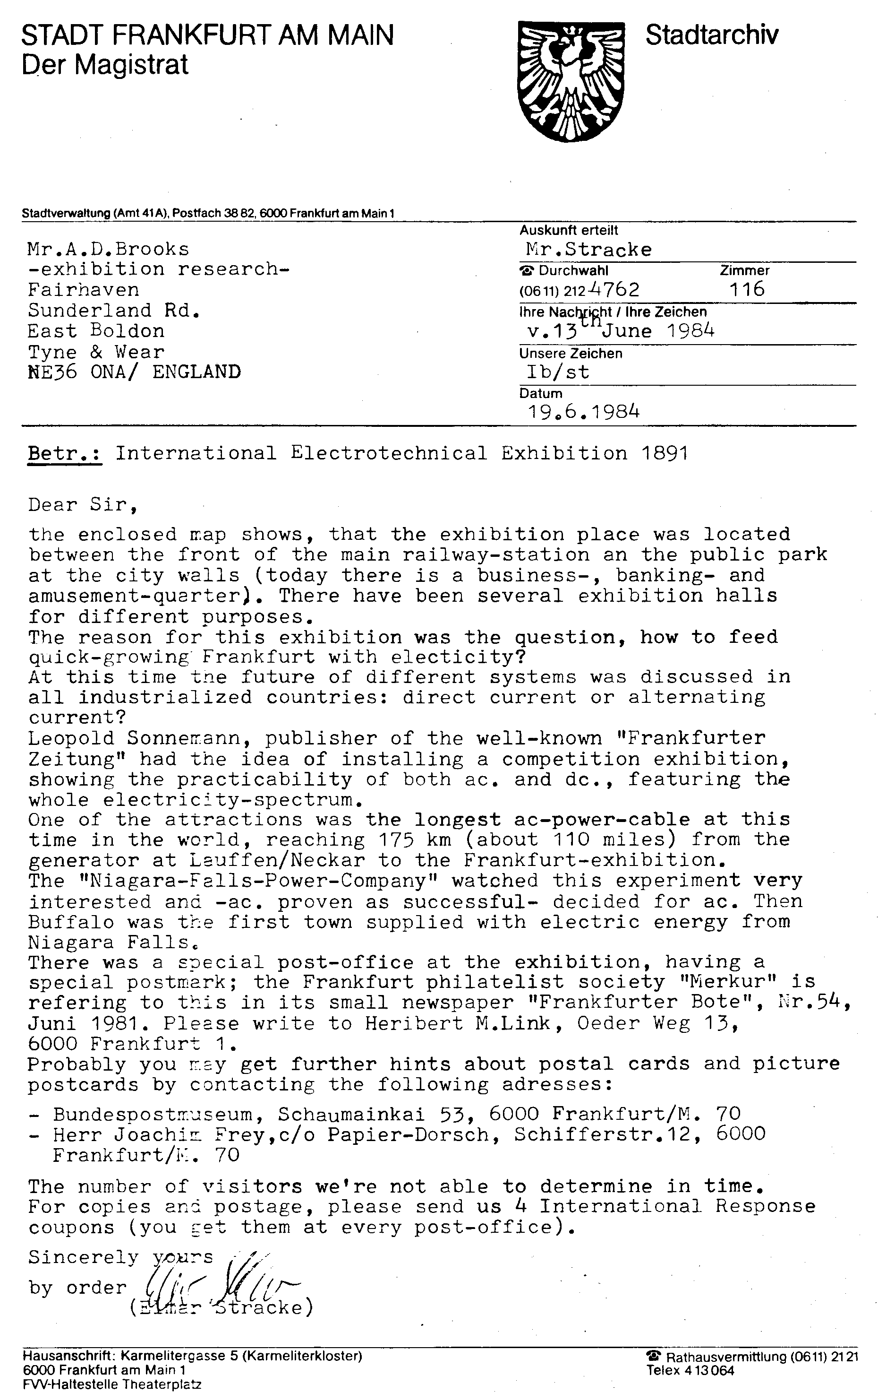

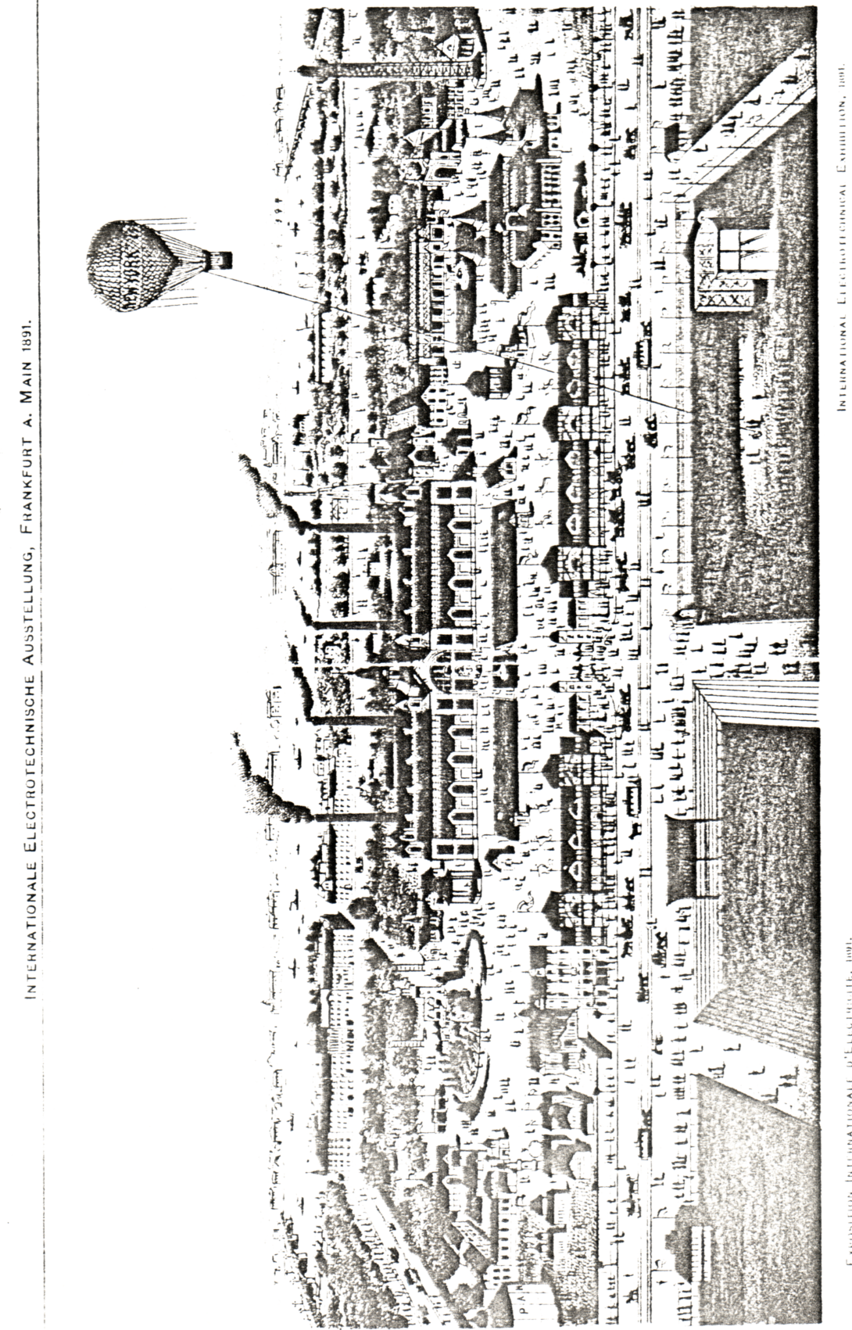

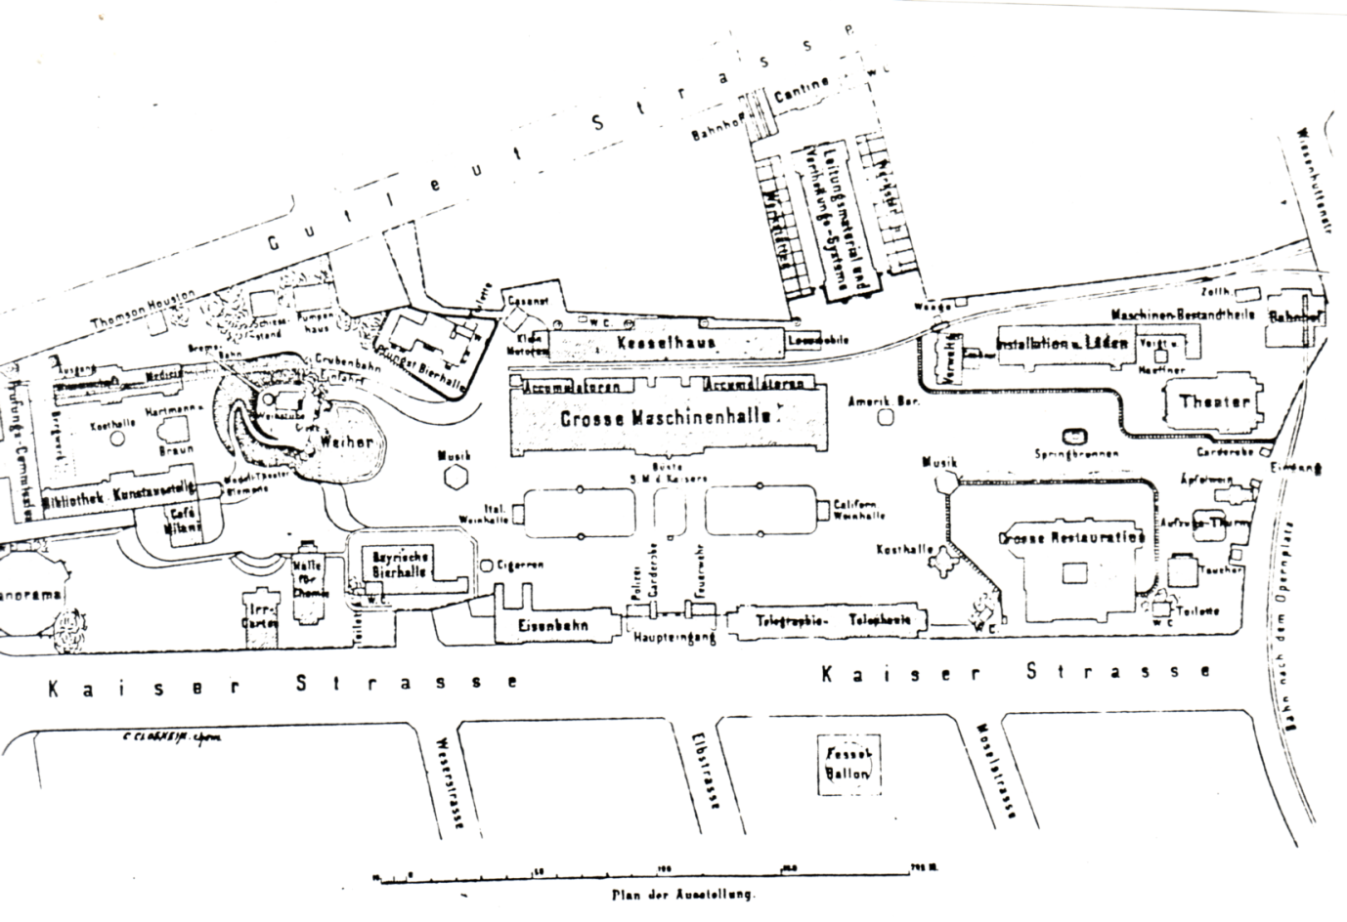

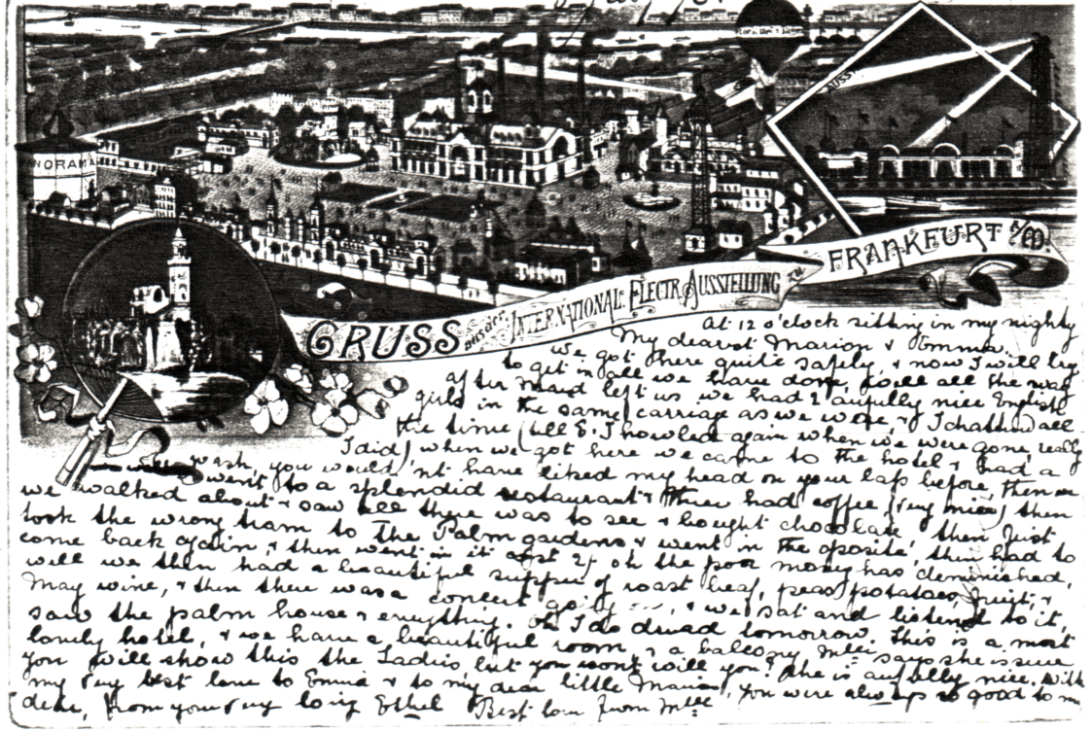

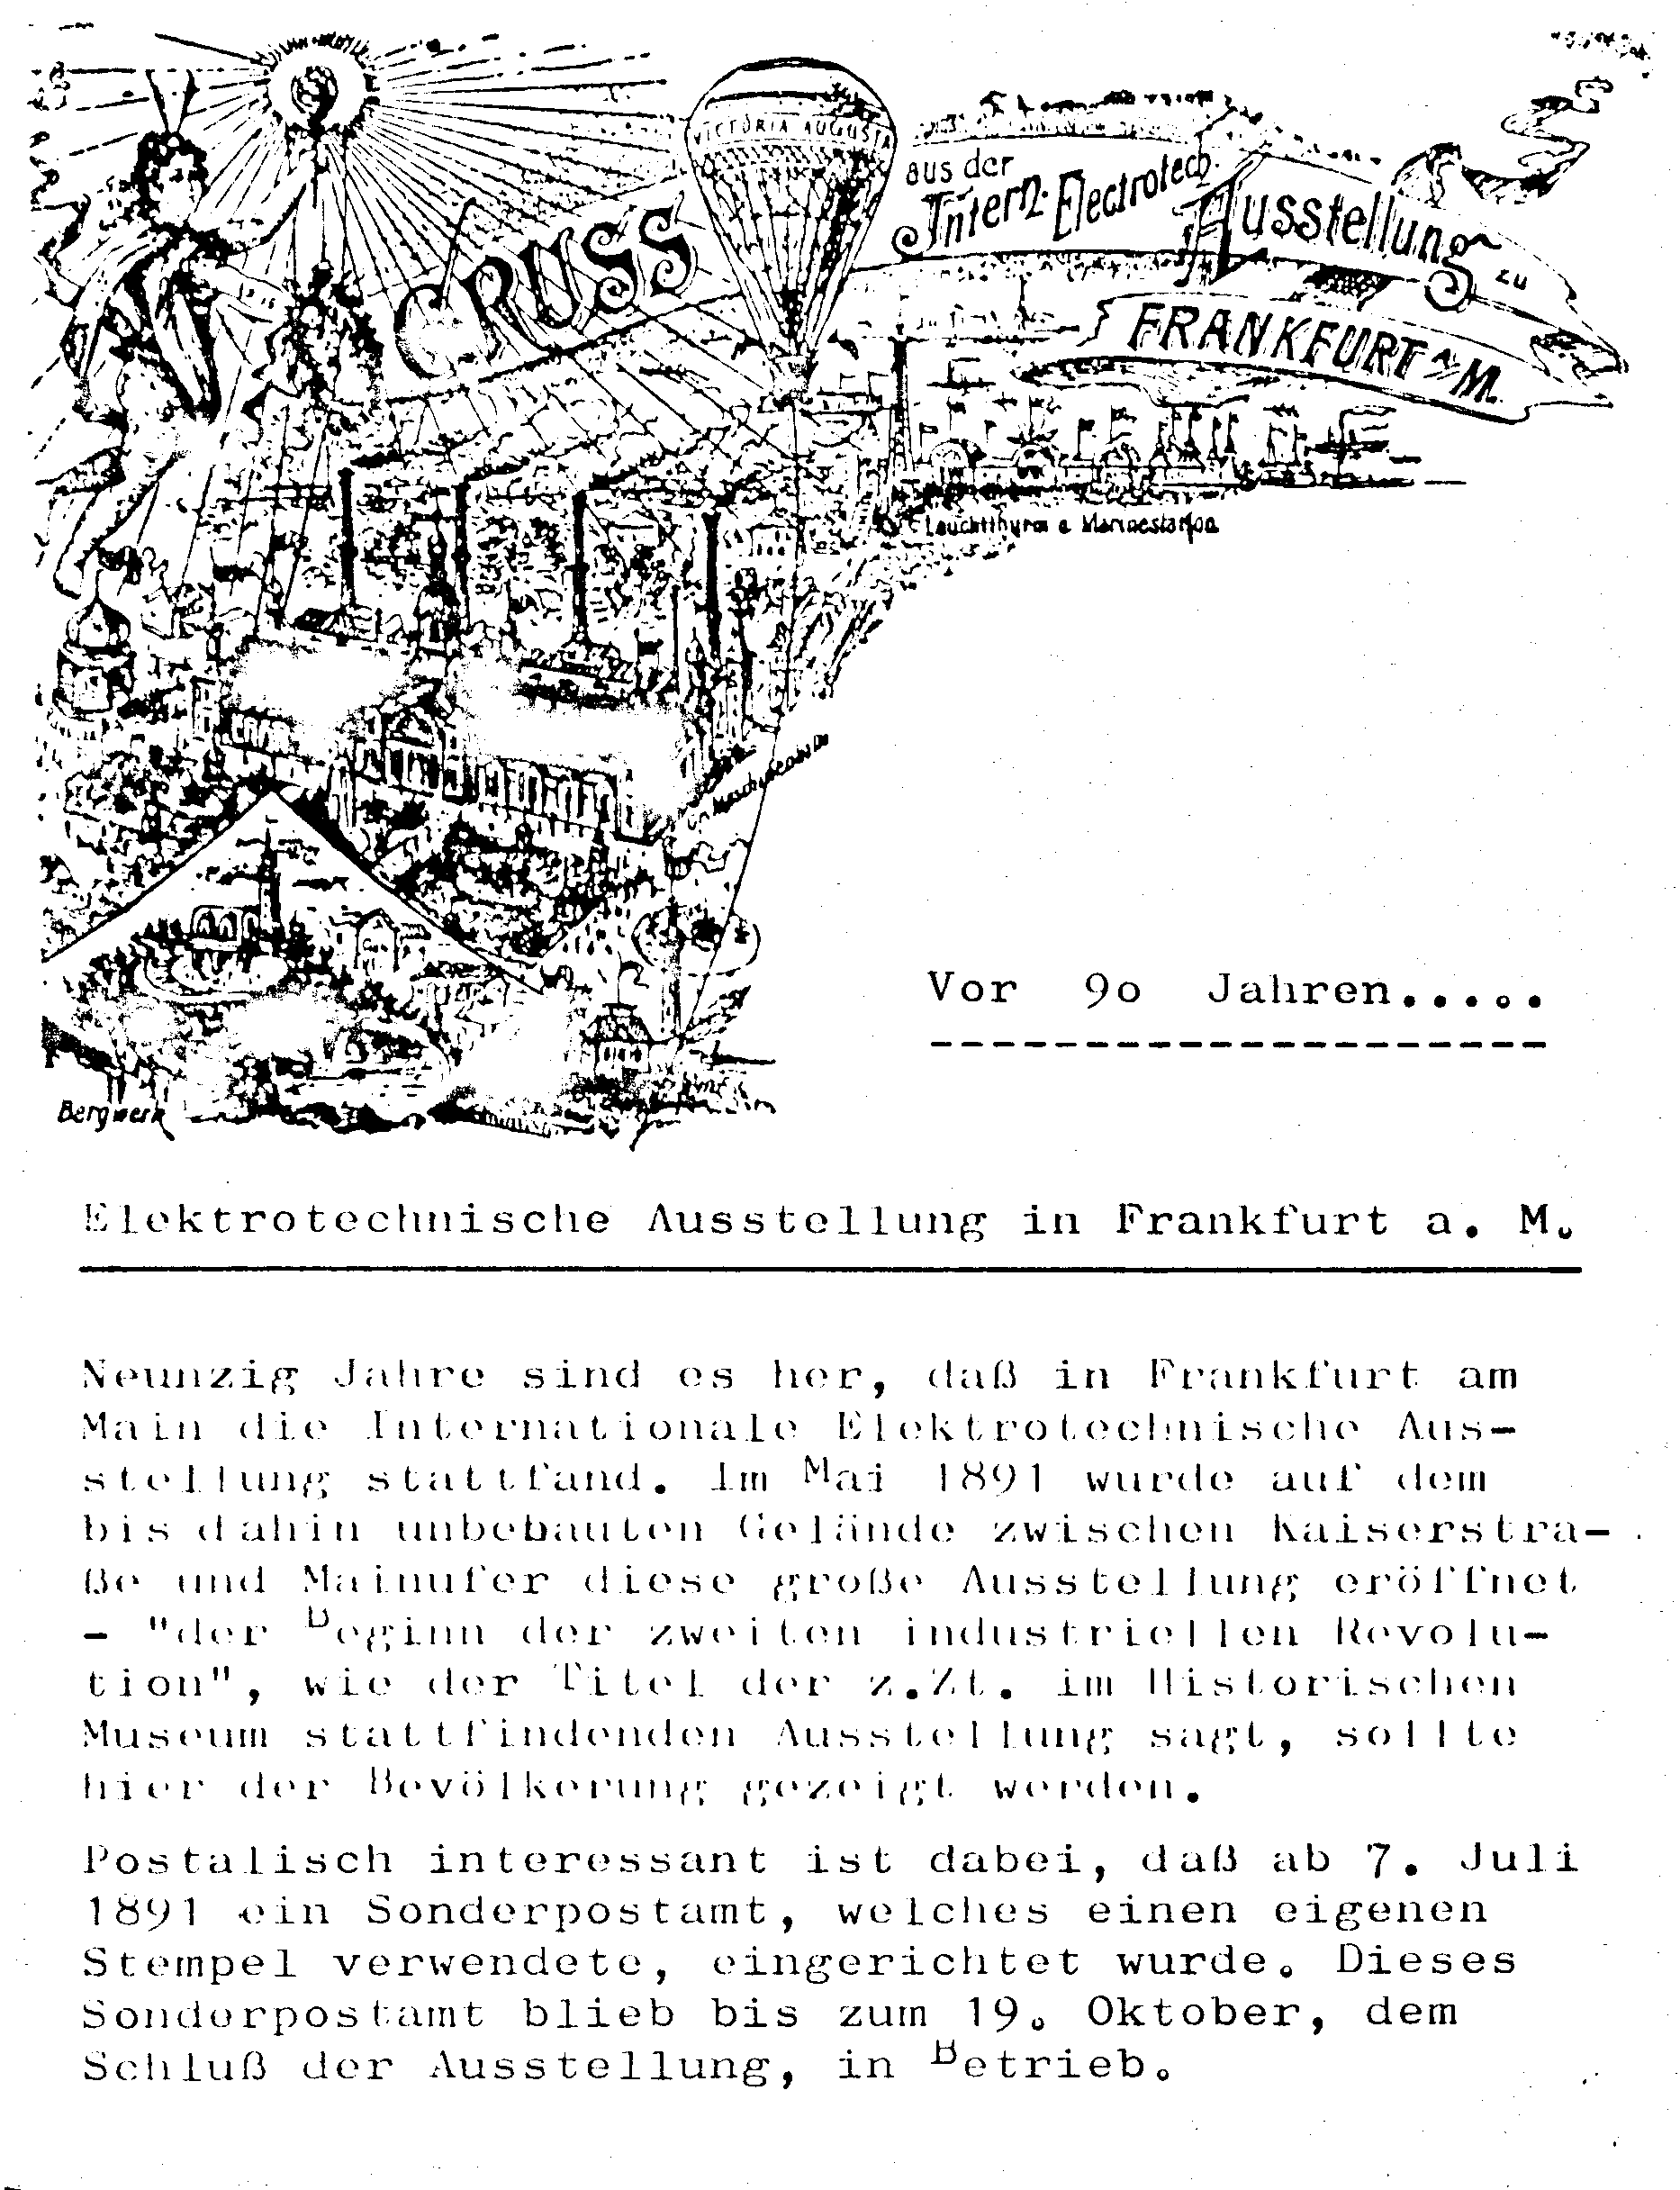

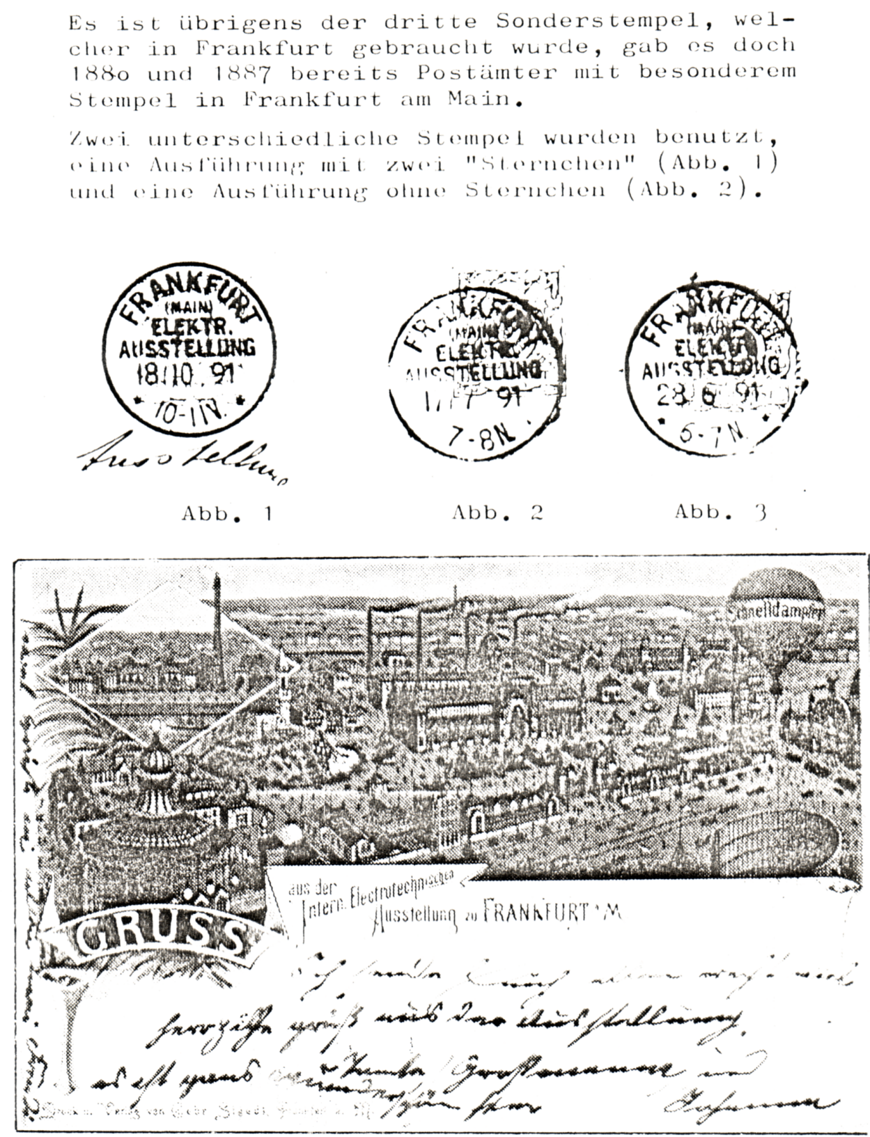

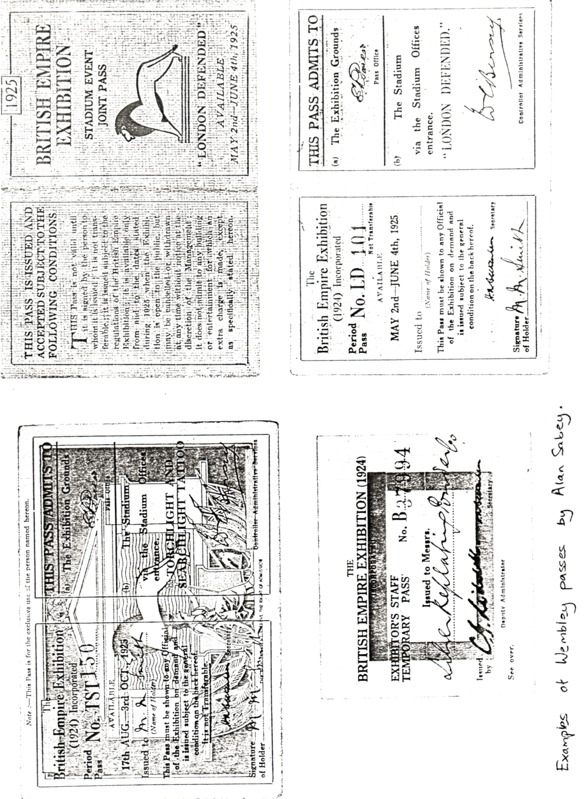

Rotarv postcards issued for the White City 1908-12

Many members keep very detailed checklists of p.p.c.’s for the exhibition, which hold great interest for them personally and I am sure that Graham Hall (Bradford) and Stanley Hunter(Scottish Ex) will not mind me saying that they record every card in this way, different printings etc., are very important to their final checklists. My own collecting habits make this type of recording very difficult and my standards of recording are somewhat simpler. I do hope however that 1 record the basic information (see attached sheet) for every p. p. c.
Rotary cards published for British exhibitions are a good example of the type of research that we, as a group, should be able to complete. They are a numbered series, quite collectable and reasonably easy to find. As real photographic cards some are very interesting, although I must admit many are dull, uninteresting views of palaces, pavilions. 1 would like to start with the Rotary publications for the White City but do not hesitate to contact me regarding the other exhibitions.. If members are able to supply the titles for any of the cards missing from the following lists I would be most grateful Full listings will be printed in future newsletters.

Franco-British 1908
6791 (A - Z?) I have cause to think that this series stops at X. Titles required
6791 G, I, N, S, Y & Z.
6792 (A - ?) Last letter I have recorded is M. Titles required
6792 I & L (plus N etc?)

Imperial-International 1909
6793 (A - Z) Titles required
6793 C, H, J, L, N, P, S, & V
6794 (A - Z) Titles required
6794 A, I, J, K, O, P, R, T - X.
6795 (A -?) Last; letter I have recorded is P. Titles required
6795 A, B, F, H, 0, (and possibly Q to ?)

Japan-British 1910
6796 (A - Z) Titles required
6796 E, F, G, H, M, N, Q, T, U, V & W
6797 (A - Z) Titles required
6797 A, B, C, F, H, 1, J, K, M, & X
6798 (A -?) Last letter 1 have recorded is S. Titles required
6798 A, D, E, H, I, K, L, M, N, S, R, (T - ?)

Coronation Exhibition 1911
6800 (1 - 46?) Last number I have recorded is 46. In this case it is easier to record the numbers that I have and ask you to supply the rest! I have
6800 3, 5, 10. 11, 30, 32, 36 & 46.

Latin-British 1912
6952 (1 - 46) Last letter 1 have recorded is S. Titles required
6952 B, E, H, K, L, M, N, O, P, R & T etc

1 have not seen, any Rotary cards for the Anglo-American, can anyone dispute this? In the first newsletter (1981) I published a listing of Rotary cards for the Festival of Empire 1911 and asked members to fill in my many gaps This particular list is still incomplete, as are Rotary lists for other exhibitions and I would like to enlist the help of members in tackling the Rotary cards. If you think you can add to my incomplete listings please send for the appropriate check 1ist(s)

