EDITORIAL Autumn 2005

I expect even Shakespear, found it a strain,
To think up new rhymes, again and again.

We had a very successful committee meeting during April at Don Knight’s Bowls club at Finchley, and I am happy to report that solutions have been found for all our pending problems. There is a full report of the meeting elsewhere in the Journal, so I will leave it at that.
A new list of members and their collecting interests is also included in this Journal, as it is long overdue, the last one was sent out in 1998.
I seem to be well ahead with the Journals, I got the Summer one out early in the second quarter of the year and now (in May) I am already working on the Autumn Journal. Although our next convention is still a long way off, this is the last Journal you will be getting before we meet at Hatfield on the last full weekend of September.

19th Convention at Ramada Hatfield Sat 24 & Sun 25 September 2005
St Albans Road West, Hatfield, Herts. phone 01707 265 411

You will remember at our last convention in 2004 we had agreed to hold this years convention at Wembley, which would have worked out rather expensive to those staying overnight. A chance remark to the receptionist as I was leaving our hotel in Bradford last year, opened up a new possibility and after Don Knight and myself had made a few enquiries, I, after consulting the other committee members decided to change the venue to the Ramada Jarvis Hotel at Hatfield which is just off the A1 only 20 miles from London.
I have provisionally booked some bedrooms and members who are going to the convention should mention when booking they want the ‘Event Rate’ for Bed & Breakfast. This is a special lower rate they do because the Study Group is using and paying for their Convention Room for the weekend. Don’t forget this, it makes a lot of difference to what they charge you.
The rates for Bed & Breakfast are, for two people sharing a double room £30 each and for one person in a single room £45. per night. As usual there will be a few of us staying on the Friday night, so there will be a get together on Friday evening in the bar On the Saturday we shall start our Annual General Meeting at 10.00 which should only last about half an hour and then carry on with displays. Tea or coffee will be available morning and afternoon, with a break for a snack at lunch time. Saturday evening we will gather at 7.00 for 7.30 for our Annual Dinner.
On the Sunday we will again start at 10.00 until lunch time. After lunch, one or two of our members with distances to travel will begin to drift off. I shall not be arranging any displays for Sunday afternoon, it will give those of us who do not meet very often time for a chat. I shall be staying Sunday night and be off home on the Monday. If you intend coming to the Convention please let me know if you are bringing a display with you. If I know what is likely to be shown it gives me a chance to work out some sort of a programme.
I say this every year, if you have not been to a convention before, do try and make it. This time it is so near to London and so convenient to get to, that even if you don’t stay over night you will still enjoy yourself. You can be sure of seeing some outstanding displays of exhibition material, and hearing some interesting talks. I am thinking of doing a display on Ballymaclinton using some of George Ithell’s material which the Study Group purchased after his death in 1995. To those who may not have known George, his main collecting interest was the Irish Village called Ballymaclinton that had a trial run at the Dublin International Exhibition in 1907, and really took off at the Franco-British Exhibition in 1908 where it must have been one of the largest exhibits, possibly only second to the stadium. It stayed at the White City for 1909 and 1910 and then moved to Crystal Palace for 1911. It’s no good having material in the Groups archives if it never gets shown to members. One thing that has not been shown before to the Exhibition Study Group in its entirity is the 140 slides that George made of his collection of Ballymaclinton.
The Editor.
An Exhibition of Exhibitions
1851-2000

Don Knight is lending some of his collection, gathered over the past 35 years to the Church Farmhouse Museum, Greyhound Hill, Hendon, London N.W.4. phone 020 8203 0130. He has put together a collection of many types of British Exhibition items, from from the Great Exhibition of 1851 to the Dome. The Exhibition is to open on the 24 September and go on until the 20 November 2005.
The museum has a permanent exhibition of a Victorian Dining Room a Victorian Kitchen, and a book shop. If you go to the Exhibition and want to make a day out, the R.A.F. Museum is just a mine away. These venues are on either side of the A41 between Hendon and Mill Hill.
The Museum opening times are Monday to Thursday 10.00-1.00 and 2.00-5.00 closed on Friday, Saturday 10.00-1.00 and 2.00 -5.30, Sunday 2.00-5.30.

Christmas cards.

There has been some response to Don Knight’s request for information on Valentine’s Franco-British Exhibition Christmas cards. Ken Rumsey who I mentioned in the last Journal came over and brought a clutch of his recent purchases.
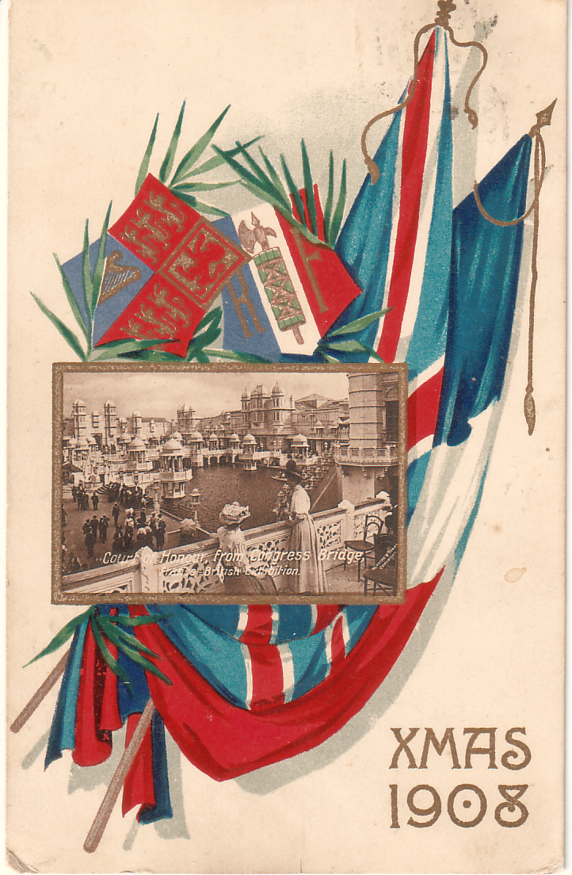
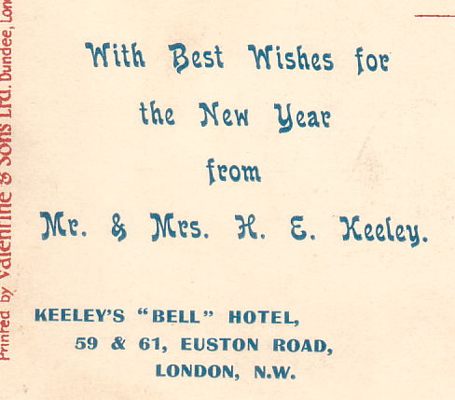
I tell you it made me feel sick as a dog. he’d got some beautiful cards. Amongst them was a new Christmas card not recorded before, a vertical left card No 346 Court of Honour, from Congress Bridge, used on 22 December 1908. What is interesting about this card is that I think it must have been remaindered after the exhibition closed, and the purchaser, the proprietor of “Bells” hotel in London, had a overprint printed on the back to personalise the cards and sent them to friends and customers. I think he must have had a quantity printed, as it would not have paid to get a printer to set up the job if he was only having a few done.
This brings the number of different cards recorded up to ten so it is possible there are twelve in the set, and they were sold in two packets of six.

Minutes of an Exhibition Study Group Committee meeting
held on Wednesday 20 April 2005 at North Finchley Indoor Bowling Club.

The meeting was opened by our President Ron Trevelyan who thanked members for attending and also thanked Don Knight for organising the holding of the meeting at his Bowls Club.
1. Apologies for absence. Peter Denley and Ken Rumsey
2. The Journal. Bill Tonkin started the meeting by informing the committee that his son Kenneth was prepared to continue sponsoring the publication of the Journal into the foreseeable future. Regarding the actual production Bill had enough ‘Postcards of the White City’ articles on disc to fill four or five pages of the Journal for about the next 20 years, that is providing the next editor wished to continue the White City series. Bill said he was quite happy to carry on contributing material, his main concern was to know there was someone willing and capable of continuing the Journal when that sad day came and a neighbour noticed there was four pints of milk on his doorstep.
Fred Peskett told the meeting he was willing to help out as Editor to learn the ropes as it were. There was a suggestion we reduce the size to a folded A5. Fred said he thought this would be a disaster and mentioned that the Crystal Palace Foundation and the Festival of Britain Society had started out with A5 publications but both had gone over to an A4 size which was far more practical as well as being cheaper and easier to produce.
One problem is the fact that Fred uses a Canon Star Writer programme on a word processor which is a small machine he can shut up and tuck away under the stairs when not in use. His main problem is that he just does not have room for a computer, printer, scanner, screen etc. Mike Perkins said he would see if there was any soft ware that could convert Canon Star Writer into something compatible with modern programmes.
Bill said he could see no reason why the Study Group could not help out financially in the cost say of a Lap Top, but if space was the main problem this was something we could not solve. It was left that Fred would visit Bill and perhaps stay over night to give them time to sort out the practicalities and hopefully come up with something.
The committee were all agreed that it was important to continue with a good Journal as for many of our members this was all they got for their annual subscription.
3. Web Master. Bill reported that following the notice in the Journal regarding a new Web Master one member, Ken Rumsey had volunteered to take this on. Unfortunately, Ken who had agreed to attend the meeting had had to drop out though business commitments and could not be present. Mike had spoken with Ken and will be visiting him to discuss the procedures. The Web Site has to be renewed in August when it will be re-registered in Ken’s name as we cannot leave it over until our A.G.M. The Study Group will pay the annual fee which is about £19.00.
4. Storage and distribution of Study Group Publications. Mike said he would like someone to take this on, but if no one came forward he would be prepared to carry on. George Burr said he would be prepared to do the packing and posting but unfortunately had no storage space for a large quantity of books. After the initial sales of books, sales dropped off and this led to a discussion on how sales could be improved. Don said in the past he had sold a fair number of books at various museums where he had loaned material to go on display. His next venture was at the Church Farm House Museum at Hendon where he was putting on a display at the end of September on Exhibitions from 1851 to the Dome. He very kindly offered to take some of the Study Group publications for the museum to offer for sale. It was agreed he would collect the books from Mike at our convention in September
5. New Secretary. The last item on the agenda was for the provision of a new secretary to replace Bill. Bill was asked to describe the various jobs that a secretary carries out, which he did. After some discussion Don announced that if no one else comes forward he would be prepared to take on the position of secretary for a period of five years. In the absence of any other offer this was accepted very gratefully by the meeting.
6. Any other business. Alan Sabey brought up the question of some one taking over the archival material that he has accumulated. It was agreed this would be discussed at our A.G.M.
There being no other business the President closed the meeting, which he said had been a very successful one, thanking those who had volunteered to take on positions. These appointments would come up for ratification at our next A.G.M. in September.

Another new 1924 Wembley Map Number 35

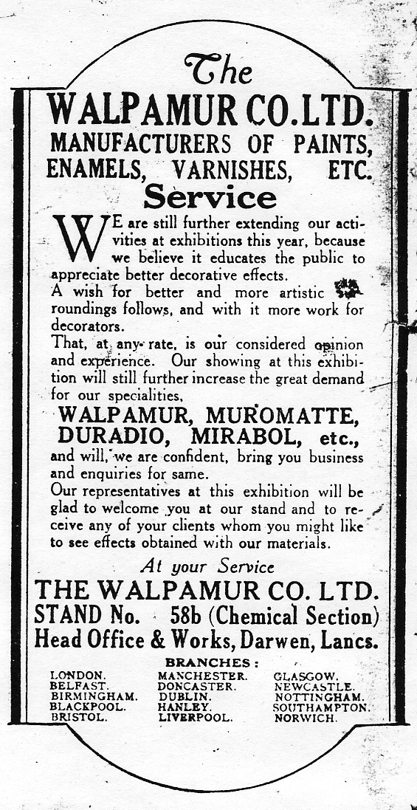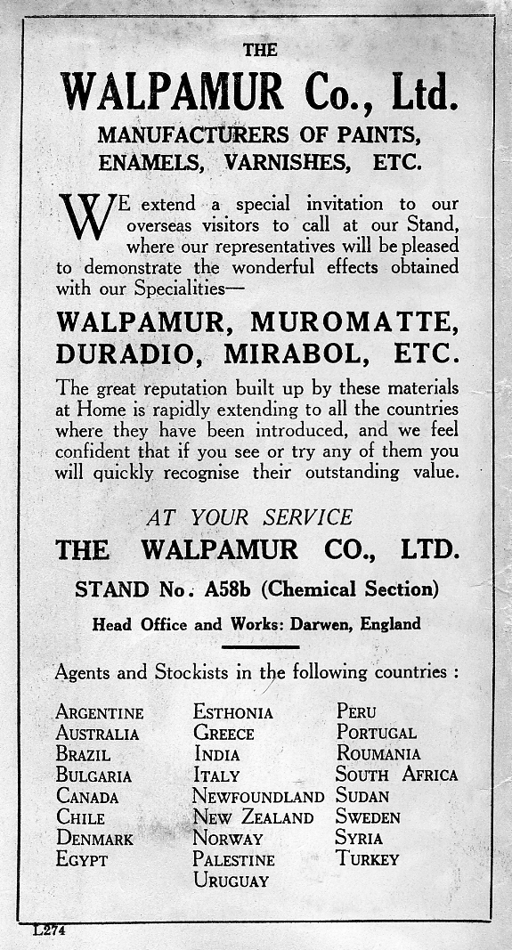
Map number 9 Map No. 35 Ref. L274

When we were doing the research into the number of different 1924 Wembley maps Mike Gorringe and Alan Sabey sent in details of a map advertising Walpamur Paints etc. and fortunately Mike sent me a photo-copy of panel I which when folded is the back page. I have recently had a Walpamur map sent to me as a present, and when I checked my one with Mike’s photo-copy I found the advert on the back page had been altered. The easiest difference to list is that No. 9 gives a list of English Branches while No. 35 lists Foreign Agents. Map No. 35 has a reference number at the bottom of panel I, L274. The illustrations are 85% of full size. Details of the other panels are,
I. Full panel advert for ‘The Walpamur Co. Ltd., and list of Foreign Agents.
K, L, M & N Picture of the Imperial Stadium and text on the British Empire Exhibition. The headings of the paragraphs are, Variety and Colour, Monster Military Tattoos, A Fellowship of Empire and The Great Home-coming.
S. ‘How the Exhibition began’ and text.
T, & U. All the World will be at Wembley, Fifteen miles of Exhibition. Bird’s eye view of the Grounds. (as Fleetway postcard No. 31).
V. Art of the Empire - The Two Georgians - Short Time Exhibits.

Exhibition Study Group

Addresses and members interests.

40th Revision 16th March 2005 05a

Abbreviations

All Br.E. All British Exhibitions
B.E.E. British Empire Exhibition Wembley.
C-C & P. Crested China, plates & Pottery.
Cong. Philatelic Congress of Great Britain.
Cry. Pal. Crystal Palace.
Earl.Ct. Earls Court.
F.O.B. Festival of Britain
For. Ex. Foreign Expos.
I.H.Ex. Ideal Home Exhibitions.
Miss. Ex. Missionary Exhibitions.
Oly. Ex. Olympia Exhibitions.
P.P.C. Picture Postcards.
Pmks. Postmarks.
PR-Eph. Printed Ephemera.
Roy. Tou. Royal Tournaments.
Scot Ex. Scottish Exhibitions.
Phil. Ex.. Philatelic Exhibitions.
Vic. Ex. Victorian Exhibitions.
W.C.Ex. White City Exhibitions.
W. F. & EX. Worlds Fairs & Expos.

Mr Leslie L. Allen. 01255 221645
10, Tewkesbury Rd, Clacton on Sea, Packet Required
Essex. CO15 3NX
Medals Crystal Palace & other Exhibitions

The Archivist. 020 8741 5159
Hammersmith & Fulham Archives.
'Lilla Husett', 191, Talgarth Rd.
London. W6 8BU.

Derek Bartlett. 01284 706 156
96 West Rd, Bury St Edmunds.
Suffolk. IP33 3LJ.
Pageants, All aspects, Postcard history.

David R Beech. 020 7323 7635
Curator, The Philatelic Collections,
The British Library, 96, Euston Rd.
London. NW1 2DB.
Prof. Burton Benedict. 510 841 6545
2805, Hilgard Avenue, Berkeley,
CA 94709. USA.
London address
11, Hillgate Place, 020 7727 3666
London. W8 7SL.
All Br. Ex., For. Ex., Ethnic displays, All aspects

The British Library. 01937 54 6267
Legal Deposit Office.
Boston Spa, Wetherby.
West Yorks. LS23 7BY.

Andrew Brooks. 015242 72526
Box Tree Cottage, anandbrooks@netscapeonline.co.uk
Overtown, Cowan Bridge, Carnforth.
Lancs. LA6 2HT.
1914-18 World War.

James Brown. 01721 752747
2, Old Smiddyfield Park, Packet required
Blyth Bridge, West Linton,
Peebleshire. EH46 7AN.
Scot. Ex., All aspects.

George J. Burr. 01932 224339
16, Western Drive, Shepperton. Packet required
Middx. TW17 8HL.
B.E.E., All aspecs.

Peter Burrows. 020 8864 4721
116, Lynton Rd, South Harrow,
Middlesex. HA2 9NN
Postal History and Military covers

E. Dilwyn Chambers. 020 8952 4992
11, Turner Rd, Edgware.
Middx. HA8 6AT.
B.E.E. All aspects

Gary Cheyne. 013 3260 6208
16, Jasmine Way, Carluke, Packet Required
Lanarkshire, Scotland. ML8 5AU
White City, all aspects. especially Walking Races

Ian Clare. 01865 730 667
68, Poplar Grove, Kennington, Packet Required
Oxford. OX1 5QP
Dealer in postcards, stamps & Postal History.
Derek Connell 01371 870681
The Three Horsehoes, Duton Hill Packet required
Nr. Great Dunmow, Essex. CM6 2DX
London events.

Dr. Paul J Conway. 01275 859504
Holcombe 8, Watercress Close, Wraxall, Packet required
Bristol. BS48 1HN.
B.E.E., All aspects.

Keith Cooper. 020 8595 3388
37, Stanley Avenue, Becontree Heath.
Essex. RM8 1JH.
B.E.E.

Curator. 020 7239 2560
Post Office Archives,
Freeling House, Mount Pleasant Complex,
London. EC1A 1BB.

Mr Philipe Dallias 41 32 7302266
55, Grand Rue, Corcelles, phidkat@span.ch
2035 Switzerland.
Japanese Exhibitions

Mr Nessan Danaher 011-6287-5368
47, Glenfield Frith Drive, Glenfield,
Leicester. LE3 8PU
Ballymaclinton.

Stuart Davidson. 020 8740 0586
56, Wendell Rd, Packet required
London W12 9RS.
Franco-British Ex.

A (Tony) P Davies. 01243 552990
'Wentbridge', Barnham Rd, Barnham, Bognor Regis.
West Sussex. PO22 0EB.
B.E.E. All aspecs.

John Davies.
3, Longfellow Rd, Packet required
Banbury, Oxfordshire. OX16 9LB
1890 Penny Postage Jubilee.

Trevor Day. 01487 710952
16, Taveners Drive, Ramsey, Packet required
Cambridgshire. PE26 1SF trevor.day2@btinternet.com
B.E.E. All aspects.

René Dee 01273 681 532
Flat 11, 13, Chichester Terrace, Brighton, Packet required
East Sussex. BN21FG rene.dee@talk21.com
Royal Horticultural Hall all aspects

Peter Denly. 01279 652 458
9, Oaklands Park, Bishop's Stortford, Packet required
Herts. CM23 2BY. denley@petelor.fsnet.co.uk
B.E.E. Commonwealth slogans, all aspects, Ballymaclinton Scottish & N. E. Coast Exhibs.

Jason Drewett. day 020 8993 6266
6, Fairly Way, Cheshunt, eve 01992 641458
Herts. EN7 6LG drewettjason@hotmail.com
Franco-British Ex.

Bill Early. 01382 669 851
7, Whitefauds Rd, Ninewells. Packet required
Dundee. DD2 1RH.
Scot. Ex., B.E.E., For. Ex., Ear. Ct., F.O.B., I.H.Ex., Vict. Ex., All aspects.

Mrs Judith Edwards. 01938 850 303
The Glyn. Cyfronydd, Packet required
Welshpool, Powys. SY21 9ER. m.edwards@welshpool.91.freeserve.co.uk
Cong., B.E.E., F.O.B., All aspects.

Dr. Brent Elliott 020 7821 3052
Lindley Library, Royal Horticultural Society brente@rhs.org.uk
80, Vincent Square, London. SW1P 2PE
Horticultural & Flower shows, 1862 International Exhibition

Godfrey Evans. 0131 225 7534 ex 4293
National Museum of Scotland. Chambers St, Packet required
Edinburgh. EH1 1JF.
Souvenirs from early Christian times to present day.

Mrs Vivien Mary Forster. 01363 84724
“Thistlegate”. Down St. Mary, Crediton, Packet Required
Devon. EX17 6EF.
International Horse Show and Dublin Horse Show.

Mr Peter Fox. 01909 774732
24, Osborne Rd, Kiveton Park,
Sheffield. S26 6PR
Medals and ephemera of all British Exhibitions esp Crystal Palace.

Patrick Frost. (Argyll Etkin Ltd.) 0207 437 7800
27, Regent St,
London. SWIY 4UA.

Terry Gazzard.
48, Stevens Close, Hampton.
Middx. TW12 3YW.

Michael Austin Gibbons. 020 8695 1092
68, Cedar Close, Packet required (not yet)
London. SE21 8JF mikeagibbons961.freeserve.co.uk.
Medals of major exhibitions London, Paris & Belgium

Robert Goff. 01483 763 214
12, Brackendene Close, Woking,
Surrey. GU21 4ED

Ramon Goodey.
403, Main Rd, Broomfield, Chelmsford,
Essex. CM1 7EJ.
Stamps and postal history of the B E E

Mike Gorringe. 01784 435025
15, Staines Rd, Wraysbury, Packet required
Middlesex. TW19 5BY. mike@gorringe86.freeserve.co.uk
B.E.E., All aspects.

John M. Greatrex. 01778 347 657
40, Wade Park Ave, Market Deeping, Packet required
Peterborough. PE6 8JL
Expo’s 1851 to 2001

Peter Griffin. 01487 813151
58, Hollow Lane, Ramsey,
Cambs. PE17 1DE.
B.E.E., 1890 Penny Post Jubilee, 1911 Aerial Post., All aspects.

James Grimwood-Taylor 01332 250970
Cavendish Auctions. Cavendish House,
153 London Rd, Derby. DE1 2SY
English Postal History, 1400-1940

Graham Hall. 01274 564518
'Moorside' 43, Micklethwaite Lane, Micklethwaite, Bingley.
West Yorks. BD16 3JW
Bradford Ex., All aspects.

Ken Harman. 020 8657 1014
36, Riding Hill, Sanderstead, South Croydon. Packet required
Surrey. CR2 9LN.
Pot lids of Cry. Pal. All Br. Ex., For. Ex., Art Nouveau, Baxter prints.

Mrs Jenny Hill. 01794 516388
44, Sycamore Close, Romsey, Packet required
Hants. SO51 5SB E-mail jenny@hillbt.freeserve.co.uk
B.E.E. Ceramics and books.

Myron C. Hill, Jnr. 2029 654 899
3900, Calvert St., N W,
Washington, D.C. 20007. USA
Crystal Palace. 1851, 1911 & 1951

Roger Hudson. 024 7668 6613
Cover Boys. P. O. Box 172, Packet required
Coventry. CV6 6NF.
Dealer in cinderella material., Postal history, Lists sent on request.

Mrs Gillian Jackson
14, White Gates Crescent,
Willaston, South Wirral. CH64 2UX
Festival of Britain

Charles Kiddle. 01256 862 701
'High Beeches' Swainshill, Alton, 106711.1065@compuserve.com
Hants. GU34 4DP.
B.E.E., F.O.B., Edgar Wallace.

Francis Kiddle. 01252 613 881
Punch Tree House, Reading Rd North, Fleet, Packet required
Hants. GU51 4HS.
Cong., For. Ex., 1890 Penny Post Ex., Stamp Ex. All aspects.

Johnathon King. 020 7323 8035
British Museum, Department of Ethnography, Packet required
Great Russell St, London. WC1B 3DG
Irish & U.S.A. Ex., Paper & post cards.

Don Knight. 020 8440 3574
2, Crescent Rd, New Barnet,
Herts. EN4 9RF.
W.C. Ex., B.E.E., Scot. Ex., Cry. Pal., Ear. Ct., F.O.B., Vict. Ex., Cong. All aspects.

Mrs Julie Anne Lambert. 01865 277047
John Johnson Collection. Bodleian Library.
Broad St, Oxford. OX1 3BG.
General interest, curator of the John Johnson Collection of printed ephemeria.

David Lockwood.
34, Firs Glen Rd. Winton. Bournmouth.
Dorset. BH9 2LT.
All Br. Ex., For. Ex. Cong., All aspects.

Brian Lund.
15, Debdale Lane, Keyworth,
Notts. NG12 5HT

Henry Maddon Library.
California State University,
5200 North Barton Ave,
Fresno. Ca 93740-0034 U.S.A.

Capt. John D. Marriner 01493 377 422
5, Blyth Rd, Caister-on-Sea, Great Yarmouth, Packet required
Norfolk. NR30 5TG.
Helicopter Mail, Apex, Perfins (GB only), Q E 2 Window booklets, Hong Kong.

Mrs Liz McKernan.
356 Ditchling Rd, Brighton,
Sussex. BN1 6JG

Mrs Janet McMorris. 01903 715 245
15, Emmabrook Court, Sea Rd, Rustington, Packet required
West Sussex BN16 2NG. janet@mcmorris.co.uk
B.E.E. post cards.

Miss Heather Mills. 01264 396857
51, Fairways, Weyhill, Andover, Packet required
Hampshire. SP11 8DW.
All exhibitions. All aspects.

John F. G. Mills. 01227 787070
70, Salisbury Rd, Canterbury. Packet required
Kent. CT2 7HH.
B.E.E., All aspects, Gold Coast, Togo, Cocoa.

Mike J. Mobbs. 01494 712486
6, Cresswell Way, Holmer Green, High Wycombe,
Bucks. HP15 6TE.
For. Ex., Pre 1939 Belgian Ex. All aspects.

Andrew J. Napier. 01689 838069
9, Bedford Terrace, Tunbridge Wells, Packet required
Kent. TN1 1YJ.
B. E. E. All aspects.

Mrs Ruth M. Napier. 01689 838069
9, Bedford Terrace, Tunbridge Wells,
Kent. TN1 1YJ.
1938 Empire Exhibition Glasgow. All aspects.

Mr Anton O’ Broin. 00 35353 33057
Kilrane, Rosslare Harbour,
Co. Wexford, Ireland.
International Exhibs, Ballymaclinton.

Mr Wilford M. Oliver. 01753 798962
13, Leiston Spur, Slough,
Berks. SL1 3JN

Mrs Jean Osborne. 01506 842858
5, Jocks Hill Cres, Linlithgow. Packet required
West Lothian. EH49 7BJ.
All Br. Ex., Cong.

Michael Pender.
6639, Waterford Lane, Sarasota.
FL. 34238. USA. wfcs@aol.com

Mike Perkins. 01384 824894
4, Churchill Drive, Amblecote, Stourbridge. Packet required
West Midds. DY8 4JS. mikeperkins@aol.com
B.E.E., All aspects.

Fred Peskett. 02392 665 630
124, Havant Rd, North End, Portsmouth. Packet required
Hants. PO2 0BP.
Cry. Pal., F.O.B., All aspects.

Ken Peters. 01959 573 686
8, Kings Rd, Biggin Hill, Packet required
Kent. TN16 3XU.
B E E

Nigel Pollard. 01225 461 842
6, Leopold Buildings, Bath.
Somerset. BA1 5NY.
B.E.E., F.O.B.

David Reynolds. 01625 537226
7, High Field Estate, Wilmslow, Packet required
Cheshire. SK9 2JR.
Ballymaclinton.

Kenneth Rumsey 020 8755 4210
69, Winchester Rd, Hanworth, Packet required
Middx. TW13 5JX
Franco-British Exhibition.

Mr J. N. Tim Rusden 01535 604415
Oatlands, Cark Rd, Keighley, tim@oatlands110.freeserve.co.uk
West Yorks. BD21 3BH
1912 Ideal stamp post cards and stamps

Alan Sabey. 020 8843 9920
46, Thorncliffe Rd, Norwood Green, Southall. Packet required
Middx. UB2 5RQ. Mob. Pho. 07710755175
B.E.E., 1908 Olympic Games, All aspects. wembleyman@aol.com

David Saddington.
2, Scholars Court, Alcester Rd,
Stratford-upon-Avon. CV37 6PN.
Wembley

Cedric A. Selway
Coopers Brook, School Lane, Abbess Roding, Ongar 01279 876 094
Essex. CM5 0NY
Wembley & 1890 exhibs Packet required

George Simner. 020 8471 2165
23, Langton Ave, East Ham. george@fobs.freeserve.co.uk
London. E6 4AN.
F.O.B., 1938 Scot. Ex., 1937 Paris Ex., All aspects.

Flo Simner. 020 8471 2165
23, Langton Ave, East Ham.
London. E6 4AN.
Tower of London.

Arthur P Smith. 020 7381 9062
22, Ongar Rd, Fulham.
London. SW6 1SJ.
Ear.Ct., Most Br. Ex., Some For. Ex., Imp. & Com. Inst. Pageants. All aspects.

Kenneth Roy Smith. 01629 55486
Glendene, Holme Rd, Matlock Bath.
Derbyshire. DE4 3NX.
Ballymaclinton at all sites, All aspects.

Alan Spencer. 0121 459 7650
25, Hawthorne Rd, Kings Norton, alan-spencer@btopenworld.com
Birmingham. B30 1EQ.
G.B. Philatelic Congresses

Mrs Ann Stevens. 01749 347311
The Smithy, Cannards Grave Rd, Shepton Mallet,
Somerset. BA4 5RE.
1938 Empire Ex Glasgow.

Ted Stevens. 01749 347311
The Smithy, Cannards Grave Rd, Shepton Mallet,
Somerset. BA4 5RE.
1938 Empire Ex Glasgow.

Paul Sweetland 01494 778948
2, Glebe Cottage, Germain St, Chesham, Packet required
Bucks. HP5 1LY paul@sweetp.net
White City 1908-14

Timothy Todd. 925 825 6104
PO Box 23784, Pleasant Hill, timtodd@pacbell.net
California 94523. USA
B.E.E. All aspects

Bill Tonkin. 020 8777 8861
23, Bramley Way, West Wickham. Packet required
Kent. BR4 9NT.
All Br. Ex., Scot. Ex., Cong., All aspects.

Kenneth Tonkin. 01743 236 328
‘High House’ 22, Porthill Rd, ktonkin@masterplug.fsnet.co.uk
Shrewsbury. SY3 8SA.
Q.E.II High value GB stamps. Shropshire Postal History

Bob O. Tough. 020 8977 1847
“The Moorings” 40, Twickenham Rd, Teddington.
Middx. TW11 8AW.
All Br. Ex., All aspects.

Mrs Gwen, O. Tough. 020 8977 1847
“The Moorings” 40, Twickenham Rd, Teddington.
Middx. TW11 8AW.
River Thames.

Ron Trevelyan. 01483 764339
23, The Gateway, Woodham, Woking.
Surrey. GU21 5SN.
B.B.E., W.C.Ex., Cry. Pal. Ex., U.S.A. Ex., All aspects.

Mrs Cynthia Wade. 01502 724 983
23, Covert Rd, Packet Required
Reydon, Nr Southwold,
Suffolk. IP18 6QZ
White City, all aspects.

J Paul Watson.
Copper Beeches 32, Normanton Rd, Packington, 01530 415272
Ashby-de-la-Zouch, Leics. LE65 1WR.
B.E.E., All aspects.

Roger F. Weeks. 01379 687486
Pastones, Bressingham Rd, Roydon, Diss,
Norfolk. IP22 5XW.
B.E.E.

Mike Welch. 01278 455139
9, Queenswood Rd, Bridgewater.
Somerset. TA6 7NB.
All Br. Ex.

Wembley History Society. 020 8428 0826
3, Clonards Way, Hatch End, Pinner,
Middx. HA5 4BT.
Wembley Local History.

Richard West. 020 8949 6020
29, Lynton Rd, New Malden,
Surrey. KT3 5ED
White City.

David Zeidler. 020 8979 0807
22, Chestnut Avenue, Hampton,
Middlesex. TW12 2NU
Railways.

Post Cards of the White City.
Part 32.
by Bill Tonkin

The view of the cascade on post card No. 433 was one of Valentine’s most popular cards. It was used by them from 1908 to 1912, and the title was altered many times, 18 times in fact, (if the exhibition title is included) sometimes titled the ‘Cascade’, sometimes ‘Congress Hall’, and sometimes to make sure they got it right the ‘Cascade and Congress Hall’, or even the ‘Congress Hall and Cascade’.
The view is known in two states, and these are listed. The difference between them is in the water of the cascade, in the original negative, the water of the cascade is shown with a few white waves as it tumbles down and is listed as ‘view with little water in cascade’. Later touched up versions shows the water of the cascade as a solid white mass, with a touch of green in the coloured cards and is listed as ‘view with white water in cascade’.
Congress Hall and Cascade, Franco-British Exhibition, London, 1908.
B/W R/Photo, view with little water in cascade, black ‘X L’ back type FB 12.
433 Title in two lines at bottom left.
Title altered to, Congress Hall, Franco-British Exhibition, Christmas, 1908.
Sepia litho view with white water in cascade, in coloured Christmas Card border
type FB Bo 2, red ‘F B seal’ back type FB 1.
433 Title in one line at bottom centre.
For other Christmas post cards of this series see under Border FB Bo 2.
For other post cards of this view see in The Great White City section, under ‘Cascade, Court of Honour’, the Imperial International Exhibition section, under ‘Cascade and Congress Hall’, the Japan-British Exhibition section, under ‘Cascade’, the Coronation Exhibition section, under ‘Congress Hall’, and the Latin-British Exhibition section, under ‘Congress Hall’.

This card is known in two states, in the second several long ladders leaning against a pavilion on the far left were removed, the cards are listed as ‘with ladders’ or ‘without ladders’
Congress Hall from Gardens, Franco-British Exhibition, London, 1908.
B/W litho with ladders, grey ‘Throughout the World’ back type FB 2.
N.n. Title in two lines at bottom left.
B/W litho with ladders, greenish grey ‘Throughout the World’ back type FB 2.
N.n. Title in two lines at bottom left.
Coloured without ladders, red ‘F B seal’ back type FB 1.
281 Title in one line at top left, top and bottom edge rouletted.
Sepia litho with ladders, black ‘Throughout the World’ back type FB 2.
N.n. Title in two lines at bottom left.
For other post cards of this view see in The Great White City section, under ‘Congress Hall from Gardens’, the Imperial International Exhibition section, under ‘Congress Hall’ and the Japan-British Exhibition section, under ‘Congress Hall’.

Congress Hall from Lagoon, Franco-British Exhibition, London, 1908.
B/W litho, grey ‘Throughout the World’ back type FB 2.
N.n. Title in two lines at top centre.
B/W litho, bluish grey ‘Throughout the World’ back type FB 2.
N.n. Title in two lines at top centre.
Coloured, red ‘F B seal’ back type FB 1.
280 Title in one line at top centre.
Coloured ‘GIANT POST CARD’, grey ‘Throughout the World’ back type FB 17.
280. Title in one line at top centre.
For other large sized post cards see under Giant post cards.
For other post cards of this view see in the Imperial International Exhibition section, under ‘On the Lagoon’, the Japan-British Exhibition section, under ‘The Lagoon’, and the Latin-British Exhibition section, under ‘The Lagoon’.

Corridor, Palace of Music, Franco-British Exhibition, London, 1908.
Sepia litho, black ‘Throughout the World’ back type FB 2.
N.n. Title in three lines at top right.
For other post cards of this view see in The Great White City section, under ‘Corridor, Palace of Music’.

