EDITORIAL Summer 2005

Our Journal’s twenty five years old
A jolly good read, so I’ve been told

Members will be aware that I have decided to stand down as secretary of the Study Group at the end of the year as I shall be 80 by then and have as my swan song recorded all the Exhibition Study Group Newsletters later renamed the Journal on to six C D’s to make producing back numbers a simple operation, and in particular in many cases, to be able to produce at the tap of a key much better copies than the originals, and much quicker.
In the Spring Editorial I rather rashly stated I would get all the Newsletters on to five C D’s, this was not to be, and it has run to six C D’s.
Our President Ron Trevelyan has asked me to call a committee meeting to discuss various matters which we cannot allow to hang over until our A G M. Ron has arranged for one to be held in April, and Don Knight has kindly made arrangements for us to have the use of a room at his Bowls Club at Finchley. The Study Group does not have a lot of committee meetings, as most of our business is done at our A G M in September. This is the third one in 25 years.
I have also now finished and am publishing in this issue a comprehensive Index incorporating page numbers for all articles from Newsletter Number 1 to No. 76, an Index which covers the 25 years the Journal has been published, building on the previous three indexes produced by Stanley K. Hunter of Newsletters 1 to 5 in 1986, James Negus of Newsletters 1 to 27 in 1993 and again by James Negus of Newsletters 1 to 56 in 2000.
One of the problems of supplying copies of the early Newsletters is that in the beginning only about ten copies of the Newsletter was made, (one for each member) and as new members joined and requested back numbers Andrew had to re-photo-copy old photo-copies and every time this was done the quality of the reproduction deteriorated until the pictures and some of the text is of very poor quality indeed.
Because of this I decided where ever possible to replace as many of the original photo-copied pictures in the early Newsletters with scanned images from originals from my own collection. I have been able to replace about 90% of the illustrations in this way. The only area where I have not been able to replace the originals, is in the case of Foreign exhibitions which I do not collect. I have also not been able to replace odd cuttings with text and pictures from newspapers etc. sent in by early subscribers to the newsletter, where often only photo-copies were sent in the first place. The quality of some of these was poor to start with and even if the originals were available, well you can’t make a silk purse out of sow’s ear.
So it can be said that in some cases reprints supplied now of the older newsletters are much better than the originals. Although the newsletters have always been published in B/W the new recorded illustrations in the Newsletters are being stored on C D’s in colour, where the original pictures were in colour. As I still only have a B/W laser printer any back numbers ordered will still be in B/W, as will on going Journals. A new broom may well decide on a clean sweep and modernise the Journal in the future.
I should like to record my thanks to Ken Rumsey and George Simner who have dropped in to see me in the last few weeks. They are both fairly regular visitors and it is always a pleasure to see them. Mike Perkins too has been coming to stay for several days about three times a year for a long time now. We are all hooked on a love of exhibitions, delving all the time and exchanging information. I don’t know what sort of a life people with no hobbies lead, my hobbies have given me un-limited pleasure all my life.
Editor
History of the Exhibition Study Group Newsletter / Journal
by
Bill Tonkin

While working on the Index it was necessary to quickly skim through all the back numbers to make the Index as complete as possible, this history is one of the side products
The first Exhibition Study Group Newsletter was produced by Andrew Brooks in 1980, probably about April. It consisted of photo-copied sheets made up by Andrew starting with a typed Editorial and any other material he could lay his hands on. On the front cover of this Journal I have reproduced the front cover of Andrew’s first Newsletter. Only ten copies were printed. From the start picture post cards were strongly featured, although all aspects of exhibition items were included.
In Newsletter no 5 in early 1986 Andrew informed us he had acquired a new electric typewriter, Two years later he told us he now had an Amstrad. To start with only the Editorial of the Newsletters was printed on Andrew’s Amstrad, starting with number 10 in 1988, all the rest of the pages whether articles copied from books and magazines, or letters sent in by members were photo-copied. The pages so produced were often in a wall to wall format and in scanning these some have had to be slightly reduced in scale to allow for the margins modern computers require. After producing ten Newsletters in the first eight years, in 1988 Karl Illingworth generously offered to take on the costs and the work involved in duplicating and posting our Newsletter from No. 11. With this work taken off his hands 1989 became the first occasion that Andrew got out four Newsletters in one year, this has been maintained ever since. In 1989 at our Manchester convention the Exhibition Study Group took a major step forward and elected a Chairman and Committee. Until then the group had been run single handed by Andrew.
In 1990 and 1991 Andrew must have acquired another computer as for these two years he was able to use computer generated front pages with decorative borders, and gave up using the cut and paste method. (Not cut and paste as in computer language but using scissors and brush in a pot of paste). In fact it was not until number 16, a check list of Post Cards of the Ideal Home Exhibitions was it all done on his computer with headers, footers and page numbers, the lot. Then it was back to scissors and paste pot for the contents up to number 24 when Andrew retired as Editor.
When Andrew retired at the end of 1991 the Newsletter was produced by a three man team with myself as Editor, and from then on I typed the Newsletters into a computer with only the illustrations pasted in (using brush and paste pot as scanners were still too expensive). I left gaps in the text for the illustrations and sent the proofs with loose illustrations to Damon Murrin who pasted these in place, he also designed the front cover for each issue and the general lay out. They were then sent on to Karl Illingworth who saw to the photo-copying and distribution. By the end of 1993 Damon had dropped out and the team was down to Karl and myself. Up until the end of 1996 the paste pot was still in use but then I got a scanner and the paste pot was made redundant.
One of the things Damon did was to get the Title of the newsletters printed by a local printer in the form of headed note paper. The font used was one that was in use in 1851. I have kept this design for the newsletters all the time I have been producing them, with just a different illustration on the front. In fact the only alteration came at our 1995 A G M when it was passed that the Newsletter should in future be known as the Journal.
When in the Spring of 1998, Karl, had to stop supporting the Journal, my son Kenneth took over and has paid for the duplicating and costs of distributing the Newsletter since that date. To start with one of his companies sponsored our journal, but he now tells me he pays for it himself.
Andrew did not include page numbers on his Newsletters, and in the reproduction of the earlier Newsletters I have introduced a footer with date and a page numbering system starting at page 1 at the beginning of each year. When I took over I did not publish the Journals on specific dates but have got one out in roughly three monthly periods titled, Spring, Summer, Autumn and Winter.
A glance at the index will show the wide range of subjects covered during the 25 years it has been going. I am very conscious that for the bulk of our members the Journal is all they get for their money. I feel that with a membership of around the hundred mark, that must mean there are a lot of members who think the Journal is worth the £8.00 a year we charge.
Letters to the Editor

Letter from Phillipe Dallais

I have had a couple of letters from Phillipe Dallais, who came over from Switzerland a couple of years ago to see my post cards of the Ainu tribe. They were a Japanese Ethnic tribe who were on display at the Japan-British Exhibition in 1910 and he photo-copied all I had. He works for the Zurich University and is engaged on building up their collection of images of Ethnic tribes at exhibitions. He is now working on the Formosans who lived in the Formosa Hamlet, again at the Japan-British exhibition. I have about thirty of these cards many signed by the natives and have agreed to let him have copies of them all. He will be able to get the signatures read by someone at the university who understands the language. Although judging by the signatures I see in English they won’t be able to decipher them. To make it easy most of the cards have their Formosan name printed in English any how.
These are some of the other letters that have come to me recently, and I am publishing them as they contain matters of interest to me and I hope to members of the Group. Anything that poses questions and leads to an increase in our knowledge of exhibitions and the cards that were available at exhibitions has got to be worth while. I am glad to act as a clearing house and record information from members which can then be published. One letter was from Don Knight as follows,

Letter from Don Knight
Dear Bill,
I have been collecting the Franco-British Exhibition post cards for 35 years. Over the years in the Study Group Journal we have seen a great deal of research Bill Tonkin has put into the listing of the hundreds of postcards produced by Valentines and the many other companies. Those of us who collect White City have a lot to thank him for all the information put into print.
Over the past few years we have seen Christmas Cards for 1908 on the front cover of the Journal, they show views of the Exhibition.
In my collection I have three, the question that needs to be answered is how many different cards there were, were they sold at the exhibition as singles or in a packet. To find this out we must look at our cards to come up with some kind of an answer. First do any of these cards come with a Franco-British or Ballymaclinton postmark or any date while the exhibition was open. Where and when was the card posted?
I know Bill has a number of these, I have three, we now need the help of other collectors to come up with the information on the cards mint or used to find out the answer, I know that Bill has some more of these cards, but do you have or know of any others.
Please have a look and get in touch with Bill or Don Knight at 2, Cresent Road, New Barnet, Herts. EN4 9RF.
Don

Now this is the sort of letters I like, that can lead to a bit of investigation, and increase our knowledge of cards at the same time. From my listing of White City post cards, I have made a list of all the Christmas cards that Don and I have got and added details of posting. Immediately one thing sticks out like a sore thumb, two different cards were sent from Luton on the same day, one owned by each of us. This is something that can be looked into straight away and I have sent a letter to Don with a picture of the correspondence side of my card to see if by chance the two cards were both sent by the same person. It also shows that one of Don’s questions can be answered straight away. Yes the Christmas cards were on sale, and were bought and posted at the exhibition as early as the 22 October 1908. It also seems likely that many were bought at the exhibition which closed on the 31 October, and were saved until Christmas before being used. Seven out of the eleven known cards were posted in the few days before Christmas.

1908 Franco-British Exhibition Christmas Cards

N.n. (485) Court of Honour, Franco-British Exhibition, Xmas, 1908.
Posted at Luton on 24 December 1908
N.n. (216) Restaurant Paillard, Franco-British Exhibition, Christmas, 1908.
1 Unused
2 Posted at Luton on 24 December 1908
N.n. (193) Royal Pavilion, Franco-British Exhibition, Xmas, 1908.
Dated in manuscript 23 December 1908 but not sent through the post
N.n. (390) The Cascade, Court of Honour, Franco-British Exhibition, Christmas, 1908.
1 Unused
2 Posted at Kings Lynn on 24 December 1908
168 In Court of Honour, Franco-British Exhibition, Christmas, 1908.
Posted in Battersea S. W. on 23 December 1908
274 On the Lagoon, Franco-British Exhibition, Xmas, 1908. Vert left.
Posted at Exeter on 25 December 1908
288 On the Western Lagoon, Franco-British Exhibition, Xmas, 1908. Vert left.
Posted at the exhibition with a Franco-British Exhibition cancellation dated 22 October 1908
433 Congress Hall, Franco-British Exhibition, Christmas, 1908.
Unused
467 Elite Gardens, Franco-British Exhibition, Xmas, 1908. Vert left
Posted at Clapham on 17 December 1908 to America, back stamp Brooklyn N. Y. 26 December 1908

Another letter was from Tony Davies

Dear Bill,
Please find above a copy of a New Zealand (Vertical) post card I recently purchased, with the Wembley Exhibition postmark but minus the stamp! Titled ‘The Town Hall, Dunedin, N.Z.’ having the number 230 on the reverse. I think this is a new card to add to the Tanner series.
Tony.

The card Tony referred to was one of the Tanner Maoriland Photographic Series which was a very long series with No. 16 being the lowest number recorded and 3481 the highest. When Mike and I were working on our book on Wembley Post Cards we decided not to attempt to list the whole series but limit the list to cards like this one that was actually posted at the exhibition. So far we have recorded 20 cards.
I imagine these cards were given away at the New Zealand Pavilion. There is no doubt that when a Country or a firm decided to exhibit at an exhibition they took the opportunity to have a jolly good clear out of any suitable cards they could sell or give away as souvenirs.
Tuck the post card printer and publisher must of had a huge stock of series with Colonial views. It was a golden opportunity to re-package the cards in a new Wembley packet and sell them off. ‘Adelaide’, ‘Australia Post and Telegraph’, ‘Ceylon’, ‘Illawarra-The Garden of Australia’, are all series that go back to the reign of Edward VII who died in 1910 and yet they turned up at Wembley and can be found with exhibition cancellations and stamps on them.

Letter from George Burr

George sent me on loan a photo-copy of a Hampton Court Illustrated Guide specially published for overseas visitors to the British Empire Exhibition 1924. Now this ties in with the various Hampton Court cards by Gale & Polden that occasionally turn up used at the exhibition. Although the ‘Guide to the Exhibits in the Pavilion of His Majesty’s Government’ makes no mention of Hampton Court it is possible they had a small stand there selling Guides and Post Cards.

Letter from Arthur Smith

At the end of February I went to Philatex and while wandering around bumped into Arthur Smith. During our chat he mentioned he had some sets of cards which he thought should be classed as Franco-British Exhibition Cards and promised to send me details of them. Photo-copies of three sets of cards arrived a couple of days later.

Dear Bill,
Old London Franco-British Exhibition

Herewith the Photostats of three sets of model cards all by John B. Thorp who also did the models of Old London on the Franco-British cards (most were coloured).
These sets all came from the same dealer, but not at the same time 2004 and 2005 which must mean they all belonged to the same man who must have visited Old London White City in 1908.
The ‘Punishments of the past’ all say ‘Old London’ on the front so they are certainly from there. The other two sets the backs are as the backs of the ‘London Gates’. I am not sure if it is a complete set, how many gates were there?
The ‘Punishments of the past’ is the latest set bought, but as the other sets don’t mention ‘Old London’ I have not mentioned it to you before.
I am of the opinion they are all White City Franco-British cards. Do you agree?

Sincerely, Arthur Smith.

I think Arthur is right and I shall include details of the sets in my list of Franco-British Exhibition cards. For starters two of the three sets show different views of the model of Old London that was one of the exhibits at the White City. Now as Arthur pointed out the model was made by John B. Thorp and the two sets of cards both have printed on the front ‘From a Model by John B. Thorp’. Arthur is to be congratulated on connecting the name with the model on display at the Franco-British Exhibition, I wonder how many other people would have known this. In Bemroses’s 1908 Official Guide for the exhibition under Old London it states ‘The artist is Mr John B. Thorp, a London architect and art modeller, and, as will be readily understood, the work has taken him several years’.
What I think is the final proof comes from the ‘Franco-British Exhibition Illustrated Review’ by F. G. Dumas. This is a magnificent book which I weighed once and it went seven pounds. “Old London in the fifteenth and sixteenth centuries was interestingly personated by a series of careful models. London as it appeared just before the Great Fire. Generally speaking, it was a most interesting exhibit, this tour back in the dead years to see Old London Bridge, Cheapside, St. Paul’s, Parliament House and the Abbey as they were then. The most popular feature of Old London was the man in costume outside the building, who passed doleful days with his feet fixed in stocks, to call attention to the show. He, too, sold post cards, a feature of many of the side-shows was the peddling of post cards in connection with them”.
There, straight from the horses mouth. The doleful man in the stocks is shown on an E. Alexander post card Number 29. ‘Old London-A Dabbler in Stocks’. The same gentleman appears on a Valentine’s card titled ‘In the Stocks, Old London’.
In a second letter to me Arthur has added that John B. Thorp was at 98, Grays Inn Road, London and advertised for work making models for Architects.
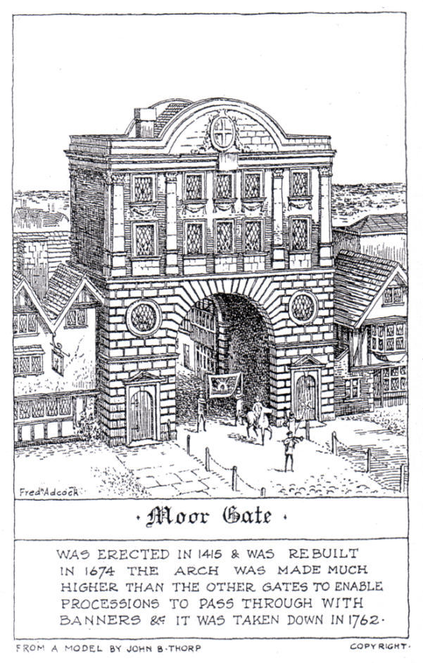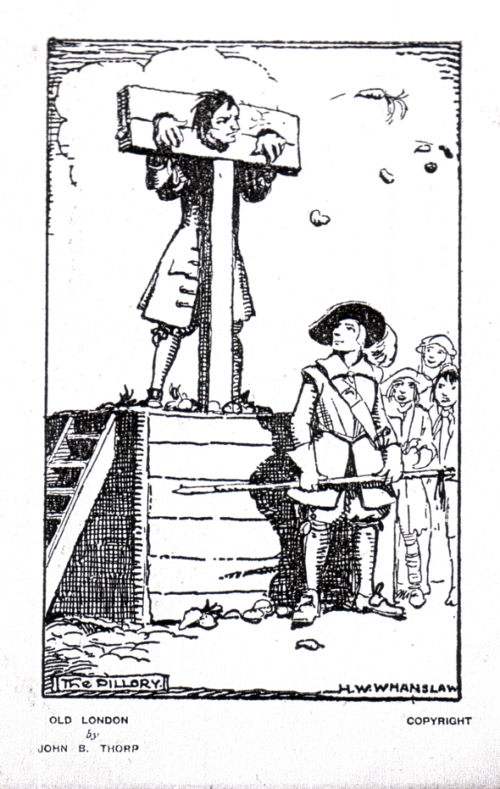
Gate Series Punishments of the Past

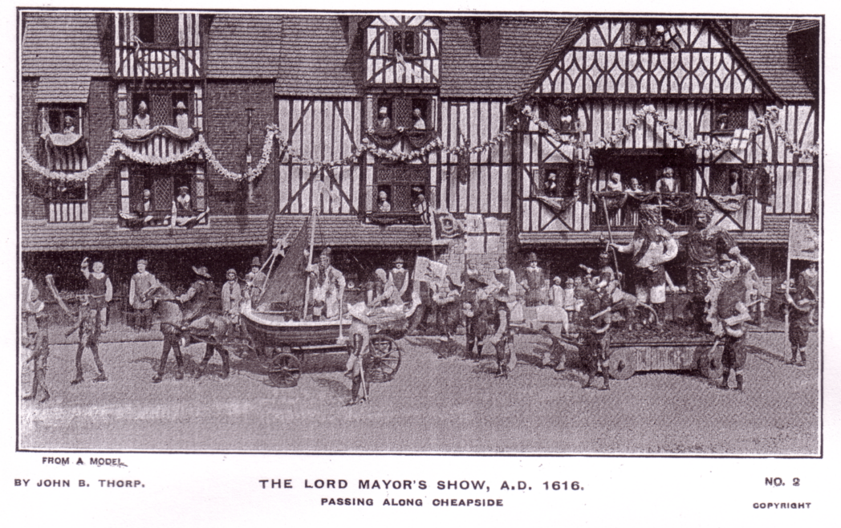
The Lord Mayor’s Show A. D. 1616

Old London. The Gate Series
Pen and ink drawings on a brownish card by Fredk Adcock, with title and brief description on the front and an imprint reading ‘From a Model by John B. Thorp Copyright’, brown back with ‘POST CARD’ measuring 48 mm, a line divider and empty dotted stamp box. All the series are Vert left.
N.n. Ald Gate
N.n. Alders Gate
N.n. Bishops Gate
N.n. Cripple Gate
N.n. End Gate
N.n. Moor Gate
N.n. New Gate

Old London. Punishments of the Past.
Pen and ink drawings by H. W. Whanslaw with a title on the front and an imprint reading ‘Old London by John B. Thorp Copyright’. The title is repeated on the back with four to six lines of descriptive text. Brown back with ‘POST CARD’ measuring 35 mm, a line divider and empty line stamp box. All the series are Vert left.
N.n. The Ducking Stool
N.n. The Drunkards Cloak
N.n. The Finger Pillory
N.n. The Fraudulent Baker
N.n. The Pillory
N.n. The Stocks

Old London. The Lord Mayor’s Show A.D. 1616
Brown printing with cream border, all the cards are numbered and have the same title and an imprint reading ‘From a Model by John B. Thorp Copyright’, brown back with ‘POST CARD’ measuring 45 mm, no divider and empty dotted stamp box.
No. 1 The Lord Mayor’s Show A.D. 1616. Passing along Cheapside
No. 2 The Lord Mayor’s Show A.D. 1616. Passing along Cheapside
No. 3 The Lord Mayor’s Show A.D. 1616. Passing along Cheapside
No. 4 The Lord Mayor’s Show A.D. 1616. Passing along Cheapside
No. 5 The Lord Mayor’s Show A.D. 1616. Passing along Cheapside
No. 6 The Lord Mayor’s Show A.D. 1616. Passing along Cheapside

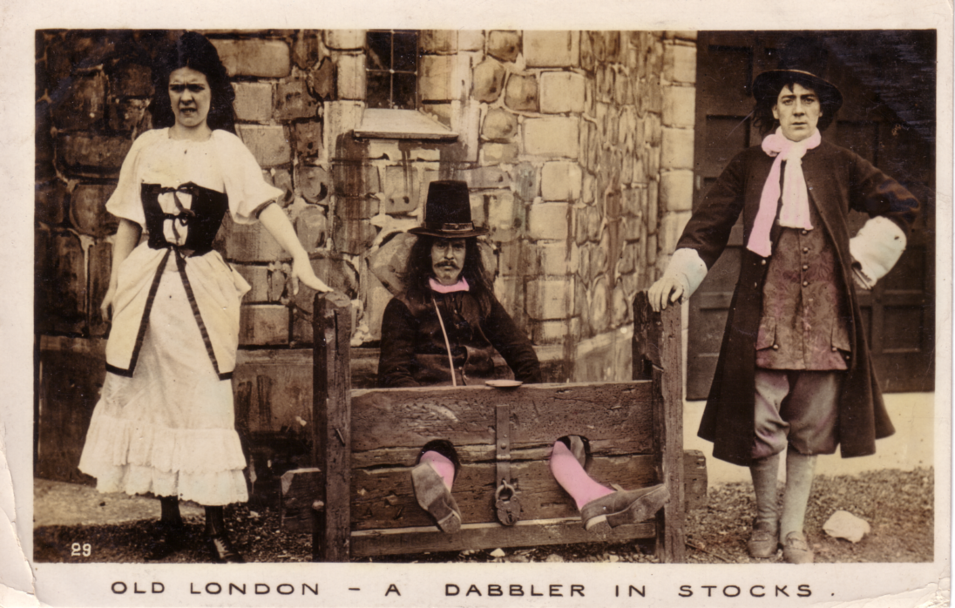

An E. Alexander post card No. 29. ‘Old London-A Dabbler in Stocks’. A contempory writer claimed he was the most popular feature of Old London who passed doleful days with his feet fixed in stocks, to call attention to the show, selling post cards!
Index to Newsletters / Journals
No. 1 (1980) to No. 76 (2005).

Nos. 1-23. Editor Andrew D. Brooks. Published irregularly without page numbers from 1980 to 1992. Each year forms one volume with continuous page numbers where more than one Newsletter was published during the year, title-leaves unnumbered. Page numbers have been added in 2005 for the purpose of this index. Part-pages counted as full pages.

Nos. 24-76. Editor Bill Tonkin. From 1992 to 2005, published quarterly, titled “Newsletter” to No. 37 and then from No. 38 titled “Journal”. Each year forms one volume divided into Spring, Summer, Autumn and Winter with continuous page numbers, title-leaves unnumbered.

Index entries are in two parts, 1-9, the first is the number of the Newsletter and the second is the page number.

Bibliography
B.E.E. 1924-25 Advertising labels by Alan Sabey & Bill Tonkin 70-34
B.E.E. Medals & Medallions by Trevor I. Harris 69-27
British Stamp Exhibition sheets, cards & labels by Glenn H. Morgan review 37-16
Cole. The Great Exhibitor Life & Works of Henry by E. Benython & A. Burton
review by Stanley K. Hunter 70-35
Ephemeral Vistas by Greenhalgh, review by Jeffrey Green 15-43
F.O.B. A List of Information Sources by John Kirby review 34-39
Glasgow's Great Exhibitions by P. & J. Kinchin, 1888, 1901, 11, 38 & 88 notice 11-11
Ideal Home Exhibition by Deborah J. Ryan preview 46-40
Index for E.S.G. Newsletters 1-5, by Stanley K. Hunter 6-24
Index for E.S.G. Newsletters 1-27 by James Negus January 1993 as a supplement 28-sup
Index for E.S.G. Newsletters / Journal 1-55 by James Negus 56-4
International Stamp Exhibition (1912) Souvenirs by Tim A. J. N. Rusden 75-54
Kelvingrove and the 1888 Exhibition by Stanley K. Hunter notice 24-8
Paxton. ‘A thing in Disguise’ Life of Sir Joseph by Kate Colquhoun review
by Stanley Hunter 70-35
Post cards of the B.E.E. by Mike Perkins & Bill Tonkin review 34-37
Ten year up-date (2004) including Snap Shots & Letter Cards 74-38
Post cards of the B.E.E. prices & check list by Mike Perkins & Bill Tonkin review 42-33
Post cards of the F.O.B. notice of intent to publish by Bill Tonkin 57-18
Printed ephemera owned and listed by Andrew Brooks 6-28
Souvenirs from Roman times to the present day. by Godfrey Evans review
by Stanley K. Hunter 54-46
Wembley Venue of Legends published by Columbus Press review by Alan Sabey 52-3
Wembley Images of London by Geoffrey Hewlett 67-61
Worlds Show The (Crystal Palace Medals) by Leslie L. Allen 71-55

Biography (Articles)
Coe. Alfred by Graham Hall Part 1 5-7
Part 2 6-16
Heath. Cuthbert of Lloyds of London by George Burr 71-50
Kiralfy. family odd newspaper cuttings 7-9
Kiralfy. Imre My Reminiscences by Imre Kiralfy 64-5
Maxim. Sir Hiram by Fred Peskett 62-36

Exhibition Study Group
Auction
List No. 1 58-46
Balance Sheets
1995-96 42-34
1996-97 Main A/C 47-65
1996-97 Packet A/C 47-66
1998-99 Main A/C 55-62
1998-99 Packet A/C 55-61
2000-01 Main A/C 63-59
2000-01 Packet A/C 63-60
2001-02 Main A/C 66-46
2002-03 Main A/C 70-36
2003-04 Main A/C 74-39
Circulating packets
Rules 27-57
Report (1994) 34-36
Report (1997 47-63
Letters regarding 51-53
Report (2002) 68-12
Resignation of Packet Secretary 73-26
Committee Meetings
Newport Pagnall 3 June 1995 37-15
Constitution
Constitution 1993 31-54
Conventions Report of
1987 York (Black Swan) 1st Convention 9-1
1988 York (Black Swan) 2nd Convention 10-1
1989 Manchester (K. Illingworth’s Home) 3rd Convention 15-38
1990 Crystal Palace (White Swan) 4th Convention Details of Venue 17-25
1990 Crystal Palace (White Swan) 4th Convention 19-36
1991 Crystal Palace (White Swan) 5th Convention 23-40
1992 Crystal Palace (White Swan) 6th Convention 27-55
1993 Wembley (Century Inn) 7th Convention 31-46
1993 Wembley (Century Inn) 7th Convention (minutes) 33-18
1994 Wembley (Century Inn) 8th Convention 35-50
1995 Wembley (Century Inn) 9th Convention 38-37
1996 Wembley (Century Inn) 10th Convention 43-47
1997 Wembley (Century Inn) 11th Convention (minutes) 47-64
1998 Portsmouth (Salisbury Hotel) 12th Convention (minutes) 50-32
1999 Portsmouth (Salisbury Hotel) 13th Convention 55-60
2000 Portsmouth (Salisbury Hotel) 14th Convention 59-51
2001 Glasgow (Kelvingrove Art Gallery & Museum) 15th Convention 63-50
2002 York (Holgate Hill Hotel) 16th Convention 67-51
2002 York (Holgate Hill Hotel) 16th Convention 68-9
2003 York (Holgate Hill Hotel) 17th Convention 71-51
2004 Bradford (Industrial Museum) 18th Convention Details of Venue 73-31
2004 Bradford 18th Convention 74-38
2005 Notice of move of 19th Convention from Wembley to Hatfield 76-6
Members
List of 1980 1-4
List of 1983 4-2
List of 1987 8-14
List of 1989 12-22
List of 1996 39-50
List of 1998 50-36
Obituary
Henry Morgan (1980) 2-3
John Allwood (1987) 7-1
Nancy Tonkin (1995) 37-17
Lyn Lane (1995) 37-17
George E. R. Ithell (1995) 39-61
John Swanborough (1997) 45-20
Mike Edwards (2001) 61-21
Stanley K. Hunter (2004) 73-18
Subscriptions
1981 75p 3-1
1987 1.00 7-1
1988 2.00 9-3
1989 5.00 11-1
1993 8.00 31-64
1998 8.00 & 13.00 52-1

Exhibitions in London
Agricultural Hall
Orient in London Missionary Exhibition (1908) 4-4
Printing, Stationery, Allied Trades Exhibition (1904) 27-59
Alexandra Palace
History of by John Allwood 2-9
Crystal Palace
Anglo-German Exhibition (1913) by Fred Peskett 47-57
Aviation at the Crystal Palace by Bob Tough 40-4
Festival of Empire by Bill Tonkin 48-5
Festival of Empire (1911), List of Rotary postcards, 1-14
History of 27-48
Letter about, from Ron Trevelyan 73-27
People & Places International Ltd A New plan for Crystal Palace by 54-40
Site plan 3-10
Design Museum, Butlers Wharf
Ideal Home Exhibition, Exhibition Deborah Sugg 29-14
Earls Court
Great Wheel
Gigantic Wheel & Recreation Towers Co., Ltd. by Alan Sabey 55-57
Great Wheel (1905) by Terry Hougham 4-12
Medals & Statistics by George Burr 57-25
Italian Exhibition (1888) by Arthur P. Smith 25-22
Paris in London Exhibition (1902) Daily Programme Printed by Gale &
Polden Part 1 13-34
Part 2 15-44
Shakespeare’s England (1912) List of Rotary, W. H. Smith, & Valentine P/C’s
by Arthur P. Smith 7-10
Notes on, packet 11-10
Earls Court / Olympia
History of by unknown author 43-48
Ideal Homes Exhibition
(1908-59), list of postcards by Andrew D. Brooks & Fred Fletcher 11-4
Revised 16-2
Additions 1st 19-39
Additions 2nd 27-60
Additions 3rd 29-17
Publicity Slogans postal cancellations by Arthur P. Smith 31-48
Festival of Britain
Building Design, pages from by Amanda Baillieu 20-4
Costain Celebrating F O B 40 years on 23-44
Eltham Pageant script of 32-9
London Characters Series by Tuck 28-8
On My Way poster labels 49-21
Picture Post Card Show (2001) display put on by F. Peskett, G. Simner & B. Tonkin 62-33
Portsmouth, Spirit of 51 Exhibition (1998) by Fred Peskett 49-27
As above 50-33
Woolwich, Remember 51 Exhibition by George Simner 50-34
Hayward Gallery
Twilight of Tsars Exhibition (1991) by Stanley K. Hunter 20-2
Hyde Park
Great International Exhibition (1851) 1850 Executive Committee correspondence 18-28
Great Exhibition by Bill Tonkin 27-48
Sesquincentenary of Great Exhibition 2001 by John K. D. Cooper 46-36
Imperial War Museum
1st World War Remembered by Bill Tonkin 50-35
Meccano Exhibition by Fred Peskett 52-2
Olympia
1886-2000 History of by Bob Tough Part 1 65-19
Part 2 66-36
International Horse Show correspondence with Vivian Forster Part 1 44-3
Part 2 45-19
Irish Exhibition (1888) by George E. R. Ithell 17-23
Irish Exhibition (1888) above article repeated 25-28
Royal Tournament by Arthur P. Smith 34-40
Royal Horticultural Society
Royal Horticultural Society Tercentenary Exhibition 73-17
Notes on 74-37
Royal Institute of British Architects
Festival of Britain in retrospect (1991) 20-2
South Kensington
International Inventors Exhibition (1885) by Arthur P. Smith 25-21
Victoria & Albert Museum
Britain Can Make It Exhibition (1946) (Alan Sabey present as a child) 9-3
Wembley, British Empire Exhibition
Advertising labels B.E.E. (1924-25): 27-55
Anchor Line by Mike Perkins 61-15
Architects Journal, notes on buildings by Fredk Chatterton FRIBA 8-26
B.E.E. Colonial Slogan Cancellations by Alan Sabey 57-19
B.E.E. in my Bonnet by Peter Griffin Part 1 32-13
Part 2 33-30
Part 3 34-44
Part 4 35-56
B.E.E. Perfins on Wembley (1924-25) stamps by John Nelson Part 1 26-32
Part 2 33-27
Part 3 40-8
Part 4 63-57
Stamp perfins, notes on 27-58
Stamp perfins, notes on 30-42
Stamp perfins, notes on 54-43
B.E.E. Saturday Relief cancellations by Alan Sabey 51-47
Cardiff at Civic Hall by Mike Perkins 68-3
Commemorative Ceramics (crested china) 1924-25 by Jenny Hill Part 1 67-55
Part 2 68-4
Development of the British Empire Exhibition by Alan Sabey 31-55
Diary of Royal Visits in 1924 by Alan Sabey Part 1 59-60
Part 2 60-7
Exhibitors stand numbers and locations, 1924-25 Sample page by Bill Tonkin 40-2
Fleetway Press 1924 Official Guide description of various editions by Bill Tonkin 60-4
Horology at Wembley by Trevor Day 73-25
Hull Civic Fortnight by Mike Perkins 41-16
King’s Speech at opening broadcast to Clacton by Alan Sabey 29-25
Life Boat House at Wembley by Bill Tonkin 28-5
Lion Advertising Label, plating study by Alan Sabey 64-9
Lloyds Bank advertising labels 42-35
Maps 1924, various printings by Bill Tonkin Part 1 51-48
Part 2 52-9
Part 3 53-27
Part 4 54-51
Part 5 71-54
Model Coal Mine at Wembley by Bill Tonkin 54-47
Moorcroft's Stand by Paul Atterbury 25-24
Mount Everest post card by Brian England 33-25
Other Wembley Exhibitions by Alan Sabey 31-59
Pageant of Empire (1924) Programme 4-10
Official documents by Bill Tonkin 21-14
Passes 1924-25 by Alan Sabey 8-22
Post Office underground Railway at Wembley by Mike Perkins 68-3
Remains of the B.E.E. by Alan Sabey 52-6
Red Cross at Wembley by Bill Tonkin 26-37
Sabey A. His exhibition at the Royal by Peter Denley 53-33
Scout Jamboree at Copenhagen trip from Wembley on United Baltic Corp. ships 28-10
Some questions by Peter Denley 57-23
Stadium construction of by Mike Perkins 24-2
The Scout Supplement pages from 12-15
Trevessa Life Boat at Wembley by Mike Perkins 41-16
Tutankhamen exhibits from the B.E.E. in the Hands on History Museum Hull 67-52
Wembley Lion The by Alan Sabey 30-43
Wembley Snippets by Alan Sabey 52-2
Wembley British Empire Exhibition Post Cards & lists
Association of Friends of the National Postal Museum (set of 1925 post cards) 58-34
Cyprus post cards on sale at B.E.E. 66-44
Fleetway post cards sorting the 1-11
Gold Coast list of Tuck’s post cards 26-34
Hartley W. P. (London & Aintree) Ltd 54-39
Further notes 71-51
Macdonald Greenlees & Williams Distillers Ltd Defenders of Empire post card 30-40
Malaya Pavilion post card printing varieties by Mike Perkins 40-3
Prince of Wales in butter by Tony Davis & Mike Perkins 49-26
Queen’s Dolls House Tuck’s post cards 31-62
White City
Anglo-American Piccaninny Band (1914) by Jeffrey P. Green 13-27
Ballymaclinton Details of George E. R. Ithell archives 42-35
Building the Great White City by Bill Tonkin 70-37
Collecting scope (1908-84), by Don Knight 8-2
Ephemera collecting (1908-79) by Don Knight 2-7
Evans. Lewis display of mathematical instruments at White City by Peter de Clercq 58-48
Franco-British Charity Fete and Bazaar (1909) 13-26
Franco-British post mark errors by Don Knight 71-58
Japan-British Exhibition (1910) Japanese cancellations by Bill Tonkin 15-39
North Surrey District School at the Franco-British Exhibition by Bill Tonkin 45-21
Official Souvenir, Hudson & Kearn, 3 editions by Bill Tonkin Part 1 49-23
Part 2 50-35
Photography at the Franco-British Exhibition 19-43
Uxbridge Road Entrance 25-18
White City Post Cards & lists
Alexander post cards (1908) 1-14
Ballymaclinton, from George E. R. Ithell’s archives Part 1 47-53
Part 2 48-2
Fetes de L’Inauguration de Exposition Franco-Britannique by Alan Sabey 56-2
Mucha Franco-British Exhibition post card by Ken Harman 49-25
101 Ranch post cards 58-35
Post cards of the White City a pre-amble by Bill Tonkin 41-22
Post cards of the White City Small publishers Part 1 A. N. Paris - Aristophot 41-24
Part 2 Small publishers, Bat Expanding Bedstead- Bovril 42-36
Part 3 Small publishers, Brennan Gyroscopic Railway- Davidson Bros 43-58
Part 4 Small publishers, Davidson Bros-East London Printing Co. 44-9
Part 5 Small publishers, Edison & Swan-Globe Newspaper The 45-25
Part 6 Small publishers, Gottshalk Dreyfus & Davis-Imp Govt Rail Japan 46-43
Part 7 Small publishers, Imperial Ottoman Tobacco Regie-Millar & Lang 48-9
Part 8 Small publishers, Millar & Lang-Moyea 49-28
Part 9 Small publishers, National Cash Register-Oetzmann 51-55
Part 10 Small publishers, Parsley Salmon-Pritchard Co. 52-17
Part 11 Small publishers, Queensland 53-34
Part 12 Small publishers, Queensland-Rapid Photo Printing Co. 54-51
Part 13 Small publishers, Rapid Photo Printing Co.-Rotary 55-63
Part 13 (continued) Small publishers, Rotary 56-15
Part 14 Small publishers, Samuels-Sutton 59-67 57-27
Part 15 Small publishers, Taber Bas Relief-A & G Taylor 59-67
Part 16 Small publishers, Tuck & Sons 60-9
Part 17 Small publishers, Unknown publishers 61-23
Part 18 Small publishers, Unknown publishers 62-43
Part 19 Small publishers, Unknown publishers-Zog 63-61
Part 20 Valentine Franco-British Exhibition Introduction 64-11
Part 21 Valentine Franco-British Exhibition Introduction 65-28
Part 22 Valentine Franco-British Exhibition Introduction 66-47
Part 23 Valentine Franco-British Exhibition Introduction 67-63
Part 24 Valentine Franco-British Exhibition Introduction 68-13
Part 25 Valentine Franco-British Exhibition Introduction 69-29
The following sections are listed by the first word of the titles
Part 26 Valentine Franco-British Exhibition Introduction-Avenue 70-40
Part 27 Valentine Franco-British Exhibition Ballymaclinton 71-61
Part 28 Valentine Franco-British Exhibition Ballymaclinton-British 72-8
Part 29 Valentine Franco-British Exhibition British-Canadian 73-34
Part 30 Valentine Franco-British Exhibition Canadian-Colleens 74-46
Part 31 Valentine Franco-British Exhibition Colonial-Congress 76-12
Rotary post cards:(1908-12) 8-23
Stapled books of post cards with counterfoils by Bill Tonkin 53-29
Valentine’s post cards (1908) Pre-exhibition & clouds by Bill Tonkin 10-14

Exhibitions outside London
Aberdeen
Aberdeen Fungus Exhibition (1874) 27-48
Bradford Industrial Exhibition (1904)
Correspondence of John Masefield by Graham Hall 3-4
Bradford Industrial Exhibition (1904) by Graham Hall Part 1 7-4
Part 2 27-59
Bradford Industrial Exhibition (1904) by Graham Hall 53-22
Bradford Industrial Exhibition (1904) New hand stamp discovery by Graham Hall 53-22
Edinburgh
Edinburgh International Exhibitions 1882, 1884, 1886 & 1890 by Stanley K. Hunter 70-34
Edinburgh (1886)
1886 International Exhibition by Stanley K. Hunter 6-20
1886 International Exhibition by Stanley K. Hunter 9-12
Edinburgh Festival (1991)
Edinburgh Festival (1991) by Stanley K. Hunter 22-33
Glasgow Empire Exhibition (1938)
Empire Exhibition by Stanley K. Hunter 44-6
Post cards of Brian Gerald by Bill Tonkin 34-46
Post cards of Brian Gerald by Stanley K. Hunter 35-54
Glasgow International Exhibition (1901)
Kelvingrove Art Gallery & Museum Centenary 2001 by Stanley K. Hunter 69-28
Grantham
Grantham Industrial Exhibition (1907) 12-14
Hull
Tutankhamen exhibits from the B.E.E. in the Hands on History Museum Hull 67-52
Liverpool
Gypsy Encampment at Liverpool International Exhibition (1886) by Sharon Floate 69-17
Newcastle-upon-Tyne
North of England Model Cottages Exhibition Newcastle,(1908)
by Andrew D. Brooks & Fred Fletcher 6-27
North East Coast Exhibition post cards 58-37
Richmond
Richmond, Belgian Soldiers Fund War Exhibition (1916) 17-21
Scottish General Exhibitions
Centenaries of 1886-88 Scottish Exhibitions by Stanley K. Hunter 6-20
Kelvingrove Vanished Palaces by Stanley K. Hunter 47-58
Kelvingrove Park Walk 17 June 2004 by Stanley K. Hunter 73-19
Trowell
The Festival Inn 33-28
Wolverhampton
Wolverhampton Art & Industrial Exhibition (1902) by Sylvia Onions 2-5
York
York Exhibitions 1866 & 1879 by Stanley K. Hunter 68-11

Foreign Exhibitions
Argentine
(1898-1950) by The Rev. Jeremy Howat 9-6
Australia
(1866-1956), by Percy Oliver Part 1 3-5
Part 2 4-8
Belgium
Belgian Exhibitions having post cards by R. Van Peteghem (A supplement to
Newsletter No. 22 22-sup
Brussells Exhibitions by Stanley K. Hunter 30-30
Brussells International Exposition 1958 A Visit to, by Bob Tough Part 1 75-63
Part 2 76-7
France
Grenoble Hydro-electric & Tourism Exhibition (1925) 7-5
Paris Great Exhibition (1855) 18-31
Paris Universal Exposition (1900)
Paris Universal Exposition What to see at (1900) by Derek B. Bartlett 24-10
Paris Universal Exposition by Ron Trevelyan 62-40
Paris Universal Exposition labels by Charles Kiddle 62-35
Paris World Fair (1989) 5-12
Germany
Frankfurt Electrotechnical Exhibition (1891) 8-17
India
United Provinces Exhibition (1911) Allabad Airmail Flight by Ken Harman 59-52
Japan
International Exposition, Tokyo-Yokohama (1940) by Stanley K. Hunter 22-33
Netherlands East Indies
Netherlands East Indies Exhibitions by Richard Wheatley 64-2
New Zealand
New Zealand & Maori presence at British Exhibitions 54-44
New Zealand Exhibitions by Ron Trevelyan 53-28
New Zealand Exhibitions & Doulton by Peter Van Gelder 52-7
South Africa
Empire Exhibition (1936-37) 35-58
Spain
Seville Expo (1992) by Ron Trevelyan 33-20
U.S.A.
California historic sites by Stanley K. Hunter Part 1 20-2
Part 2 20-7
Chicago World's Fair (1893), Ferris Wheel by Ron Trevelyan 55-57
Chicago World's Fair (1933), Century of Progress List of post cards by J May 13-31
New York World's Fair (1939-40), postcards 12-18
Pan-American Exposition, Buffalo N.Y. (1901) by Barbara M. Soper 11-7

Films featuring Exhibitions
Expo’s at the Movies by Stanley K. Hunter Part 1 24-5 Part 2 25-16
Bradford Exhibition on film by Graham Hall 27-58

General
As seen on TV by George Simner 51-46
Bicycles at Exhibitions by Bill Tonkin 32-2
Collecting Mania by Bill Tonkin 35-52
E-Bay letters on 68-1
Exhibition Comparisons 1851-1900 by Harold Macfarlane 1-5
Footsteps at the American World Fairs by Stanley K. Hunter 42-32
Fukasawa Yuriko Professor of Archology 1st visit 40-1
2nd visit 66-35
Glasgow Exhibitions Society (Scottish Exhibition Study Group)
Prospectus by Stanley K. Hunter 20-11
Scottish Exhibition Study Group by Stanley Hunter 54-43
Hankerchiefs from exhibitions by Brenda Mathews 45-32
International Exhibitions and National Identity by Benedict Burton 22-28
List of Exhibitions 1851-87 by Professor F. L. Simmonds 5-2
List of World Exhibitions by Ken Harman Part 1 (1760-1877) 37-23
Part 2 (1878-1904) 38-30
Part 3 (1905-1984) 39-62
Additions 40-12
London Exhibition sites by Stanley K. Hunter 23-45
London Exhibition sites by Arthur P. Smith 25-19
Medals at the Super Market by Stanley K. Hunter 38-39
Missionary Exhibitions
S.P.G. by Bill Tonkin 35-61
Missionaries, John Williams & Missionary Exhibitions by Bill Tonkin 63-53
Missions letters on 76-6
Printing methods of producing prints by Ken Harman 38-45
Road to Gold by Alan Sabey 61-21
Royal Doulton at International Exhibitions by Katharine Ellis 49-18
Spring Stampex (1997) by Alan Sabey 44-7
Successful Public Speaking by Fred Peskett (wrongly attributed to S. K. Hunter) 29-22
Trade and Industry Fairs by Ron Trevelyan 52-4
Victorian & Edwardian Medals by Leslie L. Allen Part 1 72-3
Part 2 73-27
Part 3 74-40
Part 4 75-54

Philately
History of Exhibition cancellations at S. E. District Office by J. W. A. Lowder 40-9
Ideal Home Publicity slogan postal cancellations by Arthur P. Smith 31-48
London Stamp Exhibitions (1947, 1960), queries on dates and cancellations 12-17
Scottish Stamp Exhibition cards by Stanley K. Hunter 11-2
Stamp checklist, Exhibition theme by Fred Peskett 23-50

Post cards general
Checklist for British Exhibitions (1890-1982) by Fletcher & Brooks 5-5
Coe Collotype by Graham Hall 6-18
Collecting Exhibition Post Cards by Fletcher & Brooks 5-9
Exhibitions commemorated by post cards 2-15
London Museum B.E.E. & White City post cards published by 75-68
Pull outs by Bill Tonkin Part 1 36-2
Part 2 37-18
Reprints 28-2
Screen printing, by M. G. Morgan 1-10

