EDITORIAL Spring 2005

Have you paid your subs, now don’t delay,
Sit right down and get them off today.

In the last Journal I mentioned the possibility of sending sheets with reduced illustrations of post cards or any other items in place of the circulating packet. I finished up by saying “if you think this is worth looking into drop me a line”. Perhaps over Christmas is a bad time to ask you to get your brains working but I have not had a single reply.
One of the tasks I have been ducking for a long time is supplying back numbers of the Journal that are out of stock to members requesting them, which the group gets £2.00 each for. I have a large stock of Journals going back to about the end of 1998, and supplying back numbers from this stock gets done without too much delay. The problem arises when members request early numbers, especially those edited by Andrew Brooks where I have none of them in stock. A request by the Henry Madden Library of the State University of California for a complete set of back numbers (42 copies) up to 1992 when they became a member of the Group proved to be the last straw. Something had to be done.
I have a complete run of Journals myself and also a complete run of what I call ‘master copies’ which are in some cases the original proofs from which the Journal was produced by Andrew. I photo-copy from these master copies to supply members wants, but it is a very slow business and the quality of some is very poor. The first Exhibition Study Group Newsletter was produced by Andrew in 1980. It consisted of photo-copied sheets starting with an Editorial and then any material he could lay his hands on. From the start picture post cards were featured, although all aspects of exhibition memorabilia were included.
One of the problems is that in the beginning only about ten copies of the Newsletter were made for the ten members, and as new members joined and requested back numbers (as I did) Andrew had to re-photo-copy old photo-copies and every time this was done the quality of the reproduction deteriorated until the pictures and some of the text is of very poor quality indeed.
I have decided to record all the Exhibition Study Group Newsletters later renamed the Journal on to C D’s to make producing back numbers a simple operation, and in particular to be able to produce at the tap of a key, in many cases, much better copies than the originals, and much quicker.
To improve the quality of the earlier copies I decided where ever possible to replace as many of the original photo-copied pictures with scanned images from originals from my own collection. I have been able to replace about 90% of the illustrations in this way. The only area where I have not been able to replace the originals, is in the case of Foreign exhibitions which I do not collect. I have also not been able to replace odd cuttings with text and pictures from newspapers etc. sent in by early subscribers to the newsletter, where often only photo-copies were sent in the first place. The quality of some of these was poor to start with and even if the originals were available, well you can’t make a silk purse out of sows ear.
So I can safely say that in many cases reprints supplied now of the older newsletters are much better than the originals. Although the newsletters have in the past always been published in B/W the new recorded illustrations in the Newsletters are being saved on C D’s in colour. While I am supplying back numbers they will be in B/W as I don’t have a colour printer. When some one else takes over the job, if they have a colour printer, then they can print coloured newsletters. At the moment I have done the first 52 journals, and will get them all on five C-D’s. So far the following Journals have been tarted up and saved on computer,
Newsletter No. 1 Spring 1980 to No. 7 Spring 1987 on C-D Journ A
Newsletter No. 8 Summer 1987 to No. 12 Summer 1989 on C-D Journ B
Newsletter No. 13 Autumn 1989 to No. 21 Summer 1991 on C-D Journ C
Newsletter/Journal No. 22 Autumn 1991 to No. 48 Spring 1998 on C-D Journ D
Journal No. 49 Summer 1998 to No. 52 Spring 1999 on C-D Journ E
I shall get the last 24 journals on to C-D Journ-E
Once I got past number 24 published in 1992 it became easier as I had the text already saved on the computer although it was done on an amstrad and all the formatting got lost in transferring so had to be re-done. The later years are O K and should not take too long to finish the job.
The early reprints recorded on the C-D’s usually run into four or five sections because of the amount of computer space taken up by the scanning of whole A4 sheets of pictures and text. The individual sheets of the Newsletters published by Andrew were not numbered, and I have included page numbers on the reprints. This means the Index will have to be brought up to date. I have also added on to the cover the number and year of that particular newsletter, again something that was not done in the early years. Apart from these minor additions I have tried to keep the journals to as faithful a copy of the originals as possible.
The Henry Madden Library’s 42 copies are now done up in two packets (one would have been too heavy for posting) and as soon as I hear whether they want them air or sea mail they will go off. The Henry Madden Library houses the largest collection of books on exhibitions in the world and it must be regarded as a feather in our cap that they consider our Journals worthy of inclusion in their collection. I am now in a position to supply any back numbers fairly quickly so if members requiring back numbers will let me know what numbers they want I will get them done.
In the beginning only the Editorial of the Newsletters was typed out on Andrew’s typewriter, all the rest of the pages whether articles copied from books and magazines, or letters sent in by members were photo-copied. The pages so produced were often in a wall to wall format and in scanning these, some have had to be slightly reduced in scale to allow for the margins modern computers require.
In 1990 and 1991 Andrew must have acquired a computer as for these two years he was able to use computer generated front pages with decorative borders, and gave up using the cut and paste method on the front page. (Not cut and paste as in computer language but using scissors and brush in a pot of paste). In fact it was not until number 16, a check list of Post Cards of the Ideal Home Exhibitions was it all done on his computer with headers, footers and page numbers, the lot. Then it was back to scissors and paste pot for the contents up to number 24 in 1992 when he retired as Editor.
After Andrew retired the Newsletter was produced by a three man team with myself as Editor, and from then on I typed the Newsletters into a computer with only the illustrations pasted in (using brush and paste pot as scanners were still too expensive). I left gaps in the text for the illustrations and sent the proofs with illustrations to Damon Murrin who pasted these in place, he also designed the front cover for each issue and the general lay out. They were then sent on to Karl who saw to the photo-copying and distribution. By the end of 1993 Damon had dropped out and the team was down to Karl and myself. Up until the end of 1996 the paste pot was still in use but then I got a scanner and the paste pot was made redundant.
One of the things Damon did was to get the Title of the newsletters printed by a local printer in the form of headed note paper. The font used was one that was in use in 1851. I have kept this design for the newsletters all the time I have been producing them, with just a different illustration on the front. In fact the only alteration came at our 1995 A G M when it was passed that the Newsletter should in future be known as the Journal.
It should be mentioned here that one of our members, Karl Illingworth, very generously undertook the duplicating costs, collating, stapling, putting in envelopes and paying the postage of the Newsletters up until number 48, the 1998 Spring issue, when Karl, for personal reasons had to stop. Then another member, my son Kenneth took over and has paid for the duplicating and costs of distributing the Newsletter since 1998. To start with Kenneth used one of his companies to sponsor our journal, but he now tells me he pays for the Journal out of his own pocket. It should be said loud and clear that the very healthy financial state of the Study Group is due entirely to the generosity of these two members, Karl and Kenneth.
When the C-D’s are finished there is already an order for a complete run of Journals from Kenneth, as one of his interests is in building up a comprehensive philatelic library.

The Editor

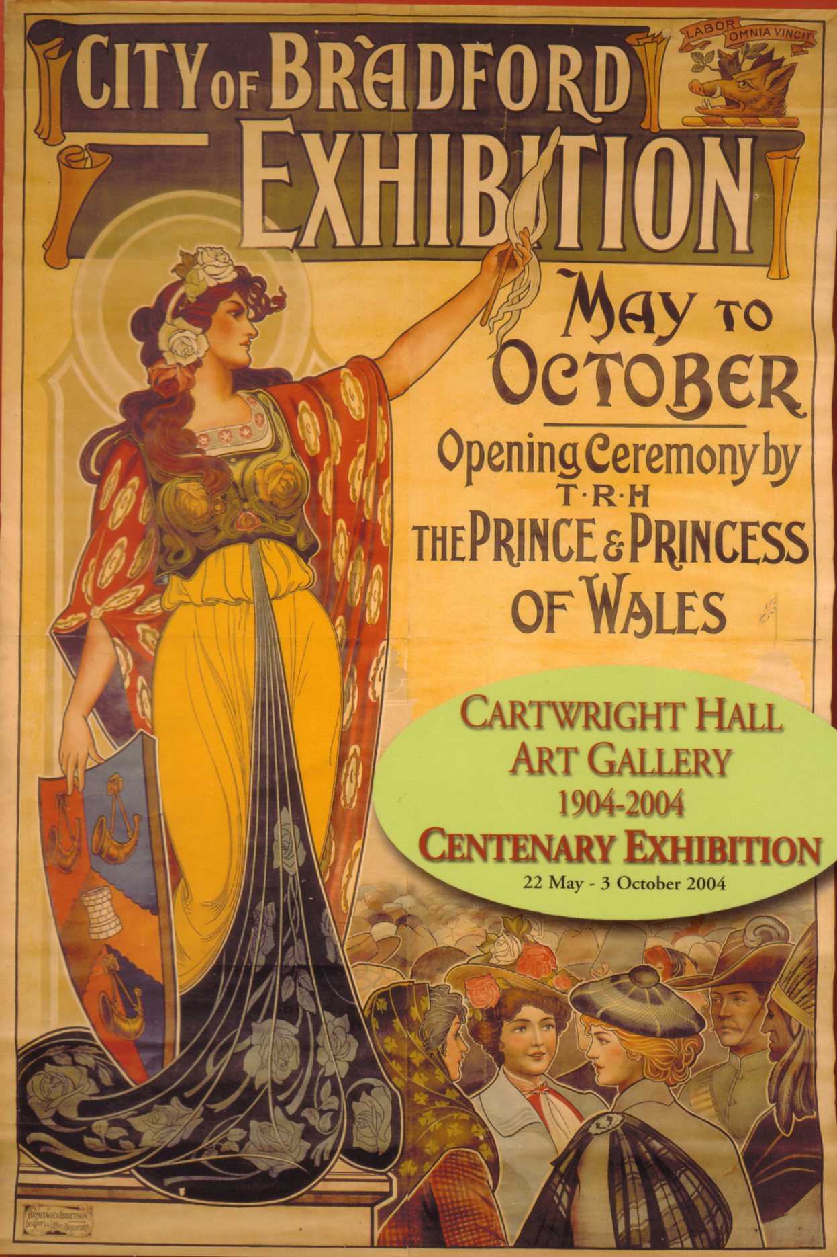

The illustration of the large wall poster on the cover of the booklet of the Cartwright Hall Art Gallery
1904-2004 Centenary Exhibition

Letters to the Editor

Since our Convention I have had several letters from Graham Hall and as they contain matters of interest I am giving a précis of them. Members who visited the Cartwright Hall Art Gallery Centenary Exhibition while up for our Convention will remember the large hanging poster and the 32 page A4 size booklet on sale about the Exhibition, the front cover shows a coloured picture of the poster (see previous page) I bought one at £4.50 and a very good buy it was too. It was certainly a very up market publication showing some of Graham’s post cards. After the exhibition closed Graham Hall managed to get a small quantity from them which he can offer to members at £1.50 each. This includes the packing and postage which will cost Graham £1.01 first class, or 83p second class. He says it will have to be on a ‘first come first served’ basis. Graham lent a lot of his own material for the exhibition, which took them over two months to return, only after he pestered them several times. In the “Hurry” they managed to lose one of his 1904 Bradford Exhibition post cards. If anyone wants a booklet contact,
Graham Hall.
“Moorside”, 43, Micklethwaite,
Bingley,
West Yorks. BD16 3JW
Phone 01274 564518.

At the opening of the exhibition in May Cartwright Hall used an illustration of the poster on their invitations to the preview of the exhibition, and I have to thank Graham for sending me one. It is a beautiful coloured card measuring 6 x 8¼
In Graham’s raking around in the West Yorkshire Archives he came across a lot of old telegram forms addressed to the 1904 Bradford Exhibition. He sent me a couple of photo-copies of the telegrams and asks if I or any member can shed a light on the post office cancellations on the forms. Now this sort of material is so rare that people like me can’t afford it. (There will be a brief pause for readers to wipe their eyes)......Graham says he knows that a special skeleton hand stamp was used and in over thirty years he has only found one example, and that had been stamped on the back of an unused non exhibition post card. Apparently the archive has dozens of these telegram forms with the skeleton hand stamp on.
Referring to the experts Stitt Dibden’s 1962 ‘Priced Catalogue of British Exhibitions 1840-1940’ states “A temporary Post Office was opened in the Memorial Hall, Bradford during the run of the exhibition and a circular dated stamp was in use. The hours of business originally set between 11.0 a.m. and 6.0 p.m. were extended in early June to 8.0 p.m.” Stitt Dibden uses as an illustration a hand drawn single ring stamp dated 22 May 04.
The entry in ‘Special Event Postmarks of the United Kingdom (Second Edition 1973)’ by G. R. Pearson is interesting, and comments “It would appear that this was a stamp used for documentation purposes and was used by favour on postal items as the known example is on an unused postcard.” Now this is different to what Stitt Dibden says, who implies the stamp was in use for the whole of the exhibition. The ‘unused post card’ is familiar and I wonder if he is referring to Graham’s copy. Do you still have yours Graham? and is it dated 22 May 04? Both Stitt Dibden and Pearson use the same hand done 22 May 04 drawing to illustrate their respective books. The flaws in the way the writing is done is absolutely identical in both cases.
Pearson in his revised 1991 ‘Special Event Postmarks of the United Kingdom has redrawn parts of the Bradford Exhibition illustration still keeping the 22 May 04 date. He has also added to his earlier description “A squared circle hand stamp with code “BE” is reported but an example has not been seen.”
So to Graham Hall must go the credit of discovering a third hand stamp (assuming the squared circle one exists). This appeared on some of the telegram forms and is a double ring stamp with ‘BRADFORD EXHN MY 20 04’. He very kindly sent me a photo-copy of the double ring stamp and wonders which came first, and did one replace the other? This may be solved if Graham can get back to the archives and note all the dates of the two hand stamps on the telegram forms.
At the moment all the evidence appears to suggest these cancellations were only used on telegrams, not with standing Stitt Dibden’s valuation in 1962 of £5.00 postally used on cover.

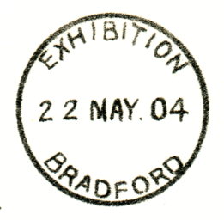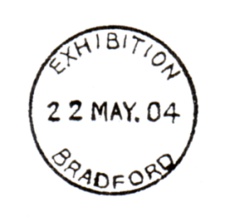

Illustration of hand stamp Illustration of hand stamp
Stitt Dibden used in 1962 used in Pearson 1991. note
and Pearson 1973 redrawn ‘MAY.’ (not to scale)

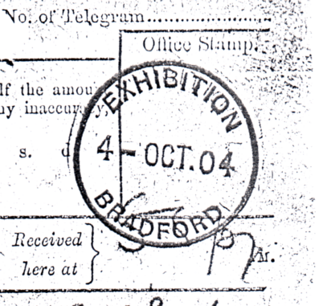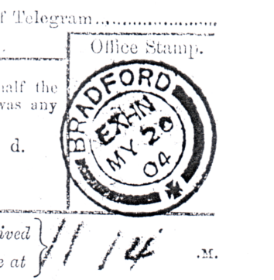

Hand stamp on telegram in Previously unrecorded hand
West Yorkshire Archives stamp on telegram in West
Yorkshire Archives

It would seem that neither Stitt Dibden or Pearson ever had access to an illustration of the Bradford Exhibition Cancellation and had to rely on a hand drawn example. The impressions found by Graham on telegram forms are both therefore unique.

Letter from Mike Perkins,

Dear Bill,

Could you please place the following adverts in the next edition of the Journal.
Situations vacant
Book Sales Wanted. Someone to handle group book sales. This arduous position will involve putting a book in a ‘Jiffy bag’ about once a month and posting it. Space needed to store about 15 boxes of books (I use the loft). Can deliver books.

Webmaster Wanted Someone with computer and internet access to run the Group web site. Scope unlimited. Files and training will be given. (Plus software if needed).

I will continue in the above roles until August, the web site will close at the end of August unless taken over (and the hosting and domain name renewed)

Yours sincerely Mike.

I have suggested to Mike with the committees approval that he renews the site which will cost the group about £30.00 but will ensure that our name on the internet survives, as nothing can be decided until our next AGM in September. If we then decide to let our web site lapse it will be a pity, but we can afford to lose the £30.00.
The loss of someone to handle our book sales is more serious. If no one is prepared to spend the very little time and effort to take this job on, the question arises what do we do with our stock of books? I estimate half an hour should cover putting a book in a ‘Jiffy bag’, and by Mike’s comments above, at one a month, this will involve about six hours work a year. Alan Sabey’s appeal over two years for someone to take over his Study Group archives has met with a stony silence and it has to be faced that in our modern society there is a definite reluctance to tear oneself away from the box and take on a voluntary job. This applies to clubs of all types, scouts and guide packs are closing because of a lack of adults ready to lead them, stamp societies, post card clubs, you name it and they have the same problem. Nancy formed and organised single handed a local history society which used to have attendances of about 80, this closed down a few years ago because not a single member was prepared to see it survive if it meant a small amount of personal effort. It’s all very sad.

Letters from Missionary card collectors

I have had quite a lot of correspondence with three collectors of Missionary cards. One lives in Australia and I wrote about him some time ago in the Journal, after we met by chance in a fair at Worcester. Dr Derek Pocock wrote to me in December to say he had just been awarded a large silver medal for his display of Universities Mission to Central Africa post cards. He goes on to say he mainly scored for research “so much credit is really mine” which was kind of him.
Another collector also a Doctor is Dr Sandy Brewer and in our correspondence she happened to mention that E. Stuart Hardy was a lady. This was the artist who illustrated many of the early missionary cards who I had assumed was a man. But no, Sandy was right and she sent me details of Edith’s early life.
The third collector is Shirley Baker who has been able to let me have photo-copies of some of the Universities Mission to Central Africa packets. Shirley is so keen she even lives in a house named Mpemba after one of the Mission stations. We have been working together to try and sort the cards into the various series, and where packets list the contents and series number on the front, this is a great help. So far we have between us Packets 1, 4, 5, 9, 10, 11 and 12. If anyone has any of the missing packets, even without cards please let me know.

19th Convention at Hatfield 2005

At our last convention at Bradford it was agreed we move back to the London area and meet this year at Wembley. Alan Sabey had got some prices from a new hotel as the one we used to hold our convention in had closed down. As I was paying up after the convention I thanked them for looking after us so well and remarked to the young lady it was a pity they had no hotels down South. Oh, but we have she replied and gave me a booklet.
On the Monday I phoned their head office and found they could do us a much cheaper deal than the Wembley hotel had offered us. I let Alan Sabey know of this and asked him to hang fire and not book us in at Wembley until I had made other enquiries.
I had arranged to visit the philatelic club in Croydon where Don Knight was giving a display on the Tuesday, and we went through the booklet together. He knew of the Jarvis Hotel at Hatfield and agreed to call in and look it over.
As you can see both the conference room hire (Hatfield £300 as against £620 for one and a half days) and the bed & breakfast charges (Hatfield £60.00 for a two sharing a double room against £95.00 and for one person in a single room Hatfield £45.00 against £75.00) are considerably lower. I contacted the officers and committee of the Study Group, suggesting we change the venue, and hold the 2005 convention at Hatfield and all were in favour of the change. So the venue for next September is the Ramada Jarvis Hatfield. St. Albans Road West, Hatfield, Herts. AL10 9RH phone 01707 265411. The hotel is just off the roundabout on the M25 which should be convenient for everyone to find.
I shall remind you all nearer the time but when you book mention these prices as they are a special ‘Event Rate’ for people attending conferences held in the hotel.

Visit to the World International Exhibition Brussels 1958
by
Bob Tough
Part 2 the Belgian stamps and cancellations.

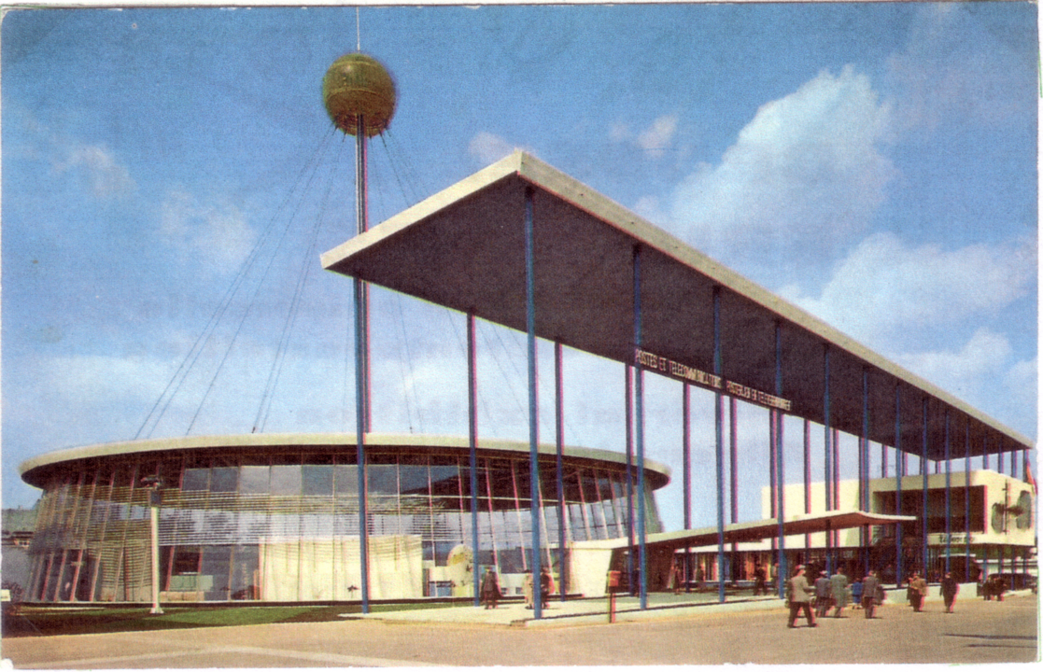

The Post and Telecommunications Pavilion at the last Worlds Fair, there had been a number of these exhibitions since 1851 when Prince Albert arranged the first one, the Great Exhibition in Hyde Park, London.

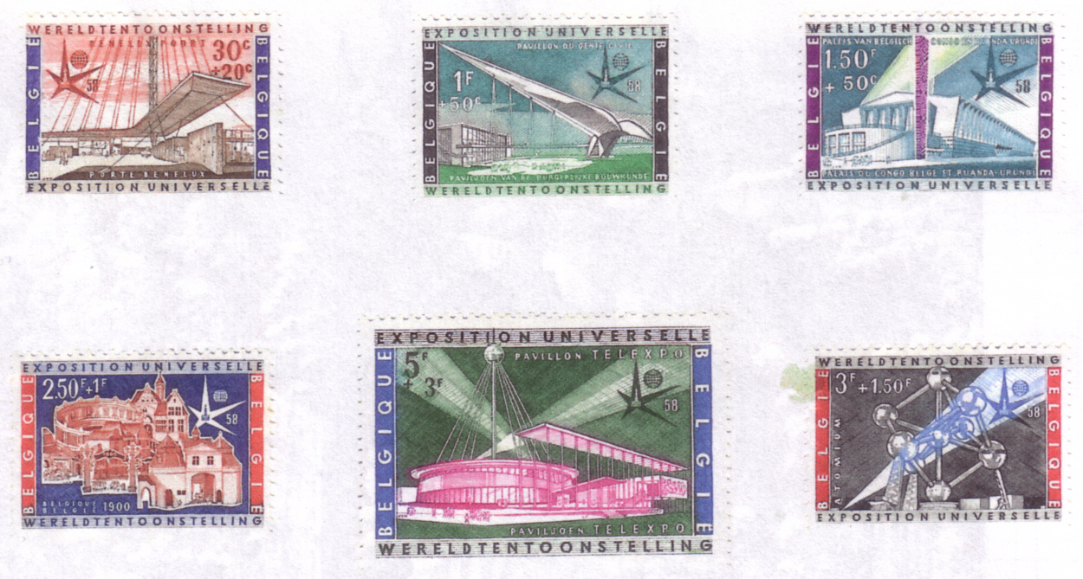

17th April 1958. Inauguration of the Brussels International Exhibition issue.

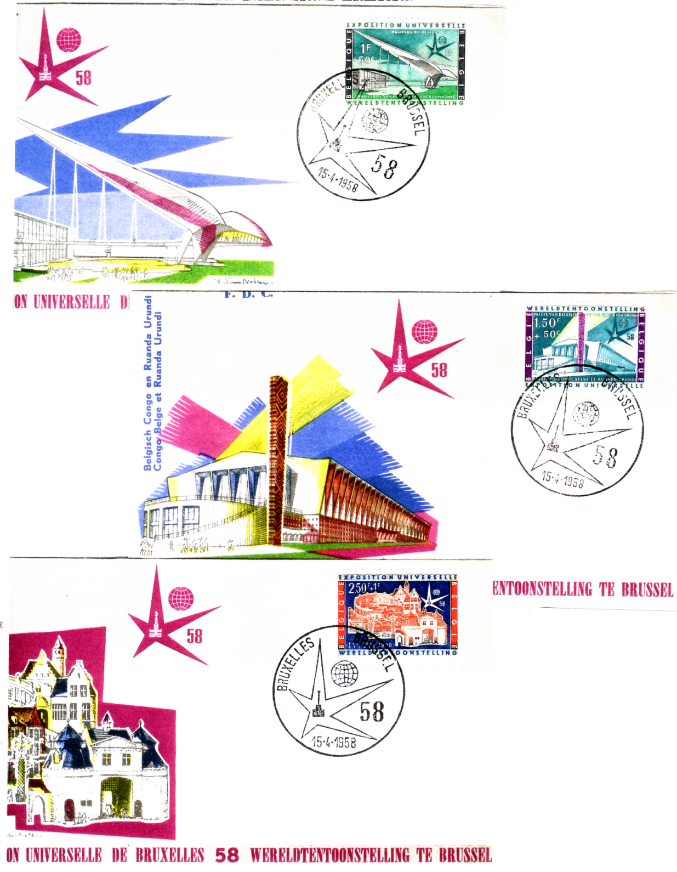

Official First Day covers with first day cancellations.

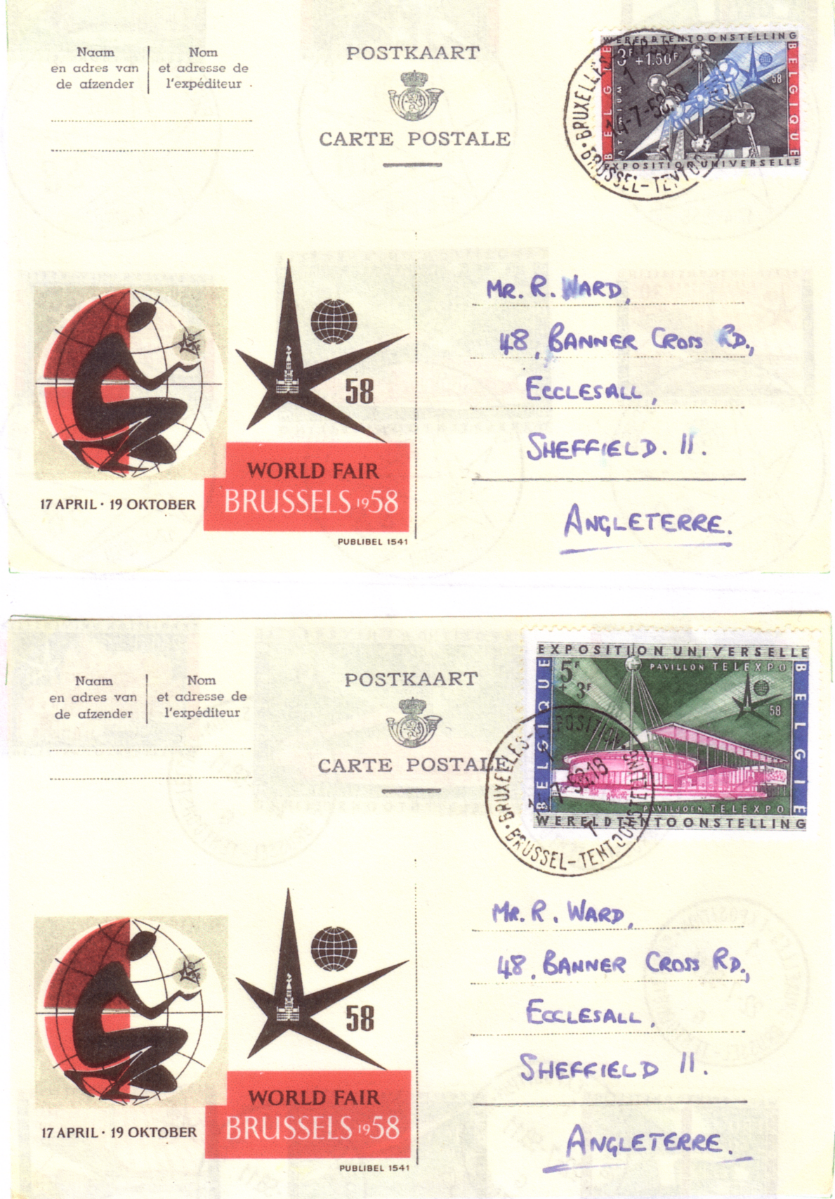

Stationery cards with exhibition cancellations.
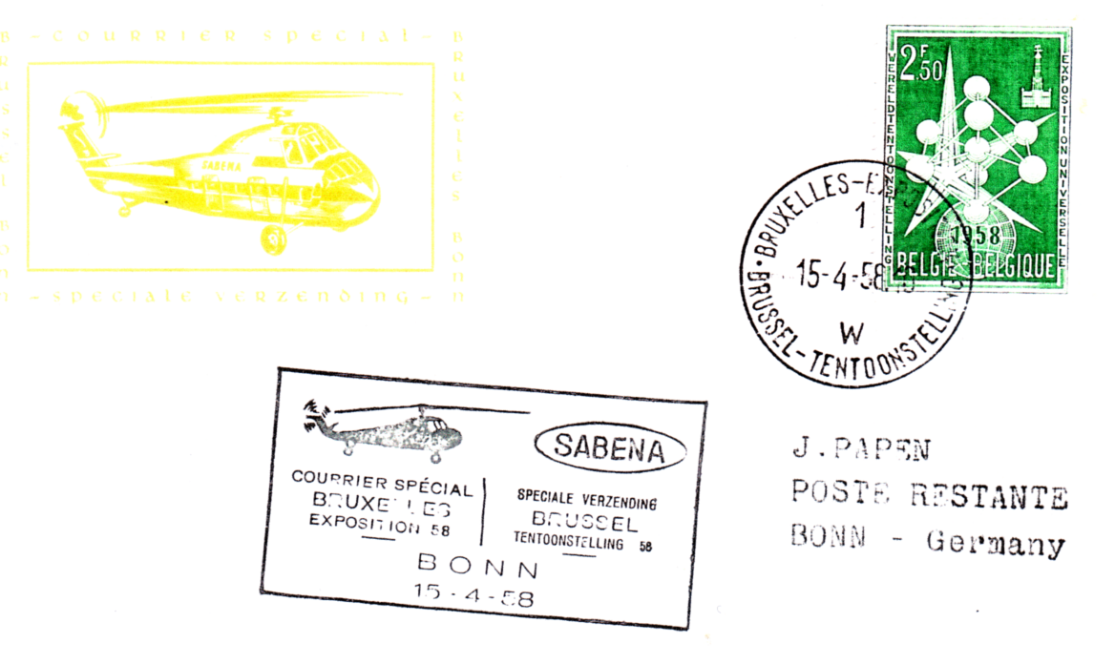
Cover flown by Sabena helicopter cancelled at the Exhibition two days before it opened and flown to Bonn, with arrival cancellation on reverse. 1957 Exhibition series stamp.

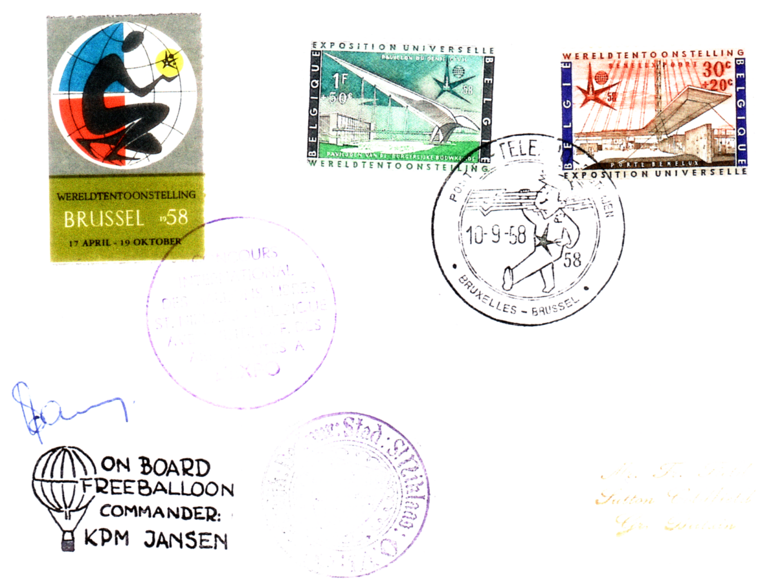

Balloon Flight card flown from the Exhibition grounds with Exhibition label, three special cachets and signed by the pilot.

Unfortunalely on these two covers some of the cachets and cancellations are either in pale yellow or pale violet and have not copied very well. Editor

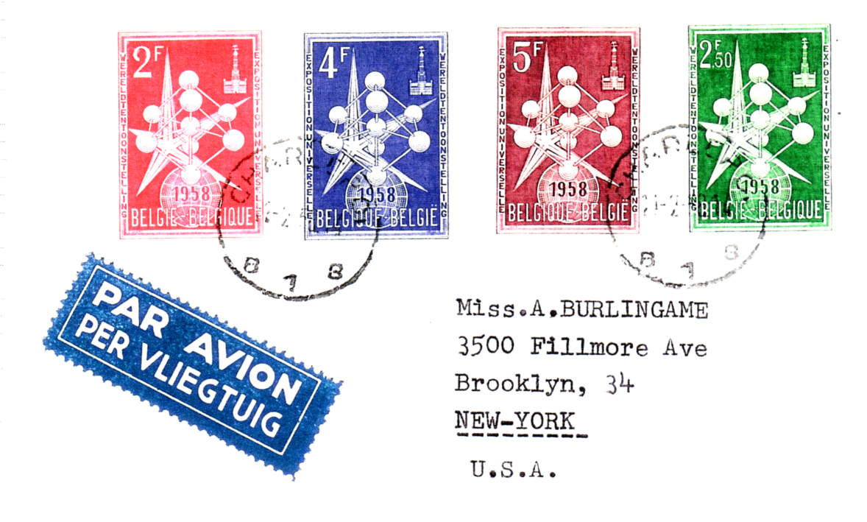
The first issue of Brussels Exhibition Stamps

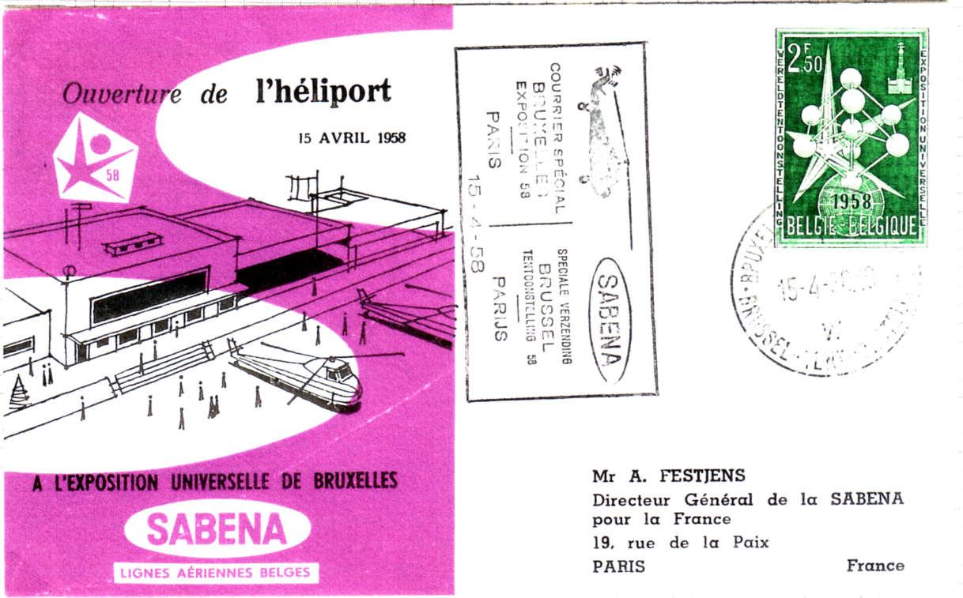

Cover commemorating the opening of the Exhibition Heliport on 15th April 1958

Part 3 covering the special cancellations of the other participating countries
will be in the summer Journal.
Post Cards of the White City.
Part 31.
by Bill Tonkin

There are two different views published under title ‘Colonial Avenue, Franco-British Exhibition, London, 1908’ as they are not all numbered, a brief description is given to enable them to be identified. They are listed as type 1 and 2.
Type 1. This card shows a view of the Daily Mail Pavilion
Colonial Avenue, Franco-British Exhibition, London, 1908. (A pre exhibition forerunner.)
B/W litho, sunk plate with large white border, black ‘Throughout the World’ back type FB 2.
N.n. Split title in one line at bottom centre.
B/W litho, greenish grey ‘Throughout the World’ back type FB 2.
N.n. Title in one line at bottom left.
Coloured, red ‘F B seal’ back type FB 1.
N.n. Title in two lines at top left.

Type 2. This card has the Indian Pavilion in the background, and two rickshaws to the right.
Colonial Avenue, Franco-British Exhibition, London, 1908.
B/W litho, sunk plate with large white border, black ‘Throughout the World’ back type FB 2.
N.n. Split title in one line at bottom centre.
B/W litho, sunk plate with large white border, greenish grey ‘Throughout the World’
back type FB 2.
N.n. Split title in one line at bottom centre.
B/W litho, black ‘Throughout the World’ back type FB 2.
N.n. Title in one line at bottom right. The title floats between 5 mm and 12 mm below the imprint, which would indicate there were several printings. This also occurs to a lesser degree on the coloured cards, but only those titled ‘Colonial Avenue’.
Coloured, red ‘F B seal’ back type FB 1.
233 Title in one line at top right, with number.
N.n. Title in one line at top right, without number.
Title altered to, India, Franco-British Exhibition, London, 1908.
B/W litho, black ‘Throughout the World’ back type FB 2.
N.n. Title in one line at bottom left, left edge rouletted.
Coloured, dark grey ‘F B seal’ back type FB 1.
233 Title in one line at top right, left edge rouletted.
Coloured, red ‘F B seal’ back type FB 1.
233 Title in one line at top right, left edge rouletted.
Title altered to, Indian Palace, Franco-British Exhibition, London, 1908.
B/W litho, black ‘Throughout the World’ back type FB 2.
N.n. Title in two lines at bottom centre.
Coloured view, in ornamental Britannia and Marianne border type FB Bo 1, red ‘F B seal’ back type FB 1.
233 Title in one line at top centre.
For other post cards with this border, see under Border FB Bo 1.
Title altered to, Indian Palace, Upper Crescent, Franco-British Exhibition, London, 1908.
Sepia R/Photo, black ‘X L’ back type FB 11.
233 Title in two lines at bottom centre.
Title altered to, Indian Palace, (Upper Crescent), Franco-British Exhibition, London, 1908.
Coloured, red ‘F B seal’ back type FB 1.
N.n. Title in one line at top right.
For other post cards of this view see in the Great White section, under ‘India’.

This view has the bandstand in the mid centre and Australia on the left.
Colonial Section from Flip-Flap, Franco-British Exhibition, London, 1908.
Coloured, red ‘F B seal’ back type FB 1.
492 Title in one line at top left.
For other post cards of this view see in The Great White City section, under ‘Colonial Section from Flip-Flap’.

There are three different pre exhibition forerunner post cards published under title ‘Colonnade, British Applied Arts Palace’ as they are not numbered, a brief description is given to enable them to be identified. The first one was the only vertical card the other two were horizontal.
Type 1. This was the only post card published in a vertical format.
Colonnade, British Applied Arts Palace, Franco-British Exhibition, London, 1908. (A pre exhibition forerunner.)
B/W litho, sunk plate with large white border, grey ‘Throughout the World’ back type FB 2.
N.n. Title in two lines at bottom centre. Vert left.
B/W litho, sunk plate with large white border, greenish grey ‘Throughout the World’
back type FB 2.
N.n. Title in two lines at bottom centre. Vert left.
B/W litho, greenish grey ‘Throughout the World’ back type FB 2.
N.n. Title in two lines at bottom right of centre. Vert left.
Coloured on this card there are at least two different cloud types, red ‘F B seal’
back type FB 1.
N.n. Title with tails in two lines at bottom centre. Vert left.

Type 2. This is a horizontal post card, the view looks down the Colonnade curving to the left, the balustrade and urns are on the right of the passage.
Colonnade, British Applied Arts Palace, Franco-British Exhibition, London, 1908. (A pre exhibition forerunner.)
B/W litho, sunk plate with large white border, black ‘Throughout the World’ back type FB 2.
N.n. Split title in one line at bottom centre.
B/W litho, sunk plate with large white border, greenish grey ‘Throughout the World’
back type FB 2.
N.n. Split title in one line at bottom centre.
B/W litho, dark grey ‘Throughout the World’ back type FB 2.
N.n. Title in two lines at bottom left.
B/W litho, grey ‘Throughout the World’ back type FB 2.
N.n. Title in two lines at bottom left.
B/W litho, greenish grey ‘Throughout the World’ back type FB 2.
N.n. Title in two lines at bottom left.
Coloured, grey ‘Throughout the World’ back type FB 2.
N.n. Title in two lines at top left.
Coloured, red ‘F B seal’ back type FB 1.
N.n. Title in two lines at top left.
Title changed to, Colonnade in British Applied Arts Palace, Franco-British Exhibition, London, 1908.
Sepia R/Photo, black ‘X L’ back type FB 11.
N.n. Title in one line at bottom centre.

Type 3. This post card, similar to the preceding one is also horizontal, it looks down the Colonnade curving to the right, the balustrade and urns are on the left of the passage.
Colonnade in British Applied Arts Palace, Franco-British Exhibition, London, 1908. (A pre exhibition forerunner.)
B/W litho, sunk plate with large white border, greenish grey ‘Throughout the World’
back type FB 2.
N.n. Split title in one line at bottom centre.
Coloured, grey ‘Throughout the World’ back type FB 2.
N.n. Title in two lines at bottom right.
Coloured, dark grey ‘Throughout the World’ back type FB 2.
N.n. Title in two lines at bottom right.
Coloured, red ‘F B seal’ back type FB 1.
N.n. Title in two lines at bottom right.

On this title ‘Valentine’s Series Copyright’ on the front can be found in four types. Some cards were published without the imprint and are listed as ‘without Valentine’s Series Copyright’, some have a split imprint with ‘Valentine’s Series’ on the left and ‘Copyright’ on the right, listed as ‘with a split Valentine’s Series Copyright’, some have the imprint in two lines in a horizontal position, listed as ‘with a horizontal Valentine’s Series Copyright’ and the imprint can also be found printed at an angle, listed as ‘Valentine’s Series Copyright at an angle’. If the angled imprint is on the left this is noted, if it is on the right this is not listed as this is the normal position.
Colonnade in Court of Honour, Franco-British Exhibition, London, 1908. (A pre exhibition forerunner.)
B/W litho, sunk plate with large white border, dark green ‘Throughout the World’
back type FB 2.
N.n. Split title in one line bottom centre, with a split ‘Valentine’s Series Copyright’.
B/W litho, sunk plate with large white border, greenish grey ‘Throughout the World’
back type FB 2.
N.n. Split title in one line bottom centre, with a split ‘Valentine’s Series Copyright’.
N.n. Split title in one line bottom centre, with ‘Valentine’s Series Copyright’ at an angle on the left.
N.n. Split title in one line bottom centre, without ‘Valentine’s Series Copyright’.
B/W litho, grey ‘Throughout the World’ back type FB 2.
N.n. Title in two lines at bottom left, without ‘Valentine’s Series Copyright’.
B/W litho, bluish grey ‘Throughout the World’ back type FB 2.
N.n. Title in two lines at bottom left, with ‘Valentine’s Series Copyright’ at an angle.
B/W litho, greenish grey ‘Throughout the World’ back type FB 2.
N.n. Title in two lines at bottom left, with ‘Valentine’s Series Copyright’ at an angle.
B/W litho, deep greenish grey ‘Throughout the World’ back type FB 2.
N.n. Title in two lines at bottom left, with ‘Valentine’s Series Copyright’ at an angle.
Coloured, grey ‘Throughout the World’ back type FB 2.
N.n. Title in two lines at bottom left, with a horizontal ‘Valentine’s Series Copyright’ to the left.
N.n. Title in two lines at bottom left, without ‘Valentine’s Series Copyright’.
Coloured, greenish grey ‘Throughout the World’ back type FB 2.
N.n. Title in two lines at bottom left, with a horizontal ‘Valentine’s Series Copyright’ to the left.
Coloured, red ‘F B seal’ back type FB 1.
N.n. Title in two lines at bottom left, with a horizontal ‘Valentine’s Series Copyright’ to the left.

There are three different pre exhibition forerunner post cards published under title ‘Colonnade, Palace of Music’ as they are not numbered, a brief description is given to enable them to be identified. One is a horizontal post card and the other two are vertical.
Type 1. This post card was the only one in a horizontal format.
Colonnade, Palace of Music, Franco-British Exhibition, London, 1908. (A pre exhibition forerunner.)
B/W litho, sunk plate with large white border, dark grey ‘Throughout the World’
back type FB 2.
N.n. Split title in one line bottom centre.
B/W litho, sunk plate with large white border, greenish grey ‘Throughout the World’
back type FB 2.
N.n. Split title in one line bottom centre.
B/W litho, sunk plate with large white border, grey ‘Throughout the World’ back type FB 2.
N.n. Split title in one line bottom centre.
B/W litho, grey ‘Throughout the World’ back type FB 2.
N.n. Title in two lines at bottom left.
B/W litho, bluish grey ‘Throughout the World’ back type FB 2.
N.n. Title in two lines at bottom left.
B/W litho, greenish grey ‘Throughout the World’ back type FB 2.
N.n. Title in two lines at bottom left.
Coloured, red ‘F B seal’ back type FB 1.
N.n. Title with tails in two lines at bottom left.

Type 2. In the second view the entrance to the Colonnade has a square top, this is a vertical post card.
Colonnade, Palace of Music, Franco-British Exhibition, London, 1908. (A pre exhibition forerunner.)
B/W litho, sunk plate with large white border, grey ‘Throughout the World’ back type FB 2.
N.n. Title in two lines bottom centre. Vert left.
B/W litho, sunk plate with large white border, deep green ‘Throughout the World’ back
type FB 2.
N.n. Title in two lines bottom centre. Vert left.
B/W litho, sunk plate with large white border, greenish grey ‘Throughout the World’
back type FB 2.
N.n. Title in two lines bottom centre. Vert left.
B/W litho, bluish grey ‘Throughout the World’ back type FB 2.
N.n. Title in two lines at bottom right of centre. Vert left.
B/W litho, greenish grey ‘Throughout the World’ back type FB 2.
N.n. Title in two lines at bottom centre. Vert left.
B/W litho, dark green ‘Throughout the World’ back type FB 2.
N.n. Title in two lines at bottom centre. Vert left.
Coloured, red ‘F B seal’ back type FB 1.
N.n. Title in two lines at bottom centre. Vert left.

Type 3. The third view is very similar to the preceding card, but the entrance to the Colonnade has a round top.
On this post card ‘Valentine’s Series Copyright’ on the front can be found in two types. Some post cards were published with a split imprint with the words reversed, ‘Copyright’ on the left and ‘Valentine’s Series’ on the right, listed as ‘with a reversed split Copyright Valentine’s Series’, and some have the imprint in two lines in a horizontal position, listed as ‘with a horizontal Valentine’s Series Copyright’
Colonnade, Palace of Music, Franco-British Exhibition, London, 1908. (A pre exhibition forerunner.)
B/W litho, sunk plate with large white border, deep green ‘Throughout the World’ back
type FB 2.
N.n. Title in two lines bottom centre, with a reversed split ‘Copyright Valentine’s Series’. Vert left.
B/W litho, sunk plate with large white border, greenish grey ‘Throughout the World’
back type FB 2.
N.n. Title in two lines bottom centre, with a reversed split ‘Copyright Valentine’s Series’. Vert left.
Coloured, grey ‘Throughout the World’ back type FB 2.
N.n. Title in two lines at bottom centre, with a horizontal ‘Valentine’s Series Copyright’ to the left. Vert left.
Coloured, greenish grey ‘Throughout the World’ back type FB 2.
N.n. Title in two lines at bottom centre, with a horizontal ‘Valentine’s Series Copyright’ to the left. Vert left.
Coloured, red ‘F B seal’ back type FB 1.
N.n. Title in two lines at bottom centre, with a horizontal ‘Valentine’s Series Copyright’ to the left. Vert left.

Concert Hall, Ballymaclinton. (M’Clinton’s Town erected by the makers of M’Clinton’s Soap).
Coloured, greenish grey ‘POST CARD’ with four lines of text, back type FB 13.
403 Title in two lines at top right of centre.
Sepia Litho, greenish grey ‘POST CARD’ with four lines of text, back type FB 13.
N.n. Title in two lines at top centre.

Congress Hall, Franco British Exhibition, London, 1908. No. 389, see under Cascade, Franco-British Exhibition, London, 1908. No. 389.

Artist’s drawing of the Congress Hall and Lake. These post cards do not have the Valentines imprint on the front.
The Congress Hall, Franco-British Exhibition, London.
Coloured, sunk plate with white border, dark grey ‘Throughout the World’ back type FB 2.
N.n. Title in one line at bottom left.
Sepia litho, grey ‘Throughout the World’ back type FB 2.
N.n. Title in one line at top left.

The view of the cascade on post card No. 433 was one of Valentine’s most popular cards. It was used by them from 1908 to 1912, and the title was altered many times, 18 times in fact, (if the exhibition title is included) sometimes titled the ‘Cascade’, sometimes ‘Congress Hall’, and sometimes to make sure they got it right the ‘Cascade and Congress Hall’, or even the ‘Congress Hall and Cascade’.
The view is known in two states, and these are listed. The difference between them is in the water of the cascade, in the original negative, the water of the cascade is shown with a few white waves as it tumbles down and is listed as ‘view with little water in cascade’. Later touched up versions shows the water of the cascade as a solid white mass, with a touch of green in the coloured cards and is listed as ‘view with white water in cascade’.
Congress Hall and Cascade, Franco-British Exhibition, London, 1908.
B/W R/Photo, view with little water in cascade, black ‘X L’ back type FB 12.
433 Title in two lines at bottom left.

