EDITORIAL Winter 2004

That time of year is here once more
and Christmas cards through the letter box pour.

I will start by thanking all those who send me a Christmas card each year. I have remembered to put an Exhibition Christmas Card on the front page, as you may recall I forgot last year. This is a Franco-British card by Valentine & Sons of which I have seven different. I have not seen one of these for years although I have reason to think there may be one more to the set.
I don’t send out cards. When Nancy died I was not prepared to do this chore, instead I send out a Christmas Letter. I must admit there was some doubt in my mind when I did the first one, as it seemed to me that I was just blowing my own trumpet. To my surprise there was an immediate response, people enjoyed getting it, not only that but friends sent me a Christmas letter in return. I am sure the growth of personal computer possession helped to bring this about.
There is no doubt that one man, Bill Gates, has transformed the way the world communicates. I would certainly be lost without mine. It has helped me in all my hobbies, outside the world of exhibitions which I now spend most of my time on.
Looking back on past Journals I see that exactly two years ago I wrote about a member resigning because there were too much interest shown by me as the Editor on post cards which was reflected in the Journal. I accepted this and said in answer that I am only too ready to publish anything, and by a coincidence in that Journal I published the first of a fine two part article on crested china sent in by a new member Jenny Hill.. Currently another member has sent in a long article on Exhibition Medals which is being spread over four Journals. I am at present trying to get together a team to produce a monograph on White City advertising labels. This is quite a large subject although not large enough to consider publishing a book on it, but we must wait and see how it comes along.
In the Spring issue of last year there was some debate by members on the effect of E Bay on collecting and one member Trevor Day stated “It has to be said that I have far too often returned from fairs empty handed and disappointed having only found average items, in poor condition at extortionate prices and I have done what anyone should do and carried on walking.” Trevor saw and recognised the early indication of things to come.
Today one has to face the fact that the days of going to a fair and coming back with a load of nice cards is finished. When I look back at my records and take the two day fair at York for instance, which has always been a favourite of mine, it makes depressing reading. In two years the average price of cards I have bought has more than doubled. Looking on the brighter side I have had a jolly good innings, and I can’t see anyone catching me up, which after all is what collecting is all about.
Alan Sabey has asked me to give you all a reminder that your subscriptions are due.

The time has come to send your subscriptions to Alan Sabey, his address is on the inside of the front cover. £8.00 Home or £12.00 Abroad.

At our A.G.M Mike Perkins resignation as Packet Secretary was accepted, and there was a suggestion that the packet be continued in a different way. Instead of sending the actual items it was suggested that photo-copies of the items be circulated with a number, and when the item had been purchased it was then posted to the member concerned who had bought it. The advantage of this is that there would be no more lost packets and it would be relatively cheap to post the illustrated sheets on to the next member. Neither would the sender have to get a certificate of posting, just pop it in the pillar box. This may not cut out loss through the post, but at least it would restrict the amount of loss.
One disadvantage is that prospective buyers would not actually see the item until it had been paid for and received. If you think it is worth looking into drop me a line.

The Editor
Souvenirs of the 1912 International Stamp Exhibition.
by
A. J. N. Rusden

For some time one of our members Tim Rusden has been collecting information on the Post Cards and Ideal Stamps available as souvenirs at the 1912 International Stamp Exhibition. He has now published two small catalogues on the subject. The one on the Post Cards is of six pages and is priced at £3.00 and the Ideal Stamp catalogue is 16 pages and is priced at £6.00, plus postage of 28p for either, or 42p for both catalogues. They can be obtained from Tim Rusden, Oatlands, Cark Rd, Keighley, West Yorkshire. BD21 3BH

Baby Incubators.

One of the visitors to our convention was David King a friend of Graham Hall, he brought along a bound volume of a magazine called ‘The Jackdaw’ published at the time of the 1904 Bradford Exhibition putting a tag in each page where was an mention of the exhibition, while looking through it I was struck by a short article. David kindly photo-copied and gave it to me on the Sunday. I know I have a warped sense of humour but perhaps some one else will think it’s funny.

The Perils of Incubators.

We hear that Bradford is likely to be saddled with a quite unexpected charge and responsibility, on account of the baby incubator at the Exhibition. Two immature infants were borrowed from Leeds, and having been duly incubated, the mothers were sought with a view to their re-assuming the care of their offspring. The ladies however have vanished. Application has been made to the Bradford Guardians to accept these derelicts in the Children’s Home, and though they have naturally demurred, it seems likely that they will have to assume the responsibility. If the mothers are not found, Bradford will have to pay for the upbringing of these babies until they are sixteen years old. It has come to a pretty pass when Leeds sends its foundlings for Bradford to incubate and bring up.

A Collection of Victorian & Edwardian Exhibition Medals
by
Leslie L. Allen
Part 4 and final part.

1886 Kensington, Colonial & Indian Exhibition by ? Bronze 24 mm.
Obverse Arms of Australia
Reverse Six line legend, Struck in / Commemoration / of The / Colonial & Indian / Exhibition / 1886
BHM 3211
1886 Ditto by ? Brass, White metal 19 mm.
Obverse Bare head of Australian Aborigine left.
Reverse Similar to reverse of BHM 3211
BHM 3213
1886 Ditto by ? Brass 19 mm.
Obverse Similar to obverse of BHM 3213
Reverse Similar to reverse of BHM 3211 but the legend reads Indian & Colonial
1909 White City, Imperial International Exhibition by Vaughton ? Bronze 17 mm.
Obverse Edward VII draped bust left. Legend around the border, Edward VII Rex Et Imp.
Reverse Aerial view of the exhibition buildings. Legend above Imperial International / Exhibition, legend below, London 1909
1909 Ditto by Vaughton White metal 38 mm.
Obverse Similar to obverse of Bronze 17 mm specimen above
Reverse View of the exhibition buildings, Legend above, Imperial Pavilion. In exergue London 1909
1872 Kensington, International Exhibition by J. S. & A. B. Wyon White metal 30 mm.
Obverse Victoria crowned veiled bust left, Legend around, Victoria Regina Signed J. S. & A. B. Wyon Sc
Reverse The Albert Hall, Legend in tablet below Struck in / Exhibition / MDCCCLXXII
BHM 2943
1872 Ditto by J. S. & A. B. Wyon White metal 30 mm.
Obverse Conjoined heads of Industry Britannia and Mercury left
Reverse Similar to reverse of BHM 2943
BHM 2942
1873 Ditto by J. S. & A. B. Wyon Gilt bronze 30 mm.
Obverse Prince of Wales bare head left, Legend around the border H.R.H. The Prince of Wales K.G. / President of Royal Commission. Signed J. S. & A. B. Wyon SC
Reverse The Albert Hall. Legend in tablet below, Struck in / Exhibition / MDCCCLXXIII
BHM 2967, F 323.4
1873 Ditto by J. S. & A. B. Wyon Bronze 30 mm.
Obverse Prince Arthur bare head left. Legend around the border, H.R.H. Prince Arthur K.G.
Reverse Similar to BHM 2967
BHM 2968
1873 Ditto by G. Morgan Gilt white metal 70 mm.
Obverse Prince of Wales draped bust left. Legend around the border, Albert Edward Prince of Wales. President. Signed G Morgan Sc
Reverse The Albert Hall and other South Kensington buildings. Legend around the border, London Annual International Exhibition of all Fine Arts Industries and Inventions.
BHM 2964, E 1622, F 324.4, T 180a.
1874 Ditto by J. S. & A. B. Wyon White metal 30 mm.
Obverse Similar to obverse of BHM 2967
Reverse Similar to reverse of BHM 2967 but dated 1874
BHM 2995
1874 Ditto by G. Morgan Bronze 51 mm.
Obverse Prince of Wales bare head left, Legend around the border, Albert Edward Prince of Wales President. Signed G. Morgan SC
Reverse Similar to reverse of BHM 2964. Stamped on edge, William Green, Catalogue No. 6141
BHM 2992, E 1633, F 325.5, T 180b.
1833 Kensington International Fisheries Exhibition by L. C. Wyon & Pinches Silver
45 mm.
Obverse Victoria diademed head left, Legend around the border, Victoria Regina Signed L. C. Wyon
Reverse Marine life between legend, International / Fisheries / Exhibition 1883. Signed Pinches F.
BHM 3153, E 1694.
1883 Ditto Exhibitors Pass by Waterlow’s White metal 47 mm.
Obverse Crowned Royal Arms with supporters. Legend around the border, The Great International Fisheries Exhibition, London. 1883
Reverse Legend above marine life, Exhibitors / Free Pass / Charles C. Capel. Signed Waterlow’s Limited London Wall London.
1883 Ditto Committee Pass by Waterlow’s ? Bronze 26 mm.
Obverse Similar to the obverse of the Exhibitors Pass.
Reverse Three line legend, Committee / H. Lee / 1883
1884 Kensington International Health Exhibition by L. C. Wyon & Pinches. Silver, Bronze 45 mm.
Obverse Victoria diademed head left. Legend around the border, Victoria Regina Signed L. C. Wyon
Reverse Health & Learning, standing before a terrestial globe. Legend above, The International Health Exhibition. In exergue London 1884 Signed J. Pinches London.
BHM 3175, E 1704.
1885 Kensington International Inventions Exhibition by R. Neal White metal 33 mm.
Obverse Three line legend, International Inventions Exhibition / London / 1885 Signed Neal
Reverse View of an old London Street. Legend around the border, Ye Olde London Street. Signed HMR
BHM 3197
1885 Ditto by L. C. Wyon Bronze 45 mm.
Obverse Victoria diademed head left. Legend around the border, Victoria Regina Signed L. C. Wyon
Reverse Invention & Music seated upon a cartouche, four line legend, 1885 / International / Inventions / Exhibition
BHM 3198, E 1715, F 326.6.
1899 National Temperance Catering Exhibition by H. B. Sale Gilt bronze 51 mm.
Obverse Legend on shield between two chefs, Awarded / to / Mr Saml. / E. Short. Legend around, National Temperance Catering Exhibition / London / 1899. Signed H. B. Sale Birm.
Reverse Restaurant scene within a quatrefoil. Legend around on a raised border, National Temperance Caterers Association.
1865 Reformatory & Refuge Union Exhibition by J. S. Wyon Bronze 58 mm.
Obverse Prince of Wales bare head left. Legend around the border, Albert Edward Prince of Wales Signed J. S. Wyon SC
Reverse R & RU monogram. On a ribbon around, To seek and to save that which was lost. Legend around the border, International Reformatory Exhibition London 1865
BHM 2845
1906 Ditto by A. Wyon Bronze 57 mm.
Obverse Edward VII bare head right. Legend around the border Edward VII King of All the Britons and Emperor of India. Signed Allan Wyon.
Reverse Similar to reverse of BHM 2845, but the legend reads, Jubilee Industrial Exhibition London 1906
1880 St. Pancras Industrial Exhibition by ? Bronze 39 mm.
Obverse Easel, beehive, wheel and palette. Legend around upon a raised border, St. Pancras Industrial Exhibition
Reverse 1880 in a laurel wreath.
1881 Ditto by ? Bronze 39 mm.
Obverse Similar to obverse of 1880 above
Reverse 1881 in laurel wreath.
1865 South London Industrial Exhibition by ? White metal 42 mm.
Obverse Prince of Wales plumes above legend in floral wreath, South / London Industrial / Exhibition / 1865 / C. Murphey / Secy.
Reverse Fame attended by Learning and Industry.
1865 South London, Working Classes Industrial Exhibition by J. Moore Bronze 51 mm.
Obverse Medal / of / Merit in a wreath of oak surrounded by twenty petals bearing the names of artists, inventors, and other prominent persons. Legend around upon a raised border, South London, Working Classes Industrial Exhibition. MDCCCLXV.
Reverse Fame attended by Industry and Learning. Legend above Honour to the Industrial Classes Signed R.W. Martin. Del, J. Moore. F.
1869 South London, Working Classes Third Industrial Exhibition by J. Moore Silver, Bronze 52 mm.
Obverse 1869 on shield supported by two cherubs. Legend around, South London, Working Classes Industrial In exergue, Third Exhibition Signed Marion B. Broom D. Joseph Moore. F.
Reverse Artisan at work bench, Agriculture Art & Music on clouds in background.
BHM 2908
1865 Tottenham, Edmonton & Enfield Industrial Exhibition by W.J. Taylor Silver
42 mm.
Obverse Head of Athena wearing helmet left.
Reverse Legend in centre, Industrial Exhibition Legend around upon a raised border
Tottenham, Edmonton and Enfield / June 1865 Stamped on edge Mr J. Smith 2nd Award.
1887 Tower Hamlets, Peoples Palace Apprentices Exhibition by J.A. Restall Bronze
45 mm.
Obverse A wreath of laurel and oak. Legend around upon a raised border, The Peoples Palace London / Apprentices 1887 Exhibition
Reverse Industria attended by apprentices, exhibition building in the background. Signed J.A. Restall
1888 Tower Hamlets, Peoples Palace Workman’s Industrial Exhibition by J.A. Restall Silver 52 mm.
Obverse Named to Arthur Jones within a wreath of laurel and oak. Legend around upon a raised border, Peoples Palace Workman’s Industrial Exhibition.
Reverse Murcury attended by Labour & Art, exhibition building in the background. Signed J.A. Restall Birm.
1888 Ditto, but in bronze and awarded to Wm. Smith (in original case)

1889 Tower Hamlets, Peoples Palace Workman’s & Apprentices Ind Ex by J.A. Restall Bronze 51 mm.
Obverse Legend in centre, People’s / Palace / Chairman / Sir Edmund Hay-Currie / Awarded to / C. Munson Pilgrim. / 1899. Legend around upon a raised border, Workman’s & Apprentices. / Industrial Exhibition.
Reverse Three men working at forge. Signed J.A. Restall.
1906 Tower Hamlets, Peoples Palace & East London Hort. Soc. by J.A. Restall Bronze
39 mm.
Obverse View of the Palace between columns. Legend around the border The Peoples Palace and East London Horticultural Society. 1894.
Reverse Legend in a floral wreath, Chrysanthemum Show / Won by / Mr T. Simper / Section I. / Class 23.
T 213a.
1906 UK Railway Temperance Union Industrial Exhibition. by Toye & Co. Bronze
45 mm.
Obverse A steam locomotive above laurel sprays. Five line legend, United Kingdom Railway Temperance Union / Industrial / Exhibition / May / 1906
Reverse Laurel wreath.
BHM 3943
1906 Ditto, by ? Silvered Bronze four pointed cruciform 27 x 27 mm.
Obverse A steam locomotive. Text at top, UK, Text to left, R, Text to right, T, Text below U.
Reverse Legend in centre, Award / of / Merit.
ND Wandsworth, Industrial Exhibition. by ? Bronze 42 mm.
Obverse Five line legend in laurel wreath, Third Class / Prize / Wandsworth / Industrial / Exhibition.
Reverse Fame attended by Learning and Industry.
1879 Westminster, Industrial Exhibition. by Pinches Bronze 51 mm.
Obverse City Arms within Star of David. Legend around the border, Westminster, Industrial Exhibition.
Reverse Four line legend in laurel wreath, Awarded / to / P.G. Hepworth / 1879 Signed J. Pinches London.
1891 Westminster, Polytechnic Industrial Exhibition. by J.S. & A.B. Wyon Bronze
57 mm.
Obverse Legend in the centre, Young Men’s Christian Institute / Industrial / 509 / Regent St / Polytechnic / London / Exhibition, wide border around containing symbols of art industry and music. Signed J.S. & A.B. Wyon
Reverse St. George & the Dragon. Legend above The Lord is our Strength Signed After W Wyon R.A. J.S. & A.B. Wyon
1896 Westminster, Royal Aquarium Craftsmen’s Exhibition. by ? Bronze 33 mm.
Obverse Incuse Legend, Craftsmen’s / Exhibition / Royal / Aquarium / 1896
Reverse Incuse Legend in laurel wreath, H.A. / Barns.
1893 Westminster, Wesley Hall Industrial Exhibition. by Vaughton Bronze 39 mm.
Obverse Incuse Legend, Wesley Hall / Industrial Exhibition. / 1893
Reverse Laurel wreath. Signed Vaughton.
1908 White City, Franco-British Exhibition by J.W.L. Bronze 24 mm.
Obverse John Bull greeting Concorde. Legend above Franco-British / Exhibition / 1908 Signed J.W.L.
Reverse Crowned oval shields on sprays of oak and laurel. Legend around L’entente Cordiale
1908 Ditto by ? Aluminium 39 mm.
Obverse Aerial view of the Exhibition buildings. Legend above Franco-British / Exhibition, in exergue, Court of Honour / London / 1908.
Reverse With the compliments of / The / Aluminium / Corporation Ltd / 54, Parliament St, / London. S.W.
Lytham.
1879 by ? Bronze 44 mm.
Obverse Borough Arms and motto. Legend around the border Lytham Industrial and Loan Exhibition / 1879
Reverse Legend above seaweed, Awarded to / Mr David Hedges / Stuffed Birds.
Malvern.
1906 By W.J. Dingly Silver 42 mm.
Obverse Industry standing, Art seated. Legend to right Industry / and / Art.
Reverse Legend in laurel wreath Malvern / 1906 / Alice A Allen. Signed W.J.D.
Manchester.
1880 Industrial Exhibition Company by Elkington Bronze 56 mm.
Obverse Blank centre. Legend around upon a raised border Industrial Exhibition Company Limited. Established 1880. / Manchester
Reverse Learning attended by Art and Industry. Signed Elkington & Co.
1887 Royal Jubilee Exhibition by Heaton White metal, Bronze 45 mm.
Obverse Victoria diademed head left. Legend around upon a raised border, Royal Jubilee Exhibition Manchester. 1887 Signed Heaton.
Reverse View of the exhibition building. In exergue, Opened by T.R.H. The Prince / & Princess of Wales / May 3rd 1887.
BHM 3346, T 215a, W & E 2171A.
1887 Ditto by ? Gilt white metal 34 mm.
Obverse Victoria veiled draped bust left. Four line legend Jubilee 1877 / With / Geo. Brown Son’s / Compliments
Reverse Aerial view of the Exhibition buildings. Legend above, Royal / Jubilee / Exhibition. In exergue Manchester / 1887
W & E 2802
1887 Ditto by ? White metal 39 mm.
Obverse Prince & Princess of Wales draped busts left. Legend around on a raised border, Their Royal Highnesses The Prince and Princess of Wales
Reverse The Exhibition buildings. Legend above, Royal / Jubilee / Exhibition. Legend below, Manchester / 1887
1894 by ? Silver 45 mm.
Obverse Steamship and swing bridge. Legend around on a raised border British & Colonial Industrial Exhibition. Manchester 1894.
Reverse City Arms above cartouche, four conjoined shields below.
Needham Market.
1867 by J. Moore Bronze 45 mm.
Obverse Three line legend Needham Market Fine Art & Industrial Exhibition / Prize Medal / July 1867.
Reverse Industria seated with distaff. Legend above Diligentia Vincit Omnia Signed J. Moore F.
Newcastle Upon Tyne
1840 by ? White metal 41 mm.
Obverse Ten line legend, This Medal / was struck for / the / Exhibition / of objects connected with / Art, Manufacture / and / Science / at Newcastle Upon Tyne / 1840
Reverse The Tower of St. Nicholas Church. Legend around the border, Indocti Discant et Ament Meminisse Periti
BHM 1982, T 209
1887 by Reid & Sons. Silver 51 mm.
Obverse 1887 above City Arms. Legend around on a raised border, Newcastle-Upon- Tyne, Royal Mining, Engineering & Industrial Exhibition.
Reverse View of the City and bridge. Legend above, Queen’s Jubilee Year Signed Reid & Sons
BHM 3343, E 1730.
Norwich.
1867 by J.S. Wyon. Bronze 58 mm.
Obverse Prince of Wales bare head left. Legend around the border, Albert Edward Prince of Wales. Signed J.S. Wyon. SC
Reverse City Arms. Legend around upon a raised border, Norwich & Eastern Counties Industrial Exhibition 1867 / Prize Medal.
1881 by L.C. Wyon. Bronze 45 mm.
Obverse Victoria diademed head left. Legend around, Victoria Regina. Signed L.C. Wyon.
Reverse Marine life. Legend in tablet 1881 National / Fisheries / Exhibition
BHM 3111
Oldham.
1883 by Hinton & G.F.S. White metal 38 mm.
Obverse Borough Arms. Seven line legend in wreath, Fine Art and / Industrial / Exhibition / Opened by / Sir John Lubbock Bart / F.R.S. D.C.L. M.P / Aug 1st 1883. Signed G.F. & S.
Reverse View of Library. Legend above, Free Reference Library & Museum. In exergue Oldham
BHM 3154, T 205a.
Plymouth.
1881 by J. Moore White metal 51 mm.
Obverse Five line legend in laurel wreath, Plymouth / Art and / Industrial / Exhibition / 1881
Reverse Art Industry and Labour in a trefoil. Legend around, Without these cannot a City be Inhabited Signed J. Shelley. Del. J. Moore SC.
1904 by J.A. Restall Bronze 39 mm.
Obverse Industria seated holding a shield of Arms amid symbols of Art and Industry. Legend above, Plymouth Exhibition.
Reverse Lighthouse and ship. Legend above Eddystone Lighthouse.
1906 by J.A. Restall Bronze 38 mm.
Obverse Fame amid symbols of Art Industry and Transport. Legend around West of England Manufactures & Industrial Exhibn / Plymouth / 1906 Signed Restall. Birm.
Reverse Borough Arms in seascape.
Preston.
1865 by J. Moore Bronze, White metal 45 mm.
Obverse 1865 above Borough Arms. Legend around the border, Preston Exhibition of Art and Industry / Josh Isherwood Esqr Mayor.
Reverse Arms between three circles with symbols of Art Industry and Learning. Signed J. Moore
1875 by ? Bronze, White metal 45 mm.
Obverse Three Shields. Legend on a ribbon around the border, Preston Exhibition opened by the Rt. Hon. Col. Taylor M.P. Chancellor of the Dutchy Aug. 9. 1875
Reverse Lion and industrial symbols in roseace.
BHM 3022
Richmond.
1881 by J.S. & A.B. Wyon Silver 45 mm.
Obverse Crowned Borough Arms. Legend around the border, Industrial Exhibition Richmond Surrey
Reverse Industria seated left with distaff amid symbols of Art Industry and Music. Signed J.S. & A.B. Wyon Stamped on edge Awarded to A. Tidey, for water colour drawing. April 1881
Elsecar.
1886 by J. Moore Bronze 58 mm.
Obverse 1886 within a laurel wreath. Legend around upon a raised border, Wentworth and District Exhibition. / Earl Fitzwilliam. K.G. President.
Reverse View of stately home, in exergue Wentworth Woodhouse signed Josh. Moore F.
Royton.
ND by J.A. Restall Bronze 45 mm.
Obverse View of St. Paul’s Church. Legend above, Photographic Exhibition Legend around upon a raised border, In Aid of Restoration of Royton Parish Church of St. Paul
Reverse Fame between columns above Borough Arms camera to left, easel to right. Signed J.A. Restall
Saltaire.
1887 by Heaton. White metal 32 mm.
Obverse Victoria diademed veiled head left. Legend around upon a raised border, Victoria Reg, Jubilee Year. / 1887. Signed Heaton.
Reverse View of Saltaire Institute. In exergue Saltaire. Legend around upon a raised border The Royal Yorkshire Jubilee Exhibition. / 1887
BHM 3347, T 190a, W & E 2170F.
Sheffield
1892 by J.A. Restall Bronze 45 mm.
Obverse City Arms in laurel wreath. Legend above, Sheffield 1892. Legend below, Awarded for Excellence. Legend on a ribbon around the border Yorkshire Trades / & Industrial Exhibition.
Reverse Industria standing amid symbols of Art Industry and Learning. Signed J.A. Restall Birm.
1897 by J.A. Restall Bronze 45 mm.
Obverse Industria standing amid symbols of Art Industry and learning. Legend around upon a raised border, Third Yorkshire Trades and Industrial Exhibn Sheffield / 1897. Signed Restall Birm.
Reverse Legend in wreath of palm, Awarded / for / Merit
Sunderland.
1894 by ? White metal 32 mm.
Obverse View of Town Hall. Legend in centre, To / Commemorate the / Sunderland / Exhibition / 1894. Arms below.
Reverse Britannia with sea horses. Legend around the border, Opened by the Right Worshipful the Mayor of Sunderland.
Taunton.
1881 by Leighton Bronze 45 mm.
Obverse Borough Arms in trefoil with symbols of Art Science and Industry. Legend around the border, Taunton Art Science and Industrial Exhibition 1881 Signed Leighton Birm.
Reverse Laurel wreath.
Torquay.
1888 by ? Bronze 45 mm.
Obverse View of Castle. Legend around upon a raised border, Torbay Dart & Teign Industrial Exhibition.
Reverse Legend in wreath, Torquay / 1888. Named on edge, J. Bartlett Dartmouth.
Tynemouth.
1882 by Reid & Sons Bronze 51 mm.
Obverse Neptune in sea chariot. Legend around upon a raised border, North East Coast Exhibition / Prize-1882-Medal. Signed Reid & Sons. Newcastle Upon Tyne.
Reverse Eight line legend in wreath of maritime symbols. Naval / Architecture / Marine / Engineering / Fishery Life Saving / and Coast Lighting / Appliances etc. / Teignmouth.
Ulverston.
1873 by ? Silver 45 mm.
Obverse Lighthouse on a hill. Legend around the border Ulverston and District Industrial and Fine Arts Exhibition. 1873.
Reverse Legend in laurel wreath, Prize Medal. Legend around the border, Honour is the reward of Industry.
Unknown location.
ND by Vaughton Bronze 39 mm.
Obverse PSA monogram in shield, Symbols of Art and Industry in quatrefoil. Legend around, Pleasant Sunday Afternoon Industrial Exhibition.
Reverse Laurel wreath. Signed Vaughton.
Upton on Severn.
1876 by G.R. Clarke & W.J. Taylor Silver 48 mm.
Obverse 1876 in a floral wreath. Legend around the border, Upton on Severn Industrial Exhibition Instituted 1873 Signed G.R. Clarke. F.
Reverse Head of Athena left wearing helmet. Signed W.J. Taylor London. On the edge Rev. L.H. Rudd. Section II Class H.
Walsall.
1897 by H.B. Sale Gilt bronze 45 mm.
Obverse Borough Arms. Legend around the border, General Trades, Art and Industrial Exhibition. Feb. 1st to 27th 1897.
Reverse Industria seated with distaff amid symbols of Art Industry and Transport, buildings in background. Signed H.B. Sale Birm.
Whitnash.
1865 by J. Moore White metal 38 mm.
Obverse Five line legend, Whitnash / Industrial / Exhibition / St. Margaret’s Day / 1865.
Reverse Tower between trees. Legend above Whitnash Church, In exergue Ora Et Labora Signed J. Moore F. Birmm.
BHM 2849
Wick.
1868 by Kirkwood Bronze 45 mm.
Obverse Legend in laurel wreath, Wick Legend around the border, Caithness Industrial Exhibition / March 1868
Reverse Industria seated with distaff amid symbols of Industry. In exergue Industria Ditat Signed Kirkwood & Son. Edinb.
Wigan.
1897 by Vaughton & Sons. Silver 39 mm.
Obverse Borough Arms. Legend around upon a raised border, Wigan & District Trades, Industrial, & Arts Exhibition. Signed Vaughton Birm.
Reverse Legend in laurel wreath, 1st / Prize / for / Oil Painting / awarded / to / E.G. Harrison 1897 signed Vaughton Birm.
Wishbech
1884 by ? White metal 44 mm.
Obverse Five line legend Wisbech / Industrial / & Fine Art / Exhibition / May 1866
Reverse A sword and a rope upon crossed keys within a quatrefoil. (Lid of case inscribed Honourable Mention)
Wolverhampton.
1884 by ? Gilt white metal 44 mm.
Obverse Three crowned shields in a quartrefoil. Legend around the border, Wolverhampton & Staffordshire / Fine Arts & Industrial Exhibition
Reverse View of a building. Legend above, Honour to Art, to Industry Success / 30 May 1884. In exergue Art Gallery
T 209a.
1896 by ? Gilt bronze 44 mm.
Obverse Legend in centre, Wolverhampton / 1896. Legend around the border, Trades & Industrial Exhibition
Reverse Industria holding scroll, cherub to left. Legend on the scroll, Awarded / for / Excellence.
Worcestershire.
1882 by ? White metal 39 mm.
Obverse Exhibition building. Legend above, Worcestershire / Exhibition. in exergue Opened / July 18th 1882
Reverse Arms in cartouche. Legend around the border, Floreat Semper Fidelis Civitas.
BHM 3141, T 203a.
Wrexham.
1876 by G.T. Morgan Bronze, White metal 48 mm.
Obverse Potter at work bench being watched by a blacksmith. Legend around upon a raised border, Art Treasures & Industrial Exhibition of North Wales & Border Counties. Signed Morgan
Reverse Shield of Arms. Legend in ribbon, W. Cornwallis West Chairman Wm Chaffers Manager & Hon. Sec. Legend around upon a raised border, Patron H.M. Queen Victoria Prest. The Duke of Westminster / 1876.
BHM 3034.
York.
1879 by Ottley Bronze 76 mm.
Obverse Legend in wreath, Awarded to / Gibbs & Howard. Legend around upon a raised border, Yorkshire Fine Art and Industrial Exhibition.
Reverse View of the Guildhall. In exergue York 1879. Signed Ottley Medallist Birm.

The entry for Elsecar is a correction sent in by Leslie L. Allen and would have appeared incorrectly under Rotherham. While I have been able to not include it under Rotherham I had forgotten at the time to alter and include it in the E section.
Leslie writes, By Courtesy of Peter Fox, we are able to confirm from the Exhibition Catalogue that the exhibition was held in the Market Hall at Elsecar on the Wentworth Estate, in aid of the neighbouring Hospitals and Infirmaries, and not at Rotherham. There were 80 classes from the “Best Brass Band” to the “Best 12 brown eggs”.
Elsecar.
1886 by J. Moore Bronze 58 mm.
Obverse 1886 within a laurel wreath. Legend around upon a raised border, Wentworth and District Exhibition. / Earl Fitzwilliam. K.G. President.
Reverse View of stately home, in exergue Wentworth Woodhouse signed Josh. Moore F.

Visit to the World International Exhibition Brussels 1958
by
Bob Tough
Part 1 the Exhibition.

In the summer of 1958 we had planned to take a holiday in Belgium aboard my father’s 40 ft Motor cruiser, “Thamesa”. The cruise would be Internationally organised with cruisers from many European countries, although predominantly British. Total normally about 80 boats. The start would be at Ostend and it would finish at Brussels for the International Exhibition. The cruise was called the Pavilion D’Or (The Golden Burgee). organised every two or three years before the last World War and for several years after the war.
As with motor cruising holidays the weather proved bad on the trip to Ramsgate. Weather prevented the start from Ramsgate on the crossing to Ostend. My father and mother stayed aboard the boat and my cousin and I crossed to Ostend by passenger boat and stayed at the Terminus Hotel there, visiting the Exhibition each day by train. There was a special station outside the main entrance and the train ticket included entrance to the exhibition. Hotels in Brussels were very crowded, we knew Ostend very well, having visited it many times aboard “Thamesa”.

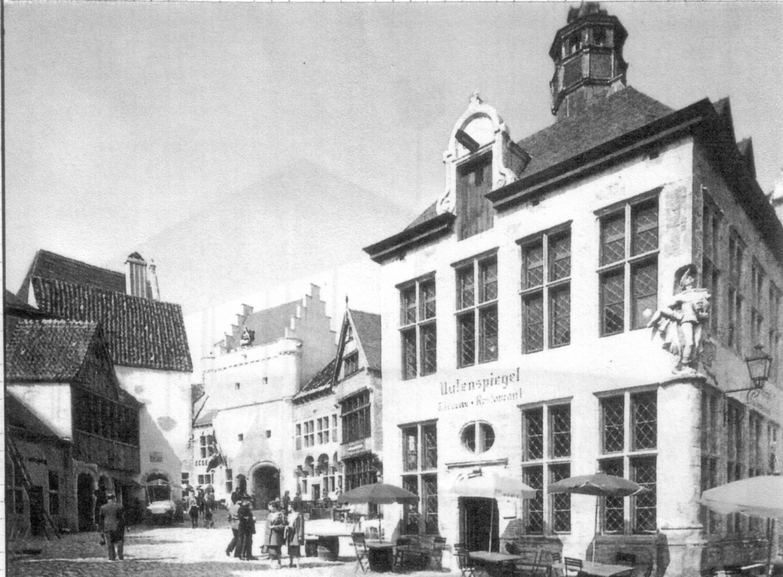

Gay Belgium

The following morning after arrival, we set out early on the train which was non-stop to the exhibition and carried on to Brussels itself. The entrance through the Belgian Exhibition Hall was very impressive. This led to a Courtyard of fountains and pools. The centre thoroughfare was dominated by the Atomium. This is a model of the structure of the atom. It still remains today after the rest of the exhibition buildings have been demolished. Walking up the central thoroughfare, on the right hand side is what was then called “Gay Belgium”, with reproductions of typical Belgian buildings, cafes, drinking halls etc., built around the market place. There was also a very big funfair, and in the far corner a sports stadium. On the left hand side there was a very large building with displays from the Belgian Congo. Further along there was the United Nations Building and the very beginning of the European Community, the iron and steel corporation building between France and Germany. There was a Luxembourg building, also buildings from Tunisia.
The thoroughfare ends with a modern ornamental column. An overhead skilift type transporter is provided the length of the thoroughfare. Towards the end it also leads off at right angles on the left hand side to the three largest buildings in the exhibition. There is also an overhead walkway leading to these buildings. They comprise the American Pavilion, which is circular with a very large pool in the centre, showing American achievements, also the relaxed life in America. When we visited the building there was a fashion show taking place. I took a colour photograph which won a photographic competition that year.

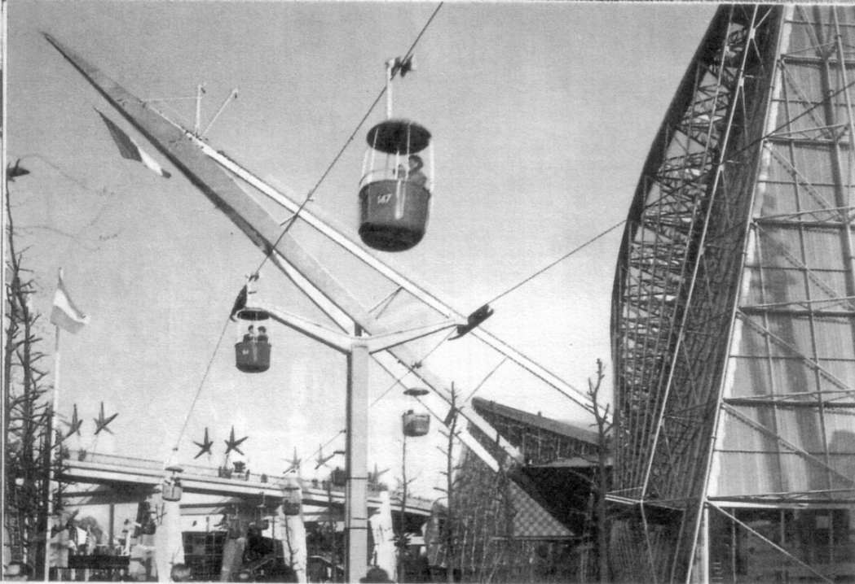

Skilift and French Pavilion.

In complete contrast and opposite was the Russian Pavilion. This was square and heavily built, dominated by a huge statue of Lenin. Their exhibits included the Sputnik, which had just completed the first circuit of the earth in space. Russia were ahead of America in this field. Opposite was the French Pavilion, this had a very unusual shape and contained typical French exhibits. A long, ornamental shaft projected from the building at 45 degrees over the raised walkway.

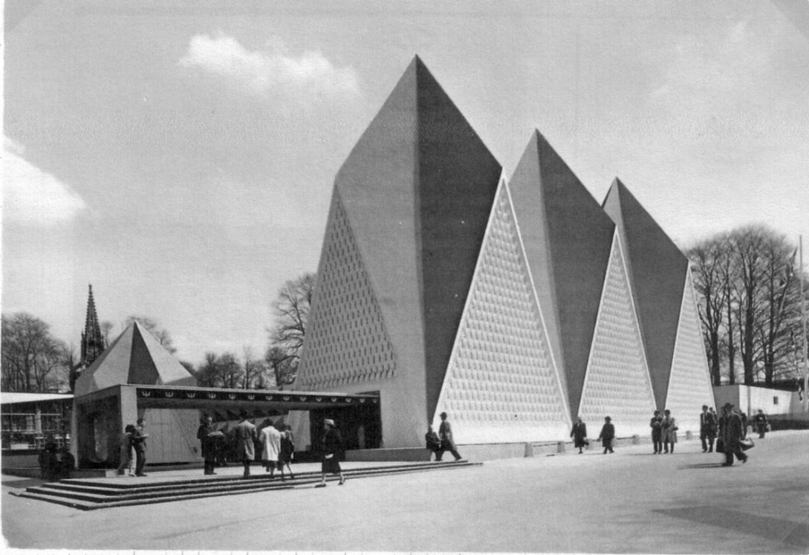

The British Pavilion.
The Walkway itself was decorated with large reproductions of the exhibits symbol at fairly close intervals.This with the Atomium in the background produced an odd scene. A much smaller but no less striking building was that provided by the Vatican, which included a Chapel of very modern design and some religious relics.

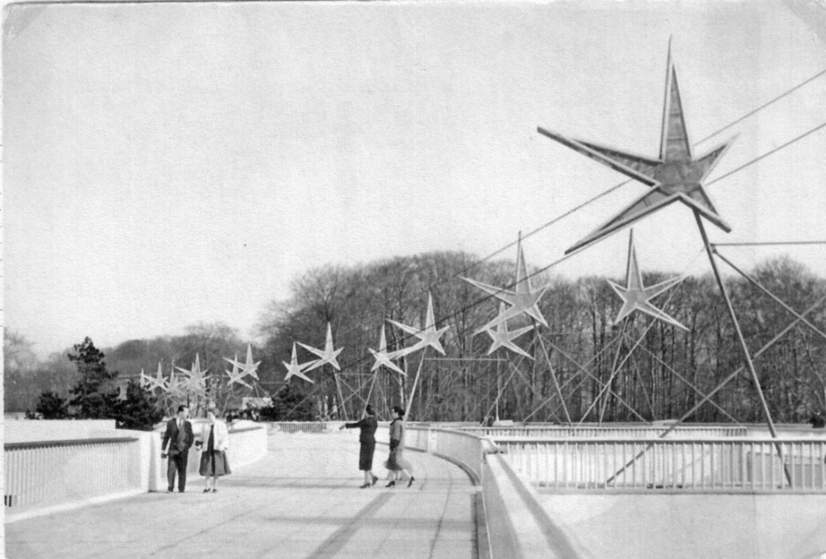

The Raised Walkway.

Beyond these large buildings at the far end of the exhibition ground, were the pavilions of Japan, The Philippines, Dominican Republic and Iran. Also a beautifully built temple reproduced from Cambodia. In the centre of the exhibition ground, at the far end, were the German, Swiss, Turkish, Spanish, Moroccan and Portuguese pavilions.
In this area Britain also had two halls, one representing tradition, which was made up of three conical buildings and another representing British achievements. At the time Britain was in the lead in radio astronomy and nuclear power provision. The comet was the world’s first jet airliner. Peter Twist held the air world speed record with the Fairy Delta II, John Cobb held the world speed record on land and Donald Campbell the world speed record on water. Displays from the commonwealth countries were also included except for Canada. Their pavilion was next to Russia, amongst the largest buildings, although theirs was much smaller. Near the Canadian building there were also pavilions from Finland, Argentina, San Marion, Tunisia, Holland, Liechtenstein and Israel. The Czechoslovakia, Hungary, Sudan, and United Arab Republic, Jordan, Iraq and Saudi Arabia pavilions were all behind the Russian pavilion, between it and the United States Pavilion. All these had typical displays from the respective countries. The whole of the left hand side of the thoroughfare back to the Belgian Entrance Hall was devoted to Belgium exhibition buildings including the Post Office, the civil engineering building, which incorporated a free standing “arrow” of 80 metres at 45 degrees. A display of flags of all the districts of Belgium, fountains and waterfalls and a number of other buildings displaying facets of Belgian life.
It took three days to walk round the exhibition and even then we had not visited a number of the displays from the various countries. Special stamps were produced by the Belgians covering three different issues, these received a special cancellation if posted in the office on site. A number of countries throughout the world produced special stamps and in some cases these were on sale in the appropriate pavilion and would be cancelled for transmission with the Belgian post. Many series of post cards were produced, there were also special flight covers and a special opening day cancellation.
In the “Gay Belgium” area each night there were dances and displays. We did not however attend any of these as we made for our hotel in Ostend. We managed to spend a little time in Brussels itself which is an attractive city. The whole visit was to a very spectacular exhibition, very well presented and meticulously prepared.
Was it the last World Exhibition of this type?

Part 2 on the Stamps and cancellations will appear in the next Journal.

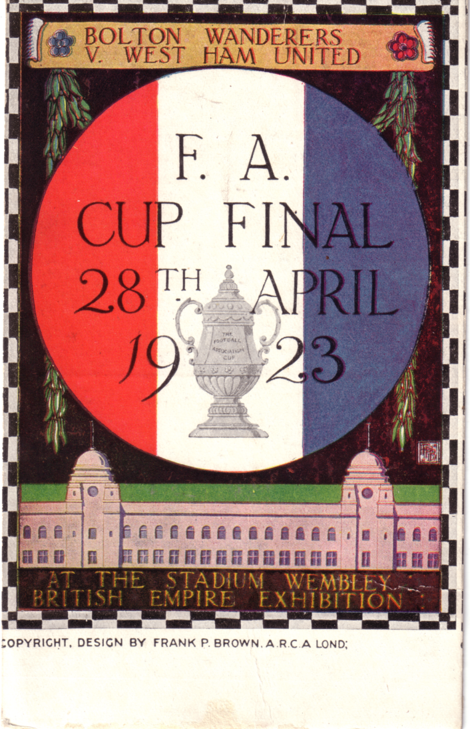

British Empire Exhibition and 1923 Cup Final post card
They don’t come rarer than this

One of our members Bryan Horsnell has sent in a request for information on any post cards, photographs, tickets, posters, programmes, ephemera and memoribilia covering sporting and non sporting events at the Stadium. He is working on an illustrated history covering all events held at the Stadium from 1923 to 2003. He is looking for information on the more unusual items.
Bryan has a collection of stadium post cards and is now hunting for the scarcer cards, without much luck. I imagine the above card is the only known example, although I know a member has another one of the set featuring the Rodeo.

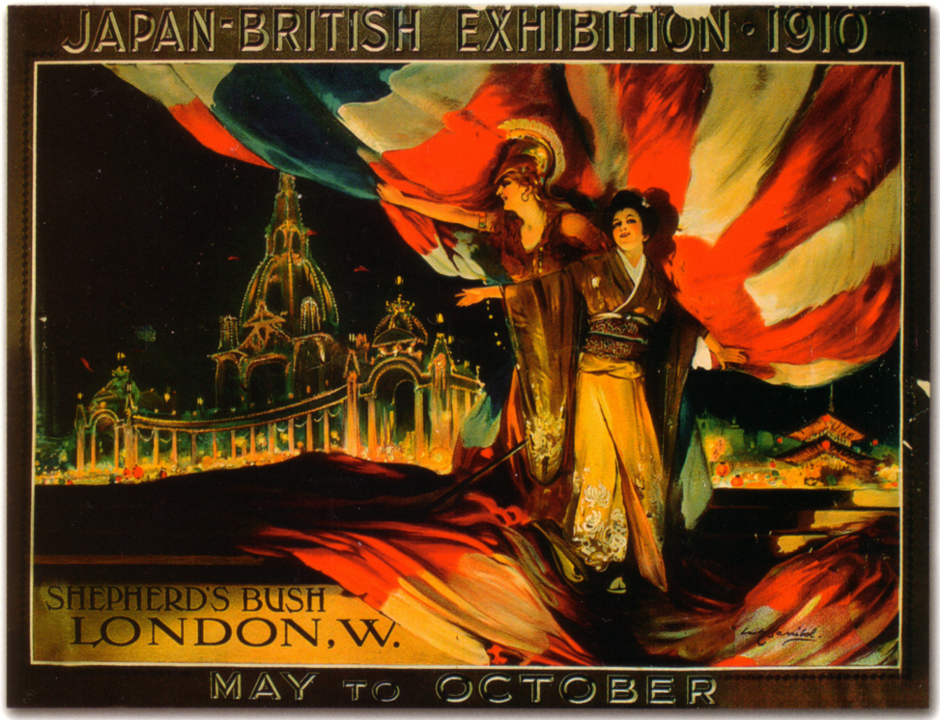

1910 Japan-British Exhibition poster

Some time ago I went to the London Museum with Alan Sabey, they had on a display of British Empire Exhibition material, and going into the shop afterwards saw some interesting coloured postcards they had for sale. One illustrates one of the bronze plaquette souvenirs by Madge Kitchener (I think they were on sale by the Royal Mint at Wembley) and another two cards show reproductions of White City exhibition posters. Alan bought a small supply and can offer them at 50 p each. The cards are modern size 6 x 4¼ inches so send him a large addressed envelope with a first or second class stamp on it.

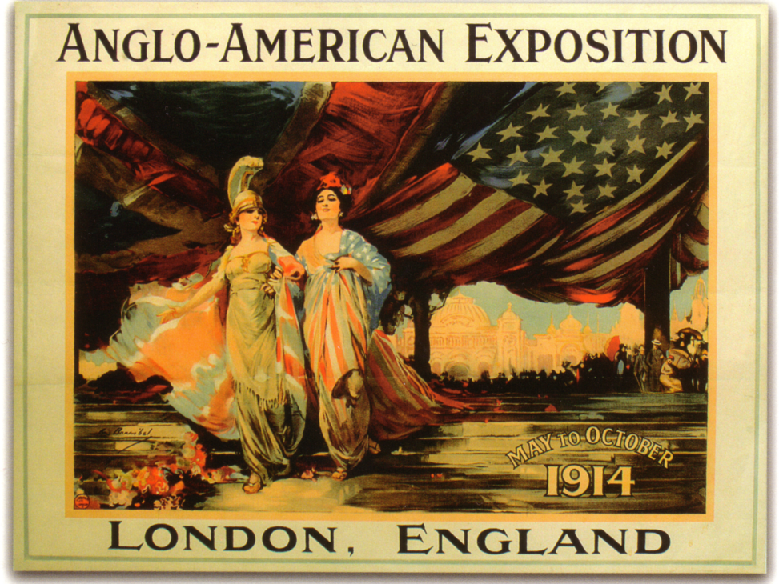

1914 Anglo-American Exposition poster

