EDITORIAL SUMMER 2004

Where does the time go
I just do not know

I can remember when I was a child my mother once said “The older you get the faster time goes” I didn’t mean much to me then, but how right she was. I can’t remember her saying anything about forgetting things as you get older, but there she couldn’t know everything.
The Royal Horticultural Society is celebrating its 200th anniversary this year and have decided to hold a two day exhibition on the 14 and 15 September 2004. I forget how René Dee the Managing Director found out about the Exhibition Study Group, but we have had several meetings, and at the last one on 10th May Francis Kiddle, René and myself spent about two hours at a meeting. René wants the exhibition to reflect the past history of the Society and in particular feature the many non floral exhibitions that have been held at the halls, which explains the involvement of the Exhibition Study Group.
The R. H. S. started in Hatchards Book Shop in Piccadilly on the 7th March 1804 and a hundred years later in 1904 the first Hall was built on their freehold site.
Initially he intended including the 1862 International Exhibition as this was held in the grounds owned by the R. H. S. but after reflection decided not to include this and concentrate on the many events held in the halls in the last 100 years. Members will be aware of the many philatelic events starting with the 1912 Jubilee International Stamp Exhibition, the 1923 London International Stamp Exhibition, the 1934 International Air Post Exhibition (Apex) and of course for many years Stampex was held at the Horticultural Halls certainly from 1969 to 1982 and probably even later until they made the, what many regard as the disastrous move to Islington.
Other long running exhibitions were the Universal Cookery and Food exhibition, Schoolboys Exhibition, later becoming the Schoolboys Own Exhibition when the Girls Exhibition started, and the Model Engineer Exhibition. Many of these are remembered by the advertising labels, post cards and catalogues which are now collectors items.
Judith Edwards and Captain John Marriner have both agreed to loan material if needed and with Francis Kiddle’s lot and my own odds and ends we should be able to put on a good show for them.
Our 18th Convention at Bradford will soon be upon us and Graham Hall has arranged for some reservations at the Ramada Jarvis Hotel at Bradford Rd, Bingley. Phone number 01274 567 123. I shall be staying there on Friday 24th, Saturday 25th and Sunday 26th nights. For more details and maps see article on the convention on page 31.
I announced at our last convention that I should be retiring as secretary at our 2005 convention. I shall be a couple of months short of 80 then and I feel it is not a healthy state of affairs for any organisation to rely on a secretary that old. There has got to be someone younger to take over, otherwise the Study Group could cease to exist, its as simple as that. So far there have been no volunteers for the position. It is not a time consuming job and it has not clashed with my other interests, but to carry on until a neighbour notices there are five pints of milk on the doorstep would be irresponsible to say the least. If the Study Group is to have a future, it has got to have a secretary.
The sad news of Stanley Hunter’s death means that the Scottish Exhibition Group which like ourselves in the beginning was a one man band, is now in a very sad position. As far as I know there is no committee or officers to carry on Stanley’s good work, and there has never been published, as far as I know a list of members. This will make it very difficult for anyone to carry on.
One of my first jobs when I became secretary of the Group in 1992 was to prepare a constitution, Andrew Brookes had already organised a set of officers as far back as 1989, and a few years later a committee of four was added. Before that, like Stanley, Andrew did everything himself. Of our original ten founder members in 1981 we are now down to three, Andrew Brooks, Graham Hall and Don Knight. My own membership dates from the early 80’s but I do not know the year.
The Editor.
Stanley K. Hunter

It is with very great regret that I have to inform members that one of our few surviving founder members Stanley K. Hunter was found dead at his home on 12 June. Neighbours had contacted the police when he had not been seen for several days, and his elder brother Morton gave permission for the police to break down the door. He was found sitting in front of the
television set, which was still on. It is assumed he died from a heart attack, but a post mortem is to be held. Stanley will be remembered for his incredible knowledge of all the Scottish Exhibitions, and indeed all exhibitions. He was Chairman of the Worlds Fairs Collectors Association in 2000-2001 with his membership of that organisation going back to 1992, and was President of the Exhibition Study Group from 1992-1994, becoming a member when the group started in 1981.
He was the author of the Study Group’s Publication No 1 the 332 page ‘Kelvingrove and the 1888 Exhibition’ (1990) and Publication No 3 ‘Footsteps at the American Worlds Fairs’. (1996). Only a few days ago he sent me a programme of his proposed tour of Kelvingrove Park which was to have taken place on June 17, and I think it is fitting that this last project he was engaged on should be recorded in the Journal.
At the request of his family the Study Group has sent a donation to FOGM (Friends of Glasgow Museums)

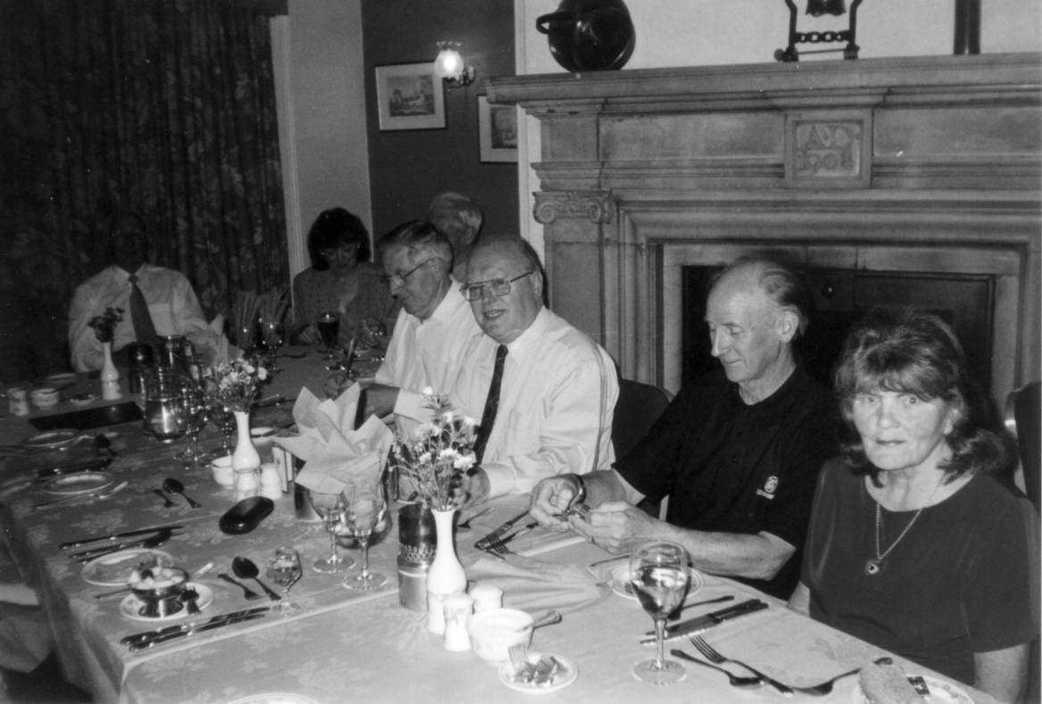

Stanley K. Hunter (in centre) at the 2002 York Convention

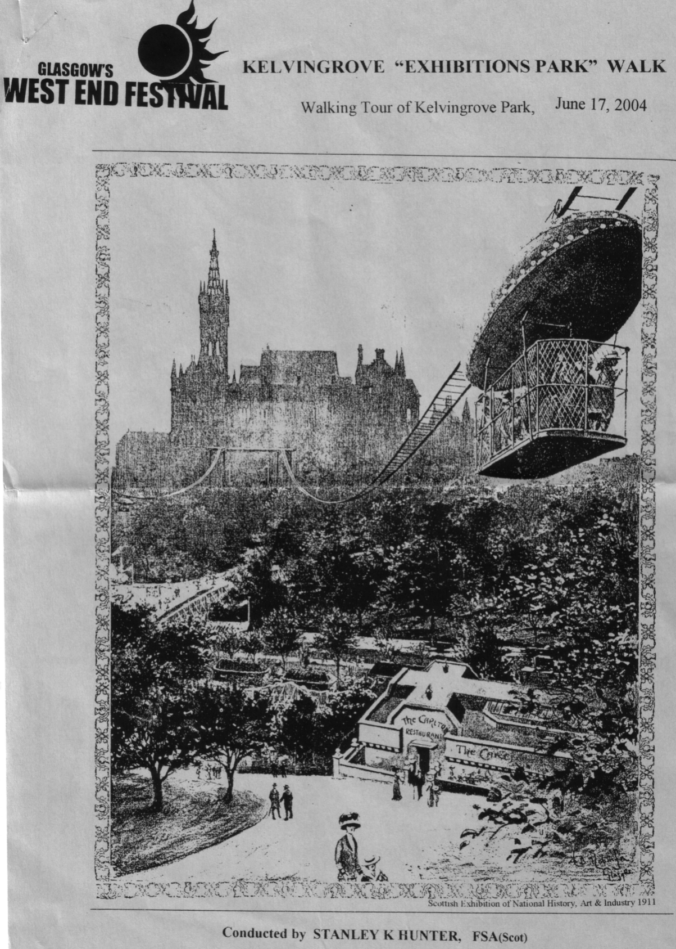

The tour guide produced by Stanley Hunter for his projected tour of Kelvingrove Park, which unfortunately never took place.
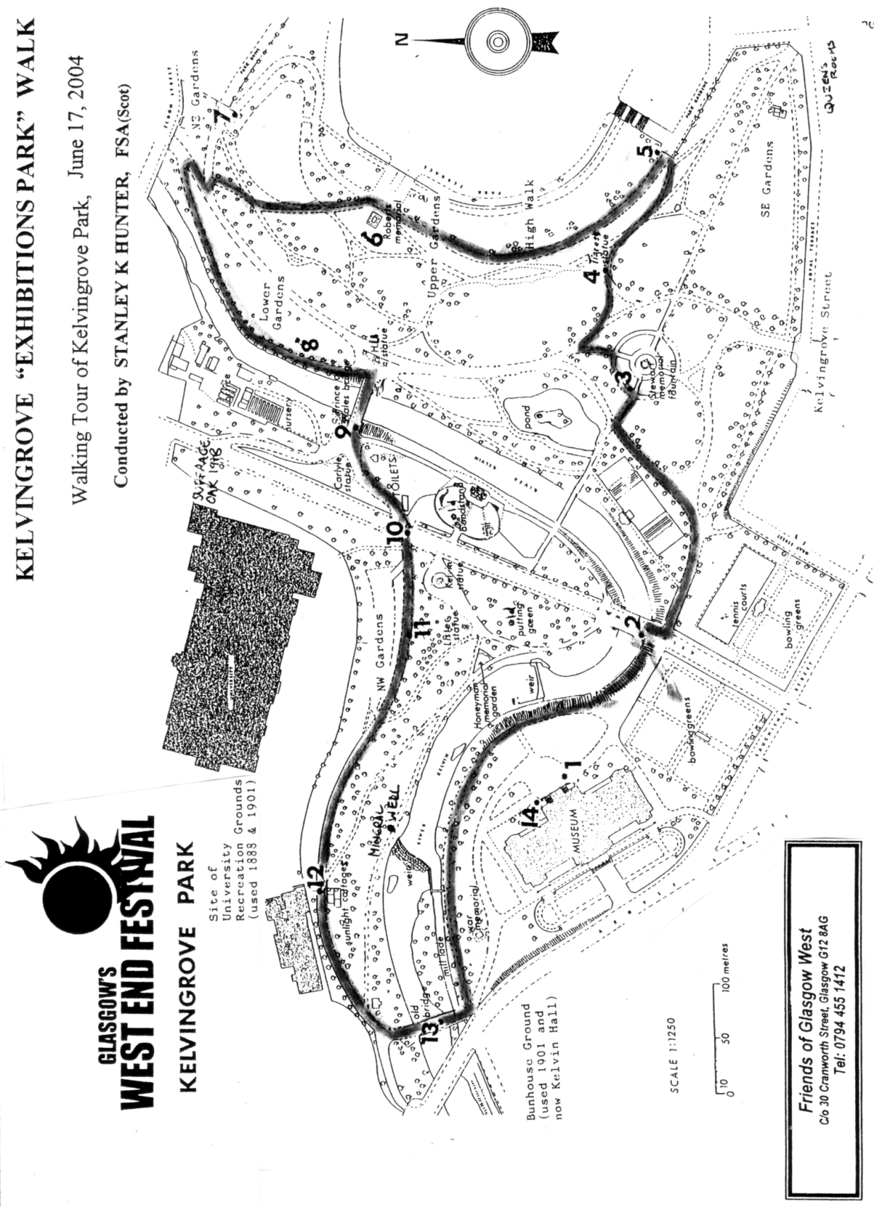

The route Stanley had worked out with the 14 view points marked.

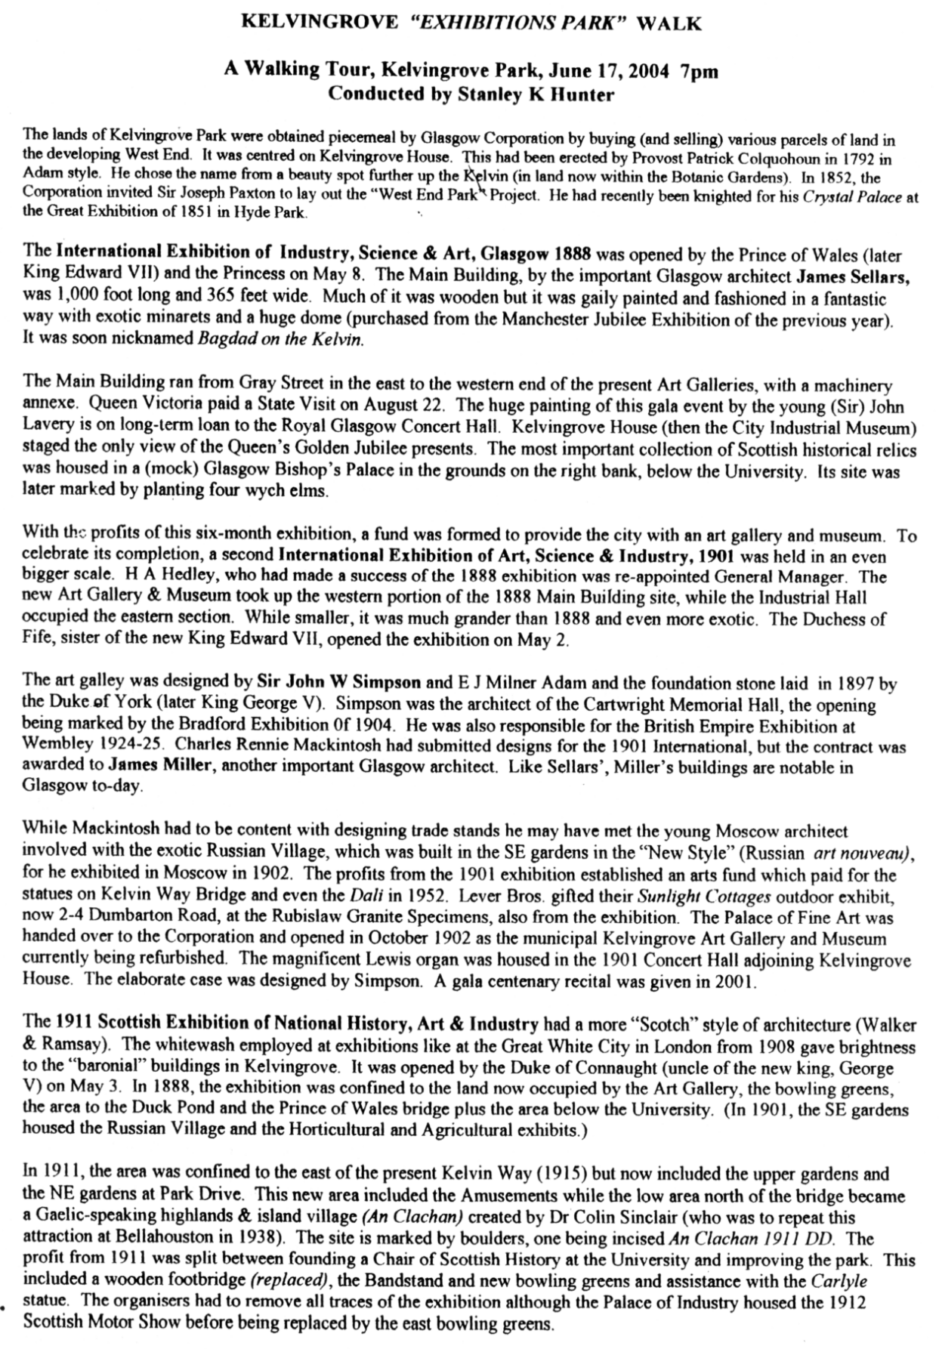

A brief description of the three exhibitions held in Kelvingrove Park.
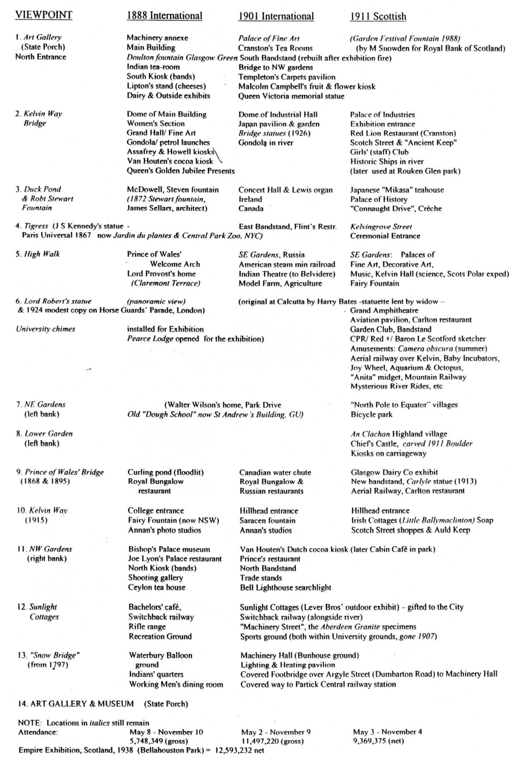

A description of what once could have been seen from the 14 view points.

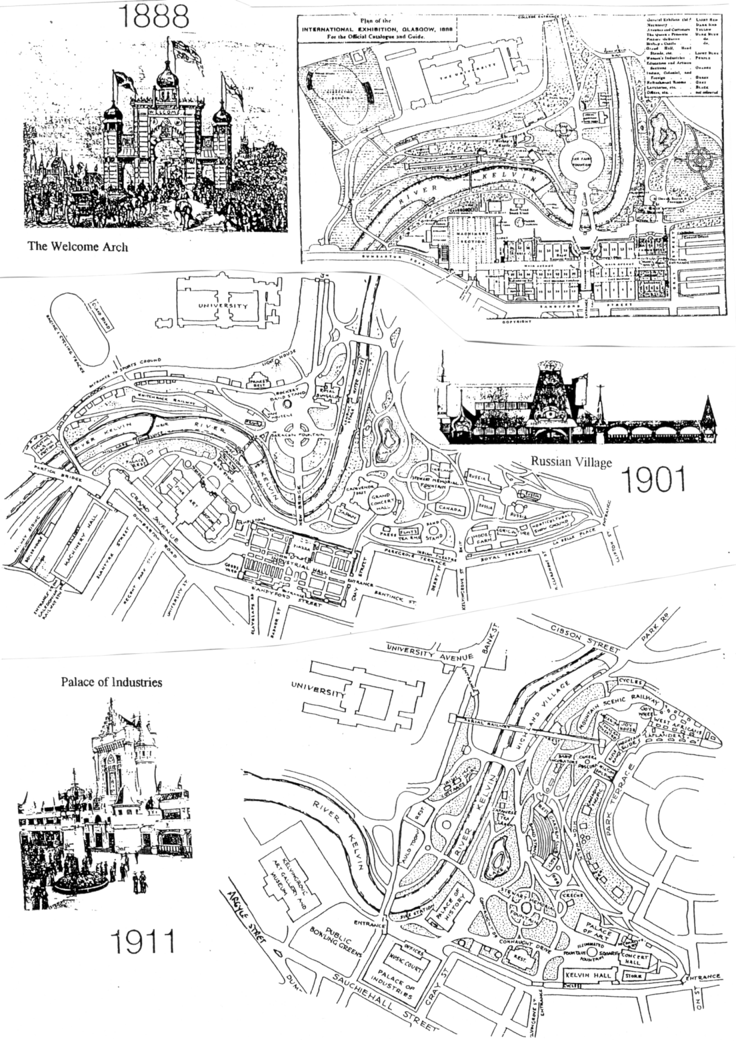

Site plans of the 1888, 1901 and 1911 Exhibitions held in Kelvingrove Park.
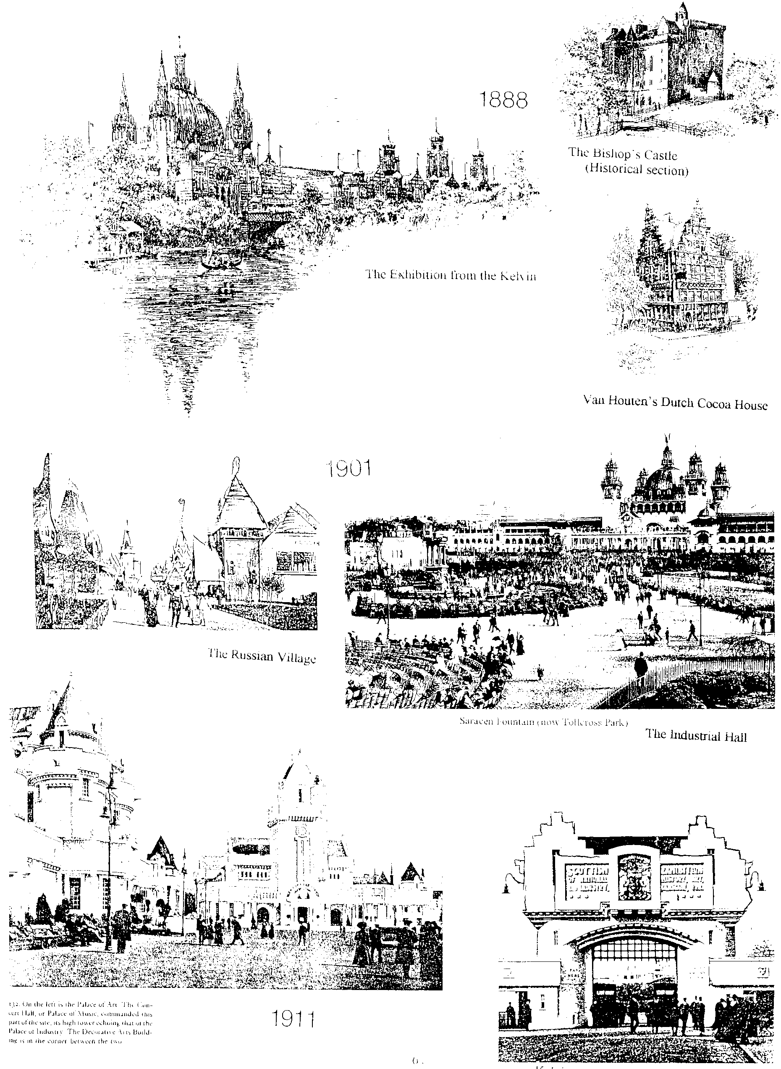

Views of the 1888, 1901 and 1911 Exhibitions held in Kelvingrove Park.

Horological Exhibits at the British Empire Exhibition, Wembley
By
Trevor Day
The task of collecting the various exhibits was largely carried out by the various Trade Associations, and the Watch and Clock Section, as detailed below, was bought together by the British Horological Institute, representing the Horological Industry of the Empire.
As was fitting in the most up to date Exhibition that the world had ever seen, the British Empire Exhibition was fitted almost entirely with Electric Clocks. These clocks were to be found in most of the Palaces and buildings in prominent positions. One of the firms responsible for the installation was Gent & Co. of Faraday Works, Leicester. They dealt with all manner of Electric Clocks, but are remembered as the Inventor and Proprietor of the “PUL-SYN-ETIC” System of Impulse Clocks as installed at the B.E.E.
Over 50 “PUL-SYN-ETIC” Impulse clocks were scattered across the Exhibition, in the entrances, Grounds, Cafes, Restaurants and in the Palace of Engineering, where close to the Watt Gate, the Transmitter operating the whole scattered system could be seen working. The transmitter in the Watt Gate was fixed upon the ebonised frame carrying Messrs. Pilkington’s exhibit of the largest piece of Plate Glass in the World.

Some of these Impulse Clocks were adapted to carry advertising legends and were protected by registration and became known as the “Winged Clocks of Wembley”. Winged clocks could be seen In the Palace of Engineering, at the Watt Gate, the Arkwright Gate, the Kelvin Gate, the Railway Bay, Café East, Café West, Bank Café and on some dozens of exhibitor stands. Also in the Grounds, at the Grand Restaurant, the Regent Restaurant, the Harmony Buffet, the Colonnade Tea Rooms, the Colonnade Café, the South-West Entrance and the Exhibition Stand.
Gent & Co. also manufactured Turret Clocks driven by their Patent “Waiting-Train” movement. In these clocks, wind and weather, sleet or snow, did not affect the time-keeping, as the hands were driven by a slow speed motor which “waits” at the end of each half minute until the time circuit freed it to operate another half minute. Two Turret Dial Clocks were installed at the Old London Bridge, and a further two operated at The Times Building and the Crosse & Blackwell Building respectively
The following is a list of all the exhibitors of the Clock and Watch Section at the B.E.E
A. ALEXANDER & SON Watches
61, Allesley Old Road, Coventry
C. A. V. SMALL TOOLS LTD The “Wade” Bench Lathes
181, Queen Victoria St, London, E.C.4
G. COTTON & SONS Mainsprings
7, Percival Street, London, E.C.1
DENNISON WATCH CASE CO LTD Watch Cases, Sovereign Purses etc.
Handsworth, Birmingham
F. W. ELLIOT LTD Clocks
105, Hatton Garden, London, E.C.1
ENGLISH CLOCK & WATCH MANUFACTURERS LTD Clocks and Watches
Hollyhead Road, Coventry
GENT & CO LTD Electric Clocks
Faraday Works, Leicester
B. T. GREENING LTD Clocks
30, Hatton Gardens, London E.C.1
HALL BROS. Surveying Instruments
49/53, Spencer Street, London E.C.1
E. HARROP Watch Cases and Expanding Watch 99/119, Roseberry Ave, London E.C.1 Bracelets
THE HORSTMANN GEAR CO LTD Newbridge Clocks etc.
Newbridge Works, Bath
THOMAS MERCER Marine Chronometers, Astronomical Eywood Road, St. Albans Clocks etc.
E. J. PEARSON & SONS LTD Watch Straps etc.
275, St. John Street, London E.C.1
PLEASANCE & HARPER LTD Grandfather Clocks
4, Wine Street, Bristol
T. A. REYNOLDS, SONS & CO Clocks, Barometers and Scientific 40, Percival Street, London E.C.1 Instruments
ROTHERHAM & SONS LTD Watches, Watch Cases etc.
Coventry
SHORT & MASON LTD Scientific Instruments
Aneroid Works, Macdonald Road, London E.17
JOHN SMITH & SONS Clocks
42, St. Johns Square, London E.C.1
J. CICERI SMITH Scientific Instruments etc.
401, High Road, London W.4
ALEX STEUART Electric Regulator and Electric 85, Pitt Street, Edinburgh Turret Movement
STLIC WATCH CASE CO LTD Watch Cases
42, Frederick Street, Birmingham
THE SYNCHRONOME CO LTD The Free Pendulum Precision 32/34 Clerkenwell Rd, London E.C.1 Regulator
WALTER TARBOX & CO Watch Straps etc.
36, Canonbury Square, London N.1
F. THOMS Watch Cases and Keyless Work
25, Spencer Street, London E.C.1
P.P. THORNTON Engraved Dials
Great Haywood, near Stafford
USHER & COLE Watches and Chronometers
339, St. John Street, London E.C.1
WARWICK TIME STAMP CO Time and Date Stamps
5, Camden Passage, London N.1
WHITE & REDGROVE LTD Jewellery
13, Charterhouse St, London E.C.1

Resignation of Packet Secretary

Mike Perkins has written to me tendering his resignation from the position of Packet Secretary. He wrote “the decision has not been taken lightly, but I find the enthusiasm for the job, and the pleasure that I derived from doing it, are no longer there. I did manage to get a packet out into circulation early this year, but it disappeared into the postal system never to be seen again, this was the final straw!”
Ron Trevelyan our President has written to Mike thanking him for his services over the past years. “I accept your resignation with great reluctance Mike, knowing that you have carried out a successful operation for many years. I am sure that Study Group members who have benefited from the packet by selling or buying material will join me in thanking you for all your hard work and, not least, putting up with various frustrations along the way. I am grateful for your offer to help any other member who might wish to take over this post.”

I have also had a letter from Ron Trevelyan under the heading of,

Crystal Palace.

I was interested to read in the Spring Journal about the apparent slip-up by Royal Mail in relating the Crystal Palace of 1854 to the Great Exhibition of 1851. I recently went along to the Dulwich Picture Gallery to an exhibition entitled ‘Crystal Palace at Sydenham’ which received a fair amount of publicity in the Sunday newspapers etc. This was, of course, designed to coincide with the 150th anniversary of the completion of the construction of the South London building. The exhibition sought to bring out the relationship between what was called the ‘parent building’ in Hyde Park and the later one in Sydenham, which was reckoned to be almost twice the size (Royal Mail please note). Some of the exhibits were borrowed from the V 7 A Museum and the Museum of London etc.
The contemporary paintings, photographs and engravings at the exhibition demonstrated what a wealth of activity took place in the Palace and its grounds such as the Handel Festivals with enormous choirs and audiences, the legendary fireworks displays, the staging of the Festival of Empire in 1911 and in the early days of the Imperial War Museum. The Architectural Courts had large scale reconstruction’s which were a great help to artists of the time like Holman Hunt to improve the accuracy of archaeological or historical details in their paintings.
I also enjoyed watching some fairly lengthy sequences of Pathe News. One showing crowds of marchers in the grounds in the 1930’s who were supporting some kind of peace movement, but more dramatic were scenes of the fire with collapsing segments of building and firemen fighting a losing battle.
I purchased an informative and well illustrated book at the exhibition entitled ‘Palace of the People’ The Crystal Palace at Sydenham 1854-1936 by J. R. Piggott published by Hunt & Co. London. I think I paid around £20 for it.
Little did I realise that the title of the exhibition was going to be controversial until I mentioned it to you. You maintain that the Crystal Palace was in Penge not Sydenham and that you have a map to prove it. Perhaps it was just as well that you did not have time to visit the exhibition since this could have led to some amendments along the way. Maybe this will provide some scope for a piece of doggerel.
P.S. I understand that you and Fred Peskett have been busy collaborating on a listing of Crystal Palace post cards. I am sure we all await the outcome with interest.

A Collection of Victorian & Edwardian Exhibition Medals
by
Leslie L. Allen
Part 2.

Dudley
1898 by ? Gilt white metal 51 mm.
Obverse Symbols of Trade & Industry. On a tablet above, Dudley. On a tablet below, 1898. Legend around upon a ribbon, Engineering Trades and Industrial / Exhibition
Reverse Legend in laurel wreath, Awarded to / Palethorpes Limited

Edinburgh
1884 by H. B. Sale White metal 33 mm.
Obverse Conjoined draped busts of Prince & Princess of Wales left. Legend around upon a raised border, H.R.H. The Prince of Wales and H.R.H. The Princess Alexandra. Signed H. B. Sale.
Reverse Seven line legend, In / Commemoration / of The / Edinburgh / Forestry / Exhibition / 1884
Bhm 3172.

1886 by A. S. & Co. White metal 35 & 39 mm.
Obverse Aerial View of the exhibition buildings. Signed A. S. & Co. Lenzie.
Reverse Eight line legend, Commemorative / of / International / Exhibition / Industry, Science / and Art / Edinburgh / 1886

1886 by P. Westren. Bronze, Silvered white metal 45 mm.
Obverse Exhibition buildings with a balloon above. In exergue, Under the Patronage of / Her Most Gracious Majesty / The Queen. Legend around within an ornate border, International Exhibition of Industry Science and Art. / Edinburgh 1886.
Reverse Views of five different buildings in the City of Edinburgh. Legend around upon a raised border, Peter Westren Manufacturer of Historical Scottish Jewellery / “Old Edinburgh” and 27 Frederick Street Edinburgh.
BHM 3215

Glasgow
1888 by ? White metal 35 mm.
Obverse View of the exhibition building.
Reverse Eight line legend, Commemorative / of the / International / Exhibition / of / Industry. / Science and Art / Glasgow. 1888

1890-1 by R. Scott Bronze 64 mm.
Obverse City Arms in trefoil. Legend around upon a raised border, East End Exhibition / Glasgow. 1890 - 1891.
Reverse Scotia seated right, buildings and ships in the background. Signed R. Scott

1901 by D. Mc C. Silver 17 mm.
Obverse View of the exhibition buildings. In exergue, D. Mc C.
Reverse Four line legend, Glasgow / International / Exhibition. / 1901.

1901 Ditto by ? Bronze 22 mm.
Obverse Conjoined crowned busts of King Edward VII & Queen Alexandra left. Legend around, Edward VII and Alexandra. 1901.
Reverse View of the Exhibition buildings. Legend around upon a raised border, Glasgow International Exhibition. / 1901.

1901 Ditto by C. Lauer Bronze 24 mm.
Obverse View of the Exhibition buildings. Legend above, Glasgow Exhibition. in exergue 1901.
Reverse City Arms. Legend around upon a raised border, Let Glasgow Flourish . J. W. L.

1901 Ditto by C. Lauer Bronze 24 mm. Silvered white metal 27 mm.
Obverse King Edward VII draped bust half left. Legend around the border, King Edward VII of England and Emperor of India.
Reverse View of the exhibition buildings. Legend around upon a raised border, Glasgow International Exhibition. / 1901.

1901 Ditto by ? Gilt brass - shield shape 36 x 24 mm.
Obverse View of the exhibition buildings. In exergue, Sports section.
Reverse City Arms. Legend around, Glasgow / International / Exhibition. / 1901.
1901 Ditto by ? Aluminium shell 38 mm.
Obverse View of the exhibition buildings. Legend above, International Exhibition. In exergue, Glasgow. / 1901.
Reverse Nine line legend, Souvenir / of the / International / Exhibition / of / Industry / Science / and Art / Glasgow / 1901.

1901 Ditto by Napier & Wilks White metal 38 mm
Obverse City Arms. Legend around upon a raised border, Glasgow International Exhibition. 1901.
Reverse View of the exhibition buildings & grounds. In exergue, Opened May / 1901. Signed Napier & Wilks Glasgow.

1903-4 by C.C. Macdonald Bronze 64 mm.
Obverse City Arms. Legend in a cartouche, Awarded to / James Bromfield. Legend around the border, Glasgow. East End Industrial Exhibition / 1903-4.
Reverse Scotia amid symbols of learning and industry, buildings in the background. In exergue, For / The Glasgow / Royal Infirmary. Signed C. C. Macdonald Glasgow.

Grantham
1899 by Vaughton & Son. Silver 39 mm.
Obverse Borough Arms. Legend around upon a raised border, Grantham Industrial & Fine Art Exhibition
Reverse Legend in laurel wreath, Awarded to / A. Paterson / Jan 1899. Signed V & S

Great Yarmouth
1894 by H.B. Sale Gilt bronze 45 mm.
Obverse Borough Arms. Legend around the border, Trades and Industrial Exhibition / Yarmouth / July, Aug Sept 1894.
Reverse Industria seated left with distaff amid symbols of trade and industry, buildings in the background. Legend above, Awarded for Excellence. Signed H. B. Sale. Birm.

Guildford
1907 by ? Gilt Bronze 45 mm.
Obverse Six line legend, Awarded to / Shelvey & Co. Ltd / for / Dry Ginger Ale / Guildford / 1907. Legend around upon a raised border, Manufacturers & Traders. / Exhibition.
Reverse Industria seated amid symbols of trade and industry.

Hastings & St Leonards
1864 by Keesey White metal 38 mm.
Obverse Twelve line legend, The Hastings / and St Leonards / Working Classes / Industrial / Exhibition / Opened / October 1864. / The earth is the Lords and / the fullness thereof, / the world and they / that dwell / therein.
Reverse Borough Arms above harbour scene within a laurel wreath. Signed Keesey Birmm.

1867 by Keesey White metal 38 mm.
Obverse Nine Line legend in laurel wreath. The / Hastings / and / St Leonards / Industrial / Exhibition / opened / September / 1867
Reverse Industria seated holding shield of arms etc., ships in background. Legend above, The earth is the Lords and the fullness thereof. In Exergue, 1867 Signed Keesey Birm

Nd by J. A. Restall Bronze 51 mm.
Obverse Borough Arms on a cartouche. Legend around upon a raised border, Hastings and St. Leonards. / Health Exhibition.
Reverse Fame seated attended by Industry and Hygiene. Signed J. A. Restall.

Huddersfield
1883 by Pearce & Sons. White metal 38 mm.
Obverse Eight line legend in floral wreath, Fine Art and / Industrial / Exhibition, / Opened by / His Grace The / Duke of Somerset / K.G. / July 7th 1883
Reverse View of school. Legend above, Technical School & Mechanics Institution. In exergue, Huddersfield. Signed Pearce & Sons.
BHM 3152

1883 Ditto- by Pearce & Sons. White metal pin back badge 40 mm.
Obverse Similar to reverse of BHM 3152.
Reverse Ten line legend, Manufactured / in the / Exhibition / by / Pearce & Sons / Huddersfield / Leeds / and / Leicester / 1883

Hull
1870 by ? Bronze 45 mm.
Obverse Eight line legend, Working Mens / Art / and / General / Exhibition / Hull / 1870
Reverse Borough Arms in laurel wreath.

Leeds
1858 by J. Moore Bronze 45 mm.
Obverse Industry seated with distaff. Legend around border, Exhibition of Local Industry. Leeds. City Arms between 1858. Signed J. Moore Birmm.
Reverse Nineteen line legend of names of the committee in a beaded circle. Legend around, Visited by H.R.H. The Prince Consort Septr 7th 1858.
BHM 2640.

1868 by J. Moore Silver, Bronze 45 mm.
Obverse Three line legend, Leeds Industrial Exhibition / Prize Medal / 1868
Reverse Industria seated right with distaff. Legend above, Diligentia Vincit Omnia Signed J. Moore.

End of Part 2 to be continued

Eighteenth Convention Bradford 2004

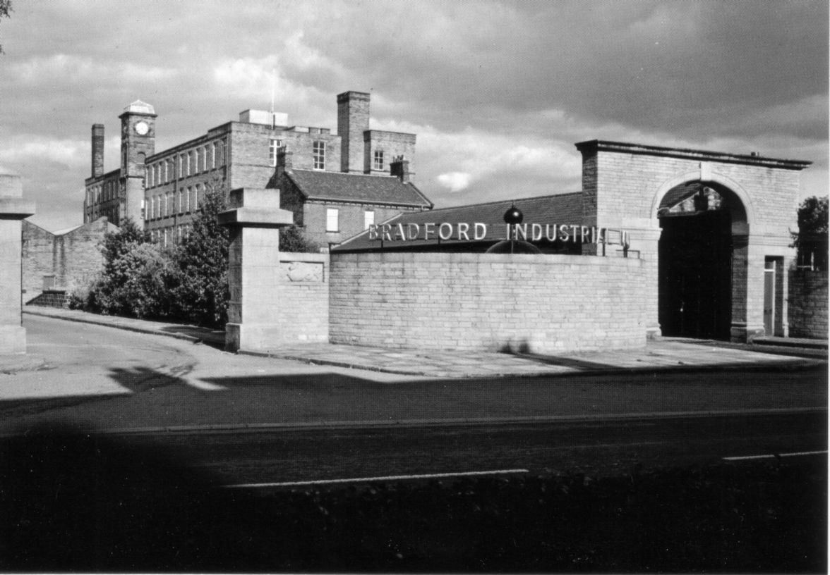

The Bradford Industrial Museum

The Bradford Industrial Museum Moorside Road where our meetings will be held. Graham Hall who does a lot of voluntary work for the museum and is organising this years convention, has managed to obtain a room for our meetings free of charge. He has also been able to arrange for tea and coffee breaks and sandwiches at mid day. We shall start at 10.00 on Saturday morning, 25 September for our Annual General Meeting which should not take more than about 20 minutes, and then there will be talks and displays through to about 4.30 when we shall finish for the day. Saturday evening we shall be meeting at the Ramada Jarvis Hotel for our annual dinner at about 7.30
On the Sunday we shall again start at 10.00 going on till mid day when those who have long distances to travel will start to drift off. Those that are not rushing off can stay on at the museum for a chat amongst themselves, or perhaps go along to the Cartwright Hall where there is a display which includes material relating to the 1904 Bradford Exhibition which was held in the Cartwright Hall and Lister Park.
It is important that those members who are going to bring displays should let Graham (on 01274 564 518) or myself (on 020 8777 8861) know so we can organise some sort of programme. I usually bring several displays myself in case we run out of displays but it has never happened yet.
If you have not all ready booked in at the Ramada Jarvis mention that you are part of the block booking for the Exhibition Study Group made by Graham last June at a fixed price of £27.00 for bed & breakfast, and £10.00 for our dinner. I booked up about a month ago and got a single room, but I understand single rooms are in short supply, and single persons may have to accept a double room.
I should like to thank Graham for supplying the originals of the illustrations used in this article.
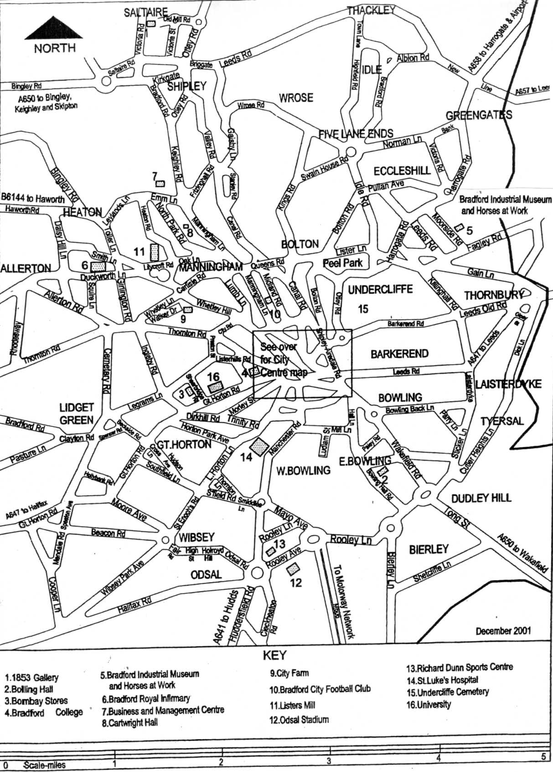

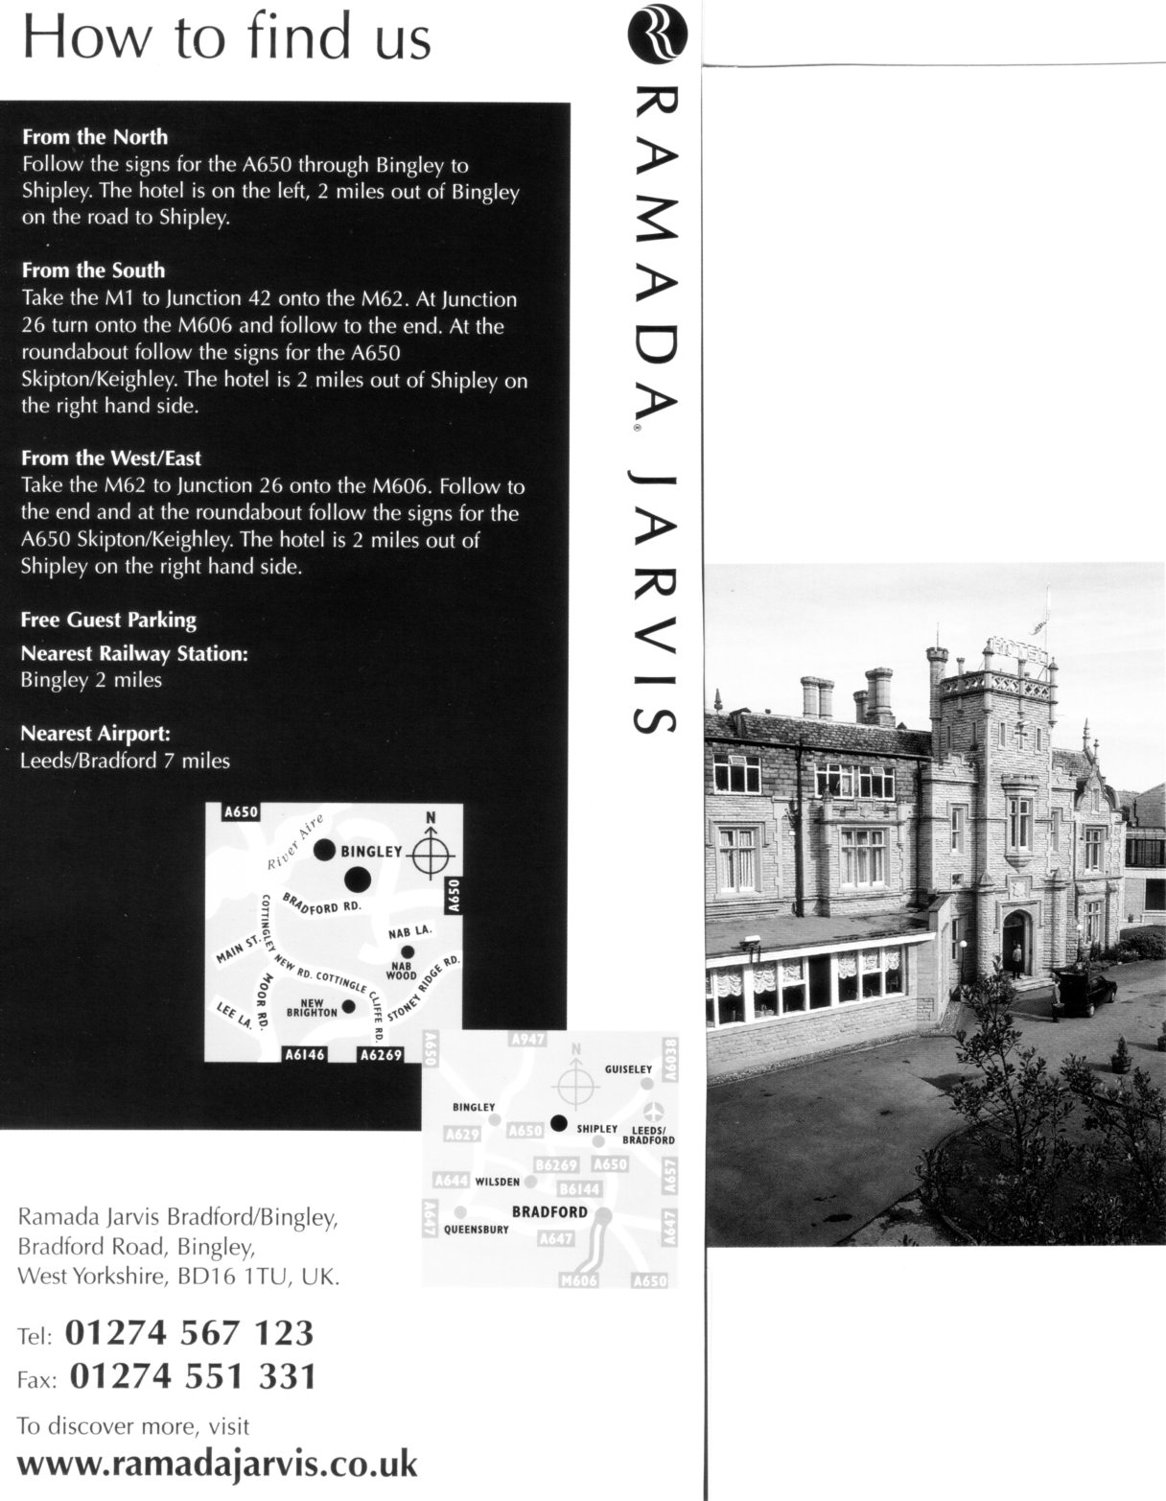

Post Cards of the White City.
Part 29.
by Bill Tonkin

Type 3. The third view is of the corner of the Palace seen across a bend in a narrow water way.
British Applied Arts Palace, Franco-British Exhibition, London, 1908. (A pre exhibition forerunner.)
B/W litho, sunk plate with large white border, black ‘Throughout the World’ back type FB 2.
N.n. Split title in one line bottom centre.
B/W litho, greenish grey ‘Throughout the World’ back type FB 2.
N.n. Title in one line at bottom left.
Coloured, red ‘F B seal’ back type FB 1.
N.n. Title in one line at top left.
N.n. Title in one line at top right.

Type 4. Distant view of the Palace, bandstand at left of view.
British Applied Arts Palace, Franco-British Exhibition, London, 1908
Sepia litho, black ‘Throughout the World’ back type FB 2.
N.n. Title in two lines at top left.

Type 5. Swan boat heading towards bridge, with a motor boat just going under the bridge. Palace of Applied Arts on the left of Lagoon.
British Applied Arts Palace, Franco-British Exhibition, London, 1908.
Coloured view in ornamental Britannia and Marianne border type FB Bo 1, red ‘F B seal’ back
type FB 1.
126 Title in two lines at top centre.
For other post cards with this border, see under Border FB Bo 1.
Title altered to, Palace of British Applied Arts, Franco-British Exhibition, London, 1908.
Coloured GIANT POST CARD, brown ‘Throughout the World’ back type FB 17.
126 Title in two lines at top right.
Coloured GIANT POST CARD, grey ‘Throughout the World’ back type FB 17.
126 Title in one line at top left.
For other large sized post cards see under Giant post cards.
For other post cards of this view see in the Imperial International Exhibition section, under ‘Palace of Applied Arts’.

Type 6. This card is known in two states, in the original is a group of workmen, one carrying a step ladder, and with a pile of earth beside a hole dug in the ground, there is also the corner of a building shown in the bottom right corner. In the second state the workmen have been converted into visitors, and the hole, pile of earth, and the corner of the building removed. These are listed as ‘with workmen’ or ‘with visitors’.
British Applied Arts Palace, Franco-British Exhibition, London, 1908.
B/W litho with workmen, black ‘Throughout the World’ back type FB 2.
N.n. Title in two lines at top left, left edge rouletted.
Coloured with visitors, red ‘F B seal’ back type FB 1.
163 Title in two lines at top left, left edge rouletted.
Coloured with visitors, dark grey ‘F B seal’ back type FB 1.
163 Title in two lines at top left, left edge rouletted.
Sepia litho with workmen, black ‘Throughout the World’ back type FB 2.
N.n. Title in two lines at top left.
Sepia R/Photo with workmen, black ‘X L’ back type FB 11.
163 Title in two lines at bottom left.
For other post cards of this view see in the Great White section, under ‘British Applied Arts Palace’.

Type 7. A diagonal pathway in front of the buildings.
British Applied Arts Palace, Franco-British Exhibition, London, 1908.
Coloured, red ‘F B seal’ back type FB 1.
167 Title in one line at top right.

British Applied Arts Palace at Night, Franco-British Exhibition, London, 1908.
B/W R/Photo, black ‘X L’ back type FB 11.
239 Title in two lines at bottom centre.
Sepia R/Photo, black ‘X L’ back type FB 11.
239 Title in two lines at bottom left of centre
Title altered to, Franco-British Exhibition, British Applied Arts Palace Night Effect.
B/W Photogravure on cream, black ‘Throughout the World’ back type FB 2.
239 Title in two lines at bottom left, left edge rouletted.

British Education Building, Franco-British Exhibition, London, 1908.
Coloured, red ‘F B seal’ back type FB 1.
399 Title in one line at top left.

British Science Palace, Franco-British Exhibition, London, 1908.
B/W litho, black ‘Throughout the World’ back type FB 2.
N.n. Title in two lines at top centre to right.

Burgoyne’s Bungalow, Franco-British Exhibition, London, 1908.
B/W litho, grey ‘Throughout the World’ back type FB 2.
N.n. Title in two lines at bottom left.
For other Burgoyne cards see under Burgoyne in the main list.

A Busy Day, Franco-British Exhibition, London, 1908.
Coloured, red ‘F B seal’ back type FB 1.
270 Title in one line at top right.
270 Split title in one line at top right of centre.
For other post cards of this view see in The Great White City section, under ‘A Busy Day in Court of Arts’.

Butter Exhibit, Canadian Pavilion, Franco-British Exhibition, London, 1908.
Coloured, grey ‘SOUVENIR POST CARD’ without divider, back type FB 8.
N.n. Title in one line at bottom centre, without ‘Valentine’s Series Copyright’.
Coloured, greenish grey ‘SOUVENIR POST CARD’ without divider, back type FB 8.
N.n. Title in one line at bottom left, without ‘Valentine’s Series Copyright’.

Section C.

Canada, Past and Present, Franco-British Exhibition, London, 1908.
Double width Panorama type card, on the back the right half has a printed post card back while the left half is blank. Very often the halves become detached, and are mistaken by collectors for normal cards. In this instance they can easily be recognised, as the left half has only part of the title ‘Canada, Past and Present, Franco-British Exhibit’, while the right half has the rest of the title ‘ion, London, 1908.’, and a blank back
Coloured, dark grey ‘SOUVENIR POST CARD’ without divider, back type FB 8.
N.n. Title in one line at top left of centre of the double width card.
Coloured, greenish grey ‘SOUVENIR POST CARD’ without divider, back type FB 8.
N.n. Title in one line at top left of centre of the double width card.
For other cards of this type see under Panorama.

Canada’s Red Grain Hopper, Franco-British Exhibition, London, 1908.
Coloured, dark grey ‘SOUVENIR POST CARD’ without divider, back type FB 8.
352 Title in two lines at bottom left. Vert left.
Coloured, grey ‘SOUVENIR POST CARD’ without divider, back type FB 8.
352 Title in two lines at bottom left. Vert left.
Coloured, greenish grey ‘SOUVENIR POST CARD’ without divider, back type FB 8.
352 Title in two lines at bottom left. Vert left.

Canadian Fur Exhibit, Franco-British Exhibition, London, 1908.
Coloured, dark grey ‘SOUVENIR POST CARD’ without divider, back type FB 8.
351 Title in two lines at top right.
Coloured, grey ‘SOUVENIR POST CARD’ without divider, back type FB 8.
351 Title in two lines at top right.
Coloured, greenish grey ‘SOUVENIR POST CARD’ without divider, back type FB 8.
351 Title in two lines at top right.

Canadian Pacific Pavilion, Franco-British Exhibition, London, 1908.
Coloured, red ‘F B seal’ back type FB 1.
309 Split title in one line at top centre.
309 Split title in one line at top right.
Title altered to, Canadian Pacific Railway Pavilion, Franco-British Exhibition, London, 1908.
B/W litho, black ‘Throughout the World’ back type FB 2.
N.n. Title in two lines at bottom right.
For other post cards of this view see in The Great White City section, under ‘Canadian Pacific Pavilion’.

Canadian Pavilion, Entente Cordiale, Produced in Butter, Franco-British Exhibition, London, 1908.
Coloured, grey ‘SOUVENIR POST CARD’ without divider, back type FB 8.
323 Title in two lines at bottom centre. Vert left.
Coloured, greenish grey ‘SOUVENIR POST CARD’ without divider, back type FB 8.
323 Title in two lines at bottom centre. Vert left.
Title altered to, Entente Cordiale, (produced in butter), Canadian Pavilion, Franco-British Exhibition, London, 1908.
B/W litho, black ‘Throughout the World’ back type FB 2.
N.n. Title in three lines at bottom centre. Vert left.

There are five different views published under the title ‘Canadian Pavilion’ as they are not all numbered a brief description is given to enable them to be identified, they are listed as type 1 to 5.
Type 1. A view with Valentine’s Post Card Kiosk in the mid left foreground.
Canadian Pavilion, Franco-British Exhibition, London, 1908.
Sepia litho, black ‘Throughout the World’ back type FB 2.
N.n. Title in two lines at bottom centre.
For other post cards of this view see in The Great White City section, under ‘Canadian Pavilion’.

