EDITORIAL WINTER 2003

Gloom and doom at the post card fair,
I nearly went to one that wasn’t there.

Our Convention at York was a great success, and I am sure everybody enjoyed themselves. I always feel it does not get the support from members that it should. But looking at it another way over the last three years our attendance has averaged a fraction over 17 each year. Last year was bad for the number of members who had to drop out at the last moment through illness. Still that’s nearly one in five of our members who do attend. When I think of some of the other specialist societies whose annual convention I have attended in the past, like the Salmon Study Group and the Railway Postcard Collectors Circle we are not doing too badly, if you counted their attendance on one hand you would have a few fingers left over. Mike Perkins attended one convention, I think it was connected with a South Africa study group and there was just two of them there.
I have just spent the most disastrous weekend at post card fairs in memory. It started off with my friend Peter Leigh asking me if I would like a lift to the Cheltenham Race Course fair. This is very convenient as he lives only two roads away and it’s silly driving two cars to Cheltenham and back. On this occasion I politely declined his kind offer. I know a lovely farmhouse I have been staying at for 17 years now and Fred the proprietor runs me down to the local pub on Saturday evening where I have a nice meal and it has to be said more than a few drinks. He picks me up later and I drive home on the Sunday. Usually calling in at the trout farm at Colesbourne to get a few trout’s. They net them out and gut them while you wait, and you can’t get ‘em fresher than that.
I only have myself to blame but I left it until the Thursday evening before booking up at the farm, and they could not fit me in. So I had to get back to Peter ‘cap in hand’ to see if he was still going to Cheltenham as I had changed my mind and would like a lift. Fine he said and Saturday morning saw us on the road.
Piecing things together the story seems to be that one of the organisers of the Cheltenham Fair wanted to go to the Norwich Fair which was on the same day as Cheltenham, and he persuaded his co-organiser to put their fair, already advertised for October 11, back two weeks. The collectors who turned up on the 11th found there was no fair. Unfortunately when Freda and Ron tried to get dealers to attend the fair on the revised date they found to their dismay that most of their regulars were already booked in elsewhere. Collectors who were notified of the change of dates turned up to find instead of three halls of dealers there was just over one hall. Changing the date of a fair after it has been advertised is an exercise where there are no winners. The organisers have learnt a very expensive lesson as they must have lost heavily on the fair.
Being back early on the Saturday evening I decided to go to Bloomsbury on the Sunday. I would have done as well to have stayed in bed. As I left Bloomsbury I ran into detour after detour for a Students March and Demonstration. The journey home that I usually do in about 50 minutes took me three hours, plus £11.00 I paid for a street atlas of London to find my way home. They say it never rains but it pours.
While I am in a cheerful mood I might as well let you know that I am now diabetic. But as my Doctor told me, “not to worry, you will die of something else before diabetes kills you”. I wonder what he knows that he’s not told me.
This brings me to a matter I put before the Convention at our A.G.M. I notified the meeting that in two years I shall be 80 and intend retiring as secretary of the Study Group then. If I’d known I was going to live so long I would have looked after myself better. But seriously, if there is not someone ready to take over the position, the group will grind to a halt. The Study Group is a very successful society and I would be failing the group if I do not take steps to ensure it carries on into the future. Perhaps the way forward is to have a small committee responsible for producing the Journal. This is not an onerous task I usually get it done in three or four days, certainly under a week.

The Editor.
Cuthbert Heath. Maker of the Modern Lloyds of London.

By George Burr.

Many articles have been written in the Study Group's Journals over the years, about the British Empire Exhibition, however I cannot recall any mention of the Insurance, of this Great Event. From the above book, I can inform the E.S.G. of the undertaking by C. E. Heath & Co. Ltd., of this risk for 1924.
Cuthbert Heath had been involved with the Underwriting of Insurance Risks, of many types for 44 years, when he took on the whole risk of the B. E. E. himself. If we start the extracts from the Book in 1921, one can judge for yourself, the high esteem in which he was held by Members of his syndicate and all Members of Lloyds.
At Lloyds, in 1921, he was presented with the portrait by Sir William Orpen commissioned by members of his syndicate, and perhaps for the first time became aware that he was held in something more than admiration. With all his qualities, said Sidney Boulton at the presentation dinner. "we love best in him the patience, the fairness, the kindliness, and the gentleness that never fail, amid all the hurry and worry of our daily work. Cuthbert Heath, you are an old darling and we all love you". The market's affection was to be visibly demonstrated in 1924, the year of the British Empire Exhibition. Despite the fact that exhibitions usually turned out to be expensive risks for the insurer, Heath was firmly of the view that Lloyd's should, as a goodwill gesture, guarantee the Exhibition without asking any premium. For its aims was, he wrote, "to serve more than one object. It relieves unemployment and it will be the means of bringing many visitors and much money to this country besides promoting trade. It is felt that not only should Lloyd's be willing to help where others have done so, but that in view of the great interest felt in the Exhibition by the Prince of Wales, it would be a nice thing to give this guarantee to him, as some acknowledgement from Lloyd's of all he has done.” Heath not only promoted the idea in the market, but on one memorable day, broked the risk himself in the Room. He was now 65 and for several years had not been seen in the Room since increasing deafness had led to his transacting business in his office. His second cousin, Philip Heath, recalled the unusual event: "One afternoon business was proceeding at Lloyd's in its usual decorous way. An underwriter happened to look up and noticed a tall, stooping figure standing patiently in a queue waiting his turn to see a leading underwriter, and this was only right and proper, for at Lloyd's it is a rigid rule that everyone, whether a leading broker or a junior clerk, must take his turn in the queue with the others. With a shout the underwriter left his box and ran across the room to greet Mr Heath the broker (not Mr Heath the famous underwriter) waiting to show the Empire Exhibition risk to a leading underwriter. Others had seen him too, and pandemonium broke out. All business at Lloyd's stopped. Underwriters threw aside their books and rushed to join the crowd round the rather bewildered old gentleman. They were cheering him, they were patting him on the back, they were trying to shake his hand, they were telling him how wonderful it was to have him among them again after all this time. The demonstration lasted for several minutes-then Lloyd's went back to work and Cuthbert went on with his job. The queue in which he had been standing mysteriously disappeared so that he was in front of the underwriter. The latter glanced at the slip on which details of the proposed guarantee were shown, wrote down a large line on behalf of the syndicate he represented and initialled it, then with a broad smile he said "Nothing for you to pay Mr Heath." He crossed out the proposed rate shown on the slip and substituted '0%'. Cuthbert thanked him politely and went on to see the other underwriters. Each time the queue disappeared and every underwriter wrote his line, large or small, according to the size of his syndicate. All these hardheaded business men knew perfectly well that they were bound to face a heavy loss on the policy and they couldn't care less. This was their way of showing their affection. The underwriters at Lloyd's had every reason to be proud of the way in which they behaved on that famous day. It was perhaps their finest hour. The book does not indicate, whether there were any substantial claims or whether this risk was covered also during 1925.
Kind permission has been given by Messrs David & Charles Ltd., to reproduce from the book, also The Heath Lambert Group for which we acknowledge our thanks. For members who wish to read more of Cuthbert Heath, the details are as follows Cuthbert Heath Maker of the Modern Lloyds of London, by Antony Brown published 1980 ISBN.0-7153-7942-9.1.

W. P. Hartley’s Advertising Post Cards.

It is not often we get any reliable information on the quantities of post cards used at exhibitions. Some three years ago I exchanged some information with Nick Hartley the grandson of the founder who was doing a history of the firm, and he was able to give me some information regarding their post cards.
On 27 August 1923 Messrs Clark & Sherwell of Northampton had their photographer at the Aintree Works taking 46-48 B/W photographs of the interior and exterior, as well as the pottery and the fruit farm in Bedfordshire. 24 of these were chosen for publication and on 1 September 2 million were ordered. Some of these were used at the Bristol Grocers Exhibition. A further 5 million were ordered at 8/6 per thousand on 6 February 1924 which included seven new cards, five of which were taken in Seville.
At the same time 3 million colour post cards were ordered from Kingsway Press Ltd., at 12/- per thousand, which were reproductions of the Marmalade and Preserves show cards. So for Wembley 8 million cards were ordered plus what was left from the first 2 million after some were used at the Bristol Exhibition. The operation cost them £4775 for 10 million post cards, and remembering that in the good old days there were 240 pennies in a pound, this works out at nearly 9 cards for a penny.
One card in my collection has the message “We have come up to the British Industries Fair today, and I bagged this card off a stand.” unfortunately it’s not postally used so the year is not known. Of course not all of the cards would have been used at exhibitions. Post cards played a large part in the advertising of firms products, and Hartley’s would have made some of their cards available to their customers, who in turn would have used them for advertising purposes. Another Hartley card in my collection was sent by a grocer H. Brown & Son of Hellifield to notify a customer that his son F. Brown would be calling ‘when your order will be esteemed a favour’, this card was used in July 1928.

The Seventeenth Annual Convention 2003.

by Ron Trevelyan.

The Exhibition Study Group gathered at York at the Holgate Hill Hotel for its 17th Convention and Annual Dinner. At the A.G.M. Ron Trevelyan took over as President from Mike Perkins who had completed his three year stint in office. Over one and a half days there were eight interesting and varied displays by members on a number of different subjects (see below). There was also much friendly but earnest discussion which after much good food and drink seemed to get even more profound. For instance, questions like ‘What is an Exhibition’? and ‘What is a post card’? provoked plenty of debate but also showed there was no one simple answer to either question.

Displays on Saturday.

Don Knight, as is traditional, presented the opening display which featured White City post cards and memorabilia. Pride of place was taken with a document autographed by the White City organiser Imre Kiralfi who was famous for his involvement in many other exhibitions/fairs world-wide. Visitor comments from post card backs were quoted to build up a picture of a wet White City on the opening day of the Franco-British Exhibition 1908 with some buildings still to be completed. A selection of post marks followed with oddities such as the reversed date (80 instead of 08). A detailed article on his post mark researches will appear in a future Journal. We then saw post cards which came giant sized, panoramic, printed in French, silk cards and Christmas cards, as well as a selection of exhibition labels all relating to the White City. Another interesting item shown was tile made in Belgium which a B.B.C. Blue Peter team had dug up whilst excavating the Italian Gardens at the White City in the 1980’s.
Note, during a pre-convention visit to the National Railway Museum in York Don thought an early locomotive seen on an operational turntable might have been on display at the Franco-British Exhibition in 1908. His enquiries there revealed it was a 1907 engine and it remains for him to check a relevant post card. Watch this space.

Ron Trevelyan traced the history of the British Industries Fair in slogan post marks and publicity labels from its inception in 1915 to its demise in 1957, plus some other miscellaneous trade fair labels. B.I.F. slogan were widely used in the mail and the labels fell into four main types: Arms, Britannia, Key and Key in oval, with some variations. Examples of all these types were shown.
We heard that B.I.F. started in W.W.1 under the Board of Trade auspices to promote the sale of goods from a limited sector range of British industry who were not involved in meeting war requirements. From 1920 onwards the scope of the B.I.F. was greatly increased. The Department of Overseas Trade, formed in 1917, took over B.I.F. organisation until it was absorbed back into the Board of Trade in 1948. London venues for the Fair included the Royal Agricultural Hall, Islington (1915) the Victoria and Albert Museum (1916-17), the London Dock (1918-19), the Crystal Palace (1920), the White City (1921-37), Olympia 1930-51), and Earl’s Court (1920-57), the latter three containing some gap years. Other venues were Glasgow (1918-20), and Birmingham, Castle Bromwich (1920-57). No B.I.F. were held between 1941 and 1946. With one or two exceptions a full range of the labels and slogans for the lifetime of the B.I.F. were displayed.
Finally we learned that the B.I.F. had run its course by 1957 and fell victim to the more specialised fairs on the continent. The Board of Trade subsidy was switched to allow British Industry to participate in specialised trade fairs overseas (example labels shown).

Bill Tonkin gave a wide ranging display of British Exhibition cards dating back to 1862. Many of these events took place in venues such as South Kensington, The Royal Hospital Chelsea, the Crystal Palace, Earl’s Court and Olympia. Some of the exhibitions displayed were not exactly household names such as the Australian Convict Ship Exhibition at Plymouth in 1905.

Peter Denley presented a comprehensive display of Wembley slogan post marks. He mentioned in passing that his parents had owned and used a Liptons Tea Caddy from Wembley 1924 for many years. The earliest Wembley slogan on display was dated 9 October 1922. We saw slogans from Krag continuos impression machines, single and double circle hey dolphin machines, hand stamps and metered mail. The complete range of Pageant of Empire, Torchlight Tattoo, ‘London Defended’ and ‘Fellowship’ followed. Finally a selection of advertising slogans from the Empire countries were put up, including the ‘Australian Products’ one. All the examples shown were of high quality.

Stanley Hunter focused on Sir Joseph Paxton, whose life was celebrated in a recent book, and the Crystal Palace which he designed. We saw a document autographed by Paxton which was followed by a very comprehensive range of post cards, cigarette cards and modern post cards and stamp issues all showing Paxton, the Crystal Palace or personalities involved in the staging of the Great Exhibition of 1851. This demonstrated what a popular subject this has been over the years. The New York Crystal Palace, which housed an exhibition in 1853, was also included in the display. Interestingly, Paxton’s design for it was turned down, but like its British counterpart it burnt down.

Don Knight ended the displays on the first day with something he described as ‘out of the cupboard’. This consisted of G.B. special event post marks from the 1960’s era, including stamp fairs and exhibitions, and showed just how easy it was in this period to commission a special post mark for all manner of events. Don’s material had been dormant for some time before being resurrected.
Sunday Morning.

Alan Sabey gave evidence to the convention of the research he has been carrying out on the Wembley exhibit of Tutankhamen’s tomb which now resides in Hull. A detailed background to Alans display was contained in his article in Journal 62 (Winter 2002). It will be recalled that Alan and Bill Tonkin visited Hull on their way home from the 2002 Convention in York. Coupled with a further visit to Hull in July, Alan has compiled a dossier of articles and photographs on this interesting feature of the Wembley Exhibition. The Convention Display therefore represented the ‘fruits of his labours’. The Convention was very appreciative of Alen’s work and he in turn made it clear that the record he had created was intended for the future use of the Study Group and not for him personally.

In the final display of the Convention John Marriner decided to show G.B. Victorian perforated postal stationery. His choice of material stemmed from the fact that he felt he lacked the post card resources of most of the members of the Study Group. It was an interesting and unusual selection of postal stationery cards, envelopes and newspaper wrappers with a variety of perforations ranging from holes, clips and the more usual perfins. It will be remembered that John won a silver medal at Glasgow 2000 for an entry of G.B. perfins.

Some of the members who have long distances to travel start drifting away during Sunday afternoon, so we do not have any displays after lunch. It is nice to have time for a gossip as there are usually a few members who do not go home until the Monday morning.

Books.

We have had several new members join recently one of them Peter Fox, saw one of the cards Mike Perkins has put in dealers stock boxes. Peter phoned me and we had a long conversation, and it turns out that Peter collects Crystal Palace medals. He happened to mention that a friend of his Les Allen had written a book on Crystal Palace medals, and gave me his phone number.
I rang Les for details of his book and he has written what must be the definitive work on Crystal Palace and related exhibition medals. 276 pages hard back with over 800 illustrations. Although this is advertised at £29.50 Les offered me a copy for £25.00 post free which I have now got. He is also very generously making the same offer to any of our members who would like a copy. The surprising thing is that firstly I had never heard of the book, because I usually get to hear of any exhibition related books that are published, and secondly Les had never heard of the Exhibition Study Group. He is into the coin and medal world and didn’t know that outside that area there is a very strong society interested in collecting all exhibition memorabilia.

New members

Mr Leslie L. Allen. 01255 221645
10, Tewkesbury Rd, Clacton on Sea, Packet Required
Essex. CO15 3NX
Medals Crystal Palace & other Exhibitions

René Dee 01273 681 532
Flat 11, 13, Chichester Terrace, Brighton, Packet required
East Sussex. BN2 1FG rene.dee@talk21.com
Royal Horticultural Hall all aspects

Dr. Brent Elliott 020 7821 3052
Lindley Library, Royal Horticultural Society brente@rhs.org.uk
80, Vincent Square, London. SW1P 2PE
Horticultural & Flower shows, 1862 International Exhibition

Mr Peter Fox. 01909 774732
24, Osborne Rd, Kiveton Park,
Sheffield. S26 6PR
Medals and ephemera of all British Exhibitions esp. Crystal Palace.

Mr J. N. Tim Rusden 01535 604415
Oatlands, Cark Rd, Keighley, tim@oatlands110.freeserve.co.uk
West Yorks. BD21 3BH
1912 Ideal stamp post cards and stamps

David Saddington.
2, Scholars Court, Alcester Rd,
Stratford-upon-Avon. CV37 6PN.
Wembley

Alan Spencer. 0121 459 7650
25, Hawthorne Rd, Kings Norton, alan-spencer@btopenworld.com
Birmingham. B30 1EQ.
G.B. Philatelic Congresses

Tim Rushden has asked me to publish the fact that he is anxious to acquire any material of the 1912 Jubilee International Stamp Exhibition. especially the Ideal Stamps and the post cards of the Ideal Stamp. Any information would be welcome. See above for address. It is about time someone tackled a listing of all the post cards published by the Junior Philatelic Society. I know there is an enormous range of colours. I have a few of these cards but not enough to tackle anything list wise.

Another relatively new member Bryan Horsnell has requested me to ask for any post cards of the Wembley Stadium. He is looking for some of the really scarce items like the Salmon and the Reitz card.
J. Salmon post card No. 2735 The Stadium by C. T. Howard.
Castle Series. General view including Stadium, Canada, India, and the wonderful Burmese Palace and Gardens
Beagles Nos 695 H, K and L.
Reitz. Wembley Sports Stadium
Kingsway Real Photo S15336, 15337 and 15539.
Bryan Horsnell. 275, Overdown Rd, Tilehurst, Reading. RG31 6NX phone 0118 942 4448

1924 British Empire Exhibition Maps
by
Bill Tonkin

Members will remember that some time ago (five years actually) the Group did some research into the 1924 coloured maps done by Kennedy North and printed by Dobson Molle & Co., Ltd. When opened out they measure 29½ x 20, and folded approximately 3¾ x 6¾. The map is very colourful with a green and black border and shows a plan of the site with the main buildings named.
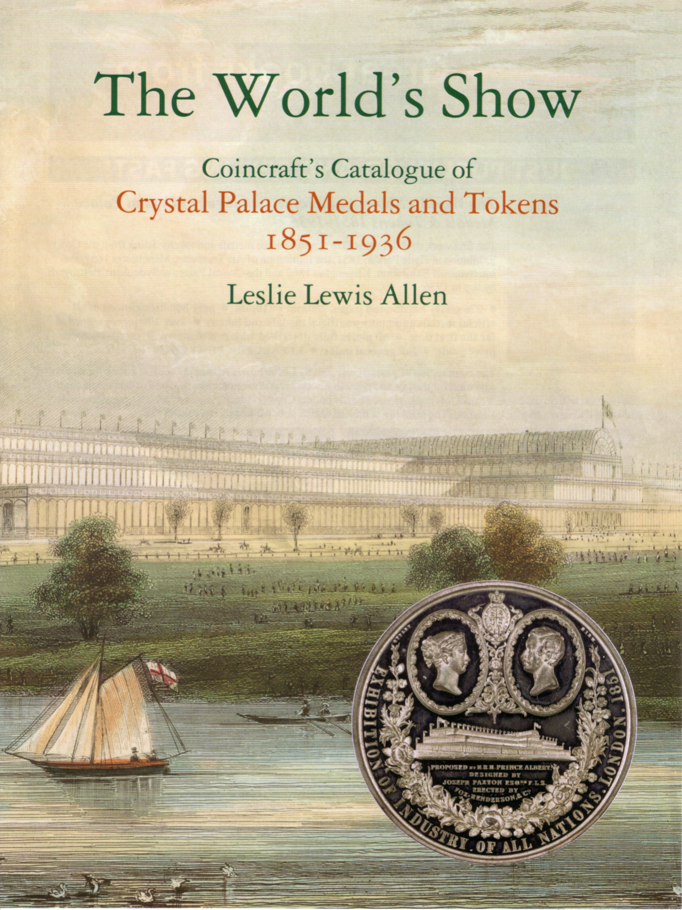

The World’s Show. Crystal Palace Medals and Tokens 1851-1936. Obtainable from Mr Leslie L. Allen. 10, Tewkesbury Rd, Clacton on Sea, Essex. CO15 3NX at the reduced price of £25.00 post free (in the U.K.) to members of the Study Group. All medals and tokens fully described with rarity rating and a comprehensive price guide. Over 200 pieces recorded for the first time.

It was discovered that the back of the maps carried different advertisements and eventually we found there was no less than 32 different backs.
When folded it is divided up into 24 panels of information or advertising matter with pictures, which I have named A to X, see table below. Some panels are joined to make a double width panel, and in some cases four panels are joined, to make an even larger display.

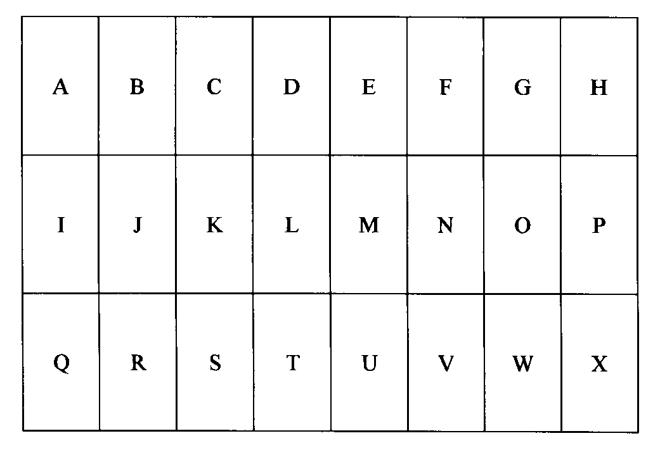
Layout and letters allocated to each panel on the back of the map.

No alteration has been recorded in the contents of panels A, B, C, D, E, F, G, H, J, O, P, Q, R, W and X, and these are listed just in case you do find anything different.
Panel Text
A. Picture and text on Canada.
B & C. Five pictures and text on West Africa, East Africa, Bermuda, West Indies and British Guiana.
D & E. Picture and text on British Government Pavilion.
F & G. Five pictures and text on Burma, Malaya, Palestine & Cyprus, Ceylon and Hong Kong.
H. Picture and text on Australia.
J. Front of map when folded.
O. Picture and text on Newfoundland.
P. Picture and text on New Zealand.
Q. Picture and text on South Africa.
R. Picture and text on Palace of Engineering.
W. Picture and text on the Palace of Industry.
X. Picture and text on India.

Panels K, L, M, and N are known in two types, headed British Empire Exhibition, the first type consists of paragraphs titled ‘Variety and Colour’, ‘Monster Military Tattoos’, ‘Fellowship of Empire’ and ‘The Great Home Coming’, this is listed as ‘F. of E.’ In the second type with the same heading the paragraphs are now titled ‘Variety and Colour’, ‘The Tomb of Tut’. ‘Monster Military Tattoos’, and ‘An Empire Parliament’, this is listed as ‘Tut.’

Panels that seem to be altered with each map are I, K, L, M, N, S, T, U and V. These are listed in a condensed form in the index and more fully in the main listing.
Since those articles five years ago two more maps have turned up. I will only list those panels that are known to alter, I, K, L, M, N, S, T, U and V. If any member wants a complete listing of the 1924 Wembley maps, please let me know and I will send you a copy.

Contents of different panels on Map number 33
I. Advert for British industries Fair 1924. Without printers reference number. 7 mm between box and ‘For fuller etc.’ seven lines of text measures 33 mm deep.
K, L, M & N Picture of the Imperial Stadium and text on the British Empire Exhibition. The headings of the paragraphs are, Variety and Colour, The Tomb of Tut, Monster Military Tattoos, and An Empire Parliament.
S. Advert for the special arrangements made by the London Midland and Scottish Railway with costs of tickets.
T & U. Advert with map and text by the London Midland and Scottish Railway.
V. Advert with text for organisers of parties.

Contents of different panels on Map number 34
I. Advert for John Moir & Son Limited. L274/111op. With the complements of.
K, L, M & N Picture of the Imperial Stadium and text on the British Empire Exhibition. The headings of the paragraphs are, Variety and Colour, Monster Military Tattoos, A Fellowship of Empire and The Great Home-coming.
S. How the Exhibition began - Primary Purposes - A Co-operative Effort.
T, & U. All the World will be at Wembley, Fifteen miles of Exhibition. Birds eye view of the grounds (as Fleetway post card No. 31).
V. Art of the Empire - The Two Georgians - Short Time Exhibits.

Abreviated up to date list of Map types.

Contents of panel Contents of Contents of
I panels panels
K, L, M & N S, T, U & V

Beldams Pilot. L 274 72 op F. of E. How the Exhibition began Map No. 20
Blank without any printing F. of E. Clyde Shipping Map No. 11
British Industries Fair ? Electrical Industries Map No. 16
British Industries Fair F. of E. How the Exhibition began &
Dean & Dawson Map No. 12
British Industries Fair Tut Blank without any printing Map No. 23
British Industries Fair Tut Canadian Pacific Railway Map No. 21
British Industries Fair Tut Downs Coulter & Co. Map No. 28
British Industries Fair Tut G. W. R. Map No. 2
British Industries Fair Tut Gold Coast Building Map No. 29
British Industries Fair Tut How the Exhibition began Map No. 15
British Industries Fair Tut L. N. E. R Map No. 22
British Industries Fair Tut Lloyds Bank (Goffin) Map No. 4
British Industries Fair Tut Polytechnic Tours Map No. 7
British Industries Fair Tut South Wales Evening Express &
Western Mail Map No. 3
British Industries Fair Tut Staverley Iron & Coal Co. Map No. 30
British Industries Fair Tut . How the Exhibition began Map No. 10
British Industries Fair Tut. Metro Map No. 25
British Industries Fair & Eastman’s Tut How the Exhibition began Map No. 17
British Industries Fair & Thomas Cook Tut How the Exhibition began Map No. 13
British Industries Fair (Plus two lines) Tut Lloyds Bank (Not Goffin) Map No. 26
British Industries Fair P 129/b 7 mm. F. of E. Metro Map No. 1
British Industries Fair P 129/b F. of E. Lloyds Bank (? artist) Map No. 18
Drewery Car Co L 274 op F. of E. How the Exhibition began Map No. 14
L. M. & S. R. F. of E. L. M. & S. R. Map No. 24
L. M. & S. R. Tut L. M. & S. R. Map No. 33
L. N. E. R. F. of E. L. N. E. R. Map No. 19
Londons Underground F. of E. Under.... Train, Bus or Tram Map No. 5
Mallinson F. of E. How the Exhibition began Map No. 6
John Moir & Son Ltd. L274/111op F. of E. How the Exhibition began Map No. 34
Siemans F. of E. Siemans Map No. 8
Stevens & Williams Stand F. of E. How the Exhibition began Map No. 31
Toegansprijs (Printed in Dutch) Tut How the Exhibition began Map No. 32
Travel by Metro F. of E. Metro Map No. 27
Walpamur F. of E. How the Exhibition began Map No. 9

The Franco-British Exhibition 1908.
Post mark errors, inverted 80 and others.
by
Don Knight.

The Prince of Wales who became Edward VII 1901-1910, visited the Paris Exhibition in 1900, he was impressed with the fine buildings, the Eiffel Tower and its display of industry and products from countries around the world. The Eiffel Tower, which was a major attraction, stood 990 feet and is still there today. Another thing he did was to travel the moving footpath. On getting back to London he started to talk to the Dignitaries and Members of Parliament saying how it would be great to hold an exhibition in Britain, along with France, to display the products of both countries and the British Empire and to try to promote The Entent Cordial between the two countries.

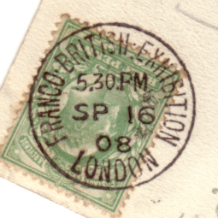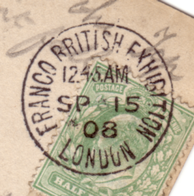

Small 08 Large 08

The British Government started to talk about this in 1905 and asked the French to join in an exhibition to be held in 1908, they agreed to this and it was called The Franco-British Exhibition.
The site was to be at Shepherds Bush, London, on an area of wet farmland which covered 140 acres. Work started on the site 3 January 1907 with work being done day and night and at the height of building over 8,000 men were working on the site each day. The buildings were to be fire proof, the framework of iron was put up, brickwork done and the roofs put on. When this had been done, the plasterers went in before the floors were laid and cast in fibrous plasterer, all the ornate work that was to go on the exterior and interior of the buildings. The plasterers then fixed this and the painters then painted the exterior of the buildings white, the paths, lagoons, bridges and bandstands built and the gardens laid.
On Wednesday the 14 May, in pouring rain, the Prince and Princess of Wales (George V 1910-1936) opened the Franco-British Exhibition in the Court of Honour. (today the site of the B.B.C. Television Studios Wood Lane) It cost 1/- (one shilling or 5p) for adults to get into the exhibition, children 6d (six pence or 2½p). On entering the exhibition the visitors entered the Court of Honour seeing all the ornate buildings and water, they stood and looked and said “White City” for which the area is known to this day. There was over one hundred buildings, the largest was the Machinery Hall. It was in this the electricity was generated to light the exhibition, the Court of Honour alone had 160,000 light bulbs. Visitors could ride on the Swan Boats or Electric Launches for 6d from the Court of Honour and around the lagoons seeing many of the fine buildings. A visit to the Ballymaclinton Irish Village was not to be missed or to see the Senegalese Village.

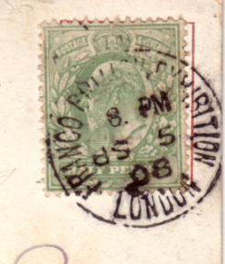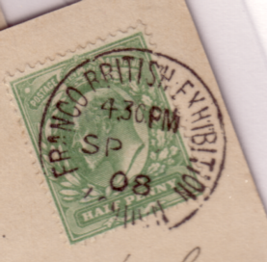

Inverted SP Missing date

It was on the 26 May when King Edward VII and President M. Falliers of France visited the exhibition, they arrived at 3 pm and stayed just two hours. On leaving the Daily Mail, who had its own pavilion with reporters, type setters and a printing press published a paper reporting their visit. It was on this day the post office started to hand stamp the cards posted at the exhibition and did so until it closed on the 31 October 1908. The Ballymaclinton Village had its own post office and hand stamp, used from June until 31 October 1908. When the exhibition closed there had been over 8,200,000 visitors.
Collecting post cards from the Franco-British exhibition can be very easy, everyone did post card collecting then and these were put into post card album’s which have kept them in good condition over the years. With over 8 million visitors, nearly everyone would have posted a card or cards in the exhibition grounds and taken home a few cards or packets of cards, these packets were numbered and produced in many colours. The Exhibition Official Printers Valentines produced their ranges of post cards in colour, black and white and sepia, these were on sale at newsagents in the Shepherds Bush area and around London. It s possible to find cards of the exhibition posted before the exhibition opened.
Collecting post marks of the Franco-British Exhibition can be quite easy due to the number of visitors it had. Finding cards posted on the opening day is not very easy but can be found with machine cancel or with a Shepherds Bush hand stamp for 14 May 1908. It was not until King Edward VII and President Falliers visited the exhibition on the 26 May 1908 the post cards were cancelled with the Franco-British Exhibition hand stamp, this date is not very common.
There were two hand stamps used, and if we look very hard there are two ways of seeing the difference in the hand stamps. One is the placing of the letters around the ring of the hand stamp, with the other being the size of the 08. The larger 08 can be called hand stamp No. 1 and the smaller size can be called hand stamp No. 2.
The mail was collected from post boxes that were inside some of the larger buildings and the hand stamp applied at the following times 11.30 am, 12.15 am, 1.45 pm, 3 pm, 4.30 pm, 5.30 pm, 7 pm, 8 pm, 9 pm and 9.30 pm.
In collecting post cards and post marks over the last 35 years I have found that it is possible to collect more than 1,000 cards alone from the Franco-British Exhibition their various types and by various printers. Subsequently, the picture post card views were used for the 1908 exhibition, were re-issued for later exhibitions held at White City with just the title being changed.
The collecting of post marks starts slowly and when finding items not listed or recorded elsewhere, collecting becomes more specialised. In Pearson’s book of Special Events it shows the Franco-British Exhibition and shows that the inverted 08 can be found but with no firm dates, time or period recorded. Here are my findings and, with the help of other collectors, it can be added to nearly 100 years after the exhibition so that a record of this can be published. How did the inverted 08 happen ? was the hand stamp dropped and had to be reassembled ? or did one or a number of postmen do it on purpose or was it an accident. The answer will never be known. We do have post marks to prove it happened, now we must try to get the correct period and times.

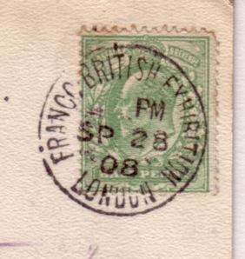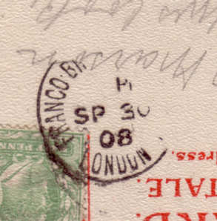

Missing time 28 SP Missing time 30 SP

The hand stamp used for the error was the one with the smaller 08, the No. 2 hand stamp.
The hand stamp was correct when used on Thursday 17 September 08 at 5.30 pm.
It was inverted on Friday 18 September 80 at 5.30 pm.
It was inverted on Saturday 19 September 80 at 4.30 pm
It was inverted on Saturday 19 September 80 at 5.30 pm
It was inverted on Saturday 19 September 80 at 7 pm
It was inverted on Saturday 19 September 80 at 9 pm
It was inverted on Monday 21 September 80 at 12.15 am
The hand stamp was correct when used on Monday 21 September 08 at 5.30 pm.

Post mark errors noted on hand stamp No. 1 with the larger 08 are,
With missing date .....September 08 at 12.15 am.
With missing date .....September 08 at 4.30 pm.
With missing date .....September 08 at 9 pm.
Inverted SP Saturday 5 September 08 at 8 pm.
Inverted SP Saturday 5 September 08 at 9 pm.
No time Monday 28 September 08 at.....pm.
No time Wednesday 30 September 08 at.....pm.

It is also possible to find hand stamps in which the numbers 8 and 9 are inverted.
If you can add to this information please contact Don R. Knight. 2, Crescent Road, New Barnet, Herts. EN4 9RF.

Don, Please note I have added one new time to your Inverted SP, and missing date list. Bill

And a final request Charles Kiddle is trying to track down a post card or post cards of American Indians by an artist named Selige. It looks as if there were a series of 20 published, but if he can track down one it will help. He’s at, P. O. Box 13, Alton, Hants. GU34 4DW. tel 0044 1256 862701 or E Mail to charleskiddle@connect.com
Post Cards of the White City.
Part 27.
by Bill Tonkin

Section B.

Ballymaclinton Carpet Workers, Franco-British Exhibition, London, 1908. with additional heading (M’Clinton’s Town erected by the makers of M’Clinton’s Soap). at top right in red.
Coloured, greenish grey ‘POST CARD’ with four lines of text, back type FB 13.
391 Title with tails, in one line at bottom left.
391 Title without tails, in one line at bottom left.

The title ‘A Ballymaclinton Colleen’ was used for six different post cards, they feature different girls in different settings, and are listed as types 1 to 6, a brief description is given for each card. This would not have been necessary had all the cards been numbered, but unfortunately they are not. For another card of this type see under ‘An Irish Colleen’ No. 381.
Type 1. A vertical card of the Head and shoulders of Colleen facing right.
A Ballymaclinton Colleen, (Photo by Skillman), (M’Clinton’s Town erected by the makers of M’Clinton’s Soap).
Coloured, grey ‘POST CARD’ with four lines of text, back type FB 13.
N.n. Title in four lines at bottom left, without ‘Valentine’s Series Copyright’.
Vert left.

Type 2. A vertical card with a Colleen in a cloak with hood, hand on latch of closed door.
A Ballymaclinton Colleen, Franco-British Exhibition, London. 1908.
Coloured, greenish grey ‘POST CARD’ with four lines of text, back type FB 13.
394 Title without tails, in two lines at bottom left. Vert left.
Coloured, grey ‘Throughout the World’ with ‘Correspondence at an angle, back type FB 3
394 Title with tails, in two lines at bottom left. Vert left.
Title altered to, A Ballymaclinton Colleen, Franco-British Exhibition, London. 1908. with an additional heading (M’Clinton’s Town erected by the makers of M’Clinton’s Soap). at top right.
Coloured, greenish grey ‘POST CARD’ with four lines of text, back type FB 13.
394 Title with tails, in two lines at bottom left. Vert left.
394 Title without tails, in two lines at bottom left. Vert left.
Coloured, brown ‘POST CARD’ with four lines of text, back type FB 13.
394 Title without tails, in two lines at bottom left. Vert left.
Coloured, brownish grey ‘POST CARD’ with four lines of text, back type FB 13.
394 Title without tails, in two lines at bottom left. Vert left.
Title altered to, A Ballymaclinton Colleen, (M’Clinton’s Town erected by the Makers of M’Clinton’s Soap).
B/W litho, grey ‘POST CARD’ with four lines of text, back type FB 13.
N.n. Title with capital ‘M’ to ‘Makers’ in three lines at top right, without ‘Valentine’s Series Copyright’. Vert left.

Type 3. A vertical card of a Colleen in blouse with hand on latch of partly open door, right hand in pocket of overall.
A Ballymaclinton Colleen, Franco-British Exhibition, London. 1908.
Coloured, grey ‘Throughout the World’ with ‘Correspondence’ at an angle, back type FB 3.
395 Title with tails in two lines at bottom left of centre. Vert left.
Title altered to, A Ballymaclinton Colleen, Franco-British Exhibition, London. 1908. with an additional heading (M’Clinton’s Town erected by the makers of M’Clinton’s Soap). at top left.
Coloured, greenish grey ‘POST CARD’ with four lines of text, back type FB 13
395 Title without tails in two lines at bottom left. Vert left.
For other post cards of this view see in the Imperial International Exhibition section, under ‘A Ballymaclinton Colleen’

Type 4. A vertical card of a Colleen sitting on low wall by doorway, with fishing net hanging behind her.
A Ballymaclinton Colleen, Franco-British Exhibition, London. 1908.
B/W litho, grey ‘Throughout the World’ back type FB 2.
404 Title in two lines at top left of centre, With ‘Valentine’s Series Copyright’, the number is placed very high on the card. Vert left.
Title altered to, A Ballymaclinton Colleen, (M’Clinton’s Town erected by the makers of M’Clinton’s Soap).
Coloured, greenish grey ‘POST CARD’ with four lines of text, back type FB 13.
N.n. Title in two lines at top right. Vert left.
Title altered to, An Irish Colleen. A coloured card similar to the one above is known with the usual ‘Valentine’s Series Copyright’ at the bottom right corner, but the back is not a normal Valentine White City exhibition back, and has an inscription at the left side ‘Johnson, Belfast.’ This card is included for its design relationship, it is not an exhibition card.

Type 5. A vertical card of a Colleen standing and leaning back on short length of fence and with left hand resting on fence. On the litho printings it will be seen that the short length of fence is free standing, on the coloured cards the left edge of the negative is trimmed off, and the end of the fence is not seen.
A Ballymaclinton Colleen, Franco-British Exhibition, London, 1908.
B/W litho, grey ‘Throughout the World’ back type FB 2.
405 Title in three lines at top right. Vert left.
Title altered to, A Ballymaclinton Colleen, Franco-British Exhibition. (Ballymaclinton, erected by the makers of McClinton’s Soap).
Coloured, greenish grey ‘POST CARD’ with four lines of text, back type FB 13.
405 Title spelt ‘McClinton’s’, not the usual ‘M’Clinton’s’ with tails in two lines at bottom centre. Vert left.
Title altered to, A Ballymaclinton Colleen, (M’Clinton’s Town erected by the Makers of M’Clinton’s Soap).
B/W litho, grey ‘POST CARD’ with four lines of text, back type FB 13.
405 Title with capital ‘M’ to ‘Makers’ in three lines at top left. Vert left.
Title altered to, A Colleen, Ballymaclinton, (McClinton’s Town, erected by the makers of McClinton’s Soap), Franco-British Exhibition.
Coloured, greenish grey ‘POST CARD’ with four lines of text, back type FB 13.
N.n. Title spelt ‘McClinton’s’, not the usual ‘M’Clinton’s’ in three lines at bottom centre. Vert left.
For another card of this type see under McClinton’s Soap in the main list.

Type 6. A vertical card of a Colleen shown from the waist up, wearing a red scarf, with elbow on fence and resting head on back of hand, facing left.
A Ballymaclinton Colleen, Franco-British Exhibition, London, 1908
Coloured, greenish grey ‘Throughout the World’ with ‘Correspondence’ at an angle,
back type FB 3.
N.n. Title in two lines at top left, with ‘Valentine’s Series Copyright’ to the left.
Vert left.
Title altered to, A Ballymaclinton Colleen, (M’Clinton’s Town erected by the makers of M’Clinton’s Soap).
Coloured, greenish grey ‘POST CARD’ back with four lines of text, type FB 13.
N.n. Title in two lines at top left, with ‘Valentine’s Series Copyright’ to the left.
Vert left.
N.n.. Title in two lines at top centre, with ‘Valentine’s Series Copyright’ to the left. Vert left.
Title altered to, A Colleen, Ballymaclinton, (M’Clinton’s Town erected by the Makers of M’Clinton’s Soap).
B/W litho, grey ‘POST CARD’ back with four lines of text, type FB 13.
406 Title in two lines at top centre, with ‘Valentine’s Series Copyright’. Vert left.

Three Colleens, one sitting on a donkey.
Ballymaclinton Colleens, Franco-British Exhibition, London, 1908.
B/W litho, greenish grey high ‘Harp’ back type FB 14.
N.n. Title in one line at top left, without ‘Valentine’s Series Copyright’.
Coloured, grey ‘Throughout the World’ with ‘Correspondence’ at an angle, back type FB 3.
176 Title without tails in three lines at bottom left.
Coloured, greenish grey small size ‘Throughout the World’ back type FB 5.
176 Title without tails in three lines at bottom left.
Coloured, greenish grey ‘POST CARD’ with four lines of text, back type FB 13.
176 Title without tails in three lines at bottom left.
Coloured, greenish grey low ‘Harp’ back type FB 15.
176 Title without tails in three lines at bottom left.
Coloured ‘GIANT POST CARD’, grey ‘Throughout the World’ back type FB 17.
N.n. Title in two lines at bottom left.
For other giant cards, see under Giant post cards.
Sepia litho, black ‘Throughout the World’ back type FB 2.
N.n. Title in one line at top left, without ‘Valentine’s Series Copyright’.
Title altered to, Ballymaclinton Colleens, (M’Clinton’s Town erected by the Makers of M’Clinton’s Soap).
B/W litho, brownish grey ‘POST CARD’ with four lines of text, back type FB 13.
N.n. Title with capital ‘M’ to ‘Makers’ in two lines at top left, without ‘Valentine’s Series Copyright.
Title altered to, Irish Village Colleens, Franco-British Exhibition, London, 1908.
Sepia R/Photo, black ‘X L’ back type FB 11.
176 Title in two lines at bottom left.

Two colleens, one seated by St. Patrick’s Cross. The litho printed cards have different cloud patterns, but they are very feint, the coloured cards are ‘with clouds’ or ‘without clouds’.
Ballymaclinton Cross, (M’Clinton’s Town erected by the Makers of M’Clinton’s Soap).
B/W litho, grey ‘POST CARD’ with four lines of text, back type FB 13.
N.n. Title with capital ‘M’ to ‘Makers’ in four lines at top right. Vert left.
Title altered to, Ballymaclinton Cross, (M’Clinton’s Town erected by the makers of M’Clinton’s Soap).
Coloured without clouds, grey ‘POST CARD’ with four lines of text, back type FB 13.
179 Split title with small ‘m’ to ‘makers’ in two lines at top. Vert left.
Title altered to, Ballymaclinton, Franco-British Exhibition, St. Patrick’s Cross.
B/W litho, greenish grey ‘high Harp’ back type FB 14.
N.n. Title in three lines at top right. Vert left.
Title altered to, Donaghmore Cross, Ballymaclinton, Franco-British Exhibition, London, 1908.
Sepia litho, black ‘Throughout the World’ back type FB 2.
N.n. Title in four lines at top right. Vert left.
Title altered to, St. Patrick’s Cross, Ballymaclinton, (Erected by the Makers of M’Clinton’s Soap), Franco-British Exhibition.
Coloured, grey ‘GIANT POST CARD’ with four lines of text, back type FB 19.
N.n. Split title with capital ‘M’ to ‘Makers’ in two lines at top right, without ‘Valentine’s Series Copyright’.
For other large sized post cards see under Giant post cards.
Title altered to, St. Patrick’s Cross, Ballymaclinton, Franco-British Exhibition.
B/W litho, grey ‘low Harp’ back type FB 15.
N.n. Title in three lines at top right. Vert left.
Title altered to, St. Patrick’s Cross, Ballymaclinton, Franco-British Exhibition, London, 1908.
B/W litho, black ‘high Harp’ back type FB 14.
N.n. Title in four lines at top right. Vert left.
B/W litho, green ‘high Harp’ back type FB 14.
N.n. Title in four lines at top right. Vert left.
B/W litho, greenish grey ‘high Harp’ back type FB 14.
N.n. Title in four lines at top right. Vert left.
Coloured without clouds, grey ‘Throughout the World’ with ‘Correspondence’ at an angle back type FB 3.
179 Split title in two lines at top. Vert left.
Coloured without clouds, brown small size ‘Throughout the World’ back type FB 5.
179 Split title in two lines at top. Vert left.
Coloured with clouds, grey small size ‘Throughout the World’ back type FB 5.
179 Split title in two lines at top. Vert left.
Coloured without clouds, greenish grey small size ‘Throughout the World’ back type FB 5.
179 Split title in two lines at top. Vert left.
Coloured without clouds, grey ‘low Harp’ back type FB 15.
179 Split title in two lines at top. Vert left.
Title altered to, St. Patrick’s Cross, Ballymaclinton, (M’Clinton’s Town erected by the Makers of M’Clinton’s Soap).
B/W litho, brownish grey ‘POST CARD’ with four lines of text, back type FB 13.
N.n. Title with capital ‘M’ to ‘Makers’ in five lines at top right. Vert left.
Title altered to, St. Patrick’s Cross, Ballymaclinton, (M’Clinton’s Town erected by the makers of M’Clinton’s Soap).
Coloured without clouds, grey ‘POST CARD’ with four lines of text, back type FB 13.
179 Split title with small ‘m’ to ‘makers’ in two lines at top. Vert left.
Coloured, grey ‘GIANT POST CARD’ with four lines of text, back type FB 19.
N.n. Title with small ‘m’ to ‘makers’ in three lines at top left, without ‘Valentine’s Series Copyright’.
For other large sized post cards see under Giant post cards.
Title altered to, St. Patrick’s Cross, Ballymaclinton, (M’Clinton’s Town erected by the makers of M’Clinton’s Soap), Franco-British Exhibition.
Coloured without clouds, brownish grey ‘POST CARD’ with four lines of text, back type FB 13.
179 Title in three lines at top. Vert left.
Coloured without clouds, greenish grey ‘POST CARD’ with four lines of text, back type FB 13.
179 Title in three lines at top. Vert left.
For other post cards of this view see in the Imperial International Exhibition section, under ‘Ballymaclinton Cross, (M’Clinton’s Town erected by the makers of M’Clinton’s Soap)’.

