EDITORIAL AUTUMN 2003

Here is a new book, hot off the press
It’s not the only, hot thing, I guess.

When Dr Chatfield’s Catalogue of Pre-1950 Labels (Cinderella Stamp Club Handbook No. 8) was published in 1991 he was able to mention about 70 different labels for the 1924 & 1925 British Empire Exhibition, a lot of these were not described or illustrated.
Three years later Alan Sabey published ‘Publicity Labels of the British Empire Exhibition Wembley 1924-25 and within two years published a supplement to cover all the new information that had come in as a result of the 1994 publication.
Over the next few years both these booklets which were published in limited numbers sold out and became unavailable. It was decided to publish through the Exhibition Study Group a book to include both the original and the supplement, plus all the new material that had accumulated during the last six years. Alan and myself have been working for some time on this new book which lists over 300 different labels.
This 60 page booklet has now been published and will be made available to Exhibition Study Group members at the very low price of £1.50. Like the Festival of Britain book published by the Study Group this is a non profit making exercise aimed to benefit our members and is again being sold at below the actual printing costs. To collectors outside the Study Group it will be priced at £5.00. plus in both cases an extra £1.50 to cover postage and packing. Unfortunately if any of our American members want a copy the postage and packing will be £4.00. Copies will be available at the convention if you let Mike Perkins know you want to collect one at the basic price of £1.50.
Members might wonder why we are doing this rather than look for some profit from the venture. A glance at our balance sheet for the year elsewhere in this issue will show you that we have a very healthy balance of just over £8,000. This has been discussed at conventions in the past and it has been agreed that the accumulating of a large bank balance is not our object in life. Letting members have the benefit via our publications seems a good way to whittle it down a bit. Although if we sell enough at £5.00 we shall still come out smiling.
It should be mentioned here that our healthy bank balance is mainly, even entirely, due to the generosity of two members, Karl Illingworth and Kenneth Tonkin, who almost since the Study Group started, have taken on board all the work and costs of printing, stapling, packing and posting of our Journals to members, at no cost to the Study Group. Andrew Brooks of course did the first few Newsletters as they were called then when the Study Group started, but in those days we had nothing like the membership we have now, when we send out over 100 Journals each issue.. There is no doubt that this is the reason we have been able to keep our subscription rates at the same level for so many years.
That is the main news for this Journal, so what else is there to say. Else where there is news about the convention. The article on Gipsies in the summer Journal has caused some interest and I have had a request for a Journal from a book shop specialising in Gipsy books, also a phone call from a collector of Gipsy post cards. Apparently from what he said some gipsy cards are selling for a lot of money, even more expensive than exhibition cards.
Fred Peskett has started working on a comprehensive listing of Crystal Palace post cards. Although we always think of him as a Festival of Britain man his other interest is The Great Exhibition of 1851 and of the Crystal Palace after its removal to Penge where it opened in 1854. He does have other interests and is still playing with his meccano set. Well perhaps that’s an understatement as from what he tells me he has every boxed meccano set from No. 1. I think he once told me he has estimated his meccano bits and pieces weighs a quarter of a ton. I have just invented a new word, a ‘collectaholic’. I think we both come into this category. If anyone wants to join the Ancient Order of Collectaholic’s, just send me £10.00 for your life membership and you’re in.

The Editor.
PUBLICITY LABELS

OF THE

BRITISH EMPIRE EXHIBITION

WEMBLEY

1924 - 1925

Alan Sabey and Bill Tonkin.

First Published 2003

Exhibition Study Group Publication No. 6

Copyright Exhibition Study Group.

Published by the
Exhibition Study Group. 23, Bramley Way, West Wickham, Kent. BR4 9NT.

ISBN 0 9524065 3 5

Copies can be obtained from Mike Perkins at 4, Churchill Drive, Amblecote, Stourbridge
West Midds. DY8 4JS. Tel. 01384 824894

Price to members £1.50 plus £1.50 packing & postage. P & P to America £4.00
Price to non members £5.00 plus packing & postage as above.
Please make cheques out to Mike Perkins.

Some E Mails from Stanley Hunter.
Bill
That feature on the Gipsy Encampment at Liverpool (Summer) was quite fascinating. Just a correction - the Liverpool "Shipperies" of 1886 was the first major ENGLISH international exhibition outside London. It opened on May 11 but at that time Scotland was hosting its third Board of Trade-approved International Exhibition. Attendance was recorded as 2,769,632.
A stone sundial marks the opening of the Edinburgh International Exhibition of Industry, Science & Art by Prince Albert Victor of Wales, on May 6. There are also trial stonemason's pillars still at the edge of the Western Meadows. These were to demonstrate the wearing powers of all the local quarried stone. The differences are remarkable. Nearby, in Jawbone Walk are the actual whale jawbones exhibited at the Zetland & Fair Isle Knitting stand in 1886. ( Robert Burns' father laboured to convert the site from a lochan to a public park called the Meadows.)
The first Edinburgh International was held in what is now the Prince's Mall in 1882, in Princes Street, in the capital's centre. The second was in 1884 in the grounds of the Donaldson's School for the Deaf, near Murrayfield Stadium. Approval is being given to convert the impressive building to luxury flats although the grounds where the exhibition was staged are protected.
The fourth (and final) Edinburgh International was held in the Meggetland, also to the west. It marked the opening of the Forth Bridge in 1890. This is open land, rugby pitches and athletic grounds. Housing is planned for the site. One exhibit in 1890 was a "Gipsy Camp", near the Union Canal. Did Lazzy Smith bring his encampment to Edinburgh in 1890?

Stanley
Bill

2003 has seen two important biographies of giants of The Great Exhibition of 1851.

THE GREAT EXHIBITOR - The Life and Work of Henry Cole.
(Elizabeth Bonython & Anthony Burton) recalls the life of Sir Henry Cole (1808-82).

Starting as a humble clerk in the English National Records Office, he campaigned for improvements in the keeping of the National Records and obtained a reputation as an polemicist. Although a civil servant he spread his interests over the railroad boom, the Universal Penny Post and national museums. His support for (Sir) Rowland Hill ensured the introduction of the adhesive postage stamp in 1840 , conceived by a Scottish publisher as far back as 1834. "Old King Cole" (1808-82) even invented the Christmas card.
A strong supporter of the idea of a Great Exhibition of All Nations and the resultant museums that were to spread in the adjoining land bought with the profits of 1851, he became the founding Director of the Victoria & Albert Museum, the world's pioneer museum of art and design. He was consulted at both the 1855 and 1867 Paris Universal Exhibitions. He had visited the 1849 Paris National Exposition.

The hardback 328 page book is published by the Trustees of the V&A, London at £35.00 ISBN 1 85177 3266

A THING IN DISGUISE - The Visionary Life of Joseph Paxton
(Kate Colquhoun) tells the story of the architect of the Crystal Palace in 1851.

Like Cole, he was a humble birth, but touched with genius. The obscure title refers to the magic that Paxton was to wield in glass. He started as a garden boy and was then employed by the wealthy Duke of Devonshire. He was his Head Gardener at the age of 23. He made Chatsworth the finest garden in the British Isles. It is still a major tourist attraction.
Like Cole, he had many other interests, from botany to the chaotic railroad system that was spreading throughout the British Isles. It was at a boring meeting of the Midland Railway that he doodled a very rough sketch on his blotter for a possible solution to the problem of a design for the building to hold The Great Exhibition. A service is to be held at Chatsworth in September, to mark the centenary of the death of Paxton. Sadly, this clashes with our 2003 Annual Convention at York. It is to be hoped that displays will acknowledge Paxton.
The book records that Paxton (1803-65) submitted a plan for the 1853 NY exposition. He was consulted by the French Emperor for the Paris Universal of 1855 and submitted a design for the 1867 Paris Universal. It also recalls his work on the West End project for Glasgow in Scotland. Its
Kelvingrove Park was to hold three major international exhibitions, with a total of over 25 million visitors 1888-1911.
BBC Radio 4 ran a serialisation of the book July 21-24. (I only heard to-day's account). There is a Paxton family tree on WWW.apvm51.dsl.pipex.com/SirJosephPaxton1.htm The book (h/b pp307) is published by Fourth Estate, London & NY. ISBN 0-00-714353-2. The British edition is £18.99. There is a web site www.4thestate.com

Stanley

I have also had an E Mail from Alan Sabey who recently visited the York National Railway Museum as he thought they may have some details of the Wembley Neverstop Railway and the Road-Rails exhibit at Wembley. “Sorry Sir, never heard of them” he was told.

There is another book recently published on the history of Earls Court and Olympia ‘From Buffalo Bill to the Brits’ by John Glanfield. It is a hardback priced at £14.99 ISBN 0 7509 2998 7 and published by Sutton Publishing.

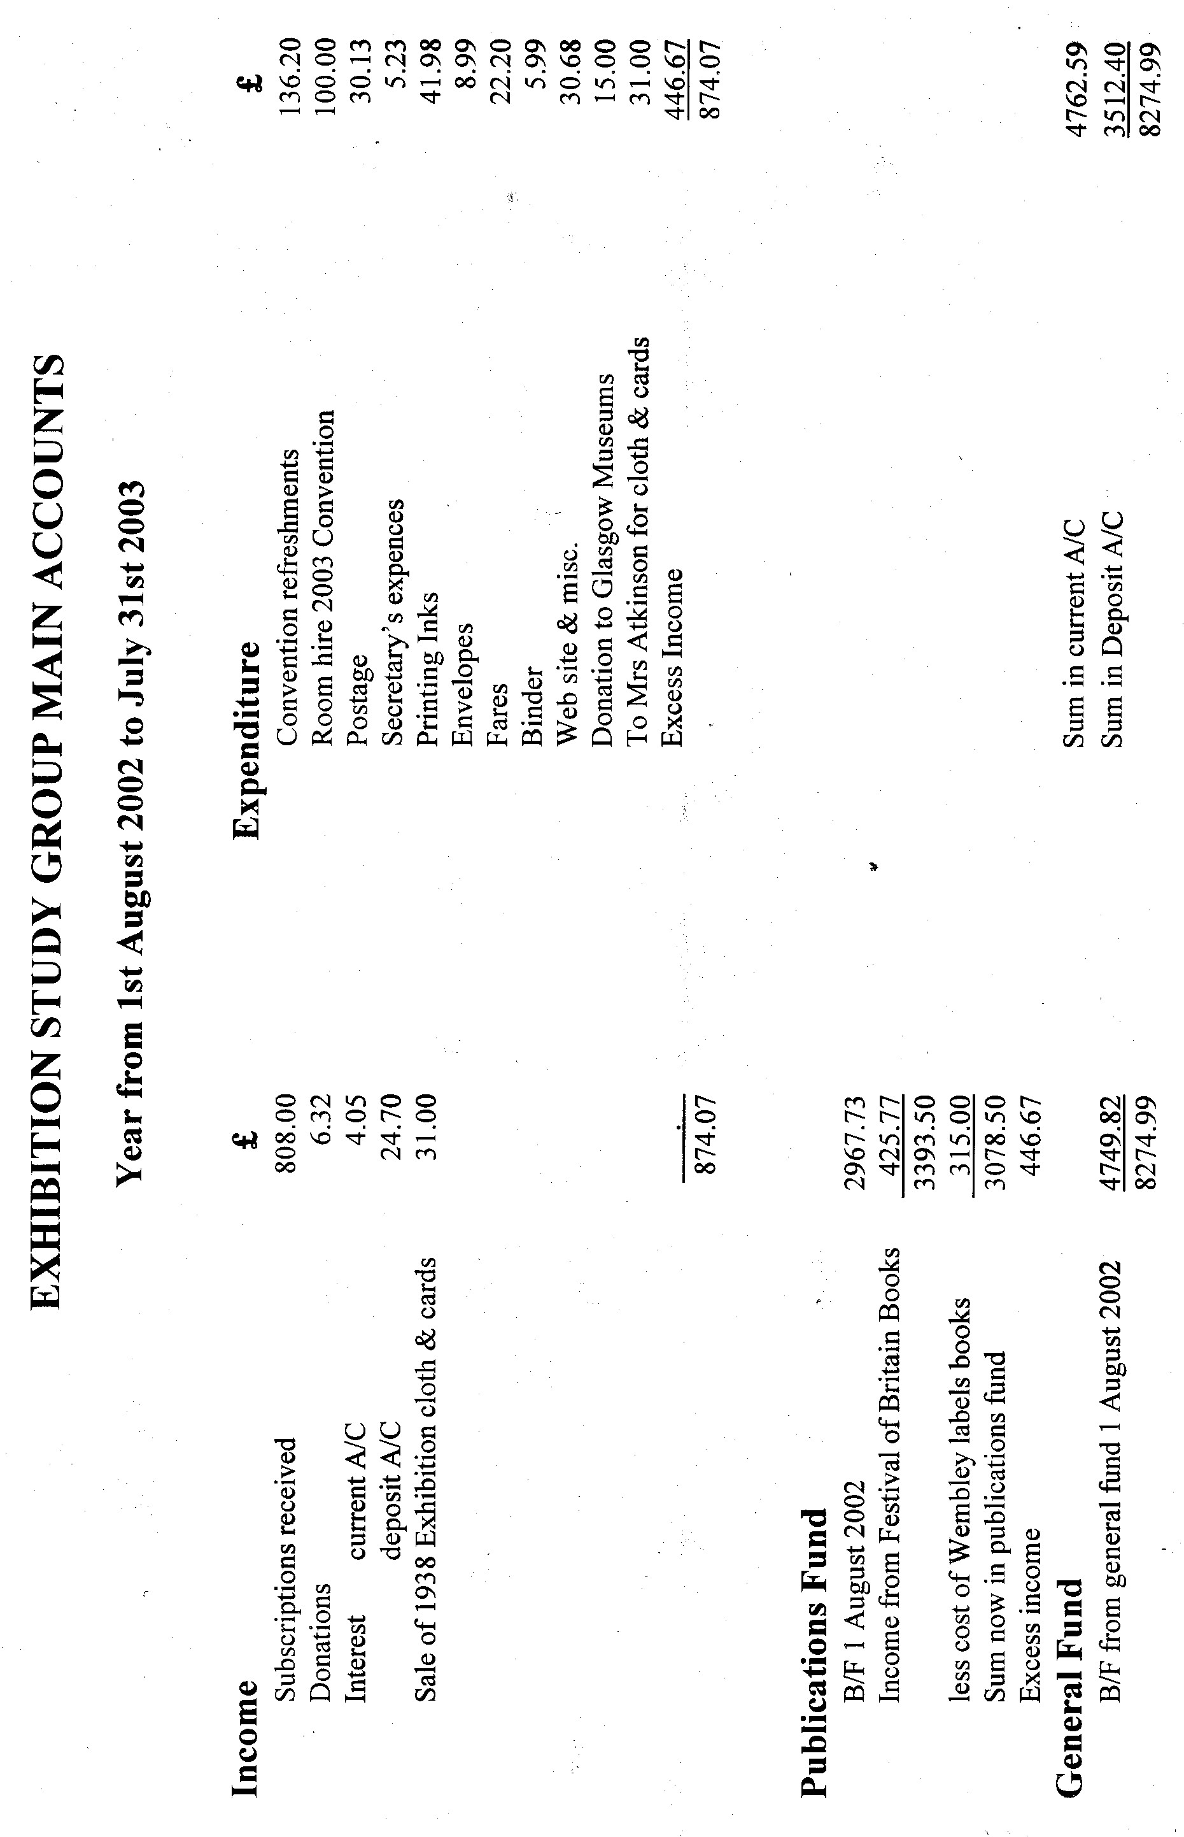

The Great White City.

This is taken from ‘The Franco-British Illustrated Review’
Published by Chatto & Windus. Edited by F. G. Dumas.

Two architects supervised the construction of all the buildings of the Franco-British Exhibition. Mr John Belcher, A.R.A., P.P.R.I.B.A., was the architect-in-chief of the Palaces, and M. Tourdoire was the architect-in-chief of the Pavilions. J. Belcher also designed the Palace of Decorative Arts and advised on the steel contracts and other matters. Amongst the buildings he supervised was the Education Building designed by Mr Charles Gascoyne and a number of other designs. The British Applied Arts Palace and French Applied Arts Palace were designed by Mr J. B. Fulton and Mr L. G. Detmar respectively. Contemporary architects consider the British Applied Arts Palace to be the finest building in the whole exhibition.
The two entrances were the work of a young French Architect M. René Patouillard-Demoriane. The Court of Honour was adapted from a design by M. Fournier de St. Maur, who unfortunately died in 1906. The Palace of Music was by Claude Martello, and the Palace of Women’s Work by Maurice Lucet. I will not go into a long list of the designers and architects for all the pavilions. This is covered fully in ‘The Franco-British Illustrated Review’ edited by F. G. Dumas. This is a beautiful book and the thing that strikes you first is the weight 5¾ lbs. I know books should not be evaluated by their weight but to me, I find heavy books attractive, I relate it to good quality paper and nice binding.
Although the Franco-British Exhibition soon acquired the name of ‘The White City’ it was by no means the first White City. The Manchester Heathcote’s & Brown’s White City was up and going at least a year before the Shepherds Bush White City. The entrance in Manchester had ‘White City’ in big letters at roof height.

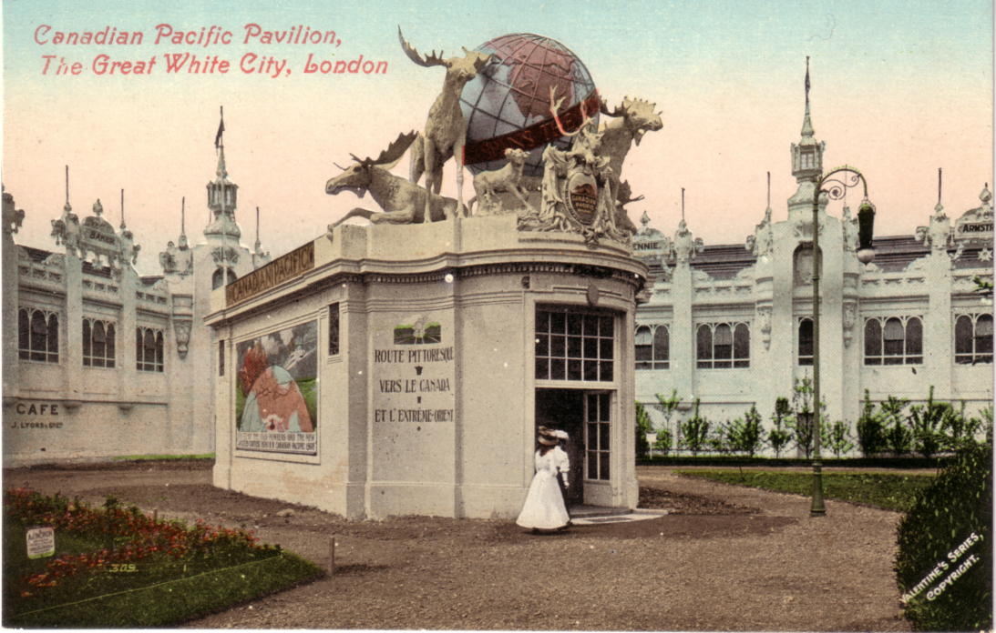

Sculpture made of plaster of Paris on a wood and canvas framework.

If the exhibition at Shepherd’s Bush has done nothing else, it has shown Londoners what can be done with that strange material, fibrous plaster. It is everywhere. On skeletons of steel and concrete, the whole city is clothed in it. The beautiful and stately domes and columns that have the appearance of stone are built of wood, canvas, tow and plaster cement, at about one fifth of the cost of the more solid material. The beautiful Court of Honour, dazzling in its virgin white, delighting the eye with its domes, minarets, mouldings, lattice work and delicate traceries, is nothing but lath and plaster. The great palaces , with all their appearance of stone like solidity, may claim a skeleton of steel and concrete and no more, all the rest is fibrous plaster. But this city is no weakling, it is weather proof and remarkably strong, and with an occasional coat of paint should live for a quarter of a century at least. At that time they did not know what 1914 held in store for them.
The method of work employed in building is, first to make a framework of wood, over which is stretched a layer of canvas, a layer of fibrous plaster is then placed over the canvas, followed by more layers of canvas and more layers of plaster. This is continued until the dome, column, or whatever it may be, is ready for the decorative artist, who forms the delicate traceries from a composition called ‘staff’. which is a finer form of fibrous plaster, composed of plaster, cement, glycerine, dextrine etc. , with a basic material of cotton wool. In point of interest the use of fibrous plaster in building is far exceeded by its decorative use. The noble statues and groups which have the apparently solidity of marble, together with the delicate mouldings and entwining wreaths, represent the greatest skill of the plasterer and modeller. in figure work, first class modellers only can be employed. In the beginning the same method is used as in building, but in place of the decorative artist with ‘staff’ the sculpture now appears and he goes over the whole design with clay. When he has finished his modelling, a gelatine mould is taken and the plaster cast is made, atone fifth of what would have been the cost had the figure been executed in stone. When the cast is dried, it receives several coats of shellac to make it waterproof, and is then ready to fill its allotted space.
In cases where a knowledge of carving is united with that of the modellers art, the expense of casting and time also may be saved by building the figure in plaster of Paris on the wood and canvas framework. This method was adopted with the group that adorns the pavilion of the Canadian Pacific Railway in the Garden of Progress. For the four animals in the quadriga that adorns the Palace of Decorative Arts but one cast was used. The Quadriga took over three months in preparing and is perhaps the finest illustration of the plaster modellers art, if we accept the monster figure adorning the Palace of French Applied Arts. The figure here referred to, standing with uplifted hand holding a torch, measures over twenty feet in height. A very beautiful illustration of the plaster modellers work is the central figure of the floral sun dial in the Garden of Progress, facing the Pavilion of the Colectivité Délieux. This sundial is one of the graceful features of the exhibition.

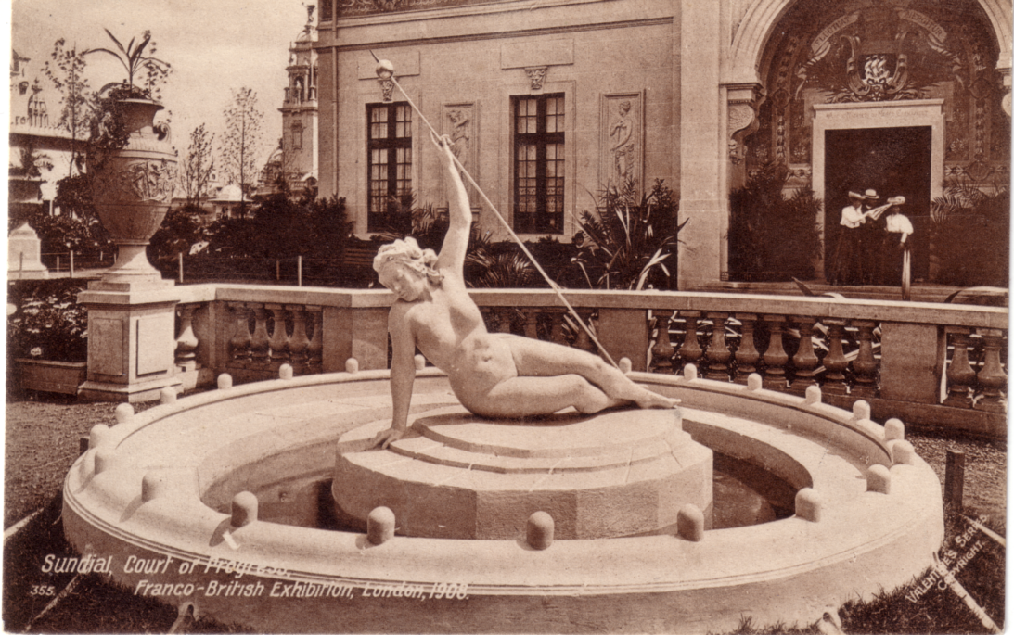

Sun dial in the Garden of Progress.

Another instance of the plaster modellers work is the great shield at the Uxbridge Road Main Entrance. This shield was ten weeks in the making. It is so large (it is about 16 ft broad and over 16 ft in height) that it had to be made and placed in position in sections, the whole afterwards pieced together with cement. Here in addition to wood canvas and plaster, there is a generous admixture of clay, which is principally used in the formation of the flowers at the base of the shield.
As an illustration of the gargantuan efforts employed in building and decorating the White City, it may interest the reader to learn that the monuments and figures adorning the main buildings range in height from seven to thirty feet and number over two hundred, while the busts, heads, medallions, centre pieces, etc. , run into four figures.
Fibrous plaster is largely used on the continent for decorative purposes, but as a substitute for brick and stone it was practically unknown in England before the birth of the City of White Palaces.

Treasurers Report for the 17th Convention 2003

I wish to apologise for my absence on the Saturday of our convertion owing to a family commitment, but I hope to be able to join you at our dinner on Saturday evening, and shall give a display on the Sunday. The balance sheet is apearing in this journal and although it has not been audited yet, this will be done before the meeting and a signed copy will be on display.
As we are well into the black I do not propose any alteration to the subscription and ask all members to pay promptly which makes my job a lot easier. Please remember that I have other things in my life than the Group.
We still have about the same number of members. We have removed several for non payment of subscriptions and these were mainly those who joined last year to get the Festival book at a reduced price. There have been several resignations but we have had eight new members join in this last year. I would like to thank Mike for setting up the web site from which several have downloaded the application form.
I send reports to the philatelic press and Brian Lund but only see the Philatelic Bulletin so do not know if reports appear in the other magazines. If anyone does see a mention of the Study Group would they please send me a photo-copy as I keep a press cutting book.
If there are any questions about the balance sheet I shall be pleased to answer them on the Sunday.

Alan Sabey. Treasurer.

Don Knight, who those of you who attend our conventions will know is a jolly good speaker with a first class collection is greatly in demand by clubs to give displays. He is appearing at the following clubs in the next few months,
Wednesday 3rd September to the Watford Philatelic Society, meeting at Watford Library at 7.45 for 8.00. Display on the British Empire Exhibition Wembley
Thursday 25th September to the Amersham Philatelic Society, meeting at the Community Centre at 7.45 for 8.00. Display on the British Empire Exhibition Wembley
Monday 6th October to the Hertford Philatelic Society meeting at St. Andrew’s Church Hall, St Andrew’s Rd, 7.30 for 7.45. Display on the British Empire Exhibition Wembley
Tuesday 7th October to the Hounslow Philatelic Society, meeting at the Community Centre at 7.45 for 8.00. Display on the Festival of Britain and the Dome
Friday 17th October for 9 months The London Museum is mounting a small display in their ‘1920 to 1930 Exhibition’ showing some of Don’s Wembley crested china.

On a much lower key I have to admit I too am giving a display to the Sutton & Cheam Philatelic Society at 8.00 on Thursday 18th September at the Elmcroft Community Centre, London Rd, North Cheam.

17th Annual Convention at York 2003.

Don’t forget our convention will be on Saturday 27th and Sunday 28th of September at York, where we will be meeting at the same venue The Holgate Hill Hotel. their Phone number is 01904 653786 and they can be reached on <info@holgatehillhotel.co.uk>. The hotel is in Holgate Rd which is off Blossom Street, almost in the centre of York. There is parking for cars, and it is not too far from the station if you are coming up by train. Please let me know if you are going to bring a display so I can work out some sort of a programme. Just down the road is a pub called the ‘Crystal Palace’ which I’ve never got round to visiting, although I believe Fred Peskett has called in. I shall be staying there Friday night and I expect there will be several other members present. I provisionally booked some rooms when we were there last year, so mention this when you book.
I would like to see some of our members who do not come to our convention turn up, as it is a very pleasant weekend meeting other exhibition collectors and seeing some interesting displays. As I have mentioned else where Alan Sabey will not be able to be with us on the Saturday, but hopes to see us at our Annual Dinner on the Saturday evening and will be displaying his British Empire Exhibition Advertising Labels on the Sunday.
If you have never been to a convention just remember that Don Knight, Stanley Hunter and myself have never missed a convention since the first one, and several other members come regularly, we would not go year after year if we didn’t enjoy ourselves. So give it a try.

While I am on about the convention Alan Sabey has told me that he lent a member something at our last convention. Unfortunately he cannot remember what it was he lent or who he lent it to. So if anybody did borrow something from Alan would they please return it, or contact him about returning it. It is extremely annoying when you lend an item and it does not come back. It has happened to me, Nancy had a very valuable book on the History of Beckenham, one of a limited edition of a 100, that a few years ago I lent out. It would only have been to one of two people but like Alan I can’t remember which one it was. Needless to say they have both denied borrowing it. It leaves a nasty taste in the mouth.

Post Cards of the White City.
Part 26.
by Bill Tonkin

Un-numbered postcards of the Franco-British Exhibition.

This list contains all the titles of the Franco-British Exhibition post cards published without a number, in alphabetical order. Where a card may be part of a series all of the same view but with different titles, some with a number and some un-numbered, or where the same view has been republished for another exhibition perhaps several years later bearing a number, this number has been entered in brackets. Each change of title has been listed but minor differences like the use of a capital ‘M’ for a small ‘m’ have been ignored, although these are listed in the main listing.
Where in the main list there may be three or four different views all given the same title they have been grouped into types, 1, 2, 3 & 4 etc. these type numbers have been included in the last column.

A Ballymaclinton Colleen, Franco-British Exhibition, London, 1908 (406) Type 6.
A Ballymaclinton Colleen, (M’Clinton’s Town erected by the Makers of M’Clinton’s
Soap). (394) Type 2.
A Ballymaclinton Colleen, (M’Clinton’s Town erected by the makers of M’Clinton’s
Soap). (404) Type 4.
A Ballymaclinton Colleen, (M’Clinton’s Town erected by the makers of M’Clinton’s
Soap). (406) Type 6.
A Ballymaclinton Colleen, (Photo by Skillman), (M’Clinton’s Town erected by the makers of
M’Clinton’s Soap). Type 1.
A Colleen, Ballymaclinton, (McClinton’s Town, erected by the makers of McClinton’s Soap),
Franco-British Exhibition. (405) Type 5
A Dutch Love Story, Reconciliation.
A Dutch Love Story, Tender Moments.
Algerian Palace, Franco-British Exhibition, London, 1908. (A pre exhibition forerunner.)
Algerian Pavilion, Franco-British Exhibition, London, 1908. (268)
An Irish Colleen. (404) Type 4.
Arrival by Airship at the Franco-British Exhibition, London, 1908.
Australia, Franco-British Exhibition, London, 1908.
Australian Palace, Franco-British Exhibition, London, 1908. (307)
Avenue of Progress, Franco-British Exhibition, London, 1908.
Ballymaclinton Colleens, (M’Clinton’s Town erected by the Makers of M’Clinton’s Soap). (176)
Ballymaclinton Cross, (M’Clinton’s Town erected by the Makers of M’Clinton’s Soap). (179)
Ballymaclinton, Franco-British Exhibition, Colleens clamouring for their Letters.
Ballymaclinton, Franco-British Exhibition, Colleens Dancing. (175)
Ballymaclinton, Franco-British Exhibition, London, 1908.
Ballymaclinton, Franco-British Exhibition, Main Street and Ancient Church. (177)
Ballymaclinton, Franco-British Exhibition, St. Patrick’s Cross. (179)
Ballymaclinton, (Irish Village), Franco-British Exhibition, London, 1908. (A pre exhibition forerunner.)
Ballymaclinton, (M’Clinton’s Town erected by the makers of M’Clinton’s Soap). (402)
Baynard’s Castle and Entrance to Fleet Ditch.
Bridge in Court of Honour, Franco-British Exhibition, London, 1908. (A pre exhibition
forerunner.) Type 1.
British Applied Arts Palace, Franco-British Exhibition, London, 1908. (A pre exhibition
forerunner.) Type 1.
British Applied Arts Palace, Franco-British Exhibition, London, 1908. (A pre exhibition
forerunner.) Type 2.
British Applied Arts Palace, Franco-British Exhibition, London, 1908. (A pre exhibition
forerunner.) Type 3.
British Applied Arts Palace, Franco-British Exhibition, London, 1908 Type 4.
British Science Palace, Franco-British Exhibition, London, 1908.
Burgoyne’s Bungalow, Franco-British Exhibition, London, 1908.
Butter Exhibit, Canadian Pavilion, Franco-British Exhibition, London, 1908.
“By Jove! I should like to live here”, (Ballymaclinton, Franco-British Exhibition)
Canada, Past and Present, Franco-British Exhibition, London, 1908. (Panorama)
Canadian Pavilion, Franco-British Exhibition, London, 1908. Type 1.
Canadian Pavilion, Franco-British Exhibition, London, 1908. Type 2.
Canadian Scenic Railway, Franco British Exhibition, London, 1908. (A pre exhibition forerunner.)
City of Paris Pavilion and Gardens, Franco-British Exhibition, London, 1908. (264)
Colleens clamouring for their Letters, Ballymaclinton, Franco-British Exhibition.
Colleens Dancing, Ballymaclinton, (M’Clinton’s Town erected by the Makers of M’Clinton’s Soap), Franco-British Exhibition. (175)
Colleens Dancing, Ballymaclinton, (M’Clinton’s Town erected by the makers of M’Clinton’s Soap).
Colonial Avenue, Franco-British Exhibition, London, 1908. (A pre exhibition forerunner.)Type 1.
Colonnade, British Applied Arts Palace, Franco-British Exhibition, London, 1908. (A pre
exhibition forerunner.) Type 1.
Colonnade, British Applied Arts Palace, Franco-British Exhibition, London, 1908. (A pre
exhibition forerunner.) Type 2.
Colonnade in British Applied Arts Palace, Franco-British Exhibition, London, 1908. (A pre
exhibition forerunner.) Type 2.
Colonnade in British Applied Arts Palace, Franco-British Exhibition, London, 1908. (A pre
exhibition forerunner.) Type 3.
Colonnade in Court of Honour, Franco-British Exhibition, London, 1908. (A pre exhibition
forerunner.)
Colonnade, Palace of Music, Franco-British Exhibition, London, 1908. (A pre exhibition
forerunner.) Type 1.
Colonnade, Palace of Music, Franco-British Exhibition, London, 1908. (A pre exhibition
forerunner.) Type 2.
Colonnade, Palace of Music, Franco-British Exhibition, London, 1908. (A pre exhibition
forerunner.) Type 3.
Corridor, Palace of Music, Franco-British Exhibition, London, 1908.
Court of Arts, Franco-British Exhibition, London, 1908. (A pre exhibition forerunner.) Type 1.
Court of Arts, Franco-British Exhibition, London, 1908. (A pre exhibition forerunner.) Type 2.
Court of Arts from Congress Hall, Franco-British Exhibition, London, 1908. (Panorama)
Court of Arts from Fine Arts Palace, Franco-British Exhibition, London, 1908. (Panorama)
Court of Arts, North, Franco-British Exhibition, London, 1908. (Panorama)
Court of Arts, South, Franco-British Exhibition, London, 1908. (Panorama)
Court of Honour, Franco-British Exhibition, London, 1908. (A pre exhibition forerunner.)Type 1.
Court of Honour, Franco-British Exhibition, London, 1908. Type 5.
Court of Honour, Franco-British Exhibition, London, 1908. Type 6.
Court of Honour, Franco-British Exhibition, London, 1908. Type 18.
Court of Honour, Franco-British Exhibition, London, 1908. (184) Type 15.
Court of Honour, Franco-British Exhibition, London, 1908. (217 Type 21.
Court of Honour, Franco-British Exhibition, London, 1908. (488) Type 28.
Court of Honour, Franco-British Exhibition, Xmas, 1908. (488) Type 28.
Court of Honour from Congress Bridge, Franco-British Exhibition, London, 1908. (346) Type 24.
Court of Honour from Congress Hall, Franco-British Exhibition, London, 1908. (A pre
exhibition forerunner.)
Court of Honour from Congress Hall, Franco-British Exhibition, London, 1908. (Panorama)
Court of Honour from Congress Hall, Franco-British Exhibition, London, 1908. (191) Type 1.
Donaghmore Cross, Ballymaclinton, Franco-British Exhibition, London, 1908. (179)
Elite Gardens and Flip-Flap, Franco-British Exhibition, London, 1908. (220)
Elite Gardens, Franco-British Exhibition, London, 1908. (Panorama )
Entente Cordiale, Franco-British Exhibition, London. Type 3.
Entente Cordiale, Franco-British Exhibition, London, 1908. Type 1.
Entente Cordiale, (produced in butter), Canadian Pavilion, Franco-British Exhibition, London, 1908. (323)
Entrance Court of Honour, Franco-British Exhibition, London, 1908. (A pre exhibition forerunner.)
Entrance Machinery Hall, Franco-British Exhibition, London, 1908. (A pre exhibition forerunner.)
Entrance to Court of Progress, Franco-British Exhibition, London, 1908. (A pre exhibition
forerunner.)
Entrance to Fleet Ditch.
Entrance to Irish Village (Ballymaclinton), Franco-British Exhibition, London, 1908. (A pre
exhibition forerunner.)
Entrance to Machinery Hall, Franco-British Exhibition, London, 1908. (A pre exhibition forerunner.)
Exhibition Railway, Franco-British Exhibition, London, 1908. (267)
Fine Art Palace, Franco-British Exhibition, London, 1908. (A pre exhibition forerunner.) Type 1.
Fine Art Palace, Franco-British Exhibition, London, 1908. (A pre exhibition forerunner.) Type 2.
Fisherman’s and Model Cottages (Art Gallery behind), Ballymaclinton, Franco-British Exhibition,
London, 1908.
Fisherman’s and Model Cottages (Art Gallery behind), Ballymaclinton, (M’Clinton’s, Town erected
by the makers of M’Clinton’s Soap), Franco-British Exhibition.
Fisherman’s and Model Cottages, Ballymaclinton, Franco-British Exhibition.
Fisherman’s and Model Cottages, Ballymaclinton, Franco-British Exhibition, London, 1908.
Fisherman’s and Model Cottages, Ballymaclinton, (M’Clinton’s Town erected by the makers of
M’Clinton’s Soap), Franco-British Exhibition.
Fisherman’s Cottage, Ballymaclinton, Franco-British Exhibition, London, 1908.
Flip-Flap and Spiral Railway, Franco-British Exhibition, London, 1908.
Flip-Flap at Full Height, Franco-British Exhibition, London, 1908.
Flip-Flap Cage, Franco-British Exhibition, London, 1908.
Flip-Flap, Franco-British Exhibition, London, 1908. Type 1.
Flip-Flap, Franco-British Exhibition, London, 1908. (142) Type 2.
Flip-Flap from Elite Gardens, Franco-British Exhibition, London, 1908. (220)
Franco-British Entente Cordiale. Type 3.
Franco-British Entente Cordiale. Type 3.
Franco-British Exhibition, Court of Honour, Night Effect. (191) Type 1.
Franco-British Exhibition, Entente Cordiale. Type 2.
Franco-British Exhibition, Entrance to Irish Village. (178)
Franco-British Exhibition, London.
Franco-British Exhibition London, Entente Cordiale. Type 3.
Franco-British Exhibition London, Entente Cordiale. Type 3.
Franco-British Exhibition London, The Entente Cordiale. Type 3.
Franco-British Exhibition, London. (Multi view) Type 1.
Franco-British Exhibition, London. (Multi view) Type 3.
Franco-British Exhibition, London, 1908. (Multi view) Type 2.
Franco-British Exhibition, London, 1908. (Multi view) Type 3.
Franco-British Exhibition, London, 1908. “Salutation”.
Franco-British Exhibition, London, Opened by H.R.H. Prince of Wales, H.R.H. Princess of
Wales May 14th 1908. (Multi view) Type 1.
Franco-British Exhibition, London, Opened by H.R.H. Prince of Wales, H.R.H. Princess of
Wales May 14th 1908. (Multi view) Type 2.
Franco-British Exhibition, London. “Unity”.
French Applied Art Palace, Franco-British Exhibition, London, 1908. (A pre exhibition forerunner.)
French Colonies, Franco-British Exhibition, London, 1908. (A pre exhibition forerunner.)
French East Africa, Franco-British Exhibition, London, 1908. (268)
Garden Club and Royal Pavilion, Franco-British Exhibition, London, 1908. (A pre exhibition
forerunner.)
Garden Club, Franco-British Exhibition, London, 1908. (A pre exhibition forerunner.) Type 1.
Garden Club, Franco-British Exhibition, London, 1908. Type 2.
Garden Club, Franco-British Exhibition, London, 1908. Type 3.
Grand Restaurant, Franco-British Exhibition, London, 1908. (A pre exhibition forerunner.)
Grand Trunk Railway Pavilion, Franco-British Exhibition, London, 1908. Type 1.
Grand Trunk Railway Pavilion, Franco-British Exhibition, London, 1908. Type 2.
Grand Trunk Railway Pavilion, Franco-British Exhibition, London, 1908. Type 3.
Grand Trunk Railway Pavilion, Franco-British Exhibition, London, 1908. Type 4.
Grand Trunk Railway Pavilion, Franco-British Exhibition, London, 1908. Type 5.
Grand Trunk Railway Pavilion, Franco-British Exhibition, London, 1908. Type 6.
Grand Trunk Railway Pavilion, Franco-British Exhibition, London, 1908. Type 7.
Greetings from London, Franco-British Exhibition, London, 1908.
H.M. King Edward VII and President Fallières at Franco-British Exhibition. Type 1.
H.M. King Edward VII and President Fallières at Franco-British Exhibition. Type 2.
H.M. King Edward VII and President Fallières, Ballymaclinton, Franco-British Exhibition.
H.M. King Edward VII and President Fallières, Ballymaclinton, Franco-British Exhibition,
London, 1908.
H.M. King Edward VII and President Fallières in Irish Village, Franco-British Exhibition.
“I don’t want to come home” (Franco-British Exhibition.)
Imperial Pavilion Lake, Franco-British Exhibition, London, 1908. (A pre exhibition forerunner.)
In Court of Arts, Franco-British Exhibition, London, 1908. (A pre exhibition forerunner.)Type 3.
In Court of Arts, Franco-British Exhibition, London, 1908.
In Court of Honour, Franco-British Exhibition, London, 1908. (A pre exhibition forerunner.)Type 2.
In Court of Honour, Franco-British Exhibition, London, 1908. (A pre exhibition forerunner.)Type 3.
In Court of Honour, Franco-British Exhibition, London, 1908. Type 6.
In Court of Honour, Franco-British Exhibition, London, 1908. Type 7.
In Elite Gardens, Franco-British Exhibition, London, 1908. (A pre exhibition forerunner.)
In Paris Pavilion, Franco-British Exhibition, London, 1908. Type 4.
In The Court of Honour, Franco-British Exhibition, London, 1908. (A pre exhibition forerunner.) Type 3.
In The Court of Honour, Franco-British Exhibition, London, 1908. (A pre exhibition forerunner.) Type 4.
In the Farmyard, Ballymaclinton, (M’Clinton’s Town erected by the Makers of M’Clinton’s Soap).
In the Grounds, Franco-British Exhibition, London, 1908. (471)
In the Stocks, Old London, Franco-British Exhibition, London, 1908.
Indian Palace, Franco-British Exhibition, London, 1908. (A pre exhibition forerunner.)
Indian Palace, (Upper Crescent), Franco-British Exhibition, London, 1908. (233) Type 2.
Indo-China Palace, Franco-British Exhibition, London, 1908. (262)
Interior of M’Kinley’s Cottage, Ballymaclinton, Franco-British Exhibition, London. 1908. (211)
Interior of M’Kinley’s Cottage, Ballymaclinton, (M’Clinton’s Town erected by the Makers of
M’Clinton’s Soap). (211)
Irish Colleens-Fortune Telling. (409)
Irish Village Colleens, Ballymaclinton, Franco-British Exhibition.
Irish Village Colleens, Ballymaclinton, Franco-British Exhibition, London. 1908.
Irish Village Colleens, Ballymaclinton, (M’Clinton’s Town erected by the makers of M’Clinton’s
Soap), Franco-British Exhibition.
Jaunting Car, Ballymaclinton, Franco-British Exhibition, London, 1908. (233)
(M’Clinton’s Town erected by the makers of M’Clinton’s Soap).
M’Kinley Cottage and Irish Art Gallery, Ballymaclinton, (M’Clinton’s Town erected by the
Makers of M’Clinton’s Soap). (510)
Machinery Hall, Franco-British Exhibition, London, 1908. (315)
Machinery Hall Entrance, Franco-British Exhibition, London, 1908. (A pre exhibition forerunner.)
Main Street and Church, Ballymaclinton, (M’Clinton’s Town erected by the Makers of M’Clinton’s
Soap). (177)
Main Street, Ballymaclinton, (M’Clinton’s Town erected by the Makers of M’Clinton’s Soap)
Meeting of Jacques Cartier and Donacona in Canada 1535 (produced in Canadian Butter), Franco-
British Exhibition, London, 1908.
Model Cottage, Ballymaclinton, Franco-British Exhibition, London, 1908.
Model Cottage, Ballymaclinton, (M’Clinton’s Town erected by the makers of M’Clinton’s Soap).
New Zealand Minerals, Franco-British Exhibition, London, 1908.
New Zealand Pavilion, Franco-British Exhibition, London, 1908.
New Zealand Sporting Trophies, Franco-British Exhibition, London, 1908.
North Front, British Applied Arts Palace, Franco-British Exhibition, London, 1908. (A pre
exhibition forerunner.)
North Towers, Court of Honour, Franco-British Exhibition, London, 1908.
Oetzmann’s Model Cottage, Franco-British Exhibition, London, 1908.
Old Charing Cross.
Old Cheapside.
Old London Bridge.
Old St. Paul’s.
Old Tudor House, Franco-British Exhibition, London, 1908. (A pre exhibition forerunner.)Type 1.
Old Tudor House, Franco-British Exhibition, London, 1908.(A pre exhibition forerunner.)Type 2.
Old Tudor House, Franco-British Exhibition, London, 1908. Type 3.
Opening Ceremony of the Franco-British Exhibition by T.R.H. Prince and Princess of Wales.
Palace Gardens, Franco-British Exhibition, London, 1908.
Palace of French Applied Arts, Franco-British Exhibition, London, 1908.
Palace of Music, Franco-British Exhibition, London, 1908. (A pre exhibition forerunner.)Type 1.
Palace of Music, Franco-British Exhibition, London, 1908. (A pre exhibition forerunner.)Type 2.
Palace of Women’s Work, Franco-British Exhibition, London, 1908. (A pre exhibition forerunner.) Type 1.
Palace of Women’s Work, Franco-British Exhibition, London, 1908. (A pre exhibition forerunner.) Type 2.
Palace of Women’s Work, Franco-British Exhibition, London, 1908. (A pre exhibition forerunner.) Type 3.
Palace of Women’s Work, Franco-British Exhibition, London, 1908. (A pre exhibition forerunner.)
Type 4.
Palace of Women’s Work, Franco-British Exhibition, London, 1908. Type 5.
Palace of Women’s Work, Franco-British Exhibition, London, 1908. Type 6.
Palaces of Art and Music, Franco-British Exhibition, London, 1908. (Panorama)
Paris Pavilion, Franco-British Exhibition, London, 1908. Type 1.
Paris Pavilion, Franco-British Exhibition, London, 1908. Type 2.
Paris Pavilion, Franco-British Exhibition, London, 1908. Type 3.
Paris Pavilion, Franco-British Exhibition, London, 1908. (334)
Pavilion Louis XV, Franco-British Exhibition, London, 1908. (A pre exhibition forerunner.)
President Fallières.
Prince and Princess of Wales at Franco-British Exhibition, London, 1908. Type 1.
Prince and Princess of Wales at Franco-British Exhibition, London, 1908. Type 2.
Prince and Princess of Wales at the Franco-British Exhibition, London, 1908. Type 3.
Reflections, British Applied Arts Palace, Franco-British Exhibition, London, 1908.
Restaurant Pailiard, Franco-British Exhibition, Xmas, 1908. (216)
Rickshaw, Franco-British Exhibition, London, 1908. (209)
Round Tower, Ancient Church, and Linen Loom Factory, Ballymaclinton, (Erected by the
makers of M’Clinton’s Soap), Franco-British Exhibition. (233)
Round Tower, Ancient Church, and Linen Loom Factory, Ballymaclinton, Franco-British
Exhibition, London, 1908. (233)
Round Tower, Ballymaclinton, Franco-British Exhibition, London, 1908. (233)
Round Tower, Ballymaclinton, (M’Clinton’s Town Erected by the makers of M’Clinton’s Soap). (233)
Royal Pavilion, Franco-British Exhibition, London, 1908. (A pre exhibition forerunner.) Type 1.
Royal Pavilion, Franco-British Exhibition, London, 1908. (Probably a pre exhibition forerunner.) Type 2.
Royal Pavilion, Franco-British Exhibition, Xmas, 1908. (193)
St. Patrick’s Cross, Ballymaclinton, (Erected by the Makers of M’Clinton’s Soap), Franco-
British Exhibition. (179)
St. Patrick’s Cross, Ballymaclinton, Franco-British Exhibition. (179)
St. Patrick’s Cross, Ballymaclinton, (M’Clinton’s Town erected by the Makers of M’Clinton’s
Soap). (179)
School Exhibit, Paris Pavilion, Franco-British Exhibition, London, 1908.
South Australian Fruit and Wool, Franco-British Exhibition, London, 1908.
South Front, British Applied Arts Palace, Franco-British Exhibition, London, 1908. (A pre
exhibition forerunner.)
South Front, Palace of Women’s Work, Franco-British Exhibition, London, 1908. (A pre
exhibition forerunner.)
Stadium, Franco-British Exhibition, London, 1908. (A pre exhibition forerunner.) Type 1.
Stadium, Franco-British Exhibition, London, 1908. (A pre exhibition forerunner.) Type 2.
Stadium, Franco-British Exhibition, London, 1908. (Panorama)
The Cascade, Franco-British Exhibition, London, 1908. (304)
The Cascade, Franco-British Exhibition, London, 1908. (389)
The Congress Hall, Franco-British Exhibition, London.
The Court of Honour, Franco-British Exhibition, London, 1908. (168) Type 13.
The Flip-Flap, Franco-British Exhibition, London, 1908. Type 1.
The Forge, Ballymaclinton, (M’Clinton’s Town erected by the makers of M’Clinton’s Soap).
The Indian Theatre, Mr Irani, Manager. Type 1.
The Indian Theatre, Mr Irani, Manager. Type 2.
The Pavilion, Franco-British Exhibition, London, 1908. (A pre exhibition forerunner.)
The Queen at the Franco-British Exhibition, London, 1908.
The Royal Pavilion, Franco-British Exhibition, London, 1908. (A pre exhibition forerunner.)Type 1.
The Scenic Railway, Franco British Exhibition, London, 1908. (132) Type 1.
The Slide of Joy. (Franco-British Exhibition.)
The Spiral Railway, Franco-British Exhibition, London, 1908.
The Stadium, Franco-British Exhibition, London, 1908. (A pre exhibition forerunner.) Type 2.
The Stadium, Franco-British Exhibition, London, 1908. (110) (A pre exhibition forerunner.)Type 3.
The Stadium, Franco-British Exhibition, London, 1908. (Panorama)
Tower of British Applied Arts Palace, Franco-British Exhibition, London, 1908. (A pre
exhibition forerunner.)
Tower of French Applied Arts Palace, Franco-British Exhibition, London, 1908. (A pre
exhibition forerunner.)
Tower, Palace of Music, Franco-British Exhibition, London, 1908.
View from Bridge, Court of Honour, Franco-British Exhibition, London, 1908. (A pre
exhibition forerunner.)
View from Cascade Café, Franco-British Exhibition, London, 1908.
View from Colonial Bandstand, Franco-British Exhibition, London, 1908. (A pre exhibition forerunner.)
View from Concert Hall, Franco-British Exhibition, London, 1908. (A pre exhibition forerunner.)
View from Decorative Arts Palace, Franco-British Exhibition, London, 1908. (Panorama)
View from Palace of Music, Franco-British Exhibition, London, 1908. (A pre exhibition forerunner.)
View from Stadium, Franco-British Exhibition, London, 1908.
West Entrance, French Applied Arts Palace, Franco-British Exhibition, London, 1908. (A pre exhibition forerunner.)
Woman Firemen.
Woman Firemen, The Colleens Brigade at the Franco-British.

Valentine’s post cards of the Franco-British Exhibition 1908.

Section A.

Algerian Palace, Franco-British Exhibition, London, 1908. (A pre exhibition forerunner.)
B/W litho, sunk plate with large white border, greenish grey ‘Throughout the World’
back type FB 2.
N.n. Split title in one line bottom centre.
B/W litho, black ‘Throughout the World’ back type FB 2.
N.n. Title in one line at top right.
B/W litho, greenish grey ‘Throughout the World’ back type FB 2.
N.n. Title in one line at top right.
Coloured, red ‘F B seal’ back type FB 1.
N.n. Title in one line at top right.
Title altered to, French Colonies, Franco-British Exhibition, London, 1908.
B/W litho, sunk plate with large white border, grey ‘Throughout the World’ back type FB 2.
N.n. Split title in one line bottom centre.
B/W litho, sunk plate with large white border, greenish grey ‘Throughout the World’
back type FB 2.
N.n. Split title in one line bottom centre.

Algerian Palace Entrance, Franco-British Exhibition, London, 1908.
Sepia R/Photo, black ‘X L’ back type FB 11.
367 Title in two lines at bottom centre. Vert right.
Sepia litho, black ‘Throughout the World’ back type FB 2.
367 Title in two lines at bottom centre. Vert left.

Algerian Pavilion, Franco-British Exhibition, London, 1908.
Coloured, red ‘F B seal’ back type FB 1.
N.n. Title in one line at top right.
N.n. Title in one line at top left.
Title altered to, French East Africa Palace, Franco-British Exhibition, London, 1908.
B/W litho, black ‘Throughout the World’ back type FB 2.
N.n. Title in one line at top centre, with ‘Valentines Series Copyright’ on the right.
N.n. Title in one line at top centre, with ‘Valentines Series Copyright’ on the left.
N.n. Title in one line at top right, with ‘Valentines Series Copyright’ on the left.
Coloured, red ‘F B seal’ back type FB 1.
N.n. Title in one line at top left.
N.n. Title in one line at top right.
Sepia R/Photo, black ‘X L’ back type FB 11.
268 Title in two lines at bottom left.

Arrival by Airship at the Franco-British Exhibition, London, 1908.
Coloured artists drawing, black ‘Throughout the World’ back type FB 2.
N.n. Title in two lines at top centre, without ‘Valentine’s Series Copyright’.
Vert left.
For other post cards of this view see in The Great White City section, under ‘Arrival by Airship at The Great White City’.

Artist’s post cards. Post cards drawn or painted by artists were probably produced before the exhibition opened so Valentine’s would have something to offer the public. Apart from pull-outs, these were not used after the Franco-British and White City period, although one card showing a rickshaw was republished for the Japan-British Exhibition.
This series is of a comical nature, some bear the signature of the artist concerned, the title is in a white panel at bottom, and none have ‘Valentine’s Series Copyright’
Coloured, greenish grey ‘Throughout the World’ with ‘Correspondence’ at an angle,
back type FB 3.
“By Jove! I should like to live here”, (Ballymaclinton, Franco-British Exhibition)
N.n. Title in non capital letters. Vert left.
“I don’t want to come home” (Franco-British Exhibition.)
N.n. Title in capital letters. Vert left.
The Slide of Joy. (Franco-British Exhibition.)
N.n. Title in capital letters. Vert left.
N.n. Title in non capital letters. Vert left.
For other cards of this series see in The Great White City section, and the Japan-British Exhibition section, under Artist’s cards. For other non comic cards in the Franco-British section drawn by artists see under ‘Arrival by Airship’, ‘The Congress Hall’, ‘Court of Honour’, ‘Entente Cordiale’, Flip-Flap, ‘Franco-British Exhibition, London’, ‘Greetings from London’, ‘Old London’, ‘Royal Pavilion’, ‘Salutation’ and ‘Unity’.

Australia, Franco-British Exhibition, London, 1908.
Sepia litho, black ‘Throughout the World’ back type FB 2.
N.n. Title in one line at top right.
For other post cards of this view see in The Great White City section, under Australia.

Australian Palace, Franco-British Exhibition, London, 1908.
Sepia litho, black ‘Throughout the World’ back type FB 2.
N.n. Title in two lines at bottom left. Vert left.
Title altered to, Australian Pavilion, Franco-British Exhibition, London, 1908.
Coloured, red ‘F B seal’ back type FB 1.
307 Title in one line at top centre. Vert left.

Australian Palace, Central Hall, Franco-British Exhibition, London, 1908.
Coloured, red ‘F B seal’ back type FB 1.
292 Title in two lines at bottom centre.

Australian Palace, New South Wales, Franco-British Exhibition, London, 1908.
Coloured, red ‘F B seal’ back type FB 1.
294 Title in two lines at bottom centre.

Australian Palace, Queensland Court, Franco-British Exhibition, London, 1908.
Coloured, red ‘F B seal’ back type FB 1.
290 Title in two lines at bottom left of centre.

Australian Palace, Waterfall, Franco-British Exhibition, London, 1908.
Coloured, red ‘F B seal’ back type FB 1.
291 Title in two lines at bottom left. Vert left.

Australian Pavilion, Franco-British Exhibition, London, 1908.
This card is known in two states, in the first there is a long ladder leaning against the pavilion and a workman, in the second state the negative was altered and the ladder and workman removed. The cards are listed as ‘with ladder’ or ‘without ladder’.
B/W litho, without ladder, black ‘Throughout the World’ back type FB 2.
N.n. Title in two lines at top left of centre.
Coloured, without ladder, red ‘F B seal’ back type FB 1.
N.n. Split title in one line at top centre.
N.n. Title in one line at top left.
N.n. Title in two lines at top left.
Coloured view without ladder, in ornamental Britannia and Marianne border type FB Bo 1, red ‘F B seal’ back type FB 1.
257 Title in one line at top centre.
For other post cards with this border, see under Border FB Bo 1.
Sepia R/Photo, with ladder, black ‘X L’ back type FB 11.
257 Title in two lines at bottom left of centre.

Australian Pavilion, Franco-British Exhibition, London, 1908. No. 307. see under Australian Palace, Franco-British Exhibition, London, 1908.

Avenue of Progress, Franco-British Exhibition, London, 1908.
Sepia litho, black ‘Throughout the World’ back type FB 2.
N.n. Title in one line at top left.

