Editorial No 7-February 1987.

It is with deep regret and a sense of loss that I report to members the sad news of the death of John Allwood, one of the foremost collectors of exhibition material in the country. John was a keen member of the Study Circle from its inception, always ready to help with articles and individual research problems. His work, ‘The Great Exhibitions’, will always be one of my favourite reference books.
This time we have an item from Don Knight (White City) and another from Graham Hall (Bradford). The cover is a collage of items from the 1986 Expo.
I was green with envy when I received a card sent by Karl Illingworth from the Washington State Pavilion but you should have seen the goodies he kindly sent to Fred and I when he came back! The bottom half of the cover is a double page from the Expo. Passport showing some of the cachets received when you visited each pavilion.
1 have contributed a short item on the Expo, of Hydro-Electric Power and Tourism (strange combination) held at Grenoble in 1925 (do we have a member who visited this world famous expo?)
For the interest of those members keen on Imre Kiralfy, I’ve inserted a few old newspaper clippings. The really keen ‘Kiralfy Watchers’ can send for new material too detailed for this newsletter.
The four postcard checklists of Shakespear’s England, held at Earls Court in 1912 have been produced by a new member, A. P. Smith. Any spelling or other mistakes in the list will be mine. I’ve not written Shakespear’s England, Earls Court, every time, either!
Does anyone know where M. Graham-Bonnalie is Living? His newsletter was returned ‘Not Known at this Address’ ie. 17a Fairlawns...
Newsletter No. 6 went out to 35 members at a cost of approximately 55p per copy (inc. post.) If you have a big X at the bottom of this page I’m afraid you will not receive another unless you send a £1 subs, or equivalent in stamps The next newsletter will contain an updated membership list, any change of address, postcode etc. please let me know in good time. Also your geographical collecting area (Brit. Expo./ Brit. & For. Expo. / Brit. Expo. Pre-1914 / Scottish Expo. / World Expos., All dates, etc. ) and collecting habits ( Post cards / Printed ephemera / China etc. )
1 would also like some adverts! Members who wish to buy, sell or advertise a service can purchase space at £3.00 per page ( min. ¼ page £1 ) Every full page I can sell will pay for two pages of the newsletter.
Finally I would like to sound out members with regard to a day’s conference on Oct. 3 1987. I suggest York as a suitable venue, it can be reached by most members in less than 2-3 hours. If ten members are willing to take part and pay a few pounds (less than £5 ) for the hire of a room, then I will go ahead with making the arrangements. A suggested timetable as follows,
10.00-11.00 am. White City Exhibitions.
11.00-12.00 noon Scottish Exhibitions.
1.00-1.30pm. Dinner.
1.30-2.30pm. Provincial Exhibitions
2.30-3.30pm Earls Court or Wembley.
3.30-4.30pm. Foreign Exhibitions.
Each hour would be divided into a half hour talk/display by a member followed by short display of choice items by the rest of the audience! Members would be expected to make their own dinner arrangements but the venue would be at a suitable hotel, so this should be no problem. The long dinner break would give members time to socialize. Wives and family would be most welcome, they would certainly enjoy the pleasures of York. Let me know as soon as possible if you are interested.
Good Luck and Good Hunting
Andrew and Fred.

The White City 1908 – 84
by
Don Knight

It is now some fifteen years since I found my first picture postcard and postmark from the Franco British Exhibition, 1908 held at Shepherds Bush, London.
This Exhibition was visited by more than 8,200,000 visitors, who very quickly after its opening on the 14th May, 1908 called it “The White City” as all the exhibition buildings and halls were painted white. Visitors sent picture postcards by the million and Valentines the official publishers for the exhibition soon started to include the title of “White City” on the postcards.
Collecting postcards over fifteen years shows that it is possible to collect more than 1,000 postcards from the Franco British Exhibition, which were printed by some 24 companies. In 1909 the exhibition became the Imperial International Exhibition, in 1910 the Japan-British Exhibition, in 1911 the Coronation Exhibition, in 1912 the Latin-British Exhibition and in 1914 the Anglo-American Exhibition. Each year the titles were changed and it seems that the number of postcards printed decreased, but it is possible to collect 500 plus from these exhibitions.
I have collected many items of interest from these exhibitions, souvenir china produced by Grafton and Goss, spoons, badges and sheet music. But where does the collecting of exhibition material stop?

In 1927 Greyhound racing was held in the White City Stadium and the Greyhound Derby was held there until 1984, so that one can collect programmes from greyhound meetings, Speedway also started in 1927 but only for one season, then in 1976 it returned, with a team known as the White City Rebels, for just three seasons. International, Intercontinental and the World championships were staged there.
In 1932 a new running track was laid and the Amateur Athletic Association held the A. A. A. championships there until 1969. Other athletic events included the 24 hour track walking, British Games, Caledonian Games, International sports meetings and floodlight meetings. The Women’s championships, Oxford v Cambridge varsity meeting and many schools championships were staged there.
The 1930’s saw professional boxing with such great names as Len Harvey, Larry Gins and Primo Camera, and in 1948/9 Freddie Mills, Bruce Woodcock, Gus Lesnevich, Randolph Turpin and Don Cockell.
1947 saw the start of the International Horse Show and in 1948 King George VI presented a cup to be competed for each year. The horse shows stopped in the 1960’s and returned for just one year in 1983 but things did not run too well, so it was moved to Wembley.
A Searchlight Tattoo was held in the stadium in 1952, Queens Park Rangers used the stadium in 1933 and again for the 1962/3 season. In 1966, the year of the World Cup, a group one match was played when Uruguay played France.
In 1976 when I produced a small book on the Exhibitions held at the White City, I made contact with the publicity officer at the Stadium and managed to get some Greyhound Derby programmes and posters right through to the last one in 1984, also a race card from the last meeting held on the 22nd September, 1984. I visited the Stadium a few days before the Greyhound Association had to vacate it and was given some unique items to add to my collection, i.e. specimen season tickets from 1942 until 1960 for greyhound meetings, many items with reference to the Greyhound Derby’s car park tickets, bookmakers and press tie on tickets, restaurant tickets, horse jumping tie on tickets in various colours (change of colour for each day), specimen season ticket book from 1962/3 when Queens Park Rangers played at the White City.
My interest in the Great White City has led me into putting a 35 minute cine film together. In this is the story of the Exhibitions, shown with postcards, programmes, souvenir china, views of the Stadium and what is built on the 140 acre exhibition site today. I give a live commentary and play a tape recording of the music played at the Exhibition bandstands in 1908-14. I have shown this to a number of history societies.
The Stadium was demolished between October, 1984 and April, 1985, and the site sold to the British Broadcasting Corporation for £34,000,000.

1904 Bradford Industrial Exhibition
by
Graham Hall

The event was in no way exceptional or unusual for during the late Victorian and Edwardian period many provincial towns and cities eagerly demonstrated to the world their Industrial versatility with special exhibitions. All sprung from the initial example of The Great Exhibition held at the Crystal Palace in 1851.
There were two prime reasons for holding the Bradford Exhibition when the idea was first born towards the end of the 1890’s. Firstly Lord Masham, of Lister’s Mill ;fame, had been eager to provide the finance for the building of a new art gallery which it was intended from the start would be a permanent memorial to Edmund Cartwright the inventor of the power loom. To celebrate the opening of the building an exhibition of some kind was suggested.
Later when Cartwright Hall was perhaps two-thirds complete, around the middle of 1902, the detailed plans for an elaborate exhibition were put forward. The event was not only to celebrate the opening but also to promote Bradford produced goods, textiles in particular but literally every industry of which there was a wide spectrum at the time was to be invited to take part. The rapid expansion of industry during the mid-Victorian era had already begun to lose some momentum therefore it was perhaps a very opportune moment for an exhibition of this kind. This plus the fact that two similar events held in Glasgow in 1901.and Wolverhampton in 1902 spurred the organisers onto greater things,
The exhibition committee, headed by its chairman, Alderman J. S. Toothill, planned three individual sections to the event, the art exhibition to be held in Cartwright Hall the industrial exhibition which it was planned would be held in a huge temporary industrial hall building and a musical event housed in a similar concert hall building. The site for the exhibition was to take up space around Cartwright Hall in the centre of Lister Park. Approximately two-thirds of the park were to be fenced off roughly the area bounded by the existing perimeter path.
Meanwhile the old Lister family mansion built in 1769 and used by the corporation as a refreshment centre since 1870 when the estate had been purchased from Lord Masham, was demolished during l898 - 1899.The contracts for masonry and excavation work on the new art gallery were signed in March, 1900 and the foundation stone was laid by Lord Masham,on Thursday the 24th of May, 1900. This event being reached with some difficulty on the contractors part. Williarm Farnish the main contractors, found that due to the nature of the sub-soil the foundations had to be taken twenty feet deeper than planned which added £1,500 to the already growing estimate for building the hall. The £40,000 gift from Lord Masham towards building the hall was certainly not going to cover the whole cost. The final estimate, excluding all furnishings and lay-out of the forecourt reached £55,000 and even this was finally exceeded by nearly £5,000.
Escalating costs were due to several factors, the architects for one added slightly to their designs as work progressed and practical difficulties in the building operations, did on occasions arise. Labour difficulties proved to thorn in the side for the corporation, nearly a year being added to the planned completion through strikes. It’s interesting to note the wages then in operation given on a written report concerning delays prepared by the architects and dated 13th. January, 1902.
William Farnish, main contractors, paid masons, fixers and bricklayers 9d. per hour whilst excavators and labourers were paid 6d. per hour. W.H. Pick of Bradford, contractors for the woodwork, paid an hourly rate to carpenters and joiners of 8½d. per hour. H. Braithwaite & Co. of Leeds paid an hourly rate to plumbers of 9d. per hour, as also did J.H. Nelson who had the contract for the roofing work paying their slaters the same amount. Thomas Cordingley and Sons, paid the-highest rate, their plasterers being paid 9½d per, hour and, labourers 6½d. The lowest paid skilled workers were-the .painters under the employ of Messrs John Hawkins who were on an hourly rate of 7¾d per hour.
The original -planned opening was intended to be the autumn of 1903 but a mason’s strike lasted ten months and a joiners dispute sixteen. Delays were so bad due to a plasterers dispute that their work was eventually finished by non-union labour.
With regard to materials used in the building of Cartwright Hall it was envisaged from the beginning that local sandstone should be used entirely on the exterior, all of which came from quarries at Idle. Interior walls were lined with Bath stone and the reception hall is paved with Belgian and Sicilian marble. The corridors were floored in oak with the majority of remaining woodwork in American Walnut. Originally the picture galleries were draped with one thousand yards of silk tapestry in terra-cotta colour woven by Lister & Company at a cost of one hundred and fifty pounds.
The hall was planned to be lit by electricity and the original list of tenders submitted for the work still exists. Twenty four firms were invited to tender, approximately seven being local companies. The lowest for two thousand three hundred and fifty pounds was submitted by the Northern Electrical Company of Doncaster, but the firm was pencilled off the list with the comment that their work was not up to standard. In contrast to this the highest tender came from R. J. Nicholson & Company of Manchester with figure of four thousand three hundred and three pounds. ;Wood, Slack & Company of Blackburn were eventually the successful contractors for an as yet, unknown sum.
All contractors employed on the site had to abide by a written agreement drawn up by the corporation and the architects and this contained an interesting number of clauses. For example clause four, Works to be finished by 31st December 1902. A penalty of ten pounds per day would apply for contracts amounting to over one thousand pounds if work exceeded this time limit, and one pound per day for smaller contracts.
This was providing that delay was not due to bad weather strikes or fires. A similar agreement was also drawn up in relation to the architects. Clause one states that the architects are to provide plans for the building with a total expenditure not to exceed thirty eight thousand pounds. Clause four: Architects to have five per cent commission on the cost of the building. This was later modified by agreement limiting commission to five per cent on forty five thousand pounds. One third on completion of plans, one third on certificate of half builders costs being due and one third on the passing of the final accounts. One third of their five per cent commission on forty five thousand pounds amounted to seven hundred and fifty pounds. The architects were also allowed travelling expenses at the rate of three pounds three shillings per journey. Clause 11 of this agreement also states, that the corporation may abandon erection of the building if necessary, or defer building of the hall or even alter the plans.
Close to the hall John Simpson, the architect, drew up a list of additional accounts incurred by contractors which included the following. William Farnish, main contractors, added one hundred and fifty seven pounds three shillings and nine pence to their account for laying the foundation stone, erecting scaffolding in connection with it, fixing the special bronze plaque in the main entrance and various alterations to the clerk of works office in Cartwright Hall. An additional cost of four hundred and twenty-five pounds seventeen shillings and sixpence was also allowed for overtime carried out by contractors.
The hall was finally completed and the keys handed to the corporation on the 9th of April, 1904. The opening ceremony had already been planned, and who better to perform it than Lord Masham himself. This took place four days later on Wednesday the 13th. of April.
It is interesting to note that the building is strictly not complete as the architect John Simpson, intended. He had drawn up plans for a sandstone bandstand, which was approved in the design stage by the corporation in January of 1904. This was to have been an integral part of the hall standing in the middle of the gardens laid out in the forecourt. Work was deferred on this because preparations for the art and industrial exhibition were at an advanced stage and one of the two main entrances to the event was to be positioned almost directly in front of Cartwright Hall and it was thought that the bandstand would cause congestion. Why it was never built after the exhibition finished remains a mystery but John Simpson was certainly annoyed because he wrote a letter to Alderman Toothill the exhibition committee chairman, in July of 1905 making, clear his views on why it should be built.
The statue of Edmund Cartwright situated in the hall is worth a mention. Sculpted by Mr. H. C. Fehr of London following a commission given him by Lord Masham. Mr. Fehr had done excellent work on the statues in Leeds city square (although not the major work of the Black Prince). The statue of Cartwright is executed in white marble on a green marble base, with the gentleman depicted with scholarly robes in a seated position. Note that the compasses held in the right hand are an entirely separate part of the statue and have been broken on occasions over the years. Total cost of the statue amounted to one thousand two hundred pounds.
Mr. Butler Wood, art and museums director for Bradford, Frederick Stevens, the Town Cleric, and Alderman Toothill previously mentioned were the more important members of the exhibition committee.
Mr. W. H. Knight was appointed manager of the exhibition and John Masefield later to gain fame in other fields became secretary to the fine art section of the exhibition. We can gain a fascinating insight into the man through the profuse correspondence he wrote to members of the exhibition organising committee and the corporation. He was given the appointment in late 1902, having served in a similar capacity at the Wolverhampton Exhibition that year. From his first application for the post, dated the 3rd. of November, 1902, until the 10th. of April, 1905, the correspondence totals one- hundred and seven letters, nineteen telegrams and four postcards. Time does not allow us to cover this in detail but we have given some of the more important below which have a bearing on our story.
Many of the planned attractions at the exhibition had already been seen at similar events throughout the country, and the Paris Exposition of 1900. The Bradford Exhibition organisers modelled their plans on those of the Glasgow International Exhibition of 1901, which was centred around the opening of Glasgow Art Gallery also designed by John Simpson. A good model to use because the exhibition had finished up with a profit of over thirty-thousand pounds.
Plans for the two major exhibition buildings had to be drawn up and work on them begun, the temporary industrial hall and concert hall buildings were designed by the joint honorary architects, J. Ledingham, F.R.I.B.A. and Mr. F .E. P. Edwards, A.R.I.B.A. The .industrial hall covered an area of sixty-thousand square feet with a central isle and six transepts. The, construction .was of wood covered on three sides and the roof with galvanised iron, the facade being of fibrous plaster. Messrs. Moulson & Sons were the successful contractors for the masonry and carpentry work. Messrs Horne carried out all the plaster work, Messrs. Mellows the glazing and Messrs. Atkinson & Pbillipson all the plumbing.

International Exposition of Hydro-Electric Power and Tourism
Grenoble 1925

Grenoble was chosen as the site because it had been involved in pioneering work in H. E. P. as far back as 1867 when installations were built near some big waterfalls. Also in 1885, Marcel Deprez wrote about his experiences in transporting electric current over a considerable distance. As far as tourism was concerned, Grenoble was ideally placed as a gateway to the southeast. It acted as a centre from where , in summer the visitors could see the High Alps, and also it was a very important winter sports centre.
The aim of the Expo, was to show all the latest developments in H. E. P. and the most modern electrical appliances available on the market. As far as tourism was concerned the Expo, was held to show the latest developments in the hotel trade and all the associated industries connected with tourism.
The pavilions can be seen on the plan and most are self-explanatory. The railway companies, for example, had on show not only those units perfected for use by the tourists but also a locomotive put into use where H. E. P. had enabled electrification of some lines.

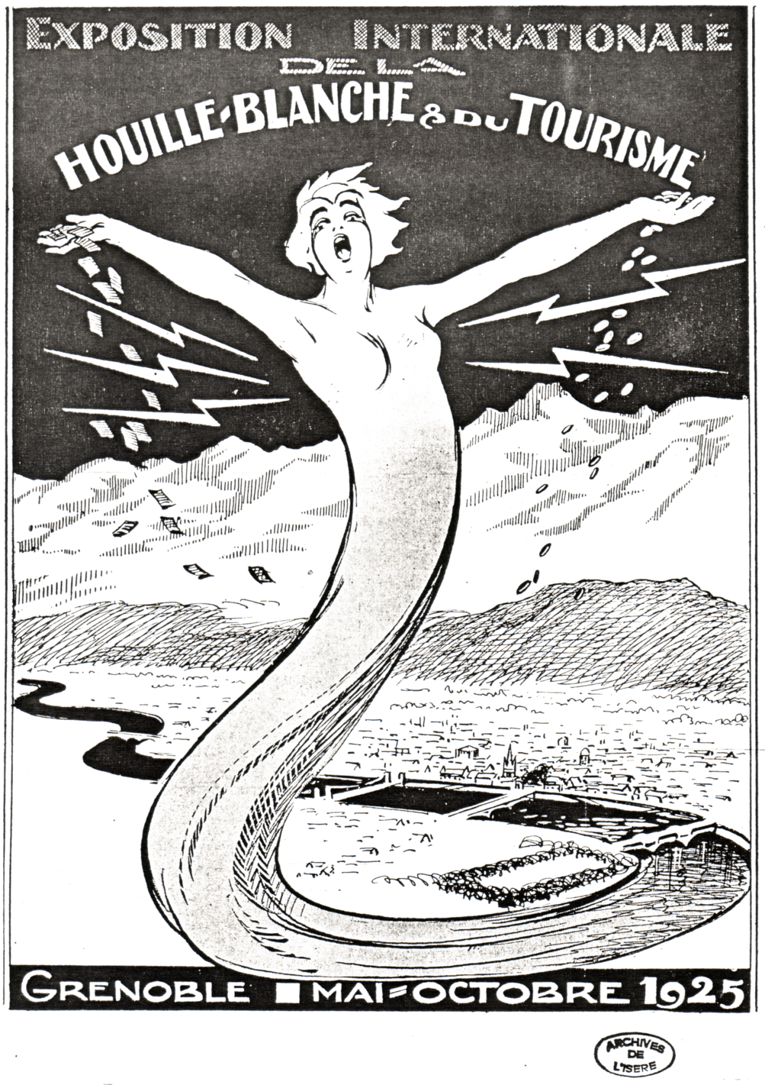

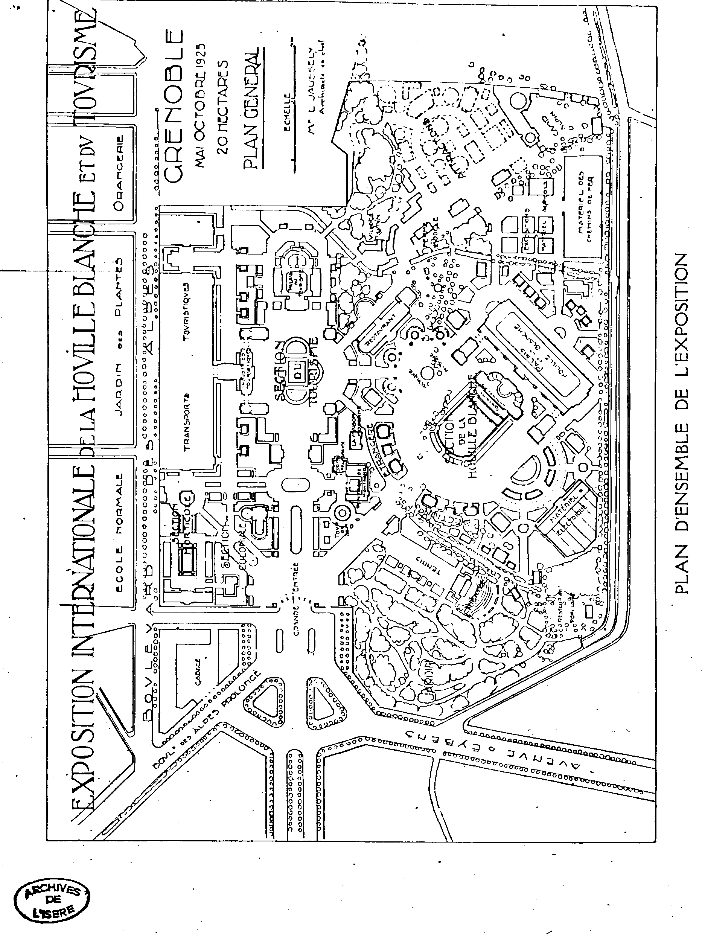

Various newspaper articles dealing with the Kiralfy’s
by
Andrew Brooks.
Newspaper cutting of 10 May 1919

Imre Kiralfy, known all over the world as an organizer of pageants and spectacular dramas, died on April 27 at his home in Brighton, England, aged seventy-four.
Mr. Kiralfy’s reputation as an organizer of these events had been established in Europe before he came to this country in 1869. He was one of the first to cultivate the field now held by men of the type of Louis N. Parker and Percy Mackaye. Born in Budapest in 1845, he appeared on the stage when he was four as a mimic in “Preciosa” He studied music and dancing in his youth, appearing in German theatres for several years as a dancer.
When he was twenty three he began already to organize pageants and processions, was in fact decorated by King Leopold of Belgium in 1868 for his management of a monster fete in Brussels. It included operas, pantomimes, sports and a spectacle in which 4000 soldiers took part.
After coming to this country in 1869, he remained here twenty five years. During that time he became noted not only as a dancer, his brother and sister, with himself, being known as the “Kiralfy Family” in the “Black Crook”; but as a producer of great spectacles, some of them partly operatic in character. Of these, “Columbus,” in 1892 with Barnum, and “America,” in Chicago, for Abbey and Grau, were probably his greatest triumphs.
In London during the same period he produced “Nero” in 1891 and “Venice” in 1893, In 1895, on his return to England, Mr. Kiralfy reconstructed the Earl’s Court Exhibition, and in 1908 designed the “Great White City,” and planned the Stadium for the London Olympic games.

Bolossy Kiralfy the Stage Napoleon of the Eighties
Late Impressario Once put on Show in Which 2,500 Performers Were Used
Newspaper cutting of 8 May 1932

With the death several weeks ago in London of Bolossy Kiralfy the hands of time, for those who remember the New York of the ‘70s and ‘80s, were for a brief moment turned back, and nostalgic memories were recalled of the “maitre” who at one time had produced the grandest show on earth, using 2,500 performers, had restaged the performance in Paris, where he built an artificial lake big enough for eight large barges, and was hailed as “the Napoleon of the stage”, and has been a forerunner of contemporary! “glorifiers” with his great enterprise, the Eldorado Amusement Park, seating 15,000 persons top the Palisades at’ Weehawken.
Bolossy Kiralfy was eighty-four years old when he died, and in his prime had combined most of the talents of a Ziegfeld, a Morris Gest and a Tex Rickard. He was stage manager, producer, librettist, ballet master, financial entrepreneur, playwright and his own publicity director all rolled into one.
With his brother Imre he had led a small troupe through all the courts of Europe; he had made the first experiments in the theatre with Mr. Edison’a newly discovered electric lights; he had produced gigantic and breath-taking spectacles in London, Paris, Brussels, Berlin and Cologne. He did things in a big way. During the latter decades of the nineteenth century he was probably, despite P. T. Barnham’s claim, the “greatest showman on earth”.
Kiralfy, the ballet master, In New York during the late ‘70s, has been recalled by Otis Skinner In his volume Memoirs, “Footlights and Spotlights”. As a very young actor, he worked for the Kiralfy’s.
“The Kiralfy brothers, Imre and Bolossy,” says Mr. Skinner, “were dancers of Hungarian birth who, by industry and shrewdness, had become authoritative producers of spectacular ballet pieces in America. Their entertainment was a sort of forerunner, of the New York Hippodrome. To see Bolossy at work with a stage full of girls was to behold a pale, excitable foreigner with a long stick with which he thumped the measure of the dancing steps, and his voice, hoarse with shouting and a chronic catarrhal cold, barking out:Von-two-tree, Von- two-tree, No no Stop Vot’s de matter wit de back line? No please Ladies! LADIES! Vonce more Von-two-tree etc.
The old line girl had been with the brothers for years and a decent, hard working lot they were; many of them breadwinners of families, good mothers and wives, and for the most part bright and comely. There were no motor cars waiting for them at the stage door; their shapely bodies were not clad in silk and sealskin; when they shed their pink tights and tarlatan skirts and dressed for the street they looked like a company of milliner workers. The ballerinas of the higher order were more gorgeous, but they took their work as a matter of fact, spending two and three hours each day at the theatre, practicing their steps and keeping their legs supple and muscular. Bolossy had a large, placid wife who had gone to flesh quite irretrievably. On the night of the dress rehearsal when the poor maitre was beside himself with nerves, the lady planted herself in his pathway and purred: ‘‘Bolossy, you have not petted me today” “Nor Elsie” he cried, “I have not had time.”

Kiralfy sent for Panama Exposition
New York Times newspaper cutting of 13 October 1913

Imre Invited to Plan Big Pageant, like that at World’s Fair, San Francisco.
Had big success abroad.
Son now here, says father. Has drawn hundreds of thousands of visitors to London.

It has, been twenty years since Imre Kiralfy went over to England to show the people over there what spectacles were, not as an eye doctor; but as a showman, and for years he had them going so! that he hasn’t had much of a chance to come back. But he is due over here soon, and his son, Charles, who has arrived, at the Waldolf says that his mission is to consider at the invitation of the San Francisco
Exposition people, a big pageant modelled on the lines of the great spectacle Mr. Kiralfy had for the-World’s Fair at Chicago in 1893, with the probability of making it a permanent exhibition, such as Mr. Kiralfy is now running at Shepherd’s Bush, London.
Charles Kiralfy, who is associated in business, with his father, said that from the time his father took over at Olympia, the great hall built by the Royal Agricultural Society, his ideas of shows have “gone” among the English, and that the provincial, who never wanted to go to London to have a good time now considers it a resort, and great amusement enterprises of the kind long known in the United States have sprung up, all over Great Britain.
The elder. Kiralfy usually has proceeded on the plan of incorporating some sort of commercial exhibition with a spectacle or pageant. When they got up the Franco-British at Shepherd’s Bush four years ago in connection with the Olympic Games, Mr. Kiralfy was made Dlrector General. They pu t up huge buildings, intended to be used for only a year. Their exteriors were made of staff, but owing to the strict regulations of the London County Council the rest of the structures, of steel and concrete had to be as nearly permanent as they could be made, and the result was that the next year Mr. Kiralfy opened, another (hyphen) - British Exhibition and has continued to do it each year with continuing success.

Shakespear’s England Post Cards
by
A. P. Smith

Rotary Real Photographic. Glossy, Sepia.
Series 6951
A Plymouth Harbour Gates, Interior. (V)
B Plymouth Harbour Gates, and Quay.
C Gates of Plymouth Harbour.
D Shakespear’s Village showing Porch House.
E View of Shakespear’s Village.
F Tudor House.
G Old Houses, Holborn Bars.(V)
H Entrance to the Fortune Theatre.
I The Old Globe Theatre.
J Entrance to Dragon’s Gorge.(V)
K The River Caves.(V)
L The Great Aerial Flight.
M Irish Tea Gardens.
N Group of Madrigal Singers and Morris Dancers.
O Interior of Igorrote Village.
P Old Holborn Bars.
Q Western Gardens by night.
R Western Gardens by night.(slightly diff.)
S Western Gardens by night.(slightly diff.)
T The Great Water Chute(water view)
U Igorrote Village.
V Western Gardens.
W Western Gardens(slightly diff.)
X The Great Water Chute.(land view)
W.H.Smith-Real Photographic, Glossy, Sepia.
1 Mermaid Tavern.’
2 A Corner of Shakespear’s England.
3 Types of Costume at Shakespear’s England.(three ladies with dog)
4 Types of Costume at Shakespear’s England(two ladies) (V)
5 Visit of Queen Alexandra to the ‘Revenge’, Shakespear’s England.
6 A street in Shakespear’s England. (V)
7 Western Gardens,
8 Western Gardens (slightly diff.)
9 Trinity College Fountain, Shakespear’s England. (V)
10 Ashby St. Legers, Shakespear’s England.
11 Globe Theatre, Shakespear’s England.
12 Dixter Hall.
W. H. Smith Real Photographic. Matt. Sepia. No numbers but 18 recorded and this is almost certainly the total.
A Corner of Shakespear’s England.
Visit of Queen Alexandra to the ‘Revenge’.
Shakespear’s Library at Shakespear’s England.
Mermaid Tavern.
Western Gardens.
Halbardiers at Shakespear’s England.
The Revenge.
Apprentices at Shakespear’s England.
The Revenge at Shakespear’s England.
On the Quay at Plymouth Hoe.
Glee Singers.
Winwife and some Apprentices at Shakespear’s England.(V)
Elizabethan Buildings at Shakespear’s England.
Pipe and Tabor players at Shakespear’s England.(v)
A Corner of Shakespear’s England (V)
Fortune Theatre at Shakespear’s England. (V)
Street in Shakespear’s England. (V)
Types of Costume at Shakespear’s England.
Valentine & Sons. Dundee. Coloured.
141 The Lake, Queens Court.
142 The Amusements.
143 Bandstand.
144 The Chute Lake.
145 Western Gardens.
146 Queens Court and Bandstand.

