EDITORIAL SPRING 2003

It’s spring and cold, and I’m getting old
The good shepherd’ll soon drive me into his fold
(but not yet I hope)

My comments about the internet in the Spring 2002 Journal have resulted in two E-Mails sent to me recently. Mike Goring seems to support my views and Trevor Day shows the other side of the picture. I have published both items in full.

Dear Bill,

I feel I must say a few words about the situation with 'Ebay Bidding System' as the bidding is now getting out of hand, particularly with British Empire Exhibition items. I don't know if you have bid within the Ebay system, but at present, ordinary items are being bought for very silly money, pushing up the prices way beyond the value of the relevant item. A recent item sold for over A390.00 after hovering at A345.00 plus!! Yes, if you want an item and are prepared to pay silly money, all well and good, but the final price is then totally unrealistic.
You may want to comment about this in the next Newsletter, as you have done in the past about Postcard Fairs. This is not a sour grapes story, albeit that I did bid for three recent interesting items, but there is a need to bid sensibly in the circumstances.

Regards,

Mike Gorringe

Dear Bill

Whilst agreeing with the sentiment in the email above, I feel I must add my own point of view to the debate, particularly as I am probably one of the more active members of the ESG within the Ebay community. I have not commented before, despite the editorial comments in the newsletter of Spring 2002 describing the process of internet auctions as "complete madness" and those who participate in them as having "more money than sense".
I would describe myself as a BEE collector whose disposable income would not normally qualify me to enter into what is not always a cheap hobby so I use my knowledge of the BEE to buy items outside of Ebay. These are then offered for sale on Ebay with the hope of making a profit which can then fund further purchases either to sell or to keep. I have been registered with Ebay since January 2000 and in this time have bought in excess of 100 BEE items and sold a similar amount, most of which has gone to the same small circle of buyers. In addition to this I must have sold a further 100 or so items privately. I believe this activity both as a buyer and seller places me in a unique position to comment. My comments are a reflection of my own opinions and experiences and are not intended to divide, alienate, identify or accuse anyone so please do not take offence if they differ to your own views. I value my membership of the ESG highly alongside my participation over the internet and believe the two should compliment each other.
The main point of the original comments is that "bidding is getting out of hand" and individuals are paying considerably more than an item is worth. At times this is true, but surely an individual must balance the cost of an item against the pleasure that will be gained from it over a period of time and whether another opportunity to buy will present itself. This is up to each individual to decide for themselves and should not be criticised by others.
In the Price Guide to the BEE postcards book the authors freely admit to having paid " well over the odds for a card we had not got", demonstrating that we are all a little guilty at times. It is still however a fairly regular occurrence that items sell at what seems an incredibly reasonable price . The one lesson I have learnt in my three years on Ebay, is not to be too disappointed when an item that I would like to buy goes beyond what I am prepared to pay, because two collectors are in a bidding war, as often the same item will be listed several months later and only reach a fraction of the original price.
The Internet is often used as a scapegoat for all the world's evils and some of it is true, but the Internet and Ebay in particular has enabled me to buy varied items at a range of prices and has the ability to make "rare" items seem a lot more common. There is also a sense of satisfaction when buying items from Canada, USA, Australia and other far flung reaches of the Empire, and bringing them back to their country of origin after 70 years. This in turn has fuelled my interest and enthusiasm in the BEE .I work full time and am a family man and whilst I still love visiting fairs from time to time, Ebay saves me considerable travelling time and expense and I can buy from the comfort of my own house at a time that suits me.
It has to be said that I have far too often returned from fairs empty handed and disappointed having only found average items, in poor condition at extortionate prices and I have done what anyone should do and carried on walking. Through my sales on Ebay, I have established many contacts with people interested in the BEE and the ESG has gained at least two new members as a result of my recommendations. It must also be recognised that the general public is now aware that everything has a value and the days of picking up bargains in the 1970's for a few shillings when it would have been unfashionable have long gone. The publicity surrounding the redevelopment of Wembley Stadium will also have had a detrimental effect on values if you are buying or a positive effect if you are selling. I challenge anyone to tell me where such an array of similar items can be bought cheaper.
It is also interesting to note that the ESG held an auction of BEE items in 2000. Of the 49 lots only 26 sold and there were only bids from approx. 10 people. The guide prices listed at the time in the newsletter were not that short of what these items would have been likely to reach on Ebay.
In conclusion, whilst there are some negative aspects to Ebay there are far more positives, and no one is forced to participate. It may not be the preferred vehicle for everyone but it's success and popularity with both buyers and sellers is undoubted. I would encourage everyone to use their knowledge and enter into the fun ( and the risk ) of buying and selling as it can be an absorbing hobby, whilst at the same time increasing your own collection. For me it is a WIN, WIN situation.

Kind Regards

Trevor Day

In reply to Mike and Trevor, I see nothing wrong in a collector doing a bit of buying and selling to augment his collection, or to make a profit, and admit that if I wished to dispose of part of my collection or my duplicates, selling them through E-bay would undoubtedly bring in a much better return. One reason why I do not dispose of my surplus to dealers is because they would offer so little, I would rather hang on to them.
Trevor states “editorial comments in the newsletter of Spring 2002 describing the process of internet auctions as “complete madness” and those who participate in them as having “more money than sense”. I must point out that I did not in fact put it quite like that, what I said was “It has to be said that there are a number of collectors about, who seem to have a lot more money than sense and the internet seems to be designed to cater for these people. The thought of trying to out bid the rest of the world to get an item for my collection seems to me to be complete madness.” I did not and do not condemn all internet transactions as I am sure many of them are based on fair prices. Unfortunately once an outrageously high price has been paid for an item, it seems to set the future value for that item for years to come.
I first came upon this fact many years ago (before internet) when a wealthy collector paid £40 for a Wembley Army Recruitment card. At the time the going rate for that card was about £15, but once the word got round, from then on all the dealers marked it up to the higher price.
I personally have never bought a card through the internet, not because I’m against it, but partly because I don’t know how to do it (I really am as thick as two planks when it comes to using a computer, I can manage simple jobs and that’s about it.) and partly because I enjoy going to post card fairs. I shall be at Yeovil next month staying at a very nice lodging where last year they served me with a fine sweet sherry in a beautiful cut wine glass. I was invited to help myself from the decanter to a second and third glass if I wished, and spent the evening reading a book I found in their book case “With a Rod in India” written about a hundred years ago. Perhaps not every bodies cup of tea, but I enjoyed myself and hope this year will be as good. (Having now been to Yeovil, it was as good)
I have friends who tell me they get bargains through the internet, but at the moment it is not for me. It has to be said that getting good cards at post card fairs is getting increasingly difficult, and now after advertising for cards in the Picture Postcard Monthly for thirteen years the amount of cards sent to me has dropped to its lowest ever, only 678 last year, compared with some years when I have received over 3,000 cards.
Numbers of cards sent have fallen dramatically over the last few years (2000) 2567, (2001) 1617 and (2002) 678. With sendings dropping by a 1000 cards per year as they have for the last three years, unless there is a turn round my advertising days will soon be over. While it is early to project figures for this year, already there are indications there will be a further drop. Then perhaps I shall be forced onto E-bay.

Graham Hall writes to me to say he is working on our 2004 convention which he is helping to organise. We shall hold it at Bradford and celebrate the 100 anniversary of the 1904 Bradford Exhibition. Graham had hoped to be able to get the convention held in the Cartwright Hall but has settled for holding it in the Bradford Industrial Museum where like Stanley Hunter at Glasgow he seems to be well in with the Keeper of Technology at the museum

Wembley Snippets.
by
Mike Perkins.

I recently came across the following whilst looking through Lloyds List & shipping Gazette.

Cardiff at Wembley

Cardiff will occupy the Civic Hall at the British Empire Exhibition from July 21 to 30 inclusive. Among the exhibits will be a great oil painting, measuring 40 ft. by 10 ft., showing the city Hall, Law Courts and the National Museum of Wales. This will afford visitors some idea of the way in which the city has taken advantage of one of the finest municipal buildings seen in Europe. A picture of similar size will give a view, from the air, of Cardiff Docks showing the compact lay-out, which enables ships to obtain a quick turn-round. The North and South Halls will be devoted to the city’s exhibitors, and coal, wagon-building, wire-ropes, Welsh textile manufacture, driving belts for machinery, and many other products will be on view. In the Centre Hall there will be models of early and modern types of steamships, showing the great advances made in steamship construction

The Civic Hall at Wembley was sited just inside the South entrance, facing up Southern Run, and was used by six towns and cities during 1924 to display their history and commerce. The Hall was booked as follows:
Bristol May 29 to June 13
Derby June 14 to June 28
Hull July 2 to July 15
Cardiff July 17 to July 31
Salford August 1 to August 14
Liverpool September 12 to October 2

Post Office Underground train at Wembley.

Thanks to Alan Sabey we are including in this sending a copy of the 2003 Spring Stampex catalogue as one of the pictures is of a model of the Post Office underground railway which was on display at the British Empire Exhibition at Wembley 1924. The special railway to be used for carrying mail only, was under construction at that time and was opened for use in 1927.

British Empire Exhibition 1924 - 25 Commemorative Ceramics.

Part 2

by

Jenny Hill

In 1932, Carlton merged with Birks, Rawlins and Co. Ltd. (Savoy China), who also made crested ware, being particularly known for their detailed World War I models. The Savoy BEE crest was another version of the Herrick lion, this time balancing on two globes on a yellow shield with flags around it, topped by Prince of Wales feathers.

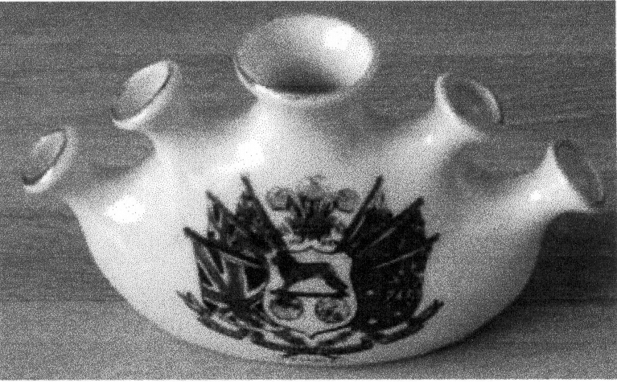

Figure 14. Savoy China BEE crested vase.

Willow Art

Hewitt Bros. (Willow Art) produced a variety of crested ware for the BEE in 1924. It was cheaply produced, the pieces being generally simple in shape. The barrel below is typical, being sparsely decorated with a single transfer, instead of having a smaller design on the back, as Grafton did. The Willow barrel lacks even the usual gold rim. Willow Art also made an ashtray with a model of ‘Old London Bridge’ (a feature of the exhibition which bore no resemblance to any real London bridge). In 1925 the firm, like so many others, became part of the Cauldon group.

Paragon China

Paragon, known for their fine tableware and ‘fancies’ or small decorative items, made good quality BEE souvenirs. They produced a crest featuring another version of the Herrick lion in yellow with a blue or sometimes black mane, with the legend ‘a present from Wembley’ underneath. A separate transfer of two Union Jacks often accompany this. The company also produced a cup and saucer with a border of flags on a rope.

The Cup of Knowledge

This was a retailer, listed in the official catalogue for 1925. Several firms, including Booths, Paragon and Aynsley produced cups and saucers for this firm, all with similar patterns of playing cards inside the cup. Again, I am not sure of the symbolism, although the title suggests it is mystic in origin.

Josiah Wedgwood & Sons Ltd.

Wedgwood held a prominent position at the BEE in 1924. Their portico in the Palace of Industry was in classical Adam style to match their famous Jasperware. On their stand, they displayed tableware and decorative wares. The company produced a small range of BEE Jasperware commemoratives featuring the Herrick Lion, including a matchbox container and small dishes.

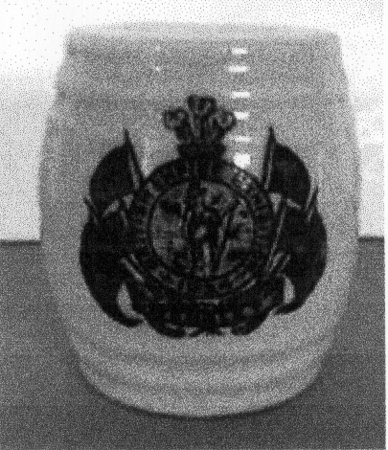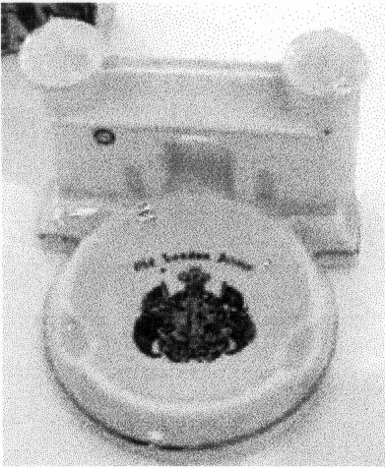

Figure 15. Willow Art barrel. Figure 16. Willow Art Old London Bridge ashtray.

The following year they concentrated instead on the Paris Exposition des Arts Decoratifs et Industriels Modernes, which was to give its name to the Art Deco style.

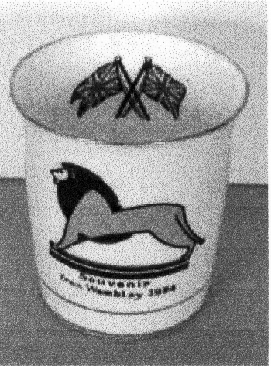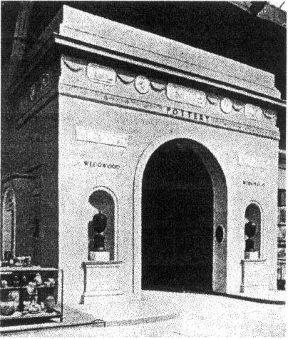

Figure 17. Paragon China tot beaker. Figure 18. The Wedgwood portico.

Sir Lawrence was also President of the Design and Industries Association in the 1920s, so was clearly interested in modern design. The pottery aimed to produce aesthetically pleasing, peasant-style pottery, of the type imported cheaply and in great quantity from Europe. The men had to be trained from scratch and funding was obtained from the British Red Cross and the Order of St John and Jerusalem.
Because the company started from nothing, it was unhampered by existing tradition and equipment that dogged so many other potteries in the 1920s. Moulds were specially designed and their earthenware was made in a fine, white body. This was suitable for both decorative and utilitarian wares, in order to make the pottery as commercially viable as possible.

Percy Metcalfe, who worked for Ashtead Potters, designed the BEE ‘Lion of Industry’ to represent ‘the undefeated courage of British Industry in times of difficulty’. This stood on a huge plinth in the Palace of Industry, topping the Fleetway Press kiosk, which sold the official guidebooks and maps, including a brightly coloured map known as the Jazz map.

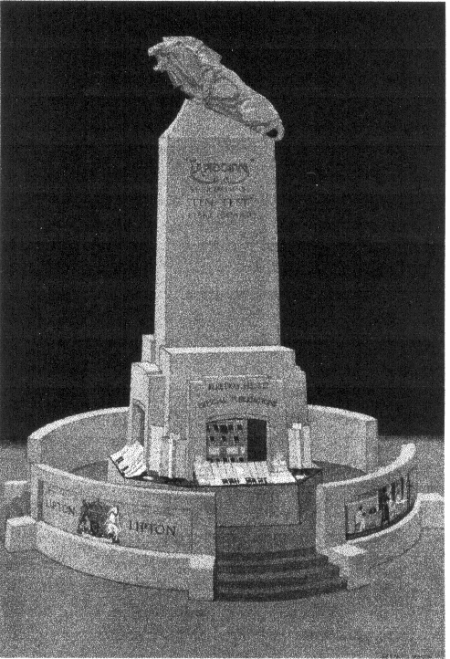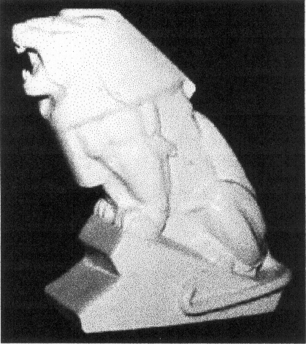

Figure 19. The Fleetway Press kiosk. Figure 20. Ashtead ‘Lion of Industry’.

Metcalfe also made a ceramic ‘Lion of Industry’ souvenir for Ashtead Potters and a plaque to hold the BEE medal.
Ashtead produced plates commemorating various Empire Pavilions, including South Africa, Burma, Australia and Nigeria. These plates were aimed at a more avant-garde market than crested ware, with a strong use of graphics reminiscent of that sometimes seen on Pilkingtons Lancastrian ware of the same era.
The BEE was an early marketing opportunity for Ashtead. Sir Lawrence ensured that the Ashtead stand had press coverage as well as a royal visit. It was, as a ‘goodwill society’ or charitable concern, the only pottery to be mentioned by name in the official guidebook, where its wares were described as ‘a new type of pottery, both distinctive and inexpensive’. As you can see from their BEE stand, attended by King George V and Queen Mary, many Ashtead items had simple geometric decoration unusual in British ceramics of 1924

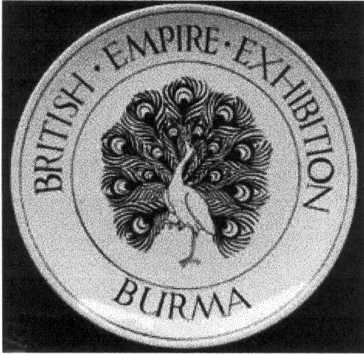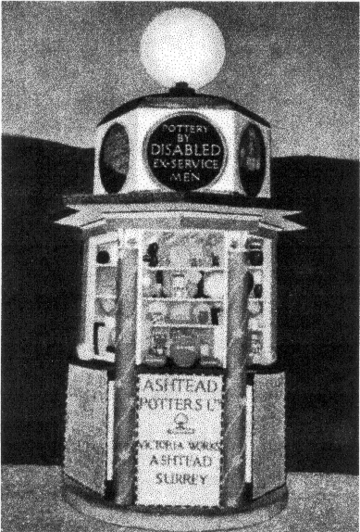

Figure 21. Ashtead Burma Pavilion plate. Figure 22. Ashtead kiosk.

Ashtead also made a plate featuring the Herrick Lion, with geometric border.

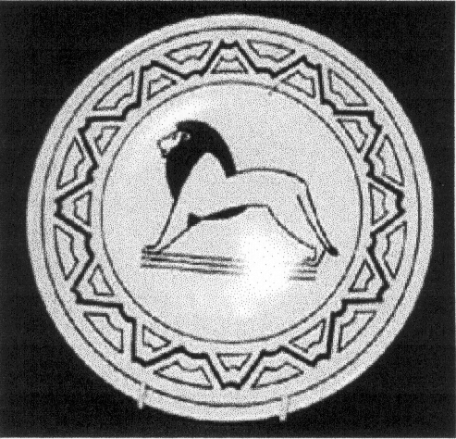

Figure 23. Ashtead Herrick Lion plate.

Ashtead displayed examples of their wares in the Palace of Arts in 1924 and 1925 and also in the Palace of Housing and Transport in 1925. Pieces were shown in The Illustrated Guide to the Palace of Art 1925. Although they were unable to afford an elaborate portico, they had a shop in the West Quadrant in 1924 and a ‘cherry’ kiosk.
Kiosks were an important feature of the BEE in 1924, though many were cleared the following year to improve the vistas. They were novel in design, reflecting the logos and emblems of the various products. Sir Lawrence Weaver’s 1925 book Exhibitions and the Art of Display, described them as having a similar effect to a 3D poster, being bright, colourful and good for promoting brand awareness. One example is the Ashtead kiosk, one of 46 ‘Cherry’ kiosks by Emberton, so called for the globular electric light fitting on the top.

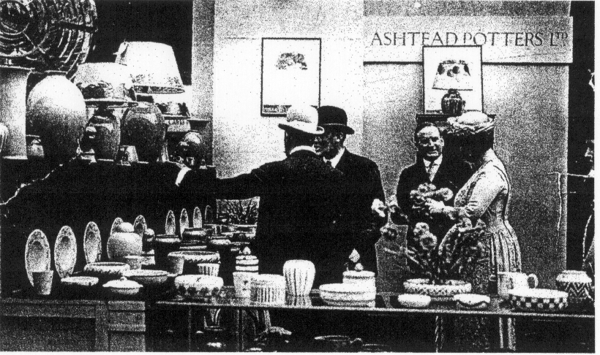

Figure 24. Ashtead BEE stand.

In 1925, Ashtead craftsmen demonstrated the advantages of the gas-fired kiln in the Palace of Industry, although the pottery itself used the cheaper bottle kilns at this time. After Sir Lawrence’s death in 1930, the company declined. It closed in 1935, unable to withstand economic depression and cheaper competition.
Many other companies made a few items of BEE commemorative ware, including Poole, Royal Doulton and A.E. Gray, where a young Susie Cooper produced a commemorative silver lustre cup and saucer, recently shown at Wedgwood’s Susie Cooper centenary exhibition.
This article is designed to give a flavour of what is available to the collector and put the various firms in their historical context. BEE ceramics is a fascinating area to research and collect, with a great variety of pieces available, even though much crested ware was discarded as unfashionable after World War II.

Bibliography

Archives/Libraries

Bourne Hall Museum, Ewell, London
Brent Archive, Brent Library, London
British Library, Colindale, London
Grange Museum, Neasden, London
Public Records Office, Kew:
Royal Society of Arts Library, London
Stoke–on-Trent Library & Archive
Wedgwood Museum 20th c Archive, Barlaston, Stoke-on-Trent

Guidebooks and Catalogues

Ashtead Pottery catalogue, c.1926.
British Empire Exhibition 1924, Catalogue of the Palace of Arts, (London, 1924).
British Empire Exhibition 1925, Illustrated Catalogue of the Palace of Arts, (London, 1925).
British Empire Exhibition 1924, Official Guide, (London, 1924).
British Empire Exhibition 1925, Official Guide, (London, 1925).
British Empire Exhibition 1924, Official Catalogue, (London, 1924).
British Empire Exhibition 1925, Official Catalogue, (London, 1925).
London and the British Empire Exhibition 1925, Illustrated Guidebook, (London, 1925).

Journals

‘British Empire Exhibition, Wembley 1924: Fiftieth Anniversary’, (Wembley History Society, 1974).
Mourey, G., ‘La Section Britannique’, Art et Decoration, Vol.XLVIII, (1925).
Pottery and Glass Record, Vols.6 and 7, (1923-24 and 1924-25).
Pottery Gazette and Glass Trade Review, Vols. IL and L, (1924-25).
Richmond, L., ‘The Lure of Wembley’, The Studio, Vol XLIV, (Jan-June 1924), pp.312-16.
Weaver, Sir Lawrence, ‘Exhibitors’ Architecture’, Architectural Review, Vol. LV, 1924.

Books

Andrews, S., Crested China, (Horndean, 1980)
Bartlett, J. A., British Ceramic Art 1870-1940, Atglen, 1993)
Carrington, N., Industrial Design in Britain, (London, 1976)
Casey, A., 20th Century Ceramic Designers in Britain, (Woodbridge, 2001)
Godden, G., Encyclopaedia of British Pottery & Porcelain Marks, (London, 1991 edn.).
Hallam, E., Ashtead Potters Ltd. in Surrey, 1923-1935, (privately published, 1990)
Knight, D. R. and Sabey A. D., The Lion Roars at Wembley, (privately published, 1984)
Maxwell, D., Wembley in Colour, (London, 1924).
Pine, L., Millers Goss and Crested China, (London, 2001)
Pine, N., The Price Guide to Crested China, (Horndean, 1992 and 2000)
Pine, N., The Price Guide to Arms & Decoration on Goss China, (Horndean, 1991)
Weaver, Sir L., Exhibitions and the Art of Display, (London, 1925).

Acknowledgements

Malcolm Barres-Baker, The Grange Museum
Trevor Day
Joy Hallam, Ashtead expert
Jeremy Harte, Bourne Hall Museum
Anne Lemon

With thanks for assistance with pictures and information.

End

The 2002 16th Exhibition Study Group Convention and Annual Dinner
by
Alan Sabey

The Group met at the Holgate Hill Hotel in York on September 28th and 29th for the 16th Annual General Meeting which was chaired by Vice President Ron Trevelyan as the President Mike Perkins was unable to attend. Secretary Bill Tonkin gave a short report of the activities of the group. This was followed by the Treasurer, Alan Sabey who presented the Accounts which showed a healthy balance and said he thought it was unnecessary to raise the subscriptions from their present level of £8 for an UK member, £12 for an UK couple and £13 for all other members. Membership stands at just over the one hundred mark. The accounts were approved and passed by the meeting.
The Meeting also approved the publication of a new book listing the Advertising Labels for the British Empire Exhibition of 1924 & 1925 by Alan Sabey and Bill Tonkin for which a lot more material has been added since the last publication by the Cinderella Stamp Club.
After the AGM came the displays by our members.
Don Knight showed postcards of exhibitions held abroad, and this was followed by Stanley Hunter‘s display of ephemera and documents relating to the proposed exhibition in Tokyo in 1940 that had to be cancelled because of the War.
Fred Peskett showed his other favourite subject, Crystal Palace, with postcards and ephemera such as Season Tickets. 1911 saw the Festival of Empire being staged there and just three years later, the Palace was taken over as the Royal Naval Division and used for training purposes. The Crystal Palace grounds were the site for aviation and balloon flights. The display finished with scenes of the fire in 1936 and the demolition of the Towers in 1940 because it was thought that the Germans were using them as landmarks for their air raids on London during the War.
Alan Sabey showed his collection of Advertising Stickers for the British Empire Exhibition at Wembley, with examples of the many different types produced. The display included some on firms’ letters to clients, bill heads and the Lloyds Bank labels for the exhibition correctly used on the reverse of envelopes to the customers of the branches of Lloyds Bank. The Lloyds Bank labels included an imprint block of the scarce violet shade. These labels are the subject of the next publication to be brought out by the Group.
Graham Hall travelled over from Bradford to give us a preview of what we can expect when the 2004 Convention will be held at the Industrial Museum in Bradford to mark the centenary of the 1904 Bradford Exhibition and the opening of the Cartwright Hall on April 13th 1904. The main exhibition opened at Lister Park on May 4th 1904. James Rosemont was the contract photographer for the exhibition. It was noted that the supposed postmark was in fact only used on Telegrams.
John Marriner, a new member on his first visit to a convention showed an award-winning exhibit on the 1934 Apex exhibition. This was a large display of special postmarks and cachets, Autogyro and Pigeon Post items.
George Simner who, this time showed items connected with the 1937 Exhibition in Paris occupied the end of the first day’s displays. This was in the nature of a World Fair covering 44 countries and was the first opportunity for Communist Russia to participate since the turmoil of 1917. A look at the postcards of the German and Russian Pavilions showed that the German one was taller and the German Eagle overlooked the Russian workers depicted on their Pavilion. Some interesting cards were the blue night time scenes and these were accompanied by postal items and printed ephemera such as brochures.
Sunday morning’s displays began with a display of continental exhibitions between 1922 and 1939 from Ron Trevelyan. Starting with the Marseilles Exhibition of 1922, we saw colourful labels about various French colonies and a Season Ticket. The famous Arts Decoratif Exhibition of 1925, which gave its name to a fashion era - Art Deco - in the 1930’s, had buildings built on both banks of the River Seine. In 1929 in Spain the Ibero-Ameriano Exhibition and the International Exhibition in Barcelona ran concurrently and the recall it there were view postcards and cards of replica posters. Also seen were Cinderella labels of Spanish Art and the 1929/1930 obligatory tax stamp used on cover. 1930 saw the exhibition to mark the centenary of the founding of Belgium. This exhibition was held in two areas each with its own theme. Antwerp was the base for Colonial, Maritime and Flemish Art. Liege was used to show Science, Industry, Social Economy, Agriculture and Music. The 1931 Colonial Exposition was marked with an issue of stamps. The later exhibitions features were 1934 Naples and Porto where again there was a stamp issue; Brussels 1935 and Paris 1937.
George Burr spoke about Ferris Wheels, from Earl’s Court, Blackpool, Vienna, and Paris to the London Eye. A number of the earlier ones, 1895 to 1906, were commemorated with souvenir medallions, a particular interest of George’s. There were also models of the Eiffel Tower in various sizes.
Don Knight talked of his many visits to the Millennium Dome at Greenwich and showed publicity leaflets, covers and souvenirs.
Bill Tonkin brought the weekend’s meeting to a close by showing postcards he had bought at the York Postcard Fair. These were quite varied in theme.
The different displayers exemplified the wide variety of collectibles from stamps, printed ephemera such as guide books and Passes to picture postcards and publicity labels and showed that the Group is not, as has been suggested, just a postcard club. However postcards form the base for any collection, as they are the most readily available souvenirs for the public to buy.

YORK A Postscript to 2002
by
Stanley K Hunter

YORK was the venue of our first two annual conventions, in 1987 and 1988. Both were held at The Black Swan, and were very successful and entertaining. Who can forget the spontaneous applause when Don Knight reprised his TV performance of his 1908 Flip-Flap, as at the Franco-British Exhibition at London’s Great White City?
The 2002 convention was equally instructive and fun – although a few old faces were missing due to various domestic problems, etc. Our venue was the Holgate Hill Hotel in Holgate Road. Trust Bill to pick up a locale only a few doors away from the Crystal Palace public House! The walls are adorned with views of the Crystal Palace.
York is unusual in that it can boast its very own Exhibition Square. I once again visited it, almost within the shadow of York Minster itself. It fronts the York City Art Gallery at Bootham Bar, an important gate of the ancient City Wall. (The Minster was shown on a 1969 GB stamp while a roof boss, c.1355, was shown on a 1974 Xmas stamp.)
The first major exhibition in York was held in the grounds of the Bootham Park Asylum in 1866. This is a few hundred yards west, on the north side of the Bootham road. This was the first Yorkshire Fine Art & Industrial Exhibition and was housed in temporary wooden buildings, designed by Edward Taylor. There is public access to these grounds, which houses a number of NHS buildings as well as a sports field which could well have staged the 1866 York Exhibition and also the Festival of Britain in 1951.
The success of 1866 spurred citizens to mount another exhibition. A site was obtained in the grounds of St Mary’s Abbey. This time, the exhibition building would be constructed of wood, bricks and stone, again designed by Edward Taylor and placed at the Bootham Bar.
This new building had a façade built in the Italian Renaissance style, which was to form the western side of the 1879 exhibition. Its area held the second Yorkshire Fine Art & Industrial Exhibition. The building then housed annual art exhibitions. In 1892, the exhibition building was sold to the York City Council for a modest fee and it became the City Art Gallery.
Its forecourt area is now Exhibition Square with its statue of William Etty (1787-1849), the city’s most famous artist. The gallery held a major exhibition of his work in 1911, when the statue was erected. Modern postcards of the Bootham Bar show Exhibition Square and its modern fountains. Not far are many antique shops and even malls where “exhibition” material is available.
York 1879 is famous for bringing forward to the public, the work of Thomas Steven (1828-1888) with his woven silk pictures – since known to collectors as “Stevengraphs”. Visitors to York 1879 could actually witness his Jacquard looms producing silk pictures celebrating the exhibition. Most were then mounted on card, singly or, in groups of views, a new innovation.
His silk pictures appeared at many exhibitions – such as the Edinburgh International of 1886 and the International Exhibition, Glasgow 1888. (As this was the year of Steven’s death, the 1888 pictures are quite scarce.) The Stevengraphs were big sellers at the 1893 World’s Columbian Exhibition in Chicago.

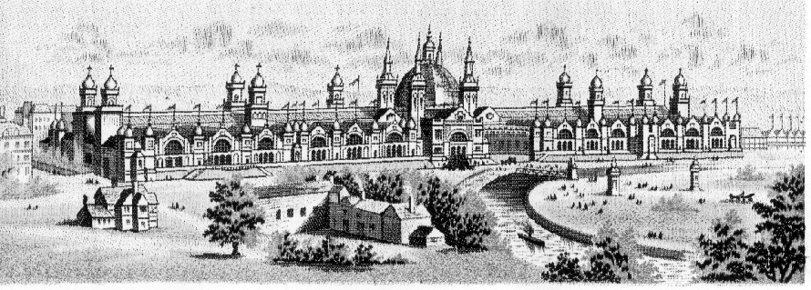

Stevengraph of the 1888 International Exhibition Glasgow

I did pick up a really fine Edinburgh “Festival of Britain” mug to add to my one and only Brentleigh Ware FoB item (a china cigarette box) but saw another in the set (albeit not Edinburgh). Are there any other Brentleigh collectors out there?
To mark the Festival of Britain, a York Festival was run June 3-17, 1951. It opened with a service in York Minster, which was used for concerts and recitals. The ticket order form gives a plan for the performances in the Minster. Attractions included the Hallé with Barbirolli (portrayed on a 1980 GB stamp) and the LPO with Sir Adrian Boult and Elizabeth Schwarzkopf.
The highlight of the Festival was the York Mystery Plays performed in the Museum Gardens. These were the fullest versions staged since 1580. The Art Gallery itself hosted a number of Festival musical concerts and recitals. Other Festival events were held throughout the city, including the Railway Museum. Two blocks of flats designed for the Festival are within walking distance, near York Castle. The York Public Library holds a copy of a University of Sheffield dissertation (1985) on the York Festival of 1951. The Library had held its own Festival exhibition, including material on the Mystery Plays.
Make a date to be in York this September. Who knows what you will find in this ancient city? Bill will probably not be able to organise a Masked Georgian Ball or a Festival Regatta with Night River Carnival – or even dancing in the “Big Top” in Bootham Park as in 1951, but the Convention should still be fun.

The Circulation Packet.
by
Mike Perkins.

I have received several letters in the past few months asking about the Packet. Well, at the moment, the Packet is dormant. The Packet is aimed at providing members with the opportunity to sell surplus material, at roughly market prices, to their fellow members. Dealers, if they want the material, will give you about half what you paid for it, so the Packet, when running, is beneficial to seller and buyer. HOWEVER, if no one sends me any material to sell, there is nothing to run the Packet with. !!
I have had no material at all for over two years - the last Packets have all been made up from one member who was selling his Wembley collection. He was very pleased with the sales, the Group made a good commission, and a number of members commented that it was nice to see good material - Material you don’t see in dealers stocks these days.
So there you have it, send me your spare material and lets get the Packet up and running again. One light at the end of the tunnel, one of our (delightful) lady members has let me have some of her spare cards, mainly White City, but I haven’t had any of those for many years. These will hopefully start going out at the end of April.
Post Cards of the White City.
Part 24.
by Bill Tonkin

Pre exhibition forerunners. (continued)

Court of Arts, Franco-British Exhibition, London, 1908. Type 1.
Court of Arts, Franco-British Exhibition, London, 1908. Type 2.
Court of Honour from Congress Hall, Franco-British Exhibition, London, 1908.
Court of Honour, Franco-British Exhibition, London, 1908. Type 1.
Entrance Court of Honour, Franco-British Exhibition, London, 1908.
Entrance Machinery Hall, Franco-British Exhibition, London, 1908.
Entrance to Court of Progress, Franco-British Exhibition, London, 1908.
Entrance to Irish Village, Ballymaclinton, Franco-British Exhibition, London, 1908.
Entrance to Machinery Hall, Franco-British Exhibition, London, 1908.
Fine Art Palace, Franco-British Exhibition, London, 1908. Type 1.
Fine Art Palace, Franco-British Exhibition, London, 1908. Type 2.
French Applied Arts Palace, Franco-British Exhibition, London, 1908.
French Colonies, Franco-British Exhibition, London, 1908.
Garden Club and Royal Pavilion, Franco-British Exhibition, London, 1908.
Garden Club, Franco-British Exhibition, London, 1908.
Grand Restaurant, Franco-British Exhibition, London, 1908.
Imperial Pavilion Lake, Franco-British Exhibition, London, 1908.
In Court of Arts, Franco-British Exhibition, London, 1908. Type 3.
In Court of Honour, Franco-British Exhibition, London, 1908. Type 2.
In Court of Honour, Franco-British Exhibition, London, 1908. Type 3.
In Elite Gardens, Franco-British Exhibition, London, 1908.
In the Court of Honour, Franco-British Exhibition, London, 1908. Type 3.
In the Court of Honour, Franco-British Exhibition, London, 1908. Type 4.
Indian Palace, Franco-British Exhibition, London, 1908.
Machinery Hall Entrance, Franco-British Exhibition, London, 1908.
North Front, British Applied Arts Palace, Franco-British Exhibition, London, 1908.
Old Tudor House, Franco-British Exhibition, London, 1908. Type 1.
Old Tudor House, Franco-British Exhibition, London, 1908. Type 2.
Palace of Music, Franco-British Exhibition, London, 1908. Type 1.
Palace of Music, Franco-British Exhibition, London, 1908. Type 2.
Palace of Women’s Work, Franco-British Exhibition, London, 1908. Type 1.
Palace of Women’s Work, Franco-British Exhibition, London, 1908. Type 2.
Palace of Women’s Work, Franco-British Exhibition, London, 1908. Type 3.
Palace of Women’s Work, Franco-British Exhibition, London, 1908. Type 4.
Pavilion Louis XV, Franco-British Exhibition, London, 1908.
Royal Pavilion, Franco-British Exhibition, London, 1908. Type 1.
Royal Pavilion, Franco-British Exhibition, London, 1908. Type 2.
South Front, British Applied Arts Palace, Franco-British Exhibition, London, 1908.
South Front, Palace of Women’s Work, Franco-British Exhibition, London, 1908.
Stadium, Franco-British Exhibition, London, 1908. Type 1.
Stadium, Franco-British Exhibition, London, 1908. Type 2.
Stadium, Franco-British Exhibition, London, 1908.(No. 110.) Type 3.
The Pavilion, Franco-British Exhibition, London, 1908.
The Royal Pavilion, Franco-British Exhibition, London, 1908. Type 1.
The Stadium, Franco-British Exhibition, London, 1908. Type 2.
The Stadium, Franco-British Exhibition, London, 1908. Type 3.
Tower of British Applied Arts Palace, Franco-British Exhibition, London, 1908.
Tower of French Applied Arts Palace, Franco-British Exhibition, London, 1908.
View from Bridge, Court of Honour, Franco-British Exhibition, London, 1908.
View from Colonial Bandstand, Franco-British Exhibition, London, 1908.
View from Concert Hall, Franco-British Exhibition, London, 1908.
View from Palace of Music, Franco-British Exhibition, London, 1908.
West Entrance, French Applied Arts Palace, Franco-British Exhibition, London, 1908.

Numbered postcards of the Franco-British Exhibition.

In the following list of titles the prefix ‘A’, ‘An’, ‘In’, ‘In the’, ‘On’, ‘On the’ and ‘The’ is included in the title. Where more than one title has been used for a view each one is listed, but in this abbreviated list I have not listed the many minor varieties of title, especially as appear in the Ballymaclinton postcards. In the full listing every variation is listed.
Where in the main list there may be several different views all given the same number they have been grouped into types, 1, 2, 3 & 4 etc. these type numbers have been included in the last column.
This then is a list of cards where the number is known but it must be borne in mind that not all of the cards listed under a particular number will in fact have a number on it.

108 Court of Arts, Franco-British Exhibition, London, 1908.
110 Stadium, Franco-British Exhibition, London, 1908. (This is the only pre exhibition forerunner known to be given a number, it occurred when the card was published with an ornamental border, and appears on that card only.) Type 3.
112 Court of Honour, Franco-British Exhibition, London, 1908.
115 French Applied Arts Palace, Franco-British Exhibition, London, 1908.
117 Palace of Women’s Work, Franco-British Exhibition, London, 1908.
126 British Applied Arts Palace, Franco-British Exhibition, London, 1908.
Palace of Applied Arts, Franco-British Exhibition, London, 1908.
129 Entrance to Machinery Hall, Franco-British Exhibition, London, 1908.
132 Canadian Scenic Railway, Franco-British Exhibition, London, 1908. Type 1.
Scenic Railway, Franco-British Exhibition, London, 1908. Type 1.
The Scenic Railway, Franco-British Exhibition, London, 1908. Type 1.
Scenic Railway, Franco-British Exhibition, London, 1908. Type 2.
142 Flip Flap, Franco-British Exhibition, London, 1908. Type 2.
The Flip Flap, Franco-British Exhibition, London, 1908. Type 2.
The Flip Flap, Franco-British Exhibition, London, 1908. Type 4.
146 St. Patrick’s Cross, Ballymaclinton. (M’Clinton’s Town erected by the Makers of
M’Clinton’s Soap).
162 In Court of Honour, Franco-British Exhibition, London, 1908.
163 British Applied Arts Palace, Franco-British Exhibition, London, 1908.
167 British Applied Arts Palace, Franco-British Exhibition, London, 1908.
168 In Court of Honour, Franco-British Exhibition, Christmas, 1908.
In Court of Honour, Franco-British Exhibition, London, 1908.
Swan Boats, Court of Honour, Franco-British Exhibition, London, 1908.
The Court of Honour, Franco-British Exhibition, London, 1908.
169 Palace of Music, Franco-British Exhibition, London, 1908.
171 Senegalese Village, Franco-British Exhibition, London, 1908.
175 Ballymaclinton, Franco British Exhibition, Colleens Dancing.
Colleens Dancing, Ballymaclinton, Franco-British Exhibition, London, 1908.
Colleens Dancing, Ballymaclinton, (M’Clinton’s Town erected by the Makers of
M’Clinton’s Soap)
Colleens Dancing, Ballymaclinton, (M’Clinton’s Town erected by the Makers of M’Clinton’s Soap), Franco-British Exhibition.
Colleens Dancing (Morton’s Carpet Factory on the left) Ballymaclinton, Franco-British
Exhibition, London, 1908.
Colleens Dancing (Morton’s Carpet Factory on the left) Ballymaclinton. (M’Clinton’s Town
erected by the Makers of M’Clinton’s Soap), Franco-British Exhibition.
176 Ballymaclinton Colleens, Franco-British Exhibition, London, 1908.
Ballymaclinton Colleens (M’Clinton’s Town erected by the Makers of M’Clinton’s Soap).
Irish Village Colleens, Franco-British Exhibition, London, 1908.
177 Ballymaclinton, Franco-British Exhibition, Main Street and Ancient Church.
Irish Village Street, Franco-British Exhibition, London, 1908.
Main Street and Ancient Church, Ballymaclinton, Franco-British Exhibition, London, 1908.
Main Street and Ancient Church, Ballymaclinton. (M’Clinton’s Town erected by the Makers
of M’Clinton’s Soap), Franco-British Exhibition.
Main Street and Church, Ballymaclinton. (M’Clinton’s Town erected by the Makers of
M’Clinton’s Soap).
Main Street Ballymaclinton. (Erected by the Makers of M’Clinton’s Soap).
178 Entrance to Irish Village (Ballymaclinton), Franco-British Exhibition, London, 1908.
Entrance to Irish Village, Franco-British Exhibition.
Entrance to Irish Village, Franco-British Exhibition, London, 1908.
Franco-British Exhibition, Entrance to Irish Village.
Irish Village, Franco-British Exhibition, London, 1908.
Main Entrance, Ballymaclinton, Franco-British Exhibition, London, 1908.
Main Entrance, Ballymaclinton (M’Clinton’s Town erected by the Makers of M’Clinton’s Soap).
Main Entrance, Ballymaclinton, The M’Kinley Cottage on the right. (M’Clinton’s Town erected by the Makers of M’Clinton’s Soap), Franco-British Exhibition.
Main Entrance, (The M’Kinley Cottage on the right), Ballymaclinton, Franco-British Exhibition, London, 1908.
179 Ballymaclinton Cross (M’Clinton’s Town erected by the Makers of M’Clinton’s Soap).
Ballymaclinton, Franco-British Exhibition, London, 1908, St. Patrick’s Cross.
Donaghmore Cross, Ballymaclinton, Franco-British Exhibition, London, 1908.
St. Patrick’s Cross, Ballymaclinton (Erected by the Makers of M’Clinton’s Soap), Franco- British Exhibition.
St. Patrick’s Cross, Ballymaclinton, Franco-British Exhibition.
St. Patrick’s Cross, Ballymaclinton, Franco-British Exhibition, London, 1908.
St. Patrick’s Cross, Ballymaclinton (M’Clinton’s Town erected by the Makers of M’Clinton’s Soap).
St. Patrick’s Cross, Ballymaclinton (M’Clinton’s Town erected by the Makers of M’Clinton’s Soap), Franco-British Exhibition.
182 Court of Honour, Franco-British Exhibition, London, 1908.
Court of Honour from Congress Hall, Franco-British Exhibition, London, 1908.
183 Court of Honour Entrance, Franco-British Exhibition, London, 1908.
Entrance to Court of Honour, Franco-British Exhibition, London, 1908.
184 Court of Honour, Franco-British Exhibition, London, 1908.
In Court of Honour, Franco-British Exhibition, London, 1908.
185 Bridge in Court of Honour, Franco-British Exhibition, London, 1908.
187 Court of Honour, Franco-British Exhibition, London, 1908.
Lake in Court of Honour, Franco-British Exhibition, London, 1908.
Swan Boats, Court of Honour, Franco-British Exhibition, London, 1908.
191 Court of Honour at Night, Franco-British Exhibition, London, 1908.
Court of Honour from Congress Hall, Franco-British Exhibition, London, 1908.
Franco-British Exhibition, London, 1908, Court of Honour, Night Effect.
192 Garden Club, Franco-British Exhibition, London, 1908.
193 Royal Pavilion, Franco-British Exhibition, London, 1908.
Royal Pavilion, Franco-British Exhibition, Xmas, 1908.
194 Grand Restaurant, Franco-British Exhibition, London, 1908.
198 Palace of Women’s Work, Franco-British Exhibition, London, 1908.
202 Elite Gardens, Franco-British Exhibition, London, 1908.
Garden Club & Elite Gardens, Franco-British Exhibition, London, 1908.
Garden Club, Franco-British Exhibition, London, 1908.
206 Court of Arts (South), Franco-British Exhibition, London, 1908.
209 A Rickshaw, Franco-British Exhibition, London, 1908.
Rickshaw, Franco-British Exhibition, London, 1908.
210 Franco-British Exhibition, London, 1908, Court of Honour, Night Effect.
In Court of Honour at Night.
211 Interior of McKinley’s Cottage, Ballymaclinton, Franco-British Exhibition, London, 1908.
Interior of McKinley’s Cottage, Ballymaclinton, Franco-British Exhibition, London, 1908, (M’Clinton’s Town erected by the Makers of M’Clinton’s Soap).
. Interior of M’Kinley’s Cottage, Ballymaclinton, Franco-British Exhibition, London, 1908.
Interior of M’Kinley’s Cottage, Ballymaclinton, (M’Clinton’s Town erected by the Makers of M’Clinton’s Soap).
212 Louis XV. Pavilion.
213 Royal Pavilion.
214 Franco-British Exhibition, London, 1908, Court of Honour, Night Effect.
In Court of Honour at Night, Franco-British Exhibition, London, 1908.
215 Court of Honour at Night, Franco-British Exhibition, London, 1908.
Franco-British Exhibition, London, 1908, Court of Honour, Night Effect.
216 Franco-British Pavilion, Franco-British Exhibition, London, 1908.
Restaurant Paillard, Franco-British Exhibition, London, 1908.
Restaurant Paillard, Franco-British Exhibition, Xmas, 1908.
220 Elite Gardens and Flip Flap, Franco-British Exhibition, London, 1908.
Elite Gardens, Franco-British Exhibition, London, 1908.
Flip Flap from Elite Gardens, Franco-British Exhibition, London, 1908.
In Elite Gardens, Franco-British Exhibition, London, 1908.
The Flip Flap from Elite Gardens, Franco-British Exhibition, London, 1908.
224 Western Lagoon, Franco-British Exhibition, London, 1908.
227 Court of Arts from Lake, Franco-British Exhibition, London, 1908.
View from Imperial Terrace, Franco-British Exhibition, London, 1908.
229 Entrance, Ceylon Village, Franco-British Exhibition, London, 1908.
233 Colonial Avenue, Franco-British Exhibition, London, 1908.
India, Franco-British Exhibition, London, 1908.
Indian Palace, Franco-British Exhibition, London, 1908.
Indian Palace, Upper Crescent, Franco-British Exhibition, London, 1908.
239 British Applied Arts Palace, at Night, Franco-British Exhibition, London, 1908.
Franco-British Exhibition, London, 1908, British Applied Arts Palace, Night Effect.
240 Palace of Women’s Work, Franco-British Exhibition, London, 1908.
241 Elite Gardens, Franco-British Exhibition, London, 1908.
243 Fine Art Palace, Franco-British Exhibition, London, 1908.
Fine Art Palace & Lagoon, Franco-British Exhibition, London, 1908.
244 Lagoon, Franco-British Exhibition, London, 1908.
Western Lagoon, Franco-British Exhibition, London, 1908.
Western Lagoon Bridges, Franco-British Exhibition, London, 1908.
245 French Applied Arts Palace, Franco-British Exhibition, London, 1908.
Palace of French Applied Art, Franco-British Exhibition, London, 1908.
248 Court of Honour, Franco-British Exhibition, London, 1908.
250 Court of Honour, Franco-British Exhibition, London, 1908.
251 Western Avenue, Franco-British Exhibition, London, 1908.
253 Towers, British Applied Arts Palace, Franco-British Exhibition, London, 1908.
254 Court of Arts Gardens, Franco-British Exhibition, London, 1908.
257 Australian Pavilion, Franco-British Exhibition, London, 1908.
258 Canadian Pavilion, Franco-British Exhibition, London, 1908.
262 Indo-China Palace, Franco-British Exhibition, London, 1908.
263 Upper Crescent, Franco-British Exhibition, London, 1908.

