EDITORIAL WINTER 2002

Now Christmas is coming so let’s raise a cheer
and soon after that it’ll be the new year.

The Convention went off very well, although during the previous week or so six members had to cancel, which was disappointing. Bob Tough had got a display ready and then at the last moment he and Gwen had to drop out, Andrew Brooks phoned me to say he could not make it because their son had just broken his leg in two places, and they were off to care for their son and two grandchildren. Mike Perkins had to miss his first convention owing to a sudden attack of Glaucoma and was rushed off to hospital, where he tells me they drilled three holes in his eye to relieve the pressure. I saw him a couple of weeks ago and his sight is nearly back to normal. Peter Denley who was bringing his wife also had to drop out at the last moment as his daughter was unexpectedly coming home for a short holiday from Kuwait. Last but not least the man we were looking forward to keep us laughing all week end, Anton O’Broin wrote to say he could not make it this year.
Nevertheless there was about eighteen of us there and a good time was had by all. A newish member Capt. John D. Marriner attended his first convention and gave a display on the 1934 Airmail exhibition that has won him a silver medal at Stampex and which he improved on at Glasgow 2000 where it won him a Vermeil medal.
After the convention Alan Sabey and myself stayed on for another day and went over to Hull to see what must be the finest display of objects exhibited at the British Empire Exhibition still in existence. Alan has done an article on our visit which is published in this Journal, so I need say no more about it.
And now for something on a more sombre note, The Study Group has just lost a member and I should like to quote from his letter of resignation. “The Newsletter, which is what holds the Group together and for which for most of us is all we get for our sub, is dominated by postcard items, and while I myself do collect BEE postcards, I am interested in many other collectibles connected with the BEE and these are virtually never featured. I know that the Editor’s consuming passion is postcards, but the Newsletter ought to reflect the interests of the whole membership.”
Well I agree with everything he writes, and purely by coincidence this copy of the Journal has part one of a first class article by a new member Jenny Hill. Now Jenny only joined in September of this year and she has already sent me a 16 page article for the Journal on Wembley Crested China. A hard copy in the post with illustrations, and the text on an E-mail so I have not had to type the article out, such luxury I am not used to. This will be published in two parts in our current winter and 2003 spring edition. Unfortunately this degree of enthusiasm is almost unique in the Study Group.
I hope nobody is under the impression that I am holding back a lot of interesting articles on various exhibition subjects in order to flog my own particular horse. The truth is that without my contributions the Journal would be a very slim edition each quarter. It would be nice if I could be flooded out with articles, and I am very grateful to those members who do contribute, Alan Sabey (5), Ron Trevelyan (3), Stanley Hunter (3), Ken Harman (1), Fred Peskett (1), Bob Tough (1) Mike Perkins (1), and Jim Negus who did the index, eight members in the last three years.
I have tried, and hope I have succeeded in making the Editorial a chatty and informative opener to the Journal. as I am well aware that for the bulk of our members if they don’t attend our convention or take the packet the Journal is all they get for their money. Getting back to post cards I admit the bulk of the pages of the Journal are devoted to them, but this is because this is the area of collecting that I know most about and can write about.
I am aware that if you are not interested in the White City the last half a dozen pages in the Journal are a dead loss to you, but, this has drawn in new members who have seen one of the parts on Mike’s web site. This week Alan notified me of three new members who have just joined and two of them are White City collectors. Another member joined to get all the back numbers of the Journal containing my White City parts, he has since placed an order for a complete run of Journals back to number one, which I am half way through supplying. So it’s not all doom and gloom.
The Editor.
Tutankhamun or Tutankhamen,
Wembley and Hull - The connection

by Alan Sabey

As everyone knows, Howard Carter and Lord Carnarvon made the famous discovery of this Pharaoh’s tomb in The Valley of The Kings in Egypt in November 1922, just two years before the British Empire Exhibition at Wembley. The discovery was the talk of the day and, as a result, a cult of Egyptian style jewellery, clothing and even buildings such as offices and cinemas began.
A decision was taken to construct a replica of the tomb in the Amusement Park at Wembley. The person responsible for the accuracy of the work was Arthur Weigall, the eminent Egyptologist (1). Egypt had never been part of the British Empire but the British at one time had an administration there and that is probably why the replica tomb was built where it was and not in the main part of the Exhibition. (It was hardly ‘an Amusement‘) Howard Carter got to hear of this reconstruction and brought a Court Case to try and get it stopped. His hopes were in vain and the Case was concluded just before the opening of the Exhibition in April 1924. The display went ahead.
In the meanwhile, under the guidance of William Aumonier, a team of craftsmen comprising his two sons and twelve decorative artists, carvers in wood and stone, and carpenters (2) from Hull, made life size replicas of the Gold Throne, couches and chairs, chests and caskets and one of the guardian statues. These were made in a studio near the Tottenham Court Road in London for display at Wembley. The idea was to show visitors how the interior of the tomb comprising three chambers in actual size had looked, exactly as it had been found in 1922.

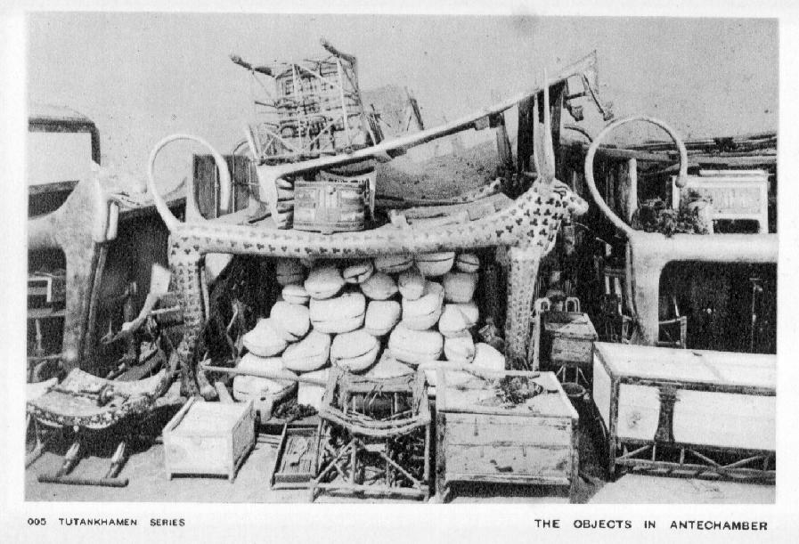
Some of these items were copied for the British Empire Exhibition and can now be seen in the Museum in the old Grammar School in the centre of Hull.

Visitors to the British Empire Exhibition in both years were fascinated with these replicas as this was still in the age when the average man-in-the-street did not go abroad for his holidays and touring in places like Egypt was more for the aristocracy and the wealthy.
After the close of the Exhibition in October 1925, Mr Albert Reckitt of Reckitt & Sons Ltd of Hull purchased the replicas for his private collection. In 1936 he presented them to the City of Hull Museums. They have now found a permanent home in the ‘Hands on History’ Museum in the Old Grammar School in the centre of Hull.
I had heard that these items ended up in a museum in Hull but on receiving an enquiry from a researcher into ‘Egyptology in London’ for a book, I found the Hull Museums website and sent a message asking about the replicas. Very soon a reply came back by e-mail confirming the name of the actual Museum where these items now are and details about opening etc. This was passed to the researcher who informed me that the help from our Group would be acknowledged in his forthcoming book.
As we were about to hold our 2002 Convention in York, and Bill had been kind enough to take me up to York with him in his car, I had the thought that we might divert to Hull on our way home to see these items, which can be regarded as an additional item to my article on where Wembley Exhibition items can be found now. As suggested in the e-mail I telephoned the Museum to check that it would be open the following Monday. I was happy to hear that it was and looked forward to seeing another example from my favourite exhibition. There is a multi-storey car park opposite the very large Holy Trinity Church and is only a couple of minutes walk away from the Museum.

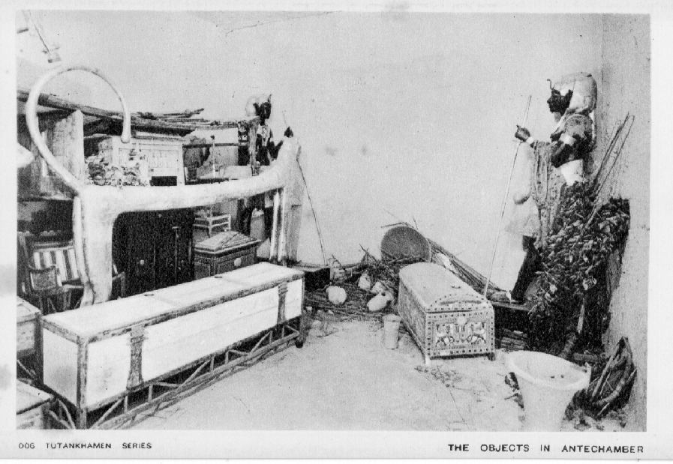
Replicas of the beds or couches were one of the items on display at Hull

When we arrived at the Museum we informed the lady behind the counter as to why we were there and she directed us upstairs to a couple of rooms and there before our eyes were the replicas in bright gleaming colours, looking to all the world as if they had just been made, and not eighty years previously. The attendant handed us a listing of the items before us, but unfortunately this was only for use within the Museum. Naturally we asked if there were any publications or postcards to buy, but there were not. I asked if it was possible to obtain a photocopy of the pages and the man must have taken kindly to us ‘southerners’ with our London accents who were only passing through Hull that day, and arranged to get copies made for us at a nearby photocopying shop. I settled the amount due myself with a second set for Bill and I was asked to complete an enquiry form because we were asking for background information on the replicas and how they came to be in Hull. We both found the Museum staff extremely helpful.
Very soon some more photocopies arrived by post with one page from an article in the Reckitt & Sons in-house magazine “Ours” in the May 1936 edition. It was suggested that a charge might be due for the additional photocopying. Part of the text sent says that all records of accessions during the 1930’s were at the Albion Street Museum and were totally lost when the building was destroyed during a bombing raid in June 1943.
As I was keen to build up a file on these ex-Wembley replicas I telephoned David Richardson, Hull’s Assistant Education Officer, to say that the Group would be quite willing to pay for any photocopying, and explained that I wished to build up a permanent record of the Tutankhamen replicas for future members of the Group. David said he would contact their Finance officer and would let me know the cost. Very soon after, an envelope arrived with the set of photocopies of the Reckitt article and a note to say that they were providing our Group with them free of charge. This is a very generous gesture and I wrote back thanking them very much for their assistance.
All the photocopies are now housed in a binder together with a page from the Daily Mail for September 30th 2002 where scientists had reconstructed how they thought Tutankhamen had looked three thousand years ago. This is the system often used these days for reconstructing a face from X-rays of the skull and other modern technology. A few days later there was a very interesting television programme about how they thought that Tutankhamen had met his death at only 17 or 18 years of age. A Pharaoh about whom little was known at one time, has now become very well known.
British members will be able to recall the time in 1972 when items connected with Tutankhamen went on a world tour and for a time were on display in the British Museum in London. Most visitors had to endure long waits unless you were very fortunate. The day that we went I think we only queued for about forty-five minutes, but the display areas were very crowded. I am one of the few people who has seen them three times, firstly in the Cairo Museum as part of a Mediterranean cruise, then in London and thirdly again in Cairo during a holiday in Egypt.
By the way, the name Tutankhamun can be spelt in a number of different ways, all of which are correct! (I raised this point with the Post Office on the issue of the stamps in 1972 and they told me they had checked with the British Museum.)

Items on Display at Hull

Hippo-headed couch, Cow-headed couch, Lion-headed couch, black bed, white bed, Guardian of the Tomb, Wooden effigy or mannequin, Golden Throne, small chair, Golden Shrine, Gilt casket, chest, carrying chest, large chest, brown chest, white box, plain ochre coloured chair, two Alabaster vases, Folding stool, white stool, red stool, folding camp bed, a game of Senet and the Gold Face Mask (which has become the most famous object of all).

Post Cards

I have found a number of postcards of the Tutankhamen artefacts but sadly all are mint cards.
One thing is important, they cannot possibly date from earlier than 1922 and they are not British Museum issued cards.
All are titled tutankhamen series and were published by the Bruce Co. London. They appear to be a very long series and I have noticed differences that split them into 5 types. Liz. McKernan wrote an article (3) about the postcards for P.P.M. published in the November 2002 edition, in which she states, in relation to this series of cards “The photos used in this series appear to be identical to those taken by Harry Burton of the Metropolitan Museum of Art in New York, who photographed every stage of the excavation and every object found inside.”
Every card has, on the front left side, a number followed by ‘tutankhamun series’, and on the right is the title of the card. The backs have a standard format of POSTCARD across the top with an almost joining T division and FOR CORRESPONDENCE on the left and FOR ADDRESS on the right. The words ‘Printed in England’ appear in the stamp box.
An imprint “Copyright Publication by the Bruce Co. London” appears down the left hand back of every card.
Types 4 and 5 look to me to have this printed in a style reminiscent of the 1950’s and 1960’s. However the size of the lettering and whether the stamp box is made up of solid or dotted lines creates the five types as follows -
Words in Italics are only a description and do not appear in the text on the front of the card.

Type 1. Sepia printing, back printed in black, ‘POSTCARD’ measures 39 mm. dotted line stamp box 004 The passage to antechamber vertical left
005 The objects in antechamber couches and boxes
006 The objects in antechamber couch and statue
014 The canopic canopy vertical left
015 The tutelary Goddess Isis vertical left
042 An Alabaster casket
043 An ivory and gilt casket
044 The King’s jewellery box

Type 2. B/W, back printed in brown, ‘POSTCARD. measures 40 mm. solid line stamp box.
002 The Valley of the Kings

Type 3. B/W, back printed in black, ‘POSTCARD’ measures 52 mm. dotted line stamp box.
024 The King’s Sceptres

Type 4. B/W, back printed in black, ‘POSTCARD, measures 43 mm. dotted line stamp box.
019 The alabaster canopic chest. vertical right
055 The King’s centre-piece. vertical left

Type 5. Back printed in black, ‘POSTCARD’ measures 30 mm. dotted line stamp box.
072 The King’s Ba (Soul) pectoral ornament

I have held onto these cards in the hope that one day one will turn up with a Wembley stamp and message such as “just seen these things at Wembley”, and we will know the source. It is my considered opinion that Type 1 being sepia pictures could have been issued around the time of the Exhibition.

The question that still needs to be answered is “Why did a London based firm publish cards of the Tutankhamen find?”

Footnote: texts marked (1) and (2) are taken directly from the article in “Ours” May 1936 and grateful thanks are extended to Hull Museums who supplied copies of the article. The article by Liz McKernan is also acknowledged (3).

British Empire Exhibition 1924 - 25 Commemorative Ceramics.

by

Jenny Hill

The British Empire Exhibition (BEE) was the most prestigious inter-war event in the UK. Designed to encourage trade between Britain and its Empire in a time of economic struggle for Britain, it attracted 17.5 million visitors in the 1924 season. For comparison, the Great Exhibition of 1851 attracted just six million over a similar period. The BEE was huge, covering 216 acres and served by three new railway stations. It was mainly built in concrete, a contemporary material reflecting the desired image of a modern Britain. Countries from all over the Empire took part. To give an idea of its vast scale, Wembley stadium covered less than a tenth of the site.
The two largest buildings were the Palaces of Industry and Engineering. The Palace of Industry contained a pottery section, where the latest British technology, such as a rotary kiln and a gas kiln, were demonstrated. These were far cleaner, safer and with greater temperature control than the coal-fired bottle kiln still prevalent in the Potteries in the 1920s. The pottery section was reached through three tall porticoes representing Wedgwood, Moorcroft and Pilkington’s, each in a different style to reflect their company’s produce. Many firms had stands there while others, particularly art potteries, had smaller displays in the Palace of Arts.
A great deal of commemorative pottery was produced for the BEE, mainly crested china. These items were small, mostly inexpensive and came in a vast array of shapes to encourage collecting. Aimed at the cheaper end of the market, this type of ware was extremely popular from the 1880s to the 1930s as a reminder of an enjoyable day out.
Crested ware was sold in shops, stalls and kiosks at the BEE. Most crested ware had a printed black or sepia outline and was hand coloured, full colour printing not yet being available. Scenic transfers are much rarer than other BEE crests, needing more skill to produce.
The lion, symbol of power and might, was a strong theme of the exhibition. A stylised lion, designed by J. C. Herrick, appeared on advertising literature and was used on crests by several companies, including Goss, Grafton and Paragon. Some firms, including Goss and Wembley China, also made Wembley Lion models for the BEE.

W. H. Goss

Crested ware is generically known as Goss ware, after the earliest and most famous crested ware manufacturer, W. H. Goss. The founder’s son, Adolphus, saw the vast sales potential of heraldic porcelain and each major town and city soon had a Goss copy of a local archaeological artefact, decorated with the appropriate coat of arms. Originally each shape could only be sold in its town of origin, but in time Goss agents could order any model from the range, although it had to be decorated with the local coat of arms. So, for example, you might find a Glastonbury shaped vase with the arms of Sheffield.
The Goss stall is shown below, the picture being taken towards the end of the event in October, judging by the sale signs and the fur coats. You can just make out a Shetland pony model on the top shelf, though Goss mostly concentrated on the various vases, jugs and urns for which they were famous, rather than include more contemporary subjects as many of their rivals did.

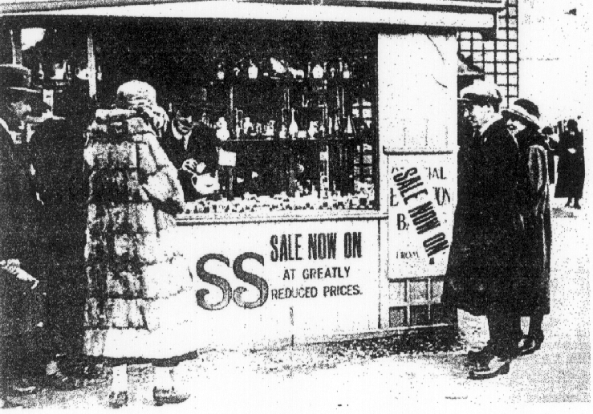
Figure 1. The Goss stall at the BEE.

Goss appear to have made only two new shapes for the BEE, a Wembley Lion and a model of Wembley Stadium. Instead, they decorated existing shapes with new transfers. The stylised lion, yellow on a red ground, is the most commonly seen Goss BEE crest.
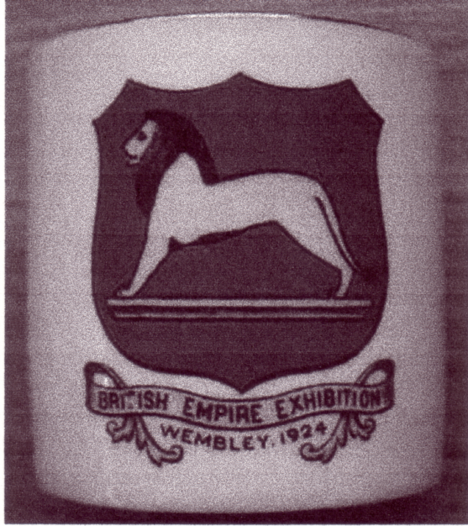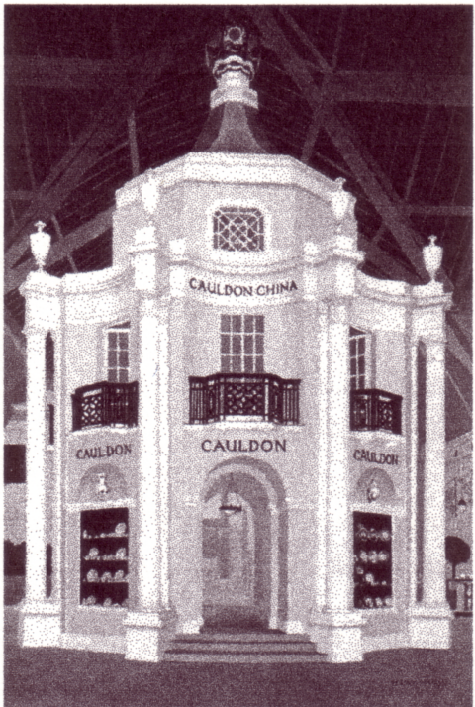
Figure 2. Example of Goss BEE souvenir Figure 3. The Cauldon pavilion.
with Herrick lion transfer.

Goss also produced pictorial transfers featuring scenes from the BEE, including Old London Bridge, the British Government Building and the Indian Pavilion. Goss were taken over by Cauldon in 1929.

The Cauldon Group

By the 1920s many firms made crested china, the largest being Harold Taylor Robinson’s Cauldon group, which included Arcadian (trademark of Arkinstall & Sons). Cauldon had a large pavilion in the Palace of Industry at the BEE, topped by their crown logo displaying mainly tableware.
Arcadian was by then the most prolific and successful crested ware manufacturer in the UK, selling their wares everywhere from pubs and seaside kiosks to china shops. Although not so finely modelled or painted as Goss, they cost very little and offered an extraordinary range of shapes. By 1924, Robinson had a controlling interest in many pottery companies, including Geo. L. Ashworth & Bros. (Mason’s Ironstone) and Henry Alcock Pottery Co., as well as several firms noted for their crested ware. These included Wardle’s Art Pottery Ltd., Ford & Pointon (Fords China) and Charles Ford (Swan China). The last two companies were linked before being taken over by Cauldon and carry similar swan marks.
Robinson set up Wembley China specially to produce BEE souvenirs. Wembley China was sold from two kiosks in the grounds of the BEE in 1924. The company’s crest for 1924 is the most detailed and well-designed of the BEE devices. It shows a seated Britannia with Union Jack shield and recumbent lion over a scene with a coal mine, Sir Francis Drake’s ‘Golden Hind’ and a First World War biplane. All of these features could be seen in one form or another at the BEE and represented Britain’s industrial might and the expansion of the Empire. The whole scene is surrounded by flags of the Empire and banners carrying the name, place and dates of the exhibition. Because of the scale of Robinson’s enterprise, this is the most common BEE crest, being also used by other companies in the Cauldon group, notably Arcadian and Cauldon. Wembley China’s stylised lion mark, along with Arcadian’s crown-topped logo, is the most commonly found mark on BEE crested ware, although not all ware carrying the Cauldon group crest is marked.

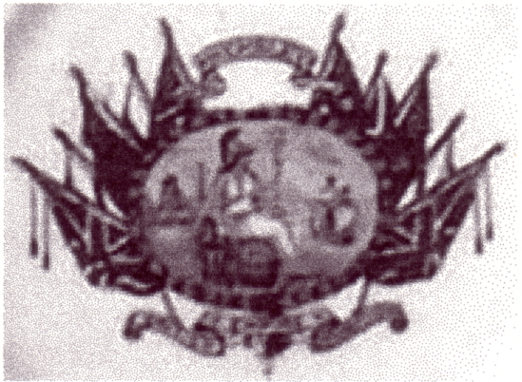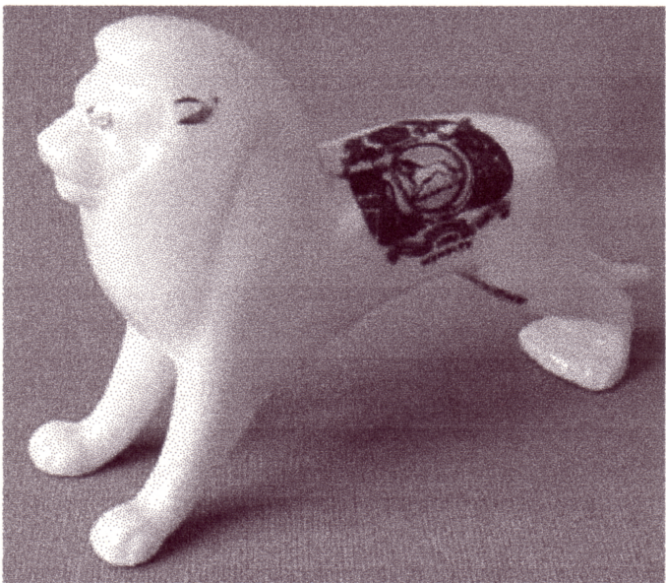
Figure 4. Cauldon group Britannia crest. Figure 5. Arcadian Wembley lion.

A different Arcadian crest is seen for the BEE in 1925, a Herrick lion in a circle on a blue background, topped by a globe and enclosed by two Union Jacks. Here, it is shown on a model of the Wembley lion.
Several BEE specific models were produced by Wembley China, including the British Government Building complete with miniature lions, Queen Mary’s Dolls House (the real version of which was on display in the Palace of Arts), Old London Bridge (a feature seen in several postcards of the exhibition) and Wembley Stadium.
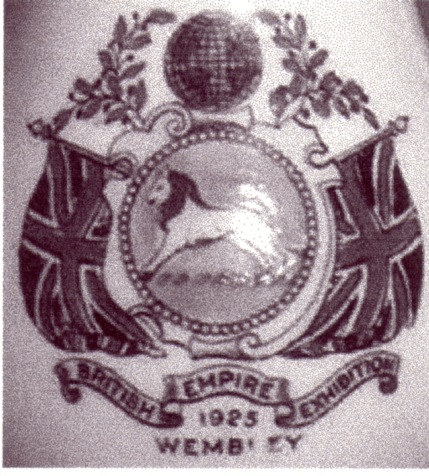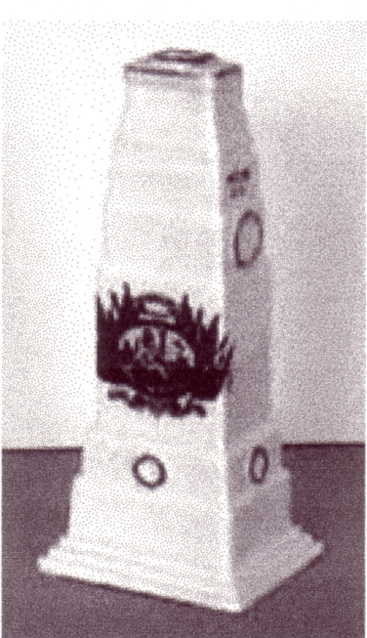
Figure 6. Close up of Arcadian BEE Figure 7. Wembley China
1925 lion crest. Cenotaph

Many existing Arcadian models were used for BEE ware, probably chosen for their popularity. These included war-related items, such as the Whitehall Cenotaph and a submarine; items associated with the home, such as fireplaces and flat irons; boots, beakers and many different vases.
Animals were a popular theme of the day. Arcadian/Wembley examples include a rabbit which, if viewed from a different angle, looks like a duck. An example of this is at The Grange Museum in Neasden, London. ‘Lucky’ items, such as black cats and white heather became popular following World War I. Black cat transfers appear on many Arcadian shapes, often with the message ‘Good Luck from Wembley’.
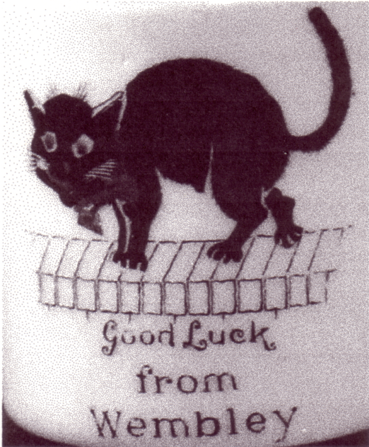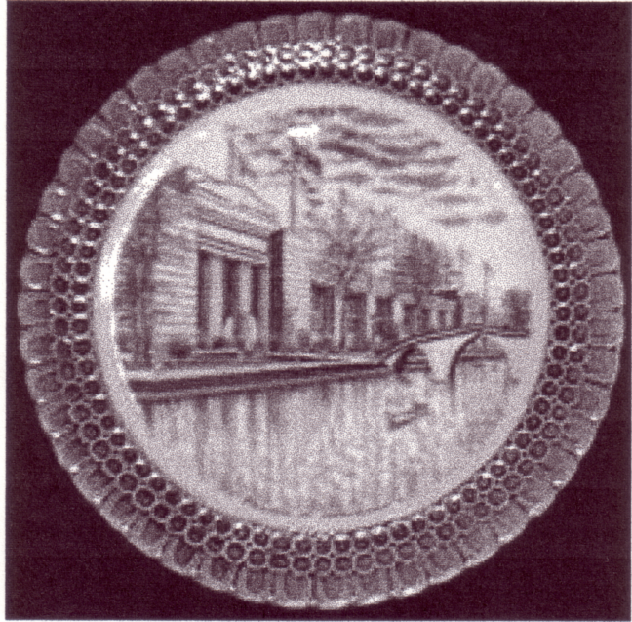
Figure 8. Arcadian black cat Figure 9. Cauldon blue and white Palace of
design. Industry plate.

Arcadian’s Black Cat series of models, which were introduced not long before the exhibition, sometimes appear with BEE crests. Twenty-four different models were made, including cats on a sledge and a cat in an armchair. The more complicated, such as four cats sitting on a roof with their tails dangling down to form the words ‘good luck’, are only rarely seen, as they were expensive to produce and buy. Other cats seen include cartoon character Felix the Cat and the Cheshire cat from Alice in Wonderland.
More unusual items include sporting items, varying from a large horse and jockey to a golf club head; various regional models, such as a Welsh Tea Party group and finally a hand holding a pig’s trotter. If anyone is aware of the origin of this, please let me know. Perhaps a drinking club?
The Cauldon group also made a series of plates decorated in blue with scenes from the exhibition, including the Palace of Industry. These designs fill the plate, whereas many other plates are seen with a tiny transfer in the centre.
Although Robinson controlled several household name companies for a time, such as Coalport, Royal Crown Derby and Royal Worcester, the Cauldon group did not survive the depression of the 1930s, changing tastes and competition from such firms as Gemma of Czechoslovakia being contributory factors. Cauldon’s owner, Harold Taylor Robinson, had been the largest employer in North Staffordshire from 1920 to 1930, but was bankrupt by 1932.

Grafton China

Alfred B. Jones & Sons (Grafton China) was another major manufacturer of BEE crested ware, with several different transfers including a range showing the ‘Lights o’ Wembley’, sunset scenes similar to the impressionistic illustrations in Donald Maxwell’s BEE commemorative book, Wembley in Colour (1924). Their most common crests show the Herrick lion, as do those of Carlton, Goss, Paragon and others.
The vase below shows a Grafton crest of a yellow Herrick lion with blue mane over a globe, with the countries of the British Empire in red. As with many Grafton BEE pieces, the back is decorated with a tiny pair of orange lions and the inscription ‘Souvenir Wembley Exhibition 1924’. Another Grafton crest shows the Herrick lion in a circle edged with the names of various Empire countries. A third shows the Herrick lion with sun setting behind, though confusingly this is also seen on Carlton china. Grafton ware is of good quality, translucent, finely potted and well painted.
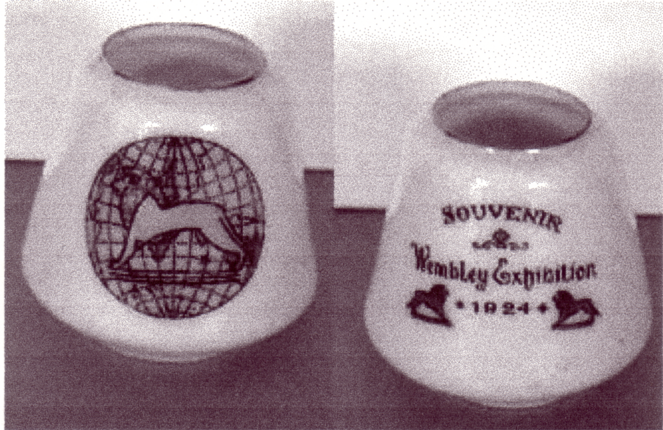
Figure 10. Grafton Egyptian vase, back and front.

Carlton China and Savoy China

Wiltshaw and Robinson (Carlton China) was the firm Harold Taylor Robinson began his career with in 1899, although he never succeeded in taking over the firm.
Carlton had three BEE crests; the most common being a standing Britannia with white Herrick lion on a bi-coloured red and yellow shield. A yellow Herrick lion in blue circle is seen on smaller items and a Herrick lion over a sunset similar to Grafton’s also appears, though not accompanied by their tiny twin orange lions.

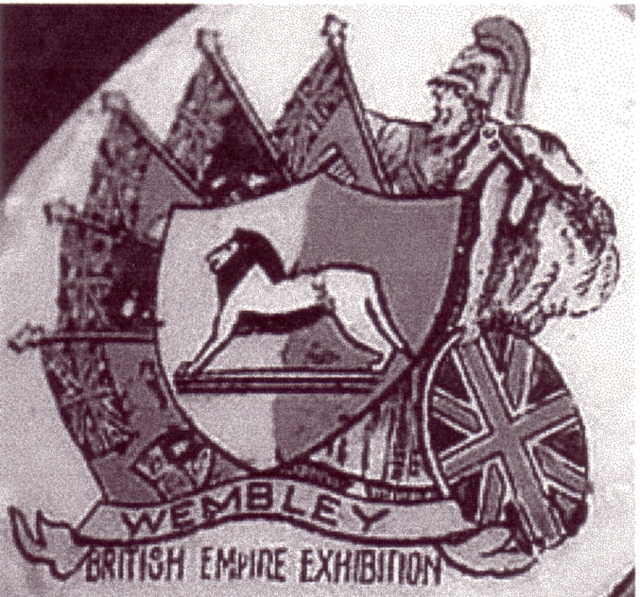
Figure 11. Carlton’s most common BEE crest.

Carlton made a good range of animals and birds with BEE crests, including a puppy looking at himself in a hand mirror, with the inscription ‘Me Twice’, an example of which is at The Grange Museum. Their distinctive series of birds with green bases, including ducks and geese, sometimes appear with BEE crests. A few models were designed specifically for the exhibition, such as an ashtray with a standing Herrick lion model.
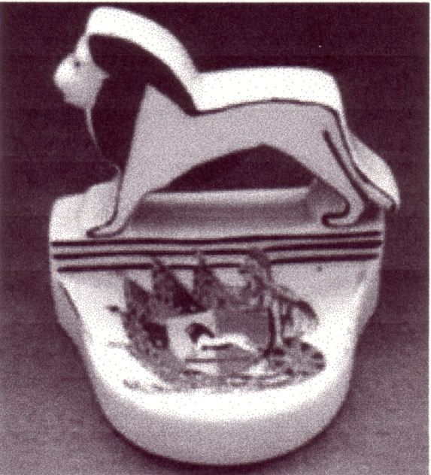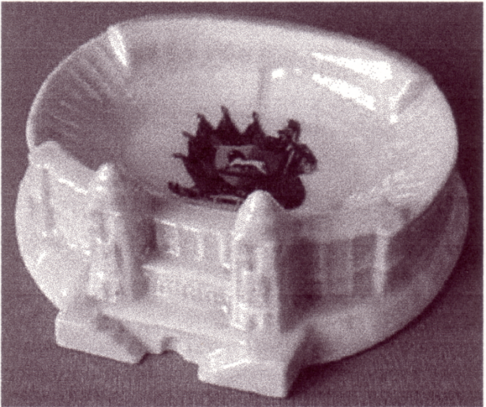
Figure 12. Carlton Herrick Lion ashtray. Figure 13. Carlton Wembley Stadium.

Carlton also produced a model of Wembley stadium, opened in 1923 in preparation for the BEE and the 1923 FA Cup Final.

End of part 1.

A reminder to those who have not paid their subscriptions yet. Send it in and wish our Treasurer a Happy Christmas and Prosperous New Year at the same time. This will save you one lot of postage. Don’t forget, do it now.

PUBLICITY LABELS
OF THE BRITISH EMPIRE EXHIBITION
WEMBLEY
1924 - 1925

There will be a full report in the next Journal on our AGM but I will take this opportunity to inform you that the Study Groups next publication is nearly ready for going to print. The two publications on British Empire Exhibition advertising labels have both been out of print for some years and Alan Sabey and myself have been working on a completely new book to cover the material in the two previous books and all the new finds that have come to light in the last six years.
At our AGM it was proposed, seconded and passed that the Study Group pay for this new publication and it should be offered to members at below the printing cost the same as the Festival of Britain book two years ago. I am at this stage not able to say what the price will be until quotes have been received and a final decision made.

Wembley
by Geoffrey Hewlett

Images of London have just published a book by Geoffrey Hewlett on Wembley, 128 pp, 220 illustrations, ISBN 0 7524 2633 8 at £11.99 It can be obtained from Des Barber. 13, Milton Avenue, Kingsbury, London. NW9 0EU. Phone 020 8204 4815. I don’t know if there is much exhibition interest in it as I have not seen a copy, but Des can tell you.

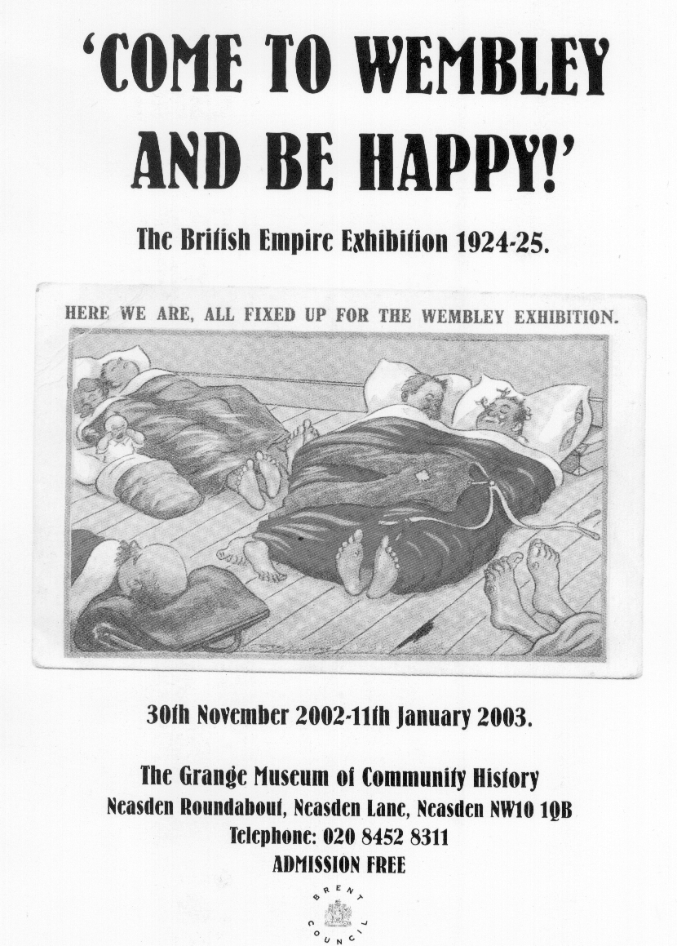

Grange museum are holding an exhibition on a previous exhibition, held in Wembley in 1924-25. Some of you might have heard of it. The have distributed the above flyer about their show, and have used as an illustration a post card not known to the Authors of ‘Postcards of the British Empire Exhibition Wembley. When Alan saw the flyer he asked where they had got the card from, it was on display they said, and were good enough to unlock the cabinet so he could examine the card and get the number printed on the back. It was published by Regent No. 1430 They also had another unlisted Regent card No. 1420, which he got details of and forwarded on to me. Thanks to Alan Sabey for the information.
Post Cards of the White City.
Part 23.
by Bill Tonkin

214 Court of Honour Night Effect, Franco-British Exhibition, London, 1908.
284 Court of Honour Night Effect, Franco-British Exhibition, London, 1908. Vert left. (rough edge at top)

List of Valentine’s Postcards from letter cards with the top and bottom edge
perforated or rouletted.

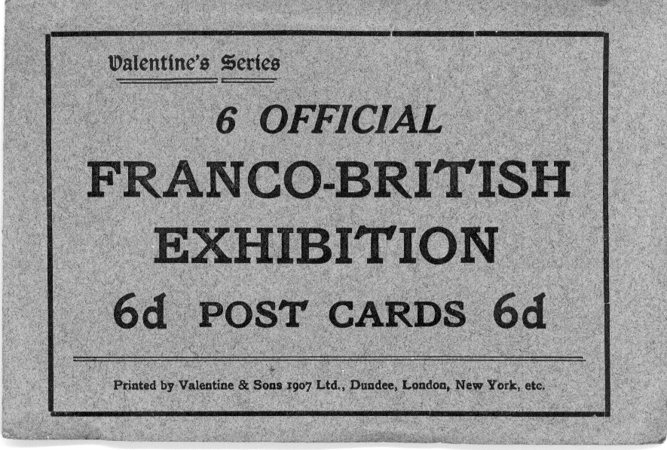

Letter card containing six post cards rouletted at the top and bottom (except the first and last card)
and folded concertina style, in a dark grey folded cover with black printing

Letter card No. 1. Franco-British Exhibition.
Coloured postcards with a red ‘FB seal’ back, rouletted on the top and bottom edges. These are listed from top to bottom.
281 Congress Hall from Gardens, Franco-British Exhibition, London, 1908.
331 Flip Flap and colonial Bandstand, Franco-British Exhibition, London, 1908.
N.n. View from Flip-Flap, Franco-British Exhibition, London, 1908.
132 Scenic Railway, Franco-British Exhibition, London, 1908.
220 In Elite Gardens, Franco-British Exhibition, London, 1908.
250 Court of Honour, Franco-British Exhibition, London, 1908. The bottom edge is smooth.
There must have been two printings of this letter card as No. 220 is known titled with and without the ‘In’ in ‘In Elite Gardens, Franco-British Exhibition, London, 1908.’

Letter card No. 2. Franco-British Exhibition.
Coloured, with a grey ‘Famous Throughout the World’ back, perforated on the top and bottom edges.
132 Scenic Railway, Franco-British Exhibition, London, 1908. The bottom edge is smooth.

Pre exhibition forerunners.

Valentine’s needed to have a large stock of cards for sale on the opening day of the Franco-British Exhibition, and they would have been preparing for this probably months ahead of the event. They were able to take photographs of the various pavilions before they were completed, and these would be handed over to artists who finished them off. Lawns and pathways would be painted in, shrubbery and trees added, and to give the pictures a bit of life, visitors would also be drawn in. None of these cards are numbered, although this is not perhaps totally correct, as one card, a view of the Stadium had no number when published as a coloured card, but when published with an ornamental border was given number 110 in very small figures printed in the design.
As soon as the exhibition opened Valentine’s photographers would have been busy, taking the many hundreds of shots that would be turned into postcards, and within days, these would have been on sale. It is likely that the forerunners would have been replaced with a large range of cards showing the exhibition and all its wonders as soon as possible, and the forerunners gradually phased out. It is noticeable that while possibly hundreds of thousands of valentine’s cards were remaindered after the exhibition closed, there were very few of the pre exhibition forerunners amongst them. These remaindered cards were sold by wholesalers at 4/- per thousand to be used for advertising or ¼d change after the various exhibitions closed. In today’s decimal currency this works out at £1 for 5,000 cards, for a wholesaler to be able to sell at this price, Valentine’s must have almost given the cards away. So far, very few of the forerunners have appeared as advert cards, in fact it would seem only one firm ‘Rood Bros.’ had some, which would support the idea that they were phased out, as other cards took their place.
The forerunners are easily identified, as all the figures of people can be seen under a magnifying glass as crude drawings and not photographs of real people, the pathways, buildings and areas of lawns are shown as solid patches of colour, and also the forerunners were only used for the Franco-British Exhibition in 1908. The forerunners often used the same title for two or three different views, and these are listed as type 1., type 2., etc. They also used different titles for the same view. For full details of any postcard see in the main section.
Another type of card which was also probably produced before the exhibition opened were cards drawn by artists. Apart from a few odd views this includes the series ‘Conveyances’, ‘Entente-Cordiale’ and ‘Old London’. Artist drawn cards, like the forerunners were only used for the Franco-British Exhibition and the White City, although one card showing a rickshaw was republished for the Japan-British Exhibition.

Algerian Palace, Franco-British Exhibition, London, 1908.
Ballymaclinton (Irish Village), Franco-British Exhibition, London, 1908
Bridge in Court of Honour, Franco-British Exhibition, London, 1908.
British Applied Arts Palace, Franco-British Exhibition, London, 1908. Type 1.
British Applied Arts Palace, Franco-British Exhibition, London, 1908. Type 2.
British Applied Arts Palace, Franco-British Exhibition, London, 1908. Type 3.
Canadian Scenic Railway, Franco-British Exhibition, London, 1908.
Colonial Avenue, Franco-British Exhibition, London, 1908.
Colonnade British Applied Arts Palace, Franco-British Exhibition, London, 1908. Type 1.
Colonnade British Applied Arts Palace, Franco-British Exhibition, London, 1908. Type 2.
Colonnade in British Applied Arts Palace, Franco-British Exhibition, London, 1908. Type 2.
Colonnade in British Applied Arts Palace, Franco-British Exhibition, London, 1908. Type 3.
Colonnade in Court of Honour, Franco-British Exhibition, London, 1908.
Colonnade Palace of Music, Franco-British Exhibition, London, 1908. Type 1.
Colonnade Palace of Music, Franco-British Exhibition, London, 1908. Type 2.
Colonnade Palace of Music, Franco-British Exhibition, London, 1908. Type 3.

Knight and Sabey, p.157.

