EDITORIAL Autumn 2002

The hot days of summer are here at last
Get out while you can, it will soon go past

I had an interesting phone call the other day all the way from Japan. It was from a young lady Yuriko Fukasawa who visited me some few years ago, whose main interest is in the Ainu, an ethnic Japanese tribe who in the early years of Japan’s awakening, were gradually driven off the mainland and are now living on the Island of Yezo. She had lived for two years among them and wrote a thesis on their customs which got her, her Doctorate. Since then she has gone on to become a full blown Professor of Archaeology and is now based at Sapporo International University.
There has been a lot of interest in the Ainu during the last few years and this seems to be centred on a visit made to Britain in 1910 by five Ainu men, four women and a child to appear in a small village set up at the White City for the Japan-British Exhibition. This was reported in the Times of the 16th April 1910, although from the post cards it seems there might have been two children. Philipe Dallias of Lausanne University visited me to go through my Ainu post cards. He took them back with him to photograph for the University records. These were returned to me a few weeks later. It seems I have more pictures of the Ainu at the White City than is available anywhere else.
On her first visit Yuriko only had time for a brief look at some of my cards. She now wanted to go through my 1910 Japan-British Exhibition cards in some depth, as like myself she finds it an absorbing exhibition. Could I give her the name of a hotel in or near West Wickham where she could stay for a few days. I suggested that as I had a spare bedroom she would be very welcome to stay with me, and about a week later she arrived, complete with lap top computer, a lap top scanner and spent nearly three days delving into, and scanning my Japan-British Exhibition collection.
On Yuriko’s last day after she had broken the back of the job, I suggested we spent the Saturday at the Haywards Heath post card fair, where she was overjoyed to find a few Japan-British cards to add to the few she found in my boxes of duplicates. One card she found was a common Valentine one showing a group of Ainu which the dealer was asking £9.00 for. I advised her against buying it as it was a £1.50 to £2.00 card. She went ahead and bought it, as she said, they do not have post card fairs in Japan and it might be a long time before she saw another one. Unfortunately she had to leave Saturday night so was not able to come to Bristol with me on the Sunday where I saw an identical card in immaculate condition for £2.00.
It is very gratifying to me to know that collecting post cards which for so long has been in my opinion a very much underrated hobby, is now moving into an area of respectability. Had someone told me ten years ago that people would come from Switzerland and even further afield from Japan to see my cards it would be unbelievable, but it has happened.
When I look back to when I first started to collect post cards, one of the things that attracted me was the fact that almost nothing was known about them. It was a field wide open, waiting for someone to start the research. I had been involved with stamp collecting for many years and was packet secretary of one of the largest philatelic societies in the country for 21 years, but as I saw it there was very little scope for a person with modest means to carry out any serious research into stamps.
With post cards it was very different, they were cheap and there were so many opportunities for original research. When the Exhibition Study Group published the book by Mike Perkins and myself on the British Empire Exhibitions back in 1994 it was, I believe the first major publication devoted in such depth to a post card subject. We were both very pleased when it was awarded the Desmond Chamberlain Trophy for outstanding research. It is the standard work on the subject and will remain so for the foreseeable future. Last year the Study Group published ‘Post Cards and Related Collectibles of the Festival of Britain’ by George Simner and myself, and I am very happy to say this has also been awarded the Desmond Chamberlain Trophy which we will receive at the Post Card Show at the end of August. In getting this trophy for the second time I have established a position in the post card world that I could never have got anywhere near, in the philatelic world.
I’m still getting around to the fairs but it has to be said that good cards are very few and far between. Some of the prices being asked by dealers seems to me to be out of this world. While collectors are willing to pay these prices, they will continue to rise. Thank goodness I built up my collection when I did, as it would be impossible to do it now.
I will close by reminding you that the end of September will see the Convention upon us and I am looking forward to it. To meet friends who I may only see once a year, all goes to make a very pleasant weekend. I am lucky as I have plenty of friends who keep in touch with me on exhibition matters, but I remember Karl Illingworth once saying to me that the convention was the only opportunity he had of meeting other exhibition collectors from one year to the next. Karl has unfortunately dropped out of sight but if anyone knows his where abouts I would like to know. Alan Sabey and myself will be travelling up together on the Friday and shall be staying Friday, Saturday and Sunday night coming back on the Monday. There will be a crowd of us as usual as there are others staying on the Friday and Saturday nights.
The Hotel is just outside the city walls about half a mile from York Railway Station and about the same from the National Railway Museum. The hotel has its own car parking area within the grounds. The nearest pub is about five minutes walk, and is called the ‘Crystal Palace’.
The address is, Holgate Hill Hotel. 124, Holgate Road, York. YO24 4BB. The phone number is 01904 653786 and E-mail address is <info@holgatehillhotel.co.uk> Here’s looking forward to a good convention and if you are coming please let me know if you will be bringing a display.
I still have a few hotel brochures and if anyone would like one let me know and I will pop one in the post but time is getting short if you have not already booked.

The Editor.

Olympia 1886 - 2000
Part 2.
by
R. O. Tough MBE

Royal Naval and Military Tournament

1906 saw the first performance of the ‘Royal Naval and Military Tournament’ at Olympia. It had started out as the ‘Grand Military Tournament and Assault of Arms’ and opened on the 22nd

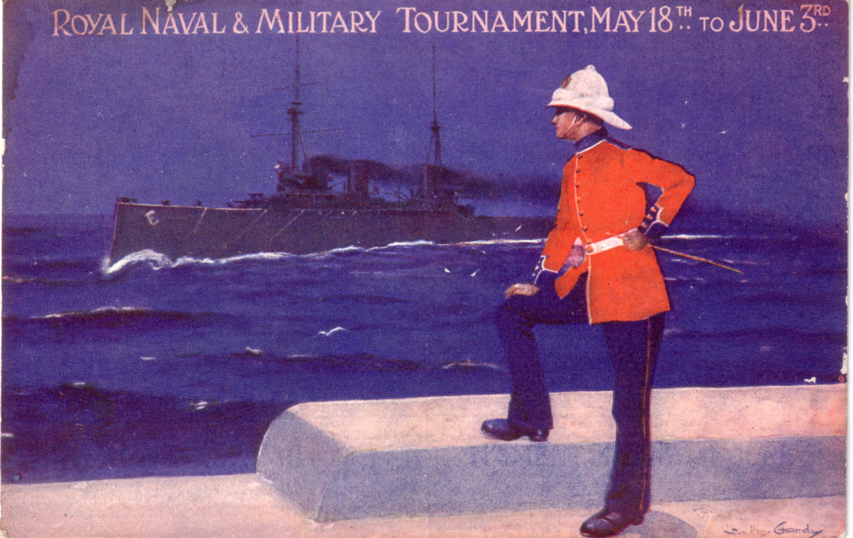

1911 Royal Tournament poster type card
June 1880 at the Agricultural Hall, Islington in North London. It was not until 1884 that Queen Victoria became Patron and gave permission for the Royal prefix to be added to the title. The Royal Navy first took part in 1897 and in 1905 it became the ‘Royal Naval and Military Tournament’. In 1919 the newly formed Royal Air Force joined in and for one year it was called ‘The Royal Naval, Military & Air Force Tournament’. This long title was dropped next year when it adopted its last change of title and became ‘The Royal Tournament’.

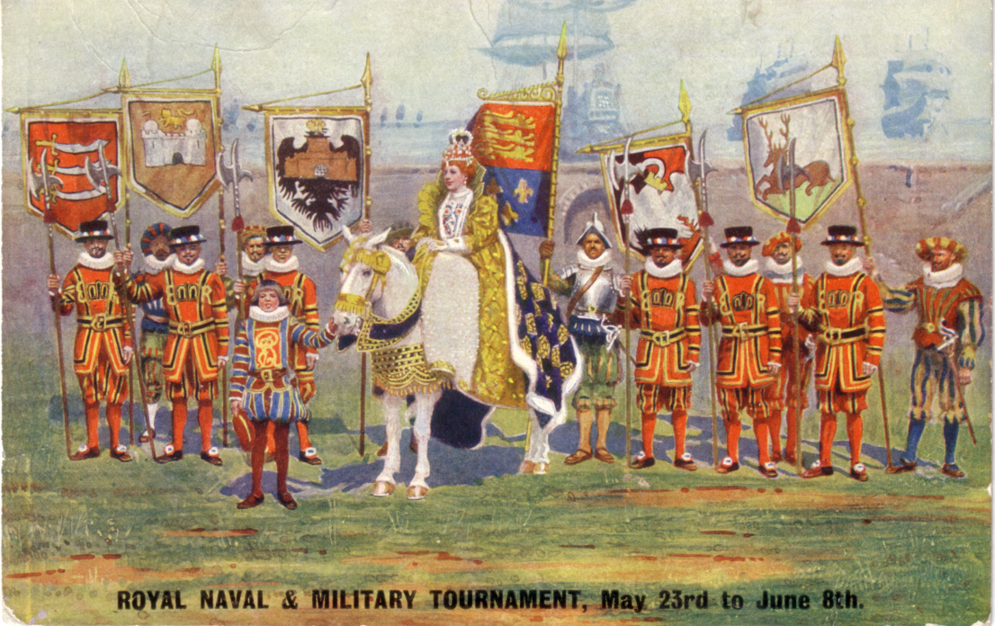

1912 Royal Tournament Queen Elizabeth reviewing her troops at Tilbury. It was here she made her stirring speech which included “I know I have but the body of a weak and feeble woman, but I have the heart of a King, and a King of England, too.”

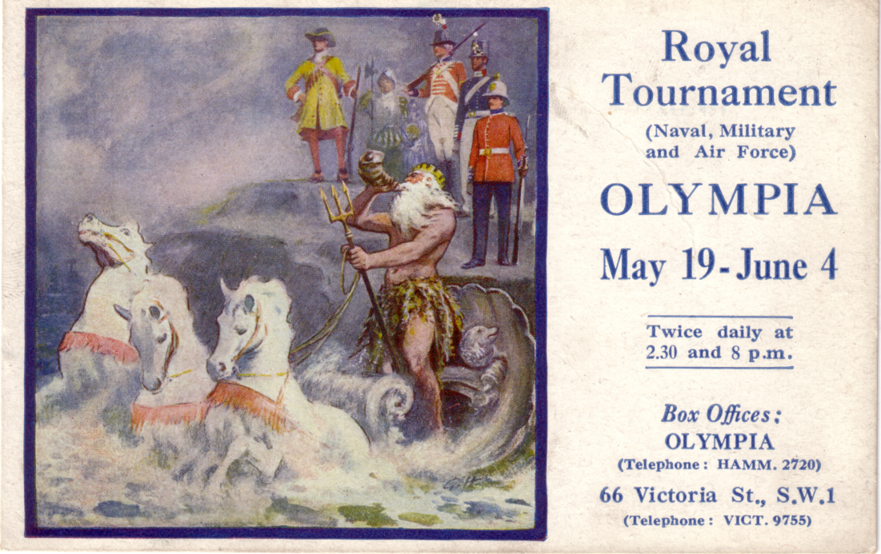

1921 Royal Tournament, Neptune rules the waves.

One of the competitions held during the first Tournament in 1880 was ‘Cleaving the Turks Head’ where mounted officers had to cleave an imitation head mounted on a pole at full gallop. This was later abandoned in favour of ‘Cutting the Lemon’ in deference to our Turkish allies. An early example of political correctness ?
The Tournament has always enjoyed Royal Patronage and a feature on many of the hundreds of post cards issued for the event was the Royal Box which was constructed to a different design each year. Gale and Polden who published the tournament cards for many years, always made sure they had a photographer there on the Royal visit days.
Apart from the war years 1915-1918 and 1940-1946 it was held every year at Olympia until 1950 when the demand for seats exceeded the capacity of Olympia and it moved to Earl’s Court. The first Tournament was held over five days, but by the 1930’s this had extended to 18 days which became the norm. In 1993 it was cut to 12 days because of manpower reductions in the Services.
The object of the Tournament apart from providing a competition among the Armed Forces was charitable and all profits from the Tournament were donated to Service charities. The B.B.C. televised the event for 40 years until it was taken over by L.W.T.

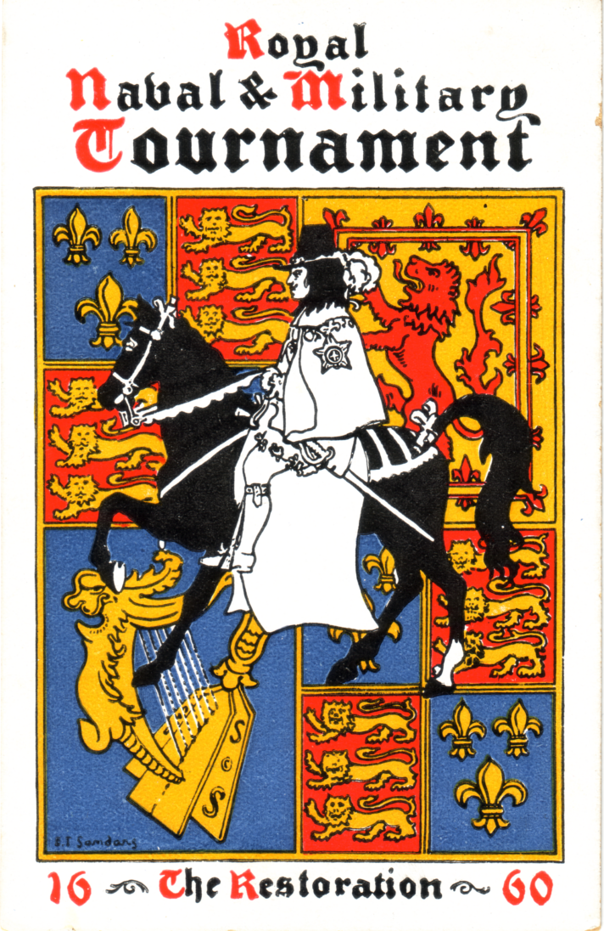

In the earlier tournaments a different theme was chosen for each year. In 1906 it was ‘Tilting in Olden Times’, 1907 ‘The Tournament in Olden Days’, 1908 featured the ‘West African Regiment’ 1909 ‘Transportation of Troops to a Theatre of War’, 1910 it was ‘Britannia’s Muster’, 1911 ‘Heroes of British History’ 1912 ‘The Call to Arms 1588’, 1913 ‘The Restoration 1660’, and 1914 ‘The Romans in Britain’. After a break for the first World War the themes were continued.

International Horse Show

1907 saw the start of another long running series of shows at Olympia, the International Horse Show. Like other shows at Olympia it was marked by some wonderfully attractive poster type post cards. Apart from the war periods the International Horse Show was held every year at Olympia, but when it commenced again in 1947 after not being held from 1940 - 1946 it moved to Shepherds Bush.

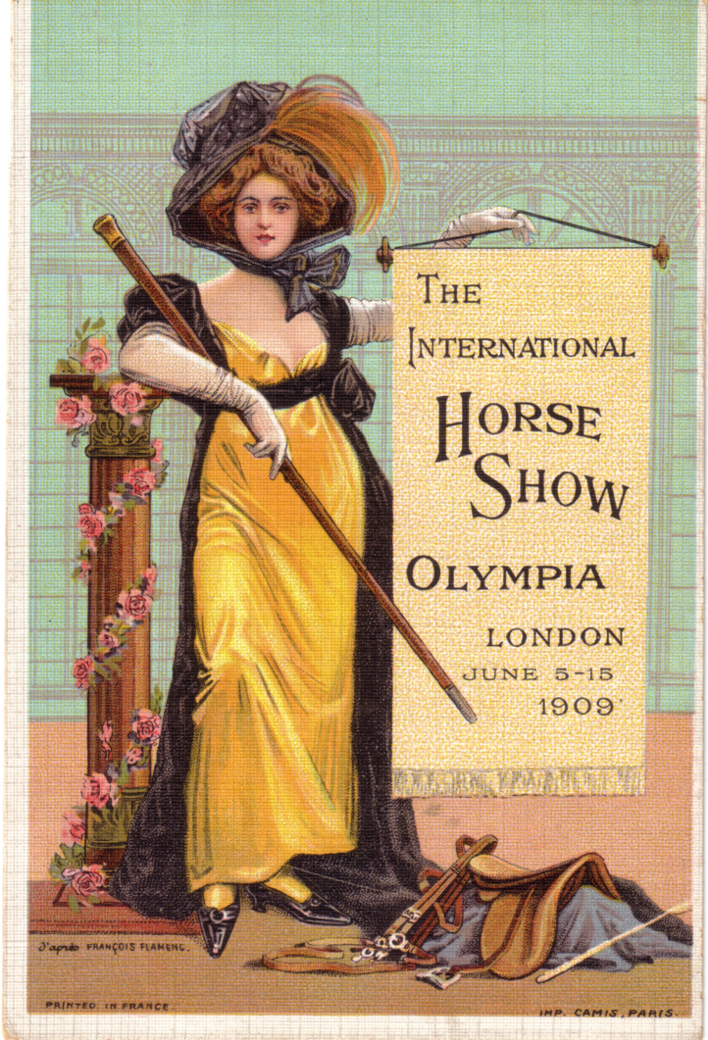

The International Horse Show 1909.

Many firms connected with Horses and the many allied trades had stands at the 1908 Horse Show and many advertised on International Horse Show post cards among them Thos. Carroll, corn merchant, Thomas Pettifer & Co., had on display their world renowned Horse, Sheep and Cattle Medicines, Llewellen & Co., Ltd., of the Walsall Saddlery Works, who advertised they had manufactured specially for the Exhibition one of the most magnificent and complete collections of harness, saddlery and appointments. Johnson, Walker & Tolhurst Ltd who at stand No. 6 exhibited jewellery and plate of interesting design, Dennis Bros., at stand No. 53 joining the Royal Box, Mills & Sons importers of American carriages, and one of Orpwood’s specialities was Mr F. V. Gooch’s patent Firm Seat Polo Saddles used by H.R.H. Duke of Connaught.
Even firms like Harrods used these cards to advertise their ‘Ladies Tailor Made Coats in Blanket Fleece at 42/- or in Harris tweed at 63/-.’ Their ‘Last word in Parisian Model frocks & suits’ were slightly dearer at 10½ gns.
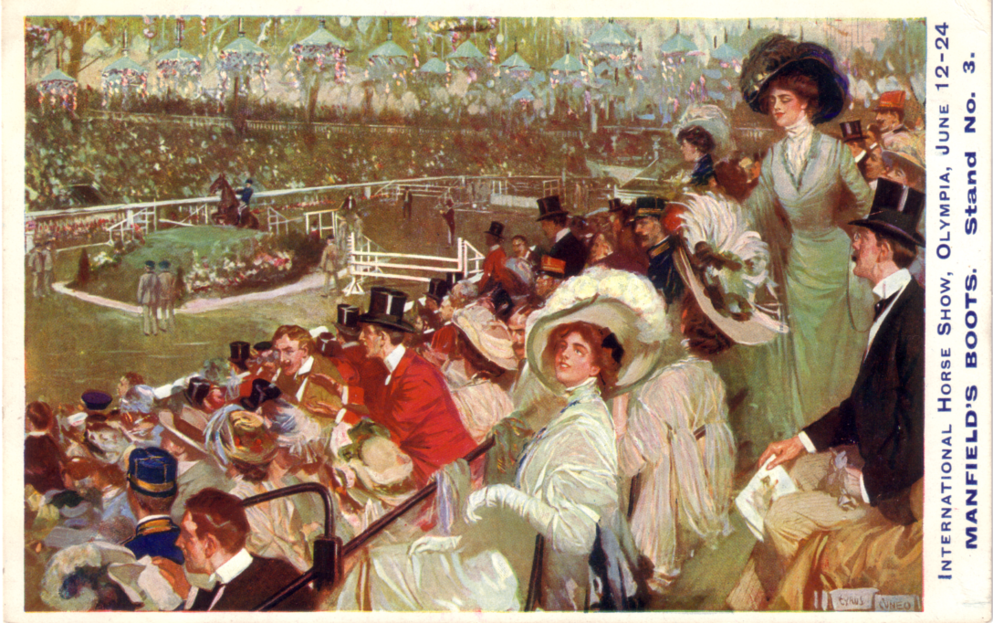

The International Horse Show 1911. Manfield & Sons advertised their Gentlemen’s High Class Footwear on Horse Show post cards, and on another card their choice designs in Ladies Coloured Footwear.

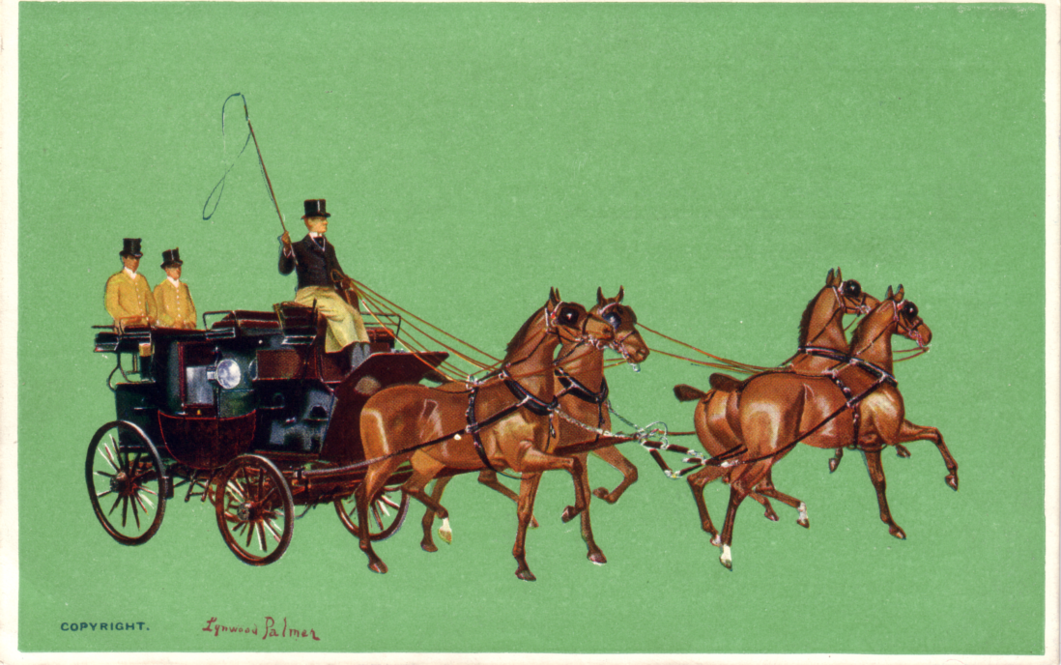

The International Horse Show 1908.

Daily Mail Ideal Home Exhibition

The years 1905, (The Motor Show) 1906 (The Royal Tournament) and 1907 (The International Horse Show) saw the start of shows that were to each run for nearly a century and in 1908 another was to bring the number of long runners up to four. The Daily Mail Ideal Home Exhibition, probably the most popular of them all.
It was founded by Wareham Smith, Advertising Manager and head of the Special Publicity Department of the Daily Mail as a means of increasing the advertising revenue of the Daily Mail. Smith had worked his way up from a clerk to become a Director of Associated Newspapers, publishers of the Daily Mail. He saw exhibitions as the way to raise advertising revenue and the Mail’s first attempt was an exhibition of British and Irish Lace, this was so successful that the results encouraged the next step which was the Ideal Home Exhibition.

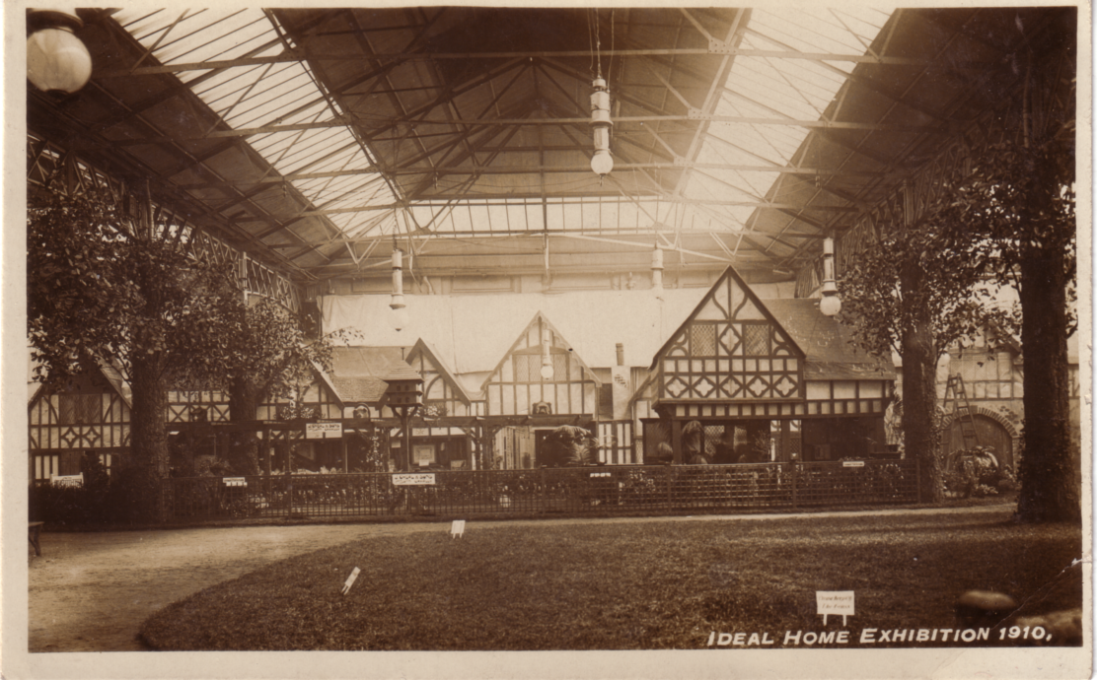

The central theme of the 1910 Ideal Home Exhibition was the Tudor Village, and this was featured on several series of post cards.

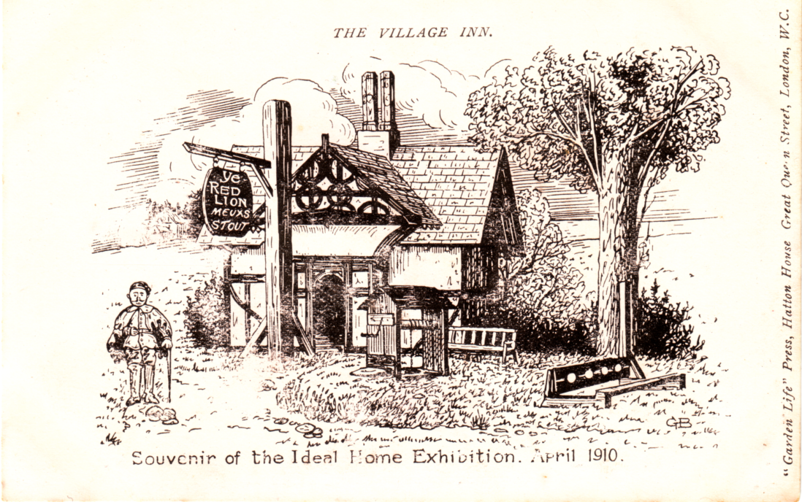

1910 Ideal Home Exhibition, pen and ink drawing of the Tudor Village.

Over the years two features became favourites, one was a different theme for each year, we had the Tudor Village, the Dutch village, the Russian Village, the Royal Gardens and Kitchens throughout the World, to name a few. The Tudor village was staffed by people in Tudor dress and the shops were occupied by firms that had been in business for at least a hundred years.
The other feature was to have show piece houses built every year in Olympia itself. Architects were encouraged to enter a competition and in the first year nearly 450 did so. Medals were awarded for plans divided into three price bands, and judged by Sir Edwin Lutyens. In 1908 there was a Tudor type bungalow and in 1910 a two story house designed by Mr Rupert Davison. The house had a living room, parlour, four bedrooms, a bath room and kitchen. In those days it would have cost about £600 to build.

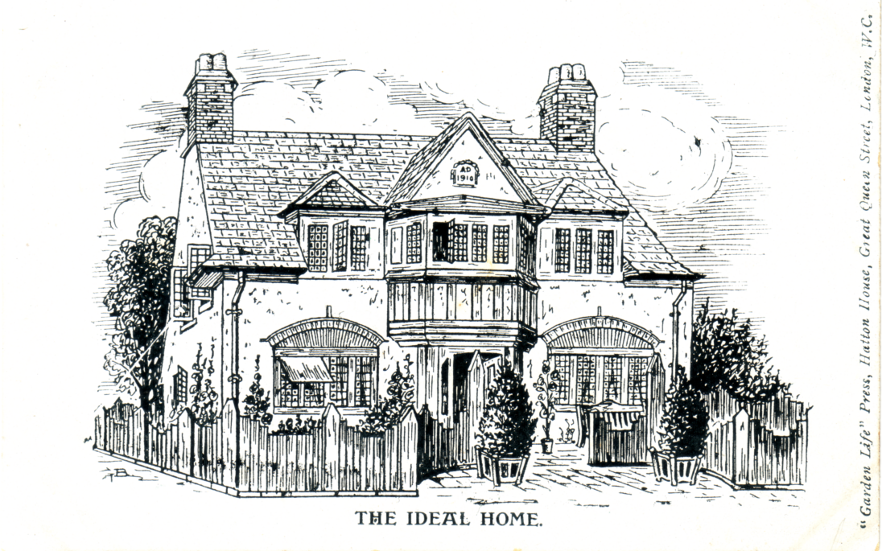

Pen and ink drawing of the 1910 Ideal Home at the Exhibition. This house was actually constructed inside Olympia in six days ready for decorating by Holloway Brothers (London) Ltd.

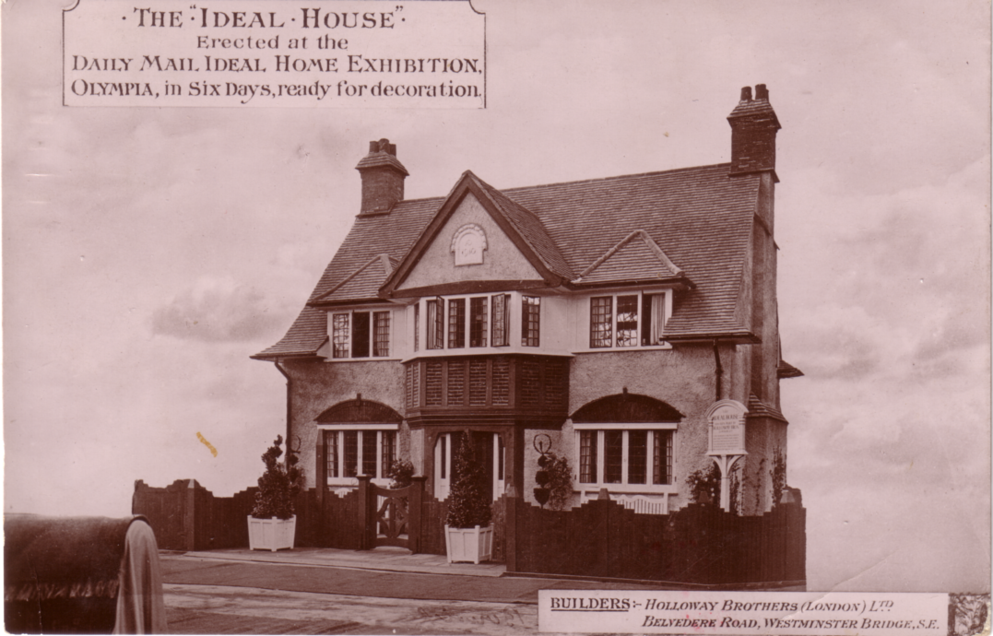

Photograph of the 1910 Ideal Home at the Exhibition.

In 1912 the centrepiece was an 11 roomed half timbered detached house chosen from 700 entries. It was designed by Mr Reginald Fry and built by H. & G. Taylor, Builders. After the exhibition closed the house was dismantled and rebuilt at Park Langley where it was put up for sale at £1,100 including fittings. It is still standing and would be valued well into seven figures today.
It has been recorded that Lord Northcliffe was not in favour of the exhibition and refused to visit the first two events, but was persuaded by his wife to visit the third one in 1912.
The Ideal Home Exhibition continued at Olympia until 1978, but then like the Royal Tournament lack of space for the expanding exhibition forced it to move to Earl’s Court for 1979.

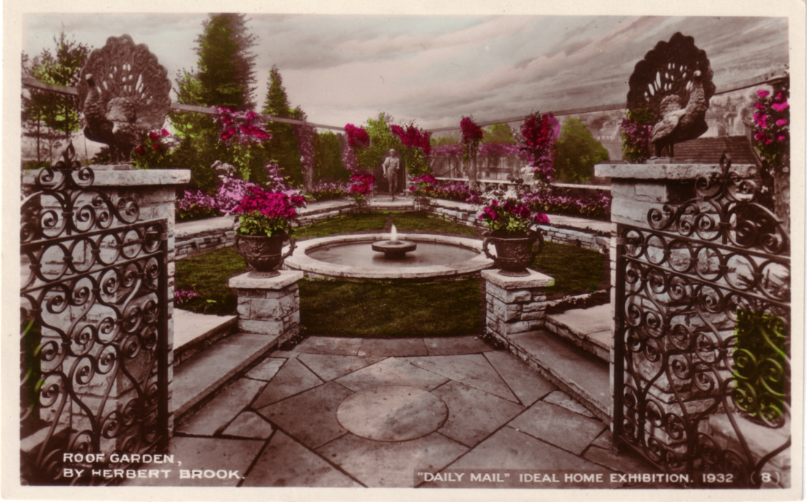

1932 Ideal Home Exhibition

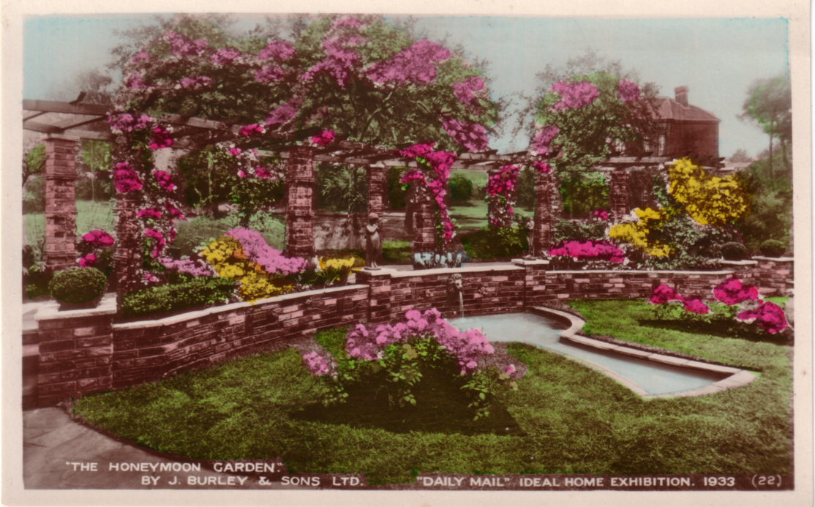

1933 Ideal Home Exhibition

Many hundreds of post cards were published for the Ideal Home Exhibition over the years but the designs were no where like the beautiful poster type cards, or the many advertising and trade cards published for the other early Olympia exhibitions. For the first few years there were cards of interest, but by the early 1920’s they started published long series of views of gardens set out by various nurseries and landscape gardeners. This was carried out every year, up into the late 30’s when post cards produced for the exhibition virtually ceased apart from a few odd sets of six that persisted into the 50’s.
End of part 2.
Cyprus B.E.E. Post cards.

I recently received an E-mail from: ‘Anthony Antoniou’ <undonis@hotmail.com> Tony is not a member of the Study Group but if I can answer anybody’s queries I do.
Dear Bill,
I am a collector of postcards of Cyprus. I recently came across a set of 6 cards from Ceylon that were produced by Tuck’s for the B.E.E. 1924. Which got me thinking. One of the series of postcards of Cyprus published by Tuck’s in the 1920’s (exact date unknown) consists of 12 cards (photos by J. P. Foscolo). These cards are numbered 10, 11, 13, 15, 18, 22, 26, 39, 41, 47, 51 and 55 and were sold in an envelope listing the 12. The numbering has lead people to suggest they may be part of a larger empire/world series. I thought it may be possible that, like the Ceylon postcards, these were also produced for the B.E.E. The B.E.E. Official Catalogue shows that both Tuck’s and J.P. Foscolo (a photographer and postcard publisher from Cyprus) participated in the exhibition. I understand that, along with Mike Perkins, you have produced two books on the subject of postcards of the B.E.E., one being a price guide and check list. I have not been able to locate any copies here in Australia and did not wish to purchase them simply on the off-chance that they may contain something of relevance. Your assistance in any way would be greatly appreciated.
Regards, Tony

Dear Tony.
Thanks for your E Mail regarding Foscolo postcards at the British Empire Exhibition at Wembley in 1924 and 1925. Yes they were available from the Cyprus section in 1924 and from the Cyprus Pavilion in 1925.
In my records I have a photo-copy of No. 11, ‘Donkeys loaded with Fuel’ with an exhibition stamp and posted at the exhibition on 29 August 1924. They would have been purchased or given away at stand No. 4 (crafts) in section G, (the Cyprus section). Stand No. 4 displayed pictures, photographs, post cards and publications. Foscolo’s name is not mentioned in the 1924 catalogue.
In 1925 Cyprus had its own small pavilion and the 1925 catalogue devotes a lot more space to the exhibits and mentions J. P. Foscolo in the private exhibits section, exhibiting photographs. Post cards (presumably his) were still available in the crafts section.
By a coincidence I have another No. 11, ‘Donkeys loaded with Fuel’ unfortunately not posted but with a written message on the back “My Dear Grandson, Am sorry I have no birthday card, this is one I had left from Wembley, ‘Cyprus’. Granddad and I went there............Am putting some stamps in letter for you” This explains why the post card was not posted. This post card could have been got by Grandma in 1924 or 1925.
Your E Mail cleared up one point I have never been sure whether the twelve cards known were all that were published or since the numbers went up to 55, I should keep on looking. Do you have the packet because Tucks often printed on the packet ‘Specially produced for the British Empire Exhibition’ or words to that effect.
All the best, Bill.

This brought a reply from Tony,
Dear Bill,
I do not have the envelope that contained the cards but I have attached a scanned image of one that appeared in the Cyprus Study Circle’s ‘Circular Post’. It was included as part of an article by G. White. He did not provide an image of the rear of the envelope. However, as he says “They were on sale around 1928”, it would be safe to say there is nothing linking the envelope to the B.E.E.
I have in my possession only two cards from that series. One is No. 39 not posted with brown text on the back and a handwritten 1924. The other is No. 13, posted from the U.K. on 19 Nov. 1925 with black text on the back. Neither G. White or S. Lazarides (in his book on Cyprus post cards ‘Panorama of Cyprus’) makes any mention of possible varieties.
The card that you indicate was sent on 29 August 1924 may be the earliest known postally used example. The Lazarides also gives 1928 as the earliest recorded date. I have since written to him about my 1925 copy.

The questions remaining in my mind are,
1 Why the staggered numbering system?
2 Were the cards available before the B.E.E.?
3 Could there be two (or more) distinct printings?
Best regards, Tony.

This made me get out my Cyprus cards to see what I could make of Tony’s questions, also to refer to our book on B.E.E. cards. The first thing I spotted was a mistake in the book (Yes dear reader, you’re as surprised as I am). Somehow an extra number and title had crept in ‘No. 21. View from Mt. Troodos. Cyprus.’ Going back to our notes made when the book was just a gleam in the eye, I can find no mention of this number or title, there is a No. 26. View from Mt. Troodos. Cyprus. which is a vertical card, but no horizontal No. 21. of the same title. We had listed 13 titles but now accepting one was an error, it brings the list down to 12 and these are the same 12 numbers and titles as listed on the Tuck’s envelope. The image of the Tuck envelope Tony E-mailed me was of too poor a quality to reproduce in the Journal.
So there is no doubt in my mind that these were the only titles published by Tuck. It may well be that Foscolo originally photographed 50 or so views of Cyprus, all of which were probably numbered for reference purposes, and Tuck selected 12 of the views and left their Foscolo reference number on them. I shall be surprised if any of the intermediate numbers were published by Tuck, as none have ever been recorded that I know of.
I do not know the answer to the second question. Nearly all the cards recorded are not postally used and until one turns up with a pre 1924 post mark we shall not know the answer to this one.
Could there be two or more distinct printings? Here the answer is yes and no. At the time the book was written we only knew of brown backs, and we were not even sure that they were B.E.E. cards. We stated “It is possible that this series were available at the exhibition, but no card has been seen with Wembley stamp and exhibition cancellation to confirm this”. Since then we now know that cards were available at the exhibition and some were postally used at the exhibition.
Tony mentions there are two colours of backs, brown and black and at a first glance this is so. Amongst my Cyprus B.E.E. cards I have four pairs of views each with both a brown and black back. A careful examination convinced me that they were not different printings, any minor flaw on one card like broken frame line to the stamp box or irregularity of the divider was repeated on its sister card, this was so on all four pairs. When I came to look at the colour I realised they were not black at all. When examined under a strong magnifier (I use an 8X) I found that my black backs were in fact a very dark brown. I would hazard a guess that at some time during the print run the machine ran low on ink and the ink tank was refilled with a much darker shade of brown, almost black in fact.
And now a bit of sad news, way back, Mike and I agreed to differ on whether the Tuck Cyprus cards were B.E.E. cards or not. I thought they were and kept all of mine. Mike was convinced they weren’t and got rid of his. When they started turning up with Wembley cancellations he regretted this and is still trying to replace them, so far without complete success. I am still No. 41 missing so if anyone has a spare copy I should be grateful.

Stop Press

Since doing this my computer crashed and I have been without a computer for about a week. This Journal was nearly finished but I was unable to complete it. The computer has just come back and I hope to finish it today, keeping fingers crossed.

Articles Wanted

I would welcome articles any member cares to send me. These can be hand-written, typed or a print out, or if you realy want to spoil me on a floppy saved on Microsoft Office 6.

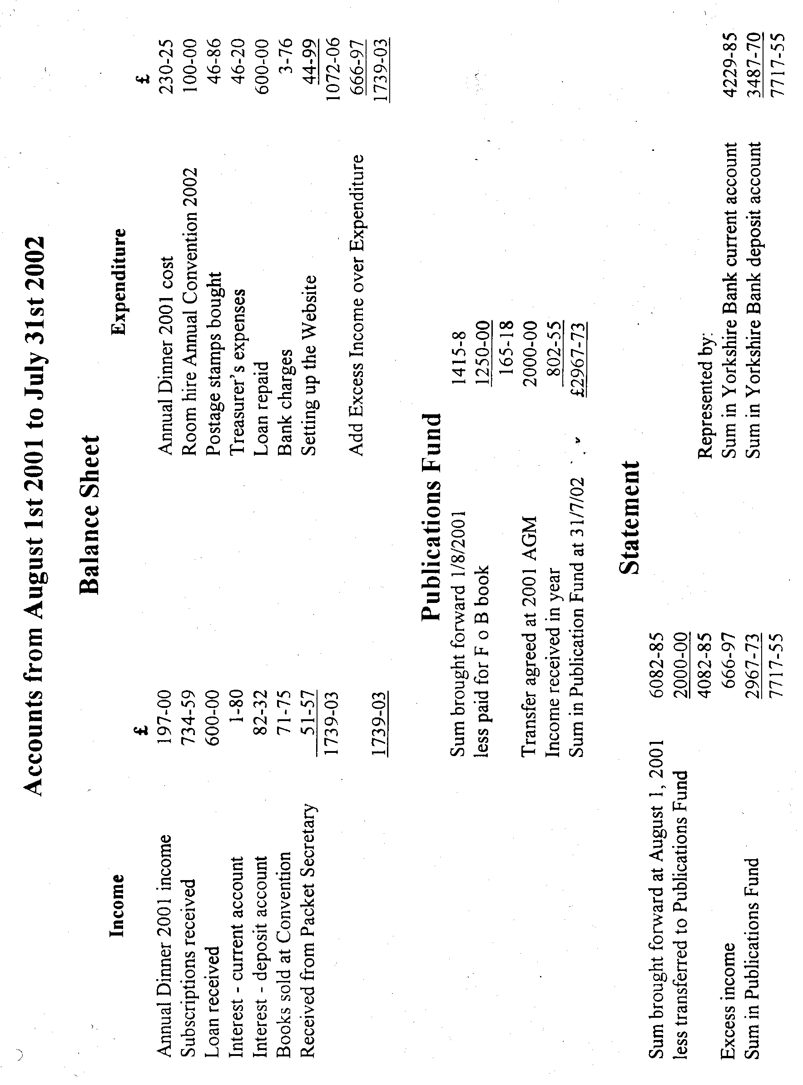

Post Cards of the White City.
Part 22. by Bill Tonkin

Postcards in Stapled Books with Counterfoils.

Postcards were not only sold singly or in packets, but were also sold in books of twelve stapled at the edge of the counterfoil. The books measured from 8¼" to 8½" x 3½" with the counterfoil taking up 2¾" to 3" of this. As well as showing a miniature view of the postcard, there was also room for the writer to record details of whom the card was sent to and the date, etc. The counterfoils and view were in B/W even if the postcard was coloured. The postcard was either perforated or rouletted (a row of short slits) to make it easier to tear away from the counterfoil, which remained as a stub in the book. The rouletting used by Valentine’s for the White City postcards, as measured by a stamp perforation gauge is 12¾, while if the means of separating or tearing out the postcard was by perforation holes, then these measured 11. Both of these measurements represent the number of holes or slits in 2 cm, which is the standard method of measuring the number of perforation holes on stamps.

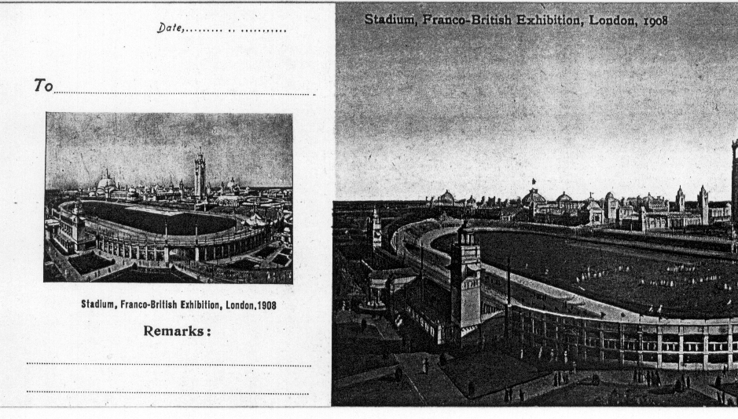

This illustration shows part of the postcard and the counterfoil. It is interesting
to note that in the book of coloured postcards from which this illustration came
Valentine’s slipped up and used a miniature view different to the full sized card.
When Valentine’s published the book with B/W postcards this was corrected.

While the majority of books were rouletted, this was not a very efficient way of providing a means of tearing out cards without damage, and the perforated system gave a much cleaner ‘tear’. At least one series of cards are known to have come from a rouletted book, and when a further run was printed, changed from rouletting to perforation holes.
The complete books are not often seen, and very few have survived, one exploded book is known with one page missing. The postcards themselves are easily identified as the left edge of the postcard has a rough edge where it has been torn out of the book. In the case of vertical cards the rough edge is along the top of the card. It is from studying single postcards that the following lists have been compiled.
It is possible that not all the books contained twelve cards as there were only six ‘Night Effect’ cards, this will not be resolved until a book of cards turns up. It is this set of six cards that is known both rouletted and perforated.
List of Valentine’s Postcards from Books with the left edge
perforated or rouletted.

Titles with numbers in brackets, are where the number is known but does not appear on the card. Titles with ‘N.n.’ are for views that were never allocated numbers. The lists have been classified as Book No. 1, Book No. 2, etc. but the books were not in fact numbered, and with the exception of books No. 1 to No. 5, the lists have been compiled from loose cards.
The colour of the covers of books 1, 2 & 3, has been given as lilac. Over the years this has faded to buff, but traces of the original colour can sometimes be seen on the inside of the books.

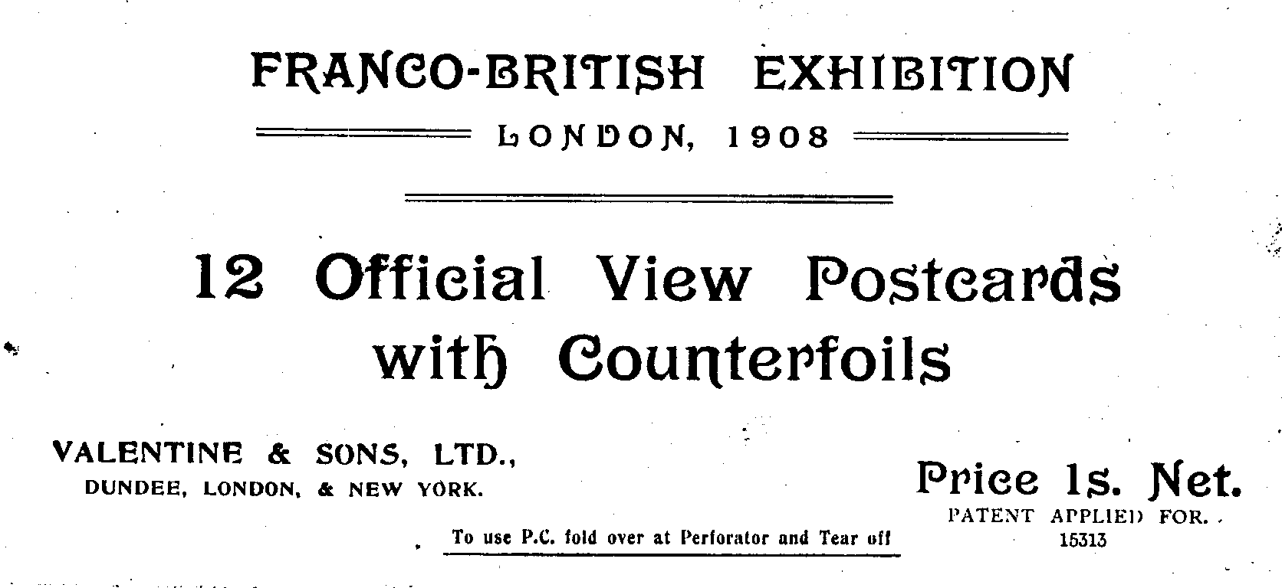

Booklet with lilac covers, reduced to 75 % of full size.

Book No. 1. Lilac cover details not known. In this book the miniature view of the Stadium on the counterfoil is different to the view on the postcard. This mistake occurred on all the books of coloured cards. Contents, Coloured postcards with a red ‘FB seal’ back, rouletted on left edge. An exploded book with one card and counterfoil missing is known, the missing card was probably No. 178 Entrance to Irish Village. (Ballymaclinton) as this card is known with a rouletted left edge. As the order in the book is not known they are listed in numerical order.
N.n. Stadium, Franco-British Exhibition, London, 1908.
112 Court of Honour, Franco-British Exhibition, London, 1908.
(115) French Applied Arts Palace, Franco-British Exhibition, London, 1908.
117 Palace of Women’s Work, Franco-British Exhibition, London, 1908.
132 Canadian Scenic Railway, Franco-British Exhibition, London, 1908.
163 British Applied Arts Palace, Franco-British Exhibition, London, 1908.
178 Entrance to Irish Village. (Ballymaclinton), Franco-British Exhibition, London, 1908
194 Grand Restaurant, Franco-British Exhibition, London, 1908.
(217) Court of Honour, Franco-British Exhibition, London, 1908.
220 In Elite Gardens, Franco-British Exhibition, London, 1908.
233 India, Franco-British Exhibition, London, 1908.
243 Fine Art Palace and Lagoon, Franco-British Exhibition, London, 1908.

Book No. 2. Lilac cover with ‘Franco-British Exhibition, London, 1908. 12 Official View Postcards with Counterfoils. Price 1s. Net.’ Contents, Coloured postcards with a dark grey ‘FB seal’ back, rouletted on left edge. Listed in order as in the book. The counterfoil is cream and the B/W picture on the counterfoil has a white border.
112 Court of Honour, Franco-British Exhibition, London, 1908.
194 Grand Restaurant, Franco-British Exhibition, London, 1908.
(115) French Applied Arts Palace, Franco-British Exhibition, London, 1908.
163 British Applied Arts Palace, Franco-British Exhibition, London, 1908.
233 India, Franco-British Exhibition, London, 1908.
243 Fine Art Palace and Lagoon, Franco-British Exhibition, London, 1908.
220 In Elite Gardens, Franco-British Exhibition, London, 1908.
(217) Court of Honour, Franco-British Exhibition, London, 1908.
117 Palace of Women’s Work, Franco-British Exhibition, London, 1908.
132 Canadian Scenic Railway, Franco-British Exhibition, London, 1908.
N.n. Stadium, Franco-British Exhibition, London, 1908.
178 Entrance to Irish Village, Franco-British Exhibition, London, 1908

Book No. 3. Lilac cover with ‘Franco-British Exhibition, London, 1908. 12 Official View Postcards with Counterfoils. Price 1s. Net.’ as No. 2. Contents, Coloured postcards with a black ‘FB seal’ back, rouletted on left edge. Listed in order as in the book. Although the contents are the same as book No. 2 they are stapled in a different order.
112 Court of Honour, Franco-British Exhibition, London, 1908.
163 British Applied Arts Palace, Franco-British Exhibition, London, 1908.
132 Canadian Scenic Railway, Franco-British Exhibition, London, 1908.
117 Palace of Women’s Work, Franco-British Exhibition, London, 1908.
194 Grand Restaurant, Franco-British Exhibition, London, 1908.
233 India, Franco-British Exhibition, London, 1908.
243 Fine Art Palace and Lagoon, Franco-British Exhibition, London, 1908.
178 Entrance to Irish Village, Franco-British Exhibition, London, 1908
(217) Court of Honour, Franco-British Exhibition, London, 1908.
220 In Elite Gardens, Franco-British Exhibition, London, 1908.
N.n. Stadium, Franco-British Exhibition, London, 1908.
(115) French Applied Arts Palace, Franco-British Exhibition, London, 1908.

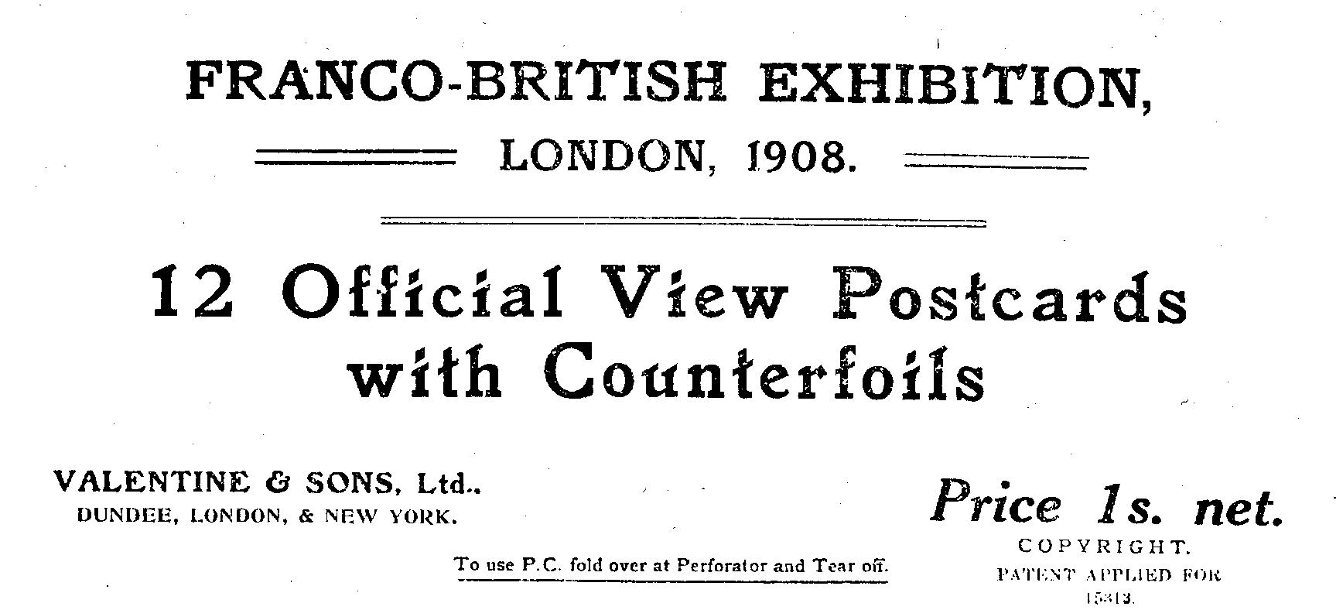

Booklet with dark green covers, reduced to 75 % of full size.

Book No. 4. Dark green cover with ‘Franco-British Exhibition, London, 1908. 12 Official View Postcards with Counterfoils. Price 1s. net.’ The printing on the cover is larger than on the lilac covers. In this book the miniature view of the Stadium has been replaced with one to match the postcard. Contents, B/W litho postcards with a black ‘Famous Throughout the World’ back, rouletted on left edge. Listed in order as in the book.
(217) Court of Honour, Franco-British Exhibition, London, 1908.
N.n. Stadium, Franco-British Exhibition, London, 1908.
(112) Court of Honour, Franco-British Exhibition, London, 1908.
(243) Fine Art Palace and Lagoon, Franco-British Exhibition, London, 1908.
(132) Canadian Scenic Railway, Franco-British Exhibition, London, 1908.
(194) Grand Restaurant, Franco-British Exhibition, London, 1908.
(115) French Applied Arts Palace, Franco-British Exhibition, London, 1908.
(178) Entrance to Irish Village. (Ballymaclinton), Franco-British Exhibition, London, 1908
(163) British Applied Arts Palace, Franco-British Exhibition, London, 1908.
(233) India, Franco-British Exhibition, London, 1908.
(117) Palace of Women’s Work, Franco-British Exhibition, London, 1908.
(220) In Elite Gardens, Franco-British Exhibition, London, 1908.

Book No. 5. Dark green cover with ‘Franco-British Exhibition, London, 1908. 12 Official View Postcards with Counterfoils. Price 1s. net.’ the same as No. 4. In this book the miniature view of the Stadium has been replaced with one to match the postcard. Contents, B/W litho postcards with a black ‘Famous Throughout the World’ back, rouletted on left edge. Listed in order as in the book. Although the contents are the same as book No. 4 they are stapled in a different order.
(217) Court of Honour, Franco-British Exhibition, London, 1908.
(243) Fine Art Palace and Lagoon, Franco-British Exhibition, London, 1908.
(117) Palace of Women’s Work, Franco-British Exhibition, London, 1908.
(115) French Applied Arts Palace, Franco-British Exhibition, London, 1908.
(233) India, Franco-British Exhibition, London, 1908.
(132) Canadian Scenic Railway, Franco-British Exhibition, London, 1908.
(112) Court of Honour, Franco-British Exhibition, London, 1908.
(194) Grand Restaurant, Franco-British Exhibition, London, 1908.
(163) British Applied Arts Palace, Franco-British Exhibition, London, 1908.
(178) Entrance to Irish Village. (Ballymaclinton), Franco-British Exhibition, London, 1908
(220) In Elite Gardens, Franco-British Exhibition, London, 1908.
N.n. Stadium, Franco-British Exhibition, London, 1908.

Book No. 6. Details of book not known. Contents, B/W litho postcards with a grey ‘Famous Throughout the World’ back, rouletted on left edge.
(112) Court of Honour, Franco-British Exhibition, London, 1908.
(117) Palace of Women’s Work, Franco-British Exhibition, London, 1908.
(220) In Elite Gardens, Franco-British Exhibition, London, 1908.

Book No. 7. Details of book not known. Contents, B/W litho postcards with a dark grey ‘FB seal’ back, rouletted on left edge.
112 Court of Honour, Franco-British Exhibition, London, 1908.
(217) Court of Honour, Franco-British Exhibition, London, 1908.

Book No. 8. Details of book not known. Contents, B/W photogravure postcards with a black ‘Famous Throughout the World’ back. The booklet was published in two types and are known either rouletted or perforated.
191 Court of Honour Night Effect, Franco-British Exhibition, London, 1908.
210 Court of Honour Night Effect, Franco-British Exhibition, London, 1908.
214 Court of Honour Night Effect, Franco-British Exhibition, London, 1908.
215 Court of Honour Night Effect, Franco-British Exhibition, London, 1908.
239 British Applied Arts Palace Night Effect, Franco-British Exhibition, London, 1908.
284 Court of Honour Night Effect, Franco-British Exhibition, London, 1908. Vert left. (rough edge at top)

Book No. 9. Details of book not known. Contents, B/W photogravure postcards with a black ‘Famous Throughout the World’ back, perforated on left edge.
191 Court of Honour Night Effect, Franco-British Exhibition, London, 1908.
210 Court of Honour Night Effect, Franco-British Exhibition, London, 1908.

