EDITORIAL SUMMER 2002

I’m sorry the Journal’s a little bit late
The days pass by at a wicked rate

Since the spring Journal was published I have been up to York to do the two day post card fair, and took the opportunity to stay up for an extra day, staying at the Hotel where we shall be holding our 2002 convention in September. I have chosen the Holgate Hill Hotel who can offer us a very up market setting at what I feel is a reasonable price. I stayed there one night after the York Fair and was very satisfied with the service. There has been some criticism that some of the hotels we have stayed at in the past have been a little on the seedy side, which I accept, The Holgate Hotel will not fall into this class I assure you.
They have a large breakfast area which we can have from 10.00 until 4.00 for our displays and from 10.00 until mid-day on the Sunday. They will do our Saturday annual dinner for £13.50. There are 33 en suite rooms, but it is important to reserve a room as soon as possible if you are intending to attend the convention.
The rooms are £32.50 for each person in a double room and £40.00 for a single person, this includes breakfast.
I have provisionally booked seven double rooms and two single rooms, so when you book please mention you are part of the Exhibition Study Group, group booking. I suggest you include a deposit of say £20.00.
There is a large lounge with a bar and I am sure we shall have a very comfortable week end. I shall be staying Friday, Saturday and Sunday night myself, and I am sure there will be as usual, others staying on the Friday and Saturday nights.
The Hotel is just outside the city walls about half a mile from York Railway Station and about the same to the National Railway Museum. The hotel has its own car parking area within the grounds. The nearest pub is about five minutes walk, and is called the ‘Crystal Palace’. I haven’t tried the beer but I shall do so in September.
The full address is, Holgate Hill Hotel. 124, Holgate Road, York. YO24 4BB. The phone number is 01904 653786 and E-mail address is <info@holgatehillhotel.co.uk> Here’s looking forward to a good convention and if you are coming please let me know if you will be bringing a display.
I brought back a number of hotel brochures with me and if anyone would like one let me know and I will pop one in the post. I have already sent one to all the regular people and have a few left over.
York post card fair was very good and it was quite like the old days with plenty of good material for sale, I came back with just over 100 cards, although it must be said by the time I had got round to checking them I found there were a lot of duplicates that I had already got. I have come to accept there is no way of avoiding this. I would need a trolley to carry all the books listing what I have, that is assuming I had time to compile the books. I normally carry eight small note books full of information that covers just a fraction of my collection. Any surplus cards will eventually find their way into the packet, so buying duplicates is not a complete disaster.
In the last issue I mentioned the packet of six Heath Robinson Ideal Home Exhibition cards priced at £150. At Cheltenham last weekend I saw the dealer had reduced them to £40 which is a step in the right direction. Another dealer at the same fair had an identical set with the packet for £30. Since these cards are catalogued at £1.50 each in the latest catalogue published by John Smith I just cannot understand these ridiculous prices. They would only be justified if the dealers could sell them at those figures. But there, it seems every Tom Dick and Harry selling post cards knows more about values than John Smith. I wonder how they explain away the fact that his latest catalogue is its 28th edition.
It has to be said that the Bloomsbury post card fair is unfortunately in a state of rapid decline. It would appear the organisers are finding it difficult to find enough dealers to fill the rooms and one is increasingly aware of the many tables which just display a smattering of ephemera. If the whole lot on some of the tables sold, it would not cover the cost of the table, so it is fairly obvious they are giving the tables free to dealers rather than see them empty. I also get the impression a lot of regular dealers are no longer attending. In March I did the whole of the large room and moved into the small room where I bought a bit of ephemera for £7. I remarked to the dealer I had spent more on his stand than in the whole of the large room on post cards.
That day my most spectacular buy was a card bought from the book fair, by a coincidence I had illustrated an identical card on the front of the 2001 Winter Journal. I always try to illustrate an exhibition Christmas card every winter. It is for the 1886 Colonial & Indian Exhibition and the illustration was of a card owned by Karl Illingworth which he loaned me many years ago (1995) when I was doing a list of ‘pull-out’ cards. Karl’s card was missing the tag which sticks out of the side of the card, when this is pulled out it slides a small set of views of the exhibition out of the body of the card so the pages can be opened. At the time neither Karl or myself realised the tag and internal moving mechanism existed, and it was not until I found a non overprinted example that it became clear. My card is complete with the tag. I now have both the standard card and the card overprinted ‘A Merry Christmas and a Happy New Year’. Although not true post cards, as they have plain backs they are very scarce items and apart from Karl’s there is only one other that I know of.
Early post cards seem to be in the news with the sale for £31,750 of an 1840 Hook card sent through the post stamped with a penny black. The pundits are still arguing about whether it can be classified as a picture post card or not, some saying that it was before the date that the post office authorised the sending of picture post cards in 1894, although plain cards had been allowed since 1870. Certainly at around the early 1840’s the sending of illustrated envelopes often hand drawn was firmly established. Henry Cole who played a large part in the organising of the 1851 Great Exhibition had his own Christmas cards printed as early as 1843 but I imagine these were sent in envelopes as we do it today. The card was designed by J. C. Horsley R.A. and I believe they have one in the Victoria & Albert Museum. I feel the case against the Hook card being classed as a picture post card as it was before the 1894 date, is a bit shaky as the post office set up a special post office at the 1891 Royal Naval Exhibition and again in 1893 for the Forestry & Gardening exhibition where they cancelled with a special hand stamp, picture post cards to commemorate the exhibitions, these were accepted for posting.
Bob Tough one of our regular convention attendee’s with his wife Gwen has sent me a long article based on the display he gave in 1999 on the subject of Olympia. The article runs to just over 100 pages so it will have to be trimmed a bit, but there are so many beautiful post cards and covers illustrated that I am going to try and publish as much as possible, dividing it into two or three Journals.
Some time ago Stanley K. Hunter sent me an E-Mail as follows,
Dear Bill,
I meant to mention that there had been a minor drama at Kelvingrove the other morning! At about 1 am, a passer-by spotted ropes suspended from the roof of the Art Gallery. It was a commando-style break-in. The intruders had accessed one of the minarets but as there was no direct access to the main building, they didn't manage to get anything. The left behind their gear.
Stanley.
One should not feel respect for illegal deeds requiring a degree of daring, especially when the anticipated outcome is robbery, but I’m afraid if I was a Judge on the case I think I might give a more lenient sentence in this instance, than for a mugger who beats up an old lady and leaves her mentally scarred for the rest of her life.
Some years ago I knew the man who ran the local sub post office. One day he was held up by a man with a shot gun who took his money and fled. Within a year he had to sell the business, because every time a man came into the post office he wondered if the man was going to pull out a gun. It so got him down that in the end he could not bear to be in the post office by himself, so he gave it up and got a job without the worry.

The Editor.
Olympia 1886 - 2000
Part 1.
by
R. O. Tough MBE

At the Exhibition Study Group Convention in 1999 I gave a display covering the Olympia Exhibition Centre with descriptions, post cards and covers of a number of the main events held there in 114 years. It was not intended to be a complete description of any of the numerous types of exhibitions held there, some of them running over 60 years.
There are more detailed histories of individual exhibitions particularly the ‘Ideal Home’ by Deborah Ryan and several articles in the Exhibition Study Group quarterly Journal, also British Exhibitions and their Post Cards, Parts 1 & 2 by F. A. Fletcher and A. D. Brooks.

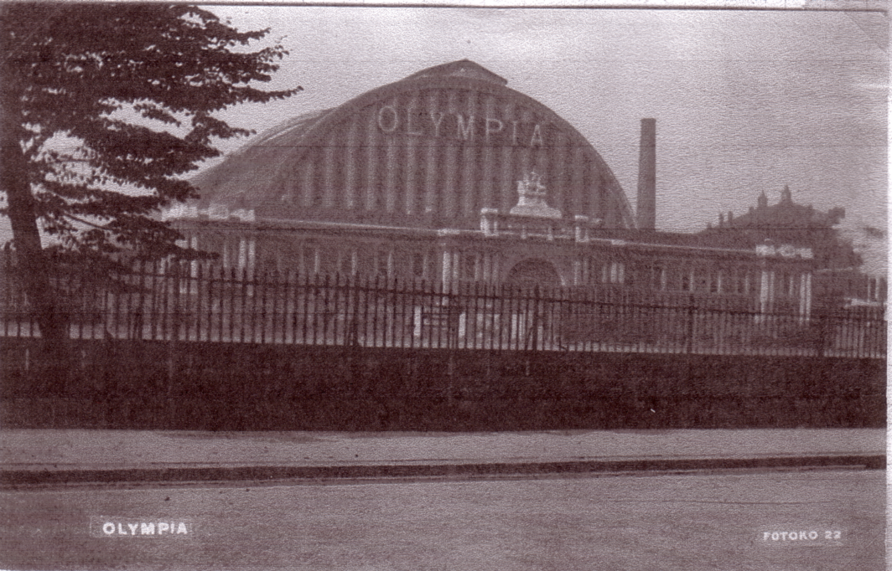

The Grand Hall opened on 26th December 1886 for a show put on by the Paris Hippodrome Circus

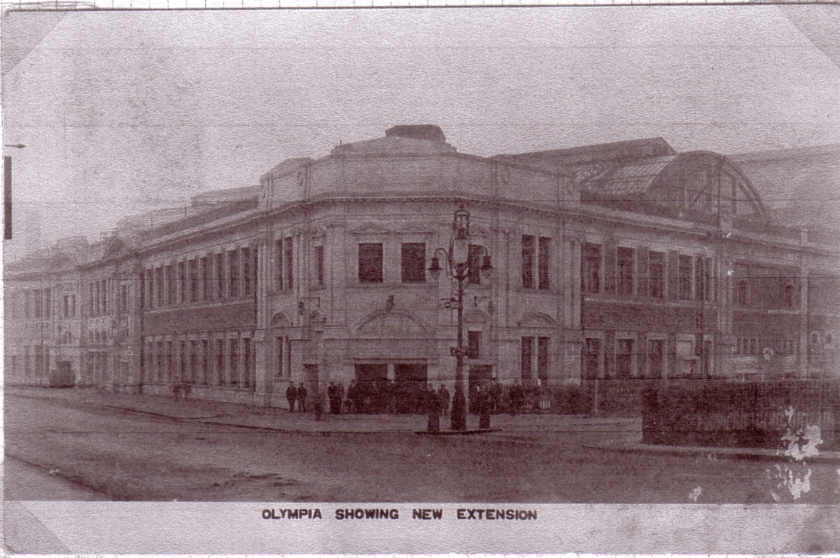

The National Hall completed in 1923.
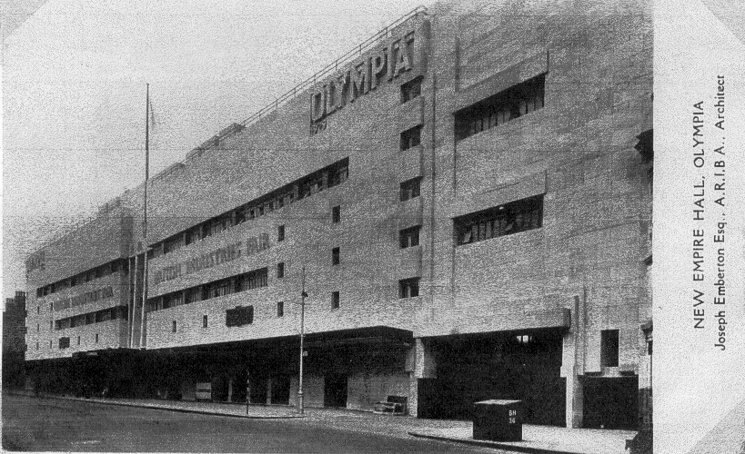

The Empire Hall opened in 1929

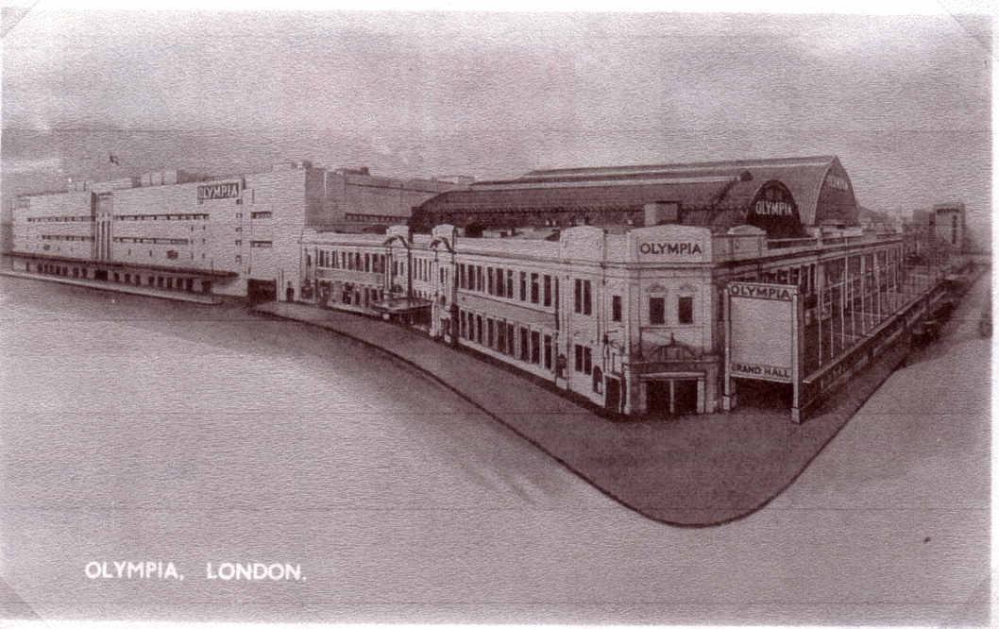

The completed complex was then one of the largest exhibition centres in Europe.

In several cases however there were individual exhibitions or a shorter series of exhibitions which were of particular importance in attracting customers to business in this special way. The World’s first major motor show and a very early major aero show took place in the Grand Hall at Olympia. It provided an ideal venue for circuses, special types of plays and mixed entertainment as it had such a large visitor capacity.
The three main exhibition halls still remain open today, attracting a wide variety of exhibitions, although traffic worries in London now threaten the future, especially as car parking is so difficult and Olympia is not on a direct underground line.
It is interesting to look back on a major exhibition complex which has had such a wide variety of uses in over 100 years.
Following the remarkable success of the Great Exhibition in Hyde Park, there was a large surplus of earnings. A large area of Kensington opposite the exhibition site in Hyde Park was purchased. This site is now occupied by the Kensington Museums including the Victoria and Albert, the Imperial College and the Albert Hall. An exhibition building was constructed where the Natural History Museum stands now, it was intended to be permanent.
In 1862 the Agricultural Hall was built as a large exhibition centre in Islington. General Burnaby decided that a much larger permanent exhibition centre, similar to the Agricultural Hall, should be built in West Kensington. He formed The National Agricultural Hall Company to build the New Agricultural Hall, designed by Harry E. Coe. This was to be called the Great Hall, the name later changed to Grand Hall. It was opened on the 26th December 1886 with the Paris Hippodrome Circus. This started a tradition for nearly 80 years of a circus performing in the Grand Hall, Olympia, starting on Boxing Day each year or earlier.
The venture was successful and it was decided to add an additional hall called the National Hall, which was completed in 1923. A further hall was built called the Empire Hall which opened in 1929 for the British Industries Fair.

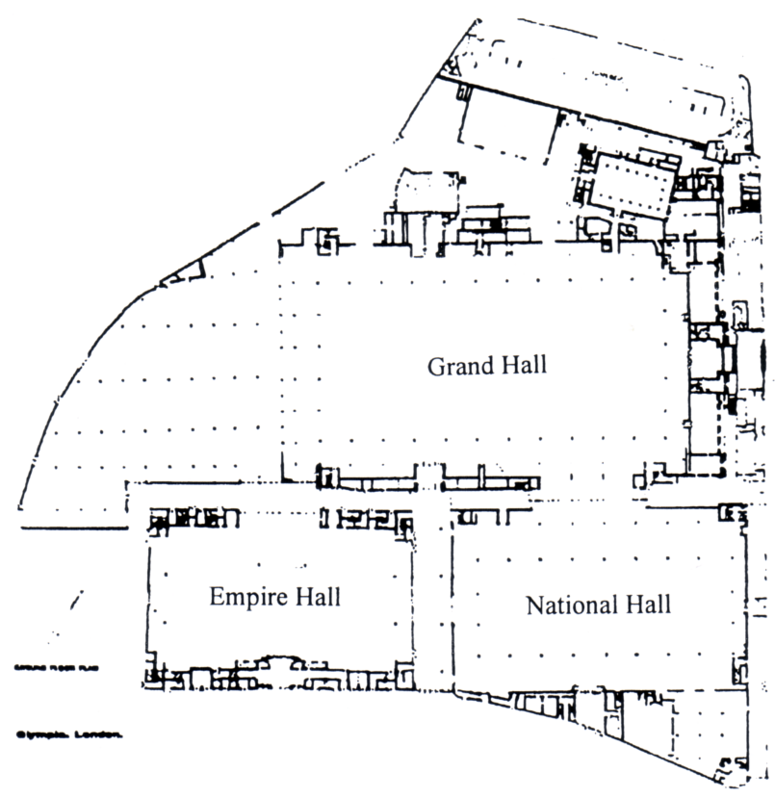

Site plan showing the position of the three halls.

Post Office.
Postal facilities were provided for exhibitors and later for the public from 1892, although apparently the first cancellation is only known on telegrams (0.1). The first post mark generally used (0.1a) is known from 1894 - 1914. Although it was used for a long period it is not a common cancellation and may have only been available to exhibitors. The next cancellation (0.2) was used from 1926 - 1933 and again from 1963 - 1970. This cancellation is fairly common. The next cancellation (0.3) is very difficult to find and is only known to be used in 1931, similarly (0.4) is only known to be used in 1933. Cancellation (0.5) is quite common, used from 1947 - 1970. Cancellation (0.6) (not illustrated) was used on registered mail from 1948 - 1961 and cancellation (0.7) was used from 1969 - 1970. There was also a parcel cancellation (0.8) which has been found from 1961 - 1966. These were general cancellations used at the exhibition centre post office. Some exhibitions, like the Ideal Home and Philympia had their own special cancellations. Slogan cancellations were used throughout the country, advertising the British Industries Fair which took place at Olympia from 1929 - 1953. For part of this time the fair also occupied the White City and the Birmingham Exhibition Hall. There were also other special exhibition cancellations for individual exhibitions.

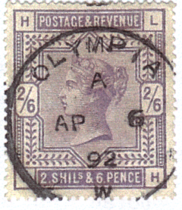
Queen Victoria 2/6 stamp with Olympia cancellation (0.1) used on the first known date.
It is believed this was only used on telegrams.

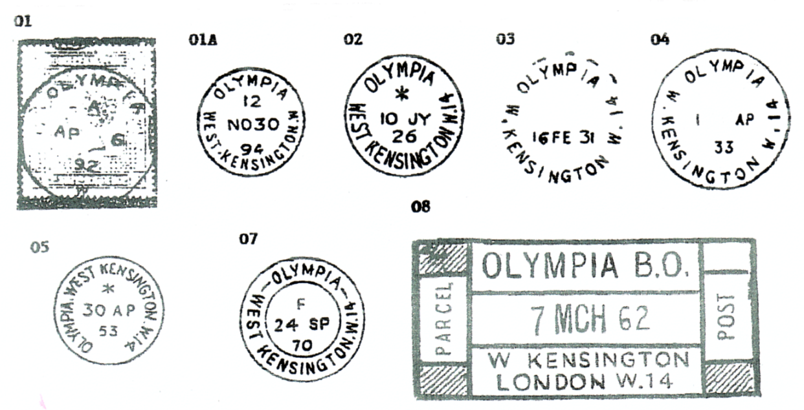

Some of the cancellations used at Olympia.

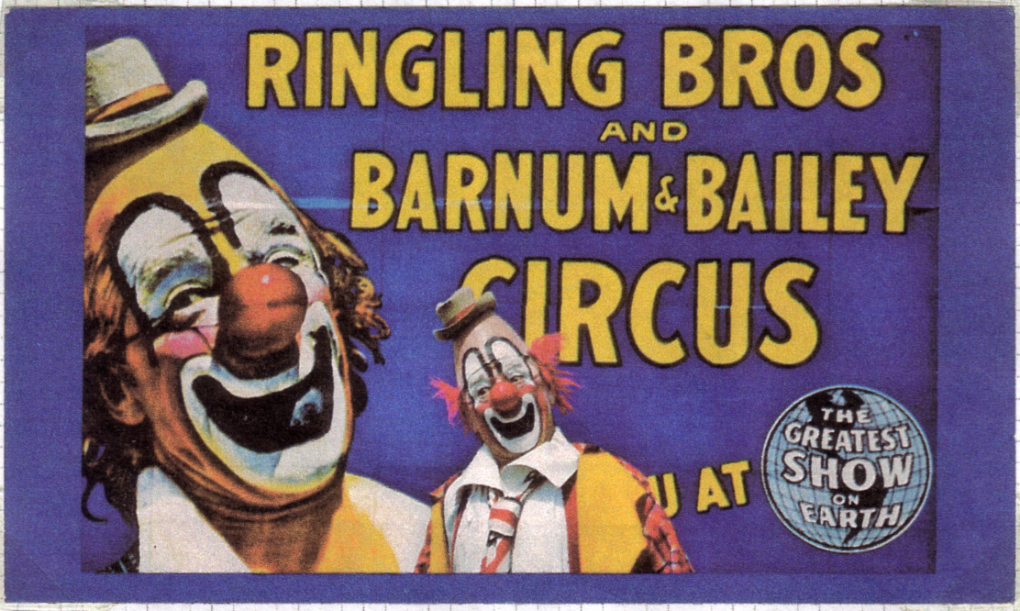

A beautiful Ringling Bros. and Barnham & Bailey post card.
Circuses.
The tradition of circuses at Olympia attracted Barnham and Bailey who used Olympia regularly, Buffalo Bill’s Wild West Show, arranged by Colonel Cody, also used the open exhibition ground at Earl’s Court. More recently Carl Hagenbeck appeared at Olympia. The last circus to appear was Bertram Mills, which continued into the 1960’s, although interest in circuses was waning. Unfortunately Bertram Mills circus had a fatal accident when a motor cyclist, performing on a wall of death in the Big Top, lost control of his motor bike and was fatally injured in the fall. Also the prejudice against animals acts affected the appeal of circuses.

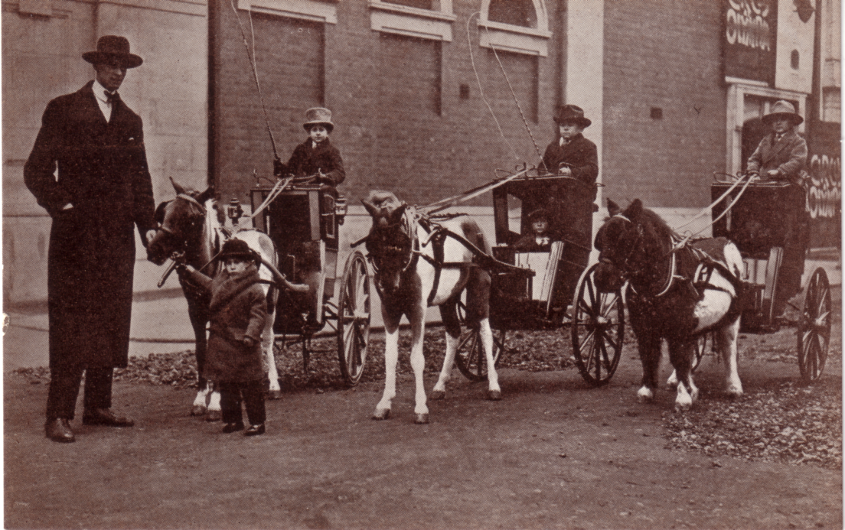

Bertram Mills ‘Tiny Town’ Circus held at Olympia for the 1926 Christmas.

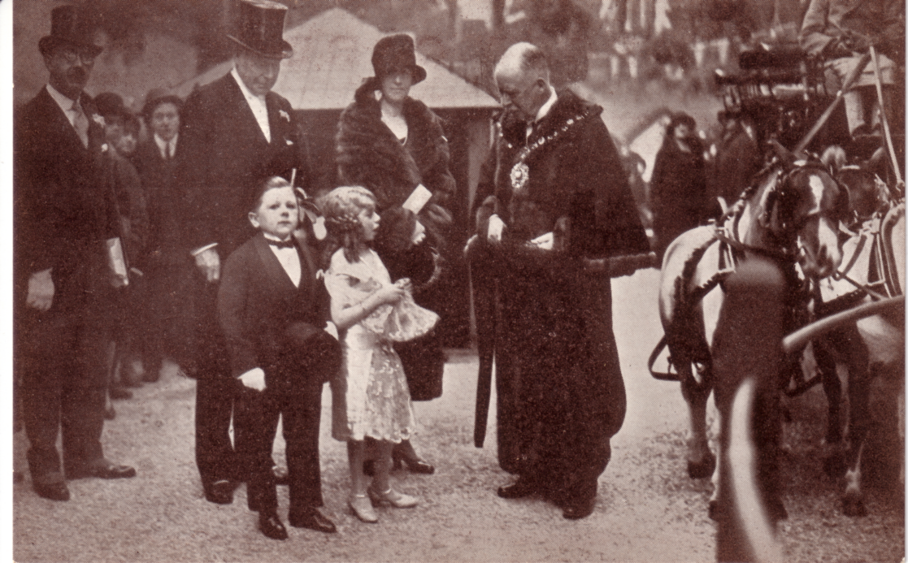

Bertram Mills ‘Tiny Town’ Circus, the performers meet the Mayor.

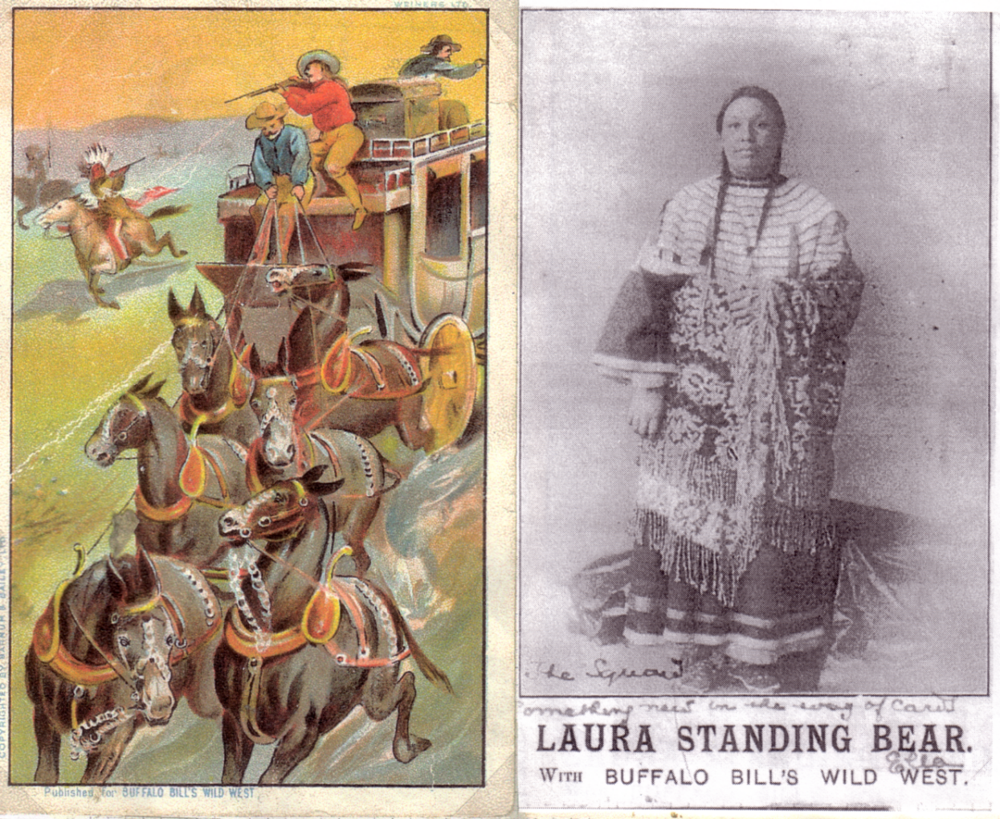

1903 Buffalo Bill’s Wild West Show

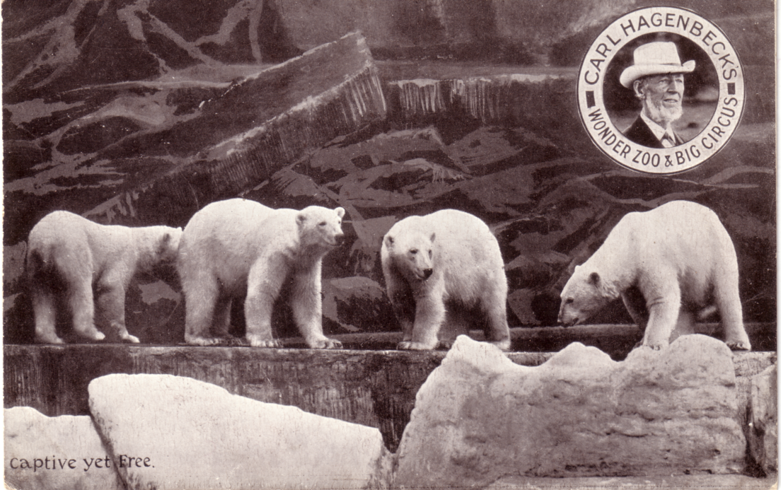

Carl Hagenbeck’s Wonder Zoo and Big Circus.
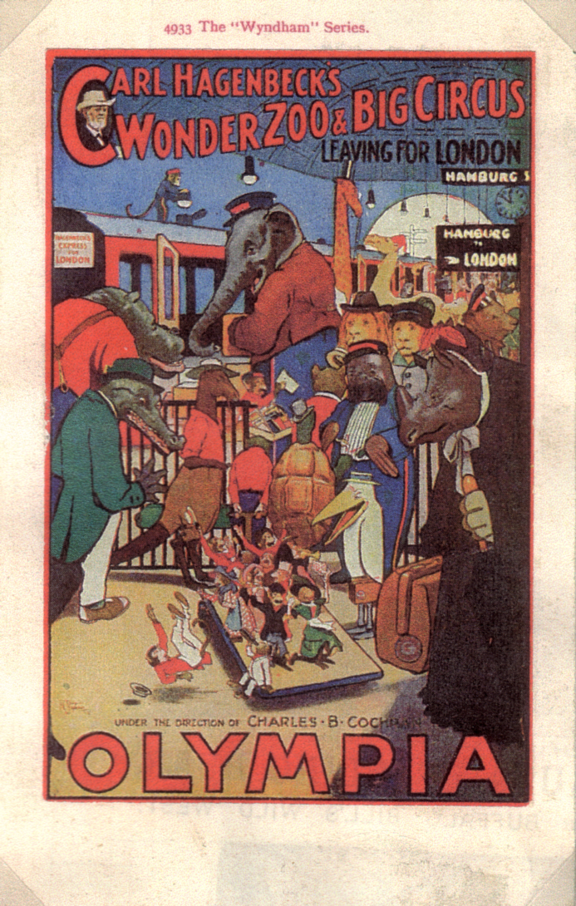

Carl Hagenbeck’s Wonder Zoo and Big Circus.

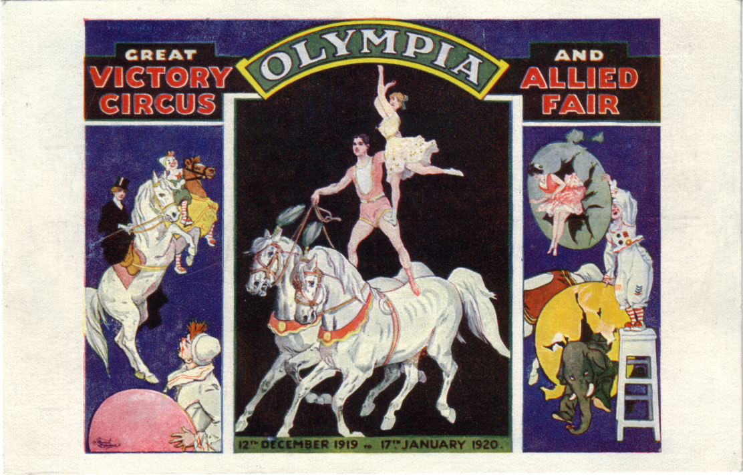

The Great Victory Circus and Allied Fair
Open all day from 12th December 1919. Admission 1/3 (including tax)
International Motor Shows
The first large international motor show in Britain, organised under the auspices of the R.A.C., took place at Olympia in 1905. There had in fact been three much smaller motor shows previously but this one organised by Imre Kiralfy occupied the whole of the Grand Hall and set the pattern for motor shows at Olympia for the next thirty years. Motor shows at that time also included boats, a tradition which also continued after the war. There was however a boat show in Olympia in 1920.

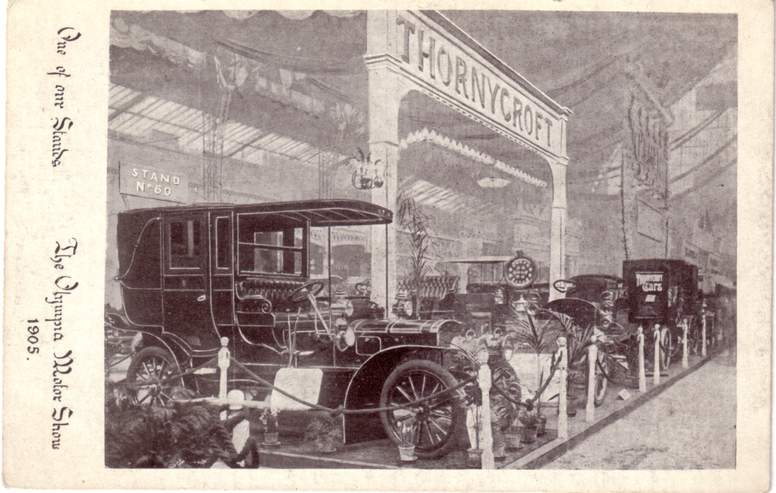

The Olympia Motor Show 1905

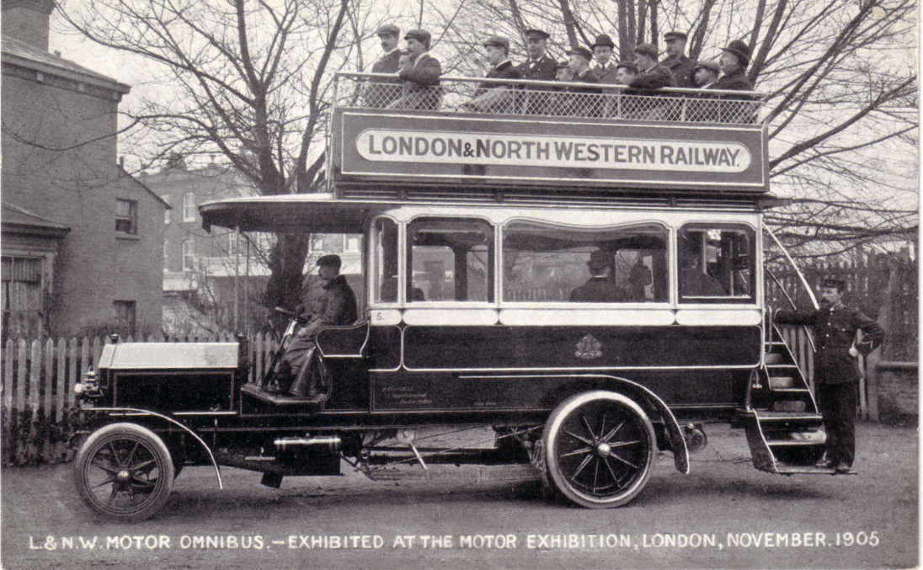

London & North Western Railway bus exhibited at the 1905 Motor Exhibition.
On the post cards in 1905 it seemed to be called either the Motor Show or Motor Exhibition.

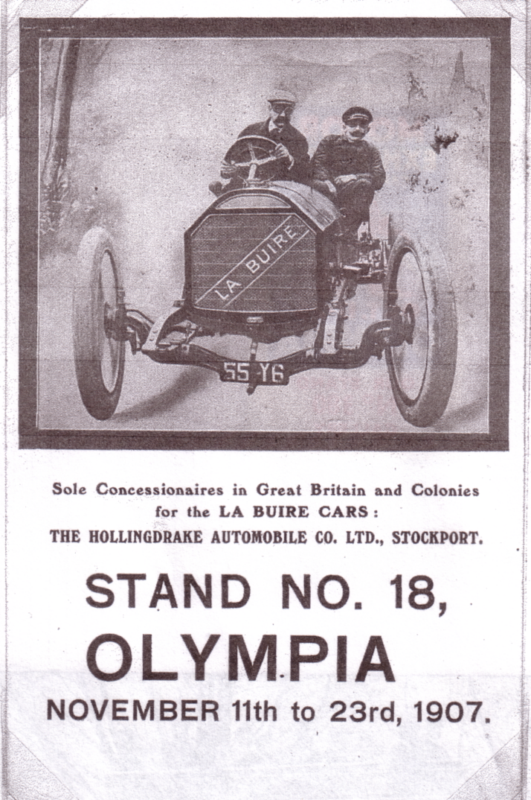

1907 6th International Motor Show

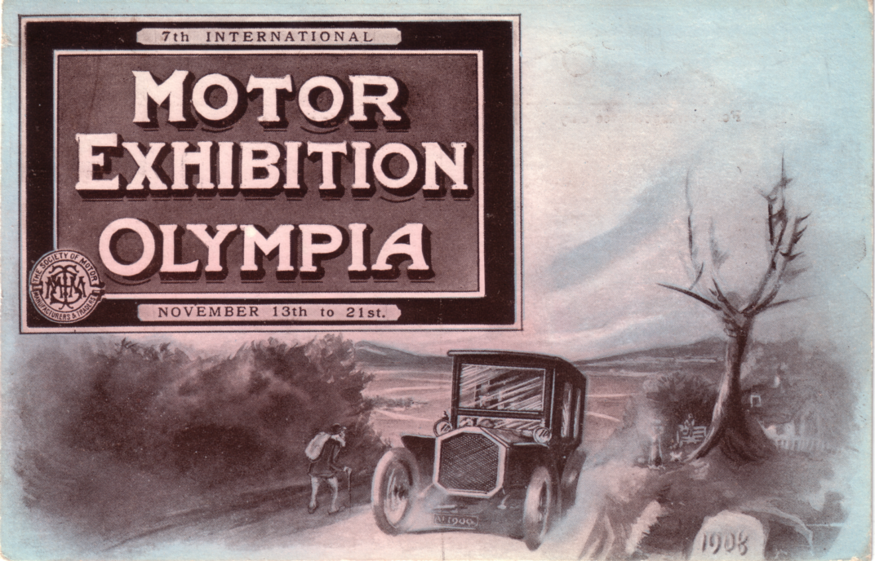

1908 7th International Motor Exhibition held at Olympia.

Mammoth Fun City
This was produced in 1906 by the famous showman C. B. Cochran and covered a wide variety of acts, including a quartet of young ladies, comedy, traditional bands and animal acts. This showed the wide range of uses to which Olympia could be adapted.

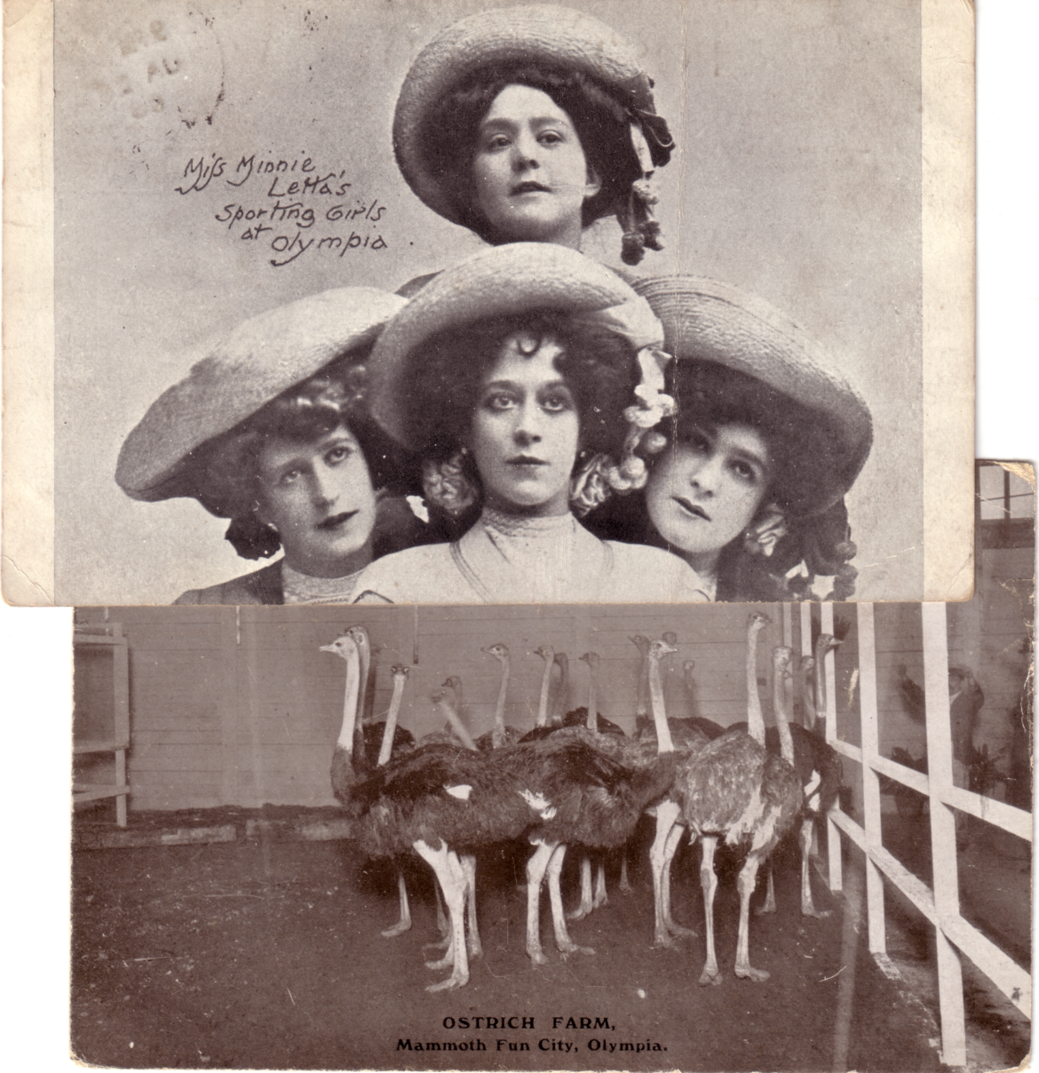

Miss Minnie Letta’s Sporting Girls and the Ostrich Farm both at the Mammoth Fun City at Olympia in 1906

to be continued

Post Cards of the White City
Part 21.
by
Bill Tonkin

This continues with illustrations of the many different backs used by Valentine for the Franco-British Exhibition. All together there were 20 different backs not counting the different colours.

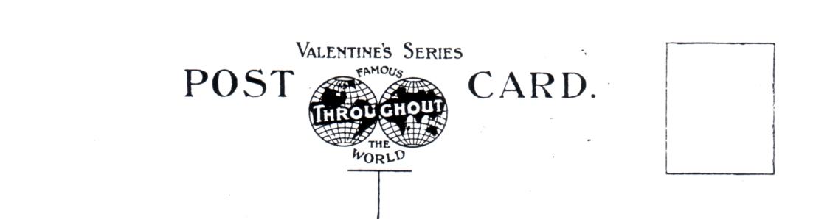

FB 5. smaller size with the logo reduced in size by 3 mm and there is no imprint down the side.
It is printed in a wide range of colours, black, brown, dark grey, deep green, green,
greenish grey, grey and red brown.

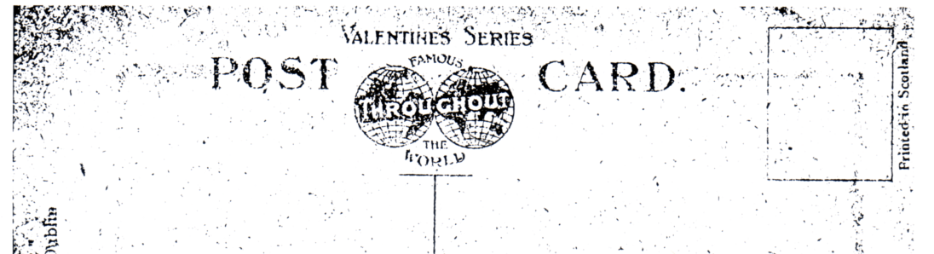

FB 6. small size logo as FB 5. but with an imprint ‘Valentine Dublin’ down the left side and
‘Printed in Scotland’ alongside the stamp box. This back was used on only two postcards.

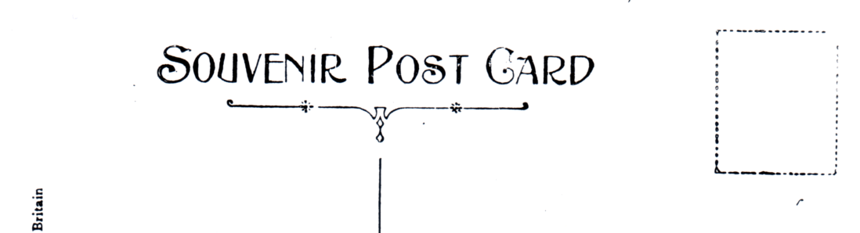

FB 7. Souvenir Post Card with a single line divider this back was used for some of the
Australian Pavilion postcards.

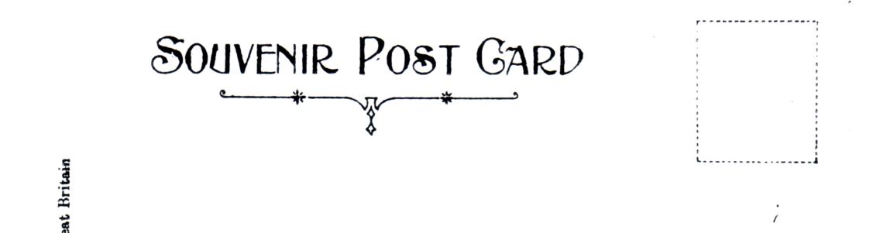

FB 8. Souvenir Post Card without a divider this back was used for the
Canadian Pavilion postcards.

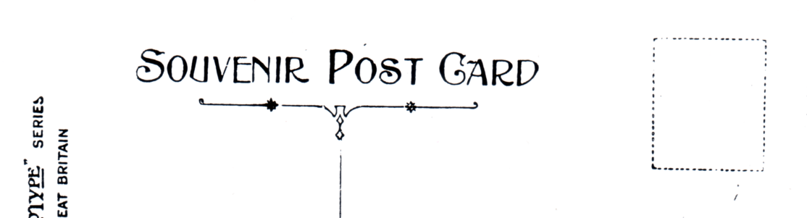

FB 9. Artotype Souvenir Post Card with a single line divider this back was used
for the Artist painted ‘Entente Cordiale’ postcards.

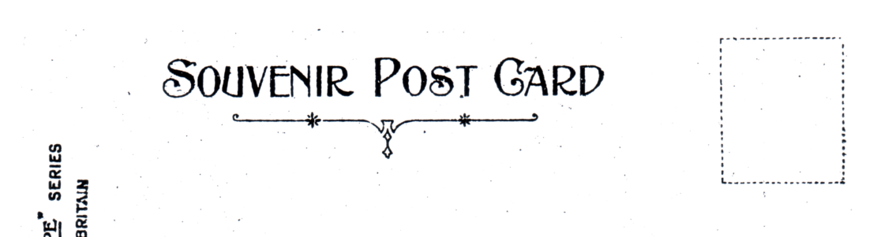

FB 10. Artotype Souvenir Post Card similar to FB 9. but without a divider this back was used
for the Artist painted ‘Entente Cordiale’ postcards.

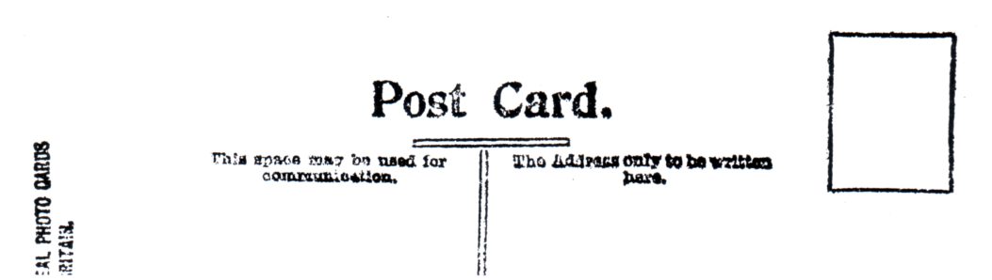

FB 11. X L Series, this back was used for most of the real photographic cards.
The black printing of the back is often very blurred.

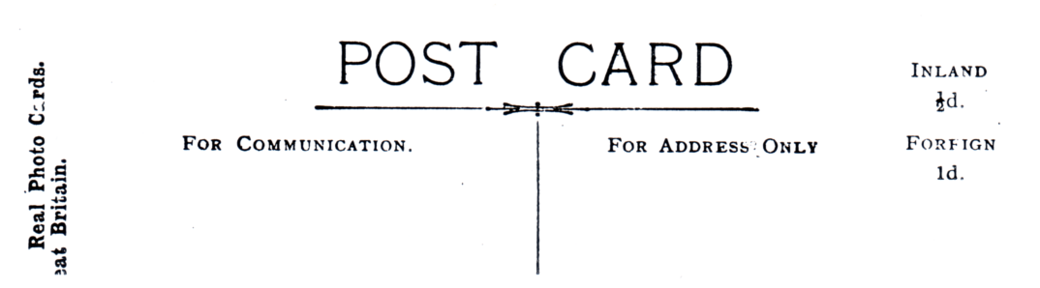

FB 12. X L Series, this back was also used for some of the real photographic cards.
The quality of the printing is much better than FB 11.

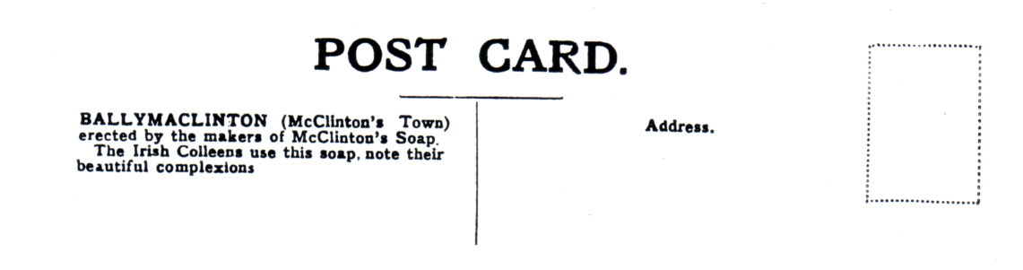

FB 13. this back was used for many of the Ballymaclinton postcards,
not only in 1908 but also in 1909.

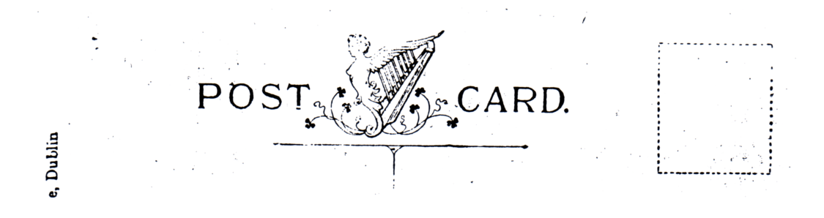

FB 14. the ‘High Harp’ back. there are three types of this back, in the high type the imprint
‘Valentine Dublin’ at the side is high up on the card, coming above the ‘T’ divider.

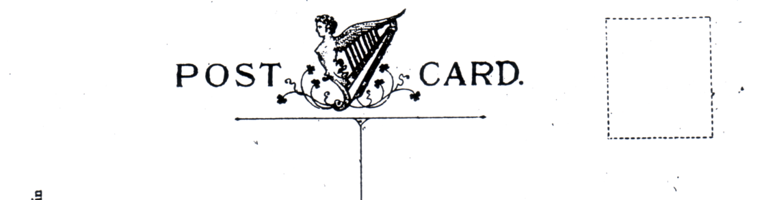

FB 15. in the ‘Low Harp’ type the top of the imprint ‘Valentine Dublin’ at
the side comes 13 mm below the ‘T’ divider.

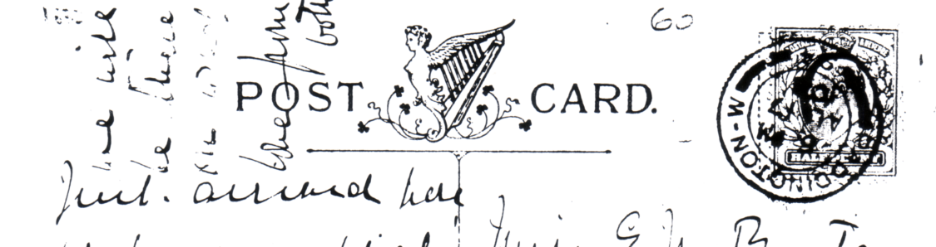

FB 16. in the third type of harp back there is no ‘Valentine Dublin’ imprint. This back was
only used for one of the B/W reprints of the ‘Interior of M’Kinley’s Cottage’.

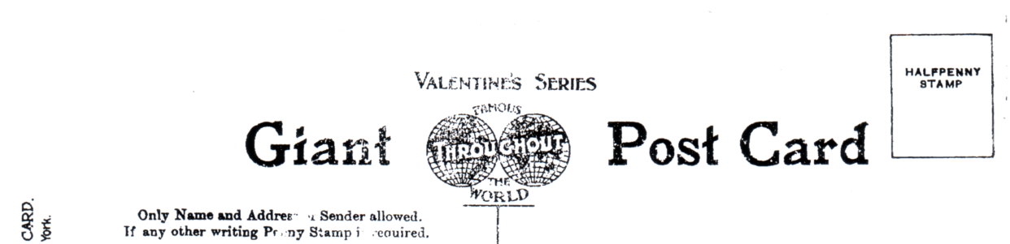

FB 17. Valentine’s used a slightly different back for the coloured and real photographic giant
postcards, this is the back for the coloured cards. The illustration is 85% of full size.

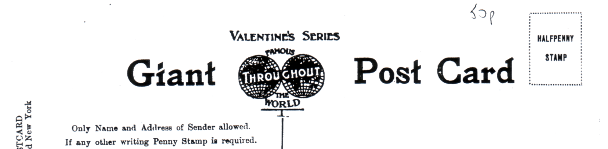

FB 18. Valentine’s used a slightly different back for the real photographic giant postcards,
the difference is in the setting out of the text, and the stamp box is in dotted lines.
The illustration is 85% of full size.

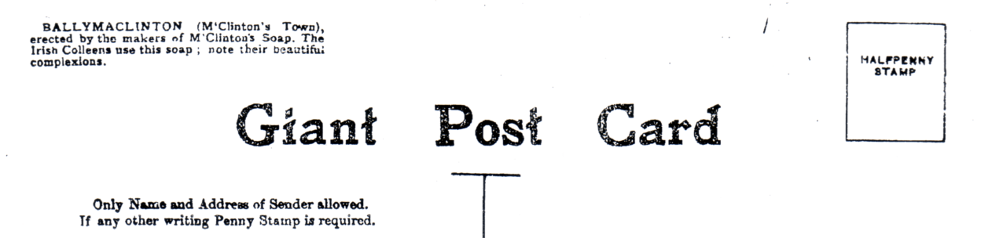

FB 19. this is the back used for the Ballymaclinton postcards.
The illustration is 85% of full size.

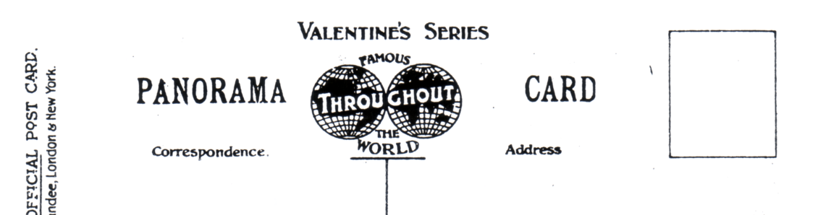

FB 20. this back was used for the double width panoramic cards. Valentine’s also used the standard
‘Red Seal’ FB 1, the ‘Throughout the World’ FB 2, and the ‘Souvenir’ FB 8 backs for the double width cards. As these are illustrated as standard backs, they are not duplicated as panoramic backs.

Borders.

To make some of their standard views more attractive, Valentine’s added coloured borders. The views feature some of the pre exhibition forerunners and some of the low numbers of the numbered range. From this it can be assumed these cards were published very early during the Franco-British Exhibition. There were four different series published with borders.

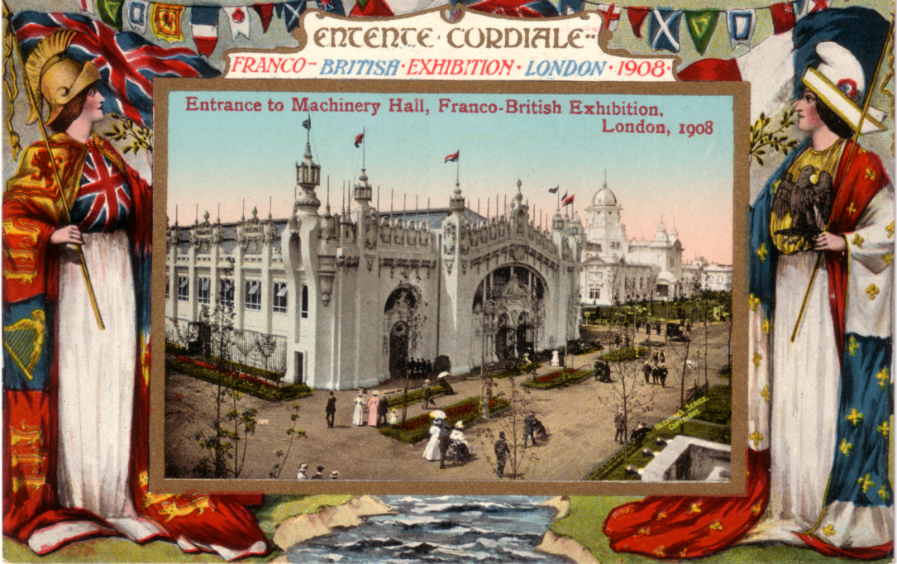

FB Bo 1. Coloured view in ornamental Britannia and Marianne border.

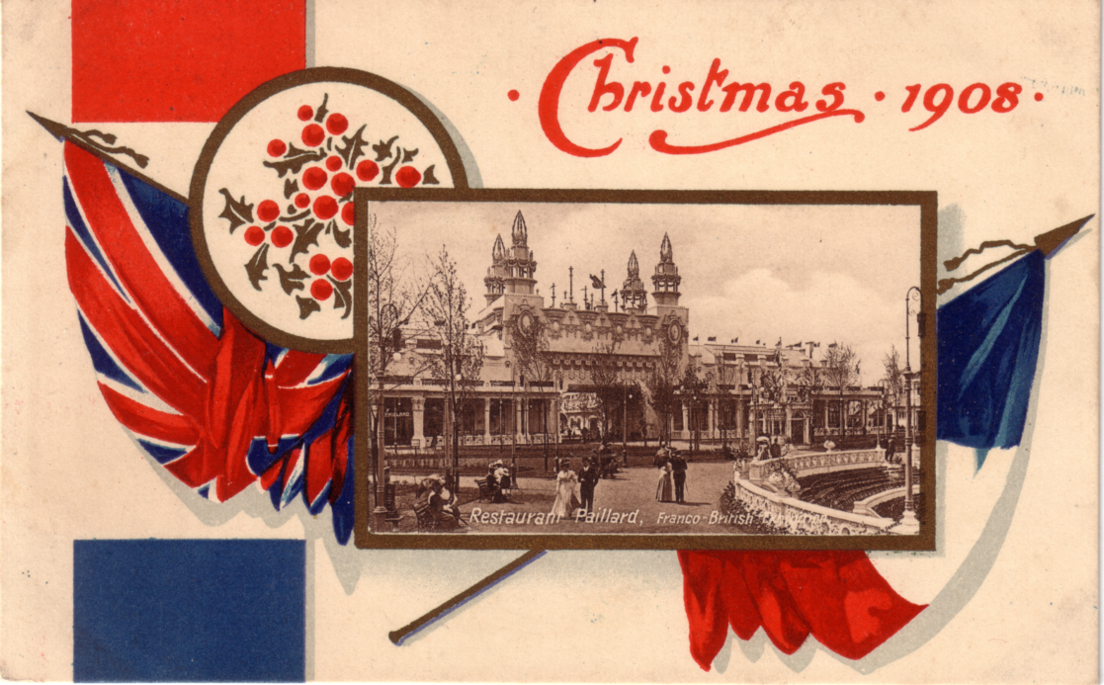

FB Bo 2. Sepia litho view in coloured Christmas Card border. There were
four different borders and only one is illustrated. They all have either
‘Xmas 1908’ or ‘Christmas 1908’ in the design.

The design of both BO 1 and BO 4 made it easy for them to be converted into ‘pull outs’ by cutting along three sides of the gold border round the view. Some of the views are known used for both standard and pull out postcards.

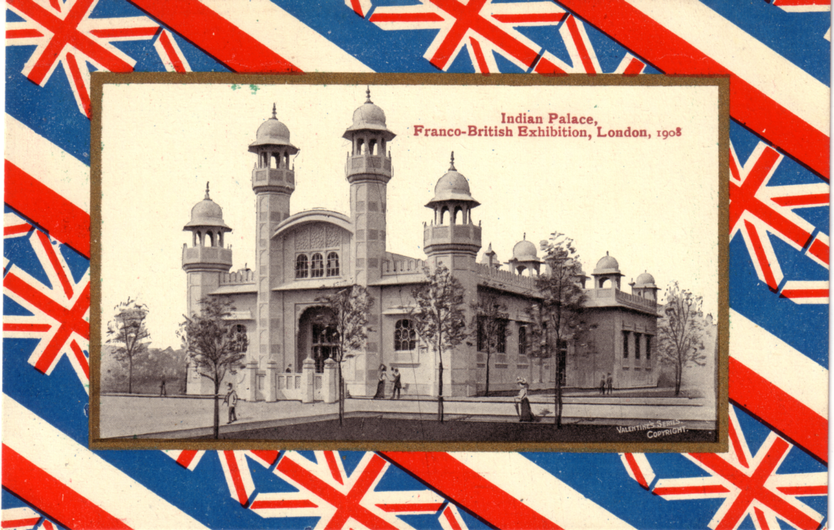

FB Bo 3. B/W Photogravure view in a red, white and blue border with the Union Jack
and French flag in diagonal stripes.

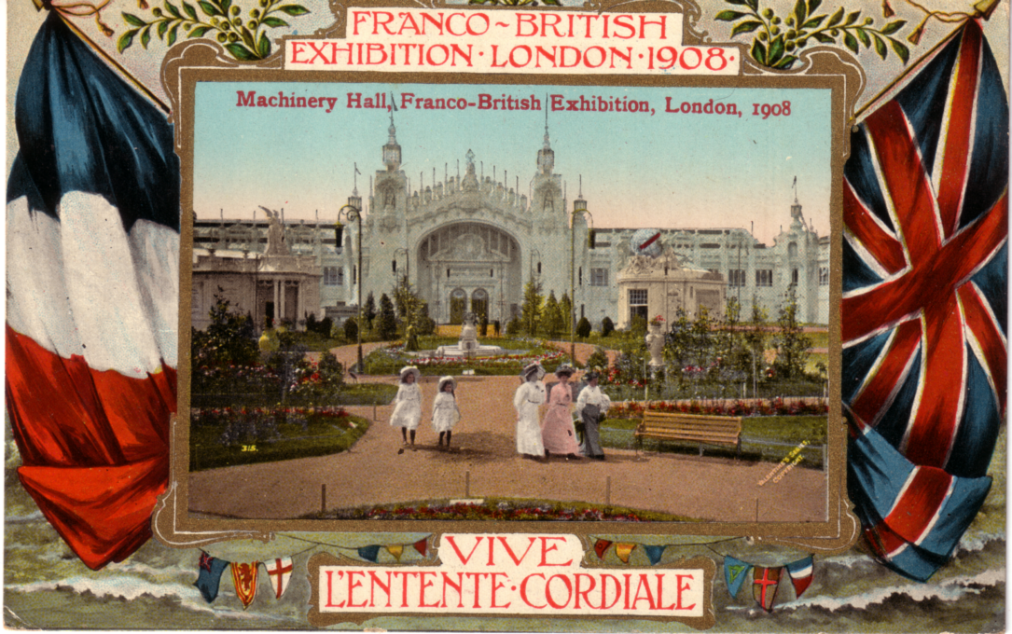

FB Bo 4. Coloured view in ornamental French and British flag border.

