EDITORIAL SPRING 2002

I’m starting off with a little talk
About our next convention at York

Actually I haven’t got much to say about York. I have been on to the Tourist Board who have sent me a list of hotels with conference facilities attached, and have whittled the list down to two. I shall be visiting both at the beginning of April when I shall be in York for the two day postcard fair, and when I have decided will make a provisional booking. So by the time I get out the next Journal I should be in a position to say where the convention will be held. Both prospective venues are within about ten minutes walk from the centre of the city for those of you who want to saunter round the Snickelways, or even ramble in the Shambles.
I have already had three members assure me they will be coming to York as they enjoyed the Glasgow convention so much. The encouraging thing is they are not among the old faithfulls but members who made Glasgow their first or second attendance at our convention. Before I leave the Glasgow convention Alan Sabey lent a member an item at the convention and has forgotten who he lent it to or what it was. So If someone reading this has an item belonging to Alan can they please make the effort to return it.
It was in February 1987, that Andrew Brooks (then secretary) announced he was going to hold a one day convention, to take place at York, in October of that year. I can still remember that first convention, it was a wonderful do. You must realise that until then collectors were isolated people, who in the main never met anyone else with the same interest. To spend a whole day hearing people talk exhibitions and see selections on display from some of the great collections, was an experience never to be forgotten. It was so successful that everybody wanted a two day event next year, as it has been ever since. We have held conventions at York (twice) Manchester (once), Crystal Palace (three times) and Wembley (five times), Portsmouth (three times) and met in Glasgow last year for our fifteenth convention. This is always held on the last full weekend of September. The meetings start at 10.00 and consist of displays and talks given by our members, and covers Exhibitions held in this country, and abroad. On the Saturday night we hold our Annual Dinner.
A lot of good came out of that first York Convention, it was there that Nancy and I met a bloke called Mike Perkins who came back to our hotel for a chat afterwards and stayed till about two o’clock in the morning if I remember rightly. It’s a friendship that has lasted and Mike comes down and stays with me for three or four days, two or three times a year. Certainly if we had not met at York the Wembley book would never have been written. We also meet at most of the big post card fairs for a cup of coffee and a chat, so I suppose in all I probably see him about twenty times a year.
The prices some dealers are asking for post cards is now quite unbelievable. At Yeovil last week at about the forth table I visited, a dealer showed me a packet of six Heath Robinson cards issued for the 1934 Ideal Homes Exhibition. He had put a price of £150 on the set and asked me if I thought he had got the price right. I told him I thought four pounds each was nearer the mark which did not seem to please him. Half a dozen tables further on another dealer had about ten of the same cards, a set and some duplicates in immaculate condition and he was asking £1.50 each. I made a point of going back to the first dealer and told him what was available a dozen yards away. I don’t think it made his day. During the two days at Yeovil I could have bought several dozen of the cards which are by no means scarce at prices between £1.50 and £2.50.
It has to be said that there are a number of collectors about, who seem to have a lot more money than sense and the internet seems to be designed to cater for these people. The thought of trying to out bid the rest of the world to get an item for my collection seems to me to be complete madness. In a recent Journal I told of the Wedgwood half pint Festival of Britain mug at £870 and the two Festival Guides that an advertiser was asking £350 for. At Bipex Derek Popplestone had a Festival record for sale at I think £15 or was it £25.? Anyhow it was snapped up by another dealer before the fair opened who auctioned it, where it fetched £180. Now one cannot blame the dealer who after all is out to get the best price he can for his goods.
But if collectibles are now to be disposed of more and more via the internet or by auction it seems we are going to be in for a very expensive time. When you get two collectors both trying to out bid the other we are likely to see a lot of funny prices reached and of course once a high price has been paid for something, it tends to establish a valuation for that particular item.
There is a gleam of light at the end of the tunnel, the local bookshop tells me that books advertised on the internet are actually forcing prices down, if a book has a price tag of £30 in no time at all someone is offering it for £25 and then at £20.
Alan tells me there are still a few members who have not paid their subscriptions yet. £8.00 in the UK or £12.00 abroad.

The Editor.

Netherlands East Indies Exhibitions.
by
Richard Wheatley FRPSL
Part 1.

Colonial Exhibition Semarang 1914.

This was the first of the large exhibitions to be held in the colony and the only one before the Great War. It took place between 20 August and 30 November 1914 at Semarang, which is a major port on the north coast of Java.
It was publicised by special postmarks, which were employed to cancel the stamp. Quite often an additional strike was struck alongside or upon the reverse of a cover. These special ‘hammer’ type handstamps were used for this exhibition at 15 main post offices, 9 of which were on the island of Java.

Banjermasin (Borneo) Bandoeng
Batavia Buitenzorg
Cheribon Djokjakarta
Koetaradja (Sumatra) Makasser (Celebes)
Medan (Sumatra) Padang (Sumatra)
Semarang Soerabaja
Solo Weltevreden

A. A. Shiller in ‘Nederland East Indies Postmarks & Cancellations’ states the period of use as “August to November 30th. However I have one of these marks from Medan dated 2-4-14 and two from Weltevreden dated 18-6-14 (fig 1) and 28-3-14 (fig 2). So it is clear that the special handstamp was in use well before the exhibition, which is what one would expect.

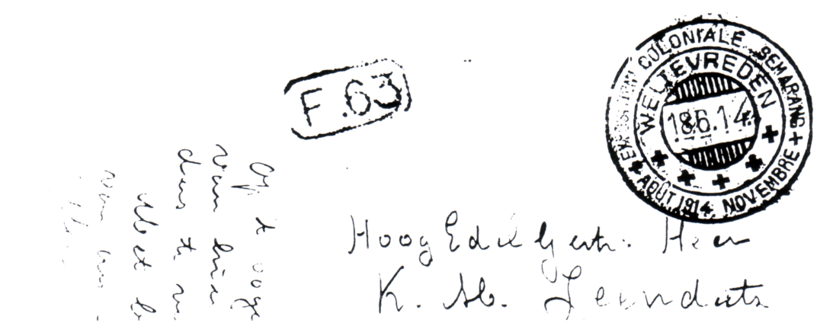

Fig 1. Exhibition postmark of Weltevreden 18-6-14.
5 cent postal stationery card to a retired major in Holland.

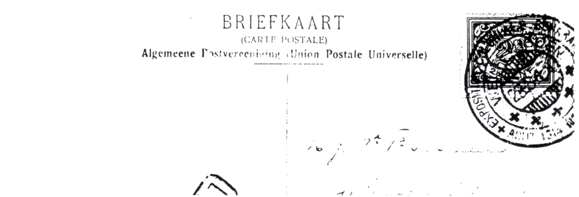

Fig 2. Exhibition postmark of Weltevreden 28-3-14.
Picture post card franked 2½ cent, to Holland.

Stamp Exhibitions.

During the inter-war years in the Netherlands East Indies invariably the Dutch language appears in the postmarks and special handstamps. This made sense, for the majority of the business and correspondence was carried out in Dutch. Very occasionally an Indonesian (Malay) word or expression may appear, these being used for convenience, as the indigenous word was in common use and there was no point in attempting a translation into Dutch.

Malang 1930.
The first postage stamp exhibition (postzegeltentoonstelling) to be held in this country was in 1930, at the town of Malang in east Java. It was a two day affair, from 18 to 19 January.
Advance publicity for the event was provided by a special ‘hammer’ type handstamp, which was used from 11 June 1929, but strangely only at Malang post office (fig 3). It was then used during the exhibition at the temporary branch post office.

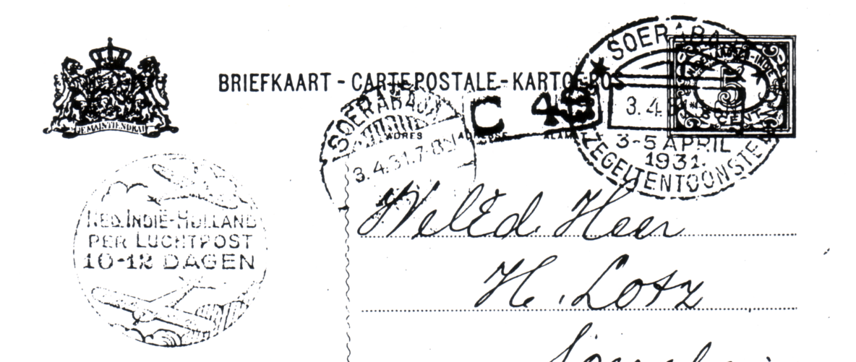

Fig 4. Soerabaja handstamp used in violet on the first day of the exhibition.
5 cent postal stationery card with promotional cachet for the 10 to 12 day airmail
service to Holland. Delivery locally within two hours of posting.

Soerabaja 1931.
The first exhibition was followed up the next year with another postzegeltentoonstelling, this time over three days (3 to 5 April 1931) in the large port of Soerabaja, again in east Java. As before, a similar special ‘hammer’ type handstamp was used for publicity prior to the event (fig 4). This was only employed at Soerabaja post office, from 12 March to 2 April in black ink. For the three days of the exhibition, the special handstamp was used at the temporary branch post office using violet ink.

Fig 3 1930 handstamp used at Malang Fig 7. Centenary of the postage stamp 1940

Batavia 1937.
After the initial flurry of enthusiasm for stamp exhibitions there was a gap of six years before the next one.
On this occasion it was held in Batavia in west Java, during the Pasar Gambir (Indonesian for annual fair). This was held from 27 to 31 August 1937. During the course of the fair a temporary branch post office was set up using a special large circular ‘hammer’ type handstamp (fig 6). This handstamp features the Pasar Gumbir pavilions and is known used in red and black ink.

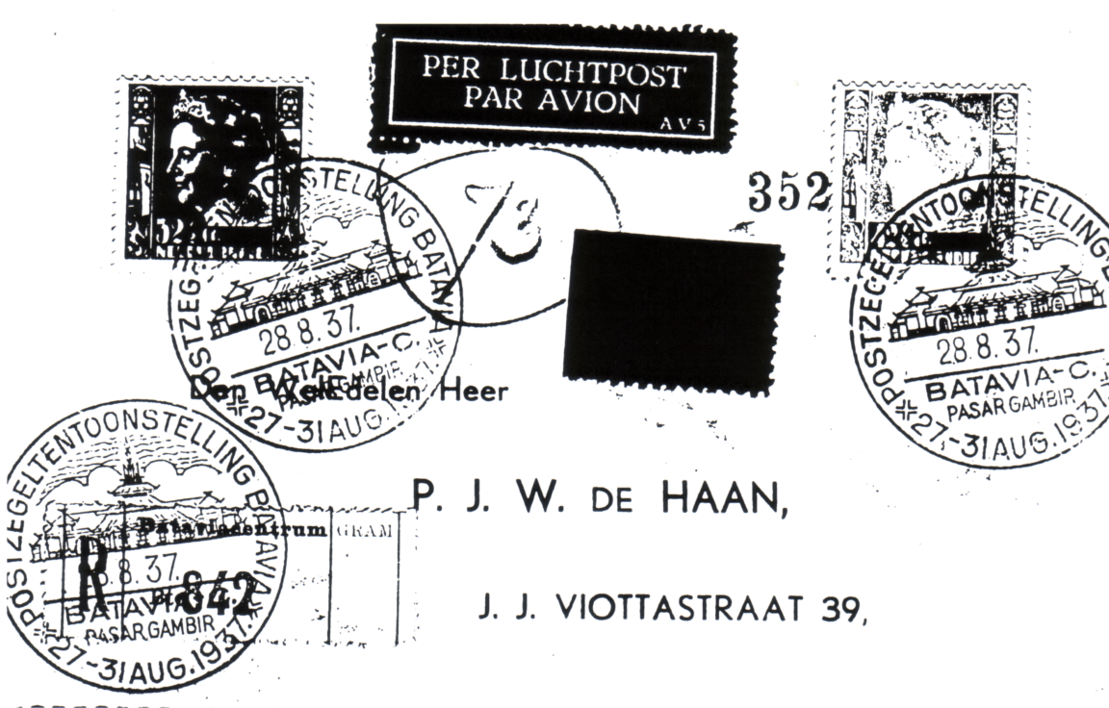

Fig 6. 1937 Batavia handstamp in black used on 2nd day of the exhibition. Franked
75 cents for registration, express and airmail

Batavia 1940.
By 1940 philately was well established in the Netherlands East Indies and there was a national philatelic society (Vereneging). For the centenary of the first postage stamp, the society produced a special ‘hammer’ type handstamp (fig 7). This is a translation of the Dutch inscription.
Eeuwfeest Postzegal - Centenary Postage Stamp
Ned. Ind. Ver(eneging) - Nederlands East Indies Society
Verzamelaars - collectors
A special post box was placed in the branch post office in the Hotel des Indes, Batavia. This special handstamp in violet cancelled all letters placed in the box on 6 May 1940. It is reported that about 4,000 covers were serviced..

My Reminiscences
by
Imre Kiralfy

The Strand Magazine in 1909 published a series of articles taken from the autobiography of Imre Kiralfy who became in his lifetime one of the greatest figures in the domain of public spectacle and mammoth entertainment’s the world has known. In 1909 he had just finished the successful Franco-British Exhibition and was into his next epic the Imperial International Exhibition. Held in the 140 acre piece of ground at Shepherds Bush which he had converted into a huge pleasure ground. All the buildings, halls and pavilions were painted white from which the term White City was born.
One of these articles covers his life from his first appearance on the stage as a gypsy child in Weber’s “Preciosia” when he was four years old. This led to a tour with the show to Germany where he was presented as an infant prodigy to Frederick William IV of Prussia. By the time he was eight he thought he would like to become a conjuror and then later a musician learning the piano and violin. At the age of 14 he heard his first composition played by an orchestra in Milan.
It was in 1867 when Imre was 22 that he went to Paris to visit the International Exhibition in the Champs de Mars that he finally decided what his role in life was to be. The article carries on,

This was the supreme achievement in the way of pageants and exhibitions. Not a single detail escaped me. I went about daily viewing this great spectacle, in whole and in parts from every point of view and to my youthful mind the greatest man in the world then was the director-in-chief of that great exhibition. At night, often until the early hours of the morn I wrote music. I loved to write for large orchestras. I set to full orchestra many of the compositions of my then friend Camille Schubert, purely for the pleasure of the work. A year later found me in Brussels on the eve of a great municipal fête, which was to last a week. There were to be races, balls, festivals, operas, pantomimes, sports and games. Four thousand soldiers had been told off to participate in the preparation of these fêtes. In the very midst of the organisation the master of ceremonies, harassed and overworked, lost his reason. I have since been told the municipality itself was at its wits end to find someone to carry on the work of organisation. By chance luckily enough for me, my name was mentioned, and at only 23 years of age I became installed as the director of the Brussels fêtes. But my path was not one of roses. To my dismay I found everything in confusion, but I plucked up courage, flung myself with enthusiasm into the business, planned a spectacle on a far more colossal scale than my predecessors, and put into practice some of the ideas I had already formed.
After my initial success at Brussels came a calm. I found no chance in Europe to repeat my triumph, and so resolved to emigrate to America. One day in 1869, I landed in New York. There I was destined to remain for a quarter of a century. I saw instantly that the great popular want in America was spectacle, spectacle that was more or less familiar to Europeans. Spectacular dramas there were, but they were on a very small scale, and greatly deficient in either colour or magnificence. I introduced into American theatres a scenic representation of Jules Verne’s “Round the World in 80 Days” and this served me as a vehicle for the production of gorgeous scenic effects, but before that came a mammoth spectacle called “The Black Crook”.
No theatre would serve to exploit the vast pictures which I began to conceive in my mind. I envied the ancient Romans their Coliseum and their wide, free amphitheatres My first experience in architectural work was in Philadelphia, where I was confronted by the necessity of building a theatre, or of not exhibiting the spectacle. I felt that the time had come, so I drew up plans of my own, and that is how the Broad Street Theatre came to be built.
The idea of a play dealing with Siberia and the Nihilists occurred to me, and I handed over the plot and details to an American dramatist, Bartley Campbell, commissioning him to write it for me. But although a large sum was paid on account, when Campbell finished the work he refused to give it to me. He produced it himself with enormous success, he called it “Liberis” so that opportunity was lost. However, I took the matter before the courts, but here again fate intervened, for Bartley Campbell suddenly went insane and died in an asylum. This failure proved another turning point in my career. I decided to dispense with theatres, to “produce” in the open air, to create my own spectacle in some untrammelled expanse outside the city. I found on Staten Island, near New York,
just the spot I wanted, and there, at St George’s, constructed a colossal stage and scenery, I engaged a thousand performers and produced “The Fall of Babylon”. That was over twenty years ago. Great as the success of this experiment was, I had something still more ambitious in my mind. This was “Nero” or, “The Burning of Rome”. For this spectacle I constructed a stage with a proscenium opening four hundred and eighty feet wide, and employing one thousand five hundred performers.

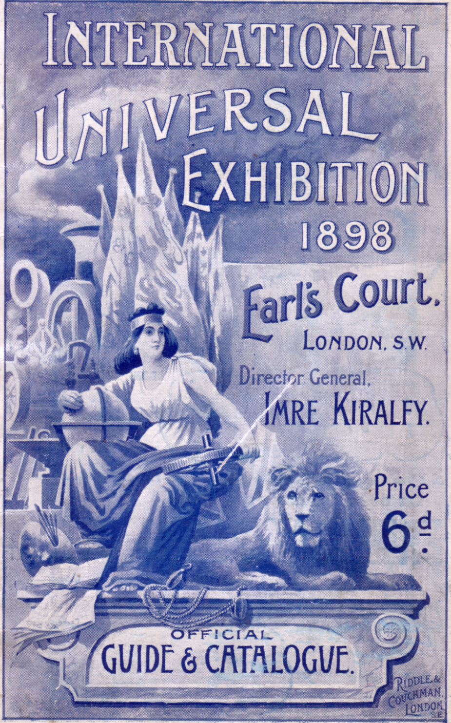

Guide and catalogue for the International Universal Exhibition 1898 at Earl’s Court

But to make this statement conveys no idea of the labour of organisation and operation. When a drama is produced on such a large scale, of what use would be a stage manager or a promoter confronted by such distances? I had to create a special system of control, so that I could communicate with the performers and “heads”. To do this I caused thirty electric bells, invisible and inaudible to the public, to be placed on the stage at intervals, and so, by a code of signals operated from a gigantic keyboard, I was master of the situation.
In the same way the conductor of the orchestra kept all the singers and dancers in unison, all by a single pressure on a button, ringing numerous bells, which unison greatly mystified the audience. As to the size and management of the scenery, one scene represented the exterior of Nero’s palace, approached by a series of terraces and steps, upon which no fewer than five hundred performers, singers, dancers and figurantes were grouped in a scene of revelry. These had previously taken their places at the wings, and then, at a signal, the whole mighty scene, performers and all was rolled in on a series of circular railway tracks.
You may, perhaps, suppose that this enterprise was sufficient for me at one time, but I found opportunity also to produce at the same time an original pantomime at the New York Academy of Music, a leading metropolitan theatre. One scene represented a graveyard by moonlight, a beautiful, artificial moon rising at the back. It so happened that one night I was watching “Nero” when the real moon rose with splendid effect behind the palace of the Caesar’s. Yet many spectators must have supposed it was an artificial moon, for I overheard a young lady near me say to her mother, “Ah, yes, it’s pretty, but not so realistic as the one in Mr Kiralfy’s pantomime at the Academy of Music!”.
Those were the days of P. T. Barnum, the famous American showman. Although he was then an old man, I suppose he thought I was beginning to invade his own particular domain. At all events, he saw “Nero”, and offered me a great sum to be allowed to produce it in connection with his own show in London. I was just then starting for London, so he commissioned me to examine Olympia and tell him whether or not it would be suitable for “Nero”. I told him it would, and so “Nero” , rewritten and produced on a much smaller but more artistic scale, was seen by Londoners.

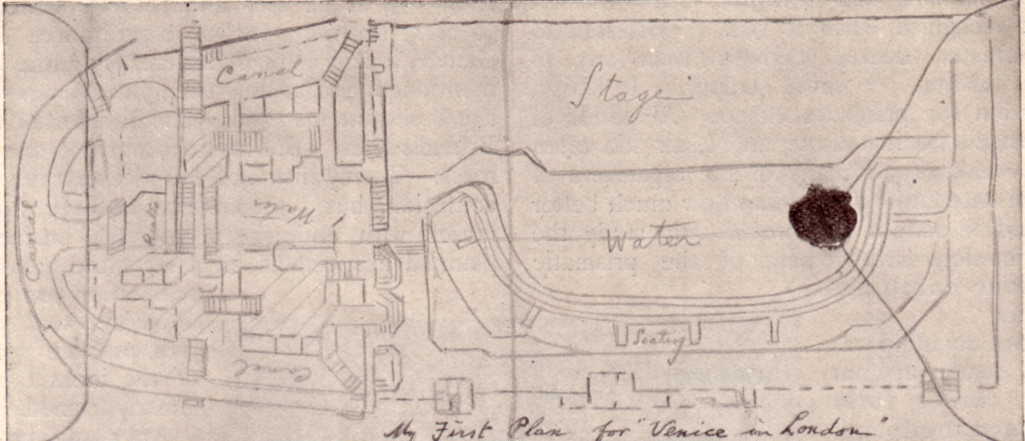

Kiralfy’s original sketch for Venice in London on the back of an envelope.

It was while I was staying at Barnum’s place at Bridgeport, Connecticut, that the idea of “Venice” flashed across my mind, not a “Venice in Italy” but a Venice transported to London. I took out a scrap of paper, an envelope, from my pocket, and then and there schemed out my idea. My mind went back to my studies of Venice thirty years before, the whole thing as it should be rose up before me, and down it went, even the details, on the back of that envelope. When “Venice” attracted its thousands and hundreds of thousands to Olympia in 1892, it had all arisen naturally from my plans on the back of that envelope.
A still greater opportunity was at hand for me. The Colombian Exhibition was to bring the whole universe to Chicago. A dramatic pageant on an unprecedented scale was demanded, and that is how “America” in twelve acts, came into being at the immense auditorium in Chicago, the largest theatre then in the world. There has since been a larger one. I have built it myself. “America” I am told, marks an epoch in the history of the stage. On its commercial side, at all events, no such average of receipts has ever been recorded before.
By this time I had resolved to settle down in London. Incidentally I may mention that it was not my first period of residence in the worlds capital, for in the middle ‘seventies, during a visit, I had met an English lady who became Mrs Kiralfy and my eldest son was born here. But London seemed to offer the greatest chances of the lasting success I sought. Some years before, overtures had been made me by the gentlemen associated with the series of exhibitions at Earl’s Court. They offered me flattering terms to produce a spectacle in connection with the German Exhibition, but I saw that nothing could be done with Earl’s Court unless a long lease could be obtained, all the old buildings pulled down, and a wholly new scheme carried out. Such a lease of twenty-one years was now obtained. A syndicate was formed to carry out my ideas, and I was appointed director-general. I had never ceased planning schemes of architecture and of colour, and I think I might say that for some years I found at Earl’s Court a fairly ample field for my energies. There I produced in succession the “Empire of India”, “India and Ceylon”, “The Victorian Era”, “The Universal Exhibition”, “Greater Britain”, “Woman’s”, “International”, “The Military Exhibition” and Paris in London”.
Then this part of my career came to an end. It was all only a prelude to what I shall consider the summit of my life’s achievements in the domain of public spectacle, the Franco-British Exhibition at Shepherds Bush. In all this I felt it was necessary to surpass all my previous labours. I must have something at once novel and commanding, something in keeping with the greatness of the project.
One night I lay awake in bed and, as if by magic, I saw stretched out in my mind’s eye, an imposing city of palaces, domes and towers, set in cool, green spaces and intersected by many bridged canals. But it had one characteristic which made it strangely beautiful. Hitherto I had dealt in colour in the shimmering hues of gold and silver. This city was spotlessly white. I saw it all in an instant, and the next day I had jotted down the scheme of what London was to know as the “White City”. More than four years were needed, four years of unremitting toil, to make that scheme a reality. But on the day when His Majesty King Edward VII and President Fallières of the French Republic, in the midst of a cheering multitude, visited the Franco-British Exhibition I knew that the result had justified all the labour. That was the proudest day of my life.
It would seem strange indeed if the “White City” which was reared with such pains and labour on the barren wastes of Shepherds Bush, should have been as evanescent as a summer’s dream. Fate and the public voice have preserved it from that destiny, and I hope the great Imperial Exhibition now opening will be considered worthy of its forerunners.
Looking back now upon a public career of nearly sixty years, it is very gratifying to me to think that I have never rested content with that which both my friends and critics have thought to be my best. I fear I have never followed the adage and let well enough alone. Still more gratifying is the thought that I may have helped to raise the standard of spectacular entertainment and that I have contributed something to the artistic needs as well as to the gaiety of the nations.

The end.

This was written in 1909 and we know that Imre Kiralfy did not indeed rest on his laurels. He continued to mount huge exhibitions up to the outbreak of the 1914-18 war.

Extract from The Times 29th April 1919.

Death of Imre Kiralfy, Exhibition Organiser.

The death occurred from heart failure at Brighton on Sunday of Mr Imre Kiralfy, who was best known to Londoners as the organiser of exhibitions and spectacular displays in which direction he met with a considerable measure of success up to the outbreak of war.
He started operations at Olympia and Earl’s Court but by 1908 his ideas had outgrown both these places of entertainment and he conceived the plan of erecting at a great pleasure ground at Shepherds Bush. In a comparatively short time he converted 140 acres of ground into the “Great White City and Stadium” and the dazzling buildings and the colossal scale on which everything was carried out drew hundreds of thousands of people there. It was opened with the Franco-British Exhibition in 1908, this was followed in due course by an Imperial International Exhibition, A Coronation Exhibition, a Latin-British Exhibition and an Anglo-American Exhibition. The outbreak of war brought Mr Karalfy’s activities to an end. The White City became in turn a drilling place for recruits, a medical inspection centre and an aeroplane factory, and with succeeding years most of the Dazzling white paint and of the glory that once caused people to flock to Shepherds Bush have passed away.

Extract from The Times 24th June 1919.

Wills and Bequests

Mr Imre Kiralfy of Tower House, Cromwell Rd, S. W., the originator of the series of International Exhibitions in London , the first of which was the Franco-British display at Shepherds Bush. Gross value, £136,680

The bulk of this article was sent to me by one of our members Derek B. Bartlett, it came from a tatty old copy of the Strand Magazine (Derek’s description). I have also recently acquired the personal archives of Fred Fletcher one of the founder members of the Exhibition Study Group which contained details of Imre Kiralfy’s life which I have incorporated into this article.
The Editor.

A plating study of a sheet of 1924 British Empire Exhibition Advertising Labels.
by
Alan Sabey

I recently managed to acquire one of the few known complete sheets of the salmon coloured advertising labels published for the 1924 British Empire Exhibition at Wembley. There is no imprint on the selvidge. Fourteen of the sixteen labels can be plated and a brief description of the flaws is given. Numbers for the labels has been allocated as follows.

1 2 3 4
5 6 7 8
9 10 11 12
13 14 15 16

1 Imperfect upper left corner
2 Blob on middle line under Lions feet
3 Broken R
4 Break on top frame, blob on lower frame line
5 Indistinct ear, stop after third line below feet, missing left claw on foot
7 Stop on body under the end of mane
8 Entirely different shape of S of BRITISH
9 Blob on top line and under foot of Lion
10 No serif under right leg of H and imperfect B of BRITISH
11 Breaks on inside of back leg of Lion
12 Stop in upper margin, breaks in lower front mane
14 Large blob in M of EMPIRE
15 Stop on front leg of Lion, stop after second E of EMPIRE
16 Stop above the Lion’s tail, stop to right of back of Lion

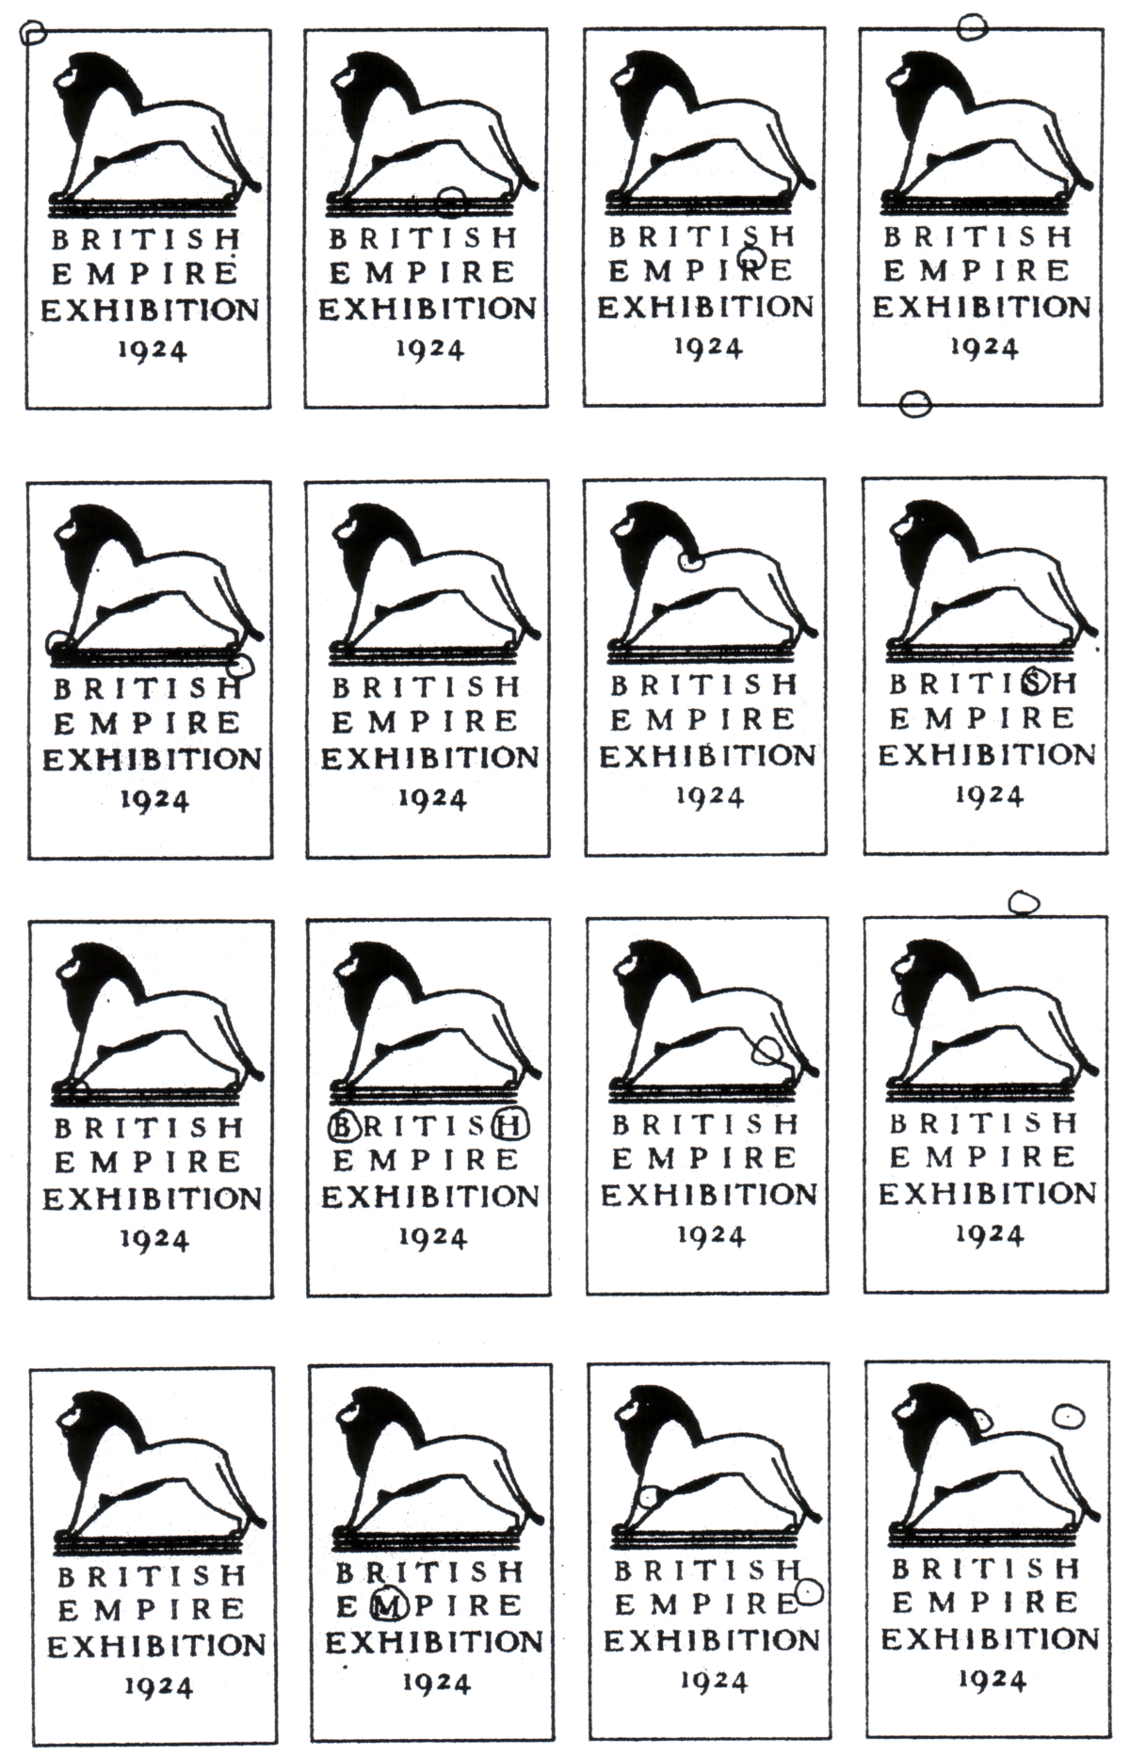
Post Cards of the White City
Part 20.
by
Bill Tonkin

The last part 19 published in the Winter Journal of ‘Post Cards of the White City’ saw us come to the end of the small publishers section. This has covered all the publishers with the exception of Valentine & Sons Ltd. Part 20 makes a start on this truly vast area of collecting.

Valentine’s post cards of the Franco-British Exhibition 1908.

To list the post cards of the White City exhibitions from 1908 to 1914 when the outbreak of the Great War put an end to them, has long been an ambition of mine. When I first joined the Exhibition Study Group I corresponded with Andrew Brooks on the subject, and we worked together on a list of all the known numbers of Valentine’s cards.
Even then I realised it would be a big undertaking, and that I did not possess the knowledge of how to set about it. The first requirement was to build up a large collection, so I would have the material to work on. Over the last fifteen years or so, I have built up what is probably the largest collection of White City exhibition cards in existence. I have never counted them but they fill twenty one boxes, and there must be in the region of seven to eight thousand cards.
With the non Valentine’s cards there was no problem, and as these comprise nearly half of the collection, it was time consuming, but straight forward work, compiling lists of the various small publishers in alphabetical order. The problems really started when I reached Valentine & Sons.
After several trial runs I decided that the sheer number of Valentine’s cards would have produced a list with so many alterations of titles and cross references, that it would have been very difficult to locate a card, especially if it had a common title like ‘Court of Honour’ which would have needed possibly 30 to 40 pages alone. I decided the cards would have to be split up into sections, and as the exhibition of the year seemed the most logical thing, this is what has been done. Even so cards titled ‘Court of Honour’ has taken 15 pages in the first Franco-British section.
Valentine’s used the name ‘Great White City’ in a lot of their titles, in place of a specific exhibition, and these have all been listed together in section 2.
Section 1. 1908 Franco-British Exhibition and the 1908 Ballymaclinton cards.
2. Cards titled The Great White City published in 1908, 1909, 1910, 1911 and 1912.
3. 1909 Imperial International Exhibition and the 1909 Ballymaclinton cards.
4. 1910 Japan-British Exhibition.
5. 1911 Coronation Exhibition.
6 1912 Latin-British Exhibition.
7. 1914 Anglo-American Exposition.
The National Gas Exhibition in 1913 was a trade exhibition which only ran for one month. Neither Valentine or Gale & Polden published postcards for it, and apart from one poster type card no others are known to me. This has been placed in section N small publishers under National Gas Exhibition.
One anomaly found in the 1908 section, was cards with Franco-British Exhibition in the title on the front, and a Great White City back, these have been listed under Franco-British Exhibition. Cards with Great White City on the front, but Franco-British backs have been listed in the Great White City Section. In other words, the exhibition named on the front or picture side of the card, takes precedence over the exhibition named on the back. The following non related backs have been recorded. It could well be that these are mistakes on the part of Valentines. In the Franco-British Exhibition section only three instances are known where this mistake occurs.

Franco-British Exhibition on the front with The Great White City on the back
The Great White City on the front with Franco-British Exhibition on the back
The Great White City on the front with Imperial International Ex. on the back
The Great White City on the front with Coronation Exhibition on the back

Numbering System.

Valentine’s used a numbering system for many of their White City Exhibition cards, known numbers ranging from No. 108 to No. 859, unfortunately the numbering system was not used on all of their cards. Many views were not given numbers at all, some views were given numbers but the number did not appear on all the various printings, The real photo card might be numbered while the coloured card has no number, or the coloured card may be numbered while the B/W card is not. For some reason sepia cards were seldom numbered. This can even vary within the same process and you can have coloured cards with and without numbers.
The lack of numbers up to 108 can be explained by accepting that these numbers were allocated, but not included on the artist drawn cards which Valentine’s were able to produce before the exhibition opened. These I have called ‘Pre exhibition forerunners’.
Almost without exception none of these pre exhibition forerunners for the Franco-British Exhibition are numbered. The only exception that I have found is one card, a view of the Stadium which had no number when published as a coloured card, but when published with an ornamental border was given number 110 in very small figures printed in the design.
Valentine’s also on occasions used the same number and the same title for different views as in the case of No. 142 titled ‘Flip Flap’, where three different pictures taken at different times were used. Indeed one view has been so altered by being reduced in size, that we could say there are four different cards.
To add to the confusion some of the pull outs used a different numbering system, running from No. 706 to No. 1268. In some cases the numbers given to pull outs duplicate numbers of the main system on completely unrelated cards. One Coronation Exhibition card ‘Irish Section, Glendalough’ number 786, is given the same number as a pull out for the same exhibition titled ‘One of the (H)attractions of the Coronation Exhibition’. Pull outs made from views of the exhibition were generally not given pull out numbers but retain their original number. Even this was not a hard and fast rule, and ‘Indian Woman and Child’ was given No. 824 as a normal post card, and No. 821 as a pull out.
There was also a short series of cards for the Japan British Exhibition numbered 1 to 10. Some of these are also known with the main number, for example the same view titled ‘Spring, the Four Seasons’ can be numbered either 8, or 670, but no card has been found with both numbers printed on it.
Cards for other exhibitions published by Valentine’s during the White City period 1908 to 1914 including the 1908 Scottish National Exhibition, the 1911 Festival of Empire at the Crystal Palace, the 1913 Liverpool Exhibition and their series for the Earls Court, all had numbering systems of their own, within the White City range, and it is possible to have post cards for two different exhibitions with the same number. For example No. 108 can be a 1911 Festival of Empire or a Franco-British card, and No. 142 can be the Flip-Flap at the Franco-British Exhibition or a card titled ‘The Amusements’ at Earls Court.

Range of numbers used for each exhibition, and total of different numbers published.

1908 Franco-British Exhibition 108 to 582 174
1908-14 The Great White City 112 to 859 97
1909 Imperial International Exhibition 108 to 594 86
1910 Japan-British Exhibition 1 to 10 10
132 to 758 101
1911 Coronation Exhibition 132 to 824 72
1912 Latin-British Exhibition 532 to 844 33
1914 Anglo-American Exposition 455 to 844 6

Un-numbered titles of post cards published for each exhibition.

1908 Franco-British Exhibition 114
Pre exhibition forerunners 61
1908-14 The Great White City 75
1909 Imperial International Exhibition 37
1910 Japan-British Exhibition 37
1911 Coronation Exhibition 21
1912 Latin-British Exhibition 1
1914 Anglo-American Exposition 0

Titles.

One of the main problems in listing the titles of Valentine’s printed coloured cards, was the enormous variety of titles found on the same view. The title of any given view was not part of the plate used for printing the cards. If this had been so the title would have been identical on all the cards of that view. Instead when Valentine’s decided to reprint a view, the title was redone from scratch. This meant that if during the course of the Franco-British Exhibition a certain view was reprinted, say fifteen times, each batch of printings would have had a new title prepared and used just for that batch. When the printing run was finished, the plate was saved but the title was scrapped. When another printing was required, the plate was taken from the stores, and a new title produced to go with it.
Since there was no need to keep any record of the title of the previous printing, or any need to match the setting or style with the first printing, it follows that the title on the second printing would be different in many respects from the first. A third printing would be different again from the previous two and so it went on. One advantage of not having permanent titles on the printing plate, was that the same plate could be used again year after year, with just the title altered for the next White City exhibition.
It may well have been left to the whim of the person preparing the title whether it was in one line, two lines, three or even four lines. It may be found at the top of the card to the left, in the centre, or to the right, or in any intermediate position, the same applies to its position at the bottom of the card. If the title was in more than one line, then the first word of the second line in relation to the line above would be different. There was endless variety, with every batch of printings different. When the title was printed at least the font was the same, but when the title was hand written (manuscript), then there would be a difference in the form of the individual letters. To complicate matters, more than one person was engaged in hand writing the titles, and the same view is known where there are two distinct styles of hand written title, indicating a reprint with the title written by a second person. In this list the position of the title has been given i.e. ‘title in two lines at bottom left’, but it was not felt necessary to go further into too much minor detail of the position or variations of the title. Where the title is in manuscript form this is listed, and some notice is given to the style of manuscript.
On some cards especially Ballymaclinton there are two distinct styles of writing titles, the easiest thing to look for is the way ‘h’ and ‘n’ are written. They can either have long tails, described as (with tails) or do not have tails (without tails). There are other differences in individual letters but these are simple to spot and are listed.
There is another respect in which the title of a given view can be different. Valentine’s seemed very lax on the actual wording of a title, and did not worry if it got altered, ‘Court of Honour’ can be reissued as ‘In Court of Honour’ or ‘The Court of Honour’ or even ‘In the Court of Honour’. ‘Court of Honour at Night’ can become ‘Court of Honour, Night Effect’, and there are many more extreme examples of changes, such as ‘Donaghmore Cross’ into ‘St. Patrick’s Cross’ and ‘Irish Village Street’ into ‘Main Street and Ancient Church, Ballymaclinton’.
It is possible that Ballymaclinton cards changed their titles with every reprint and views are common with anything from two or three, up to eight different titles. This has meant that a certain amount of cross referencing has been necessary. It was felt that all cards of the same view printed from the same plate or negative, of a particular exhibition should be kept together whatever the title.
Where there are a number of different titles for the same view they are sorted out into alphabetical order and listed under the first title. All the secondary titles follow also in alphabetical order with the note ‘title altered to’ until all the changes of title are recorded. Elsewhere in the list each of the secondary titles will be listed with a reference pointing to where the complete list of the various titles for that view at the particular exhibition can be found. At the end of the list will be found a reference to which other exhibitions that view was published for and the title used for the other exhibition.
Sometimes a change of name was justified, the Olympic Games took place while the Franco-British exhibition was on, and a card titled ‘Imperial Sports Club’ (No 299) shows a view of the headquarters for the games. After the games finished the building became the ‘Lagoon Grill Room’ and the title on the card was altered to ‘Band Stand and Canal’. Sometimes of course the occupiers of a pavilion changed when a particular exhibition was over. For instance after the Franco-British exhibition closed, the French interests departed and some of the pavilions were renamed.
In placing a title in its alphabetical order in the list, the prefix ‘A’, ‘An’, ‘In’, ‘In the’, ‘On’, ‘On the’ and ‘The’ is ignored, as far as the location of the title is concerned, although it is not left out of the description, i.e. ‘In the Grounds’ will be found under Grounds in section ‘G’ and not section ‘I’ for ‘In’, ‘In Court of Honour, under ‘Court’ and ‘The Flip Flap’ under ‘Flip’.
When it appears, the name of the exhibition ‘Franco-British Exhibition, London, 1908.’ is usually printed in full on a card, but some times the ‘1908.’ or even ‘London, 1908.’ is left out. In most cases this comes after the title, but in several instances i.e. ‘Franco-British Exhibition, London, 1908. “Salutation”.’ the title comes after the name of the exhibition. In the listing the name is given as it appears on the card, but it will be found in the ‘S’ for ‘Salutation’ section, and not in the ‘F’ for ‘Franco’ section.
Valentine’s used their system of re-titling each batch printed, for many years. It was still being done on the real photographic cards for the 1938 Empire Exhibition at Glasgow, where views can have up to half a dozen manuscript titles all with slight variations. The same thing happened with their 1951 Festival of Britain cards.

Valentine’s Imprint.

Valentine’s imprint or lack of it on the front of cards is also worthy of study. ‘Valentine’s Series Copyright’ on the front can be found in six different positions. These variations occur almost entirely on the pre exhibition forerunners. It would seem that once Valentine’s got the forerunners out of the way they settled down to a standard imprint at an angle in the bottom right corner.
Often Valentine’s would publish a card with the imprint moved to two or three different positions, this is especially so in the case of the ‘Sunk Plate with large white border, type of card. Here they even managed to get ‘Valentine’s Series Copyright’ printed the other way round, as ‘Copyright Valentine’s Series’.
Cards are even known with two imprints. This occurs when for instance a white imprint is printed on a white path, where it does not show up. It is reprinted moving it on to say a dark lawn where it is more visible, and Valentine’s did not bother to remove the first imprint.
1. Some cards were published without the imprint and these are listed as ‘without Valentine’s Series Copyright’.
2. Some have a split imprint with ‘Valentine’s Series’ on the left and ‘Copyright’ on the right, listed as ‘with a split Valentine’s Series Copyright’. Measurements are given for the gap between ‘Series’ and ‘Copyright’.
3. The split imprint can be varied with the words changed round, ‘Copyright’ is on the left and ‘Valentine’s Series’ on the right, these are listed as ‘with a reversed split Copyright Valentine’s Series’.
4. The imprint can be in two lines in a horizontal position, listed as ‘with a horizontal Valentine’s Series Copyright’ and can be in the bottom right corner.
5. The imprint can also be in two lines in a horizontal position, listed as ‘with a horizontal Valentine’s Series Copyright’ in the bottom left corner.
6. The imprint can also be found printed at an angle, listed as ‘Valentine’s Series Copyright at an angle’. If the angled imprint is in the left bottom corner this is noted,
7. If the angled imprint is on the right this is not listed as this became the normal position for it to be.

Backs of the post cards of the Franco-British Exhibition.

While most collectors are naturally mainly concerned with the front or picture side of a post card, there is much of interest in the printed backs as well. Altogether Valentine’s used 20 different backs for their Franco-British Exhibition post cards, not counting the wide range of colours. Three of these were used for the giant sized post cards and one for the panoramic double width post cards. All of these are illustrated and numbered from FB 1. to FB 20.
The importance of the colour is that a different coloured back often means a different printing and sometimes an examination of the front will reveal different clouds in the sky or a different setting of the title.
When we come to the colours of the backs, things get a little more difficult. Some of the backs like FB 1. the ‘Official F B Seal’ which was used for a large proportion of Valentine’s cards were printed in three colours, black, dark grey and red. The black and dark grey backs were only used in stapled books of post cards. The red back was the most common one used by Valentine’s and there must still be many tens of thousands of them about.
The second most common type was FB 2. the ‘Famous Throughout the World’ back. This came in black, grey, greenish grey, bluish grey, green and deep green. It is easy to lay out a dozen cards with the backs ranging from grey to greenish grey, but it is difficult to decide just where you stop calling a colour grey and start calling it greenish grey. In this I have only listed both shades where there is a clear recognisable difference. The same applies to the difference between greenish grey and bluish grey, it can be very difficult deciding what to call an intermediate shade.
FB 3. was used on some of the artist’s painted postcards and also some of the Ballymaclinton cards. There was no great range of colours only grey and greenish grey.
The next back FB 4. had a short life and was used on the multi view postcards and cards featuring members of the Royal Family at the opening. These would all have been available on the opening day or very soon after. FB 4 was also used on some of the pre exhibition forerunners
FB 5 the smaller version of the ‘Famous Throughout the World’ back and comes in about eight colours, it was used for Ballymaclinton postcards.
There is some doubt if the postcards with back FB 6. are exhibition cards. They are included for the design relationship.
The next four Souvenir backs, FB 7, FB 8, FB 9 and FB 10, were all used for specific series like the Australian Pavilion, Canadian Pavilion and the Entente Cordiale.
The two X L Series backs were both used for real photographic cards FB 11 was used more often than FB 12.
The difference in the three Welsh Harp backs is in the position of the imprint down the side. The differences can be seen in the illustrations. The third type without an imprint is only known on one of the B/W litho reprints of ‘Interior of M’Kinley’s Cottage, Ballymaclinton’.
The illustrations of the three ‘Giant’ backs have been slightly reduced in size

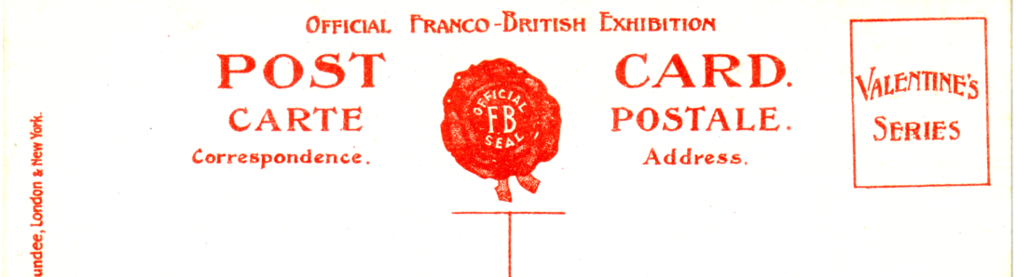

FB 1. printed in red the most common of all the White City Exhibition postcard backs.
It is also known in black and dark grey on postcards sold in stapled booklets.

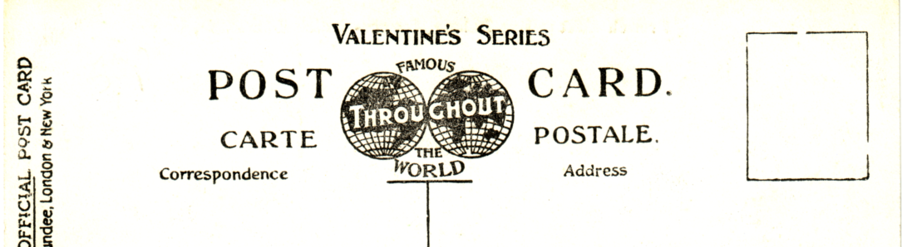

FB 2. the second most common back printed in black, grey, greenish grey, bluish grey,
green and deep green

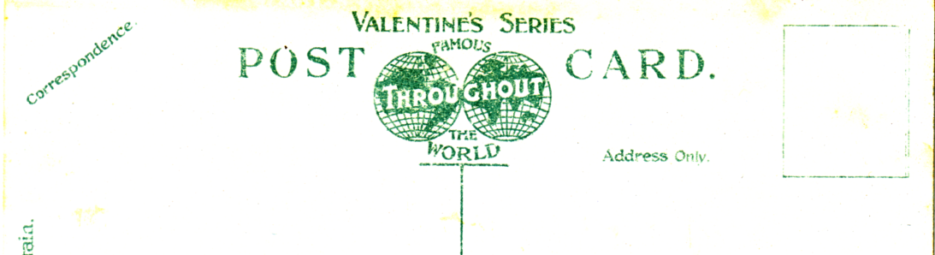

FB 3. similar to FB 2. but without the ‘Official ‘ imprint down the side,
and with ‘Correspondence’ in small letters at an angle in the top left corner.
This was a seldom used back used mainly on artist painted cards.

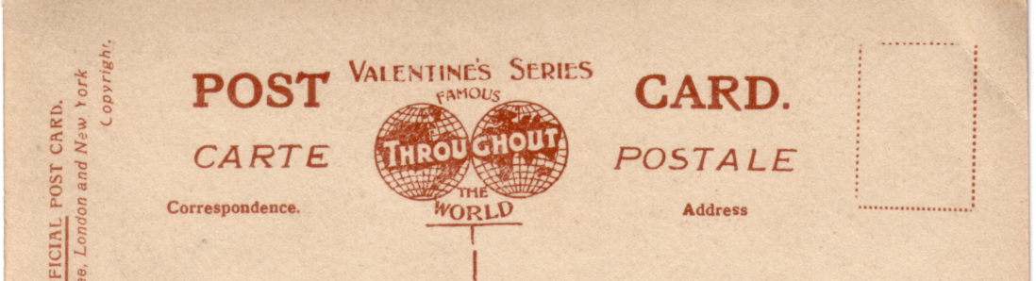

FB 4. again similar to FB 2. but with many differences, one is that ‘Carte Postale’ is in italics.
It was used for real photographs and is in black or a deep reddish brown.

