EDITORIAL WINTER 2001

This year’s convention is gone and past
Time to start planning the next one fast

I usually come away from our annual convention thinking “well that was a good do, it will be a hard act to follow”. After the Glasgow convention organised by Stanley Hunter I realised the treats laid on by Stanley for the weekend will probable never be equalled, let alone surpassed. It was a first class do, elsewhere in the Journal Ron Trevelyan has done a report of the proceedings.
Having it in Scotland meant we lost a few members who did not wish to face the long Journey, but we made up for it by attracting a few of our Scottish members. Jean Osbourne who lives at Linlithgow who had been looking forward to attending, wrote to me saying her son had picked that weekend to get married so she couldn’t make it. Gary Cheyne of Lanarkshire who phones me for a chat now and again I was able to meet in the flesh, and it was nice to see Andrew Brooks again after a gap of a couple of years. Some members living in the South flew up, I had so much luggage including the six wooden display frames, that I had to take the car. I drove up to Stourbridge near Birmingham and stayed with Mike Perkins overnight and continued next day to Glasgow. We were going to take it in turns driving but in the end Mike did all the driving both ways and I stayed with him again at Stourbridge on the way back.
Wyn Anderson who I think has attended all of our conventions since the first, has had to give up as her legs have finally packed up on her. She always took photographs of the displays and became our official unpaid photographer. The pictures of this years convention were taken by Jan McKelvie who kindly sent me copies for the Journal.
New members Anton O’Broin who collects Ballymaclinton travelled from Ireland and Jan McKelvie and her husband Bob came from Omaha, Nebraska. Jan collects the 1898 Trans-Mississippi Exposition and the 1904 St. Louis Worlds Fair, Bob is not so much into Expositions but is into vintage cars.
The weekend was not without its disaster, or rather potential disaster, on the Saturday Stanley had dashed home lunch time to get something and found a fax message from the hotel where he had booked our annual dinner cancelling the meal. Apparently their chef who had been so co-operative wishing to make a good impression (his words) had suddenly walked out on them leaving them no time to find a substitute. Fortunately Stanley was at such short notice able to find an alternative venue to cater for us, no mean feat on a Saturday afternoon.
I mentioned in the last Journal that George Simner, Fred Peskett and I had agreed to mount a display at the Post Card Show of Festival of Britain collectibles at the request of the organisers The Postcard Traders Association. In this months Picture Postcard Monthly there was a glowing report of our display. The writer said, “it met with the universal epithet of being “dull”” and carried on to say “I think that the fault must have been with the quality of the cards or their layout”. Ah well, you can’t win em all.
I think the only comment I have to make about the Post Card Show is the rocketing prices of post cards. Looking back in my records I find that since last year the average price of the cards I bought at the Show went up by 94%. In the years 1994 to 2000 the average cost of my purchases at the Show increased by a total of 34% or about 5% a year. Valuations of post cards given in John Smith’s catalogue are completely ignored by some dealers, the common coloured views by Valentine of the Franco-British Exhibition he lists at 50p each. At Bloomsbury in October I could have bought plenty at that price but one hopeful dealer had priced them at £5.00 and some at £6.00 each.
In the 2002 catalogue John Smith the compiler says “any single card if priced, packaged and filed in the dealer’s box must surely be worth a nominal £1.50, the price of a cup of tea”, he then goes on to say on the same page that many cards are in 20p and 50p boxes and do not sell and wonders what the true value is. The answer is I am afraid, that no amount of pricing, packaging and filing in dealers boxes will transform a pigs ear into a silk purse. If a card falls into the category of unsellable rubbish whatever price the dealer puts on it, it remains unsellable rubbish.
It’s time dealers went through their stocks taking out the cards they have had for years and know they will never sell and dumping them. I suppose 90% of the time I spend at fairs is looking at cards I have seen over and over again, just on the off chance a new card has been put in. Very few dealers keep their new cards separate from their old stock. If this practice was more common it would save me hours and hours at fairs.
While I am on the October Bloomsbury I have a sad story to tell. Not having anyone to tell me when to alter the clocks I got up to Bloomsbury an hour before the general opening time. Faced with the option of hanging around for an hour or paying the early entry fee of £5.00 I decided to give it a try. I went round getting madder and madder at the number of dealers not open for business and at last could bear it no longer. I complained to the organiser and to be fair to him he immediately gave me a refund, so for the last half an hour before opening time I went out and had a cup of tea. I think, if it is not legally wrong to take money from the public knowing the dealers are not at their stands then it is morally wrong to what is in effect robbing the public. It spoilt the day for me and by lunch time I was so fed up I came home. I also complained to Brian Lund who said he would be happy to print any comments I sent him. A situation where dealers have the time to go through other dealers stock buying cards so they can put a further mark up on them before giving collectors a chance to see them, cannot be an ideal state of affairs but no words of mine will ever alter it.
On a happier note members of the Study Group sometimes drop in to see me for a chat and a cup of tea. A couple of weeks ago Trevor Day came I showed him a book ‘Exhibitions and the Arts of Display’ by Sir Laurence Weaver. This is a really first class book mainly about the exhibitors stands at the 1924 Wembley exhibition. He went away and within a few days had located a copy on the internet. It cost him £85 which is what I paid for my copy. A couple of months ago another member Kenneth Rumsey visited me and it’s a repeat story, except I lent him a copy of the Franco-British Exhibition Illustrated Review. This again is a massive book (it weighs just over 7 lbs) he was so impressed with it he too found a copy on the internet at £60. The point I’m coming to, is that a dealer at Bloomsbury offered Mike and later myself a stapled Wembley booklet, with I imagine about 16 pages for £75. This illustrates the grossly inflated value some dealers put on their goods. Neither of us of course bought it, between five and ten pounds would have been nearer the mark.
With this issue of the Journal I have come to the end of the listing of the White City post cards published by the smaller firms, which just leaves Valentine & Sons Ltd. The next issue will make a start on the cards they published for the Franco-British Exhibition. This will be followed by their cards for the other White City exhibitions in chronological order.

15th Convention Glasgow 2001

By Ron Trevelyan

The venue for the 2001 Convention presented most Study Group members with the need to think well ahead in planning their journeys. Hence members arrived in Glasgow by road, rail and air from all parts after making the necessary arrangements weeks or even months in advance.
The convention started with a ‘curtain raiser’ on the Friday evening when the Friends of Glasgow Museums laid on an informal reception at the Transport Museum. This included drinks and nibbles followed by a very interesting tour of the museum, which had been kept open especially for our benefit. It was very generous of the Friends to do this for us.
Things started in earnest on the Saturday with the A.G.M. which was held in the Education Room at Kelvingrove Art Gallery and Museum. Afterwards the displays continued for the rest of the day and until late on Sunday afternoon. As a backdrop Stanley Hunter produced different standing displays for each day which consisted of tables covered with exhibition books, publications and memorabilia from his own collection. It was a pity that time was so limited to savour these. The amount of material can be judged by the fact that a local taxi was filled to the brim when it was time to pack up on a wet Sunday afternoon.
The displays by members and guests introduced plenty of variety into the proceedings.
Mrs Ann H Wright, was introduced to the meeting by Stanley Hunter who explained she was the granddaughter of H. A. Headley who after working at several major exhibitions in London became General Manager of the Edinburgh International Exhibition of 1886. He held the same position in both the 1888 and 1901 Glasgow International Exhibitions and died in 1911. Mrs Wright showed some souvenirs that had come down to her from her grandfather. These included a presentation plaque from the French Section at 1901 and the V.I.P Visitors Books from 1888 and 1901 containing royal signatures.

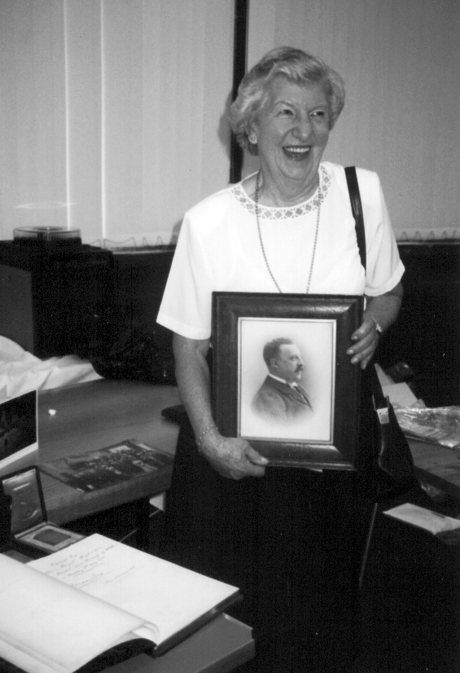

Mrs Ann H. Wright holding picture of her grandfather H. A. Headley,
in front of her is one of the signed V I P visitor books.

Graeme Cruickshank, a Scottish member, entertained us with a slide show on the 1886 Edinburgh International Exhibition. Graeme’s main collecting interest is in the early Scottish pottery which many firms exhibited in exhibitions.
Fred Peskett, showed a large selection of hand drawn artwork of Festival of Britain china and metal souvenirs, which he said showed up the small details of the objects better than photographs. Fred mentioned his experience of working in a drawing office, but by any standards the detailed work was still quite remarkable. Some of the items featured at the Picture Post Card Show 2001 in London where the main display celebrated the FoB’s 50th anniversary.
Don Knight, gave two contrasting displays. The first was on the Greenwich Dome when Don’s enthusiasm put to rest the ‘dome and gloom’ surrounding this much maligned venue. He had managed to gather up a wealth of material, including philatelic first day covers, and took full advantage of closing down sales. Who knows whether his persistence will lead to the collection being regarded in ten years time as the most comprehensive of its kind. His second display on the 1938 Scottish Empire Exhibition was more conventional and contained a large collection of post cards.

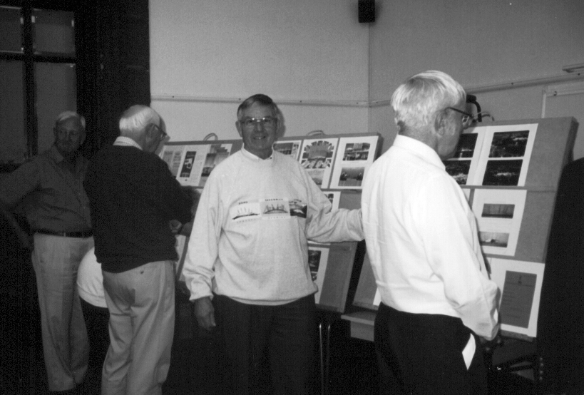

Don Knight with part of his Millennium Dome display, he’s even wearing a
Millennium Dome souvenir sweater.

Godfrey Evans, regaled us with a slide show of items produced by a local pottery company in Scotland which included life size figures of Queen Victoria and Prince Albert. Albert was thought to be holding plans for the Great Exhibition 1851. The firm that made the statues were known to have exhibited their wares at exhibitions.

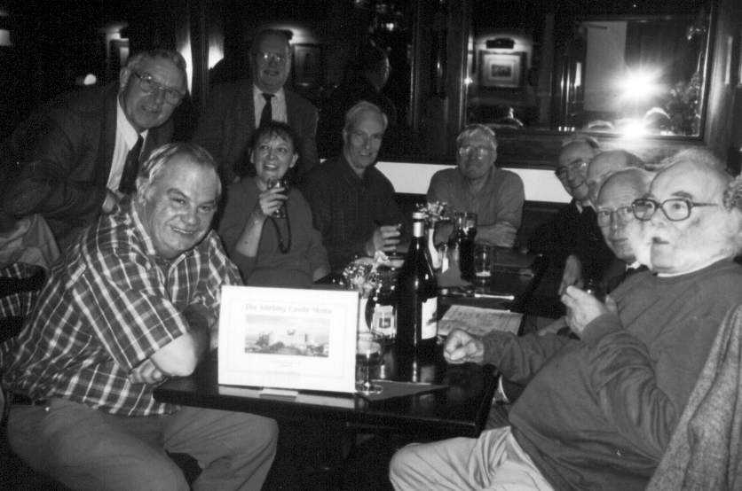

Relaxing during the evening with three of our four surviving founder members.
Don Knight, Stanley Hunter and Andrew Brooks.

Alan Sabey, provided some philatelic gems from his gold medal Wembley Exhibition collection. One intriguing item was an imperf stamp which was shown to have been removed from a complete sheet minus one stamp in the Royal Collection. (Not by Alan!) Alan was allowed to visit the Royal Collection to examine the sheet and his copy fitted the hole in the sheet exactly.
Bill Tonkin, showed two post card displays. The first was his famous in depth examination of White City cards by Valentines, showing how resourceful the printers were in recycling both the scenes and the figures for future events. He later put up some of the Festival of Britain cards which formed a large part of the Picture Postcard Show 2001 display. This was a fitting accompaniment to the recently published Festival of Britain book by Bill and George Simner on sale at the convention.
Ron Trevelyan traced the origins of Trade and Industry Fairs back to Roman times with a mixture of stamps, postmarks, publicity labels and post cards. In this country the British Industries Fair from 1915 to 1957 played a major role, as did overseas events like the Leipzig Fair (1165 to the present day).
Stanley Hunter, rounded off the proceedings with a slide show of the major international exhibitions held in Kelvingrove in 1888 and 1901 and the Scottish National event held in 1911.
Visitors to the Convention included a prominent Scottish philatelist, Margaret Morris, who is currently President of the British Thematic Association. She attended the displays on both days and clearly enjoyed them. With the convention open to the public we did get a few people in who were visiting the museum.
Our thanks must go to Stanley Hunter who put so much time and effort into making the weekend an enjoyable one for us all, even though he had to contend with some unwelcome and unexpected changes of plan.

Missions, Missionaries and Missionary Exhibitions.

By Bill Tonkin.

The missionary movement while its main purpose was to spread the word of the Lord to the heathen, is never the less closely connected to exhibitions. In fact the only book I know of specifically written on how to organise and set up an exhibition was published by the Church Missionary Society in 1899, it’s a little 132 page book titled ‘A Manual for Stewards at Missionary Loan Exhibitions’.
The purpose of the exhibitions was two fold, on the spiritual side, to spread the word and entice the public to take a more active part in religion, bringing to their notice the millions of people throughout the world who had never been evangelised and secondly to raise funds to further the work done by missionaries working out in the field.
To supply the exhibition organiser there were firms that would send everything needed to set up an exhibition, the curios, native artefacts, the sign boards and notices, it all came ready to lay out. This explains why some missionary exhibitions held many miles and many months apart look familiar, they would have been supplied by the same firm.
While many of the exhibitions only lasted a few days the big one in 1908 was the Orient in London at the Royal Agricultural Hall from June 4 to July 11 put on by the London Missionary Society. Another big one was the Church Missionary Society’s ‘Africa & the East’ again in the Royal Agricultural Hall from June 8 to July 3 1909. Smaller versions of ‘Africa & the East’ toured the country for several years.
The story of some of the early Missionary Societies is interesting. One of them was the brain child of a clergyman the Rev Dr. Haweis whose imagination was fired by the story of Captain Cook, especially where Cook described the various South Sea Islands he discovered, peopled by savage cannibals. He determined these savages should become Christians, educated and taught a better way of life. At a meeting with seven friends in a coffee house off Cornhill they formed a company the Missionary Society later to be renamed the London Missionary Society, their object not to discover new islands in the South Seas, but to convert the inhabitants of those far off islands to Christianity.
They bought a small sailing ship the “Duff” and appointed Captain Wilson to be the commander. He sailed from the Thames on August 10th 1796 taking with him six carpenters, two shoemakers, two bricklayers, two sailors, two smiths, two weavers, a surgeon, a hatter, a shop keeper, a cotton factor, a cabinet maker, a tin worker, a draper, a harness maker, a butcher and four ministers. What they had in common, was that they were all missionaries going out to risk life and limb in their effort to pass on the message.

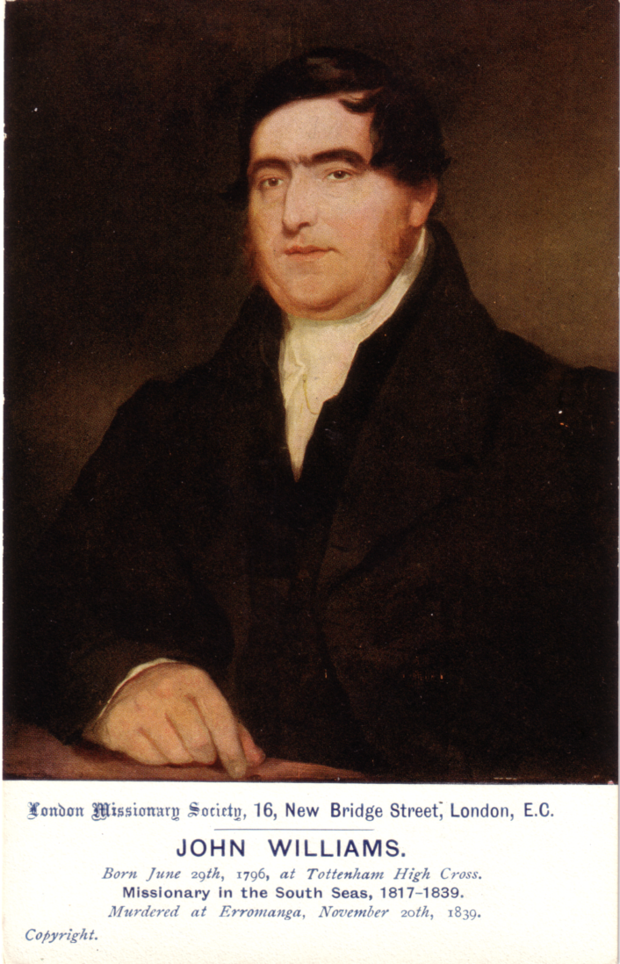

John Williams of the London Missionary Society.

The missionaries themselves were completely dedicated to their chosen way of life, giving up everything to go off to some God forsaken (in the true sense of the word) place to devote the rest of their lives to converting savages. One such person was John Williams and I recently found a book ‘John Williams The Shipbuilder’ by Basil Mathews telling his story. This book has supplied most of the material for this article.
John Williams was born on June 29th 1796 and as a child he lived in the times when Captain Cook and Nelson were real life heroes, who stirred the imagination of all lads including young John. At the age of 14 he was apprenticed to a north London Ironmonger by the name of Tonkin. At the end of the day when the shop closed John would go into the workshop where the iron goods were made, and there learnt to use the forge and anvil till he became a skilled blacksmith. One Sunday the wife of the Ironmonger invited him to attended church with her and the story goes that while listening to the sermon by the Rev Timothy East he made the decision that was to take him from his life at the ironmongers and set him on the path to becoming a missionary. Later he heard a sermon by the Rev Mathew Wilks who spoke of the need for missionaries to go out to the South Sea islands to convert savages. John offered his services to the Missionary Society and at the age of 20 was accepted. Before he sailed he married Mary Chauner who at 19 was a year younger than him and they left for Sydney in the “Harriet”. The voyage took a year and he spent his time learning all he could about sailing ships and seamanship.
At Rio two other missionaries Mr and Mrs Threlkeld joined the ship and on arrival they all took passage on the “Active” going to New Zealand and Tahiti which they reached in November 1817. On an adjoining island Eimeo, Williams found a skeleton, just the keel and ribs of a boat that had been started and never finished. Williams and Threlkeld decided to finish making it, Williams taking on the job of doing all the ironwork needed, so within three days of landing in Tahiti he was working the forge a job he was experienced at. Within eight days the boat was finished and named “Haweis” after the founder of the Missionary Society.
A few months after arriving at Tahiti their first child a son John Chauner was born. Their maiden voyage was to Huahine where they were welcomed and asked to stay. By now they had learnt enough of the language to make themselves understood and this quickly improved so he was soon able to preach to the natives in their own language. The older missionaries said they had never known any man to pick up the language so quickly as John Williams. Tamatoa, the king of Raiatea a neighbouring island, asked Williams and Threlkeld if they would come to live in Raiatea to teach and help convert his people. Soon the two missionaries with their families were on their way to Raiatea which was to be their home and base for many years, in Williams case for the rest of his life.
Williams was able to make lime by burning coral and by mixing this with sand, could make a form of concrete plaster from which he built his home and a church. He constructed a mill to crush sugar cane and set up a school to teach the natives to read the only book that had been written in their language, The Gospel according to St Luke, printed on a small press by the missionaries in Huahine.
There were other islands round Raiatea that Williams wished to visit so he decided to build another boat, it was to be 16 feet long. As there was no forge or iron on Raiatea the boat was held together by cinet a fibre cord. Nails were only used to fix the planks to the stem and sternpost.
Soon Williams set his eyes further afield and realised he would need a stouter ship and during a trip to Sydney bought a new schooner of 80 - 90 tons called the “Endeavour”. When the ship arrived Tamatoa who by now was a staunch friend said the islanders would pay for it and as they had no money he filled her with coco-nut oil and arrowroot to be sold to the merchants of Sydney. The name of the ship was later changed to “The Beginning” (Te Matamua).
Williams was now busy training natives to become missionaries and as soon as they were ready were dispatched to neighbouring islands to convert and teach. They were welcomed by the inhabitants as the new religion which did not require human sacrifice of members of the family was very acceptable and quickly spread. Not all of Williams trips to islands were successful at Mangaia the two coloured missionaries and their wives he landed barely escaped with their lives and Williams reluctantly had to pass that one by. At another island Atiu where two teachers had been sent, they were stripped of all their goods, refused food, and were in a sorry state. Undaunted Williams and Tamatoa met Roma-tane the King of Atiu and were able to show him the error of his ways and convert him to Christianity.
Later Williams visited Rarotonga leaving a teacher behind to instruct the natives. Two more missionaries Mr and Mrs Pitman arrived at Raiatea and as soon as the had learnt the language they too went to Rarotonga. At this time the natives worshipped wooden idols decorated with feathers, the missionaries persuaded some of the islanders to burn their idols and when fearfully they obeyed and found there were no dire consequences from their fallen gods they accepted the new religion. The story goes that at the first burning the missionary cooked some bananas in the glowing embers of the idols and ate them. This effectually killed any lingering fear of the power of the idols. The ceremony of burning the gods became one of the missionaries strongest weapons.
On one occasion while at Rarotonga engaged on building a church, Williams had the need to send a request to his wife for a tool and using charcoal and a chip of wood wrote his message and sent a native to deliver and collect the tool. This utterly amazed the natives who could not understand how the chip of wood could talk. By this time Williams could speak the language of the Rarotonga’s and spent his evenings translating the Gospel of St. John into the Rarotongan language and writing a simple A B C. These were sent back to Huahine by the next vessel that sailed there and printed. These were used to teach the islanders how to read and write.
While on Rarotonga Williams had no ship of his own and as he wanted to visit distant islands he decided to build a more substantial ship than the ones he had built at Eimeo and Raiatea which were not capable of tackling the 1,000 mile voyages he intended to make. Williams had no saw to make planks no canvas for sails or rope for rigging. The only iron on the island was a piece of chain left behind years ago by a visiting ship, driven off by the natives. Making his own forge and anvil he had to kill three of the four goats on the island to make leather for the bellows, unfortunately rats eat the leather. He next tried a wooden box bellows that took ten men to pump, once this was working he was able to convert the chain into nails. He used wedges to split tree trunks into planks and an axe head used as an adze to finish the planks to size. He designed a rope making machine using fibre from the bark of the hibiscus tree to make the ropes needed. He even made a crude lathe to turn sheaves for the blocks needed to raise the sails. Within fifteen weeks of laying down the keel the ship was finished and named the “Messenger of Peace”. On the first trip the mast broke and they limped back to the bay where he had built the ship. A new mast was soon fitted and Williams made many voyages to distant islands travelling as far as Samoa.

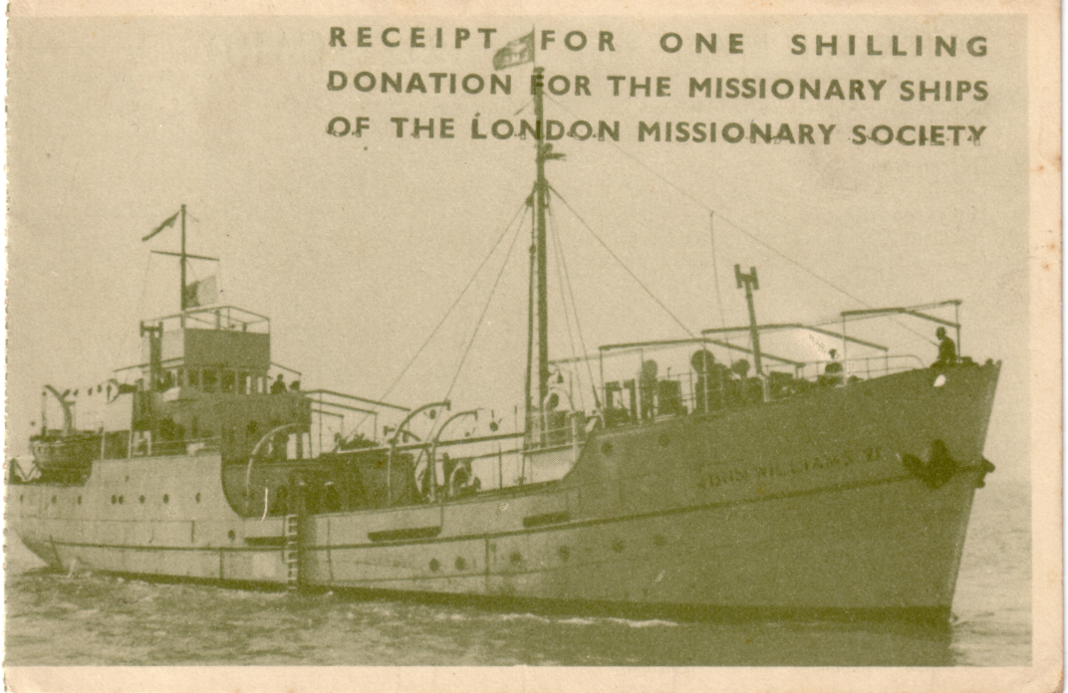

This post card of the “John Williams VI” has a rouletted left edge showing it came from a booklet.
and was given as a receipt for a donation of a 1/- to the London Missionary Society.

The arrival of another missionary Mr Smith and his wife who had come to take over from Williams meant that as soon as they could be taught the language Williams would be free to take on even longer journeys. This meant his ship would need to be enlarged and reinforced. He now had iron and copper sheet that had come from Britain and made the ship six feet longer with a new stern.
Williams visited many islands converting the peoples to Christianity and it was his wife Mary’s health that made it necessary for them to return to Britain after an absence of seventeen years. Back in Britain he travelled the country telling of his adventures.
He wrote several books “ A Narrative of Missionary Enterprises in the South Sea Islands, with remarks upon the Natural History of the Islands, Origin, Languages, Traditions and Usage’s of the Inhabitants.” This ran into many editions. He also wrote “Missionary Enterprises”.
His aim was to raise enough money to buy a substantial vessel and continue his travels and he was eventually able to buy a brig the “Camden” on which Williams with sixteen other missionaries would sail to the South Sea Islands. On the voyage Williams taught the other missionaries the Tahitian language which they would need once they arrived.
Once back in the South Seas Williams continued to visit far away islands on the “Camden|” converting savages. His last trip was to the New Hebrides among the black cannibal islanders of the Western Pacific. The ship moored off Erromanga the island that had driven off Captain Cook many years ago. Williams with two friend Harris and Cunningham were rowed to the beach and landed, where they were attacked, only Cunningham managed to reach the boat the other two were clubbed to death on the beach, and dragged away.
When the news reached Sydney a ship-of-war H.M.S. “Favourite” under Captain Croker was commissioned to sail to Erromanga and some of the natives were captured and questioned as to what had happened to Williams, “we ate him” they replied. They were able to recover his skull and a few bones which were brought back and buried at Apia in Samoa.
The “Camden” returned to Britain and a collection raised over £6,000 to buy a new ship named the “John Williams” launched in March 1844 and for twenty years she sailed the South Seas carrying on the work started by Williams until in 1864 she was wrecked on Danger Island near Rarotonga. Again collections raised more money, £11,000 this time and “John Williams II” set sail in January 4 1866 and was wrecked on the Island of Niué on her first voyage. Within a year money had been raised for “John Williams III” which was launched in October 1868 and after many years service was sold in 1895. It had already been replaced two years previously by a steam yacht “John Williams IV”. By 1930 this too needed replacing and again by collections nearly £15,000 was raised for a new auxiliary schooner “John Williams V”. The next ship “John Williams VI” was christened by H.R.H. Princess Margaret on the Thames on the 5th August 1948.
It is claimed that the money for the ships was collected mainly by children, but I have no doubt collecting boxes at the hundreds, probably thousands of missionary exhibitions also helped raise the money. Speaking only yesterday to an elderly lady at the local church coffee morning about the John Williams ships, she told me she remembered children collecting the old 1940’s half-penny’s with the ship on, to put into London Missionary Society collecting boxes.
The London Missionary Society published postcards of John Williams and of several of the ships named after him. People who donated one 1/- towards the “John Williams VI” were given a receipt in the form of a post card torn from a book of receipt post cards.

Brussels World’s Fair 1958, Expo 67 (Montreal), Expo 70 (Osaka), Expo 92 (Sevilla)
and Expo 2000 (Hannover).

Wanted. American collector seeks Expo 92 theme pavilion pamphlets (especially from the 15th Century and Navigation exhibits) Also interested in other paper material including post cards from Expo 92 as well as items from Expos 58, 67 and 70. Send description, condition and price information to Mark Aitken of 7604, Elba Rd, Alexandria, Virginia, 22306 USA.

A Mural by Frank Charles Medworth RBA 1892-1947

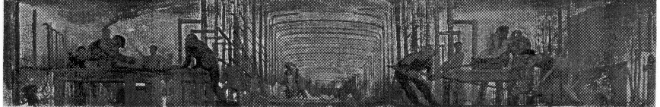

The mural seems to be a scene in a ship building yard, on the far right of this rather poor reproduction is the bow of a large ship, so it may have been some where in the
Palace of Engineering.

I have had an enquiry about a design for a portico by Medworth that was displayed at the 1924 British Empire Exhibition, where it may have been positioned over a doorway in one of the stands or pavilions. The picture depicts ship and barge building on the Thames probably at Rotherhithe. Can anyone help? if so please let me know.

Perfins on British Empire Exhibition Stamps
by
John Nelson

Members may remember that some years ago the Perfin Society carried out some research on perfined Wembley stamps. The results were published in our Autumn Journal No. 26 in 1992. Additional information has been published by John which he has kindly let us print and appeared in Journals No. 33 Summer 1994, No. 40 Spring 1996 and No. 54 Autumn 1999. Over the years some of our members have contributed to his research which he has allways acknowledged in the Perfin Bulletin and on his most recent update in their Bulletin he thanks Paul Watson, Alan Sabey and Myself.
Information received since the last update was published in 1999, which includesdetails of three new dies, continues to indicate that perfins on the 1925 issues (apart from Waterlow and Aerated Bread Company) are very difficult to find. So also are those on cover of which no new examples are reported on this occasion.
The user of the die SX (monogram) S8630.01m, scarce on Wembley commemoratives is now known to have been Essex & Co., Wall-paper Printers, 114-116 Victoria Street, London, SW.
New Dies.
1. B/S B6440.03, 1924 1½d, British & Foreign Bible Society, 146, Queen Victoria Street, London, E.C.4. Exhibitors in 1924 (Palace of Industry, U859) and 1925 (Stand U853).
2. NUI N3370.04, 1924 1½d, National Union for Insurance, Approved Friendly Society, 6, 7 & 8, Colebrook Row, Islington, London, N.1. No apparent exhibition connection.
3. TT/CoLd T4520.02 1924 1½d, Thomas Tapling & Co., Limited, Furniture and Carpet Warehousemen, 31-45, Gresham Street, 118-110, Wood Street and 55-67, Leonard Street, London, E.C.2. No apparent exhibition connection.
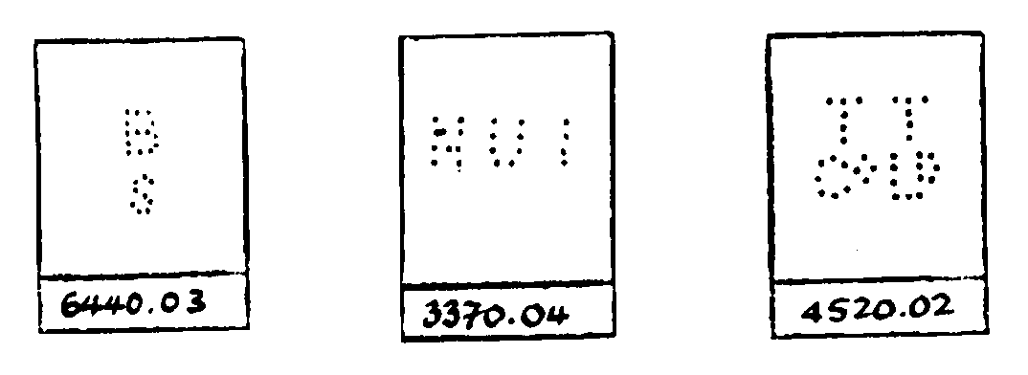
Additional Stamps.
ABC A0530.05 1925 1½d.
BE/RP B2500.01 1924 1½d.
C.B C0470.04 1924 1½d.
DM D3110.03 1924 1½d. Also in block of four.
D.S D4370.01 1924 1d. (2) and 1½d.
ETC E4700.05 1924 1½d. (2).
F.G F1590.01 1924 1½d. (2).
GL/Co G3130.01 1924 1½d.
H&P H5690.02 1924 1½d.
HW/Ld H7770.01 1924 1d. and 1½d. (2).
JDW/M J2270.03 1924 1½d.
J.S/&Co J6980.03 1924 1½d.
J/TS J7900.03 1924 1d.
J.W J8280.01 1925 1d.
M.N M4130.01 1924 1½d.
M&P/P M4560.01 1924 1d.
MW/Co M6020.02 1924 1½d. (2).
O&Co O0480.01 1924 1½d. (3).
R R0010.43 1925 1d. (2).
S.L S4320.03 1924 1½d.
SM/L S5090.04 1925 1½d.
TP/Ld T3600.02a 1924 1½d. (2).
W/&Co W1340.03a 1925 1d. (2).
W&S W6680.07v 1925 1½d. (2).
W&S W6680.24 1924 1½d.

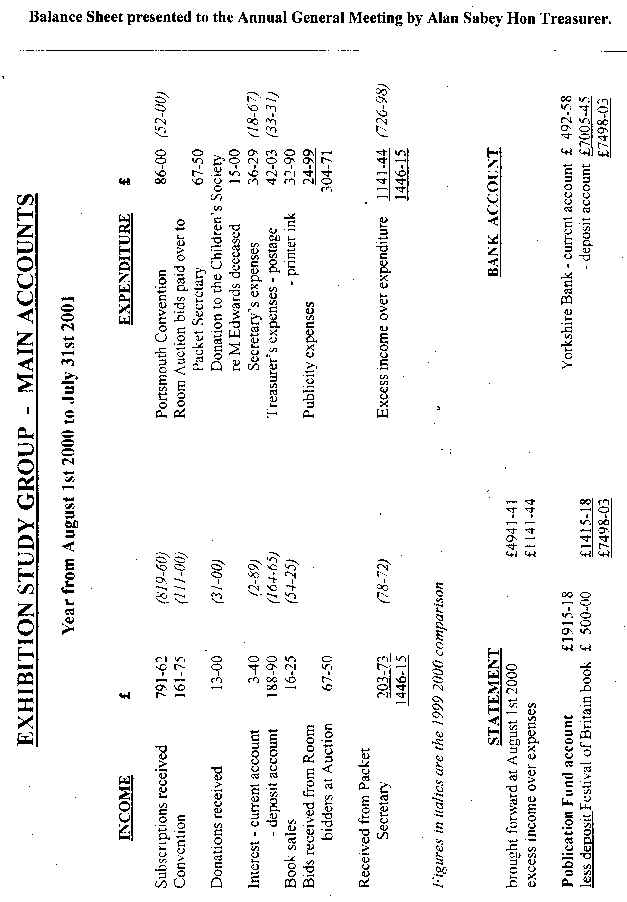
Packet Balance Sheet presented to the Annual General Meeting by Mike Perkins Hon acket Secretary.

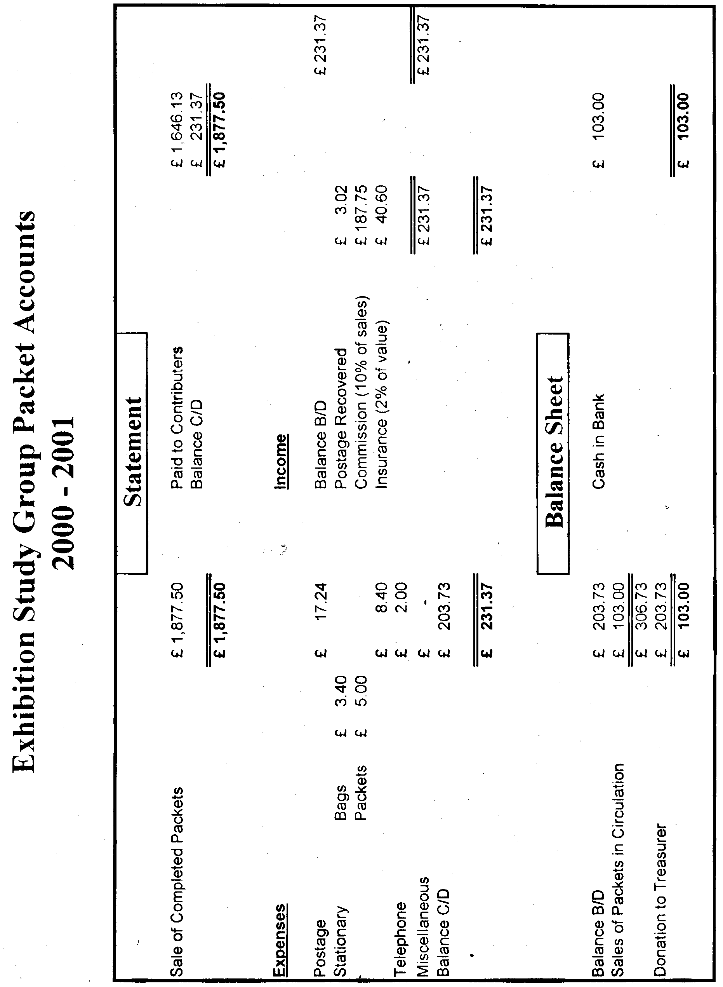

Post Cards of the White City
Part 19.
by
Bill Tonkin

Type 15. Sepia R/photo with white border, title in white capital letters, brown back ‘POST CARD’ in the same font as type 9 but more spaced out, without stop measures 37 mm. 68 in place of a stamp box, single line divider.
N.n. Franco-British Exhibition. London. from a Balloon. (With impressed oval stamp at bottom right reading ‘Copyright Wakefields Brentford & Chiswick’)
N.n. Visit of the King & President to the Exhibition. (With impressed oval stamp at bottom right reading ‘Copyright Wakefields Brentford & Chiswick’)
N.n. Visit of the King and President to the Exhibition. (This is a different view to the above card. With impressed oval stamp at bottom left reading ‘Copyright Wakefields Brentford & Chiswick’)

Type 16. Sepia R/photo with white border, brown back ‘POST CARD’ without stop measures 43 mm. 68 in place of a stamp box, single line divider and ‘Published by Wakefield, Wholesale Postcard Publishers, Ealing. W. London.’.
N.n. Franco-British Exhibition. London. W. (Birds Eye View from Balloon). Copyright Photo by Wakefield. Ealing . W.

Type 17. Sepia R/photo with white border, brown back ‘POST CARD’ in the same font as type 10 but more spaced out, without stop measures 37 mm. Number in place of a stamp box altered to 78, single line divider.
N.n. Franco-British Exhibition. London. Copyright Photo by Wakefields. Brentford and Chiswick.

Type 18. Sepia R/photo without white border, title in white capital letters, black back ‘POST CARD’ without stop measures 46 mm. line stamp box with ‘Printed in England’, double line ‘T’ divider.
N.n. Visit of the King & President to the Exhibition. (With embossed oval stamp at bottom left reading ‘Wakefields Brentford & Chiswick’. The stamp is different to the previous oval stamps, ‘Copyright’ is missing and ‘Wakefields’ is in script.)

Type 19. B/W R/photo with white border, brown back ‘POST CARD.’ with stop measures 51 mm and has ‘Real Photographic Series’ underneath, line stamp box with ‘Printed in England’, double line ‘T’ divider.
N.n. Franco-British Exhibition. London. Photo from Balloon. by Wakefields. Brentford and Chiswick.

Type 20. Sepia R/photo with white border, black back ‘POST CARD.’ with stop measures 69 mm. double line ‘T’ divider.
N.n. Franco-British Exhibition. London. W. (Birds Eye View from Balloon). Copyright Photo by Wakefields. Chiswick & Brentford.

Type 21. B/W R/photo with white border, brown back with ‘Published by Wakefield. Wholesale Postcard Publishers, Ealing, W., London. down the left side. There are variations in the spacing of the imprint but these are not listed. These cards were almost certainly produced by Rotary and have the usual variations of ‘POST CARD’ which are listed. The measurement for ‘POST CARD’ is given for the words and does not include the stop if there is one.
N.n. Franco-British Exhibition. London. W. (Birds-Eye View from a Balloon). Copyright Photo by Wakefield’s. Ealing.
A. ‘POST CARD.’ measured 37 mm, with full stop.
C. ‘POST CARD’ measured 39 mm, without full stop.
D. ‘POST CARD.’ measured 40 mm, with full stop.

Type 22. Sepia R/photo with white border, brown back with ‘Published by Wakefield. Wholesale Postcard Publishers, Ealing, W., London. down the left side as in type 20. These cards were almost certainly produced by Rotary and have the usual variations of ‘POST CARD’ which are listed. The measurement for ‘POST CARD’ is given for the words and does not include the stop if there is one.
N.n. Franco-British Exhibition. London. W. (Birds-Eye View from a Balloon). Copyright Photo by Wakefield’s. Ealing.
D. ‘POST CARD.’ measured 40 mm, with full stop.

Type 23. B/W R/photo with white border, brown back with ‘Published by Wakefield. Wholesale Postcard Publishers, Ealing, W., London. down the left side as in type 21. Like type 21 these cards were almost certainly produced by Rotary and have the usual variations of ‘POST CARD’ which are listed. The measurements given do not include the stop if there is one. ‘Photo by Wakefield Ealing’ written on the negative.
N.n. Franco-British Exhibition. London. W. (Wood Lane Entrance). Copyright.
D. ‘POST CARD.’ measured 40 mm, with full stop.
N.n. Franco-British Exhibition. London. W. (Main Entrance). Copyright.
Vert right.
C. ‘POST CARD.’ measured 39 mm, with full stop.

Type 24. B/W R/photo with white border, brown back as type 29. but without ‘Published by Wakefield. Wholesale Postcard Publishers, Ealing, W., London. down the left side. Like type 21 these cards were almost certainly produced by Rotary and have the usual variations of ‘POST CARD’ which are listed. The measurements given do not include the stop if there is one.
N.n. The Flip-Flap, Franco-British Exhibition. London. Copyright by Wakefield’s. Brentford & Chiswick. (Arms in upright position)
D. ‘POST CARD.’ measured 40 mm, with full stop. Vert right.
N.n. The Flip-Flap, Franco-British Exhibition. London. Copyright by Wakefield’s. Brentford & Chiswick. (Arms at an angle)
A. ‘POST CARD.’ measured 37 mm, without full stop. Vert right.
D. ‘POST CARD.’ measured 40 mm, with full stop. Vert right.

Webb. Thos. & Sons Ltd.
Thos. Webb & Sons, Ltd., Dennis Glass Works, Stourbridge published two series of post cards and one trade card.
Type 1. B/W photogravure trade post card with a view of their stand taking up 75% and the rest filled with advertising text. The back is a coloured map by G. W. Bacon showing the position of their stand.
N.n. View of Glass Works at Franco-British Exhibition.
For other Bacon map advert post cards see under, Berthon Boat Co., Ltd., Chubb & Sons Lock and Safe Co., Ltd., J. Loebnitz, Alexander Marks & Son and the Patent Steam Carpet Beating Co., Ltd.

Type 2. B/W photogravure advert post card, perhaps these series should not be called advert cards as the name of Thos. Webb does not appear anywhere on the cards. There is no doubt they were published by Webb’s as they were printed by Mark & Moody, Ltd., of Stourbridge which is Webb’s home town. Green back ‘POST CARD.’ with stop measures 48 mm. line stamp box with ‘Halfpenny Stamp’.
Series, Views at the Glass Furnace. (Franco-British Exhibition). (This is in sloping capital letters)
No. 1. Making a Wine Glass. “Gathering the Bowl. Vert right.
No. 2. Making a Wine Glass. “Mavering.” Vert right.
No. 3. Making a Wine Glass. Casting on the Stem.
No. 4. Making a Wine Glass. “Chalk-marking the Bowl.” Vert right.
No. 5. Making a Wine Glass. “Wetting off.”
No. 6. Making a Wine Glass. “Shearing.” Vert right.
No. 7. Making a Wine Glass. “Opening the Bowl.” Vert right.
No. 8. Making a Wine Glass. “Taking-in.”

Type 3. B/W photogravure advert post card, (see comment above on type 2.) green back, ‘POST CARD’ without stop measures 54 mm. line stamp box with ‘A Half-Penny Stamp to be placed here.’ There is no printers credit but they were probably printed by The East London Printing Co. The pictures are the same but the printing on the front has been re-set, some of it in a different size. Part of the title is under lined.
Series, Views at the Glass Furnace. Franco-British Exhibition. (This is in upright letters)
No. 1. Making a Wine Glass. “Gathering the Bowl. Vert right.
No. 2. Making a Wine Glass. “Mavering.” Vert right.
No. 3. Making a Wine Glass. Casting on the Stem.
No. 4. Making a Wine Glass. “Chalk-marking the Bowl.” Vert right.
No. 5. Making a Wine Glass. “Wetting off.”
No. 6. Making a Wine Glass. “Shearing.” Vert right.
No. 7. Making a Wine Glass. “Opening the Bowl.” Vert right.
No. 8. Making a Wine Glass. “Taking-in.”

Weiner J.
Type 1. Sepia photogravure, the backs are printed in black and brown, dotted stamp box with ‘Stamp’ in it. There is an imprint down the left side reading ‘Printed and Published by J. Weiner, Bank Buildings, Kingsway, London. W.C.’. All the titles end in ‘101 Ranch, Wild West, Anglo-American Exposition, Shepherd’s Bush, London, Eng.
N.n. A Group of Cowboys-
A. Black back.
B. Brown back.
N.n. A Group of Cowgirls-
A. Black back.
B. Brown back.
N.n. A Group of Indians of the
B. Brown back.
N.n. A Mexican-
B. Brown back. Vert left.
N.n. Cossacks-
A. Black back.
B. Brown back.
N.n. Indian Chiefs-
B. Brown back.
N.n. Mexican Champions of the
A. Black back.
B. Brown back.
N.n. “Minnie Ha-Hah”
B. Brown back. Vert left.
N.n. Mr Johnny Baker, the world’s famous crack shot and Arenic Director-
A. Black back. Vert left.
B. Brown back. Vert left.
N.n. Mr Zack T. Miller of (Riding horse)
B. Brown back. Vert left.
N.n. Mr Zack T. Miller of (Standing by horse)
B. Brown back. Vert left.
N.n. The Old-Time Stage Coach-
B. Brown back.
N.n. Two of the Indians of the
A. Black back. Vert left.
B. Brown back. Vert left.

Type 2. Sepia photogravure, the backs are printed in brown, dotted stamp box with ‘Stamp’ in it. The imprint down the left side has been altered and now reads ‘Copyright, J. Weiner, Bank Buildings, Kingsway, London. W.C.’. All the titles end in ‘101 Ranch, Wild West, Anglo-American Exposition, Shepherd’s Bush, London, Eng.
N.n. Wife of Chief “Spotted Weasel.” Vert left.

Wheeler. E. H.
E. H. Wheeler used three different backs for their post cards two were black and one was brown.
Type 1. Sepia R/Photo with white border, black back ‘POST CARD’ with dot measuring 49 mm. At the top of a very short line divider is a scroll ornament, and double top bars to the ‘T’ divider, and an empty dotted stamp box. ‘Photo & Published by E. H. Wheeler 54-56, Caledonian Rd, London, N.’ down left side. All the titles end with ‘Franco-British Exhibition.’
16. Scenic Railway,
18. Machinery Halls,
32. The Lagoon,
33. The Lagoon,
34. “Daily Mail” Building,

Type 2. Sepia R/Photo with white border, black back ‘POST CARD’ with dot measuring 49 mm. ‘T’ divider without scroll, with double top bars and an empty dotted stamp box. ‘Photo & Published by E. H. Wheeler 54-56, Caledonian Rd, London, N.’ down left side. All the titles end with ‘Franco-British Exhibition.’ Apart from the missing scroll the back is the same as type 1.
10. Machinery Halls,
11. Palace of Womens Work,
15. Western Avenue,
18. Machinery Halls,
19. The Flip Flap,
20. In the Art Gardens,
21. Garden of Progress,
24. Garden of Progress,
29. Birds Eye View,
31. Court of Honour,
32. The Lagoon,

Type 3. Sepia R/Photo with white border, brown back, there are variations of the measurement of ‘POST CARD’ between 36 and 37 mm and it is with and without stop. ‘T’ divider with double top bars and no stamp box. ‘Photo & Published by E. H. Wheeler 54-56, Caledonian Rd, London, N.’ down left side. All the titles end with ‘Franco-British Exhibition.’
22. The Elite Gardens,
26. Cascade Café & Palace of Music,
29. Birds Eye View,

Where to Dine in London.
Coloured Valentine’s “Unity” post card overprinted on the front with ‘Where to Dine in London, “The Pall Mall Restaurant”’ and ‘Where to stay at Boulogne Sur-Man, “Hotel Folkestone”’. Picture of Britannia and French maid in national dress waving their respective flags across the channel. Grey ‘Throughout the World’ back type FB 2.
N.n. Franco-British Exhibition, London. “Unity”.

Whitstable Oyster Fishery Company.
B/W photogravure multi view post card, showing four views, Stall at the Franco-British Exhibition, Off to the beds, At Work and Home once more. Green back with a single line divider.

Wigan Coal & Iron Co., Ltd.
Type 1. B/W R/Photo advert card with white border, brown back with Wigan Coal & Iron Co., Ltd. .....1908. down left side in two lines. The second line is a space for a date (dotted line) followed by 1908.
N.n. Stand No. 559. Machinery Hall. Franco-British Exhibition 1908.

Type 2. B/W R/Photo advert card with white border, brown back with Wigan Coal & Iron Co., Ltd....... down left side in two lines. The second line is a space for a date (dotted line) without 1908. One card is known with the date ‘May 13 1909’ written in and the message reads “Have you received Wagon 2539, it was sent forward on Monday”.
N.n. Stand No. 559. Machinery Hall. Franco-British Exhibition 1908.

Wildt & Kray.
Coloured, sunk plate with large white borders, split title in gold, all the titles end in Franco-British Exhibition which is in italics, the first part of the title is printed in capital letters. Grey back with imprint down left side reading ‘Wildt & Kray, London, E.C. Series No. 1514. Printed in England.’
N.n. Australian Section.
N.n. Indian Section.
N.n. Machinery Hall.
N.n. Palace of British Applied Arts.
N.n. Palace of British Industries. Vert left.
N.n. Palace of French Applied Arts.
N.n. Palace of Women’s Work.
N.n. Part of Elite Gardens.
N.n. The Court of Honour by Night.
N.n. The Court of Honour.
N.n. The Flip Flap. Vert left.
N.n. The Opening Ceremony.
N.n. The Palace of Music.

Williams & Sons. J. I.
J. I. Williams & Sons, published two nearly identical advert post cards. One is in B/W and the other is in a very dark brown. Apart they would be difficult to tell the difference although when compared together the difference is obvious. Fortunately in the advertising matter at the right side of the picture, there is an easy means of identifying them. The B/W card reads ‘J. I. Williams & Sons, Brook House,’ in two lines and gives the address of E. P. Archer, A.R.I.B.A., while the dark brown card reads ‘J. I. Williams & Sons, Builder, Brook House,’ in three lines and does not give the address of Archer.
Type 1. B/W combination photogravure and line printing, with advertising text on the front. Black back with the left half filled with advertising text.
N.n. Section of Early English House Erected at the Franco-British Exhibition by J. I. Williams & Sons, Brook House, Oxted, Surrey. Designed by E. P. Archer, A.R.I.B.A., 46, Queen Victoria Street, E.C.

Type 2. Dark brown combination photogravure and line printing, with advertising text on the front. Black back with the left half filled with advertising text.
N.n. Section of Early English House Erected at the Franco-British Exhibition by J. I. Williams & Sons, Builder, Brook House, Oxted, Surrey. Designed by E. P. Archer, A.R.I.B.A.

Williams. S. T.
Sepia R/Photo without border, brown back with ‘POST CARD’ without stop measuring 40 mm., ‘T’ divider and empty line stamp box. Imprint down left side reads ‘S. T. Williams, 54, Bouverie Road, N.’
N.n. Franco-British Exhibition. Photographed from an Aeroplane. Copyright No. 110.

Wrench. E. Ltd.
Coloured with white border and large white panel at bottom with title, black back ‘POST CARD.’ with stop measures 48 mm., dotted stamp box with ‘Inland ½d. Stamp Foreign 1d.’
The Wrench Series.
No. 8505 Bearing a Burden. Vert left.
No. 8506 Umbrellas and Commerce. Vert left.

Small Publishers Section Y & Z.

Yenjo Shoten Ltd. Tokyo, Japan.
Coloured advert post card, blue back ‘POST CARD’ in outline letters, ‘T’ divider and dotted stamp box. Imprint down left side reading ‘“Digestin” A pure isolated vegetable digestive Ferment for Gelatinous and Farinaceous matters’.
N.n. “Digestin” Exhibited at the Anglo-Japanese Exhibition 1910. The latest medicine for all digestive ailments. Patented in 12 Countries. Prepared by Yenjo Shoten Ltd., Tokyo, Japan.

“Zims Wear”
Brown photogravure with white border, black back ‘POST CARD.’ with stop measures 40 mm. single line ‘T’ divider, empty dotted stamp box, imprint down left side reading ‘Franco-British Exhibition: Palace of French Industries. Office: 18, Cheapside E.C.’
N.n. Ask for “Zims Wear” The Hall Mark of Sterling Quality in Ribbed Knit Underwear.

“Zog”
Coloured advert post card with white border, black back ‘POST CARD.’ with stop measures 39 mm. double line ‘T’ divider, empty stamp box and ‘“Zog” cleans Paint’ at bottom left.
N.n. Souvenir of “Zog” House Anglo-American Exhibitn. London 1914. (View of Zog kiosk)
N.n. Souvenir of “Zog” House Anglo-American Exhibitn. London 1914. (View of interior of Zog kiosk) Vert right.

