EDITORIAL AUTUMN 2001

The jobs are done, I can put up my feet
With nothing to do, life is so sweet

The last few months have been very hectic Nancy at the time of her death had nearly finished a book on the first hundred years of her old school, Churchfields. This I have finished and have given it to the school to use as a fund raiser, It was published in June and should earn them a few bob. Her main book on the History of Beckenham has now sold out of the first print run of 4,000 copies and the publishers wanted it revised before printing a second edition. This has now been done and it was delivered to the publishers at the end of July to give them time to get it out for the Christmas sales. The royalties just about keep me in booze, so I like to think that Nancy’s still looking after me.
Also finished is my last book which is now at the printers ‘Post cards and related collectibles of the Festival of Britain’. Although initially I was going to restrict it to post cards I decided to extend it to cover the advertising labels, packet seals, printed commemorative and first day covers and the postal history of the Festival. The latter items are not large enough to warrant separate publications and I thought it a good opportunity to gather all the knowledge of these subjects together in one book. George Simner has helped me over the last year or so, mainly with the postal history side. He’s even got a few post cards I haven’t got. I hope it will do for the festival what Mike Perkins and my book has done for The British Empire Exhibition. and I am confident it will become the standard work on Festival collectibles for many years to come. Our Wembley book was a good book and this one is too. It is the same size, about 200 A4 pages and I don’t think it will ever be surpassed. It will be the Exhibition Study Group publication Number 5. and I hope to have copies available at Bipex and certainly at our convention. I have not fixed the price yet but it should come out at about £14.00.
I have also finished and will publish at some time a list of exhibitors at the British Empire Exhibition in 1924 and 1925 giving their address, stand number, stand location and the year they exhibited. It has been culled from the three editions of Fleetway’s 1924 catalogue, their 1925 catalogue and catalogues of the Canadian Pavilion, Jamaica Pavilion, Palestine Pavilion and Ulster Pavilion. This runs to 172 A4 pages and will probably be published on a disc.
I had also been approached by Derek Popplestone of the Postcard Traders Association to provide the main display at Bipex (or the Picture Postcard Show as they now call it) for 2001. The theme for this year is to celebrate the 50th anniversary of the Festival of Britain. I agreed to do this and suggested that George Simner and Fred Peskett be co-opted so that it could be a joint effort by the Exhibition Study Group and Festival of Britain Society. Derek wanted it to cover all aspects of collectibles and George agreed to tackle the stamp and postal history side while Fred is displaying part of his unique ephemera collection. I am doing the post cards and have just finished writing up about 300 sheets so all together there will be on display just over 500 sheets. The four day display will certainly be the largest display of Festival material ever put on. For those who don’t get any magazines the Picture Postcard Show is on Wednesday 29 August 11am to 8pm, Thursday 30 August 11am to 7.30pm, Friday 31 August 11am to 7.30pm and Saturday 1 September 10am to 5pm.
Still furiously blowing my own trumpet I can at last say that the text of the book on the post cards of the White City exhibitions in now finished apart from some tidying up and adding some more illustrations. I have said before that the Franco-British Exhibition was becoming very popular most of our new members over the past year are collectors of this and the other White City exhibitions. It is going to run to over 600 pages and I will probably decide to publish it in disc form rather than in the traditional book format. I don’t like the idea but it will never pay to publish it in the conventional book form.
In our last Journal I complemented Alan Sabey on his gold medal awarded at Belgica, but I don’t think I have mentioned another member who has also done very well in the competitive field, John Marriner at Glasgow 2000 last November won a Vermeil medal for his 1934 Air Post Exhibition entry and a Silver medal for an entry on G.B. perfins. His Air Post Exhibition entry had previously won him a silver so he had improved his entry to move up a step. Congratulations John.
The Editor.
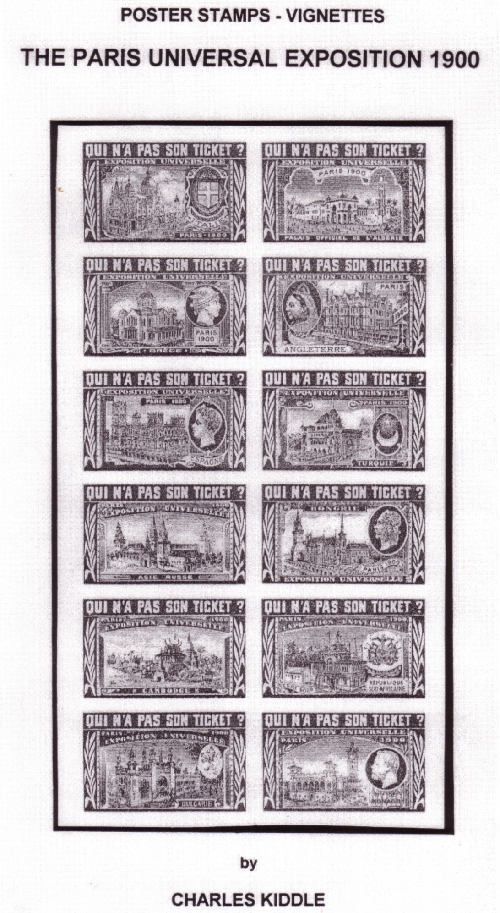
Poster Stamps-Vignettes The Paris Universal Exposition 1900
by Charles Kiddle

Another book written by one of our members is by Charles Kiddle on the stickers, publicity labels or as he calls them vignettes of the 1900 Paris Exposition. A catalogue of 142 A4 pages over 60 in full colour, he sets out to illustrate the 1000’s of vignettes in full size each given a catalogue number. This includes much information previously unknown to collectors. It has been published to celebrate 100 years of French vignettes. The catalogue gives information about the exposition and illustrates mainly in colour, associated items such as post cards with or depicting vignettes of the exposition. This is a major work of Cinderella philately.
Charles points out that the cost of publishing 50 copies of a quality catalogue are horrendously high, especially when you consider you have to give six away to various government bodies. The price is £46.00 post free in the U. K. Charles is a man of many parts, not only in the field of philately where he is a very high flyer indeed, but is also the author of ‘A Guide to the First Editions of Edgar Wallace’ which is another of my collecting interests. Not first editions I hasten to add.
For those interested in Cinderella material the book can be obtained at P.O. Box 13, Alton, Hants, GU34 4DP, phone number 0044 1256 862701 or <106711.1065@compuserve.com>

Letters and E Mails to the editor.

Postal orders bought at exhibitions.
New member Tim Todd has asked me to advertise his desire to obtain information or examples of Postal Orders cancelled at the British Empire Exhibition or at any other exhibition. He can be reached at <timtodd@pacbell.net> or at P.O. Box 23784, Pleasant Hill, California, 94523. U.S.A.

E Mails.
As it looks as if this E Mail business might catch on, it may be a good idea to consider publishing in a copy of the Journal a list of E Mail numbers for members so they may contact each other. My number is <bill.tonkin@virgin.net>. I suggest anybody who wishes their number to be recorded in this way sends me an E Mail with their number and I will make out a list to include in a future Journal.

Dutch East Indies.
Alan Bartlett of 6, Simmons Place, Staines. TW18 3HW is asking for any information on two exhibitions held in the Dutch East Indies, the 1914 Colonial Exhibition at Semerang and the 1920-28 Industries Fairs in Bandoeng. Alan’s interest extends to the circumstances that led to all the colonial exhibitions and fairs especially those held in the colonies themselves. This is a very narrow field but there may be some member who can help him.

Wrestling at the Paris International 1889.
William Baxter is researching the history of European wrestling and apparently there were several very important competitions took place at the Paris 1889 exhibition. There was also a Highland Games at the exhibition and he would like any information on that too. Again this is a very off the beaten track request, but someone might have a 1889 programme or guide or know something. W. Baxter. 13, Balvie Road, Milngavie, Glasgow. G62 7TB.

Post cards of the White City.
Randy Treadway of 11502 E. 212 Street, Lakewood, California. 90715. U.S.A. <koala@earthlink.net> has come across parts 9 and 10 of Post cards of the White City published in our Journal, on the internet and asks if parts 1 to 8 are available. The short answer is yes. He goes on to say are they available in electronic format and can they be E Mailed to him ? Here again the answer should be yes but is in fact no. I should be only too happy to do this for him but I don’t know how to.
I imagine it must be done by using an ‘attachment’ whatever that is. Both Alan Sabey and Mike Perkins have tried sending me attachments and in Alan’s case a three page document was transformed into 320 pages of gobble-de-gook. Thank goodness I didn’t click on the print button. Mike sent me a copy of the index of the Journals but only half of it came through, the rest was again pages and pages of gobble -de-gook. Unfortunately it takes a long time to teach an old dog new tricks, but I shall get there in the end, or not as the case may be. If I do get there I should like to help Randy, as he is interested in trading information on the White City post cards with other collectors, and this is a subject dear to my own heart.

The Ainu tribe at the 1910 Japan-British Exhibition
Another new member Phillipe Dallais is researching the Ainu a Japanese aboriginal tribe who live on Yezo one of the Japanese islands. He is collecting information for the Neuchâtel Museum of Ethnography. I have agreed to loan him some of my material and sent him a copy of a cutting from The Times of 16 April 1910 describing the Ainu’s journey to this country on the “Kagamaru”, in all five men, four women and one child came to Britain and lived in the Ainu village at the Japan-British Exhibition. Phillipe knows Dr Fukasawa who is now back in Japan, she visited me a couple of times in 1996 when she was researching the Ainu. If any members have anything on the Ainu, Philippe would be glad to hear from them on <phidkat@span.ch> Philippe Dallais. Grand Rue 55, 2035 Corcelles, Switzerland.

Close Encounters with Sir Hiram Maxim
by
Fred Peskett

Close encounters with Sir Hiram Maxim?, well not exactly, I must have missed him by some forty odd years. Never the less, our paths seem to have crossed several times.
Members of the Exhibition Study Group will know of Sir Hiram Maxim, inventor of the famous Captive Flying Machines installed in the Earls Court Exhibition grounds, the Crystal Palace, also at the fairgrounds at Blackpool and Southport. Hiram Maxim was also the inventor of the rapid firing Machine Gun (for which he was knighted in 1901 when he became a naturalised British subject) and as an aviation pioneer, it was from the latter areas that our paths crossed.
Hiram Maxim was born in the small town of Sangerville, Maine in the United States on the 5th of February 1840. Following an uneventful school life he became an apprentice coachbuilder, later on working as a machinist in a Maine factory and then for a short time in shipbuilding. During this time he developed an interest in all things mechanical with an appetite for experimenting on mechanical devices. He became unhappy in America and came to Britain in his late twenties where he settled down at South Norwood. His passion for mechanics continued resulting in several patents for a proposed helicopter and a lighter than air flying machine. However it was his idea for a quick firing machine gun, that finally gave him fame and to some degree fortune.
It was also the machine gun which became my first encounter with Maxim, during an engineering apprenticeship with Vickers Armstrong Ltd., Crayford, Kent. The Crayford works was originally known as the Vickers Sons and Maxim Works and prior to that as the Maxim Works. Although most of the factory buildings during my time there were constructed in the 1930’s there were a few that once formed part of the original 1890’s Maxim factory.
In 1953 during the second year of my apprenticeship, I was assigned to the Vickers Machine Gun Department, for “fitting” experience. The building where guns were built was one of the original Maxim workshops used for the assembly and testing of machine guns since Hiram Maxim first developed his water cooled weapons in the 1890’s. Very little had changed in the intervening years.
It may be of interest to know how the gun was assembled and tested, a procedure that probably had remained unchanged from the very first production.
Looking back I doubt if the workshop would ever been given a clean bill of health as a workplace in 2000. It had a clay/dirt floor, with very little window light and certainly no ventilation. A loft was a storeroom for all the piece parts used to assemble the machine gun, each part being carefully oiled and wrapped in greaseproof paper, Alongside was the drawings and tool stores. The
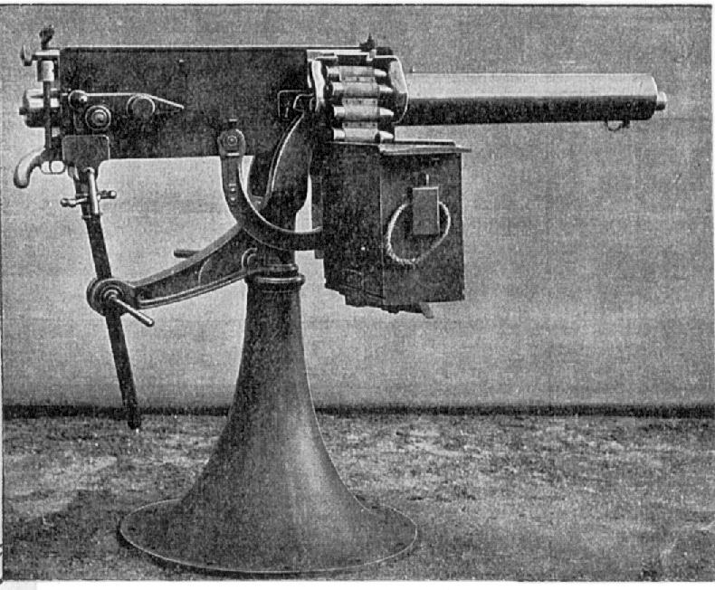

parts and fabrications were manufactured elsewhere in the Crayford Works. Apart from minor changes the machine gun was almost identical to maxim’s original design. The guns were assembled in batches of six (there was no good reason for this). Armed with a job ticket, I would go to the finished parts stores and collect six trays of piece parts, (just like a meccano set.) A set of blue prints and all the jigs and fixtures needed to assemble a gun. The first job was to serial number each item, and enter the serial numbers into a log book that dated back to before the second world war . The reason for only six to a batch was that all screws and replacement parts for this batch were unique to
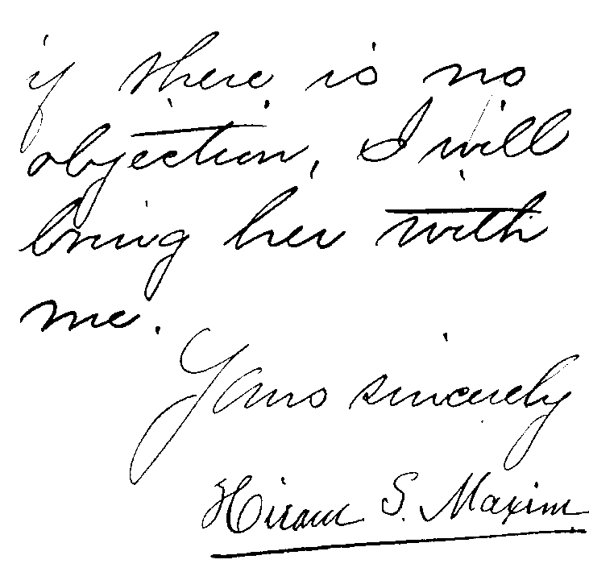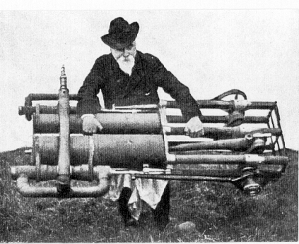

Part of the last page of a letter to the Admiralty, Sir Hiram Maxim demonstrates the lightness
accepting an invitation to demonstrate his new gun. of his new steam engine
‘Her’ is his wife who accompanied him.
this batch only, the next batch would have different sizes of threads and minor but significant differences to dimensioning. When assembled and ready for shipment, no two guns within the range of six serial numbers would go to the same destination. This ensured that if the weapon had to be abandoned on a battlefield, it could not be made serviceable again by using the parts from another gun. Having been serial numbered, the barrel was handed to a very aged fitter for final straightening, he was well past retirement when I was there. He had been straightening machine gun barrels for well over forty years and was probably the only person who had the knack of doing it ! His only tools were several lead hammers, a large block of tree trunk that had almost become fossilised, a “vee” shaped bracket mounted on a tripod also a box with a light source inside hung on the wall. A small hole in the face of the box displayed a glass with several concentric rings engraved and filled with black enamel. He would take a barrel, place it in the vee shaped tripod and point the business end at the light, rotate the barrel and determine the straightness, if there was a slight kink he would see this by the off centring to the rings on the glass. Such a barrel would then be placed at an angle on the block and given several delicate blows with one of the hammers. Such was his skill that nine times out of ten he would take out any imperfections with one hit. The barrel would then be passed to an inspector who would test the straightness with a sophisticated device called a collimator, the total permissible waver allowed was less than 0.0005 inches (half of one thousandth part of an inch) over the 18 inch length of the barrel.
The assembly of the gun itself was very much a straightforward procedure, attention being paid to keeping ones hands constantly covered with lanolin to prevent rusty finger marks on the polished steel components. Then came the best bit, test firing !
The completed gun was taken up into a tower above the loft to a test chamber and fitted to a dummy mount, a couple of hundred rounds were then fired into a hopper that was filled with damp sand, these rounds were special lead bullets, this test ensured that the mechanisms were all working correctly. The gun would then be taken to a range some two miles away and put through its paces with live rounds to test the accuracy and final proofing.
As the junior on the team I had to climb up into the hopper after each firing to recover the compacted lead for re-cycling, a very mucky task indeed.
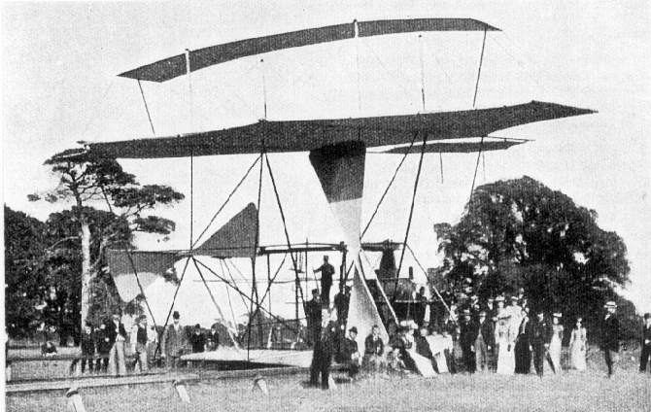

The flying machine getting ready for a trial at Baldwins Park.

My next encounter was barely a few months after I left the Machine Gun Department and continued the “Fitting” in the Power Samas Assembly Shop (Power Samas was one of the Electro-Mechanical punched card tabulating and accounting machines, before computers) Vickers owned land adjacent to the Crayford Greyhound Track, the Power Samas Shop was a single story building some 60 ft long by 60 ft wide, located at one end was about 400 ft of rough land leading to the front doors, two long iron rails stretched from the doors to the end of this field, approximately 9 ft apart, every 10 ft or so was a giant wooden sleeper, the track finally disappeared into a row of poplar trees which marked the boundary. This building and land was once rented by Hiram Maxim and was where he constructed his first steam powered flying machine which actually lifted off the ground on July 31st 1894 even if only for a brief moment with a height of just a few inches. One of the sleepers tilted during the flight and severed the airscrew causing the flying machine to crash into deep muddy ground. The machine was a write off with a financial loss to Maxim of £25,000.
In order to raise capital for his next flying experiment he constructed a small model of his idea for a Captive Flying Machine in his back garden at South Norwood. A selection of the “Gentlemen from the Press” were invited to his home for a demonstration of his new machine on March 4th 1904. The resulting stories in the Times and other newspapers caused a sensation, especially Maxim’s announcement that he intended to build a full size contraption for the Earls Court Exhibition and that an even larger version was being designed to thrill the crowds at the Crystal Palace, he further gave a piece of prophetic foresight, in that his experiment would lead to a lighter than air machine that would be of enormous value to this country as a military engine of war.
The flying machines were very popular, whizzing joyriders around at speeds of up to 100 mph. Hiram Maxim used one of the gondolas on the Crystal Palace machine to fit flying controls, which gave him much information on the theory of aerodynamics.

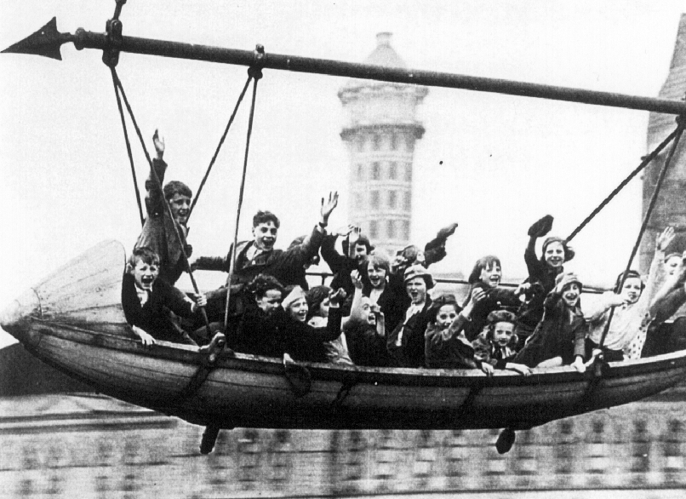

The Captive Flying Machine at the Crystal Palace, no hands and apparently no safety measures either. A Coronation treat in 1937 for a South London Schools Party Day

After several more attempts to build a real flying machine Sir Hiram was overtaken by other pioneers, the Wright Brothers in the U.S.A. Fellow ex patriot, Samuel Franklin Cody in Britain and Louis Bleriot in France. By the time he died in 1916, soldiers on the war fronts were using the weapons of his creation, and real flying machines were engaged in aerial combat.
The Crystal Palace Captive Flying Machine remained in service up to 1946 then gradually fell into decay until 1948 when a fire in the motor house destroyed much of the supporting framework, it was finally reduced to scrap in 1949 by the George Cohen 600 Group.
My third and perhaps final encounter is through collecting Crystal Palace ephemera and the Exhibition Study Group, whereby I have put together a small collection of aviation related items of events that happened at the Crystal Palace. Hiram Maxim and his flying machine being part of the story.

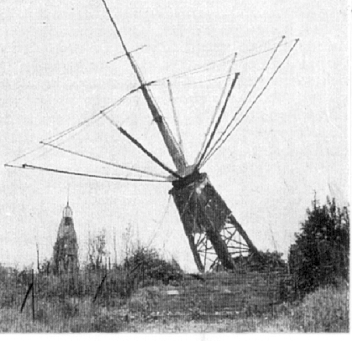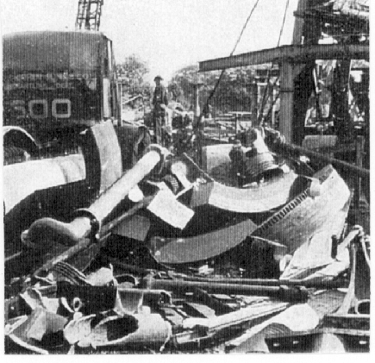

The Tower topples, demolished by the George The end, a pile of scrap iron.
Cohen 600 group.

The Vickers factory at Crayford I understand was closed in the 1970’s and turned into smaller factory premises, most of the original features have now been demolished. The Maxim aircraft shed was demolished up to the tops of the window levels in the late 1950’s and rebuilt as part of a printing works, what was left of the track was also removed at this time.
During the fifth and final year of my apprenticeship I had yet another encounter with a famous aviation engineer, Barnes Wallis, but that is another story.
George Cohen’s 600 Group have over the years been responsible for demolishing The Giant Wheel at Earls Court, the Water towers at Crystal Palace in 1940 and the Dome of Discovery and much of the South Bank Exhibition in 1952. (Did I see one of their engineers sizing up the one at Greenwich last week?)

Paris Universal Exposition 1900
by
Ron Trevelyan

Two visits to exhibitions held in London last year revived my interest in the major Exposition held in Paris 100 years ago. The first exhibition was at the Royal Academy between January and April and was entitled ‘1900 Art at the Cross-roads’. It presented a cross section of paintings and sculpture made at the turn of the last century and looked back at the Exposition Decennale held within the Paris Universal Exposition. This was the largest international exhibition of contemporary art ever held and was housed in the Grand Palais. The selection of works on display was restricted to those created since 1889 and came from 29 nations including France.
My second visit was to the Victoria and Albert Museum where a major exhibition was staged entitled ‘Art Nouveau 1890-1914. This took place between April and July. The Paris Exposition was held when Art Nouveau was at its height and the influence of the designers of this art fashion could be seen everywhere. The V. & A. exhibition portrayed a number of cities where the fashion took hold, including Paris with a mock up of a Metro Station designed by Hector Guimard.
I decided to follow up my exhibition visits with a display on Paris 1900 to the Exhibition Study Group Convention in Portsmouth in September 2000 and I thought it may be of interest if I noted down some of the information I unearthed for the display. The momentum for the Paris event, which heralded the new century, was driven by international rivalries and the major Chicago Worlds Fair was a challenge not to be ignored. Paris had one major feature already in place in the form of the Eiffel Tower which had been built for the 1889 Paris Exposition. A giant Ferris Wheel (La Grande Roue) was also constructed emulating the original which was such a success at Chicago 1893. The tower and wheel certainly made their mark on the Paris skyline. When the French President Emile Loubet opened the 1900 event on the 14th April much work had still to be done and the opening ceremonies had to contend with building sites and mud. Eventually the 210 pavilions were up and running and over 40 countries were represented, many of these with extensive colonial interests around the world. The Exposition site covered about 277 acres which represented about a quarter of Paris. The Exposition Commissioner-General Alfred Picard had set out the aims of the event as: Education and Instruction; Fine and Decorative Arts; Technology; Labour; State Welfare and Hygiene. There were also permanent features introduced as a result of the Exposition,
1 The city’s first underground line (Metro).
2 A new railway station the Gare D’Orsey to accommodate trains powered by electric engines.
3 A new bridge the Pont Alexandre III named after the late Tsar of Russia.
4 The Grand Palais and Petit Palais both built to be permanent, unlike other pavilions.
Public transportation within the Exposition was itself a major attraction and proved a talking point among visitors. An electric train circled the site in twenty minutes and running parallel in the opposite direction a ‘Trottoir Roulant’ (moving pavement) which was over two miles long. This allowed visitors to glide past the various pavilions and attractions and from the comments I have seen on post cards it was a big hit with those who rode on it. It was even divided up into three tracks with different speeds. There were warning signs in many languages in case those carried along became too complacent i.e. ‘Caution: Beware of the trees.’ ‘Put out neither head nor legs’.
Electric light illuminations were a major feature of the Exposition and created a fairy tale atmosphere. Every evening at the palace of Electricity 5,700 incandescent bulbs were lit at the flick of a switch. Combined with water cascades (Chateau d’Eau) and the liberal use of glass and mirrors this produced some spectacular effects.
With the River Seine flowing right through the middle of the Exposition all the foreign pavilions were ranged on one side along the Quai de Nations. Facing them on the opposite bank was the site for various entertainment’s and attractions. Many of the buildings had an oriental flavour, whilst the British pavilion was modelled on a famous Jacobean Manor House known as ‘The Hall’ at Bradford on Avon. This was designed by Lutyens in the style of the early 17th century and contained furniture by William Morris & Co., and stained glass by Edward Burne-Jones. The building was intended to portray a view of England before the changes made by the industrial revolution.
There were major art displays in the Exposition. Apart from the Exposition Decennale I mentioned earlier, the Grand Palais which opened on 2nd May 1900 celebrated French art achievements during nine post Revolutionary decades between 1800 and 1889 at the Exposition Centennale. In addition the Petit Palais staged a survey of French art from the middle ages to the age of Watteau. The French artist Rodin found himself with only two sculptures in the official French sculpture section and organised a major retrospective exhibition of 150 works in a pavilion constructed at the Place d L’Alma which was near the fairground attractions. This exhibition opened on 1st June and was very popular with visitors ranging from Oscar Wilde to the French Minister of Education.
The Paris 1900 Exposition is most certainly a happy hunting ground for collectors of postcards, exhibition labels and other ephemera. It is interesting that printing machines were exhibited at the time which produced post cards with a clear and well defined image. The technique used was that of an acid bath machine followed by an ‘etch powdering’ process. The particular post cards were ‘L.L.’ of Paris. There is much useful information about the exhibition labels / poster stamps which proliferated as a result of the Exposition in an article by Charles and Francis Kiddle in the march 2000 issue of the Stamp Magazine. Charles has produced a comprehensive catalogue listing more than 4,000 of these.
When the Exposition closed on 12th November 1900 some 48 million people had been to see the sights. This figure was unsurpassed until the 1967 Montreal Exposition. It appears that a small financial loss was incurred, but this has to be set against the permanent features which were left in Paris. Paris also staged the Olympic Games at the same time, but this was regarded as by some as a half hearted affair. It seems that winners were required to pay for their own medals.
I shall end my Paris 1900 story on a slightly bizarre note. The Mayors of France were invited to a banquet held for President Loubet at the Exposition. I am not sure whether the organisers knew what they were letting themselves in for, but in the event 20,777 mayors turned up for the feast. They were served on 606 tables and the food was provided by 11 kitchens.
Acknowledgements
1900 Art at the Cross-roads, Royal Academy catalogue
Ephemeral Vistas. Paul Greenhalgh
Cinderella Corner. Stamp Magazine March 2000

Our 2001 Convention
by
Stanley K. Hunter

The last page of this edition of the Journal is a form to be filled in if you are planning to attend the 2001 Convention in Glasgow, please fill this in and return it to Stanley Hunter. It is vital for him to have this so he can finalise the programme and confirm numbers for the dinner on Saturday night. The Friends of Glasgow Museums have invited us to have an informal welcome ‘do’ on the Friday evening. The Head of Glasgow Museums and the Chairman of ‘The Friends’ both hope to be there. There will be quite a crowd of us staying at the Sandyford including Andrew Brooks, Don Knight, Mike Perkins, Bill Tonkin, and possibly a couple from Nebraska and from Florida. Staying nearby is Alan Sabey, Peter Denley, Flo & George Simner and Ann Stevens & husband. Anton O’Broin is hoping to come from Ireland and Gary Cheyne is on the spot in Scotland. The Sandyford is only five minutes away from the Art Gallery where we are holding the convention.
The Saturday night dinner will be held at the Kelvin Park Lorne Hotel, directly opposite the Sandyford, which has a restaurant, but again I must stress I must know numbers to be able to book enough seats on a Saturday night when restaurants are always busy.
The convention will open on Saturday with our AGM starting at 10.00 to 11.00. The convention will then be open to the public and we can expect local philatelists and post card collectors for the displays as well as members of the Scottish Exhibition Study Group and members of the public. The displays will be in four sessions, Saturday morning / afternoon and Sunday morning / afternoon. The displays will start at 11.00 on both days. There will be breaks for tea or coffee and biscuits during each session, and a break for lunch at midday from 1.00 to 2.00.
We will have a guest of honour, Mrs Young, who is the grand-daughter of H. A. Hedley the General Manager of both the 1888 and 1901 Glasgow Internationals. He had been involved in important London exhibitions in the 1880's before making a great success at Glasgow and the 1886 Edinburgh International Exhibition. She will be showing family portraits of Mr & Mrs Hedley along with VIP exhibition visitors books, signed by royalty, etc. Strictly, a one-off display. We are also inviting the son of the Superintendant of Bellahoustan Park who was 11 years old at the time of the Exhibition and lived in the park all through the exhibition. We also hope to have a police officer who patrolled the exhibition and has some good stories to tell.
As to displays, I have had numerous offers already: The Greenwich Dome, Edinburgh International 1886, Trade Exhibitions, the Trans-Mississippi International at Omaha 1898, Wembley, Festival of Britain, & Valentine's Franco-British Exhibitions 1908, Kelvingrove 1888, 1901 & 1911, Bellahouston (Empire) 1938, Glasgow Garden Festival 1988. We may also be able to have a private view of "Edwardian Summer". This is a display of 1901 Exhibition photographs (many from glass lantern slides) which will have been dismantled by the time of the convention. Most images had never before been seen in public.
We will also have a table top slide projector (Kodak carousel) I can also bring if needed a CD/audiotape player and play CD’s from the "Crystal Palace Champions - National Brass Band Champions 1928-36".
The free car park there is actually just an open space at the State Porch Entrance (North).
We got a nice "plug" in “Scottish Philately”, the newsletter of the Association of Scottish Philatelic Societies. This goes to about 50 stamp clubs in Scotland and Northern Ireland. It highlights "gems from the gold medal Sabey Collection of Wembley British Empire Exhibition 1924-25."
We are being gifted the room (now K3, the Education Room), for our Convention It was Pavilion 2 in 1901 and housed exhibits from the Glasgow School of Arts.
Once again the sooner I get your return, the sooner I can get the best results. If anyone is arriving early or staying later, they should let me know and I can arrange special activities or a special tour.
Post Cards of the White City
Part 18.
by
Bill Tonkin

Unknown Publisher Number 5.
B/W litho, black back with ‘CARTE POSTALE’ and double line divider, no stamp box.
46. Algerie - Ecole de Tapis Arabes. Collection Idéalé. Y.S.

Section 4. Photogravure printings by unknown publishers.

Unknown Publisher Number 1. Formosa Hamlet.
B/W photogravure with large white borders sometimes on two sides and sometimes on all four sides. Plain back. Apart from the names of the natives there is no other printing on the post cards.
N.n. Api Patogaton. Vert.
N.n. Bachago Bagaban. Vert.
N.n. Bachio Bajaijan. Vert.
N.n. Chaibai Pujajon. Vert.
N.n. Pasuriba Kojugi. Vert.
N.n. Ruji Suruchan. Vert.
N.n. Rusubaba Arapai. Vert.
N.n. Rusuyajan Bajajim. Vert.
N.n. Tibo Salongai (Chief) Vert.
N.n. Togachi Rumuchi. Vert.
N.n. Tugie Kalowan, Chief. Vert.

Section 5. Real photographic post cards by unknown publishers.

Unknown Publisher Number 1.
Sepia R/Photo with large white borders and an extra wide border on the left, black back ‘POST CARD’ without stop measures 42-43mm. ‘T’ divider in double lines underneath. No stamp box.
N.n. No title. (Bird’s eye view of the Bandstand)
N.n. No title. (Cane furniture in front of Royal Pavilion)
N.n. No title. (Launch and Swan Boat in Court of Honour)
N.n. No title. (Stadium from Flip-Flap)

Unknown Publisher Number 2.
This series of views of the opening of the Franco-British Exhibition are known with two different backs.
Number 2. Type A. R/Photo with white border, black back, ‘POST CARD.’ with stop measures 45mm. ‘T’ divider, without stamp box. Under the manuscript title is written ‘.Y.Co’.
N.n. Opening of Franco-British Exhibition - Arrival of Prince and Princess.

Number 2. Type B. R/Photo with white border, black back, ‘POST CARD.’ with stop measures 69mm. double line ‘T’ divider, without stamp box. Under ‘POST CARD’ in large capital letters is ‘For Communication’ and ‘For Address Only’.
N.n. Opening of - - Franco-British - Exhibition - .
N.n. Opening of Franco-British Exhibition - - Arrival of - - Maharajah of Nepal.

Unknown Publisher Number 3.
R/Photo, green back with ‘The address to be written on this side’ in large capital letters under ‘POST CARD’ without stop measuring 45mm. Line stamp box with ‘Inland Half penny Stamp Foreign One Penny’.
N.n. Franco-British Exhibition. 1908. (Gardens and Palace of Women’s Work)
N.n. Franco-British Exhibition. 1908. (Wood Lane Entrance)

Unknown Publisher Number 4.
Sepia R/Photo with white borders, brown back ‘POST CARD.’ with stop measures 51mm. ‘T’ divider in double lines with single line top bar. No stamp box.
N.n. No title. (Gardens and Palace of Women’s Work)

Unknown Publisher Number 5.
Sepia R/Photo, the view is in a three inch embossed circle, to the right or left of the post card. Sometimes the embossing is missing. Opposite the view is the title which is the same on all cards seen, ‘A Souvenir of the Franco-British Exhibition Shepherd’s Bush 1908’. Black back ‘POST CARD.’ with stop measures 51mm. ‘T’ divider with an O at the junction of the lines. No stamp box but with ‘Postage’ where the stamp would go.
N.n. A Souvenir of the Franco-British Exhibition Shepherd’s Bush 1908. (A crowd outside the Canadian Pavilion with a sign reading ‘Ballymaclinton Irish Village’)
N.n. A Souvenir of the Franco-British Exhibition Shepherd’s Bush 1908. (Court of Honour, visitors embarking from a launch on left.)
N.n. A Souvenir of the Franco-British Exhibition Shepherd’s Bush 1908. (Court of Honour, visitors queuing for seats on launch with another launch just leaving the pier.)

Unknown Publisher Number 6.
These show two views of Kathleen Hicks the Junior Weaving Champion of Northern Ireland and were available at Ballymaclinton, they are known with four different backs. One view is of Kathleen facing the camera out in the open in the Irish Village listed as a vertical post card. The other view is taken inside a cottage with her sitting sideways to the camera and is a horizontal card. In both views she is sitting at a table with a small hand loom and an iron cauldron used for collecting donations for charity. A message on one post card reads “Mother saw this little girl making ties yesterday”.
Number 6. Type A. R/Photo, black back ‘POST CARD.’ with stop measures 51mm. ‘T’ divider with an O at the junction of the lines. No stamp box but with ‘Postage’ where the stamp would go.
N.n. No title. Vert right.
N.n. No title. Horizontal.

Number 6. Type B. R/Photo, black back ‘POST CARD.’ with stop measures 55mm. There is a cross between POST and CARD. The double line divider has four leaves at the junction with the top bars. Without stamp box.
N.n. No title. Vert right.

Number 6. Type C. R/Photo, black back ‘POST CARD.’ without stop measures 55mm. There is a printed number after CARD ‘79B’. There is a single line ‘T’ divider and no stamp box.
N.n. No title. Vert right.

Number 6. Type D. R/Photo, black back as type C. but the number is altered to ‘88B’.
N.n. No title. Vert right.

Unknown Publisher Number 7.
There are two types of this series the only difference being in the size of ‘POST CARD’.
Number 7. Type A. R/Photo with white borders, black back ‘POST CARD’ without stop measures 52mm. There is a printed number after CARD ‘38G’. Short ‘T’ divider. No stamp box.
15/3 Franco-British Exhibition, 1908. Wood Lane Entrance.

Number 7. Type B. R/Photo with white borders, black back the same as type A. except ‘POST CARD’ without stop measures 53mm. There is the different printed number after CARD ‘01C’. Short ‘T’ divider. No stamp box.
15/4 Franco-British Exhibition, 1908. Main Entrance. Vert left.

Number 7. Type C. R/Photo with white borders, black back the same as type A. except ‘POST CARD’ without stop measures 55mm. There is the same printed number after CARD ‘38G’. Short ‘T’ divider. No stamp box.
15/4 Franco-British Exhibition, 1908. Main Entrance. Vert left.

Unknown Publisher Number 8.
R/Photo of the chefs and cooking staff at the Banqueting Hall in the Garden Club, brown back ‘POST CARD’ without stop in outline letters measures 61mm. The ‘T’ divider is in double lines.
N.n. Garden Club Japan British Exhibition June 1910

Unknown Publisher Number 9.
R/Photo with white borders, the views have rounded corners within the borders, black back ‘POST CARD.’ with stop measures 62mm. with ‘T’ divider, line stamp box with ‘1.’ inside.
N.n. Japan-British Exhibition. (Palace of Women’s Work)
N.n. The Cascade, Japan-British Exhibition. Vert right.
N.n. The Floating Island, Japan-British Exhibition. (Long seat in centre foreground)
N.n. The Floating Island, Japan-British Exhibition. (View of three Japanese buildings across the water)
N.n. “Uji” Village, Japan-British Exhibition. (Close up of Lamp standard at right side)
N.n. “Uji” Village, Japan-British Exhibition. (Close up of Lamp standard at right of centre)

Unknown Publisher Number 10.
There are several series of post cards with large outline ‘POST CARD’ backs. These can be sorted into those with a divider and those without. They have letters, and or numbers in the stamp box. It is difficult to say whether these are private photographs or commercial products, many of them have manuscript titles which lifts them out of the general private photographic range.
Number 10. Type A. R/Photo with large white borders, black back ‘POST CARD’ without stop in outline letters measures 65mm. with double lines underneath, but no divider. Dotted stamp box with the letters ‘DIA’ inside.
N.n. Cascade. Court of Honour. White City. London.
N.n. Court of Honour by Night. White City. London. (Pier in foreground)
N.n. Court of Honour by Night. White City. London. (Water in foreground)
N.n. Gardens. White City. London.

Number 10. Type B. Sepia R/Photo, black back ‘POST CARD’ without stop in outline letters measures 66mm. with ‘T’ divider, line stamp box with ‘M5’ inside.
N.n. Franco-British Exhibition, 1908. (Fountain and The Pavilion) Back inverted.
N.n. Franco-British Exhibition, 1908. (Gardens and Palace of British Applied Arts)
N.n. Franco-British Exhibition, 1908. (Machinery Hall)
N.n. Franco-British Exhibition, 1908. (Palace of British Applied Arts and Flip-Flap)
N.n. Swan Boating, Franco-British Exhibition, 1908.

Number 10. Type C. Sepia R/Photo with large white birders, black back as type B. ‘T’ divider, line stamp box with ‘M5’ inside.
N.n. No title. (The Cascade) Back inverted.

Number 10. Type D. Sepia R/Photo, black back as type B. ‘T’ divider, line stamp box with ‘M5’ inside.
N.n. No title. (Court of Honour)

Number 10 Type E. Sepia R/Photo with white borders, black back ‘POST CARD’ without stop in outline letters measures 66mm. with ‘T’ divider, line stamp box with ‘O.1.’ inside.
N.n. No title. (Fountain and The Pavilion. Same view as in Type B.)

Number 10. Type F. Sepia R/Photo with white borders, black back ‘POST CARD’ without stop in outline letters measures 66mm. with ‘T’ divider, line stamp box with ‘R51.’ inside.
N.n. No title. (Gardens and Palace of Women’s Work)

Small Publishers Section V.

Vertigen. H. & Co., London.
Vertigen published several series of post cards.
Type 1. Sepia litho, title in sloping letters ending in ‘Franco-British Exhibition.’ black back ‘POST CARD.’ with stop measures 41mm. H. Vertigen & Co., London. E.C. down left side and empty line stamp box.
N.n. Court of Honour.
N.n. Court of Honour by Night.
N.n. The Palace of Music.

Type 2. Sepia litho, title in upright letters ending in ‘Franco-British Exhibition.’ black back ‘POST CARD.’ with stop measures 41mm. H. Vertigen & Co., London. E.C. down left side and empty line stamp box.
N.n. Lake showing Court of Progress.
N.n. The Flip Flap at Work.
A. Vert left.
B. Vert right.
N.n. The Irish Village.
N.n. The Royal Pavilion.

Type 3. Coloured Comic card, black back ‘POST CARD.’ with stop measures 46mm. H. Vertigen & Co., London. E.C. down left side, single line divider and ‘Printed in Holland’ sideways in dotted stamp box.
N.n. The Flip-Flap. (Policeman in large boots).

Victoria.
B/W photogravure, black back with ‘VICTORIA The Garden State of Australia’. ‘National Series of Post Cards’ in scrolls at top. Line stamp box with small scrolls in each corner.
N.n. The Leviathan Rock, Buffalo Mountains.

Vollenweider. Arnold. Alber.
B/W litho printing, black back with ‘CARTE POSTALE’ measuring 47mm and a single line divider.
N.n. École Professionelle de Broderies Indigènes. Vert left.

Vuitton. L.
Coloured advert card, with ‘“l’Entente Cordiale” Auto Camping L. Vuitton, Trunk & Bag Manufacturer’ at top, black back with ‘CARTE POSTALE’ and postal instructions in French.
N.n. Franco-British Exhibition 1908 Groupe XV-Classe 99.

Small Publishers Section W.

Wakefield, Chiswick.
Although their range of views on post cards was not great Wakefield’s more than made up for it by the large number of different backs or variations of the fronts, 23 are listed and it is unlikely this is the end of the story. Wakefield’s were publishers and farmed their work out to various printers. Some were produced in Germany, others were produced by an unknown firm who printed numbers in place of the stamp box, known numbers are 48, 58, 68 and 78. The various backs would suggest Wakefield’s used a number of printers to produce their cards. They also used Rotary to produce some of their real photographic post cards.
Wakefield’s also used different addresses possibly as they expanded, Chiswick, Ealing, Brentford, and Brentford & Chiswick.
Type 1. Dark greenish litho, sunk plate with large white borders, title in red, black back ‘POST CARD’ without stop 28mm. line stamp box with ‘Inland ½d. Foreign 1d. Printed in Germany’ and double line divider.
No. 114 Franco-British Exhibition, Birds Eye View Taken from Balloon. Copyright Photo. Wakefield Chiswick.

Type 2. Blue black litho, sunk plate with large white borders, title in red, black back ‘POST CARD’ without stop 28mm. line stamp box with ‘Inland ½d. Foreign 1d. Printed in Germany’ and double line divider.
No. 114 Franco-British Exhibition, Birds Eye View Taken from Balloon. Copyright Photo. Wakefield Chiswick.

Type 3. Dark greenish litho, sunk plate with large white borders, title in red, black back ‘POST CARD.’ with stop measures 37mm. line stamp box with ‘Inland ½d. Foreign 1d. Printed in Germany’ and single line divider.
No. 111 Franco-British Exhibition, Birds Eye View Taken from Balloon. Copyright Photo. Wakefield Chiswick.

Type 4. Sepia litho, sunk plate with large white borders, title in red, black back ‘POST CARD.’ with stop measures 37mm. dotted stamp box with ‘Inland ½d. Foreign 1d. Printed in Germany’ and single line divider.
No. 115 Franco-British Exhibition, Visit of Their Majesties the King and Queen. Copyright Photo. Wakefield Chiswick.

Type 5. Blue-black litho, sunk plate with large white borders, title in red, black back ‘POST CARD.’ with stop measures 37mm. dotted stamp box with ‘Inland ½d. Foreign 1d. Printed in Germany’ and single line divider.
No. 115 Franco-British Exhibition, Visit of Their Majesties the King and Queen. Copyright Photo. Wakefield Chiswick.

Type 6. Blue-black litho, title in red, black back ‘POST CARD’ without stop measures 35mm. dotted stamp box with ‘Inland ½d. Foreign 1d.’ and ‘Printed in Germany’ down the side outside the stamp box, single line divider.
No. 116 Franco-British Exhibition, Wood Lane Entrance. Copyright Photo. Wakefield Chiswick.

Type 7. B/W litho, title in red, black back ‘POST CARD’ without stop measures 35mm. dotted stamp box with ‘Inland ½d. Foreign 1d.’ and ‘Printed in Germany’ down the side outside the stamp box, single line divider.
No. 111 Franco-British Exhibition, Birds Eye View Taken from Balloon. Copyright Photo. Wakefield Chiswick.
No. 113 Franco-British Exhibition, General Birds Eye View Taken from Balloon. Copyright Photo. Wakefield Chiswick.

Type 8. B/W R/photo with white border, title in black, brown back ‘POST CARD.’ with stop measures 44mm. empty line stamp box, single line ‘T’ divider.
No. 111 Franco-British Exhibition, Birds Eye View Taken from Balloon. Copyright Photo. Wakefield Chiswick.
No. 114 Franco-British Exhibition, Birds Eye View Taken from Balloon. Copyright Photo. Wakefield Chiswick.

Type 9. B/W R/photo with white border, title in black, brown back ‘POST CARD.’ with stop measures 41mm. empty line stamp box, single line ‘T’ divider with a heavy top bar.
No. 112 Franco-British Exhibition, The Great Stadium-Olympic Games 1908. Taken from Balloon. Copyright Photo. Wakefield Chiswick.
No. 114 Franco-British Exhibition, Birds Eye View Taken from Balloon. Copyright Photo. Wakefield Chiswick.

Type 10. Sepia R/photo with white border, title in white capital letters, brown back ‘POST CARD’ without stop measures 33mm. In place of a stamp box there is a number printed, in this case 58, single line divider.
N.n. Franco-British Exhibition London from a Balloon.

Type 11. Sepia R/photo with white border, title in white capital letters, brown back ‘POST CARD’ in the same font as type 9 but more spaced out, without stop measures 37mm. 58 in place of a stamp box, single line divider.
N.n. Wood Lane Entrance to Franco-British Exhibition Shepherds Bush.

Type 12. Sepia R/photo with white border, title in white capital letters, brown back ‘POST CARD’ in the same font as type 9 but more spaced out, without stop measures 37mm. 58 in place of a stamp box, single line divider, ‘Photo By Wakefield” Brentford’ down left side.
N.n. Visit of the King & President to the Exhibition. (With impressed round stamp at bottom left reading ‘Copyright Wakefield’s Brentford’)

Type 13. Sepia R/photo with white border, brown back ‘POST CARD’ in the same font as type 9 without stop measures 33mm. 68 in place of a stamp box, single line divider.
N.n. Franco-British Exhibition. London. W. Photo from Balloon. by Wakefield’s. Brentford & Chiswick.
N.n. Franco-British Exhibition. London. W. Photo of “The Stadium” from Balloon. by Wakefield’s. Brentford & Chiswick.

Type 14. Sepia R/photo with white border, title in white capital letters, brown back ‘POST CARD’ in the same font as type 9 but more spaced out, without stop measures 37mm. 68 in place of a stamp box, single line divider.
N.n. Visit of the King & President to the Exhibition. (With impressed oval stamp at bottomleft reading ‘Copyright Wakefield’s Brentford & Chiswick’)
N.n. Visit of the King and President to the Exhibition. (This is a different view to the above card. With impressed oval stamp at bottom left reading ‘Copyright Wakefield’s Brentford & Chiswick’)

Type 15. Sepia R/photo with white border, brown back ‘POST CARD’ in the same font as type 9 but more spaced out, without stop measures 37mm. Number in place of a stamp box altered to 78, single line divider.
N.n. Franco-British Exhibition. London. Copyright Photo by Wakefield’s. Brentford and Chiswick.

