EDITORIAL SUMMER 2001

Now the gout’s a thing of the past
I’m getting about again at last

Yes I know these rhymes are getting pretty pathetic but it’s just another sign of declining mental powers. I would like to thank those members who wrote to me commiserating with my health ups and downs. At the moment I’m having one of my ups and everything in the garden is fine.
Once the gout had cleared up I was able to get about again and in April did the York post card fair. In my opinion York and Cheltenham are two of the best post card fairs there are and I seldom have a poor day at either. This time it all went my way and for once Mike Perkins was not present which was a bit of a bonus. At every major fair I go to, Mike has seen all the exhibition cards before I can get in the front door, this explains why he has an outstanding Wembley collection and I have a poor second best. One dealer told me he had brought a new stock of exhibition cards with him and when I started to go through it I recognised it as the Fred Fletcher collection. Older members of the Study Group will know the name as he was one of our founder members. On his death his collection was sent to Phillips who split it up into about 16 lots. The first time round only two lots sold and the remainder was put into their next auction at reduced estimates and a dealer bought the lot. That’s how it came to be at York. Fred had loaned us some of his cards to include in our book on Wembley post cards and when I saw these cards again I knew where they had come from. I asked the dealer and he confirmed he had bought them from Phillips. One card I was glad to get was the Lustre Pearls advert card, they had stand No. 7 on old London Bridge or King’s Gate as it was named in the 1924 exhibition. This card is unique as far as I know as I have never heard of another one. All of Fred’s missionary exhibition cards were there and I finished up the day with 168 cards in my bag.
At the beginning of May I went to the Festival of Britain Society convention held at the Festival Hall, they certainly had a grand turnout, there were nearly eighty people turned up. George Simner and Fred Peskett are to be congratulated on a very successful day. Their day is not organised in the same way as is our convention, as it is more of an open meeting offering an opportunity to sit around and have a chat, with no set displays which have always been a feature of our convention.
Being the 50th anniversary of the Festival has meant they have been able take full advantage of this and both George and Fred have been in great demand for mounted small exhibitions, or loaning Festival material to libraries and museums all over the place. I think the main difference between the two groups is that while we have tended to attract collectors of exhibition material, the FOB Society has attracted people who visited and remember the Festival.
There has been one not so pleasant side effect of the popularity of the Festival and this has been the rocketing of prices of Festival post cards and memorabilia. At the last Bloomsbury one dealer had priced all his run of the mill Festival post cards at £5 each. I can’t quite see the logic of this, if a dealer is unable to sell a card for £1.50 or £2.00 are collectors really going to fall over themselves to pay £5 for it ?
When we look at other collectibles it is reported in the May Festival Times that a Wedgwood half pint mug that a couple of years ago would have been considered expensive at £50, is now commanding a price of £780. It would be unfortunate indeed if the efforts of George and Fred have had the result of pricing Festival memorabilia beyond the reach of the average collector.
Getting back to the prices of post cards while there will always be a lot of common Festival cards that will never be worth more than a couple of pounds, there are never the less a lot of very scarce if not downright rare cards that must be worth a lot of money. Fortunately dealers generally do not know what is common and what is rare in this field so there are still bargains to be picked up, but it is getting increasingly difficult to find them.
Last, but certainly not least, I wish to congratulate Alan Sabey on wining a gold medal and the Judges Felicitations at the International Stamp Exhibition Belgica 2001. Those of us who have been privileged to see parts of Alan’s display will know the scope and depth of his collection. Gold medals often go to collections of Victorian or Edwardian material, to have been awarded a gold for George V is an additional achievement.
The Editor
Anchor Line
by
Mike Perkins

From time to time I have a go at mounting my cards onto sheets and I try to give some background to the illustrations on the cards, their publisher, and the company that issued them. I like to try and tell a story with the cards. I thought some of our other members might like to share in the story of Anchor Line and it’s ships.
The story of Anchor Line can be said to date from 1856 when a steamship service between Glasgow and New York was commenced by the Handyside Brothers and Thomas Henderson, who already ran sailing ships in a number of trades. In the 1860’s, services were introduced into the Mediterranean from both Scotland and North America. The retirement of the last Handyside in 1873 encouraged the Henderson family to take an interest in the Todd and MacGregor shipyard at Partick which, as D. and W. Henderson was to build many Anchor Line ships. In 1875 Anchor Line established it’s other major route with services from Glasgow and Liverpool to Bombay. The services to the Mediterranean were discontinued in the 1890’s as Anchor Lines years of growth came to an end. The name was changed to Anchor Line (Henderson Brothers) Ltd. in 1899 and there was a period of consolidation in which the fleet came to include fewer, but larger more specialised ships for it’s North Atlantic and Indian Routes. This was the first formal use of Anchor Line as part of a ship owning company : previous ships had been owned or managed under the names of various Henderson’s.
1911 saw the end of the company’s independence when it’s shares were bought by the Cunard Steamship Co. Ltd.. There were far-reaching consequences for the Anchor Line, but the only outward change was the addition of a white line between the black hull and the red boot topping, which added considerably to the ship’s smartness. In 1912 Anchor’s Calcutta services were transferred to Brocklebank’s, the service bearing the title Anchor Brocklebank Line. A further joint operation imposed on the line by Cunard was Anchor-Donaldson Ltd., established in 1916. Four Donaldson Line ships were transferred to this company to operate a service between Glasgow and Eastern Canada.

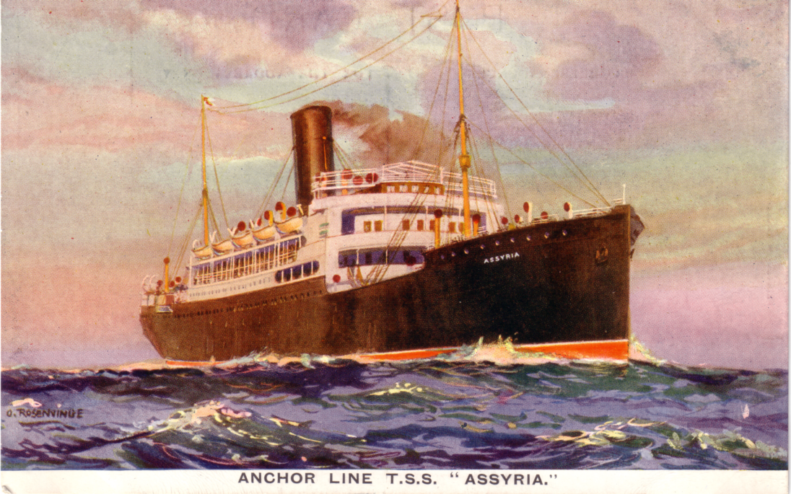

T. S. S. “Assyria”

Anchor line ships suffered very badly during the First World War, only the Columbia surviving. The post-war reconstruction program was ambitious, involving five new ships, bigger than any previous Anchor Line vessels. Alas, recession and the drastic reduction in emigration to North America in the 1920s ended the Mediterranean to New York service. Anchor Line now had surplus tonnage and completion of some vessels was postponed. This, along with the generally depressed trading conditions lead the company, along with Cunard, into financial difficulties. In 1935 Anchor Line ( Henderson Brothers ) Ltd. was in liquidation and its assets were transferred to Anchor Line (1935) Ltd. in which Runciman ( London ) Ltd. had a major stake.
Once again war hit the company’s ships hard, only one of the Atlantic liners remained in 1945, and the replacements were cargo liners with very limited passenger accommodation. As a result, the Bombay service assumed a new importance to Anchor Line.
The 1960s saw the end of much of the company’s traditional trade. Passenger sailing’s to India ceased early 1966, and the North Atlantic service closed in 1967. But Anchor Line continued with renewed vigour. Runciman’s operations were transferred to Glasgow, whilst Moor Line ships were registered under Anchor Line ownership and took the remaining sailing’s to India. Walter Runciman plc bought other Scottish companies in the early 1970s, and added to Anchor Line.
Anchor Line was perhaps Glasgow’s best known shipping company, and its name has meant that it has endured to be one of the city’s last.

The ships themselves, sailing across the world’s oceans, also have a story to tell, and here is a brief history of the ships illustrated on the Wembley cards. I should mention that when a ship is sold (or lost), the name is re-used over and over.

Assyria.
Built in 1908 by AG Friedrich Krupp Germaniawerft of Keil, Germany. 8142 gross tonnage and 448 feet long. Anchor Line purchased just two ex-German ships after W.W.I, including Assyria which had been built for Hamburg Amerika Line as the Ypiranga. The cargo-passenger ship was intended for the Bombay route, but after entering service in 1921 she spent 4 years running to New York, such was the shortage of North Atlantic Ships. Sold in 1929, she enjoyed a long career serving Portuguese colonies as Colonial, lasting until 1950 when she was wrecked off Scotland, heading to Clydeside breakers as Bisco 9.

California.
Built in 1923 by Alexander Stephen & Sons Ltd., of Linthouse. 16792 gross tonnage and 553 feet long, and the third boat to have this name. California was essentially a North Atlantic ship, but each year made several sailing’s to Bombay. She was taken over for conversion to an armed merchant cruiser in 1939 and served in this role until April 1942. By then there was need for troopships, and in this capacity she made 2 voyages to both South Africa and India. Her 3rd trooping voyage was her last, and on-route to Freetown she was bombed and set on fire by aircraft west of Portugal on 11 July 1943, and sank.
Sister ship to the Lancastria (Cunard Line), but with additional promenade deck, and almost identical to the Tuscania.

Cameronia.
Built in 1920 by William Beardmore & Co. Ltd. of Dalmuir. 16280 gross tonnage and 575 feet long, and again the second boat to have this name. The Cameronia was the first of Anchor Line’s much needed post-war ships for the North Atlantic. She was launched in record time, but her entry into service was delayed by an industrial dispute over the ending of bonus payments, and she was taken to Cherbourg for completion. Her carer was long and varied, and as a WW2 troopship she was involved in the invasions of North Africa, Sicily and Normandy. This left her apparently worn out, but she was bought out of lay-up in 1947 for further trooping and later carrying emigrants to Australia.
The Ministry of Transport bought her in 1953, renaming her Empire Clyde, but leaving management with Anchor Line. Broken up at Newport late in March 1958 by John Cashmore & Co..

Castalia.
Built in 1906 by Barcley Curle & Co. Ltd. of Whiteinch. 6388 gross tonnage and 441 feet long, and again the second boat to have this name. Although Anchor Line’s association with D & W Henderson’s yard ended in 1899, only slowly did the line turn to other builders such as Barcley Curle. The Castalia survived both wars, and in 1949 was sold to an Italian line, running a service to Central America. After 5 years as the Marengo and Urania II, the old ship was broken up in Japan at the end of 1953.

Circassia.
Built in 1902 by D & W Henderson & Co. Ltd. of Partick. 6717 gross tonnage and 450 feet long, and again the second boat to have this name. She was notable for spending her entire career running to India, even when requisitioned by the Government in W.W.I. Broken up in 1931.

Columbria.
Second boat to have this name built in 1902 by D & W Henderson & Co. Ltd. of Partick. 8292 gross tonnage and 485 feet long. Served on the Northern Patrol as the armed merchant cruiser HMS Columbella being the only one of Anchor Lines major passenger ships to survive. Sold in 1926 to Greek owners as the Moreas. Sailed between Piraeus and New York. Broken up at Venia in 1929.

Elysia.
Built in 1908 by D & W Henderson & Co. Ltd. of Partick. 6368 gross tonnage and 441 feet long, and again the second boat to have this name. During WWI the Elysia had torpedoes fired at her at least 5 times, the last attack in May 1918 causing heavy casualties and severe damage. She showed a similar capacity take punishment during WW2. During an attack by a group of Japanese surface raiders in the Indian Ocean on 5 January 1942, she took several torpedoes and lasted 4 days before sinking.

Massilia.
Built in 1902 with a gross tonnage of 5156, she was a near sister ship to the Olympia. Launched on the 21st of August for the India service, she made her maiden voyage to Bombay. During WWI she was used several times as a hospital ship, sailing between Suez and India. In June 1919 she made her first trans.–Atlantic crossing from Glasgow to Boston. She made occasional Atlantic crossings between 1921 and 1929, but was otherwise an India ship. Sold on the 13th of March 1930 and broken up.

Olympia.
Built in 1902 by D & W Henderson & Co. Ltd. of Partick. 5124 gross tonnage and 400 feet long, again the second boat to have this name. A sister ship to the Massilia, she was essentially a cargo ship for the Indian service with accommodation for just over 50 cabin class passengers. After W.W.I. both ships were occasionally used on the North Atlantic service. After returning to the Bombay route, she was broken up at . in 1926.

Scindia.
Built in 1900 by D & W Henderson & Co. Ltd. of Partick. 5127 gross tonnage and 400 feet long, she was the third boat to carry this name. Scindia was delivered for the India service, but also sailed on the Glasgow to Mediterranean service. She survived WWI, and in 1919 was transferred to the Glasgow to New York service to assist the Columbia – Anchor Lines sole surviving North Atlantic passenger vessel. Sold for demolition on the 25th of April 1927.

Tuscania.
Built in 1922 by Fairfield Shipbuilding & Engineering Co. Ltd., of Govan. 16991 gross tonnage and 552 feet long, and again the second boat to have this name. The splendid Tuscania was intended to trade between Italy and New York, but the imposition of U.S. immigration quotas meant she only made a few such voyages. Tuscania was then used on a number of Anchor and Cunard services, including Anchor Line routes from the UK to New York and to Bombay, Cunard’s London to New York service, plus a certain amount of cruising and trooping. In 1939 she was sold to the General Steam Navigation Co. Ltd. of Greece, and became the Nea Hellas, but with the fall of Greece she returned to British control and Anchor Line management. After W.W.II spent as a troopship, her Greek owners refitted her for their Mediterranean to New York service. After a further refit, she was renamed New York in 1955, and steamed on until 1961 when she was broken up in Japan.

Anchor-Donaldson Line.

Athenia.
Built in 1923 by Fairfield Shipbuilding & Engineering Co. Ltd., of Glasgow. 13465 gross tonnage and 526 feet long. A Cunard ‘A’ class ship, the twin-screw turbine steamer Athenia had features in common with contemporary Anchor and Cunard Line vessels. She was best known for her tragic end; torpedoed without warning by U30 within 7 hours of the out break of W.W.II on the 3rd of September 1939 whilst on a routine voyage from Liverpool to Montreal. The loss of 93 passengers and 19 crew was a grim foretaste of what unrestricted submarine warfare had in store.

Cassandra.
Launched on 27th of June 1906 by Scotts Shipbuilding & Engineering Co. Ltd. of Grennock. 135 gross tonnage and 455 feet long. Completed in September 1906 for the Donaldson Line. Transferred to Anchor – Donaldson Ltd. in 1916. Transferred back to Donaldson in 1925, she was converted to a livestock and general cargo carrier and renamed the Carmia. In December 1929 she was sold to A. Bernstein of Germany and renamed Drachenstein. Broken up at Keil by Deutsche Werk AG in 1934.

Saturnia.
Built in 1910 by Charles Connel & Co. Ltd., of Glasgow. 8611 gross tonnage and 456 feet long. One of four ships transferred from the Donaldson Line to the newly formed Anchor-Donaldson Line in 1916. This joint venture operated passenger services from Glasgow to Canadian ports. Saturnia survived WWI and was sold for breaking up at Genoa in 1928.
As mentioned earlier, Cunard took over Anchor Line in 1911, and it was fortuitous that both lines used names for their ships ending in “---ia”, so that when Cunard borrowed an Anchor Line ship for one of it’s services, the public would still think that the ship was a Cunarder by it’s name.
Cunard appear to have been the major ship owner in the years after the First World War, and this probably explains why so many shipping cards of this period are found with similar backs - perhaps Cunard simply ordered cards for all it’s lines from the one printer. More of Cunard later.

the end

Kelvingrove Guest Houses & Hotels for the
2001 Convention 29th-30th September, by Stanley Hunter

Stanley Hunter has sent in the following list of hotels to stay at for the convention. Mike Perkins, Andrew Brooks and myself have booked in at the Sandyford Hotel and should arrive on the Friday.
Would any members intending to take up a display please contact Stanley at 34, Grey Street, Kelvingrove, Glasgow. G3 7TY. His phone number is 0141 339 2775

ALAMO GUEST HOUSE 46 Gray Street (overlooking park, bowling greens and tennis courts) (2 Single, 1 Twin, Double & Triple, 5 Family - 2 en suite, 1 private) £30.00 full Scottish Breakfast Scottish Tourist Board Commended Visa/Access street parking opposite

ALDARA GUEST HOUSE, 5 Bentinck Street (6 rooms)
£15.00 street parking (no brochure available)

ANGUS HOTEL 970 Sauchiehall Street at Gray Street (breakfast room overlooks park and bowling greens and tennis courts) Scottish Tourist Board *** AA RAC Acclaimed. Single £44 Twin/Double £29.00, Triple/Quad £26.00. Scottish Breakfast, all en-suite, satellite tv, tea/coffee, direct & digital phones, radio radio alarm, hairdryer, laundry/ironing, restricted free parking. web www.angushotelglasgow.co.uk

ARGYLL HOTEL 973 Sauchiehall Street (Opposite the Angus) Scotish Tourist Board *** RAC **, Scotland's Personal Hotels. Single from £56, Double/Twin from £70 Weekend rates from £46-£60) as above but elevator, street parking, Bar/Restaurant, street parking
web www.argyllhotelglasgow.co.uk

BEERSBRIDGE LODGE 50 Bentinck Street at Gray Street, Single £30, Double £35, Family £45 incl Continental breakfast. en suite, shower, street parking (no brochure available

THE FLOWER HOUSE 33 St Vincent Crescent, off Argyle Street (Singles,
Doubles/Twins) £30.00 (no brochure available) web www.scotland2000.com/flowerhouse
not recommended if you suffer from hay-fever - it is a veritable Kew Gardens. The (1850) tree-lined crescent is a cul de sac, overlooking the (1860) St Vincent Bowling Green. It is handy for the Exhibition.

THE KELVINGROVE HOTEL 944 Sauchiehall Street (25 rooms) Scottish Tourist Board *** Single £38, Twin/Double £29.00, Triple £25.00, Quad £21.00 (includes Breakfast)
No Smoking, Cable & Sky, tea/coffee, direct dial, street parking
web www.kelvingrove-hotel.co.uk

PARK HOTEL guest house, 960 Sauchiehall Street. £15.00 street parking (no brochure available)

THE SANDYFORD HOTEL 904 Sauchiehall Street (45 rooms, one of seven West End hotels) Single £29, Double/Twin £48, Family of 3 £60 all en suite with Scottish Breakfast
colour tv, direct dial, street parking This seems a good choice if there is going to be a group. Same chain as The Town House, in the next block.

SMITH'S HOTEL 963 Sauchiehall Street (since 1928) Scottish Tourist Board Recommended, RAC Listed Single £20/ £25 en suite £35, Double/Twin £19.00 en suite
£ 25.00, Triple en suite £22.00. Full Cooked Breakfast

All the above listed are within easy walking distance of each other, the Kelvingrove Art Gallery and a wide selection of restaurants and bars, including two Gaelic ones. (Other ethnic restaurants include Chinese, Indian ("largest in Britain"), East European, several Tapas Bars, a new Greek Taverna, Thai, Italian, there is even a McDonald's!)

Ten minutes walk takes you to Byres Road in the heart of the student quarter - and the nearest Sushi diner plus the top restaurant in the city (By the way, full Scottish Breakfast should include most of an English Breakfast but may also include potato scones, black pudding, fruit pudding and other such cholesterol delicacies, plus porridge as a cereal option.)

The prices quoted are strictly subject to change. As they all cater for exhibitors/popstars to the Scottish Exhibition and Conference Centre, they can book out well in advance. I have not patronised any of the premises but will check if you want and send you their latest colour brochure (if they have one). You can also check their web-site if they have one.
Most of the area is based on honey-coloured sandstone tenements and terraces built in the 1870's and 80's. All have been extensively refurbished. Bentinck Street's north side is attributed to James Sellars, the acclaimed architect responsible for the International Exhibition of 1888, a few yards away. (He certainly built the church there, which now
serves as the High Court in the "Taggart" tv police dramas - much of which is filmed in the environs, including the park and recently in the Art Gallery.)

The IMAX cinema (Scotland's first) and the Science Centre will be operational on the site of the Glasgow Garden Festival 1988. The 100 metre high Millennium Tower (Scotland's highest free-standing building) can be seen from Kelvingrove. It replaces the Garden Festival tower which is now in Rhyl and the new attraction can easily be reached by the Garden Festival footbridge. The BBC plans to move its Scotland HQ to the site. I will not be doing any room booking but will be happy to supply telephone, fax and e-mail addresses. I will also physically check out confirmation of any booking, if wanted and tell where others are staying. The city centre is easily reached by bus from Kelvingrove. Nearest Underground Station is Kelvinhall. Nearest train stations are Exhibition Centre (Argyle Line for Glasgow Central) and Charing Cross (for Queen Street). Nearest taxi ranks are Charing Cross and Kelvin Hall (Blantyre Street), opposite Art Gallery, but taxis can be hailed. Note: Alan Sabey will be able to give you a picture of what the area is like as he was here for GLASGOW 2000 stamp exhibition.

Mike Edwards

It is with regret that I have to announce the very sudden death of Mike, husband of Judith Edwards, who although not a member of the group had attended at least one of our conventions with Judith. Mike was known to several of us and Allan Sabey had stayed with them on several occasions. The last time I met him was in a car park in Winchester, I was getting out of my car at the same time as the occupants of the next car were getting out of theirs, it was Judith and Mike, with I believe their son. The Study Group has made a donation to a charity of Judith’s choice.

One of our new members Ken Rumsey has been over to visit me several times and has brought me some reprints he has had done of odd pages of the London Illustrated News and the Graphic for 1908. These all have pictures or articles on the Franco-British Exhibition, or the 1908 Olympics which took place at the exhibition. They are A3 in size (this is twice as large as a sheet of A4 paper) and there are sixty sheets in number. He has had ten lots printed and will sell them to members at the cost price of £10.00 plus some thing for postage. The quality of reproduction is first class. If any member is interested please contact Ken Rumsey, 69, Winchester Road, Hanworth, Middlesex. TW13 5JX. phone 0208 755 4201

The Road to Gold
by
Alan Sabey

After a good many years searching for suitable material for my British Empire Exhibition 1924-25 collection at fairs and exhibitions, it was finally recognised and so were my efforts when I was awarded a gold medal in the traditional section of the International F. I. P. Exhibition ‘Belgica’ held in Brussels in June 2001.

As a good many of you will probably be aware, I began to get interested in the ‘Wembley Exhibition’ as it is more often known, when the Wembley Historical Society produced a couple of publications, one of text and the other comprising pictures taken from some of their postcards in their archives at the time of the 50th anniversary of the exhibition in 1974. This display was in Barham Park Library near Wembley. I knew of the stadium and remember going with my parents in 1951 to see Dick Whittington on ice in the Empire Pool. When I first saw those photographs taken around the exhibition I was really captured by the whole thing and wished that I could have been around to see it for myself. The 1951 Festival of Britain, which I did see with my parents, was nothing in comparison.

I soon found out that Bill Stitt-Dibden, who at one time lived in Wembley before moving to Leicestershire where he died in the 1960’s, had carried out some work into the philately of the exhibition. His books had gone into the subject a certain amount, but I felt in my bones that there was a lot more which had not been discovered. I began asking dealers what they had got, and frequently the answer was ‘just the two stamps’. I found there was a set of four items of special exhibition postal stationary issued in 1924 and in 1925. Like the stamps, the year on the postal stationary had been altered for the second year. It was only recently that I discovered that the visitor in 1925 had to specifically ask for the 1925 issue otherwise he was sold the previous year’s. I think that this accounts for the scarcity of the 1925 issues of both stamps and the postal stationary, particularly the Three Half pence Post Card correctly used. It was intended for visitors from abroad to be able to send messages home. The sales figures for this item are extremely low and the numbers correctly used are even lower!

Because of my eagerness to find items for my collection, I was soon referred to among the stamp trade as “Mr Wembley”. This name has stuck and I now use something similar as my E-mail address. Dealers will note that if one is seriously interested in a subject or stamp issue, the collector will find that items come his or her way. Personally I have found that the trade are keen to help one build a collection, probably because they realise they have a new client! To be fair, they get some satisfaction from knowing that they sold the collector a certain item or collection, which has helped in the building of the collection. I have been fortunate in purchasing, some years ago, a collection of proofs and cuttings from the Post Office Circular, a staff production, which announced the opening of the exhibition in April 1924 and through to the closure to the public in October 1925, and the eventual final closure to exhibitors and staff employed on the site in December 1925. I recently purchased a very last day cover from a well known auction house, which with these cuttings concludes the display nicely. The Judges look for these additional items as being part of the story and will award the exhibitor extra marks for these appropriate yet unusual, if not, scarce items.

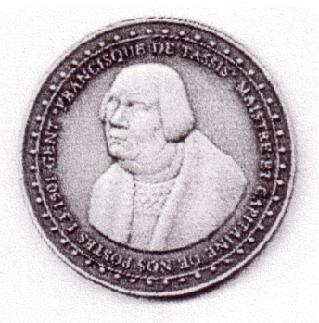

Gold medal awarded to Alan Sabey at Belgica 2001

The secret of success is to look out for the unusual and rare items. Yes they do turn up occasionally. I was fortunate in being able to purchase items from a famous collector. I was in the right place at the right time, in reality and financially. I have often found that if one dithers as to whether to buy an item or not, and lets it go, the collector is unlikely to get the chance again. Within reason, it is always best to purchase an item when you see it, especially if it will enhance your collection.

Preparation and thought must be taken when putting an entry together as a certain number of marks are awarded for this. Before I complete and return the application form to enter, I write out a sheet or sheets of paper with lines from 1-80 or 128, depending on the number of frames being requested. I then mark these off at every 16 (the composition of the display frame four rows of four sheets) and write down exactly what I intend to show on every sheet. This way I can work out whether my entry will look balanced and more importantly, whether I have sufficient material for all the pages. Nothing looks more obvious than a ‘padded out’ entry and the judges will spot it. I got asked once why I had put a lot of perfins in. My answer was that each of the companies who security perforated the stamps were actually stand holders at the exhibition. Once you have mounted up the items for your frame, you will need to decide which pages are philatelically important and place them in the centre block of four sheets in the centre of the frame as this is the point to which the eye naturally goes. Many people think that everything must be in strict order. It does not have to be, as long as you get the important items in the centre and that if you have say two covers on a page at one end of a row, the same should apply at the other end of that row. Always place your ‘heaviest’ looking items, large blocks or large covers, on the bottom row of the frame so that your display ‘sits’ comfortably on it.

The ‘writing up’ is best done on a computer and the judges will always award higher marks if this is the case. In fact, I believe that computer writing up is preferred even to very neat writing or print. It is so easy these days being able to set up the size of the page manually and thus centering will come easily. One point that should be noted and you will lose marks if you do this , is that entries must not be written up on A4 sheets. Not only does it look out of place but also they stick out like a sore thumb when placed along side entries on proper album size pages. I now use plain ivory tinted sheets obtained from the local stationers. The grill on album pages is unnecessary when using a computer whose printer will print in straight line anyway. It is not difficult to mount stamps or covers neatly and squarely in place. Some computer programs will allow for a box to be printed on the sheet where the item is to go. Some collectors use this method and others, like me, prefer to back all their items with coloured card. When using this method, and there is no hard and fast rule either way, but the border around the item should be minimal, otherwise, if you still use black, it will look as if the item is in mourning! Personally I have found a stock of grey card which is permanently available at an art shop, and I think it complements the colours of the stamps, in my case just two colours. If you are going to use a coloured card to back your items, take one or two different ones to the art shop or stationers and judge how your item will look against this colour. You should also be quite sure that the coloured card will continue to be available as your collection grows over the years! I recently saw an entry where the main items were backed in one colour and what the collector considered rare were backed in red. I consider this to be tacky and feel that all items whether rare or common should be displayed in a similar way. If you wish to draw the attention of the judges to something rare, say so in your write up. However beware of using phrases such as “the only one known”. Someone is sure to come up with another, and will delight in telling you so! Try using “one of only two seen” or similar wording. If you know the numbers sold for a particular item, show it in the writing up and the judges will take this into account when assessing your philatelic knowledge marks. Try and include the unusual facts, the ones that others might not think of, and it could be to your advantage. I have done this and was given the ‘Felicitations of the Judges’ for my research for the ‘Belgica’ entry.

Post Cards of the White City
Part 17.
by
Bill Tonkin

Unknown Publishers.
Most publishers usually printed their name or trademark somewhere on their products, but there are many series of post cards where the printer or publisher is not known. Coloured, litho, line printed and photogravure post cards could only be produced by post card manufacturers who had the necessary equipment to do them. However many of the real photographic post cards would have been taken by visitors and are really personal snap shots, that when they were developed and prints made, were enlarged on to thin card with a printed post card back.
These personal snap shots can often be identified by the fact that the views are not level, the amateurs taking the films finding it difficult to hold the camera straight. Another pointer is the lack of titles, or if there is a title, it is in manuscript form written on to the negative, as they did not have the facility to print proper titles. Unfortunately at this period and for many years after, post card manufacturers were also writing titles in manuscript, indeed Valentine’s were still doing it for the 1951 Festival of Britain post cards. Another pointer is that the old small nearly square films when reproduced on to post card sized prints left wide margins on the right and left side of the post card. These one off personal snap shots with post card backs are outside the scope of this listing, but it has to be said it is sometimes not easy to decide which are which.
To assist in locating post cards in the unknown publishers listing they have been sorted into sections and listed as ‘Unknown Publisher Number 1 and so on.
Section 1. Coloured printings by unknown publishers.
Section 2. Line printings by unknown publishers.
Section 3. Litho printings by unknown publishers.
Section 4. Photogravure printings by unknown publishers.
Section 5. Real photographs by unknown publishers.
In addition the measurement of ‘POST CARD’ of each type in each section starts with the shortest measurement and goes on to the longest measurement.

Section 1. Coloured printings by unknown publishers.

Unknown Publisher Number 1.
Coloured poster type post card, showing a figure representing Peace and Commerce with the two flags, designed by Hill Sutton & Co., London. The brown back is filled with an announcement of the opening of the Franco-British Exhibition and the various attractions and ticket prices.
N.n. The Franco-British Exhibition 1908 May to October Shepherd’s Bush, London. Vert.

Unknown Publisher Number 2.

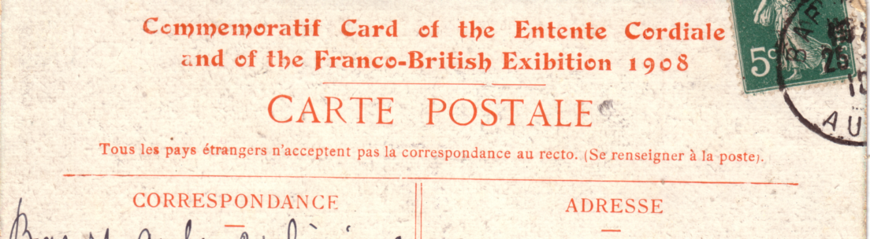

Unknown publisher No. 2.

Coloured, orange back with ‘Commemoratif Card of the Entente Cordiale and of the Franco-British Exhibition 1908’ above ‘CARTE POSTALE’.
N.n. Franco-British Exhibition, 1905 Vers la Paix Universelle 1908

Unknown Publisher Number 3.

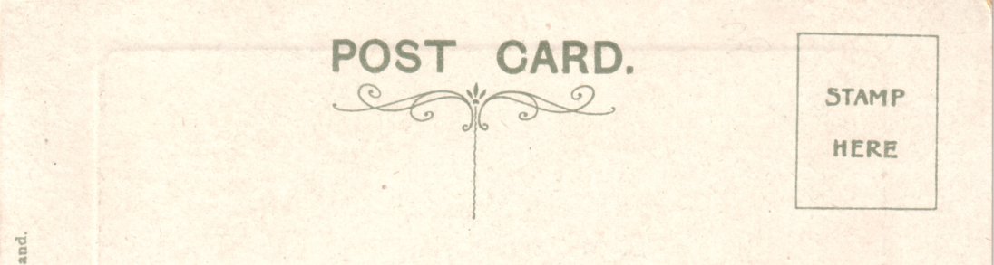

Unknown publisher No. 3.

Coloured sunk plate with large white borders, title in gold, dark grey back ‘POST CARD.’ with stop measures 42mm. there is a short divider with a fancy scroll type top and ‘Stamp Here’ in a line stamp box. ‘Printed in England’ down left side. The first part of the split title is in capital letters and all the titles end with ‘Franco-British Exhibition’ in sloping letters.
N.n. Court of Honour. (Swan boat at bottom centre)
N.n. Court of Honour.(Wide pathway with visitors at the side of lake)
N.n. Dorando’s Arrival at the Stadium.
N.n. Dorando Receives Her Majesties Gold Cup.
N.n. Elite Gardens.
N.n. General View from flip-Flap.
N.n. Machinery Hall.
N.n. Palace of British Applied Arts.
N.n. Palace of French Applied Arts.
N.n. Palace of India.
N.n. Palace of Women’s Work. (Front view)
N.n. Palace of Women’s Work. (Side view)
N.n. Part of Elite Gardens.
N.n. Rickshaws in the Exhibition Grounds.
N.n. Royal Pavilion.
N.n. Swan Boats on Lagoon, Court of Honour.
N.n. The Court of Honour by Night.
N.n. The Court of Honour.
N.n. The Flip Flap. Vert left.
N.n. The Flip-Flap. (Horizontal)
N.n. The Opening Ceremony.
N.n. The Palace of Music. (Close up view with lamp post in centre)
N.n. The Palace of Music.(Distant view, pathway in front of building and close up of visitors)
N.n. Wood Lane Entrance.

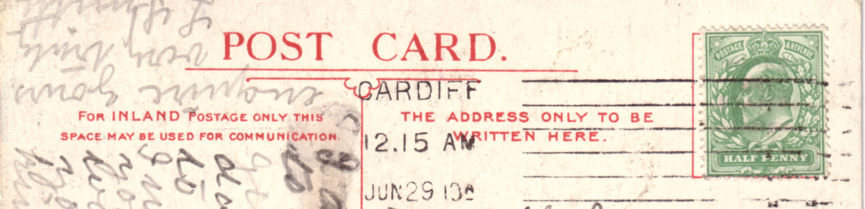

Unknown publisher No. 4.

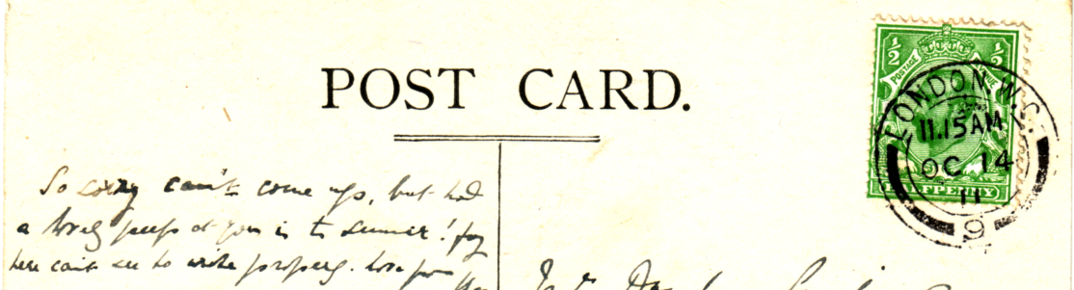

Unknown publisher No. 5.

Unknown Publisher Number 4.
Coloured, red back ‘POST CARD.’ with stop measures 45mm.
N.n. Franco-British Exhibition, 1908. Interior Canadian Pavilion.

Unknown Publisher Number 5.
Coloured poster type post card, showing a figure holding a large Union Jack. Black back, ‘POST CARD.’ with stop measures 48mm..
N.n. Coronation Exhibition 1911 Great White City Shepherds Bush, London. Vert left.

Unknown Publisher Number 6.

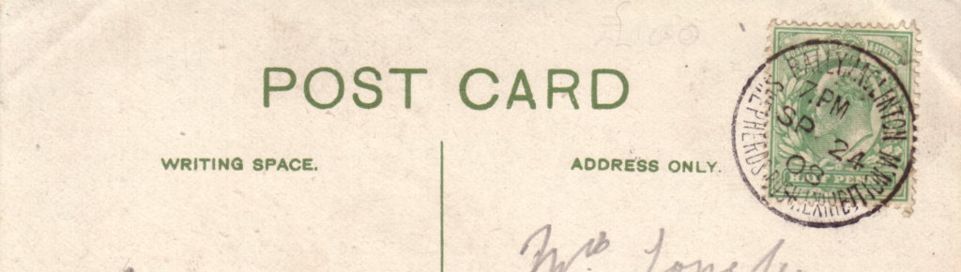

Unknown publisher No. 6.

Coloured, green back ‘POST CARD’ without stop measures 50mm. These are possibly of Indian manufacture. Both post cards listed were posted at the Ballymaclinton Post Office.
N.n. Mahommedans at Prayer. Delhi.
N.n. Taj Mahal. Agra.

Section 2. Line printings by unknown publishers.

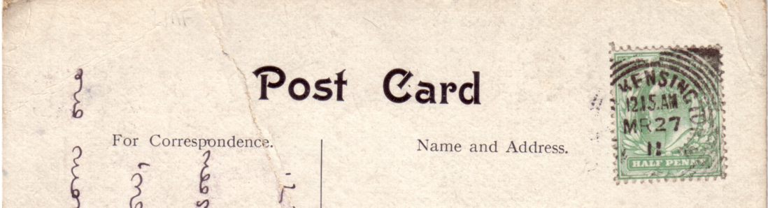

Unknown publisher No. 1.

Unknown Publisher Number 1.
B/W line printing, black back with ‘POST CARD’ without a stop measuring 41mm. This comic ‘policeman’ post card would be a standard design with ‘Franco-British Exhibition’ or any other town added in as required. Copyright and drawing by C. Griffith.
N.n. Our Local Force. Old Lady, “Where do I get the tram for Franco-British Exhibition?” Robert. “Well, Mum, if you keep Just where you are, you’ll get it in the small of your back”.

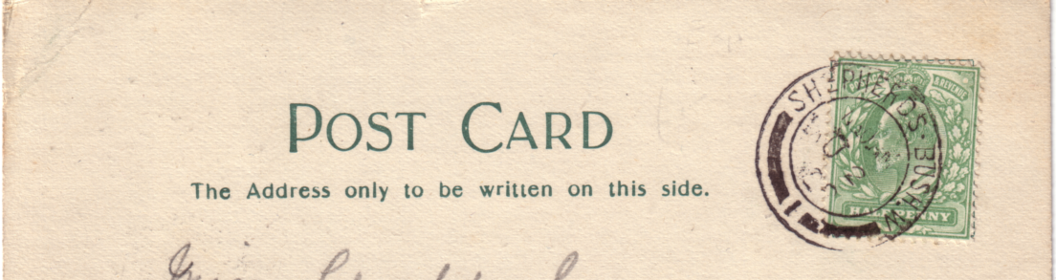

Unknown publisher No. 2.

Unknown Publisher Number 2.
B/W line printing, green back with ‘POST CARD’ without a stop measuring 43mm. This is a comic ‘Devil’ post card where a red Devil is inserted into the message in place of the written word Devil. Although the post card does not mention which exhibition, it was posted at Shepherds Bush August 25 1908.
N.n. At the Exhibition. No time to write. How the Devil Are You.

Unknown Publisher Number 3.

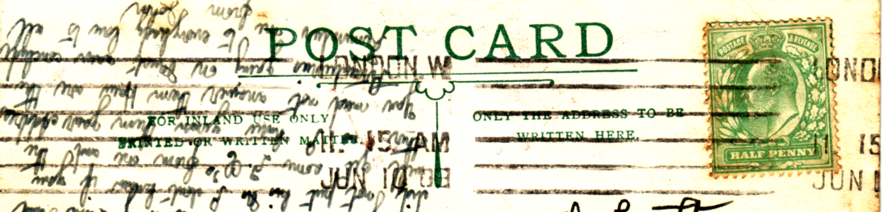

Unknown publisher No. 3.

Blue pen and ink drawing of the King and French President, with crossed flags between them, the flags have red added to them. Green back with ‘POST CARD’ without a stop measuring 54mm. This post card is possibly published by the East London Printing Co., as the back is the same as is used on known cards of theirs, it does not however have the usual ‘E.L.P Co.’ initials in the design, instead there is ‘S C’ in a circle.
N.n. Souvenir of the Anglo-French Exhibition, Visit of the King and French President.

Section 3. Litho printings by unknown publishers.

Unknown Publisher Number 1.

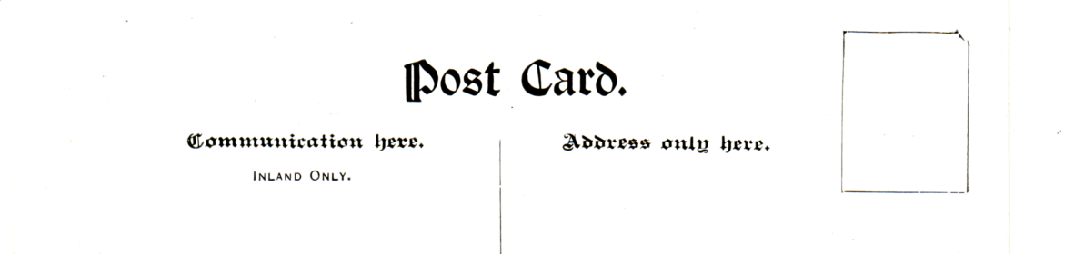

Unknown publisher No. 1. type A.

B/W litho of views in the Australian Court. Although there is no clue to the printers of the type A. post cards, type B. were almost certainly printed by Valentine’s and published by the Australian Commissioners. The cards are known with three different backs.
Number 1. Type A. Black back ‘POST CARD.’ in Gothic type font with stop measures 30mm, empty line stamp box. The views are the same as in type A. but given different titles. The titles are now printed vertically in white panels at the sides.
N.n. Wine Kiosk-South Australian Court. Franco-British Exhibition.
N.n. Preserved Fruit-South Australian Court. Franco-British Exhibition.

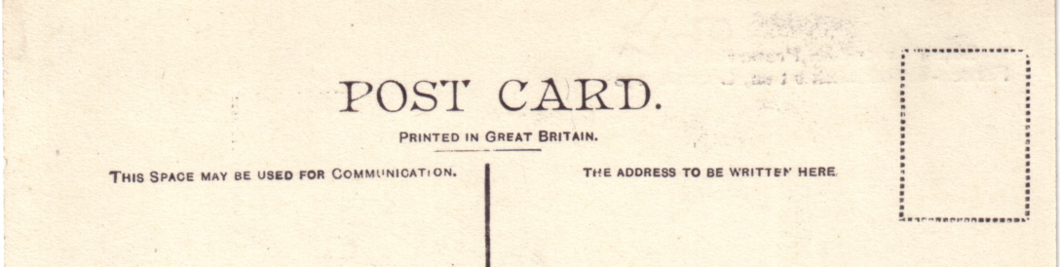

Unknown publisher No. 1. type B.

Number 1. Type B. Black back ‘POST CARD.’ with stop measures 42mm, underneath this is ‘Printed in Great Britain’, empty dotted stamp box. All the titles in type B. and C. end in ‘Franco-British Exhibition. London. 1908’.
N.n. South Australian Court. (Same as Wine Kiosk-South Australian Court. Franco- British Exhibition).
N.n. South Australian Fruit and Wool.
N.n. South Australian Preserved Fruit. (Same as Preserved Fruit South Australian Court. Franco-British Exhibition).

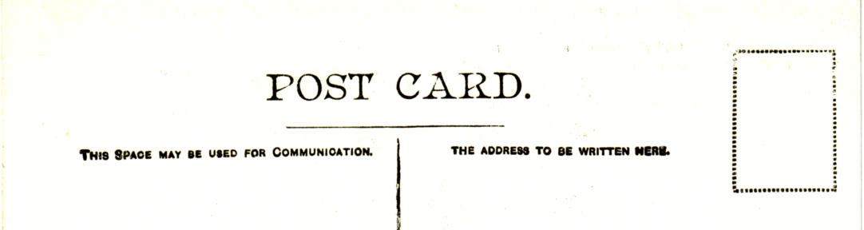

Unknown publisher No. 1. type C.

Number 1. Type C. Black back ‘POST CARD.’ with stop measures 42mm, without ‘Printed in Great Britain’, empty dotted stamp box.
N.n. South Australian Court. (Same as Wine Kiosk-South Australian Court. Franco- British Exhibition).
N.n. South Australian Fruit and Wool.
For other post cards of this view see in the Franco-British Exhibition section, under ‘South Australian Fruit and Wool’.

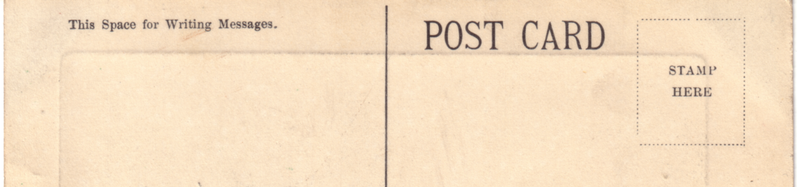

Unknown publisher No. 2. type A.

Unknown Publisher Number 2.
B/W litho, sunk plate with large white borders, title in red, black back. This series of post cards has a number on the front with a different number on the back (listed in brackets) and is divided into three types. The back of the cards, the postal instructions and the dotted stamp box are identical, the difference is in ‘POST CARD’ which is printed in three different fonts. It is on the right side of the back and not in the centre as is usual. All the titles end in ‘Franco-British Exhibition. London 1908. It is possible each type was published as a set of 12 cards, so far the missing titles have not been recorded.
Number 2. Type A. ‘POST CARD’ with small serifs measures 31mm. The font used is a tall narrow type.
C. 1622. The Palace of Railways, Shipping, Iron and Steel. (2430)
On this card two different cloud patterns are known.
C. 1623. General View of the Indian Court, taken from the Court of Honour. (2420)
C. 1624. The Élite Gardens showing Bandstand. (2421)
C. 1628. The Exhibition and Lakes by night, Illuminated. (2424)
C. 1629. The Canadian Palace. (2426)
C. 1630. The Australian Palace. (2425)
C. 1631 The Garden Club Palace. (2428)

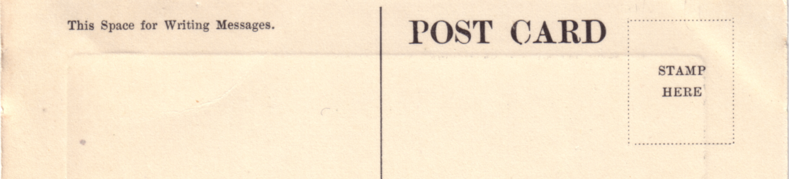

Unknown publisher No. 2. type B.

Number 2. Type B. ‘POST CARD’ with large serifs measures 35mm. The font used is a bold type.
C. 1621. The Palace of Music. (2429)
C. 1623. General View of the Indian Court, taken from the Court of Honour. (2420)
C. 1624. The Élite Gardens showing Bandstand. (2421)
C. 1625. The Stadium showing Swimming Bath and Cycling Track. (2422)
C. 1627. The Exhibition and Lakes by night, Illuminated. (2423)
C. 1631 The Garden Club Palace. (2428)
C. 1632. The Indo China Palace. (2427)
On this card two different cloud patterns are known.

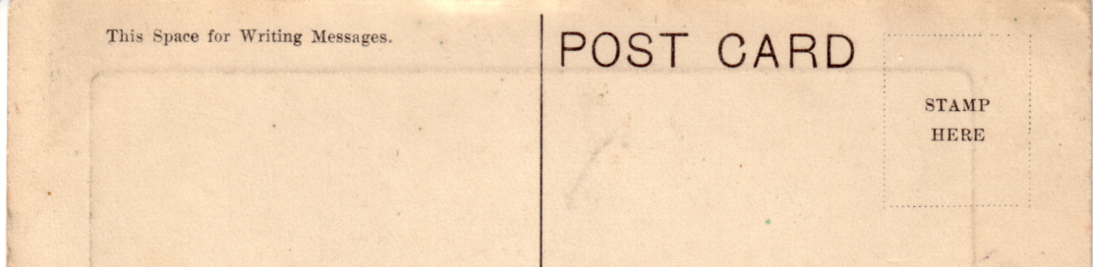

Unknown publisher No. 2. type C.

Number 2. Type C. ‘POST CARD’ without serifs measures 38mm. The font used is a short wide type.
C. 1621. The Palace of Music. (2429)
C. 1622. The Palace of Railways, Shipping, Iron and Steel. (2430)
C. 1628. The Exhibition and Lakes by night, Illuminated. (2424)
C. 1629. The Canadian Palace. (2426)
C. 1631 The Garden Club Palace. (2428)
C. 1632. The Indo China Palace. (2427)

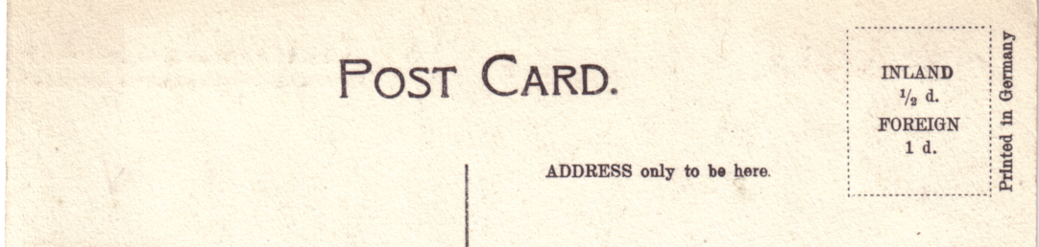

Unknown publisher No. 3.

Unknown Publisher Number 3.
B/W litho, titles in red capital letters at the top of the post card. Black back ‘POST CARD.’ with stop measures 36mm, dotted stamp box with ‘Inland ½d. Foreign 1d.’ and ‘Printed in Germany’ down right side of stamp box. All the titles end in ‘Franco-British Exhibition, London.
N.n. Australian Building.
N.n. Canadian Building.
N.n. Fine Art Palace.
N.n. New Zealand Building.
N.n. Palace of British Applied Arts, showing Gardens.
N.n. Palace of British Applied Arts.
N.n. Palace of French Applied Arts.

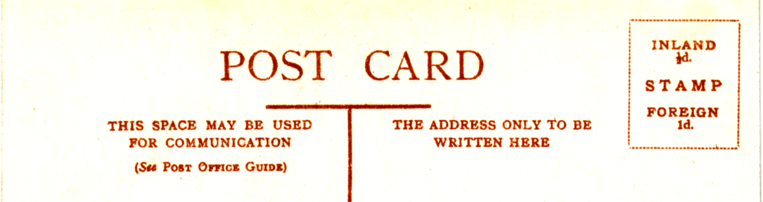

Unknown publisher No. 4.
N.n. Palace of Music & Palace of French Applied Arts.
N.n. Palace of Women’s Work.
N.n. The Court of Honour.
N.n. The Palace of Music.

Unknown Publisher Number 4.
A fairly common series that had the same back printed in a reddish brown and ran into half a dozen different styles of printing the title on the front, or the printing on the back. Some of the series have names printed on the back such as E. B. Horwood or ‘The Excellent Series. M. & D., London. Each series has the same views which leads one to assume they all came from the same stable.
Number 4. Type A. B/W litho printing, The titles are all preceded with ‘Franco-British Exhibition, London.-’ this is printed in capital letters, the title which follows is printed in normal letters using upper and lower case. The back is printed in reddish brown with ‘POST CARD’ measuring 47mm. The dotted stamp box has ‘Inland ½d. Stamp Foreign 1d.’ and apart from ‘(See Post Office Guide)’ all the printing on the back is in capital letters. Type A. does not have ‘Printed in England’ down the left side, all the other types do. There were at least two printings on some cards as all those showing factory chimneys in the background were re-published later with the chimneys removed. Types B, C, D, E & F either show or do not show chimneys which would seem to indicate there was only one printing of these types. The cards are not so common as type A.
N.n. Entrance to the Court of Honour.
A. With two chimneys.
B. Without two chimneys.
N.n. On the Lagoon.
N.n. The Algiers-Tunis Bazaar.
N.n. The British Textile and Education Buildings.
N.n. The Cascade and Congress Hall. Vert left.
N.n. The Congress Hall.
N.n. The Court of Honour.
A. With four chimneys.
B. Without four chimneys.
N.n. The Fine Art Palace.
N.n. The Irish Village. Vert left.
N.n. The Lagoon.
A. With two chimneys.
B. Without two chimneys.
N.n. The Palace of French Applied Arts.
N.n. The Palace of French Applied Arts and Lagoon.
N.n. The Palace of Music and Gardens.
N.n. The Palace of Women’s Work.
N.n. The Stadium.
N.n. The Uxbridge Road Entrance.
B. Franco-British Exhibition, London in two lines. Vert left.
N.n. The Visit of King Edward VII. and the President of the French Republic.

Number 4. Type B. This is the same as type A. except there is now ‘Printed in England’ on the back down the left side.
N.n. Entrance to the Court of Honour. (Without two chimneys)
N.n. On the Lagoon.
N.n. The British Textile and Education Buildings.
N.n. The Canadian Hall.
N.n. The Cascade and Congress Hall. Vert left.
N.n. The Court of Honour. (Without four chimneys)
N.n. The Fine Art Palace.
N.n. The Irish Village. Horizontal.
N.n. The Irish Village. Vert left.
N.n. The Lagoon.
N.n. The Lagoon and British Education Building.
N.n. The Palace of French Applied Arts.
N.n. The Palace of French Applied Arts and Lagoon.
N.n. The Palace of Music and Gardens.
N.n. The Palace of Women’s Work.
N.n. The Scenic Railway.
N.n. The Stadium.
N.n. The Uxbridge Road Entrance.
A. Franco-British Exhibition, London in one line. Vert left.
B. Franco-British Exhibition, London in two lines. Vert left.
N.n. The Wood Lane Entrance.

Number 4. Type C. This is the same as type B. with ‘Printed in England’ on the back down the left side. The title is now all printed in capital letters, in type A. and B. only ‘Franco-British Exhibition, London. was printed in capitals. Also in type C. there is no full stop and bar after ‘London’ these are replaced with two vertical square dots.
N.n. The Court of Honour. (Without four chimneys)
N.n. The French Applied Arts Palace and Lagoon.
N.n. The Palace of Music and Gardens.

Number 4. Type D. This is the same back as type B. but with ‘E. B. Horwood & Co., Ltd., London. and ‘Printed in England’ on the back down the left side.
N.n. Entrance to the Court of Honour. (With two chimneys)
N.n. On the Lagoon.
N.n. The British Textile and Education Buildings.
N.n. The Congress Hall.
N.n. The Court of Honour. (With four chimneys)
N.n. The Fine Art Palace.
N.n. The Irish Village. Vert left.
N.n. The Lagoon.
N.n. The Palace of Music and Gardens.
N.n. The Palace of Women’s Work.
N.n. The Uxbridge Road Entrance.
A. Franco-British Exhibition, London in two lines. Vert left.
N.n. The Visit of King Edward VII. and the President of the French Republic.
N.n. The Wood Lane Entrance.

Number 4. Type E. This is the same back as type B. but with ‘The Excellent Series.-M. & D., London. and ‘Printed in England’ underneath on the back down the left side.
N.n. Entrance to the Court of Honour. (With two chimneys)
N.n. The Algiers-Tunis Bazaar.
N.n. The Congress Hall.
N.n. The Court of Honour. (With four chimneys)
N.n. The Lagoon.
N.n. The Palace of French Applied Arts.
N.n. The Palace of French Applied Arts and Lagoon.
N.n. The Palace of Music and Gardens.
N.n. The Palace of Women’s Work.
N.n. The Stadium.
N.n. The Visit of King Edward VII. and the President of the French Republic.

Number 4. Type F. This is the same back as type B. with ‘Printed in England’ on the back down the left side. The title is now all printed in upper and lower case letters, there is no full stop only the bar after ‘London-’. New views were used for type F.
N.n. The Court of Honour.
N.n. The Elite Gardens and the Flip-Flap.
N.n. The Palace of Music.

