EDITORIAL WINTER 2000

Winter’s come with lots of rain,
and the fields are under water again.

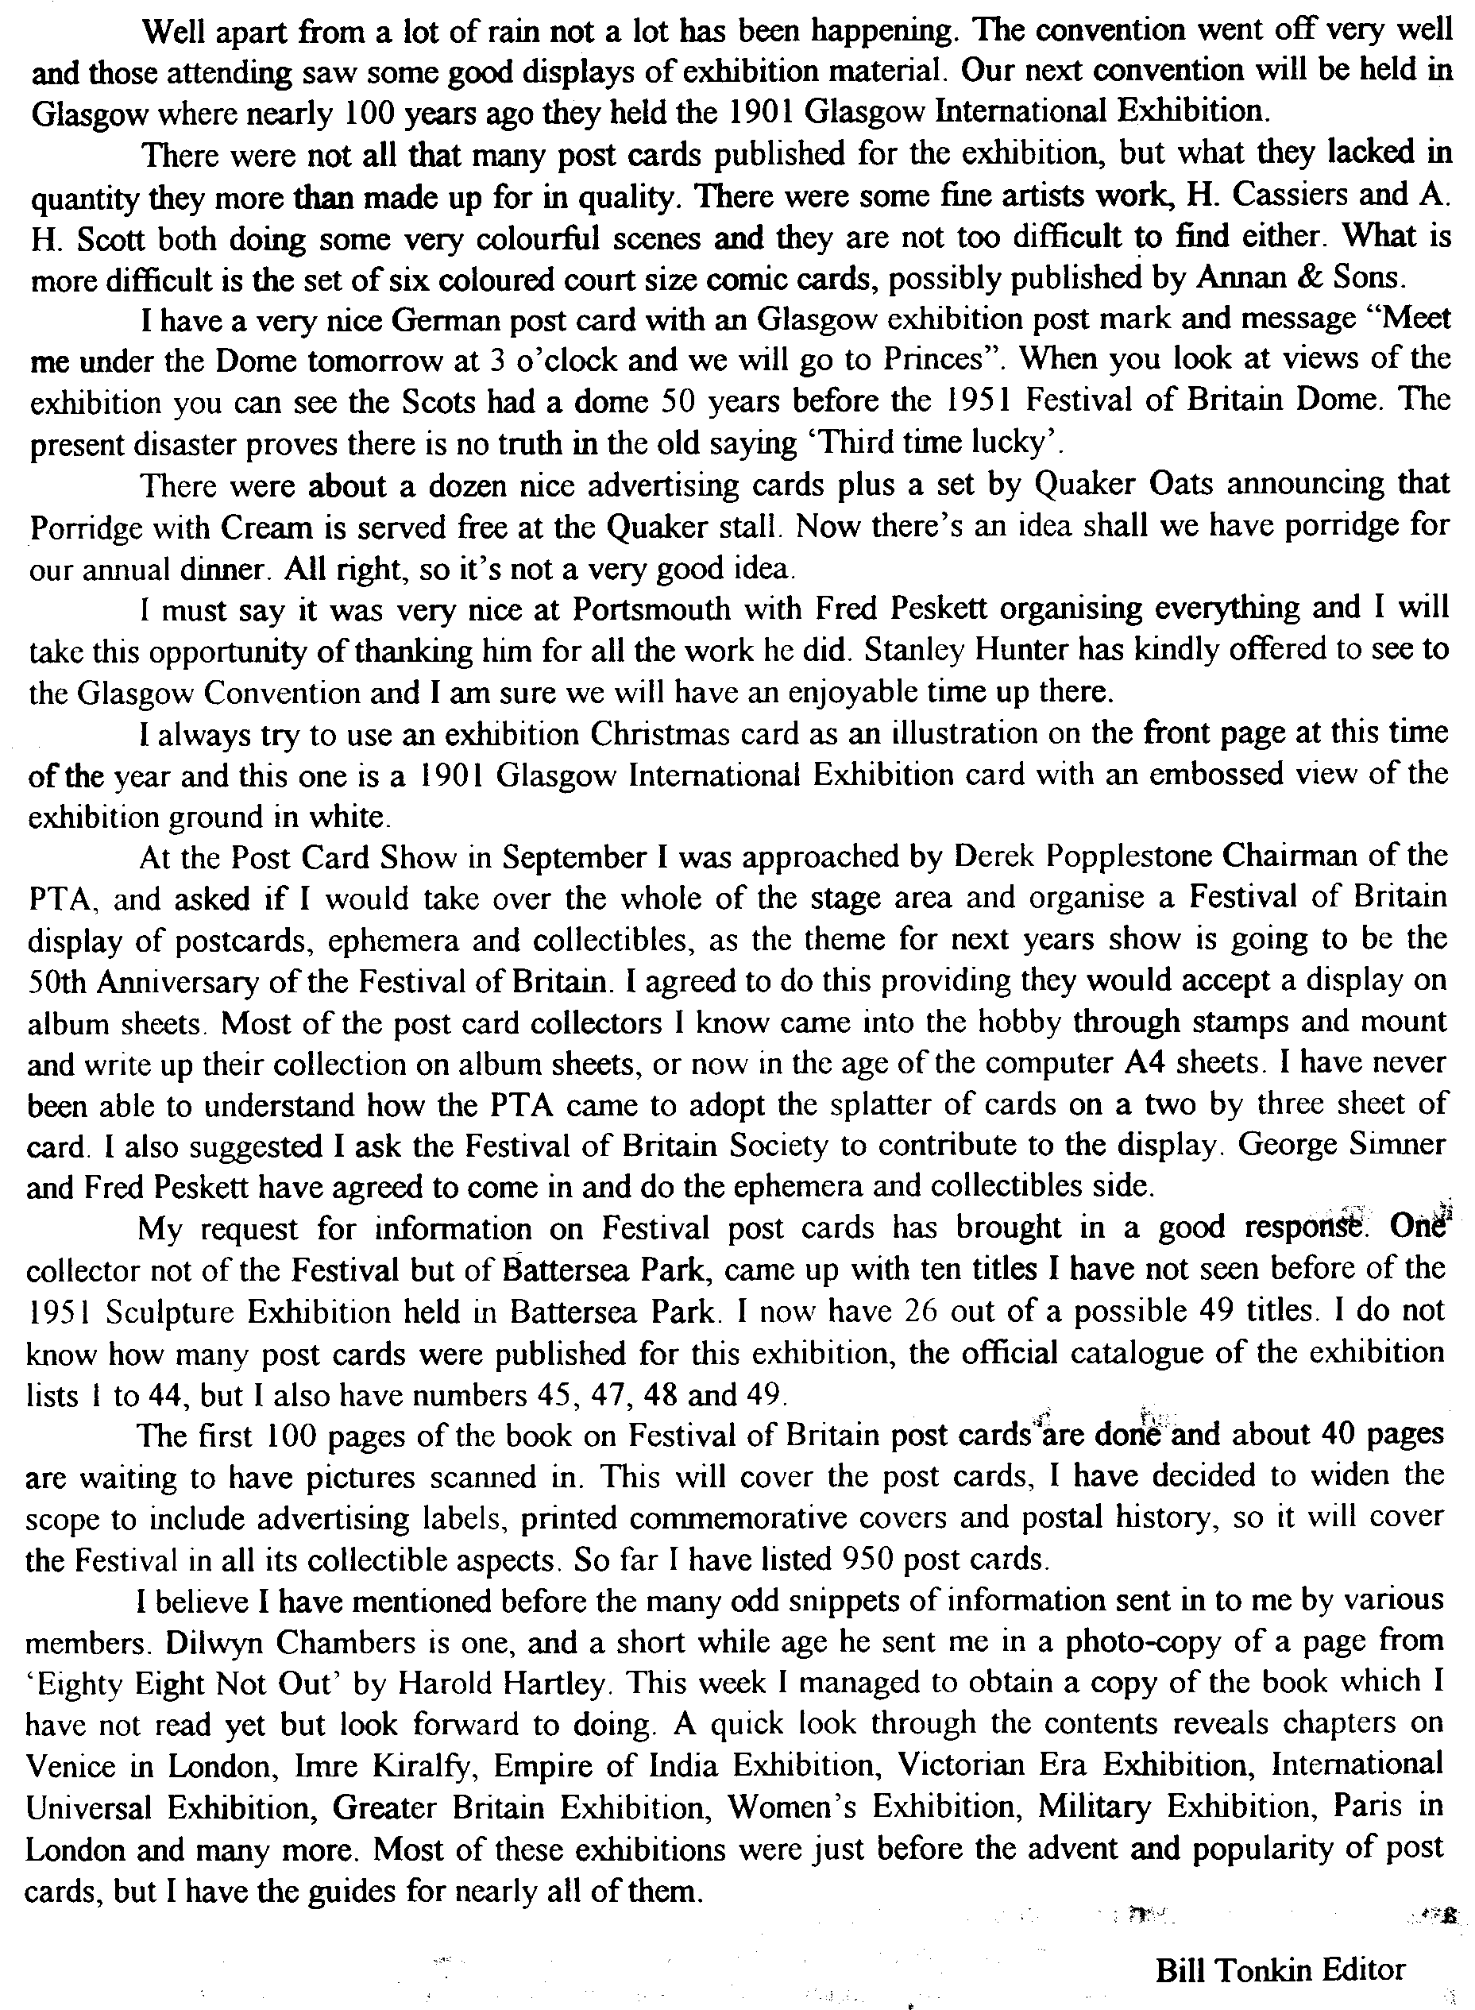
THE FIRST AUCTION
by
Mike Perkins

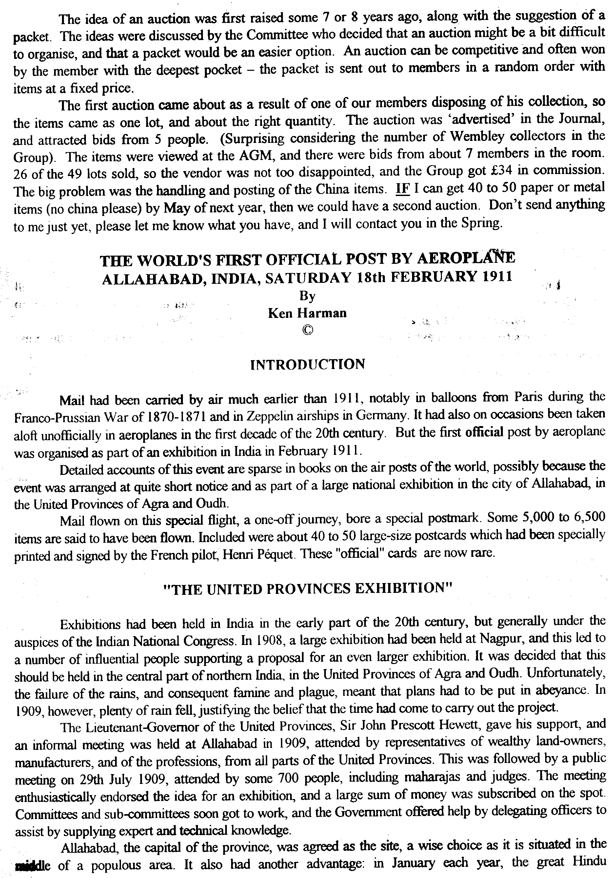
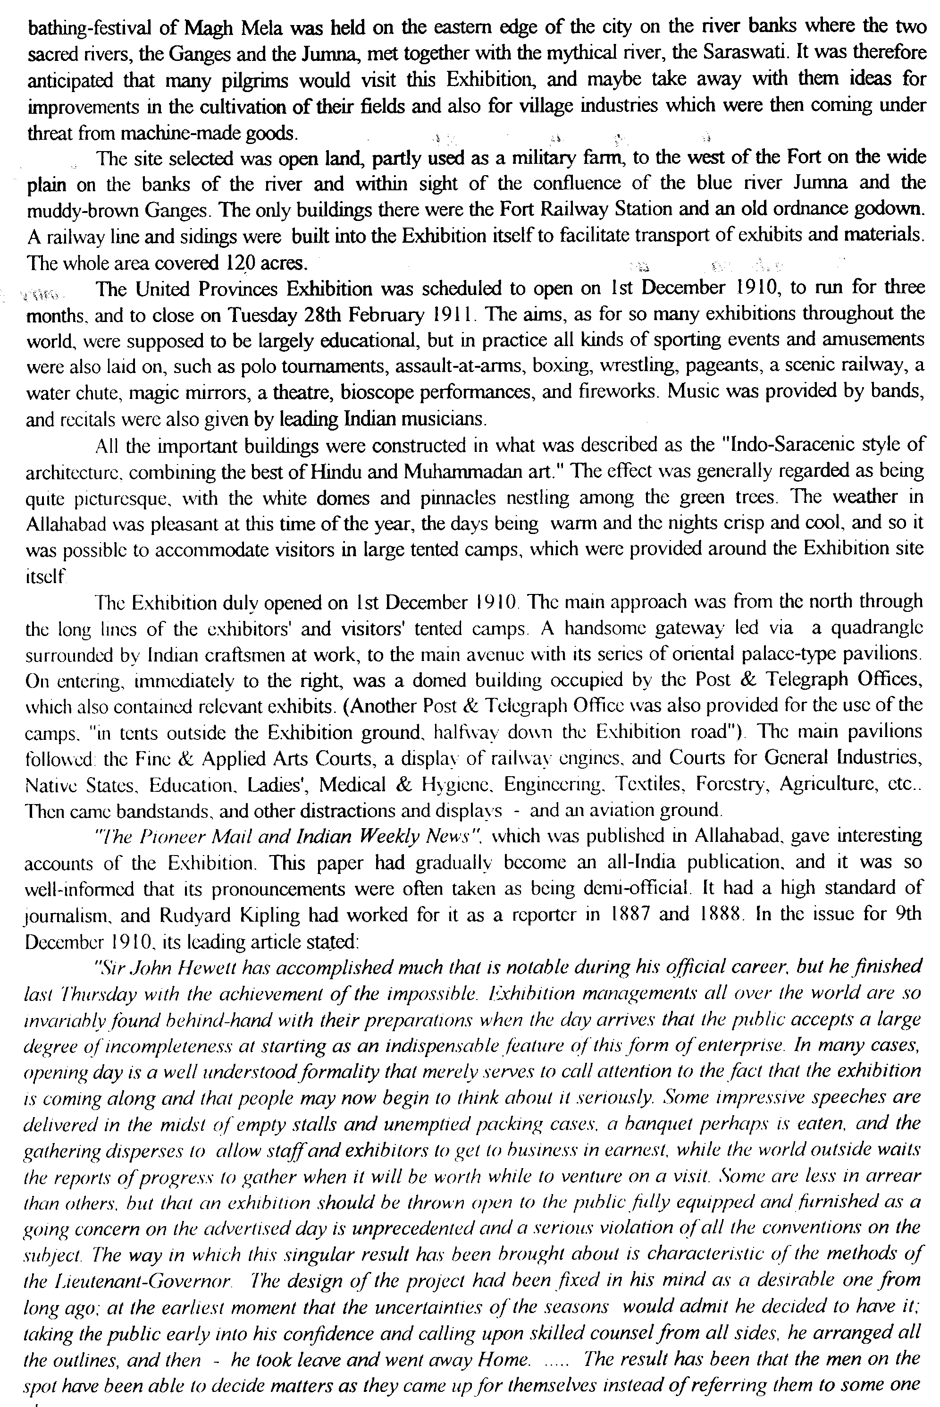
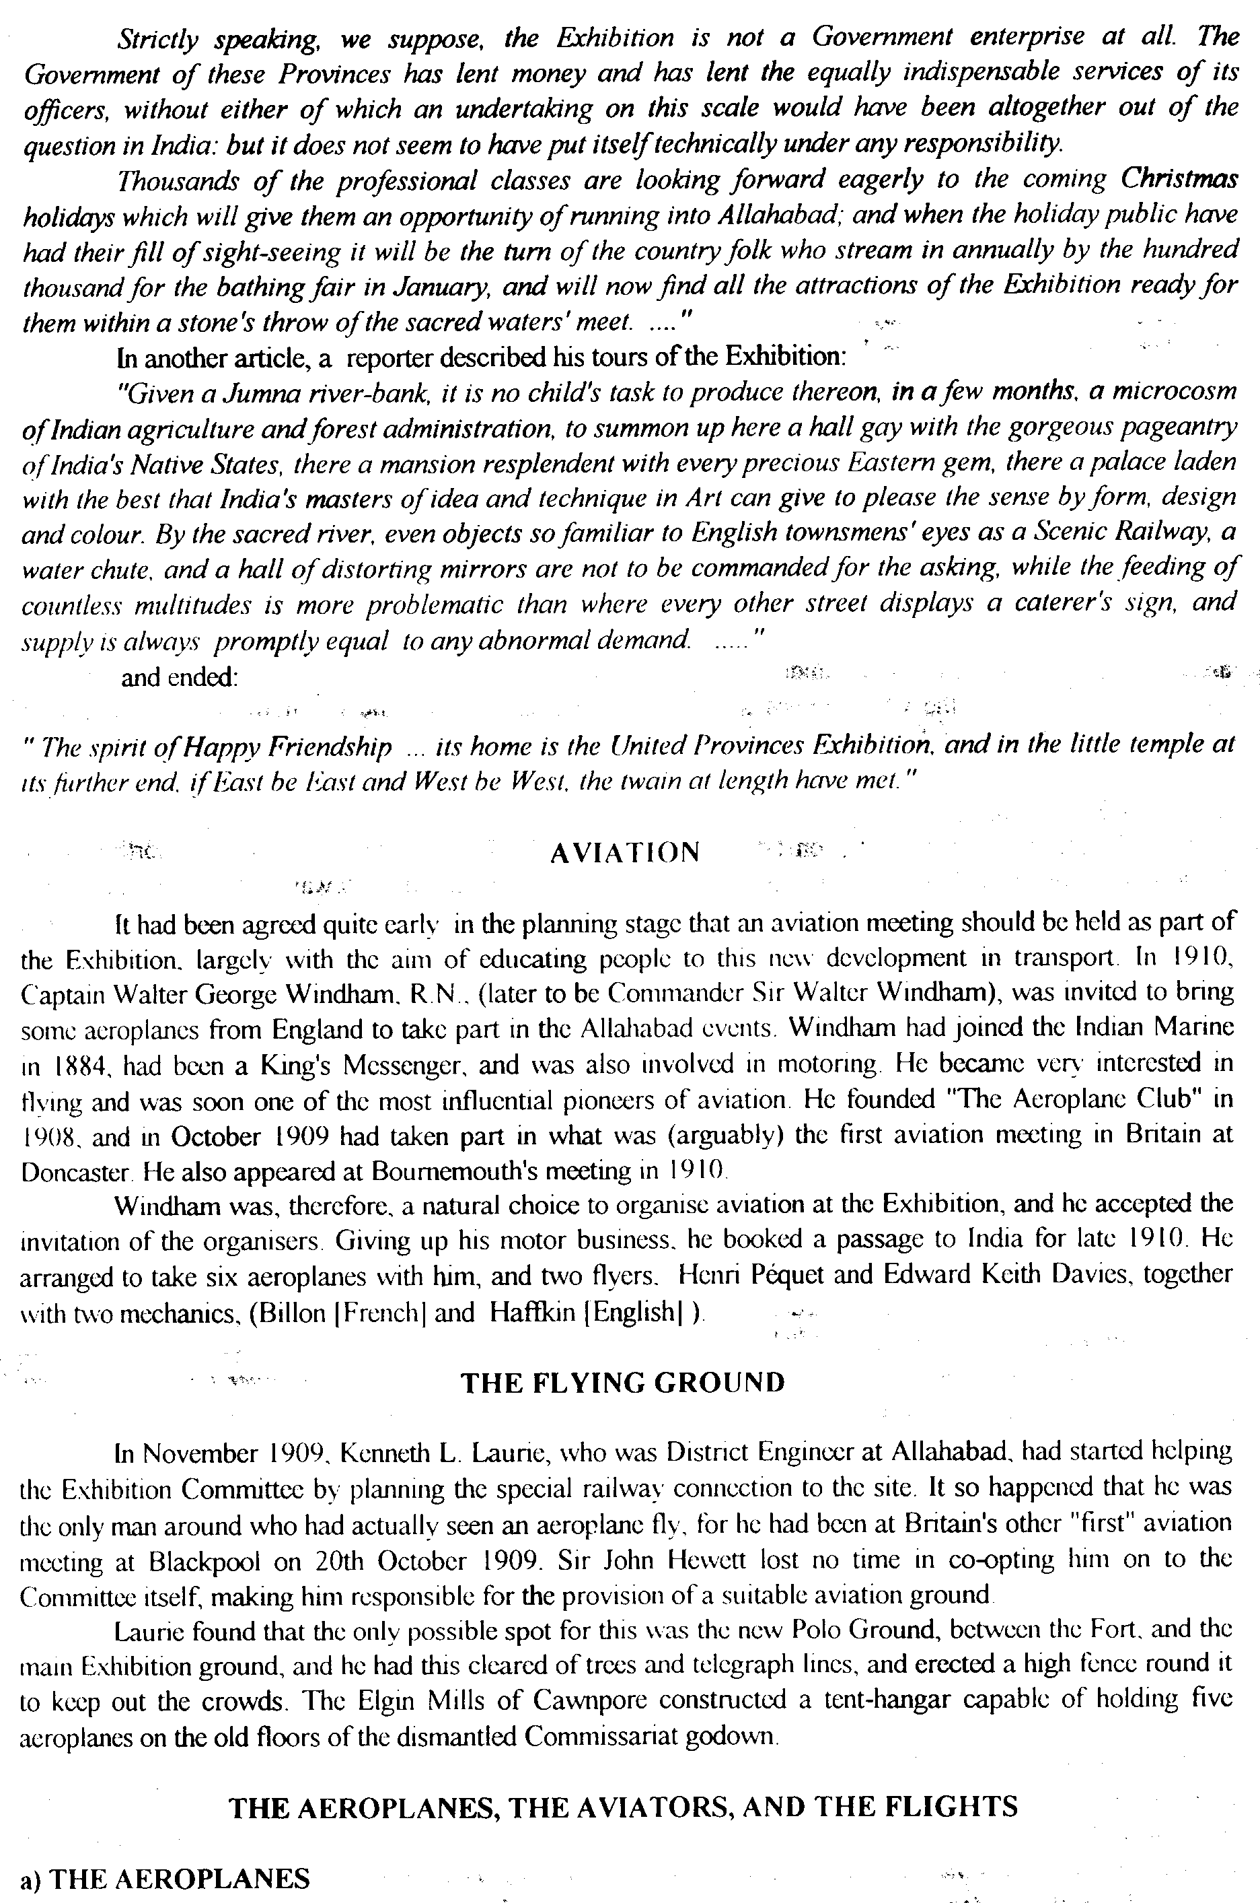
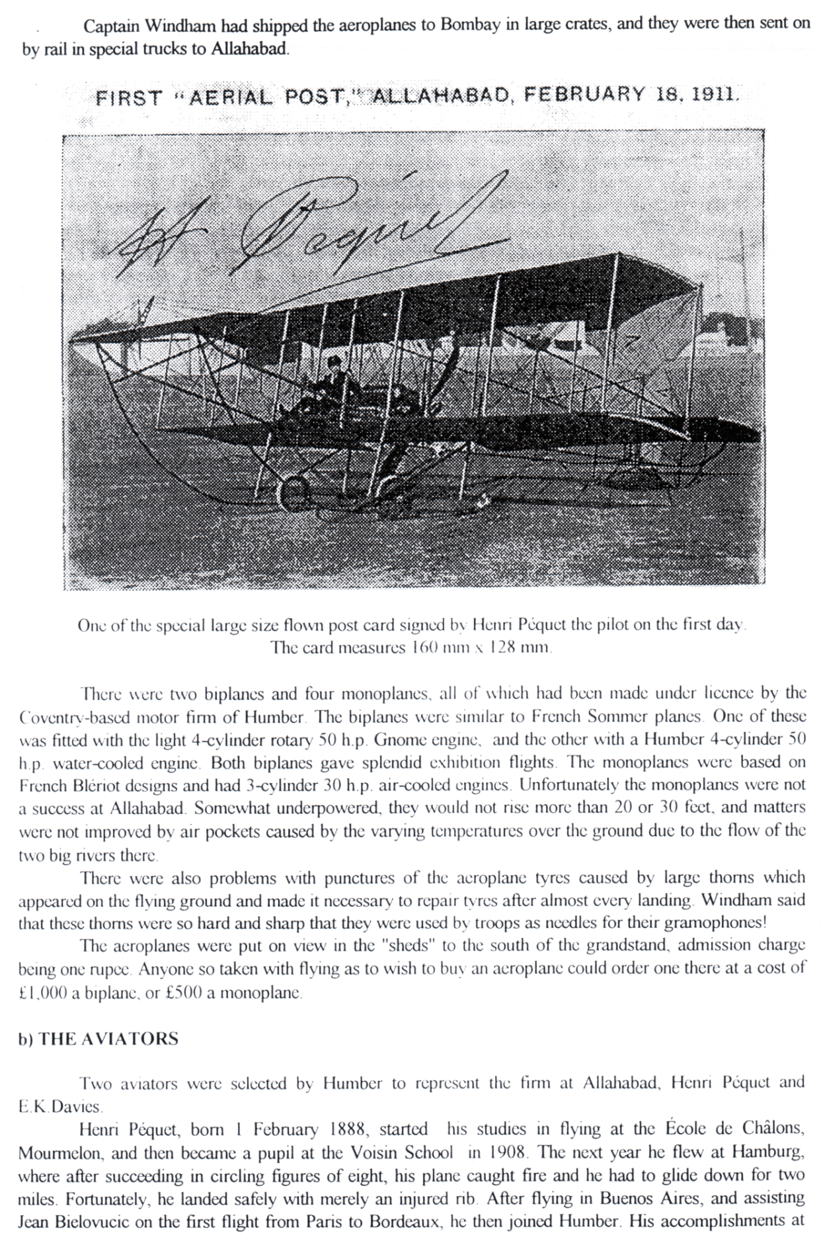
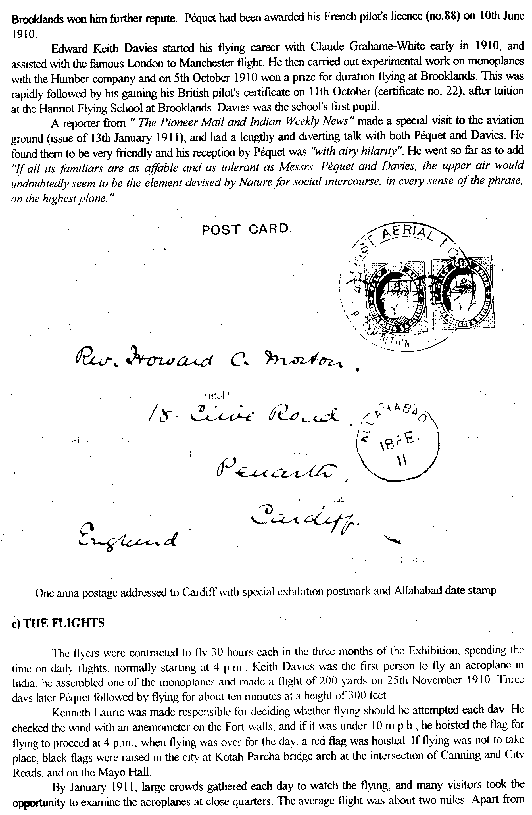

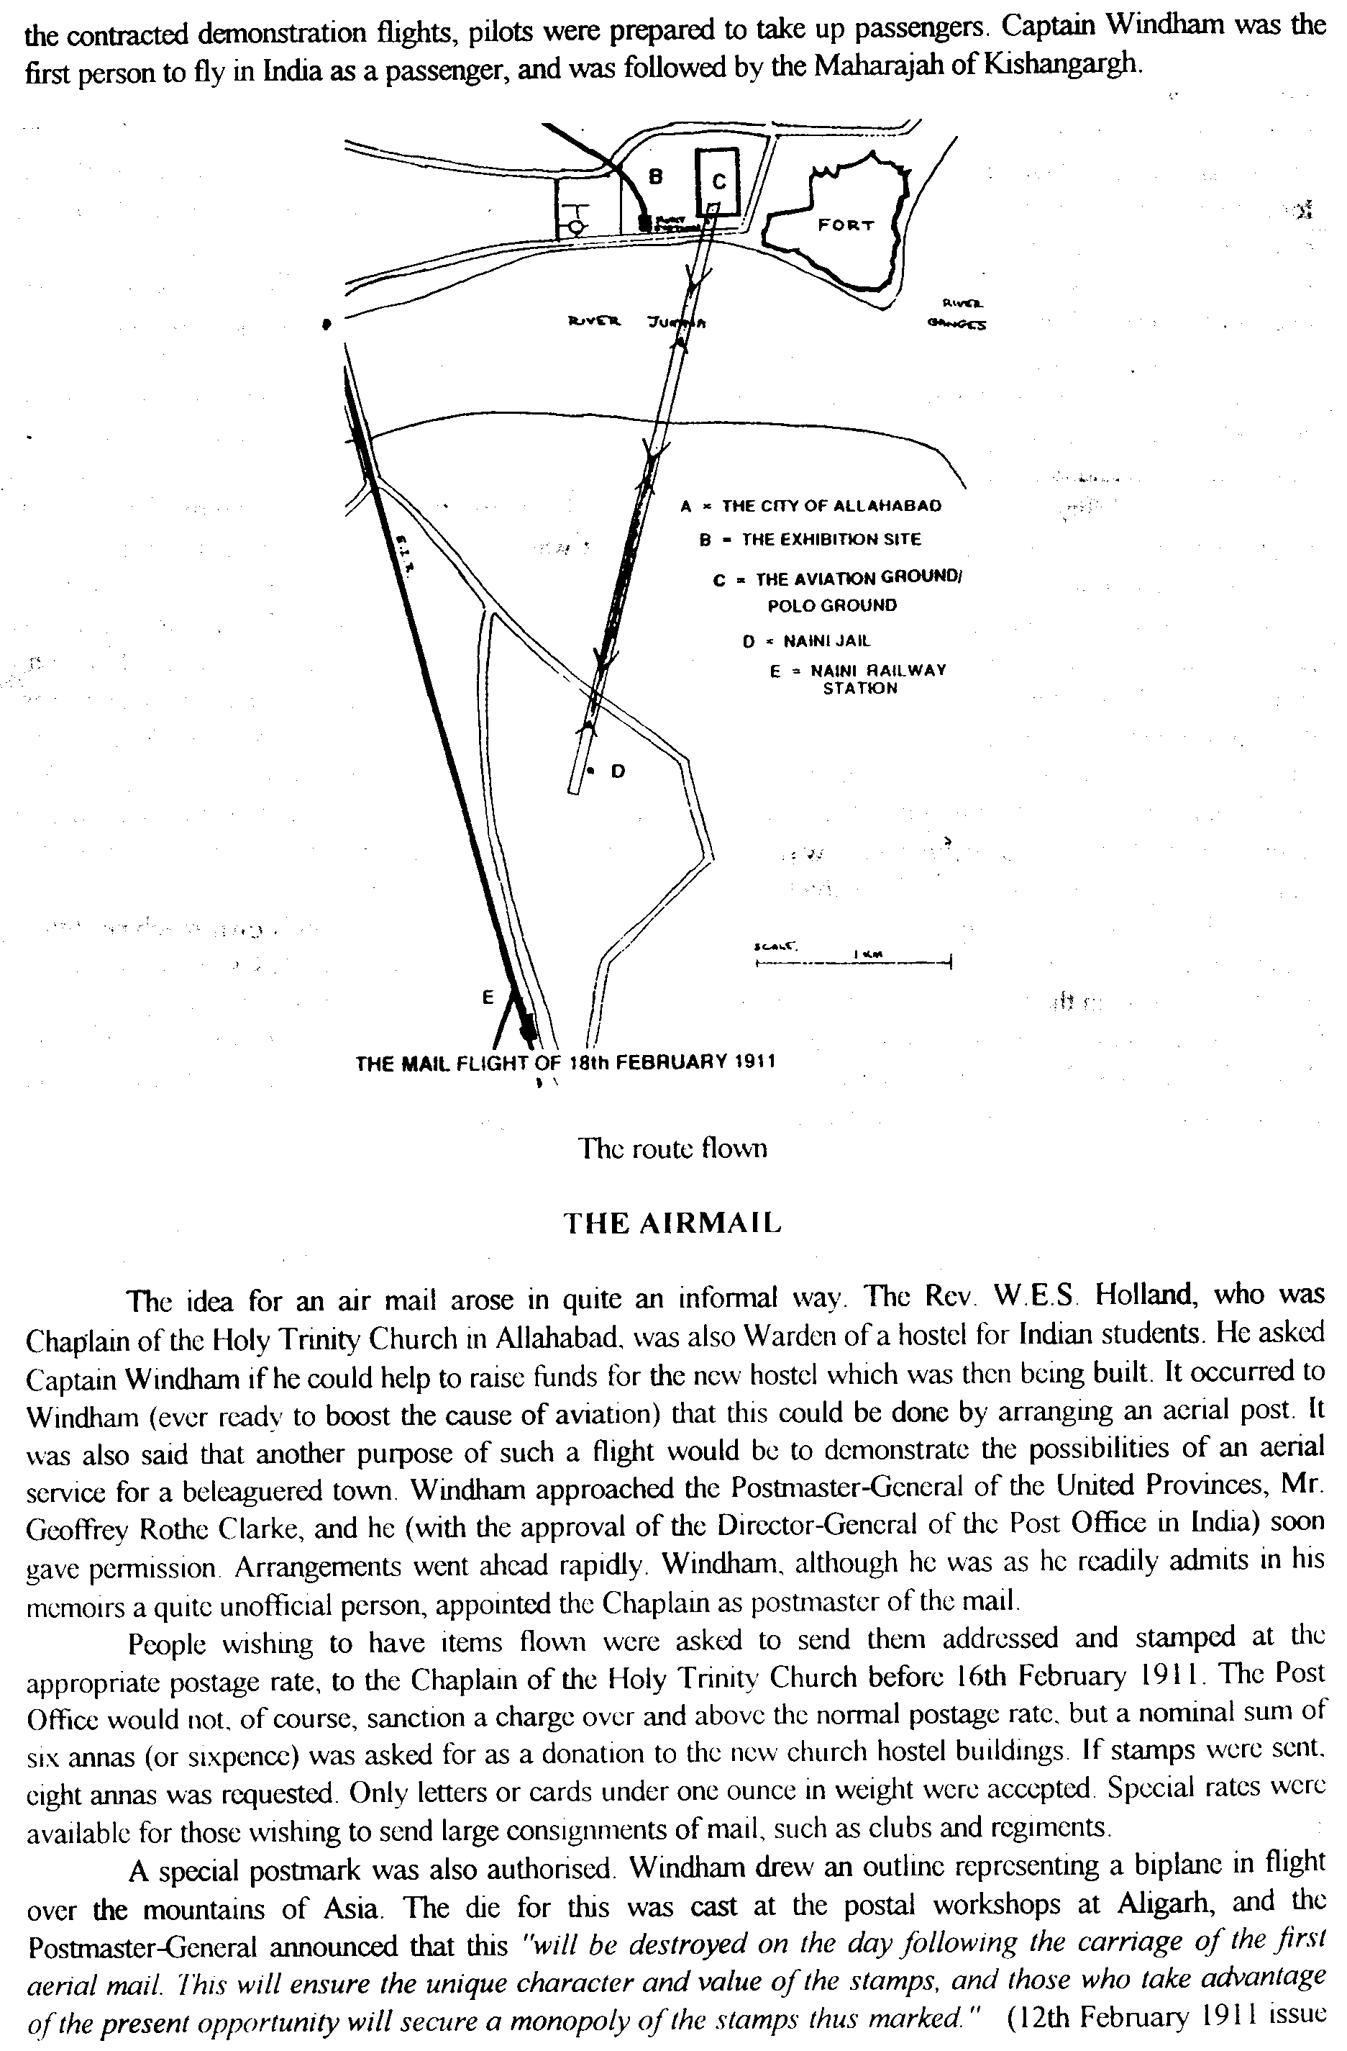
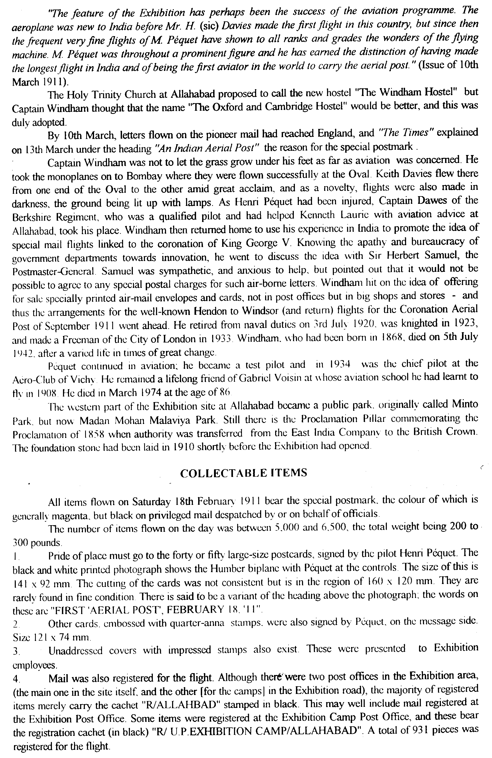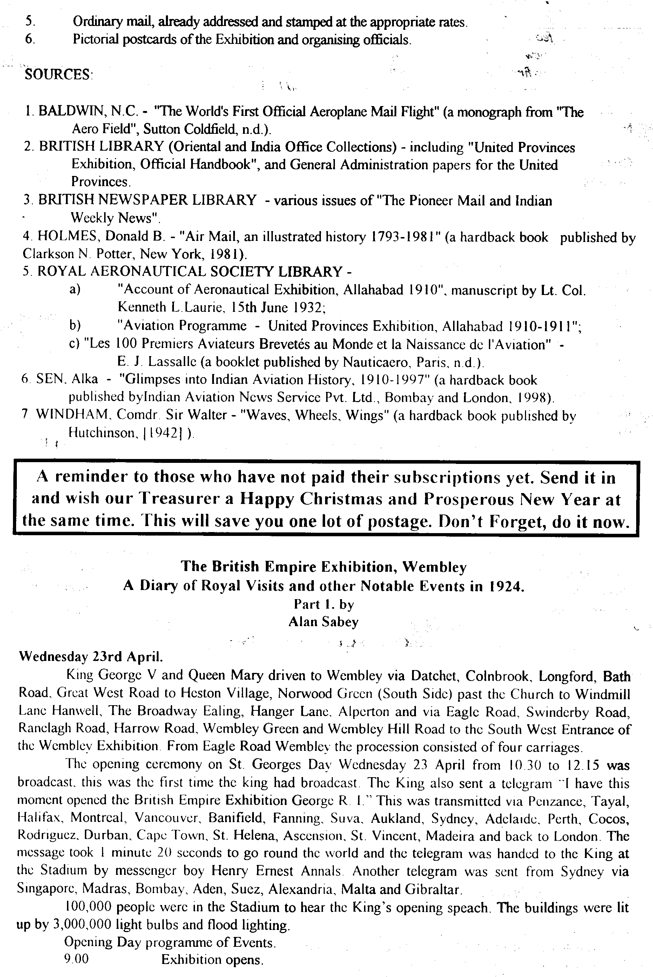
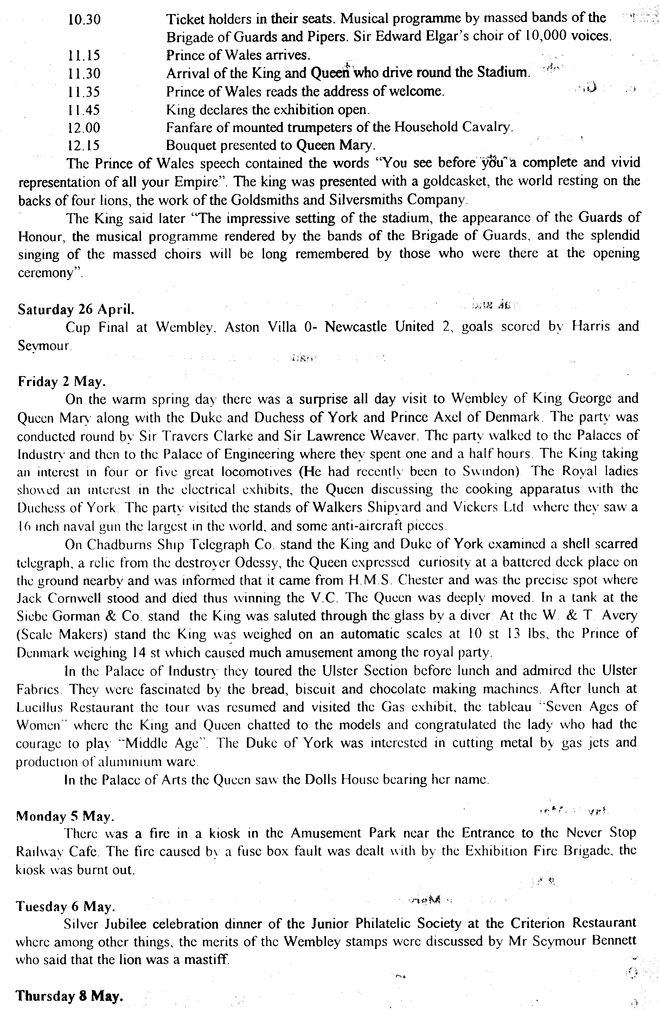
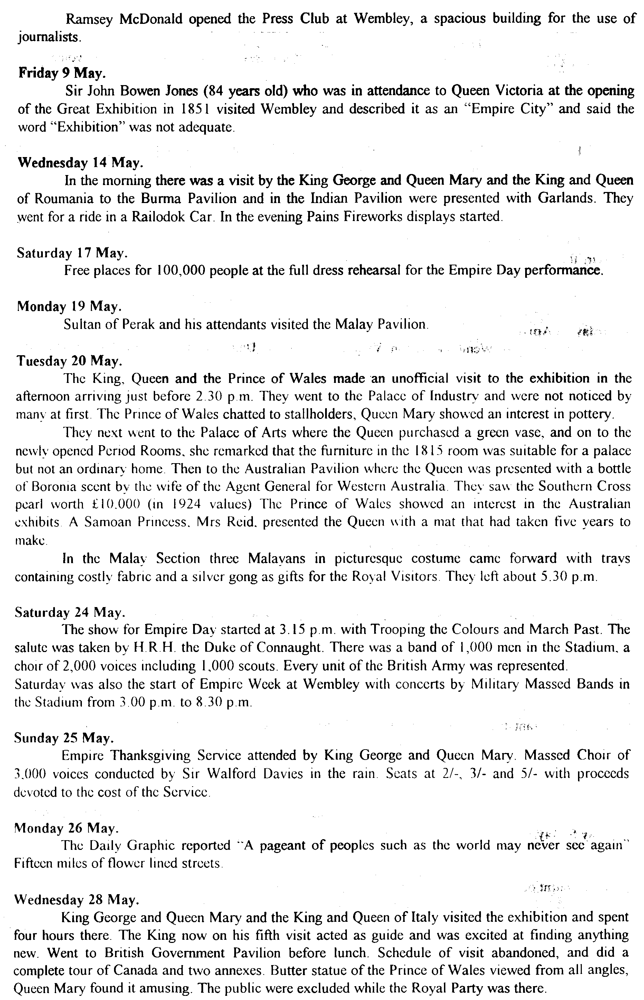
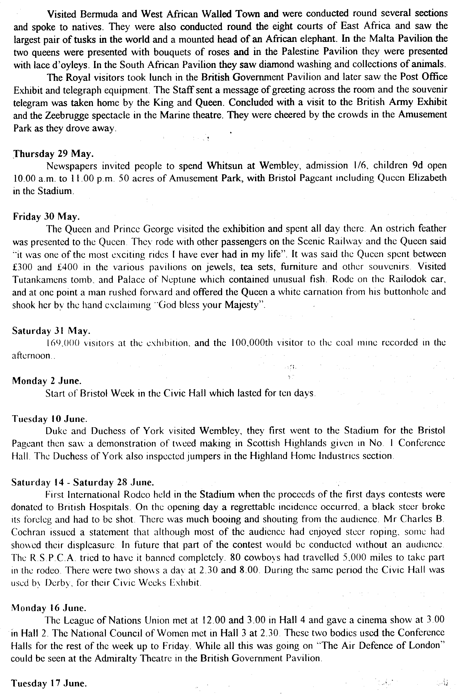
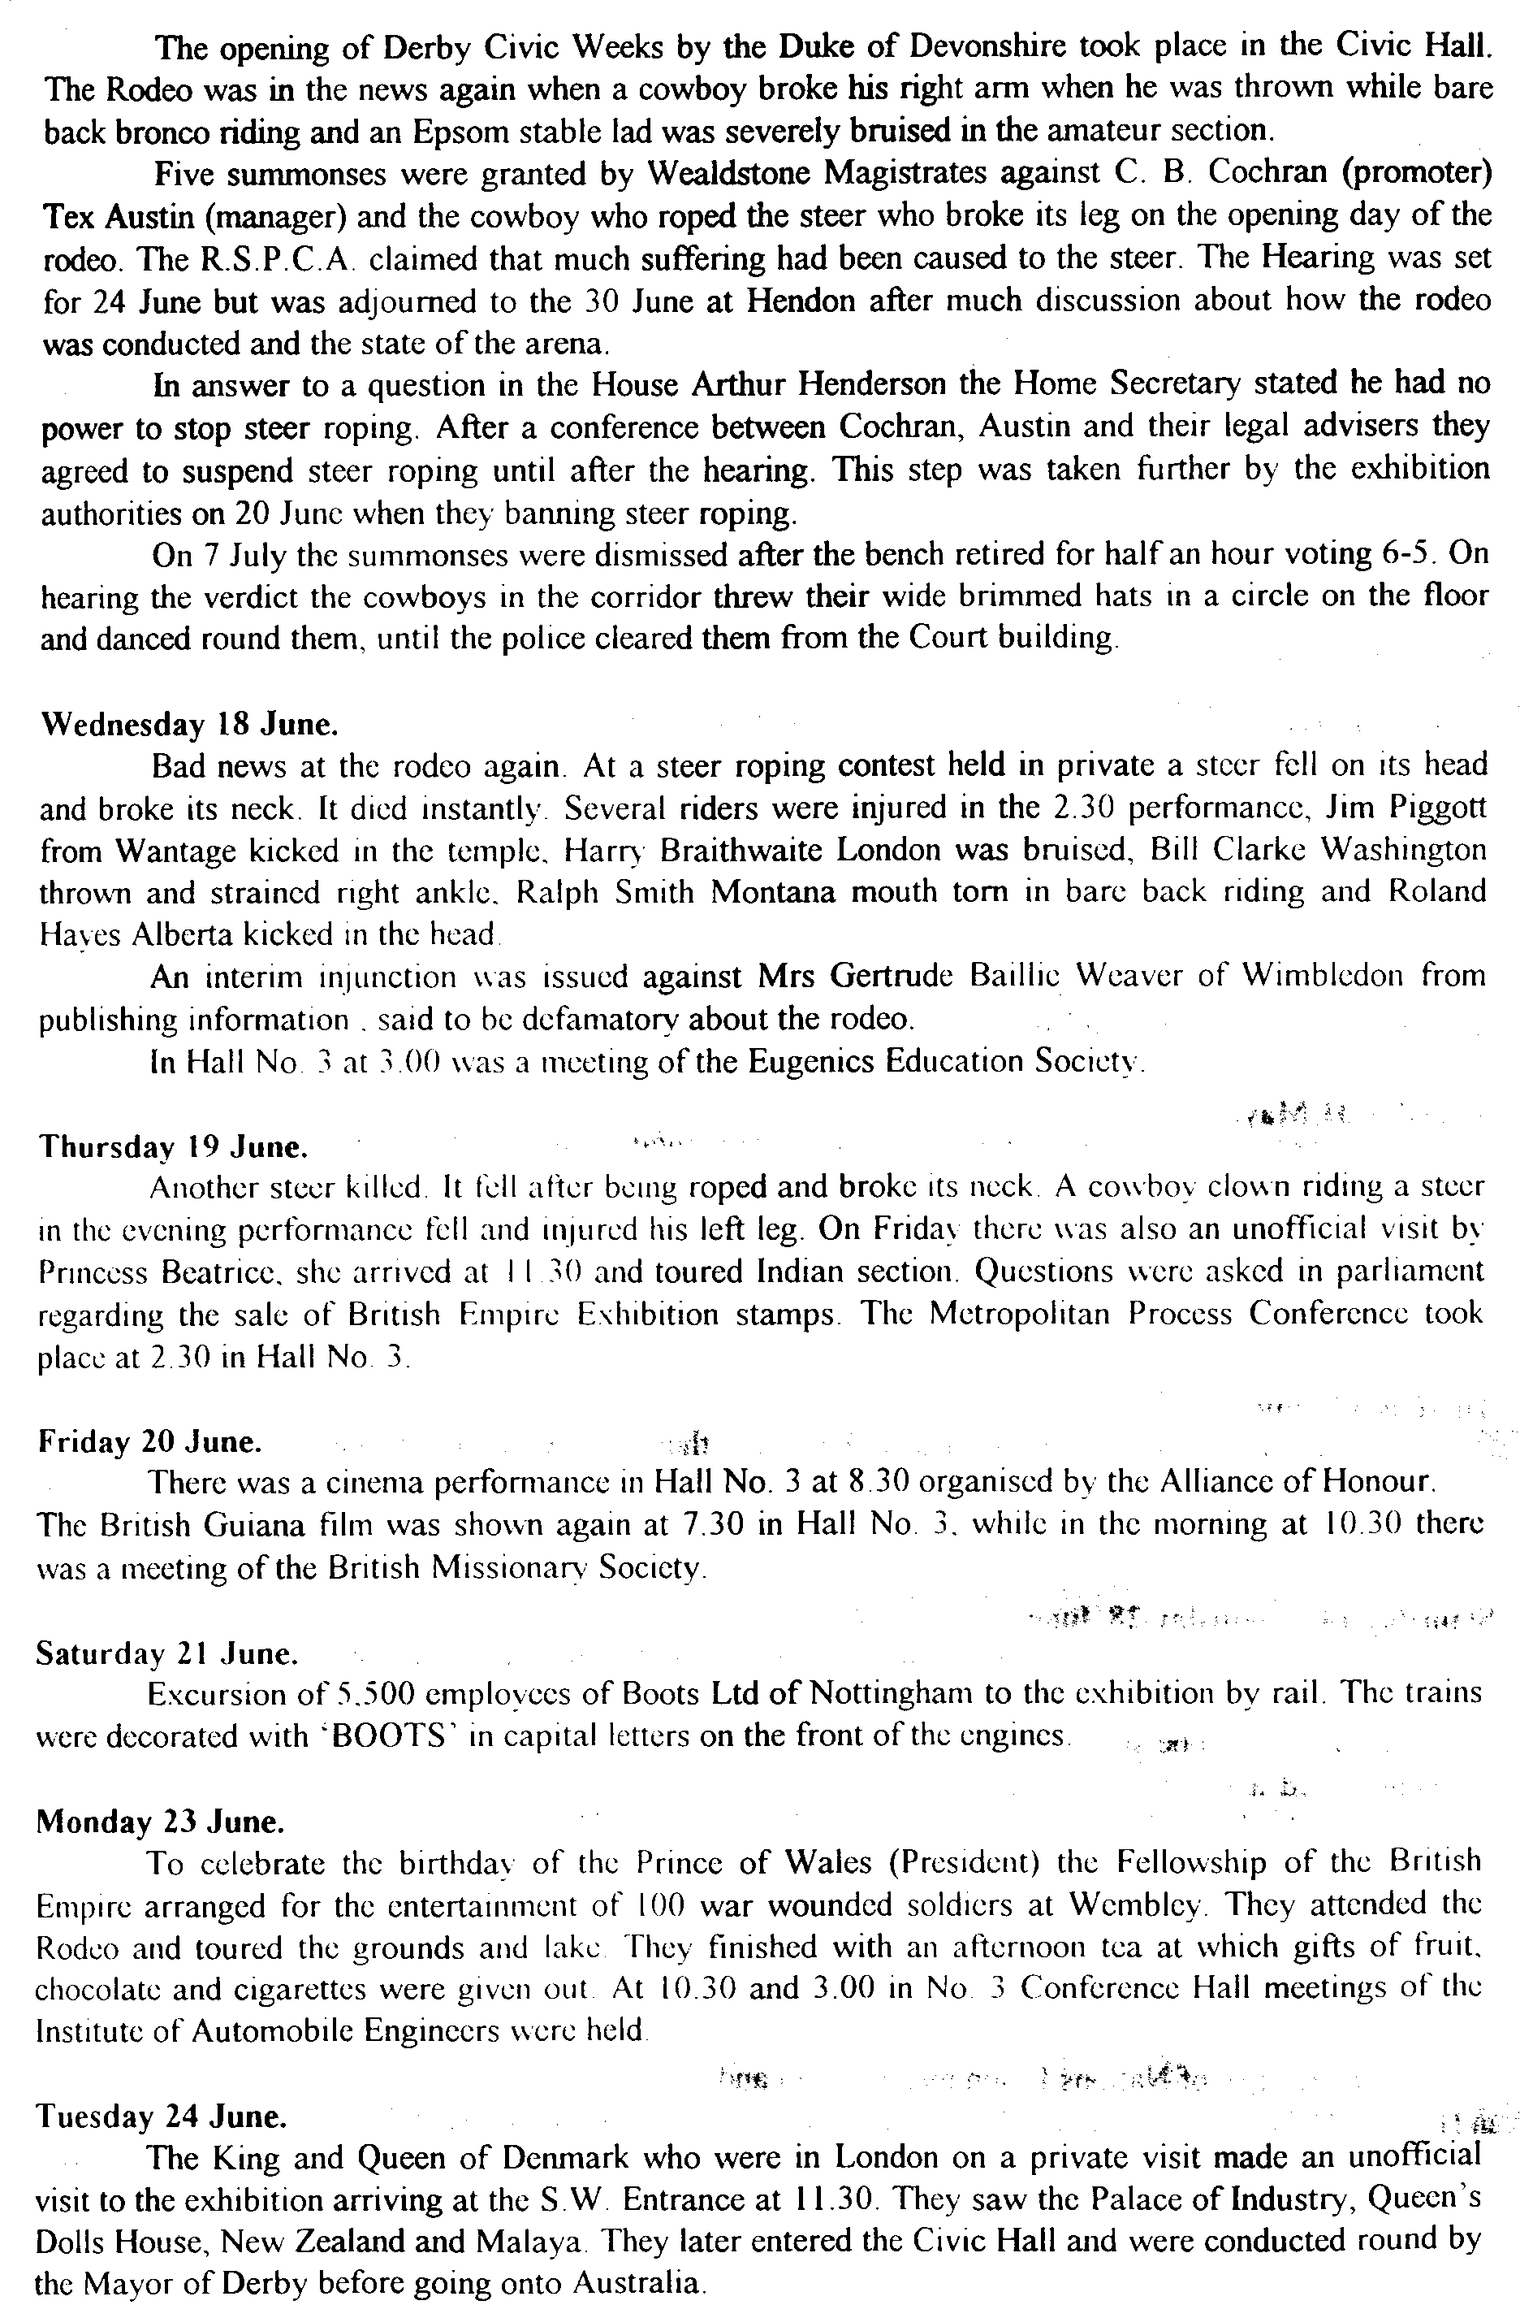
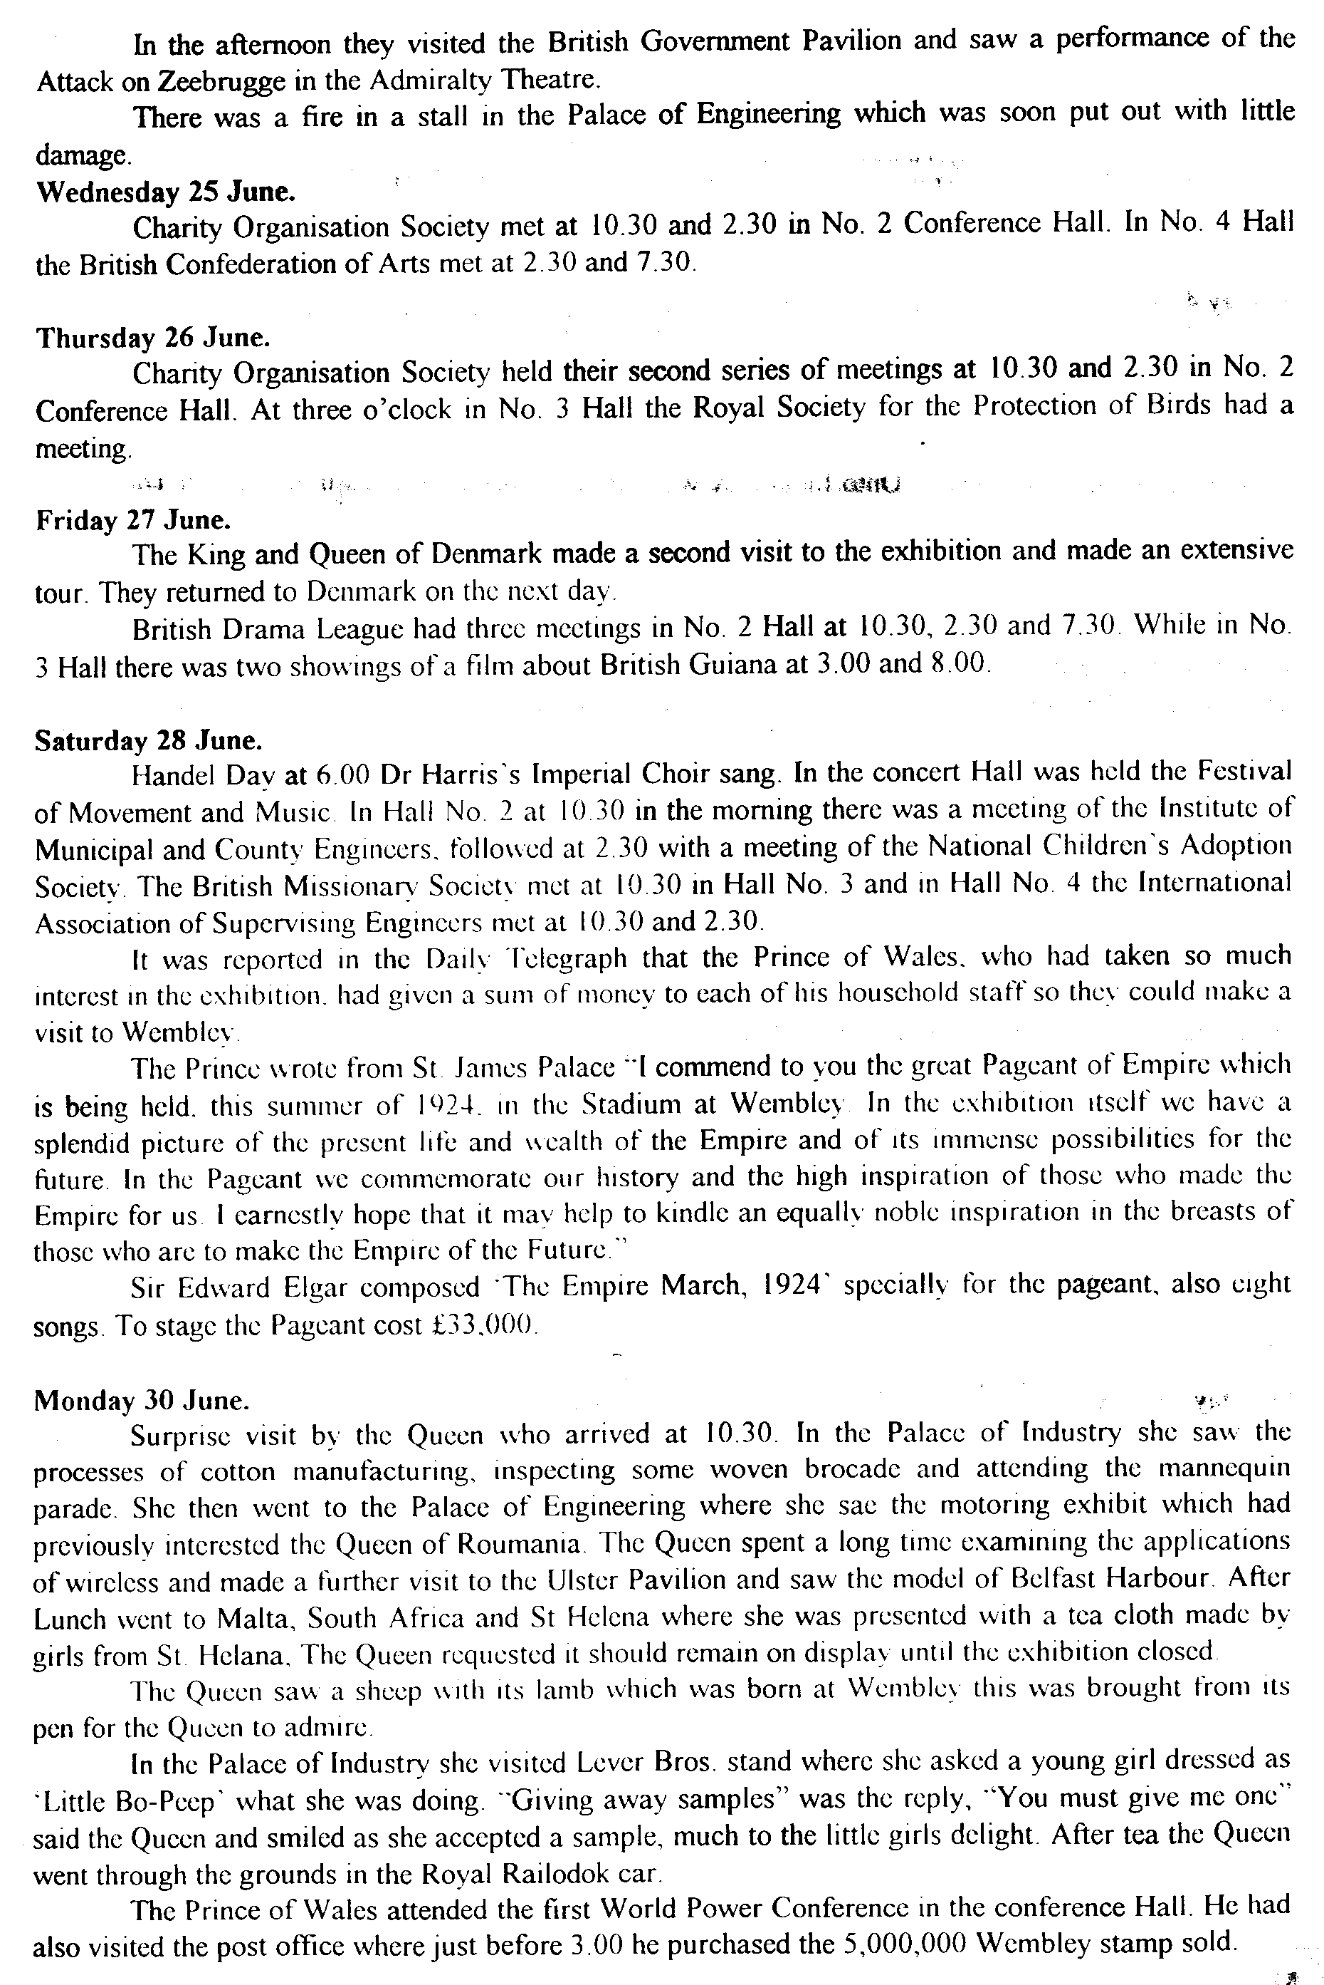
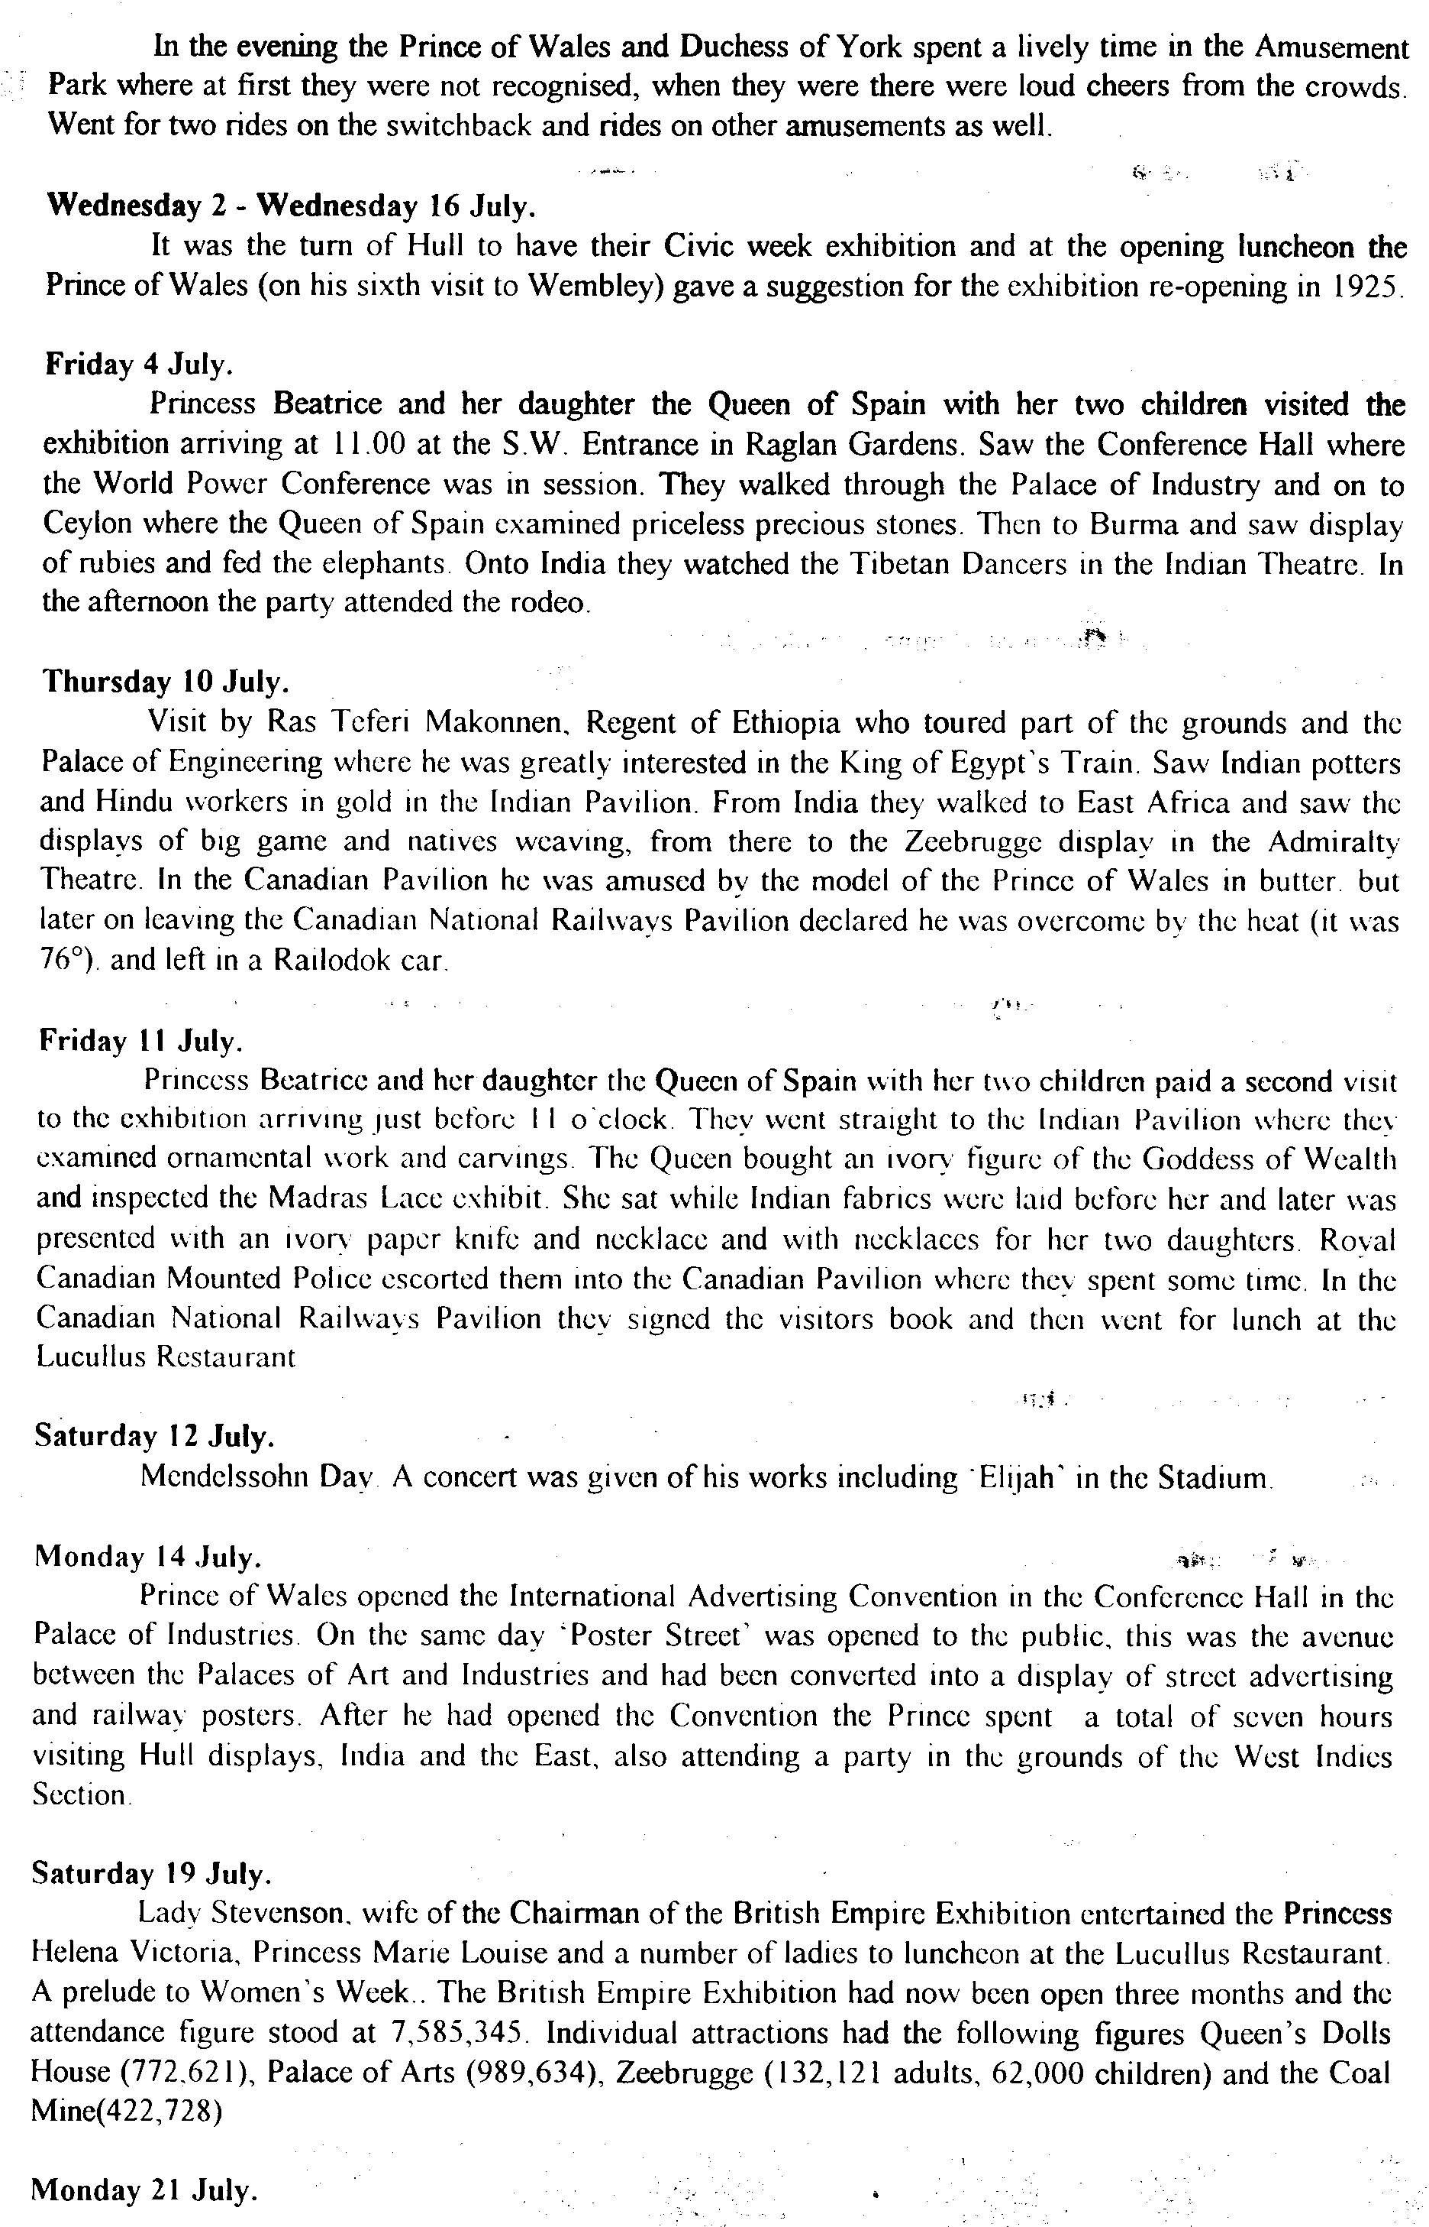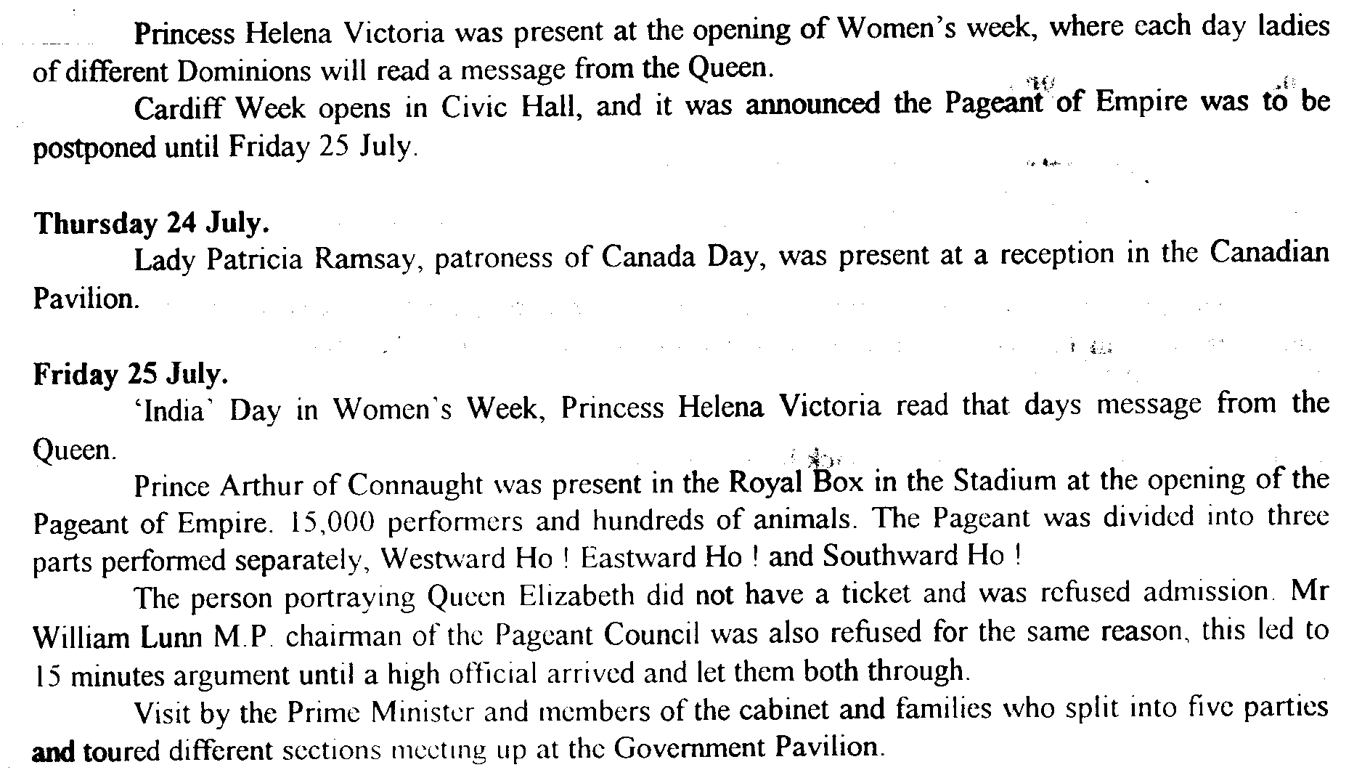
Post Cards of the White City
Part 15.
By
Bill Tonkin

Taber Bas Relief Co. See under Samuels Limited type 4.

Tanaka. R. Kyoto, Japan.
R Tanaka displayed Japanese Silk Art and published a series of post cards showing his goods and prices.
B/W litho printing with the text in blue, each card has a heading ‘R. Tanaka’s Exhibit to Japan-British Exposition, 1910.’ at the top and a number and title at the bottom or side. The backs are printed in blue and red with the British and Japanese flag.
No. 4. 6ft 4 fold Screen. Silk Hand Embroidery work. Price £129.
No. 10. A. 3,3/4 x 3,3/4 Silk Hand work Embroidery. B. 2,2/6 x 6,9/12 Silk Hand cut Velvet. C. 2,2/6 x 6,9/12 Silk Hand cut Velvet. Price Pair £77.
No. 11. 3. x 5 3/4 Framed Picture. Silk Hand Embroidery. Price £28.
No. 14. 4, 1/4 x 2, 8/12 Framed Picture. Silk Hand Cut Velvet Work. Price £28.

Tanqueray, Gordon & Co., Ltd.
B/W photogravure advert post card showing the stand of Tanqueray, Gordon & Co., Ltd. at the Japan-British Exhibition. Black back, ‘POST CARD’ measures 44 mm., ‘T’ divider with ‘Affix Halfpenny Stamp’ in a line stamp box.
N.n. Tanqueray, Gordon & Co., Ltd. Japan-British Exhibition. 1910.

Tartar Camp.
These post cards were probably produced by the same firm that produced the Hagenbeck type 1. cards as the backs are identical and both were printed in Saxony.
B/W litho printing, green back All cards have the same title ‘Imperial International Exhibition 1909 Tartar Camp’ with most of the titles in a white panel at the bottom.
N.n. Imperial International Exhibition 1909 Tartar Camp. Large group of Tartars at meal time, two tents in background.
N.n. Imperial International Exhibition 1909 Tartar Camp. Two men and two ladies dancing before seated spectators, one tent in background.
N.n. Imperial International Exhibition 1909 Tartar Camp. Group of 17 men, women and children, front row seated, one tent in background.
N.n. Imperial International Exhibition 1909 Tartar Camp. Man with camel loaded with children and tent poles, four men seated in front of tent.
N.n. Imperial International Exhibition 1909 Tartar Camp. Man on horse with camel on end of rope.
N.n. Imperial International Exhibition 1909 Tartar Camp. 7 men, women and children all smoking pipes in front of tent.
N.n. Imperial International Exhibition 1909 Tartar Camp. Tarters kneeling at altar for religious ceremony. (title in white panel at the right side)

Tasmanian Government.
The Tasmanian Government published a series of post cards for the Franco-British Exhibition. The cards come in two colours, a greyish sepia and a bluish sepia. The imprint on the left reads ‘Designed and Printed by John Vail, Government Printer, Tasmania.’ and the round stamp box has ‘Stamp Here’.
Series 1. greyish sepia photogravure, black back
N.n. A Prize Merino Ram. “President.”
N.n. An Apple Trophy.
N.n. Carting Blackwood Logs to Scottsdale.
N.n. Hydraulic Tin-Sluicing.
N.n. Loading Potatoes at Devonport.
N.n. Mount Lyell Smelters. Queenstown.
N.n. Orchards in the Glenorchy Valley.
N.n. Preparing Poultry for Export.
N.n. Tasmanian Gold Mine, Beaconsfield.

Series 2. bluish sepia photogravure, black back
N.n. A Tasmanian Timber Mill.
N.n. British and Foreign Woolbuyers Inspecting Wool.
N.n. Electric Light and Power Station.
N.n. English Trout.
N.n. Hauling Timber through Forest. Vert left.
N.n. Hop-Picking at New Norfolk.
N.n. Magnet Silver Mine, near Waratah.
N.n. Packing Stores for the Mines.
N.n. Shipping Apples for England.

Taylor. A. & G.
A. & G. Taylor’s R/Photo post cards are very prone to fading, so much so that sometimes it is difficult to see a view. The ability to identify and list Taylor’s post cards becomes even more difficult as the numbers on the L’Entente Cordiale cards are hidden in the design and are not readily visible. The title also is incorporated in the design which has been listed as types in numerical order.
The Reality Series was published with four different backs, type A. to D. the main difference being in the size of ‘POST CARD’ and the wording in the stamp box and imprint. The Orthochrome Series has two different backs type E. and F.
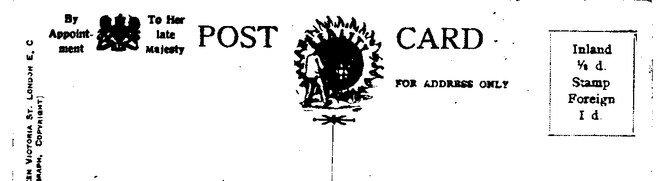

Type A. ‘POST CARD’ without stop measures 60-61 mm. The dotted stamp box has ‘Inland
½d. Stamp Foreign 1d.’ and in the imprint the spelling of ‘Victoria St.’ is abbreviated
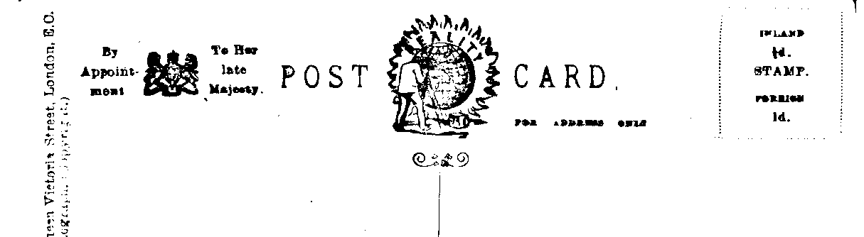

Type B. ‘POST CARD.’ with stop measures 55 mm. The dotted stamp box has ‘Inland
½d. Stamp Foreign 1d.’ and in the imprint the spelling of ‘Victoria Street,’ is in full.

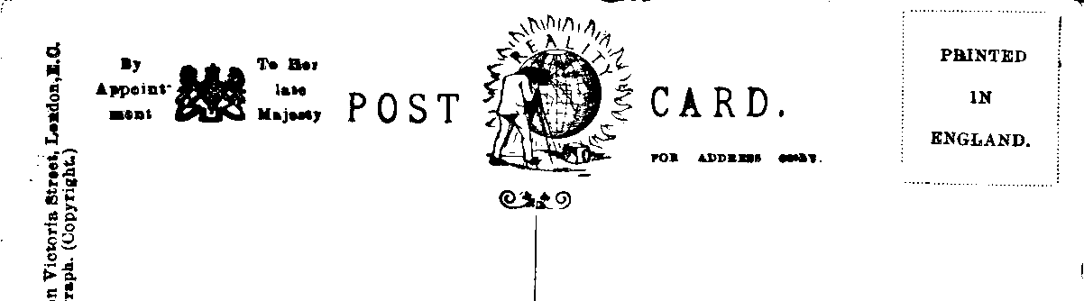

Type C. ‘POST CARD.’ with stop measures 55 mm. The dotted stamp box now has
‘Printed in England.’ and in the imprint the spelling of ‘Victoria Street,’ is in full.

Type D. The back is as type C except that ‘POST CARD’ is again reduced and now
measures only 53 mm.

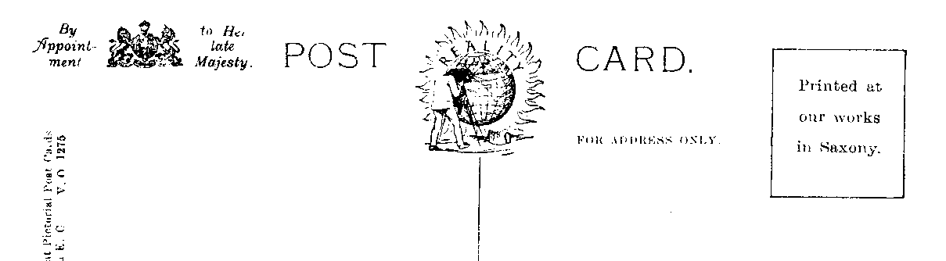

Type E. ‘POST CARD.’ with stop measures 60 mm. The line stamp box now has
‘Printed at our works in Saxony.’

Type F. ‘POST CARD.’ with stop measures 60 mm. The line stamp box has ‘Affix
Stamp’ and the imprint has been altered to three lines.

Series 1. Hand tinted sepia R/Photo showing three views, Palace of British Applied Arts, The Flip-Flap and Court of Honour in a floral design of four bunches of roses, brown back type C. ‘POST CARD.’ with stop measures 55 mm. Dotted stamp box with ‘Printed in England.’ The imprint on the left side in two lines reads, ‘A. & G. Taylor’s Reality Series, 70, Queen Victoria Street, London, E.C. Genuine Silver Print Photograph. (Copyright).’
Z. 1968. Souvenir Franco-British Exhibition 1908. L’Entente Cordiale. Inverted back.

Series 2. Hand tinted sepia R/Photo showing clasped hands in a heart shaped frame with a floral surround, brown back type B. ‘POST CARD.’ with stop measures 55 mm. The dotted stamp box has ‘Inland ½d. Stamp Foreign 1d.’ and in the imprint the spelling of ‘Victoria Street,’ is in full.
Z 2019 L’Entente Cordiale Franco British Exhibition London 1908. Vert left.

Series 3. Sepia R/Photo showing clasped hands in a heart shaped frame with a floral surround, brown back type B.
Z 2019 L’Entente Cordiale Franco British Exhibition London 1908. Vert left.

Series 4. Hand tinted sepia R/Photo showing a view above crossed French and British flags in a floral design which like the view is different for each number. Brown back type A. ‘POST CARD’ without stop measures 60-61 mm. The line stamp box has ‘Inland ½d. Stamp Foreign 1d.’ The imprint on the left side in two lines reads, ‘A. & G. Taylor’s Reality Series, 70, Queen Victoria St. London, E.C. Genuine Silver Print Photograph. (Copyright).’
Z. 2025. Franco British Souvenir London 1908 L’Entente Cordiale. Houses of Parliament. Vert right.

Series 5. Sepia R/Photo showing a view above crossed French and British flags in a floral design which like the view is different for each number. Brown back type A.
Z. 2023. Franco British Souvenir London 1908 L’Entente Cordiale. London Bridge.
Vert left.
Z. 2025. Franco British Souvenir London 1908 L’Entente Cordiale. Houses of Parliament. Vert left.
Z. 2029. Franco British Souvenir London 1908 L’Entente Cordiale. The Tower of London. Vert right.

Series 6. Sepia Real Photo, the title is split with ‘The Franco-British Exhibition.’ on the left and the title on the right. As there are variations in the settings of the titles, the measurement of the gap between the two parts are given. Even where the gap measures the same the position of the number which is printed underneath the title can vary. Brown back type A. One card is without a second part to the title, Z. 2221, it shows the entrance to the Senegal Village and in this instant the measurement is between ‘Exhibition’ and ‘Z. 2221’.
Z. 2215 The Franco-British Exhibition. Palace of Music.
A. Gap measures 54 mm.
B. Gap measures 57 mm.
C. Gap measures 60 mm.
Z. 2216 The Franco-British Exhibition. Palace of French Applied Arts.
A. Gap measures 38 mm.
B. Gap measures 39 mm.
Z. 2217 The Franco-British Exhibition. Palace of Women’s Work.
A. Gap measures 45 mm.
B. Gap measures 49 mm.
Z. 2218 The Franco-British Exhibition. Palace of British Applied Arts.
A. Gap measures 37 mm.
B. Gap measures 39 mm.
C. Gap measures 40 mm.
Z. 2219 The Franco-British Exhibition. Court of Honour & Lake.
A. Gap measures 45 mm.
B. Gap measures 48 mm.
Z. 2220 The Franco-British Exhibition. Elite Gardens & Royal Pavilion.
A. Gap measures 34 mm.
B. Gap measures 36 mm.
C. Gap measures 39 mm.
Z. 2221 The Franco-British Exhibition. (Entrance to Senegal Village)
Z. 2222 The Franco-British Exhibition. Court of Honour & Indian Court by Night.
A. Gap measures 22 mm.
B. Gap measures 24 mm.
Z. 2223 The Franco-British Exhibition. Palace of British Applied Arts.
A. Gap measures 35 mm.
B. Gap measures 48 mm.
Z. 2224 The Franco-British Exhibition. The Flip-Flap.
A. Gap measures 64 mm.
Z. 2225 The Franco-British Exhibition. Court of Honour.
A. Gap measures 54 mm.
B. Gap measures 55 mm.
C. Gap measures 57 mm.
Z. 2226 The Franco-British Exhibition. Australian Pavilion.
A. Gap measures 55 mm.

Series 7. Sepia Real Photo, the title is split with ‘The Franco-British Exhibition.’ on the left and the title on the right. Brown back type C. As there are variations in the settings of the titles, the measurement of the gap between the two parts are given.
Z. 2215 The Franco-British Exhibition. Palace of Music.
A. Gap measures 56 mm.
Z. 2216 The Franco-British Exhibition. Palace of French Applied Arts.
A. Gap measures 38 mm.
Z. 2217 The Franco-British Exhibition. Palace of Women’s Work.
A. Gap measures 48 mm.
Z. 2218 The Franco-British Exhibition. Palace of British Applied Arts.
A. Gap measures 36 mm.
Z. 2219 The Franco-British Exhibition. Court of Honour & Lake.
A. Gap measures 45 mm.
Z. 2220 The Franco-British Exhibition. Elite Gardens & Royal Pavilion.
A. Gap measures 38 mm.
Z. 2221 The Franco-British Exhibition. (Entrance to Senegal Village)

Series 8. Sepia Real Photo, Brown back type D. This is the same as type C except that ‘POST CARD.’ with stop is again reduced and now measures only 53 mm.
Z. 2218 The Franco-British Exhibition. Palace of British Applied Arts.
A. Gap measures 38 mm.
Z. 2226 The Franco-British Exhibition. Australian Pavilion.
A. Gap measures 53 mm.

Series 9. Sepia Real Photo plate sunk with large white border, Brown back type C.
Z 2234 The Franco-British Exhibition. “The Flip-Flap” and Band Stand.

Series 10. Hand tinted sepia R/Photo showing seven views, Palace of Women’s Work, Palace of British Applied Arts, Court of Honour, Court of Honour & Indian Court by Night, Palace of French Applied Arts, The Flip-Flap and Palace of Music in a floral design. Back type C.
Z. 2240. L’Entente Cordiale Souvenir Franco British Exhibition 1908.

Series 11. Hand tinted sepia R/Photo showing three views, Court of Honour & Indian Court by Night, Palace of Women’s Work, and Court of Honour in a floral design. Back type C.
Z. 2241. Souvenir Franco British Exhibition 1908. L’Entente Cordiale. Inverted back.

Series 12. Sepia Real Photo, Brown back type A. These post cards are similar to the L’Entente Cordiale cards and have a view and in a separate frame a man and two women posing in a floral design which is different for each number.
Z. 2274. We had Plenty of Fun at the Exhibition. Palace of British Applied Arts.
Z. 2275. Our Time was Well Occupied at the Exhibition. Court of Honour.

Series 13. Coloured plate sunk with large white border, brown back type E. ‘POST CARD.’ with stop measures 60 mm. The line stamp box now has ‘Printed at our works in Saxony.’ and the two line imprint on the left reads ‘A. & G. Taylor’s “Orthochrome” Series of Copyright Pictorial Post Cards. 70 & 75, Queen Victoria St. London E.C. V.O. 12.....’ with a number on the back.
V.O. 1273 Franco-British Exhibition 1908. The Palace of Women’s Work.
V.O. 1274 Franco-British Exhibition 1908. The Palace of French Applied Arts.
V.O. 1275 Franco-British Exhibition 1908. The Palace of British Applied Arts.
V.O. 1276 Franco-British Exhibition 1908. The Flip-Flap and Band Stand.
V.O. 1277 Franco-British Exhibition 1908. The Court of Honour and Indian Court by Night.
V.O. 1278 Franco-British Exhibition 1908. The Court of Honour and Lake.

Series 14. Coloured comic post card, red-brown back type F. ‘POST CARD.’ with stop measures 60 mm. The line stamp box has ‘Affix Stamp’ and the three line imprint on the left reads ‘A. & G. Taylor’s “Orthochrome” Series Copyright Z O 29..... 9, Long Lane, Aldersgate St., London, E.C. Printed in Saxony.’ with a number on the back. These cards were published for the Japan-British Exhibition.
Z O 2967 At the Exhibition “By the Sword of my Fathers, that Chap is Asking for Trouble!!”
Z O 2968 At the Exhibition Uncle Podger (Nervously) “Hi! Easy Over The Stones Young Feller!!”

