EDITORIAL SPRING 2000

Still dodging the old man with the sythe,
but it’s getting harder to stay alive.

A couple of weeks ago I called into the local Boots to collect my shopping bag full of pills, when I had the missfortune to pass out, and fell on the floor. They sent for an ambulance and before they drove me off to Bromley Hospital I asked one of the nurses if she’d slip out and get me a bit of ‘addock for my tea. She said no, she wasn’t allowed to leave patients unattended in the ambulance, but apart from that I can’t fault the health service. They reckon I had jumped up too quickly from the seat and caused a tempory loss of blood to the brain, so I’ll have to be more careful in future. I went up to the Bristol fair that week end, staying just outside Cheltenham for the night on the way back.
So as you can see I’m still getting around and have just come back from Yeovil which was a good fair. I met a member of the Study Group who told me, that thinking I might be there he had brought his collection of Wembley post cards along, as he had decided to give up collecting the B.E.E. partly in order to concentrate on other things and partly because he was finding it difficult to find any good Wembley post cards any more. He had priced them all up and I spent a very enjoyable hour sitting in the car park, going through his collection taking out all the cards I wanted, 89 in all. It is not often that such good luck comes my way, but at the same time I am sorry that a member has decided to stop collecting Wembley. Another member I had a long chat with at Yeovil was Arthur Smith.
There are some very funny prices being asked for exhibition cards now. It would seem that some dealers are testing the market and puting a £25 price on cards that would normally fetch three or four pounds. Perhaps they are curious to see if they will sell at that price. I think they will find it easier to over price cards, than to find collectors willing to pay grossly inflated prices.
Having said that it must be admitted that some cards are still very cheap. I was talking about this to George Simner with regard to Festival of Britain post cards. I think the problem is that basically very few dealers know enough about Festival cards to set a value on them. I see cards of the ‘Campania’ up to the seven pound mark and this must be the most post carded aircraft carrier of all time. It is the same with the coloured Far Tottering and Oyster Creek Railway cards, these are very common cards, and if a dealer put them in his 20p box he would still not sell them. Conversely there are many small publishers post cards which are underpriced, and very difficult to find.
Alan Sabey has asked me to remind all members who have not paid their subscription’s that these were due in October. Else where there is a notice to this effect. Also a short article from Alan about Franco-British post cards which is an exhibition we do not usually associate with Alan. I think the 1908 Olympics is the connection, which he is interrested in.
I hope you all saw the Exhibitions programme on Boxing day. Unfortunately although I got the Journal off to Kenneth in time to let you all know about the programme, I forgot to put the address labels in. This was not noticed until he was ready to post them, and then the labels got bogged down in the Christmas postal hold up. So much for good intentions. The programme featured two of our members Don Knight and Gérard Levy of Paris who I met at Bipex two years ago. It was a good programme, even if they tried to cram a pint into a half pint pot.
I shall look forward to meeting any members of the Study Group who are attending the London International Stamp and Cover Show on Saturday March 4th, when Chris Rainey and Trevor Davis the organisers have kindly let us have the use of a room for a meeting from 10.15 to 12.15.
Most of this Journal is taken up with the updated index kindly done for us by Jim Negus. Members may remember he first tackled this job in 1993 when he produced an index for numbers 1 to 27 of the news letter. The present complete index runs from our first Newsletter up to the last issue of 1999.
I have now nearly finished the listing of the exhibition post cards of the White City from 1908 to 1914, which runs to well over 400 pages. It has been a mammoth task, with the Valentine section being a real headache. The rest was easy, just time consuming, but the decision of how to present the Valentine’s in a way that made the final result usable was a problem.

Bill Tonkin Editor.
SUBSCRIPTION REMINDER

To those who of you who have not yet paid the annual subscription which became due in October 1999 Please let me have your remittance for either £8.00 or £13.00 (as appropriate), otherwise I shall have no option than to ask the Secretary to remove your name from the Membership List for non-payment.

THIS WILL MEAN THAT YOU WILL NOT RECEIVE ANY MORE OF THE EXHIBITION STUDY GROUP JOURNALS, NOR THE CIRCULATING PACKET (if you are on that list).

Yours sincerely,
Alan Sabey
Treasurer

NEWLY DISCOVERED FRANCO-BRITISH EXHIBITION CARDS

by Alan Sabey

A couple of years ago, I picked up a range of numbered postcards connected with the Exhibition which I had never seen before. The were all in the “Exhibitions” section of the dealer’s stock but were not batched together.
As I put the cards on one side, I realised that they are all numbered and when I put them in order, I discovered that I had 1 - 10. The dealer told me that she had not had them in stock for very long and she was sure that she had not already sold any of them. It seems therefore that I have found a set of ten cards that are new to most collectors. From what I can gather from other collectors of French material, ten would be a usual number (being already metric).
The titles are all in French which I have listed below with a rough translation. The main title is FETES DE L’INAUGURATION DE L’EXPOSITION FRANCO-BRITANNIQUE (Mai 1908)

1. M. Fallieres, President de la Republique, debarquant a Douvres est recu au nom du Roi par le Prince de Connaught. M.Fallieres, The French President disembarks at Dover and is met by the Prince of Connaught on behalf of the King

2. L’Arrivee a Douvres - M. Fallieres, President de la Republique et le Peince (sic) de Connaught sur le Pier. The arrival at Dover - Monsieur Fallieres, The President of the Republic and the Prince of Connaught on the jetty.

3. Arrivee a Londres - M. Fallieres, President de la Republique est recu par S.M.Edouard VII et conduit au Palais Saint James. The arrival in London - M. Fallieres, President of the republic is received by His Mjesty Edward VII and is taken to St. James’ Palace.

4. M.Fallieres,President de la Republique, qui vient de visiter le Home des Institutrices Francaises se dispose a se rendre a l’Hopital Francais. M.Fallieres, President of the Republic visiting French Insitiutions wished to visit the French Hospital.

5. L.L.M.M. le Roi et la Reine d’Angleterre et M. le President de la Republique visitent l’Exposition. Their Majesties the King and Queen of England and the President visit the Exhibition.
(This is a view taken in the Court of Honour at the White City.)

6. Le Prince et la Princesse de Galles, le Lord Maire et la Lady Mayeress se disposent a recevoir M le President de la Republique au GuildHall. The Prince and Princess of Wales and the Lord Mayor and Lady Mayoress waiting to receive the President at the Guild Hall. This card is vertical left

7. Arrivee de M. le President de la Republique au Guild Hall ou il vient assister au Diner offert par le Lord Maire. The arrival of the President at the Guild Hall

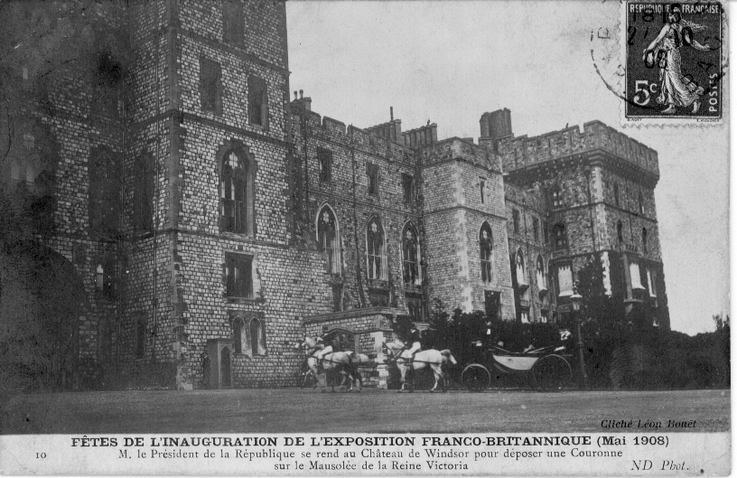

8. M. Fallieres, President de la Republique et le Lord Maire quittent le Guild Hall apres la Ceremonie de reception. Monsieur Fallieres and the Lord Mayor leaving the Guild Hall after the Reception Ceremony

9. M. Fallieres, President de la Republique et M. Pichon, Ambassadeur de France,quittent le Palais Saint-James pour se rendre au Palais de Buckingham. The President and M. Pichon, the French Ambassodor, leaving St James’ Palace for Buckingham Palace.

10. M. le President de la Republique se rend au Chateau de Windsor pour deposer une Couronne sur la Mausolee de la Reine Victoria. The President leaving Windsor Castle to lay a wreath at the Mausoleum of Queen Victoria.

I recently went to a card fair in Paris to look for these cards, and each dealer told me that they had not seen them. One dealer wanted to buy the one I had taken with me as an example!! They must be very scarce cards and apart from Cliche Leon Bouet and ND Phot. there is nothing to identify the publishers.

The Duke of Connaught was a brother of King Edward VII, so the Prince could have been his son. From card no. 2 the other person does not look old enough to have been the Duke of Connaught.

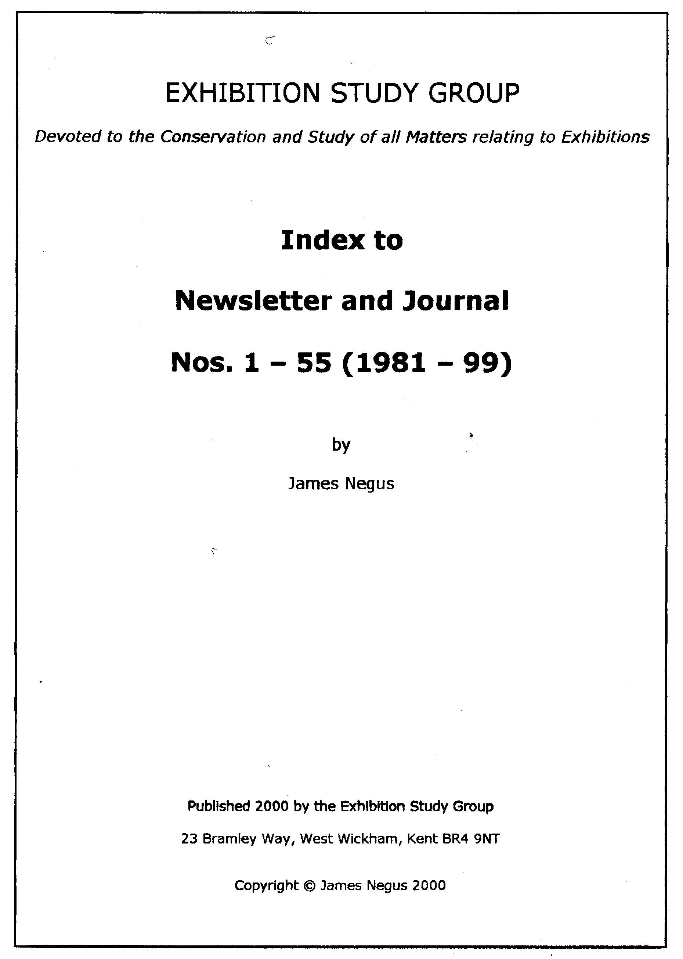

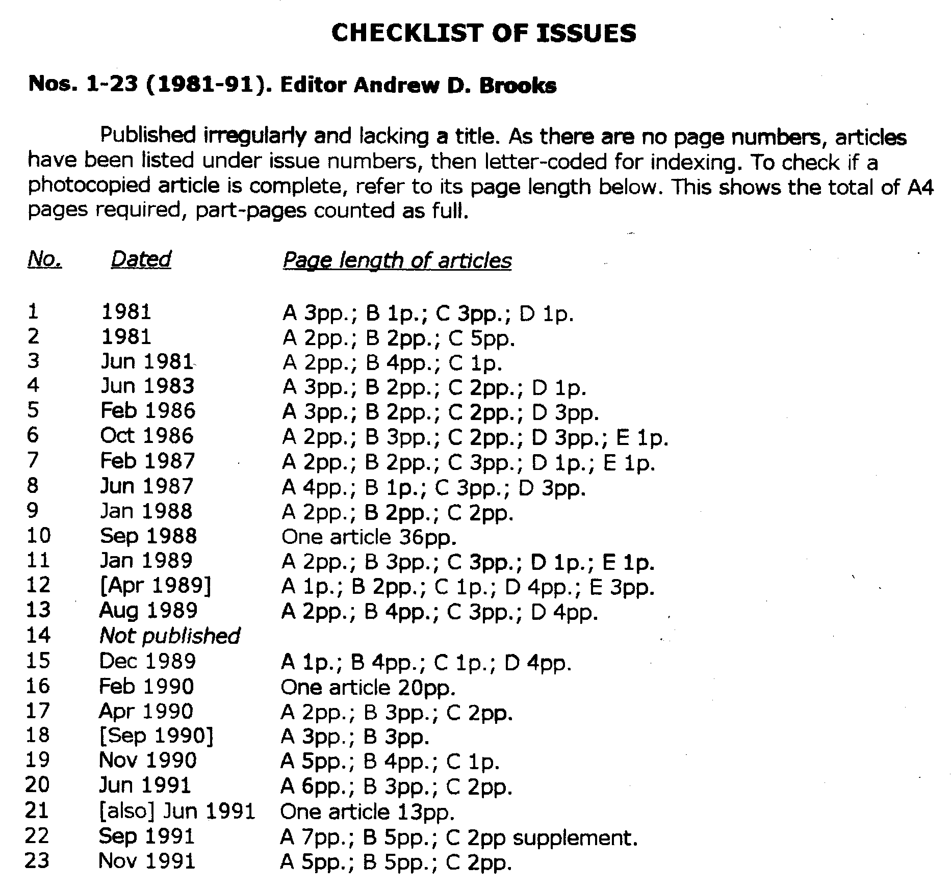

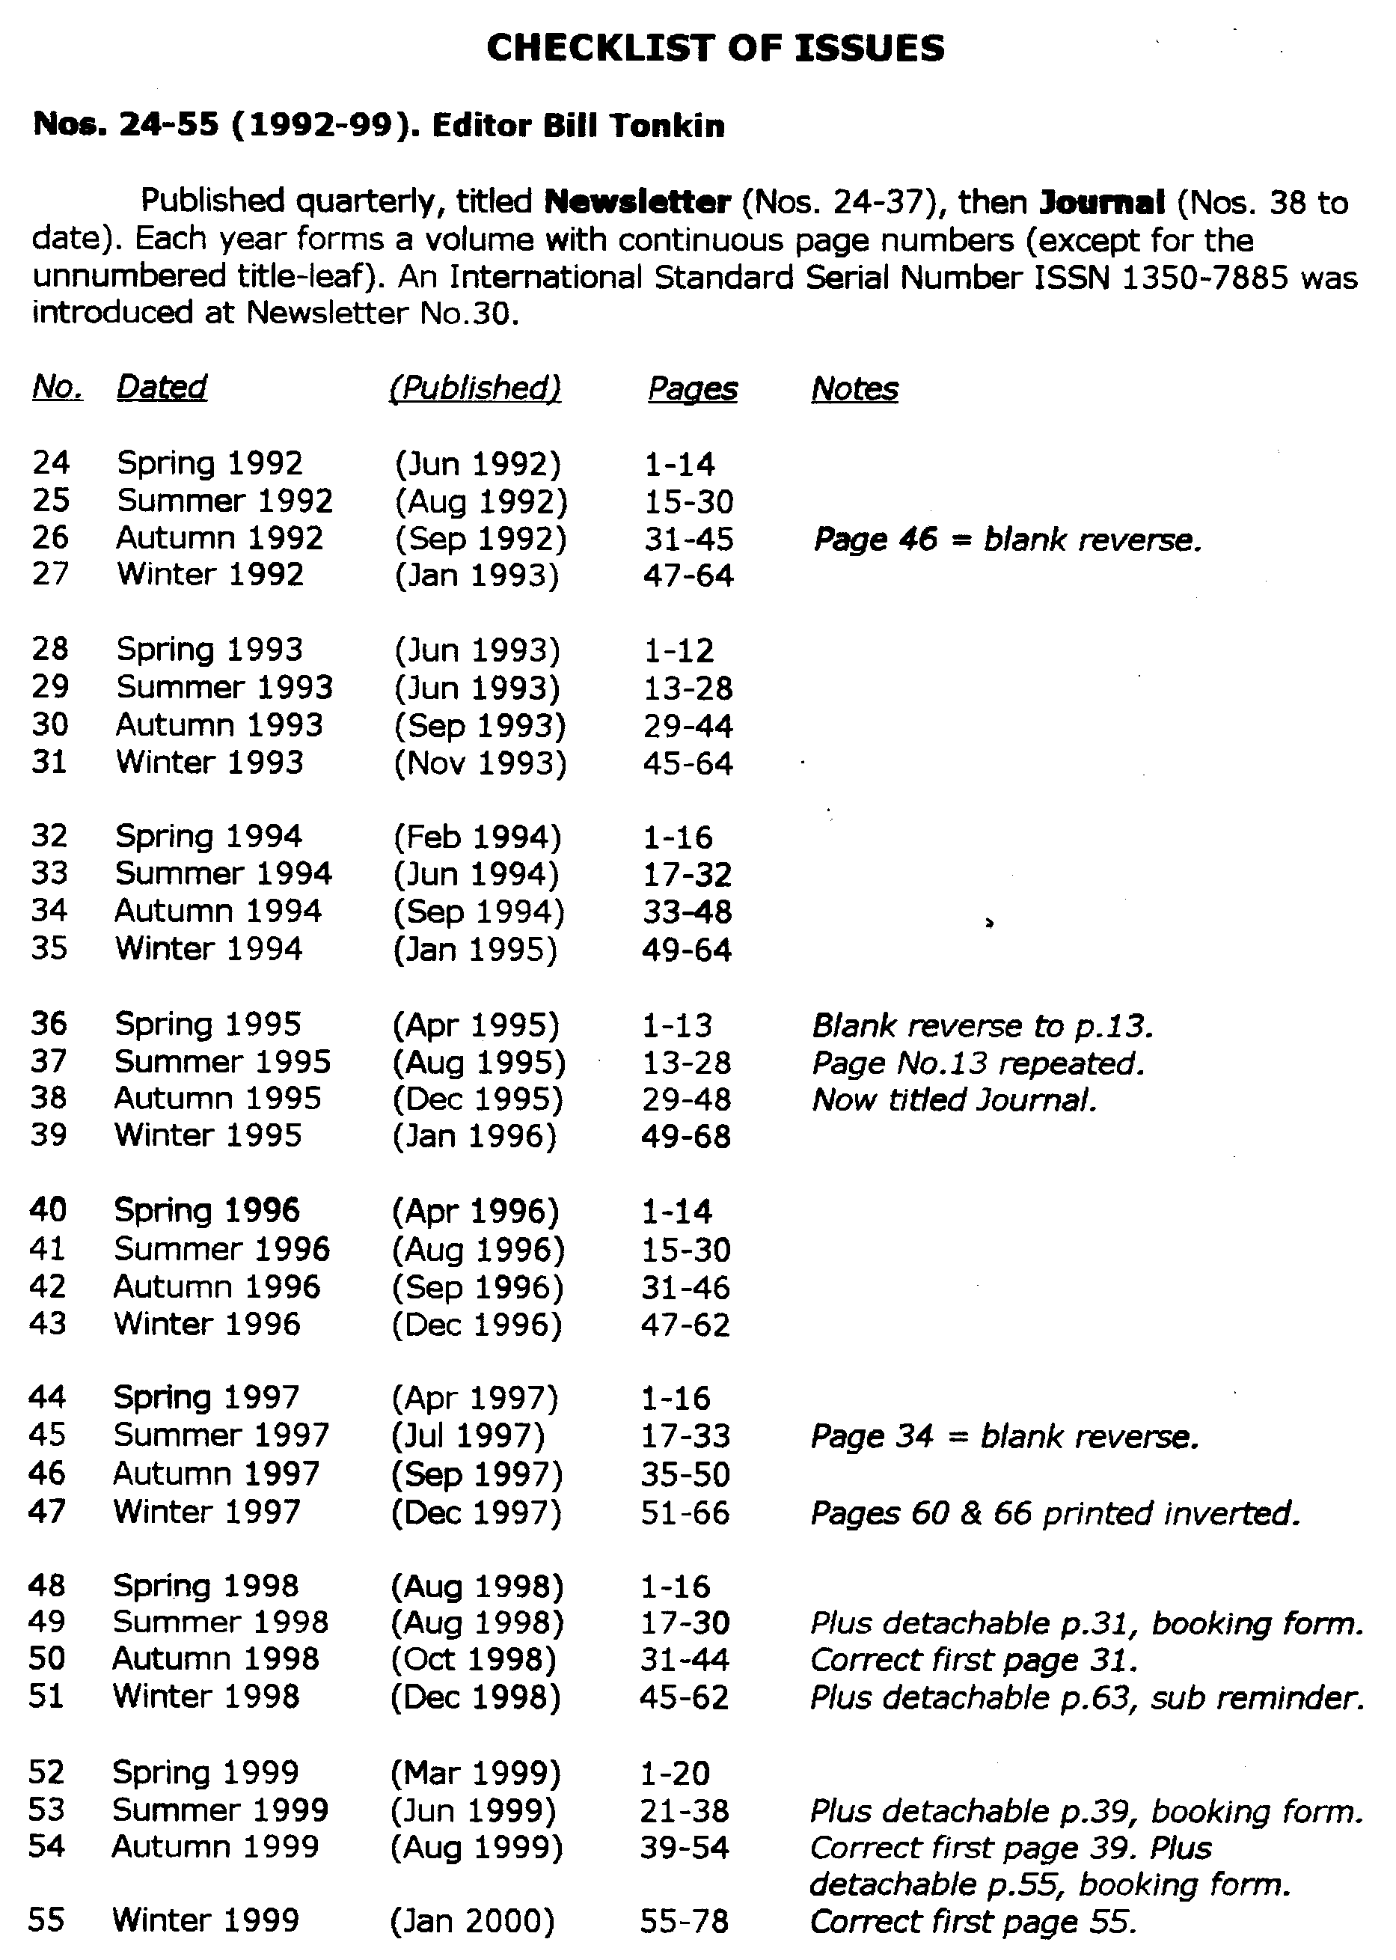

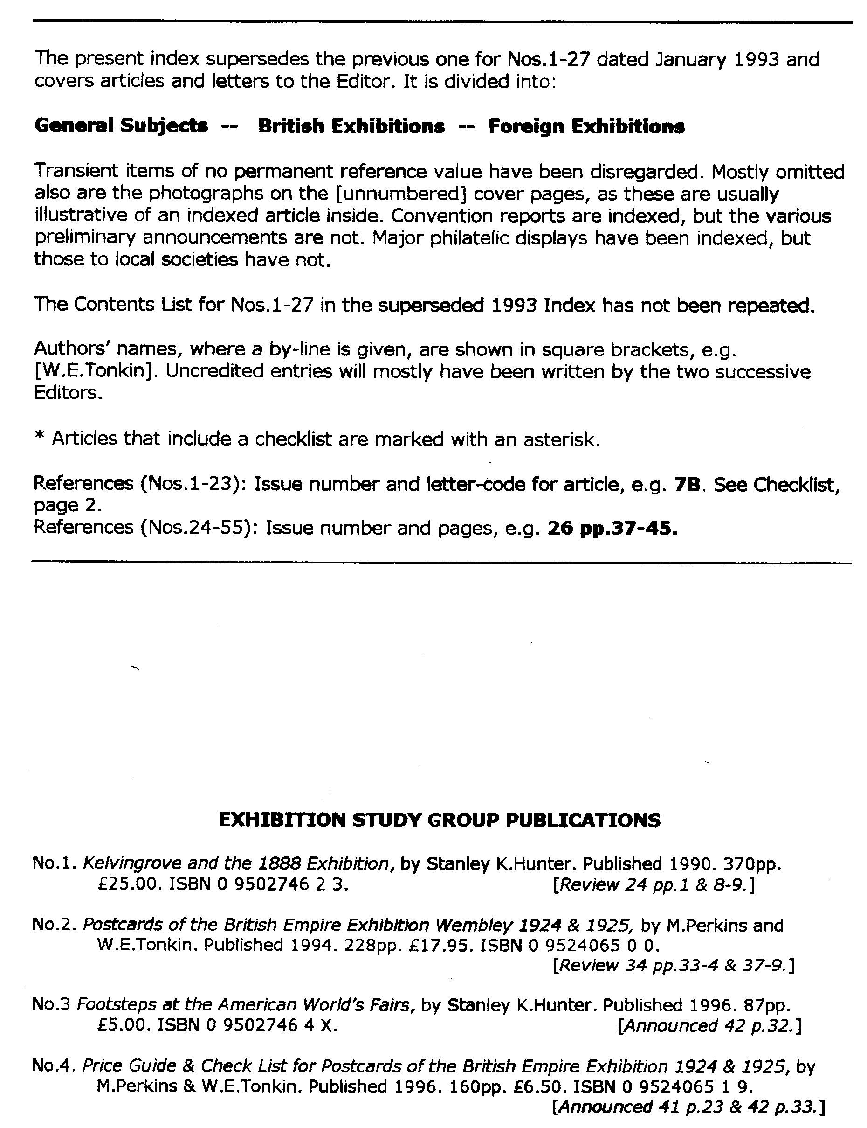

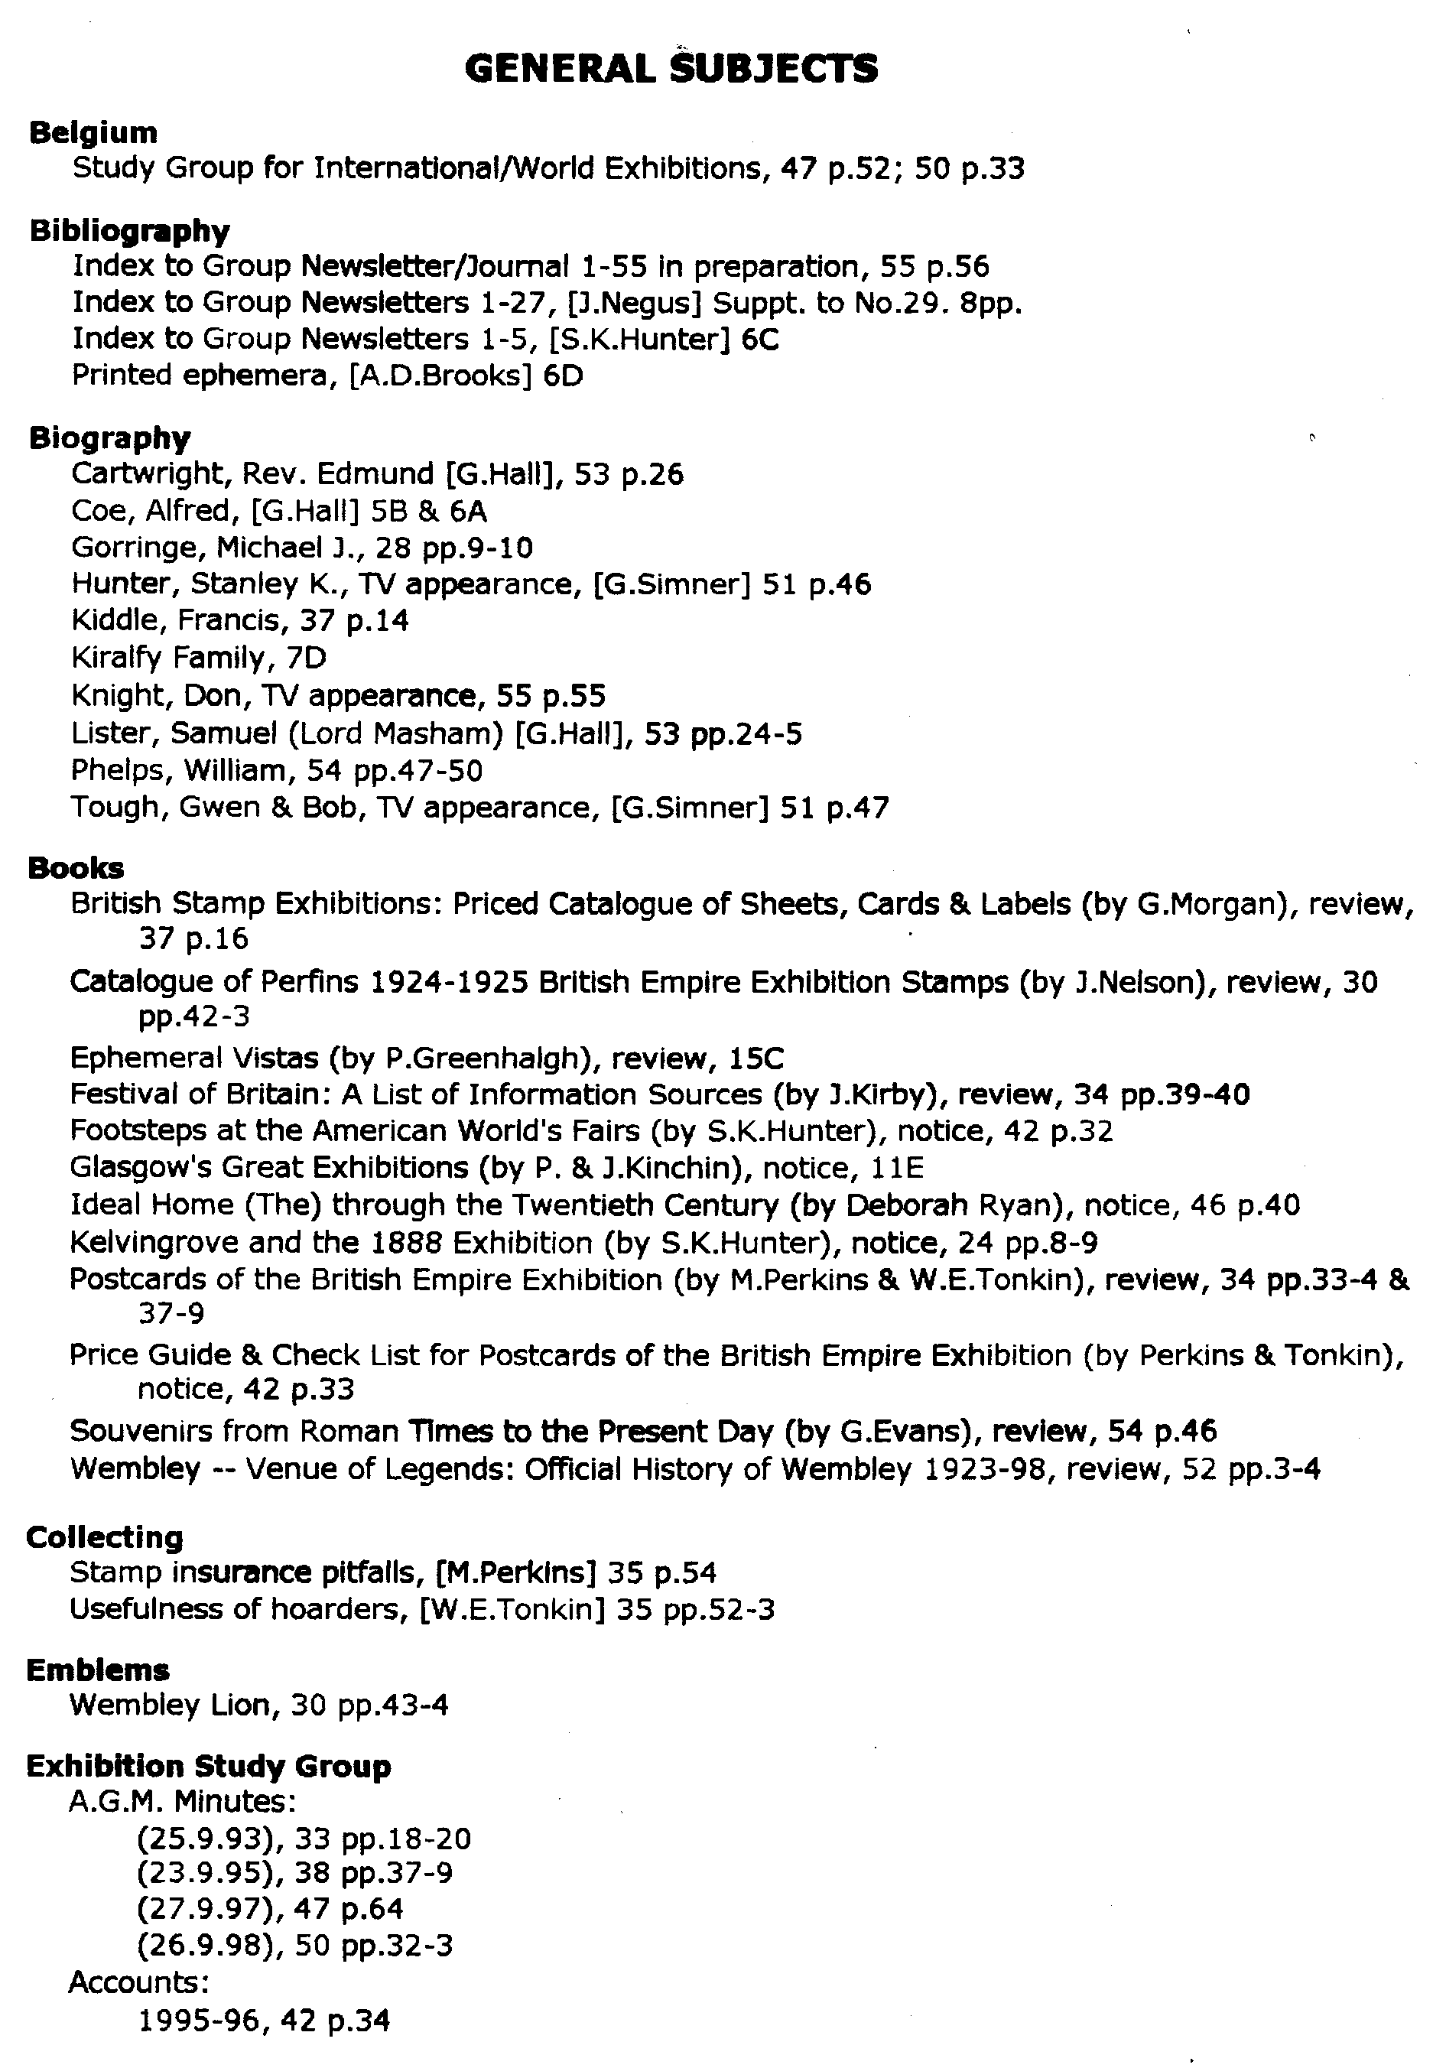

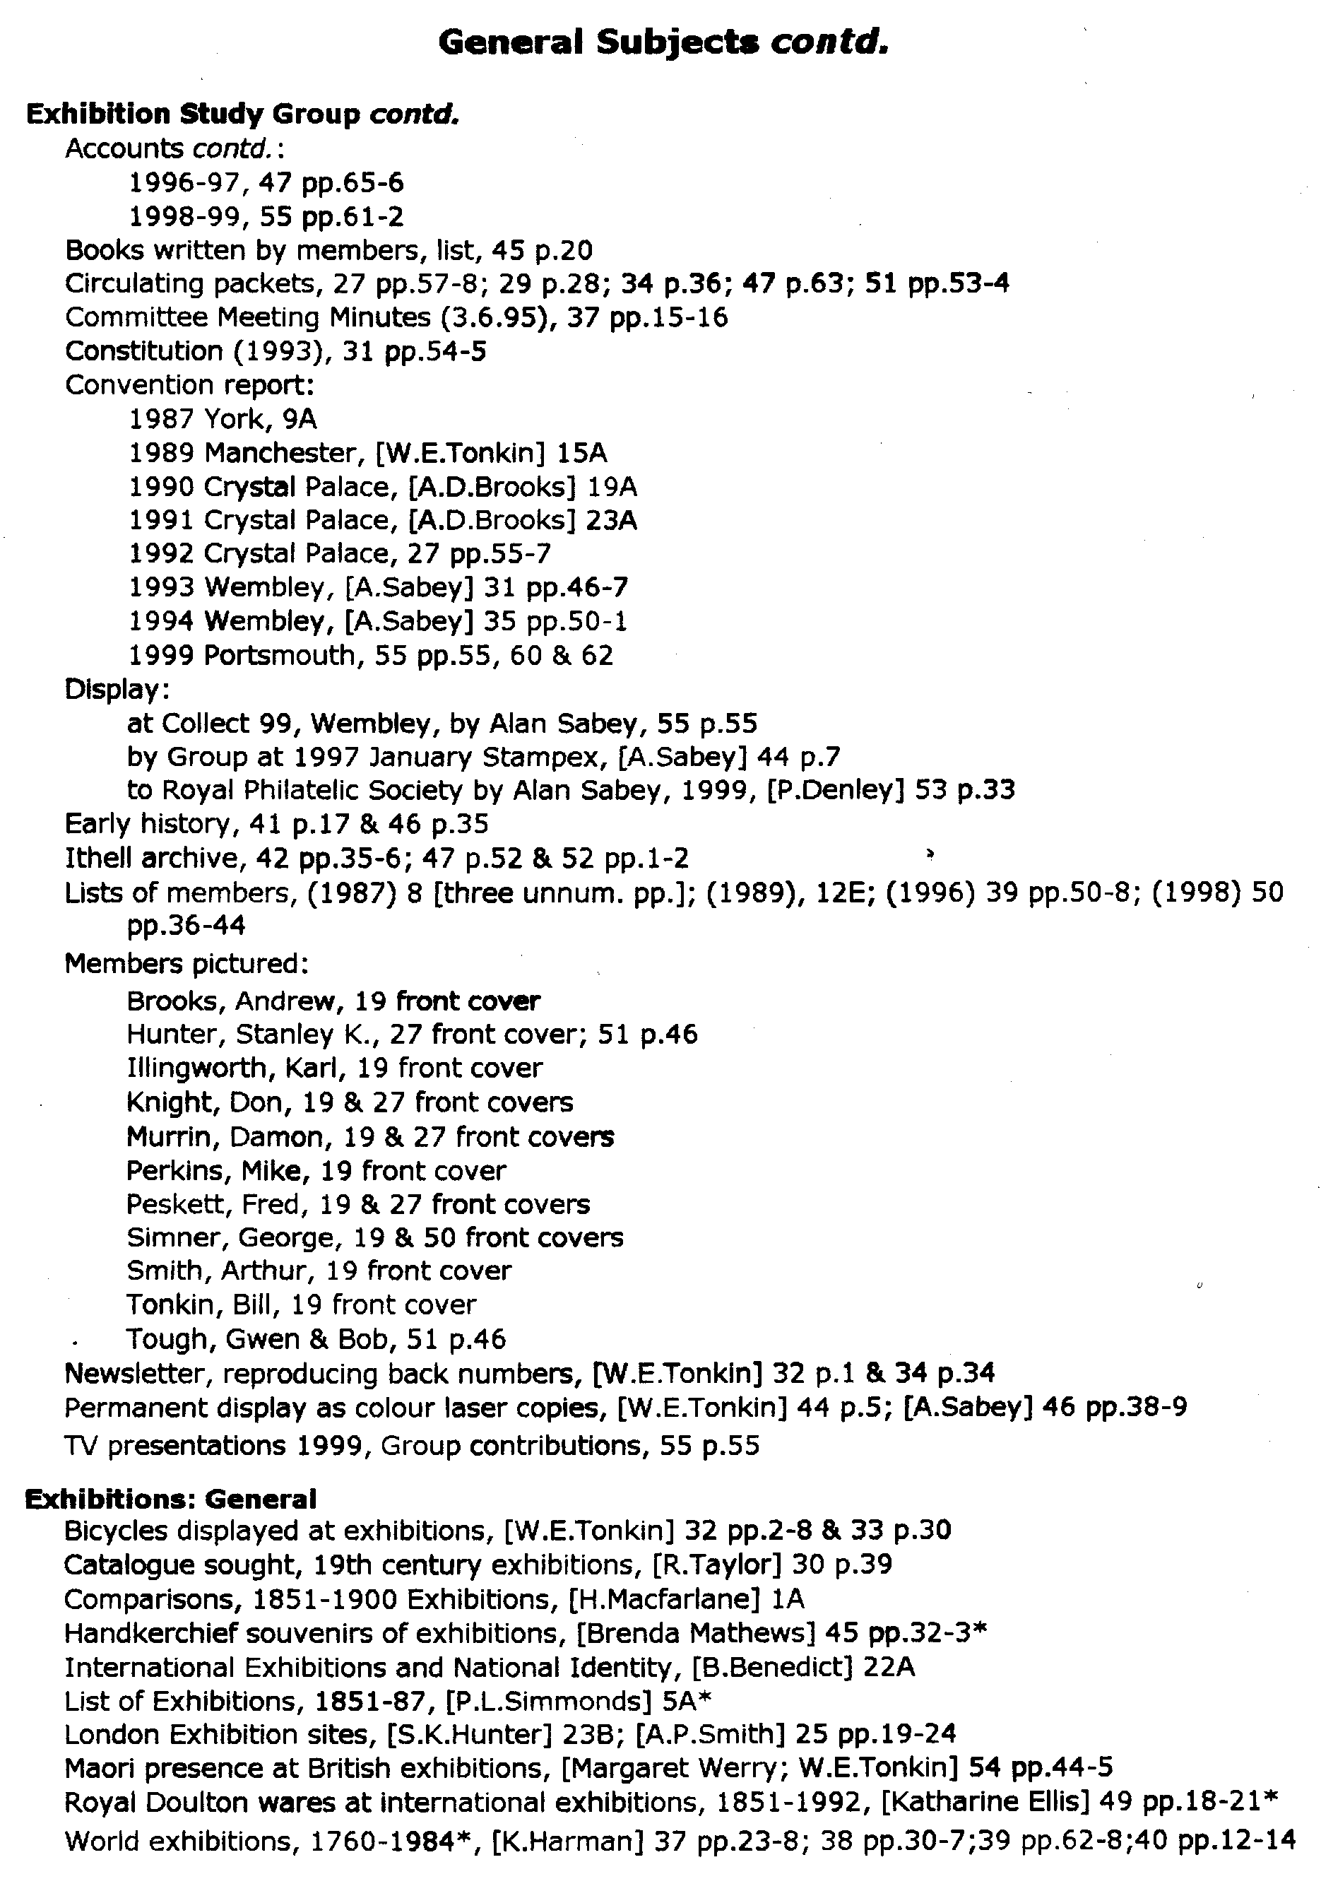

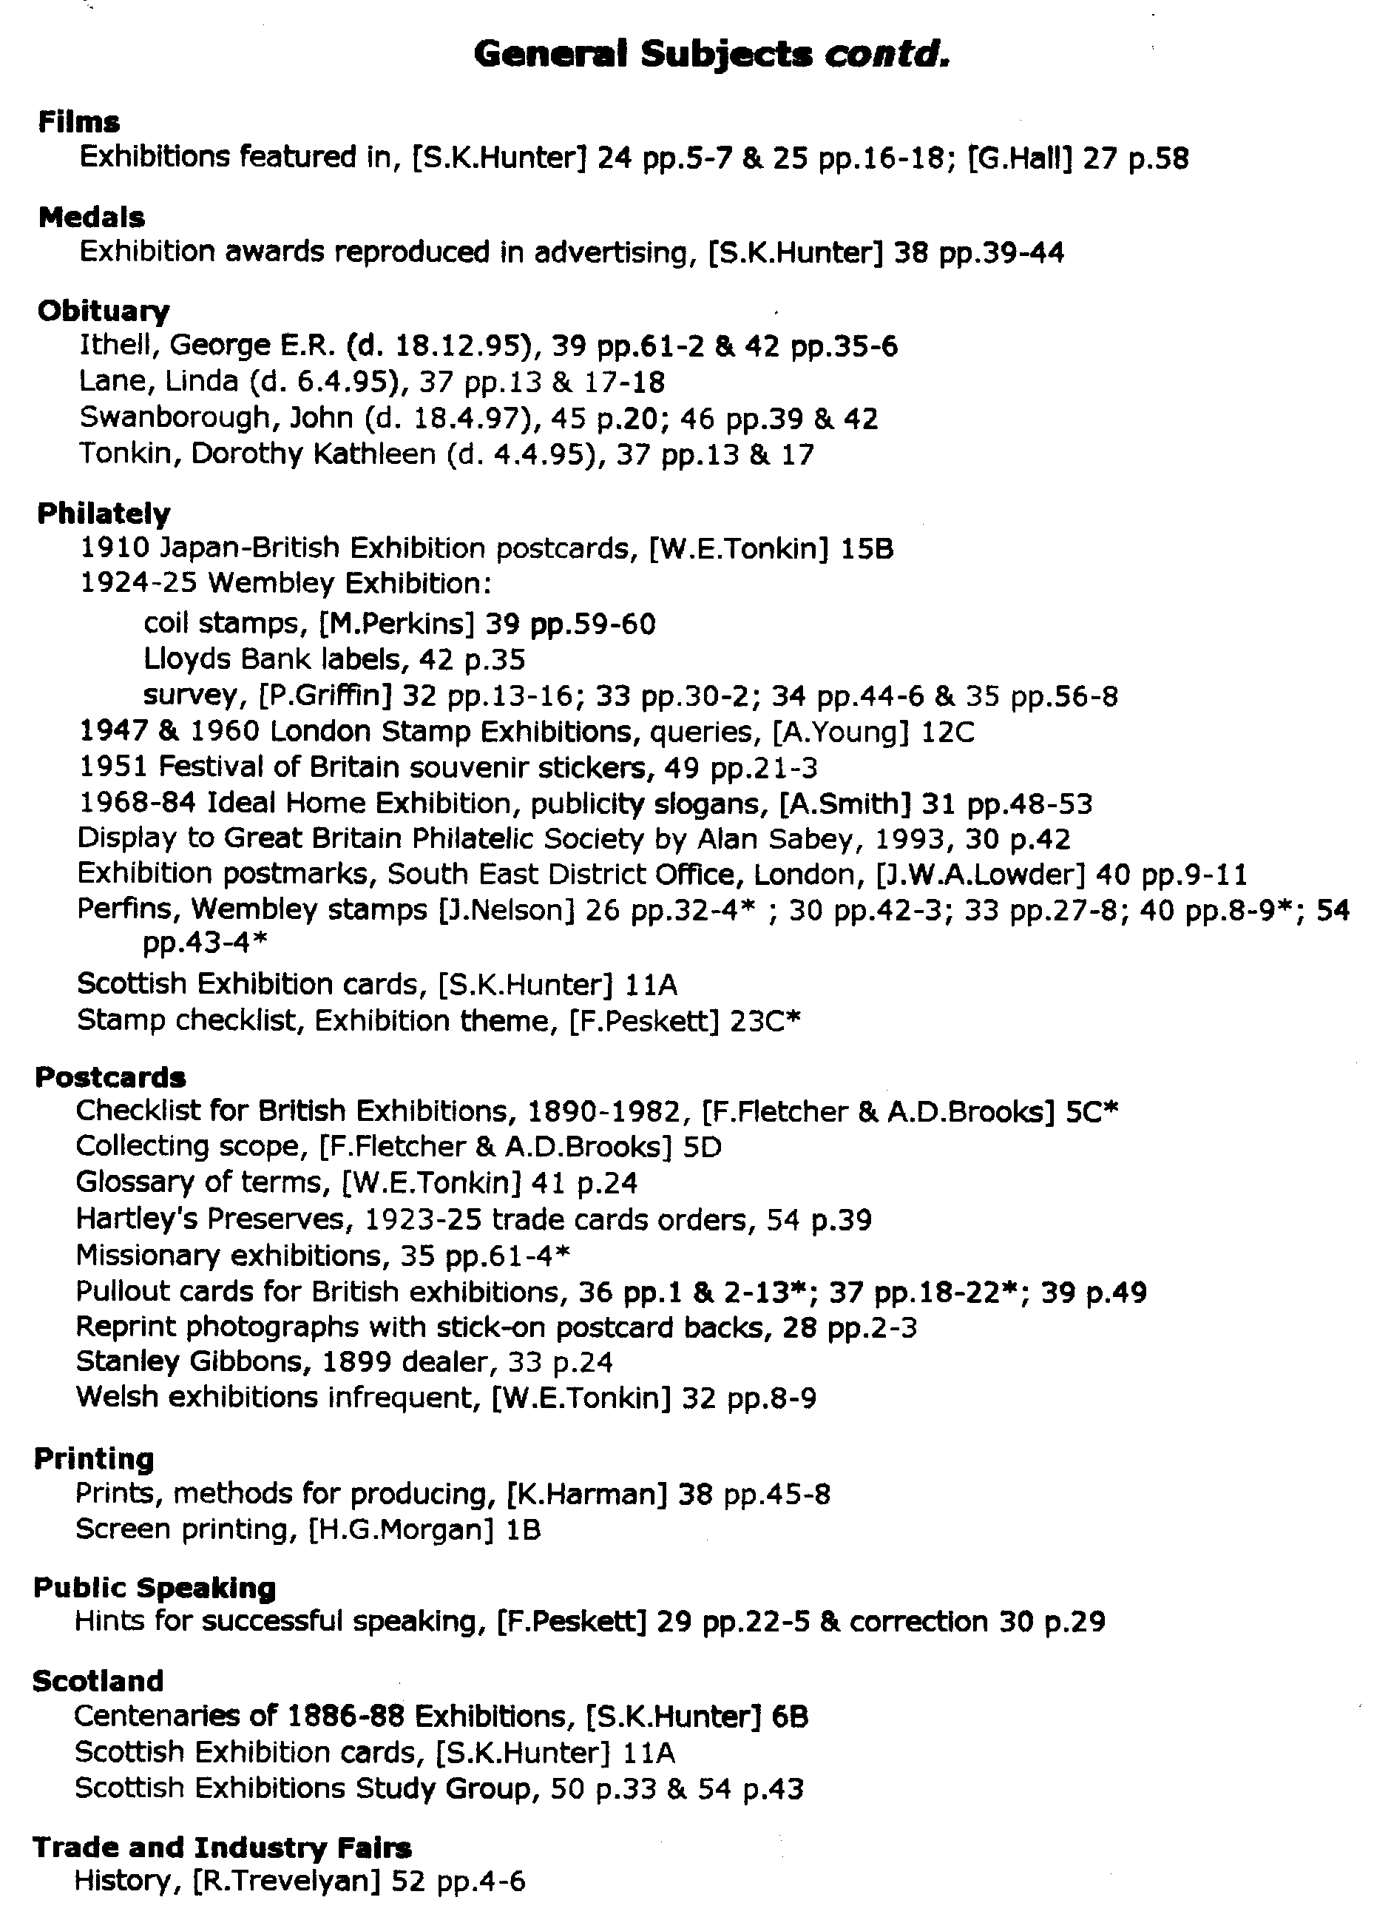

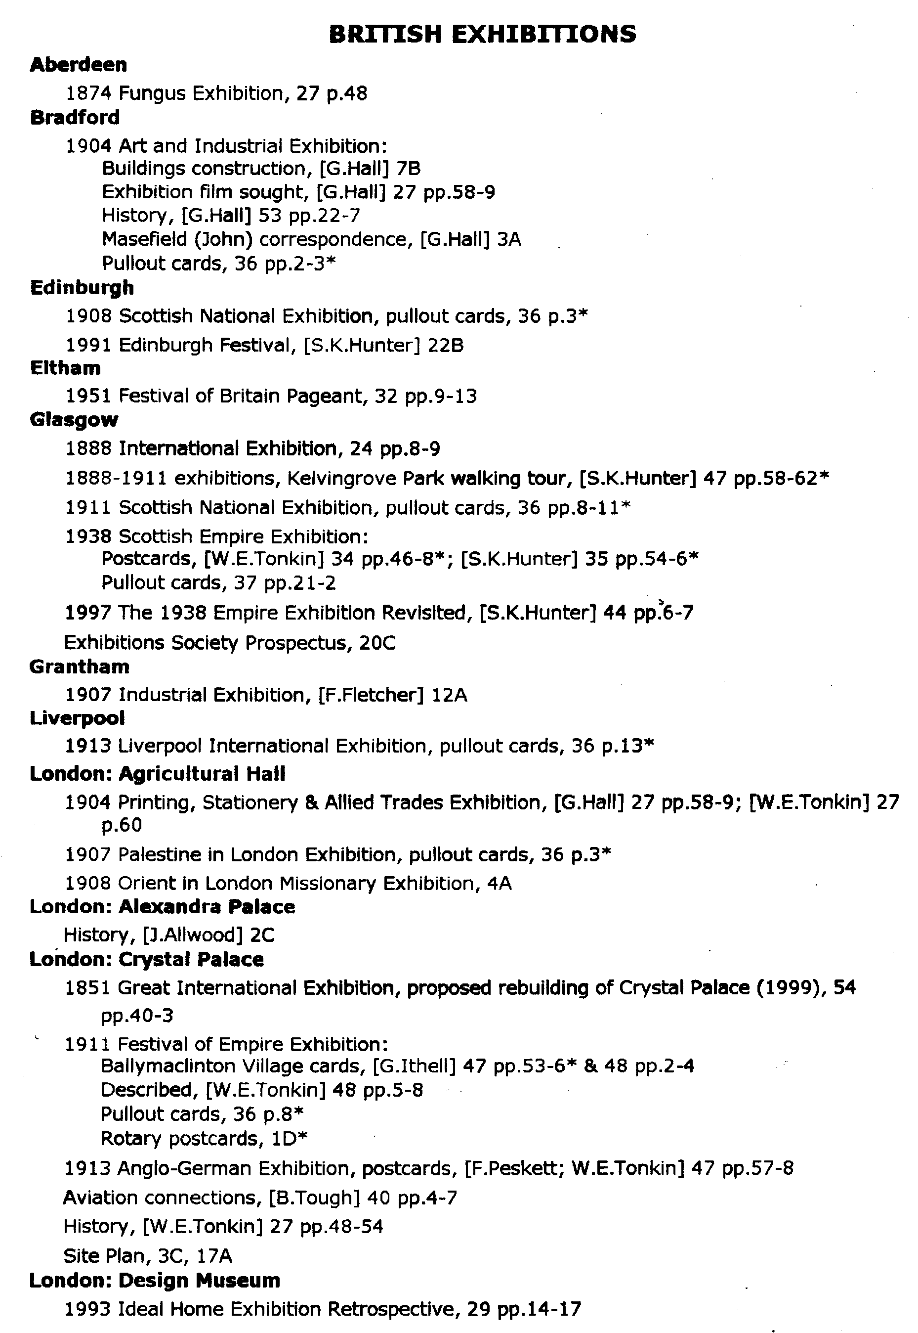

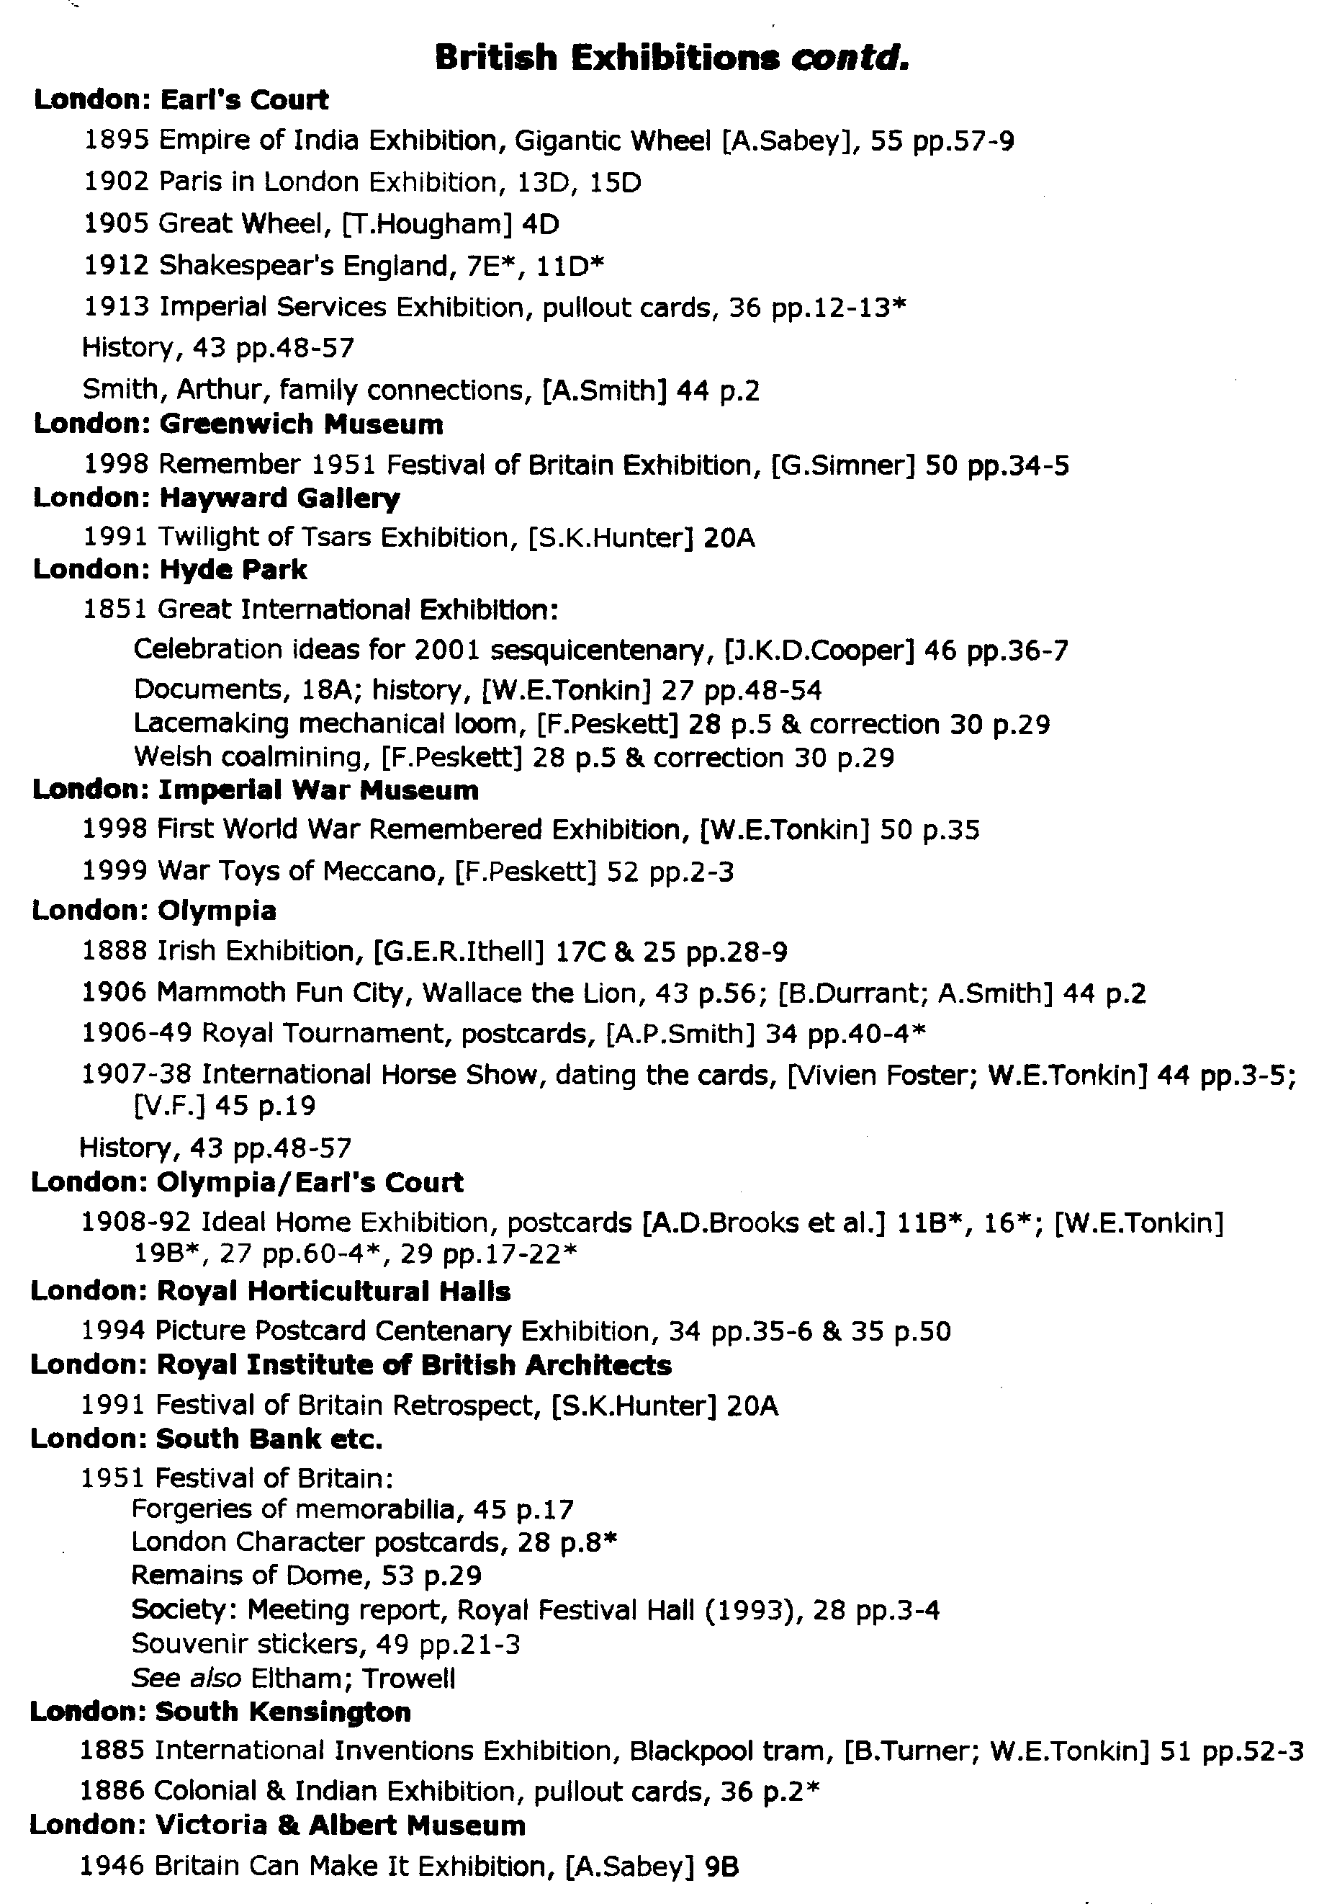

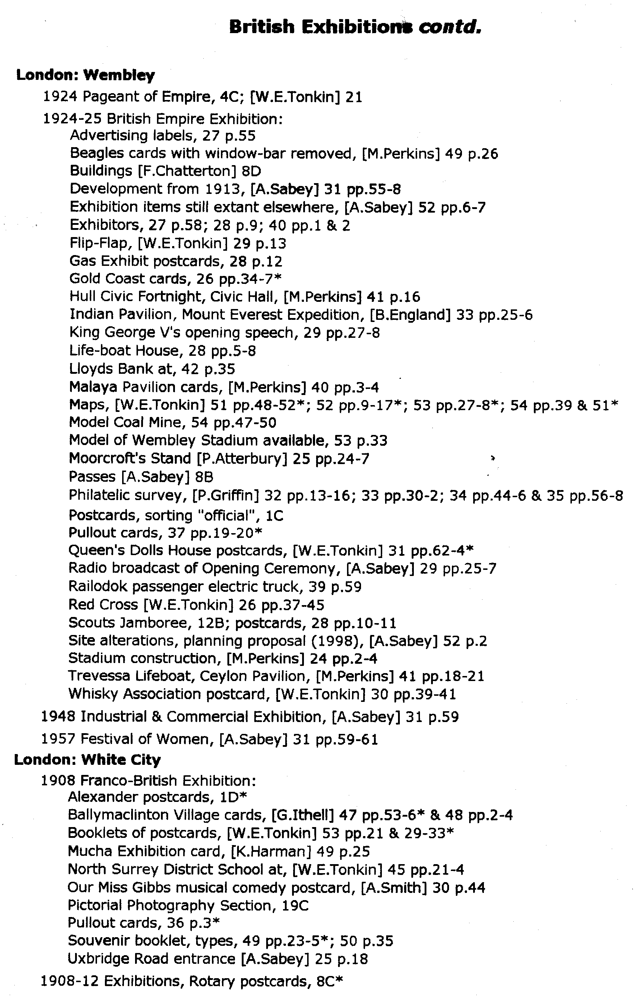

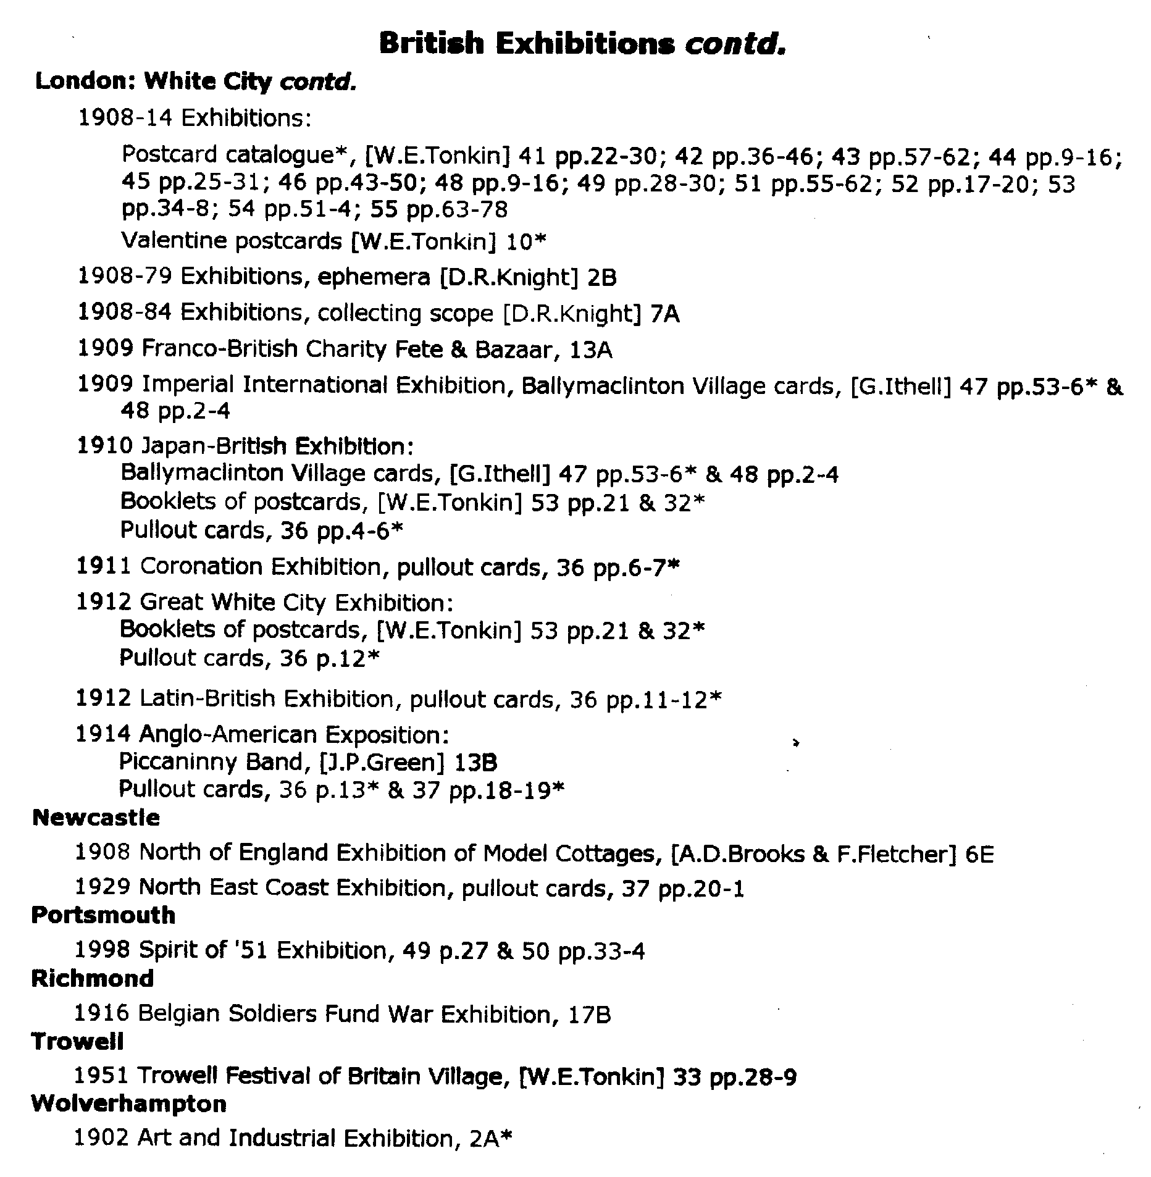

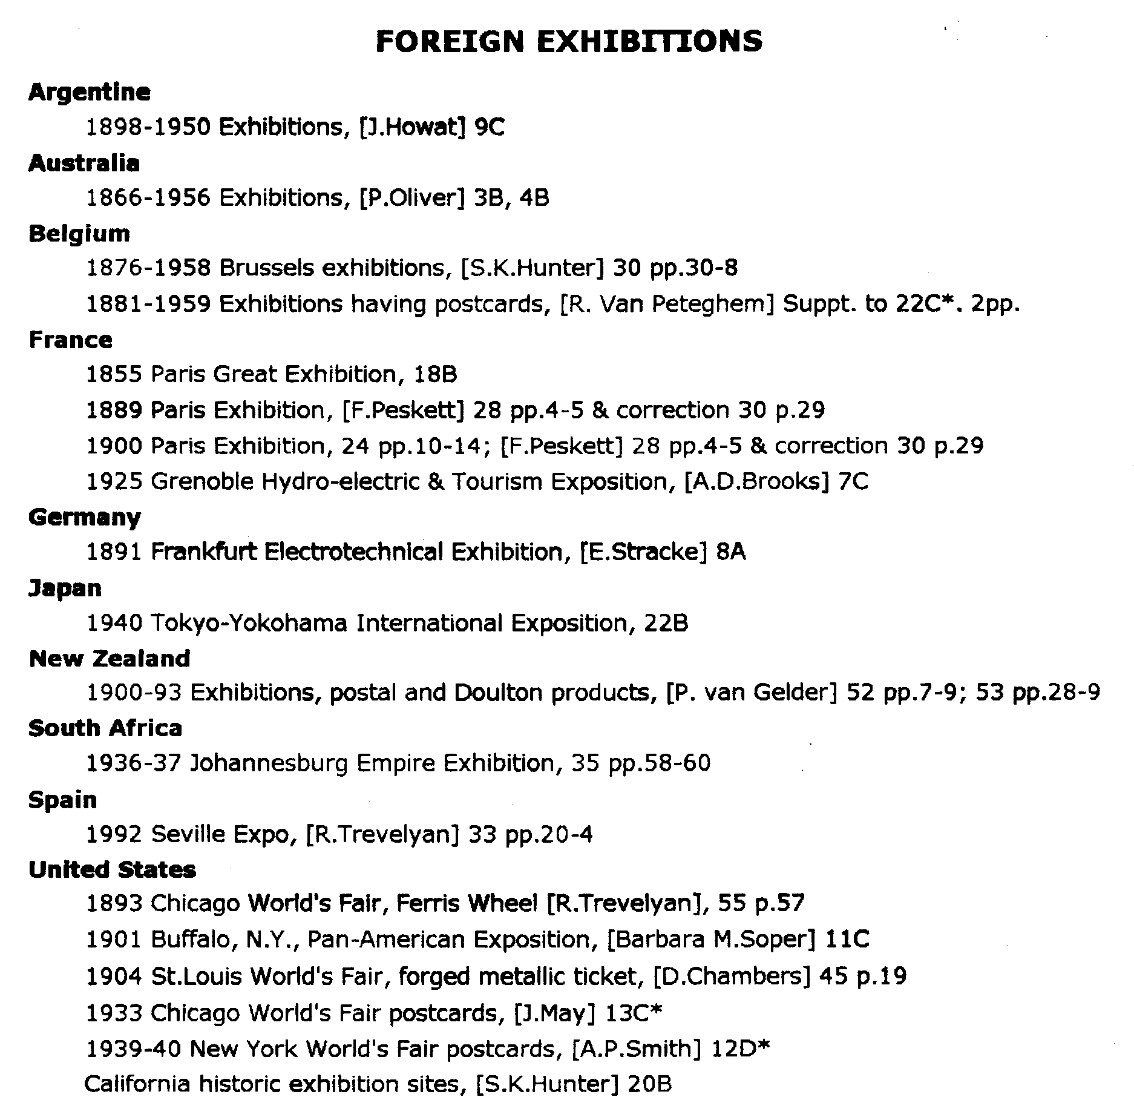

Post Cards of the White City
Part 13.
by
Bill Tonkin

This finishes the listing of the Rotary post cards which was started in the winter 1999 Journal, If any member can fill any of the many gaps I should be pleased to have details.

6952 H Beneath the Revolving Flip-Flap.
D. ‘POST CARD’ measures 40mm, without full stop.
6952 I The Cascade.
C. ‘POST CARD’ measures 39mm, with full stop. Vert right.
6952 J General View.
D. ‘POST CARD’ measures 40mm, without full stop.
6952 K Court of Honour by Night.
D. ‘POST CARD’ measures 40mm, without full stop.
6952 L Court of Honour by Night.
D. ‘POST CARD’ measures 40mm, without full stop.
6952 M The Cascade by Night.
C. ‘POST CARD’ measures 39mm, without full stop. Vert right.
6952 O Birds-eye View.
D. ‘POST CARD’ measures 40mm, without full stop.
6952 R Latin America.
C. ‘POST CARD’ measures 39mm, without full stop.
6952 T Fine Art Palace.
D. ‘POST CARD’ measures 40mm, without full stop.
6952 W Life-Saving at Sea Appliances.
D. ‘POST CARD’ measures 40mm, without full stop.
6952 X Elite Gardens.
D. ‘POST CARD’ measures 40mm, without full stop.

Franco-British Exhibition, Type 17. 6971. Photographic Series. Several cards are known with 6971 on the front. This is a misprint and should be 6791, they are entered under that series.

Japan-British Exhibition, Type 18. 9931. Photographic Series. Sepia R/Photo, brown back. Only one card is known of this series which may have been published for the Japan-British Exhibition. It has a non exhibition postmark for July 8 1910 so the date is right. It is a card showing a couple in amourous daliance with the lady in Japanese costume, in a studio with a Japanese type back cloth but different from the Millar & Lang and Tuck series.
9931 E “Oh these Geisha Lips!”
E. ‘POST CARD’ in a large thin font measures 40mm, with full stop.
Vert right.

