EDITORIAL WINTER 1999

It’s Christmas, let’s dance round the Holly tree,
or better still have a sherry with me.

Well that’s made a poor start to the Journal, let’s hope it gets better as we go along. There’s lots of news to pass on so I will start by mentioning that the Group was asked if we would put on a display at Collect 99, the show put on by Stanley Gibbons at Wembley in October. Alan Sabey told me he had been approached by Gibbons who were looking for a display of Wembley collectibles. He could manage some ephemera and crested china, and I suggested putting on a 64 sheet display of the rarest British Empire Exhibition postcards. By rare I mean postcards where, as far as we know there are less than two or three copies known. As it turned out the bulk of the display consisted of cards where only one copy is known. Mike Perkins and Alan agreed to lend me some cards from their collections, to add to mine, and I agreed to mount and write it up. Those of you who managed to get to our convention were able to get a preview of the display. In all it comprised of about 120 of the scarcest Wembley cards there are, and if I say it myself it was a mouth watering display.
Our convention in September went off very well, although during the last few days I thought it would turn out to be a bit of a disaster. George Simner phoned me up to say Flo and he would not be able to make it on the Saturday as his family had organised a surprise trip on the Orient Express for his birthday or something.. Apparently they usually pull the thing by a diesel engine, but that wouldn’t do for George, he wanted to be taken down by a steam engine, which only happens on convention weekends. From one or two hints I heard, I got the impression the family wanted to send him on a one way trip to Istanbul, but Flo wouldn’t hear of it, so George is still with us. It was something to do with belly dancers I believe. The next call was from Don Knight who is this years County President, which is a great honour, and just about as high as you can get in the bowling world. He had a do he had to attend, but promised to get down for the Sunday. Cynthia Wade also dropped out as she wanted to attend a convention of Spode China collectors which unfortunately was on the same weekend. Then I had apologies from Paul Watson who was coming with his wife for the first time, he had to go into hospital only coming out a few days before the convention started. Last of all Barbara Smith phoned us on the Friday at Portsmouth to tell us that owing to business reasons she had to drop out. However all the old faithful’s turned up and we enjoyed ourselves, with a total of 20 members signing the attendance book.
Members of the Study Group have been involved with the Association of Friends of the National Postal Museum in the design of a commemorative cover and insert for next years International Stamp Show 2000 to be held at Earls Court. The group was asked if they could come up with some ideas, and I loaned them some postcards of the Great Wheel at Earls Court. At a recent Council meeting one of these cards was selected to be used for the illustration on the cover. Alan Sabey was asked to find out some details about the wheel, and has written the text for the insert stiffener card, which will include a map of the area in 1901.
The commemorative cover will be available for each day of the Show with a special hand stamp, I hope to have more details to report in the Spring Journal. It looks as if the cost with a set of stamps will be in the region of £5.00.
I think I have mentioned that I have been approached by two film companies regarding programmes they are making for TV. One has now been shown and is the first in the ‘Lost Gardens’ series. I got a friend to video it as I was not home that evening, and found it very interesting. I was very impressed with the way they have brought some of the postcards I lent them to life. One which I have used as an illustration, they have cunningly made the water to appear as a moving stream with a rippling effect. Anybody not in the know would never guess that it was a postcard they were looking at. In all the water on several postcards was treated like this.
The other TV presentation will be on Boxing day at 20.00 on Channel 4. The title had been altered to ‘Making an Exhibition of Ourselves’ but I have just heard it has been changed back to its original title ‘Great Exhibitions’. As far as I know Don Knight appears in it, demonstrating his working model of the Flip-Flap. Members may remember seeing this at one of our early conventions. Perhaps we could see it again sometime Don? The Study Group has a small supply of the Channel 4 booklet titled “Great Exhibitions from the Crystal Palace to the Festival of Britain” this 32 page A4 size booklet can be obtained from Alan Sabey at £4 00. Stanley Hunter, George Simner and myself get mentioned and there are about a dozen reproductions of exhibition postcards. It’s well worth four pounds.
I should now like to record my thanks to Jim Negus who has been working on an updated index for the Newsletter or Journal as it is called now, and when he gets this issue will finish off the index. at that point. It will cover from No. 1 (1980) to No. 55 (December 1999) a period of 20 years. We have come a long way since Newsletter No. 1 was published by Andrew Brooks, who was our first secretary, editor and treasurer, not that we had any money to treasure. It was circulated to just ten members including himself. Five of the original ten members are still with us, and our membership is now well over the 100 mark. News Letters came out very spasmodically in the beginning, and only seven were published in the first seven years. No. 7 came out in February 1987, and in this issue Andrew announced the holding of our first one day convention, to take place at York, in the October of that year. After that newsletters became more regular, and we now send out four a year.
Looking through the last index Jim did for us in 1992 which went from No. 1 up to No. 27, it’s surprising the amount of ground the various articles have covered. When you see the new Index I think you will be even more impressed. I should like all members to ponder on this, the Journal is as good as the articles you the members send in. I would go even further than that and say the Exhibition Study Group itself, is as good as it’s members want it to be. If member interest should ever fade away then the group itself would fade away.
Every one of you has got some aspect of your collecting interest that is worth writing about, whether it is written in biro or sent to me typed out, and if you have a computer, on a floppy disc as well. As far as I am concerned this is the ultimate blessing as I can feed a floppy in, edit it if necessary, and it cuts my work load down enormously. When you consider the number of members who collect crested china for instance, with never a single word ever written on the subject, I think something should be done. This is a huge collecting area that has been completely ignored.
The Group has been offered a room at the London International Stamp and Cover Show ‘Philatex’ on March 4th 2000 between 10.15 and 12.15. So if any of you are going to the show look in and meet some old friends.

The Editor.

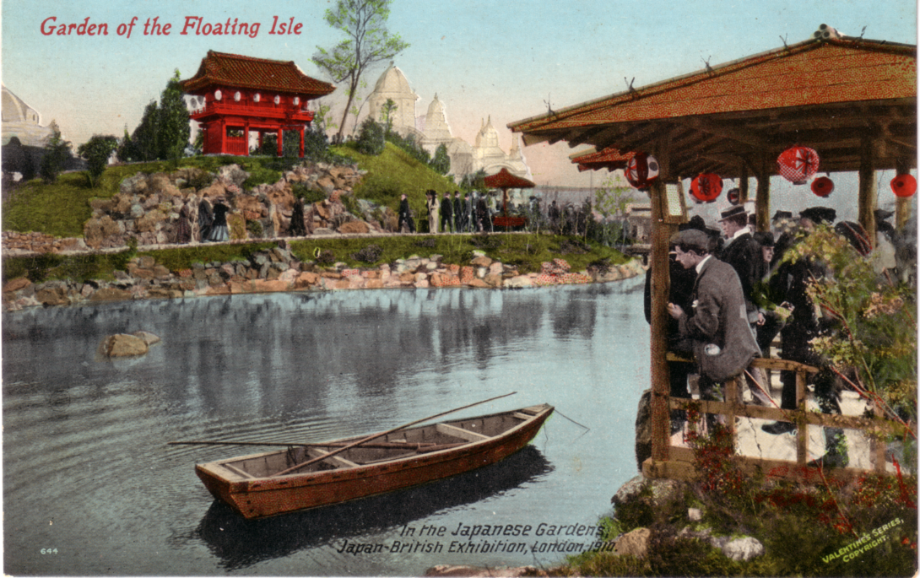

Flashback Productions the firm who made the film ‘Lost Gardens’ shown during November
on television, carefully super-imposed a rippling effect on the water to convert the still view
into a moving view, on this and several other of my postcards they used.
The Ferris Wheel
by
Ron Trevelyan

After undertaking to give a display on the two Chicago World’s Fairs held in 1893 and 1933 to the Study Group Convention in Portsmouth, I began to appreciate the significance of the Ferris Wheel. As part of the planning for the 1893 Fair people from Chicago visited the 1889 Paris Exposition and were, of course, very impressed by the Eiffel Tower. The Ferris Wheel was the US response to this. I also realised just how topical this was when photographs began appearing in the daily press showing the attempts made to raise the 450 foot monster Millennium Wheel by the side of the Thames in London.
The original Ferris Wheel was invented and constructed by George W. Ferris, who was a Pittsburg engineer and bridge builder. He received the go ahead in November 1892 for the wheel to be sited on the Midway Pleasance amusement area of the 1893 Chicago Fair and it was ready by late June 1893. There is no doubt that the wheel was an engineering marvel. For example, the 45 feet long axle was the largest single piece of steel that had yet been forged. The wheel was 250 feet in diameter and at its full height at the top (264 feet) visitors could view the fair and parts of Chicago.
The 36 wood veneered gondolas each housed 60 people, of whom 40 could sit on plush covered swivel chairs. Each ride costing 50c including two revolutions and lasted for 20 minutes. During each revolution six stops were made so that the load from six gondolas could be changed at a time.
The 1893 Chicago Fair was the first to have a separate amusement area and the latter proved to be a very important source of revenue, leading to solvency for the whole event. The Ferris Wheel played a major part in the finances, grossing over $726,000 against expenses of $400,000. A profit for the wheel even after the Fair corporation had taken its pre-arranged slice.
After the 1893 Fair closed the Ferris Wheel was dismantled until 1895 when it was used locally again, without much success. It surfaced again at the St. Louis Worlds Fair in 1904 and was finally scrapped in 1906. My understanding is that the giant steel axle was buried in the grounds of the Fair.
Since then Ferris or similar wheels have become standard fixtures at World’s Fairs and expositions, although, they have not been until now on the same scale as the original. Hence, at the Osaka Exposition in 1970 the wheel was less than 150 feet high and its 20 gondolas carried only five people in each.
No doubt Mr Ferris would be pleased to know that his invention, larger than ever, will live on in London to help celebrate the Millennium.
Acknowledgements The Anthology of World’s Fairs. Burton Benedict
Footsteps at the American World’s Fairs. Stanley Hunter
The Chicago World’s Fair of 1893. Stanley Appelbaum

The Gigantic Wheel and Recreation Towers Co., Ltd.
Earls Court Exhibition Grounds.
by
Alan Sabey

At the turn of the last century there was another Great Wheel in London, and it was at the former Earls Court exhibition grounds near to where ‘Stamp Show 2000’ is being held, the wheel was a larger version of the original Ferris wheel at the World’s Columbian Exposition in Chicago which was open from May 1st to October 30th 1893.
Work began on the construction of the Gigantic Wheel at Earls Court in March 1894 and its location was near the Lillie Bridge Works of London Transport and could be easily seen by looking in an easterly direction from West Kensington Underground Station. For those wishing to locate the site in today’s world, with the many changes made to the road layout in that area after the Second World War, it would be east of where the Great Cromwell Road begins after the traffic lights of the junction of Talgarth Road and North End Road, where the present road bears to the left (if one is heading east) over the railway bridge by a large brick built warehouse, which was formally William Whiteley’s Depositories. From that point if one stands on the opposite side of the road to the depositories and looks across to ‘Earls Court 2’ the wheel would have been right in front of you.
The Earls Court Exhibition Grounds in those days were in three sections separated by railway lines. The western-most section backed onto Beaumont Road and Mund Street heading south down North End Road from West Kensington Station. For postcard collectors this was where the ‘Western Gardens’ (a view often seen on postcards) were. The second section heading east was across the Midland Railway by footbridge and is the section which is now fully occupied by London Transport, this was the location of the Gigantic Wheel at its northern end. The third and eastern-most section was the triangle between various parts of the District Line and the West London Extension Railway, where the present Earls Court Exhibition building was built in 1937. The Empress State Building (the large triangular shaped office building) stands on the middle of the three parts of the Exhibition Grounds.
Eight four foot square and 150 foot high supporting columns were constructed at which level there were two promenade or recreation rooms. The bearings on the plummer blocks at the top were the largest ever constructed and were made by the Tandem Smelting Syndicate Ltd., of Jubilee Buildings, Queen Victoria Street, London, E.C. who were the largest smelter and the greatest experts on anti-friction metals in Europe. These plummer blocks on which the axle rested weighed 11 tons each and the Axle, built in East Greenwich by Maudsley Sons & Field, was in one inch plates. When assembled it was a steel tube which had been constructed in three sections that was 35 feet long and seven feet in diameter. It weighed 60 tons and was brought from Greenwich to Earls Court by road in June 1894, which aroused much interest from the general public en route.
Work on the assembly of the Wheel was slow because of the 1894 Exhibition that was in progress, but this closed early so that the wheel could be built and this was done in four sections each weighing 150 tons and was achieved about the end of June 1895 ready for testing by the Company Engineer, Mr J. J. Wheeler M.I.C.E. on July 3rd 1895.
The total height of the Earls Court wheel was 300 feet this is lower than the Millennium Wheel on the South Bank of the River Thames next to County Hall which is about 450 feet (135 metres) high. There were 40 cars, constructed by Brown, Marshall & Co., of Birmingham, each measuring 24 feet long, nine feet wide and ten feet high capable of carrying 30 passengers each. Thus the total capacity of the full wheel was 1,200 persons. Ten of the cars were furnished as first class at a cost of £100 each, five of these were for non smokers and the other five for those wishing to smoke. the other 30 cars were furnished in a plainer style. There were eight platforms on either side of the wheel for embarking on one side and disembarking on the other side.
The wheel was driven by steam from two 50 horse power Robey engines housed in an engine house at the foot of the towers. The driving mechanism was a pair of chains which were 1,000 feet in length and weighed eight tons. Either chain was capable of driving the wheel so there was said to be no danger of it stopping. However according to the Daily Graphic on May 23rd 1906 the wheel stopped suddenly two days before. 74 people were suspended on the wheel overnight for 15 hours. Some people let down strings in the hope of getting food. Some men climbed the metalwork to reach the lower cars with some refreshments. On their return to solid ground each person was given a £5 note (a great deal of money in 1896) by way of compensation.
Access to the Recreation rooms at the tops of the towers was by a double funicular railway. On a clear day the view from the top of the wheel was over the sights of London in one direction and to Windsor Castle in the other direction. At night there was a double row of glow lamps around its circumference and the cars were lit by electricity. Construction of the wheel was carried out by Mr Walter Basset’s Company, and on Saturday 27th April 1895, Mrs Basset ceremonially screwed the last bolt in each rim of the wheel.
The wheel opened to the public on July 6th 1895 for the ‘Empire of India Exhibition’ and last turned on the closing day of the 1906 Austrian Exhibition. Due to high winds and frost not much headway was made in the dismantling of the wheel until a months contract was made on February 8th 1907, because the wheel company became bankrupt so it had to be dismantled to sell the metal in order to raise funds for the creditors.

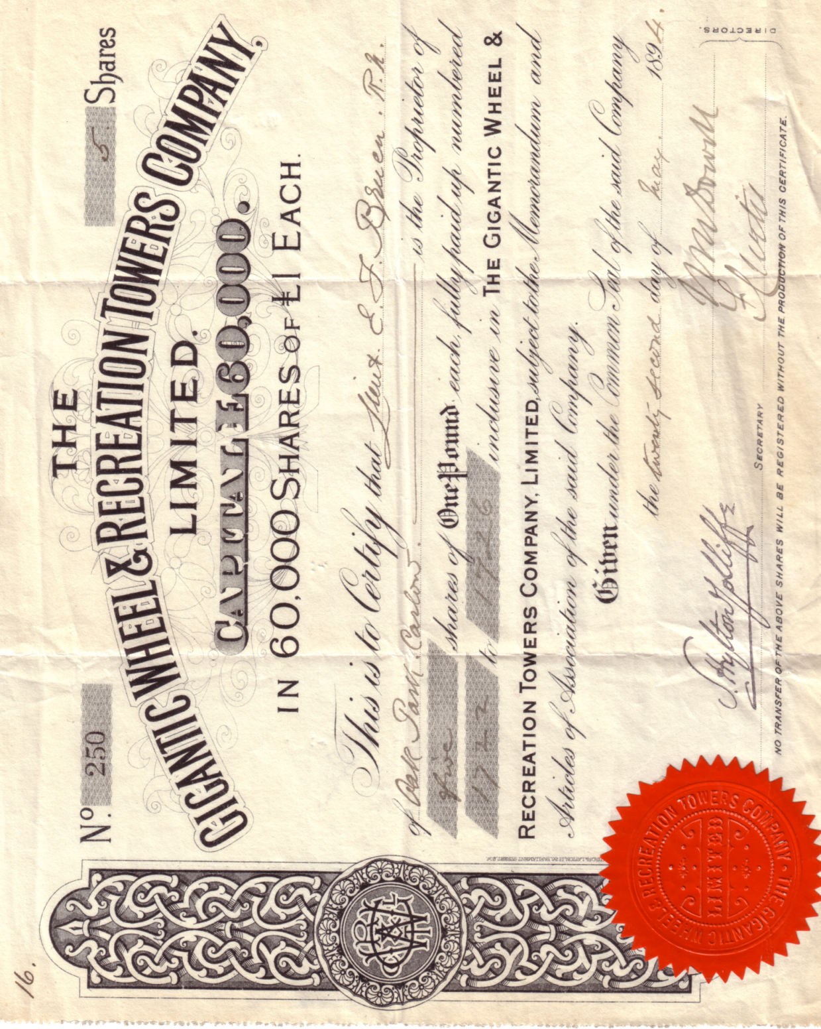

Certificate for five shares of The Gigantic Wheel & Recreation Towers Co., Ltd.

It had a life of 11 years but in that time had given visitors unparalleled views over London and the Home Counties, before the days of aircraft.
To summarise The weight of the wheel was 600 tons
The weight of the axle was 60 tons
The weight of the eight supporting legs was 250 tons
The weight of the 40 cars (4 tons each) was 160 tons
Giving a total unladen weight of 1,070 tons
This article was written originally for The Association of Friends of the National Postal Museum, for the stiffener card to be inserted in their special envelope to mark ‘Stamp Show 2000’ at Earls Court. The building being used is on one of the sections of the original Earls Court Exhibition Grounds.

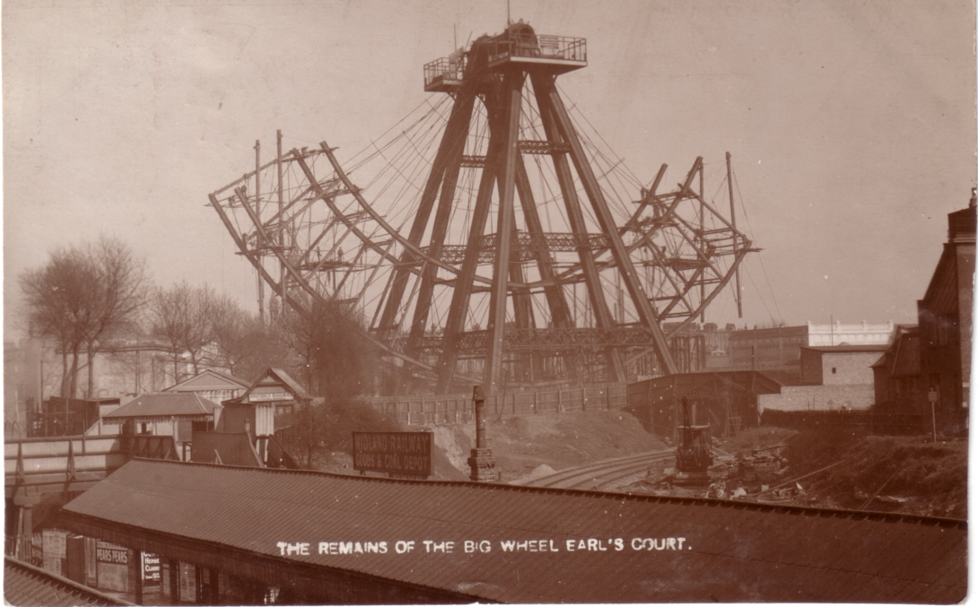

The Wheel was purchased for dismantling by George Cohen, Sons & Co.,
Scrap Iron Merchants, 600, Commercial Road, |London, E.

Alan wishes to record his thanks for information and maps supplied by Christine Bayliss of Hammersmith & Fulham Archives, and to Arthur Smith, who are both members of the Study Group, to Keith Whitehouse for information, and to the staff at the Guildhall Library, London for access to ‘The Times’ of April 30th 1895 and to ‘Engineering’ of May 3rd 1895.

13th Annual Convention 1999

The last weekend in September saw 20 of us down at Portsmouth for our Annual Convention. This should have been at Wembley but was re-located to Portsmouth owing to us being informed that The Century at Wembley was being demolished. We started with our President Fred Peskett in his third year welcoming members. The A.G.M. did not take long as there was no contentious matters to come up. In his report Bill Tonkin the secretary said he thought that the time was coming when we must seriously consider either an assistant secretary or a Journal editor. He has been in hospital three times this year, and is not immortal. It is important that there is a stand in waiting in the wings ready to take over. There were no volunteers for either post.
Alan Sabey gave a brief report on our financial position which is very healthy, owing largely to having had sponsors who pay the postage costs, and print the Journal. A vote of thanks was given to Kenneth Tonkin who has undertaken this. Mike Perkins gave a report on the packet which is still going strong. Nearly £1,000 of postcards, stickers and postal history items was sold bringing in commission of £98.77. Peter Denly was voted on to the committee, apart from this there were no alterations to our line up of officers and committee.
It was decided we shall meet in Portsmouth for 2000, and in Glasgow for 2001 when Stanley Hunter offered to see to the arrangements.
The first display of the day was given by Stanley Hunter and concerned the two visits of Buffalo Bill and his circus to Glasgow. Not only has Stanley an incredible knowledge of even the most obscure Scottish Events, but he is a good speaker, and a joy to listen to.

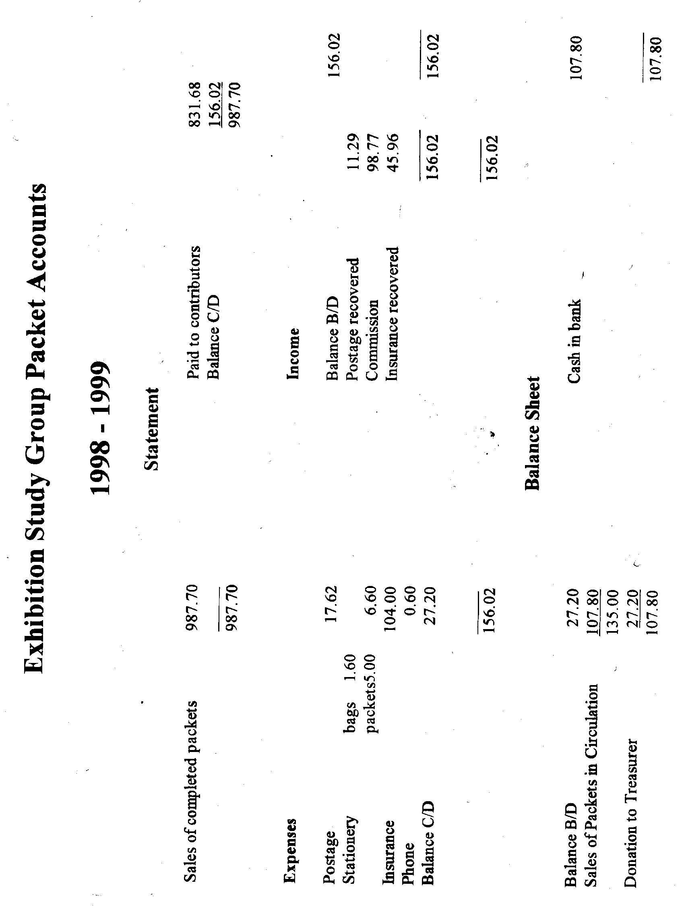

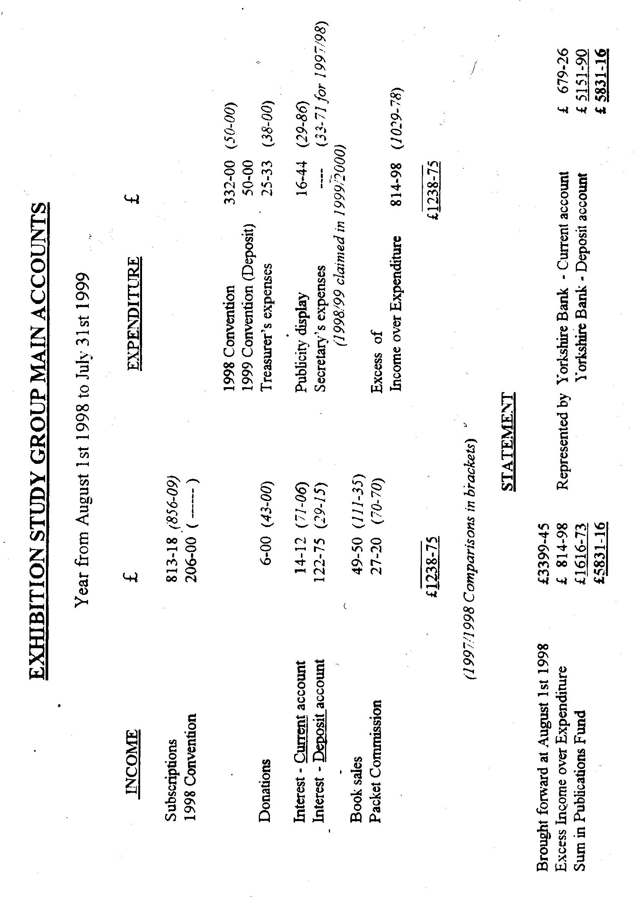

The next speaker was Ron Trevelyan who covered the 1893 and 1933 Chicago World’s Fairs, he was followed by Alan Sabey with a display of the 1908 Olympic Games postcards and cancellations on the relevant days of the games. There were no special cancellations used for the games, but Olympic collectors look for the Franco-British Exhibition handstamp used on the days when events took place. Allan was able to show some of these dates on both the Franco-British and the Ballymaclinton postmarks.
Bill Tonkin gave members a pre-view of the display put on by several members of the Group to be shown at ‘Collect 99’ on rare British Empire Exhibition postcards. Amongst the rarities shown was the set of seven Copes Bros. advertising cards the first time a complete set has ever been shown.
Bob Tough gave a display of the many exhibitions held at Olympia, from the International Horse Show to the Royal Tournament. 1999 sadly saw the last Tournament to be held, it was started in 1880. The last display on the Saturday was by Godfrey Evans who gave a talk and showed a video of the Souvenir Exhibition held at the National Museum of Scotland where Godfrey is curator. Before we finished Bill auctioned some items sent to him by Andrew Brooks, with the request that the money raised should be used to provide wine for members dining that evening. This raised the sum of £55 Peter Denly and Ron Trevelyan were entrusted to spend this to the best advantage at the local Thresher Wine Shop. In the event they only spent £25 so there was a surplus of £30 left over to be spent at our next convention in 2000. Andrew’s health was toasted at our dinner Saturday evening, and a pleasant time was had by all.
The displays on Sunday was started off by Don Knight who showed Festival of Britain material. This included an artist drawn postcard of the Travelling Exhibition, this was a previously unknown card, never seen before by Fred Peskett, George Simner or Bill, or anyone else for that matter.
This was followed by a thematic stamp display on the Olympic Games by Alan Sabey, and Fred Peskett concluded the displays with ‘Gems of the Great Exhibition’. The rest of the morning was spent looking at videos of exhibition related subjects including Freds appearance in Collectors World.

Post Cards of the White City
Part 13.
by
Bill Tonkin

Rapid Photo Printing Co., Ltd. London, E. C. The
The Rapid Photo Co. published several series of cards for the Franco-British and the Imperial International Exhibitions. The views were the same in types 1, 2 and 3. The imprint down the left side of the back comes in three types. In type A. ‘The Rapid Photo Printing Co., Ltd., London, E.C.’ is in one line in capital letters, all of the same height. This type A. imprint appears on nearly all Rapid postcards and it was not felt necessary to list each card as type A., it is only listed where types B. and C are known.. In type B. all the initial letters of each word of the imprint is in a larger size capital letter, this is listed as ‘Type B. with large initial letters.’ In type C. the imprint is now in two lines with the addition of ‘Printed in England’ as the second line.
Type 1. Sepia R/Photo plate sunk with large white borders, brown back. All the titles are preceded with ‘The Franco-British Exhibition.’ in bold letters.
P.S. 263-1. The Lake in the Court of Honour.
P.S. 263-2. The Stone and Mineral Products of the Australian Colonies. Vert left.
P.S. 263-3. The Court of Honour.
P.S. 263-4. The Stadium.
P.S. 263-5. The Court of Honour.
P.S. 263-6. The Indian Palace.
Note. In addition to P.S. 236-6. in the bottom left corner, this card is also known with ‘Rapid Photo Co. E.C.’ in the bottom right corner.
P.S. 263-7. The Court of Honour.
Note. On this card the number is in the bottom right corner.
P.S. 263-8. The Court of Honour by Night.
P.S. 263-9. Palace of Women’s Work.
P.S. 263-10. The Flip-Flap. Vert left.
P.S. 263-11. The Palace of Music.
P.S. 263-12. The Scenic Railway.

Type 2. B/W and Sepia R/Photo with white border, brown back. All the titles are preceded with ‘The Franco-British Exhibition.’ in bold letters, and ‘Rapid Photo. E C’ in bottom right corner. There can be some difficulty in sorting the B/W and sepia, as some of the sepia cards are so dark as to be almost black.
V.384. 1 The Lake in the Court of Honour.
A. B/W.
Imprint type A. letters all the same height.
Imprint type B. with large initial letters
B. Sepia.
V 384. 2 The Stone and Mineral Products of the Australian Colonies.
A. B/W. B. Vert left.
B. Sepia. A. Vert right.
B. Vert left.
V 384. 3 The Court of Honour.
A. B/W.
B. Sepia.
V 384. 5 The Court of Honour.
A. B/W.
B. Sepia.
V 384. 6 The Indian Palace.
B. Sepia.
V 384. 7 The Court of Honour.
B. Sepia.
V 384. 8 The Court of Honour by Night.
A. B/W.
B. Sepia.
V 384. 9 Palace of Women’s Work.
B. Sepia.
V 384. 10 The Flip-Flap.
B. Sepia. A. Vert right.
B. Vert left.
V 384. 11 The Palace of Music.
B. Sepia.
Imprint type A. letters all the same height.
Imprint type C. in two lines with ‘Printed in England.’
V 384. 12 The Scenic Railway.
B. Sepia.
Imprint type A. letters all the same height.
Imprint type C. in two lines with ‘Printed in England.’
V 384. 13 The Stadium Taken from the Flip-Flap.
B. Sepia.
V 384. 14 Entrance to the Franco-British Exhibition.
B. Sepia. A. Vert right.
B. Vert left.
V 384. 15 The Indian Arena, Elephants Shooting the Chute.
B. Sepia.
V 384. 16 Wood Lane Entrance.
B. Sepia. A. Vert right.
V 384. 17 Wood Lane Entrance.
B. Sepia.

Type 3. Sepia R/Photo with the view which is the same as in types 1 and 2 are slightly reduced in depth to give room for a second title printed in manuscript at the bottom, this is listed in italics. The original title has been re-written and is now in the picture, instead of underneath as previously. There is also an additional picture in a small circular frame within the view. This is listed in brackets.
C. 390-1. The Lake, The Franco-British Exhibition. (Two people about to kiss by gate.)
Why we were late in returning home from the Exhibition.
C. 390-2. The Stone and Mineral Products of the Australian Colonies. The Franco-British Exhibition. (Two small children in tin bath.) Other products not so numerous in Australia. Vert right.
C. 390-3. The Court of Honour, The Franco-British Exhibition. (Man with barrel of Beer.)
I could not get enough to drink at the Exhibition otherwise than this.
C. 390-5. The Stadium, Franco-British Exhibition. (Bulldog and Poodle at table with a bottle of beer.) “L’Entente Cordiale” Interval for refreshments during the contests
Note. The second title is printed and not in manuscript.
C. 390-6. The Flip-Flap. (Couple kissing.) Having a high time at the Exhibition.

Type 4. R/Photo, brown back. Only one card from this series has so far been seen. It is likely that all the titles are preceded with ‘Imperial International Exhibition.’ in bold letters.
V 407-9 Lagoon, Court of Arts.
Imprint type C. in two lines with ‘Printed in England.’

Type 5. Very dark sepia R/Photo with brown back. Titled ‘Franco-British Conundrums’. This series of cards shows two pictures, usually of the exhibition but not always, in round and oblong frames. There is also a conundrum on the card. See note under type 2 regarding difficulty in sorting B/W and sepia.
C. 1072-1. Flip-Flap, Scenic Railway.
C. 1072-2. No title.(Two Lions) Palace of Music.
Note. This card is known with an overprint on the back ‘With Best Wishes for a Bright & Happy Christmas. From.....................
C. 1072-3. No title.(Couple kissing) Indian Arena.
C. 1072-4. No title. (Couple under umbrella) Palace of Women’s Work.
C. 1072-5. No title.(Ruined man) Palace of Woman’s Work.

Renard Road and Rail Transport Corporation, Ltd. The
A rubber stamp of the above firm in two lines is known on the back of the Valentine card showing the Renard Road Train.
Renard Road Train, Franco-British Exhibition, London, 1908.
For other cards of this view see in Valentine’s section under Exhibition Railway.

Ridgways Teas.
Cards from the Formosa Oolong Tea series are known overprinted on the front with ‘Ridgways Teas’ in blue.

Rival Photographic Series. See under Gottschalk, Dreyfus & Davis.

Robinson & Cleaver Ltd.
Robinson & Cleaver manufacturers of Irish linen, published two types of cards for the Franco-British Exhibition.
Type 1. Coloured advert card, black back with ‘BOOK CARD’ and Robinson & Cleaver’s address at the bottom. This card which is larger than the normal post card size, and measures 153mm x 110mm is sometimes found cut down to normal post card size. An uncut version should have large white borders.
Robinson & Cleaver’s Ltd. Exhibit, Linen Loom Cottage, Ballymaclinton.

Type 2. B/W trade cards showing various aspects of their exhibit, black back.
Robinson & Cleaver’s Exhibits, Hand Loom Damask Weaving.(Back with advertising text.)
Robinson & Cleaver’s Exhibit of Irish Linens.(Back inverted with view of the Royal Irish Linen Warehouse, Belfast.)

Rood Bros.
Rood Bros. were using remaindered Valentine’s Great White City and Franco-British Exhibition cards to notify customers that their representative would be calling. They seem to have been used from 1916 and no dates earlier than this are known to the author. It would appear Rood’s employed three travellers, Mr Hill, Mr Sears and Mr Tomlin, as well as one of the brothers who also went out on the road. The cards have type written messages on the back in purple.
Mr Hill.
The message reads “Dear Sir or Madam, our Mr Hill hopes to have the pleasure of calling upon you on Monday, Yours truly, Rood Bros.” Four examples are known all mentioning Monday as the day of call.
586 Scottish Village Post Office, Great White City, London. dated 14 July 17.
586 Scottish Village Post Office, Great White City, London. dated 28 July 17.
N.n. Multi view card (type 1.) dated August 11 17.
N.n. Multi view card (type 1.) dated August 11 17.
Note. The last two are to different shops in Sholing, Hants.

Mr Rood.
The message reads “Dear Sir or Madam, our Mr Rood hopes to have the pleasure of calling upon you on Weds, Yours truly, Rood Bros.”
N.n. Court of Honour, Franco-British Exhibition, London 1908. Not postally used

Mr Sears.
The message reads “Dear Sir or Madam, our Mr Sears hopes to have the pleasure of calling upon you on Fri, Yours truly, Rood Bros.”
N.n. Palace of Music, Franco-British Exhibition, London, 1908. Vert right.
dated Jul 21 17

Mr Tomlin.
The message reads “Dear Sir or Madam, our Mr Tomlin hopes to have the pleasure of calling upon you during the coming week, Yours truly, Rood Bros.”
N.n. French Applied Arts Palace, Franco-British Exhibition, London, 1908.
dated Jun 17 16

Rotary.
Rotary were a very prolific printer and publisher of postcards, which they sold under their own name. They also printed many cards which were published by various manufacturers as advert or trade cards. Apart from most of the White City exhibitions, the Franco-British (six series), the Imperial International (three series), the Japan-British (three series), the Coronation (two series) and the Latin-British (one series), Rotary also covered virtually all the important exhibitions, including the 1911 Glasgow, 1911 Crystal Palace Festival of Empire, 1912 Shakespeare’s England at Earl’s Court, and the 1909 English Church Pageant. They produced R/Photo cards of a very high quality, but they were never able, or perhaps never bothered to produce a standard back for their cards. ‘POST CARD’ was produced in four different measurements, and in two different fonts. Even the full stop after ‘POST CARD’ seemed to be used in a very casual manner, sometimes it’s there, sometimes it’s not. In some series the stop comes in four different sizes, and the difference is so great you can almost measure it, but the size of the stop is not listed.
The measurement for ‘POST CARD’ is given for the words and does not include the stop if there is one.
Type A. ‘POST CARD’ measured 37mm
Type B. ‘POST CARD’ measured 38mm
Type C. ‘POST CARD’ measured 39mm
Type D. ‘POST CARD’ measured 40mm
Type E. ‘POST CARD’ in a large thin font measures 40mm.
‘POST CARD with full stop’ or ‘without full stop’ is listed. ‘Rotary Photographic Series’ down the left side of the back also varies slightlu in length, but this is not listed.
Franco-British Exhibition, Type 1. P. 738. Boudoir Plate Sunk Series. Sepia R/Photo, plate sunk with large white border, brown back. All the titles are preceded with ‘The Franco-British Exhibition’. ‘POST CARD’ comes in several measurements, and sometimes has a full stop but not always. Even the full stop comes in four distinct sizes from a very small dot to a very large dot.
P. 738. A “Palace of Music.”
D. ‘POST CARD’ measures 40mm, with full stop.
P. 738. B “Palace of Women’s Work.”
C. ‘POST CARD’ measures 39mm, with full stop.
P. 738. C “Palace of British Applied Arts.”
A. ‘POST CARD’ measures 37mm, with full stop.
P. 738. D “Palace of French Applied Arts.”
A. ‘POST CARD’ measures 37mm, with full stop.
P. 738. E “Royal Pavilion.”
D. ‘POST CARD’ measures 40mm, with full stop.
P. 738. F. “Indian Palace.”
C. ‘POST CARD’ measures 39mm, with full stop.
P. 738. H The Stadium.
C. ‘POST CARD’ measures 39mm, with full stop.
P. 738. I “Fine Art Palace.”
C. ‘POST CARD’ measures 39mm, with full stop.
P. 738. J. “Court of Honour.”
C. ‘POST CARD’ measures 39mm, with full stop.
P. 738. K. “Court of Honour.”
C. ‘POST CARD’ measures 39mm, with full stop.
P. 738. M. “Court of Honour by Night.”
A. ‘POST CARD’ measures 37mm, with full stop.
P. 738. N. “Court of Honour.”
A. ‘POST CARD’ measures 37mm, with full stop.
P. 738. O “Palace of British Applied Arts.”
A. ‘POST CARD’ measures 37mm, with full stop.
P. 738. Q “Grand Band Stand & Cascade.”
A. ‘POST CARD’ measures 37mm, without full stop.
P. 738. R. “Machinery Hall.”
D. ‘POST CARD’ measures 40mm, with full stop.
P. 738. S. “Elite Gardens & Franco-British Pavilion.”
D. ‘POST CARD’ measures 40mm, with full stop.
P. 738. T Main Entrance.
C. ‘POST CARD’ measures 39mm, with full stop. Vert right.
P. 738. V The Stadium.
C. ‘POST CARD’ measures 39mm, with full stop.
P. 738. W “Birds Eye View.”
A. ‘POST CARD’ measures 37mm, with full stop.
P. 738. X. “New Zealand Pavilion.”
D. ‘POST CARD’ measures 40mm, with full stop.
P. 738. Y “Australian Pavilion.”
C. ‘POST CARD’ measures 39mm, with full stop.
P. 738. Z. “Canadian Pavilion.”
D. ‘POST CARD’ measures 40mm, without full stop.

Franco-British Exhibition, Type 2. P. 1935. Boudoir Plate Sunk Series. Sepia R/Photo, plate sunk with large white border, brown back. All the titles are preceded with ‘The Franco-British Exhibition’. As very few of this series has come to light it is not known if ‘POST CARD’ comes in several measurements as in type 1. As it is possible the measurements are given.
P. 1935 B “Court of Honour.”
D. ‘POST CARD’ measures 40mm, with full stop.
P. 1935. E. “Garden Club.”
D. ‘POST CARD’ measures 40mm, with full stop.

Franco-British Exhibition, Type 3. 2451. Photographic Series. Sepia R/Photo, brown back. It is not known if this is one of a series of exhibition cards, from the subject it could well be, but it is surprising that no other cards have turned up.
2451 O H.M. King Edward & President Fallières. Vert right.
D. ‘POST CARD’ measures 40mm, with full stop.

Franco-British Exhibition, Type 4. 6741. Photographic Series. Sepia R/Photo, brown back. On the only two cards seen of this series both have two small oval frames in the top corners, on the left a picture of President Fallières, and on the right a picture of H.M. King Edward VII.
6741 A Franco-British Exhibition. 1908.
D. ‘POST CARD’ measures 40mm, with full stop.
D. ‘POST CARD’ measures 40mm, without full stop.
6741 C Franco-British Exhibition. Court of Honour.
D. ‘POST CARD’ measures 40mm, with full stop.

Franco-British Exhibition, Type 5. 6742. Photographic Series. Sepia R/Photo, brown back. There is possibly only one card in this series, there are two large oval frames with flags each side of a shield, on the left a picture of President Fallières below ‘Vive le President’, and on the right a picture of H.M. King Edward VII below ‘Long Live our King’.
6742.A. Souvenir L’Entente Cordiale. (In scrolls)
A. ‘POST CARD’ measures 37mm, without full stop.

Franco-British Exhibition, Type 6. 6791. Photographic Series. Sepia R/Photo, brown back. All the titles are preceded with ‘The Franco-British Exhibition.’
6791 A Grand Band Stand & Cascade. The top left corner shows part of the roof of an adjacent building
C. ‘POST CARD’ measures 39mm, with full stop.
D. ‘POST CARD’ measures 40mm, with full stop.
6791 A Grand Band Stand & Cascade. . The roof of an adjacent building has been removed from the top left corner.
C. ‘POST CARD’ measures 39mm, with full stop.
D. ‘POST CARD’ measures 40mm, with full stop.
6791 B The Palace of Music.
A. ‘POST CARD’ measures 37mm, with full stop.
C. ‘POST CARD’ measures 39mm, with full stop.
6791 C The Palace of Women’s Work.
A. ‘POST CARD’ measures 37mm, without full stop.
C. ‘POST CARD’ measures 39mm, with full stop.
D. ‘POST CARD’ measures 40mm, with full stop.
6791 D The Palace of British Applied Art.
A. ‘POST CARD’ measures 37mm, with full stop.
D. ‘POST CARD’ measures 40mm, with full stop.
6791 E The Palace of French Applied Art.
A. ‘POST CARD’ measures 37mm, with full stop.
D. ‘POST CARD’ measures 40mm, with full stop.
6791 F The Royal Pavilion.
A. ‘POST CARD’ measures 37mm, with full stop.
C. ‘POST CARD’ measures 39mm, with full stop.
D. ‘POST CARD’ measures 40mm, with full stop.
6791 G The Indian Palace.
A. ‘POST CARD’ measures 37mm, with full stop.
A. ‘POST CARD’ measures 37mm, without full stop.
C. ‘POST CARD’ measures 39mm, with full stop.
6791 H The Court of Honour.
A. ‘POST CARD’ measures 37mm, with full stop.
D. ‘POST CARD’ measures 40mm, with full stop.
D. ‘POST CARD’ measures 40mm, without full stop.
6791 I The Stadium.
A. ‘POST CARD’ measures 37mm, without full stop.
C. ‘POST CARD’ measures 39mm, with full stop.
D. ‘POST CARD’ measures 40mm, with full stop.
6791 J Fine Art Palace.
C. ‘POST CARD’ measures 39mm, with full stop.
D. ‘POST CARD’ measures 40mm, with full stop.
6791 K Court of Honour.
A. ‘POST CARD’ measures 37mm, with full stop.
A. ‘POST CARD’ measures 37mm, without full stop.
B. ‘POST CARD’ measures 38mm, with full stop.
D. ‘POST CARD’ measures 40mm, with full stop.
6791 L Court of Honour.
A. ‘POST CARD’ measures 37mm, without full stop.
C. ‘POST CARD’ measures 39mm, with full stop.
D. ‘POST CARD’ measures 40mm, with full stop.
6791 M The Palace of Women’s Work.
A. ‘POST CARD’ measures 37mm, with full stop.
C. ‘POST CARD’ measures 39mm, with full stop.
D. ‘POST CARD’ measures 40mm, with full stop.
6791 N Court of Honour by Night.
A. ‘POST CARD’ measures 37mm, with full stop.
C. ‘POST CARD’ measures 39mm, with full stop.
6791 O The Court of Honour.
A. ‘POST CARD’ measures 37mm, with full stop.
C. ‘POST CARD’ measures 39mm, with full stop.
D. ‘POST CARD’ measures 40mm, with full stop.
6791 P The Palace of British Applied Arts.
A. ‘POST CARD’ measures 37mm, with full stop.
D. ‘POST CARD’ measures 40mm, with full stop.
D. ‘POST CARD’ measures 40mm, without full stop.
6791 Q The Court of Arts.
D. ‘POST CARD’ measures 40mm, with full stop.
6791 R The Machinery Hall.
A. ‘POST CARD’ measures 37mm, with full stop.
D. ‘POST CARD’ measures 40mm, with full stop.
Note. This card is also known printed with the wrong number and reads 6971 R. Cards with backs type A and D exist both with stops.
6791 S Elite Gardens & Franco-British Pavilion.
C. ‘POST CARD’ measures 39mm, with full stop.
D. ‘POST CARD’ measures 40mm, with full stop.
Note. This card is also known printed with the wrong number and reads 6971 S. The card has a type D back without stop.
6791 T Wood Lane Entrance.
D. ‘POST CARD’ measures 40mm, with full stop.
6791 U Main Entrance. Vert right.
A. ‘POST CARD’ measures 37mm, with full stop. Vert right.
6791 V Birds-eye View of the Stadium from Balloon.
D. ‘POST CARD’ measures 40mm, with full stop.
6791 W Birds-eye View from Balloon.
A. ‘POST CARD’ measures 37mm, with full stop.
D. ‘POST CARD’ measures 40mm, with full stop.
6791 X New Zealand Pavilion.
D. ‘POST CARD’ measures 40mm, with full stop.
6791 Y Australian Pavilion.
A. ‘POST CARD’ measures 37mm, with full stop.
D. ‘POST CARD’ measures 40mm, with full stop.
6791 Z Canadian Pavilion.
A. ‘POST CARD’ measures 37mm, without full stop.
C. ‘POST CARD’ measures 39mm, with full stop.
D. ‘POST CARD’ measures 40mm, with full stop.

Franco-British Exhibition, Type 7. 6792. Photographic Series. Sepia R/Photo, brown back. All the titles are preceded with ‘The Franco-British Exhibition.’
6792 A Court of Arts.
D. ‘POST CARD’ measures 40mm, with full stop.
6792 B Court of Honour.
D. ‘POST CARD’ measures 40mm, with full stop.
6792 C Court of Honour.
D. ‘POST CARD’ measures 40mm, with full stop.
D. ‘POST CARD’ measures 40mm, without full stop.
6792 D Garden of Progress.
D. ‘POST CARD’ measures 40mm, with full stop.
6792 E The Garden Club.
A. ‘POST CARD’ measures 37mm, with full stop.
D. ‘POST CARD’ measures 40mm, with full stop.
6792 G House of McKinley.
D. ‘POST CARD’ measures 40mm, with full stop.
6792 H “Irish Village”
D. ‘POST CARD’ measures 40mm, with full stop.
6792 I “Irish Village”
D. ‘POST CARD’ measures 40mm, with full stop.
6792 J Flip-Flap.
D. ‘POST CARD’ measures 40mm, with full stop.
6792 K Flip-Flap.
D. ‘POST CARD’ measures 40mm, with full stop. Vert right.
6792 L Flip-Flap.
D. ‘POST CARD’ measures 40mm, with full stop. Vert right.
6792 M Scenic Railway.
A. ‘POST CARD’ measures 37mm, with full stop.
6792 N Scenic Railway.
A. ‘POST CARD’ measures 37mm, with full stop.
D. ‘POST CARD’ measures 40mm, with full stop.
6792 O Scenic Railway.
D. ‘POST CARD’ measures 40mm, with full stop.

Imperial International Exhibition, Type 8 6793. Photographic Series. Sepia R/Photo, brown back. All the titles are preceded with ‘Imperial International Exhibition, London, 1909.’
6793 C Chemistry Hall.
D. ‘POST CARD’ measures 40mm, with full stop.
6793 E Fine Art Palace.
D. ‘POST CARD’ measures 40mm, with full stop.
6793 H Wood Lane Station Entrance.
D. ‘POST CARD’ measures 40mm, without full stop.
6793 I Palace of Music.
D. ‘POST CARD’ measures 40mm, with full stop.
6793 J Court of Honour.
D. ‘POST CARD’ measures 40mm, with full stop.
6793 K Court of Honour.
D. ‘POST CARD’ measures 40mm, with full stop.
6793 L Court of Honour.
A. ‘POST CARD’ measures 37mm, with full stop.
D. ‘POST CARD’ measures 40mm, with full stop.
6793 M Scenic Railway.
D. ‘POST CARD’ measures 40mm, with full stop.
6793 N Scenic Railway.
C. ‘POST CARD’ measures 39mm, with full stop.
D. ‘POST CARD’ measures 40mm, without full stop.
6793 P Flip-Flap. Vert right.
D. ‘POST CARD’ measures 40mm, with full stop.
6793 Q Flip-Flap. Vert right.
D. ‘POST CARD’ measures 40mm, with full stop.
6793 R Flip-Flap.
D. ‘POST CARD’ measures 40mm, with full stop.
6793 S Irish Village.
B. ‘POST CARD’ measures 38mm, with full stop.
D. ‘POST CARD’ measures 40mm, with full stop.
6793 U Irish Village, “Home of McKinley”
D. ‘POST CARD’ measures 40mm, with full stop.
6793 W New Zealand Pavilion.
D. ‘POST CARD’ measures 40mm, with full stop.
6793 X The Witching Waves.
D. ‘POST CARD’ measures 40mm, with full stop.
6793 Y Dahomey Village.
D. ‘POST CARD’ measures 40mm, with full stop.
6793 Z The Imperial Pavilion.
D. ‘POST CARD’ measures 40mm, with full stop.

Imperial International Exhibition, Type 9. 6794. Photographic Series. Sepia R/Photo, brown back. All the titles are preceded with ‘Imperial International Exhibition, London, 1909.’ Some of these cards have an overprint on the back in blue reading ‘Hearty good Wishes’ and a four line poem.
6794 A The Imperial Pavilion.
D. ‘POST CARD’ measures 40mm, with full stop.
6794 B Court of Honour by Night.
C. ‘POST CARD’ measures 39mm, with full stop.
D. ‘POST CARD’ measures 40mm, without full stop.
6794 C The Court of Honour.
D. ‘POST CARD’ measures 40mm, with full stop.
6794 D Birds-eye View of the Stadium, from Balloon.
D. ‘POST CARD’ measures 40mm, with full stop.
6794 E The Scottish Village.
D. ‘POST CARD’ measures 40mm, with full stop.
6794 F The Imperial Pavilion.
D. ‘POST CARD’ measures 40mm, with full stop.
6794 G General View.
D. ‘POST CARD’ measures 40mm, with full stop.
6794 H Health & Pleasure Resort.
B. ‘POST CARD’ measures 38mm, with full stop.
6794 I The Imperial Pavilion.
D. ‘POST CARD’ measures 40mm, with full stop.
6794 J The Imperial Pavilion & Women’s Palace.
D. ‘POST CARD’ measures 40mm, with full stop.
6794 K Historical Government & Industrial Exhibits.
D. ‘POST CARD’ measures 40mm, with full stop.
6794 L Elite Gardens from Imperial Pavilion.
A. ‘POST CARD’ measures 37mm, without full stop.
9694 N Imperial Pavilion & Women’s Palace by Night.
C. ‘POST CARD’ measures 39mm, with full stop.
6794 O Imperial Pavilion by Night.
D. ‘POST CARD’ measures 40mm, with full stop.
6794 P Court of Arts by Night.
D. ‘POST CARD’ measures 40mm, with full stop.
6794 Q Imperial Pavilion
D. ‘POST CARD’ measures 40mm, with full stop. Vert right.
6794 R Woman’s Palace.
D. ‘POST CARD’ measures 40mm, with full stop.
6794 S Court of Honour by Night.
D. ‘POST CARD’ measures 40mm, with full stop.
6794 T Court of Honour by Night.
D. ‘POST CARD’ measures 40mm, with full stop.
6794 U The Cascade.
D. ‘POST CARD’ measures 40mm, with full stop. Vert right.
6794 V Elite Gardens.
A. ‘POST CARD’ measures 37mm, with full stop.
B. ‘POST CARD’ measures 38mm, with full stop.
6794 W Motor Racing Tracks.
D. ‘POST CARD’ measures 40mm, with full stop.
6794 Y Birds-eye View.
D. ‘POST CARD’ measures 40mm, with full stop.
6794 Z Court of Arts.
D. ‘POST CARD’ measures 40mm, with full stop.

Imperial International Exhibition, Type 10. 6795. Photographic Series. Sepia R/Photo, brown back. All the titles are preceded with ‘Imperial International Exhibition, London, 1909.’
6795 A Court of Arts & Women’s Palace.
C. ‘POST CARD’ measures 39mm, with full stop.
6795 B Court of Honour.
D. ‘POST CARD’ measures 40mm, with full stop.
6795 C Witching Waves.
D. ‘POST CARD’ measures 40mm, with full stop.
6795 D The Cascade by Night.
D. ‘POST CARD’ measures 40mm, with full stop. Vert right.
6795 E Imperial Pavilion.
D. ‘POST CARD’ measures 40mm, with full stop.
6795 F Chinese Pavilion.
C. ‘POST CARD’ measures 39mm, with full stop.
6795 I On the Lagoon.
D. ‘POST CARD’ measures 40mm, with full stop.
6795 J On the Lagoon. Vert right.
D. ‘POST CARD’ measures 40mm, with full stop. Vert right.
6795 K The Alpine Excelsior Railway.
D. ‘POST CARD’ measures 40mm, without full stop.
6795 L The Alpine Excelsior Railway.
D. ‘POST CARD’ measures 40mm, with full stop.
6795 M Court of Arts, shewing Palace of Applied Arts & Imperial Pavilion.
D. ‘POST CARD’ measures 40mm, with full stop.
6795 N On the Lagoon by Night.
D. ‘POST CARD’ measures 40mm, with full stop.
6795 O Industrial & Machinery Hall by Night.
A. ‘POST CARD’ measures 37mm, with full stop.
6795 P Daily Mail Building by Night.
D. ‘POST CARD’ measures 40mm, with full stop.
6795 Q Palace of Applied Arts by Night.
D. ‘POST CARD’ measures 40mm, with full stop.
6795 R Dahomey Village. Vert right.
D. ‘POST CARD’ measures 40mm, with full stop. Vert right.
6795 S Carl Hagenbeck’s Arctic and Tropical Sensation.
D. ‘POST CARD’ measures 40mm, with full stop.
6795 T The Alpine Excelsior Railway.
D. ‘POST CARD’ measures 40mm, with full stop. Vert right.
6795 W Women’s Palace by Night.
D. ‘POST CARD’ measures 40mm, with full stop.

Japan-British Exhibition, Type 11. 6796. Photographic Series. Sepia R/Photo, brown back. All the titles are preceded with ‘Japan-British Exhibition 1910.’ Some of the cards have a small picture of a Japanese nature in a small oval frame. Where this is so it is noted in brackets. ‘POST CARD’ is printed in two types of font, the usual one and a much larger and thinner type. Some of these cards have an overprint on the back in blue reading ‘Hearty good Wishes’ and a four line poem, the same as in series 6794.
6796 B Garden Club.
E. ‘POST CARD’ in a large thin font measures 40mm, with full stop.
6796 C Court of Honour.
E. ‘POST CARD’ in a large thin font measures 40mm, with full stop.
6796 D Court of Honour. (Portrait of Japanese girl.)
B. ‘POST CARD’ measures 38mm, with full stop.
B. ‘POST CARD’ measures 38mm, without full stop.
6796 F Scenic Railway. (Portrait of Japanese girl.)
D. ‘POST CARD’ measures 40mm, with full stop.
E. ‘POST CARD’ in a large thin font measures 40mm, with full stop.
6796 G Scenic Railway.
D. ‘POST CARD’ measures 40mm, without full stop.
6796 H Scenic Railway.
D. ‘POST CARD’ measures 40mm, without full stop.
E. ‘POST CARD’ in a large thin font measures 40mm, with full stop.
6796 I Flip-Flap. (Portrait of Japanese girl.)
D. ‘POST CARD’ measures 40mm, with full stop. Vert right.
E. ‘POST CARD’ in a large thin font measures 40mm, with full stop.
Vert right.
6796 J Flip-Flap. Vert right.
D. ‘POST CARD’ measures 40mm, with full stop.
E. ‘POST CARD’ in a large thin font measures 40mm, with full stop.
6796 K Flip-Flap. (Portraits of two Japanese girls.)
B. ‘POST CARD’ measures 38mm, with full stop.
D. ‘POST CARD’ measures 40mm, with full stop.
E. ‘POST CARD’ in a large thin font measures 40mm, with full stop.
6796 L Imperial Pavilion.
D. ‘POST CARD’ measures 40mm, without full stop.
6796 M The Imperial Pavilion.
D. ‘POST CARD’ measures 40mm, without full stop.
E. ‘POST CARD’ in a large thin font measures 40mm, with full stop.
6796 N Court of Honour by Night.
E. ‘POST CARD’ in a large thin font measures 40mm, with full stop.
6796 P Imperial Pavilion. (Japanese girl with sunshade.)
D. ‘POST CARD’ measures 40mm, with full stop.
E. ‘POST CARD’ in a large thin font measures 40mm, with full stop.
6796 Q Imperial Pavilion. (Portrait of Japanese girl.)
C. ‘POST CARD’ measures 39mm, without full stop.
D. ‘POST CARD’ measures 40mm, with full stop.
6796 R General View.
E. ‘POST CARD’ in a large thin font measures 40mm, with full stop.
6796 S Imperial Pavilion.
D. ‘POST CARD’ measures 40mm, without full stop.
E. ‘POST CARD’ in a large thin font measures 40mm, with full stop.
6796 T Court of Honour by Night.
D. ‘POST CARD’ measures 40mm, without full stop.
6796 U Imperial Pavilion.
B. ‘POST CARD’ measures 38mm, without full stop.
E. ‘POST CARD’ in a large thin font measures 40mm, with full stop.
Vert right.
6796 V Court of Honour by Night.
D. ‘POST CARD’ measures 40mm, with full stop.
6796 X The Cascade. Vert right.
B. ‘POST CARD’ measures 38mm, without full stop.
D. ‘POST CARD’ measures 40mm, without full stop.
E. ‘POST CARD’ in a large thin font measures 40mm, with full stop.
6796 Y Elite Gardens.
D. ‘POST CARD’ measures 40mm, without full stop.
E. ‘POST CARD’ in a large thin font measures 40mm, with full stop.
6796 Z Birds-eye View.
A. ‘POST CARD’ measures 37mm, with full stop.
D. ‘POST CARD’ measures 40mm, with full stop.

Japan-British Exhibition, Type 12. 6797. Photographic Series. Sepia R/Photo, brown back. All the titles are preceded with ‘Japan-British Exhibition 1910.’ As in series 10 some of the cards have a small picture of a Japanese nature in a small oval frame. Where this is so it is noted in brackets. ‘POST CARD’ is printed in two types of font, the usual one and a much larger and thinner type.
6797 A Court of Honour.
E. ‘POST CARD’ in a large thin font measures 40mm, with full stop.
6797 C On the Lagoon.
D. ‘POST CARD’ measures 40mm, with full stop.
6797 D On the Lagoon. (Portraits of three Japanese girls.)
D. ‘POST CARD’ measures 40mm, with full stop. Vert right.
D. ‘POST CARD’ measures 40mm, without full stop. Vert right.
6797 E Mountain Railway. (Portrait of Japanese girl.)
D. ‘POST CARD’ measures 40mm, with full stop.
D. ‘POST CARD’ measures 40mm, without full stop.
6797 G General View.
E. ‘POST CARD’ in a large thin font measures 40mm, with full stop.
6797 H Court of Honour by Night. (Portraits of two Japanese girls.)
B. ‘POST CARD’ measures 38mm, with full stop.
D. ‘POST CARD’ measures 40mm, without full stop.
E. ‘POST CARD’ in a large thin font measures 40mm, with full stop.
6797 J Japanese Garden of Peace.
D. ‘POST CARD’ measures 40mm, with full stop.
E. ‘POST CARD’ in a large thin font measures 40mm, with full stop.
6797 K Japanese Garden of Peace showing Japanese Waterside Pavilion.
D. ‘POST CARD’ measures 40mm, without full stop.
E. ‘POST CARD’ in a large thin font measures 40mm, with full stop.
6797 L Japanese Garden of the Floating Islands.
D. ‘POST CARD’ measures 40mm, without full stop.
E. ‘POST CARD’ in a large thin font measures 40mm, with full stop.
6797 M Japanese Garden of the Floating Islands.
D. ‘POST CARD’ measures 40mm, with full stop.
E. ‘POST CARD’ in a large thin font measures 40mm, with full stop.
6797 N Japanese Garden of the Floating Islands.
E. ‘POST CARD’ in a large thin font measures 40mm, with full stop.
6797 O Entrance to Aino Home.
D. ‘POST CARD’ measures 40mm, without full stop.
E. ‘POST CARD’ in a large thin font measures 40mm, with full stop.
6797 P Interior Poetic Japan.
B. ‘POST CARD’ measures 38mm, with full stop.
E. ‘POST CARD’ in a large thin font measures 40mm, with full stop.
6797 Q Poetic Japan.
D. ‘POST CARD’ measures 40mm, without full stop.
E. ‘POST CARD’ in a large thin font measures 40mm, with full stop.
6797 R Imperial Japanese Commission Pavilion.
E. ‘POST CARD’ in a large thin font measures 40mm, with full stop.
6797 S Formosa Hamlet.
D. ‘POST CARD’ measures 40mm, with full stop.
E. ‘POST CARD’ in a large thin font measures 40mm, with full stop.
6797 T Japanese Silk Weaving Room in Poetic Japan.
E. ‘POST CARD’ in a large thin font measures 40mm, with full stop.
6797 U Japanese Fair.
E. ‘POST CARD’ in a large thin font measures 40mm, with full stop.
6797 V Witching Waves.
E. ‘POST CARD’ in a large thin font measures 40mm, with full stop.
6797 W Formosa Tea Room.
E. ‘POST CARD’ in a large thin font measures 40mm, with full stop.
6797 X Japanese Garden of the Floating Islands.
A. ‘POST CARD’ measures 37mm, without full stop.
E. ‘POST CARD’ in a large thin font measures 40mm, with full stop.
6797 Y Japanese Pagoda, showing man on Stilts.
E. ‘POST CARD’ in a large thin font measures 40mm, with full stop.
6797 Z View of Japanese Garden of Peace.
E. ‘POST CARD’ in a large thin font measures 40mm, with full stop.

Japan-British Exhibition, Type 13. 6798. Photographic Series. Sepia R/Photo, brown back. All the titles are preceded with ‘Japan-British Exhibition 1910.’ ‘POST CARD’ is printed in two types of font, the usual one and a much larger and thinner type.
6798 A Japanese Garden of the Floating Islands.
D. ‘POST CARD’ measures 40mm, with full stop.
E. ‘POST CARD’ in a large thin font measures 40mm, with full stop.
6798 B Japanese on Stilts.
E. ‘POST CARD’ in a large thin font measures 40mm, with full stop.
Vert right.
6798 C Interior of Mountain Railway.
D. ‘POST CARD’ measures 40mm, without full stop.
E. ‘POST CARD’ in a large thin font measures 40mm, with full stop.
6798 D Japanese Garden of the Floating Islands.
B. ‘POST CARD’ measures 38mm, without full stop.
E. ‘POST CARD’ in a large thin font measures 40mm, with full stop.
6798 E Japanese Garden of the Floating Islands.
A. ‘POST CARD’ measures 37mm, without full stop.
D. ‘POST CARD’ measures 40mm, with full stop.
6798 F Yachting Cruises.
D. ‘POST CARD’ measures 40mm, with full stop.
D. ‘POST CARD’ measures 40mm, without full stop.
6798 G Great Mountain Railway.
D. ‘POST CARD’ measures 40mm, with full stop.
D. ‘POST CARD’ measures 40mm, without full stop.
6798 I Fine Art Palace.
D. ‘POST CARD’ measures 40mm, with full stop.
6798 L Japanese Government Department.
A. ‘POST CARD’ measures 37mm, without full stop.
6798 N Palace of Japanese Education and Industry.
D. ‘POST CARD’ measures 40mm, without full stop.
6798 O Sunken Bandstands in Elite Gardens.
D. ‘POST CARD’ measures 40mm, with full stop.
E. ‘POST CARD’ in a large thin font measures 40mm, with full stop.
6798 P Japanese Government Department.
D. ‘POST CARD’ measures 40mm, with full stop.

Coronation Exhibition, Type 14. No series number. Photographic Series. Sepia R/Photo, brown back. All the titles are preceded with ‘Coronation Exhibition 1911’. In this series Rotary has used cards left over from previous exhibitions. The margins have been trimmed down, removing the old title and a new title in blue or silver has been printed near the top of the card. Sometimes enough of the top of the old title has been left to identify what series the card came from, and where this is known it has been included in brackets. As there are no numbers the cards (which are fairly scarce) have been listed in alphabetical order.
Court of Honour. (Possibly from Imperial International series 6795 letter B.)
Court of Honour by Night. (Source unidentified.)
Imperial Pavilion. (From Japan-British series 6796 letter M.)

Coronation Exhibition, Type 15. 6800. Photographic Series. Sepia R/Photo, brown back. All the titles are preceded with ‘Coronation Exhibition 1911’. In this series Rotary has stopped using letters of the alphabet to identify their cards and have gone on to a numbering system, the highest number recorded is 47, but there may be others after this. They have also stopped using the large thin ‘POST CARD’. Until now all their cards have had ‘Printed in England’ in place of the stamp box, but in this series this has been altered to ‘Printed in Britain’.
6800-10 Flip-Flap.
D. ‘POST CARD’ measures 40mm, with full stop. Vert right.
6800-11 Flip-Flap.
D. ‘POST CARD’ measures 40mm, with full stop
6800-15 Imperial Pavilion.
D. ‘POST CARD’ measures 40mm, without full stop.
6800-22 Birds-eye View.
D. ‘POST CARD’ measures 40mm, without full stop.
6800-23 Court of Honour.
D. ‘POST CARD’ measures 40mm, without full stop.
6800-24 The Cascade by Night.
D. ‘POST CARD’ measures 40mm, without full stop. Vert right.
6800-25 On the Lagoon.
D. ‘POST CARD’ measures 40mm, without full stop.
6800-26 On the Lagoon.
D. ‘POST CARD’ measures 40mm, without full stop. Vert right.
6800-29 Palace of Music.
D. ‘POST CARD’ measures 40mm, without full stop.
6800-30 General View.
D. ‘POST CARD’ measures 40mm, without full stop.
6800-32 Japanese Gardens.
D. ‘POST CARD’ measures 40mm, without full stop.
6800-34 Japanese Gardens.
B. ‘POST CARD’ measures 38mm, with full stop.
6800-35 Japanese Gardens.
D. ‘POST CARD’ measures 40mm, without full stop.
6800-36 Great Mountain Railway.
D. ‘POST CARD’ measures 40mm, without full stop.
6800-38 Fine Art Palace.
D. ‘POST CARD’ measures 40mm, without full stop.
6800-41 Canadian Pavilion.
D. ‘POST CARD’ measures 40mm, without full stop.
6800-44 Newspapers of the Empire.
D. ‘POST CARD’ measures 40mm, without full stop.
6800-47 The Whirlpool.
D. ‘POST CARD’ measures 40mm, without full stop.

Latin-British Exhibition, Type 16. 6952. Photographic Series. Sepia R/Photo, brown back. All the titles are preceded with ‘Latin-British Exhibition 1912’. Rotary has reverted to using letters of the alphabet to identify their cards and have stopped putting ‘Printed in Britain’ in place of a stamp box, this corner of the card is now left blank.
6952 A Band Stand in Elite Gardens.
D. ‘POST CARD’ measures 40mm, without full stop.
6952 B Caves of Laughter.
D. ‘POST CARD’ measures 40mm, without full stop.
6952 C Catlins Royal Pierrots.
D. ‘POST CARD’ measures 40mm, without full stop.
6952 E The Joy Ride.
D. ‘POST CARD’ measures 40mm, without full stop.
6952 F Court of Honour.
D. ‘POST CARD’ measures 40mm, without full stop.
6952 G Court of Honour & Cascade.
B. ‘POST CARD’ measures 38mm, without full stop.
D. ‘POST CARD’ measures 40mm, without full stop.
6952 H Beneath the Revolving Flip-Flap.
D. ‘POST CARD’ measures 40mm, without full stop.
6952 I The Cascade.
C. ‘POST CARD’ measures 39mm, with full stop. Vert right.
6952 J General View.
D. ‘POST CARD’ measures 40mm, without full stop.
6952 K Court of Honour by Night.
D. ‘POST CARD’ measures 40mm, without full stop.
6952 L Court of Honour by Night.
D. ‘POST CARD’ measures 40mm, without full stop.
6952 M The Cascade by Night.
C. ‘POST CARD’ measures 39mm, without full stop. Vert right.
6952 O Birds-eye View.
D. ‘POST CARD’ measures 40mm, without full stop.
6952 R Latin America.
C. ‘POST CARD’ measures 39mm, without full stop.
6952 T Fine Art Palace.
D. ‘POST CARD’ measures 40mm, without full stop.
6952 W Life-Saving at Sea Appliances.
D. ‘POST CARD’ measures 40mm, without full stop.
6952 X Elite Gardens.
D. ‘POST CARD’ measures 40mm, without full stop.

Franco-British Exhibition, Type 17. 6971. Photographic Series. Several cards are known with 6971 on the front. This is a misprint and should be 6791, they are entered under that series.

Japan-British Exhibition, Type 18. 9931. Photographic Series. Sepia R/Photo, brown back. Only one card is known of this series which may have been published for the Japan-British Exhibition. It has a non exhibition postmark for July 8 1910 so the date is right. It is a card showing a couple in amourous daliance with the lady in Japanese costume, in a studio with a Japanese type back cloth but different from the Millar & Lang and Tuck series.
9931 E “Oh these Geisha Lips!”
E. ‘POST CARD’ in a large thin font measures 40mm, with full stop.
Vert right.

