EDITORIAL AUTUMN 1999

Death Death where is thy sting,
but not before a final fling.

How’s that for a nice morbid couplet, not that I’m thinking of going to the great post card fair in the sky yet, but this business of growing old gracefully, does mean that the sell by date is getting ever nearer. I have been in hospital three times this year so far, and have missed a lot of good fairs.
On a much happier note I have been approached by another film company requiring information on Japanese Gardens. This led to an afternoon visit by one of the team to glean a little knowledge and look at some postcards of Japanese gardens. Apparently they are engaged on doing a film which will be televised later this year on a Japanese Garden at Gatton Park which was originally laid down about 1910. I suggested the owner might have used some of the garden effects which were sold off at the end of the Japan-British Exhibition and the lass mentioned they have come across one of the stone lanterns which may well have come from the gardens at the White City. They have also found the remains of a tea house which is being reconstructed. The tea house was an important part of a Japanese garden and there was a lot of ritual observed in tea drinking.
I asked if those engaged on the project were aware that Japanese gardens did not have flowers growing, as you would find in an English garden, although they would feature water plants such as the Iris and lotus. Water was another essential in a Japanese garden, and if there was no water available then a dry stream bed would be incorporated, with sand to simulate the flow of water amongst the rocks of the stream bed. In the beautiful book on Japanese gardens by the du Cane’s published in 1908 they mention a temple garden near Kyoto where the stream was represented by thousands of pine needles, all carefully ‘flowing’ in a smooth pattern until they came to a rock and then like water the pine needles would twist and turn in every direction. The rest of the garden was of course free of needles, a puff of wind and hours of work to re-arrange the pine needles. Raphael Tuck incidentally used twenty four of the illustrations from this book for a series of cards they published as souvenirs for the Japan British Exhibition.
I got the impression the advisors employed did not fully appreciate the care that goes into the placing of the stepping stones, which are always a part of the garden near the tea house, these are generally no more than two inches above the ground. In olden times stepping stones for the Emperors garden would be six inches high, for a Daimyo four inches, for an ordinary Samurai nearly three inches and for common folk an inch and a half in height.
Well that’s enough about gardens, Flashback Television Ltd hope to be able to let me have a video of their film hopefully in time for it to be shown at our convention.
I have to thank Dilwyn Chambers for some additions to the Wembley map saga, he has one with the printing on the back of the map in Dutch, and another one advertising Royal Brierley Crystal cut glass on the Stevens & Williams Ltd Stand No. 436. This brings the total up to 33. Dilwyn also sent me a photo-copy of a page from the Bedford Official Guide for 1956 where it states that on Mill Meadows one of the larger islands in the river is a band stand which came from the 1924 British Empire Exhibition. Does anyone live near Bedford and know if it’s still there ?
A Nick Hartley, has also got in touch with me, he is writing a history of his grandfather, and the firm he founded, W. P. Hartley (London & Aintree) Ltd., the Jam, Marmalade & Preserve Company. He wanted to know if Hartley’s had exhibited at the British Empire Exhibition? the answer was yes, and I gave him the stand numbers and location for both years. Also a list of advertising postcards Hartley’s published for the event. These few crumbs I was able to cast upon the water were returned a hundred fold when in reply Nick was able to give me a lot of information I certainly did not know.
Hartley’s employed a Northampton firm, Clark & Sherwell to visit the factory and fruit farms taking 46-48 photographs around August 27th 1923, of which 24 were chosen for publication. This led to a first order on September 1st 1923 for 2 million post cards, some of them being used for the 1923 Grocers Exhibition held at Bristol. On February 6th 1924 a further 5 million postcards were ordered at 8/6 per thousand, this included seven new cards, five of which were taken in the orange groves at Seville. At the same time 3 million of the coloured postcards were ordered from Kingsway Press Ltd at 12/- per thousand. So for use at the Bristol and the Wembley exhibitions and for other purposes Hartley’s ordered a staggering 10 million postcards.
This, I believe for the first time, gives us some idea of the huge numbers of postcards used by firms for advertising. From a Hartley card in my possession I think the firm distributed some of these to their customers for advertising purposes, as I have one with a rubber stamp on the back reading ‘H. Brown & Son, Grocers etc., Post Office, Hellifield’ and the message “Dear Madam, I hope to call on you Monday July 30th (instead of Aug. 6th) when your order will be esteemed a favour”.

Editor.

Letters to the Editor.

People and Places International Ltd.

I have had some correspondence from an organisation called People and Places International Ltd., who have come up with an alternative idea for the Crystal Palace site development. They are applying for planning permission to build a model of the 1851 Great Exhibition building at Blackheath, where it will stay for a year, and then move it onto the Crystal Palace site. As I understand it there is a lot of support for the scheme and steps are already being taken to prepare an Act of Parliament to allow it to go forward. I wrote to Raymond Hall joint managing director as follows.

Dear Mr Hall,

Many thanks for sending me a copy of the discussion document for Crystal Palace, Sydenham and Blackheath. I should like to make the following observation which is a personal one and not put forward, as from the Exhibition Study Group, of which I happen to be the secretary of.
I would like to make the point that the Crystal Palace was never in Sydenham, is not in Sydenham now, and is never likely to ever be in Sydenham. The Crystal Palace when it was re-erected in 1852-54 was sited in Penge, which for nearly 150 years has been ignored. This has gone on for long enough and I feel now is the time to put this right.
The only justification I can find for this well established error is that if you approach the Palace from London you came through Sydenham, ignoring the fact that equally well if you came from the other direction you come through Anerley, or through Norwood, or even Forest Hill.
The 1894-96 25 inch to the mile ordinance maps of the area clearly show that the bulk of the Palace building (apart from a small slither at the South Transept Entrance) and the larger part of the grounds was in Penge, and the rest of the grounds was in Beckenham. When Penge became part of Beckenham and later both became part of the London Borough of Bromley, it is Bromley who now administers the Palace area.
It is interesting to note when you go back to the last big do at the Crystal Palace in 1911 The Festival of Empire and Pageant of London, Penge was given the place of honour and was the first to stage a scene in Part 1, (Roman London The Triumph of Carausius) while Sydenham followed 15 scenes later in Part 3 Scene 2 (Pocahontas at the Court of James I).
And finally you may have overlooked the fact that the name of the 200 acre estate bought by Paxton to be the new site for the Crystal Palace was Penge Place. So why not get it right, drop Sydenham, and start talking about the Penge Crystal Palace.

All the best for your project,

Bill Tonkin.

Thanks to Raymond Hall, some material has been made available to me for inclusion in our Journal on this proposed venture, which I think will be of interest to many of us. The Exhibition Study Group is not in the business of trying to influence planning bodies, but this is surely better than a eighteen screen cinema that some cretin has thought up.

DO YOU WANT THE CRYSTAL PALACE REBUILT IN CRYSTAL PALACE PARK?

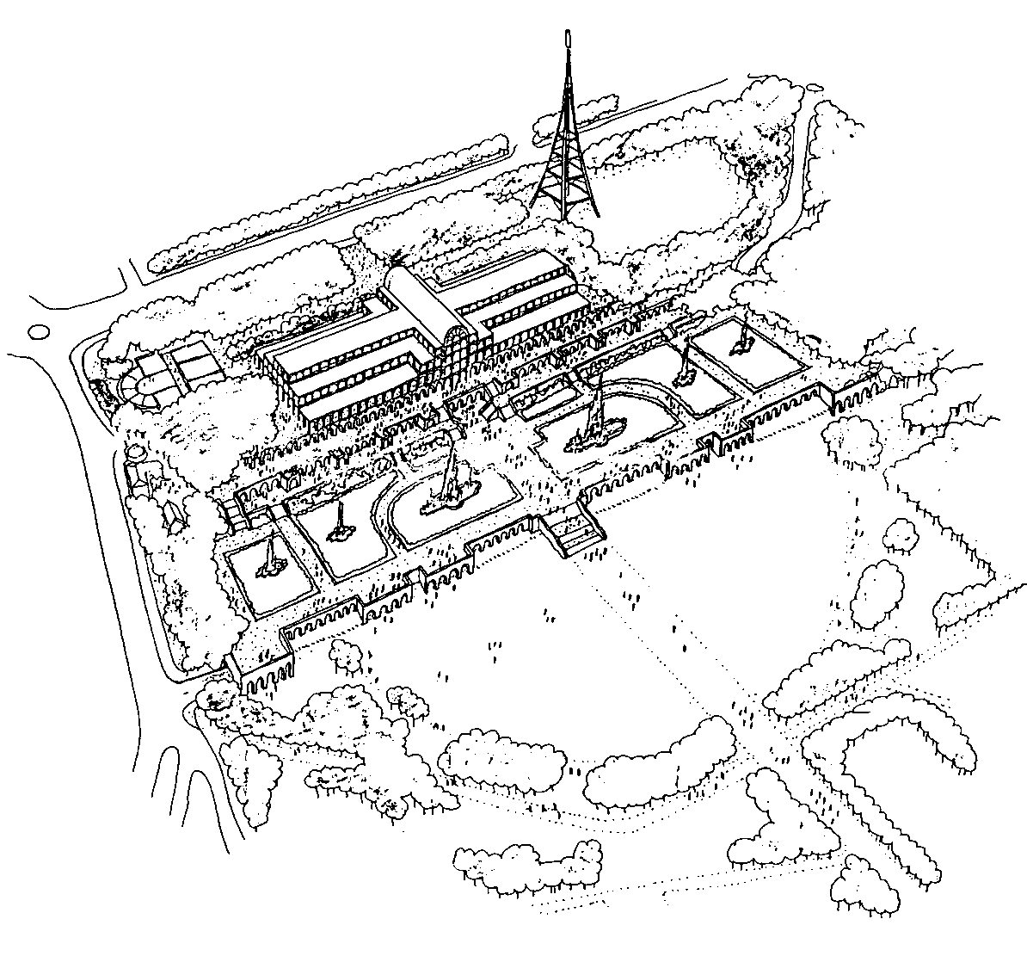

Reproduced by kind permission of People and Places International Ltd, 16 Belmont Hill, London SE13 5BD

Plans to rebuild The Crystal Palace
to Sir Joseph Paxton's original, Hyde Park design of 1851
have recently been submitted to Bromley Council
by a company called People and Places International Ltd.

If accepted, People and Places' plans will:

- retain the trees along Crystal Palace Parade, planted in memory of the original Palace
- build The Crystal Palace set back from the Parade, alongside most of the foundations of the original Palace
- build underground auditoria, under The Crystal Palace - so there is room for a balanced mix of arts, eating, leisure, educational, heritage and cultural facilities, to be agreed with local residents
- reinstate the Italian Terrace, with its fountains, walkways, gardens and stone arched walls
- conceal all parking facilities beneath the restored Italian Terrace
- incorporate side access to the car park and remove all existing parking in the northern half of the park, so the park becomes car-free parkland, safe and visually pleasing for pedestrians
- landscape the central area of the park, to create a "village green" at the heart of the park
- help design a 21st Century eco-park that is environmentally friendly
- establish the park as a focus and business provider for the area
(as Windsor Castle does in Windsor)

PEOPLE AND PLACES PROPOSE
SOMETHING FOR ALL AGES,
RETURNING THE PALACE THE WORLD LOVED
TO ITS HOME OF CRYSTAL PALACE.

For the Crystal Palace to return home:
- plans for an 18 screen multiplex, with a rooftop car park, need to be dropped
- London and Regional Properties needs to be willing to provide its services within The Crystal Palace, rather than the multiplex currently proposed.
- People and Places' plans need to be approved by Bromley Council
- Parliament needs to pass an Act permitting Bromley Council to enhance the park in this way

Rebuilding The Crystal Palace is possible
if we all act
NOW

Write NOW to:

(1) Your MP at The House of Commons, Westminster, London SW1A 0AA
e.g. Jacqui Lait (Beckenham)
Tessa Jowell (West Dulwich)
Malcolm Wicks (Croydon North);
Jim Dowd (Lewisham West)

(2) Ian Livingstone of London and Regional Properties
40 New Bond Street, London W1Y 9HR

(3) Chris Maines and John Holbrook, Joint Leaders of Bromley Borough Council, The Civic Centre, Stockwell Close, Bromley, Kent BR1 3UH

telling them:
- you have heard of The Crystal Palace plans
- your reasons why you would like The Crystal Palace to be rebuilt
- you would like them to support this project rather than the one
with the rooftop car park currently planned
A copy of your letter would be appreciated, with written permission for us to quote your comments

For a summary of the outline planning proposals
please send us two second class stamps

For further information, contact us
at:

REBUILD THE CRYSTAL PALACE
88 Westow Hill, London SE19 1SB
e-mail: rtcp@phoenixshoes.co.uk

NB: The current plans to build a multiplex with a rooftop car park are well
advanced and building will start soon unless the plans are overturned.
It is therefore important that you write without delay.

Scottish Exhibitions Study Group.

Some members will be aware that Stanley Hunter, a few years back had the idea of starting a Scottish Exhibitions Study Group. As at the time this coincided with his being elected President of the Exhibition Study Group for three years, he did not go ahead with the idea. Since stepping down he has now formed the group and I have just received their newsletter No. 4 for Spring 1999. They have had their first A.G.M. at Falkirk on March 20, which I was unfortunately unable to attend.
The subscription is £5.00 per year made out to S. K. Hunter at 34, Gray St, Kelvingrove, Glasgow. G3 7TY. The format is much the same as our own Journal, but of course devoted to Scottish Exhibitions. It has to be said that Stanley is much more skilled in the use of the computer than I am, it takes a lot longer to teach old dogs new tricks. He gives a list of web sites for those on the internet.
Scottish Exhibition Group http://www.biggar-net.co.uk/sesg.
1938 Glasgow Empire Exhibition http://clyde-valley.com/glasgow/empire.htm
Glasgow Garden Festival http:clyde-valley.com/glasgow/garden.htm
Exhibition Study Group http://clubs.yahoo.com/clubs/expos
Buffalo Bill in Glasgow 1891-1904 http://members.aol.com/TNAIS2BB.html
World’s Fairs Collectors Society http://members.aol.com/bbqprod/wfes.html
Wayne Robbins on behalf of the postcard Traders Association is also organising a web site for the Exhibition Study Group, and as soon as I have details I will let you know.

Perfins on the British Empire Stamps.

A letter from John Nelson, of the Perfin Society, including his new Bulletin 279.

Dear Bill,
........the new P.K/L. Wembley Perfin which you reported to me........The item appeared in the Bulletin last month and the only response I have had is conformation from the Bulletin Editor, Rosemary Smith, that she has the P.K/L. perfin with a Paddington postmark. This adds up to a provisional identification of the die with Peter Keevil & Sons Ltd.
The ever vigilant Alan Sabey has recently been in touch regarding another new Wembley die he has discovered, the letters being TT/CoLd. I have written to him saying that the most probable (almost certain) identity of this one is Thomas Tapling & Co., Ltd., Furniture and Carpet Warehousemen, 31-45 Gresham St, 108-110 Wood St and 55-67 Leonard St Finsbury, London. E.C.2.
As I have just done a Wembley survey update for our Bulletin this new one will have to wait until I do the next update in about a years time.

Bulletin 279.
It is more than three years since my last update on the Wembley perfin survey appeared in the Bulletin and since then I have not received a great deal in the way of additional information. However a recent letter from Bill Tonkin The Secretary of the Exhibition Study Group, advising me of a die discovered by a member of the Group which has not been previously noted, prompts me to bring the list of reported stamps and dies up to date.
The new die P.K/L. is similar to P2800.01 and .01a in the illustrated catalogue but it is not identified. Various other PK/L (without stops) dies have been identified in Tomkins with Peter Keevil & Sons Ltd, but not the dies with the stops. If any members have examples of P.K/L. dies on other stamps or covers with postmarks or other information which might help with identification perhaps they could let me know.
New Die.
P.K/L. P2800.01/01a 1924 1½d no postmark. Suggested identities 1. Peter Keevil & Sons, and “. Pearson & Knowles Coal & Iron Co., Ltd. Warrington, who were exhibitors in 1924.

Additional Stamps and Covers.
D.S. D4370.01 1924 1d
ET E4660.03 1924 1½d
H&P H5690 1924 1½d
HW/LD H7770.01 1924 1½d Cover pmkd. London E.C. 19 Jun 1924
(see Bulletin 296 pages 14-15)
M&P/P M4560.01 1924 1d and 1½d
MW/Co M6020.02 1924 1d
O&Co O0480.01 1924 1½d and 1925 1½d
S.L S4320.03 1924 1½d
TP/LD T3600.02a 1924 1d pmkd London 2 Oct 1924
W/&Co W1340.03a 1924 1½d
W&S W6680.07 1924 1½d and 1925 1d (it now seems certain that
this is a small ‘SPG’ type die used by Waterlow & Sons themselves which explains all the variations, including die W6680.24
With acknowledgements to Kim Bjarnt, Terence Wood, Rosemary Smith, Alan Sabey and Bill Tonkin.
John Nelson.

New Zealand and Maori presence at British Exhibitions.

I have had a letter from Margaret Werry of Chicago as follows, I was recently in the United Kingdom conducting research on New Zealand representation in World’s Fairs and Exhibitions during the period 1890-1914. I was given your name by librarians at the Hammersmith and Fulham Archives, who suggested that you might be able to help me with my investigations. I am interested generally in exhibitions with an ‘Empire’ theme and representation from the British Colonies and dominions (including permanent displays such as the Imperial Institute), and in particular in the coronation celebrations of the summer of 1911, at Crystal Palace (Festival of Empire, Pageant of London) and at the White City (the Coronation Exhibition). I have been researching in detail the activities of one particular group of Maori performers who entertained at both of these exhibitions. They went by the name of the Arawa Maoris, and were headed by a woman named Maggie Papakura, or Guide Maggie. I am also interested in examining their performance in the context of other ‘native villages’ or ‘exotic performances’ of the era.
I have met with members of the Crystal Palace Foundation who were very helpful in suggesting sources for publications, ephemera and records of C.P. exhibitions during this period. Might you have similar suggestions regarding the White City? I have already covered many major London based collections (at the British Library, the Minet, the V & A, Museum of London, Hammersmith & Fulham (Lila Buset Library), the Bishopgate Institute) and a few individuals who have collections of memorabilia.
I would be most grateful for any information or contacts you might have that would be of interest to me. I would also be more than happy to report my findings in your group’s newsletter.

Margaret Werry

Dear Margaret,

Thank you for your letter regarding New Zealand’s involvement in exhibitions. While I cannot help you regarding Maggie Papakura, I am of course aware that New Zealand had a presence at many of the early exhibitions. I have a fairly large collection of exhibition catalogues, and can give you a brief list of exhibitions that had New Zealand sections.
1862 International Exhibition. A New Zealand section plus small sections for the provinces of Nelson, Otago and Wellington. There is no mention of Maori participation.

1886 Colonial and Indian Exhibition. A New Zealand section plus a Maori Court, containing displays but no Maoris.

1908 Franco-British Exhibition. One of the larger buildings was the New Zealand Pavilion, but as far as I know no Maoris. By now the colonies were finding the need to attract immigrants to settle, and from now till the late 1920’s this was an important reason for participating in exhibitions.

1909 Imperial International Exhibition. I have no record of the New Zealand Pavilion for 1909, but as it was there for 1908, 1910 and 1911 I am sure it was there in 1909.

1910 Japan-British Exhibition. The New Zealand Pavilion was still being used but there was no Maori presence as far as I know.

1911 Coronation Exhibition. White City. The New Zealand Pavilion was still being used but there was no Maori presence as far as I know.

1911 Festival of Empire. Crystal Palace. This was not an exhibition like the earlier examples but was a series of pageants. Part 4, Scene 4 was titled The Signing of The Treaty of Waitangi and was performed by New Zealand visitors.

1924 British Empire Exhibition. Again there was a large building, the New Zealand Pavilion, which featured a magnificent Maori house “Mata-Atua”, but there is no mention of Maoris present.

1925 British Empire Exhibition. Although held on the same site and with the same title, the 1925 exhibition was not a continuation of the 1924, but was different in many respects. There was still a New Zealand Pavilion but the Maori house seems to have gone. It is noticeable that most of the ephemera or pamphlets handed out at the exhibition were nearly all concerned with offers to families prepared to emigrate to New Zealand. This was not restricted to that country, Canada, South Africa, Rhodesia and Australia were all trying to attract settlers.

1938 Empire Exhibition. Scotland. Again New Zealand had a large pavilion with Maori artefacts on display.

This may not be of much help but it is the best I can do.

Can any member add anything to this? if so I shall be pleased to forward any information on to Margaret.

A book review by Stanley K Hunter.

Souvenirs
From Roman Times to the Present Day
by
Godfrey Evans.

NMS Publishing Ltd., ISBN 1-901663-24-8 £12.99

This delightful book covers a wide range of souvenirs devoted to places and events. While there are sections devoted to pilgrimages, from the Holy Land and Lourdes to Graceland, and from holiday resorts like Blackpool to Coney Island, exhibitions are well covered.
The book (pp 106 colour cardbound) accompanies the exhibition ‘Souvenirs, A Sentimental Journey’ now at the Royal Museum of Scotland, Edinburgh, until January 9th 2000. Godfrey Evans, a member of our group, is the curator it and wrote the book. Among those loaning material were Don Knight and myself. A feature of the book is the wide range of high quality illustrations. There must be 150 exhibition souvenirs illustrated. Among the many exhibitions covered is the Great Exhibition of 1851 and Crystal Palace.
Although the exhibitions covered are hugely eclectic, the exhibition covers some souvenirs in detail. The glassware of the Edinburgh and Glasgow Internationals and Nationals 1886-1911 is particularly well represented and beautifully photographed.
There is a lovely collection of ‘crested china’ from the Great White City 1908-14. Both the British Empire Exhibition at Wembley and the Empire Exhibition, Scotland are also well featured. Even the Douglas, Isle of Man Exhibition of 1892 has a souvenir illustrated.
Exhibitions held in Europe (Paris, Brussels and Vienna) and the United States are commemorated. All the classic World’s Fairs from Philadelphia 1876 to Seattle 1962 are there. The centrepiece of this section must be the large selection from the N.Y. World’s Fair 1939-40. This is hugely collectable and will no doubt attract American visitors to the 1999 Edinburgh International Festival.
Both the book and exhibition cannot fail to introduce the general public to the history of exhibitions.
The normal retail price of the book is £12.99. Visitors to the exhibition can buy it at £9.99. Members of the Study Group may receive this concession price of £9.99 if they contact me direct. Please add 70p for 2nd class postage or £2.69 for U.S.A. Printed Matter rate ($20.00 in U.S. dollars). There is an admission charge to the Royal Museum (Which also admits to the New Museum of Scotland) There is a permanent display case on exhibition souvenirs in the Museum of Scotland and a small interactive in the Royal Museum.

I can also thoroughly recommend this book, as I think it is first class and would like to congratulate Godfrey Evans on a job well done.
Editor.

1999 Convention at Portsmouth

Members will be aware that as reported in the Summer Journal we have had to change our venue to the Saville Hotel, 38-39 Clarence Parade, Southsea, Portsmouth, PO5 2EU. phone 01705 822491 / 812526, as the Century Inn is being demolished. So far I have only had 18 people notify me that they will be attending, which is down on previous years. Facilities for playing videos will be available and some exhibition related videos will be shown. The last page of the Journal is again a form to fill in if you are coming. Please let me know if you intending to come. As an added attraction ??? I hope to be bringing a lot of my surplus post cards for sale, with the usual percentage going to club funds. I would like to see more new members turning up, as it is a very enjoyable social occasion for meeting other collectors with the same interests.

The Model Coal Mine.

Most of this is taken from an article that appeared in ‘The Model Engineer and Electrician’ on January 29th 1925.

One of the attractions in the Mining Hall attached to the Coal Mine at the British Empire Exhibition in 1924 was a model coal mine measuring 14 ft by 8ft 6ins and about 8 ft high. This model was the work of a one time colliery worker, then working on the railways, William Phelps of Treherbert South Wales. Phelps was a man without training in engineering or mechanical work, without a workshop such as a model engineer usually considers necessary, and without the capital to purchase the parts of the model, which are so frequently obtained ready made to save time. It took 20 years of his spare time helped by his wife to make the model, and he was largely dependent upon the information he gathered from the pages of ‘The Model Engineer’ for the knowledge of how to make and use the tools and appliances which he found necessary in its production.

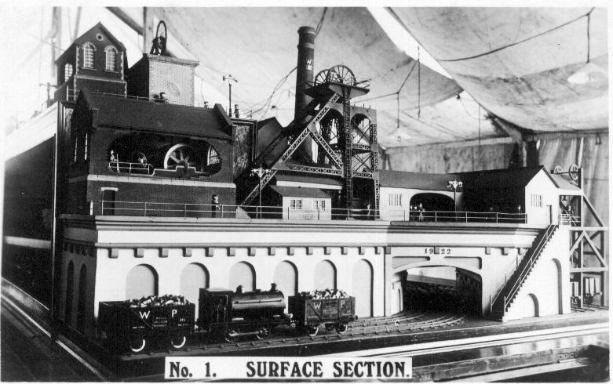

Nearly the whole model was made from scrap material found in the various waste heaps which abound in coal mining districts. The electric bulbs, and motors which provide the power to produce the lifelike working motions of the men being almost the only parts which have been purchased.
On two of its faces the model shows the surface works, buildings and operations, the other two faces are sections, showing at the surface the railway, pit head, fan, winding engine house and pumping engine, and beneath these the bottom of a shaft with sump etc., hauling and pumping appliances, and the working faces on the four seams of coal. One of these, the upper thin seam, has been added since the model came to London, and since the photograph was taken.
The writer mentions a photograph, and in the article three of the four illustrations of the model are the same as the post cards that were on sale at the exhibition. No 4 Section of the underworking of the mine is different from the post card although it shows the same view of the model taken at a slightly different angle. This section also shows the tramways, wagons, stables, drifts and crosscuts, ventilation doors and brattice cloths, with horses and men at work.
For those who have the four post cards which are numbered 1 to 4, the article describes the views in detail. These four cards do not have any mention of the British Empire Exhibition on them but so many are known with Wembley stamps and exhibition post marks and comments, that there is no doubt they were on sale at the exhibition. No. 1 Surface Section, shows on the extreme left the end of the engine winding house, exhaust fan house and pit head which can be seen to better advantage on card No. 3. The pit head frame made of iron of various sections, riveted together and stayed with lattice work cross pieces, as is the modern practice. The ladder to the top where there are two large pulleys over which the winding ropes travel when hoisting or lowering the cages carrying the men or the coal trucks up and down the shaft. The engine house is seen with one side wall broken open to show the massive winding engine and the model men operating it.

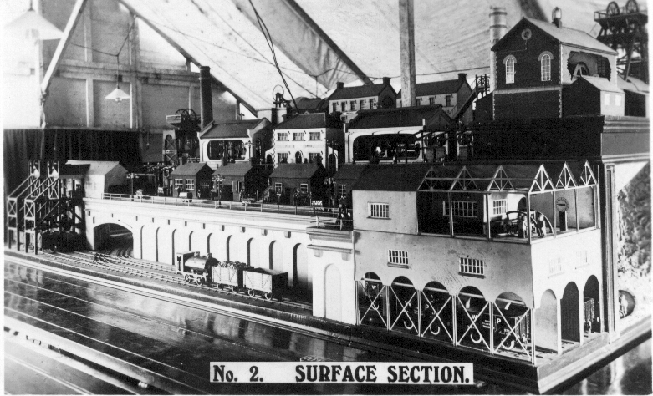

The sheds at the pit head, with weighing appliances, turntables etc., over which the full trucks pass, returning when emptied to the shaft for their next journey. These wagons or trucks are pushed by little models of men, who walk along, putting one leg before the other in the most natural manner. Then we see a party of men with their safety lamps ready to go down the mine. Coming down the stairway with its protective rails we come to the lowest level we find the railway with a tank engine and four loaded wagons ready to be shunted off. It will be noted that the railway wagons have the initials of their owner ‘W. P.’ painted on their sides in the authodox fashion. There are in this section 16 models of men 10 of them carrying safety lamps. Also the skew bridge is properly finished off with the date of its opening, 1922 cut in the stonework.

View or card No. 2 shows the surface with many of the buildings, machines, appliances, etc., which one finds at a colliery, this time on four levels, so that a greater number and variety can be shown than would be the case if it was all on one level. On the left side we see the skew bridge or tunnel from the No. 1 coal face. Just outside where the two sets of rails join the main line, the points being well shown. Here again we have a ‘Pecket’ locomotive and loaded coal wagons. On the extreme left are two tip-over screens, worked most naturally by five of the model men, receiving the coal from two of the tram wagons, seen in view No. 1 as brought from the pit head, and discharging direct into the railway wagons marked ‘W. P., Model Collieries, Treherbert, with their regular number, and Load 10 tons, Tare 5-10-0’ nothing seems to have been over looked. On the right side in a shed a further six wagons are waiting their turn to be loaded up.

The next level is full of life, next to the screening plant already mentioned is four boilers with their furnaces supplying steam for the winding engine and other stationary engines, and behind them the tall round red brick chimney carrying the legend ‘W. P. 1922’. At these furnaces are three model men, one the engineer-in-charge, another raking one of the fires, and the third busy stoking, all the men are in motion. Next to the furnaces is the lamp room. The lamps are being prepared for issue to the men, and some of them are alight to show that they are all in order. Two other men are sitting outside the lamp room with their lamps alight, and from the motions of their heads are having a good ‘mag’ before going down. Next is the smithy, without which no mine could carry on, the fire is alight with one man holding a piece of iron in it and the smith and striker are at work at the anvil. In the engineer’s shop inside which several men are seen working, one at a treadle lathe and another working a ratchet drill. Adjoining this is the woodworking shop, outside the workshop are two men one turning a large grindstone, and the other carefully grinding an axe on it. and another man sawing a plank. Another man is planing up some wood. The action of this man should be watched as the movements are very natural. The whole of the body swings from the feet, and the arms working from the shoulders have the elbows dropped at each return stroke. The action has been caught perfectly. Further along a man is seen continually shovelling mortar into a mortar pan driven by a stationary engine.

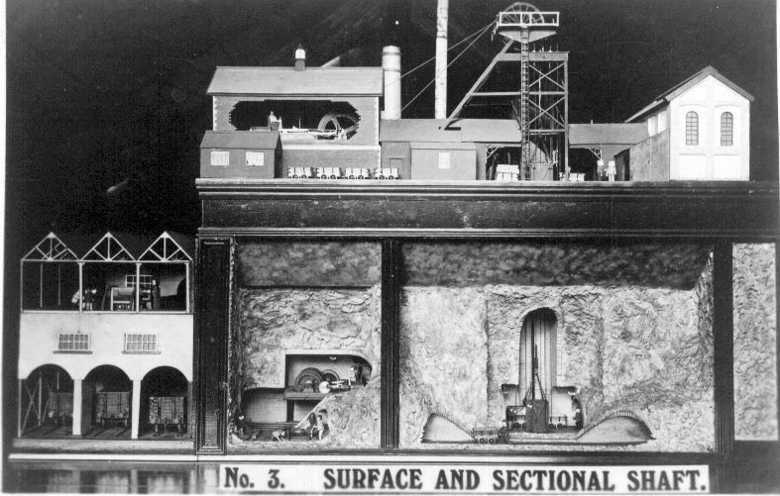

On the third level are three buildings, in one are two high speed generators with their workmen attending them, next is the ‘Pay Office’ with some 14 to 16 men waiting for the office to open. Then there is another battery of four horizontal boilers with their workmen at work as usual. The chimney is again a round brick one but this time built of white bricks, both chimneys are protected by lightening conductors. On the top level is another chimney taller than the others and square built, more slender than the round ones. There is a locomotive, wagons and sheds, but this will be dealt with in view No. 4 where it is seen to better advantage.
View No. 3. Surface and Section Shaft. This is at the further end of the model and on the left is shown an end view of the screening and tipping shed mentioned before. Next is the winding engine house with a powerful horizontal engine used for winding the cage up and down the shaft. In this instance the pit head frame surmounted with the large pulleys is of plain ironwork without the lattice cross struts. In the shaft is a cage which has just been brought to the surface, and the whole place is lit by electric light. Below this is a section of the mine showing the rock formation and the bottom of the shaft with the excavations around it for the pumps, fans and other plant, and the entrances to the levels or drifts on either side. These will be seen to be bricked round as they have become permanent structures, and the bricking does away with the necessity of renewing the supports from time to time as would be the case if they were in timber. In the shaft there is a second cage which is at the bottom when the other is at the top. Along the front of the section is a line of tram rails along which one of the men is seen walking very naturally, one leg following the other in quite the correct style and without a limp pushing along one of the empty tram wagons, the bricked tunnel being cut away to show up the working. Some distance to the left of the shaft we find another excavated chamber on two levels where is seen the haulage engine drawing the trams by means of wire ropes to and from the workings. Close by is one of the cubby-holes with seats and two men with lamps having a rest and an animated conversation.
We come now to the fourth view, this is a section of the workings on the seams of coal underground. on the surface is a 4-4-2 locomotive hauling three loaded 10 ton coal wagons and a miners open passenger wagon. There is also a signal box, a footbridge over the line and several buildings, one of them an inn, the ‘Miners Arms’ and a number of tram wagons. At the right hand there is another engine house driving the ventilating fan which serves to ventilate the mine through the upcast shaft. Underground we are shown the workings on four seams. On the post card there are only three seams shown. The two lower seams are worked on the ‘independent stall’ system and the next one on the ‘Nottingham’ or open face system. In the model the top or fourth seam is a thin seam and is worked partly by manual labour and partly by machinery. On the lower seam are a number of model men at work getting coal and doing the many other jobs incidental to coal mining. The seam is shown partly cut away with a section of uncut coal between the galleries and the working face. There are also a number of blocks, consisting of timber props and boards filled with stones and rubbish from the workings. These blocks which the miners call ‘cogs’ or ‘chocks’ not only save the hauling and the winding of the waste, but enable it to be used to hold up the roof as the work advances, and thus again saves a lot of timber or other supports. The pit props will be seen in some places broken and bent by the pressure of the roof. All together on this seam there are 24 men mostly working and 22 lamps. Three of the men are sitting down having a snack, two of them energetically working their jaws to get down their bit of ‘grub’.

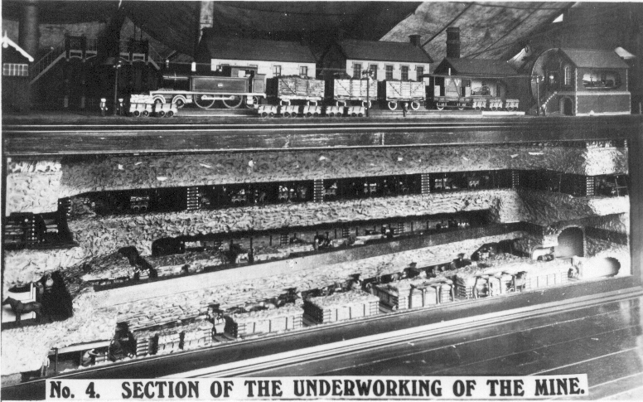

In the second seam there is a six stall stable and five pit ponies with a stable man grooming one of them, and again about two dozen men with two out of sight although their lamps can be seen gleaming in the distance. It is not very difficult to get a man to walk along putting one foot in front of the other in a natural way when he has his hands on a tram wagon, but it is much more difficult to make the man stand up alone and walk along. The model men, in this respect seem just like children, they can walk when they are hanging on to something, but it is a different matter when they try to strike out on their own. The maker of the model Mr W. Phelps was at Wembley at the time the article was written and was crouched under the model adjusting one of the men to walk upright along the tramway track at this seam and a description is given. “He would walk along for a few inches, taking his steps quite nicely, then like a child when it feels itself falling, he would begin to run and then degenerate into a slide, with both legs dragging behind for a few inches until it was evident he had given up the idea of walking. Try again was not enough, it was try, try, try again, and it took nearly an hour before the man would walk properly.” When on display Mr Phelps is normally in his cubby hole under the model superintending the working of the various activities of the model.
It is not surprising that it took twenty years to make the model, in all, there are nearly 200 figures in addition to the wagons, ponies, engines etc., and most of them are in motion. The power for the lights and motors comes from the local supply service at Wembley but Mr Phelps has his own dynamos and accumulators for use when necessary. The only criticism the writer was able to find was that while everything in the model was practically to scale, the heads of the men were larger in proportion to their bodies. He does concede that a good model maker is not necessarily a good sculptor.

1924 British Empire Exhibition Maps
Part 4
by
Bill Tonkin

Contents of different panels on Map number 32.

I. Full panel advert for Hall Marked Trophies and Royal Brierley Crystal Cutt Glass on Stevens & Williams stand No. 436 Section M. With printers ref. L274 680P.
K, L, M & N Picture of the Imperial Stadium and text on the British Empire Exhibition. The headings of the paragraphs are, Variety and Colour, Monster Military Tattoos, A Fellowship of Empire and The Great Home-coming.
S. How the Exhibition began - Primary Purposes - A Co-operative Effort.
T, & U. All the World will be at Wembley, Fifteen miles of Exhibition. Bird’s eye view of the Grounds. (as Fleetway postcard No. 31).
V. Art of the Empire - The Two Georgians - Short Time Exhibits.

Contents of different panels on Map number 33.

Note, all the text on the back is printed in Dutch, the map side is as normal in English.
I. Panel I is almost identical with panel J except that the printing is reversed, i.e. the black printing is in white and the white printing is in black. London is spelt Londen and at the bottom is TOEGANSPRIJS 1/6 KINDEREN HALVE PRIJS
K, L, M & N Picture of the Imperial Stadium and text on the British Empire Exhibition. The headings of the paragraphs are, Variety and Colour, The Tomb of Tut, Monster Military Tattoos, and An Empire Parliament.
S. How the Exhibition began - Primary Purposes - A Co-operative Effort.
T, & U. All the World will be at Wembley, Fifteen miles of Exhibition. Bird’s eye view of the Grounds. (as Fleetway postcard No. 31).
V. Art of the Empire - The Two Georgians - Short Time Exhibits.

Post Cards of the White City
Part 12.
by
Bill Tonkin

Type 2. J. Coloured with a thin white border within a dark grey border, title in capital letters printed in brown. The backs are printed in three colours, dull orange, red-orange and yellow.
Boys Grammar School, Brisbane, Queensland.
A. Red-orange back.
Custom House, Brisbane, Queensland.
C. Dull orange back.
Eagle and Queen Streets, Brisbane, Queensland.
A. Red-orange back.
Executive Building, William Street, Brisbane, Queensland.
A. Red-orange back.
Girls Grammar School, Brisbane, Queensland.
B. Yellow back.
C. Dull orange back.
Girls Grammar School, Ipswich, Queensland.
A. Red-orange back.
Parliament House, Brisbane, Queensland.
A. Red-orange back.
Queen Street, Brisbane, looking towards Petrie’s Bight.
A. Red-orange back.
Queen Street, Brisbane, showing Queensland National Bank.
A. Red-orange back.
Queensland Club, George Street, Brisbane, Queensland.
A. Red-orange back.
School of Arts and Technical College, Rockhampton, Central Queensland.
A. Red-orange back.
State School, South Brisbane, Queensland.
C. Dull orange back.
Technical College, Ipswich, Queensland.
A. Red-orange back.
View of South Ipswich, Queensland.
C. Dull orange back.

Series 3. With G. A. Vaughan imprint and with information under ‘Correspondence’. Again type 3 cards seem to be more common than type 1, The titles were printed in both styles sloping and upright, and there was a much reduced range of fronts. There were no mono coloured pictures, and the fronts have been sub-divided into four types. B/W, type 3-A, coloured with grey border, type 3-B, coloured with double grey borders, type 3-C, and coloured without a border, type 3-D. The backs are printed in 11 different colours, In type 3-A. one card bears a number, this is the only one seen.
Type 3. A. B/W with stone border on stone faced card, title in capital letters, the backs were printed in two colours, pale orange and lilac.
A Train Load of Sleepers leaving Landsborough, Southern Queensland.
A. Lilac back.
Bluff at Child Island, Central Queensland.
A. Lilac back.
Bourbon Street, Bunderberg, Southern Queensland.
A. Lilac back.
Chaff cutting at Westbrook, Darling Downs, Southern Queensland.
A. Pale orange back.
Invictor Sugar Mill, Bunderberg, Southern Queensland.
A. Pale orange back.
Jimbour Shearing Shed, Darling Downs, Southern Queensland.
A. Pale orange back.
J 170 Lucerne Carting at Queensland Agricultural College Gatton, Southern Queensland.
A. Lilac back.
Panorama of Toowoomba, Darling Downs, Southern Queensland.
A. Lilac back.
Reflections, Boonah, Southern Queensland.
A. Pale orange back.
Stack Building on the Darling Downs, Southern Queensland.
A. Lilac back.
View of Warwick(From Town Hall), Darling Downs, Southern Queensland.
A. Lilac back.
View of Warwick, (From Waterworks), Darling Downs, Southern Queensland.
A. Lilac back.
View on the Commonage, Warwick, Darling Downs, Southern Queensland.
A. Lilac back.
Wild Birds Nest, Keppel Island, Central Queensland.
A. Lilac back.

Type 3. B. Coloured with a thin white border within a grey border, title in sloping letters using capitals and non capitals, olive-yellow back.
A Rock on the Coast, Central Queensland.
Among the Islands, North Queensland.
Coast Scene, Central Queensland.
Dent Island Lighthouse, Whitsunday Passage, North Queensland.
Harvesting on the Darling Downs, Southern Queensland.
Haycock Island, Hinchinbrook Passage, North Queensland.
In Gloucester Passage, North Queensland.
Magnetic Island, near Townsville, North Queensland.
On the Coast Central Queensland.
Scene at Maroochy, North Coast Railway, Southern Queensland.
Scene in Hinchinbrook Passage, North Queensland.

Type 3. C. Coloured with a thin white border within a light grey-blue border, within a thin blue line box within a wide grey blue border. Title in capital letters printed in white, rose-red back.
Cattle on Glengallen, S. Queensland.
Creek Scene, Darling Downs, S. Q. Vert left.
Creek Scene, Killarney, S. Queensland.
Draught Horses, Darling Downs, S. Queensland.
Fat Sheep, Darling Downs, S. Queensland.
Main Range, Toowoomba, Southern Queensland.
Pinnacle Rock, Percy Island, N. Queensland. Vert right.
Ploughing, Darling Downs, S. Queensland. (Back view of three ploughing teams)
Ploughing, Darling Downs, S. Queensland. (Four horses in right foreground)
Rugged Rock, Rockingham Bay, North Queensland. Vert right.
Talgai West, Darling Downs, Queensland.
Typical Country, Darling Downs, S. Queensland.
Typical Dalby Country, Darling Downs, S. Queensland. Vert right.

Type 3. D. Coloured without a border, title in red with sloping letters using capitals and non capitals. These backs were printed in seven different colours, and some views are known with backs printed in four of them, it is possible that in time cards will be found with backs in all seven colours. The colours are, crimson, dull purple, light brown, purple-brown, red, rose-carmine and scarlet.
Barron Falls, Cairns Railway, North Queensland
C. Dull purple back. Vert right.
F. Rose-carmine back. Vert right.
Barron Gorge, Cairns Railway, North Queensland.
B. Light brown back.
E. Crimson back.
Blackall Range, North Coast Railway, Queensland.
C. Dull purple back.
F. Rose-carmine back.
G. Red back.
Clearing Forest, Nerang, Southern Queensland.
A. Scarlet back.
C. Dull purple back.
D. Purple brown back.
F. Rose-carmine back.
Fig Tree, Tewantin, N. C. Rly., Queensland.
E. Crimson back.
G. Red back.
Swan Creek, Killarney, Southern Queensland.
E. Crimson back.
Tweed Heads, Southern Queensland.
D. Purple-brown back.
E. Crimson back.
G. Red back.
Wheat Farm, Emu Vale, Killarney, Southern Queensland.
A. Scarlet back.
B. Light brown back.
C. Dull purple back.
Wide Bay Creek, North Coast Railway, Queensland.
B. Light brown back.
G. Red back.
Yeppoon, near Rockhampton, Central Queensland.
B. Light brown back.
C. Dull purple back.
F. Rose-carmine back.

Rankin. J. A. Draper, Chelmsford.
A Card from the 1910 Bruxelles Exposition remaindered after the exhibition closed, is known with a small circular rubber stamp on the back of J. A. Rankin, a draper in Chelmsford, who would have given it in place of a farthing change to customers.
Exposition de Bruxelles, 1910. Le Grand Palais.

Rapid Photo Printing Co., Ltd. London, E. C. The
The Rapid Photo Co. published several series of cards for the Franco-British and the Imperial International Exhibitions. The views were the same in types 1, 2 and 3.
Type 1. Sepia R/Photo plate sunk with large white borders, brown back. All the titles are preceded with ‘The Franco-British Exhibition.’ in bold letters.
P.S. 263-1. The Lake in the Court of Honour.
P.S. 263-2. The Stone and Mineral Products of the Australian Colonies. Vert left.
P.S. 263-3. The Court of Honour.
P.S. 263-4. The Stadium.
P.S. 263-5. The Court of Honour.
P.S. 263-6. The Indian Palace.
P.S. 263-8. The Court of Honour by Night.
P.S. 263-9. Palace of Women’s Work.
P.S. 263-10. The Flip-Flap. Vert left.
P.S. 263-11. The Palace of Music.
P.S. 263-12. The Scenic Railway.

