EDITORIAL SUMMER 1999

The spring has sprung the grass is riz,
I wonder where the butterflies is.

I was going to start by telling you all about my operation, and spells in hospital, but it will keep for another day when I can’t think of anything more interesting to write about. I am still getting about, and during the last five weeks managed to get to Bristol, York, Wembley, Cheltenham and Colchester, adding another 181 cards to the collection, or to be more precise, collection and swap boxes. It has to be said that a small percentage of my purchases go into the swap boxes. I wish it were not so, but I cannot remember everything I have, and although I always carry nine note books about with me to fairs, these in effect only cover the tip of the iceberg. In the past I have missed good cards through not being sure whether I had them or not. So now if I’m in doubt I usually buy them to be on the safe side.
About six months ago I sold about 600 White City exhibition cards to a member of the group, and more recently about 400 Wembley cards to another member. This leaves me with about three and a half boxes of swaps, and one day I shall get round to pricing them all up and bringing them to a convention or putting them in lots of packets. Although I don’t go in for counting there must be about 1,500 cards to dispose of.
New details of the 1924 Wembley maps are still coming in, and as far as response from members is concerned, this has been our most successful exercise so far. With so much co-operation there is now quite a lot known about these maps.
This has tempted me to start another line of research, this time into the booklets of post cards published for the various exhibitions held at the White City. I must admit that in the past I have tended to ignore these when I have been offered them. Usually on the grounds that I have got all the cards contained in the booklets anyhow. This was a mistake, and I should have grabbed them when I could. Mike and I found that booklets for Wembley exhibition cards are very scarce indeed, and as far as we know there is only one Schweppes booklet in existence plus one incomplete set of stapled stubs. We have never seen a Malaya basket booklet, and can only surmise its existence because of cards that appear to have come from a booklet and one information page from the booklet.
A lot more White City exhibition booklets were published, and so far I know of a possible dozen, from the evidence of odd cards which have obviously come from booklets. I know of only two booklets and neither are complete. one without a cover has been split up and dispersed, and the other is still stapled as a booklet but is one card short. There was also at least one booklet published for the Festival of Britain. It consists of twelve post cards and in place of the counterfoils, twelve snap shots also perforated so they can be torn out. The interesting thing is that when the post cards or snap shots are torn out of the booklet, there is nothing on them to indicate they have anything to do with the Festival, it is only the cover which has the Festival logo on it. So that is going to be the next research project.
At short notice we have had to look for a new convention venue and bearing in mind that our 1997 Convention at Portsmouth was such a success, and after discussing it with some of the committee we have decided to go to Portsmouth again for 1999. Fred Peskett has kindly made enquiries at the hotel we stayed at, and they are free for the last weekend in September Saturday and Sunday the 25th and 26th. Elsewhere in the Journal (on the last page) you will find a form to tear out and send to me if you are coming to the Convention.
Fred has been very busy organising various exhibitions here , there and everywhere, and on the 25th of March I met him at the pre-opening ceremony of an exhibition he has been involved in at the Imperial War Museum “From the Bomb to the Beatles”. This runs until the 29th of May and features some of Fred’s Festival of Britain material. A few of Fred’s meccano models are also on display including one of the Flip Flap. All together it was a very pleasant evening out, I met several members of the Exhibition Study Group and Festival of Britain Society members, the free wine flowed like water and tasted a lot better, afterwards Fred and I managed to find our way back to Waterloo, without too much difficulty.

The Editor.
The 1904 Bradford Art & Industrial Exhibition
by
Graham Hall

Introduction

Back in the mid 1980’s I put together some articles about the exhibition, which at least gave a concise picture of the event, but did not tell the whole story. For one thing there were no illustrations, and after all whilst other forms of ephemera are undoubtedly collected, postcards are surely amongst the most popular. Therefore we shall use them scattered amongst our story and in future articles delve into them in more depth.

In approaching the subject yet again I felt I had to literally go back to the roots and try to answer a few questions on the way. A viewpoint I’ve taken is to try and put myself in the shoes of a total stranger to the subject who would quite rightly not have a clue about the event and probably come up with the following,

A. Why was the event held ?

B. Over what period ?

C. What was the significance of it being held in Lister Park ?

D. Why was the magnificent new public art gallery round which the exhibition centred called “Cartwright Hall” ?

There will be others but these will do for now, and we will try and answer them as we go along, but first I thought it may give us a clearer beginning to relate how I first came across the subject.

I’m now going back around 45 years to early school days when in the early 1950’s most schoolboys seemed to collect everything and anything. Yes I must admit I was one of them, although before I had reached my ‘teens postcards had already began to run through my veins. Admittedly at that time it was usually holiday postcards acquired from family and friends. Occasionally I would be given something ‘exotic’ like a Spanish embroidered card or a fancy pull-out novelty card. Ah those were the days !

Then we come to September 1963. By then I was working but postcards were not forgotten, far from it. Thoughts turned to trying to contact others in the area having similar interests. The easiest way was to write to the local paper in the hopes that they would publish a letter. So off it went to the “Bradford Telegraph & Argus” and I never thought anymore about it, until a reporter and photographer turned up at the door.

The results of the publicity were astounding and I will never forget it as long as I live. Letters poured in not just from those having similar collecting interests but from lovely kind generous people who sent cards, albums you name it. I spent weeks replying to them all.

What came of it all ? Well certainly mountains of cards, and many I’m sorry to say were passed on to others in the immediate period afterwards. I was naive, young and ignorant ! Never the less I did retain all the local material - which was the nucleus of the ‘Bradfordiana’ collection. I also gathered together a band of local enthusiasts which by April 1964 formed The Bradford & District Postcard Society, now the oldest provincial club surviving. Amongst the local postcards were a number which at the time puzzled me, views of strange buildings and what was obviously views of an ‘event’ bearing the words ‘Bradford Exhibition’. I hadn’t a clue what they referred to but it rapidly became an obsession to find out !

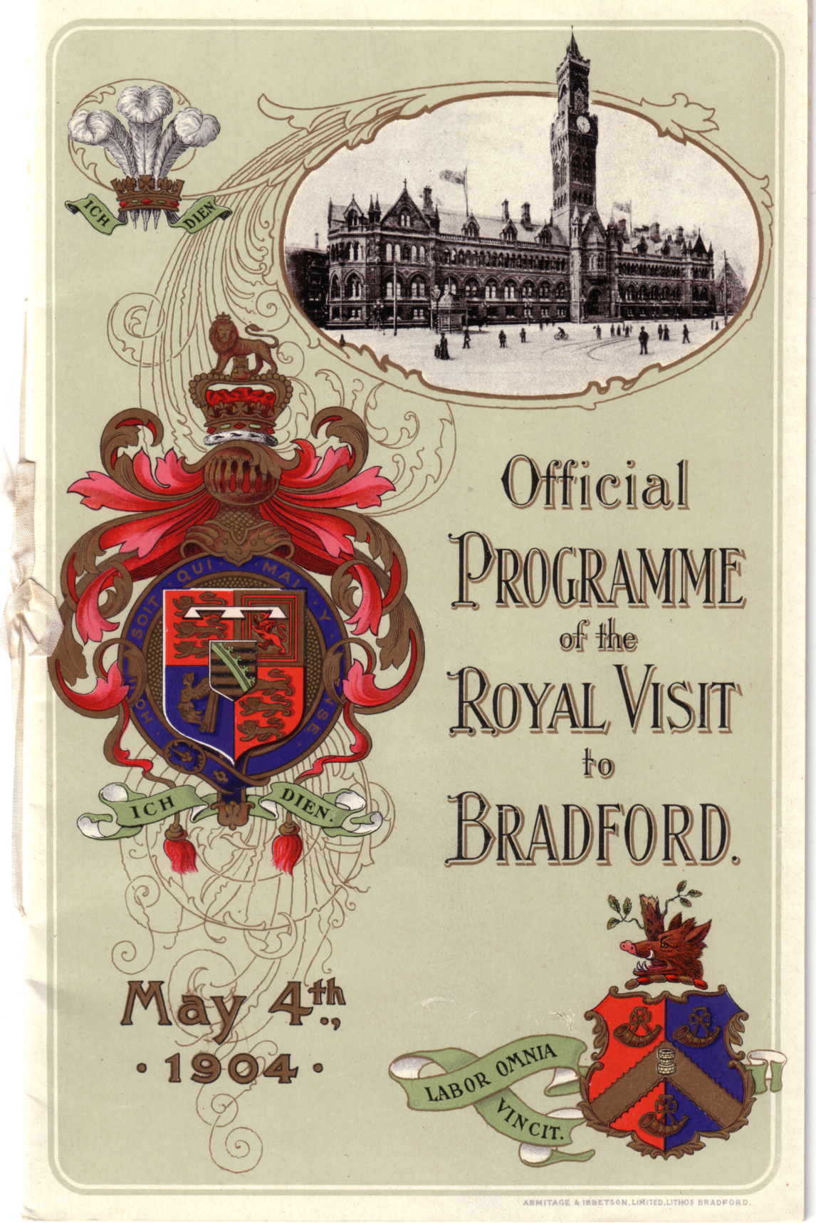

The Official Programme for the Royal Visit at the
Opening of the 1904 Bradford Exhibition.
The cover, a magnificent example of the printers art combining line and screened photogravure
printing, by Armitage & Ibbetson Limited, Bradford, in black, blue, green, red and gold.

Over the years since, business well and truly got in the way of research, and what should have taken weeks tended to run into years. Very frustrating, but at least I have been fortunate in not only piecing the story together, but also in acquiring several hundred postcards along with several drawers full of ephemera, anecdotes from people who had relatives or friends visiting the exhibition, newspaper articles about it and goodness knows what else.

So without more ado let’s embark on our journey and delve into a provincial exhibition which was not unique by any means but none the less important. Nor was it the first to be held in Bradford, and I’m grateful to both Andrew Brooks and Stanley Hunter for bringing that fact to my attention.

In the Beginning

I feel it is important to relate something of the lives of two of the most important people without whom the exhibition would never have taken place, Samuel Lister and Edmond Cartwright. The following will answer questions C and D in our introduction.

Samuel Cunliffe Lister was born in Manningham Hall, Bradford, on the 31st of December 1815, and he lived there until his family moved to Farfield Hall near Addingham in 1870. Initially Samuel Lister was trained for entry into the church, his grandmother having left him the family living of Addingham. The vocation was not for him though and he was sent by his father, Ellis Cunliffe Lister, to the offices of Shand Turner & Co., Merchants, in Liverpool for a year.

In 1817 his father erected Red Beck Mill at Shipley for his elder son John. Power looms were not in use at the time and all manufacturing had to be done by hand in the cottages of Shipley and the surrounding district. The yarn was spun at Red Beck Mill and used for making shawls. In 1832 Samuel Lister became commercial traveller for his brother and embarked on a trip to the United States to sell shawls. Before he was 21 he had travelled to America six times, and this was at a period when each outward and return journey took at least three months.

By 1837 Ellis Cunliffe Lister had erected Manningham Mills in Bradford for his two sons. He also entered into partnership with Mr James Ambler and the mill was stocked with spinning and weaving plant. Several members of the Lister family were involved with the business but it was to be James Ambler and Samuel Lister who hit it off together. Both were highly gifted and extremely inventive, working together for a number of years to perfect the combing of wool by machinery. Manningham Mills were eventually totally equipped with the wool combing machines they developed and Samuel Lister in particular nurtured what was to become a vast industrial empire with mills not only in Bradford, Halifax and Keighley but extensive production sites in both France and Germany. Lister and Ambler were not the inventors of the wool combing machine, this was the work of the highly gifted Edmund Cartwright whom we will deal with later, but they did perfect it, and make it highly successful on a commercial basis.

Samuel Lister developed his engineering skills and inventiveness over a wide spectrum, far beyond the bounds of textiles. In a two volume Victorian tome published in 1884, ‘Fortunes Made in Business’, Samuel Lister has a whole chapter to himself. He invented and patented the vacuum air brake used eventually by the railways but he never made money from it. When his patent ran out Westinghouse of America took up the idea and needless to say made a fortune. Lister developed the velvet loom spending over £360,000 of his own money in the process, something which brought him close to financial ruin. This again had originally stemmed from the genius of Edmund Cartwright who had invented the power loom.

His whole lifetimes work almost came to nothing when on the 25th of February 1871, a disastrous fire virtually destroyed Manningham Mills causing over £70,000 of damage. In a way it proved to be a blessing in disguise for it gave Samuel Lister the opportunity to build something even finer, the second great Manningham Mills creating the largest silk weaving mill in Europe. Still standing it covers over 18 acres of land with the two main sections five floors high. In total over 50
acres of working floor space with the frontage alone being 350 yards long. The chimney, 250 ft high, stands as one of the great industrial monuments and at the height of production the mill used 50,000 tons of coal a year, provided by coal mines in Pontefract owned by Lister.

He rapidly became one of the most powerful and richest industrialists in the country, and was created a Peer in July 1891, taking the title of Lord Masham, from Masham village in North Yorkshire near where he had his country seat, Swinton Castle. In 1875 a statue of Lord Masham was erected in Lister Park, the only one (of many) in the city to be erected during the lifetime of the person it represents. He was also made a Freeman of Bradford in 1896.

His philanthropy stretched far and wide. On the 17th of May 1870, he offered the corporation the chance to purchase Manningham Hall and its grounds, which cover 52 acres, for the then ridiculously low figure of £40,000. This was under the provision that the corporation made it into a public park for the benefit of all Bradfordians. It was by the way, estimated to be worth at least £60,000. A few years later he set up an unemployment relief scheme putting many to work building a lake within the park, a feature which was used to great effect when the exhibition came along in 1904.

We can see by this brief description of his life that he owed much to Edmund Cartwright, and he never forgot this. By the late 1890’s Bradford’s cramped Public Library and combined Art Gallery in Darley Street was becoming a problem and this set old Sam Lister’s mind working. What finer monument to the great inventor Cartwright than a Public Art Gallery named in his honour ? The die was cast.

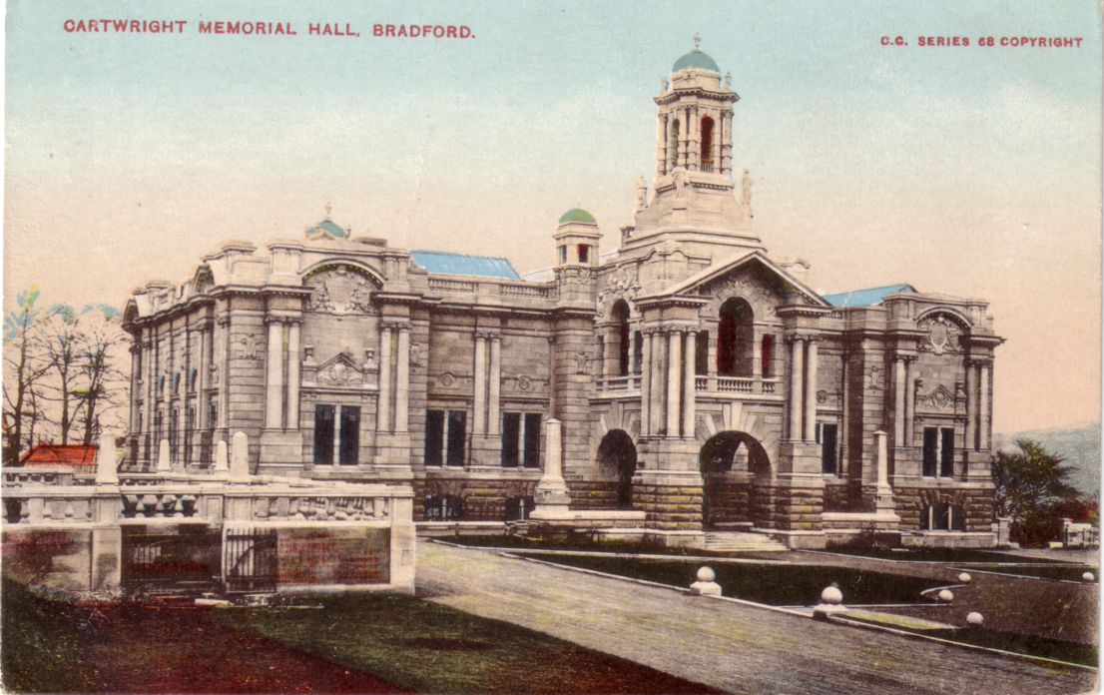

Cartwright Memorial Hall

Lord Masham lived not only to see his dream of a permanent memorial to Cartwright, he performed the opening ceremony, but he also lived to see the exhibition. He died on the 2nd of February 1906, after catching influenza at his home, Swinton Castle, he was 91. His influence on Bradford and its staple trade was immense and the Lister company remained a major force in the area long after his death. The mill employed over 4,000 people in its hey-day, but the company owned mills in many other parts of the country. He was held in such high esteem by the workers that they themselves chose to have the mill closed on the day of his funeral, and lose a day’s wages. Lord Masham is buried in the family vault at Addingham. Thankfully we still have his mill, although more about that later in our story, and Lister Park along with Cartwright Hall to remember him by.
The Rev. Edmund Cartwright D.D., also lived to a ripe old age, he was 81 years old when he died in 1823 having been born in 1743 in the village of Marnham, Nottinghamshire. A Yorkshire connection came fairly early in life when his education began at Wakefield Grammar School. At the age of 14 he went to university College, Oxford, where he trained as a classics scholar. He entered the church after university, moving back to Marnham. In 1772 he married Alice Whitaker of Doncaster and shortly after became curate of Brampton in Derbyshire. In 1779 he became Vicar of Goadby Marwood in Leicestershire.

It was a visit to Matlock in 1784 that set him off on a new path in life. Overhearing a conversation about Richard Arkwright’s newly invented spinning machinery he began to take notice. It seems that the locals, hand loom weavers, were now unable to keep up with the rapid production of spun thread, so why not a powered loom ? Within a year Cartwright had drawn up a patent for a crude powered loom which was far from perfect, but this was the seeds of greater things to come. Whilst still working on improvements he turned his skills to woolcombing, and a patent was drawn up in 1785, followed by a further patent in 1792. All the machines he worked on were crude, but the very nucleus on which the great Victorian textile industry is based. Unlike Lister he never became rich with any of his inventions, far from it because with the work on textile machinery alone he spent £40,000 of his own money. Parliament eventually realised the importance of his work and granted him the sum of £10,000 !

What must be remembered is that Edmund Cartwright had such an inventive brain, years ahead of his time, and he drew up many, many patents. At one period in his life he worked as Farm Manager at Woburn Abbey, between 1801 and 1807. Here he spent time on a number of agricultural inventions and gained a silver medal from the Society of Arts for his invention of the three furrowed plough. In 1805 he was made an honoury member of the Board of Agriculture, receiving a gold medal from them for his work on fertilisers and the plough. During a time spent in London he became a friend of Robert Fulton both of them working on designs for a steamboat, which continued at Woburn. Cartwright brought out designs for fire-proof bricks and he did work on a steam engine. There were lots more inventions too numerous to mention here.

Finally at the age of 66 he retired to a small farm at Hollanden near Sevenoaks. He died on the 30th of October 1823, at Hastings after suffering a long illness and he is buried at Battle Church in Sussex.

Postscript. Should anyone wish to read about Samuel Lister and his business I would recommend ‘A Fabric Huge’, by Mark Keighley published in 1989. It was published in conjunction with Lister & Co. PLC, who hold the copyright. Also, if you can obtain it, ‘Illustrated History from Hipperholme to Tong’ by James Parker published locally in 1904. Sadly there has never been a reprint of this fine book which contains much information both on Lord Masham and his family, Edmund Cartwright and details of the opening of the Bradford Exhibition which had taken place only weeks before publication date. Lister & Co. also produced volumes of a house magazine in hard back form throughout the 1920’s which are a mine of information, and cover the life of Samuel Lister in serial format.

In relation to Edmund Cartwright, ‘A Memoir of Edmund Cartwright’ was republished, verbatim, from the original of 1843. Whilst written in the flowery language of the early Victorian era it is still a fascinating volume and an eye-opener to the work of this genius. Believe me I have only sketched out the life of the man !

To be continued

Editor’s note. Many of our newer members will not know Graham Hall. Of the original ten founder members of the Study Group, Graham is one of the four still with us. I think I must of met him at our first convention at York in 1987, and since then we have bumped into each other perhaps half a
dozen times at fairs. His knowledge of Bradford and specifically the 1904 Bradford Exhibition is unique, I am pleased that he has at last tackled the job of getting some of his knowledge down on paper.
Graham tells me he has a spare copy of the Opening Ceremony programme as illustrated, if anyone wants it at £10.00. I have it myself and it’s a beautiful programme. First to ring him at 01274 564518 gets it.

When he told me he was retiring and would now have more time for his hobbies I felt I had to point out to him that this idea that when you retire, you have all the time in the world to do things near and dear to your heart, is a snare and a delusion. What happens is that you change one job where you work about eight hours a day for another job where you work anything from 12 to 18 hours, seven days a week without pay. Anyhow joking apart, I’m looking forward to the next instalment of the story of Bradford and its exhibition.

1999 Convention.

Owing to a last minute notification that our venue at Wembley ‘The Century’ is being demolished in June we have decided to go back to Portsmouth for 1999. As we found in 1997 there is certainly a lot to see in Portsmouth, and we shall not go short of things to do. I should like to thank Fred Peskett who has been good enough to find time to visit the hotel, to make the arrangements with the proprietor, and has provisionally booked on behalf of the Exhibition Study Group a number of single and double rooms. Once again the Hotel is letting us have the use of their large room for our meetings at no charge, as we will be booking a number of bedrooms.
Members hoping to attend the convention should book early The charges for bed & breakfast are £18.00 for a single room and £32.00 for a double room. They will also be doing our annual dinner on the Saturday evening. In the event of there not being enough single rooms available and you are prepared to share a room please let me know. It is always a problem finding a hotel with sufficient single rooms. The Address of the hotel is
The Saville
38-39 Clarence Parade,
Southsea, Hampshire.
PO5 2EU
Phone 01705 822491 or 01705 812526
The back page of the Journal is a form for sending to me if you are coming to the convention. The success of the convention depends on you the members turning up and making it a success.

1924 British Empire Exhibition Maps
Part 3
by
Bill Tonkin

I have had some more details of maps sent into me, so I will start off with four new ones from Mike Perkins, and follow with one from Trevor Batchelor. This now brings the total to 31 different maps.

Contents of different panels on Map number 27.

I. Full panel advert for Travel by Metro to the Exhibition.....Under Cover all the way.
K, L, M & N Picture of the Imperial Stadium and text on the British Empire Exhibition. The headings of the paragraphs are, Variety and Colour, Monster Military Tattoos, A Fellowship of Empire and The Great Home-coming.
S, T, U & V Advert, The ‘Metro’ Route to the Exhibition.
Contents of different panels on Map number 28.

I. Advert for British Industries Fair 1924. Without printers reference number. 5mm between box and ‘For fuller etc.’ seven lines of text measures 33mm deep.
K, L, M & N Picture of the Imperial Stadium and text on the British Empire Exhibition. The headings of the paragraphs are, Variety and Colour, The Tomb of Tut, Monster Military Tattoos, and An Empire Parliament.
S, T, U & V Advert for, Downs, Coulter & Co. (of Bradford).

Contents of different panels on Map number 29.

I. Advert for British Industries Fair 1924. Without printers reference number. 5mm between box and ‘For fuller etc.’ seven lines of text measures 33mm deep.
K, L, M & N Picture of the Imperial Stadium and text on the British Empire Exhibition. The headings of the paragraphs are, Variety and Colour, The Tomb of Tut, Monster Military Tattoos, and An Empire Parliament.
S, T, U & V Advert for Gold Coast Building.

Contents of different panels on Map number 30.

I. Full panel advert for L.M.S. The “Best Way”.
K, L, M & N Picture of the Imperial Stadium and text on the British Empire Exhibition. The headings of the paragraphs are, Variety and Colour, Monster Military Tattoos, A Fellowship of Empire and The Great Home-coming.
S, T, U & V Advert for London Midland & Scottish Railway.

Contents of different panels on Map number 31.

I. Advert for British industries Fair 1924. Without printers reference number. 5mm between box and ‘For fuller etc.’ seven lines of text measures 33mm deep.
K, L, M & N Picture of the Imperial Stadium and text on the British Empire Exhibition. The headings of the paragraphs are, Variety and Colour, The Tomb of Tut, Monster Military Tattoos, and An Empire Parliament.
S, T, U & V Advert for The Staverley Coal & Iron Company Limited.

The end

New Zealand Exhibitions.

Peter van Gelder who sent in the article on New Zealand Exhibitions, has pointed out several errors that have crept in (on my part I hasten to add, for which I apologise). On page eight it should read “a 1d card with the Zealandia stamp design”. Zealandia like Britannia, is a national allegorical figure. There were also a couple of spelling mistakes, Auckland where I missed out the ‘c’ and on page seven “Christchurch is a principal town”

There was also a letter from Ron Trevelyan saying how interesting he found the article, adding. During a visit to New Zealand in 1998 a Christchurch dealer ‘persuaded’ me to purchase a set of the seven publicity labels for the 1907-7 Christchurch Exhibition, to which Peter refers. The dealer also mentioned that Label No. 6 (the Maori carving one) was scarcer than the others. It was only when I returned home that I discovered the reason for this. According to a reference book on New Zealand stamps which I consulted, the No. 6 label could only be obtained by purchasing a lottery ticket costing 2/6 which was used to help fund the exhibition. The label was stuck to the ticket by a substantial amount of glue, judging by what remains on my copy of the label.
I also bought a set of the stamps issued for the New Zealand and South Seas Exhibition held in Dunedin. These stamps, ½d, 1d and 4d were on sale only at the exhibition, held between November 1925 and May 1926.

Remains of the 1951 Dome.

Dilwyn Chambers often sends me snippets from newspapers or books relating to exhibitions and here is one such snippet published by the Daily Mail, from a letter sent in by Peter Dawson who worked for the firm that dismantled the dome.
It was dismantled by the demolition company Goodman & Price, who stored the materials at their yard at West Drayton. most of the materials eventually finished up in a landfill site. Eight of the large beams were saved and were used to make a bridge across part of the River Colne. When the land each side including the Old Mill, was built up, the bridge was given a facelift, and the beams were concreted over.

Firework Displays at Exhibitions.

I have been asked to publish this request, does anyone have any information on firework displays at exhibitions, if so would you like to contact George Amabilino at 9, Cranbourne Crescent, Potters Bar, Herts. EN6 3AD phone 0170 765 1923.

Postcards in Stapled Books with Counterfoils.
by
Bill Tonkin

Postcards were not only sold singly or in packets of six or twelve, but were also sold in books of twelve stapled at the edge of the counterfoil. The books measured from 8¼" to 8½" x 3½" with the counterfoil taking up 2¾" to 3" of this. As well as showing a miniature view of the postcard, there was also room for the writer to record details of whom the card was sent to and the date, etc. The counterfoils and view were in B/W even if the postcard was coloured. The postcard was either perforated or rouletted (a row of short slits) to make it easier to tear away from the counterfoil, which remained as a stub in the book. The rouletting used by Valentine’s for the White City postcards, as measured by a stamp perforation gauge is 12¾, while if the means of separating or tearing out the postcard was by perforation holes, then these measured 11. Both of these measurements represent the number of holes or slits in 2cm, which is the standard method of measuring the number of perforation holes on stamps.

While the majority of books were rouletted, this was not a very efficient way of providing a means of tearing out cards without damage, and the perforated system gave a much cleaner ‘tear’. At least one series of cards are known to have come from a rouletted book, and when a further run was printed, changed from rouletting to perforation holes.

The complete books are not often seen, and one exploded book is known with one page missing. The postcards themselves are easily identified as the left edge of the postcard has a rough edge where it has been torn out of the book. In the case of vertical cards the rough edge is along the top of the card. It is from studying single postcards that the following lists have been compiled.

It is possible that not all the books contained twelve cards as there were only six ‘Night Effect’ cards, this will not be resolved until a book of cards turns up. It is this set of six cards that is known both rouletted and perforated.
The last time Mike Perkins was down he spotted a Franco-British Exhibition postcard with both the top and bottom edges rouletted. At first this would lead one to assume that it came from a pane with a card above it and a card below it, in other words a pane of three cards. so far I have found four different postcards with the top and bottom edge rouletted, and again this would lead one to think that if there were four such panes, which would give a total of twelve cards this is what one would expect. Now the surprising thing is that since then, after going through thousands of Valentine’s cards I have been unable to find a single card with just the top or just the bottom rouletted. So perhaps they did not come from a book of cards, but instead came from a letter card type folded pack, where they were all joined together like a concertina. I think this must be the case as the sides are smooth

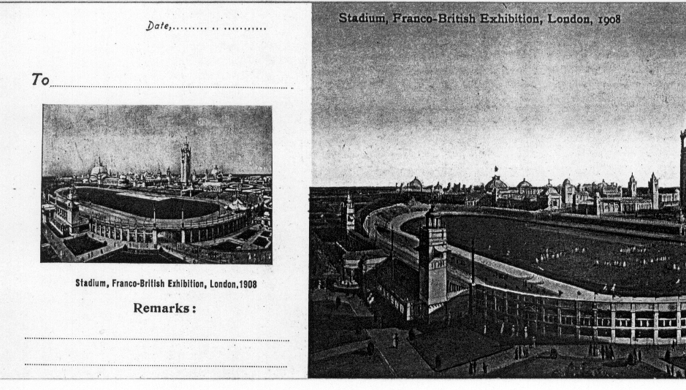

This illustration shows part of the postcard and the counterfoil. It is interesting
to note that in the book of coloured postcards from which this illustration came
Valentine’s slipped up and used a miniature view different to the full sized card.
When Valentine’s published the book with B/W postcards this was corrected.

If any readers have any booklets of postcards then I should be glad to hear from them with details of the contents. I know they should exist for the Franco-British Exhibition, the Great White City, and the Japan-British Exhibition, from finding cards with the rough left edge, also I have details of two Franco-British Exhibition books. This style of presenting cards in a book form was not restricted to the White City, as topographical books are known for many areas. One book is known for the British Empire Exhibition published by Schweppes, and publishers were still producing books of postcards in 1951 for the Festival of Britain.

For the Italian Exhibition at Earl’s Court in 1904 an unknown publisher produced six cards in three panes of two one above the other, but again I have never seen the complete book, only the cards with perforated edges.

List of Valentine’s Postcards from Books with the left edge
perforated or rouletted.

Titles with numbers in brackets, are where the number is known but does not appear on the card. Titles with ‘N.n.’ are for views that were never allocated numbers. The lists have been classified as Book No. 1, Book No. 2, etc. but the books were not in fact numbered, and with the exception of books No. 1 and No. 4, the lists have been compiled from loose cards. It would have
been possible to make an educated guess as to what the missing cards were in books No. 2 to No. 6, but I have only listed what is actually in existence.

Book No. 1. Franco-British Exhibition. In this book the miniature view of the Stadium on the counterfoil is different to the view on the postcard.
Coloured postcards with a red ‘FB seal’ back, rouletted on left edge. An exploded book with one card and counterfoil missing is known, it was probably No. 178 Entrance to Irish Village. (Ballymaclinton) as this card is known with a rouletted left edge.
N.n. Stadium.
112 Court of Honour.
(115) French Applied Arts Palace.
117 Palace of Women’s Work.
132 Canadian Scenic Railway.
163 British Applied Arts Palace.
178 Entrance to Irish Village. (Ballymaclinton)
194 Grand Restaurant.
(217) Court of Honour.
220 In Elite Gardens.
233 India.
243 Fine Art Palace and Lagoon.

Book No. 2. Franco-British Exhibition.
Coloured postcards with a dark grey ‘FB seal’ back, rouletted on left edge.
112 Court of Honour.
(115) French Applied Arts Palace.
132 Canadian Scenic Railway.
194 Grand Restaurant.
217 Court of Honour.
220 In Elite Gardens.
233 India.
243 Fine Art Palace and Lagoon.

Book No. 3. Franco-British Exhibition.
Coloured postcards with a black ‘FB seal’ back, rouletted on left edge.
194 Grand Restaurant.

Book No. 4. Franco-British Exhibition. Dark green cover with ‘Franco-British Exhibition, London, 1908. 12 Official View Postcards with Counterfoils. Price 1/- net.’ At the moment this is the only complete book known, in fact even this has one card missing, but fortunately the counterfoil remains in the book. In this book the miniature view of the Stadium on the counterfoil has been replaced with one to match the postcard.
B/W litho postcards with a black ‘Famous Throughout the World’ back, rouletted on left edge.
N.n. Stadium.
(112) Court of Honour.
(115) French Applied Arts Palace.
(117) Palace of Women’s Work.
(132) Canadian Scenic Railway.
(163) British Applied Arts Palace.
(178) Entrance to Irish Village. (Ballymaclinton)
(194) Grand Restaurant.
(217) Court of Honour. (Title in two lines at top left. A card is also known with a rouletted edge with the title at top right)
(220) In Elite Gardens.
(233) India.
(243) Fine Art Palace and Lagoon.
Book No. 5. Franco-British Exhibition.
B/W litho postcards with a grey ‘Famous Throughout the World’ back, rouletted on left edge.
(112) Court of Honour.
(117) Palace of Women’s Work.
(220) In Elite Gardens.

Book No. 6. Franco-British Exhibition.
B/W litho postcards with a dark grey ‘FB seal’ back, rouletted on left edge.
112 Court of Honour.
(217) Court of Honour.

Book No. 7. Franco-British Exhibition.
B/W photogravure postcards with a black ‘Famous Throughout the World’ back, rouletted on the left edge. This series of six cards were published in both styles, and are known both rouletted and perforated.
191 Court of Honour Night Effect.
210 Court of Honour Night Effect.
214 Court of Honour Night Effect.
215 Court of Honour Night Effect.
239 British Applied Arts Palace Night Effect.
284 Court of Honour Night Effect. Vert left. (rough edge at top)

Book No. 8. Franco-British Exhibition.
B/W photogravure postcards with a black ‘Famous Throughout the World’ back, perforated on left edge.
191 Court of Honour Night Effect.
210 Court of Honour Night Effect.
214 Court of Honour Night Effect.
284 Court of Honour Night Effect. Vert left. (rough edge at top)

Book No. 9. The Great White City.
Coloured postcards with a red ‘JV seal’ back, rouletted on left edge.
N.n. Western Lagoon.
208 Palace of Music. Vert left (rough edge at top)
270 A Busy Day in Court of Arts.
302 Wood Lane Entrance.
308 Avenue of Progress.
336 Machinery Hall (French Section)
338 Court of Progress.
(369) View from Flip-Flap.
372 Elite Gardens.

Book No. 10. The Great White City.
Coloured postcards with a grey ‘JV seal’ back, rouletted on left edge.
586 Scottish Village Post Office.

Book No. 11. The Great White City.
B/W litho postcards with a black ‘Famous Throughout the World’ Franco-British Exhibition back, rouletted on left edge.
(132) Scenic Railway.

Book No. 12. Japan-British Exhibition.
Coloured postcards with a grey-green ‘Lion and Rising Sun’ back, rouletted on left edge.
549 Imperial Tower.
566 Flip-Flap.
Letter card No. 13. Franco-British Exhibition.
Coloured postcards with a red ‘FB seal’ back, rouletted on the top and bottom edges.
N.n. View from Flip-Flap.
132 Scenic Railway.
220 Elite Gardens.
281 Congress Hall from Gardens.

The Alan Sabey display at the Royal
by
Peter Denley

Having been invited to the ‘Royal’ for a display I headed towards Devonshire Place for 1.00 pm, and I was not very surprised to find myself in the pleasant company of Bill Tonkin and Ron Trevelyan.

We had all arrived for the purpose of enjoying a 52 frame (600 sheets) display of Wembley Exhibition postal history and stamps mounted by Alan Sabey FRPSL. If you find displaying 16 sheets in competitions a daunting prospect, 600 sheets is just something else.

Alan had been invited by the Royal to mount his display on this date as it was the nearest to St. George’s Day (April 23rd) when the Wembley Exhibition opened to the public 75 years ago. To coincide the British Philatelic Bulletin, in publication No. 6 devoted an entire issue to the British Empire Exhibition at Wembley. The text of the article was the work of Alan, which was supported by photographs of the many facets of his Wembley collection.

This has been a fitting tribute to Alan, and for those of us that also aspire to collect Wembley philatelic material, it was a wonderful afternoon, to be able to see the full range of stamps, their design, plate numbers, coils, postal stationery and the now famous imperforate stamp cut from a sheet the remainder of which is in the Queen’s collection. Stamps were accompanied by the slogans put out by the post office in Great Britain and the Commonwealth, to advertise the event and many of the displays that took place in the arena, for both 1924 and 1925.

It was a stunning display, which was admired by many of our foremost philatelists during the afternoon and commented upon by them in glowing terms. We add our congratulations, well done.

Models of Wembley Stadium

Mike Gorringe informs me that Danbury Mint are producing a series of models of stadiums, including Arsenal, Liverpool, Manchester United, Newcastle United, Aston Villa, Blackburn Rovers, Everton, Glasgow Celtic, Glasgow Rangers, Leeds United, Tottenham Hotspur and West Ham United. Mike wrote to them asking if they were going to do a Wembley Stadium, and the answer is yes. It is at the moment in course of production and when available will cost £63.90. This can be paid in five instalments of £12.78.
The models vary from 12 x 10 x 3 to 10 x 9 x 3 and are hand painted on a wooden plinth. I do not have the size of the Wembley one, but if you are interested write to Danbury Mint, Cox Lane, Chessington, Surrey. KT9 1SE or phone 0181 391 2291.
Post Cards of the White City
Part 11.
by
Bill Tonkin

Queensland.
The Queensland Government produced a long series of cards showing views of Queensland, and various industries such as farming and mining. The cards fall into two groups, the one we are interested in has ‘POST CARD QUEENSLAND AUSTRALIA’ as a heading at the top of the card in a fancy scroll design, and under this is ‘Franco-British Exhibition, 1908. The other group has ‘Intelligence and Tourist Bureau’ over the scrolled heading, but without mention of the exhibition, this series can also be sub-divided into several types, but these are outside the scope of this listing as they were not exhibition cards.
They were done probably to show the attractions Queensland had to offer to families considering emigrating, and were distributed at the Franco-British Exhibition in 1908. The cards can be divided into three main groups. Series 1. has a single line divider, and no message under ‘Correspondence’ on the left side. Series 2. has a single line divider, and in addition each card bears on the back under ‘Correspondence’, a snippet of information such as ‘The total value of Queensland Imports in 1906 was £8,311,466’. Series 3. has single line divider, with an imprint along it reading, ‘G. A. Vaughan, Government Printer’ and also some information on the back under ‘Correspondence’, as in type 2.
The cards came in a wide range of styles, coloured, B/W, or printed in a single colour, without border, or with a small white borders, large white or coloured borders, white borders within coloured borders, and in short every style imaginable. The backs too were not short on variety, being printed in almost every colour of the rainbow, bright carmine, bright reddish-violet, bright rose, bright scarlet, crimson, deep green, drab, dull blue, dull blue-green, dull green, dull orange, dull purple, dull yellow-green, green, light blue, light brown, lilac, mauve, olive-grey, olive-yellow, orange, pale orange, purple-brown, red, red-orange, rose-carmine, rose-red, sage-green, scarlet, steel-blue, turquoise-green, vermilion, yellow, yellowish-green, and possibly others. These colours have been identified using the Stanley Gibbons Stamp Colour Key.
It would seem that in most cases the colour of the backs is relevant to the style of printing of the fronts. In series I, there were four different colours used for the backs, in series 2 there were 19 colours, and in series 3 there were 11 colours used, giving a total of 34 different coloured backs. There was some sort of order kept as no colour used in one series was used again in either of the other two series. Many types of fronts are known with a back of only one colour, but there are several instances where a type of front can be found with the backs printed in more than one colour. Even a particular view, can be found with backs in more than one colour, one is known with the back in four different colours and several are known with three. The number of different views published runs into hundreds.
The printing of the title comes in two types, one is in a sloping style using capital and non capital letters, and the second in an upright style using all capital letters.
Series 1. Without imprint or information under ‘Correspondence’. This series is known with the front printed in B/W, type 1-A, sepia, type 1-B, deep lilac type 1-C and coloured, type 1-D. The backs in this series are printed in four different colours.
Type 1. A. B/W with white border and title in capital letters, the backs are printed in two colours, dull yellow-green and sage-green.
A Dairy Farm at Gracemere, Central Queensland
A. Dull yellow-green back.
A Farmer’s Home, Alton Downs, Central Queensland.
A. Dull yellow-green back.
A Farmer’s Home, Central Queensland.
A. Dull yellow-green back.
A Settler’s Home, Alton Downs, Central Queensland.
A. Dull yellow-green back.
B. Sage-green back.
Bringing Sugar-cane to a Mill, Central Queensland.
A. Dull yellow-green back.
Butter Factory, Gladstone, Central Queensland.
A. Dull yellow-green back.
Creek Scene, Near Fairy Bower, Central Queensland
B. Sage-green back. Vert right.
Lake’s Creek Meatworks, Fitzroy River, Central Queensland.
A. Dull yellow-green back.
Natives of Central Queensland.
A. Dull yellow-green back.
Pure Bred Shorthorn Cows, Central Queensland.
A. Dull yellow-green back.
Scene in Central Queensland.
B. Sage-green back.
The Convent, Rockhampton, Central Queensland.
A. Dull yellow-green back.
The Harp Cave, Olsen’s Caves, near Rockhampton, Central Queensland.
A. Dull yellow-green back.
The Lands Office, Rockhampton, Central Queensland.
A. Dull yellow-green back.
The Tallow Room, C. Q. M. E. Coy.’s Works, Lakes Creek, near Rockhampton.
B. Sage-green back.

Type 1. B. Sepia with white border and title in capital letters, the backs are printed in two colours, dull yellow-green and sage-green.
A Day’s Sport with the Net, Central Queensland.
A. Dull yellow-green back.
A Farmer’s Home, Alton Downs, Central Queensland.
A. Dull yellow-green back.
At the Mouth of the Fitzroy River, Central Queensland.
A. Dull yellow-green back.
Bringing Sugar-cane to a Mill, Central Queensland.
B. Sage-green back.
Net-fishing at Emu Park, Central Queensland.
A. Dull yellow-green back.

Type 1. C. Deep lilac with white border and title in capital letters, deep green back.
A Dry Blower for Gold Recovery, Central Queensland.
A Settler’s First Home. “Roughing it for a time” Central Queensland.
Mount Etna, near Rockhampton, Central Queensland. Vert right.

Type 1. D. Coloured with white border, wide at each side, title in capital letters, bright scarlet back.
Albert Bridge, Indooroopilly, near Brisbane, Queensland.
Coffee Plantation, Mackay, North Queensland.
Ermeo Point, Mackay, North Queensland.
Evening Shadows, Central Queensland. (Note this card has normal size borders)
Loading Sugar-cane, Bundaberg District, Queensland. (Note this card has normal size borders)
The Endeavour River, Cooktown, North Queensland.
View on Dobson’s Track, Mackay, North Queensland.

Series 2. Without imprint but with information under ‘Correspondence’. There are far more cards, and far more variety in type 2, and a larger range of mono coloured pictures. The fronts have been sub-divided into ten types. those printed in B/W, type 2-A, chocolate, type 2-B, slate-violet,
type 2-C, deep turquoise-green, type 2-D, dull blue, type 2-E, coloured with white border and sloping title, type 2 F, with upright title, 2-G, with light grey border, 2-H, with grey-blue border, type 2-I and with dark grey border type 2-J. The backs were printed in 19 different colours.
Type 2. A. B/W with white border and title in capital letters, the backs were printed in two colours dull blue and bright carmine.
A View of Toowoomba, Darling Downs, Southern Queensland.
A. Dull blue back.
Cream Depot, Darling Downs, Southern Queensland.
A. Dull blue back.
International Mine, Etheridge Goldfield, Queensland.
B. Bright carmine back.
Mount Malloy Copper Mine, North Queensland.
B. Bright carmine back.
M’Phail’s Copper Mining Claim, Cloncurry, Queensland.
B. Bright carmine back.
Mount Shamrock Mill, Queensland.
B. Bright carmine back.
Nil Desperandum Battery, Etheridge Goldfield, Queensland.
B. Bright carmine back.
Normandy Goldfield, near Bowen, North Queensland.
B. Bright carmine back.
Paw Paw Grown at Marburg, Southern Queensland. Vert left.
A. Dull blue back.

Type 2. B. Chocolate with white border and title in capital letters, bright carmine back.
Pineapple Garden near Cardwell, North Queensland.

Type 2. C. Slate-violet with white border and title in capital letters, the backs were printed in dull green and bright reddish-violet.
A Typical Bush Hay Press, Queensland.
A. Dull green back.
Esk Township, Stanley District, Southern Queensland.
A. Dull green back.
Government Surveyors at Work, Queensland.
A. Dull green back.
Lamb Marking at Warra, 180 miles west from Brisbane, Southern Queensland.
A. Dull green back.
Rosevale Cheese Factory, West Moreton District, Southern Queensland.
A. Dull green back.
Tin Mining at Koorboora, North Queensland.
B. Bright reddish-violet back.

Type 2. D. Deep turquoise-green with white border and title in capital letters, bright rose back.
A Colliery in the West Moreton District, South Queensland.

Type 2. E. Dull blue with white border and title in capital letters, the backs were printed in bright carmine, dull blue, dull green, and mauve.
At a Model Dairy in Central Queensland.
C. Mauve back.
Burnett River at Bundaberg, Southern Queensland.
C. Mauve back.
Condamine River, Southern Queensland.
C. Mauve back. Vert right.
Emu Vale Falls, Darling Downs, Southern Queensland.
A. Dull blue back. Vert left.
Farmers at Work, Darling Downs, Southern Queensland.
A. Dull blue back.
Fat Sheep for Market, Darling Downs, Southern Queensland.
A. Dull blue back.
Front View of No. 1 Dredge, Cania, Queensland.
D. Bright carmine back.
Lyon’s Bridge over Lockyer Creek, Southern Queensland.
B. Dull green back.

Type 2. F. Coloured with white border, title in sloping letters using capitals and non capitals, vermilion back.
A Farm near Yeppoon, Central Queensland.
A Foster-mother.
A House in Dunk Island, North Queensland.
Brick and Tile Works, Darra, near Brisbane.
Cid Harbour, North Queensland.
Scene at Caboonbah, Southern Queensland.
Scene at Mount Pleasant, Southern Queensland.
Scene at West Haldon, Southern Queensland.
View at Emu Park, Central Queensland.

Type 2. G. Coloured with white border and title in capital letters printed in brown, the backs are printed in two colours, bright carmine and yellowish-green.
A Dairy Farmer’s House, Central Queensland.
B. Yellowish-green back.
A Harvest Gathering, Central Queensland.
B. Yellowish-green back.
Botanic Gardens, Brisbane, Queensland.
A. Bright carmine back.
Carrying Wool to Railway Station, Central Queensland.
B. Yellowish-green back.
Cattle making for Water, Central Queensland.
B. Yellowish-green back.
Dairy Cattle, Central Queensland.
B. Yellowish-green back.
Dairy Herd at Gracemere, Central Queensland.
B. Yellowish-green back.
Dipping Sheep, Central Queensland. Vert right.
A. Bright carmine back.
Farmers at Work, Central Queensland.
B. Yellowish-green back.
Looking for Cattle, Central Queensland.
B. Yellowish-green back.
Pineapple Garden near Cardwell, North Queensland.
A. Bright carmine back.
Poddy Calves, Gracemere, Central Queensland.
B. Yellowish-green back.
Pure Bred Shorthorn Cows, Central Queensland.
B. Yellowish-green back.
Sugar-cane grown by White Labour, Central Queensland. Vert right.
A. Bright carmine back.
View on Cairns Railway, North Queensland. Vert right.
A. Bright carmine back.
Watering Sheep on a Station in Central Queensland.
B. Yellowish-green back.
Type 2. H. Coloured with a thin wite border within a light grey border, title in sloping letters using capitals and non capitals. There are seven different coloured backs in this series, drab, dull blue-green, green, light blue, olive grey, orange and turquoise-green.
A Beauty Spot in Central Queensland.
A. Light blue back.
A Prospector’s Home, North Queensland.
A. Light blue back.
Among the Islands, Central Queensland.
D. Orange back.
Aukland Creek, Gladstone, Central Queensland.
D. Orange back.
Cania Gold Dredge, Gladstone District, Central Queensland.
A. Light blue back.
B. Green back.
In Gloucester Passage, North Queensland.
F. Turquoise-green back.
G. Drab back.
In the Famous Hinchinbrook Passage, North Queensland.
E. Olive-grey back.
Linderman Island, Whitsunday Passage, North Queensland.
C. Dull blue-green back.
Lion Island, Whitsunday Passage, North Queensland.
F. Turquoise-green back.
On a farm at Fernvale, Southern Queensland.
D. Orange back.
On the Coast, Central Queensland.
A. Light blue back.
Percy Island, North Queensland.
A. Light blue back.
C. Dull blue-green back.
Scene at Mooloolah Heads, Southern Queensland.
B. Green back.
Scene at Palm Islands, North Queensland.
A. Light blue back.
The Beach at Emu Park, Central Queensland.
D. Orange back.
The Family Group of Islands, North Queensland.
B. Green back.
Watsonville, a Tin Mining Township, North Queensland.
C. Dull blue-green back.

Type 2. I. Coloured with a thin white border within a light grey-blue border, title in sloping letters using capitals and non capitals, steel-blue back.
A Poultry Farm, Central Queensland.
A View of Marburg, Southern Queensland.
A View of the Upper Brisbane River, Southern Queensland.
Clermont, Central Queensland.
Fritzroy Bridge, Rockhampton, Central Queensland.
Minden (Farming District), Southern Queensland.
Typical Home, Central Queensland.
Villa Garden, Central Queensland.

