EDITORIAL SPRING 1999

It’s spring and it’s lovely to be alive,
still dodging the old man with the scythe.
(but it gets harder every year)

1998 was a good year and 1999 has started off even better, I have been approached by a film company who are making a fifty minute film to be shown on television later this year. They are paying me as a consultant and the film is to be about exhibitions, particularly those held at the White City and Wembley. They would like to find some one who actually went to the Franco-British Exhibition in 1908. The best they have come up with so far is a lady whose mother was one of the Ballymaclinton Colleens.
So if you know of any one who went to the White City before the first World War please let me know. I have been able to give them the names of several people who went to the British Empire Exhibition in 1924. About five years ago I was up in our hobbies room with Nancy who was on the phone, and I heard her saying “and you saw him come into the stadium and start going round the wrong way”, her next comment was “and you actually saw the Flip-Flap working”. By this time I was on the other phone and it turned out she was talking to one of the members of her Local History Society.
The old chap only lived about a dozen houses away, and the next Sunday we were invited round for a glass of sherry, we visited him four or five times over the next couple of months. He agreed to do me a short article on his experience, when as a young child he was taken by his parents to see the Olympic Games, held during the Franco-British Exhibition. I could not push him as he was rather frail, although he was mentally alert, and was still writing articles about local history. He lived to be nearly 100, but I never got the article.
Another thing the producer wanted was any messages on post cards referring to early exhibitions. I remembered when I had a lot of Andrew Brooke’s collection on approval after he had sold it, there were twelve Japan-British Exhibition cards filled with comments of a tour round the exhibition. I had not bought them as I already had the cards, fortunately the dealer concerned, still had the cards and I was able to get them sent to me on approval. When the producer saw and read them, they were just what he wanted. I was able to suggest a deal with him, that I bought the cards and he paid me for the use of them. So we both did well out of it and the dealer got his price.
I have been able to put the producer in touch with Don Knight who still has the working model of the Flip-Flap he displayed at one of our early conventions. They have been out to see Don twice to look at some of his collection. I have also got Alan Sabey involved, and he took the producer and a cameraman on a tour round the Wembley site, where they filmed parts of what is left of the exhibition. Alan tells me that the Fiji Pavilion which was still there only a couple of years ago and used as an engineering works, has now been demolished. This is a pity as that was one of the best preserved complete pavilion still in existence. Alan has also been able to point the film makers to an old lady who can just remember being taken to an exhibition at the White City, but cannot remember what year it was.
Alan tells me there are still some outstanding subscriptions not paid yet, so please get your cheque book out now and get it off to our treasurer, A. Sabey. 46, Thorncliffe Rd, Norwood Green, Southall, Middx. UB2 5RQ
There is a form on the back page of the Winter Journal, if you can’t find the form, just send £8.00 or £13.00 if living abroad. (Will foreign members please send in Sterling)
I had arranged to meet George Burr at the Twickenham fair as he was going to bring me a sample of some four ring binders he has to dispose of. These will be ideal for keeping our archive material in, including the George Ithell papers which I have now started sorting out and cataloguing. There are about 200 35mm negatives that George took of things related to Ballymaclinton, including nearly 50 of Colleens, all identified by name from the collection formed by Mr Harry Pringle Wilson which George had managed to track down. Wilson was the manager of the soap company, ‘D. Brown & Sons and McClinton’ and was responsible for the engagement of the staff including the Colleens,
who were to travel to London and work in the village. He must have advertised for presentable young Irish girls, prepared to travel, requesting them to send him a post card sized photograph. It is from this collection of about 160 photographs that George’s copies were made.

The Editor.

Wembley “Snippets”
by
Alan Sabey

The new advertising leaflet for the Museum of London shows a 1925 Wembley Exhibition poster on the page with the information in Japanese. The Museum has a section about the Exhibition and I shall endeavour to find out whether this item is one of their possessions and whether it is on display. Watch this space !
A friend visited the Foreign and Commonwealth Office on the weekend of September 19th & 20th 1998 when public buildings such as Government offices were open to the public for the first time.
On the first floor corridor to the Ghurka Stairs, there is a large painting on the corridor wall entitled “India’s Homage to the Tomb of the Unknown Warrior in Westminster Abbey” (Frank O Salisbury, 1924). It was presented by the artist at the conclusion of the British Empire Exhibition, Wembley, where it had hung in the Bengal Court. The Earl of Birkenhead, Secretary of State for India, unveiled the painting at the India Office on 11th December 1924
The Group is registered with the London Borough of Brent as an interested party in any alterations at the Exhibition site including the Stadium and original Exhibition buildings. As a result, I have recently been sent several letters together with copies of the plans for alterations to the left-hand end of the Palace of Industry which is out of use at the moment.
The proposed alterations for which Planning permission was being sought are as follows:-
“Listed building consent for refurbishment of ground floor and first floor office, redecoration of the exterior, structural repairs to building and steel balustrade, removal of obscure glazing on ground floor, complete with security grilles, revamp of entrance with rendered section to complement general features, removal of signage, resurfacing of car-park and repairs to / replacement of front fence.”
On behalf of the Group, I wrote in reply that the metal fence proposed was out of keeping with the main features of the building, particularly the balustrade on the first floor. “ The metal fence to be erected across the frontage of the building should be in keeping with the style and detail of the first floor balustrading, although taller than this. This, along with the railings up the steps leading to the Terrace of the Stadium, and the remaining portion of railings on Empire Way outside the Arena towards York House is in the original style planned by the original architects of the Exhibition site.”
On January 7th 1999, I was pleased to receive a letter from the Planning department informing me that at the meeting on December 29th 1998, Planning permission had been refused and the reason given was :- “The colour and two tone nature of the external painting and the design of the front boundary fence have a detrimental effect on the appearance and character of this Listed Building and would be contrary to policies E30 and E31 of the Adopted Unitary Development Plan. The remaining elements of the proposal are considered to be satisfactory.”
This is certainly evidence that the London Borough of Brent’s Planning department are taking notice of our remarks and observations!

A New Exhibition at the Imperial War Museum
by
Fred Peskett

As all Crystal Palace collectors will know the Palace was the first home of the Imperial War Museum, “The Victory” Exhibition of the machinery of war in 1920 featured many items from both sides of the 1914-1918 conflict and formed the basis of the National Collection which is now housed in the old Bedlam Hospital at Lambeth.
It is therefor fitting that the I. W. M. should be the venue for a new exhibition that I have been working towards “The War Toys of Meccano”. In looking back I suppose this exhibition is the result of some 50 years of research and collecting. During the long summer school holidays of the 1940’s I used to be taken to the I. W. M. by an aunt who worked at St. Thomas Hospital nearby, where I would spend the day drawing the tanks, guns, military vehicles and the tools of war. Back home I would attempt to recreate the things I had seen in my trusty old 1939 Meccano Set. Ever since then I have added to the initial No. 6 outfit, and have formed a unique collection of outfits, parts and ephemera which spans the life of Frank Hornby’s invention first marketed in 1901.
In 1996 I staged for Portsmouth City Museum an exhibition called “The Wonderful World of Meccano” which not only smashed all previous attendance records, but received International acclaim for which I was made Honorary Member of the Society of International Meccanomen, The Guild of Amsterdam, The Swiss Meccano Society and the Canadian Guild.
Having put that one on, I thought it would be a difficult task to stage another without repetition, however old memories and scanning through the instruction books which accompanied each set, and the hundreds of Meccano Magazines published from 1916 - 1980 revealed hundreds of “War toys” so it seemed like a good theme, which I put to the Directors of the I. W. M. last autumn. The idea appealed to them, so I was invited to draw up a short list of about 40 models divided into four main sections. 1914 - 1918, the inter war years, 1939 - 1945, and the post war years. The final selection was cut to some 32 models together with period packaging, books, magazines, advert posters and the like, the result will I hope be colourful, entertaining and educational.
The exhibition is scheduled to open on 3rd February and continue until late September 1999. So what is on show? I have started off with a model of the Flip-Flap, the amusement ride featured at the Franco-British Exhibition in 1908 and subsequent White City exhibitions, because it was from this that a device called the “Aeroscope” was designed for use in the trench warfare in the 1914 - 1918 conflict. An observer was elevated high into the air on a rotating platform to view enemy activity. I don’t know if the system was effective, but it must have been less vulnerable than balloons or kites. The Aeroscope, field guns, Old Bill Bus, 1916 tank, 1917 Submarine and a monoplane feature in the first section, with a number of outfits from the 1914 - 1918 period.
The inter war years feature a huge model of the Schnieder Trophy Seaplane, the Supermarine S6 from which the spitfire was developed and other aviation models from the rare Aeroplane Constructor Outfits of the 1933 - 1939 period.
World War II is covered by a giant model of H. M. S. Revenge, 5ft long in battleship grey, this was a demonstration model made for the Toy Section at Selfridges in 1929. Tanks, submarines, a heavy howitzer, and a number of artillery pieces complete the section.
The post war years are represented by the 1970’s Army Multikits developed by Meccano just before the company in the U. K. went into liquidation. The product is still manufactured in France, so the final item is the Vickers Machine Gun in use from 1914 and still in service today. This is represented by a half scale model using piece parts from 1990’s Meccano. Although it cannot be operated by visitors I can say it does work ! It fires magazines of spring clips at a fair velocity and makes the characteristic rat - a - tat sound. (beware pussy cats)
If you are able to visit the I. W. M. I hope you will enjoy this effort. For the record I have used over 6,000 piece parts and 3,500 nuts and bolts for the construction of the models on show. For a few months at least pressure on my ceiling beams has been reduced.

Wembley - Venue of Legends.
The Official History of Wembley 1923 - 1998
ISBN 190221052-2

A new publication reviewed by
Alan Sabey.

This new publication in late 1998, with a forward by the Prime Minister Tony Blair, is in A4 format and approximately ¼" thick is The Official 75th Anniversary Magazine, and is published by Columbus Press Ltd., Jordan House, 47, Brunswick Place, London. N1 6EB. 0171 417 0700.
The history of the Stadium is divided into several chapters. The first contains information and pictures of the Cup Final at Wembley in 1923, including photographs of the construction of the Stadium and of the crowd scenes at that first match there. This is followed by some rare photographs such as the procession of the King and Queen’s Carriage around the Stadium at the opening of the British Empire Exhibition in April 1924.
For the Olympic Games of 1948, there are two full pages of information and pictures starting with the Lighting of the Olympic Flame in Greece to its being carried in Wembley Stadium by John Mark. Included are also scenes of the unveiling of the Olympic Plaques at Wembley. Later on there is a section on the 1966 World Cup match.
The book is profusely illustrated with black and white and colour photographs, and although basically a football orientated book, at the cost of £ 3.50 it should be an essential item for the bookshelf of anyone interested in the British Empire Exhibition of 1924-25 and or the Olympic Games.

Trade and Industry Fairs
by
Ron Trevalyan

Until now my interest in trade and industry fairs has been very low key to say the least. However I kept noticing that I had a bundle of British Industries Fair Postmarks lying neglected in the bottom of a drawer. Then somewhat haphazardly I began to acquire stamps and attractive looking exhibition labels connected with trade events whenever I went to stamp fairs. This led to a stamp
competition entry based on stamps and postmarks only, and at the last Exhibition Study Group Convention I was able to show a wider selection.
Suitably encouraged with my growing collection I thought it would be useful to look up the purpose of trade fairs and their history and some interesting facts have emerged. Trade and industry fairs do, of course, have a continuing role in the world of commerce and are quite separate from the large world of expos where direct selling in National Pavilions is prohibited. Essentially they aim to promote trade, especially in new products, and provide a kind of temporary market where buyers and sellers can do business.
My enthusiasm was really aroused when I discovered just how far back in time trade fairs go. They certainly featured in the Roman Empire, when the Romans introduced markets and fairs into northern Europe to encourage trade with their captured provinces. When the Roman Empire disintegrated in the 5th Century there was a gap in organised until the reign of Emperor Charlemagne in France (771 - 814). Fairs evolved from local markets and religious festivals or at trade caravan route intersections. They were a mixture of religious, business and entertainment’s. These ancient and medieval fairs were often held under charters granted by the King or the Lord of the district. Some historical clues can be found in the language. The Latin word ‘feria’ means holiday whilst the German word ‘messe’ has two meanings, religious sacrament or fair. I was also intrigued to discover that the rules of these ancient fairs became the basis for European business law.
In Britain typical examples of medieval events as described above were the St. Bartholomew’s Fair in London, from 1102 onwards which was England’s main cloth fair and Old Nottingham Goose Fair where you could see droves of 20,000 geese. In more recent times the Great Exhibition of 1851 could be considered to be a major trade show. As its full title suggests (The Works of Industry of all Nations) there was a chance for Britain and the Empire, as well as foreign countries (for the first time), to exhibit materials, machinery and manufacturers.
The British Industry Fair, which probably started me off in this area, deserves consideration. In 1915 the Department of Overseas Trade began this national trade fair to counter the trade problems caused by World War I. It continued until 1957 in various venues such as Castle Bromwich, in Birmingham and the White City, Earl’s Court and Olympia in London. However the Board of Trade ceased to support it in 1954 and the B.I.F. became the victim of competition from the large Continental fairs which were international and because fairs were becoming more specialised.
On the Continent, especially in Germany, town fairs have occurred since the middle ages, e.g. Leipzig since 1164. The Hanover Fair had an unlikely boost. After world War II the Allied occupying forces suggested an export fair to stimulate employment and increase exports. It is now

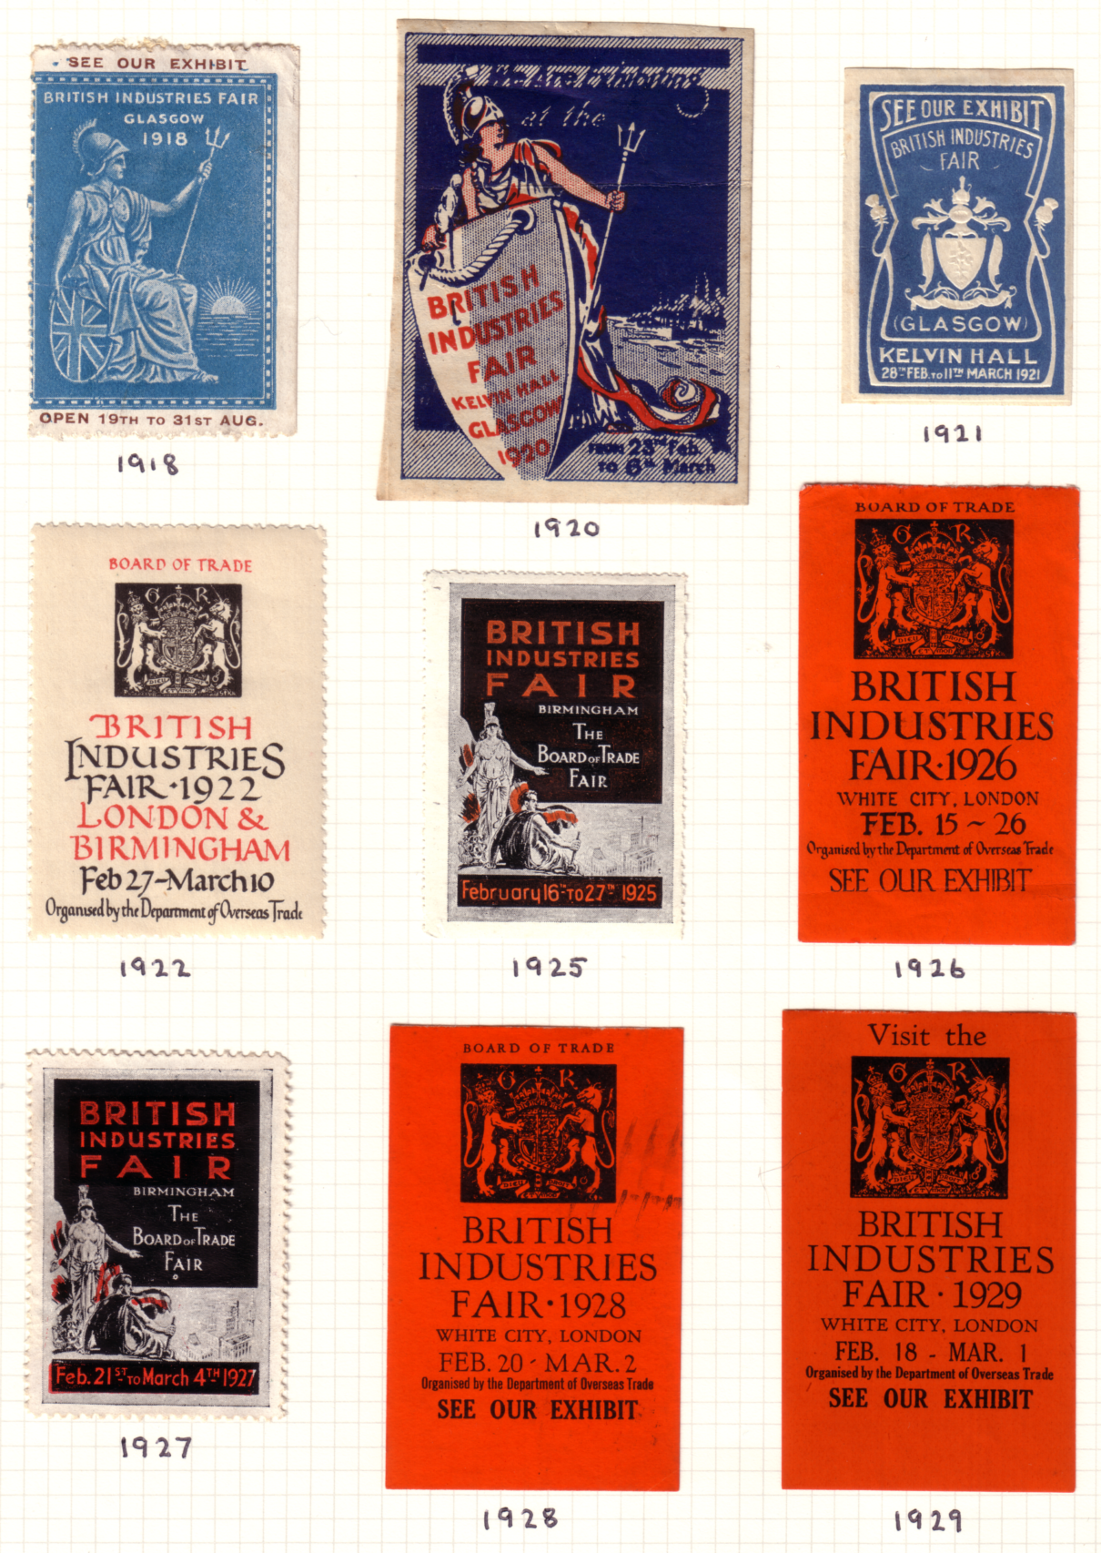
Advertising labels for the British Industries Fair

one of the largest trade fairs in the world. The annual Paris Fair began in 1904 and the variety of slogan postmarks advertising fairs in many countries testify to their continuing importance. Postage stamps too can be found world-wide which portray trade fairs in places as far afield as El Salvador and Zimbabwe.
So it seems that trade and industry fairs have changed a great deal over the years and will continue to adapt to the particular markets they serve. As far as I am concerned the bundle of B.I.F. slogans has opened up a four lane highway in this particular area and from the amount of collectable material around it is not likely to end up in a cul-de-sac. This is probably another case of a side collection bursting its banks!

Items from the British Empire Exhibition that can still be seen elsewhere.
by
Alan Sabey

Lions from the British Government Pavilion.
The most well-known items which can be seen to this day are two of the six Lions which ‘guarded’ the British Government Pavilion until its demolition in 1973. These are now situated near the entrance to the Animal Kingdom at Woburn Abbey in Bedfordshire. They are to be found on either side of the drive and can be seen without having to enter the Animal Kingdom.
Lion of Industry.
A version of the Lion of Industry can also be seen in a gallery on the top floor of the Victoria and Albert Museum in South Kensington.
Drinking Fountains.
Two drinking fountains from the Main Avenue or Kingsway of the Exhibition grounds have found their way to Barham Park at the Sudbury end of Wembley where they have been placed either side of an ornamental gate leading to a small garden area.
Ministry of Labour Hut.
On Sunday April 24th 1983 contractors moved a square building from the garden of a house in Wembley ,where it had been used as a Summer House, to the Grange Museum of Local History at Neasden. This building was one in which labourers were recruited for construction of the Exhibition between 1922 and 1924 and has the inscription “Ministry of Labour” along the top. The house where it was originally, was sold for redevelopment and the building was offered to the Grange Museum. Unfortunately it has remained in its original untreated condition ever since because it was found to contain Asbestos and would need thousands of pounds spent on it. It remains to this day with a flimsy polythene sheeting over it.
Lion Heads from the Garden Club.
The building which was the Wembley Garden Club during the 1925 Exhibition was demolished several years ago, but it was decided to save the two Lion Heads from above the entrances and they have now been set in the wall by the entrance to the new building on the site. Those who came on the walk around the Exhibition site with me in September 1993 will have seen them.
Foundation Stone from the Union of South Africa Pavilion.
In a similar vein, the Foundation Stone from the Pavilion of the Union of South Africa was transferred to the new building in the rebuilding in the 1950’s.
Thrones used by King George V and Queen Mary at the Opening Ceremony.
In the Parish Church of St. John, Wembley at the western wall are to be found the two thrones used by King George V and Queen Mary at the Opening Ceremony in the Stadium in 1924.
City of Bath Pavilion.
The little pavilion of “Aqua Sulis” for the City of Bath was returned to Bath after the close of the Exhibition and was re-erected in 1926 in the Botanic Garden with a suitable plaque.
Queen Mary’s Dolls’ House.
Which was on display in a room in the Palace of Arts is now on display at Windsor Castle, and at one time it was possible to purchase a set of six postcards produced by Topical Press Ltd.
Half Timbered Wooden House.
“Falconers”, Mount Hill, Salcombe, Devon was originally built as a half-timbered house for the 1925 Exhibition by the Federated Home Grown Timber Merchants’ Association as a demonstration of the use of English Oak for construction, and other native timbers for interior decoration. The Exhibition brochure stated:- “The house is built exactly as half timbered dwellings were in the 15th Century, every timber, joint, mortise and tenon has been produced by the handwork of craftsmen in the manner of 450 years ago and there probably does not exist in this country a
building more clearly illustrating the conditions under which our ancestors lived at that period and during the following 450 years”. After the close of the Exhibition, the house was purchased by Lady Moore and removed to Salcombe where it was erected in 1926 on its present magnificent site on 4 acres.
This information was from the Knight, Frank and Rutley Sale Catalogue of 1984 - it is interesting to note here that these same agents handled the sales by auction of the buildings and contents of the Exhibition site at Wembley, and also of course they produced the catalogue ready for the auction of the Crystal Palace in 1911, although in the event the auction did not take place.
Wrought Iron Gates.
On the Welsh borders is a garden, Hergest Croft, which is open to the public and within it are two wrought iron gates, one of which came from Wembley. The gate in question has a spray of feathers in its design and I should imagine that it was originally sited in the Horticultural Section. It was purchased after the close of the Exhibition and erected in these Gardens with a special purpose-made frame bearing the initials of the first owners - William Hartland Banks and Dorothy Banks. WHB has “19” beneath his initials and DB has “25” beneath her initials, thus giving the year as 1925. Apart from a brief mention in the Guide Book to the Hergest Croft, there is no other indication as to the source of the gate.

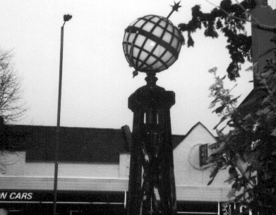

Wembley Light Fitting at a Nursing Home in Cannon Hill.

‘World Globe’ lamps.
On the right-hand side of the right entrance to a rather exclusive Nursing Home in Southgate at the top of Cannon Hill, opposite Selborne Road, are lamps set on modern iron posts. These are the ‘World Globe’ lights that illuminated the Exhibition for two years. At first I was disappointed when I recently went there, thinking that only the glass globes had survived. However when I entered the drive and looked behind all the bushes along the frontage with the pavement, I was delighted to see three of the original decorated concrete lamp standards but without the “Exhibition” type lamps, just ordinary modern circular ones. Still, after 75 years we must think ourselves fortunate that so many things have survived a World War and the hands of developers.

New Zealand Exhibitions seen through Postal and Doulton Products.
by
Peter van Gelder.

Doulton Wares have long been popular in New Zealand. This popularity traces back to John Shorter, who a hundred ago was Doulton’s agent in Sydney, Australia. He introduced a wide variety of Doulton products into New Zealand’s specialist china shops. Then partly in response to the resulting public enthusiasm and partly to develop such an obviously profitable market, the Doulton Company began to produce special designs with New Zealand themes or commemorating New Zealand personalities and events.
Two Exhibitions at Christchurch. ‘The Canterbury Jubilee Exhibition’ was held in 1900, this Canterbury being a province (founded in 1850) with Christchurch as its principle town. There were two Doulton designs for this event, one represents 1850 and shows J. R. Godley with
Christchurch Cathedral, the other represents 1900 and shows William Reece with the Exhibition Pavilion. Done in sepia, these designs were applied to rack plates and to jugs.
The next event was on a larger scale. It was the International Exhibition held in Christchurch during 1906-07. The show opened on 1st November 1906 and ran for five and a half months. A set of four commemorative postage stamps was issued. The ½d value shows the arrival in New Zealand of the Maori, the 1d shows Maori art against the background of a Maori village, the 3d shows the landing of Captain Cook in 1769, and the 6d depicts British annexation (or, more correctly, the proclamation of British Sovereignty). The three lower values were issued for the exhibition’s opening day, and the 6d followed 16 days later.
It is the 1d value which has the most interesting story attached to it. The original printing colour for this stamp was claret, but the authorities then decided that colour was too dark to show off the design effectively. So a new printing was ordered, with the colour changed to vermilion. Next, all but 16 of the claret sheets were destroyed on official orders. But somehow one sheet (i.e. 60 stamps) of the rejected claret colour got into circulation. This happened either by their being sold in error at the Exhibition Post Office, or by their deliberate (but unofficial) release during or after the exhibition period. So the question is “did they fall or were they pushed?” Whatever the true facts of this, the claret stamps are great rarities, and any copy changing hands nowadays commands a price of several thousands of New Zealand dollars.
Doulton and the 1906 Exhibition. John Bates, a Christchurch china shop owner, organised a spectacular display of Royal Doulton wares for the 1906 exhibition. (The Company had received a Royal Warrant from King Edward VII in 1901, from when onwards its products have been marked “Royal Doulton” rather than “Doulton Lambeth”.) The Company also produced commemorative tea plates for the exhibition. Sepia was again the design’s colour, and with a border of intertwined laurel leaves, these plates show the Exhibition Pavilion.
Publicity labels. Another collectable item from the 1906 International Exhibition is the set of seven publicity labels. These had no postal validity. The seven design subjects are, a map of New Zealand, a Maori man, a Kiwi, a Maori woman, a Tui (bird), Maori carving and R. J. Seddon (prime minister, then recently deceased). These labels remain fairly common, except for the red label bearing the Maori carving.
Interestingly another set of labels was issued for the Aukland Exhibition in 1913-14. This time there was a set of five, they are less stamp like in appearance and they are decidedly scarce. The design subjects are, Royal Artillery Band at the gateway, the harbour, the National Flag, a sailing ship and a Maori canoe.
Aukland 1913-14. The rather mundane set of four postage stamps issued for the Aukland Exhibition consisted of overprinted versions of four long serving definitive stamps. These exhibition stamps were available for postage within New Zealand and to Australia only. As a result, they were rather little used. Two thirds of the printing remained unsold and so were eventually destroyed.
Far less well known than the stamps were the postal stationery cards. These have a central boxed heading on the address side, reading “AUKLAND EXHIBITION 1913-14”. There was a ½d value showing King Edward VII (died 1910) on the imprinted stamp, and a 1d card with the New Zealand stamp design. On the back each card has an Aukland view, e.g. “Fish ponds and Entrance to Exhibition” appears on some ½d cards. In all there are six different views to collect on half penny cards and seven on the penny cards. These are amongst the scarcest of all New Zealand postal stationery cards and nowadays change hands for up to £100 each.
The 1992-93 Exhibition. Moving on nearly eighty years we come to the Counterpost Royal Doulton Ceramics Exhibition. New Zealand Post sponsored this show and to mark the event issued a set of six stamps featuring Doulton products. Additionally there is a beautiful miniature sheet showing a scene at Doulton’s Lambeth works in Victorian times. This exhibition was two years in the making and was organised to tour New Zealand’s major towns. It opened in Wellington late in November 1992, then visited Christchurch, Dunedin, Hastings and Aukland, where it closed at the end of October 1993. The “Old Charlie” character Jug was the official exhibition symbol. In all, 750 exhibits were shown, of all types and sizes, including a special section featuring New Zealand motifs. There were several rare and unusual items never before exhibited. The Sir Henry Doulton Gallery
(which is the Company’s museum at Burslem) lent several pieces for the show, and many other items came from private and public collections in New Zealand and Australia. It all formed a fitting celebration of New Zealand’s century long love affair with Doulton.

Letters to the Editor

Dear Bill,
The Stamp Show 2,000 at Earl’s Court.
Should our group publicise itself?

One of the features at The Stamp Show 2000 will be an area where Specialist Societies can display on 16 sheet frames, either material on their area or information about their society. The cost per frame will be 50.00 inc. VAT, and will be in units of two or four frames.
The central feature of the Specialist’s area will be the ABPS (Association of British Philatelic Societies) stand where information about the Study Group can be available, but we will need volunteers to staff it.
I would like to propose that we apply for two frames which would take 32 sheets, this would cost the Group £100.00. Personally I feel that we should use some of our money to promote the Group and this will be at a major International level philatelic exhibition. We could go even further and apply for four frames to show 64 sheets and costing £200.00. It would be helpful if members could let Bill know what they think of the idea.
I would also like to remind members that I should like some more laser copies of some of your choicest items for display purposes such as the above, so that we do not have the problem of security when original and sometimes valuable material is involved. Don’t forget the study Group will pay all your costs in getting the laser copies done

Alan Sabey.

1924 British Empire Exhibition Maps
Part 2
by
Bill Tonkin

My short article on the 1924 British Empire Exhibition maps has caused a lot of interest, and several members sent me in details of maps they had. Thanks to Stanley Hunter and Mike Gorringe who has been collecting these for some time and sent me details of thirteen different maps he has. Thanks also to Des Barber who has checked through the archives of the Wembley History Society and found two, and has also found two more in the collection of Geoff Lane. Alan Sabey has sent me details of maps owned by Jean Alexander and Judith Edwards, also details of maps in the London Museum. So information is pouring in and here is some of the new information.
At the moment I have details of 37 maps and out of this lot there are 26 different ones. The chances are that if you have got two maps they are more likely to be different, than two the same. Initially I thought that the contents of some panels did not alter, and the publishers sold the advertising panels to whoever they could, and it was these that changed. It now appears that this is not always so. I have one report that the picture of Newfoundland in panel O comes in two types, one with the building facing to the right, and the other one facing to the left. Judith Edwards is going to let me see these two maps. If we are coming up with this sort of variation, then I think it may be necessary to give an illustration of each panel, so that members can check their maps panel by panel. This is going to be the only way to bring to light an instance where a non advertising panel may come in two different types.
This brings me to the second problem. Mike Gorringe in his letter kindly offered to send me his maps to inspect, and I took him up on his offer. When I went through them I found his map with an advert for Lloyds Bank, which includes a large drawing of their pavilion on panels S and T, was different from mine. My drawing is signed by Ernest Coffin, Mike’s is by an unknown artist. The bulk of the text on panels U and V is the same but the heading is different. In the non Coffin one the
second line of text reads ‘Head Office: 71, Lombard Street, London, E.C. 3.’, The Coffin one reads ‘Head Office London, E.C. 3.’ On both adverts the next ten lines is identical, although at the end the list of associated and affiliated banks is different.

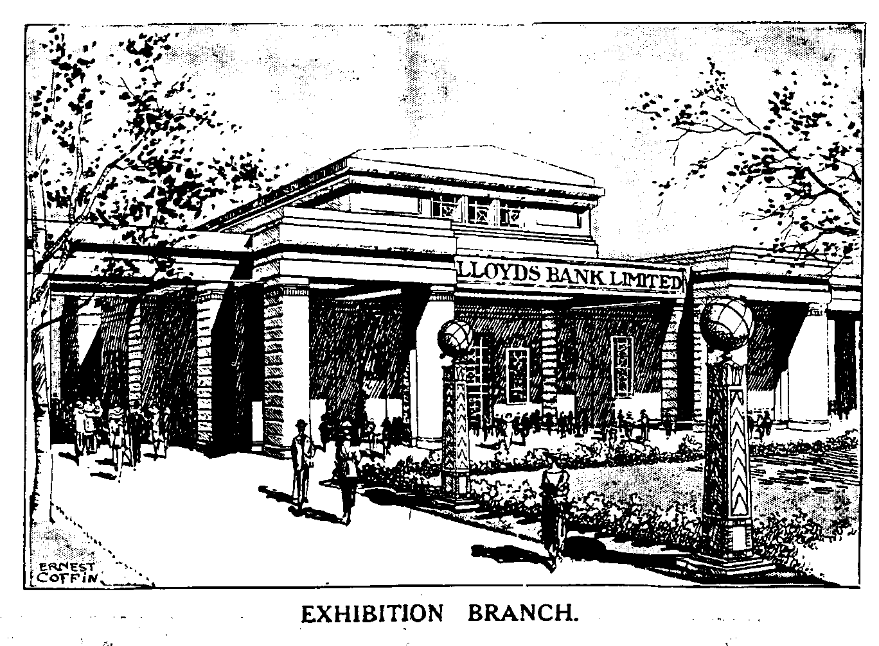
Drawing of Lloyds Bank by Ernest Coffin from Map No. 4.

The list is already becoming so complex that I think there is a need for an index, and in this I have listed the advertisers in panel I in alphabetical order. This panel is usually the back of the folded map, and can be seen at a glance, without having to unfold the map. Unfortunately it is not as easy as that because there are now 17 maps known all with British Industry Fair backs but with other different panels inside, so you still have to open them up.
The second column of the index lists the two types of write up on the exhibition in panels K, L, M and N. Two sections headed ‘Variety and Colour’ and ‘Monster Military Tattoos’ are the same in both types, but in each type the other two sections are different. In one the third section is headed ‘A Fellowship of Empire’ and the fourth section ‘The Great Homecoming’ listed as ‘F. of E.’, in the other one the second section is headed ‘The Tomb of Tut’ and the fourth section ‘An Empire Parliament’ listed as ‘Tut’. It will be observed that maps with adverts for Lloyds Bank and the Metro have been published with both the ‘F. of E.’ and ‘Tut’ texts, so it is important to check this.
The third column lists the contents of advertisers in panels S, T, U and V.
Index

Contents of panel Contents of Contents of
I panels panels
K, L, M & N S, T, U & V

Beldams Pilot. L 274 72 op F. of E. How the Exhibition began Map No. 20
Blank without any printing F. of E. Clyde Shipping Map No. 11
British Industries Fair Tut Blank without any printing Map No. 23
British Industries Fair Tut Canadian Pacific Railway Map No. 21
British Industries Fair Tut . How the Exhibition began Map No. 10
British Industries Fair ? Electrical Industries Map No. 16
British Industries Fair Tut G. W. R. Map No. 2
British Industries Fair F. of E. How the Exhibition began &
Dean & Dawson Map No. 12
British Industries Fair Tut How the Exhibition began Map No. 15
British Industries Fair. P 129/b F. of E. Lloyds Bank (? artist) Map No. 18

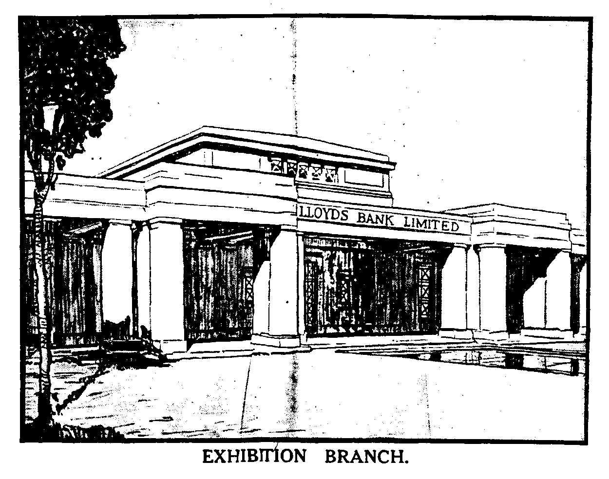
Drawing of Lloyds Bank by an unknown artist from Map No. 26. As far as the building is
concerned it could almost be a tracing from Coffin’s original drawing

British Industries Fair Tut Lloyds Bank (Coffin) Map No. 4
British Industries Fair Tut L. N. E. R Map No. 22
British Industries Fair Tut Polytechnic Tours Map No. 7
British Industries Fair Tut South Wales Evening Express &
Western Mail Map No. 3
British Industries Fair Tut. Metro Map No. 25
British Industries Fair P 129b F. of E. Metro Map No. 1
British Industries Fair & Eastman’s Tut How the Exhibition began Map No. 17
British Industries Fair & Thomas Cook Tut How the Exhibition began Map No. 13
British Industries Fair (Plus two lines) Tut Lloyds Bank (Not Coffin) Map No. 26
Drewery Car Co. L 274 op F. of E. How the Exhibition began Map No. 14
L. M. & S. R. F. of E. L. M. & S. R. Map No. 24
L. N. E. R. F. of E. L. N. E. R. Map No. 19
London’s Underground F. of E. Under.... Train, Bus or Tram Map No. 5
Mallinson F. of E. How the Exhibition began Map No. 6
Siemans F. of E. Siemans Map No. 8
Walpamur F. of E. How the Exhibition began Map No. 9

With the increased amount of information sent to me, and material I have been able to examine a picture is beginning to build up. It would seem that as far as the adverts on panels S, T, U
and V are concerned, if an advertiser was prepared to take all four panels, he could have them. If when a new printing of the maps was required the publishers had not got an advertiser to take up the offer, they inserted a standard fill-up, a four panel piece of text titled ‘How the Exhibition began’. This happened on eight out of the 26 different maps recorded, or as an alternative they just left the space blank. This also happened on panel I, it was unusual but it did happen.. If they could not get a customer to take four panels they would sell him a half size space, i.e. only two panels T and U, and fill in the empty space each side with the first and last panel of their standard fill-up.
I am reprinting details of maps number 1. to 13 which appeared in the Winter Journal, as nearly half of them have had additional information added, and I thought it would be convenient to have everything in one issue. In future I shall only print any new information that comes in.

Contents of each panel on Map number 1.

A. Picture and text on Canada.
B & C. Five pictures and text on West Africa, East Africa, Bermuda, West Indies and British Guiana.
D & E. Picture and text on British Government Pavilion.
F & G. Five pictures and text on Burma, Malaya, Palestine & Cyprus, Ceylon and Hong Kong.
H. Picture and text on Australia.
I. Advert for British industries Fair 1924. With printers reference P 129/b. 7mm between box and ‘For fuller etc.’ seven lines of text measures 33mm deep.
J. Front of map when folded.
K, L, M & N Picture of the Imperial Stadium and text on the British Empire Exhibition. The headings of the paragraphs are, Variety and Colour, Monster Military Tattoos, A Fellowship of Empire and The Great Home-coming.
O. Picture and text on Newfoundland.
P. Picture and text on New Zealand.
Q. Picture and text on South Africa.
R. Picture and text on Palace of Engineering.
S. Advert with two pictures and text by the “Metro”.
T & U. Advert with map and text by The “Metro” Route to the Exhibition.
V. Advert with two pictures and text by the “Metro”.
W. Picture and text on the Palace of Industry.
X. Picture and text on India.

Contents of different panels on Map number 2.

I. Advert for British industries Fair 1924. Without printers reference number. 5mm between box and ‘For fuller etc.’ seven lines of text measures 33mm deep.
K, L, M & N Picture of the Imperial Stadium and text on the British Empire Exhibition. The headings of the paragraphs are, Variety and Colour, The Tomb of Tut, Monster Military Tattoos, and An Empire Parliament.
S. Advert with mileage chart and text by the G W R.
T & U. Advert with map and text by the G W R.
V. Advert with text on Excursion Bookings by the G W R.

Contents of different panels on Map number 3.

I. Advert for British industries Fair 1924. Without printers reference number. 5mm between box and ‘For fuller etc.’ seven lines of text measures 33mm deep.
K, L, M & N Picture of the Imperial Stadium and text on the British Empire Exhibition. The headings of the paragraphs are, Variety and Colour, The Tomb of Tut, Monster Military Tattoos, and An Empire Parliament.
S. Advert by the ‘South Wales Evening Express’.
T & U. Advert with drawn picture and text by the ‘Western Mail’.
V. Advert with text by the ‘Western Mail’.

Contents of different panels on Map number 4.

I. Advert for British industries Fair 1924. Without printers reference number. 5mm between box and ‘For fuller etc.’ seven lines of text measures 33mm deep.
K, L, M & N Picture of the Imperial Stadium and text on the British Empire Exhibition. The headings of the paragraphs are, Variety and Colour, The Tomb of Tut, Monster Military Tattoos, and An Empire Parliament.
S, T, U & V. Advert with drawing of the bank (by E. Coffin) and text by Lloyds Bank Ltd.

Contents of different panels on Map number 5.

I. Full panel advert for London’s Underground, The Way to Wembley.
K, L, M & N Picture of the Imperial Stadium and text on the British Empire Exhibition. The headings of the paragraphs are, Variety and Colour, Monster Military Tattoos, A Fellowship of Empire and The Great Home-coming.
S. How to get to the British Empire Exhibition, by Underground.
T, & U. Map and text, By Train, Omnibus, or Tram to the British Empire Exhibition.
V. By Motor Bus, By Tram.

Contents of different panels on Map number 6.

I. Advert for Wm. Mallinson & Sons Ltd. 130-138 Hackney Rd, London, E. 2. Picture of Palace of Industry Stand No. S. 757. With printers reference L 274 5op.
K, L, M & N Picture of the Imperial Stadium and text on the British Empire Exhibition. The headings of the paragraphs are, Variety and Colour, Monster Military Tattoos, A Fellowship of Empire and The Great Home-coming.
S. How the Exhibition began - Primary Purposes - A Co-operative Effort.
T, & U. All the World will be at Wembley, Fifteen miles of Exhibition. Bird’s eye view of the Grounds. (as Fleetway postcard No. 31).
V. Art of the Empire - The Two Georgians - Short Time Exhibits.

Contents of different panels on Map number 7.

I. Advert for British industries Fair 1924. Without printers reference number.
K, L, M & N Picture of the Imperial Stadium and text on the British Empire Exhibition. The headings of the paragraphs are, Variety and Colour, The Tomb of Tut, Monster Military Tattoos, and An Empire Parliament.
S. ‘Special Notice to Overseas Visitors’ and text
T & U. ‘A Week in London’ and ‘A Weekend in London’ with text.
V. ‘Polytechnic Holiday Tours’ with text

Contents of different panels on Map number 8.

I. Advert for Siemens Electric Lamps.
K, L, M & N Picture of the Imperial Stadium and text on the British Empire Exhibition. The headings of the paragraphs are, Variety and Colour, Monster Military Tattoos, A Fellowship of Empire and The Great Home-coming.
S. Picture of a Bulb, Siemens Gasfilled Lamps, Voltage and Wattage chart
T, & U. ‘Siemens Electric Lamps’ and text with a picture of Big Ben at each end.
V. Picture of a Bulb, Siemens Vacuum Lamps, Voltage and Wattage chart.
Contents of different panels on Map number 9.

I. Full panel advert for ‘The Walpamur Co. Ltd., and description of services.
K, L, M & N Picture of the Imperial Stadium and text on the British Empire Exhibition. The headings of the paragraphs are, Variety and Colour, Monster Military Tattoos, A Fellowship of Empire and The Great Home-coming.
S. ‘How the Exhibition began’ and text.
T, & U. All the World will be at Wembley, Fifteen miles of Exhibition. Bird’s eye view of the Grounds. (as Fleetway postcard No. 31).
V. Art of the Empire - The Two Georgians - Short Time Exhibits.

Contents of different panels on Map number 10.

I. Advert for British industries Fair 1924. Without printers reference number. 5mm between box and ‘For fuller etc.’ seven lines of text measures 33mm deep.
K, L, M & N Picture of the Imperial Stadium and text on the British Empire Exhibition. The headings of the paragraphs are, Variety and Colour, The Tomb of Tut, Monster Military Tattoos, and An Empire Parliament.
S. How the Exhibition began - Primary Purposes - A Co-operative Effort.
T, & U. All the World will be at Wembley, Fifteen miles of Exhibition. Bird’s eye view of the Grounds. (as Fleetway postcard No. 31).
V. Art of the Empire - The Two Georgians - Short Time Exhibits.

Contents of different panels on Map number 11.

I. Blank without any printing.
K, L, M & N Picture of the Imperial Stadium and text on the British Empire Exhibition. The headings of the paragraphs are, Variety and Colour, Monster Military Tattoos, A Fellowship of Empire and The Great Home-coming.
S, T, U & V. Advert for Clyde Shipping Co.

Contents of different panels on Map number 12.

I. Advert for British industries Fair 1924. Without printers reference number. 5mm between box and ‘For fuller etc.’ seven lines of text measures 33mm deep.
K, L, M & N Picture of the Imperial Stadium and text on the British Empire Exhibition. The headings of the paragraphs are, Variety and Colour, The Tomb of Tut, Monster Military Tattoos, and An Empire Parliament.
S. How the Exhibition began - Primary Purposes - A Co-operative Effort.
T, & U. Advert for Dean & Dawson Ltd.
V. Art of the Empire - The Two Georgians - Short Time Exhibits.

Contents of different panels on Map number 13.

I. Advert for British industries Fair 1924. Without printers reference number, 11mm between box and ‘For fuller etc.’ seven lines of text measures 38mm deep, with an additional ‘Thomas Cook & Sons’ advert at the bottom in three lines.
K, L, M & N Picture of the Imperial Stadium and text on the British Empire Exhibition. The headings of the paragraphs are, Variety and Colour, The Tomb of Tut, Monster Military Tattoos, and An Empire Parliament.
S. How the Exhibition began - Primary Purposes - A Co-operative Effort.
T, & U. All the World will be at Wembley, Fifteen miles of Exhibition. Bird’s eye view of the Grounds. (as Fleetway postcard No. 31).
V. Art of the Empire - The Two Georgians - Short Time Exhibits.
Contents of different panels on Map number 14.

I. Advert for Drewery Cars Co., Ltd. Ref No. L 274 op
K, L, M & N Picture of the Imperial Stadium and text on the British Empire Exhibition. The headings of the paragraphs are, Variety and Colour, Monster Military Tattoos, A Fellowship of Empire and The Great Home-coming.
S. How the Exhibition began - Primary Purposes - A Co-operative Effort.
T, & U. All the World will be at Wembley, Fifteen miles of Exhibition. Bird’s eye view of the Grounds. (as Fleetway postcard No. 31).
V. Art of the Empire - The Two Georgians - Short Time Exhibits.

Contents of different panels on Map number 15.

I. Advert for British Industries Fair 1924. Without printers reference number. 5mm between box and ‘For fuller etc.’ seven lines of text measures 33mm deep.
K, L, M & N Picture of the Imperial Stadium and text on the British Empire Exhibition. The headings of the paragraphs are, Variety and Colour, The Tomb of Tut, Monster Military Tattoos, and An Empire Parliament
S. How the Exhibition began - Primary Purposes - A Co-operative Effort.
T, & U. All the World will be at Wembley, Fifteen miles of Exhibition. Bird’s eye view of the Grounds. (as Fleetway postcard No. 31).
V. Art of the Empire - The Two Georgians - Short Time Exhibits.

Contents of different panels on Map number 16.

I. Advert for British Industries Fair 1924. Without printers reference number. 5mm between box and ‘For fuller etc.’ seven lines of text measures 33mm deep.
K, L, M & N ?
S. Electrical Industry, picture of a generator and text.
T, & U. Electrical exhibits, picture of a ship and text.
V. Text and outside electrical installations.

Contents of different panels on Map number 17.

I. Advert for British Industries Fair 1924. Without printers reference number, 5mm between box and ‘For fuller etc.’ seven lines of text measures 33mm deep. and advert at bottom for Eastman’s The London Dyers and Cleaners, Stand H 277.
K, L, M & N Picture of the Imperial Stadium and text on the British Empire Exhibition. The headings of the paragraphs are, Variety and Colour, The Tomb of Tut, Monster Military Tattoos, and An Empire Parliament
S. How the Exhibition began - Primary Purposes - A Co-operative Effort.
T, & U. All the World will be at Wembley, Fifteen miles of Exhibition. Bird’s eye view of the Grounds. (as Fleetway postcard No. 31).
V. Art of the Empire - The Two Georgians - Short Time Exhibits.

Contents of different panels on Map number 18.

I. Advert for British Industries Fair 1924. With printers reference P 129/b. 7mm between box and ‘For fuller etc.’ seven lines of text measures 33mm deep.
K, L, M & N Picture of the Imperial Stadium and text on the British Empire Exhibition. The headings of the paragraphs are, Variety and Colour, Monster Military Tattoos, A Fellowship of Empire and The Great Home-coming.
S, T, U & V Advert with drawing of the bank (details not known) and text by Lloyds Bank Ltd.
Contents of different panels on Map number 19.

I. Advert for L. N. E. R.
K, L, M & N Picture of the Imperial Stadium and text on the British Empire Exhibition. The headings of the paragraphs are, Variety and Colour, Monster Military Tattoos, A Fellowship of Empire and The Great Home-coming.
S, T, U & V Advert for L. N. E. R.

Contents of different panels on Map number 20.

I. Full panel advert for Beldams Pilot Packings & Jointings. Ref No. L 274 72 op. There is a red white and blue Beldam’s sticker in the bottom right corner.
K, L, M & N Picture of the Imperial Stadium and text on the British Empire Exhibition. The headings of the paragraphs are, Variety and Colour, Monster Military Tattoos, A Fellowship of Empire and The Great Home-coming.
S. How the Exhibition began - Primary Purposes - A Co-operative Effort.
T, & U. All the World will be at Wembley, Fifteen miles of Exhibition. Bird’s eye view of the Grounds. (as Fleetway postcard No. 31).
V. Art of the Empire - The Two Georgians - Short Time Exhibits.

Contents of different panels on Map number 21.

I. Advert for British Industries Fair 1924. Without printers reference number. 5mm between box and ‘For fuller etc.’ seven lines of text measures 33mm deep.
K, L, M & N Picture of the Imperial Stadium and text on the British Empire Exhibition. The headings of the paragraphs are, Variety and Colour, The Tomb of Tut, Monster Military Tattoos, and An Empire Parliament.
S. A world Spanning Holiday, Cross Channel Service & All-British Route to the Orient.
T & U. Advert for Canadian Pacific Railway.
V. Peopling the Prairie, and Canadian Pacific in Europe.

Contents of different panels on Map number 22.

I. Advert for British Industries Fair 1924. Without printers reference number. 5mm between box and ‘For fuller etc.’ seven lines of text measures 33mm deep.
K, L, M & N Picture of the Imperial Stadium and text on the British Empire Exhibition. The headings of the paragraphs are, Variety and Colour, The Tomb of Tut, Monster Military Tattoos, and An Empire Parliament.
S, T, U & V Advert for L. N. E. R.

Contents of different panels on Map number 23.

I. Advert for British Industries Fair 1924. Without printers reference number. 5mm between box and ‘For fuller etc.’ seven lines of text measures 33mm deep.
K, L, M & N Picture of the Imperial Stadium and text on the British Empire Exhibition. The headings of the paragraphs are, Variety and Colour, The Tomb of Tut, Monster Military Tattoos, and An Empire Parliament.
S, T, U & V Blank without any printing

Contents of different panels on Map number 24.

I. Advert for L. M. & S. R.
K, L, M & N Picture of the Imperial Stadium and text on the British Empire Exhibition. The headings of the paragraphs are, Variety and Colour, Monster Military Tattoos, A Fellowship of Empire and The Great Home-coming.
S, T, U & V Advert for L. M. & S. R.
Contents of different panels on Map number 25.

I. Advert for British Industries Fair 1924. Without printers reference number. 5mm between box and ‘For fuller etc.’ seven lines of text measures 33mm deep.
K, L, M & N Picture of the Imperial Stadium and text on the British Empire Exhibition. The headings of the paragraphs are, Variety and Colour, The Tomb of Tut, Monster Military Tattoos, and An Empire Parliament..
S. Advert with two pictures and text by the “Metro”.
T & U. Advert with map and text by The “Metro” Route to the Exhibition.
V. Advert with two pictures and text by the “Metro”.

Contents of different panels on Map number 26.

I. Advert for British Industries Fair 1924. Without printers reference number. 5mm between box and ‘For fuller etc.’ nine lines of text measures 43mm deep.
K, L, M & N Picture of the Imperial Stadium and text on the British Empire Exhibition. The headings of the paragraphs are, Variety and Colour, The Tomb of Tut, Monster Military Tattoos, and An Empire Parliament..
S, T, U & V Advert with drawing of the bank, (not by E. Coffin) and text by Lloyds Bank Ltd.
On map No. 26 the seven lines of text under the British Industries Fair advert, is increased to nine lines by the addition of ‘Full details of arrangements for visiting the Exhibition may be obtained at any Passenger Agent’.

Post Cards of the White City
Part 10.
by
Bill Tonkin

Parsley Salmon.
B/W advert card with a view of the stand of Richard B. Green & Co., Ltd., on this card can be seen a placard on the stand reading ‘Diploma of Honour’. (see also under Green. Richard. B., on that stand the placard proudly proclaims ‘four Gold Medals’.) Black back.
Exhibit of Parsley Salmon, Franco-British Exhibition, London, 1908. Awarded Diploma of Honour. The Highest award for Salmon.

Parsley Salmon also published a series of advert cards with a single title ‘London’, these either have a figure to be seen in London and three London views, or a composite of eight London views. They all have a white area in which is embossed ‘Parsley Brand Salmon’ in red. On the back is an overprint in red in five lines reading ‘Franco-British Exhibition / 1908. / Diploma of Honour. / Highest Award / For Salmon. This is over advertising matter which covers half the card. It would appear these cards were sent to their customers advising them of the award at the exhibition.
Sepia R/Photo advert card with embossing picked out in red, printed by Raphael Tuck & Sons, brown back with the left half filled with advertising matter in black with a red overprint.
London. Bank of England & Royal Exchange, Ludgate Hill & St. Pauls London Bridge. with a figure of a Policeman on right
London. The Tower Bridge, Westminster Abbey and The Tower of London. with a figure of a Beefeater on the left.
London. Mansion House, Rotten Row Hyde Park, St. Pauls Cathedral, Houses of Parliament, Tower Bridge, The Griffin, Trafalgar Square, Westminster Abbey.

Patent Steam Carpet Beating Co., Ltd.
G. W. Bacon map card showing the site of the Franco-British Exhibition picked out in red. On the black and red back is a plan of the exhibition site with their stand location picked out in red.
Patent Steam Carpet Beating Co., Ltd.
Paternoster Series.
Coloured comic card published by the Avenue Publishing Co., black back.
Another Japanese Exhibition. Vert left.

Peerless Shamrock.
Type 1. L’Entente Cordiale Series. Sepia R/Photo, view in a circular embossed frame, the right side of the card has a border of an embossed garland of flowers, in the centre of this is printed ‘L’Entente Cordiale, Souvenir, Franco-British Exhibition 1908. Yellow brown back.
Court of Honour from the Bridge.
Fine Art Palace.
Palace of British Applied Art.
Palace of French Applied Art.
Palace of Music.
Palace of Women’s Work.
The Rikshas.
The Scenic Railway.
Up in the Flip Flap.

Type 2. Sepia R/Photo cards with a view of the cage of the Flip Flap full of visitors. Under the picture is printed the chorus of popular songs about the Flip Flap. Yellow brown back.
333 Come along up in the Flip Flap. Vert right.
335 Take me on the Flip Flap. Vert right.

Perkins & Sons.
B/W litho printing with title in brown on the front, brown back with a number in the top left corner.
20 Franco-British Exhibition, Wood Lane Entrance.

Perrier Table Water.
Coloured advert card showing the Perrier pavilion, brown back.
Souvenir Perrier Pavilion, Franco-British Exhibition, 1908.

Philco Publishing Co. The
Philco published three series of cards for the Franco-British Exhibition, the first two series are of standard views. Very dark sepia almost black R/Photo, brown back. All the titles are preceded with ‘Franco-British Exhibition.’
Philco Series 3477.
3477A. Court of Honour by night.
3447B. Australian Section.
3477C. Elite Gardens.
3477D. Court of Honour.
3477E. The Scenic Railway.
3477F. Court of Honour Showing Pleasure Boats.

Philco Series 3478.
3478A. The Palace of Music.
3478B. The Indian Section. (This is from the original photo showing the long ladders)
3478C. Palace of French Applied Arts.
3478D. Part of Elite Gardens.
3478E. Palace of Women’s Work.
3478F. Part of Elite Gardens.
Philco Series 3479.
Series 3479 shows a young child loosely draped in strips of cloth and a hand mirror with four un-named views of the exhibition in place of the glass. There is also a string of pearls, and all the cards have the same title ‘A Memento of the Franco-British Exhibition’ within a mass of ornamental scrolls.
3479D. A Memento of the Franco-British Exhibition. Palace of Women’s Work, Part of Elite Gardens, Court of Honour Showing Pleasure Boats and Court of Honour by night.
3479E. A Memento of the Franco-British Exhibition. The Indian Section, Australian Section, The Scenic Railway and Palace of Women’s Work.
3479F. A Memento of the Franco-British Exhibition. The Palace of Music, Palace of French Applied Arts, Elite Gardens and Part of Elite Gardens.
Phillips Godfrey Tobacco.
Type 1. Coloured advert card showing the Godfrey Phillips Pavilion, Green back.
The Godfrey Phillips Tobacco Exhibit, Franco-British Exhibition.

Type 2. Coloured advert card showing the Godfrey Phillips Pavilion as above, Green back with 50mm diameter reproduction of the medal awarded at the exhibition.
The Godfrey Phillips, Franco-British Exhib.

Pictograph Publishing Co.
It cannot be said that this series of cards are exhibition cards. They are reproductions of paintings by Ella du Cane, and five of the six were published by Tuck’s for the Japan-British Exhibition, and it is for this reason they are included. Strangely du Cane is given no credit on the cards as being the artist, although on some her signature can be seen.
“Oilograph” Japanese Gardens Series.
Coloured with brush impressions like the Tuck’s Oilfacsims, black back with title and number on the back..
No. 619 Wistaria in a Kyoto Garden. Vert left.
No. 620 Satake Garden, Tokyo.
No. 621 A Landscape Garden. Vert left.
No. 622 Cherry Blossom, Chion-in-Temple. Vert left.
No. 623 Plum Blossom and Lanterns. Vert left.
No. 624 Azaleas, Nagaoka.

Plymouth Co-operative Drug Co.
A printed advert for the Plymouth Co-operative Drug Co., 20, Cornwall St, Plymouth., can be found on the backs of Valentine’s Japan-British Exhibition cards, remaindered after the exhibition closed. Coloured, grey-green back type JB 1. The advert takes the form of four lined doggerel, which is listed.
Type 1. My hair is white , but not with years, You know that well my darling Nora,
The simple truth is, I forgot, To use the Plymouth Hair Restorer. 1/- per Bottle, 3 for 2/6.
590 Wiggle Woggle, Japan-British Exhibition.
683 Winter, The Four Seasons, Japan-British Exhibition.

Type 2. His auburn locks were failing fast, Which made him much despair;
But now his tale of woe is past-He uses our “Luxhair”. 1/- per Bottle
717 The Little Cyclone, Japan-British Exhibition.

Type 3. Should you have a little Corn, upon your little toe,
Use a little of our Solvent, And the little Corn will go. 7½d per Bottle.
523 Congress Hall by Night, Japan-British Exhibition, London, 1910.
Type 4. “I have a cold, a bad, bad cold, I caught it in the rain;
But Stoddart’s Influenza Cure, Will send it off again. 1/- per Bottle.
701 Uji Village, Japan-British Exhibition.

Poteau E.
B/W French advert card for a furnishing firm in Paris with Londres-Exposition franco-britannique, 1908. at the top, black back.
Reproduction de tenture et mobilier de la Reine Marie Antoinette. E. Poteau, Fabricant, 59, rue de Turenne, Paris.

Power. W. M.
Coloured advert card showing the stand of a picture and picture frame restorer A Valentine & Sons card with brown back type FB 2, with rubber hand stamp in purple, reading Franco-British Liberal Arts. Exhibit 1b, Hall 3., in three lines.
386 Franco-British Exhibit, Stand No. 1, Hall 3.

Price’s Patent Candle Co., Ltd.
These coloured trade cards of various historical scenes, have mention on the brown back, of the medals awarded at exhibitions, the titles are also on the back. These lists of awards are in several types.
Type 1. The only Grand Prize specially for Toilet Soaps (class 90) Franco-British Exhibition 1908.
Battle of the Nile, August 1, 1798.
Bombardment of Alexandria, July 11, 1882.
Kassassin, Egyptian War, 1882.

Type 2. Two Grand Prizes, Franco-British Exhibition, 1908.
Balaklava, Crimean War, Oct 25, 1854.
Blake and Van Tromp, 1652-3.
Lucknow, Indian Mutiny, 1857.
Spannish Armada, 1588.
The Glorious First of June, 1794.
Waterloo, June 18, 1815.

Type 3. Four Grand Prizes in 1910. Brussels (2), London (1) Buenos Aires (1).
Balaklava, Crimean War, Oct 25, 1854.
Battle of Plassey, June 23, 1757.
Blake and Van Tromp, 1652-3.

Pritchard & Co.
A printed advert for Pritchard & Co., picture framer and photographer of 138, Aldersgate, can be found on the backs of an unknown publisher’s Franco-British Exhibition cards, remaindered after the exhibition closed.
Coloured trade card with title in gold, plate sunk with large white borders, back printed in black.
Dorando’s Arrival at the Stadium. Franco-British Exhibition.
Machinery Hall. Franco-British Exhibition.
Palace of French Applied Arts. Franco-British Exhibition.
The Court of Honour by Night. Franco-British Exhibition.

