EDITORIAL WINTER 1998

It’s Christmas, and the time to be Merry,
Let’s hope Bill keeps away from the Sherry.

Well here we are again, another Journal, another year older, and even less post cards to be found at the fairs. This is getting serious and I am coming very near to having blank days. I spent three days at Bipex this year, and although I managed to get just over 70 cards there was nothing to throw my hat in the air about. I suppose the best card I got was a Tuck’s Festival of Britain card, one of the ‘Campania’ series No. FSC 3, and at £1.50 a good buy. And that’s another thing, the numbers on postcards seem to be getting smaller and smaller. Just now I could hardly read FSC 3. Getting back to fairs, out of the 56 I have been to this year, at 13 fairs I found only 38 cards, which is an average of less than three cards per fair. No wonder my hair’s going white.
It seems whenever you talk to either dealers or collectors, the story’s the same, there just are not any good cards about any more. Anybody new starting to collect must find it very difficult. I have tried fairs and advertising for cards, and still do very well, but I suppose a large part of my purchases are varieties of cards I already have. I like varieties and because my advertising has given me the opportunity to examine over 15,000 cards sent to me in the last nine years I have been able to build up a collection that’s going to be a job to beat.
I have never been keen on buying cards at auctions, but perhaps I should start thinking about it. It will mean travelling to see lots as auctioneers descriptions are meaningless. Also I think deep down I don’t want to start acquiring cards by bidding more than anyone else in the room is prepared to go to, and finish up with box fulls of duplicates I have paid over the top for, and no chance of seeing even a fraction of my money back.
In the Summer editorial I mentioned the collection of 83 ‘cut-out’ cards coming up at Sotheby’s with an estimated valuation of between £4-6 thousand, well it didn’t get a single bid and was returned to the owner. I managed to get in touch with him through Sotheby’s with an offer for two of the cards, but by then he had already sold them and wouldn’t tell me who bought them.
I am sorry if so much of the editorial is about postcards, but out of all the exhibition collectibles, it’s the subject I know most about. I seem to remember saying, or writing recently that the Exhibition Study Group is not a postcard club, but having said that it must be admitted it is the most popular area of collecting. Perhaps because it is within the financial reach of all of us, but let us not forget that there are some beautiful cards about, still at very low prices.
It is some time since I appealed for articles, but I would welcome some of you writing short bits on anything you like. It would be a bad thing if the Journal became a one man band effort, always expressing one mans views.. This is one reason why the Convention is such a welcome break. I get the opportunity to see what other people are collecting,, how they are collecting, and I always come away inspired.
I can still remember the impression Arthur Smith’s talk and display on the Royal Tournament made on me some years ago at one of the conventions at the Crystal Palace. It certainly sharpened my appetite for the tournament. Another tournament collector from Preston comes down and stays with me for a few days once a year, and has done so for about three years now. He is researching the tournament and we compare notes. I bumped into him at a fair and got chatting and that’s how it started.
I am sorry that more members don’t make the effort to get to our convention, and feel that in a way it is my fault for not making it sound more interesting. A collector by himself is isolated and has nothing to feed his enthusiasm. I have made many friends through meeting them at the convention. Mike Perkins is one, we met at the first do at York and have been firm friends ever since, with our book as a tangible proof of what getting together with someone with the same interest can lead to.
Our book on the 1924-24 British Empire Exhibition cards will remain the standard reference work on the subject for many years to come. Many friends within the group helped us with details and made it what it is. I have no doubt in my mind that if Andrew Brooks had not started the conventions the book would never have seen the light of day.
I owe an apology to Alan Sabey for forgetting to include in the Autumn Journal a form for you to fill in and send off with your subscriptions. It‘s the back page of this journal so please get it off to Alan as soon as you can.

The Editor

As Seen on T.V.
by
George Simner

I have just been made to realise, that going to work full time makes you miss a lot of what’s going on.
Having to take early retirement I now occasionally get time to watch daytime T.V. and twice this week have switched on the tele whilst eating my lunch and seen familiar faces on the screen.
On Monday 16th November I was watching ‘Collectors Lot’ on channel 4 at 3.30, and saw Stanley Hunter showing and talking about the 1938 Empire Exhibition held in Glasgow (Scotland). Stanley is a master on his subjects and showed a lot of his collection. There were several versions of china Taits towers. One was picked out specially by Goss, as it features the Clachan Highland Village painted on it. There was also spoons, a tea strainer, and a hand bag mirror. There were photo’s taken of people who visited the exhibition, but as Stanley said they looked more like passport photo’s (still very collectable however). He also showed compacts and other items, some made of butterfly wings (which would be illegal to make now).
Amy Johnson whilst on a visit to the exhibition was shown a quick way out and in return she autographed a season entrance ticket, which has found its way into Stanley’s collection.
Stanley said he went to the exhibition but could not remember much as he was taken round in a Moses basket. He showed two signs that he said were perhaps his favourite items. One was a flat cut out of a queue of people waiting for a bus. This was used to indicate the bus routes and stop. The other sign was of a waiter with a tray in his hand serving people sitting at a table. This was used to show you where to find the restaurants, these signs were to be found around the exhibition.
As the norm nowadays, Stanley had a lot of collectibles on the table but the camera and the presenter only just touched the fringe. I would liked to have seen all of the programme devoted to Stanley’s collection and to have heard him talk about it, as to coin a phrase “he knows what he’s talking about”. Stanley mentioned that he became interested in exhibitions because he lives near Kelvin Grove. Well done Stanley.

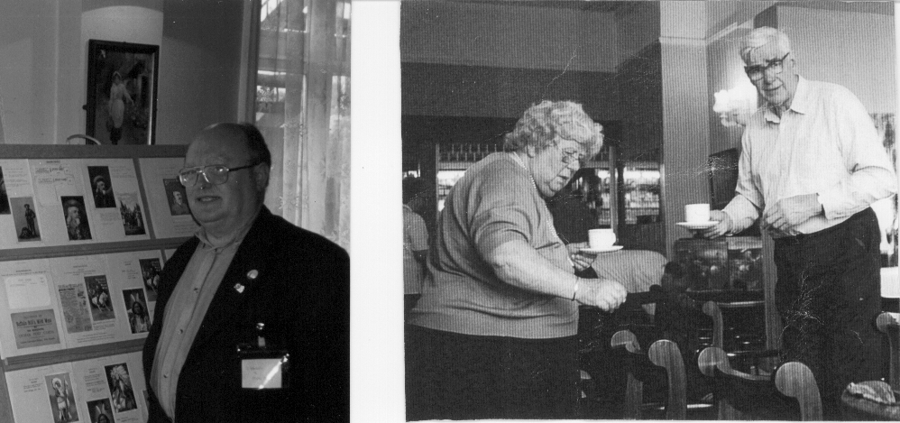

Stanley K. Hunter Gwen and Bob Tough
That was Monday’s surprise, then on Tuesday the 19th November there was a programme on B.B.C. 2 called “History Hour”. I had just gone out of the room to use my computer when my wife called me back into the room, she had recognised another face. It was Bob Tough. He was talking about his father and what he did in the 1939-45 war when our troops needed to be evacuated from Dunkirk. The Navy needed small boats to get close to the beaches so as they could get the men off and transferred to larger ships laying off shore.
Bob’s father had a business along the Thames at Teddington and he was asked to find and collect the small boats. He did, 200 in all. As the Navy did not have people to crew these Bob’s father was asked to find these as well. Once again he succeeded, 400 people, two for each boat. The rest is History. What a father to be proud of !
Bob’s family is still on the river at Teddington. They have a boat yard there which is run by his sons. He still goes there quite often (just to over see).
Bob also spoke of Barnes Wallace, of the bouncing bomb fame, and that he used a water tank not far from Bob’s yard to do his testing. Bob said that he had used the tank himself to test his model boats before making them full size. Well done Bob.
As all members of the Exhibition Study Group already know, both of these T.V. stars are members too. I think they are to be congratulated on the way they presented their subjects, the Group can be proud of them.
I think that this article has proved my point, that working gets in the way of the things that really matter.

The Saturday Relief Cancelling Machine for the
British Empire Exhibition 1925
by
Alan Sabey.

In May 1924 it was realised that there might be a need for assistance in cancelling the mail posted at the Exhibition on Saturdays, which was the main day that the working man could go (The Exhibition was not open on Sundays) without having to take a day off. In Post Office file M1433/1928 there is correspondence which states that “difficulty is anticipated in handling at the N.W.D.O. (North West District Office) the proceeds of the last collection at the British Empire Exhibition on Saturday nights, and it may be necessary to deal with the correspondence at the Inland Section”. However the need never seemed to arise as only one machine, simply dated 1924 was used to cancel the mail.
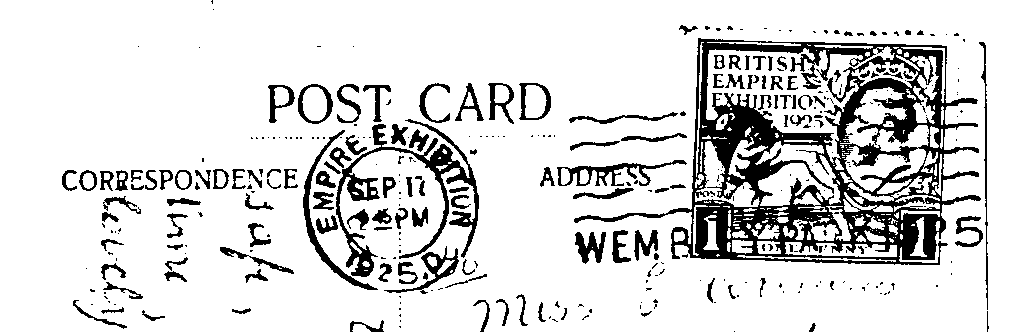

The normal 1925 “D” cancellation in small letters

In 1925 it was a different story, most of the mail was cancelled by the “Empire Exhibition 1925 D” machine which according to the Post Office files was sited at the Inland Section at Mount Pleasant Sorting Office. The files also state that the machine without the “D” were at the North West District Office which was near Euston Station.

Of all the “1925” type machine cancellations seen, all are timed at 9.45pm and the earliest known date is May 30th (a Saturday). It would therefore seem that this machine was a Saturday Relief cancelling machine at the North West District Office.
Unfortunately there is nothing in the files to say whether this relief machine was first used on the opening day Saturday May 9th or whether it came into use later. A card has been seen cancelled with this type on October 31st 1925, that is without the “D” after the year.

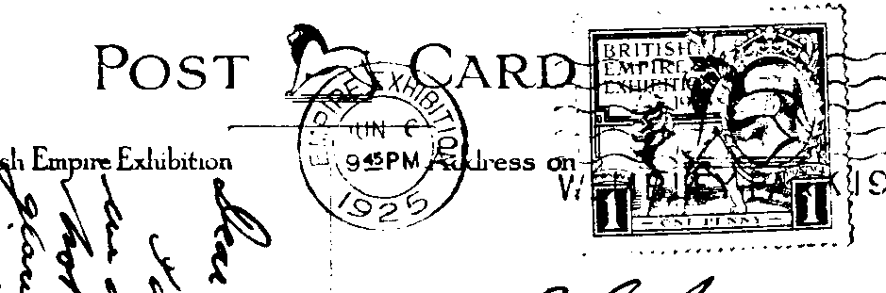

The 1925 Saturday Relief cancellation in larger letters without “D”

Alan is still requiring the following dates, May 9, 16, 23, 30, June 13, 20, July 18, 25,
August 8, 22, September 5, 19, 26, October 3, 10, 17, 24. He would be pleased to hear from members who may be able to help him with these.

1924 British Empire Exhibition Maps
by
Bill Tonkin

Members will be familiar with the series of coloured maps done by Kennedy North and printed by Dobson Molle & Co., Ltd. When opened out they measure 29½ x 20, and folded approximately 3¾ x 6¾. The map is very colourful with a green and black border and shows a plan of the site with the main buildings named. The bottom third of the map shows the main bus, train and tram routes to the exhibition. I use the word series because if you study the backs closely, you will find they are not all the same.
So it is with the back of the map that we should pay special attention to. When folded it is divided up into 24 panels of information or advertising matter with pictures, which I have named A to X, see table below. Some panels are joined to make a double width panel, and in some cases four panels are joined, to make an even larger display.
It has been known for some time that there were different backs, and the difference is in the panels containing advertisements for various firms. As far as I know nobody has really looked into it, so here’s a start. This item is so common selling for only a few pounds, that I should imagine there is not a collector of Wembley ephemera that does not have one or more in his collection. So make an effort and check on yours and please let me know if you have any that are different to this first list. I have been told there are about 20 different maps
So far I have five of these maps and thanks to collaboration from Mike Perkins and Alan Sabey, can record eight more, each one of which is different. The difference seems to be limited to five panels, lettered I, S, T, U and V which were all used for adverts. In another four panels K, L, M, and N the picture and heading ‘British Empire Exhibition’ is the same, but there are two different texts and here I will just list the headings of the chapters. For a quick reference these can be divided into text with a paragraph titled ‘The Tomb of Tut’ see map number 2, and text without the paragraph titled ‘The Tomb of Tut’ see map number 1.
Until much more is known about the backs I cannot say definitely that the other panels do not vary, this is something that will become clear if I get a good response from members.

Contents of each panel on Map number 1.

A. Picture and text on Canada.
B & C. Five pictures and text on West Africa, East Africa, Bermuda, West Indies and British Guiana.
D & E. Picture and text on British Government Pavilion.
F & G. Five pictures and text on Burma, Malaya, Palestine & Cyprus, Ceylon and Hong Kong.
H. Picture and text on Australia.
I. Advert for British industries Fair 1924. With printers reference P 129/b. 7mm between box and ‘For fuller etc.’ seven lines of text measures 33mm deep.
J. Front of map when folded.

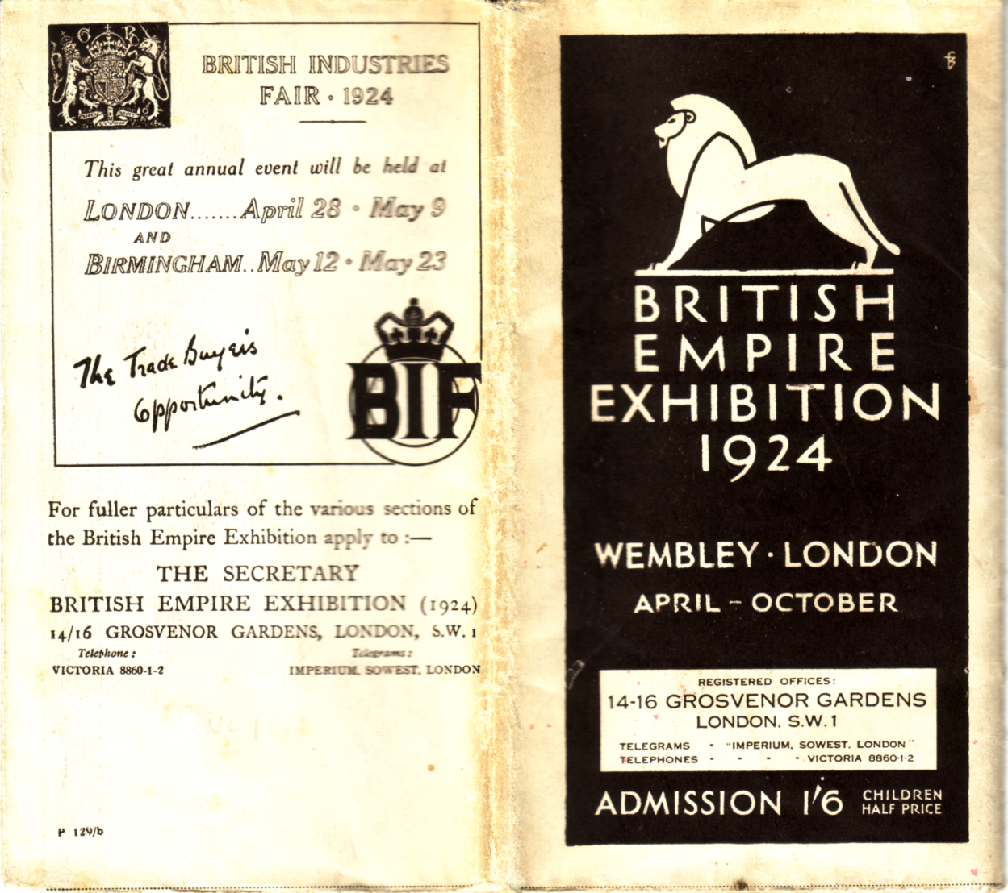

Panel I and J, which when folded form the front and back. Note the printers reference
number P 129/b in the bottom left of panel I.

K, L, M & N Picture of the Imperial Stadium and text on the British Empire Exhibition. The headings of the paragraphs are, Variety and Colour, Monster Military Tattoos, A Fellowship of Empire and The Great Home-coming.
O. Picture and text on Newfoundland.
P. Picture and text on New Zealand.
Q. Picture and text on South Africa.
R. Picture and text on Palace of Engineering.
S. Advert with two pictures and text by the “Metro”.
T & U. Advert with map and text by The “Metro” Route to the Exhibition.
V. Advert with two pictures and text by the “Metro”.
W. Picture and text on the Palace of Industry.
X. Picture and text on India.

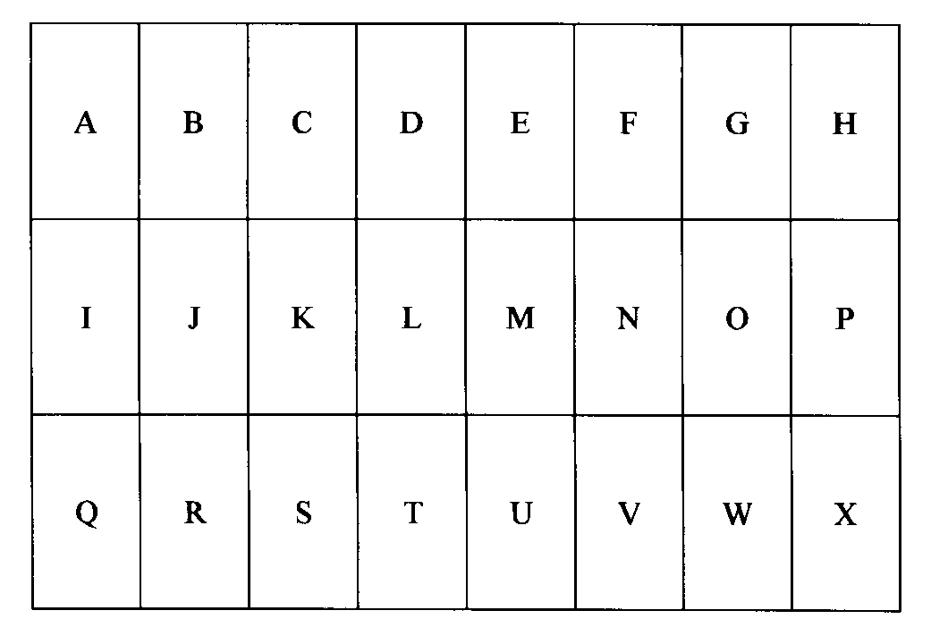
Layout and letters allocated to each panel on the back of the map.

As far as I know the contents of panels A, B, C, D, E, F, G, H, J, O, P, Q, R, W and X do not alter, so I will only list those panels that are known to alter. It is however important that members check these as something might turn up different to mine.

Contents of different panels on Map number 2.

I. Advert for British industries Fair 1924. Without printers reference number. 5mm between box and ‘For fuller etc.’ seven lines of text measures 33mm deep.
K, L, M & N Picture of the Imperial Stadium and text on the British Empire Exhibition. The headings of the paragraphs are, Variety and Colour, The Tomb of Tut, Monster Military Tattoos, and An Empire Parliament.
S. Advert with mileage chart and text by the G W R.
T & U. Advert with map and text by the G W R.
V. Advert with text on Excursion Bookings by the G W R.

Contents of different panels on Map number 3.

I. Advert for British industries Fair 1924. Without printers reference number. 5mm between box and ‘For fuller etc.’ seven lines of text measures 33mm deep.
K, L, M & N Picture of the Imperial Stadium and text on the British Empire Exhibition. The headings of the paragraphs are, Variety and Colour, The Tomb of Tut, Monster Military Tattoos, and An Empire Parliament.
S. Advert by the ‘South Wales Evening Express’.
T & U. Advert with drawn picture and text by the ‘Western Mail’.
V. Advert with text by the ‘Western Mail’.
Contents of different panels on Map number 4.

I. Advert for British industries Fair 1924. Without printers reference number. 5mm between box and ‘For fuller etc.’ seven lines of text measures 33mm deep.
K, L, M & N Picture of the Imperial Stadium and text on the British Empire Exhibition. The headings of the paragraphs are, Variety and Colour, The Tomb of Tut, Monster Military Tattoos, and An Empire Parliament.
S, T, U & V. Advert with drawing of the bank by E. Coffin and text by Lloyds Bank Ltd.

Contents of different panels on Map number 5.

I. Advert for London’s Underground, The Way to Wembley.
K, L, M & N Picture of the Imperial Stadium and text on the British Empire Exhibition. The headings of the paragraphs are, Variety and Colour, Monster Military Tattoos, A Fellowship of Empire and The Great Home-coming.
S. How to get to the British Empire Exhibition, by Underground.
T, & U. Map and text, By Train, Omnibus, or Tram to the British Empire Exhibition.
V. By Motor Bus, By Tram.

Contents of different panels on Map number 6.

I. Advert for Wm. Mallinson & Sons Ltd. 130-138 Hackney Rd, London, E. 2. Picture of Palace of Industry Stand No. S. 757. With printers reference L 274 5op.
K, L, M & N As map No. 1.
S. How the Exhibition began - Primary Purposes - A Co-operative Effort.
T, & U. All the World will be at Wembley, Fifteen miles of Exhibition. Artist’s impression - aerial view from the North West Entrance.
V. Art of the Empire - The Two Georgians - Short Time Exhibits.

Contents of different panels on Map number 7.

I. Advert for British industries Fair 1924. Without printers reference number.
K, L, M & N Picture of the Imperial Stadium and text on the British Empire Exhibition. The headings of the paragraphs are, Variety and Colour, The Tomb of Tut, Monster Military Tattoos, and An Empire Parliament.
S. ‘Special Notice to Overseas Visitors’ and text
T & U. ‘A Week in London’ and ‘A Weekend in London’ with text.
V. ‘Polytechnic Holiday Tours’ with text

Contents of different panels on Map number 8.

I. Advert for Siemens Electric Lamps.
K, L, M & N Picture of the Imperial Stadium and text on the British Empire Exhibition. The headings of the paragraphs are, Variety and Colour, Monster Military Tattoos, A Fellowship of Empire and The Great Home-coming.
S. Picture of a Bulb, Siemens Gasfilled Lamps, Voltage and Wattage chart
T, & U. ‘Siemens Electric Lamps’ and text with a picture of Big Ben at each end.
V. Picture of a Bulb, Siemens Vacuum Lamps, Voltage and Wattage chart.

Contents of different panels on Map number 9.

I. Advert for ‘The Walpamur Co. Ltd., and description of services.
K, L, M & N Picture of the Imperial Stadium and text on the British Empire Exhibition. The headings of the paragraphs are, Variety and Colour, Monster Military Tattoos, A Fellowship of Empire and The Great Home-coming.
S. ‘How the Exhibition began’ and text.
T, & U. Bird’s eye view of the grounds, and a hand drawn artist’s impression similar to the Fleetway post card No. 31.
V. Art of the Empire - The Two Georgians - Short Time Exhibits.

Contents of different panels on Map number 10.

I. Advert for British industries Fair 1924. Without printers reference number. 5mm between box and ‘For fuller etc.’ seven lines of text measures 33mm deep.
K, L, M & N Picture of the Imperial Stadium and text on the British Empire Exhibition. The headings of the paragraphs are, Variety and Colour, The Tomb of Tut, Monster Military Tattoos, and An Empire Parliament.
S. How the Exhibition began - Primary Purposes - A Co-operative Effort.
T, & U. All the World will be at Wembley, Fifteen miles of Exhibition. Artist’s impression - aerial view from the North West Entrance.
V. Art of the Empire - The Two Georgians - Short Time Exhibits.

Contents of different panels on Map number 11.

I. Plain back.
K, L, M & N Picture of the Imperial Stadium and text on the British Empire Exhibition. The headings of the paragraphs are, Variety and Colour, Monster Military Tattoos, A Fellowship of Empire and The Great Home-coming.
S, T, U & V. Advert for Clyde Shipping Co.

Contents of different panels on Map number 12.

I. Advert for British industries Fair 1924. Without printers reference number. 5mm between box and ‘For fuller etc.’ seven lines of text measures 33mm deep.
K, L, M & N Picture of the Imperial Stadium and text on the British Empire Exhibition. The headings of the paragraphs are, Variety and Colour, The Tomb of Tut, Monster Military Tattoos, and An Empire Parliament.
S. How the Exhibition began - Primary Purposes - A Co-operative Effort.
T, & U. Advert for Dean & Dawson Ltd.
V. Art of the Empire - The Two Georgians - Short Time Exhibits.

Contents of different panels on Map number 13.

I. Advert for British industries Fair 1924. Without printers reference number, 11mm between box and ‘For fuller etc.’ seven lines of text measures 38mm deep, with an additional ‘Thomas Cook & Sons’ advert at the bottom in three lines.
K, L, M & N Picture of the Imperial Stadium and text on the British Empire Exhibition. The headings of the paragraphs are, Variety and Colour, The Tomb of Tut, Monster Military Tattoos, and An Empire Parliament.
S. How the Exhibition began - Primary Purposes - A Co-operative Effort.
T, & U. All the World will be at Wembley, Fifteen miles of Exhibition. Artist’s impression - aerial view from the North West Entrance.
V. Art of the Empire - The Two Georgians - Short Time Exhibits.

Letters to the Editor.

I have had a letter from a non-member asking for information, which I am publishing in the hope that someone can help him.
Brian Turner. 19, Norfolk Rd, Lytham St. Annes, Lancs. FY8 4JG phone 01253 730909
I wonder if you, or any of your members can help me, with a problem that has frustrated me for nearly 30 years. My speciality is Blackpool Trams, on which I have written several books.
In 1885 (from May to Sept.) a Blackpool electric tram operated in the grounds of the Inventors Exhibition in South Kensington. In fact there were two trams lines in the exhibition grounds, the other one with a car driven by compressed-air. It’s the Blackpool one I’m particularly keen to illustrate.
Although I’ve found a plan of the line in the exhibition programme at Kensington Library, I’ve been unable to find any pictures. The Science Museum have no record of it (or so they say). It seems extraordinary that no photographs have survived of an event right in the heart of London. Can you help in any way?

I replied to this, Dear Brian,

Thank you for your letter regarding Blackpool Trams, and the lack of illustrations. I too suffer from the same problem, I have never been able to find a card of the Never Stop Railway, which transported visitors round the 1924-25 British Empire Exhibition. Neither has anyone else ever seen one, it is just incredible that no post card exists of this unique railway.

My own main interest is in postcards of exhibitions and I know of no postcards of the 1885 International Inventions Exhibition. I do not have the 1885 programme, but I have several of the daily programmes published for that exhibition. None of these illustrate the tram. It is possible that the Tram was a late arrival as the June 23rd programme only mentions “The Air Car is now plying daily in the South Promenade”, while July and August programmes mentions “The Air Car and the Electric Car are now plying daily in the South Promenade”.

I will publish your request in our quarterly Journal to see if anyone knows anything, and three other sources you might try are
1. Ask Brian Lund editor of ‘Picture Postcard Monthly’ at 15, Debdale Lane, Keyworth, Nottingham, NG12 5HT, to print your request in his magazine. I am sure there will be no postcards, but someone interested in transport cards might be able to help you.
2. Contact Neil Parkhouse of Lightmoor Press, 47-49 High Street, Lydney,Gloucs, GL15 5DD. he publishes ‘Archive’ a quarterly magazine on transport.
3. Check on ‘The Illustrated London News’ for 1885 There would almost certainly be an article and illustrations, which might include the tram.
I think that is as far as I can help you, if any of these avenues produce something, I would appreciate it if you could let me have a photo-copy of anything that comes to light.

Letters regarding the Circulating Packet

I have had a letter from a member regarding a circular he has received from another member regarding the possibility of setting up a second circulating packet within the group. In this instance I have with held the names of the writers.

Dear Bill,

I thought you should see this letter which recently came to me (unsolicited) from one of our members. Maybe you already know about it, but it concerns me that,
a) The club membership list could be used by ‘dealers’ (160 cards on list attached).
b) The idea of starting a private club within our club.
c) The undermining of our packet and the subsequent loss of revenue to the club.
Maybe I worry needlessly, but I do think our committee might like to be informed and consider the implications.
regards,
The enclosed letter was as follows,

Firstly please excuse this unsolicited letter, My name is ............. and like you I am a member of the Exhibition Study Group. I recently received the Autumn edition of the E.S.G. Journal and took the liberty of noting your name and address. I collect post cards of the British Empire Exhibition Wembley 1924/25, and over the last twelve months have been disappointed with the infrequent distribution and lack of Wembley cards, especially if you happen to be in the bottom half of the distribution list.
It then occurred to me that there are probably other members of the group who like me have collected duplicate cards over the years and would like to swap with or sell to other members with similar interests, hence this letter.
I have prepared a list of a number of cards I would like to swap or sell and am sending a copy to several members who are particularly interested in B.E.E., hoping they will be of interest. I have not included Fleetway Press sepia cards as they are so common, but can prepare a separate list if you were interested.
If you are interested in seeing any of the cards please let me know by letter, phone or Email and I will be pleased to send them on approval. I would especially be pleased if you could let me know of any duplicates you might have to swap or sell.
If I can get half a dozen or so people interested perhaps we could start a new packet service for just B.E.E. cards and each put ten cards in at a time and circulate that. That way we would get to see more relevant cards on a more regular basis, what do you think?
Yours sincerely,

I can see nothing wrong in a member contacting another member with the same interests, that is one of the reasons the list is published. If a member has cards he may wish to dispose of and wishes to offer them to a friend rather than put them in the club packet, again there is nothing wrong in this. I myself have frequently let members have cards in this way, and members have let me have cards also.
I do think it is wrong to attempt to set up a circulating packet in opposition to the existing one. I have discussed this with Mike Perkins who as you are aware runs our packet, and his comments are as follows.

Dear Bill,
Here is some information regarding the member who feels he is being hard done by with regard to the packet. Out of the 18 packets that he received he has been in the top half 13 times and in the bottom half five times, He has been first on the list once and last on the list once, and in the next packet to go out he is second on the list.
I do make regular appeals for material, I can only send out what members send in to me! I have had material from only 13 members in four years of running the packet, and I am extremely grateful to the regulars who send me their spare material as and when it accrues.
There are currently 36 members who are willing to buy material from the packet, but only 6 or 7 who send me material. If there is so much material floating around out there do please let me have it.
Mike.

So there you are, the club packet goes out to all who wish to receive it, without favouritism to anyone, with the order picked out at random and different for each packet that goes out. The group has had two lost packets in the last three years, not through any dishonesty on the part of members, and in each case the group has made full restitution to subscribers of material to the extent of in total just over £400. I am of the opinion that the packet serves a good purpose to all the members and I should be sorry for this service to become fragmented by a member or members deciding to do their own thing. Four of the officers and committee of the group are keen Wembley collectors, and as far as I know, none of them have been contacted with an offer of material by the member concerned, I hope this is not the start of a ‘them and us’ situation.
POST CARDS OF THE WHITE CITY

Part 9.

by
Bill Tonkin

N.C.R. (National Cash Registers).
B/W advert card showing the stand of the N.C.R. Co., it has ‘Anglo-American Exhibition, White City, London, 1914.’ at the top of the card, and two lines of text at the bottom. Green back.
Anglo-American Exhibition, White City, London, 1914.

New Fabro Printing Process Co., (1913)
This process gave a velvet like feel to those areas printed by this method, the rest of the printing is as ordinary printing. Under a powerful glass it would seem that a glue base was applied and some sort of fibrous material stuck on the glue. Black back.
The Anglo-American Exposition, The Great White City. May to October 1914.

Noel Park Estate. Wood Green.
Sepia advert card with five views of the estate, green back with a purple rubber stamp reading ‘Franco-British Exhibition.’ in two lines.
Mark Rd, Mark Rd, Church of St. Mark, Lymington Av. and Morley Av.

Oetzmann & Co., Ltd.
The Oetzmann advert cards are a much under rated series of cards and well repay a closer look. I am sure many collectors pass these by in dealers boxes, with the thought “I’ve got that one”, and are not aware of the wide range of types that exist on the three different views of the cottage or cottages, the four interior views, and the Bristol Toilet Service. Each view or picture has been awarded a series number, and for the cottages these are listed as series 1, 2 and 3.
Series 1. View of the bungalow.
Series 2. View of the two story black and white cottage.
Series 3. View showing both the bungalow and the two story black and white cottage.
There are four different interior views of the Oetzmann’s furnished rooms, these are listed as series 4, 5, 6 and 7, the easiest way to differentiate between them is to describe what is on the round or oval table.
Series 4. ‘Candle stick and Inglenook’ describes a three stemmed candle stick on an otherwise bare table. This view is taken from two points one showing the Inglenook fire place and this is mentioned in the title.
Series 5 ‘Candle stick and Windows’ describes the same view, but looking at the room from a different direction, this faces windows on two walls and a door.
Series 6. ‘Vase’ describes a table with a tall slender vase with what looks like poppy heads or tulips in it, there are also two books and some papers on the table.
Series 7. ‘Rose bowl’ describes a table with a rose bowl of flowers and a single book.
Series 8. The Bristol Toilet Service.
There are 14 different adverts used by Oetzmann, and these are described as Advert type A to Advert type N. To assist in sorting them out they are grouped into the various series they were used for.
Series 1. The bungalow. In this series there are five adverts listed according to the number of lines in the advert, starting from 15 to 21 lines. This ignores the top line ‘Correspondence’ which is not part of the advert.
Advert type A. 15 lines of text including the heading ‘Oetzmann’s Bungalow Cottage’ which is in one line. The next to last line reads ‘Euston Square Station (Met. Rly.). The last line centred under the line above reads ‘Warren St. Station (Tube). This is the only advert to mention Euston Square, on all the others it is Gower St.
Advert type B. Very similar to type A, there are 15 lines of text including the heading ‘Oetzmann’s Bungalow Cottage’ which again is in one line. The next to last line reads ‘Gower St. Station (Met. Rly.) or’, the last line is justified to the left under the line above, reading ‘Warren St. Station (Tube).
Advert type C. 18 lines of text including the heading ‘Oetzmann’s Bungalow Cottage’ which is now in two lines. The next to last line reads ‘Gower St. Station (Met. Rly.) or’ and the last line reading ‘Warren St. Station (Tube) is centred under the line above.
Advert type D. 19 lines of text including the heading ‘Oetzmann’s Bungalow Cottage’ in two lines. There is no mention of any underground station and the next to last line reads ‘has Showrooms at’ and the last line, ‘Hampstead Rd., London, W.’
Advert type E. 21 lines of text including the heading ‘Oetzmann’s Bungalow Cottage’ in two lines. The next to last line reads ‘Gower St. Station (Met. Rly.) or’ and the last line reading ‘Euston Rd. Station (Tube) is centred under the line above.
Series 2. The two story black and white cottage. Starting with the Imperial International Exhibition Oetzmann’s changed their advertising policy and now concentrated on offering free booklets on furnishings to people who wrote in for them, on the post cards given out at the exhibition. These ranged from five to eight booklets, and are listed in that order. The last advert, type J is not for booklets and has 17 lines.
Advert Type F. Under ‘Please send me one of the following:’ are listed five booklets that would be sent free on application. They are, 1. “Bungalows & Cottage Homes”, 2. Writing Table Booklet, 3. Easy Chair Booklet, 4. “Window Furnishing Up to Date”, and 5. Special Bargain Lists.
Advert Type G. This advert is similar to type A, with five booklets on offer, except for one line, the second free offer has been altered from a ‘Writing Table Booklet’ to a ‘General Furnishing Catalogue’.
Advert Type H. Under ‘Please send me one of the following:’ an extra booklet has been added, there are now six booklets that would be sent free on application. They are, 1. General Furnishing Catalogue, 2. Booklet “Notes on Pianos”, 3. Writing Table Booklet, 4. Easy Chair Booklet, 5. Air Gas Booklet, and 6. Stock Bargain List.
Advert Type I. This is very similar to type C, except the range of free booklets has now been increased to eight they are, 1. General Furnishing Catalogue, 2. “Bungalows & Cottage Homes”, 3. Booklet “Notes on Pianos”, 4. Writing Table Booklet, 5. Easy Chair Booklet, 6. “Window Furnishing Up to Date”, 7. Air Gas Booklet, and 8. Stock Bargain List.
Advert Type J. This is a 17 line advert, it advises that ‘Oetzmann’s Black and White Cottage, estimated cost to build £400 to £450’ and ‘Two Full Sized Bungalow Cottages Costing from £230 to £260 can be seen Erected and Furnished Complete in the Showrooms’.
Series 3. The bungalow and two story black and white cottage. In this and the further series there was another change of policy and Oetzmann’s stopped using a range of adverts for each series, and restricted themselves to publishing only one advert in each series. They also published more cards without adverts that could be used for correspondence.
Advert Type K. Consisting of 13 lines of text, it mentions the Bungalow can be supplied for £230 and the two storey Cottage for approx. £400 to £450.
Series 6. Vase.
Advert Type L. On the left side is four lines of text reading ‘ Descriptions and detailed list of the furnishing of this Cottage, free on application to Oetzmann & Co., Ltd., Hampstead Road, W.’
Series 7. Rose bowl.
Advert Type M. Under ‘Please send one of the following Booklets:’ are listed 13 titles that would be sent free on application.
Series 8. The Bristol Toilet Service.
Advert Type N. Four lines of text with room for a name and address underneath, this is a simple order form for ordering Single Sets @ 6/9, Toilet Pails complete @ 4/9 and Sponge Bowls @ 1/9
There are 16 known different backs not counting the different colours or adverts. These are listed as back type 1 to back type 16, and covers the five exhibitions that Oetzmann’s published cards for at the White City. All the measurements for ‘POST CARD.’ include the stop.
Franco-British Exhibition.
Back type 1. This was Valentine’s standard ‘Famous Throughout the World’ back, with their name removed from above the two worlds logo, and without the imprint down the left side. ‘Carte Postale’ measures 69mm.
Back type 2. This is very similar to type 1 except that ‘Carte Postale’ is in larger letters and is more spaced out measuring 75mm.
Back type 3. This is unusual in that Valentine’s used the standard back with their name above the two worlds logo, and their Official Franco-British Exhibition imprint down the left side. See note at bottom.
Imperial International Exhibition.
Back type 4. ‘POST CARD.’ measures 44mm with a 29mm line underneath. There are no postal instructions and the stamp box has ‘Halfpenny stamp to be placed here’.
Back type 5. ‘POST CARD.’ measures 44mm with a ‘T’ divider in the centre. It also has ‘This space may be used for correspondence’ (43mm) and ‘The address to be written here’ as well as ‘Halfpenny stamp to be placed here’ in the stamp box.
Back type 6. This is very similar to back type 5 ‘POST CARD.’ measures 45mm, and the postal instructions on the back are in a heavier and slightly larger print, ‘This space etc.’ now measures 49mm.
Back type 7. ‘POST CARD.’ measures 45mm without a line underneath. There are no postal instructions and the stamp box has ‘Halfpenny stamp to be placed here’.
Back type 8. Reduced size post card with the stamp box closer in. As back type 7 but with a line under ‘POST CARD.’ measuring 14mm.
Back type 9. ‘POST CARD.’ measures 45mm with a ‘T’ divider. There are postal instructions and the stamp box has ‘Affix stamp here’. ‘The address only to be written here’ is in two lines.
Back type 10. ‘POST CARD.’ measures 45mm with a ‘T’ divider. The postal instructions have been altered and now include ‘only’ and ‘The Address etc.’ is altered to ‘Address only to be written here’ in one line. there is a blank stamp box.
Back type 11. This again is very similar to back type 6 but ‘POST CARD.’ measures 52mm, and the stamp box now has ‘Affix Half-penny Stamp’ (with hyphen).
Japan-British Exhibition.
Back type 12. ‘OETZMANN’S COTTAGES SOUVENIR POST CARD’ with ‘Correspondence’ and ‘Address’.
Back type 13. As back type 12, but without ‘Correspondence’ or ‘Address’.
Back type 14. Reduced size post card as back type 13 with the printing also reduced in size. Coronation Exhibition.
Back type 15. ‘OETZMANN’S COTTAGES SOUVENIR POST CARD’ without ‘Correspondence’ or ‘Address’, and GR in stamp box.
Latin-British Exhibition.
Back type 16. ‘SOUVENIR POST CARD. from LATIN-BRITISH EXHIBITION.’ without ‘Correspondence’ or ‘Address’, and a blank stamp box.
Note. This was the standard ‘Famous Throughout the World’ back used by Valentine’s on many of the Franco-British Exhibition Official Post Cards printed and published by Valentine’s. It is strange that it was used on cards published by Oetzmann, who must have given instructions that they did not wish the printers name to appear on their cards. It could be that this back was printed by mistake on Oetzmann’s cards, it is certainly very scarce and out of the many hundreds of the bungalow cards examined only two, one with, and one without an advert have been seen. This may also have applied to the small imprint on the front ‘Valentine’s Series Copyright’, as the bungalow cards are found with and without the imprint.
Series 1 The Bungalow.
Certainly the most common advert card of all time, they must have been given away in their tens of thousands. This coloured card shows a white walled bungalow with its red tiled roof, that cost £200 to £230 to build and Oetzmann’s would furnish it complete for 45 guineas. The cards were printed from four plates which can be identified by the number of red flowers in the garden. The descriptions refer to the flowers under the window on the right of the cottage. These are described as,
Series 1 type 1, (no flowers). Where there are no flowers between the three plants or on the centre plant under the window, and very few flowers on the plants in the tubs each side of the path.
Series 1 type 2, (small spray). There is now a single small spray of red flowers in the centre between the first two plants.
Series 1 type 3, (two clumps). It can be seen that there are now two small clumps of red flowers between the first and second plant under the window.
Series 1 type 4, (full bloom). The flowers have really come out in bloom, the gap between the two plants is now full of red blossoms and the two tubs are also full of flowers.
There were five different settings or layouts of the adverts on the back of the cards, listed in order of the number of lines of text, as advert type A, B, C, D and E. There were also four different backs not counting the various colours, listed as, back type 1, 2, 3 and 12. If that is not enough there were four different titles in an upright style of print unless otherwise stated. The titles are,
Oetzmann’s Country Cottage, Franco-British Exhibition, London.
Oetzmann’s Country Cottage, Franco-British Exhibition, London, 1908.
Oetzmann’s Exhibition Cottage, Awarded Gold Medal 1908.
Oetzmann’s Model Cottage, Franco-British Exhibition, London, 1908.
In compiling the list of series 1 cards it was thought it would be simpler to list them as they progress from type to type of picture, rather than in any other way.

Series 1. Type 1 (no flowers). There are no flowers between the three plants or on the centre plant under the right window, and very few flowers on the plants in the tubs each side of the path.
Series 1. Type 1A. Coloured advert card, without the ‘Valentine’s Series Copyright’ imprint on the front. Grey Japan-British back type 12, with ‘Correspondence’ and ‘Address’, advert type A with 15 lines of text, The next to last line reads ‘Euston Square Station (Met. Rly.) or’.
Oetzmann’s Exhibition Cottage, Awarded Gold Medal 1908.
A. Title in sloping letters.

Series 1. Type 2 (small spray). There is now a single small spray of red flowers in the centre between the first two plants, on the right under the window.
Series 1. Type 2A. Coloured advert card, with the ‘Valentine’s Series Copyright’ imprint in the left corner on the front, and the ‘Famous Throughout the world’ logo without ‘Valentine’s Series’ over it, back type 1. comes in various colours, and ‘CARTE POSTALE’ measures 67mm. The advert type E with 21 lines of text, has Gower St. in the next to last line.
Oetzmann’s Country Cottage, Franco-British Exhibition, London, 1908.
A. Title in one line.
A. Black back.
B. Brown back.
C. Green back.
D. Red back.
B. Title in two lines.
A. Red back.

Series 1. Type 2B. Coloured advert card, with the ‘Valentine’s Series Copyright’ imprint in the left corner on the front, grey ‘Famous Throughout the World’ logo with ‘Valentine’s Series’ over it and Valentine’s imprint down the left side, back type 3. The advert type D with 19 lines of text, has ‘Showrooms at’ in the next to last line. No underground station is mentioned.
Oetzmann’s Model Cottage, Franco-British Exhibition, London, 1908.
A. Title in one line.

Series 1. Type 2C. Coloured advert card, with the ‘Valentine’s Series Copyright’ imprint in the left corner on the front, grey ‘Famous Throughout the World’ logo with ‘Valentine’s Series’ over it and Valentine’s imprint down the left side, back type 3. There is no Oetzmann’s advert on the back.
Oetzmann’s Model Cottage, Franco-British Exhibition, London, 1908.
A. Title in one line.

Series 1. Type 3. (two clumps). The difference in this picture is that there are now two small clumps of red flowers between the first and second plant under the right window.
Series 1. Type 3A. Coloured advert card, this is known with and without ‘Valentine’s Series Copyright’ imprint in the left corner on the front. ‘Famous Throughout the World’ logo with ‘CARTE POSTALE’ enlarged and more spaced out, now measuring 75mm, back type 2, advert type B, with 15 lines of text which is very similar to advert type A except that the address has been altered from ‘Euston Square Station’ to ‘Gower St. Station’.
Oetzmann’s Exhibition Cottage, Awarded Gold Medal 1908.
A. With ‘Valentine’s Series Copyright’ imprint.
A. Grey back, small ‘a’ to ‘awarded’.
B. Grey-green back, small ‘a’ to ‘awarded’.
B. Without ‘Valentine’s Series Copyright’ imprint.
A. Grey back, small ‘a’ to ‘awarded’.
B. Grey-green back, small ‘a’ to ‘awarded’.
C. Grey back, capital ‘A’ to ‘Awarded’.

Series 1. Type 4. (full bloom). The flowers have really come out in bloom, the gap between the two plants is now full of blooms and the two tubs are also full of flowers. the card comes with and without ‘Valentine’s Series Copyright’ imprint on the front. In type 4 there are three different adverts on the backs, types B, C and D, two types of back 2 and 3, as well as three different titles.
Series 1. Type 4A. Coloured, grey back type 2, with spaced out ‘CARTE POSTALE’, advert type B with 15 lines of text with Gower St. Station. Small ‘a’ to ‘awarded’.
Oetzmann’s Exhibition Cottage, awarded Gold Medal 1908.
A. With ‘Valentine’s Series Copyright’ imprint.
B. Without ‘Valentine’s Series Copyright’ imprint.

Series 1. Type 4B. Coloured, grey back type 1, advert type C with 18 lines of text, title without ‘1908’. With and without ‘Valentine’s Series Copyright’ imprint on the front.
Oetzmann’s Country Cottage, Franco-British Exhibition, London.
A. With .‘Valentine’s Series Copyright’ imprint.
B. Without .‘Valentine’s Series Copyright’ imprint.

Series 1. Type 4C. Coloured, various coloured backs type 1, advert type E with 21 lines of text, with and without ‘Valentine’s Series Copyright’ imprint on the front. 1908 added to title.
Oetzmann’s Country Cottage, Franco-British Exhibition, London, 1908.
A. With ‘Valentine’s Series Copyright’ imprint.
A. Brown back.
B. Grey back.
C. Grey-green back.
B. Without ‘Valentine’s Series Copyright’ imprint.
A. Grey back.
B. Grey-green back.
C. Slate back.

Series 2 Two story black and white cottage. This card shows a view of the much larger two story black and white style cottage. It was published in colour and sepia for the Imperial International and Japan-British Exhibitions. The sepia cards were printed on a brownish card, and come in two sizes, the normal size and a reduced size, the measurements of which are given. Again there is a lot to look for in series 2 cards including five different adverts listed as Advert type F to Advert type J. In compiling the list of series 2 sepia cards it was thought it would be simpler to list them according to the number of offers in the advert, rather than attempt a chronological order. There was also seven different backs listed as back type 4, 7, 8, 9, 10, 13 and 14.

Series 2. Type 2A. Sepia trade card, printed on a brownish card, brown back type 13, advert type F, with five offers, the second is a ‘Writing Table Booklet’.
Oetzmann’s Black and White Cottage, Japan-British Exhibition 1910.

Series 2. Type 2B. Sepia trade card, reduced in size to 115mm x 89mm, printed on a brownish card, brown back type 14 which is similar to type 13, but with everything reduced in size, advert type F, with five offers, the second is a ‘Writing Table Booklet’.
Oetzmann’s Black and White Cottage, Japan-British Exhibition 1910.

Series 2. Type 2C. Sepia trade card, printed on a brownish card, brown back type 13, advert type G, with five offers, the second has been altered to ‘General Furnishing Catalogue’.
Oetzmann’s Black and White Cottage, Japan-British Exhibition 1910.

Series 2. Type 2D. Sepia trade card, printed on a brownish card, brown back type 4, with a 29mm line under ‘POST CARD.’ but no divider, advert type H, with six offers.
Oetzmann’s Black and White Cottage, Impl. Internl Exhibition 1909.

Series 2. Type 2E. Sepia trade card, printed on a brownish card, brown back type 7, without a line under ‘POST CARD.’ or divider, advert type I, with eight offers.
Oetzmann’s Black and White Cottage, Impl. Internl Exhibition 1909.

Series 2. Type 2F. Sepia trade card, reduced in size to 115mm x 89mm, printed on a brownish card, brown back type 8, which is similar to type 7, but with everything reduced in size and a 14mm line under ‘POST CARD.’ without divider, advert type I, with the same eight offers.
Oetzmann’s Black and White Cottage, Imperial International Exhibition 1909.

Series 2. Type 2G. Coloured trade card, grey back type 9 with ‘POST CARD.’ measuring 44mm, and with ‘Affix stamp here’ in the stamp box. ‘The address only to be written here’ is in two lines, advert type J, with 17 lines.
Oetzmann’s Black and White Cottage, Impl. Internl Exhibition 1909.

Series 2. Type 2H. Coloured trade card, grey back type 10 with ‘POST CARD.’ measuring 44mm. The postal instructions have been altered and now include ‘only’ and ‘The Address etc.’ is altered to ‘Address only to be written here’ in one line, and there is a blank stamp box. advert type J, with 17 lines.
Oetzmann’s Black and White Cottage, Impl. Internl Exhibition 1909.

Series 3. The bungalow and two story black and white cottege. In this series there are two houses shown on the card, on the left the Bungalow and on the right the two story Black and White Cottage. These cards were used for the Imperial International Exhibition, Japan-British Exhibition and the Coronation Exhibition. The B/W cards had no advertising matter on the back, while a new advert was used on the coloured cards. The same advert was used for all three exhibitions, although on the Coronation Exhibition cards the lines of the advert are closed up very slightly, there is only 1mm difference. Four different plates were used for the picture and these can be easily identified.
Plate 1. With domes. Two domes of exhibition buildings can be seen behind the bungalow, there is also a tall white post and a tree in the foreground to the right of centre.
Plate 2. Without domes. In this plate the exhibition buildings in the background have been removed leaving a plain background, the post and tree remain.
Plate 3. With nine posts. For the coloured cards new plates were made and in plate three an artist has been to work adding gardens in front of the two buildings and a stretch of garden at the bottom of the card to the right. The tall post and tree have been removed and the posts of the low chain fence in front of the houses have been altered and now contains nine posts. Behind the houses there are trees, and clouds in the sky. On the coloured cards part of the title “Oetzmann’s” is in quote marks.
Plate 4. With thirteen posts. plate four is the same as plate three except for the chain fence which is now extended in front of both houses and consists of thirteen posts. This plate was only used for the Coronation Exhibition.
There was only one advert used on series 3 cards consisting of 13 lines of text, it mentions the Bungalow can be supplied for £230 and the two storey Cottage for approx. £400 to £450.
There are three different backs, back type 5. used for the Imperial International Exhibition cards, back type 13. used for the Japan-British Exhibition cards without ‘Correspondence’ and ‘Address’, and back type 15. used for the Coronation Exhibition cards.

Series 3. Type 3A. B/W photogravure advert card with a view of the two cottages, with ‘cottages’ spelt in the plural, in the background behind the bungalow can be seen the domes of other exhibition buildings plate 1. Black back type 5. without any advertising matter.
Oetzmann’s Bungalow & Black & White Cottages, Imperial International Exhibition.

Series 3. Type 3B. B/W photogravure advert card with the same view of the two cottages with ‘cottage’ spelt in the singular, the domes of other exhibition buildings in the background behind the bungalow has been removed plate 2. Black Japan-British Exhibition back type 13, without ‘Correspondence’ or ‘Address’. There is no advertising text on the back.
Oetzmann’s Bungalow & Black & White Cottage, Japan-British Exhibition.

Series 3. Type 3C. Coloured advert card with the same view of the two houses, but now well touched up by an artist, the domes of other exhibition buildings in the background are still missing, the position of the white fencing posts has been altered, gardens and shrubs have been added, and even a lady visitor as been painted in on the path plate 3. with nine posts, Japan-British Exhibition back type 13, without ‘Correspondence’ or ‘Address’, advert type K. with 13 lines of text.
“Oetzmann’s” Cottages, Japan-British Exhibition.
A. Dark grey back.
B. Grey back.

Series 3. Type 3D. Coloured advert card with the same view of the two houses, as type 14 but plate 4 shows further touching up by an artist there are now 13 posts, Grey Coronation Exhibition back type 15, advert type K. The depth of the advert has been squeezed up very slightly, about 1mm, but there is no difference in the 13 lines of text.
“Oetzmann’s” Cottages, Coronation Exhibition.

Interior Views of Room. There are four different views of the interior of Oetzmann’s furnished rooms listed as Series 4, 5, 6 and 7.

Series 4. Candle stick and Inglenook.
There are two different backs, back type 6. used for the Imperial International Exhibition cards, and back type 11. used for the Imperial International Exhibition cards.
Series 4. Type 4A. Sepia advert card, printed on a brownish card, brown back type 6, ‘POST CARD.’ measures 45mm with a ‘T’ divider. There are slight differences in the measurements of the titles and quality of the printing. Where the title measures 84mm, the printing is of a very high quality, and this shows up well on the polished surface of the table where the high lights are very clearly defined. Where the title measures 85mm the printing is very coarse, and the high lights on the table are barely seen. This coarseness affects the whole card. There is no advert on the back.
Living Hall, showing Inglenook, Oetzmann’s Black and White Cottage.
A. Title measures 84mm, fine printing.
B. Title measures 85mm, coarse printing.

Series 4. Type 4B. Sepia advert card, printed on a brownish card, brown back type 11, ‘POST CARD.’ measures 52mm. The rest is as back type 6. There is no advert on the back.
Living Hall, showing Inglenook, Oetzmann’s Black and White Cottage.
A. Title measures 85mm, coarse printing.

Series 5. Candle stick and Windows.
There are three different backs
Back type 6. used for the Imperial International Exhibition cards.
Back type 13. used for the Japan-British Exhibition cards without ‘Correspondence’ and ‘Address’.
Back type 15. used for the Coronation Exhibition cards.
Series 5. Type 5A. Sepia advert card, printed on a brownish card, brown back type 6, ‘POST CARD.’ measures 45mm with a ‘T’ divider. There is no advert on the back.
Living Hall, showing Recessed Windows - Oetzmann’s Black and White Cottage.

Series 5. Type 5B. Coloured advert card, grey Japan-British Exhibition back type 13, without ‘Correspondence’ and ‘Address’.
Living Hall, Oetzmann’s Black & White Cottage.

Series 5. Type 5C. Coloured advert card, Coronation Exhibition back type 15.
Living Hall, Oetzmann’s Black & White Cottage.
A. Dark grey back.
B. Grey back.

Series 6. Vase.
There was only one advert and one back used on series 6 cards consisting of four lines of text reading ‘ Descriptions and detailed list of the furnishing of this Cottage, free on application to Oetzmann & Co., Ltd., Hampstead Road, W.’
Series 6. Type 6A. Sepia advert card, printed on a brownish card, brown back type 6, ‘POST CARD.’ measures 44mm with a ‘T’ divider, and advert type L.
Living Hall. Furnished by Oetzmann & Co., Ltd., Imperial International Exhibition.

Series 7. Rose Bowl.
There was only one advert and one back used on series 7 cards consisting of ‘Please send one of the following Booklets:’ out of a list of 13 titles that would be sent free on application.
Series 7. Type 7A. B/W trade card, black Latin-British Exhibition back with ‘SOUVENIR POST CARD’ type 16. Advert type M.
The Living Hall, Gidea Park Cottage, Furnished by Oetzmann & Co., Ltd.

Series 8. The “Bristol” Toilet Service.
There was only one advert and two backs used on series 8 cards, the advert consisting of four lines of text with room for a name and address underneath, is a simple form for ordering Single Sets @ 6/9, Toilet Pails complete @ 4/9 and Sponge Bowls @ 1/9.
The two backs are type 13. for the Japan-British Exhibition cards, without ‘Correspondence’ and ‘Address’, and back type 15. used for the Coronation Exhibition cards.
Series 8. Type 8A. Coloured trade card showing items of toilet china ware. Grey Japan-British Exhibition back type 13. without ‘Correspondence’ and ‘Address’, advert type N which can be filled in to order items from the “Bristol” New Toilet Service.
Oetzmann’s New Toilet Service The “Bristol” etc.

Series 8. Type 8B. Coloured trade card as type 8A, grey Coronation Exhibition back type 15, advert type N which can be filled in to order items from the “Bristol” New Toilet Service.
Oetzmann’s New Toilet Service The “Bristol” etc.

