EDITORIAL SUMMER 1998

“‘Here at last’ he calmly said,
‘Woman ne’er shall find my bed’
Ah! the good saint little knew
What that wily sex can do”

‘ere I can almost hear you say, what’s this, has Bill flipped his lid at last and gone in for the softest of porn. No dear reader, while browsing through the Official Guide & Catalogue of the Coronation Exhibition held at the White City in 1911 I came across the above. One of the attractions in the Irish Section was a reproduction of “St. Kevin’s Kitchen” at Glendalough, noted for its seven churches. Glendalough was founded by St. Kevin, a hermit in the sixth century, and the place became the Mecca of Ireland, for people from all parts were attracted by the fame of the saint, and religious buildings sprang up all around.
St. Kevin’s Kitchen was the saints home, and after his death it was converted into a church. In the guide, it is related that St. Kevin in order to escape the “eyes of the most unholy blue” of a fair maid left his “kitchen” for an almost inaccessible cave. The maid traced him up the giddy cliff, and he woke up one morning to find her gazing at him. With a bound he rose and hurled her into the lake many hundreds of feet below.
I must admit that I have not come across a lot of hermits in my time, the are always portrayed as gaunt and scraggy old men dressed in a skirt like dress with a long staff. I thought the staff was to help these frail old men on their way up to the cave, but I see it all now, the staff is to beat the women off.
My trials and tribulations with man’s best friend the computer has taken a new turn, Mike came to stay with me for a few days, and on looking at the computer found the thing has, at some time while at the repair shop, been down graded from 32 rams to 8 rams, so after a year of problems getting it up graded I am now back where I started. I would like to thank all those who wrote to me commiserating on my misfortunes. One member, Jim Negus, related a traumatic experience when he had a message come up “hard disc failure”, he lost everything and went out and bought a new computer.
By the time you get this you will have had the much delayed Spring issue of the Journal, and if I can get the next one out fairly soon I shall have caught up. I must apologise to all our members for the serious hiccup in getting the Journals out, but when the Winter one comes out just before Christmas I shall be up to date.
It is coming round again to convention time, and our old venue at The Century at Wembley has been booked again, also provisional bookings at Mrs Mulaineys Guest House. On the last page of the Journal is a questionnaire for you to fill in if you are going to make it this year. An early reply would be appreciated.
Some of you may have noticed there was a note in both the ‘Exporter’ a stamp trade magazine and the P.P.M. about a collection of cut outs with tags, in two albums coming up for auction at Sotheby’s in the July 16th sale. P.P.M. gave a few more details there are 83 items, said to be very scarce, estimated at £4,000-£6,000. If it reaches half way between those two figures that works out at £60 per card. Coming back to earth, since it mentioned a Japanese house I decided to go up and have a look at the collection. There was only four Japan British Exhibition cards, three if you don’t count the duplicate, and of these there was only one I had not got., so I won’t be bidding for that lot.
The bulk of the cards, were for instance, the cut out shape of a kipper from Yarmouth, and while I don’t know what these are worth, I should have said three or four pounds at top whack. Within the last six months I have picked up three of these cut outs for the Japan-British Exhibition at £5, £5 and £6. I have about a dozen of them, and I doubt if I’ve ever paid more than £10 for one. The I.P.M. Catalogue illustrates a cut out in their 1997 issue with a valuation of £6, which I should have thought was about right. I’ve no doubt Sotheby’s will prove me wrong, or will they, time will tell.

The Editor.
ROYAL DOULTON AT INTERNATIONAL EXHIBITIONS
by
Katharine Ellis

(First published in “Gallery” - The Royal Doulton Collectors Club Magazine - Spring 1992)

This year, the city of Seville in Southern Spain is hosting EXPO ’92, and Royal Doulton is one of the major sponsors of the British Pavilion. But what is an “Expo”? Well, Expo is the short term for a Universal Exhibition, the highest ranking of international exhibitions. “Universal” in the context of an Expo relates to the universality of the exhibition theme rather than to the number of participating nations, and the aim of any Expo is to provide an historic overview of all aspects of human endeavour illustrative of that theme. The theme of EXPO ’92 is well suited to the city of Seville, from which , in 1492, Christopher Columbus set out across the ocean. EXPO ’92 will be a celebration of all that man has achieved since the fifteenth century, but it will also provide an insight into future technological developments.
The first Universal Exhibition took place in London in 1851. The Great Exhibition, as it was named, was a showcase of Victorian prosperity generated by the Industrial Revolution. The Crystal Palace, which housed the exhibition, was itself a symbol of the advances in technology that were being made at the time.
The idea of giving awards for products displayed at an exhibition has its origins even earlier, in France of the late eighteenth century, when prizes began to be awarded to exhibitors at Bazaars. However, in spite of great efforts by the French Minister for Agriculture and Commerce, Monsieur Buffet, in 1849, France was unable to gain support for an International Exposition. So it was that Prince Albert encouraged Great Britain in its own bid for a Universal Exhibition, in a speech which he delivered at a banquet given by the Lord Mayor of London at the Parliamentary Session of 1849: “The Exhibition of 1851 would afford a true test of the point of development at which the whole of mankind has arrived in this great task, and a new starting point from which all nations would be able to direct their further exertions”.
Universal expositions not only give nations the opportunity to show the world a people’s artistic and industrial achievements, but they also act as a stimulus to individual companies to develop new as well as existing products. Exhibitions have often been the launching pad for new products for Royal Doulton, and the stimuli for new developments.
At the 1851 Great Exhibition, Doulton and Watts exhibited mostly stoneware pieces of a utilitarian nature. However, the Art Journal Catalogue for the Exhibition illustrates a series of white terracotta vases made by the company and makes the following comment: “This column is devoted to a series of Vases, executed in white terracotta, by Doulton and Watt, of Lambeth, whose attention has only recently been directed to objects of an artistic character, those we have engraved may be regarded as a prelude to further success, which increased experience must insure”. The vases on display at the 1851 Exhibition were certainly forerunners of the salt-glaze stoneware pieces which were to be developed at Doulton’s Lambeth Art Pottery from the 1880’s.
The first piece of Doulton Ware, as it came to be known, to be displayed at exhibition was a salt-cellar which appeared at the London Exhibition of 1862. The piece lacked colour and detail, as did the thirty vases, mugs and pots exhibited at the 1867 Paris Exhibition. However, the modest display in Paris encouraged Henry Doulton to make greater efforts, and with the help of John Sparkes of the Lambeth School of Art, a substantial display of pots was prepared for the International Exhibition of 1872 held in Kensington. The Doulton Ware impressed both the art critics and the public. Queen Victoria noticed the new ware and ordered pieces to be sent to Windsor. Thus began a long and continuing relationship between the company and the Royal Family.
By 1876, the year of the Philadelphia Exhibition, great strides had been made in the development of Doulton Ware. Nearly, 1,500 pieces were shown at the Exhibition, including several impressive works in terracotta by George Tinworth. Doulton received five first class awards and the Exhibition marked the start of a close relationship between the company and the North American market.
After the Paris Exhibition in 1878, Doulton was awarded the Grand Prix - the highest honour ever granted to any pottery. This was further proof, if it was needed, of the success of Doulton Ware. The first examples of pte-sur-pte painting on Doulton stoneware were shown at the Paris Exhibition.. Experiments in this technique had been going on for a year or two before the Exposition and among the first artists to master the art of applying several layers of slip to the stoneware body to achieve a slightly raised design were Eliza Banks, Florence Barlow and Eliza Simmance. Henry Doulton’s own personal contribution to the success of Doulton Wares and to the Pottery Industry was recognised by the French government who, following the Paris Exhibition, bestowed upon him the title of Chevalier of the Legion of Honour.
Over the next fifteen years Doulton exhibited its wares at many International Exhibitions from Jamaica to Calcutta. Three International Exhibitions took place in Britain during this period - at Liverpool in 1886, Manchester in 1887 and Glasgow in 1888. The Liverpool Exhibition was opened by queen Victoria. During her visit to the Doulton Pavilion, she watched a vase being thrown upon the wheel, and then decorated on the spot by Arthur Pearce. The finished piece was later presented to the Queen. So impressed was she with her vase that, on knighting Henry Doulton in 1887, she commented on her pleasure at having seen the process of manufacture at the Liverpool Exhibition.
Sir Philip Cunliffe-Owen, the then director of the Victoria and Albert Museum in London, described Doulton’s display at the World Columbian Exhibition in Chicago in 1893 as “Henry Doulton’s Greatest Triumph”. At this exhibition, in addition to the pieces from the Lambeth Studios, magnificent bone china produced by Doulton’s new studio at Burslem was shown to the world. The Art Studios spent eighteen months producing the most spectacular pieces, each new in shape, design and decoration and unlike anything hitherto seen. Among the beautiful pieces on display were several large vases in the Renaissance style, richly painted by artists from the Burslem Studio including Hancock, White, Wilson, Piper and Mitchell. The Columbus Vase, painted by the French artist Labarre, Stood nearly six feet high. It was surmounted by a figure of the great navigator, who has now also inspired the creation of the new Columbus figure which is to be displayed at EXPO ’92. Other outstanding exhibits included the Dante and Diana vases - the latter surmounted by a figure of the god Jupiter. These pieces were all modelled by Charles Noke and demonstrated his genius to the world.
It was at this exhibition too that Noke’s first collection of independent free-standing figures was shown. These figures were made in a parian body and tinted an ivory or vellum shade. The early Noke figures did not appear to be very popular with collectors at the time, possibly because they seemed pale in colour when compared with the gay contemporary figures produced in France and Germany. Nevertheless, these early figures marked an important stage in the revival of the art of Staffordshire figure making by Royal Doulton.
Doulton took seven of the highest awards in Chicago - the largest number granted to any pottery firm. If there were any doubts remaining about the success of the Doulton Burslem works as an Art Pottery and a business, they were quickly dispelled by the exhibits at Chicago.
The Burslem Pottery was to go from strength to strength. In the late 1890’s Slater, Noke and other artists in the Burslem Studio set about trying to recreate the glaze effects used by the ancient Chinese master-potters. In particular, they wished to produce the vivid lustrous red glaze, often splashed, streaked or mottled with blue, turquoise, yellow green and grey, to which French collectors of Chinese pottery had given the generic title Flamb
By 1904, the year of the St. Louis Exhibition in the USA, after much experimentation and trial and error, the new Royal Doulton flamb wares were ready to be shown to the public. The collection was received with much acclaim and Royal Doulton won thirty medals, including the Grand Prix and four gold medals.
By the early years of the 20th century the fashion for elaborate exhibitions had waned. Nevertheless, smaller events were held in London in the 1920’s, at which Royal Doulton continued to exhibit examples of its tableware and giftware. In 1951 the Festival of Britain was held to celebrate the centenary of the Great Exhibition. Although this event was only national in character, it set the scene for the revival of International Exhibitions.
At the Brussels International Exhibition in 1958, Royal Doulton won the Grand Prix, the highest award granted in the ceramic section. The centrepiece of the Royal Doulton stand was a figure entitled The Marriage of Art and Industry by Peggy Davies to a design by Jo Ledger, this figure symbolises the arts and sciences and the relationship between them which is such an important tradition in the history of Royal Doulton..
For EXPO ’92 Royal Doulton produced a variety of special pieces. Mantilla, designed by Eric Griffiths and originally part of the Haute Ensemble range, is to be reissued in a limited edition of 1,992 pieces. To celebrate the discovery of the Americas by Columbus, a limited edition figure of the great navigator has been created. In addition , a specially-created statue, Discovery, modelled by Angela Munslow, a student at the Sir Henry Doulton School of Sculpture, will stand in the reception area of the British Pavilion. The Collectors Club’s specially commissioned small size character jug of Christopher Columbus will also be on display in the British Pavilion.
Royal Doulton is very proud to be the official supplier of tableware to the dining areas in the British Pavilion. Moreover, Royal Doulton will also be providing tableware for the food halls around the EXPO site. Souvenir pieces bearing the colourful EXPO ’92 logo will be available from the shops at the event.

Principal Exhibitions in which Royal Doulton has participated and awards won.

1851 Great Exhibition, London. First Class Medal for Stoneware.
1862 Kensington, London. Only Medal for Drainpipes.
1867 Paris. Only Medal for Drainpipes.
1869 Amsterdam. Extraordinary Mention.
1871/2 London. Honourable Mention.
1873 Vienna. Five Medals for Progress.
1876 Philadelphia. Five First Class Awards.
1877 Cape Town. Gold Medal and Diploma.
1878 Paris. Diploma of Honour and six Medals.
1879 Sydney. Four First Class Awards.
1880 Melbourne. One Gold Medal and eight Silver Medals.
1883 Amsterdam. Two Diplomas and the Highest Award by ‘Acclamation’.
1883/4 Nice. Three Diplomas of Honour.
Calcutta. Three Gold Medals, Three Silver Medals and four Bronze Medals.
1884 Paris Exhibition of Decorative Arts. Hors Concours.
1884 London Health Exhibition. Ten Gold Medals, fifteen Silver Medals
and five Bronze Medals.
1886 London Indian and Colonial. A Commemorative Medal and Diploma.
1886 Liverpool. Three Gold Medals for Sanitary Appliances
and Art Pottery.
1886 Edinburgh. One Gold Medal, two Silver Medals and three Bronze Medals.
1887 Manchester. Two Medals.
1887 Newcastle. One Gold Medal, two Silver Medals
and one Bronze Medal.
1888 Glasgow.
1888 Melbourne. One First Class Award and one Second Class Award.
1889 Paris. Grand Prix, two Gold Medals and one Bronze Medal.
1891 Jamaica. Two Diplomas of Honour.
1892 Tasmania. First Class Award.
1893 Algiers. Diploma of Honour and Gold Medal
1893 Chicago. Seven of the highest awards, largest number to any firm of potters in the world.
1894 Liverpool. Two awards.
1895 Belfast. Two Gold Medals.
1895 Californian International Exposition. Medal and Diploma of Honour.
1900 Paris. Hors concours.
1901 Antwerp. Grand Prix.
1901 Glasgow. Three Diplomas.
1904 St. Louis. Grand Prix, four Gold Medals and twenty three Bronze Medals.
1906/7 Christchurch.
1910 Brussels.
1911 Turin.
1913 Ghent.
1920 British Industries Fair, London.
1924 British Empire Exhibition, London.
1935 Royal Academy Exhibition of British Art
in Industry. London.
1951 Festival of Britain.
1958 Brussels International Exhibition. Grand Prix.
1967 Montreal International Exhibition. Canada.
1970 Osaka Universal Exhibition. Japan.
The Group would like to thank Val Baynton of Royal Doulton for permission to reprint this article

“ON MY WAY” STAMPS”

Souvenir Sheets of stickers for the Festival of Britain. 1951.

These sheets of eight hexagonal stickers showing 15 different views of London (The Festival site was included on both sheets to make 16 stickers in all) were claimed by the promoters to be the first ever printed in Great Britain, of scenes of London. They combine to show some of the most historical and important monuments, together with the heraldry with which they are associated. At the time they were published it was claimed they were to be the fore-runners of similar souvenir sheets of stickers which would be issued gradually to cover all the lovely and historic towns and places of Great Britain. As far as I know this ambitious project never materialised, as apart from the Festival sheets I have not seen any others. It was hoped they would be of interest not only to the layman, but to the philatelist. They were designed and emblazoned by Vic Henderson, illustrated by Margaret Bartlett and printed by Harrison & Sons, Ltd. The heraldry details on the sheets were examined by Mr. Scott-Giles, the well-known authority on heraldry, to ensure they were correct in every detail. Mr. Scott-Giles was the author of, “Romance of Heraldry.”
“Civic Heraldry of England & Wales”
“Boutell’s Heraldry” Revised by C.W. Scott-Giles.
Although there is a lot made of the heraldic content of these sheets, it is all in the selvage, there is no sign of any heraldry on the actual stickers. The complete sheets have a perforated margin on the left side about 60mm wide, and the sheets are sometimes offered without this margin which has become detached.
The two sheets each contained eight stickers and both were published in two colours.
(a) Was called by the publishers the “City of London” sheet although this does not appear on the sheet, it was comprised of the following views,
The Mansion House, The Monument, The Guildhall, The Royal Exchange, St. Pails Cathedral, Tower Bridge, The Tower and The Festival Site. It was printed in Orient Blue & Black, and Cinnamon Brown & Black.
(b) Was called the “City of Westminster” sheet (see above) and had the following views,
Houses of Parliament, The Horse Guards, Piccadilly Circus, The Theatre Royal Haymarket, Westminster Abbey, The National Gallery, Trafalgar Square, and The Festival Site. It was printed in Jade Green & Black, and Rose Red & Black.
The “ON MY WAY” Souvenir Sheets were official souvenirs for the Festival of Britain. They came in a large envelope with a descriptive pamphlet giving an outline of the history of the stickers, The purposes of these “ON MY WAY” stickers was to “provide Great Britain with pictorial stickers

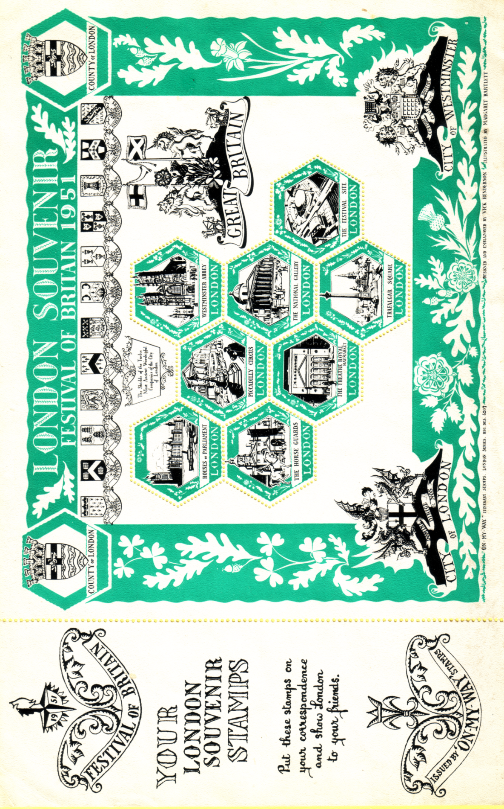
which were worthy of the sincere consideration of the connoisseur and philatelist”, “and to provide the public with a worth-while souvenir, which by affixing to letters or notepaper, makes them a very attractive gift and gives great pleasure both to the sender and recipient. Also, if one is a visitor to London (and later any-where in Great Britain) it is very natural and delightful way of letting one’s friends know of one’s movements when travelling. In many respects it is better than a picture postcard as one can write privately and this is more novel and exciting.”
“It hoped, too, that these sheets will help to further the slow but rising interest in heraldry, the history of which is the history of Great Britain’s heritage. The City of London and its commercial wealth and greatness is in great measure founded on the enterprise and industry of its ancient Companies and Guilds, whose interesting shields are depicted in these sheets.”
These stamp sheets were intended as the birth of a great idea to publicise Great Britain to the world in a pleasant but very effective way. It was a small private enterprise with no financial backing, and was only able to distribute the souvenir sheets through a comparatively small number of stores and shops. “ON MY WAY” souvenir sheets were available for purchase at 2/- per sheet at the following places”.
South Bank Exhibition (W.H. Smith & Son’s book & paper kiosks.)
Battersea Festival Gardens (The Stamp Shop and Kiosk 44 The Stamp Kiosk.)
Selfridge’s Stamp Shop.
Fortnum & Mason.
Hamley’s of Regent Street.
Peter Jones Gift Shop, Sloane Square.
Wards Art Shop, King’s Road, Chelsea.
Truslove & Hanson, Sloane Street, & Clifford Street, Bond Street.
Bumpus’s Book Shop, Oxford Street.
Thomas Wallis, Oxford Street.
Boot’s of Reagent Street.
they could also be obtained through any branch of W.H. Smith & Son Ltd..
As it was only a small private enterprise, there was no money available for any expensive advertising and for this reason they did not get a lot of publicity at the time.

Franco-British Official Souvenir

This fairly common souvenir booklet printed and published by Hudson & Kearns, Ltd., has a coloured picture pasted on the front of a French lass pinning a rosette on to John Bull’s lapel, (see front of Journal) needs more than a cursory glance. There are at least three types of this souvenir known, having 44pp, 40pp and 32pp not including the covers. Apart from the front of the covers which are the same , the backs and inside of the covers are different for the three editions. In listing the contents page numbers have been allocated, although the pages are not in fact numbered. I have also used the terms first, second and third to differenciate between the three printings, and not to imply that the 44 page book was a ‘first edition’, and the others reprints.
This is not an instance of just a fewer pages in the books, the actual make up and sequence of the pages has been altered in each edition. The 32 page edition actually has pictures that do not appear in either of the larger editions. If any readers have a copy of this booklet, please check up on your pages, and if you have a different one to my three please let me have details of it.

44 page edition 40 page edition 32 page edition
(First) (Second) (Third)
Inner
front
cover H. E. Randall advert. Same as 1st Blank

Page 1 Title page. Same as 1st Same as 1st
Page 2 Title in small picture. Same as 1st Same as 1st
Page 3 The Court of Honour Same as 1st Same as 1st
Illuminated.
Page 4 The Court of Honour by Day. Same as 1st Same as 1st
Page 5 British Textiles Building. Same as 1st Same as 1st
Page 6 The British Applied Arts Same as 1st Same as 1st
Building.
Page 7 Lagoon & French Applied Same as 1st Same as 1st
Arts Building.
Page 8 The French Applied Arts
Building. Same as 1st Same as 1st
Page 9 Exhibit of Flowering Plants. The Court of Arts. Same as 2nd
Page 10 Exhibit of J. Buchanan & Co. The Palace of Women’s Work. Same as 2nd
Page 11 The Court of Arts. The Garden Club. Same as 2nd
Page 12 The Palace of Women’s Machinery Hall. Same as 2nd
Work.
Page 13 The Garden Club. Machinery Hall (Interior.) Same as 2nd
Page 14 Machinery Hall. The Fine Arts Palace. Same as 2nd
Page 15 Machinery Hall (Interior.) The British Education Section. Same as 2nd
Page 16 The Fine Arts Palace. The Palace of Music. Birds Eye View.
Page 17 The British Education Section. Bandstand in Court of Arts. Birds Eye View.
Page 18 The Palace of Music. Across the Court of Arts to. The Palace of Music.
Congress Hall
Page 19 Bandstand in Court of Arts. Congress Hall. Bandstand in Court of Arts.
Page 20 Across the Court of Arts to Birds Eye View. Across the Court of Arts to
Congress Hall. Congress Hall.
Page 21 Congress Hall. Birds Eye View. Congress Hall.
Page 22 Birds Eye View. The Royal Pavilion. Same as 2nd
Page 23 Birds Eye View. Ville de Paris. Same as 2nd
Page 24 The Royal Pavilion. Canada. Same as 2nd
Page 25 Ville de Paris. The Australian Building. Same as 2nd
Page 26 Canada. The Indian Building. Same as 2nd
Page 27 The Australian Building. Tunis & Algiers. Same as 2nd
Page 28 The Indian Building. The Great Stadium. Same as 2nd
Page 29 Tunis & Algiers. The Tudor House. Same as 2nd
Page 30 The Great Stadium. The Grand Restaurant. Same as 2nd
Page 31 The Tudor House. A Great Colonial Industry. The Sunken Bandstand
Page 32 The Grand Restaurant. Primrose Cottage. Coat of Arms
Page 33 A Great Colonial Industry. Chiswick Polish Co.
Page 34 Primrose Cottage. Chocolate Menier.
Page 35 Restaurant Paillard. The Pavilion of Schweppes Ltd.
Page 36 The Pavilion of the Imperial Moet & Chandon.
Ottoman Tobacco Regie.
Page 37 Chiswick Polish Co. Oetzmann’s Bungalow Cottage.
Page 38 Chocolate Menier. The Daily Mail Pavilion.
Page 39 The Pavilion of Schweppes. Irvine & Homocea
Page 40 Moet & Chandon. Wrights Coal Tar Soap advert.
Page 41 Oetzmann’s Bungalow Cottage.
Page 42 The Daily Mail Pavilion.
Page 43 Irvine & Homocea.
Page 44 Wrights Coal Tar Soap advert.
Inner
back
cover Schweppes advert. Blank Blank
Outer
back
cover Keen, Robinson advert. Same as 1st Blank
For years I have noticed in the I.P.M. catalogue mention of an exhibition card by the artist Mucha. I have never seen a copy until Ken Harman showed me one he has just obtained, and was good enough to send me a coloured laser copy of it. It is a truly magnificent card, he also enclosed some notes, which I produce below.

The ‘Mucha’ Franco-British Exhibition Card
by
Ken Harman

Dear Bill,

I have done a bit of digging around on the card I showed you and the story goes as follows. “JOB” the initials of Jean Bardou, divided by a diamond shaped lozenge forming the “O”, were manufacturers of cigarette papers, and asked artists to design posters and calendars during the period 1895 to 1914. Two of the subjects (one for an 1897 calendar and another for an 1898 poster) were designed by Alphonse Mucha.
The 1897 picture of a lady with long blonde hair in a white dress was used by JOB on four occasions, and are numbered by Q. David Bowers and Mary L. Martin in their “The Postcards of Alphonse Mucha” (U.S.A. 1980) as numbers 171 to 174.
The Franco-British Exhibition card is 172, they had offices at 5-7, Piccadilly Mansions, 17, Shaftesbury Avenue, London, and according to the card were printed and cut on a “Rotative” machine by L. Chambon, Paris, possibly done on site at the exhibition.

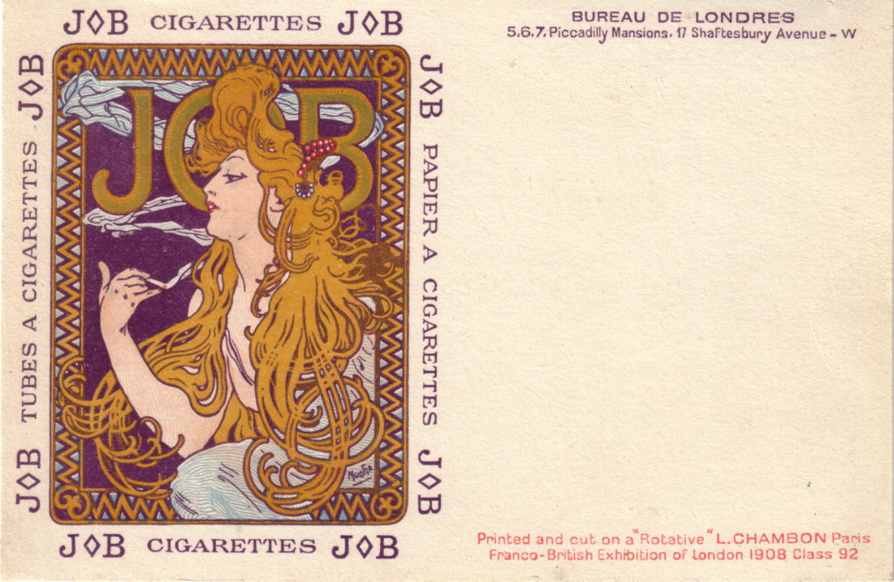

A beautiful card of which Bowers & Martin estimate there are possibly 200 in existence.

B.E.E. at Wembley still draws the crowds.
by
Peter Denly

Last year whilst putting together the 1998-99 programme for the Bishop’s Stortford Philatelic Society, I noticed that the Exhibition Study Group Treasurer, Alan Sabey had registered his name on the list of speakers contained in the B.P.A. handbook.
With not a little self interest, I rang Alan and was able to arrange for him to give a talk to our Society on the 3rd June. 1998. As he was already booked to talk in Huntingdon in May, without re-sorting his material he could cover the two events with one display. Plus, I and my fellow members would enjoy a guided tour of material, much of which was shown at Stampex, and which has achieved high international award.
The display, in two halves, started with 112 sheets of commonwealth slogans and concluded with a further 112 sheets devoted to the 1d and 1½d stamps and Wembley postmarks. All the material shown was presented in fully written up pages, which is of great benefit to the audience, as they can really appreciate each item when invited to view.
Being a collector of Wembley postal slogans, rather than the stamps (I think I left it too late), it was a delight to see virtually the full range of slogans issued by the Commonwealth countries. Of particular interest were the Singapore continuous cancellations and the Jamaica ‘Free’ mark. Alan has yet to see another example of these two items.
One slogan in the collection has thrown up a mystery. For 1925 the Australians ran British Empire Exhibition - Always ask for Australian Products. With B.E.E. removed the postal authorities continued to run this up until 1941. However Alan has an example used in Hamilton in 1927. But Hamilton is not recorded as having a B.E.E. slogan at all. So how did it acquire the slogan “Always ask for Australian Products”?
The stamps section was equally delightful, covering essays signed by Harold Nelson, the designer, sheet numbers, proofs, wrappers, errors, misplaced perforations and coil joins plus leaders. Also displayed was the unique imperforate 1½d 1925 stamp, which has proved to be the one missing from a sheet in the possession of the Queen. This section was rounded off with some multiple use of the stamps including examples of the postmarks applied at the exhibition pavilions and post office.
Again writing up allowed viewers to fully appreciate the material despite the modesty with which the presenter talked about each sheet.
Overall the display proved to be a great draw to round off the Huntingdon season and an equally firm attraction for the start of our season in Bishop’s Stortford, showing that Wembley can still draw the crowds.

Wembley Variations
by
Mike Perkins
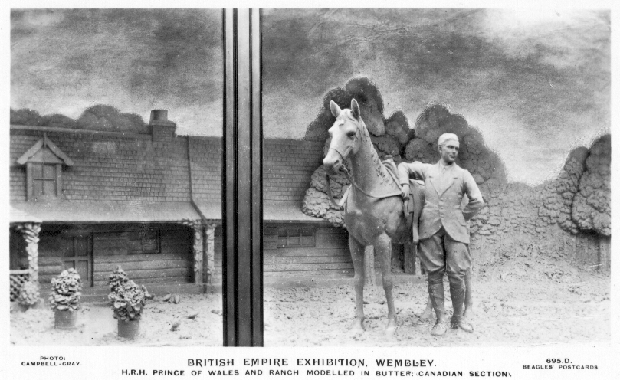

Tony Davis of Bognor sent Bill a photo-copy of this card which neither Bill or myself had seen before. It is by Beagles No 695 D. I suspect Beagles produced a few of these, and then concious that the window bar spoilt the view carefully took it out. I expect you all have the card without the bar which is fairly common. Beagles No 695 0 Jack Hobbs Modelled in Butter and Wildt & Kray No 63 also of Jack Hobbs in butter both show signs of the window bar removed, but neither card has been seen with the window bar. Has anyone got one, if so a photo-copy would be appreciated.
Festival of Britain Exhibition

Fred Pesket has been working with the Portsmouth City Museum for some time organising their major summer/autumn exhibition, which will take place from 8th August to 22nd of November. Members of the Festival of Britain Society and the Study Group have made material available, and Fred has scoured Museums and Archive sources to borrow material for the exhibition. Make no mistake this will be a wonderfull show, and certainly the largest ever mounted relating to a past exhibition.

The object of the exhibition is to tell the story of the Festival of Britain and its influence on the development of style in Britain in the 1950’s. The exhibition will not attempt to cover the Festival comprehensively but will give a flavour of the event through objects, graphic material, souvenirs and, very importantly, the personal experiences of the people involved, e.g. designers, workers and visitors. The story will unfold through these rather than being text driven. Sections will cover.

1. The roots of the exhibition, links with 1851

2. The concept

3. Building the Exhibition

4. The South Bank Exhibition, a very large section to be split into sub sections to cover the ‘visitors experience’ including the Dome of Discovery and the Royal Festival Hall.

5. Battersea Park Gardens

6. Affiliated exhibitions nationally

7. The Travelling Exhibitions

8. Local Events/Exhibitions in Portsmouth and the South Coast.

9. The close of the Exhibition and its legacy

10. The influence of the Festival on fashion

11. The influence of the Festival on household goods

12. The influence of the Festival on furniture

13. Food and consumables in 1951

Some linked activities are also being planned, including films of the Festival year in the afternoons and evenings, a 1951 Vintage Vehicle Rally, a revival of the first National Jazz Federation Concert at the Royal Festival Hall, as an open air event in the museum gardens and a 1951 fashion show.

If you would like any further details contact Fred Peskett. 124, Havant Rd, North End, Portsmouth, Hants. PO2 0BP telephone 01705 665630
POST CARDS OF THE WHITE CITY

Part 8.

by
Bill Tonkin

Millar & Lang Ltd. continued from part 8.

Type 12. Coloured plate sunk with large white border and the title printed in red, brown back with a number under the trade mark.
No. S 197. Congress Hall, Franco-British Exhibition. Vert left.
No. S 197. Court of Honour, Franco-British Exhibition.
No. S 197. Palace of British Applied Arts, Franco-British Exhibition. Vert left.
No. S 197. Part of Waterway. Franco-British Exhibition. Vert left.
No. S 197. Senegalese Village, Franco-British Exhibition.
No. S 197. The Ceylon Village, Franco-British Exhibition. Vert left.

Type 13. Coloured comic cards, with the British and French flags over wreaths in each corner at the top, brown or green backs. This series was not numbered on the back, but the cards do have small numbers on the front, there was three series numbered 676, 677 and 678. Many of the cards feature a ‘red devil’ and he is used, in place of the word ‘devil’ in the wording on the front, where this occurs the word ‘devil’ has been used in the list. All the cards have ‘Franco-British Exhibition’ in large letters, and some in addition to the title in English, have it repeated in French printed in red. Where this is so it is noted in the list. It would appear that series 676 and 677 came with two colours of backs, while 678 was published with a brown back only.
676 For ever and ever, Vive L’amitie, Palace of Music. Vert left.
A. Brown back.
B. Green back.
676 L’Entente Cordialé.
A. Brown back.
B. Green back.
676 The Flip Flap. (also in French) Vert left.
A. Brown back.
B. Green back.
676 The Ricksha Ride. Voila Mam’Selle.
A. Brown back.
B. Green back.
676 We are enjoying the Exhibition very much. (also in French)
A. Brown back.
B. Green back.
676 We have arrived at the Exhibition. (also in French)
A. Brown back.
B. Green back.
677 A Pleasant Change, Mam’selle est elle visible ?
B. Green back.
677 Honourable Courts Affaire du Coeur
A. Brown back.
B. Green back.
677 I Hope you are having a devil of a good time at the Exhibition. (also in French)
A. Brown back.
B. Green back.
677 In Court of Arts, The Art of Love. Vert left.
B. Green back.
677 The Perils of the Deep, Hellas!! Mamah Disparaît.
A. Brown back.
B. Green back.
677 We are we going down to the Exhibition. (also in French) Vert left.
B. Green back.
678 I am in a Devil of a Hurry to see the Exhibition.
A. Brown back.
678 It’s a devil of a fine Exhibition ! Vert left.
A. Brown back.
678 We had a devil of a good time at the Exhibition.
A. Brown back.
678 When the devil are you coming to see the Exhibition ?
A. Brown back.
678 When the devil are you going to Flip Flap?
A. Brown back.

Imperial International Exhibition, 1909.
Type 14. Coloured with the title printed in red, green back, there is no number under the trade mark.
Congress Hall from Gardens, Imperial International Exhibition, London.
Court of Honour, Imperial International Exhibition, London.
Flip-Flap, Imperial International Exhibition, London.
Palace of Applied Arts and Crafts, Imperial International Exhibition, London.
Palace of Women’s Work, Imperial International Exhibition, London.
Palaces of Music and Applied Chemistry, Imperial International Exhibition, London.
Scenic Railway, Imperial International Exhibition, London.
The Imperial Tower (showing Flip-Flap, Imperial International Exhibition, London.
The Imperial Tower, Imperial International Exhibition, London.
The Stadium, Imperial International Exhibition, London.

Type 15. B/W litho printing, brown back, there is no number under the trade mark, except for see *.
Congress Hall from Gardens, Imperial International Exhibition, London.
* Congress Hall, Court of Honour, Imperial International Exhibition, London.
* Court of Honour, Imperial International Exhibition, London.
Palace of Applied Arts & Crafts, Imperial International Exhibition, London.
Palace of Applied Chemistry, Imperial International Exhibition, London.
* Palace of Women’s Work, Imperial International Exhibition, London.
* On these cards for some unknown reason the number has been carefully overprinted with an oblong to completely obliterate it.

Type 16. B/W litho printing, brown back with a number under the trade mark.
No. 719. The ImperialTower (Showing Flip-Flap) Imperial International Exhibition, London.
No. 720. The Imperial Tower, Imperial International Exhibition, London.
* Flip-Flap Imperial International Exhibition, London.
* On this card for some unknown reason the number has been carefully overprinted with an oblong to completely obliterate it.

Type 17. Coloured view or views in round frames with flags and floral borders, green back with a number under the trade mark.
No. 860. Court of Honour, Imperial International Exhibition, London. and Palace of Women’s Work, Imperial International Exhibition, London.
No. 861. The Imperial Tower, Imperial International Exhibition, London. Vert left.

Japan-British Exhibition, 1910.
Type 18. Coloured view of the ‘Madam Butterfly’* type of card with the same back cloth as seen in the Tuck cards of the same type.. The original photo is attributed to Bassano, and is in an oval within a green wooden picture frame type of border. Green back with a number under the trade mark.
No. 404. A Brito-Japanese Salute. Vert left.
*The Madam Butterfly Syndrome. At the time of the Japan-British Exhibition while many beautiful cards were produced, there were others that did not fall into this catagory. The publishers, perhaps felt that all the public knew about Japan was what they had seen in the opera Madam Butterfly, and decided to exploit this avenue. Someone set up a studio with a backcloth of a typical Japanese scene (English style), consisting of a house with a Japanese curled up roof in the background and to the right a stone lantern, on the left were painted some flowering irises. Sometimes a bamboo table and chair was added and two actors played the part of Madam Butterfly and young Lieutenant Pinkerton, in amorous dalliance. He usually wears a uniform and peaked cap but sometimes appears in a straw boater. It would seem a photographer named Bassano took the pictures which generally come in sets of six, these were then sold around the trade, Millar & Lang, A. & G. Taylor, Tuck who produced them in two styles real photo’s and coloured, Wildt & Kray and possibly other firms, all published Madam Butterfly cards. Tuck’s specifically for the Japan-British Exhibition, the others probably so.
Another firm Davidson Bros. did their own thing and produced a long series of at least 21 cards for the Japan-British Exhibition, using their own backcloth and actors to play the part of Madam Butterfly and Pinkerton.

Type 19. Sepia litho printing, brown back with a number under the trade mark. There are variations in the setting of some of the titles.
No. 1299. Japanese Government Department, Japan-British Exhibition, 1910.
No. 1301. Congress Hall from Lagoon, Japan-British Exhibition, 1910.
No. 1303. Court of Honour, Japan-British Exhibition, 1910.
No. 1304. Japan-British Exhibition, 1910. Court of Arts---showing Flip-Flap.

Type 20. Coloured, green back with a number under the trade mark.
No. 1306. Flip-Flap, Japan-British Exhibition, 1910.
No. 1307. Congress Hall from Lagoon, Japan-British Exhibition, 1910.
No. 1308 The Stadium, Japan-British Exhibition, 1910.
No. 1309. Court of Honour, Japan-British Exhibition, 1910.
No. 1310. Japan-British Exhibition, 1910. Court of Arts---showing Flip-Flap.

Moët & Chandon.
Slate coloured litho printed advert card, showing a view of their pavilion, slate back..
Messrs Moët & Chandon.’s Pavilion at the Franco-British Exhibition,
London 1908.

Moyea.
B/W litho printing, brown back with ‘Copyright Moyea Series, No. 25 A.’ down left side of back. Nothing is known about this series. One has a message on the back ‘Have just bought this at the Crown Colonies Pavilion’ and both cards have Franco-British Exhibition cancellations.
No. 19 A. Hairdressing, Lokoja, Northern Nigeria.
No. 25 A. Hospital Sisters Bungalow, Lokoja, Northern Nigeria.

