EDITORIAL SPRING 1998

What’s happened to the seasons, they’ve all gone wrong,
It’s supposed to be the winter, but the frogs are in full song.

Ah well, another year older, another year wiser, and you can take that with a pinch of salt. I am sure that as I lay in bed the other morning, waiting to leap out when the alarm went off, I heard a frog croaking in the pond down the garden. I do know there have been flowers out at Christmas well before their time.

I mentioned briefly in the Winter Journal that Andrew Brooks phoned me up the day after his collection came up at Phillips, to say how pleased he was with the prices his postcards fetched. I am glad for him as I had written in a previous editorial a rather gloomy forecast, so I was happy to be proved wrong. He told me he had been so dissapointed with the prices fetched for his crested china collection, that he had considered taking his cards away from Phillips and placing them elsewhere, but it was allright on the day. Items from his collection are now starting to trickle out into the market, and I know of one of his scarcer Wembley cards that has found a good home, (my home). After finding out who the dealer was who bought his Japan-British cards I spoke to the purchaser and have arranged to go through them before they go on sale.

Since writing the above much water has flowed under the bridge, I have managed to find the dealers who had bought other parts of Andrews collection, including his Crystal Palace, Earls Court, Festival of Britain, and Miscelaneous Exhibitions. All together I have acquired just over 250 cards, so I have done very well.

One interesting card I bought although I had allready got it, was a Tuck’s ‘G’ Series, Industrial Power Exhibition held in Glasgow as part of the Festival of Britain celebrations. It had been sent by Stanley Hunter to Andrew in October 1987, notifying him af the change of address of one of our members Bill Early. This set of six cards are now very difficult to find, and it took me a long time to complete my set, I believe even Fred Peskett is still looking for several of them, so Fred, if you want No. 4 ‘The Hall of Hydro-Electricity’ let me know.

So, if any of our members are thinking of moving, I would like to encourage this tradition, which for some reason, never seemed to catch on, of notifying the secretary using a rare postcard with the message written in pencil. I can thoroughly recomend this, I’m all for it. Now of course if anyone was to send a card of this scarcity through the post, it would be carefully wrapped and sent with a stiffener. It is an interesting thought that there are tens of thousands of post cards, made to be posted, that we would never dare to treat in such a cavalier fashion.

The last time I spoke to Alan Sabey he told me how well the subscriptions were coming in, I think at that point there had been one resignation and one member with their subscription unpaid, and who has since paid up.

I am doing the second installment of part of the George Ithell Archives which consisted of photo-copies of part of his collection written up as a display.

Members will be aware from the circular sent around, that this editorial was started about six months ago. So far touch wood everything is going well, and I shall catch up on the missing journals as soon as possible.
Editor.
Ballymaclinton and the Post Office.
by
George Ithell

This article is compiled from notes written on album pages by George Ithell. It will not be possible to use all the cards and photo’s George used in his display on account of the space it would require, and unfortunately many of the photographs are not good enough to use.

In 1801, David Brown the local grocer of Donaghmore, Co. Tyrone, was making soap and candles in a small room of his shop. Such was the success and demand that the factory was built and prospered further. David’s son James had twin boys by his wife Ada, David and Robert. in 1895, the firm McClintons of Belfast was annexed. !n 1907 the twins controlled the firm. Donaghmore village is on the B43 road, three miles north-west of Dungannon and six miles from Pomeroy. A brewery was the only other place of employment, and the post office was open for use in 1830.

The firm of David Brown & McClinton Ltd participated in the Irish International Exhibition in 1907. A typical cottage was used to demonstrate hygiene and cleanliness, led to better health and immunity from all prevelent ailments.

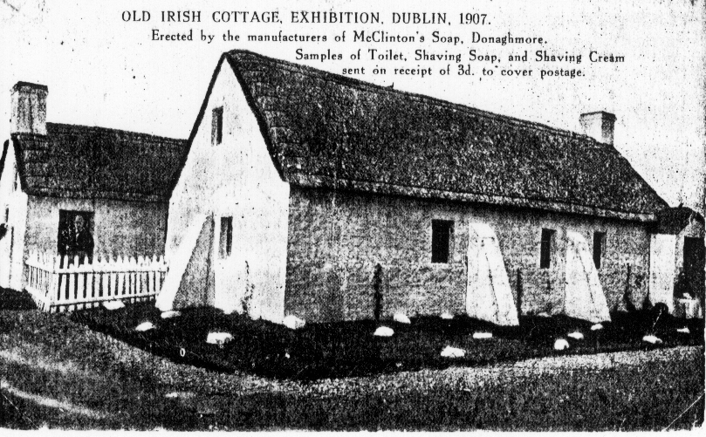

David Brown & McClinton Ltd’s Cottage in the Irish International Exhibition, Dublin 1907.

The big success and popularity of the Dublin venture prompted consideration to exhibit on a larger scale. On space already reserved for forthcoming exhibitions the area was developed as a complete village. This was Ballynaclinton in the 1908 Franco-British Exhibition, the 1909 Imperial International Exhibition and the 1910 Japan-British Exhibition.

Approximately 3,500,000 visitors passed beneath the imposing archway during the exhibitions of 1908, 1909 and 1910. The rental of £5,000 and the initialcost of £50,000 was offset by a charge of sixpence and any charitable gift of money. All profits were donated to the Health Association presidedover by the Countess of Aberdeen, wife of the Lord Lieutenant of Ireland at that time.

An informal opening of the exhibition was on May 14 1908 and all mail was collected and cancelled at the Shepherds Bush W. Post Office. The completeness of the village so impressed the
British Post Office that facilities such as a telegraphic service and special handstamps were made available. The earliest date of a Ballymaclinton postmark is July 2 1908, but a ballymaclinton card is extant posted on June 9. The village shop was selling souvenirs and cards on the opening day.

Structural alterations are obvious from the pictures on postcards with a 1909 date. The missing chimney stack and the altered roof are noticed with the rearranged notices appertaining to the hand-stamped cancel on mail posted. The village opened for visitors on June 1 1909 and closed October 26 1909.

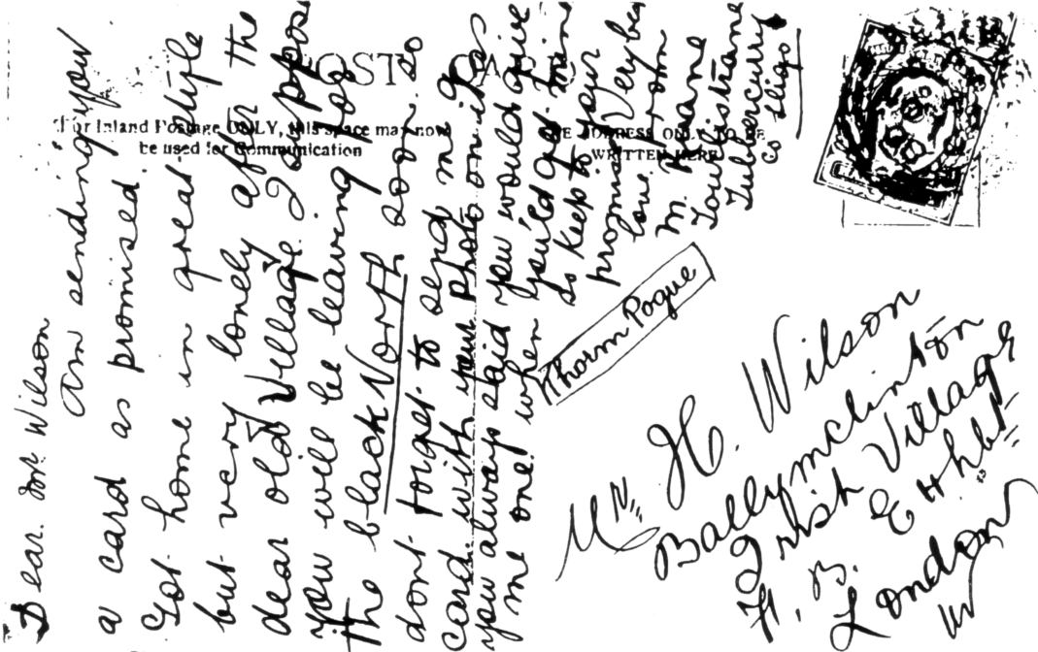

A unique card addressed to Ballymaclinton. The addressee Mr H. Wilson was the manager of the village in 1908 and 1909. The many identified ‘villagers’ are seen on photographs in the possession of Mrs I. Irwin and Mrs M. Whiteside, daughters of the late Mr Harry P Wilson, He can be seen on the extreme left of a Valentine’s postcard titled ‘Colleens Clamouring for their Letters’. The original photographs are the ones used when the colleens applied for an audition to join the staff.

Ballymaclinton was closed at the White City in 1910, but smallerprojects were built elsewhere in later years. The Post Office in 1910 at the village General Shop was not esed, but mail posted at the exhibition received cancels from Paddington W., with a Japan-British Exhibition circular date stamp or the experimental machine cancel.

A concert hall with a seating capacity of 500 was used for lectures and most forms of of indoor entertainments. A very popular demand, were the dances, which took place outdoors. Platforms to give full effect to tap dancing and fiddlers and a barrel organ provided the music.

Irish beauty, charm and expertise were the qualities which gained places for about 200 colleens as demonsrators of culture and industries in this prject. Extant original photographs identify a number of these.

Replicas of Irish history such as a Cross and a Tower were prominent and in detail. The Irish Cross in fact, was copied from Donaghmores own Cross which stands now, after 1,100 years. The Tower was 90 feet high with steps inside, giving access to the panoramic view on reaching the last.

The blacksmith was essential in those years and especially in the villages of Ireland. Surplus horseshoes at the forge were sold as souvenirs for sixpence. Meals for staff and visitors were prepared from stock grown and reared in the exhibition grounds. Two acres of vegetables, meat and
fowl, ensured a ready supply for the kitchens. A row of cottages built on the north side of the village were used for workshops, and the dormitories were above.

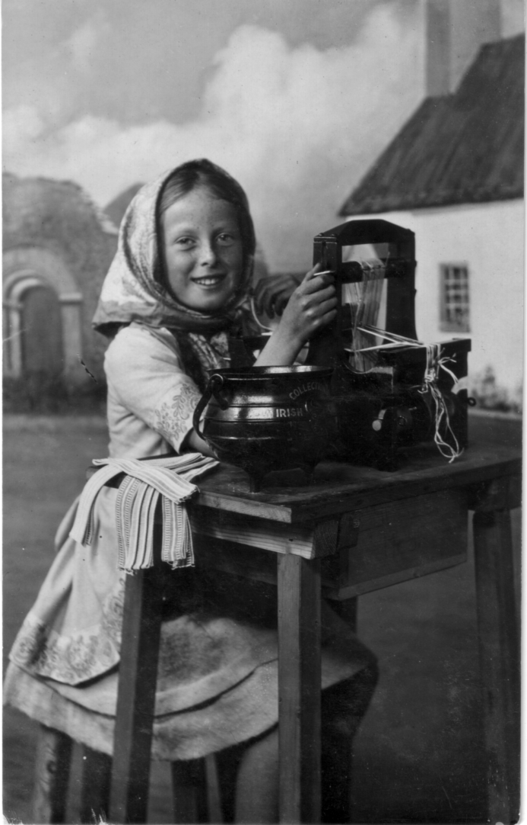

Junior Spinning Champion of Ireland Kathleen Hicks
who volunteered with other celebrities of the Arts,
Culture and Industries to act as collectors
for the charities.

Samples of various needlecrafts were very much admired. Queen Alexandra made incognito visits to see more of her hobby executed by experts. The Award lists mentioned numerous Irish convents and schools, along with famous firms for High Honours.

From an advertisment of 1908 cards were printed to customers own designs. When ordering 25,000 the cost was 25/- per 1,000, and when ordering 50,000 the rate was reduced to 20/- per 1,000. James Walkers, Dublin.
Festival of Empire Crystal Palace 1911
By
Bill Tonkin.

I am going to deal with a very short period in the history of the Crystal Palace. Just under six months in 1911, when they staged a large outdoors exhibition, and in the Palace itself the “All British Exhibition of Arts and Industries”, as well as a Pageant, all under under the title of “The Festival of Empire”.

It is difficult to deal with the Festival of Empire without overlapping a bit at the edges. The fortunes of the Crystal Palace had been in decline for many years, it was bankrupt, and receivers had been appointed in 1909. After the Festival closed the Court of Chancery ordered the sale of the property which was then valued at £230,000. It was purchased by the Earl of Plymouth who presented it to the Nation in 1913, afterwards a Lord Mayors Fund was set up to raise money to relieve him of this burden.

So the Festival of Empire could be regarded as the Crystal Palace’s swan song, and what a wonderful exit it was. It should have been held the previous year in 1910 but the sudden death of Edward VII caused it to be postponed for a year. After so much work had been done it would have been unthinkable to cancel it, the trustees would have been committed, and anxious to recoup some of their expenditure. Also, being held in the Coronation year of King George V, it was seen as part of the coronation celebrations. Indeed some of the exhibitors stressed the royal connection more the festival side.

At a luncheon given in the Savoy, the Lord Mayor asked the Mayors of the Metropolitan Boroughs for their support in a spectacle to be staged at the Crystal Palace in the summer of 1911. It was to consist of two parts, an Imperial Exhibition open from May to October, and a series of pageants running from May to July. Over £250,000 had already been raised, and it was estimated that as much again would be needed.

It was opened on the 12th of May by King George V and Queen Mary, and closed on 28th of October. Special arrangements had been made to line the streets to the Crystal Palace with some 50 to 60,000 school children. After being welcomed by the Duke of Plymouth, they made their way to the Royal Box in the centre transept to attend the Opening Concert. This was lead by the Imperial Choir of 4,500 voices making its first public appearance, singing the National Anthem conducted by Dr Charles Harriss. This has been described as a most moving spectacle with the men in the choir in black, the ladies in white with a great splash of scarlet in the centre caused by the uniforms of the Festival of Empire Military Band. One of the artists at the opening was Madame Clara Butt who sang two songs, one being Elgar’s Land of Hope and Glory.

After the official opening and a cup of tea, the Royal visitors entered a coach for a tour round the Exhibition, and on reaching the pageant ground reviewed the bulk of the 15,000 performers in the pageant. They were attended by the Earl of Plymouth and Frank Lascelles.

The Imperial Choir of 4,500 people was the brain child of Dr Charles Harriss who in July 1909 had suggested the need for a National Choir to sing a special Patriotic functions such as this. It was composed from 49 of the leading Choral groups in the Greater London area. The idea was received so well that within a month he had started enrolling members. Sectional rehearsals in the north, south, east and west were commenced in 1909, but not brought to fruition owing to the putting back of the opening. When rehearsals resumed there were three series of sectional rehearsals and then two final rehearsals of the full choir a few days before the event. It is interesting to note that one of the Choral Societies enrolled in the Imperial Choir was the Penge and Beckenham Choral Society, and I suggest the name leaves no doubt about who was top dog in those days. Members from the Bromley Choral Society also sang. The Imperial Choir was still going strong well into the 1920’s,
and Dr Charles Harriss conducted them at the British Empire Exhibition, Empire Concert on May 31st 1924.

It is perhaps surprising that there were so many singers available to choose from, but it must be remembered that in those days there was very little choice available in the way of music. A band in the park on special occasions perhaps and the concerts, so that singing was an inexpensive and popular “do it yourself” entertainment. There was of course no wireless or television.

The first seven inch single sided “Berliner” wax gramophone records had only come on the market 13 years previously. Although rapid strides had been made in the industry and the “Gramophone and Typewriter Company was now producing 12 inch records, recording methods were crude in the extreme. A performer stood in front of a large horn and bellowed into it, at the other end of the horn a cutting device cut waggly grooves in a revolving disc of wax. These were called acoustic records, and was the only economical way of recording in those days. Having said that it must also be said by the twenties a very high standard of reproduction was attained. It was not until 1924 the first electric recordings were produced.

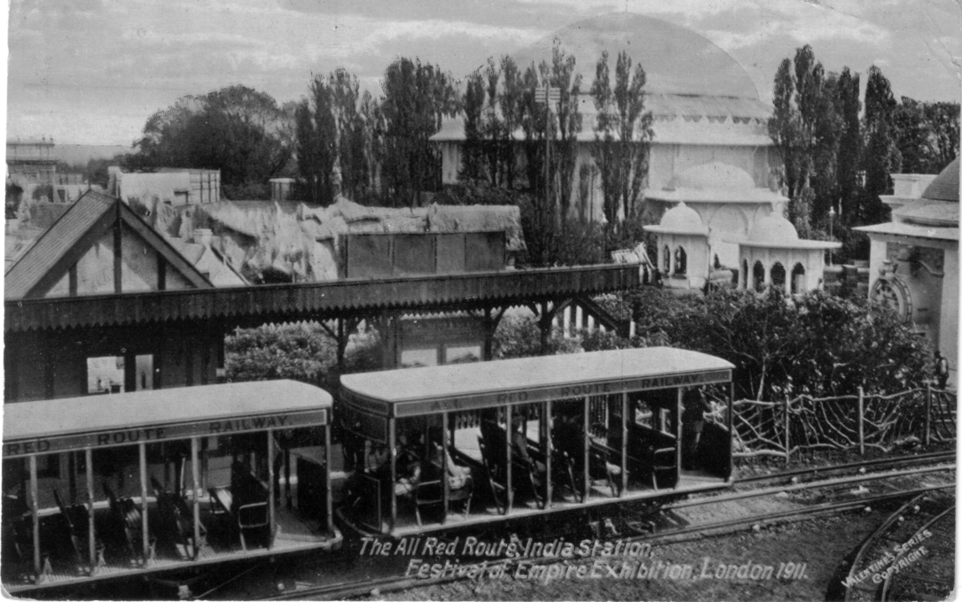

An Electric All Red Route train at India Station.

One of the attractions of the outside exhibition, was replicas of the Parliament Buildings of the Commonwealth countries constructed in miniature in the grounds. The finest of them all was the Ottawa Canadian Government Building built at a cost of £70,000. others were South Africa, Newfoundland, New Zealand and Australia. The exterior of these buildings of wood and plaster were made as exact as possible to a scale of three quarter size, except the Canadian building which according to the Canadian Guide Book published for the event, states the Canadian building was built to two thirds scale. Inside the buildings each country exhibited their products and industries, and importantly offered wonderful deals to people wishing to emigrate to a new life abroad. Vast under populated countries like Canada, South Africa, New Zealand and Australia were crying out for settlers, and this state of affairs lasted well into the 1920’s. The interior of the Palace itself was given over to the ‘All British Exhibition of Arts and Industries’ covering engineering, mining, chemistry, transport, art and the sciences, and many other industries.

There was a Tudor Village and also an Irish Village named Ballymaclinton which had become famous in 1908 when it was first built at the White City for the Franco-British Exhibition. It was claimed the colleens owed their beauty to using David Brown’s Toilet Soap. He was the
proprietor of the soap factory that built the make believe Irish Village of Ballymaclinton. There were 200 colleens at the White City site, but the village at Crystal Palace was on a much smaller scale.

The All-Red tour on a miniature electric railway was another attraction, There was a mile and a half long ‘All Red Route’ with trains leaving every minute, to conduct visitors on a tour of the Empire, stopping at a South African diamond mine, a Canadian logging camp and an Indian tea plantation amongst the other attractions. Passengers paying six pence for their ticket could leave the train at the various stations and rejoin it later.

The central theme of the Festival was a series of pageants, with 15,000 voluntary performers taking part, in a 50 acre pageant ground on the north side of the grounds. A large stand in the form of a Greek Amphitheatre with seating accommodation for 40,000 was built overlooking the pageant ground. Music was supplied by a band of 50 players, and a chorus of 500.

Historical Pageants at this time were a popular form of entertainment, and many were held through to the early 1930’s when other forms of entertainment became more popular. They were organised by a ‘Pageant Master’ and the most famous of these was Frank Lascelles. He was the organiser of most of the major pageants held in this country and abroad, including the Oxford Pageant in 1907, The Pageant for the Tercentenary of Quebec in 1908, The Bath Pageant in 1909, The Pageant for the Opening of the Union Parliament of South Africa in 1910, and what was to be the biggest of them all the Pageant of London and the Pageant of Empire held at the Crystal Palace in 1911. There was a second Pageant of Empire some years later at Wembley in 1924 as part of the British Empire Exhibition, and once again the Pageant Master was Frank Lascelles. He was still going well into the thirties, and in 1932 did two, the Historical Pageant at Bexley, and the Pageant of Leicester.

The Pageants were held from May through to July, there are conflicting dates for the performance s. Bemrose & Sons Ltd were the printers for the Festival and their publications give three different dates. One period given is May, June and July, they also give May to October. When they are a bit more specific we find June 5th to July 23rd, or June 8th to July 19th, it is all very misleading. It was performed on six days of the week, with performances or Parts as they were called, either in the afternoon at 4.30 or the evening at 8.00, there were two performances on Wednesdays and Fridays. Prices of tickets ranged from 1/- for an unreserved seat, and from 2/6 to one guinea for reserved seats. Boxes to hold six people could be booked for ten guineas, with a reduction of prices for those booking for the complete series.

The Pageant was divided into four parts, each part divided into about eight scenes. The first three parts were called the Pageant of London, and covered the history of London from is earliest days to the present. The Pageant opened with the Dawn of British History and portrayed primitive London. The scenes following were put on by 24 London Boroughs, some doing more than one scene, and in other cases up to three boroughs sharing one scene between them. Westminster Cathedral and the London Hospital Students each did a scene, and the only non British group, one compiled of American visitors did the “Departure of the Pilgrim Fathers”. Pride of place was given to Penge presumably because the Palace was in Penge, but it must also be born in mind that Penge around the turn of the century, was regarded as a far more important place than it is now. Penge put on “The Triumph of Carausius” under the chairmanship of Mr Bryce Grant, a well known name in Penge then and for many years remembered for the many drapery shops bearing his name. in the district.

Carausius was a Roman Officer with a lot of naval experience, sent over here by Maxilianus the Emperor to subdue pirate raids led by the Franks and Saxons taking place in the third century A. D. He was later accused in Rome of being more interested in catching the pirates when loaded with spoil which he confiscated, than in actually stopping the raids.

Unfortunately Carausius had sticky fingers, and it was perhaps doubly unfortunate that the Emperor Maximianus was also a keen collector of spoil, and when the latter discovered the Imperial
Exchequer was not getting its share which was being deducted at source, he took umbrage. I don’t know what Maximainus had planned for Carausius, perhaps he was going to be billed as the star attraction, with a couple of hungry lions at one of the spectaculars the Romans were so keen on.

Carausius got to hear of this and decided he might just as well be eaten as a wolf rather than a lamb and decided to stage a revolt and having the seamen and army behind him, became the ruler of Britain. A reign that lasted for seven years, building a strong navy and defeating the pirates, and also repeatedly defeating the Roman squadrons sent against him by Maximainus. Thus for the first time Britain (albeit under a Roman) became the ruler of the northern seas. In the seventh year of his reign he became victim of a take over bid and being surplus to requirements, redundantcy soon followed, not to put too fine a point on it, he was murdered by one of his generals. The new management did not last long, lacking experience they were soon defeated by the Romans who took control of Britain again.

This then was the bare outlines of the scene acted by Penge at the beginning of the Pageant of London. This was followed by the Borough of St. Pancras with a scene about King Alfred, all very serious with no mention of cakes. Another local Borough, Camberwell put on one about the Norman Invasion. Sydenham put on a scene about Pocahontas the Indian princess from Virginia at the Court of James Ist. Pocahontas was renowned “for features, countenance and proportion”. I’m sure if they’d had drawing pins in 1616 she would have been a pin up girl. Lewisham did May Day Revels in Merrie England, described as “a gay scene of revelry round the May Pole”. and the last scene in part three put on by Croydon was The Great War. Of course in 1911 they did not know about the Great War that was to start three years later, they were referring to the Napoleonic wars and Croydon covered the Funeral of Nelson in 1806 and the visit of the Allied Sovereigns to London to take part in the Victory Procession to the Guildhall in 1814. At the time this was a bit premature as Napoleon later escaped from Elba and the Great War was still to enter its final phase.

While the first three parts were all about London’s history played mainly by Londoners, Part four, called the Pageant of Empire was about deeds that helped to make the Empire what it then was. It was acted by Colonial visitors in London at the time. Scene one was about the Landing of Sir Humphrey Gilbert, and was undertaken by Newfoundland visitors. Scene two was Captain Cook in Botany Bay by Australian visitors, and visitors from South Africa, New Zealand, Canada and India did scenes relevant to their own history. The final scene The Masque Imperial, “An Allegory of the Advantages of Empire” was a collective effort by the Overseas Dominions.

The End

When the Lion Roared at Huntingdon
by
Peter Griffin

The 12th May 1998 had been red-circled on my Huntingdonshire Philatelic Society’s programme from the day it was isued. It read ‘Alan Sabey (Southall) British Empire Exhibition’.
My wife and I had the pleasure of Alan’s company for dinner and trust he enjoyed a good nights sleep out here in the peace and quiet of the country.
In the intervening few hours however the members of the Society were treated to an extraordinary display of mainly unique items from designs to despatch, stamps to souvenirs and of particular interest to many were the slogans and cashets from the Empire. It is surprising how few collectors are aware of these and I am sure they will be keeping an eye open for them in future.
I was given the Honour of delivering the vote of thanks on behalf of the Society, and on a personal level I say thanks again Alan for a super evening and I hope the lion may roar here again in the not too distant future.
POST CARDS OF THE WHITE CITY

Part 7.

by
Bill Tonkin

Imperial Ottoman Tobacco Régie.
Sepia litho printed advert card, brown back, the left side is a notification of a change of address to 152-158 Wardour Street, Oxford Street, London. W. on the 1st September 1908.
Kiosk of the Imperial Ottoman Tobacco Régie at the Franco-British Exhibition, 1908.

Irvine’s Pure Australian Wines.
Mono coloured litho printed view of Irvine’s stand. This is known in two colours brown and slate, also there are two different titles, one having the words ‘Grand Prix’ added. Green back.
Franco-British Exhibition, 1908. Irvine’s Australian Wine Trophy. Previous awards over 1000 Gold Medals Ec. for Purity and Quality.
A. Brown Vert right.
B. Slate Vert right.
Grand Prix. Franco-British Exhibition, 1908. Irvine’s Australian Wine Trophy. Previous awards over 1000 Gold Medals Ec. for Purity and Quality.
A. Brown Vert right.
J. C. or C. J.?
Coloured, with black back. There are the initials J. C. or C. J. in a shield between POST and CARD.
Uxbridge Rd Entrance. Franco-British Exhibition. Vert left.

Jakson John & Co., Mitcham.
B/W litho advert card showing a horse and cart leaving the fields loaded with sacks of mint. Brown back. Although this card is printed in English on the back, the title on the front is in French, and the message is in French and it was posted in France with a French stamp. On the front is a red rubber stamp reading ‘Grand Prix. Exposition Franco Britannique. Londres 1908.
3470 Récolte des Menthes de John Jakson & Co., Mitcham. (Harvesting the Mint)

Jaeger Pure Wool.
B/W trade card with a view of their stand, and on the back a coloured G. W. Bacon map with the Franco-British Exhibition marked in red.
The Jaeger Stand Franco-British Exhibition 1908. Textile Section,
Building No. 14.

Johnson (Yachting Cruises).
B/W advert card, black back. The title and message is printed in manuscript form at the bottom of the card, which shows the Johnson Pavillion at the exhibition. Black back.
Scenic Yachting Cruises Japan-British Exhibition. (Followed by six lines of message recommending the wonderful show.)

Jones & Horsfield.
B/W advert card showing various pipes and cylinders on their stand, overprinted on the front in red ‘Franco-British Exhibition, London, 1908.’ Black back.
Franco-British Exhibition, London, 1908.

Kitson-Empire Lighting Co.
Coloured advert card showing the Pavilion of the combined Kitson and Empire Co’s., at the Franco-British Exhibition, grey green back with the left side filled with advertising matter. The Kitson Lamps produced such a bright light that it was adopted by the Trinity House Athorities for use in all the lighthouses on the British Coast under their control.
No title.

L’Hermine-Declercq.
Coloured G. W. Bacon & Co., Ltd., map showing site of the exhibition, black and red back, with the left side showing a plan of the Exhibition with the position of the stand of L’Hermine-Declercq picked out in red. This is a French card, and under the plan is’ Faïenceries Artistiques L’Hermine-Declercq, Orchies (Nord-France).
No title.

Legrand’s Perfume.
B/W advert card showing a view of their stand, with the title, and addresses of their London and Paris establishments overprinted in red, black back.
L. Legrand’s Perfumery at the Franco-British Exhibition

Liebig’s Extract of Meat Co., Ltd. (OXO)
R/Photo card without white border showing their pavilion with large bull in pavilion flanked with big jars of OXO, and the Spiral Railway in the background. Black back inverted.
No title.

Line John & Sons Wallpapers.
Coloured advert card with a rainbow and a music score, black back with ‘Franco-British Exhibition, Decorative Art Section, 1908
Studies in Harmony. Vert left.

Lipton’s Tea.
Coloured advert cards with ‘Lipton Series’ and showing various stages in the production of Lipton’s Tea. Brown back with ‘Published by C. W. Faulkner & Co., Ltd., London E.C. Printed in England’ down the left side. Although there is no reference to an exhibition on the cards, one is known posted at Ballymaclinton in 1908
Loading Bullock Carts, Dambatenne Factory, Ceylon.
Plucking Tea, Dambatenne Estate, Ceylon. Vert right.
Shipping Tea, Ceylon.
Tea arriving at foot of Aerial Ropeway, Ceylon Vert right.
Weighing the plucked Tea, Ceylon.

Locomotive Publishing Co., Ltd. The
Type 1. Coloured picture of a locomotive, green back with ‘Royal Engine S.E. & C.Ry. No. 516, Franco-British Exhibition, 1908’ down left side.
No title.

Type 2. Coloured picture of a locomotive, black back with ‘L. T. & S. Rly “Southend-on-Sea” Exhibited at the Imperial International Exhibition 1909’ down left side.
No title.

London & North Western Railway.
L. & N. W. Railway used their series of Pictorial Postcards sold at 2d per set of six with the backs suitably overprinted for at least four exhibitions from the Franco-British in 1908 to the Coronation in 1912. It is fortunate that these cards are all unused, in fact I have not seen a used one. This is of particular interest because of the message in the stamp box ‘Buy the L. & N. W. Series of
Pictorial Postcards, 2d per set of six different cards Over 5½ millions sold’. As the sales increased so the message was altered, to over 6 millions, over 8½ millions over 9 millions and on to over 10 millions. Before they started giving sales figures, the message read ‘The L. & N. W. R. series of Pictorial Postcards’, this will be referred to as nil sales. The following list of cards will have after the title the number of millions in brackets and in italics, to show what group they come into. In addition to the differences in the stamp box, there are two logos between POST and CARD. Type 1 is a round medalian with Britannia in the centre, Type 2 is the same centre but surrounded with a lot of fancy scrollwork.
Franco-British Exhibition.
B/W advert card showing a view of their stand, brown back with logo type 2. The left half of the back contains a list of journey times
L. & N. W. & Caledonian Railways Exhibit Franco-British Exhibition. 1908.
(Over 8½ millions)

Imperial International Exhibition.
Coloured trade card, brown back with logo type 1, and overprinted in green ‘Imperial International Exhibition. Do not miss visiting the London & North Western Rly. Stand in the Machinery Hall for a Pleasant Holiday etc.
Attendants Compartment. L. & N. W. Royal Train. Vert left.
(Over 5½ millions)

Japan-British Exhibition.
Type 1. Coloured trade card, brown back with logo type 1, and overprinted in green ‘Japan-British Exhibition 1910. Do not miss visiting the London & North Western Rly. Stand in the Machinery Hall for a Pleasant Holiday etc.
S. S. Connemara. Holyhead & Greenore Service, etc. (Nil sales)

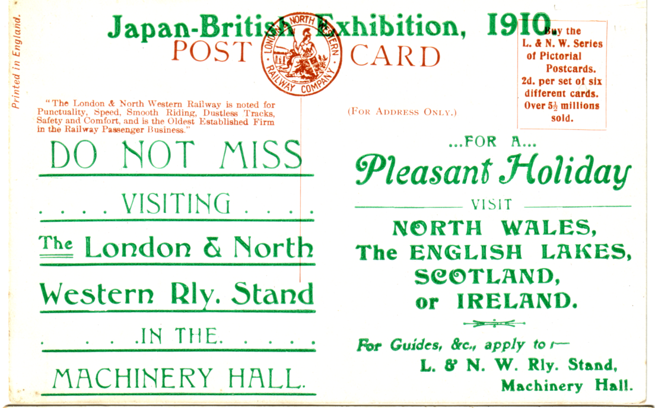

Type 1. Back of London & North Western Railway card with round logo
overprinted in green ‘Do not miss visiting the London & North Western Rly. Stand’

Type 2. B/W trade card, brown back with logo type 1, and overprinted in green ‘Japan-British Exhibition 1910. Do not miss visiting the London & North Western Rly. Stand in the Machinery Hall for a Pleasant Holiday etc.
Discharging Sleepers etc., Creosoting Sleepers etc., and Adzeing & Boring Machines. (three views in oblong frames). (Over 5½ millions)

Type 3. B/W trade card, brown back with logo type 1 and overprinted in blue ‘Visit North Wales for Your Holidays.........Do not fail to see the Cinematograph Entertainment etc.
The Evolution of the Goods Locomotive. (Seven trains 1846 to 1907)
(Over 6 millions)
L. & N. W. Express overtaking a slow Train at Bushey. (Over 6 millions)

Type 4. Coloured trade card, brown back with logo type 1 and overprinted in blue ‘Visit North Wales for Your Holidays.........Do not fail to see the Cinematograph Entertainment etc.
A train in 1887 of First Class etc., A train in 1887 for Second Class etc., and 2 AM Scotch Express etc. (Three trains in strips) (Over 5½ millions)

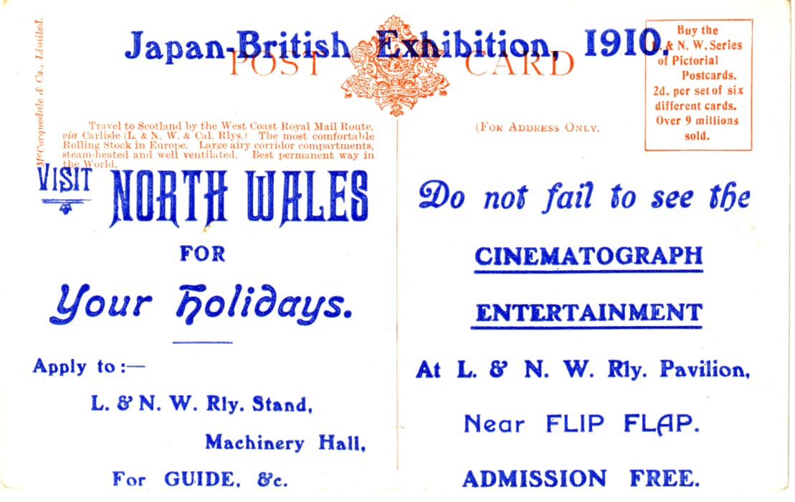

Type 2. Back of London & North Western Railway card with fancy scroll logo,
overprinted in blue ‘Visit North Wales for Your Holidays’

Type 5. B/W trade card, brown back with logo type 2 and overprinted in blue ‘Visit North Wales for Your Holidays.........Do not fail to see the Cinematograph Entertainment etc.
Entrance to Euston Station, L. & N. W. Railway. (Over 6 millions)

Type 6. Coloured trade card, brown back with logo type 2 and overprinted in blue ‘Visit North Wales for Your Holidays.........Do not fail to see the Cinematograph Entertainment etc.
Holyhead Station. Passengers embarking for Dublin. (North Wall) (Over 6 millions)
The L. & N. W. R. Scotch Express at Full Speed. (Over 9 millions)

Coronation Exhibition.
B/W advert card, black back with logo type 2, on the left half of the back, in addition to a description of the Rocket in eight lines, there is in a box a small advert for ‘Travel to Scotland’.
The “Rocket” Built 1829 and one of the L. & N. W. Superheated Locomotives Built 1911. This Model of the “Rocket” is exhibited on the L,& N. W. Stand at the Coronation Exhibition. (Two different views of the pair of Trains). (Over 10 millions).
In addition to the cards with specially overprinted backs the L & N W R Co also had a range of their ordinary post cards for distribution, these can only be identified when they are found with an exhibition cancellation.

London Underground.
Coloured advert card showing an Underground map on a black background, Brown back with an advert for the Liverpool Street Hotel, and a small map showing the underground in relation to the hotel. The text of the advert is in German.
London Underground. (In top left corner)

Margaine-Lacroix.
B/W advert card, black back. This was probably a French Fashion House as the cards show models wearing the latest style of dress. The titles are the same on cards seen so far, and it is difficult to describe the dresses.
Les “Tanagréennes” de Margaine-Lacroix a l’ Exposition Franco-Anglaise. (Lady with large hat, half turned to right looking over left shoulder, arm hanging down and holding dress) Vert left.
Les “Tanagréennes” de Margaine-Lacroix a l’ Exposition Franco-Anglaise. (Lady with large hat, standing sideways facing right looking over left shoulder, arms hanging down with hands clasped) Vert left.

Major & Co., Ltd.
Major’s were the manufacturers of Solignum a wood preservative, and as such attended many exhibitions and published advert and trade cards. These all take the same form, a vertical card with the top portion showing a building treated with their product. The title usually mentions at what exhibition the building was erected at.
Franco-British Exhibition.
Coloured with printing on the front in brown, black back with printed address of’Fredk. Creek, Sheffield House, Combmartin, N. Devon.’
Solignum at the Franco-British Exhibition, building erected for the Frazzi Fireproof Constructions Ltd., (There are another six lines of text)
Vert left.

Imperial International Exhibition.
Both cards type 1 & 2 have the same view, apart from one being in sepia and one coloured the text is also different.
Type 1. Sepia advert card with printing on the front in sepia, brown back.
“Daily Mirror” Cottage erected at the Imperial International Exhibition 1909. (There are another five lines of text) Vert left.

Type 2. Coloured advert card with printing on the front in black, black back with printed address of Major & Co., Ltd., Hull, England, and the left half of the back filled with a price list and text.
“Daily Mirror” Cottage Imperial International Exhibition, Shepherd’s Bush, Woodwork treated with Solignum. (There are another six lines of text)
Vert left.

Manfield & Sons.
R/Photo four views of the exhibition surrounding a view of their stand, brown back. As is often the case with Rotary cards POST CARD is known with and without a stop.
Franco-British Exhibition 1908 Manfield & Sons Exhibit of Boots & Shoes. (The four views are) Grand Band Stand & Cascade, The Palace of Womens Work, Court of Honour and Palace of British Applied Art.

Martell J. & F. & Co., Cognac.
B/W litho printing, black back. These cards were printed in France, in two languages, English and French.
Franco-British Exhibition, London, 1908, Exhibit of J. & F. Martell, Cognac.
Vert right.
Exposition Franco-Britannique, Pavillon J. & F. Martell, Cognac. Vert right.

Mather & Platt Ltd.
B/W with five views of their products, on a green printed background reading ‘Franco-British Exhibition 1908. Mather & Platt Ltd., Engineers, Manchester & London, Stand No.90’. Black back.
Gas Engine, Alternator, Steam Turbine, Gas Engine and Steam Dynamo.
Mercerising, Colour Printing, ?, ?, andGas Singe. (This detail is taken from a very poor photo-copy and titles of two of the machines cannot be read)
Pump & D.C. Motor, Pump & Petrol Motor, Well Boring, Pump & A.C. Motor and Pump & D.C. Motor.
Sewage Spreaders, Filters, Sewage, Filters and Water Purifying.
Turbine Fire Pump, Sprinkler, Sprinkler, Steam Fire Pump and Fire Proof Door.

McClinton’s Ltd.
This is the name of the proprietors of the famous soap firm at Donaghmore Co. Tryone, and of the perhaps even more famous, Ballymaclinton Irish Village’s situated at exhibitions at the White City and elsewhere. There is no doubt that McClinton’s published cards advertising their soaps and other toileteries. For two penny stamps you could be sent a brochure containing six cards and a bar of soap. One of these cards is numbered 3 series 1. It is not felt that these cards come within the scope of this listing. There are however cards that do, and there are several Ballymaclinton exhibition cards with printed messages on the back advertising McClinton’s Soap. It is interesting that none of the Valentine & Sons cards used thus, have backs associated with exhibition cards. In other words Valentine’s designed special backs, which may have been for use after the exhibition closed. Unfortunately not sufficient of them are known to form an opinion.
Type 1. Coloured card, grey back with ‘Valentine, Dublin.’ and under the Throughout the World logo ‘Printed in Scotland’. This is not a standard exhibition back. On the left side of the back is five lines of text starting ‘McClinton’s “Colleen” Soap is made from plant ash’ etc. There is a ‘3’ in the top left corner of the stamp box.
Miss Mahoney. A Colleen, Ballymaclinton. (McClinton’s Town Erected by the Makers of McClinton’s Soap) Franco-British Exhibition. Vert left.

Type 2. B/W litho printing, black back, again not a known exhibition back, with two lines of doggerel at top left, ‘Kiss the Blarney Stone and be Witty, Use McClinton’s Soap and be Pretty.
Kissing the Blarney Stone, Ballymaclinton, Franco-British Exhibition, London, 1908. Vert left.

Coloured advert cards showing a man leaning against a wall, looking down towards a village, blue backs with ‘David Allen & Sons Ltd., 40, Gt Brunswick St., Dublin, Harrow etc.’ down the dividing line. There are two types of this card.
Type 1. POST CARD measures 40mm
Ballymaclinton (McClinton’s Town erected by the makers of McClinton’s Soap) The White City, London. Vert left.

Type 2. POST CARD measures 38mm, and dates added.
Ballymaclinton (McClinton’s Town erected by the makers of McClinton’s Soap) The White City, London. 1908, 1909, 1910.

McIlroy Bros.
Coloured Franco-British Exhibition Valentine & Sons card sold as a remainder to McIlroy Bros., of 243-255, Commercial Rd, Landport, and used to advertise their Annual Sale of Fancy and General Drapery. Red ‘F B seal’ back type FB 4.
187 Court of Honour, Franco-British Exhibition, 1908.

Merryweather & Sons.
Merryweather’s the Fire Engine and equipment manufacturers, must have thought the Franco-British Exhibition card titled ‘Women Firemen’ and featuring their own Joe Mason ‘veteran and far famed Fire Inspector’, too good an opportunity to miss for advertising their goods. While these cards cannot be called advert cards in the strictest sense of the meaning, the hand written messages on the back, lift them into a class of their own. I need make no apology for listing them in full.
The cards used are the coloured Valentine’s cards, with grey green back type FB 1. The title at the top is ‘Women Firemen. The Colleens Brigade at the Franco-British’. At the bottom of the card is three lines of text reading, ‘Ballymaclinton’s Colleen Fire Brigade is drilled by Merry-weather’s veteran and far famed Fire Inspector, Joe Mason at the Irish Village, Franco-British Exhibition. The photograph was taken on the day of the visit of H.M. the King and President Falliers.’
While on the title it should be noted that the wording was altered at some point from ‘Brigade is drilled’ to ‘Brigade are drilled’.
Message No. 1. May we send you a copy of our pamphlet “Ladies Fire Drill” (126H) and Fire Protection of Mansions (864N) Merryweather & Sons. This was addressed to Mrs de Winton-Corry, Yately Hall, Yately, Hants. Postmarked October 2 1908.
Message No 2. Exhibition Fire Hose from Irish Village, Royal Agricultural Show, Royal Lancashire Show, Bath & West of England Show. These hoses are of highest quality, as good as new but slightly soiled, at about half price. Merryweather & Sons, Fire Engineers. This was sent to The Govenor, H.M. Prison, Derby. Postmarked October 23 1908.

Millar & Lang Ltd.
Millar & Lang were a very prolific publisher of exhibition cards, producing a long series of comic cards as well as the conventional view cards, under their “National” Series in a shield trade mark. Of the latter they produced a wide range of styles in litho or screened photo-gravure printed cards, but no real photographic cards. Their series were produced with the backs in two colours, green and brown, and in some instances series were produced in both colours.
It would seem they were not very consistant with their numbering system, which appeared under the trade mark on the back, as some of the ‘S’ numbers refer to a single card, and others refer to a series or set of cards.

Franco-British Exhibition, 1908.
Type 1. B/W litho printing plate sunk with large white border, the titles are printed in red. Brown back, there is no number under the trade mark.
Court of Arts (showing Palace of Women’s Work and Flip-Flap), Franco-British Exhibition.
Court of Honour, Franco-British Exhibition. (Front view of bridge over water)
Court of Honour, Franco-British Exhibition. (Sideways view of bridge over water)
Fine Art Palace, Franco-British Exhibition.
Indian Palace, Franco-British Exhibition.
Palace of British Applied Arts, Franco-British Exhibition.
Palace of French Applied Arts, Franco-British Exhibition.
Part of Waterway, Franco-British Exhibition. Vert left.
Senegalese Village, Franco-British Exhibition.
The Ceylon Village, Franco-British Exhibition. Vert left.
The Flip-Flap, Franco-British Exhibition. Vert left.

Type 2. B/W litho printing, with title in red, brown back, there is no number under the trade mark.
The Flip-Flap, Franco-British Exhibition. Vert left.

Type 3. Coloured plate sunk with large white border, brown back with ‘Published by Millar & Lang Ltd., Art Publishers, Glasgow & London. Copyright Photo by Wakefield, Brentford and Chiswick’ in two lines down the left side. There is no number under the trade mark.
Franco-British Exhibition, showing Court of Arts.

Type 4. Coloured comic card, pink back, there is no number under the trade mark.
The Last Car from the Franco-British Exhibition.

Type 5. Coloured, green back with number under the trade mark.
No. S 53. The Last Motor Bus from the Franco-British Exhibition.

Type 6. Coloured comic card, brown back with number under the trade mark.
No. S 178. One & Half Return for the Franco-British Exhibition. Vert left.

Type 7. B/W litho printing, title in black letters, brown back with ‘Published by Millar & Lang Ltd., Art Publishers, Glasgow & London. Copyright Photo by Wakefield, Ealing W.’ in two lines down the left side, and with a number under the trade mark. (Note change of address to Ealing W)
S 188. Franco-British Exhibition, Wood Lane Entrance.
S 189. Franco-British Exhibition, Main Entrance, Uxbridge Road. Vert left.

Type 8. B/W litho printing, title in white letters, green back with ‘Published by Millar & Lang Ltd., Art Publishers, Glasgow & London. Copyright Photo by Wakefield, Brentford and Chiswick’ in two lines down the left side, and with a number under the trade mark.
No. S 191. Birds eye view of Court of Honour, Franco-British Exhibition.
No. S 192. Birds eye view of Elite Gardens, Franco-British Exhibition.
No. S 193. Franco-British Exhibition Showing Court of Arts.

Type 9. Coloured plate sunk with large white border and the title printed in red, there are variations in the setting of some of the titles. Brown back with ‘Published by Millar & Lang Ltd., Art Publishers, Glasgow & London. Copyright Photo by Wakefield, Brentford and Chiswick’ in two lines down the left side. This is the same as type 3, except there is now a number under the trade mark..
No. S 195. The Stadium. Franco-British Exhibition.
No. S 195. Bird’s Eye View of Court of Honour, Franco-British Exhibition.
No. S 195. Bird’s Eye View of Elite Gardens, Franco-British Exhibition.
No. S 195. Franco-British Exhibition, Showing Court of Arts.

Type 10. Coloured plate sunk with large white border and the title printed in red, there are variations in the setting of some of the titles. Brown back with ‘Published by Millar & Lang Ltd., Art Publishers, Glasgow & London. Copyright Photo by Wakefield, Ealing W.’ in two lines down the left side. This is the same as type 3, except there is now a number under the trade mark, and Wakefield’s address has been altered to Ealing W.
No. S 195. Franco-British Exhibition, (Main Entrance, Uxbridge Road). Vert left.
No. S 195. Franco-British Exhibition, Wood Lane Entrance.

Type 11. Coloured plate sunk with large white border and the title printed in red, brown back with a number under the trade mark.
No. S 196. Court of Arts, (Showing Palace of Women’s Work and Flip Flap) Franco-British Exhibition.
No. S 196. Court of Honour, Franco-British Exhibition.
No. S 196. Fine Art Palace, Franco-British Exhibition.
No. S 196. Indian Palace, Franco-British Exhibition.
No. S 196. Palace of French Applied Arts, Franco-British Exhibition.
No. S 196. The Flip-Flap, Franco-British Exhibition.

