EDITORIAL WINTER 1997

Should you have a little corn, upon your little toe
Use a little of our solvent, and the little corn will go.

I will start of by admitting the little gem above is not the brain child of yours truly. It is part of the advertising blurb sent out by the Plymouth Co-operative Drug Company in 1910. Have you ever wondered what happens to all the postcards after the ball is over, or after the exhibition has closed. A purchase some time ago makes it all clear. It was a Valentine’s card for the 1910 Bruxelles Exposition with an advert printed on the back for the firm of A. J. Brown, Brough & Co., Experts in Wrapping Papers and Twines. It appears one of their sidelines was selling off exhibition cards that had passed their sell by date. They had 200,000 assorted views of the Bruxelles to clear which they were offering at 4/- per 1,000 under the description “Would do for Advertising or Farthing Change”. For those of our younger readers (if we have any) who don’t understand what 4/- is, this works out in modern currency at £1 for 5,000 cards.

This explains why so many exhibition cards are found with an advert printed on the back, they were bought by shops and firms, who used them for advertising purposes, and were either distributed around the area, or offered by drapers etc. in lieu of a farthing change. I have one with a small rubber stamped impression on the back reading ‘J. A. Rankin, Draper, Chelmsford’, this still left plenty of room for a message and address. The crafty shopkeeper got his customers to post his advert to their friends. They were also bought by firms who had a message printed on the back to the effect that “their representative would have the pleasure of calling” on a given date. Sometimes the message would be typewritten, such as “Our Mr Hill hopes to have the pleasure of calling upon you on Monday” sent to Mr Newbury, Baker and Grocer, Church Road, Sholing, Hants. from Rood Bros.

The important thing in this editorial is to complement Fred Peskett for doing a really wonderful job organising the Convention at Portsmouth in September. I have always felt if we moved out of the London area our attendance numbers would drop. Fred proved me wrong by getting the largest turnout we have ever had. It was a good job well done. Prof. Burton Benedict from America and Prof. Harold Vigis from Belgium attended, in fact Harold gave us a display on Belgian Expos. I think our final figure just topped the thirty mark, and if this includes a very small one, well I’m sure a membership application form is on the way. Else where there is a report of our AGM and meeting.

As I am working on this issue I am hoping it will be done in time to get to you before Xmas. I am having diabolical computer problems. About six months ago Mike Perkins offered to upgrade my computer from 8 rams to 32 rams, and since then I have not been able to use the scanner, fortunately it can with difficulty cope with text. Various people have tried to cure it without success, and my experience of trying to get it repaired at shops convinces me they are all cowboys, who don’t really know anything about computers, and whose sole aim in life is to sell you something and get you out of the shop. One firm told me after having the set for a week that the problem was in the mouse, which was causing the trouble. I bought a new mouse, got home and assembled it and it crashed straight away. I am at the moment trying a new firm and hope they can do better. At least they have given me a years guarantee, and I am expecting them back tomorrow morning to have another look at it.

I have mentioned before that the Exhibition Study Group is becoming known amongst academics as a source of information not readily obtained elsewhere. Eleanor Gawne of the Royal Institute of British Architects wrote and later visited me spending some time going through cards. RIBA is putting on an exhibition in the Heinz Gallery, 21, Portman Square, London,`titled “Architects and Exhibition Design in Britain 1900-1998”, and while The British Architectural Library apparently has many of the original drawings and plans of pavilions they are short of pictures of the finished buildings, Eleanor has selected about a dozen cards which I am loaning the RIBA to go on display at the exhibition. The group will get some publicity from this. The exhibition will be open from 22nd January to 7th March 1998, 11.00 to 5.00 weekdays and 11.00 to 2.00 on Saturdays. There is no charge for admission.

Rebecca Lewis of the BBC’s Time Watch Documentaries Department has also been on to me. She is in the initial stages of doing some research for a programme on the 1924 British Empire Exhibition and amongst other things, she wanted to contact people who had actually visited the exhibition at Wembley. On this one I could not help her, but within a week a Welsh Parson the Rev. A. W. Huges phoned me up out of the blue, and during the conversation casually mentioned he had been taken to Wembley by his parents when a lad of ten. He remembered they were advised to take food with them as they would be walking for such a long time they would need sustenance to keep going, and it was suggested they take a bag of raisons to eat on the way round. He said that after walking round for hours, when they reached the Amusement Park they were so tired they did not go in, which was a great disappointment to him. I passed this on to Rebecca and she has spoken to him, she is still researching Wembley but the programme has been put on hold for the time being. Incidentally he collects stickers of Welsh exhibitions

By now you will all have received a copy of the Phillips Auction catalogue where Andrew Brooks’s postcard collection is coming up for auction. I supplied them with addressed labels of our membership on the understanding the information was confidential and was not to be used for other purposes, or passed on to other bodies.

We have another Exhibition Study Group formed, this time in Belgium. It is called “Groupe d’Etude Toutes Collections Expos’ and was formed at the beginning of 1996. They were good enough to send me copies of their news letter ‘Pavillons’ for their first year No.s 1-4. They cover International / World Exhibitions, roughly the same ground as us, with a news letter about the same size and in the same format as our Journal, also being published four times a year. The emphasis is on Belgian and European Expos and is in French. Having said that the first picture on page 1 of No. 1 is of the Crystal Palace 1851. They have suggested it would be a good thing to have co-operation between the two groups, which I agree with entirely. The Editor is M. Feron. P. O. Box 45, B-4300 Waremme, Belgium. Following is an extract of the letter I have sent to Michel.

“Many thanks for your letter and back numbers of your journal. It is nice to see that another organisation has started up to cater for collectors of exhibition memorabilia of all kinds. I have sent you two years back numbers of our Journal, I am sorry the quality of several of them is rather poor, but as you are probably aware when you photo-copy photo-copies, you do lose quality. I would appreciate your 1997 back numbers so I might have a complete run of “Pavillons”. I am all for co-operation, and suggest we both become honorary members of each others group, so that from now on we shall both get each others Journals as they are published. There may well be some of our members who would wish to join your group, so perhaps you could send me details for joining G.E.T.C. “Expos” which I can put out in our next Journal, I have enclosed a form should anyone in Belgium wish to join us.”
As yet I have not had a reply to my letter, I hope to be able to give some more details in our next Journal, and will report on any further developments.

It was reported in the Autumn 1996 issue of the Journal that the Exhibition Study Group had acquired the archives of George Ithell who sadly died in December 1995. Now it would be wrong if George’s archives were to be hidden away in somebody’s loft, that is not why we purchased them. I have decided to publish some of them as two articles in the Journal, the first half appears in this issue. George studied the Ballymaclinton Village as it appeared in the Franco-British, the Imperial International and the Japan-British Exhibitions at the White City. It was also at the Festival of Empire held at the Crystal Palace in 1911. Under the title of David Brown & Son the soap manufacturers who were the owners and originators of Ballymaclinton, their goods were exhibited on a stand in the Ulster Pavilion at the 1924 British Empire Exhibition. So there should be something of interest to all of you. The first part is taken verbatim from George’s notes, and apart from a note correcting one numbering error is just as George left them.
The Editor.
Supplement
to
Posted at Ballymaclinton
by
George Ithell 1995

Since the publication of this work in 1992, interest and further research has been maintained. Consequently, postcards relevant to the theme have been recovered. Though mainly with new details of their printing, they cover more interestingly, a picture hitherto not seen. These latest finds are listed with acknowledgements to Arthur Smith of Hammersmith and G. S. Bailllie from Bungay, Suffolk, who both reported examples which differed from the original index. With these new discoveries and adding my own from the renewed searches, gives one the impression that there could be many more yet to be unearthed.

Much excitement was caused when a letter arrived from the Isle of Wight, which opened up great possibilities for a complete new chapter, but alas, circumstances prevented this. The letter was from Norah Gallaher! A copy of this book was obtained by a Mrs Isobel Scott of Belfast who, on reflection recalled that her teacher had mentioned an exhibition in London and her association with it as a child. After a great deal of effort and perseverance Mrs Scott contacted her old mentor and to the delight of both ladies, discovered that this exhibition was the subject of those recollections many years before.

Nora Gallaher’s Father was a salesman and traveller for the firm of David Brown & Son, Ltd., and Maclintons Ltd., eventually to be a director and during the period of the Village at the White City’s Japan-British Exhibition in 1910 he was the manager. Samuel Gallaher and his wife Anne were residents in the Village and took along their baby daughter, Norah, then"aged five years. Sadly, a month before a proposed second meeting with her, Norah died in June 1993, she was 89 years old. She was a remarkable lady with a memory to match. It was obvious that her time in the Village left many cherished memories. At our meeting in 1987, amongst a case full of momentous and photographs, were letters and billheads, relics from her Father’s old desk. This desk had once been the property of Irme Kiralfy, who from the outset was Director General of the White City Exhibitions.

Most of the photographs Norah had to show were taken at the Japan-British Exhibition of 1910 and included a group photograph of all the staff. Again remarkably, she was able to identify some of the staff without hesitation. Amongst these were of course, her Mother and Father, a Mr. Amos, Mr. Hicks, ‘Old Dan’, Girala Murphy and her two young friends, Kathleen Hicks and Marie Routledge. Norah is seen as on many occasions, mounted on the donkey ‘Napper Tandy’. The two younger girls, Kathleen and Marie were experts in their field of spinning and weaving,, the former being the Junior Spinning Champion of Ireland. Most of the time these girls were at a collecting post for donations, along with other celebrities who gave their services for the Health Organisation.

Amongst the many bits of ephemera, Norah gave me a couple of items which I found very interesting. One whole plate print, possibly the original photograph of my index card number 77 which is seen obviously untouched and shews Norah with other members of staff on the area of the Crystal Palace exhibit which was on show from May 12 to October 27 1911. The other Item given to me was a card written to her from her Father at Crystal Palace with the knowledge that he misses his family. It is dated on May 25 1911, so it is known that Norah and her Mother joined the staff later. The card addressed to Ivy Cottage, Donaghmore says, “I was in the old Village today and felt sorry to see it in such a dilapidated state and inhabited by natives and Indagoes, etc., etc. The exhibition in White City is not such at all and you would get thoroughly tired of it in a week. Mr McClean was over here yesterday and asking for you and Mother. The weather is just lovely and I wish you were both here. We will be in shape at about next Tuesday. There are good crowds in today.” (signed) D.. The card received the special event postmark (Whitney 405) code 3. The card is also showing a rubber stamped address, Ballymaclinton / Irish Village / Crystal Palace / London. One other postcard is extant addressed to Norwood Central Dairy, 3 & 5, Central Hill, Upper Norwood, with a request to cancel some milk! This card was dated August 21 1911, receiving the special event postmark, but the code 1, codes 1 - 8 of these postmarks are known. The Ballymaclinton handstamp, again in purple ink and the address of Crystal Palace, but signed this time by S. Gallaher, Norah’s Father! The obverse shows Nora in one of the four postcard pictures in which she is featured.

Another interesting card recovered is indexed as No. 78, similar to the previously mentioned card re. the milk. This card was however was used as an introductory card by a representative of David Brown & Sons, Ltd., intimating that a Mr. Ferris is to call in a few days and receive the favour of an order. The George V ½d definitive is cancelled at Donaghmore, Co. Tyrone on April 15 1912 and sent to an address in Lisburn. The stamp is punctured with the perfin D.B/&S, only one of three known to date. The other two addressed to firms in Manchester and Birmingham, are both on card index No. 78.A Mr. Milton and Mr. Crawshaw were the representatives respectively in these instances. These items were reported to me by the Perfin Society Editor, Mrs. Rosemary Smith, J.P.

No postcards of the 1908-1910 Exhibitions feature the young girl, Norah, but on cards found from the Festival of Empire, Imperial Exhibition in 1911 at Crystal Palace, she appears in four scenes. Although the exhibit of the Brown Brothers at this exhibition was titled Ballymaclinton, it was not on the scale as were the projects at the White City in the previous years.

Norah was able to identify many of the colleens whose photographs I was able to show her, which were those that had been reproduced from originals loaned to me by Mr. Wilson’s daughters, Mrs. Mollie Whiteside and Mrs. Isobel Irwin, both of Dungannon, Co. Tyrone. She immediately recognised Anna McErval, the sisters Cecilia and Eileen Barnard, Miss Simpson and a Daisy Beattie, of whom she was especially fond and was delighted to be able to recollect them so vividly. All these girls are also seen featured on postcards and Norah admits that she was terribly spoilt by all the staff.

In 1986 I was able to visit Robert Brown’s daughter, Miss Alice Brown who still lives in Donaghmore where she actively pursues her charitable work. For nearly sixty years her chief interest has been in the Ulster S.P.C.A. In July 1993 she had ‘a very exciting trip to Buckingham Palace’ where she received the M.B.E. from the Queen for ‘Service to the Welfare of Animals’. Memories of the days of the exhibition are not vivid, but she remembers being taken for a few days to London when only a very small child. Which venue she visited was obscure, but amongst her souvenirs were trade cards, a collection of the indexed postcards and a number of teaspoons engraved ‘Ballymaclinton’. These have been donated by her to the newly formed Donaghmore Historical Society, instituted in March 1983, which has premises on the very spot of the original soap works in Main Street. Immediately opposite is the new Post Office, the area having been very much rebuilt.

The soap firm had a site during the British Empire Exhibition at Wembley in 1924, but its participation in 1925 is not catalogued. Norah Gallaher and her family were there with a few others of the staff, but it is presumed that this exhibit was only on the scale of the first venture at Dublin in 1907. An Irish tower was however added. This part of the exhibit was a replica of the Tower in Denonish, Fermanagh, said to be the most perfectly preserved of these Irish landmarks. It commands a magnificent view for visitors to the exhibition who paid to climb the steps to the lookout.

Probably unique is an envelope addressed to Capt. The Hon. E. Cochrane at Red Castle, Co. Donegal, Ireland. Bearing the two requisite ½d Edward VII stamps, it is cancelled with the Post Office handstamp of Ballymaclinton on both definitives, dated October 26 1908. Richard Francis Ernest Cochrane (1877-1952), was the second grandson of the Earl of Dundonald and son of the famous Admiral Sir Ernest Cochrane. Captain Cochrane served in the Inniskilling Fusiliers and succeeded to the Baronetcy on the death of his Father in 1911. In 1908-1909 he was appointed a Gentleman-at-Arms to the Lord Lieutenant of Ireland the Earl of Aberdeen and this connection makes it possible that he was very familiar with and often a visitor to, the Irish Village.
Year Index Pub Style Description / Title Back Colour
No. No. type of back

1908 7j 175 Col Colleens Dancing VII Black
1908 7k 175 Col Colleens Dancing IV Grey-green
1908 7l 175 Col Colleens Dancing VII Green
1908 7m 175 Col Colleens Dancing IV Grey
1908 8n 176 Col Ballymaclinton Colleen with Donkey VII Grey
1908 8o 176 Col Ballymaclinton Colleen with Donkey III Brown
1908 8p 176 Col Ballymaclinton Colleen with Donkey III Black
1908 8q 176 Col Ballymaclinton Colleen with Donkey VII Green
1908 8r 176 Col Ballymaclinton Colleen with Donkey (Palette type) IIb Grey
1908 9j 177 Col Main Street & Ancient Church IV Grey
1908 9k 177 Col Main Street & Ancient Church II Grey
1908 10q 178 Black Irish Village Entrance Ballymaclinton III Black
1908 10r 178 Sepia Irish Village Entrance Ballymaclinton XXVIII Brown
1908 10s 178 Col Irish Village Entrance Ballymaclinton I Grey
1908 12d Sepia Cead Mile Failte on Portcullis (Vert) XXII Grey
1908 13o 179 Col Ballymaclinton Cross (Vert) V Grey
1908 13p 179 Col Ballymaclinton Cross (Vert) IV Grey
1908 14j 211 Sepia McKinley’s Cottage ? Black
1908 14k 5203.3 Sepia McKinley’s Cottage XXV Grey
1908 14l 211 Col McKinley’s Cottage V Grey
1908 14m 5203.3 Sepia McKinley’s Cottage XXV Black
1908 15d 510 Col McKinley’s Cottage (Palette type) IIb Grey
1908 16g 961H Sepia Fisherman’s & Model Cottage ? ?
1908 16h Black Fisherman’s & Model Cottage VII Black
1908 17c Sepia The Irish Village XXIII Black
1908 17d Col The Irish Village (Small frame) XXIII ?
1908 20I 223 Col The Round Tower palette type (Vert) II Grey
1908 21e Black Village Colleens Spinning (Vert) VII Black
1908 21f Col Village Colleens Spinning (Vert) ? ?
1908 24g Col Model Cottages (Art Gallery added) VIII Green
1908 30d 408 Col Colleens Dancing (Palette type) II Grey
1908 34b ? Irish Village XXVII Brown
1908 35b Sepia Pride of the Village III Black
1908 37c Sepia Irish Village Entrance (in frame) XXVII Brown
1908 37 Sepia (As 37c but in smaller frame) XIX Brown
1908 40e 394 Col Kissing the Blarney Stone (Vert) VIII Brown
1908 42a* Sepia Entrance (McKinley’s Home) XXVIII Brown
1908 45e Sepia A Ballymaclinton Colleen (Vert) III Black
1908 46b 405 Ballymaclinton Colleen (Vert) VIII Grey
? 55e 578 Col The Square Ballymaclinton
(Palette type) II Grey
1909 56 579 Col Post Office Ballymaclinton VIII Brown
1909 56 579 Col Post Office Ballymaclinton VIII Plum
1909 56 579 Col Post Office Ballymaclinton
(Palette type) II Grey
1908 61b Sepia Napper Tandy Irelands smallest horse XIII Black
80 Col Humorous cartoon (By Jove etc.) V Grey
81 Col Jaunting Car Unlisted** Red
82 Col Ballymaclinton. (Scene of centre)
83 Col The Irish Village (Variation of No. 54) XXVI Red
84 Col Ballymaclinton (Variation of No. 21) VIII Grey-green
* Original index No. 42 is now 42b.
** A red ‘White City’ seal type back not listed in G. Ithell’s book

Addendum to ‘Posted at Ballymaclinton’

Personnel identified from the issued postcards. (See page 83)

Page Index Personnel
No. No.

10 8 Left to right, Angel Atkinson, Mrs. Gee and Myrtle Atkinson
10 13 Eileen Atkinson and ‘Barney’
10 21 Myrtle and Eileen Atkinson
13 9 Left to right Eileen Atkinson, Mrs. Gee, Myrtle and Angel Atkinson
32 43 Miss Baxter
37 24 Marie Walker with donkey in the centre
37 44 Miss Simpson
52 23 Mr. H. P. Wilson extreme left with back to the wall
57 16 Miss Simens with the donkey, Mrs. Gee seated in the centre
72 50 Girals Murphy drives the cart
72 53 Miss Kavanagh stands at the left, Cecilia Barnard sitting first from the left
73 52 Eileen Atkinson
30 (Not illustrated) Includes Monica Logan and Mollie O’Brien
60 Frontspiece. (one known copy existing)***
Inside back cover
79 Norah Gallaher, as a small child on a step ladder

More identification of others may be possible, but the above are certain.

A Miss Norah Gallaher, now aged 84 and living in the Isle of Wight, has pictures and documents as proof of her Father and Mother being at the 1908 period of the Village and also photographs of herself with the girl on cards 63 and 64. Photographs are also known of Miss Gallaher with ‘Napper Tandy’ the donkey, Kathleen Hicks (the girl featured on postcards 63 and 64 who was the Junior Champion Weaver of Northern Ireland) and a Marie Routledge. Norah is featured on postcards 77, 78 and 79 as a little girl, at the Crystal Palace in 1911. She tells me that she remembers well, Daisy Beattie and Anna McErval !

1925 - 25
Norah Gallaher was at the Wembley British Empire Exhibition, with a party of no more than ten staff, A small stand was all that represented the firm of McClinton’s.

*** G. Ithell states the card on the frontispiece is No. 60, but on checking with his book this should be No. 65
Editor

the end

Since doing the editorial about a week ago, I have now got my computer back and working, so I am pressing on with the Journal. It will have to be a slightly shorter one as time is running out, if it is to go out before Christmas. I was just speaking to Andrew Brooks, he said he was very pleased with the results from the Philips Auction held yesterday.
Anglo-German Exhibition 1913
by
FredPeskett

Between 1854 and 1936 there must have been hundreds of shows, exhibitions and events at the Sydenham Crystal Palace. Most of these are well documented either from surviving programmes, or since the late 1890’s by picture postcards. Much information can also be gained from the wealth of books that have been written about the Crystal Palace.

Once in a while, some little tit-bit turns up that reveals yet another show, exhibition or some kindred event which has previously remained undocumented. One such event seems to be the Anglo-German Exhibition of 1913 which ran from May to October of that year. I know of just one postcard that relates to this exhibition, (see illustration). It is multi coloured, and printed by The New Fabro Printing Process Co., (1913) of 35 Shoe Lane, London, E.C. The reverse is not postmarked, but it does bear the ink inscription “We are rather disappointed with this exhibition, Madam Tetrazzini was here on Saturday, she has a lovely voice”.

1913 was probably not a very good time to stage such an exhibition, strained feelings towards the Kaiser were already beginning to show, also the Palace itself was in somewhat of a state of flux, having just been saved from an untimely end, by being purchased for the Nation. It seems ironic that in just a few months, the Palace would be an Admiralty Training Depot, getting sailors ready to take up hostilities against those who may have been exhibiting.

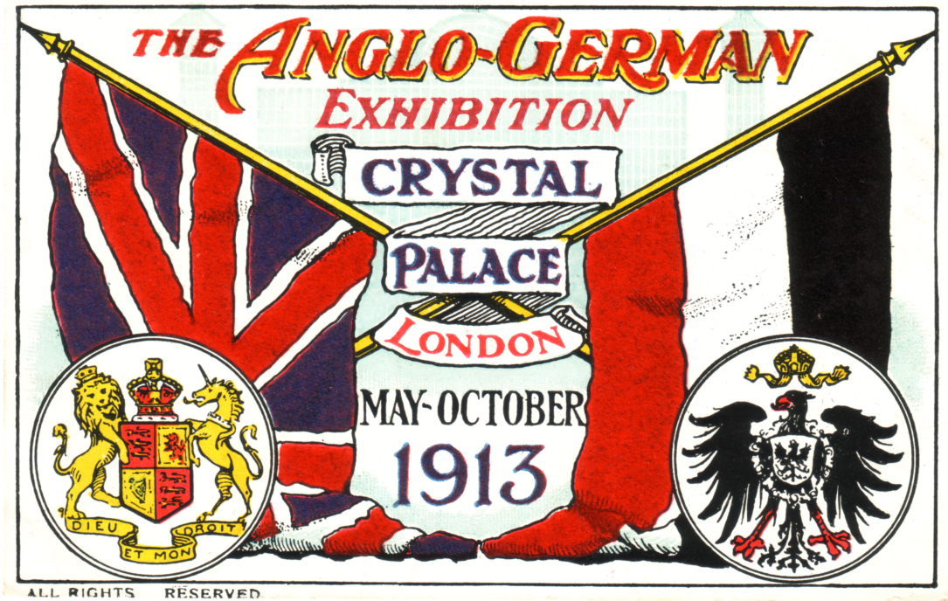

In the Fabro Printing Process the red and blue colours have a velvet feel to them, the colours
stand up from the surface of the card, almost like embossing.

Has anyone any further information on the 1913 Anglo-German Exhibition? I feel sure that with a run of six months there must have been a significant number of postcards and other ephemeral items produced, perhaps this exhibition was eclipsed by the one showing over at the White City, or just that the timing of this event by the Board of Directors of the Crystal Palace was wrong.

the end

Yes Fred, there was one other card that I know of titled ‘The Lord Mayor Visiting Oetzmann’s Antique Court’ There is a booklet for intending exhibitors at the exhibition which was to
run from the 10th May to 27th September. The booklet states, it “should create the good feeling so much desired between the peoples of the two countries”. One of the attractions being offered by the Management during the exhibition, was the holding of the Olympic Games in the grounds. I’ll pass that one over to readers, it’s the first I’ve heard of a proposed Olympic Games in 1913.

Getting back to the Oetzmann’s cards, these come with two different backs. One has ‘Souvenir, Anglo-German Exhibition 1913’ under POST CARD, and the other has Anglo-German Exhibition 1913 and the crossed flags of the two countries, between POST and CARD.

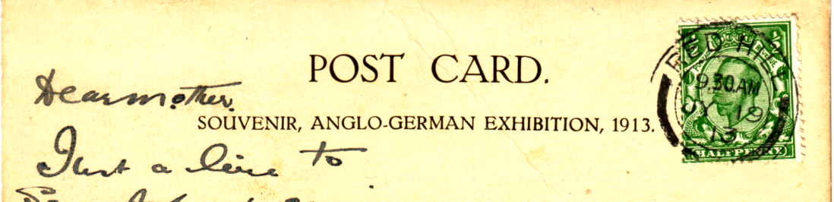

First type, Souvenir, Anglo-German Exhibition 1913

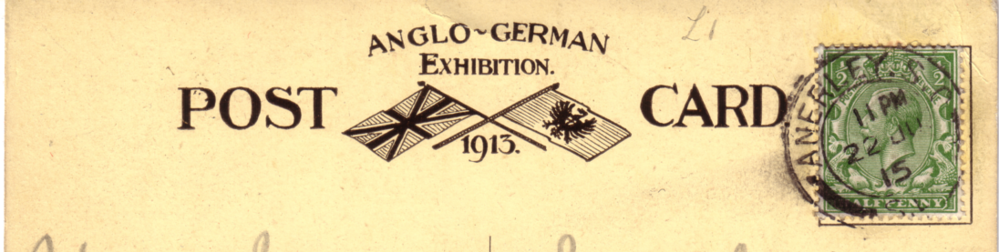

Second type, Crossed flags

Editor

The Vanished Palaces of Kelvingrove
by
Stanley K. Hunter

Notes for a walking tour around Kelvingrove Park conducted by Stanley K. Hunter on May 17, 18 and 19 1994.

The lands of Kelvingrove Park were obtained piecemeal by Glasgow Corporation by buying land (and selling) various parcels of land. It was centered on Kelvingrove House. This had been erected by Provost Patrick Colquohoun in 1792 in the Adam style. He chose the name from a beauty spot further up the Kelvin (in land now within the Botanic Gardens)

In 1852 the Corporation had the “West End Park Project” laid out by Sir Joseph Paxton, recently knighted for his Crystal Palace at the Great Exhibition.

The International Exhibition of Art, Industry & Science, Glasgow 1888 was opened by the Prince of Wales on May 8th. The main building, designed by the important Glasgow architect, James Sellars, was 1000 feet long and 365 feet wide. Much of it was wooden but it was gaily painted and fashioned in a fantastic way with exotic minarets and a huge dome. It was soon nicknamed “Bagdad on the Kelvin”.

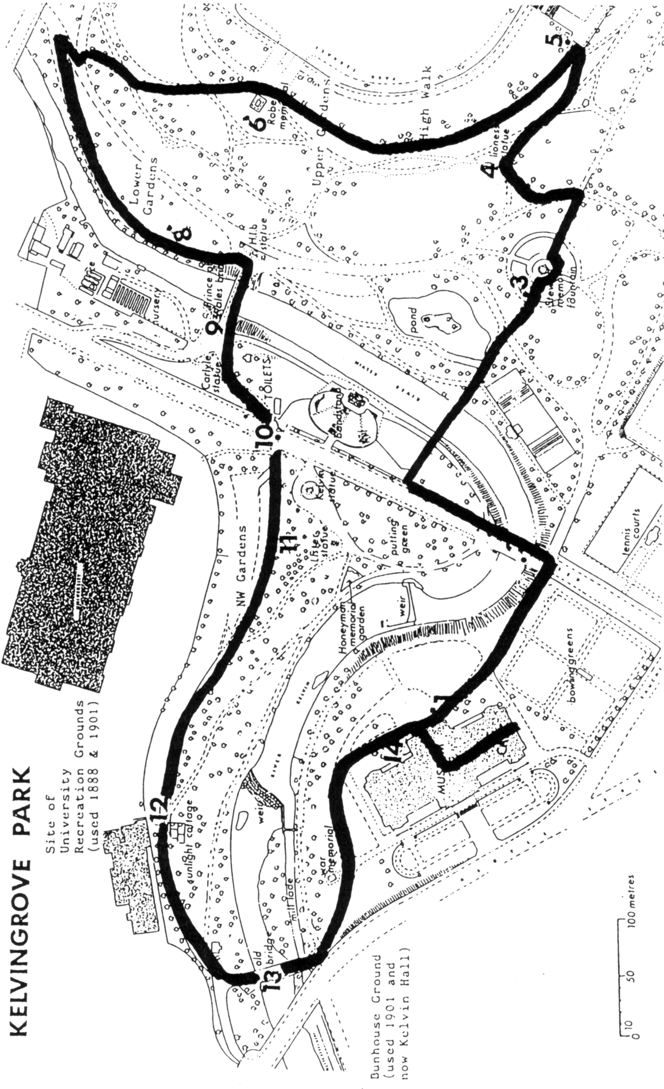

It ran from Gray Street in the East, to the west end of the present Art Galleries, plus a machinery annex. Queen Victoria paid a State Visit on August 22nd. The huge painting of this gala event by the young (Sir) John is on long time loan to the Royal Glasgow Concert Hall. Kelvin grove House, (then the City Industrial Museum), staged the only view of the Queen’s Jubilee Presents. The most important collection of Scottish historical relics was housed in a (mock) Glasgow Bishops Palace in the grounds on the right bank.

With the profits of this six month exhibition a fund was formed to provide the city with a new art gallery and museum. To celebrate its completion, a second international exhibition was held in the park on an even bigger scale. The new art gallery took up the western portion of the 1888 Main Building, while the eastern section was occupied by the Industrial Hall. While smaller, it was much grander and even more exotic. C. R. Mackintosh had submitted designs but the contract was awarded to James Miller, another important Glasgow architect. Like Sellars, Miller’s buildings are numerous in Glasgow today.

Mackintosh had to be content with designing trade stands but may have met young Moscow architect involved with the Russian Village, which was built in the S.E. gardens in the “New Style” (Russian art nouveau), for he exhibited in Moscow in 1902. The profits in 1901 established an art fund which paid for the statue on Kelvin Way Bridge and even the Dali in 1952. The Palace of Fine Arts was handed over to the Corporation and opened in 1902 as the Municipal Art Gallery and Museum. The organ in the Art Gallery was originally housed in the 1901 Concert Hall which adjoined the old Kelvingrove House. Lever Bros. gifted their Sunlight Cottages Outdoor Exhibit, now 2-4, Dumbarton Rd, at their Granite Specimens site in Machinery road from 1901.

In 1911, the exhibition had a more ‘Scotch’ architecture (Robert Walker). The whitewash employed at exhibitions like the Great White City in London to give brightness suited the ‘baronial’ buildings erected at Kelvingrove. In 1888 the exhibition grounds were confined to the land now occupied by the Art Galleries, the Bowling Greens, the area to the duckpond and Prince of Wales Bridge and the N.W. Gardens below the University. In 1901, the S.E. Gardens were also occupied. In 1911 the entire site was confined to the east of the present Kelvin Way but now included the upper gardens and the N.E. Gardens at Park Drive. This new area included the Amusements while a low area north of the Prince of Wales Bridge became a Highland Village (An Clachan) created by Dr Colin Sinclair (who was to repeat this at Bellahouston in 1938). The site is still marked by a group of boulders, one incised An Clachan 1911.

The profit from the 1911 Scottish Exhibition of History, Art, Science & Industry was split between founding a Chair of Scottish History at the University and improving the park, building a bandstand and footbridge. The organisers had to remove all other traces of the exhibition. The Palace of Industry remained to house a Scottish Motor Show but was demolished in 1912 to make way for the East Bowling Greens and Tennis Courts.

View point 1 from the Art Gallery State Porch
1888 International Exhibition
Machinery Annex, Main Building, Doulton Fountain, Indian Tearoom, South Kiosk (bands), Lipton’s Stand (cheeses), Dairy and outside exhibits.
1901 International Exhibition
Palace of Fine Art, Cranston’s Tea Rooms, South Bandstand, Bridge to N.W. gardens, Templeton’s Carpets pavilion, Malcolm Campbell’s fruit kiosk, Queen Victoria Memorial Statue.
1911 Scottish National Exhibition did not extend to this area.
1988 Garden Festival
Festival Fountain of Children by Snowdon, can be seen, moved to here from the 1988 Garden Festival..

View point 2 from the Kelvin Way Bridge
1888 International Exhibition
Dome of Main Building, Women’s Section, Grand Hall of Fine Art, Gondola petrol launches, Assafrey & Howell kiosks, Van Houten’s cocoa kiosk, Queen’s Jubilee Presents.
1901 International Exhibition
Dome of Industrial Hall, Japan pavilion & garden, Bridge statues 1926, Gondola in river.
1911 Scottish National Exhibition
Palace of Industries, Exhibition entrance, Red Lion Restaurant (Cranston), Scotch Street and Ancient Keep, Crèche & Girls (staff) Club, Historic ships in river.

View point 3 from the Duck Pond and Stewart Fountain
1888 International Exhibition
Macdowell, Steven Fountain, (1872 Stewart fountain), James sellars, architect.
1901 International Exhibition
Concert Hall & organ, Ireland, Canada.
1911 Scottish National Exhibition
Japanese “Mikasi” teahouse, Palace of History, “Connaught Drive”, Crèche

View point 4 from the Lioness statue
1888 International Exhibition
J. S. Kennedy’s gift to the City.
1901 International Exhibition
East Bandstand, Flint’s Restaurant.
1911 Scottish National Exhibition
Kelvingrove Street Ceremonial Entrance.

View point 5 from the High Walk
1888 International Exhibition
Prince of Wales Welcome Arch, Lord Provost’s home (Claremont Terrace).
1901 International Exhibition
S.E. Gardens, Russia American Railroad, Indian Theatre, Model Farm, Agriculture. Section
1911 Scottish National Exhibition
S.E. Gardens, Palaces of Fine Art, Decorative Art, Music, Kelvin Hall (science), Fairy Fountain.

View point 6 from Lord Robert’s Statue
1888 International Exhibition
(Panoramic view)
1901 International Exhibition
(Panoramic view)
1911 Scottish National Exhibition
Grand Amphitheatre, Garden Club, Bandstand, Aviation pavilion, Carlton Restaurant, Canadian PacificRailway Cinema, Red Cross, Baron Le Scotford, Amusements such as a Camera Obscura, Aerial Railway over Kelvin, Baby Incubators, Joy Wheel, Aquarium & Octupus, “Anita” Joy House, Mountain Railway, Mysterious River Rides, etc.

View point 7 from the N.E. Gardens (left bank).
1888 International Exhibition
Walter Wilson’s home, then the “Dough School of Domestic Science” now Park Campus)
1901 International Exhibition did not extend to this area.
1911 Scottish National Exhibition did not extend to this area.
North Pole, “West Africa”, Cycle Park.

View point 8 from the Lower Garden (left bank).
1888 International Exhibition did not extend to this area.
1901 International Exhibition did not extend to this area.
1911 Scottish National Exhibition
An Clachan Highland Village, Chief’s Castle, Boulders, Kiosk on carriageway

View point 9 from the Prince of Wales Bridge.
1888 International Exhibition
Curling pond (floodlit), Royal Bungalow Restaurant.
1901 International Exhibition
Canadian Water Chute, Royal Bungalow & Russian Restaurant.
1911 Scottish National Exhibition
Glasgow Dairy Co., Exhibit, New Bandstand.

View point 10 from the Kelvin Way (1915).
1888 International Exhibition
College Entrance, Fairy Fountain, Annan’s Photo Studios.
1901 International Exhibition
Hillhead Entrance, Saracen Fountain, Annan’s Photo Studios.
1911 Scottish National Exhibition
Hillhead Entrance, Irish Cottages (little Ballymaclinton).

View point 11 from the N.W. Gardens (right bank).
1888 International Exhibition
Bishop’s Palace Museum, Lyon’s Palace Restaurant, North kiosk (bands), Shooting gallery, Ceylon Tearoom
1901 International Exhibition
Van Houten’s cocoa kiosk (later Cabin Café), Prince’s Restaurant, North Bandstand, Trade stands, Bell Lighthouse searchlight.
1911 Scottish National Exhibition did not extend to this area.

View point 12 from the Sunlight Cottages
1888 International Exhibition
Batchelors Café, Switchback railway, Rifle range, Recreation ground.
1901 International Exhibition
Sunlight Cottages (Lever Bros. exhibit), Switchback railway, “Machinery Street”, Granite specimens (still existing), Sports Ground (both within University grounds) gone
1911 Scottish National Exhibition did not extend to this area.

View point 13 from the
1888 International Exhibition
Waterbury Balloon Ground, Indian quarters, Working men’s dining room.
1901 International Exhibition
Machinery Hall (Bunhouse ground), Lighting & Heating Pavilion, Footbridge over Argyle Street to Machinery Hall, Covered way to Patick Central Station.
1911 Scottish National Exhibition did not extend to this area.
At view point 14 we return to the Art Gallery (State Porch), this was the end of the walk about.

Attendances
1888 International Exhibition, May 8th to November 10th, 5,748,349
1901 International Exhibition May 2nd to November 9th, 11,497,220
1911 Scottish National Exhibition May 3rd to November 4th, 9,369,375
Packet News

Important information. Following a decision at the recent AGM it was decided that in future people wishing to sell material through the club packet will pay for the insurance of their material, though they will have the option of not insuring if they wish to carry their own risk.
The cost of insurance will be 15p per £100 per member receiving the packet. A packet will go to about 20 members, on average, per circuit. This works out at £3 per £100 for 20 members. The cost will be based on the value of the material, not on sales, and will be in addition to the 10% commission charged on actual sales.

Record Sales. I am delighted to report that Packet 25 was returned to me “sold out” after going to only three members !!! Three members purchased 54 out of the 66 cards. Of the 54 cards sold, 42 were issued for a small provincial exhibition held in north London in 1924 and 1925. The previous record was for Packet 3 which sold out after 9 members back in 1994. This packet also contained Wembley cards.

Addresses. This year, the Group has been insuring packets in circulation out of the commission charged. The insurance had to be taken out due to the loss of two packets over the last couple of years, for which the Group had to pay full value to the vendors. These losses were primarily brought about by members moving house and not telling the Group, and, more importantly, NOT TELLING ME !!! If you are moving house, could you please think about my health and let me have your new address, and the date of moving, so that I can make sure that packets get to you and are not lost. This will do wonders for my blood pressure and (prematurely) grey hair.

I have a quantity of American exhibition cards ( about 100 ) which have not gone into the Packet. If any one would like to see them please contact me. Also, there are about 30 European exhibition cards available on request.
Postage to you will have to be paid.

Mike Perkins Packet Secretary

the end

Wembley goes to Woking
by
Ron Trevelyan

All the trappings of the Wembley Empire Exhibition were safely transferred to Woking in the capable hands of Alan Sabey, who entertained members of the Woking & District Philatelic Society on 25th November.

Given the venue, Alan concentrated on the philatelic aspects of the Exhibition and his display showed just how well equipped he was to do this. The first part of the evening contained examples of postal publicity for the Exhibition around the Empire with machine slogans and catchets, including the rare North Borneo rubber cachet. The second half brought in the two stamps with varieties, perf changes, tone and paper differences etc., finishing with postal stationery, meter marks, newspaper wrappers plus telegram and parcel cancellations.

To some extent Alan was preaching to the converted. For some time Woking P. S. Library has owned a copy of ‘The Lion Roars’ and now has the two publications on Wembley labels as well. Who knows how many new converts to the Wembley creed there are in Woking after a most enjoyable evening.
Exhibition Study Group 1997 Annual General Meeting

Apologies for absence. Andrew Brooks, Stuart Davidson and Andrew Lajer.
Chairman’s address. Karl Illingworth welcomed the members to our first meeting at Portsmouth and said how pleased he was to see so many new faces.
Secretary’s report. Bill Tonkin gave a very brief report, saying the Group had had a very good year.
One of our members Deborah Ryan had published a book on the Ideal Home Exhibition, and members could get this at a reduced price.
Treasurer’s report. Alan Sabey reported we had 18 new members join during the year, and our
membership now topped the 100 mark. The balance sheet which had been distributed to all present, showed a profit on the year of £420, and we had a balance in the bank of £4,033 of which £1,616 is in our publishing fund. He pointed out that our very healthy position was due largely to the generosity of Karl.
Packet Secretary’s report. Mike Perkins reported the packet was doing very well and we had sold
£2,000 worth of material, bringing in £200 in commission. This was marred by the loss of a packet by a member who moved without notifying him. Since January the packet had been insured, which has been paid for out of the groups commission. The insurance works out at 15p per member per £100 of value on each packet sent out. It was suggested from the floor that it might be an idea for each member, before posting a packet on to the next member, phoned and make sure there had not been another ‘move’. Mike said this was a good idea and would see if there was room on the sheet to include phone numbers of members.
Election of Officers.
President. Fred Peskett.
At this point Karl stood down and Fred took over the meeting, thanking Karl for the work he
had done during his three years in office.
Vice-President Mike Perkins
Secretary Bill Tonkin
Treasurer & Publicity Alan Sabey
Packet Secretary Mike Perkins
Committee Celia Bailey
Murray Graham-Bonnalie
Stanley Hunter
Don Knight
Accounts checker George Simner
1998 Convention. Fred was organising a large exhibition to take place in Portsmouth City Museum
from May to mid September. It was suggested we might hold a day trip to visit this, rather than change the date of our convention. Fred told the meeting he could arrange for members to be invited to the formal opening. This met with the approval of members, and it was then proposed we return to Wembley for our 1998 convention. This was agreed.
Packet Insurance. There was a proposal that, “Insurance costs of the packet be charged to the
contributors of material to the packet. Insurance costs to be deducted from payments to contributors. Should a contributor not wish to have his material insured for any reason, he must notify the packet secretary in writing. Any contributor so doing shall forfeit any claim on the Exhibition Study Group for any loss of material from any cause whatever.” After some discussion this was agreed.
Publishing Fund. It was suggested that a sub committee be formed of the Secretary, Treasurer and one
Committee member, and empowered to allocate money to any member working on a book, to help towards expenses. It was suggested we should consider producing in house monographs rather than expensive publications, which because of their specialisation might have a very limited market.
Archives. We were beginning to accumulate a lot of material and the time would come when we should
have to consider the need for an archivist to list and store this material.
Honorary Life Members. It was proposed and passed that Andrew Brooks and Fred Fletcher in
recognition of their services to the Exhibition Study Group be made Honorary Life members.

