EDITORIAL AUTUMN 1997

Life goes on without a doubt,
but it’s nice when you’ve something to shout about.

No, as a matter of fact I’ve not found anything to shout about, no rare postmarks have fallen into my lap, perhaps I’ve got them all. By now many of you will know that Andrew Brooks has at last made a decision on what his future collecting interests are going to be. For many years his two main fields have been exhibitions and the first world war. In both areas he has built up first class collections, and members of the Study Group have at numerous conventions seen displays of various aspects of his exhibition collection.

He has at last decided in favour of the first world war, and by now has taken steps to dispose of his exhibition material. Initially it was his hope to sell the collection as one lot, but this did not work out, and it has been split into several lots. The postcards and crested china has gone to Phillips and should come up in November. He did not wish to sell off single items from his postcard collection as he felt that the loss of some of the more spectacular items would detract from the whole, which of course is true.

Fortunately he was prepared to split up his book and ephemera collection, and I was able to acquire quite a lot of it. (This explains the ‘mad spending spree’ mentioned in the last Editorial) The rest has gone to Peter Inch who is now working on a sales catalogue of exhibition books and guides which will go out later this year. I have arranged with Peter that this will be distributed to all members probably with the winter Journal, but for those who want to get in early, Peter will send it post free to members who write to him for a copy. His address is Inch’s Books, 82, The Mount, York. YO2 2AR. To those of you who do not know of Peter Inch, he is as far as I know the only dealer who specialises in exhibition books, I never go to York without looking him up.

Andrew along with Don Knight, Stanley Hunter and Fred Fletcher were responsible for the forming of The Exhibition Study Group. They were all collectors of exhibition memorabilia especially post cards, Andrew Brooks and Fred Fletcher were the joint authors of 'British Exhibitions and their Post Cards, Parts 1 & 2' which was published in 1978, and Don Knight was author of several books on exhibitions at the White City and Wembley. It was the interest that these books aroused that led to an informal meeting at Bipex between them, and from this the Exhibition Study Group was formed either in late 1980 or 1981 when the first newsletter was sent out to 10 members. Graham Hall is the only other founder member still in the group, I am not a founder member, I joined after reading in the P.P.M. that the group had been formed. Andrew was the driving force, the one who got things moving, he became the first secretary, published the News letter, eight issues in the first seven years, and organised our first three conventions. I can still remember the first one day convention held at York in Oct 1987, this was where I met Mike Perkins. Don Knight gave a display which included a working model of the flip flap, Graham Hall, Stanley Hunter and Burton Benedict gave displays, and afterwards we all trooped round to Inch’s Bookshop for a browse and a glass of wine. We all agreed that next year it must be a two day affair.

Although he will not be able to attend the Portsmouth Convention, Andrew has made it plain to me he does not intend to drop out of things completely, and hopes to attend future conventions to keep in touch with his many friends.

The problem of disposing of large collections of postcards is something that Mike and I have often discussed, not that either of us is considering selling our collections I hasten to add. Naturally when the time comes, a collector, if his interests have taken another direction like Andrew, or the executors, if there has been a death, wish to sell it in one go. This is convenient and saves a lot of hassle, this happened in the case of George Ithell, his Ballymaclinton collection went to auction, and I am told did not get a single bid. It was later broken up into smaller lots and did go. In a large collection there are so many cards that are virtually unsellable for two reasons, one, because they are common cards, and collectors already have them in their collection, and two, because the dealers boxes are full of these cards they will not sell in a month of Sundays. If neither the collectors or the dealers are interested in buying them, where do you go from there? The better class cards will sell as singles or sets, they are no problem, but it is the mass of common cards that’s the ball and chain.

Mike and I visited Andrew some few years ago gathering information for our book, and as far as I can remember Andrew has about four Wembley cards that we would still like to have, and we would have been prepared to pay well over the odds for them, but not to the extent of paying a lot of money to get them along with a mass of unwanted cards. That is the problem.

Those of you who attended the 1995 convention will remember Deborah Ryan who gave a talk on the Ideal Homes Exhibition. The projector broke down and she had to give the talk without slides, which must be every lecturers nightmare. Deborah was then working on a book about the Ideal Homes Exhibition, and this has now been published. It is a first class effort selling at £17.99. Members of the study group can get it at a special price of £13.00 post free. Just send me a cheque made out to W. E. Tonkin.

The Editor.

2,001 : The Sesquicentenary of the First World Fair
The Great Exhibition of 1851

By
John K. D. Cooper B.A. F.R.S.A.

The furore over the new Millennium could well overshadow the 150th anniversary of one of Britain’s most ingenious, exciting and resounding achievements of the 19th century, the Great Exhibition of 1851, the first ever World Fair. At the present time, the 2,000 Millennium ‘machine’ compounds the precedents of the Great Exhibition of 1851, and the Festival of Britain of 1951, into its promotional propaganda, but is this good enough? The relevant year 2,001 is in danger of witnessing an anti-climax caused by exhaustion and withdrawal unless something deservedly very special is planned now.

As this paper is being written, work on the dome foundations at the Greenwich site has just began following the government’s last hour go-ahead decision. No one yet knows of any future uses for the site outside the customary option of running-over what is already installed, as occurred at Wembley in 1924-5, or New York in 1939-40. It is still not too late to suggest a formula which embodies the most relevant part of the Millennium programme with a celebration, in 2,001, of 19th century enterprise, energy and prestige, as it were, under the same roof in a special, preferably central, part of the sturdy and permanent dome now envisaged. Now is the time to act if people feel strongly that London should host an event of perhaps a more cerebral nature to honour 1851, Paxton, World Fairs and Internationalism, in other words what the first Great Exhibition was all about.

The writer has long been interested in world fairs, lecturing on them and their impact on society and the arts, and also their extensive memorabilia, especially their prize medals. But it has proved difficult to maintain a constant enthusiasm about post war fairs, especially Seville, 1992. It was tragic that the role of Britain at that fair was impugned by debt and is now symbolised by the British Pavilion, unwanted and unloved, being mothballed on repatriation somewhere off the North Circular Road. Has the World Fair perhaps become an anachronism? Has the specialised trade fair or the internet, or both, made such events unnecessary? The fact remains that world fairs, first introduced by Britain and very much matured and perfected by France and the U.S.A., became a vital part of the history and folklaw of the present industrial and technical age. They have left considerable legacies to many of the countries and cities which housed them. The best have been triumphs of national propaganda and international harmony, if only temporary in many instances, through which ‘Internationalism’ was first created. Let us celebrate!

2,001 is already to be feted by the institution which, with Prince Albert as its Patron, was so vital to the first Great Exhibition: the Royal Society of Arts. The R.S.A. is diversifying its celebrations throughout the land, similar in some respects to the regional programme of the Festival of Britain in 1951, but with more tangible results for the community. This seems the sensible course and is part of a general feeling that any 2,001 ‘World Fair’ held in Britain would not be appropriate. However, the Millennium celebrations and R.S.A. 2,001 events still do not seem enough.

Britain has a great history, a phenomenal recent past, mostly to be proud of, and a tourist industry which proves it amply. Whatever may occur under the Greenwich dome in 2,000 or in 2,001, high technology, of which Sir Joseph Paxton was a founding father, ought to provide its own tribute. This age of Hologram and laser projection could surely accommodate a full scale replica of the Crystal Palace beamed, at the throw of a switch, into the night sky on site in Hyde Park from May to October, 2,001. Imagine Paxton’s delight, and how he would approve the latest methods instead of a mundane metal and glass imitation. Perhaps, in our dreams, G.E.C. and Richard Branson could come together on this one. Not a blade of grass, or a single tree, need be troubled unduly!

On the downside, if all else fails, we enthusiasts might have to be content with a postage stamp, a mug, a medal and some curious special Euro, if we are unlucky. It really is up to everyone to lobby and agitate as constructively as possible from now on. This very special occasion is a national honour and should be treated as such.

Copyright John K. D. Cooper 1997

Letters to the Editor.
Dear Editor,
Would you please include the following letter in the next issue of your excellent Journal. Readers may recall that in a recent Journal Bill mentioned the flying visit of Harold Vigis.(from Belgium ) right at the end of last year’s AGM. Harold purchased some cards off me and was sorry that he didn’t have more time to browse and chat. I recently recieved a letter from Harold asking if I can help him to find cards from some early Exhibitions.

I get very few cards from the exhibitions that he is interested in so I thought it wiuld be easier to print a letter on his behalf asking any member who may have material to correspond direct. (I am also loath to send the Packet out of the country - don’t know how we would stand on insurance.)
The Exhibitions that interest Harold are :-
London 1894 Italian exh.
1895/6 India exh.
1899 Great Britain exh
1904 Italian exh.
1906 Austrian exh.
1908 Imperial Hungarian exh.
Wolverhampton 1902
Nottingham 1903
Hanoi 1902
Budapest !897
Amsterdam 1957 Atom. Int. expo.
the Australian / New Zealand exh ???

Harold is also interested in‘solid objects’ from various English exhibitions, who sold him the 1862 pipe ? and have you any more bits like that ? If anyone can help Harold, his address is as follows :-
Prof. H. Vigis. 61, Chemin des Deux Maisons, Boite 1, 1200 Bruxelles, Belgium

Best Wishes,

Michael Perkins

Editors note. Harold hopes to be at the convention and is giving a display, so if anyone has anything for him, and they are coming, perhaps they can bring it along.

Dear Bill,

The Editorial in the Summer issue of the Journal was interesting on several points. At the Aylesbury Collectors Fair last year I saw a dealer who had a couple of Festival of Britain logos for sale. He said he had a quantity at home, I said I was interested, we agreed a price, and he said he would send them to me. They never arrived, and, as they were ‘only’ F.O.B. stuff I wasn’t too bothered. As usual I gave him my address, but didn’t get his. All I can recall is that he waas on the upper floor next to the front stairs. It looks as if someone else got hold of them and decided to use them.

At the recent Reading Postcard Club Fair I was talking to one of the officials who mentioned a members name. The name sounded familiar, as did the address, one of our members I thought. I eventually tracked him down and introduced myself. Yes, he said, he had joined the group (he collected Festival of Britain), only to find the group dominated by Wembley collectors. He received a couple of packets, which had been full of Wembley stuff, and quickly resigned!

On consideration, I suppose a large proportion of our members are interested in Wembley, but this must surely reflect its popularity, and, short of vetting members (heaven forbid) I don’t think there is much we can do. Membership is open to all. If the Journal reflects this bias it’s because the Wembley collectors have something to tell the world, and also that members who collect other things are not putting pen to paper, or in these modern times, fingers to keyboard. So come on, don’t be coy, you too can be famous for fifteen minutes, lets have a flood of items to Bill.

Best wishes

Michael Perkins.

Dear Bill,

I am very disappointed that I have not received any response to my request for photo copies of members best items for our Publicity Display. At the moment, the display comprises of the 1890 Postal Jubilee, some sheets on Japan-British postcards, and a couple of sections on the British Empire Exhibition at Wembley - traditional stamps and thematics.

Bill has often said in the Journal that we do not want to give the impression that the group is only about the White City and Wembley.

I have always said that I would be willing to guide prospective participants, so don’t think that your items would not be suitable, but phone me and discuss what you think would be suitable, and then we can get a better balance than we have at present.

Colour copying charges will be reimbursed by the Group on presentation of a receipt. So come on, think how you would like to participate (anonymously if you prefer) and get in touch with me. Phone No. 0181 843 9920.

Would you also notify the members that the Group has been given a copy of the book ‘Columbian World’s Fair Collectibles Chicago (1892 - 1893) by Howard M. Rossen and John M. Kaduck’ published in 1976. This can be loaned to members living in the U. K. only (for insurance and postal reasons) for a period of one month. The borrower to be responsible for the postage both ways (£1.60 first class or £1.25 second class). If you wish to borrow the book, please send the appropriate amount in current postage stamps to Allan Sabey, 46, Thorncliffe Rd, Norwood Green, Southall, Middlesex. UB2 5RQ. A certificate of posting must be obtained on returning the book.

Yours sincerely

Alan Sabey.

Alan also sent me a list of displays he is giving, in the near future.

Tuesday November 4th 1997 to Farnham Philatelic Society (Contact Russel Harvey 01420 22344 for details)

Friday April 17th 1998 to Wembley Philatelic Society, at St. Augustine’s Church Hall, Wembley Hill Rd, Wembley.

Tuesday May 12th, to Huntingdon Philatelic Society, (Contact PeterGriffin 01487 813 151)

Tuesday June 2nd, to Hounslow & District Philatelic Society, at The Hounslow Centre, Montague Rd, Hounslow.

Tuesday July 7th, to Pinner Philatelic Society, at The Methodist Hall, Love Lane, Pinner, Middlesex.

John Swansborough

As reported in the summer Journal, one of our members John Swansborough has recently passed away. His collection is being auctioned by Cavendish on October 25th. As this collection is one of the finest, if not the finest collection in existence, I am sure this will be of interest to many of our members.

So we have a full page advert as part of the Journal, sent in by Cavendish, together with a suitable donation to the groups funds. I felt this was a better arrangement, as I was not prepared to release a list of members names and addresses. As you will see you can apply for catalogues at a special price if you mention you are a member of the Exhibition Study Group.
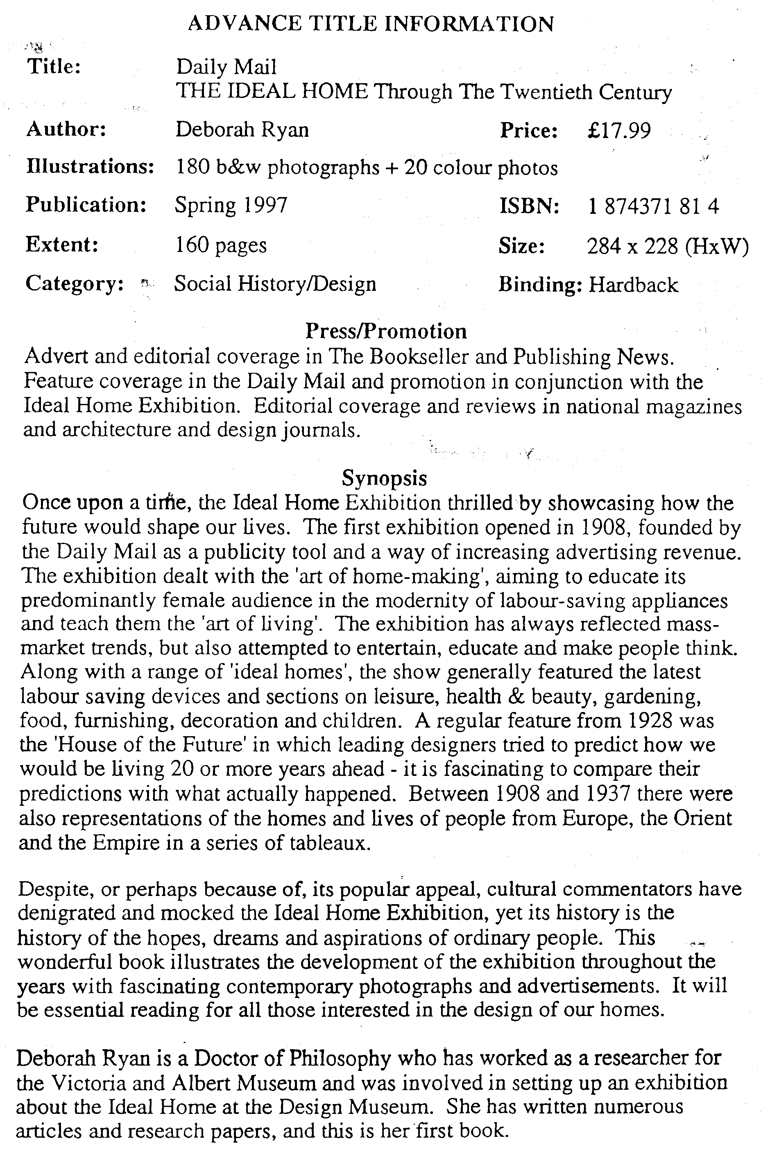
1997 Convention at Portsmouth

Every thing seems well in hand for the 1997 Convention. I met Fred Peskett at the Festival of Britain Convention on Saturday and he told me he had booked in about 20 members at the Hotel for the weekend. I think for the first time I have not had to rush around asking people if they would give a display. So far I have had seven volunteers, and surprise surprise, bearing in mind Mike’s comments in a letter to me there is not a single Wembley display.

While it is simple to work out a schedule for the programme, it does depend on our A.G.M. starting promptly at 9.30, and I would urge all members to try to be there on time. Obviously some speakers will not need the time allocated to them and some will need more, these times are not set in concrete so there can be a bit of give and take. If however we start late it puts the whole thing behind.

Programme
Friday 26th September

As members will be arriving at various times there will be a notice at the hotel advising members what is on offer.

Programme
Saturday 27th September

9.30 Annual General Meeting of the Exhibition Study Group.
10.00 1938 Glasgow Exhibition by Don Knight.
10.30 Opening Day at the Exhibitions by Bob Tough.
11.00 Break for coffee.
11.30 The Seville / Barcelona Expos 1929 / 30 by Ron Trevelyan.
12.00 Belgian Expos by Prof. Harold Vigis.
12.30 Break for Lunch.
2.00 Meet me in St Louis by Stanley Hunter.
2.30 1951 Festival Packets by George Simner.
3.00 Break for Tea.
3.30 Crystal Palace by Fred Peskett.
4.00 Laughing at Exhibitions by Bill Tonkin.
7.00 for 7.30 Annual Dinner.

Programme
Sunday 28th September

This will have been decided on the Saturday when the members will have had an opportunity to choose what they wish to do.

If there are any queries, or you have not booked yet, get on to

Fred Peskett. 124 Havant Rd,...North End, Portsmouth, Hants. PO2 0BA
Phone 01705 665630
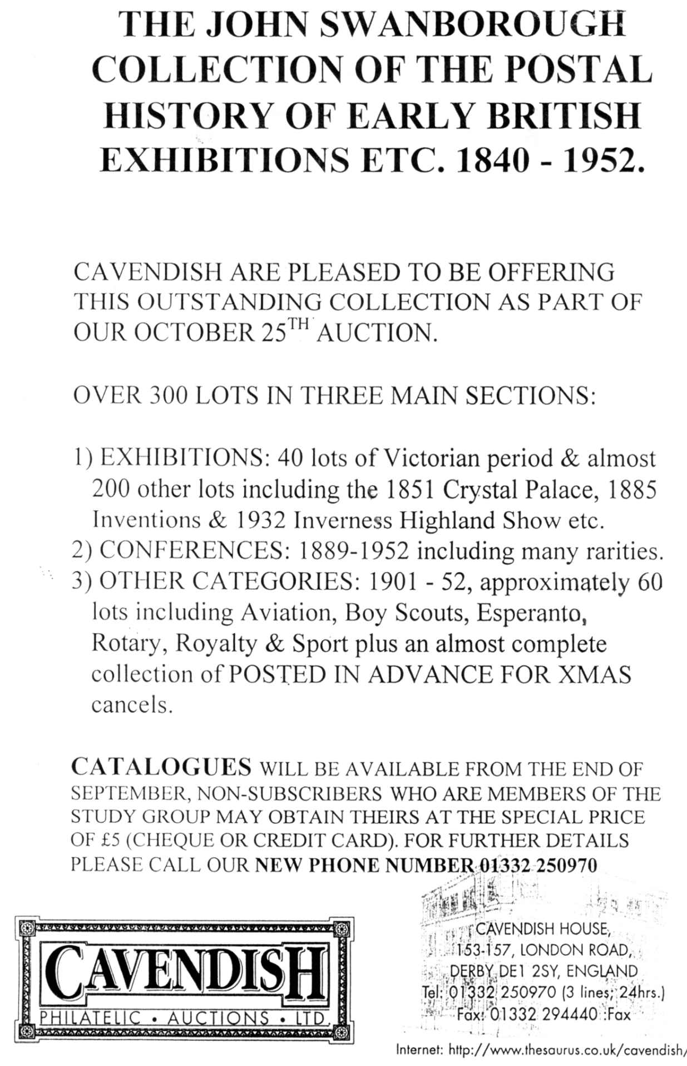
POST CARDS OF THE WHITE CITY

Part 6.

by
Bill Tonkin

Gottschalk, Dreyfus & Davis.
Coloured, brown back with ‘Stamp Here’ in dotted stamp box, ‘The Star Series, G. D. & D. L. Printed in Germany’ down left side. The backs come in two shades of brown, a mauve brown and a very deep brown almost black, these are not listed seperately. All the titles end in ‘The Imperial International Exhibition, London, 1909.’ Several of the cards were published with two different titles
A Night Fairyland.
A Scene in the Gardens.
A Splendid Night View.
General View of the Lake and Waterfall.
Promenade in the Gardens.
The Art Palace.
The Flip Flap.
The Garden Club Palace. This view is the same as ‘A Scene in the Gardens’
The Gardens showing Bandstand. This view is the same as ‘Promenade in the Garden’s
The Irish Village.
The Iron, Steel, Shipping & Railway Palace.
The Lake Showing Motorboats.
The Palace of British Arts.
The Palace of Music.
The Scenic Railway.
The Stadium showing Swimming Bath and Cycling Track.

Green. Richard B. & Co. Ltd.
B/W advert card, black back
“Our Exhibit” in Crown Colonies Pavilion, Franco-British Exhibition, 1908. (View of their stand, full of tins of Parsley Brand Salmon.) Vert right.

Guyot Braces.
Coloured advert card, brown back with ‘Printed in France’ in the stamp box, and crossed flags with ‘Souvenir from the Franco-British Exhibition 1908’ in top left corner.
Type 1. With artist’s signature ‘Ogé’.in bottom left corner.
Of Course I am a Swell can’t you see my real Guyot Braces. Vert left.
Type 2. Without artist’s signature in bottom left corner.
Of Course I am a Swell can’t you see my real Guyot Braces. Vert left.

H. B. Series. See under Hutson Brothers.

Hagenbeck’s Ceylon Village and Indian Arena.
The Hagenbeck cards present several problems in trying to list them, to start with they all have the same title ‘Franco-British Exhibition 1908 Hagenback’s Ceylon Village and Indian Arena’, this means the scenes depicted have to be described. In the descriptions the word Indian has been used to cover natives of both Ceylon and India. In series 1. the title can be found printed in black or red and this is listed, and from No. 29 the title comes in several different measurements, these have been given for all titles from this point. The title is in a single line in a white panel at the bottom of
the card, except for vertical cards where it is in two lines. It would appear there were two series numbered 1 to 40, and many of the views are repeated twice, and one view three times, each with a different number. There was a further series un-numbered, and for reference purposes these have been allocated numbers in italics.
As was a common practice, exhibitors brought along any cards they had been unable to sell at previous events, and Hagenbeck was no exception. Three series are known titled ‘Exposition Coloniale Les Elephants De L’Inde’, ‘Grande Exposition “India”’ and ‘Grande Exposition Indienne “Les Malabares”’. In series 3 and 4, again all cards had the same title and it is not known how many cards there were in each series, as they were not numbered these too have been given numbers in italics. Only one card has been seen of the last series No. 5 and this is numbered 31, and is the same as series 1. No. 31.
Cards from series 3 and 4 are known with Franco-British or Ballymaclinton cancellations, while the single card from series 5 from a message on the back., seems to have come from the Imperial International Exhibition in 1909.
Series 1. Greenish sepia, green back type A. with number in bottom left corner. All cards have the same title ‘Franco-British Exhibition 1908 Hagenback’s Ceylon Village and Indian Arena’ in a white panel at the bottom.

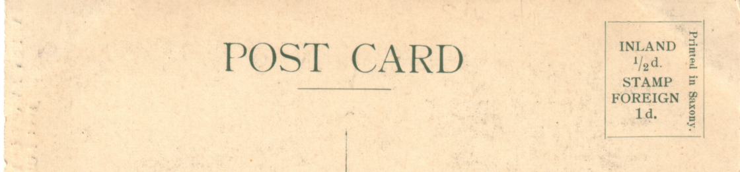

Hagenbeck back type A.

1 Potter crouched at wheel
A. Title in black.
2 Four men balancing on the top of long poles.
A. Title in black.
B. Title in red.
2 Man leading bear. Vert left.
A. Title in black.
3 Two seated Indians with monkeys on strings
A. Title in black.
B. Title in red.
4 Six Elephants climbing steps to top of slide. Vert left.
A. Title in black.
4 Three rows of Indian lads, first two rows seated.
A. Title in black.
B. Title in red.
5 Four elephants in arena, two balancing on tubs.
A. Title in black.
5 Five Indians two with drums, and one performing the basket trick.
A. Title in black.
B. Title in red.
6 Two seated snake charmers.
A. Title in black.
7 Three Indian weavers with cloths.
A. Title in black.
7 Thirteen Indian lads forming pyramid. Vert left.
A. Title in black.
B. Title in red.
8 Large group of Indians in arena with a kneeling camel.
A. Title in black.
8 Four seated Indians two painting pottery.
A. Title in black.
B. Title in red.
9 Five horsemen climbing steps to top of slide. Vert left.
A. Title in black.
9 Seven Indian dancers in front of slide, arms raised.
A. Title in black.
B. Title in red.
10 Seven Indian dancers in front of slide, arms lowered.
A. Title in black.
10 Seven Indians performing the basket trick.
B. Title in red.
11 Five Indians riding horses entering arena.
A. Title in black.
B. Title in red.
12 Two seated Indians with monkeys on strings. (As No. 3 but less of negative used)
A. Title in black.
B. Title in red.
13 Horsemen and elephants circling stage in arena.
A. Title in black.
B. Title in red.
14 Seven Indian dancers, with one hand raised.
A. Title in black.
15 Seven Indian dancers, with hand on shoulder of girl in front.
A. Title in black.
B. Title in red.
16 Four men balancing on the top of long poles. Vert left.
A. Title in black.
B. Title in red.
16 Two seated snake charmers. (Same as No. 6).
A. Title in black.
17 Three Indian weavers with cloths. (Same as No. 7).
A. Title in black.
B. Title in red.
17 Thirteen Indian lads forming pyramid. (Same as No. 7). Vert left.
A. Title in black.
18 Group of Indians in arena with a kneeling camel. (Same as No. 8).
A. Title in black.
18 Four seated Indians two painting pottery. (Same as No. 8).
A. Title in black.
19 Five horsemen climbing steps to top of slide. (Same as No. 9). Vert left.
A. Title in black.
B. Title in red.
19 Seven Indian dancers in front of slide, arms raised. (Same as No. 9).
A. Title in black.
20 Seven Indians performing basket trick. (Same as No. 10).
A. Title in black.
21 Man wrestling with bear.
A. Title in black.
22 Man leading bear. (Same as No. 2) Vert left.
A. Title in black.
23 Two seated Indians with monkeys on strings. (Same as No. 3).
A. Title in black.
23 Elephant in water having come down the slide. Vert left.
A. Title in black.
24 Six Elephants climbing steps to top of slide. (Same as No. 4) Vert left.
A. Title in black.
B. Title in red.
24 Three rows of Indian lads, first two rows seated. (Same as No. 4).
A. Title in black.
25 Four elephants in arena, two balancing on tubs. (Same as No. 5).
A. Title in black.
25 Five Indians two with drums, and one performing basket trick. (Same as No. 5). A. Title in black.
26 Elephant coming down slide. Vert left.
A. Title in black.
26 Seven Indian women.
A. Title in black.
27 Three elephants entering arena carrying baulks of timber.
A. Title in black.
27 Tall Indian with two dwarfs. Vert left.
A. Title in black.
28 Indian performing the basket trick in front of slide.
A. Title in black.
28 Drummer and three dressed up dancers.
A. Title in black.
29 One man balancing on top of long pole. Vert left.
A. Title in black.
A. Bottom line of title measures 64mm.
B. Bottom line of title measures 79mm.
29 Thirteen acrobats in set piece.
A. Title in black.
B. Title measures 127mm.
30 Performers circling round stage in arena.
A. Title in black.
B. Title measures 127mm.
30 Nine Indians, one man, four girls and four small children.
A. Title in black.
A. Title measures 106mm.
B. Title measures 127mm.
31 Three seated Indians with wood carvings.
A. Title in black.
A. Title measures 106mm.
B. Title measures 127mm.
32 Three seated jugglers, middle one balancing rod.
A. Title in black.
A. Title measures 106mm.
B. Title measures 127mm.
33 Elephant leaving water and another one on slide. Vert left.
A. Title in black.
B. Bottom line of title measures 79mm.
34 Elephant leaving water after coming down slide. Vert left.
A. Title in black.
A. Bottom line of title measures 64mm.
B. Bottom line of title measures 79mm.
35 Indian woman and child in rickshaw.
A. Title in black.
A. Title measures 106mm.
B. Title measures 127mm.
36 Seven Indian women. (Same as No. 26).
A. Title in black.
A. Title measures 106mm.
B. Title measures 127mm.
36 Elephant coming down slide (Same as No. 26). Vert left.
A. Title in black.
B. Bottom line of title measures 79mm.
37 Three elephants entering arena carrying baulks of timber. (Same as No. 27). A. Title in black.
B. Title measures 127mm.
37 Tall Indian with two dwarfs. (Same as No. 27). Vert left.
A. Title in black.
B. Bottom line of title measures 79mm.
38 Drummer and three dressed up dancers. (Same as No. 28).
A. Title in black.
A. Title measures 106mm.
B. Title measures 127mm.
38 Indian performing the basket trick in front of slide. (Same as No. 28).
A. Title in black.
B. Title measures 127mm.
39 One man balancing on top of long pole. (Same as No. 29). Vert left.
A. Title in black.
B. Bottom line of title measures 79mm.
39 Thirteen acrobats in set piece. (Same as No. 29).
A. Title in black.
A. Title measures 106mm.
B. Title measures 127mm.
40 Performers circling round stage in arena. (Same as No. 30).
A. Title in black.
A. Title measures 106mm.
B. Title measures 127mm.
40 Nine Indians, one man, four girls and four small children. (Same as No. 30).
A. Title in black.
B. Title measures 127mm.

Series 2. Greenish sepia, green back type A. without number. All cards have the same title ‘Franco-British Exhibition 1908 Hagenback’s Ceylon Village and Indian Arena’ in a white panel at the bottom. No red titles have been seen in this series.
1 Two elephants moving large square baulks of timber.
2 Three elephants carrying large logs.
3 Indian woman and child in rickshaw.
4 Elephant hitting water, and two more ready to come down slide.
5 Seven Indian jugglers?, four squatting.
A. Without title.
6 One man balancing on top of long pole.
A. No white panel title in three lines. Vert left.
7 Elephant coming down slide. Vert left.
8 Seven lads on six donkeys, with one lad to right helping.
9 Four men balancing on top of long poles. Vert left.
10 Four Indians on two wheeled carts drawn by five oxen.
11 Seven Indians, girl and two lads standing, and four small children sitting.
12 Five elephants from small to large, three largest with howdahs.
13 Nine children seated on stage in school?
14 Three elephants with howdahs, each with two attendants.

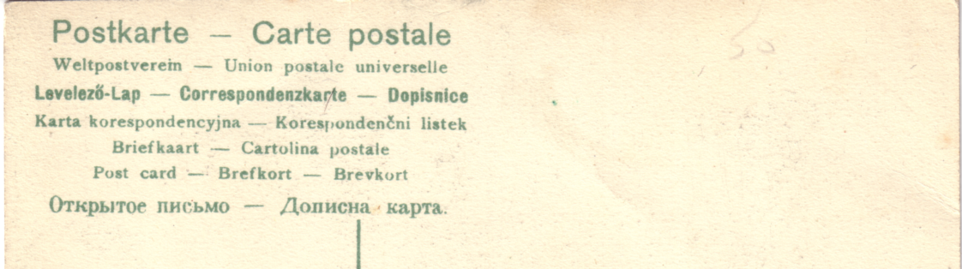

Hagenbeck back type B.

Series 3. Exposition Coloniale Les Elephants De L’Inde. Greenish sepia, green back type B. without number. All cards have the same title ‘Exposition Coloniale Les Elephants De L’Inde’ in a white panel at the bottom. No red titles have been seen in this series.
1 Two elephants moving large square baulks of timber. (Same as series 2. No. 1).
2 Three elephants in pool.
3 Two elephants carrying three logs, and rear view of third elephant.
4 Elephant hitting water, and two more ready to come down slide.
(Same as series 2. No. 4).

Series 4. Grande Exposition “India” Greenish sepia, green back type B, without number. All cards have the same title ‘Grande Exposition “India”’ in a white panel at the bottom. No red titles have been seen in this series.
1 Large group of Indians, three elephants with houdahs on right.
2 Five Indians one balancing youth on end of pole. Vert left
3 Indian woman and child in rickshaw. (Same as series 2. No. 3).
4 Four Indians and two girls preparing to do basket trick.
5 Seven Indian jugglers?, four squatting. (Same as series 2. No. 5).
6 One man balancing on top of long pole. (Same as series 2. No. 6).
A. No white panel title in one line. Vert left.
7 Three Indians with bear, drum and monkey.
8 Seven lads on six donkeys, with one lad to right helping. (Same as series 2. No. 8).
9 Nine Indians with various native craft goods.
10 Four Indians on two wheeled carts drawn by five oxen. (Same as series 2. No. 10).
11 Seven Indians, girl and two lads standing, and four small children sitting.
(Same as series 2. No. 11).
12 Five elephants from small to large, three largest with howdahs.
(Same as series 2. No. 12).
13 Nine children seated on stage in school? (Same as series 2. No. 13).
14 Three elephants with howdahs, each with two attendants. (Same as series 2. No. 14).
15 Four dancing girls on stage with men in background.
16 Four men balancing on top of long poles. Vert left.

Hagenbeck back type C.

Series 5. Grande Exposition Indienne “Les Malabares” Greenish sepia, green back type C. with number in bottom left corner. All cards have the same title ‘Grande Exposition Indienne “Les Malabares”’ in a white panel at the bottom. No red titles have been seen in this series.
31 Three seated Indians with wood carvings. (Same as Type 1. No. 31).

Harbrow. W.
B/W advert card, green back.
Kiosk, Imperial International Exhibition, London, 1909.

Harrison. George K. Ltd.
B/W advert card, black back with the left side filled with advertising matter.
Franco-British Exhibition, Machinery Hall, Stand No. 602. (Title at top)

Heinke. C. E. & Co. Ltd.
C. E. Heinke published a series of advert cards, and these can be found with two types of rubber stamp impressions on the back. One is in purple in four lines reading ‘Franco-British Exhibition / G. E. Heinke & Co. awards / Diploma of Honour & / Three Gold Medals. The other is in red in five lines reading ‘Franco-British Exhibition / Highest Awards for Diving / Apparatus. / Diploma of Honour & / Three Gold Medals. The cards can also be found without the handstamps. They are all listed, with the colour of handstamp if applied. As the cards have text on the front rather than titles the first six lines of text is given.
B/W advert card green back.
1807 The earliest type of Diver’s Helmet Five line red handstamp.
A fine specimen of Australian Pearling Lugger Without handstamp.
Illustrated Testimonial from Tilbury Docks. Heinke Four line purple handstamp.
Mother of Pearl Shells brought from Four line purple handstamp.
Mother of Pearl Shells brought from Without handstamp.
One of the Treasure Boxes and Without handstamp.
Two Divers working under water with Five line red handstamp. Vert left.
Two swords recovered from S.S. Indus Four line purple handstamp.
Two swords recovered from S.S. Indus Without handstamp.

Holland. Mr. B.
A printed advert for Mr. B. Holland, Boot & Shoe Repairer of 122, West Green Road, Tottenham, N. can be found on the back of Valentines Japan-British Exhibition cards remaindered after the exhibition closed. These solicit a request for a call to collect shoes requiring repair.
Coloured trade card, grey-green back with advert printed in black.
630 Garden of Peace, Japan-British Exhibition.
701 Uji Village, Japan-British Exhibition.

Holzapfels Compositions Co. Ltd.
A printed post card sized card, advertising Holzapfels Sunlight Enamels as shown on their stand No. 339 Franco-British Exhibition.
B/W printed text only card, blank back.

Horvilleur. H.
A printed advert for H. Horvilleur of 7, Rue de Temple, 7, Paris. musical instrument manufacturer can be found on the back of a French, Franco-British Exhibition card remaindered after the exhibition closed.
Coloured advert card, red back with ‘Commemoratif Card of the Entente Cordiale and of the Franco-British Exhibition 1908. ‘CARTE POSTALE’ at the top. The left side is filled with advertising text in black.
1905 Vers la Paix Universelle 1908

Hutson Brothers.
Coloured comic cards by Donald McGill, brown back with ‘H. B. Series, London, Copyright.’ and number in bottom left corner. In 1908 There were several series of comic cards by Donald McGill and most of these are probably for the Scottish National Exhibition at Edinburgh or for sale at Earls Court. Many feature the Water-Chute or the Helter Skelter and could have been for either site, which had both these attractions, while the White City had neither.
No. 640 At the Exhibition - Would you like to Flip-Flap with me. Vert left.

Imperial Government Railways of Japan.
These cards must be one of the most beautiful series to have been published for the Japan-British Exhibition. Vivid colours, deeply embossed and the edges in gold, a luxurious production. There is nothing on them to indicate they are exhibition cards, but the Imperial Government Railways of Japan were at the exhibition, and so many of them are postally used at the exhibition, or have related messages, that there is no room for doubt. The cards were given out free at the exhibition.
The cards have a main picture , and inserted into this is two or three views in small frames. In listing them, for most of them have no overall title I will describe the main picture and give the title of the first or top view. Fortunately the small views do have individual titles.
Coloured with white border, gold edged, green back with ‘Issued by the Imperial Government Railways of Japan.’ printed by The Tokio Printing Co.
Small boat sailing on river, and three views. / Matsushima Bay.
Branch with Blossom, and two views The Ikebana or Flower Arrangement.
Globe of the world, Japan the Focus of International Communications.
Map of Japan with train and boat, Map of the Government Railways of Japan.
Tree with star shaped leaves, and two views, A Peep at the Inland Sea. Vert left
Two birds on bamboo water pipes, and two views, A Street in Tokio. Vert left.
Two Sampans and tree in blossom, and two views, The Odori, a Dramatic Dance.
Two Deer in fenced wood, and two views, Nikko Temples.
Three girls tea picking, and two views, Horyuji Temple near Nara.
Japanese warriors helmet, and three views, Mitanoshita Hot Springs Resort, Hakoni.
Dragon and flowering shrub in bowl, and two views, Yabakei Valley, Kyushu.
Mask and Drum, and two views, Nara Park.
Flowers and Banner, and one view, Imperial Palace Entrance, Tokyo.
Three men, one on a horse, and one view, Mt Fuji, Height 12,370 ft.
Woman with Drum, and two views, Mt. Fuji. Vert left.
Woman with skeins of coloured silk, and two views, Matsushima Bay. Vert left.

