EDITORIAL SUMMER 1997

To Portsmouth where the sun does shine,
and Fred is planning a wonderful time.

Elsewhere in the Journal are some details of our Convention. I have spoken to several people and they all say what a lot there is to see in Portsmouth, and that it can’t be done in a weekend.
The sun is continuing to shine on me with regard to postmarks, and I have just found a second Japan-British Exhibition machine cancellation with the town die inverted, this one is dated 7 Sept, so I now have two, dated the 5th and the 7th, I wonder if the 6th was a Sunday. This month I went to Southampton and only found seven cards, and a week later at Maidstone only got three. I did much better at Cheltenham, Guildford and Bloomsbury, and even picked up four cards at Waddon, which is a small but very friendly local fair. The advert in Picture Postcard Monthly brought in just under 100 cards of which I bought 26, so all in all I got 173 cards during May. My average for each month last year was 171, but this year so far it is down to 139.
A question I often get asked is how do I remember what I have got, and the short answer to this is I don’t. In spite of carrying round six small note books crammed with notes I still accumulate a great number of duplicate cards. The trouble is you can’t list everything in small 6 by 4 inch note books, and for my type of collecting I really need to have the cards on approval.
Like most collectors space is a problem and I have decided to slow down on the crested china, tin ware and some ephemera. Unfortunately my idea of slowing down would probably be described by others as embarking on a mad spending spree. Still that’s what collecting is all about.
Fred Peskett writes in the latest copy of “Festival Times” about the appearance of forgeries in Festival of Britain memorabilia. Apparently someone has got hold of some Festival badges originally made for soldering onto various tinware by souvenir manufacturers. These are being glued with Araldite or Super glue onto contemporary tin or copper objects and sold for high prices. Recently a dealer tried to sell a 14 inch diameter copper plate to Fred for £35 but he came unstuck (the dealer not the badge) Fancy someone trying to con Fred with a spurious Festival item, it beggars belief. However this sort of thing could fool a lot of collectors so watch out. About a year ago I was offered three of these unattached Festival trade badges which I turned down as I realised what they were, it was at a collectors fair possibly at Orpington, I can’t remember where, or who the dealer was.
While I am on the Festival of Britain there may be some members who do not know there is a Festival of Britain Society. They send out a quarterly newsletter and meet once a year in London. The treasurer is George Simner. 23, Langton Ave, East Ham, London. E6 4AN. 0181 471 2165 and I think the subscription is £7 per annum, or half price if you’re in your dotage like yours truly.
It’s funny how often you can find an exhibition connotation in the most unexpected things. A few weeks back I attended the local history meeting in Beckenham, and a friend showed me a book he’d had for some years, a history of the North Surrey District School at Anerley. Although I cannot claim to be too involved in local history Nancy was, and some of her interest has rubbed off on me, anyhow I borrowed the book, and when I got home and read it, realised what a gem it was. The originals of the illustrations in the book were part of an invited display at the Franco-British Exhibition. I have been able to get an article from it for the Journal. It has made me realise that Charles Dickens wasn’t joking when he depicted the horrors of the Workhouse. One illustration of the children in a performance of the play H M S Pinafore seemed familiar and when I checked on Nancy’s collection, there it was as a postcard. There was no way of connecting the card with the exhibition, and if I had not borrowed the book the connection would have never been made. I wonder if it was part of a set and whether there are other cards out there.

The Editor.
The 11th Convention 1997 to be held at Portsmouth

Organised this year by Fred Peskett

Fred Peskett has got together a package of goodies which he will send to any member who applies to him for it at 124, Havant Road, North End, Portsmouth, Hants. PO2 0BP. or phones him on 01705 665630. This includes a questionnaire sheet and booking form for you to fill in and return to him, and half a dozen leaflets on what you can see and do in your spare time, if any.

He has negotiated a special tariff with the Saville Hotel on the Southsea sea front. The Hotel is well appointed with excellent facilities and car parking to the rear. He will include a range of room prices, starting with single rooms at £16 per night or £20 for en-suite, double rooms are slightly cheaper. The Hotel will cater for our Annual Dinner, a three course meal for £7. They will also let us have the use of their lower floor dining room for our meetings free of charge.

For those who will be there on the Friday 26 September he can arrange a visit to the D Day Museum and Southsea Castle at a much reduced admission charge. This will be around £3.00 instead of the normal £7.00 but he must know who is coming as the reduction depends on the number of people going. Or if you wish a Harbour Boat Trip taking in the RN Submarine Museum, this tour lasts about an hour. Again he can arrange a concessionary rate if the numbers are sufficient.

Friday evening a trip to Spice Island, Old Portsmouth and a call in to Nelson’s old haunt “The Still and West”

Saturday 27th will be our Convention Day and be devoted to displays by members, talking and bartering. The evening meal will be your choice from the menu, fresh vegetables, home cooking no micro-waving. I will get out a programme of displays for the Saturday but this depends on you letting me (Bill Tonkin) know well in advance what you are displaying. It would be nice if this programme could go in the Autumn Journal, this means you letting me know by the middle of June at the latest.

Sunday 28th. After breakfast and a final chat Fred has laid on a visit to the Historic Ship Collection, we will not be able to do all of this in the one day, but the admission tickets of £7.00 are valid for one year so you can return at a later date if you wish. This includes visiting the Mary Rose Henry VIII’s ship raised in 1982, HMS Warrior and Nelson’s HMS Victory. There are also three museums “The Dockyard Museum” the “Royal Naval Museum” and the “Dockyard Apprentice Museum”.

Certainly I can see this convention is all set to establish a level of excellence that is going to be very difficult to match in future years. To the many members of the Study Group who have not attended one of our conventions, I strongly suggest you give this one a try, it will be an opportunity to see material from some of the leading exhibition collections in existence, also this year more than any other there is plenty of interest for your wives or lady friends. You can promise them a much better time than being dragged round a postcard fair all day.

Burton Benedict from America and Harold Vigis from Belgium hope to attend, and it is likely Gerard Levy from France, who unfortunately had to drop out of the 1996 convention at the last moment, will be there. They don’t come all that distance unless they think it is well worth while and enjoy meeting other collectors with like interests. That’s what its all about.

This year we are extending a welcome to members of the Festival of Britain Society to join us.
Letters to the Editor

I am glad to see that Vivien Forster is keeping up her interest in the International Horse Show, she tells me she had a letter published in the “Horse and Hound” and arising from this a lady sent her a booklet “The Story of the International 1907-1957”. She photo-copied this before returning it, and has sent me some further information as follows, this updates the list in the Spring Journal.

1907 The first show was held.
1915-1919 inclusive not held during the first World War
1920 the show opened June 16 closing date not known (see below from Arthur Smith).
1929 June 20 - 29
1933 No reason given
1939 June 15 - 24
1940-1946 inclusive not held during the second World War
1947 when the show opened after war it was held at the White City and continued there until at least 1957
The two dates for 1908 and 1911 remain a mystery.

Arthur Smith writes in answer to my query, when was the Mammoth Fun Fair at Olympia ? it was 1906. He also gives me some dates for the International Horse Show
1914 4 - 16 June
1920 16 - 26 June
1939 He confirms the dates as above.
He mentions he has a 1912 card overprinted on the back with the dates June 20 - July 1, 1913. Now this is interesting, as all the cards published for the 1913 event give the date as June 19 - July 1. Fortunately I can give the answer to this one. It would seem that the organisers had cards left over from the 1912 event and had the backs overprinted with two lines through the 1912 date, and above it the date June 20 to July 1, 1913 printed in. That was their original intention and plan before they had the new cards printed. I have two of these cards, and one has an additional typewritten message on the back “The Directors of the International Horse Show in the anticipation of a very large entry find it necessary to open on Thursday June 19th instead of Friday June 20th. The show will conclude on July 1st.” This decision must have been reached in time for them to have the new cards printed with the revised date.

Dilwyn Chambers several times a year drops me a note with odd snippets of information he has seen in books or newspapers which I have published from time to time in the Journal. About the same time I read about the Festival forgeries I had this from Dilwyn, “Collectors of 1904 World’s Fair souvenirs may like to be warned that it has been established that a metallic Coco Cola ticket signed “L. A. Stamp” is spurious. A recent article includes information obtained by interviewing one of the perpetrators.”
I suppose with some of the prices collectors are willing to pay for items for their collections it was inevitable that unscrupulous people would make the effort to supply that demand.
But take heart, in the world of philately years ago someone forged a Queen Victoria 1/- stamp which came to be known as the Stock Exchange forgery, because all the forged stamps were used at the post office in the stock exchange on telegraph forms, and years later a stamp dealer Mr Charles Nissen found some. My 1985 Stanley Gibbons catalogue prices the genuine stamps at from £12 each, while the forgeries are priced at between £450 and £2,000.
Fred, if you’re still reading this, it might not be a bad idea to get that copper dish.
Exhibition Books for Sale

Alan Sabey phoned me up the other day to say he has managed to obtain a further supply of George Ithell’s book on Ballymaclinton, and I thought it might be a good idea to list books written by members of the Group that are still available. All the books are new with the exception of two used copies of British Exhibitions and their Postcards Part 1. These were donated to the group by Andrew Brooks. All prices include postage within the UK. Please make cheques out to the names listed as the supplier, not the Exhibition Study Group.

The Lion Roars at Wembley by Don Knight & Alan Sabey
The best book on the British Empire Exhibition dealing with every aspect, from
the exhibition, the many collectibles and the postal history.
From D. Knight. 2, Crescent Rd, New Barnet, Herts. EN4 9RF £13.25
The Exhibitions, The Great White City by Don Knight.
A short history of The Great White City and its many exhibitions, and covers
briefly the many collectibles.
From D. Knight. 2, Crescent Rd, New Barnet, Herts. EN4 9RF £3.25
Posted at Ballymaclinton by G. E. R. Ithell
The story of the Ballymaclinton Villages 1908-1911, and their postcards. George
Ithell was the first collector to realise the importance of the backs of postcards
From A. Sabey. 46, Thorncliffe Rd, Norwood Green, Southall. UB2 5RQ £5.75
The Postcards of the British Empire Exhibition 1924 -25 by M. Perkins & B. Tonkin
The standard work on this subject, in 1995 it won the Desmond Chamberlain
Trophy for outstanding research. Every known trade or advert card is illustrated.
From W. Tonkin. 23, Bramley Way, West Wickham, Kent. BR4 9NT. £15.95
Price guide and check list for Postcards of the B. E. E. 1924-25 by Perkins & Tonkin.
This supplement sets out to give an individual valuation for over 3,900 exhibition
postcards and a check list with boxes where you can tick the cards you have.
From W. Tonkin. 23, Bramley Way, West Wickham, Kent. BR4 9NT. £7.50
Publicity Labels of the British Empire Exhibition Wembley 1924-25 by A. Sabey.
An illustrated list of the Publicity Labels used for the exhibition together with
a guide to the values of these stickers
From A. Sabey. 46, Thorncliffe Rd, Norwood Green, Southall. UB2 5RQ £5.50
Supplement to the above book on the Wembley Publicity Labels by A. Sabey.
The supplement was published to cover the many new labels that came to light
after the publication of Publicity Labels of the B. E. E. 1924-25
From A. Sabey. 46, Thorncliffe Rd, Norwood Green, Southall. UB2 5RQ £4.00
British Exhibitions and their Postcards Part 1. 1900-1914. By Fletcher & Brooks
The first comprehensive book on exhibition postcards, for many years the
“Bible” that helped many collectors, and was partly responsible for starting the
Exhibition Study Group. Only 1 new and 2 used copies. First come first served.
From W. Tonkin. 23, Bramley Way, West Wickham, Kent. BR4 9NT. £6.50

John Swanborough

It is with regret that I have to report the sudden death of John Swanborough who was a leading authority on special postmarks, some of which he showed to us at our convention at Wembley in 1994.
He was co-compiler with Colin Peachey of “Special Event Postmarks of the United Kingdom 1991, a British Postmark Society publication, which will be a lasting memorial to his great knowledge in this field.
North Surrey District School at the Franco-British Exhibition.

by
Bill Tonkin

The North Surrey District School was asked to represent Poor Law Schools at the Franco-British Exhibition in 1908, by sending in photographs illustrating various phases of life in the institution, together with exhibits of work done in the various technical education departments. Arising from this the Board of Management decided the time was ripe to write a history of the school, and to illustrate it by using the photographs shown in the exhibition. The Superintendent Mr J. F. Thrower undertook to take on the task assisted by the Chairman Mr W. J. Hewett.
At this time the school had been going for sixty years, and was then the largest District School in existence. Now what was a District School ?, and to answer this we have to go back to 1837 to a report of the Committee appointed to enquire into the working of “The New Poor Law”. This Committee recommended “that the Poor Law Commissioners be empowered with the consent of The Guardians, to combine parishes for the support and arrangement of District Schools.

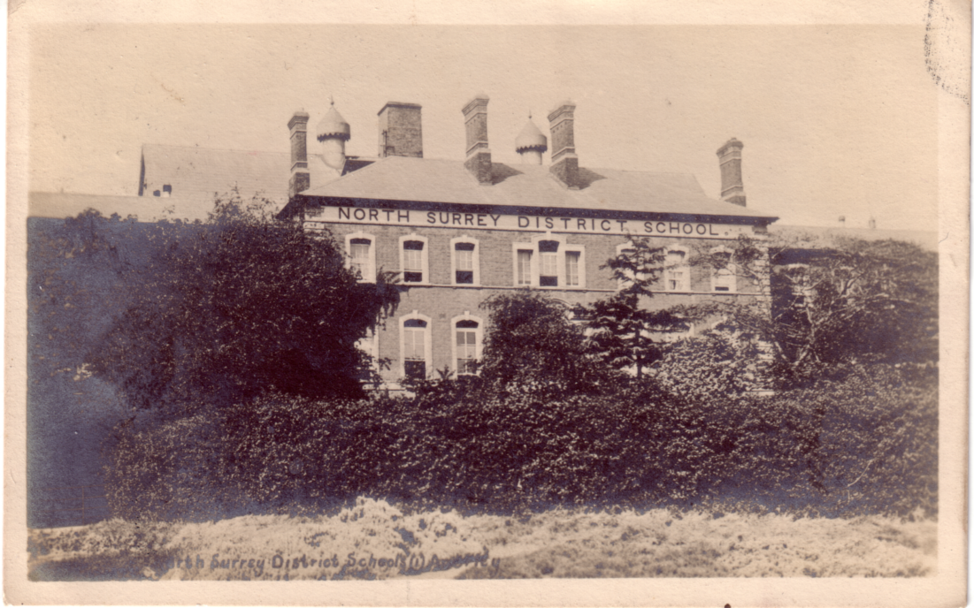

North Surrey District School at the time of the Franco-British Exhibition in 1908.

This was supported by Dr J. Kay later to become Sir J. Kay-Shuttleworth, a Poor Law Commissioner, in a report on “The Training of Pauper Children”. He claimed “the contaminating influence of adult paupers was baneful to the extreme to those children who lived in the workhouse, and whose education, such as it was, was conducted therein.”
For many years the efforts to promote District Schools had been unsuccessful, by an Act of 1845 provision was made for the establishment of these schools, but two clauses nullified the good intentions,
1. The amount to be raised for school buildings was not to exceed one fifth of the annual expenditure for the relief of the poor, and
2. No Parish could combine outside a limit of 15 miles.
Both these objections were removed by a further Act of 1848. Even then there appeared to be no great effort to do anything in the way of building, until the trial of Druet in 1894 for manslaughter. This effectively lifted the lid off the can of worms.
At this time children from the workhouse who were permanently chargeable to the Poor Law Authorities, were farmed out in their hundreds to contractors. Obviously, the lower the price charged by the contractor for ridding the ratepayers of their burden, the more likely the acceptance of the tender. The contractor on his part made sure that by supplying cheap food in starvation quantities to his little protégés he could make a substantial profit on the deal.
One is able to appreciate the feelings of Charles Dickens who held up for public sympathy the piteous plight of little Oliver, and for scorn the character of “Bumble”. Dickens incidentally was invited and attended the opening ceremony of the North Surrey District School.
To such a depth did this evil develop that at the trial of Druet it was proved that mainly owing to starvation and neglect, as many as 150 children died in a few days of cholera, at his farming establishment at Tooting. The disclosure of such dreadful facts at the searching investigation which followed the trial, gave the death knell once and for all to this much abused system of farming out.
Five Unions in an area south west of the Thames combined for the purpose of forming a District School, they were.
Wandsworth and Clapham,
Croydon,
Kingston,
Lewisham and
Richmond.
The first meeting was held in the Workhouse of the Wandsworth and Clapham Union, and it was agreed that Wimbledon Common would be a suitable site to build the new school. Lord Spencer the Lord of the Manor was approached with a request to dispose of sufficient land for this purpose. However objections from several influential residents in Wimbledon proved insurmountable, and Wimbledon Common was out.

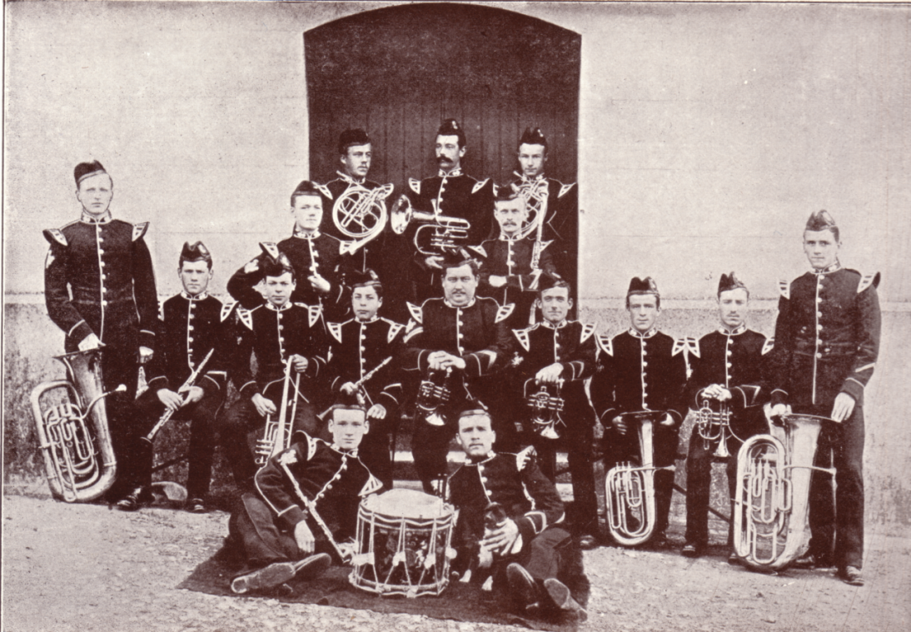

Royal Welsh Fusiliers.
This group of Bandsmen were all from the North Surrey District School. They had this photograph taken to send back to their old school. In 1908 the school band was 50 strong and by then 400 lads had been enlisted into various Army Bands.

At a meeting on July 18th a letter was read from the Vicar of Battersea, offering 55 acres of land at Penge for £3,000, this was accepted, and by September 12th the Poor Law Board agreed the
plans by architect Mr Charles Lee for the erection of a school to accommodate 600 children. Early Board of Management meetings were held in a tavern near Anerley Station, and on 20th November 1850 the school was opened.
It was a curious fact that the Chairman of the Board was not allowed a casting vote as is usually the case in public bodies. At the election of the first Chaplain the voting was equal for the two candidates and the Chairman gave a casting vote for one of them, and to clear up the position enquired of the Poor Law Board if his action was valid. The Secretary Lord Ebrington replied that under their regulations if there was an equal number of votes cast on any question “that question shall be deemed to have been lost”. This necessitated re-advertising the vacancy and at the next meeting a chaplain was elected.
From the fact that the first children came from workhouses, “trained by degraded parents or professional thieves to look upon the world as a place to exercise the viler instincts of nature”, it can be imagined they were of “a very undesirable type”, and from the records of the times such was the case. The Chaplain in a report to the Inspector of Metropolitan Schools states “Very few of the boys could give an account of the simplest facts of the Bible, only five out of the whole number could read the Irish Third Reader without hesitation, and only ten could do a sum in compound division with two figures in the divisor, and none could write a single sentence from dictation, mis-spelling almost every word of two or more syllables. Of geography, grammar and history the ignorance was universal and entire. The slightest restraint exercised over them was immediately revenged by destruction of property, a trait particularly workhouse. The girls, were, if possible, in a lower condition than the boys. The number of children at this time was 636.

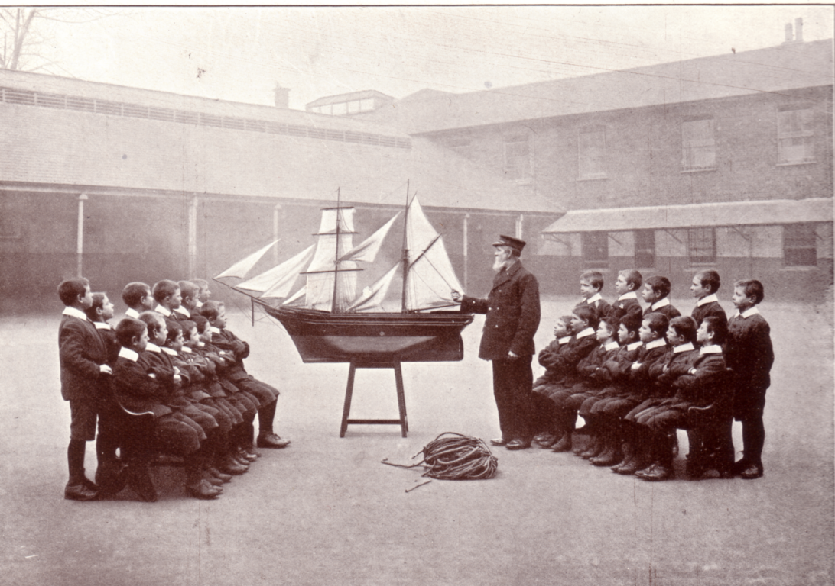

Navigation Class.
A class for the Mercantile Service and the Training Ship “Exmouth”

There was a determination to better the lot of these unfortunate children, and in the Managers first report it states “The objects of the managers, in providing skilled workmen for teaching trades, is not profit from the output of the children’s labour, but the inoculation of good habits and proper mental training, not present gain, but a more effectual means of depauperising them, by enabling them to gain their own livelihood hereafter.”
Further on we read of “the eradication of the pauper taint” “to that class from which our prisons and hulks have hitherto received their greatest importation’s”. What a terrible picture this
paints of the conditions of young orphans and unwanted children, at a time when the country was preparing for the opening of the Great Exhibition in Hyde Park.
It is interesting to note that in 1854 the opening of the Crystal Palace at Penge had such an effect on the neighbourhood that land values had increased to such an extent that a reserve price of £40,000 was decided on, should the land be offered for sale. This did not happen, although later in 1877 the Overseers and Vestry of the Hamlet of Penge did purchase about a third of an acre for £800. This was nearly as much as they had paid for the whole 55 acre site 28 years previously. At that time it was also decided that no more land should be sold.

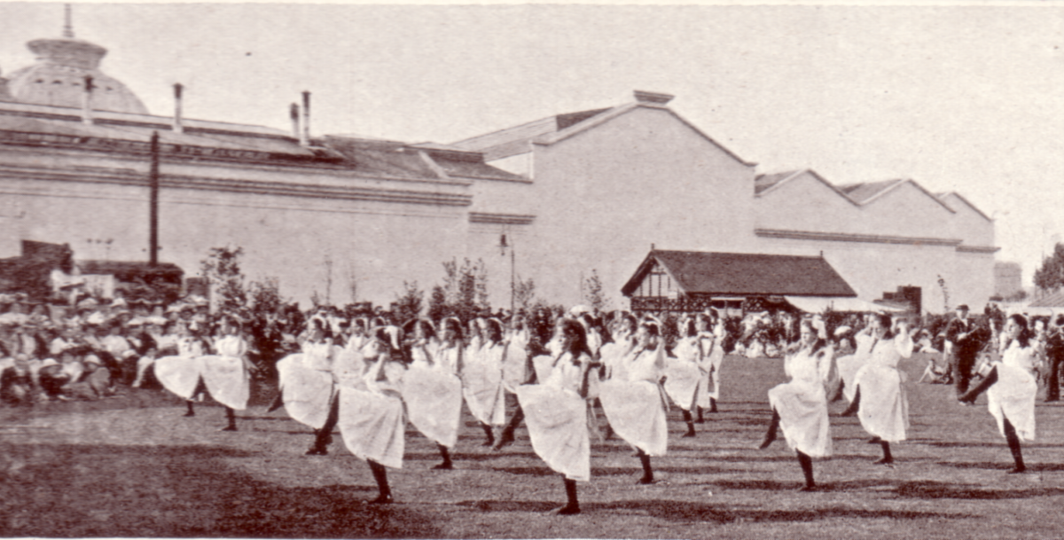

Apart from static displays of photographs and manufactured items at the exhibition, the children gave live performances of drill, band music, singing and dancing.

As early as 1883 Mr Henry Moxon a dentist was employed to examine and report on the teeth of the children at least once a quarter, he was paid £60 per annum. He was the first dentist to be appointed at any District, Separate or Workhouse School. It was to be 25 years before some day schools followed this practice. In 1886 a Convalescent Institute to hold 25-30 children was built at Broadstairs, it was named the “Wainwright Home” after J. G. Wainwright JP the Chairman of the Board of Management from 1876-1902.
On December 17th 1888 the Superintendent reported receiving 500 new sixpence’s from an anonymous donator. To many of the children this was the first sixpence’s they had ever seen, certainly the first they could call their own. This continued every Christmas until 1902 when on his death it became known that Sir Francis Barry had donated 10,000 sixpence’s annually to hospitals and institutions.
At the time of the Franco British Exhibition in 1908, the North Surrey District School was one of the finest in the country, which no doubt accounted for its being chosen to take part in the exhibition. 40 acres of its grounds was taken up by a farm with a herd of cows supplying nearly all the fresh milk consumed by the school (about 80 gallons a day). The children were taught trades to prepare them for the outside world. In the many reports on the condition of the school, by the turn of the century one point comes through time and time again, “Its cleanliness and happy look of the children” a far cry from its early days.
POST CARDS OF THE WHITE CITY

Part 5.

by
Bill Tonkin

Edison & Swan United Electric Light Co. Ltd.
It is possible there are a series of these cards, two are known both with the name and address of a different supplier printed on the back. One is an advert card meant to be sent through the post, and the other a trade card meant for hand distribution.
Type 1.
B/W photogravure advert card, black back with advertising matter on half the back, stating bulbs can be obtained from The Edison & Swan United Electric Light Co. Ltd., 58, Clarence Street, Sydney, New South Wales.
Court of Honour by Night, Illuminated by “Royal Ediswan” Lamps. Franco-British Exhibition 1908.

Type 2.
B/W photogravure trade card, black back with advertising matter stating bulbs can be obtained from No. 4 Lamp Department, The Army & Navy Co-Operative Society, Limited, 105, Victoria Street, Westminster, S.W. The back of the card also includes a price list.
Court of Honour by Night, Illuminated by “Royal Ediswan” Lamps. Franco-British Exhibition 1908.

Electric & Ordnance Accessories Co., Ltd. The
B/W litho advert card with title and advert on front in red, black back. The advert reads ‘The Controller for operating the 100 HP Motor in the Flip-Flap was supplied by The Electric & Ordnance Accessories Co., Ltd., Birmingham.’ in four lines. There is further advertising matter on the left side of the back.
The Flip Flap from Stadium, Franco-British Exhibition. London, 1908. Vert left.

Electric Supply Co’s of London.
Coloured advert card, brown back.
Shown by the Electric Supply Co’s of London. Franco-British Exhibition, 1908, Machinery Hall.

Emons. Henry.
A trade card for Henry Emons. Station Parade, Hampstead Heath. advertising a drapery sale,
can be found printed in red on the back of a Valentine & Sons coloured Franco-British Exhibition card remaindered after the exhibition closed.
N.n. The Stadium, Franco-British Exhibition, London, 1908.

EMU.
Advert card printed in various colours, with title at top, green back.
In the Victorian Government Court, at the Franco-British Exhibition.
A. Printed in red. Vert right.
B. Printed in green. Vert right.

Esperanto Day.
Blank card, green back with advert for an Esperanto Day to be held at the Japan-British Exhibition on 11th June 1910 when ‘Thousands of Esperantists will be present’. The card invites you to write to the Hon. Secretary of Esperanto Day at 133, High Holborn, London, W.C.

Fells Australian Wines. Koala Brand.
Coloured advert card, title at bottom in red, black back with the left side printed as an order form for wines.
Franco-British Exhibition, 1908.

Formosa Oolong Tea.
There were a large range of these coloured cards by various Japanese artists given away at the Japan-British Exhibition. They all have an overprint on the front ‘Compliments of Formosa Oolong Tea.’ This list is by no means complete.
At Kanbara ot Tokaido. by Hiroshige.
At Kemmokutoge. by Hokusai.
Awazu at Omi. by Hiroshige.
Mariko at Tokaido. by Hiroshige.
No title woman playing bamboo flute by Toyokuni. Vert left.
No title woman seated with drum by Toyokuni. Vert left.
No title woman standing playing drum by Toyokuni. Vert left.
Yuhigaoka at Meguro. by Hiroshige. Vert left.

Francis. H. J.
H. J. Francis was a publisher who used copyright photographs belonging to Wakefield of Chiswick. This is acknowledged on the front of the cards and they also used the same numbers.
Type 1. R/Photo, brown back with ‘POST CARD’ measuring 44mm.
212 Franco-British Exhibition, General Birds Eye View, Taken from Balloon.
Type 2. R/Photo, brown back with ‘POST CARD’ measuring 41mm.
213 Franco-British Exhibition, The Great Stadium-Olympic Games 1908, Taken from Balloon.

Fry’s Chocolate.
R/Photo advert card, brown back, printed by Rotary Photo E.C. There are many settings of the back, especially of the double line ‘T’ divider, and ‘POST CARD’ which can measure 40 or 42mm. The dot after POST CARD is sometimes left out.
300 Fry’s Chocolate & Cocoa Kiosk. Imperial International Exhibition, London, 1909. Grands Prix, Gold medals & Diplomas. “Grand Prix” Franco-British Exhibition, 1908. Vert right.

Fuller’s Ltd.
Type 1. R/Photo advert card, brown back possibly printed by Rotary.
Fuller’s Working Chocolate Factory at the Franco-British Exhibition.

Type 2. Coloured advert card, chocolate airship with gnomes climbing ladder to feed new moon with chocolate, black back.
Diploma of Honour Franco-British Exhibition 1908.

Type 3. Coloured advert card, gnomes in aeroplane feeding full moon with chocolate, black back.
Grand Prize Japan-British Exhibition 1910, Diploma of Honour Franco-British Exhibition 1908.
Furness Railway.
Sepia advert card, brown back.
Franco-British Exhibition, London, 1908. (View of their stand).

Furse W. J. & Co.
R/Photo advert card showing the Court of Honour Illuminated, brown back, printed by Raphael Tuck & Sons. This view is the same as Tuck’s A228 with the firework display taken out.
These Illuminations have been entirely carried out by W. J. Furse & Co., Nottingham. The photographe represents 20,000 lights, this being only a portion of their contracts.
A. Left side of the back has space for a message.
B. Left side of the back is filled with advertising matter.

G. A. & Co., Ltd.
This may not be exhibition an card, but is included in the list because it comes from Ella du Cane’s Japanese series, some of the views published by Tuck’s were issued for the Japan-British Exhibition. The fronts have simulated brush marks like the Tuck Oilfacsim’s
Coloured, black back with ‘La Carte “Olio” Procédé Brevété de la Maison’.
No. 631. No title. (Cherry Blossom Chion-in-Temple).

Gale & Polden Ltd.
Gale & Polden issued many series of cards for the Anglo-American Exposition, and they all (except the pullouts) have a round imprint similar to a double ring post mark 26mm in diameter but without a date, in the top left corner on the back. Between the rings is ‘Anglo-American Exposition’ and between two bars in the centre ‘London-W-’.This ‘post mark’ must be printed as the impression is too even to be done by hand. On series 1 and 2, the position of the ‘post mark’ shows hardly any rotational variation, i.e. the bars are always parallel with the top of the card and it is very accurately placed. On series 3 there is a lot of lateral variation and the position of the ‘post mark’ can vary by up to 10mm. Through to series 7 the ‘post mark was carefully positioned with little variation, but in series 8, 9, 10 and 11, no effort seems to have been made align the ‘post mark’ and it can be found with the lines pointing to every point of the compass. Only a limited amount of research has been done on this but it does appear that duplicates of any card will show the same amount of tilt of the ‘post mark’.
Series 1. Sepia, grey-green back type A, these are standard Valentine’s cards with ‘Valentine’s Series Copyright’ on the front and ‘Printed by Valentine & Sons Ltd. Dundee, London & Montreal, etc.’on the back. They are overprinted in black ‘Published by Gale & Polden Ltd., London, E.C.’ down the left side on the back, the ‘post mark’ is placed over, and partly obliterates ‘Official Great White City

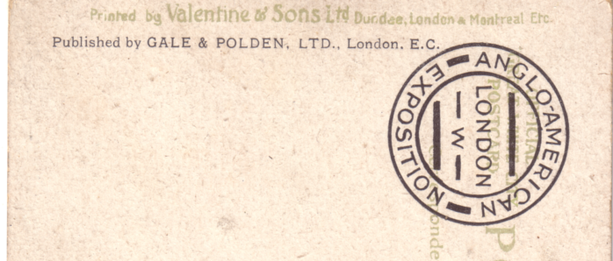

Gale & Polden back type A.

Postcard’. On the front is overprinted ‘Anglo-American Exposition’ this is usually in a different type of print to the rest of the title. As is usual with the titles of Valentine’s cards there are many different settings, and these are not listed unless they are major differences.
842 Cascade in Court of Honour, Great White City, Anglo American Exposition.

Series 2. As series 1 but coloured.
132 Anglo-American Exposition, Scenic Railway, Great White City, London.
217 Court of Honour, Great White City, London, Anglo-American Exposition.
433 Anglo-American Exposition, The Congress Hall, Great White City, London.
484 Court of Honour, Great White City, London, Anglo-American Exposition.
484 Anglo-American Exposition, Court of Honour, Great White City, London.
552 Court of Arts, Great White City, London, Anglo-American Exposition. (This title can be in the centre or to the left.)
567 Elite Gardens, Great White City, London, Anglo-American Exposition.
722 Anglo-American Exposition, Wood Lane Entrance, Great White City, London.
831 Bandstand in Court of Arts, Great White City, London, Anglo-American Exposition.
836 Anglo-American Exposition, Court of Honour, Great White City, London.
837 Flip Flap, Great White City, London, Anglo-American Exposition. Vert left.
842 Anglo-American Exposition, Cascade in Court of Honour, Great White City, London. (This title can be found in one line or two lines.)
843 Court of Honour, Great White City, London, Anglo-American Exposition.
844 Court of Honour, Great White City, London, Anglo-American Exposition. (This title can be found in different types of print.)

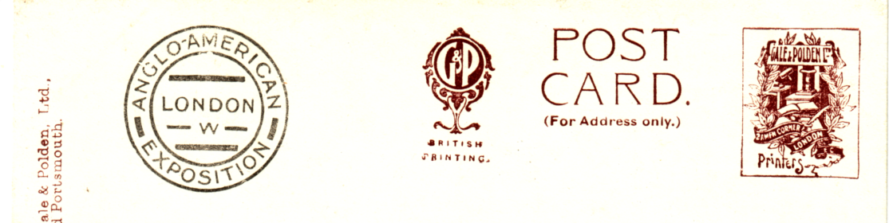

Gale & Polden back type B.

Series 3. Coloured, black Gale & Polden back type B. these are standard Valentine’s views with ‘Valentine’s Series Copyright’ on the front, but the cards were printed and published by Gale & Polden, with their ‘post mark’ on the back in black. The titles are printed in black and are all in the same style of type.
217 Court of Honour, Anglo American Exposition.
433 The Cascade, Anglo American Exposition.
567 Elite Gardens, Anglo American Exposition.
710 View from the Flip Flap, Anglo American Exposition.
837 Flip Flap, Anglo American Exposition. Vert left.

Series 4. B/WColoured, sunk plate with white border, the corners of the cards are rounded and some have deckled edges, brown Gale & Polden back type B. with the ‘post mark’ in black. Some of these are standard Valentine’s views others are not, none are numbered and do not have ‘Valentine’s Series Copyright’ on the front, the cards were printed and published by Gale & Polden. The titles are printed in black and are all in the same style of type, where the title is not in black it has been noted.
Concert Arena, Elite Gardens, Anglo-American Exposition, 1914.
Congress Hall from Imperial Terrace, Anglo-American Exposition, 1914. Vert right.
Court of Arts, Anglo-American Exposition, 1914.
Court of Honour, Anglo-American Exposition, 1914.
Promenade, Court of Arts, Anglo-American Exposition, 1914. Vert right.
The Cascade in Court of Honour, Anglo-American Exposition, 1914.
A, Title in black.
B. Title in brown.

Series 5. Coloured Comic Cards, brown Gale & Polden back type B. with the ‘post mark’ in black. The cards feature small artist drawn children in romantic situations. All the cards have ‘Anglo-American Exposition’ at the top in black, with a drawn title at the bottom in white.
Ask Papa.
These Lights are all me Girls coming to Love me.
We’re not allowed to Court without a Light.

Series 6. Sepia views in oblong or oval frames with different coloured borders including American and British Flags, brown Gale & Polden back type B. with the ‘post mark’ in black. The titles are split, on the horizontal cards the title is on the left and right, and on the vertical cards is split top and bottom.
Anglo-American Exposition, Imperial Tower from Court of Arts. (Oblong)
Anglo-American Exposition,Cascade and Concert Hall. (Oval) Vert left.
Anglo-American Exposition, Concert Arena, showing Flip Flap. (Oblong) Vert left.
Court of Honour, Anglo-American Exposition. (Oblong)
Elite Gardens, Anglo-American Exposition. (Oval)

Series 7. The Famous Piccaninny Band. Very dark sepia almost B/W, brown Gale & Polden back type B. with the ‘post mark’ in black. Split titles.
Anglo-American Exposition. “Full Play” The Famous Piccaninny Band.
Anglo-American Exposition. “Master and Man” The Famous Piccaninny Band.
Vert right.
Anglo-American Exposition. Selection Preparing “Ragtime” The Famous Piccaninny Band.
Anglo-American Exposition. The Conductor, Famous Piccaninny Band.
Anglo-American Exposition. The Famous Piccaninny Band.

Series 8. Sepia, brown Gale & Polden back type B. with the ‘post mark’ in black. The titles are split, with ‘Anglo-American Exposition, 1914’ either in two lines or three, this is on all cards, and can come before or after the title. On the night scenes the title is printed in red.
Avenue, Elite Gardens. Vert right.
Concert Arena, Elite Gardens by Night.
Congress Hall from Imperial Terrace. Vert left.
Court of Arts.
Court of Arts and Bandstand, by Night.
Court of Honour.
Court of Honour, Promenade and Cascade. Vert left.
Court of Honour showing Main Entrance.
Court of Honour, with view of Cascade.
Flip Flap. Vert right.
Gardens & Bandstand, Court of Arts. Vert right
Grand Avenue in Amusement Park. Vert right.
Grand Canon Railroad. (Should be Grand Canyon)
New York “Skyscrapers.”
Panama Canal Model.
Promenade, Court of Honour. Vert right.
Promenade in Court of Arts.
Series 9. Sepia ‘Merryland’ series, brown Gale & Polden back type B. with the ‘post mark’ in black. The titles are split, with ‘Anglo-American Exposition, 1914’ either in two lines or three, this is on all cards, and comes after the title.
Alaska Trip, in Merryland. Vert left.
Gee Whiz, in Merryland.
Human Roulette, in Merryland. Vert left.
Texas Twister, in Merryland.
The Wirlpool, in Merryland.
Witching Waves, in Merryland.

Series 10. Sepia ‘101 Ranch’ series, brown Gale & Polden back type B. with the ‘post mark’ in black. The titles are split, with ‘Anglo-American Exposition, 1914’ in two lines, this is on all cards, and comes after the title.
101 Ranch. (The title is in large letters containing views of the participants, and taking up the whole card)
Cowboy Display, 101 Ranch.
Indian Chiefs, 101 Ranch. Vert right.
Indian Dance, 101 Ranch.
On the Warpath, 101 Ranch.
Stage Coach, 101 Ranch.
The Cowboy Band, 101 Ranch.
The Cowboy Gallop, 101 Ranch.

Series 11. Sepia ‘101 Ranch’ series, brown Gale & Polden back type B. with the ‘post mark’ in black. The titles in this series are split into three parts, with ‘Anglo-American Exposition, 1914’ in three lines, on the left, the title is in the centre, and ‘101 Ranch’ on the right. The views are the same as series 10.
Indian Chiefs, 101 Ranch. Vert right.
On the Warpath, 101 Ranch.
The Cowboy Gallop, 101 Ranch.

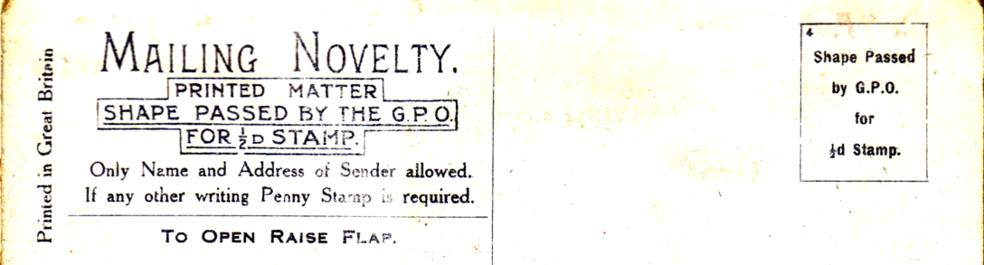

Gale & Polden back type C.

Series 12. Although these Pullouts were published by Gale & Polden it is likely that they were printed by Valentine & Sons Ltd., the layout of the back is identical to Valentine’s ‘The Great White City’ pullout cards, with the exception of the publishers name which has been altered to Gale & Polden, also the number in the stamp box is altered from ‘2’ to ‘4’. The contents are all from Valentine’s original photographs. Two different vertical strips of twelve views are known, and the same card can be found with either strip of contents. Coloured, grey back type C, ‘MAILING NOVELTY’, the next three lines of text in a lined box. Stamp box with ‘Shape passed by G.P.O. for 1/2d Stamp’ and ‘4’ in the top left corner.
Type 1. Contents vertical strip of twelve views, consisting of,
Court of Honour. / Court of Arts Bandstand. / Elite Gardens. / Court of Honour. / View from the Flip Flap. / Grand Restaurant. / The Garden Club. / Fine Art Palace. / Court of Arts. / Scenic Railway. / Congress Hall. / Wood Lane Entrance.
1059 You "Auto" come to / Anglo-American / Exposition, London.
Note.’Anglo-American Exposition, London.’ in two lines.
1159 Two / "Small Scotches" from / Anglo-American / Exposition, London. (With four lines of doggerel) Vert left.
1268 "Right away" for / views of / Anglo-American / Exposition, London. Vert left.
Note. ‘Anglo-American Exposition, London.’ in two lines, under title.

Type 2. Contents vertical strip of twelve views, consisting of,
The Garden Club. / Fine Art Palace. / Court of Arts. / Scenic Railway. / Congress Hall. / Wood Lane Entrance. / Court of Honour. / Court of Arts Bandstand. / Elite Gardens. / Court of Honour. / View from the Flip Flap. / Grand Restaurant.
1251 Held up at / Anglo-American / Exposition, London. Vert left.
1268 "Right away" / for views / of / Anglo-American / Exposition, / London. Vert left.
Note. ‘Anglo-American Exposition, London.’ in three lines.

Two other cards unfortunately have no contents, so they cannot be identified as Type 1 or 2.
1059 You "Auto" come to / Anglo-American / Exposition, / London.
Note. Anglo-American Exposition, London. in three lines
1268 "Right away" for / views of / Anglo-American / Exposition, London. Vert left.
Note. Anglo-American Exposition, London. in two lines, at the side of the title.

Green. Richard B. & Co. Ltd.
B/W advert card, black back
“Our Exhibit” in Crown Colonies Pavilion, Franco-British Exhibition, 1908. (View of their stand, full of tins of Parsley Brand Salmon.) Vert right.

Gidea Park Ltd.
Both cards are of the same view of a cottage, but one is a screened photogravure printing, and the other is a litho printing.
Type 1. B/W advert card with white border, green back with advertising matter printed in black on left side of back.
“Gidea Park Cottage”, The White City Exhibition of London.
Type 2. B/W litho without white border, black back without any advertising matter.
“Gidea Park Cottage”, The White City Exhibition of London.

Gilbey. W. & A.
Sepia advert card, black back.
Franco-British Exhibition, 1908. W & A Gilbey’s Exhibit showing their Vineyards at Château Loudenne, Medoc, France, with oxen carting grapes to the Wine Press.
Type 2. Coloured trade card, black back filled with advertising matter.
Gathering Grapes at W & A Gilbey’s Vineyards, Château Loudenne.

Globe Newspaper. The
Heavily embossed advert card known in two colours, green back.
Franco-British Exhibition, Kiosque of The Globe your Evening Newspaper.
A. Green tinted.. Vert right.
B. Grey and red tinted. Vert right.
Exhibition Hankies
by
Brenda Mathews

Readers will have noticed that some issues ago I started a ‘Letters to the Editor’ section. This has proved to be very popular, and has provided material for the Journal, Wallace the Lion and the International Horse Show correspondence to name but two. It is important that the Study Group is not written off as only being about Wembley or the White City. The collecting ramifications of both these exhibitions could swamp us, so I welcome letters or articles on other subjects. A new member Mrs Brenda Mathews has written to me, and I am publishing the bulk of her letter. I hope that those of you who have any of these, and can help her out with information, will do so. I will gladly forward any letters on to her.

Dear Bill,

When you wrote to me in February, welcoming me to the Exhibition Study Group, you mentioned that several members are into hankies and scarves.
I should be interested to learn more about these members collections and thought that if I set out the Exhibitions and Festivals of which I have souvenir hankies, this might “Start the ball rolling”.

Mine include

1908 I have several of the Franco-British Exhibition of this year. One particular one is embroidered in the corner F.B. Exhibition, with a garland of flowers, and under it is embroidered the name Lilian. It has been suggested to me that this might have been embroidered on a machine at the exhibition for a personalised gift.

1911 This large Hanky is also machine embroidered, bearing flags and the words Coronation Exhibition 1911. Interestingly, it has also with the name Lillian (but with two ll’s).

1933 This is printed as a souvenir of the Wakefield Pageant held in 1933. Enquiries of the local museum have informed me of details of this Historical Pageant of Wakefield and West Riding which was held in Clarence Park from June 17th -24th 1933.

1937 Printed “Paris Exposition International” I should be interested in information about this event.

1938 The Glasgow Empire Exhibition was commemorated on several hankies. Most of mine are printed with colourful designs showing the Nation’s flags and the Tower of the Empire building. A small cotton souvenir is embroidered with a rural scene and the words “an Clachan” Gaelic for what? (I believe ‘an clachan, means ‘a or the village’ Editor)

1951 Within my lifetime this, The Festival Of Britain, and I have a few of the event !

Several are of a satin like material, in various colours, edged with white lace and embroidered in red white and blue. One has the words “To Dear Mother” stitched under the emblem.

My favourite hanky of this festival is covered with printed scenes, including the Battle of Trafalgar, the Knighting of Sir Francis Drake and the signing of the Magna Carta.

1958 A fascinating plan of the layout of Expo 1958 held in Belgium. Around the edges are various famous Belgium buildings and sights.

1960 “Il Celostani Spartakiada Praha” I have a pink and blue handkerchief printed with flowers and these words. I should like to know what they represent.

1968 Please can someone tell me if this hanky commemorates a Festival of some sort. Stitched in black inside an oval shape are the initials I.F.B.P.W. above them is a small scene of a bridge, building and trees and the word “London”.

1988 My most recent souvenir hanky this, of the Glasgow Garden Festival, with the words and a couple of flowers embroidered in one corner.

I shall be glad to describe any of these special hankies of mine more fully if desired, or take photographs of some of them if you feel they would be of interest to accompany an article for possible inclusion in a future magazine.
Meantime, I shall carry on hunting. The Festivals and Exhibitions hankies form just a small part of my collection of Souvenir and Commemorative hankies, now numbering almost 2,000.

All good wishes,

Brenda Mathews.

As you can imagine this letter gave me much food for thought. While we have at several of our conventions seen displays of hankies, head scarves, table cloths and ties, it has never crossed my mind to wonder how you would describe them. Or rather how you would describe them sufficiently well, for another collector who has not seen yours, to be able to say, “yes, I have got that one”, or “my Franco-British Exhibition hanky is different from Brenda’s”.
A first requirement I should think is the measurements of the hanky, although this would probably have to be approximate. A description of the material, cotton or silky material, and method of manufacture, printed, or embroidered. For example “8" square cotton multicoloured printed hanky with embroidered words.........in bottom right corner” would do for a brief basic description.
An illustration would be ideal, and here my first thought was photocopying which I tried out on an old head scarf (not an exhibition one). I am fortunate in having my own copier and I found you need to experiment. The first one I tried came out black but by moving to the lightest adjustment I was able to get a good copy. I then tried a patterned tea cloth and this came out perfectly on the normal setting.
On the average copier this does restrict you to items no larger than A4 size, the ideal equipment I would say is one of the modern copiers that could copy a larger than A4 sized object and reduce the image down to say a three or four inch square picture. Photographing is the other option, this is time consuming and expensive. You can get very good results but unfortunately when you try to photocopy coloured photographs it is not always successful.
Perhaps Brenda could give this some thought, not having a collection of these myself it is difficult for me to lay down guidelines, on how she should list her collection, and the above suggestions in the end may not be practical.
We certainly have members with this material, and I hope they will get in touch with Brenda, on 01444 243774 or I shall be pleased to forward any correspondence, because this I feel is what the Exhibition Study Group is all about.

Olympic Postcards

Alan Sabey has a supply of the Society of Olympic Collectors Postcard No. 6 which is based on a 1948 water colour of the route from Greece to Wembley of the Olympic Flame. It also shows an Olympic Torch, which members may remember we displayed on our stand at Stamp 96 at Wembley. These are £1.00 each post free from Allan.

