EDITORIAL SPRING 1997

The sun shines on the rightous, it shines there all day long
It shines on rare old postmarks, which I pick up for a song

I was going to start by saying I’d had two lucky finds, and then I thought that for the amount of time I spend looking for cards, it’s not luck, I worked jolly hard for them. Without doubt I spend more time looking for cards then anyone else. certainly for exhibition cards. I did 67 fairs last year. So on the law of averages if there’s a rare card out there, I stand more chance of finding it than anyone else, except perhaps Mike Perkins. Also of course I know enough about postmarks to know a good one when I see it.
I have just in the space of about ten days found what must be about two of the rarest exhibition postmarks of the 20th century. The first came to me in a bundle of approvals and cost me £1.00 It is a card that has been cancelled twice. The first cancellation is the very difficult 1909 Imperial International Exhibition Columbia machine cancellation, this was only in use for 26 days. The time reads 12.15 AM, but there is no date, only the letter ‘N’ and the year 1909. The second cancellation is the normal double ring exhibition hand stamp also for 12.15 AM, this does have the date and year, 1 JU 09.
I should imagine the machine cancellation was wrongly assembled with an ‘N’ in place of the date. The mistake was spotted after a number of items had been cancelled on the first day the machine was used, the 1st of June, and a hand stamp was set to read the same time 12.15 AM, and the items were re-cancelled by hand.
Stitt Dibden’s book does not list this machine cancel, but when I checked on Pearson’s 1937 book it illustrates an almost identical double impression, A61, also with ‘N’ in place of the date, the time is the same 12.15, on the machine cancellation, and even the missing parts of the six lines are the same. The only difference is that the double ring hand cancel is revolved about 60° clockwise. Peachey & Swanborough 1991 does not mention the double impression.
Since the machine cancel is itself rare I should imagine the number known with the error and double impression, must be in the region of single figures. I mentioned my find to one well known collector and he offered me £275 for it.
I don’t think I have missed an opening day of Stampex since I started going in the mid sixties. Over the last few years I have gone more as a social visit as I am no longer seriously into stamps, There is usually only one postcard dealer there, Ron Mead, I meet a lot of friends and allways enjoy myself, although I don’t bother to go round all the stands. I don’t find stamp fairs as interesting as postcard fairs, they aren’t as friendly somehow. I went up this year and spent most of the opening day wandering round and didn’t look at a single dealers stock. That evening I was thinking things over, and decided if I don’t ask to look at dealers stocks, then it’s not surprising I never get anything at Stampes, once I had come to this conclusion I decided to have another go and went up next day determined to do every stand asking for exhibition material.
Thank goodness I did, the first dealer I went to produced an album for me to look through, and there were two almost identical pages. Each had a Japan-British post card at the top with the view upwards and below it a card showing the postmark, both of them were the Japan-British Columbia machine cancellation. The collector had mounted up these two identical sheets because he knew what the difference was, one was the missing time slug variety. He also did not believe in writing up his collection, so when eventually the collection passed into a dealers hands, this knowledge was lost, and the dealer priced them both at the same price not realising one was a very scarce postmark. This again is a postmark where you can count the known examples on the fingers of one hand.
Since writing this I have had two more finds, the first is a Festival of Britain card with a post mark with the wavy bars and the festival logo in the centre, but no town die. In place of this is the large round hand stamp used for registered letters, or used when the stamp has been put in a position so that it misses the cancelling machine. I have spoken to Fred Pesket and he tells me the machine broke down twice during the festival. Those I have spoken to have never seen an example.
The last and again a very scarce post mark I bought is another Japan British Columbia machine cancel with an inverted town die Peachey and Swansborough in their Special Event Postmarks of the United Kingdom 1991 records that an example is known dated 7 Sep, mine is dated Sep 5, so that’s a new one for the book. I seem to remember Don Knight displaying an example of this at a convention some years back.

The Editor

Letters to the Editor.

The picture in the Winter issue of the Journal of Wallace the Lion caused some interest and two members wrote to me regarding him.

Dear Mr Tonkin,
In the Winter 1996 issue of the ESG Journal I was interested to see the photograph on p. 56 of the African black-maned lion, Wallace.
I expect you know what my question is going to be. Could he possibly have been to Blackpool to inspire Stanley Holloway’s Albert and the Lion? I have no idea of the dates, but suspect it’s more likely he was named after the consumer of Young Albert. If you could enlighten me, I’d be most grateful.
Yours sincerely Brian Durrans.

Arthur Smith went one better,

Dear Bill,
I am particularley interested to see that card on the lion “Wallace” because Marriot Edgar who wrote the musical monologue “The Lion and Albert” performed by the late Stanley Holloway featured a lion named Wallace.
There was one great big lion called Wallace, his nose all covered with scars
He lay in a somnolent posture, with the side of his face to the bars
Now Albert had heard about lions, how they were ferocious and wild
To see Wallace lying so peaceful, well it didn’t seem right to the child
So straight way the brave little fellow, not showing a morsel of fear
Took his stick with its ‘orse ‘ead ‘andle, and pushed it in Wallace’s ear
You could see that the lion didn’t like it, for giving a kind of a roll
He pulled Albert inside the cage with ‘im, and swallowed the little lad ‘ole
The monologue dates from 1933. What I am suggesting is that Mr Edgar must have either seen the lion or had the card
Arthur goes on to say, Re. the Belgian refugee camp (The Empress Theatre was bedded out) my Grandfather was in charge on behalf of Earls Court Ltd and afterwards was awarded a medal by the Belgian Government.
I remember the first exhibition there in 1937 was ‘The Chocolate and Confectionary Exhibition’ followed in 1938 with ‘Winter Cavalcade’. At that time my younger brother had left school and got his first job at Earls Court Exhibitions as the office boy. His daughter recently gave me a picture belonging to her late father of the Ski Slope for that show which went right up to the roof inside. My brother was there for six years.
Re your editorial Gérard Léve and French Colonial races at exhibitions. Does he know that the Igorrate native village was at Earls Court in 1912? I only know of one English card, (uncommon) but as they were at the Paris “Magic City” in 1911 the unsold cards of that show were also sold at Earls Court in 1912. (These again are uncommon)
Well there you have two views, a sort of chicken or the egg situation. Was the monologue named after the lion, or the lion named after the monologue? My Wallace card is not dated, but as Wallace was at The Mammoth Fun City, Olmpia, I should think that was well before 1933, although I have about a dozen cards of this event not one of them is postally used, so I can’t date it.
Before we leave Wallace, at Bristol on Saturday I picked up another Wallace card, this is titled ‘Lion Wallace at Purchases Menagerie’, the one shown in the last issue of the Journal belonged to Sedgwicks Menagerie. This second card is not dated either. It would be nice to think that after the monologue became famous everyone that had a lion re-christened him Wallace to cash in on the free publicity, but I think Arthur is right and the cards predate the monologue probably by many years. Someone must know the date of the Mammoth Fun City at Olympia.

I have been engaged in some correspondence with one of our new members Vivien Forster, who collects the International Horse Show and the Dublin Horse Show cards, Vivien wrote to me initially asking if I knew of a listing of the International Horse Show cards. I am printing the correspondence more or less in full, as I hope it will be of interest to members and there may be some one out there who can help on the queries.

26 October, 2017
Dear Vivien,

Many thanks for your letter, I thought I was the only International Horse Show collector, now there are two of us. Many of the cards are as you say very attractive, with many poster type cards as well. Unfortunately some have a lot of white background to them and these tend to show up the marks. I have just over 100 in my collection, and if you are interested I can send you some duplicates that I have accumulated over the years.

There is no listing of these cards and if you would like to have a go we could tackle it together, as I am sure you must have some I have not got. It has been in my mind for some time to contact the organisers and see if they have any archives, or collection of programmes which would be a help in dating the cards, as although the cards often have a opening and closing date on them they nearly always leave out the year. Do you have any postally used copies for the following years ? 1919, 1920, 1921, 1923, 1925, 1927, 1929, 1930, 1932, 1933 & 1935. Or any cards for those dates which give the dates of the opening and closing. They probably did not issue any cards after 1939. There, that’s thrown you in at the deep end, hasn’t it. It’s only by collectors getting together and pooling information, that we can gradually begin to fill in all the blanks in our knowledge.

Dear Bill,

Many thanks for your letter, I was delighted to learn you also collect the International Horse Show cards. I am afraid I am a mere beginner with only 32 cards, but very willing to learn and help if I can. I have only been collecting these particular cards for the past year, and quickly realised there must be an awful lot of cards to collect. Vivien enclosed three sheets of handwritten notes on the cards she has, also some queries.

26 October, 2017
Dear Vivien,

Many thanks for your letter, you have managed to fill in one missing link, the dates for 1927. So often people say to me “I’ve only got a few cards, there won’t be anything of interest, you’ve probably got them all” and nearly always this is not so, they have a card you never expected existed. The dates as far as I have been able to work out are as follows.
1907 Jun. 7 Jun. 13
1908 Jun. 18 Jun. 27
Jun. 4 Jun. 14
!909 Jun. 5 Jun. 15
1910 Jun. 6 Jun. 16
1911 Jun. 12 Jun. 24
Jun. 14 Jun. 24
1912 Jun. 17 Jun. 29
1913 Jun. 19 July 1
There would have been a break for the war years, but I don’t know when they started again. The earliest card after the war I have is 1922. Lets say it was 1919.
1919
1920
1921
1922 Jun. 17 Jun. 24
1923 Jun. 23 Jun. 30
1924 Jun. 20 Jun. 28
1925 Jun. 22 Jun. 30
1926 Jun. 17 Jun. 26
1927 Jun. 16 Jun. 25
1928 Jun. 21 Jun. 30
1929
1930
1931 Jun. 20 Jun. 27
1932 Jun. 16 Jun. 25
1933
1934 Jun. 21 Jun. 30
1935
1936 May 30 Jun. 9
1937 Jun. 17 Jun. 26
1938 Jun. 16 Jun. 25
I have not seen any cards after this date, I would imagine they again stopped for the war years, and by the time the war was over post cards had gone out of fashion. As you can see there are lots of gaps.

Now for your queries,
1 Your Poster type coach and horses outside inn is 1922. I have two of these cards both postmarked for 1922.
2 I also have two of the Horse and four and donkey cart cards both postmarked 1911, with the dates printed Jun. 14 - 24 on the back But I also have the same card with a title added and the dates Jun. 12 - Jun. 24. I also have a vertical Poster type card which gives the year and the date 1911 Jun. 12 - 24 plus four others with the Jun. 12 date. This is a bit of a mystery
3 Your French military type descending a very steep bank is probably 1908 or even earlier. The fact that yours is post marked Feb. 20 1909 is I should have thought much too early for it to be a 1909 card, as they were not likely to be available until June of that year. I also have one of these cards with a 1909 advert for the Shire Hackney & Hunter Horse Show held in 1909 on the back. It is likely they used remaindered International Horse show cards for this advert. Top marks for spotting this is a vertical card with the horse going down a steep hill, I had not cottoned on to this one, you are right of course, the horse has started a bit of an avalanche and you can see rocks tumbling down the hill airborne in front of the horse.

I soon had a reply from Vivien, which I won’t go into in detail now as it covers items on cards on her list, which at the moment would be meaingless without publishing the list. As soon as I
can find time I will get out a list of all the cards we have in both our collections, and we can then ask for information from members to take it further. One problem is that very few of the cards have a title, which means a short description will have to be given for each card.

I have also heard from Alan Sabey our treasurer, first the good news he tells me we now have nearly 100 members 99 to be exact, the bad news is, he tells me there are still a few members who have not paid their subscriptions yet.

Allan came over for the day a few weeks ago bringing back my part of the Exhibition Study Groups display at Stampex. The Group has put on a display at about half a dozen various places and each time it has meant a great deal of inconvenience for those participating. The last do at Stampex meant we all had to get our material up to the Royal before the event and arrange to collect it afterwards. If we wanted our material insured we had to make our own arrangements. The main burden has fallen on Alan who has organised these do’s. While he was with me we discussed a idea of his that the Group should build up a collection of the choicer items of members collections. The more we talked it over the better it soounded.

This would be in the form of colour laser copies of members material together with a short write up for each item, the Group would reimburse members for the cost of the colour laser copies. These would be sent to Alan who would cut out and mount the illustrations onto album sheets and type in the write up. It should be easy to build up a superb collection of a hundred sheets or more showing really good material into an interesting display. Alan would then be in the position of being able to offer a display to any organiser at the drop of a hat, without having to worry about sucurity and the value of the material. entrusted to him. Alan was able to arrange for the Stampex material to be kept in the Royal’s strong room, as he was not prepared to take the responsibility of keeping it at home, nor would members be happy to know their material loaned for a display was not adequately safeguarded. (A full report is elsewhere).

The sheets could have a footnote at the bottom of each sheet (From the J Bloggs collection) or if the member wished for anonymity this could be left out. The sheets would all present a uniform appearence with a common heading and style. Colour laser copies are so good now that many viewers would be unaware they were not seeing the original material. It should be possible to build up enough sheets to be able to ring the changes, so the public were not seeing the same material all the time.

Would members who would like to take part in this and would like more details please phone Alan at 0181 843 9920

While on the subject of displays members may like to make a note of the following displays by members to clubs.
27 May 1997 Alan Sabey will be showing Wembley to the South Manchester Philatelic Society at Hanforth near Wilmslow.
17 September 1997 Bill Tonkin will be showing exhibition material to Twickenham Philatelic Society, Clarence Road, Teddington.
1 October 1997 Alan will be showing Wembley to the Goodmayes Philatelic Society at the Methodist Church Hall, Percy Rd, Ilford.
21 October 1997 Alan will be showing Wembley to the Leeds Philatelic Society, details not known yet.
Stamp ‘97 is on from the 24 -27 April 1997 at Hall 2 Wembley Exhibition Centre, Wembley. Stanley Gibbons will not be letting us have a free stand for Stamp ‘97 as they have for the last two years but they are making space available to us for an open meeting on Sunday 27 April from 2.00 to 4.00, so if you are planning to go to Wembley look us up. A six frame display by Alan Sabey on ‘A Thematic Look at the British Empire Exhibition’ will be in the main hall at Stamp ‘97.
1938 EMPIRE EXHIBITION REVISITED
by
Stanley Hunter.

An evening devoted to the 1938 Empire Exhibition Revisited was held on February 20, 1997 on its original site. It was organised by a local group ‘Polloshields Heritage’ and was staged in Bellahouston Park. The 1938 exhibition was held in 175 acres of the park, which lies in the South Side of Glasgow.
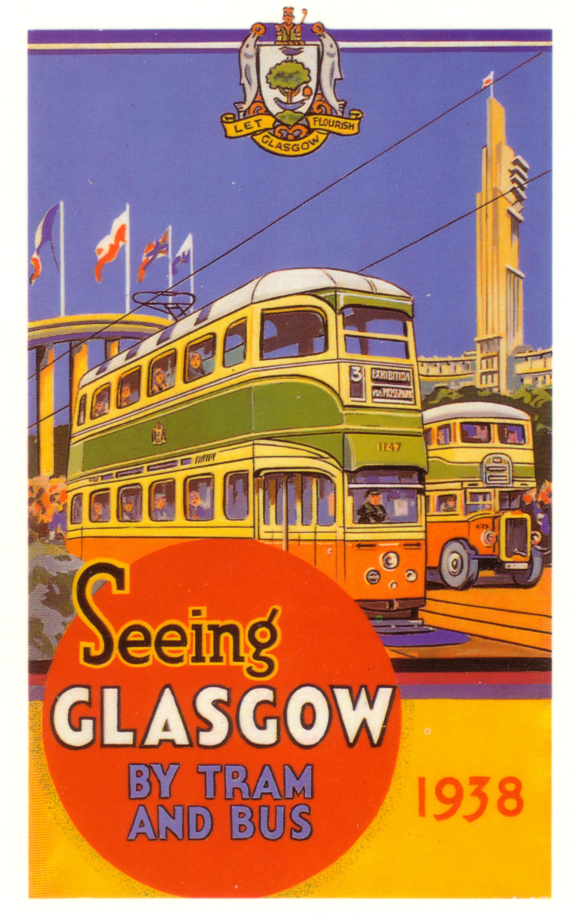
The evening programme was organised in the House for an Art Lover. This remarkable building was designed by Charles RennieMackintosh (CRM) simply for a magazine competition in 1900. It was not realised until 90 years later, as a feature of Glasgow’s reign as European City of Culture in 1990. It was completed in 1996 with funds from the European Community. CRM had
submitted plans for the 1901 Glasgow International Exhibition held in Kelvingrove Park in the city’s West End. Two frames of these (unaccepted) plans had been on show at the blockbuster CRM Exhibition staged last year in the McLellan Galleries during May to December 1996. Queues wrapped themselves round the block to pay £4 to see the exhibition. It moved to the Met. in New York to critical acclaim before moving to the Art Institute of Chicago in March 1997 and then Los Angeles County Museum until October 1997. CRM had to be content with designing a few important stands at the 1901 exhibition. Water colours of his were displayed in 1938 in the Palace of Art, the only remaining exhibition building in Bellahouston Park. One of these paintings was on show at the McLellan in 1996 and went on the USA tour. The main feature in 1997 was a talk given by broadcaster and journalist Bob Crampsey (a past Brain of Britain and former local headmaster). Bob had been to the exhibition as a young schoolboy and wrote ‘The Empire Exhibition 1938 - The Last Durbar’ which is a popular account of the exhibition, (ISBN 1 85158 122 at £12.95). His talk was illustrated by a video of a colour home movie of a trip to the exhibition, now held in the Scottish Film Archives, Glasgow.

To support him I was asked to mount a display of memorabilia and postcards and this proved popular. A number of treasured souvenirs were brought along by the audience of around 150. these varied from a beautiful doll, a hand made celtic silver crafted sporran and a little ‘Carlton Ware’
china toast rack to a Ministry of Labour Job Card for a joiner who worked at the exhibition and still lives locally. I must find out if he took part in the joiners strike at the exhibition.

I also had a supply of the new ‘Mayfair Cards of London’ postcard of ‘Glasgow 1938 Transport’ (BB789). This is based oon the cover of Glasgow Corporation’s Tram and Bus Guide for 1938. It shows a Coronation No. 3 ‘Exhibition’ Tram and a bus with Thomas S. Tait’s Tower of Empire in the background. It has already been reproduced on a smaller ‘Dalkeith’ card. A similar tram was reproduced in the British Transport set of Europa stamps issued in 1988. It was also en route to the exhibition and the actual tram shown is preserved in the Glasgow Museum of Transport at the Kelvin Hall, Kelvingrove.

Also shown in the House for an Art Lover was an extensive selection of models of Tait’s Tower, the centre piece of the exhibition. It stood over 300ft high on the drumlin which was already 170 ft above sea level. The 3,000 tons of concrete foundation still remains in the hillside, not far from the House for an Art Lover. Admission in 1997 cost £2.50 and the ticket was a facsimile of an 1938 annual season ticket, which cost 25 shillings (£1.25).

SPRING STAMPEX
by
Alan Sabey

Several members of the Group contributed to the display organised by Alan for the Thematic section of Stampex at Islington in January.
John Davies showed a fine range of material connected with the 1890 Jubilee of the Uniform Penny Postage.
Peter Denley showed a fine range of participating Empire country slogans and cachets for the 1924 British Empire Exhibition at Wembley.
Judith Edwards showed a fine range of Congress Labels from 1909 to 1940, many of which were on cover, and are difficult items to find now.
Stanley Hunter provided some sheets on the other Empire Exhibition, the one in Scotland in 1938, which contained some scarce red “Paid” postmarks.
Don Knight showed postmarks and postcards of the Franco-British Exhibition of 1908 which included errors in setting
Alan Sabey showed a three frame thematic display of what could be seen at the Wembley Exhibition by visitors in 1924 and 1925. A collection put together with the aid of guide books and other literature from the exhibition.
George Simner moved on in time with a fine display of publicity slogans, covers and postmarks for the 1951 Festival of Britain.
Bill Tonkin had a collection of Japanese postcards where a commorative postmark was applied in Japan in connection with the Japan-British Exhibition held at the White City in 1910.
Alan wishes to thank all who contributed to the display.

STOP PRESS

I have just heard from Alan Sabey and he tells me our membership is now 101. Nine members have still not paid their subscriptions yet.

We have a prospective new member Mark William Ryan 7lbs 15 ozs. I have not had an application for membership form from Deborah yet, but I’m sure it’s on its way.I understand her book on the Ideal Home Exhibition is at the printers, so double congratulations Deborah.
Those of you that attended our 1996 convention will know that we decided to hold this years convention at Portsmouth, and for those that could make the Friday to do some sight seeing in the town, making it our first three day convention. Fred Peskett has very kindly offered to handle the Portsmouth end of the Convention, and this is a report he has sent me. Fred is also getting together a package of leaflets which he will send to any members who are interested in attending our convention. We wish to know

EXHIBITION STUDY GROUP CONVENTION 1997.
by
Fred Peskett

As agreed at the Annual General Meeting at Wembley last year, this years venue will be on the South Coast at Portsmouth.
Meetings will be held in the Activities Room of the Portsmouth City Museum on the Saturday and Sunday the 27th and 28th of September. For those arriving on the Friday I can arrange some entertainment, either by visiting the D Day Museum or a tour of the local hostelries! or both.
Accommodation has been provisionally booked at the Rockingham House Hotel just around the corner from the museum, however the landlady has recently suffered a nasty accident which may mean a change of hotel. There are many reasonable hotels in the area within a short walking distance to the museum.
Refreshments at the Museum can be obtained from the on site cafe, they do a good cup of coffee and snacks including toasted sandwiches and jacket potatoes at very competitive prices. For those who require a more substantial meal, the Mary Rose public house is just three minutes away.
The Rockingham House does not provide an evening meal, but I will book one of the decent restaurants nearby.
Display boards will be available for the meetings on loan from Portsmouth Philatelic Society. Incidentally the City Records Office holds one of the finest collections of Ship Letters in the world, and will be open on the Friday afternoon.
Tours, for the Sunday afternoon I can arrange a block booking to visit Henry VIII’s Mary Rose and Exhibition and include a trip to HMS Victory, the Royal Naval Museum or HMS Warrior.

Getting to Portsmouth,
By Air.
Southampton is the nearest airport, from the airport take the train (Rail station is just two minutes walk from arrivals) to Eastleigh then change trains to Portsmouth Harbour. A No. 6 bus from the Harbour Interchange will take you to Cambridge Junction for the Hotels and Museum.

By Rail.
Book through to Portsmouth Harbour Station, then No. 6 bus to Cambridge Junction.

By Road.
From the North, to Oxford, then A34 to M3, M27 and M275 into Southsea.
From the West, M27 from Cadnam or M271 from Salisbury (off the A36) M275 into Southsea.
From the East, A27 to Hilsea then M275 into Southsea.

It should be a very nice weekend, the staff of the City Museum will make every effort to ensure things will go smoothly.
See you there
Fred Peskett.
POST CARDS OF THE WHITE CITY

Part 4.

by
Bill Tonkin

4115 Elite Gardens & Grand Restaurant, two actors in centre.
A. Top line of limerick measures 46mm. Vert right.
B. Top line of limerick measures 47mm. Vert right.
4116 Elite Gardens & Grand Restaurant, four actors in centre.
A. Top line of limerick measures 46mm. Vert right.
4117 (Two views, Swan boats in Court of Honour, & Palace of Music, four actors in centre.
A. Top line of limerick measures 43mm.
4118 (Two views, Swan boats in Court of Honour, & Palace of Women’s Work, three actors in centre.
A. Top line of limerick measures 43mm.
B. Top line of limerick measures 46mm.
4119 (Two views, Swan boats in Court of Honour, Royal Pavilion & Elite Gardens, five actors in centre.
A. Top line of limerick measures 36mm.
B. Top line of limerick measures 39mm.
4120 (Two identical views, Swan boats in Court of Honour, and Swan boats in Court of Honour, two actors in centre.
A. Top line of limerick measures 41mm, bottom line reads ‘While her heart it was filled with Delight’.
B. Top line of limerick measures 43mm, bottom line reads ‘With his “flipper” she “flapped” with Delight.
4121 (Two views, Swan boats in Court of Honour, Court of Honour, four actors in centre.
A. Top line of limerick measures 37mm.
B. Top line of limerick measures 40mm.
4122 (Two views, Swan boats in Court of Honour, & Palace of French Applied Arts, two actors in centre.
A. Top line of limerick measures 36mm.
B. Top line of limerick measures 39mm.

Series 4111. Type 2. R/Photo, black back type B.
4112 Swan boats in Court of Honour, two actors in centre.
A. Top line of limerick measures 57mm. Vert right.

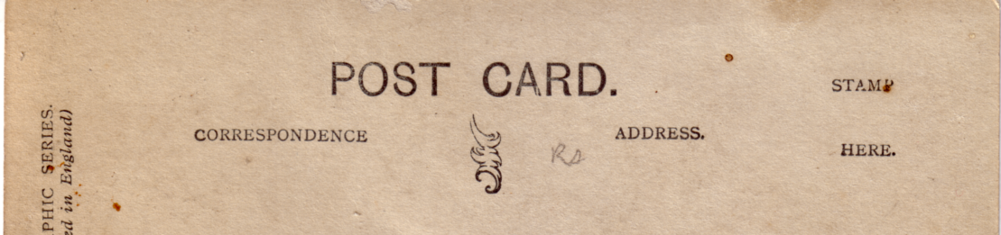

Davidson’s back type A with small bottom scroll.

Series 4144. This series consists of only a single card, a view of the Flip-Flap. It was published with three different backs, and the number on the front can be in the left or right bottom corner.
Type 1. R/Photo, black back type A.
4144 The Flip-Flap.
A. Number in left corner. Vert left.
B. Number in left corner. Vert right.
C. Number in right corner. Vert right.
D. Hand tinted, number in right corner. Vert right.
Type 2. R/Photo, black back type B.
4144 The Flip-Flap.
A. Number in left corner. Vert left.
B. Number in left corner. Vert right.
C. Number in right corner. Vert left.
D. Number in right corner. Vert right.
E. Hand tinted, number in left corner. Vert left.

Type 3. R/Photo, black back type C.
4144 The Flip-Flap.
A. Number in left corner. Vert left.

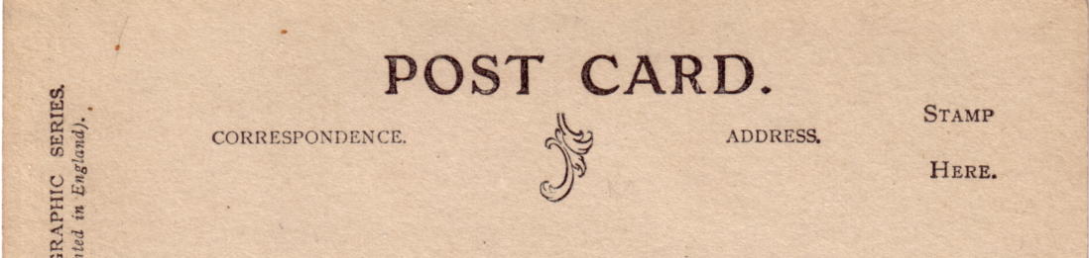

Davidson’s back type B with large bottom scroll.

Series 4210. This series consists of views of actors taken in a studio with a White City backcloth. The titles are in manuscript, and they were published with two different backs. Usually when different backs are used the whole set can be found with either back, but in this instance no card has been found with both types. Many of the vertical cards have split titles.
Type 1. R/Photo, black back type A.
4213 We had a tiring day at the White City.
4216 My word! There were some nice girls at the Exhibition.
4217 White City. Could stay here for weeks.
4218 It’s simlpy lovely at the White City.
4219 The Franco’s the place for good times.
4220 White City. / London’s full of people so I’m staying here. Vert right.
4221 We’ve had a rollicking time at the Franco.
4224 Franco-British. / This is the very place for me! Vert right.
4225 The Franco-British Exhibition. / We went to see the Fireworks and were dead beat.
Vert right.
4227 Everybody delights to Ching Ching at the Franco. Vert right.
4228 I’ve met some nice people at the White City. Vert right.
4229 We enjoyed ourselves immensely at the White City. Vert right.
4231 You mustn’t believe everything you hear about the Franco. Vert right.

Type 2. R/Photo, black back type B.
4214 Spent yesterday at the Exhibition and I’m tired out.
4215 You do here some funny stories at the Exhibition.
4222 There’s good sport on the Swan-boats.
4226 You see some funny sights on the Flip-flap.
4230 The White City is simply glorious. Vert left.
4232 I’m having a busy time at the Franco. Vert right.
4233 I’ve met an awfully jolly girl at the Franco. Vert right.
Note No. 4214 is known with a plain back.

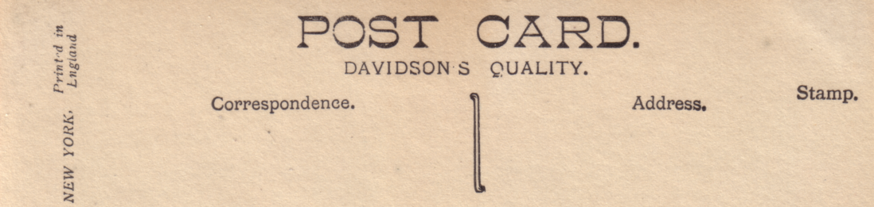

Davidson’s back type C with short outline divider.

Series 5184. This was the first of several series of seven cards in dark sepia ranging to black, each with two or three types of backs, and some views being repeated in more than one series. Most of the cards are known with, and without the letters ‘T.P.’ printed in the bottom right corner. All the titles are preceded with ‘The Franco-British Exhibition’ unless noted. In these series in addition to their sepia range Davidson’s introduced hand tinted coloured cards. There is a great deal of variety in the hand tinted cards, and while it is not possible to list them in detail, some of these differences are very collectable. It will be noticed that not all series are listed as complete, and while the missing numbers probably exist, they have not yet been seen and recorded.
Type 1. R/Photo, black back type A.
5184-1 The Court of Honour by Night.
A. With ‘T.P.’
B. Without ‘T.P.’
C. Hand tinted, with ‘T.P.’
5184-2 King & President Fallières leaving Royal Pavilion.
A. With ‘T.P.’
B. Without ‘T.P.’
5184-3 The Indian Court. (This is wrongly titled, and is actually a view of the Court of Honour.)
A. With ‘T.P.’
B. Without ‘T.P.’
5184-4 The Palace of French Applied Arts.
A. With ‘T.P.’
B. Without ‘T.P.’
C. Hand tinted, with ‘T.P.’
5184-5 The Elite Gardens and Grand Restaurant.
A. With ‘T.P.’
B. Without ‘T.P.’
C. Hand tinted, with ‘T.P.’
5184-6 The Railway Exhibition
A. With ‘T.P.’
B. Without ‘T.P.’
C. Hand tinted, with ‘T.P.’
5184-7 The Scenic Railway. (The title comes before ‘The Franco-British Exhibition’)
A. With ‘T.P.’
B. Without ‘T.P.’
C. Hand tinted, with ‘T.P.’
Type 2. R/Photo, black back type B. No cards have been seen without ‘T.P.’
5184-1 The Court of Honour by Night.
A. With ‘T.P.’
5184-2 King & President Fallières leaving Royal Pavilion.
A. With ‘T.P.’
C. Hand tinted, with ‘T.P.’
5184-3 The Indian Court. (This is wrongly titled, and is actually a view of the Court of Honour.)
A. With ‘T.P.’
5184-5 The Elite Gardens and Grand Restaurant.
A. With ‘T.P.’
5184-6 The Railway Exhibition
A. With ‘T.P.’
5184-7 The Scenic Railway. (The title comes before ‘The Franco-British Exhibition’)
A. With ‘T.P.’

Type 3. R/Photo, black back type C. No cards have been seen without ‘T.P.’
5184-1 The Court of Honour by Night.
A. With ‘T.P.’
5184-2 King & President Fallières leaving Royal Pavilion.
A. With ‘T.P.’
5184-3 The Indian Court. (This is wrongly titled, and is actually a view of the Court of Honour.)
A. With ‘T.P.’
5184-4 The Palace of French Applied Arts.
A. With ‘T.P.’
5184-7 The Scenic Railway. (The title comes before ‘The Franco-British Exhibition’)
A. With ‘T.P.’

Series 5185.
Type 1. R/Photo, black back type A.
5185-1 The Indian Court by Night. (This is wrongly titled, and is actually a view of the Court of Honour by night.)
A. With ‘T.P.’
B. Without ‘T.P.’
C. Hand tinted, with ‘T.P.’
5185-2 The Stadium.
A. With ‘T.P.’
B. Without ‘T.P.’
C. Hand tinted, with ‘T.P.’
5185-3 The Palace of Music.
A. With ‘T.P.’
B. Without ‘T.P.’
C. Hand tinted, with ‘T.P.’
5185-4 The Indian Palace. (Original negative. This has the number in the right corner and three long ladders leaning against the building, and another at the side.)
B. Without ‘T.P.’
5185-4 The Indian Palace. (Altered negative. In this the four ladders have been erased and the number moved to the left corner.)
A. With ‘T.P.’
B. Without ‘T.P.’
C. Hand tinted, with ‘T.P.’
5185-5 Swan Boats on Lake in Court of Honour.
A. With ‘T.P.’
B. Without ‘T.P.’
C. Hand tinted, with ‘T.P.’
5185-6 A View in the Elite Gardens.
A. With ‘T.P.’
B. Without ‘T.P.’
C. Hand tinted, with ‘T.P.’
5185-7 The Wood Lane Entrance. (The title comes before ‘The Franco-British Exhibition’ and the number is in the right corner.)
A. With ‘T.P.’
B. Without ‘T.P.’
C. Hand tinted, with ‘T.P.’

Type 2. R/Photo, black back type B. Only one card has been seen and this is with ‘T.P.’
5185-5 Swan Boats on Lake in Court of Honour.
A. With ‘T.P.’

Type 3. R/Photo, black back type C.
5185-1 The Indian Court by Night. (This is wrongly titled, and is actually a view of the Court of Honour by night.)
A. With ‘T.P.’
5185-2 The Stadium.
A. With ‘T.P.’
5185-4 The Indian Palace. (Altered negative. In this the four ladders have been erased and the number moved to the left corner.)
A. With ‘T.P.’

Series 5187 There are no hand tinted cards in this series in types 1 and 3, but there are in type 2.
Type 1. R/Photo, black back type A.
5187-1 The Royal Pavilion in Elite Gardens. (The title comes before ‘The Franco-British Exhibition’.)
A. With ‘T.P.’
B. Without ‘T.P.’
C. Hand tinted, with ‘T.P.’
5187-2 The Senegalese Village. (The title comes before ‘The Franco-British Exhibition’.)
A. With ‘T.P.’
B. Without ‘T.P.’
C. Hand tinted, with ‘T.P.’
5187-3 The Uxbridge Road Entrance. (The title comes before ‘The Franco-British Exhibition’.)
A. With ‘T.P.’ Vert right.
B. Without ‘T.P.’ Vert right.
C. Hand tinted, with ‘T.P.’ Vert right.
5187-4 The Palace of Women’s Work. (The title comes before ‘The Franco-British Exhibition’.)
A. With ‘T.P.’
B. Without ‘T.P.’
5187-5 The Stadium.
A. With ‘T.P.’
B. Without ‘T.P.’
C. Hand tinted, with ‘T.P.’
5187-6 The Elite Gardens. (The title comes before ‘The Franco-British Exhibition’.)
A. With ‘T.P.’
B. Without ‘T.P.’
C. Hand tinted, with ‘T.P.’
5187-7 The Court of Honour by Night.
A. With ‘T.P.’
B. Without ‘T.P.’
C. Hand tinted, with ‘T.P.’

Type 2. R/Photo, black back type B.
5187-1 The Royal Pavilion in Elite Gardens. (The title comes before ‘The Franco-British Exhibition’.)
A. With ‘T.P.’
C. Hand tinted, with ‘T.P.’
5187-4 The Palace of Women’s Work. (The title comes before ‘The Franco-British Exhibition’.)
A. With ‘T.P.’
C. Hand tinted, with ‘T.P.’
5187-5 The Stadium.
A. With ‘T.P.’
5187-7 The Court of Honour by Night.
A. With ‘T.P.’

Type 3. R/Photo, black back type C.
5187-1 The Royal Pavilion in Elite Gardens. (The title comes before ‘The Franco-British Exhibition’.)
A. With ‘T.P.’
5187-2 The Senegalese Village. (The title comes before ‘The Franco-British Exhibition’.)
A. With ‘T.P.’
5187-4 The Palace of Women’s Work. (The title comes before ‘The Franco-British Exhibition’.)
A. With ‘T.P.’
5187-6 The Elite Gardens. (The title comes before ‘The Franco-British Exhibition’.)
A. With ‘T.P.’
5187-7 The Court of Honour by Night.
A. With ‘T.P.’

Series 5205. It is possible that Davidson’s reduced this series to six cards, as no number 7 has been recorded.
Type 1. R/Photo, black back type A.
5205-1 On the Scenic Railway.
B. Without ‘T.P.’
5205-2 The Cascade.
B. Without ‘T.P.’ Vert right.
5205-3 Mc Kinley’s Cottage, Irish Village.
B. Without ‘T.P.’
5205-4 The Famous Band-stand in Elite Gardens.
B. Without ‘T.P.’
5205-5 View from the Flip-Flap.
B. Without ‘T.P.’
5205-6 Rickshaws in the Grounds.
B. Without ‘T.P.’
Type 2. R/Photo, black back type B.
5205-2 The Cascade.
B. Without ‘T.P.’ Vert left.
B. Without ‘T.P.’ Vert right.
5205-4 The Famous Band-stand in Elite Gardens.
B. Without ‘T.P.’
5205-5 View from the Flip-Flap.
B. Without ‘T.P.’
5205-6 Rickshaws in the Grounds.
B. Without ‘T.P.’

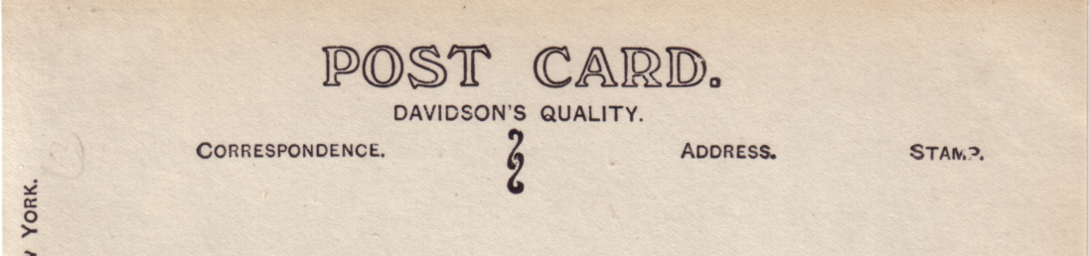

Davidson’s back type D.

Un-numbered series for the Japan-British Exhibition. This series consists of views of actors taken in a studio with a Japanese cum garden type backcloth. The titles are in manuscript, and they were published with only one type of back.
Type 1. R/Photo, black back type D.
I did have a good time at The Anglo-Jap!
I had tea with the girls at The Anglo-Jap!
I was caught napping at the Exhibition!
I was dead tired at the Exhibition and went to sleep! Vert right.
I was so tired after doing the rounds at the Exhibition! Vert right.
I was so tired out at The Exhibition but so happy! Vert right.
I’m expecting to bring off an Anglo-Japanese treaty!
I’m having a busy time at The Exhibition! Vert right.
I’m not able to write much, am so busy at The Anglo-Jap! Vert rght.
It’s simply lovely at the Anglo-Jap! Vert right.
I’ve met my fate at the Anglo-Jap Exhibition! Vert right.
I’ve sealed an Anglo-Japanese Treaty! Vert right.
One little girl asked me if I’d go to Japan, I said - “wait and see!” Vert right.
Since going to the Exhibition I’ve adopted Eastern ideas!
Tea in the Anglo-Jap Gardens is very fine!
The Anglo-Jap is a proper place for fun! Vert right.
The Anglo-Jap is the place for me! Vert right.
The dear little Japs surrounded me at The Exhibition! Vert right.
The Japanese girls at the Exhibition are simply charming! Vert right.
We have fallen in love with the girls at The Anglo-Jap! Vert left.
We met some nice girls at the Anglo-Jap! Vert right.

Type 2. R/Photo, brown back type D.
I was so tired after doing the rounds at the Exhibition! Vert right.
J. H. Dawe.
A printed advert for J. H. Dawe, 61-62, Camden Street, North Shields, upholsterer and cabinet maker can be found on the backs of Franco-British Exhibition cards remaindered after the exhibition closed.

Debenham & Freebody.
Coloured advert card, black back.
Franco-British Exhibition, 1908. Debenham & Freebody’s new premises, Wigmore Street, London, W. From a painting by Mortimer Mempes.

École Delfau.
Carpet Manufacturer, 84, Boulevard Valée, Algeria. This is a French card probably sold in the Algerian Pavilion at the Franco-British Exhibition. For other cards of this series see under M. Soupireau. B/W litho, black back on green card.
Manufacture de Tapis Algériens (École Delfau) 84, Boulevard Valée, Alger.

Department of Communications, Japan.
The Japanese Department of Communications (Post Office) originally intended to give out two cards to guests at the Opening Ceremony at the Japan-British Exhibition. It was however decided to increase this to three, and also make them available in Japan. A special hand stamp was in use at some 1st and 2nd rate post offices in Tokyo, and at two offices outside Tokyo for ten days only. The cards have no titles.
Coloured advert cards, green back with ‘Issued by the Department of Communications, Japan.
A. This card was produced from hand made Torinoko paper inlaid with two fan shaped cutouts showing Mount Fuji and a pekinese dog, by Hokusai.
B. Symbols of art and industry on a yellow background, with a small view of the Court of Honour from Valentine’s card No. 485. Part of the embossed design reads ‘In commemoration of Japan-British Exhibition, London, 1910.’
C. Multi coloured woodblock design featuring a horse and mail carriers. This card was put out to four different printers, The Toppan Printing Co. Ltd., Tokio Diakokuya, Tokio Hongo Benrido, and Tetzunosuke Tamura.

“Digestin”
See under Yenjo Shoten Ltd. Tokyo, Japan.

East London Printing Co.
These cards can be identified by the very ornate surround to POST CARD and the initials E L P Co in the centre. The fronts have a yellowish appearence and may be varnish coated.
Sepia photogravure sunk plate with the views in either oblongs or ovals of various shapes. all the titles end in ‘Imperial International Exhibition.’
A Pretty “View of the Lagoon”. Oblong Vert left.
A View in the Court of Honour. Oval.
Main Entrance (Uxbridge Road). Oblong Vert left.
Palace of Modern Arts. Oblong.
Palace of Women’s Work and the Court of Arts. Oval.
“The Court of Arts” (North View) Oval Vert left.
The Court of Honour. Oblong.
“The Fine Arts Palace”. Oval.
The Flip Flap. Oblong.
“The Scenic Railway”. Oblong.

