EDITORIAL WINTER 1996

Cheltenham York or any old where
You’re sure to see Bill at the post card fair

Those of you who even read the front cover, will have noticed the little gem of prose on the 1908 Christmas card, “Christmas Greetings kind and true, I send this day with love to you”, I couldn’t have done better myself. I’m sure you must all take great comfort in the knowledge that there’s one good poet still alive and kicking. I’m not talking about the 1908 chap, I should think he’s well and truly dead by now.
Getting back to the front cover you will notice another giant stride forward into the world of computer technology has been made. The last one was if you remember was when I found out how to get a neat border round the contents on the cover, until then I inked it in with a felt pen. Mike Perkins on his last stay with me showed me how to use my scanner, and I am now able to scan pictures directly into the Journal with some success as you can see. Before this I used to make a photo-copy of the illustration, paste it into the journal, and cover it with a piece of Letraset transparent screening sheet, which was a very time consuming and expensive process.
Our Convention went off very smoothly and a good time was had by all. Unfortunately at the last moment Karl had to drop out owing to a sudden illness in his family, which was very worrying , but fortunately not as serious as it first appeared. Another member who was down to give a display, also had to drop out at the last minute. I do prepare for these last minute upsets and bring a spare display with me in case it’s needed.
This Convention could almost have been called an international event, we had Burton Benedict over from the USA who gave us a talk and slide show, and we should have had a recently joined French member Gérard Léve, but he phoned me and said he would have to drop out as his mother died just four days before the convention. We did have another unexpected foreign member turn up, Harold Vegis from Belgium, who made a flying visit and seemed very happy with some of the cards he bought at the Convention. Since our meeting Burton has spent three days going through my collection (and still not finished). He tells me he will definitely be coming over for next years convention. So we must be doing something right.
Gérard is doing research into French Colonial races who appeared over here in exhibitions, the Dahomey and Somali people. He has sent me photo-copies of all his cards on the subject, and I am checking through my collection for items he has not got, which will take me some time.
Another new member Jonathan King who is an assistant Keeper at the British Museum, has also visited me and wants to use some of my cards to illustrate a publication he is working on for the museum, this will again be on ethnic tribes who were brought over here to appear at exhibitions. And finally another member Deborah Ryan has now got a publisher to produce her book on the Ideal Home Exhibition, she has fixed a date for them both to come and look at my Ideal Home cards, as she wants to use some for illustrations in the book.
I think this is all very encouraging, and shows that post card collections can sometimes be the only source for pictures of bygone events, this is something we have always known, and its nice that it’s now being recognised as a serious source to be explored by a much wider circle of academics.
There is no doubt that there is a great deal of interest in the displaying of ethnic groups at exhibitions, and those who attend our conventions will remember Jeff Green giving a talk on this subject at our 1995 convention. Some of these tribal groups were brought over here almost as slaves, put on show, and when the exhibition closed, the manager would abscond with the money, leaving the natives destitute and stranded, unable to speak the language and with no one to turn to for help, an appalling fate. Burton Benedict’s talk and slide show this year was also on this subject, and I am sure we are going to hear a lot more of this in the future.

The Editor.
Earls Court and Olympia
a History

Earls Court Olympia has been, and continues to be, a spectacular venue for some of the greatest shows on earth. From the thrills of the circus, the Royal Tournament and the rock concerts, to the technological marvels of the trade fairs, they have continued to entertain, educate and oil the wheels of industry for over a century.
But even before they played host to so many illustrious events, Earls Court and Olympia were receiving rave reviews. Their earliest incarnation, in the form of Olympia’s daring and magnificent Grand Hall, attracted the admiration of architects and engineers the world over. And many architectural additions to Earls Court Olympia ever since then have ensured that this fruitful relationship between the medium and the message has remained firmly in place.
The idea behind the Grand Hall, originally called the Great Hall and where the whole complex began, was conceived by a General Burnaby. Along with other senior army officers, he wanted to build a bigger venue than the existing Agricultural Hall in Islington in which to house the Royal Military Tournament. His aim was to create a place “where mimic warfare might be carried on with greater and more realistic effects than was possible in any existing hall.”
This new venue was financed by the National Agricultural Hall Company Ltd., and designed by architect Henry E. Coe. Set in five and a half acres of gardens and completed in 1886, the building was given the uninspired name of the New Agricultural Hall. The Building unofficially but quickly became known as Olympia, foretelling its colourful and eclectic future. Although the Grand Hall cost £140,000 to build (Equivalent to more than £5 million today), and contained 7,000 seats, it was the roof which really took the breath away. Built of glass, zinc and iron, the massive glazed barrel vault reached over 100 feet at its highest point and covered an area of more than three and a half acres. It also featured ball bearings mounted inside its fluted columns, enabling the whole structure to survive extremely strong winds.
Olympia opened its doors to the public on Boxing Day 1886 with the Paris Hippodrome Circus. The drama and spectacle of the show, giving the royal seal of approval with the attendance - albeit for a very private viewing - of Queen Victoria herself, with a range of young princes and princesses, ensured that Olympia would make history right from its birth. The Paris Hippodrome’s marvels included an array of 400 animals and a simulated stag hunt. The circus quickly became a Christmas tradition at Olympia, and two years later Phineas T. Barnum’s ‘Greatest Show On Earth’ took up residence. Running for three consecutive seasons, it caused an immediate sensation with exotic acts such as the vertically-challenged General Tom Thumb.
It was, however, another circus company which was to stamp Olympia in the public imagination as the home of the circus. Bertram W. Mills brought his ‘International Circus and Christmas Fair’ to Olympia in 1919 and returned every year, excepting the period 1940-45, until 1967. While the circus was regarded as a national institution, the funfair offered the kind of roller-coaster thrills and other mechanised mayhem that could not be matched by contemporaries.
But Olympia’s ability to conjure up riveting fantasy worlds goes right back to its earliest days. In 1891 the building underwent a magical transformation to become an uncanny vision of Venice, thanks to a specially-constructed canal flowing out of the Grand Hall and into the five acres of gardens surrounding it. The organisers, Imre Kiralfy and his brother Bolossy, imported 100 gondolas and gondoliers directly from the famous city to transport visitors. They also arranged a full supporting cast of exhibits, restaurants, a fine art gallery and demonstrations of the manufacture of delicate Venetian glass. The show remained in place for over a year.
Two years later, in 1893, the Venetian canals were transformed into the Bosphorus as the brothers produced another extravaganza, entitled ‘Constantinople or the Revels of the East’. Another massive success, this in turn was followed by ‘The Orient’ in 1894. The following year saw the first ever show created by Olympia’s own management - ‘The Siege of Chitral’.
By now Olympia had become firmly established, with a number of other events quickly transferring them from the original Agricultural “Aggie” Hall to the young upstart, in order to increase their potential audience. Among them were the International Horse Show, first held at Olympia in 1887, the Royal Tournament, which remained at Olympia until 1949 when it transferred to Earls Court, and numerous sporting events such as boxing and wrestling matches.
This whirl of activity, marking Olympia out as the undisputed centre of entertainment, prompted some dramatic additions to the Olympia offering. One of the most striking was the huge, maple-floor rink, constructed at the then formidable cost of £6,000 and opened in 1890, right on cue to satisfy the new craze for roller skating. It was a new-found love affair with speed, heralding the arrival of the “horseless carriage” whose prescience at the venue would soon do so much to accelerate Olympia’s international reputation.

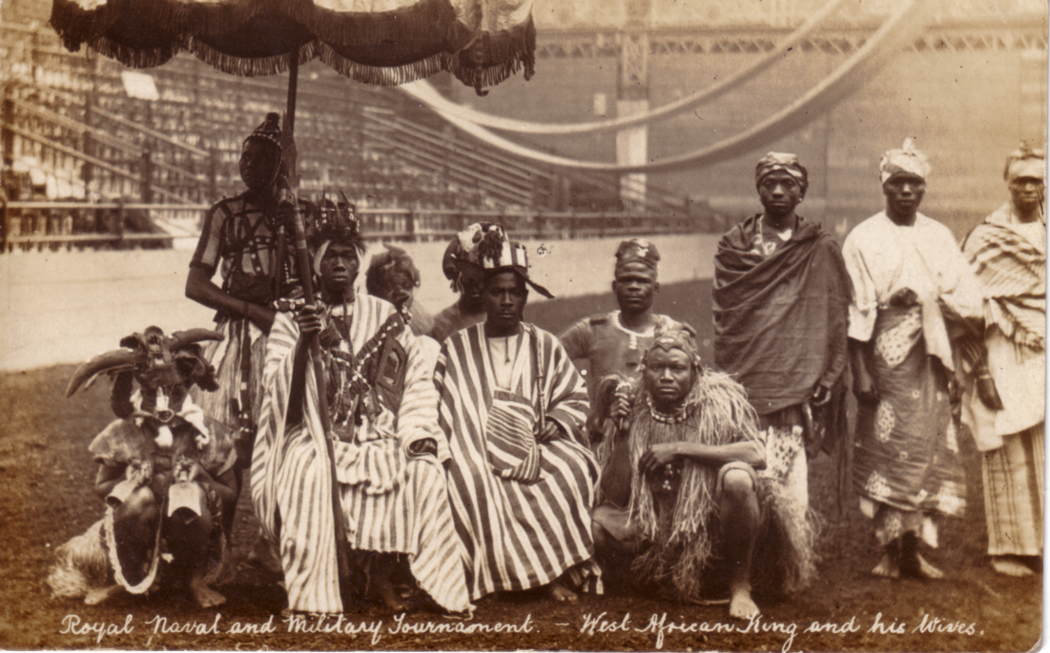

West African Regiment in the Royal Tournament
at Olympia in 1908.

But even in the years immediately preceding the arrival of this revolutionary exhibit, Olympia’s shows were manifesting a professionalism, ambition and scale of which a decade or two earlier could only have been dreamed. If Olympia could be said to have enjoyed an annus mirabilis then it was arguably in 1902 with the staging of ‘The Wild West Show’, featuring the legendary Buffalo Bill (Colonel William Cody). This box-office bonanza brought the first year of the Edwardian era to a confident close and helped dispel some of the uncertainty following the death of Queen Victoria and the end of the Boer War.
Visitors were treated to the spectacle of real, live Sioux Indians and demonstrations of crack rifle-shooting as Buffalo Bill aimed at glass balls thrown at him while galloping round the arena. The huge popularity of this Wild West recreation seemed to signal the dawning of a new Westward-looking century bringing the winds of entrepreneurial change.
This is not to say that there weren’t those who remained resolutely unimpressed at the sight of native peoples being turned into a freak show. This had already been the case a decade before when the construction of a Zulu village at Olympia brought protests at their “inhuman” treatment at the hands of the British in Africa. It is interesting to note, however, that the treatment of the Sioux Indians was inhuman enough to prevent several of them staying on in Britain after the show, and there is at least one known descendant of these exotic characters living today in the wilds of Cornwall!
A far cry from the Wild West , but of no less importance to Olympia’s early development, were trade exhibitions. They have since become the life blood of Olympia, but in 1886 when it was being built they were still a relatively new phenomenon. The prevailing thinking was that they would inevitably destroy home trade and jobs by opening the floodgates to foreign competitors. This paranoia was such that when the Grand Hall opened it had to be stated categorically that “vast national benefits have sprung from exhibitions, in all technical respects, in the improvement of industry, in the expansion of art.” It soon became clear however that increased rather than decreased trade followed hard on the heels of an Olympia exhibition.
In many ways, the early trade exhibitions were as much a spectacle for the general public as were the more overtly showbizzy events. For example, during the 1905 Motor Show - still then very much a novelty rather than a necessity - an orchestra played a specially-composed piece called “La Belle Chauffeuse” and trial runs were offered along the Hammersmith Road to whet the appetite of a generation of potential drivers. The show’s success was so encouraging that the Society of Motor Manufacturers and Traders repeated the show the following year and generated some 200,00 visitors.
Other less glamorous but no less important trade shows of the time, such as the Electrical Trades Exhibition and the Engineering and Machinery Exhibition , helped industry in general take Olympia to its heart, and the number of similar shows snowballed in the years up to the First World War. One of the most enduring was the Building Trades Exhibition which having opened at Olympia in 1907, became a biannual event for the next 70 years.

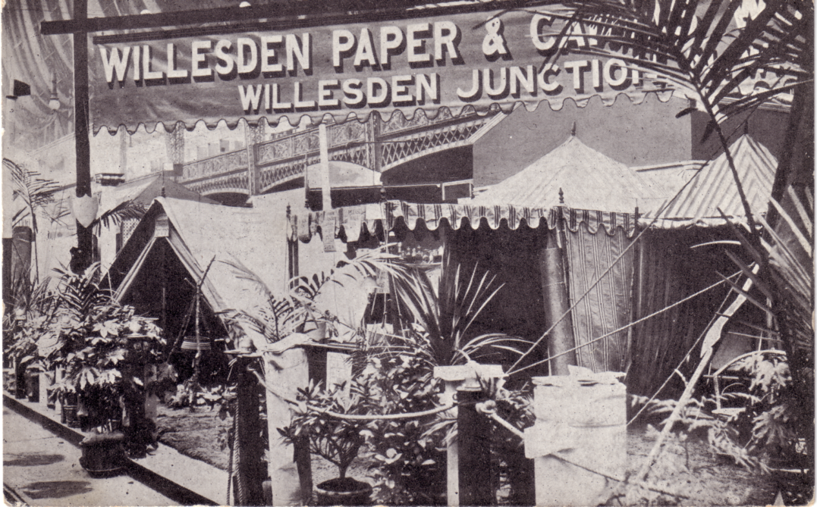

Willesden Paper & Canvas Works Ltd.
Stand at the first Ideal Home Exhibition, Olympia, 1908.

But there was one show which, perhaps more than any other, came to be associated with Olympia over the years. First staged in 1908, the Ideal Home Exhibition featured a magnificent centrepiece which could take up to five months to construct. Particularly memorable ones included a life-sized copy of the White House and the sixteenth century French Palace of Fontainbleu.
The outbreak of the first World War created a very different function for Olympia. Towards the end of 1914, the building was used as an internment camp for German civil prisoners. Then from 1915 until the end of the war in 1918 it was taken over by the War Office and served as the Royal Army Clothing Depot. But the war’s end brought a typical dynamic revival of the old Olympian style, with a “Victory Circus” presented by Mr. Bertram Mills.
Although life at Olympia returned very much to normal in the interwar period, there was the odd omen of more troubled times ahead. The British Union of Fascists, led by Oswald Mosely, staged a rally at Olympia in 1934 - albeit one which was subject to constant interruptions by vocal protesters.
World War 2 caused the curtailment of one of the most popular public ‘trade’ exhibitions of the interwar years, ‘Radiolympia’. Originally known as the National Radio and Wireless Exhibition, this new media extravaganza had come to be so much at home within Olympia since its debut in 1926, that the new title was brought in 10 years later. This great affection for the venue is understandable when one considers the following facts, in the Royal Albert Hall, the year before Radiolympia moved house, the show attracted 54,500 visitors. The following year at Olympia the number was more than twice that at 116,570! And by 1937, the attendance figures had more than doubled again.
Other shows to be cancelled because of the outbreak of war included the Business Efficiency Exhibition, the Engineering, Marine and Welding Exhibition, and no doubt to howls of despair, the 1939 Kennel Club Show. The decision proved a wise one, though, as during the course of the war six bomb incidents slightly damaged the property - although Olympia was spared the worst of the blitz. In place of events and exhibits, Olympia became home to the Royal Army Service Corps., who used it as a mechanical vehicle depot. Later it once again became as army clothing depot. It also served as a centre for troops from the occupied countries , including General de Gaulle’s Free French. At the end of the war Olympia became a demobilisation centre.

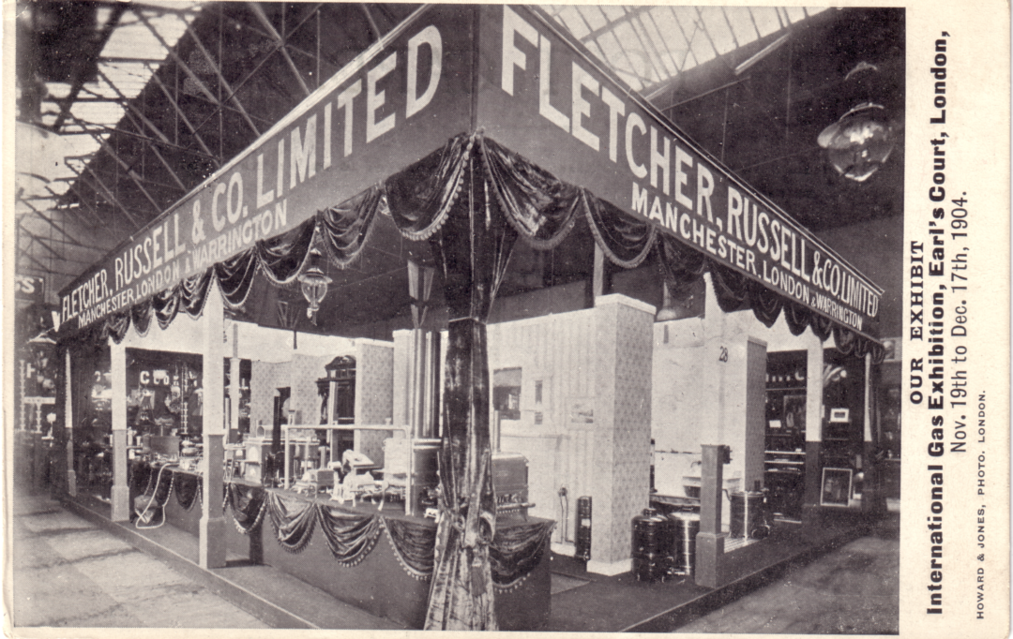

Fletcher Russell & Co. Ltd.
Exhibitit at the International Gas Exhibition, Earl’s Court, 1904.

Thankfully, Olympia’s military connections proved rather more glorious in peacetime than in war. Originally inspired by General Burnaby’s vision of a more illustrious Royal Tournament, Olympia has played host to this demonstration of military might throughout much of its long life - beginning in 1906 and lasting 40 years before it was transferred to Earls Court. The Royal Tournament’s early displays involved horsemanship, driving, drill and weapon-fighting as well as the presence of one or more detachments from foreign armies. Spectacular teamwork followed and was instantly successful, particularly in the form of the back-breaking Field Gun Competition.
The re-enactment of famous battles from history proved a big hit, as did the displays by Indian, Australian and Colonial troops introduced at the height of the British Empire. Thus the event metamorphosed from its rather parochial origins (one of the earlier events included horseback wrestling) into a comprehensive gathering of the Empire’s military prowess, and a Mecca for the imperial forces. The Navy became involved in the Royal Tournament’s first decade, while the Royal Air Force joined immediately after the First World War.
With enduringly popular shows such as the Royal Tournament on their hands, it was inevitable that the question of expansion was never far from the minds of Olympia’s management. The first extension came in the form of a small annexe to the Grand Hall ten years after it was built. In 1923 came the opening of the New Hall (later to be called, and still known as, The National Hall). This was closely followed in 1929 with construction of the Empire Hall. Designed by Joseph Emberton, it was promoted by the Department of Overseas Trade’s decision that its British Industries Fair, previously held in White City, required an extra 500,000 square feet of floor space, roughly equivalent to the two halls already at Olympia. The result, due to the lack of available site at Olympia, was a modern ,four-storey building, designed very much like a department store (Emberton was also responsible for Simpsons, Piccadilly).
Compared to its brothers, the Grand and National Halls, the Empire seemed dark, and exhibitors complained about the low ceilings. So it was given an entirely new glass roof, completed in time for Olympia’s golden jubilee in 1937. This building, refurbished and enlarged in 1984, is now known as Olympia 2 (the Grand and National Halls are known as Olympia 1). It caters specifically to the needs of small and medium-sized exhibitions. Offering hotel-standard levels of comfort and substantial conference facilities (The Olympian Conference Centre was added in 1987), it was an immediate success - of the 26 exhibitions that Olympia 2 hosted in its first year, 21 were transfers from other venues. In 1990 it was expanded even further by 17624 square feet. It is so flexible as a venue that three separate exhibitions can take place simultaneously - and the whole building can also be used with Olympia Grand and National Halls.

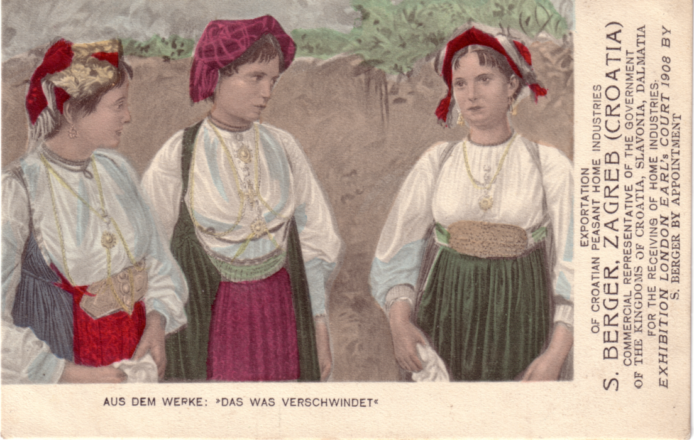

Croatian Peasant Home Industries Exhibition
Earl’s Court 1908

The hunger for more and more exhibition space was fuelled by relentlessly record-breaking attendance levels for events which stand as a testament to Olympia’s extraordinary diversity and success. This is a venue which has really seen it all: the record-breaking triumph of Britain’s biggest ever banquet catering for some 7,000 guests in 1921; and in 1949 when an ice show clown planted a smacking greasepaint kiss on the bald head of a mild-mannered chap in the front row of the audience - who turned out to be the Prime Minister Clement Atlee.
Over the years the wares on display in its halls have included food, furniture, machine tools, tobacco, radio, fashion, printing equipment, cosmetics, confectionery, motorcycles, cars, computers, boats, airships and caravans.
Also worth mentioning are the sporting occasions that have made history under the famous Olympia roof: the sensational 1904 wrestling bout between the ‘Russian Lion’ and the ‘Terrible Turk’, notable for its brevity after an injury to the Terrible Turk’s arm just 45 seconds into the match, or the boxing matches once compered by a priest in full clerical dress to give an aura of respectability to the proceedings; or closer to the present day, knock-out punches from Henry Cooper and Chris Eubank, Prince Charles in the annual International Showjumping of 1979; and the much-loved Crufts Dog Show, which had its home in Olympia from 1939 for 30 years.
There are, in effect, two Earls Courts. The original ran almost in tandem with the early Olympia, from the late 1880’s to the early 1900’s. But although extravagant shows were staged on the site which was formed by a rather forbidding intersection of some of London’s main railway stations, they were a world away from the reinforced concrete structure that we know today. This capacious building dates back to 1936, and is divided from the first Earls Court incarnation by a period of about 20 years, during which the site remained in a sort of limbo.
The name Earls Court refers to the Earl of Zetland, who owned the freehold to the land. It was he who laid the foundation stone for Olympia’s Grand Hall in 1885. In 1870 the Earls Court area was as awkward triangle of railway tracks, sidings and depots, all of which rendered it hopeless for residential development (the westward trend in London house building still stopped short of Earls Court at the time). Before the encroachment of the railway the area had been fertile gardening land, although this had been impaired by the building of the Kensington Canal in 1826.

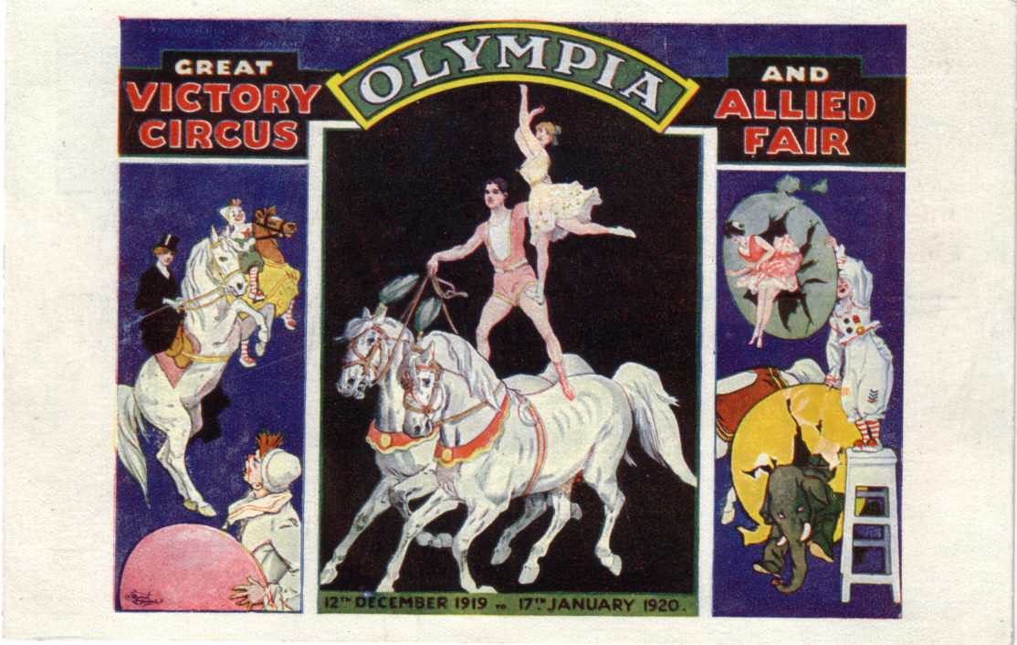

Grand Victory Circus, 12 December 1919 to 17 January 1920
F. A. Wilkins Managing Director London Great Roller Rink & Fun City 1908 to 1912
Admission 1/3

The idea to use the site for exhibitions came from a man named John Robinson Whitley. A well-travelled businessman with a background in engineering , he held the view that “one of the highest forms of human effort is to extend the knowledge and usefulness of arts, industries and commerce”. He planned to stage an American Exhibition in London. But while visiting Washington in 1886 to enlist support for the idea, Whitley found himself entranced by the spectacle of Colonel William Cody’s “Buffalo Bill” Roughriders and Redskin Show” and promptly booked them for Earls Court the following year. This chance meeting led to Earls Court’s first unqualified success and even before its neighbour Olympia staged Buffalo Bill a few years later, established the cult of the Wild West in Britain.
Whitley’s open arena with covered stand, sited in roughly the same spot as the present exhibition building, could seat 25,000 spectators. He also built an exhibition site, a long, single storey building, 1140 by 120 feet, with annexes for refreshments and the fine arts. Both buildings were put up in just four months in 1887 by two gangs of a thousand men each, working alternate shifts by day and night. Despite some hostile reviews by snobbish critics, Earls Court survived its first five-month season in fine style, with Buffalo Bill pulling in up to 15,000 visitors a day. On one occasion, the whole of Harrow School attended - so much for snobbery!
Buffalo Bill was a hard act to follow, but Whitley did his best. 1888, 1890 and 1891 saw the Italian, French and German Exhibitions and a Wild East show, presented by a troupe of French Africans. They were popular, but not popular enough to prevent Whitley retiring in 1891 with a loss. His withdrawal from Earls Court was followed by two years of uncertainty although 1893 did witness the transformation of the Earls Court arena into a shallow lake for the staging of Captain Paul Boyton’s Water Show, featuring Britain’s first water toboggan.
Later that year a new figure with ambitions equal to Whitley entered the scene. Imre Kiralfy, who had already taken Olympia by storm, negotiated a 21-year lease on the Earls Court site. In 1895 he opened for business with the ‘Empire of India Exhibition’, followed a few months later by the Great Wheel and the Empress Theatre, a 5,000-seater venue.
The Great Wheel, based on the celebrated Ferris Wheel that had been the most arresting feature of the Chicago Exhibition of 1893, could carry 1600 visitors 300 feet up into the air, affording one of the best views over London. A complete revolution took eight minutes. Although impressive, this 1100 ton structure did occasionally break down, stranding patrons far above the ground for four and a half hours (they were compensated handsomely afterwards!).
But despite this and the damning verdict of the trade publication ‘The Builder’ that “We have as little sympathy with this foolish kind of sensational toy as we have with the Eiffel Tower....It is only a pity that all the ability and cost expended in its construction should not be devoted to some more useful end than carrying coach-loads of fools round in a vertical circle” - the Great Wheel

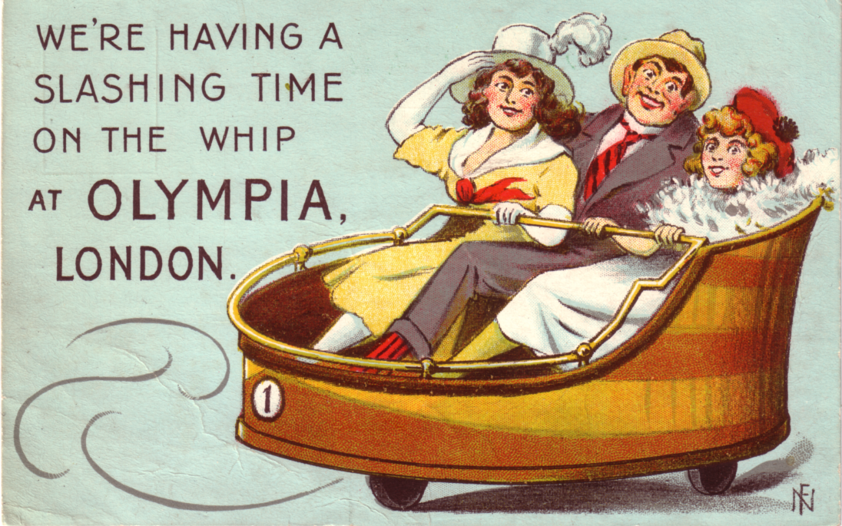

Date unknown.

survived until 1906, when it had ceased to be profitable and was promptly demolished. It had carried a total of 2.5 million customers.
Kiralfy’s own involvement with Earls Court continued in earnest until 1903 and saw the staging of such chest-beating productions as ‘Our Naval Victories’, ‘India’ and ‘China’. After the Hungarian Exhibition of 1908 Earls Court was in perceptible decline. During the First World War the Grounds were used as a Belgian refugee camp, but unlike Olympia it did not bounce back easily from this period. Some parts were used as a bus depot, others were used sporadically to stage circuses. In 1929 the Underground Electric Railways Company tried to promote a new exhibition building - but without success. A similar fate befell a proposal to turn the Empress Theatre into an ice-hockey rink
It was only in 1935, with the end of the old lease in sight, that the rebirth of Earls Court began. The new freeholders of the site, the London Passenger Transport Board, promised a new lease to a revived Earls Court Limited, controlled largely by American shareholders. The company began renovating the Empress Theatre, which reopened as an ice-skating rink seating 7,000 in November 1935 under the new name of Empress Hall.
The remaining acres were used to site the present exhibition hall. Designed by Chicago architect C. Howard Crane and managed by the firm Hegemon-Harris of New York (also responsible for overseeing construction of the Rockefeller Centre) the building was contracted fairly speedily between January 1936 and July 1937. It cost £1.5 million and was one of the largest reinforced concrete structures of its day. The complicated foundations involved the covering over of the two curves of the District Line, an operation that required the construction of sixty concrete bridges.
A triangular building, it covered nearly 450,000 square feet (almost 42,000 square metres)and offered parking for 2,000 cars. The upper floor was divisible into three sections so that four exhibitions could be shown simultaneously. The venue contained 18,500 seats, which meant that Earls Court was - and still is - the largest covered auditorium in Europe. It also contained as enormous swimming pool, built in three sections which could be raised or lowered by hydraulic jacks. This could hold a staggering two and a quarter million gallons of water. The building also featured the world’s largest thermal heating system and an excessive number of fire exits and staircases. These stringent safety measures paid off when a bomb explosion during the 1976 Boat Show saw the packed building evacuated in just a few minutes.
This mould-breaking monolith had less than a glorious start in life, as the Second World War broke out shortly after its completion. It saw out the war years as a factory making and testing barrage balloons. But the post-war period brought a potent mix of sports, entertainment and exhibition to Earls Court. There was the ‘Aquashow’ in 1948, featuring Johnny ‘Tarzan’ Weissmuller, there was boxing, badminton, ballroom championships, ice-skating shows such as ‘Ice Capades’, ‘Babes in the Wood on Ice’ and ‘Cinderella on Ice’. Then there was the Royal Tournament, a long-time resident at Olympia, which moved over from Olympia to the even more spacious new hall in 1955. Other Earls Court regulars who made the jump from Olympia included the Motor Show and International Boat Show.

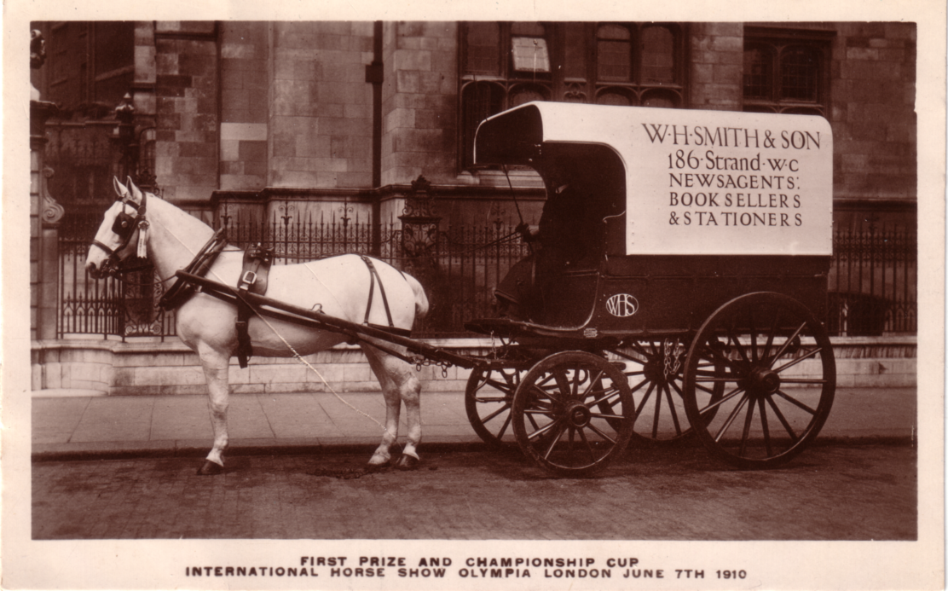

First Prize and Championship Cup.
International Horse Show, Olympia, London, June 7th 1910.

Shows in the 60’s and 70’s included the ‘Billy Graham Crusade’, USSR gymnastics, and rock concerts from the likes of David Bowie, the Rolling Stones, Pink Floyd, Elton John, Queen, Genesis and Bob Dylan. More recent years have witnessed the Grand Operas ‘Tosca’, ‘Carmen’ and ‘Aida’, a Masonic anniversary dinner, boxing from Lennox Lewis and more World-class performers such as U2, Paul McCartney, Whitney Houston, Prince and Dire Straits.
But still the expansion goes on. Earls Court heads towards the end of the millennium with an additional 17,000 square metres of space in the form of Earls Court 2, opened in 1991 at a cost of £100 million. The new area, big enough to hold four jumbo jets or 686 buses, and containing enough air to keep a human alive for 26.4 years, has already hosted crowd-pulling events such as the boxing World Championships, world wrestling and in 1992, a celebration of Her Majesty the Queen’s reign of 40 years.
The long histories of both Earls Court and Olympia are a testament to peoples appetite for the big occasion, and the celebratory sense of achievement that comes when large numbers of people gather together in one place in order to experience new things. It is a need which both halls have satisfied in grand style. But their many years of existence, through times of great uncertainty, are also testament to the business acumen of their managements.
It was not, however, until relatively late in the day, in 1973, that arguably the most far-sighted business decision was made for both Earls Court and Olympia. Until then, and despite their proximity and shared interests, the two venues had been very autonomous businesses and indeed considerable rivals. But in 1973 the two were merged to form what we now know as Earls Court

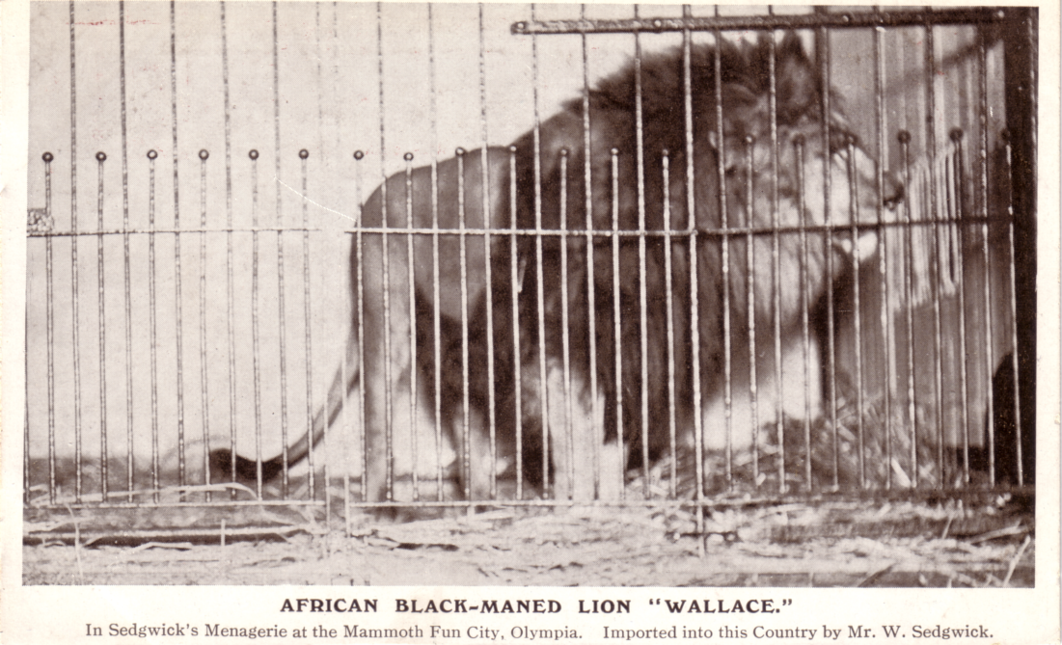

African Black-Maned Lion “Wallace”
Sedgwick’s Menagerie at the Mammoth Fun City, Olympia.
Imported into this Country by Mr. W. Sedgwick.

Olympia (ECO). Sterling Guarantee Trust, which already owned Earls Court, acquired Olympia. SGT was in turn merged with shipping company P&O in 1985 and it is P&O which steers the venues into the next century.
ECO today is an awesome operation, as at a glance at the following facts and figures will confirm, a total of just over 1,077,000 square feet of space hosting 165 events a year, attracting over 3.5 million visitors and generating around £450 million in revenues; the busiest exhibition centre in Europe, served by four international airports, linked by road, rail and 145 underground stations. And all this in the heart of London, one of the world’s most vibrant commercial and cultural centres.
But the story certainly doesn’t end there. With a firm hand on the tiller, P&O is steering ECO into yet more uncharted waters. A long-term investment programme will see, over the next few years, a range of initiatives designed to make the venue even more attractive. They include a relief road to facilitate better access for exhibitors, clear signage at the Olympia and Earls Court Underground stations, a glazed walkway and new escalator for the entrance to the Grand Hall, the new Brompton Conference Suite at Earls Court (this has now been completed), improved hospitality suites, re-glazing the Grand Hall roof with solar-protective glass and an updated heating and cooling system - to name but a few.
None of this is change for change’s sake. In fact, nothing more clearly symbolises ECO’s determination to build on its past while looking to the future than the modernisation of Olympia’s Glorious centrepiece, the Grand Hall. That once revolutionary roof has been completely replaced with state-of-the-art glass. Together with an environmentally-responsible new climate-control system and soundproofing, this will ensure the best possible conditions for exhibitors and visitors alike well into the twenty-first century. General Burnaby would still recognise his brainchild of 1886, but it is no museum piece. Earls Court Olympia is as modern today as it was when it all began.

This article was sent in to me some time ago, and unfortunately has got separated from the accompanying letter, so not knowing where it came from, I cannot give any credits for it. If I have unintentionally infringed any copyright, I apologise. My thanks to Mike Perkins who put the text on to disc for me.

Alan Sabey has asked me to remind members their subscriptions were due in October.

Postcards of the White City.

A preamble by Bill Tonkin.

Several new things have turned up on the J Beagles cards. I mentioned the thought that not all the letters of the alphabet were used, and that 24 would fit nicely into four packets. Since writing that 961 N has turned up and this just leaves letters I and Q missing. If nobody has seen these I think we can safely say that Beagles only issued 24 cards. Alan Sabey tells me he has a coloured Beagles card with a different back to the one I have listed, he will let me have a photo-copy of it, he also reports finding a copy of the 964 series and will let me have the title and details. There has also been another new find on the 964 series, one has turned up with the title covered with a gold panel, and retitled. There seems to be plenty of interest in the White City, and I hope those of you who collect these cards will continue to check up and let me know of items not listed. I am continually being told “you’ve got ‘em all” I wish I had, but the more I find out about cards the more I realise how many cards I have not got, and how much there is still to learn about cards.

POST CARDS OF THE WHITE CITY

Part 3.

by Bill Tonkin

Brennan Gyroscopic Mono-Rail Car.
Type 1. B/W advert card with green printing, green back with half the back filled with advertising text. POST CARD measures 40mm.
The Brennan Gyroscopic Mono-Rail Car. First publicly exhibited at Japan-British Exhibition. Photographed whilst running at 20 miles an hour on circular track. A further two lines of text at the bottom of the card.

Type 2. Sepia advert card with brown printing, green back without advertising text. POST CARD measures 52mm.
The Brennan Gyroscopic Mono-Rail Car. As first publicly exhibited at the Japan- British Exhibition. 1910. It is probable there is a further text at the bottom of the card, unfortunately the only card seen has the bottom cut off, however the style is the same.

Briffault Range Co.
B/W trade card, black back with a map showing the site of their stand in the French section of Machinery Hall at the Franco-British Exhibition.
No title. (Picture of cooking ranges).

Burgoyne.
Sepia R/Photo advert card with white border, brown back.
Burgoyne’s Australian Wine Bungalow, Franco-British Exhibition 1908.
The Managers Bungalow on a Burgoyne Vineyard, The Wine that makes Australia Famous.

C W S Crumpsall.
R/Photo without white border, black back.
Franco-British Exhibition 1908. C W S Crumpsall Silver Medal Cake. (Three tier cake surmounted with figure holding the horn of plenty.) Vert right.

Canadian Pacific Railway.
Coloured advert card with white border, title in English and French, in four lines printed in blue, black back. Although there is no mention of the exhibition examples are known with ‘Franco-British Exhibition’ or ‘Ballymaclinton’ cancellations, with messages relating to the exhibition, also an un-used card with ‘From the White City 1908’.
Souvenir of the Canadian Pacific Railway, the most picturesque route in the world. Souvenir du Chemin de fer Canadian Pacific, la route la plus pittoresque du monde entier. (View of mountains with fir trees in forground). Vert left.
Note. There is a similar card with a view of mountains and a lake in the foreground, the title is the same but is printed in black, and has an address at the bottom 62-65, Charing Cross, London, S.W. As far as is known this is not an exhibition card.

James Carter & Co. (Carters Tested Seeds).
Type 1. B/W or Sepia advert cards, black back with ‘Carters Tested Seeds’ in words only in top left corner, and a dotted stamp box with ‘Halfpenny Stamp’.
Franco British Exhibition. The above fine Collection of Vegetables was grown entirely from Carters Tested Seeds awarded the Gold Medal and Grand Prix in strong open competition. Exhibited by the Hon Vicary Gibbs. (Mr Edwin Beckett, gardener.
A. B/W.
B. Sepia.
5 Grand Prix & 5 Gold Medals. Franco-British Exhibition.
A. B/W.
5 Grand Prix & 5 Gold Medals. James Carter & Co. Seed Growers, 237-8, High Holborn, London, W.C. Illustrated List Post Free. How Carters Tested Seeds are Tested. In a white panel 24mm wide on right Carters Miniature Trial Grounds at Franco-British Exhibition (White City) 1908.
A. B/W.
No title. In white panel 34mm wide on right Royal Pavilion, His Majesty the King’s Pavilion, The Lawns and Flower Beds were entirely decorated by Carters. Followed by details of medals won.
A. B/W.
Type 2. B/W trade card, as above with a black back filled with printing. On each side at the top a logo with the words ‘Carters Tested Seeds’ incorporated in a drawing of a glass house interior in an oblong double lined frame. The printed back reads ‘James Carter & Co. present their complements, and beg to hand herewith goods as per esteemed order, for which payment by.....value.....is acknowledged with best thanks......
5 Grand Prix & 5 Gold Medals. Franco-British Exhibition.

Central London Tube Railway.
A pull out card published by the Central London Tube Railway, printed by H.G. Ltd. B/W with red flap to pull-out in the shape of a pillar box, with 'Quickest way to Exhibition by Tube' printed in white, and underneath times of trains from the exhibition.
Contents, horizontal strip of fourteen views, laid out as an underbround map, with the line and stations named in red. The views are of the locality of each station, and only two are of exhibition interest. Wood Lane Exhibition Station shows a view of the Wood Lane Entrance taken from a Bonnett & Shum card, while Shepherds Bush shows the Main Entrance to the Exhibition from an unknown source.
Wood Lane Exhibition Station. / Shepherds Bush. / Holland Park. / Nottinghill Gate. / Queen's Road. / Lancaster Gate. / Marble Arch. / Bond Street. / Oxford Circus. / Tottenham Court Rd. / British Museum. / Chancery Lane. / Post Office. / Bank.
No number. Central / London / Tube / Rly. Quickest way to Exhibition by Tube.

Channel Tunnel. The
B/W, brown back with an ornamental stamp box with three loops at each corner, and ‘Affix Stamp’ in the box.
Souvenir of Franco-British Exhibition 1908. The Channel Tunnel. with eight lines of poetry at bottom.

Chateau Livran, Medoc, France.
Coloured card with black back. The bottom part of the front contains details and prices of wines, and at the top is a title.
Gold Medal Claret-Franco-British Exhibition, 1908.

Chocolat Menier.
Type 1. B/W advert card with gold overprint, gold back. The view is of an exhibition stand with a message on the front ‘The quantity of Chocolat Menier consumed in one day is equal to the volumn of this structure and weighs 132,400 lbs’.
Souvenir Franco-British Exhibition, 1908. Three Grands Prix awarded to Menier.

Menier also had three series of Rotary cards overprinted on the front ‘With the Complements of Chocolat-Menier’ two lines in red. it is not known if the whole set in each case was used.
Type 2. Rotary Photographic Boudior Plate Sunk Series No. P. 738. R/Photo, brown back. Most of the titles are preceded with ‘The Franco-British Exhibition.’
P. 738. A The Franco-British Exhibition. “Palace of Music.”
P. 738. B The Franco-British Exhibition.“Palace of Women’s Work.”
P. 738. E The Franco-British Exhibition.“Royal Pavilion.”
P. 738. O The Franco-British Exhibition.“Palace of British Applied Arts.”
P. 738. S The Franco-British Exhibition.“Elite Gardens & Franco-British Exhibition.”
P. 738. U The Franco-British Exhibition.“Wood Lane Entrance.”
P. 738. Y Franco-British Exhibition. “Australian Pavillion.”

Type 3. Rotary Photographic Series No. 6791. R/Photo, brown back.
6791 E The Franco-British Exhibition. The Palace of French Applied Arts.
6791 F Franco-British Exhibition. The Royal Pavilion.
6791 U Franco-British Exhibition. Main Entrance. Vert right.

Type 4. Rotary Photographic Series No. 6792. R/Photo, brown back.
6792 E The Franco-British Exhibition. The Garden Club.
6792 M The Franco-British Exhibition. “Irish Village.”

Andre Citroen & Co.
Sepia litho printing, brown back with ‘CARTE POSTALE’ in large letters with serifs.
Our Stand at the Franco-British Exhibition, London, 1908. Vert left.

City of Tokyo.
Sepia litho printing with text printed in gold, brown back. Under the heading of ‘Greetings from Japan-British Exhibition’ underlined, the cards show models of gardens constructed by The Taiko-Yen, Shiba Park, Tokyo, Japan. and exhibited by The City of Tokyo.
A Miniature of Landscape Gardens.
A Miniature of Tea Gardens.

Clay Cross Co.
B/W advert card with five lines of advertising text on the front at the top, black back with ‘From the Clay Cross Co. Stand 630, Machinery Hall, Franco-British Exhibition, Shepherds Bush, London, W.’
General View of Pipe Bank.

Coleman & Co. Ltd.
B/W advert card with coloured bottle of Wincarnis, a tonic restorative, brown back.
A Bit of Old Norwich. (View only is printed sideways.)
Cattle Market, Norwich.
Norwich Cathedral-from the Cloisters. (View only is printed sideways.)
Norwich Cathedral-from the East.
Norwich Cathedral-South East. (View only is printed sideways.)

Cointreau.
B/W advert card, black back.
Cointreau, The finest Liqueur Triple Sec. Cointreau Fils Stand, Franco-British Exhibition. Vert left.

Cunard Steamship Co. Ltd. The
Type 1. Coloured advert card, Green back designed and printed by the Kingsway Press, London, W.C.
Cunard Line Express Steamer “Lusitania” or “Mauretania” compared with the Stadium. Franco-British Exhibition.
Type 2. B/W line printing official card published by the Cunard Steamship Co., black back with company crest between ‘POST’ and ‘CARD’.
Cunarder “Lusitania” or “Mauretania”compared with the Stadium. Franco-British Exhibition. London. The extreme length of the Stadium is 1,001 feet, and will seat 60,000 people.

Cynicus Publishing Co. Ltd.
Tinted litho, brown printing on the front on buff card. This is a multi purpose card with the locality printed in black to order, in this instance ‘The White City’. Black back with 6303 above dotted stamp box.
A Present from The White City, Accept these flowers of lovely hue, They’re painted Dearest, just like you. Vert left.

Daily Mirror.
Type 1. Sepia advert card, brown back. About a third of the front is taken up with a view of the “Daily Mirror” Model Cottage, the rest is text about the ‘Ideal Home as erected at the old English Village, Franco-British Exhibition 1908.’ Also included is an advert for ‘The Circle Permanent Building Society, and ‘Robinson & Roods, F.F.S.I., Surveyors’.
The “Daily Mirror” Model Cottage.

Type 2. Sepia R/Photo, brown back. To supplement the above card The Daily Mirror published a series of cards showing exterior and interior views of the cottage.
“Daily Mirror” Cottage in the Old English Village at the Franco-British Exhibition.
Living Room in “Daily Mirror” Cottage at the Franco-British Exhibition.
Oak Panelled Dining Recess in “Daily Mirror” Cottage at the Franco-British Exhibition.
Principal Bedroom in “Daily Mirror” Cottage at the Franco-British Exhibition.
The First Floor Landing at “Daily Mirror” Cottage Franco-British Exhibition.
Vert left.

Daily Telegraph.
The Daily Telegraph had a Pavilion for several years at the white City, and published the same card with different titles for each exhibition. Although the wording is the same, apart from the name of the exhibition there are slight differences both on the front and the back. The heading at the top reads ‘Latest & Best News from all Parts of the World.’
Type 1. Japan-British Exhibition.
B/W, green back with ‘POST CARD’ measuring 55mm.
The “Daily Telegraph” Pavilion. Japan-British Exhibition, Shepherds Bush, London.
A. Heading in capital letters measures 85mm. Vert left.
B. Heading in capital letters measures 87mm. Vert right.
C. Heading in capital letters measures 88mm. Vert right.

Type 2. Coronation Exhibition.
B/W, green back with ‘POST CARD’ measuring 51mm.
The “Daily Telegraph” Pavilion. Coronation Exhibition, Shepherds Bush, London.
A. Heading in non capital letters measures 75mm. Vert right.
B. Heading in non capital letters measures 77mm. Vert right.

Type 3. Latin-British Exhibition.
B/W, green back with ‘POST CARD’ measuring 51mm.
The “Daily Telegraph” Pavilion. Latin-British Exhibition, Shepherds Bush, London.
A. ‘Latest’ and ‘Best’ in capital letters rest in non capitals, heading measures 75mm. Vert right.

Davidson Bros. London & New York.
Davidson was one of the more prolific publishers of Franco-British cards, they were printed with three different backs. Type A. is the commonest with ‘POST CARD’ measuring 40mm, in place of a divider there is a small ornamental shape consisting of scrolls 11mm deep. Type B. has a larger size ‘POST CARD’ measuring 49mm, the curved design is in the same style but different in shape and is about the same size, apart from these points the layout of the backs are the same, with a two line imprint down the left side ‘ Davidson Bros. Real Photographic Series. London & New York. (Printed in England), and ‘Davidson’s Quality’ in the bottom left corner. Type C. has ‘POST CARD’ increased to 54mm, and ‘Davidsons Quality’ is moved to the top of the card. There is an outline divider with a knob at each end measuring 16mm. ‘Real Photographic Series’ has been left out of the imprint, which now reads ‘Davidson Bros. London & New York. Printed in England’, this is a fairly scarce back. Most of the cards can be found in two shades white and pearl, these are not listed. The cards can also be found with and without ‘T.P.’ written in the bottom right corner. Davidson only printed one series for the Japan-British Exhibition and this had a different back to the Franco-British cards, Type D. which will be described in that section.
Christmas Greetings Card.
R/Photo, two circular views with ‘Hearty Christmas Greetings’ at the top and a rhyming couplet, Christmas Greetings kind and true, I send this day with love to you. Black back type A. without imprint or ‘Davidsons Quality’.
The Elite Gardens and Grand Restaurant, & The Wood Lane Entrance.

Series 4111.
Type 1. R/Photo, black back Type A. This series consists of a view of the exhibition in an oblong frame, on the horizontal cards there are two different views, or the same view repeated twice. In the centre a picture of visitors played by actors in a round frame, and at the bottom a five line limerick in a scroll, or panel. In one instance the last line can be found in two styles, ‘With his “flipper” she “flapped” with delight’ was altered to ‘While her heart it was filled with delight. The cards are numbered but there are no titles. As the size of the lettering varies, measurements for all cards are given. While in some cases the difference is very little, it will usually be seen that the frame has been altered or redrawn as well.
4111 Palace of French Applied Arts, two actors in centre.
A. Top line of limerick measures 62mm. Vert right.
B. Top line of limerick measures 64mm. Vert right.
4112 Swan boats in Court of Honour, two actors in centre.
A. Top line of limerick measures 55mm. Vert right.
4113 Court of Honour at Night, (A.) two actors in centre
A. Top line of limerick measures 36mm. Vert left.
4114 Court of Honour at Night, (B.) two actors in centre.
A. Top line of limerick measures 58mm. Vert right.
B. Top line of limerick measures 61mm. Vert right.
4115 Elite Gardens & Grand Restaurant, two actors in centre.
A. Top line of limerick measures 46mm. Vert right.
B. Top line of limerick measures 47mm. Vert right.
4116 Elite Gardens & Grand Restaurant, four actors in centre.
A. Top line of limerick measures 46mm. Vert right.
4117 (Two views, Swan boats in Court of Honour, & Palace of Music, four actors in centre.
A. Top line of limerick measures 43mm.
4118 (Two views, Swan boats in Court of Honour, & Palace of Women’s Work, three actors in centre.
A. Top line of limerick measures 43mm.
B. Top line of limerick measures 46mm.
4119 (Two views, Swan boats in Court of Honour, Royal Pavilion & Elite Gardens, five actors in centre.
A. Top line of limerick measures 36mm.
B. Top line of limerick measures 39mm.
4120 (Two identical views, Swan boats in Court of Honour, and Swan boats in Court of Honour, two actors in centre.
A. Top line of limerick measures 41mm, bottom line reads ‘While her heart it was filled with Delight’.
B. Top line of limerick measures 43mm, bottom line reads ‘With his “flipper” she“flapped” with Delight.
4121 (Two views, Swan boats in Court of Honour, Court of Honour, four actors in centre.
A. Top line of limerick measures 37mm.
B. Top line of limerick measures 40mm.
4122 (Two views, Swan boats in Court of Honour, & Palace of French Applied Arts, two actors in centre.
A. Top line of limerick measures 36mm.
B. Top line of limerick measures 39mm.

Series 4111.
Type 2. R/Photo, black back Type B.
4112 Swan boats in Court of Honour, two actors in centre.
A. Top line of limerick measures 57mm. Vert right.

